April 2000 -- Bugs and Things

Pre-Opening
Match the insect with the food you would feed it if you caught one:
Praying Mantis a) feed soft-bodied insects and water. in small pieces
Field Cricket b) feed oatmeal or bran meal with small pieces of potato or apple.
Click Beetle c) bits of bread soaked in water, lettuce, or peanut butter.
Grasshopper d) feed types of leaves from the location you found him.
Caterpillar - e)grass sod and water
Tarantula f) eats flies or small insects, raw meat
Meal Worm g) eats most all insects and needs water.

answers: 1. f 2. c 3.a 4. e 5. d 6. g 7. b

Ceremonies
Opening
6 Cub Scouts looking around the stage.
#1: What’s that up in the sky -- a dragon, a plane, a cloud?
#2: I’ve seen lots of bugs, but never one like this. Have you?
#3: That’s a pretty bird up in that tall tree;p I wish I knew what kind it was.
#4: I wonder if we could play ball or maybe even have a picnic out here.
#5: Let’s ask our den leader or our parents, I’m sure they will let us.
#6: Boy, you guys have really opened my eyes to all the fun we can have in a backyard.

Stand and join in the Pledge of Alliegience.

Opening
2 or more cub scouts, dressed in paper bag bug costumes.
#1: My name is Litter Bug Lou.
And, ohy, what us litterbugs do!
We clutter the county with papers and trach.
At making a mess we’re really a smash.
The roadsides and parks are scenes of our folly,
We really enjoy it and think it quite jolly.
to leave behind garbage, bottles and paper,
As little momentos of our daily labor.

#2: I’m Tidy bug Ted of the Tidy Bug clan.
We work keep things spick and span,
Together we pick up the litter near and far.
And always carry litter bags in our car,.
We’ll K.O. Lou and all her bug band,
And make America again a beautiful land,
Free of litter, trash and clutter,
Won’t you help us, dear fadder and mutter?

Closing
Four scouters with copies of the Outodoor code to audience or large poster with underlined words on it.

#1: Please stand as we say the Outdoor Code together. Pause after each line for an explanation of that line.

All: AS AN AMERICAN, I WILL DO MY BEST TO: BE CLEAN IN MY OUTDOOR MANNERS
#2: I will treat the outdoors as a heritage to be improved for our greater enjoyment. I will keep my trash and garbage out of America’s water, fields, woods, and roadways.
All: AS AN AMERICAN, I WILL DO MY BEST TO: BE CAREFUL WITH FIRE.
#3: I will prevent wild fires. I will build my fire in a safe place and be sure it is out before I leave.
All: AS AN AMERICAN, I WILL DO MY BEST TO : BE CONSIDERATE IN THE OUTDOORS.
#4: I will treat public and private property with respect. I will remember that use of the outdoors is a privilege I can lose by abuse.
All: AS AN AMERICAN, I WILL DO MY BEST TO: BE CONSERVATION MINDED
#1: I will learn how to practice good conservation of soil, water, forests, minerals, grasslands, and wildlife. and I will urge others to do the same. I will be a good sportsman in all my outdoor activities.

Training Fleas
Do you know how they train fleas? They put them into a glass jar with a lid. Then the fleas try desperately to get out. They keep jumping up hitting their heads against the top of the lid. Soon they don’t jump quite as high. Soon you can take them out of the jar and put them into an arena. As long as the side of the arena is lower than the lid was on the jar, the fleas will never jump out. They got tired of hitting their heads against the top and soon never jumped that high again for fear of hitting their head again. Boys can be like fleas. If we put a lid on some inappropriate activities, we may teach them to never do them again. But we must be careful that when it comes to learning and growing we keep the lid off the jar so that they never learn to limit their creativity.

Closing Thought
One of America’s greatest conservationists, Aldo Leopold, said: “The Lord giveth and the Lord taketh away, but He is no longer the only one to do so. When some remote ancestor of ours invented the shovel, he became a giver. He could plant a tree. And when the axe was invented, he became a taker. He could chop it down.” Thus each of us possesses the power to create or to destroy. Let us use this power wisely for the good of our Country and all mankind.

Audience Participation/Skits
Picnic for Insects Only
A nature skit
The scene is the meeting hall of the International Insect League. It is their annual meeting. A sign at the back of the stage says: "International Insect League —3,561st Annual Meeting.” Have a table at one side of the stage for the chairman of the meeting and chairs on the other side for those attending the meeting.
You’ll need seven actors, each one representing a group of insects. You may use more actors, adding them to the groups. You may eliminate characters by simply referring to a group of insects and not have anyone representing them.
Costuming can be as simple or elaborate as you want. Simple signs, such as “Chairman Termite,” “Mr. Ant” or “Mr. Grasshopper,” (or “Miss Ant” and “Miss Grasshopper") can be worn by the actors. This would be enough. But if you want more, wings could be made from wire.stiffened tissue paper and tied to the body; antennae could be made from wire with plastic foam balls on the tips; the antennae could be attached to a cardboard headband.
CHAIRMAN TERMITE: This meeting will come to order. I’d like to welcome all you delegates to the 3,561st meeting of the international Insect League. Tonight, we make our plans for this summer’s picnic which is for Insects only! We don’t have any minutes from the last meeting. As you remember, a frog came in and broke the whole thing up. But we do have a treasurer’s report -- Mr. Grasshopper.
MR. GRASSHOPPER: As of today, we have on hand 2 sacks of honey, donated by the bees; 25 drops of blood, courtesy of the mosquitoes; and 5 bread crumbs the ants had left after taxes. Our supplies are really getting low.
CHAIRMAN TERMITE I thank you, Mr. Grasshopper. As you see, gentlemen, we need your help; especially since our annual picnic is coming up. All of you have your assignments for the picnic, and I’d like up-to-the minute reports — especially from the invitations committee. We certainly don’t want any PEOPLE there! The. picnic will be held in the North Woods — my friends are really looking forward to it. Mr. Ant, will you tell us how plans for food are going?
MR. ANT: We’re crawling right along. We plan to hit a lot of human picnics and kitchens before the big day. You might say, the big push is on. Our workers are out night and day. I think I can promise you all a real crumby time! Ha. Ha.
CHAIRMAN TERMITE: Thank you, Mr. Ant. We’ll be looking forward to it. By the way, don’t forget to throw in a toothpick or two for us termites. Mr. Caterpillar, may we have a report on the decorations.
MR. CATERPILLAR:. YesSirrëe. We promised you butterflies, and we’ll give you butterflies. Yessirree. My group intends to climb in their cocoons right after this meeting. so we’ll be ready for the big day. You’ll have about 2,000 butterflies arranged on trees and bushes. Yessirree. And the spiders have promised to spin a chain of webs between the butterflies. Yessirree — really spectacular!
CHAIRMAN TERMITE: We get your message, Mr. Caterpillar. Yessirree. And now, In charge of lighting, a report from Mr. Firefly.
MR. FIREFLY: Yes, we were never ones to sit back, if we did, no lights! Well, the lighting should be just as spectacular as the butterflies. 10,000 fireflies are coming.
Right now, we’re checking all their batteries. And we’re fortunate to have real experts checking them - the Japanese beetles — and we’d like to thank them. Let’s just say, we’re going to get a charge out of doing our part.
CHAIRMAN TERMITE: That’s the spirit! And now, for the surprise I’ve been saving for you — the entertainment. We’re happy to say that the entertainment for that night will be provided by none other than the beetles! (Much applause.) How are you doing, fellas?
(The beetles hum a note.)
CHAIRMAN TERMITE: That’s great, fellas. The beetles will be backed by a full orchestra of crickets. Now, with all these fantastic plans, let’s have a final important check with the grasshoppers about invitations. Have they all gone out?
MR. GRASSHOPPER: All the invitations have gone out. I tell you, it has sure kept us hopping! And from what we hear, everyone’s coming. We’ll really have to watch the gate carefully, so no people get in!
MR. ANT: Yeah. They ruin all our picnics!
CHAIRMAN TERMITE: Well, I think we’ll discourage them. The wasps will be in charge of the door.
MR. ANT: Well, I hope so. Remember last year? They came and squirted all that insect spray? Why, we had thousands of casualties. That’s why our supplies got so low. Then, we moved our picnic to the beach, and they followed us there -- same thing. And those human insects they bring with them. Why, it’s terrible.
CHAIRMAN TERMITE: The wasps have been warned to watch especially for those human insects, and to be sure, above all, not to let them in!
MR. FIREFLY: Human insects! I’m sorry, Mr. Chairman, but I wasn’t around last year. What human insects?
MR. ANT: Ha! You didn’t have to be around last year. These human insects have been around for a long time. They’re there all year long, but in the summer they are really awful! ‘they’re at the beaches, In the parks, along the streets. And, boy, I don’t want to be anywhere they are!
MR. FIREFLY: Human insects? Why, what are they called?
ALL: LITTER BUGS!!!

The Ants
Characters 6 to 8 cub scouts
Props: Paper Sacks
Setting: Skit opens with boys standing together in a backyard. Cardboard cutout trees and bushes could be used.

1st Cub: Gee, there’s nothing to do.
2nd Cub: Yeah, I know.
3rd Cub: Hey, let’s have a backyard picnic.
All: Yeah!
4th Cub: But it’s going to rain.
1st Cub I don’t think so. If it does, we can eat in the house.
2nd Cub: I’ll bring the potato chips.
3rd Cub: I’ll bring the hot dogs.
4th Cub: I’ll bring the hot dog buns.
5th Cub: I’ll bring something special!

(All walk offstage and come back carrying sacks.)
2nd Cub: Here are the chips.
3rd Cub: Here are the hot dogs.
4th Cub: Here are the hot dog buns.
5th Cub: Here are the drinks.
6th Cub: (Drops his sack) Oh No!!
5th Cub: What’s wrong?
6th Cub: I brought the ants!!

Bee Sting
1st Scout: “OOOOOOUCH, OOOOOH, OOOOOUCH”
2nd Scout: “What’s the matter with you?
1st Scout : “A Bee’s Stung my thumb!”
2nd Scout: “Try putting some cream on it then.”
1st Scout: “But the bee will be miles away by this time!”

All About Animals
Cast: Jerry, Jimmy, Johnny, Jack
Scene: Jerry is reading. He turns the pages of his book slowly. One by one, the others enter.
JIMMY: Hi Jerry. What are you doing?
JERRY: (Not looking up) Reading a book about animals.
JIMMY: It must be a good book. (He sits down and picks up another book and begins to read also)
JOHNNY: (Entering) Hi Jerry. Hi Jimmy. What are you doing?
JERRY: (Not looking up) Reading this book. (Closes book) Now I know all about animals.
JACK: (Entering) Hi guys. What are you doing?
JOHNNY: Jerry’s been reading a book. He says he knows all about animals.
JACK: OK. Then tell me what animal can Jump higher than the Empire State Building.
JERRY: (Thinks) I'll have to look it up. (He looks in index of book)
JIMMY: (Looking up from his book) I don’t think any animal can jump higher than the Empire State Building.
JOHNNY: (To-Jerry) And I thought you knew all about animals!
JERRY: So did I. (Looks sheepish) (To Jack) What animal can jump higher than the Empire State?
JACK: All of them. The Empire State Building can’t jump!

Marked Trail
Cast: An adult and any number of uniformed Cub Scouts.
Scene: Adult is helping boys pack day packs and fill thermoses, getting ready for a hike.
ADULT: This sure is a nice day for a hike.
1ST BOY: Great day.
2ND BOY: Just right for hiking in the woods.
ADULT: You mustn't keep Mr. Jones waiting. You’re lucky to have a den leader like him.
(Phone rings)
3RD BOY: I ‘11 get it. (He talks on phone to Mr. Jones, then hangs up.) Mr. Jones can’t go.
4th BOY: Why can’t we go without him?
ADULT: I don’t know if that’s a good idea. What if you should get lost.
5TH BOY: We wouldn’t get lost. The Saturday hikers always mark the trail.
ADULT: Mark the trail? How interesting.
5TH BOY: Yeah. They mark it with candy wrappers, soda cans,
4TH BOY: Newspapers
3RD BOY: Band aids (Curtain)

The Adventures Of Wonder Weevil
Props — backdrop of city buildings
Costumes --Outrageous paper bag creations with legs and antennas attached.
Introduction -- Wonder Weevil (sung to the tune of “Wonder Woman”) Disguised as an ordinary insect in Bug City is the famous crime fighter Wonder Weevil.
Wonder Weevil was going home from work one ordinary day when he saw it, evidence of a horrendous crime wave that was gripping the whole city. As he walked, he tripped on cans, paper and all sorts of trash. This was the work of the Humongous Gang of Litterbugs.
These selfish citizens of Bug City made the city ugly for everyone. Somehow he had to get help to stop this crime wave. He knew just the one to serve the cause — The Lovely Little Critter. If she could entice the gang to give her their trash, the city streets would be free of this crime.
“Litterally” speaking, she could hold the trash problem within her loving heart. if only hands would help her! She needs everyone. (Say these last two lines in a dramatically frantic and desperate voice) She needs you!!!
Have Cubs pass out trash bags made of brown sacks decorated as Litter Critters and go on a litter cleaning hike. Or pass out brown paper bags and have the pack decorate them as Litter Critter and then use them to pick up litter.

Fishing Trip
Actors: 4-8 persons
Costumes: Cub Scout uniforms and den chief uniform, fishing gear.
Props: Boat and water cardboard silhouettes, benches.
Setting: Skit begins with Cub Scouts and den chief going fishing. When they reach the lake, the boat is about _{5 - 10'} away from dock.
1ST BOY: (Walks across water and gets in boat)
2ND BOY: Wait for me! (Walks across water and gets in boat)
DEN CHIEF: Oh, well! (Steps in water and falls in. He drags himself out of water onto dock.)
3RD BOY: I’m coming. (He walks across water and gets in boat)
(The den chief tries again, and falls into water. This continues until all Cub Scouts are in boat)
4TH BOY: Do you think we should tell him where the rocks are?

Run-ons/jokes
What is a bee's favorite dance?
The bee-bop.

What bee can you throw?
What?
A Frisbee!

What is an antelope? An insect that runs away to get married.

What do you get when you cross a turkey with a centipede?
What?
Drumsticks for everyone!

What do ants sing before a ball game?
What?
The National Ant-them.

How is the beehive like a rotten potato?
How?
A beehive is a bee holder, a beholder is a spectator, and a specked tator is
a rotten potato.

Yo Duff!, what do you get when you cross a termite with a praying mantis?
I dunno, what?
An insect that says grace before eating your house.

What happened to the two silk worms that had a race?
What?
They ended up in a tie.

Why was the spider grumpy in the morning?
Why?
Because he woke up on the wrong side of the web.

Applauses
Bee Applause: Put arms out straight and pretend to fly while saying “Buzz, Buzz”.

Flea Clap: Everyone raises hand over head. Applause is accomplished by clicking the nails of the thumb and forefingers of each hand together.

Ant Applause: With two fingers of the right hand, walk them down the left arm toward the hand while saying “hup, tow, three four”. When the fingers reach opened palm grab them while saying “Gotcha!”

Mosquito Applause: With hand, slap yourself on neck, arms, and legs while saying “OOOH, AAAH, AAAH”

Spider Applause: Walk all four fingers of one hand up the other arm and then scream “EEEEKKKK!”

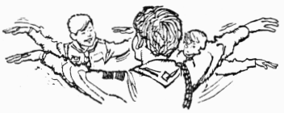
Games
6 Legged Race
Tie the left adjacent legs of two boys to each other like in a three-legged race. Now tie their arms that are next to each other together too. Have them get down on their knees and crawl in a 6 legged race to the finish line.

B.U.G.
Make three each of a bunch of insect names listed inside juice can lids. Now mix them up and give three juice can lids marked with insect names to each cub. On signal, start passing juice lids to the left. When one cub gets three of a kind, he puts his finger on his nose & the rest of the cubs must do the same. The last cub to put his finger on his nose gets a “B”. Play continues with players collecting letters until someone spells BUG. That person is now out of the game. Play continues until there is a winner.

Mr. Muffet & the Spider
One cub is Mr. Muffet & sits on a low bench in the center. The other cubs form a circle around Mr. Muffet. Mr. Muffet covers his eyes and one cub is chosen to be a spider. He must come up and touch Mr. Muffet and return to his seat without being caught. If Mr. Muffet hears the spider he tries to tag him before the spider returns to his spot in the circle. If the spider gets tagged he becomes Mr. Muffet and a new spider is chosen.

Grasshopper Relay
Relay teams line up single file. The first player in each team holds a bean bag or ball firmly between his knees. At signal, he hops to goal line and back to the starting line where he hands the bag to the next ‘grasshopper’ in line, if a player drops the bean bag, he goes back to the starting line. Team to finish first wins.

Measuring-Worm Race
In this race all contestants line up at the starting line, fall forward on signal and rest their weight on their hands. Next they draw their legs up under them and then fall forward again on their hands. This continues until the winner reaches the finish line.

Nature Alphabet Game
Divide den into two teams. • Give each team a pencil and paper and ask them to list growing things for each letter. (Example: Ant, Butterfly, Crocus, etc. ) Set a time limit. The team with the longest list wins.

Turtle Tag
To insure safety, a player must be on his back with all four feet in the air. The boy who is ‘it’ counts to ten and all turtles (other boys) must hop up and run at least ten steps before again assuming the turtle position. If ‘it’ can tag a player before he is ‘safe’ they exchange places and the other boy becomes ‘it’.

Songs
Watch Them Grow
(Tune: Three Blind Mice)

Three tiny seeds, three tiny seeds,
See how they grow, see how they grow,
With soil and water and lots of sun,
The seeds will pop up, one by one,
Watching them grow can be so much fun,
Three tiny plants.

Three big plants, three big plants,
See how they bloom, see how they bloom,
The buds appear, one by one,
They turn into flowers warmed by the sun,
Flowers, enjoyed by everyone,
Three blooming plants.

Worm Song
(tune: Yankee Doodle)
Little Ooie was a worm
A little worm was he
He sat upon a railroad track
The train he did not see

The train came rushing ‘round the curve,
It’s whistle going whooeee
But little Ooie did not turn
Now little Ooie’s gooey.

The Littlest Worm
(Like the Bear Song)
The littlest worm (repeat)
I ever saw (repeat)
Was stuck inside (repeat)
My soda straw (repeat stanza)

He said to me
“Don’t take a sip.
‘Cause if you do,
I’ll really flip.”

I took a sip
And he went down
Into my pipes,
He must have drowned.

He was my pal
He was my friend
He was pal
And that’s the end!

A Worm’s Eye View
(Tune: Home On the Range)

Oh come see my home,
Where I live all alone,
Munching onions and spinach all day.
Now you may think a worm
Doesn’t deserve his turn,
But without me the gardener would play.

Chorus
Home, home in the squash,
Where I live and I sleep and I eat.
The gardener may try
To blow me sky high,
But I’ll hide safely inside a beet.

We Are Planting
(Tune: Are You Sleeping?)

We are planting, we are planting,
Garden seeds, garden seeds,
Vegetables are growing,
Vegetables are growing,
Hoe the weeds, hoe the weeds.

A Garden
(Tune: Rueben, Rueben)

A garden is a wonderful thing,
It provides a home for bugs,
Squirmy worms and ants with wings,
And a thousand slimy slugs.

Two Little Fleas:
(Tune: “Auld Lang Syne”)
Two little fleas together sat;
They cried, and one flea said,
“I’ve had no place to lay my head
Since my old dog is dead.
I’ve traveled far from place to place,
And farther I will roam;
but the next old dog that shows his face
will be my home, sweet home.”

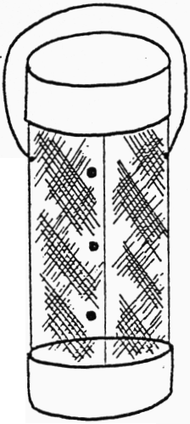
Crafts
Watercolor Butterflies
Materials: Paper coffee filters, watercolors and paintbrushes, markers, glue & glitter clothes pins (spring action or old fashioned are ok) colored paper
To color the filters, either dab on water color paint with a brush or draw on designs with markers or both. Add glue & glitter designs. Once the filter is dry, pinch it in the middle like a bow tie. Slide or clip the clothespin onto it and fan out each side of the filter to resemble a butterfly’s wings. Cut two strips of constructions paper, approximately the size of matchsticks and glue them onto the clothespin for a pair of antennae.

Bug House
Materials needed:
2 tuna or cat food cans
Screen wire 10” x 12”
3 metal paper fasteners
Plaster or caulking
Bottle cap
Wire for handle
wig (if desired)
Enamel paint

Instructions:
Form screen into 12” long cylinder, overlapping sides. Fasten with paper fasteners.
Paint cans with enamel paint. If you wish, paint a design on the lid (such as the one shown below) or use a decal. Let paint dry.
Fill bottom can halfway full of plaster or caulking. Before it hardens, stick in a twig (for bugs to crawl on) and a bottle cap (to hold water). Also, insert the screen cylinder into the paster. Let it harden.
Attach a wire handle to the sides of the screen (see illustration above). The lid sits on top of the wire cylinder and is not attached, so that it can be removed.
Then go on a bug hunt and find a bug for this nice house. Be sure to keep your bugs fed and watered if you wish to keep them.

Ladybug Crafts!!
Trivet
Simply made, this little trivet will hold hot dishes or serve as a plant mat.
From cardboard, cut an oval, 4” x
5”. Apply an oval of glue and place about 1½” of one end of a piece of yarn along the center and then wrap yarn closely around this piece. Continue adding glue and wrapping yarn, until you have covered the entire top. Add markings, gluing yarn down the center and adding felt spots and head section.

Pot Holder
Cut two ovals of corduroy, each 5½” x 7”. Glue on the markings, using yarn for a center line and felt for the spots and eye section. Put foam padding between the two pieces of cloth and stitch together with bias tape around edges.

Party Plates and Mugs
Plates: You can decorate paper plates for that next party. Use solid.colored plates. The markings can be either painted on with enamel, or made from adhesive-backed paper and pressed on.
Mugs: You can make matching mugs for the plates. Use plain mugs, painting a ladybug on the side, or making one from adhesive-backed paper.

Jewelry
Pin: This cute little pompon ladybug makes a perfect pin for your lapel or for your bulletin board or notebook.
Take a piece of cardboard, ^{3/4"} x 4”. Lay a piece of yarn along the cardboard. Take another piece of yarn and wrap it crosswise around the cardboard about 100 times. Tie the ends of the first piece of yarn tightly around the wrapped yarn, removing the cardboard. Cut all loops, making a pompon. Glue on markings, with yarn for the center line and felt for other details. Attach a safety pin to the back.
Ring: For the “stone,” use a round or oval shaped shank button. Insert a red pipe cleaner through the shank, twisting the ends, to make the ring. With enamel or fingernail polish, paint the button, adding markings.
Bracelet: Use a pipe cleaner for the bracelet, adding shank buttons for lady. bugs. Paint as you did the ring.

Pencil Decoration
Wrap a piece of corduroy, about 2” high, around the top of a pencil; glue the seam. Let a little of the corduroy extend above the pencil, gluing this end flat. Cut two ovals of corduroy, eaeh about 1W’ x 2”, and glue them together over the extended top. Add ladybug markings with a felt marker.

Hanging Ladybug
Make a tissue paper ladybug to decorate your room. Cut two ovals of tissue paper, the size you want your ladybug. With a brush and black ink, add ladybug markings to one oval. Put a line of glue about 3/4 of the way around the edge of the other oval and place the painted oval on top, pressing the edges. Stuff tissue paper inside; glue closed.

Thumbtacks
Paint the heads of thumbtacks, creating a whole bevy of tiny ladybugs to use on bulletin boards.

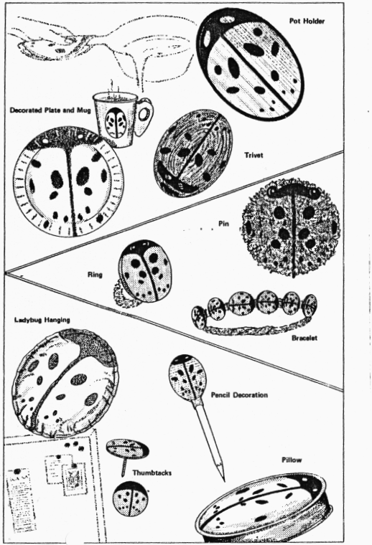

Insect Cages
It’s a sure sign of balmy weather and carefree days when the kids begin to go out and collect bugs. Here are three cages that are simple to make and designed for carrying them, hanging them, or just. keeping them — the bugs, that is!

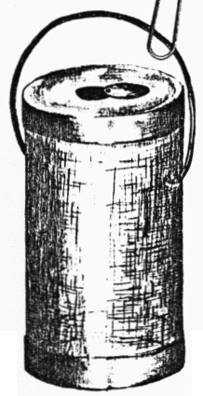
Lighthouse
With this cage, you’ll be able to see your favorite lightning bugs light up and dance around.
For the top and bottom of this cage, you will need the lid and bottom 1” from an oatmeal box. For the sides, roll a piece of screen into a cylinder to fit inside the bottom. Staple or sew seam of screen. Then, glue the cylinder inside the bottom of the box.
Use the Lid for the top, cutting a hole for dropping fireflies inside. Cover the hole with a cardboard circle, attached at one side with a paper fastener.
For the handle, curve a piece of wire and insert the ends in the sides of the cage, bending ends up on the inside to hold in place.
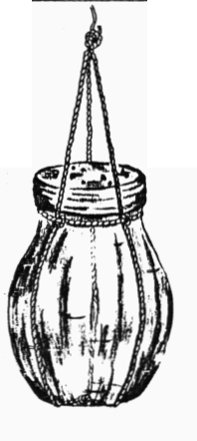

Hanging Cage
You can suspend your catch on the porch or from a tree for all to see and admire.
For this cage, use a jar, such as a jelly jar. Tie a piece of cord around the jar under the rim. Take three other pieces of cord, about 8” longer than the height of the jar, and knot one end of all three together. Glue knotted ends to the center of the jar on the bottom. Let dry.
Spacing the three cords evenly, bring them up around the jar, slipping them tinder the cord below the rim and knotting them tightly to the cord. Knot the other ends of the cords together above the jar.
To cover the top of your jar, use either a circle (If cheesecloth, secured with a rubber band under the rim, or use the original jar lid with holes punched in it.
To hang the cage, open out a paper clip into an "S" shape and insert one curved end under the knotted cord at the top. Attach the other end to a hanger.

Popsicle Stick Cage
This popsicle stick cage features flat toothpicks for bars.
The floor is 13 popsicle sticks glued to a cardboard base.
To make each side of the cage, glue bottoms of toothpicks between two popsicle sticks. Be sure to glue the toothpicks fairly close together. After all, you don’t want your bugs escaping.
To finish each side, glue a pop-sick stick crossbar to the tops of the toothpicks.
Now, glue the sides to the floor, making certain corners touch. With any gaps at the corners, your bugs will get out.
Make the roof very much like the floor, but cut the cardboard base 1/4” to 1/2" smaller than that for the floor. Cardboard on roof should fit snugly inside cage. Leave a little space between the last two sticks at both ends for attaching the roof to the cage. Attach with wires —two at the back, twisted tightly for hinges, and one at the front, twisted loosely to open and close cage.
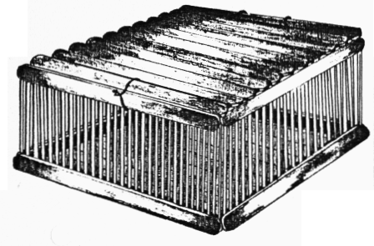
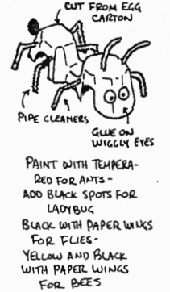
Bug Racers
Draw a ladybug or other insect on a paper plate. Cut out the drawing with scissors and then color the flipside. Next, cut two 1-inch pieces off of the straw. Roll the end of a leg or foreleg of the bug around the straw pieces and staple the edge of the paper in place.
Next cut two 4 foot lengths of string and tie them around the end of a paper towel tube. Thread the strings through the straw pieces and secure the ends with a pin or bead. To make the animal climb, tie a string around the tube and hand it overhead. Then slide the cutout to the bottom of the strings. Using the beads or pins as handles, pull the strings gently alternating from side to side, and the animal will race to the top. The first bug to the top wins the race.
PECAN SPIDERS
Make a spider from your biggest pecans by gluing on pipe cleaner legs, bent to simulate jointed spider legs. Glue a black paper circle on a white paper circle for each eye. Glue eyes in place.
These spiders make cute novelties for a whatnot shelf or can be used as decorations on house plants.

INSECT ZOO
MATERIALS
2 tuna or cat food cans
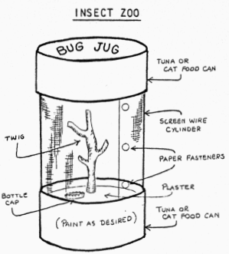
1 pop bottle cap
Casting plaster
1 piece screen 8” x 10 1/2”
3 round head paper fasteners
Stick or branch
Paint

Set one tuna can (open side up) on work table. Mix enough plaster to fill can to within 1/4" from top.
- Roll screen wire into tube 8" high and as big around as the inside of the can. Set screen down into wet Plaster.
- Push small branch into plaster in center.
- Push bottle cap, open side up, into plaster to make a 'watering hole’ for bugs.
- Use the paper fasteners to secure the screen wire shut.
- The other lid serves as the lid.
- If desired, the cans can be painted before assembling the bug jug. And a wire handle can be added at top, attached to screen, for easy carrying.
- The lid sets on top so is easily removable.
If you capture an insect alive and plan to observe it, be sure to keep it alive by feeding it.
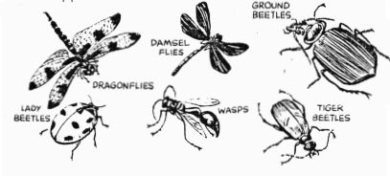
Praying Mantis - eats flies or small insects, raw meat on a toothpick in small pieces, and water.
Field Cricket - fill bottom of cage with one inch of soil. Water. Feed bits of bread soaked in water, lettuce, or peanut butter.
Click Beetle - feed soft-bodied insects and water.
Grasshopper or Walking Stick - put grass sod in bottom of cage. Water grass from time to time and add a dish of water for the insect.
Caterpillar - feed types of leaves from the location you found him.
Tarantula - eats most all insects and needs water.
Meal Worm - feed oatmeal or bran meal with small pieces of potato or apple.

Cricket Trap And Zoo
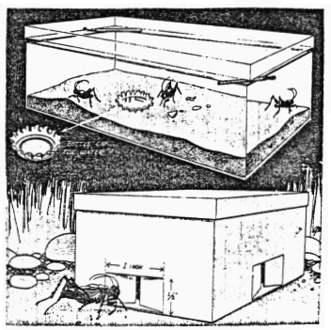
Trap is cardboard shoebox with cover. Cut doors at bottom center of ends and sides, as shown. Push doors in until they are 1/4' open. Put bread crumbs and potato peels in center of box and add lid. Listen outdoors for ‘chirping’ and set box in that area.
Zoo is a clear plastic shoebox or deep glass bowl. Put 2” of soil in bottom. Push a bottle cap into soil, open end up. Keep it full of water. Punch air holes in cover or raise cover off box by placing match sticks at two corners.

Cubs in the Kitchen
Ants On a Log
Spread peanut butter onto 3-inch sticks of celery. Top each one with a line of raisins.

Butterfly Sandwich
Cut a slice of bread diagonally into halves and arrange them on a plate with the cut edges facing out to resemble wings. Spread on cream cheese and top with sliced olives, snipped chives and strips of fresh bell pepper. For the body place a piece of pepper between the wings and add carrot-curl antennae.

Spider Cookies
Melt 2 1/2 cups of semisweet chocolate chips and 1/4 cup of milk in a microwave on high for 1 minute and 40 seconds stirring every 20 seconds. Stir in 1/2 cup of chopped peanuts and 3/4 cup of dry chow mein noodles. Drop by tablespoons onto waxed paper. Stick extra noodles into each cluster for legs. Chill.

Peanut Butter Bugs
1/4 cup creamy peanut butter
1 tablespoon wheat germ
1 tablespoon honey
3 tablespoons nonfat dry milk.
Mix in a bowl until it sticks together. Chill and then model the “clay” into a ladybug or snail and add shoestring licorice features.

Field Trips/Activity Suggestions
Cook lunch outdoors
Take a nature Hike
Have a bug hunt
Have a backyard campout
Visit a nature center or museum
Visit a farm

Hikes
Big Game Hunt
See how many different animals you can find. Decide ahead of time if birds and insects are to be included. Boys will learn to identify different species.

String Along
Take a piece of string about a yard long on your hike. Every now and then, place the string in a circle on the ground. See how many different things you can find en closed within the circle. You may be in for a surprise, for ft is not unusual to find 20 or more things. Then stretch the string in a line and see how many things touch it.

A Wonder-Full Hike
At each destination or rest stop, each person tells of the most wonderful thing he has seen along the way. Stops can be as frequent as you desire.

Stop And Spot
While hiking the leader stops and says: "I spot a __________", naming a familiar object. Everyone in the group who sees the object raises his hand. This is a good observation game.

Field Trips
Baylands Nature Interpretive Center
2775 Embarcadero Road at the eastern end. Palo Alto. (415) 329-2506. Wed-Fri 2-5, weekends 1-5. Free
(Mail c/o Palo Alto Junior Museum) This bayside nature center is on pilings out in a salt marsh, handy for the nature walks and ecology workshops it has. The exhibits show local birds, lands, and saltwater aquarium. On weekends there are also movies and slide shows as well as nature and bird walks, bike tours, wildflower shows, fish, pond, and geology programs.

Youth Scientific
16260 Alum Rock Avenue off Highway 680 to Alum Rock, San Jose. (408) 258-4322. Tues-Fri 9 - 4:30. Sat 12-4:30. Summer Sunday 11-5:30. Adults $.50. children $.10 families $1.00
A small petting area, large display of stuffed birds, and a hands on exhibit of whale bones and shark teeth as well as living hawks, owls, kestrels, snakes, newts, skunks, boa constrictors and chinchillas.

San Francisco Bay Natural Wildlife Refuge
Highway 84 near Dunbarton Bridge toll plaza at the west end of Thornton Ave, Fremont. (510) 792-3178. Daily 10-5. Free. Photo exhibits on special environmental programs, nature study walks, slide and film programs, and self guided walks through the salt marsh and diked ponds at Newark.

California Academy of Science
Golden Gate Park, south side of Music Concourse (415) 750-7145. Daily 10-5 in winter, summer till 7. Adults $4, ages 12-17 $2, age 6-11 $1. Free the first Wednesday of the month. Rates for groups by appointments.
Many thematic halls highlighting minerals, birds, cultures, space, and African safari and more.

