August 2000 -- Toughen Up

Pre-Opening
Sports Talk
Match the following terms with the proper sports by writing the number of each term in the blank by the sport it pertains to. Some terms may pertain to more than one sport.

Badminton Baseball Basketball Bowling Cricket
Football Hockey Soccer Tennis Wrestling

1. Ace 18. Fly pattern 35. Rebound
2. Alley 19. Forward 36. Ride
3. Backhand 20. Frame 37. Safety
4. Backward short-leg 21. Free throw 38. Service
5. Bird 22. Goalie 39. Silly mid-on
6. Blitz 23. Gutter 40. Slashing
7. Blue line 24. Half nelson 41. Slide
8. Bowler 25. High sticking 42. Spare
9. Bunt 26. Marking 43. Split
10. Catcher 27. Nose guard 44. Strike
11. Corner kick 28. Offside 45. Suicide squeeze
12. Double fault 29. Pin 46. Tackle
13. Double play 30. Pitch 47. Takedown
14. Dribble 31. Pop-up 48. Traveling
15. Dunk 32. Popping crease 49. Volley
16. Escape 33. Puck 50. Wicket
17. Fall 34. Racket

Answers:
Badminton - 2,3,5,34,38,49
Baseball - 9,10,13,30,31,41,45
Basketball - 14,15,19,21,35,48
Bowling 2,8,20,23,29,42,43,44
Cricket 4,8,30,32,39, 50
Football 6,18,27,28,37,46
Hockey 7,19,22,25,28,33,35,40
Soccer 11,14,19,22,26,28,30,46,49
Tennis 1,2,3,12,34,38,49
Wrestling - 16,17,24,29,36,47

Ceremonies
Opening
STAGING: Three Cub Scouts, one dressed neatly in athletic clothes, the other two dressed sloppily, looking tired, bored.
CUB * 1: (Drags on stage, looking tired, bored, and meets sharp, clean, Cub * 2) Boy, am I tired, I wish I could be in shape. I’m so weak I don’t know what to do.
CUB * 2: I have something that will get you into shape physically and mentally. Take the first step into my program and into shape by stepping over this line.
CUB * 1: (Steps over line and becomes bright, alert and athletic.)
CUB * 3: (Walks in dragging, tired and meets * 1 and * 2.) I’m so bored, I have done everything there is and nothing is left, I miss the challenges.
CUB * 2: I have something that will challenge you, train you, coach you and develop you both physically and mentally. Just step over this line!
CUB * 3: (Steps over line and becomes bright, alert, athletic.)
CUBS * 2 & 3: (together) What is this program we stepped into that gives us energy, strength, challenges and fun.
CUB * 2: It is a mental and physical fitness program...(Holds up sign reading ‘CUB SCOUTING’) — CUB SCOUTING!!!

Opening
SETTING: Five Cub Scouts, wearing various sports uniforms, holding signs with large letters on front.
S -S is for see...See yourself as others see you!
H -H is for health...Good health means a longer, better life.
A -A is for athlete...You don’t have to be an athlete to be in shape.
P -P is for patience...Have patience, take your time in your fitness program. Don’t overdo!
E -E is for exercise...Exercise keeps you in shape.

Advancement Ceremony
SETTING: Cubmaster and Asst. Cubmaster in sports or exercise clothes. Sports and exercise equipment setting around stage.
CUBMSTR: There are many ways to step into shape. They range from personal exercise to team sports to international competition. All must be started slowly, done on a regular basis, and be challenging to the abilities.
ASST CM: The Cub Scout program includes physical fitness as an important part of it. program. Each rank has requirements that challenge, but not overwhelm the boys according to their ages.
CUBMSTR: A good physical shape also requires a good mental shape. Stepping into shape is like stepping up the Scouting trail. They both make you look and feel better and they can both be fun. Tonight we are going to honor some boys who have begun taking those steps into shape and up the Scouting trail.
ASST CM: Will the following Cub Scouts and their coaches, parents, flex your muscles and step into the gym.
(Reads names)
CUBMSTR: The Bobcat is like a person just beginning to get into shape; he is unsure of what to do and how to do it. However, he has made that most important first step. Parents, your sons have earned the first rank of Cub Scouts, the Bobcat, and I would like you to present their badges to them. (Gives parents badges to give to boys.)
The next step has been taken by several boys to better their condition and advance them along the Scouting trail.
ASST CM: The gym is ready to have the following Cub Scouts and their parents step up. (Reads Wolf names)
CUBMSTR: These boys have gone beyond the beginning of their programs. While much is still new, they are making advancements everyday. They are following the program set up by their coaches and trainers and they have earned the second rank in Cub Scouting, the Wolf Rank. Parents, I am honored to give you these badges to present to your sons. (Gives parents badges.)
(Continue along with the Bear and Webelos Scouts.)

Closing
STAGING: Four Cub Scouts or Pack Leaders
* 1: Some people think if you have muscles, You must win in every game, But if they’d only stop to think, Many a loss can also be a gain.
* 2: If we’re always good sports when we lose, And learn what to do better next time, Then we really come out a winner, For experience is a teacher sublime.
* 3: It matters not that the top score we’ve won, If only we all do our best, For that’s the mark of a champion, What ere may be the test.
* 4: If you can’t do GREAT things, my friend, It matters not at all, If only you try to do in a GREAT way, Things that may seem so small!

Closing Thought
A good program for getting into shape is a continuous program that lasts a lifetime. A program that covers all aspects of the body and mind. A program that challenges our capabilities but doesn’t overwhelm. Cub Scouting is like that...a program that challenges the body and mind. It is part of a continuous program into Boy Scouts, Exploring and Adult Scouting. One of the most important things in this program is to challenge the cubs, but do so in a way they can learn and still have fun. We must be aware that each boy is an individual with different strengths and weaknesses. Each must be treated according to his needs. As each boy follows the Scouting program, going up each level, he will receive awards. These awards by themselves are worthless, but the accomplishments, experiences and gained knowledge that was needed to obtain them are priceless.

Audience Participation/Skits
“One Step At A Time”
(A Skit)
CHARACTERS: “Senior” Scout (Den Chief, Denner, Webelos), Junior Scouts
SETTING: All Scouts are on stage as skit starts.
CUB 1: When I grow up I’m going to be the world’s greatest broad jumper and jump like this (Jumps about 1 foot and falls down)
SENIOR: Well, You’ll have to remember to take it one step at a time, one step at a time.
CUB 2: Well, I’m going to be a high Jumper and win a gold medal like this...(jumps and falls flat)
SENIOR: Well, just remember that you’ll have to take it one step at a time, one step at a time.
CUB 3: Well, I’m going to be a world famous baseball player and hit homeruns like this (swings and falls)
SENIOR: Fine, fine, but remember to take it one step at a time, one step at a time.
CUB 4: I’m going to be the world’s best slam dunker (dribbles imaginary ball across stage and slam dunks it, falling)
SENIOR: Sure, sure, but remember to take it one step at a time, one step at a time.
CUB 1: Say, what are you going to be when you grow up?
SENIOR: Why, I’m going to be the greatest marathon runner that ever lived’ (Turns and starts to walk away, but trips over shoe lace)
ALL CUBS: ONE STEP AT A TIME...ONE STEP AT A TIME’

The Race Of A Lifetime
(A Skit)
CHARACTERS: Announcer; Cub Scout; Igor the Great; Freddy Fast; Steven Speed; Marty Marathon; (All super—fast runners in jogging suits or shorts, but NOT in Scout uniforms. Ideally all would have racers’ numbers.
SETTING: The race will have a starting line and finish line at opposite sides of the stage. All racers are on stage warming up as announcer starts.
ANNOUNCER: We are gathered here today to witness the greatest race ever held. With us today are the running greats of the world. Men who have set records for speed and endurance and who have astounded the world with their athletic abilities. As we prepare for this race to begin, I’ll introduce the contestants.
(Each runner steps forward and continues to warm up as he is introduced, then returns to the starting line.)
Wearing the number 1, we have IGOR THE GREAT. Igor has run the mile in 1.05 minutes. He is said to be one of the fastest men in the world. Wearing the number 2 is FREDDY FAST. Freddy has just won the four—mile race at Pensacola, Florida. He ran four miles in 5 minutes! Wearing the number 3 is STEVEN SPEED. Steven runs 20 miles in 22 minutes! A fantastic runner....he is a favorite to win this event today. Wearing number 4 is MARTY MARATHON. Marty is a world champion runner and has been clocked running 45 miles per hour for ten minutes straight! Wearing the number 5 is CUBBY SCOUT.... Cubby Scout -- there has to be a mistake here.. It says he runs a mile in under 15 minutes? Are you kidding me? What’s this kid doing in our race...he doesn’t have a chance! Oh well...we’re about to begin the race. This race is 100 yards (give or take a few) and the winner will be the champion of the world and other places. Racers to your starting positions.
On your mark ,.. get set...go!
(Racers start and all run fast but back and forth away from and toward the audience while the scout runs straight to the finish line.)
I don’t believe it, I don’t believe it! The Scout won the race!!! Let’s talk to him and see what happened. Approaches the Scout at the finish line) Tell me Cubby, how did you win this race against all of these faster racers? What was your secret?
SCOUT: There’s no secret really, it’s just something that I learned in Scouting...It’s not how fast you run the race of life, but how straight your path.
ANNOUNCER: Well, there you have it, folks, straight from the winner’s mouth...A straight path is what makes the winner’s difference and apparently Scouting teaches that straight path.

Muscle Building Champs
(A Skit)
Characters: 6 boys in uniform, holding props as described below.
Setting: All boys come on stage and speak their lines.
ALL TOGETHER: We excel in building muscles
We’re champs at that, you see;
Just listen to our stories
And I’m sure you will agree.
(Each boy steps forward as it becomes his turn to speak.)
1ST BOY: I hold the title of strongest in my den, Do you suppose it’s because of my friend?
(Holds up toy skunk, other boys hold their noses.)
2ND BOY: I’m known as the den’s muscle man this year, Most of my muscle is between my ears. (Pulls out small hat from behind his back and desperately to fit it on his head.)
3rd BOY: I hold the title of the fastest of all, I’m first in line for the chow basket call.
(Pulls out bag of cookies and begins eating.)
4TH BOY: I’m known as the champion of the high jump, One time I missed and got a big lump.
(Rubs head, with painful expression on face.)
5th BOY: To keep in shape, I exercise each day,
I wonder why my muscles turned out this way.
(Removes sweat shirt to show colorful padding on arms and legs.)
6TH BOY: I’m the champ at making things disappear, you see
Watch us all disappear, as I count to three.
(He counts slowly 1 — 2 — as curtain closes.)

Cub Olympics
Characters: TV reporter, 4 Cub athletes getting ready for the Cub Olympics.
Props: Frisbee for discuss, pole for javelin, bag of cookies, toothbrush and basin of water on stand, fake mike for reporter (can be dressed in suit jacket and have ID for his station on his lapel in large letters)
TV reporter: We're here today to interview the athletes at Pack _____ as they prepare for the challenge of this years Cub Olympics. As you can imagine, it takes months of training and hard work to get these athletes ready to compete. Let's see how they are preparing themselves for the big competition. (turns to Cub #1 with microphone) Tell me, how are you getting ready for your event in the Olympics?
Cub #1: I'm practicing my throw for the discus event. (demonstrates how to throw discus using Frisbee)
TV reporter: Great form! (turns to Cub #2) and you -- can you tell us how you are preparing to compete?
Cub #2: I'm polishing my javelin for the javelin throw (polishes pole with a rag.)
TV reporter: Good luck! (turns to Cub #3) What are you doing today?
Cub #3: I'm practicing for the standing broad jump. (does a couple of practice jumps)
TV reporter: Fine! (turns to Cub #4) And what are you doing to train for the Olympics?
Cub #4: I'm brushing my teeth! (uses basin of water and toothbrush --pretends to brush teeth)
TV reporter: Brushing your teeth! What Olympic event could you possibly be training for?
Cub #4: I'm training for the International Olympic Cookie - Eating event! (pulls out bag of cookies and stuffs some in his mouth.)

Olympic Drama
Have den line up on stage. One scout steps forward and announces that this is the first international exhibition of a new Olympic event. This is the cue for the rest of the scouts to grin as wide as possible. The narrator announces that this was the Standing Broad Grin.

Many Muscles
(A Skit)
Characters: 8 Cub Scouts: one dressed as a beautiful curvy girl. five boys wear shorts over uniform pants to resemble sweat suits., one who is in full uniform.
Props: Dumbbell, barbells, and Jumprope
Setting: Boys in shorts lined up across front
CUB SCOUT: (Comes in with full uniform on, looks at boys, asks 1st boy...) Why are you doing that?
1ST BOY: (Lifting dumbbell) Because I like many muscles.
CUB SCOUT: (goes to next boy) Why are you doing that?
2ND BOY: (Skipping rope) Because I like many muscles.
CUB SCOUT: (walks to next boy) Why are you doing that?
3RD BOY: (lifting barbells) Because I like many muscles.
CUB SCOUT: (goes to next boy) Why are you doing that?
4TH BOY: (doing pushups) Because I like many muscles.
CUB SCOUT: (walks to last boy) Why are you doing that?
5TH BOY: (doing jumping jacks) Because I like many muscles.
(Boy dressed in wig and dress walks on in front of boys
CUB SCOUT: Who are you?
GIRL: (Smiles — winks) Why, I'm Minnie Muscles!
ALL BOYS: (Whistle at her, take her by arms, and escort her off the stage.)

Shape Up
Cub 1: I can lift an elephant with one hand.
Cub 2: I don't believe you.
Cub 1: Give me an elephant with one hand and I'll show you.
Cub 3: I can bend bars with my bare hands.
Cub 4: Iron bars?
Cub 3: No, chocolate bars.
Cub 5: Why are you jumping up and down?
Cub 6: I took some medicine and forgot to shake well before using.

The Split Ball
Characters: Bud the pitcher, Bill, the reporters, Shorty the catcher, Gentleman from Australia, Other visiting gentlemen, Two flashlight operators.
Scene: Practice field. The front stage is very dimly lit. Across the back is a sheet or lightweight curtain through which a light can shine.
The success of the stunt depends on the ability of the pitcher, catcher, and flashlight operators to coordinate their movements. The pitcher pantomimes a throw. When he says, "There," a flashlight operator turns on his light and makes it shine through the screen. The light moves along the screen to resemble the flight of the ball. The catcher pretends to catch the ball, and the flashlight goes off. The movement may or may not mimic the flight of that kind of ball in a real game.
Bud comes on stage, in front of the curtain. Bill steps up to him, followed by all the visiting Gentlemen.
Bill: Hi, Bud.
Bud: Hi, Bill.
Bill: Gentlemen, I'd like you to meet Bud, the greatest pitcher in America.
Bud: Oh, come on, Bill!
Bill: It's true. Bud, these gentlemen represent the world wide athletic association. They wanted to see the greatest American pitcher, so I brought them right to you.
Bud: Well, I am flattered.
Bill: This is Mr. Grossman from Australia, Mr. Blackwell from England, etc. (Add as many names and countries as you need. Each shakes hands with Bud and then steps away.)
Grossman: Excuse me, sir. We have heard about the different ways you pitch ball. Would you demonstrate a few balls for us?
Bud: Glad to. Have a seat. (points to a row of seats and they sit.)
Gentlemen: Thank you.
Bud: Shorty?
Shorty: (appearing) Yes, Bud?
Bud: What shall I start with, Bill?
Bill: Start with your fast ball.
Bud: O.K. a fast ball. There! (light darts across screen, quickly. Gentlemen cheer.)
Bill: A slow ball.
Bud: O.K. a slow ball. There! (light moves very slowly across screen. Cheer.)
Bill: A curve ball.
Bud: O.K. a curve ball. There! (light moves in a fancy curve. Cheer)
Bill: A knuckle ball.
Bud: O.K. a knuckle ball. There! (light moves in a zig zag line. Cheer.)
Bill: How about a sinker?
Bud: O.K. here comes a sinker. There! (light glides along waist- high, then drops into mitt. Cheer.)
Grossman: Pardon me sir. I have heard about your split ball. Could you please show us?
Bud: Certainly. A split ball. There! (The two flashlights start together. They seem to separate, one high, one low on the screen. Then just as they near Shorty, they come together.)
Every one cheers, pats Bud on the back as they all exit.

Run-ons/jokes
Cub: What does a ballplayer do when his eyesight starts going bad?
Dad: He gets a job as an umpire!

1st Cub: Wow, It’s a run-home.
2nd Cub: You mean a home run.
1st Cub: No, I mean a run-home. You just hit the ball through that window!!!

Why was Cinderella such a horrible basketball player?
Why?
Because she had a pumpkin for a coach!

Cub 1: I have a chance at the baseball team.
Cub2: Are they raffling it off?

Applauses
STRONGMAN’S APPLAUSE -— Pretend to lift a heavy object and say, “Uh, Uh, Ah”.
GOLF APPLAUSE: Motion like to swing the golf club and yell “Fore”
TOUCHDOWN APPLAUSE: Quickly throw both arms up into the air with fingers close together pointing upward (as if to signal a touchdown) and yell and scream and cheer.
HOME RUN APPLAUSE ——Simulate swinging a bat at a ball, shade your eyes with your hand and yell, “Thar she goes!”

Games
Shape Walking
Start walking in a circle and keep walking between the following exercises:

1. Start hopping
2. Make yourself as small as possible
3. Make yourself as tall as possible, reach your hands high above your head
4. Bend your knees slightly, grasp your ankles
5. Walk as if the heel of one foot and the toes of the other were sore
6. Walk stiff—legged
7. Squat and jump forward from that position
B. Walk on hands and one foot with the other leg held up as if imitating a dog with a lame foot
9. Walk forward at a rapid pace...don’t run...while swinging your arms vigorously
10. Take giant steps
11. Walk forward raising your knees as high as possible
12. Run lifting your knees high
13. Walk on your hands and feet
14. Hold your left ankle with your left hand and hop around the circle on one foot

Obstacle Course
Step in old tires — walk on a 2” x 4” — crawl under a chair —make a tunnel out of a cardboard box — jump over a box or pylon

Ball Throw
Boys take turns throwing a ball and measure the distance.

Steeple Chase
Make hurdles or jump over a line of boxes.

Tangle
Lie on the floor, stomach down. Cross feet and bend the knees, drawing the feet against the thighs. Reach back and grasp the left foot with the right hand and the right foot with the left hand. Rock from side to side until enough momentum is gained to roll over onto the back. Then rock forward to the squat position. Straighten the legs, uncross feet, then remove hands from feet, and stand erect. Remember the hands should never leave the feet until you stand up.

Four-way pull
Four ropes are tied together at one end. Each Cub takes one end. About two feet behind each Beaver is an Indian club or similar object. The idea is to pull the other three Beavers in your direction, enabling you to pick up your club. First one to pick up his club, of course, wins. This game may be played with any number, provided each Beaver has a rope.

Tug of war
Each team takes hold of one end of a sturdy rope. A line is drawn inbetween them and at a given signal each team tries to pull the other over the line. You can rule that a team must pull the entire opposing team over the line to win. Or you can mark the middle of the rope (with paint or a rag tied around it), set a time limit on the pulling (one minute, for example), and the rule that the team with the middle of the rope on its side of the line when the pulling stops is the winner.

Three Ball Throw
Type: Team Game
Equipment: 3 tennis balls and a box or bucket

Divide the Cubs into two teams. One team bats and the other fields. The first batter goes to the box and throws the three balls away. He then scores "runs" over a marked course while the three balls are being returned to the box. The whole team has a bat, and the total runs are counted. Teams then change over, the second trying to beat the first's number of runs.

Jump The Creek
Each boy does his best and tries to improve his last jump Two ropes are laid parallel and close together. One at a time, the boys jump across the 'creek' After all have jumped, the distance between the ropes is increased slightly. The boys must not step in the creek (between the ropes) or on the water edge (the ropes) or they are eaten by sharks and must leave the game.

Measuring Worm Race
In this race all contestants line up at the starting line, fall forward on signal and rest their weight on their hands. Next they draw their legs up under them and then fall forward again or. their hands. This continues until the winner reaches the finish line.

Crossing The Rice Fields
Players line up in teams of two, forming two or more columns as in relay formation. On the word 'rice' the first team in each column form a wheelbarrow and race across the rice fields to the river (two parallel ropes stretched out on the floor). At the edge of the river, player A climbs on player B’s back and is carried piggy—back across the river. On the other bank, they change places for the return Journey across the river and then wheel—barrow home again.

Chinese Wrestling
Divide players into pairs and match them two at a time. Each wrestler stands on one leg (his left), the other leg being stretched forward, and folds his arms across his chest. Each wrestler hops forward and tries to unbalance his opponent with his right leg. No kicking or charging is allowed, and one player is declared winner if he forces the other to touch his right foot to the ground. The game should be played on a grassy lawn or soft ground.

Under The Bridge
Make an arch by turning two chairs forward, top to top, in front of each group. Boys are lined up in relay formation. The first boy runs to the chairs and crawls under them. Then he runs back to the other end of the room and does three deep knee bends. Then he runs back to his group, Jumping over the chair on the way. If a player knocks down one of the chairs, he must replace it before he continues. Team to finish first wins.

Ankle Race
The competitors line up at one end of the room, each one crouching or bending down and grasping his ankles. They must run to the other end of the room and back again in this position. Any competitor who takes his hands away from his ankles is sent back to the start.

Back to Back Run
The Beavers find partners, stand back to back and link elbows. Their challenge is to run to a spot and back, one front wards, the other backwards. To return to the start point after reaching the given spot, they don't turn around but merely switch roles.

Ground Walk
Sit down, grab right ankle with left hand and left ankle with the right hand. Then, without letting go of ankles, the Beaver tries to move from one point to another.

Potato Wheel-barrow Race
Organize a wheel-barrow race with a team of two children--one on the floor walking on hands and the other holding up his/her feet Put a potato on the back of each 'wheel barrow'. Listen to the shrieks of glee! If the spud falls off, the team must return to the starting line.

Strong Man Balance
Get two cubs of comparable size to stand on a short box or other sturdy balancing object. Lay a long length of rope between the two stands leaving extra rope coiled for the cubs to grab. The cubs stand on the platform and each holds onto the rope. The object is to get the other cub to lose his balance and step off the platform. This shows a combination of strength, skill and strategy.

Footprints Relay
Using heavy cardboard, cut out footprints 15" long and 8" wide. Two footprints are needed per person or team.. Play game as a physical skill (let’s see if YOU can do it) or as a competition (2 or 3 teams as a relay race at a set distance). Place both footprints one in front of the other, on the floor. Step on the first with one foot and on the second with the other foot. Now lift rear foot. Pick up footprint and move it ahead. Move lifted foot into new position. Do the same with the other foot and continue, step by step to finish line.

Travel Relay
Line up in relay position. Obstacles are placed in the way at 12 foot intervals. A tree, a mountain, a river, and another tree are the obstacles. (A boy stands for the first tree, another one bends over as in leap frog for the mountain, two lines are drawn for the river, and another boy for the last tree which is the turning point.) The players must run to the RIGHT of the first tree, LEAP over the mountain, JUMP across the river, and run to the LEFT of the last tree, running all around it and back to the back of his line. The first team to have all players complete the obstacle course is the winner.

Rhythmic Exercises
Ask the group to follow your instructions: Everyone stand — Now, hands on your hips, hands on your knees — Put them behind you, if you please — Touch your shoulders, touch your nose — Touch your ears, touch your toes — Raise your hands, high in the air — At your sides, on your hair — Above your head, as before — While you clap, 1, 2, 3, 4 — Now hands upon the empty space (head) — On your shoulders, on your face Then you raise them up so high —And make your fingers quickly fly — Then you stretch them out toward me — And briskly clap them, 1, 2, 3.

Rocking Chair
Partners sit facing each other with knees sharply flexed, feet flat on the floor. One boy’s feet and legs are between the other boy’s legs. Each sits on the other’s feet and grasps the other’s upper arms. One boy leans back and lifts the feet, pulling the other forward to a semi—standing position. Reverse the action, and continue rocking back and forth several times. After everyone has tried this, try having races.

Jump Rope Games
Relay — use one rope for each team. Run and jump down to a line and back, handing rope to next player.
Variation — jump backward "— run to line, jump 10 times and then run back. Times ropes — See how long you can jump.
Multiple jump — jump 2 boys in rope at same time.

Songs
Head & Shoulders, Knees & Toes
(Tune: There’s a. Tavern in the Town)

Head and shoulders, knees and toes, knees and toes,
Head and shoulders, knees and toes, knees and toes.
Eyes and ears and mouth and nose,
Head and shoulders, knees and toes, knees and toes.

1st time — sing straight through, touching parts of body.
2nd time — omit singing ‘head’, but still touch it.
3rd time — omit singing ‘shoulders’ and ‘head’ but still touch them.
4th time — omit singing ‘knees’, but still touch them.
5th time — omit singing ‘toes’, but still touch them.

Building Muscles
(Tune: Camptown Races)

On muscle building we work so hard,
Doo—dah , doo—dah
In garage and cellar, porch and yard,
Oh doo-dah day.

Chorus:
Our muscles how they’ve grown,
We’re stronger every day,
We exercise and practice here,
In the Cub Scout way.

We try hard to pass the test,
Doo—dah, doo—dah,
We’ve all learned to do our best,
Oh doo—dah day.
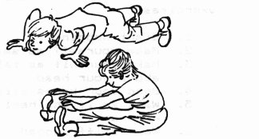
Spreading Chestnut Tree
(Action Song)
Under the spreading chestnut tree,
Where I held you on my knee,
We were happy as could be,
Under the spreading chestnut tree.

Actions
Spreading —— arms outstretched
Chest —— strike chest
Nut —— tap head
Tree —— same as spreading
Held —— hold arms as though embracing
Knee —— strike knee
Happy —— scowl and give a growl
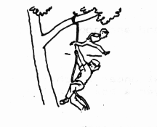
Fitness
(Tune: On Wisconsin

Hurry Cub Scouts, build your muscles,
Get in shape for play.
When we feel our very best,
We’ll do our best Each day.
Keep on running keep on jumping.
Trying to improve
When we've grown little older
We'll still be on the move
.
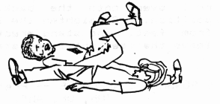

A Stretching We Will Go
(Tune: A Hunting We Will Go)

A stretching we will go,
Moving to and fro.
And when we’re done
We’ve had some fun
And stretched our muscles too.

Come on folks let’s stand
And raise up high each hand
Then spread them wide,
Now to your side
As your muscles you relax

Now let us stomp our feet,
But please don’t take your seat,
Before you’re down,
Please turn around.
And then you'll take your seat.

Crafts
Easy Barbells
Barbells can be made of plaster set in cans with short length of pipe or broom handle in between for a hand weight or long piece of pipe or broom handle for a regular set of barbells. Judge the size of cans and pipe or stick by the size of scout that will be using them.
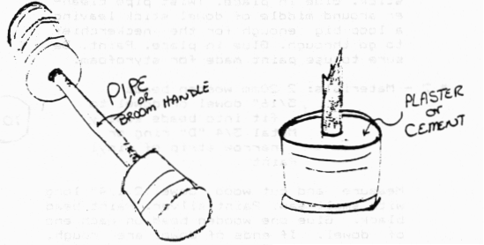
Barbell Tie Slides
#1 — Materials:
1/8” dowel stick,
1 to 2” long
2 small styrofoam balls
Paint
Pipe cleaner
Glue
Push styrofoam balls onto ends of dowel stick. Glue in place. Twist pipe cleaner around middle of dowel stick leaving a loop big enough for the neckerchief to go through. Glue in place. Paint. Be sure to use paint made for styrofoam.
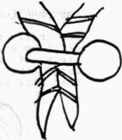
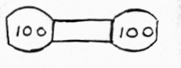
# 2 — Materials:
2 20mm wooden beads
5/16" dowel or dowel to fit into beads easily
Metal 3/4 “D” ring or narrow strip of vinyl
Paint
Measure and cut wood dowel 2 1/4” long with small saw. Paint silver. Paint bead black. Glue one wooden bead on each end of dowel. If ends of dowel are rough, sand smooth. Paint ends of dowel black to match beads. Paint desired weight on front of each barbell with white paint. Thin—line paint pen works well for this. Fasten metal “D” ring or narrow strip of vinyl to back with “hot glue” gun.

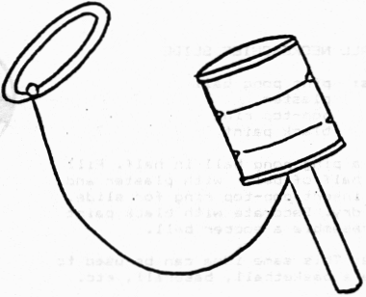
Catch Can
Nail or screw a can to a stick. Where can joins stick, tie a long string. Attach a lid small enough to fit Hold stick in hand and try to catch lid with can.

Soccer Ball Neckerchief Slide
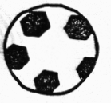
Materials:
Ping pong ball plaster
Pop-top ring
Black paint
Cut a ping pong ball in half. Fill the half of ball with plaster and insert pop—top ring for slide. Let dry. Decorate with black paint to resemble a soccer ball.
Note: This same idea can be used to make a basketball, baseball, etc.

Basketball Backboard Tie Slide Or Plaque
Materials:
Wood scraps 1/8” thick -- such as paneling or balsa,
paint, wire, mesh or nylon;
small styrofoam or wooden ball; glue
Cut backboard from wood using the pattern shown. Sand as needed. Make a hoop by wrapping wire around a 1/2 “ dowel. Bend a small strip of aluminum foil and insert through the slot in the backboard to fasten the hoop. Epoxy or glue strip the back. Cut nylon net to size of the pattern and sew or glue together. Paint the ball orange and draw lines with marking pen if desired. Paint the hoop orange and the backboard and net white. After this is dry, glue the ball and net to the hoop. Glue a metal poptop or loop on the back to hand or to use as a tie slide.
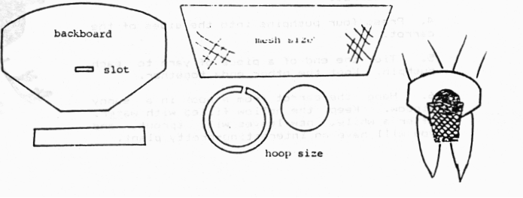

Winner’s Medal
Materials:
Metal screw—on cap
3” piece of ribbon
Paint
Tin snips
Large safety pin
Construction paper
To make the medal, cut the cap Into a flower shape and paint It. Fold a 3” piece of ribbon in half, and glue the ends to the back of the medal, Slip a large safety pin through the fold In the ribbon. Write “1st” or “2nd” on a small paper circle and glue to the center of the medal.
Take care — cut metal can be sharp.

Loving Cup Trophy
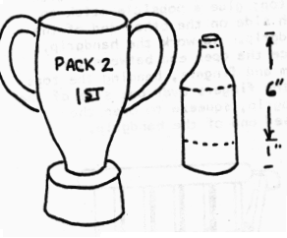
Use a quart-size bleach bottle without the handle. Cut 1” from bottom and invert for base of trophy. Use top 6” with neck removed for the bowl of the trophy. Invert bowl and glue to base.
Make handles from strips of remaining bottle. Attach to loving cup with metal paper fasteners.
Smaller trophies can be made from smaller bottles.
Spray paint trophy gold. Lettering can be painted on, if desired.

Metric Trundle Wheel
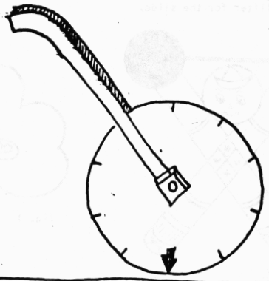
Trundle wheels are used for measuring linear distances. Set a small circle cutter at a radius of 15.9 cm. This will give you a triple—wall circle with a diameter of 31.8 cm or a circumference of 100 cm. Mark an arrow on the edge of the circle for a starting point and then mark the edge of your wheel in decimeters. Cut a 1.9 cm. hole for a center hole in the circle. Make two triple—wall handles. Cut a 1.9 cm hole in the bottom of each handle and glue the handles together at the top. Slide wheel into the handle bottoms aligning all three holes so a bolt can be inserted. Secure bolt with nuts. You may want to make some triple—wall washers for spacers between the handle bottoms and the wheel. Use the trundle to measure distances for runs, jumps, etc.

Tennis Shoe Tie Slide
Materials: Felt (yellow or white and blue), kite string, needle and thread, glue, cotton balls, curtain ring (optional). Cut 2 shoes from white or yellow felt for each slide using the pattern. To the back piece attach a 4” length of kite string or sew on a curtain ring for the tie holder.
Whip stitch sides and top closed. Stuff shoe with cotton balls to desired thickness, sew bottom of shoe shut.
Cut small strips from blue felt and glue to front of shoe (see illustration) and piece for sole of shoe.
Using piece of kite string, glue to front of shoe to look like lacing. Using 3” piece of kite string - run through the shoe using needle and tie in bow.
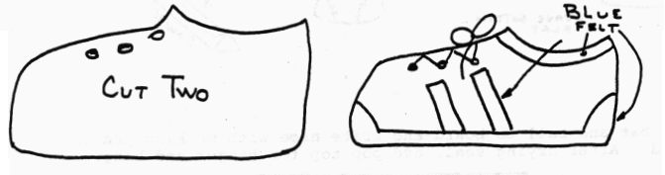
Award Plaque
This is a nice plaque to make to honor someone special. Start with a piece of heavy corrugated cardboard cut from the side of a grocery box. Draw lines across it with brown crayon to look like wood grain.
Cut a paper circle the right size to fit inside a flat plastic lid. Write a message on the paper, and decorate it as you like with crayon or marker. Glue the paper into the lid.
Using blue paper, cut a shape to form the “ribbon”. Then glue the ribbon to the cardboard base, and glue the plastic lid on top of that. Let the glue dry before presenting the plaque

“Feets” of Skill Score Board
Materials:
Posterboard
Pink construction paper
Glue
Paper punch
Paper clips
Crayons or colored pens
Patterns
In order to give the boys an incentive to work hard on these skills or any muscle building skills which they may accomplish this month, following are some patterns and ideas for personal score boards which can be made from many different materials. This also provides the boys with a craft item for the month which they can proudly display at the pack meeting and then hang in their room,
Cut an 8 1/2” x 11” piece of poster board for backboard.
Using pattern, cut feet from pink construction paper and glue to poster board. Letter poster board as shown using Cub’s own name. Punch holes in bottom of board. Copy patterns of “medals” and let each boy color them. Then glue to poster board and cut them out. Punch holes in top and bottom of each medal.
As boys complete each “feet” of skill let him hang his medal using the paper clips.
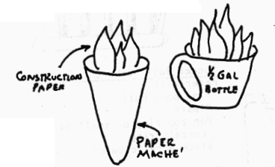
Olympic Torch
To make an Olympic torch, cover a cardboard cone shape with paper maché.
Spray paint dried maché torch. Add a flame made from red construction paper.
A torch can also be made from the top section of a round bleach bottle. Cut off this section, spray paint, and add construction paper flame.

Physical Fitness Medals
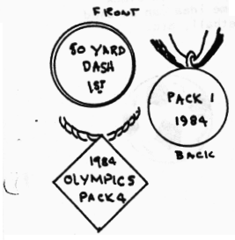
Winner’s medals can be made from various materials, including plaster, wood, plastic and cardboard. Plaster medals can be poured in plastic lid molds. Insert ring before plaster hardens, for stringing blue and gold ribbon through for wearing around the neck. Paint appropriate words on medals Diamond shape medals can be cut from cardboard or foil pans, and colored or imprinted with marking pens. When using the foil pans, tool the lettering first with a ballpoint pen, then fill in with permanent markers. These medals can also be attached to a ribbon for wearing around the neck.

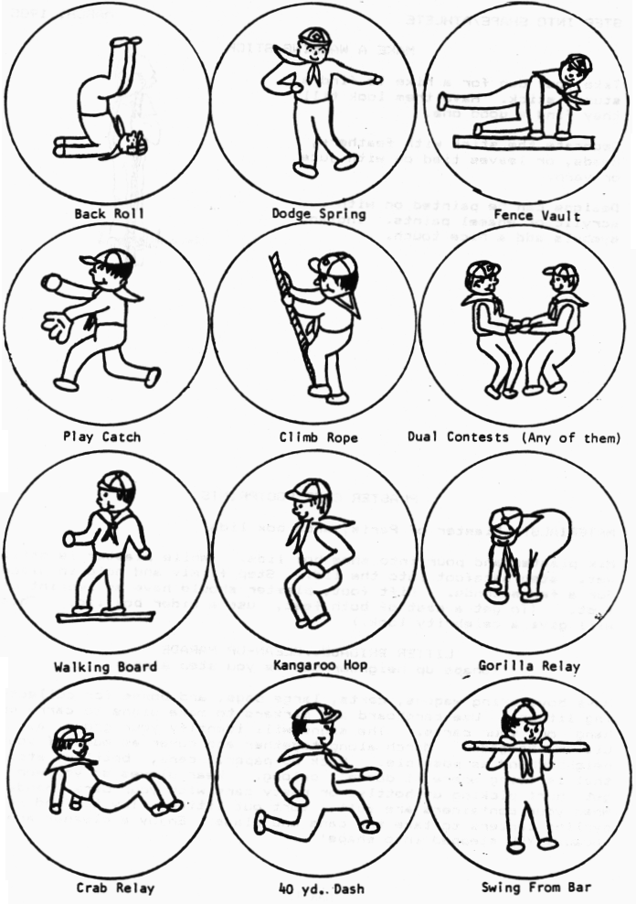
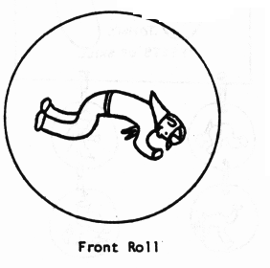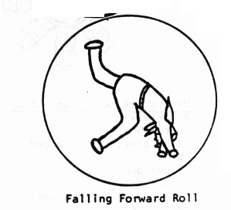
Outdoor Obstacle Course
Make a rope climb by hanging a 10—foot, one—inch rope from a tree.
To help develop balance, set a 10—foot long 2 x 6 “walking plank” securely on the ground.
Five or six old tires make an excellent zigzag course which will help the boy develop balance while building up his leg muscles.
The object is to step ‘from tire to tire as he runs the course.
Stagger tires one full pace apart.
Make a “crawl through” by using an old wooden barrel turned on its side. Cardboard boxes will work also.

Hop, Step and Jump
This is an athletic test that was popular among the boys in colonial days. In turn, each boy takes a running hop (land on the same foot), then a long step and a final jump (leaping off one foot and landing on both feet). His score is the total distance covered in the three moves which must be correct.

Make Your Own Physical Fitness Equipment
A barbell can be made using a 3—foot dowel or broomstick with 3/4" dowel or broomstick with 3/4" pipe caps on the ends. The latter are then embedded in 46 oz. —cans filled with cement. Allow cement to set overnight.
Dumbbells can be made similarly by using foot long dowels and No. 2-size cans filled with cement and placed on the ends of the dowels. Plastic quart containers filled with sand may be used instead of the cans.
A broomstick suspended at both ends in a garage, basement, or backyard makes an excellent chinning bar. This broomstick can also be set over the back of two parallel sturdy chairs.
Another way to make barbells is to take a pair of old auto brake drums (obtainable at most auto junkyards) and a 36’ length of 1 1/2” pipe. The boys can help secure the drums firmly to the pipe.
An old inner tube (not inflated) makes an excellent muscle builder for arms, legs,, back and chest.
Cubs in the Kitchen
Don’t Skip Breakfast Shortcake
2 English muffins, split in half
2 Cups Yogurt, any flavor
2 Cups fresh or canned fruit, drained
Toast the muffin halves,. Spoon 1/2 cup yogurt onto each half. Top with 1/2 cup fruit. Serves 4.

Orange Delight
1 can (6 oz) frozen orange juice concentrate
1 cup water
1/4 cup sugar
1 cup milk
1 teaspoon vanilla
11-13 medium-size ice cubes.
Combine all ingredients in blender and blend about 2 minutes.

Popeye’s Apple-Orange Spinach Salad
3/4 pound fresh spinach leaves
1 red apple cored and diced
1 orange peeled and sectioned
6 slices bacon fried crisp and crumbled
1/2 cup mayonnaise
1/3 cup frozen orange juice concentrate thawed
Wash and dry spinach; break into bite-sized pieces. Add apple, orange, bacon and toss.
In small bowl, mix mayonnaise and orange juice concentrate together. Serve dressing with spinach mixture.

Get Fit Chicken Bake
1 chicken cut into pieces
2 cups cornflakes
1/4 teaspoon salt
1/8 teaspoon pepper
1/2 teaspoon parsley flakes
Skin the chicken. Sprinkle with salt, pepper, and parsley flakes
Put the cornflakes into a plastic bag and gently crush them with a rolling pin. Put the crumbs onto a plate
press each chicken piece into the crumbs and place it in a baking dish. Bake chicken pieces uncovered at 350 degrees for one hour.

Sportsman’s Favorite Apple Cream Pie
1 prepared graham cracker crust
1 can apple pie filling
1 pint vanilla ice cream
Take the ice cream out of the freezer and let it stand until it becomes soft but has not melted.
Put the pie filling into a bowl and stir in the softened ice cream. Pour the mixture into the crust; cover the pie and freeze it for at least two hours.

