Pow Wow 2000 Classes

"
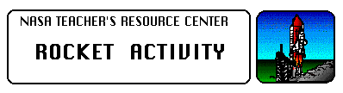

Rockets Teacher's Guide with Activities

National Aeronautics and Space Administration
Office of Human Resources and Education
Education Division

This publication is in the Public Domain and is not protected by copyright. Permission is not required for duplication.
EP-291 July 1993

Acknowledgments:
This publication was developed for the National Aeronautics and Space Administration with the assistance of the many educators of the Aerospace Education Services Program, Oklahoma State University.

Writer:
Gregory L. Vogt, Ed.D.
Teaching From Space Program
NASA Johnson Space Center Houston, TX

Editors:
Carla R. Rosenberg
Teaching From Space Program
NASA Headquarters Washington, DC

Roger Storm
NASA Glenn Research Center Cleveland, OH

How To Use This Guide
Rockets are the oldest form of self-contained vehicles in existence. Early rockets were in use more than two thousand years ago. Over a long and exciting history, rockets have evolved from simple tubes filled with black powder into mighty vehicles capable of launching a spacecraft out into the galaxy. Few experiences can compare with the excitement and thrill of watching a rocket-powered vehicle, such as the Space Shuttle, thunder into space. Dreams of rocket flight to distant worlds fire the imagination of both children and adults.
With some simple and inexpensive materials, you can mount an exciting and productive physical science unit about rockets for children, even if you don't know much about rockets yourself. The unit also has applications for art, chemistry, history, mathematics, and technology education. The many activities contained in this teaching guide emphasize hands-on involvement. It contains background information about the history of rockets and basic rocket science to make you an "expert."
The guide begins with background information sections on the history of rocketry, scientific principles, and practical rocketry. The sections on scientific principles and practical rocketry are based on Isaac Newton's Three Laws of Motion. These laws explain why rockets work and how to make them more efficient.
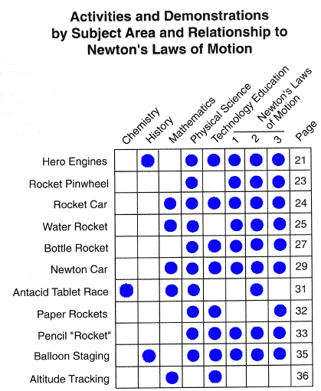The background sections are followed with a series of physical science activities that demonstrate the basic science of rocketry. Each activity is designed to be simple and take advantage of inexpensive materials. Construction diagrams, material and tools lists, and instructions are included. A brief discussion elaborates on the concepts covered in the activities and is followed with teaching notes and discussion questions.
Because many of the activities and demonstrations apply to more than one subject area, a matrix chart has been included on this page to assist in identifying opportunities for extended learning experiences. The chart identifies these subject areas by activity and demonstration title. In addition, many of the student activities encourage student problem- solving and cooperative learning. For example, students can use problem-solving to come up with ways to attach fins in the Bottle Rocket activity. Cooperative learning is a necessity in the Altitude Tracking and Balloon Staging activities.
The length of time involved for each activity and demonstration will vary according to its degree of difficulty and the development level of the students. Generally, demonstrations will take just a few minutes to complete. With the exception of the Altitude Tracking activity, most activities can be completed in less than an hour.

A Note on Measurement
In developing this guide, metric units of measurement were employed. In a few exceptions, notably within the "materials needed" lists, English units have been listed. In the United States, metric- sized parts such as screws and wood stock are not as accessible as their English equivalents. Therefore, English units have been used to facilitate obtaining required materials.

Soda Pop Can Hero Engine
TOPIC: Newton's Laws of Motion
OBJECTIVE: Rocketry
DESCRIPTION: Water streaming through holes in the bottom of a suspended soda pop can causes the can to rotate.
CONTRIBUTED BY: Tom Clausen, KSC Explorations Station
EDITED BY: Roger Storm, NASA Glenn Research Center
"

MATERIALS AND TOOLS:
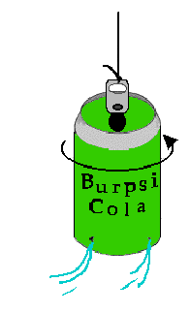
- Empty soda pop can with the opener lever intact
- Nail or ice pick
- Fishing line
- Bucket or tub of water
PROCEDURE:
- Lay the pop can on its side and using the nail or ice pick carefully punch four equally spaced small holes just above and around the bottom rim. Then before removing the punching tool for each hole, push the tool to the right (parallel to the rim) so that the hole is slanted in that direction.
- Bend the can's opener lever straight up and tie a short length of fishing line to it.
- Immerse the can in water until it is filled. Pull the can out by the fishing line. Water streams will start the can spinning.
- If the can does not spin try making the holes larger or adding a fishing swivel to the string above the can.

DISCUSSION: The Soda Pop Can Hero Engine is an excellent demonstration of Newton's Laws of Motion. The can rotates because a force is exerted by the flowing water (1 st. Law). The rate of rotation will vary with different numbers of holes and different diameters of holes in the can (2nd. Law). Try two holes and try a can with large holes verses a can with small holes. The can rotates in the opposite direction from the direction of the water streams (3rd. Law).

Aerospace Education
Services Project
Oklahoma State University
"

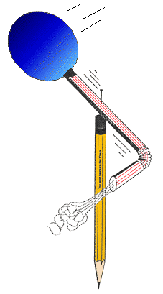Rocket Pinwheel
SUBJECT: Rocketry
TOPIC: Action-Reaction Principle
DESCRIPTION: Construct a balloon- powered pinwheel.
CONTRIBUTED BY: John Hartsfield, NASA Glenn Research Center
EDITED BY: Roger Storm, NASA Glenn Research Center
"
MATERIALS:
- Wooden pencil with an eraser on one end
- Sewing pin
- Round party balloon
- Flexible soda straw
- Plastic tape

METHOD:
- Inflate the balloon to stretch it out a bit.
- Slip the nozzle end of the balloon over the end of the straw farthest away from the bend. Use a short piece of plastic tape to seal the balloon to the straw. The balloon should inflate when you blow through the straw.
- Bend the opposite end of the straw at a right angle.
- Lay the straw and balloon on an outstretched finger so that it balances and mark the balance point. Push the pin through the straw at the balance point and then continue pushing the pin into the eraser of the pencil and finally into the wood itself.
- Spin the straw a few times to loosen up the hole the pin has made.
- Blow in the straw to inflate the balloon and then let go of the straw.

DISCUSSION: The balloon-powered pinwheel spins because of the action-reaction principle described in Newton's Third Law of Motion. Stated simply, the law says every action is, accompanied by an opposite and equal reaction. In this case, the balloon produces an action by squeezing on the air inside causing it to rush out the straw. The air, traveling around the bend in the straw, imparts a reaction force at a right angle to the straw. The result is that the balloon and straw spins around the pin.

Aerospace Education
Services Project
Oklahoma State University
"
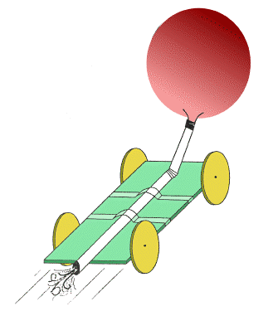Rocket Car
TOPIC: Newton's Third Law of Motion
OBJECTIVE: To construct a car to demonstrate how rockets move by means of action and reaction.
DESCRIPTION: A small car is propelled by the action/reaction force generated by a balloon.
CONTRIBUTED BY: Gregory Vogt, OSU
EDITED BY: Roger Storm, NASA Glenn Research Center

MATERIALS and TOOLS:
- 4 pins
- Styrofoam meat tray
- Cellophane tape
- Flexi-straw
- Scissors
- Drawing Compass
- Marker pen
- Small party balloon
- Ruler
- Emery Board

PROCEDURE:
- Using the ruler, marker, and drawing compass, draw a rectangle 3 by 7 inches and four circles 3 inches in diameter on the flat surface of the meat tray. Cut out each piece. Use an emery board to make the wheels as round as possible.
- Push one pin into the center of each circle and then into the edge of the rectangle as shown in the picture. The pins become axles for the wheels. Do not push the pins in snugly because the wheels have to rotate freely. Test them to be sure they rotate freely. It is okay if the wheels wobble.
- Inflate the balloon a few times to stretch it out a bit. Slip the nozzle over the end of the flexi-straw nearest the bend. Secure the nozzle to the straw with tape and seal it tight so that the balloon can be inflated by blowing through the straw.
- Tape the straw to the car as shown in the picture.
- Inflate the balloon and pinch the straw to hold in the air. Set the car on a smooth surface and release the straw.

DISCUSSION: The rocket car is propelled along the floor according to the principle stated in Isaac Newton's third law of motion. "For every action there is an opposite and equal reaction." The balloon pushes on the air and the air pushes back on the balloon. Because the balloon is attached to the car, the car is pulled along by the balloon.
"
Paper Rockets
SUBJECT: Rocketry
TOPIC: Stability
DESCRIPTION: Small flying rockets to make out of paper and propel with air blown through a straw.
CONTRIBUTED BY: Gregory Vogt,OSU
EDITED BY: Roger Storm, NASA Glenn Research Center
"
MATERIALS:
- Scrap bond paper
- Cellophane tape
- Scissors
- Sharpened fat pencil
- Milkshake straw (slightly thinner than pencil)

PROCEDURE:
- Cut a narrow rectangular strip of paper about 5 inches long and roll it tightly around the fat pencil. Tape the cylinder and remove it from the pencil.
- Cut crown points into one end of the cylinder and slip it back onto the pencil.
- Slide the crown points to the pencil tip and squeeze the points together and tape them together to seal the end to form a nose cone (the pencil point provides support for taping). An alternative to the crown points is to just fold over one end of the tube and seal it with tape.
- Remove the cylinder from the pencil and gently blow into the open end to check for leaks. If air easily escapes, use more tape to seal the leaks.
- Cut out two sets of fins using the pattern and fold according to instructions. Tape the fins near the open end of the cylinder. The tabs make taping easy.

FLYING THE PAPER ROCKET:
Slip the straw into the rocket's opening. Point the rocket towards a safe direction, sharply blow through the straw. The rocket will shoot away. Be careful not to aim the rocket towards anyone because the rocket could poke an eye.

DISCUSSION: Paper rockets demonstrate how rockets fly through the atmosphere and the importance of having fins for control. For experimental purposes, try building a rocket with no fins and one with the fins in the front to see how they will fly. Practice flying the rockets on a ballistic trajectory towards a target. Also try making a rocket with wings so that it will glide.
"
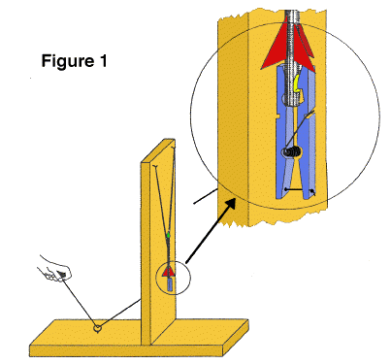Pencil Rockets
SUBJECT: Space Flight
TOPIC: Rockets
DESCRIPTION: Rockets, using pencils for their bodies, are launched with a rubber band-powered launch platform.
CONTRIBUTED BY: Gregory Vogt, OSU
EDITED BY: Roger Storm, NASA Glenn Research

MATERIALS and TOOLS:
- 2 Pieces of wood 3'X4"Xl" in size
- 2 Cup hooks
- 1 Wooden spring clothes pin
- 1 Small wood screw
- 1 Screw eye
- 2 Metal angle irons and screws
- 4 Feet of heavy string
- Iron bailing wire (18 gauge minimum)
- Several rubber bands
- Several wooden pencils (unsharpened)
- Several pencil cap erasers
- Cellophane or masking tap
- Heavy paper
- Saw
- Wood file
- Drill (3/16 inch diameter)
- Pliers

PROCEDURE
Launch Platform
- Join the two pieces of wood as shown in the diagram to form the launch platform. Use a metal angle iron on each side to strengthen the structure.
- Screw in the cup hooks and screw eye into the wood in the places indicated in figure 1.
- 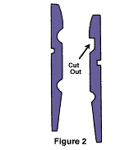Temporarily separate the wooden pieces of the clothes pin and file the "jaw" of one piece square as shown in figure 2. Drill two holes through the other wood piece as shown. Drill one hole through the first wood piece as shown.
- Drill a hole through the upright piece of the launch platform as shown and screw the clothes pin to it so that the lower hole in the pin lines up with the hole in the upright. Reassemble the clothes pin.
- Tie a knot in one end of the string and feed it through the clothes pin as shown in figure 1, through the upright piece of the platform and then through the screw eye. When the free end of the string is pulled, the clothes pin will pen. The clothes pin has become a rocket hold-down and release device.
- Loop four rubber bands together and loop their ends on the cup hooks. The launch platform is now complete.
"
Rocket
- Take a short piece of bailing wire and wrap it around the eraser end of the pencil about one inch from the end. Use pliers to twist the wire tightly so that it "bites" into the wood a bit. Next, bend the twisted ends into a hook as shown in figure 3.
- Take a sharp knife and cut a notch in the other end of the pencil as shown in figure 3.
- Cut out small paper rocket fins and tape them to the pencil just above the notch.
- Place an eraser cap over the upper end of the rocket. This blunts the nose to make the rocket safer if it hits something.

The rocket is now complete.

LAUNCHING PENCIL ROCKETS:
- Choose a wide open outdoor area to launch the rockets.
- Spread open the jaw of the clothes pin and place the notched end of the rocket in the jaws. Close the jaws and gently pull the pencil upward to insure the rocket is secure. If the rocket doesn't fit, change the shape of the notch slightly.
- Pull the rubber bands down and loop them over the wire hook. Be sure not to look down over the rocket as you do this in case the rocket is prematurely released.
- Stand at the other end of the launcher and step on the wood to provide additional support.
- Make sure no one except yourself is standing next to the launch pad. Count down from 10 and pull the string. Step out of the way from the rocket as, it flies about 75 feet up in the air, gracefully turns upside down and returns to Earth.
- The rocket's terminal altitude can be adjusted by increasing or decreasing the tension on the rubber bands.

DISCUSSION: Like the flight of Robert Goddard's first liquid fuel rocket in 1926, the pencil rocket gets its upward thrust from its nose end rather than its tail. Regardless, the rocket's fins still provide stability, guiding the rocket upward for a smooth flight. If a steady wind is blowing during flight, the fins will steer the rocket towards the wind in a process called 'weather cocking.' On NASA rockets, active controls steer during flight to prevent weather cocking and to aim them on the right trajectory. Active controls include tilting nozzles and various forms of fins and vanes.

Aerospace Education
Services Project
Oklahoma State University
"
Balloon Staging
TOPIC: Rocket staging
OBJECTIVE: To demonstrate how several stages of of a rocket can operate in steps to propel a rocket.
DESCRIPTION: Two inflated balloons are joined in a way simulate a multistage rocket launch as they slide along a fishing line on the thrust produced by escaping air.
CONTRIBUTED BY: Gregory Vogt, OSU
EDITED BY: Roger Storm, NASA Glenn Research Center
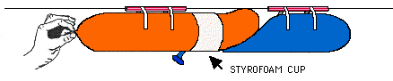

MATERIALS and TOOLS:
- 2 long party balloons (round balloon will not work)
- Nylon monofilament fishing line (any weight)
- 2 Plastic straws (milkshake size, non-bendable)
- Styrofoam cup
- Masking tape
- Scissors

PROCEDURE:
- Thread the fishing line through the two straws. Stretch the fishing line snugly across a room and secure its ends. Make sure the line is just high enough for people to pass safely underneath.
- Cut the cup in half so that the lip of the cup forms a continuous ring.
- Loosen the balloons by preinflating them. Inflate the first balloon about 3/4 full of air and squeeze its nozzle tight. Pull the nozzle through the ring. While someone assists you, inflate the second balloon. The front end of the second balloon should extend through the ring a short distance. As the second balloon inflates it will press against the nozzle of the first balloon and take over the job of holding it shut. it may take a bit of practice to achieve this.
- Take the balloons to one end of the fishing line and tape each balloon to a straw. The balloons should be pointed along the length of the fishing line.
- If you wish, do a rocket countdown and release the second balloon you inflated. The escaping gas will propel both balloons along the fishing line. When the first balloon released runs out of air, it will release the other balloon to continue the trip.

Conclusion
Travel into outer space takes enormous amounts of energy. Much of that energy is used to lift rocket propellants that will be used for later phases of the rocket's flight. To eliminate the technological problems and cost of building giant one-piece rockets to reach outer space, NASA, as well as all other space fairing nations of the world have chosen to use a rocket technique that was invented by 16th-century fireworks maker Johann Schmidlap. To reach higher altitudes with his aerial displays, Schmidlap attached smaller rockets to the top of larger ones. When the larger rockets were exhausted, the smaller rocket climbed to even higher altitudes. Schmidlap called his invention a "step rocket."

NASA utilizes Schmidlap's invention through "multi staging." A large first stage rocket carries the smaller upper stages for the first minute or two of flight. When the first stage is exhausted, it is released to return to the Earth. In doing so, the upper stages are much more efficient and are able to reach much higher attitudes than they would have been able to do simply because they do not have to carry the expired engines and empty propellant tanks that make up the first stage. Space rockets are often designed with three or four stages that each fire in turn to send a payload into orbit.

Aerospace Education
Services Project
Oklahoma State University
"
Altitude Tracking
TOPIC:Altitude tracking
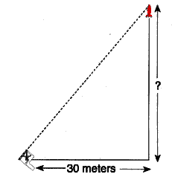OBJECTIVE: To use geometry to find the altitude of model rockets
DESCRIPTION: In this activity, students construct simple altitude tracking devices that are used to measure the angle a rocket reaches above ground, as seen from a remote tracking site. The angle is drawn on a graph and the altitude is read from a scale.
EDITED BY: Roger Storm, NASA Glenn Research Center
"
Materials and Tools:
- Altitude Tracker patterns
- Thread or lightweight string
- Scrap file folders or poster board
- Glue
- Cellophane tape
- Small washer
- Scissors
- 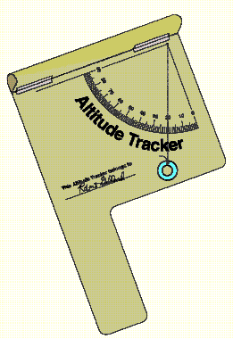Meter stick or steel tape measure (metric)
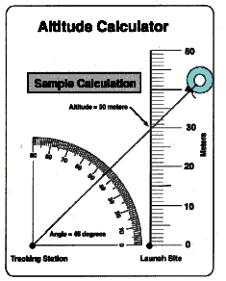
Procedure: Constructing the Altitude Tracker
- Copy the Altitude Tracker pattern on white or colored paper. Cut out the outline and glue the pattern to a piece of scrap file folder or poster board. Do not glue the hatched area to the folder or poster board.
- Cut off the excess file folder or poster board.
- Roll the hatched area at the top of the pattern into a tube and tape the upper edge along the dashed line at the lower edge. Shape the paper into a sighting tube.
- Punch a tiny hole in the apex of the protractor quadrant.
- Cut out the Altitude Calculator and punch a hole at the apex of its protractor quadrant. Glue the Altitude Calculator to the back of the tracker so that the two holes line up.
- Slip a thread or lightweight string through the holes. Knot the thread or string on the calculator side.
- Hang a small washer from the other end of the thread as shown in the diagram of the completed tracker.

Procedure: Using the Altitude Tracker
- Select a clear spot for launching water or bottle rockets.
- Measure a tracking station location exactly 30 meters away from the launch site.
- As a rocket is launched, the person doing the tracking will follow the flight with the sighting tube on the tracker. The tracker should be held like a pistol. Continue to aim the tracker at the highest point the rocket reached in the sky. Have a second student read the angle the thread or string makes with the quadrant protractor.
Procedure: Determining the Altitude
- Use the Altitude Calculator to determine the height the rocket reached. To do so, pull the thread or string through the hole in the tracker to the Altitude Calculator side until the washer stops it. Lay the string across the protractor quadrant and stretch it so that it crosses the vertical scale. (See sample calculation.)
- Read the altitude of the rocket. The altitude is the intersection point of the string and the vertical scale to that number. Add the height of the person holding the tracker to determine the altitude the rocket reached.
Discussion:
This activity makes use of simple trigonometry to determine the altitude a rocket reaches in flight. The basic assumption of the activity is that the rocket travels straight up from the launch site. If the rocket flies away at an angle other than 90 degrees, the accuracy of the procedure is diminished. For example, if the rocket flies toward a tracking station as it climbs upward, the altitude calculation will yield an answer higher than the actual altitude reached. On the other hand, if the rocket flies away from the station, the altitude measurement will be lower than the actual value. Tracking accuracy can be increased, however, by using more than one tracking station to measure the rocket's altitude. Position a second or third station in different directions from the first station. Average the altitude measurements.

Teaching Notes and Questions:
- This activity is simple enough so each student can construct his or her own Altitude Tracker. Permit each student to try taking measurements while other students launch the rockets. To assure accuracy in taking measurements, practice measuring the height of known objects such as a building or a flagpole. It may also be necessary for a few practice launches to familiarize each student with using the tracker in actual flight conditions.
- Why should the height of the person holding the tracker be added to the measurement of the rocket's altitude?

- Curriculum guides for model rocketry (available from model rocket supply companies) provide instructions for more sophisticated rocket tracking measurements. These activities involve two station tracking with altitude and compass direction measurement and trigonometric functions.
Additional Activities
- Construct models of historical rockets. Refer to the reference list for picture books on rockets to use as information on the appearance of various rockets. Use scrap materials for the models such as:
- Mailing tubes
- Tubes from paper rolls
- Spools
- Coffee creamer packages (small plastic containers that look like rocket engine nozzles)
- Cardboard
- Egg-shaped hosiery packages (for nose cones)
- Styrofoam cones, spheres, and cylinders
- Glue
- Tape

- Use rockets as a theme for artwork. Teach perspective and vanishing point by choosing unusual angles, such as a birds-eye view for picturing rocket launches.

- Research the reasons why so many different rockets have been used for space exploration.

- Design the next generation of spaceships.

- Compare rockets in science fiction with actual rockets.

- Follow up the rocket activities in this guide with construction and launch of commercial model rockets. Rocket kits and engines can be purchased directly from the manufacturer. Obtain additional information about model rocketry by contacting the

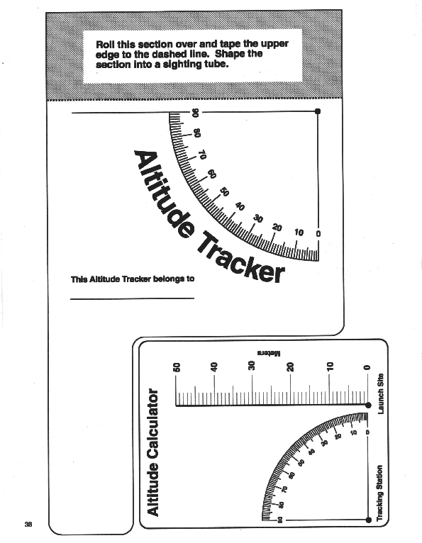ALTITUDE TEMPLATE

Antacid Tablet Rocket

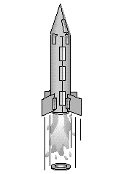Description:
Students construct a rocket powered by the pressure generated from an effervescing antacid tablet reacting with water.
Management:
For best results, students should work in pairs. It will take approximately 40 to 45 minutes to complete the activity. Make samples of rockets in various stages of completion available for students to study. This will help some students visualize the construction steps.

A single sheet of paper is sufficient to make a rocket. Be sure to tell the students to plan how they are going to use the paper. Let the students decide whether to cut the paper the short or long direction to make the body tube of the rocket. This will lead to rockets of different lengths for flight comparison.

The most common mistakes in constructing the rocket are: forgetting to tape the film canister to the rocket body, failing to mount the canister with the lid end down, and not extending the canister far enough from the paper tube to make snapping the lid easy. Some students may have difficulty in forming the cone. To make a cone, cut out a "Pacman" shape from a circle and curl it into a cone. See the pattern on the next page. Cones can be any size.
Film canisters are available from camera shops and stores where photographic processing takes place. These businesses recycle the canisters and are often willing to donate them for educational use. Be sure to obtain canisters with the internal sealing lid. These are usually translucent canisters. Canisters with the external lid (lid that wraps around the canister rim) will not work. These are usually opaque canisters.

Background Information:
This activity is a simple but exciting demonstration of Newton's Laws of Motion. The rocket lifts off because it is acted upon by an unbalanced force (First Law). This is the force produced when the lid blows off by the gas formed in the canister. The rocket travels upward with a force that is equal and opposite to the downward force propelling the water, gas, and lid (Third Law). The amount of force is directly proportional to the mass of water and gas expelled from the canister and how fast it accelerates (Second Law).

Materials and Tools:
- Heavy paper (60-110 index stock or construction paper)
- Plastic 35 mm film canister*
- Cellophane tape
- Scissors
- Effervescing antacid tablet
- Paper towels
- Water
- Eye protection
*The film canister must have an internal-sealing lid. See management section for more details.

Procedure
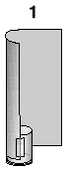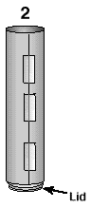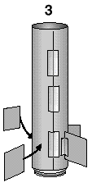1. Wrap and tape a tube of paper around the film canister. The lid end of the canister points down. Allow enough space between the lid and the bottom of the tube, so that the lid is easy to open and close. Make sure the film canister is the clear type that seals from the inside.
2. Seal the paper tube closed with tape.
3. Tape the fins to the rocket.
4. Make a nosecone and attach it to the top of the rocket with tape.
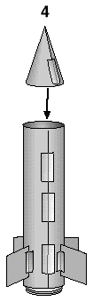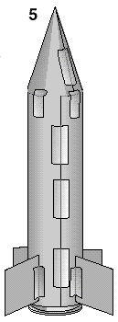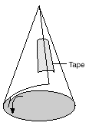
Discussion:
How does the amount of water placed in the cylinder affect how high the rocket will fly?
How does the temperature of the water affect how high the rocket will fly?
How does the amount of the tablet used affect how high the rocket will fly?
How does the length or empty weight of the rocket affect how high the rocket will fly?
How would it be possible to create a two-stage rocket?

Assessment:
Ask students to explain how Newton's Laws of Motion apply to this rocket. Compare the rockets for skill in construction. Rockets that use excessive paper and tape are likely to be less efficient fliers because they carry additional weight.

Cone Pattern:

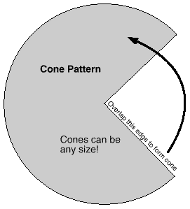Extensions:
- Hold an altitude contest to see which rockets fly the highest. Launch the rockets near a wall in a room with a high ceiling. Tape a tape measure to the wall. Stand back and observe how high the rockets travel upward along the wall. Let all students take turns measuring rocket altitudes
- What geometric shapes are present in a rocket?
- Use the discussion questions to design experiments with the rockets. Graph your results.

Safety Tips for Rocket Construction and Launch

Construction Safety Precautions:
- Always use glue in a well ventilated area.
- Cover the work area with paper or a cloth in case glue drips.

Pressure Testing Water Rockets:
- Never use glass bottles for water rockets.
- Always fill rocket completely with water when pressure testing. This will reduce the explosive hazard of the compressed air.
- Pressurize slowly, and if possible open the air pressure valve so that the air bubbles slowly into the rocket. Then back away and wait for the pressure to stabilize in the rocket with no more bubble action.

Launch Safety Precautions:
- Have each student or student group set up their own rocket on the launch pad. Other students should stand back several meters. It will be easier to keep observers away by roping off the launch site.
- Choose an open field that is clear of obstructions such as trees and wires.
- Launch under low pressure first.
- Never launch a rocket over 400ft without FAA clearance.
- Launch under zero or gentle breeze conditions.
- Never launch in a crowded area.
- Never stand directly over the launch pad while setting rocket on pad or during launch.
- Place the launcher in the center of the field and anchor it in place with the spikes or tent stakes.
- The student pressurizing the rocket should put on eye protection.
- When pressurization is complete, all students should stand in back of the rope for the countdown. Launch the rocket when the recovery range is clear.
- Only permit the students launching the rocket to retrieve it.

