December 2000 -- What Do You Do at Holiday Time?

Pre-opening

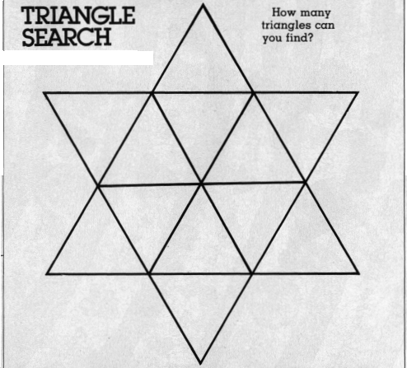

(answer: 24)

Ceremonies
Traditions Opening Ceremony
Here in America we are many. We come from many lands and with us we bring our heritages. We bring our beliefs and we strengthen America when we hold to those beliefs. Each of our traditions gives us an identity, a belonging. And when we share those traditions, we expand our circle so soon we all can belong. Whether we celebrate Christmas, or Hanukah, Kwaanza or none of these, sharing valued traditions and holding true to what they stand for will make America strong. In Cub Scouts, we are many. We come from all backgrounds and celebrate many traditions. But no matter who we are we are still part of America and we all strive to “Do Our Best”.

Christmas Opening Ceremony
Arrangement: Ten boys come on-stage and stand in line. They can be holding Christmas gifts, decorations, etc. Each speaks his line in turn:
1st CUB SCOUT: Secrets! Secrets! In the air! Merry greetings everywhere! That’s Christmas!
2nd CUB SCOUT: Cedar boughs in every nook! Holly! Everywhere you look. That’s Christmas!
3rd CUB SCOUT: Christmas trees with baubles bright, Flashing in the candle light! That’s Christmas!
4th CUB SCOUT: Hearth fires leaping high to show Faces in the firelight’s glow! That’s Christmas!
5th CUB SCOUT: Spicy smells of things to eat, Promising a welcome treat! That’s Christmas!
6th CUB SCOUT: Bundles big and bundles small! And we must not look at all! That’s Christmas!
7th CUB SCOUT: Little whispers all about! But we can’t find one thing out! That’s Christmas!
8th CUB SCOUT: Such a lot of things to do! Shopping trips and wrapping too! That’s Christmas!
9th CUB SCOUT: Time for fun and song and play! Just the year’s most happy day! That’s Christmas!
10th CUB SCOUT: Joy in all we have and do! Wishing joy for others too! That’s Christmas:
ALL: So we gladly join to say here’s to wish your happiest day - That’s CHRISTMAS!

Christmas Advancement Ceremony
PROPS: Cardboard Christmas tree with holes for various colored lights or small tree (real or artificial). Unscrew bulbs so they can be screwed in later. Small wrapped gifts under or near tree containing bulbs — each labeled with boy’s name.
CUBMASTER: (Invite boys forward to open gifts - each containing a bulb and advancement award.’ Boy screws bulb Into lights of tree)
This holiday tree is rather bleak and common but as each boy adds a bulb, the tree, and indeed the room, becomes brighter, more cheerful. The spirit of the holiday increases with each new light bulb which represent each boy’s advancement.
Cub Scouting does for a boy’s life what the bulbs do for this ordinary fir tree makes it brighter a thing of greater beauty, something to behold and enjoy. Ordinary trees and ordinary boys are special in and of themselves, but here we can witness an added dimension.
Thank you parents for encouraging your boys. Thank you Den Leaders for helping him along — because of all of you our lives are fuller, richer and brighter.

Year’s End Closing Ceremony
PROPS: House lights are dimmed. Ceremony board or log contains 7 small candles and one tall candle representing the Spirit of Cub Scouting.
CUBMASTER: (lights candles) This last ceremony for 1999 is one of rededication. Tonight four candles represent the Cub Scout ranks .. . Bobcat, Wolf, Bear and Webelos.
Will all Bobcat Cub Scouts and their parents please stand. Bobcats, do you promise in year 2000 to do your best to help other people and obey the Law of the Pack, and to advance one rank?
(They respond) We’ll do our best. (Extinguish Bobcat candle)
(Follow same procedure for Wolf and Bear Cub Scouts)
Will all Webelos Scouts and their parents please stand. Webelos Scouts, do you promise in year 2000 to do your best to help other people and obey the Law of the Pack and to earn the Arrow of Light award, if you have not already earned it?
(They respond) We’ll do our best. (Extinguish the Webelos candle)
Three candles and the Spirit of Cub Scouting candle remain burning. The three candles stand for FOLLOWS, HELPS and GIVES, which means ‘We’ll be loyal’.
Will you be loyal Cub Scouts in 2000 and beyond? (All respond)
(Three candles are extinguished)
The Spirit of Cub Scouting still burns as it does in the hearts of Cub Scouts everywhere. May it continue to burn brightly in your heart during the year 2000 as we go upward and forward in Pack Goodnight, Cub Scouts.

Advancement Ceremony
Prop: Cut out cardboard Christmas tree. Punch holes in tree to hold various colored lights. Unscrew bulbs — each will be lighted at proper time by screwing it in socket. Light at top is lighted.
CUBMASTER: As we look at our tree this evening, we see that it is dark, with only one light on. (Webelos light at top of tree).
Let us see if there are some boys here tonight who can help light the way to the top of the tree and to the highest rank of Cub Scouting.
The first step along the Cub Scout trail is the Bobcat rank. (Turn on light at bottom of tree representing Bobcat.)
Once a boy has achieved this honor, he is ready to climb. He has 12 achievements to complete. Some of these require knowledge of the U. S. Flag, of keeping strong, of safety, and being helpful to his family. We have _______ boys who have completed all these requirements.
(Call names of boys who have completed Wolf rank or who have earned Wolf arrow points. Ask them to come forward with their parents.) (Turn on Wolf light.)
As the boy grows older, and stronger, he is able to climb higher. But just as it is a little more difficult to climb the upper branches of a tree, so the achievements are a little more difficult in the Bear rank.
(Call names of boys who have earned Bear badge or Arrow Points. They come forward with their parents.) (Light Bear light.)
(Follow same procedure for giving Webelos Activity Badges, turning on a light for each different activity badge.)
These boys have helped light our tree, but it is still not quite as bright as it might be. Since they have received help from their parents and leaders, let us turn on lights for them too. (Additional lights are turned on.)
Now our tree is complete. As you have seen, it has taken the boys plus their parents and leaders to complete it. With the same effort you have shown in the past, keep on working for the highest rank in Cub Scouting. Congratulations to you and your parents for your fine work.

Closing Ceremony
NARRATOR: From the four corners of the earth, and from ocean to ocean in this great nation, if the warmth of all our Scouting brothers were combined, as we in Pack _____ have combined our light and warmth with candles tonight, then the aims and ideals of Scouting will always be our guiding light to keep our world brotherhood of Scouting great.
(Blows out candles and turns lights on)

Audience Participation/Skits
Characters: Den Leader, any number of Cub Scouts with presents.
Setting: Den Leader is standing on stage. If desired, a decorated Christmas tree may be used as backdrop. Boys enter one at a time.
First boy: Merry Christmas, Mrs. ____________. I brought you something. (Hands her a box.)
Den Leader: That's very nice, Bill, but there was no need....
Second Boy: Hi, Mrs. ______________, look at the present I brought you. (Hands her a bigger box.)
Den Leader: Well, Bob.....
Third Boy: (Rushes in) Here's a present, Mrs. ________________. Boy, it's heavy!
Den Leader: Well, Tom ... what a surprise. You really didn't have to...
Fourth Boy: (Rushes in carrying box almost too large to handle) Look what I have! Boy, are you going to like it!
Den Leader: Oh dear! Boys...
Fifth Boy: (Pushing box across floor...too heavy to carry) Here's a Christmas gift from me, Mrs. __________ It's really neat!
Den Leader: My Goodness...
Sixth Boy: (Pulling a wagon on which is a box much too large to carry.) Wait till you see this one! I really spent a lot of money!
Den Leader: Boys, you are all very kind. But I think we should have a talk about all this. Where's Jim?
First Boy: He's coming. I don't know what is taking him so long. He doesn't have a very big gift. In fact, I didn't see him carrying anything.
Second Boy: Here he is now. (Jim enters.)
Jim: Sorry I'm late for the meeting, Mrs. _______. I stayed after school to finish your Christmas present.
Third Boy: I don't see a present. Look at all the BIG presents we brought. I can't even see yours. (Smirks.)
Jim: Mine isn't very large, Mrs. ________, but I hope you'll like it. It's a poem.
All: What a present! (Lots of Laughing.)
Den Leader: May I see it, Jim. (He hands her the paper and she reads:)
I have no money, so I guess I'm poor
But I have friends, that is for sure.
I have no money so I couldn't buy
The things I'd like, though Christmas is nigh.
I have no money, but I don't care
Cause I have you, with whom to share
A happy Christmas Season.
I have no money, so I was sad;
But I looked around, and I was glad.
The things I have are worth a lot;
Some kids don't have the things I got.
I have my dad, I have my mom,
I have my dog--he loves me some.
And in my den I've learned to share.
Not things or money, but love and care.
For each of you I wish as much,
That you'll each know the work of such,
As family, friends and all the things
That last when Christmas gifts are gone.

The Twelve Days of Christmas
Characters: Bob, 12 Cub Scout friends (if den has less than 12 boys, have them repeat their entrance on stage)
Props: Items called for in skit on a table (use your imagination to create wilder items)
Setting: Bob is standing by table with props. As each boy enters, he hands him the appropriate item.

Cub #1: On the first day of Christmas my good friend gave to me -- a knob to adjust my TV. Thanks Bob.
Bob: You're welcome!
(Each cub takes items and exits. Then next cub enters from opposite side of stage)
Cub #2: On the second day of Christmas my good friend gave to me -- two napkins. Thanks Bob.
Bob: You bet!
Cub #3: On the third day of Christmas my good friend gave to me -- three French fries. Thanks Bob!
Bob: No problem!
Cub #4: On the fourth day of Christmas my good friend gave to me -- four comic books. Thanks Bob!
Bob: Glad to do it!
Cub #5: On the fifth day of Christmas my good friend gave to me -- five rusty nails. Thanks Bob!
Bob: Don't mention it!
Cub #6: On the sixth day of Christmas my good friend gave to me -- six greasy rags. Thanks Bob!
Bob: OK!
Cub #7: On the seventh day of Christmas my good friend gave to me -- seven soggy sweatshirts. Thanks Bob!
Bob: Yeah, you're right!
Cub #8: On the eighth day of Christmas my good friend gave to me -- eight mugs for milk shakes. Thanks Bob!
Bob: Give me five! (does high five with Cub #8)
Cub #9: On the ninth day of Christmas my good friend gave to me -- nine dirty dustpans. Thanks Bob!
Bob: Cool dude!
Cub #10: On the tenth day of Christmas my good friend gave to me -- ten leaping lizards. Thanks Bob!
Bob: Check you later!
Cub #11: On the eleventh day of Christmas my good friend gave to me -- eleven pies for pitching. Thanks Bob! ( A pie plate full of whipped cream can actually be thrown at Bob here - if you like!)
Bob: (wiping off cream) That's what friends are for!
Cub #12: On the twelfth day of Christmas my good friend gave to me -- twelve dump trucks dumping. Thanks Bob!
Bob: Bye, pal! (last cub exits, table is cleared of all props) Now, let's see. That was (singing) twelve dump trucks dumping, eleven pies for pitching, ten leaping lizards, nine dirty dustpans, eight mugs for milk shakes, seven soggy sweatshirts, six greasy rags, FIVE RUSTY NAILS, four comic books, three French fries, two napkins and a knob to adjust my TV. (looks at audience and wipes brow) Whew! I finally did it. I finally got my closet cleaned out!

Santa Knows About Rudolph's Nose
Characters: Santa Clause; 6 Elves (wearing Santa hats made from red crepe paper); Rudolph (wearing cardboard or paper band around head with horns attached.)
Scene: Santa sitting in an easy chair by fireplace reading newspaper. It is Christmas Eve.
Elf 1: (Comes running to where Santa is sitting and breathlessly says:) Oh Santa, come here. Bad news I must tell. Rudolph's nose is all frozen. Not a thing can he smell!
Elf 2: (Running in as other elf exits.) Hey Santa, listen here, while sad news I tell you. Poor Rudolph's nose is cold and it's turning all blue.
Elf 3: (Hurrying in as 2nd elf leaves.) Oh Santa, I've come to tell of Rudolph's plight. He has a cold in his nose that has put out his light!
Elf 4: (Follows 3rd, etc.) Santa, Oh Santa! I'm sorry to tell. Rudolph's nose is all warm and he doesn't feel well!
Elf 5: (Same as above) There's something I must say, but I'd really rather not. You see, poor Rudolph has a nose that's very hot!
Elf 6: (Same) Santa, please come! See Rudolph's burned nose! It's all black like charcoal, not red like a rose!
(After all elves have entered, spoken their parts and left, then Rudolph comes in and Santa holds up his hand to keep him from speaking.)
Santa: (While Rudolph hangs his head.) No! Don't say anything, but please let me guess. Your friends were all lying, so you've come to confess. I knew all the time that it was only a plot. For how could your nose be both cold and hot?
Rudolph: Well you see, Santa Claus, I was feeling quite low, and decided on our trip I didn't want to go. But now I've learned a lesson. The truth is always best. It could have saved me from this embarrassing mess!
(Santa pats Rudolph on the head. Rudolph smiles and scampers off stage.)

Santa's Big Secret
Characters: Santa Claus (Scout uniform under Santa suit), Reporter, Numerous elves (Scout uniforms under jackets).
Scene: Elves are in background working making toys or putting toys in sacks. Santa is directing them when reporter comes out with microphone.
Reporter: This is Scoop Smith the roving reporter for radio station KCUB, on the scene here at Santa's workshop. Santa, may we have a word with you please?
Santa: Oh sure, we're real busy getting ready for our deliveries. What can I do for you?
Reporter: All of our listeners want to know how you got into the gift- giving business. Did your father give gifts or what?
Santa: Well, it all began when I was eight years old...I just started doing good deeds, you know, helping people and such...and it just became a habit.
Reporter: Good deeds, huh, that sounds familiar. Say, what is that under your jacket?
Santa: That's my best kept secret...(Opens jacket)
Reporter: A Cub Scout Uniform!!!!!! You're a Cub Scout?
Santa: Yes, well, no. I WAS a Cub Scout, then a Boy Scout, and then an Explorer. I wear this uniform to remind me of where it all started...way back years and years ago. I just loved helping other people and doing good things.
Reporter: Well, that explains your involvement, but how do you get all of these elves to help you?
Santa: Show the man.....(Elves open jackets to show Cub Scout Uniforms.)

Run-ons/jokes
Why does Santa visit his doctor before Christmas?
Because he always get a a flue shot before he slides down chimneys.

What did Santa Claus say to the lumberjack?
There are only 23 chopping days left until Christmas

Why did Santa Claus send for a barber?
He needed someone to trim his Christmas tree.

Father: They know when you’re sleeping. They know when you’re awake. They know if you’ve been bad or good.
Mother: Are you telling Junior about Santa’s elves?
Father: No. I’m telling him about the CIA and the FBI

Why does Scrooge love Rudolph the Red-Nosed Reindeer?
Because every buck is dear to him.

Applauses
SANTA Applause: Rub your stomach while saying “Ho, Ho, Ho, Merry Christmas”.

TINY TIM Applause: “God Bless Us Every One!”

GOOD-BYE SANTA Applause: Pretend to throw a pack onto your back and say, “Merry Christmas to all and to all a Good Night!”

SNOWBALL Applause: Reach down and pick up a pretend handful of snow, pack it into a ball, pull you arm back, throw, and yell “SPLAT!!”

PRESENT CHEER: Pretend that you are opening a present. When you open the box, say, “Oooh, Aaaaah!”

Games
Christmas Swipe
A large sack containing candy and trinkets of various kinds is hung in the center of the room. Players take turns being blindfolded, turned around, and in being given an opportunity to bring down the sack with a swing of the stick. When sack breaks, all players scramble for contents. Person to break sack gets a special prize.

Ring The Bell
A holly wreath is hung from the ceiling or doorway and a small bell is suspended in center of wreath. The players line up 6 to 8 feet away and try to hit the bell with cranberries or beans. Each player gets three turns and the one with the most hits is the winner.

Santa’s Helpers
Two large identical outlines of Santa Claus are cut from pieces of cardboard. One outline is attached to the wall, while the other is cut up so that each player gets a piece of it -- a nose, beard, belt buckle, etc. Each player is blindfolded, and spun around several times. He then tries to pin his appropriate parts of Santa to the cutout on the wall. The player who comes closest, is the winner.
Snowball Relay
Players divide into two teams, and line up behind a starting line, at one end of the room. Each team is given a simulated snowball - either of cotton or Styrofoam - and a piece of cardboard. On signal, the first player on each team tries to move the ball across the floor and back, by fanning it with cardboard. (Player may not touch snowball with his hands or cardboard) Player .then gives cardboard o next team member, who repeats action. Game continues until all team members have fanned the ‘Snowball’ to finish line and back. The first team to finish is the winner.

Threading Popcorn
This game could be used at Den or Pack Meeting to trim the tree. A large supply of popped corn is placed in a bowl in preparation for game, and put in center of large table. Players are grouped around table, each with needle and thread. On signal, each player tries to thread as many pieces of popcorn as he can. At a time limit, (3-4 minutes) player with longest string of popcorn is the winner. When game is over, all of popcorn strings are tied together and used to decorate the Christmas tree.

Christmas Present Relay
Group is divided into relay teams. Runners run to a table, untie, unwrap, rewrap and tie up a Christmas package, while wearing large workman’s gloves. Then he runs back to his team to touch off the next player. Team to finish first receives candy canes.

Christmas Greetings
Each person is given a card and a pencil. Ten minutes are allowed for each contestant to write as many Christmas greetings as he can think of on his card. A prize is given to the person who thinks of the most.

Icicle Hunt
You will need numerous pieces of string in varying lengths. Hide them around the room before the boys arrive. Have the boys hunt for the “Icicles”. The leader ends the hunt after a given period of time. The winner is the boy whose icicles form the longest line when laid out end to end ... not the player who collects the most pieces.

Christmas Handshake
Give each boy five Christmas cards or seals. On signal each boy introduces himself to five parents other than his own. Each time he must leave a Christmas card or seal with them. (Parents should not accept the card or seal until the introduction is complete and the boy can repeat their name) The first den to finish assembles as a den and raises their hands in Cub Scout sign.

Stuff Santa’s Stocking
Divide Den into two teams. Tell them that since Santa fills their stockings they’re going to fill his. Give each team a sack filled with at least ten objects ... pencil, ball, book, etc. and a blown up balloon ... also in the sack is a pair of old panty hose or a long pair of tights ... at the word GO each team tries to fill their stocking first without breaking balloon .. first team through with unbroken balloon is winner ... small candy cane makes nice prize for each team member.

Hunt And Trade
From stiff construction paper, cut several sets of Christmas items such as a star, a bell, etc. Hide them around the room before people arrive. After they arrive, explain the different objects and tell the guests that the items have different values — but don’t tell them the values, Start all together, letting them look for the items. When items are found they may trade if they wish. After a time stop and read values of items. Each person receives a reward (candy) for the value of their pieces.

Kris Kringle Relay
Boys line up in teams, relay style. Each team has two shoe boxes representing Kris Kringle’s boots, On signal, each player in turn places his feet in the boxes and shuffles up to and around a chair, at the opposite end of room, He shuffles back to starting point where the next boy takes over. First team to finish wins

Jingle Bell Chow Mein
This game is a good one to test the skill of your boys. You will need 2 shallow bowls, several jingle bells (about the size of a marble), and 2 full length pencils with erasers on them.
To play the game, place all the jingle bells in one bowl. The player uses the two pencils as chopsticks. With the eraser, end down, the player tries to transfer as many bells as he can from one bowl to the other. He can use only one hand.
If only a couple players are used, set a given amount of time. When using teams, the team to get all the bells in the bowl first wins, with each boy taking his turn to transfer all bells into the other bowl, and the next boy transferring them back into the first bowl, and so on.

The Christmas Card Game
Take a set of old Christmas cards (about three times as many cards as there are players) and cut each card into two pieces, making two sets of half-cards so that each half-card in one set has its counterpart in the other. Some of the cards should be cut so that the halves are easy to spot as belonging to each other (e.g., by cutting vertically down the middle of a colored picture of a vase of flowers), and others should be made difficult to spot (e.g., by cutting along the horizon of a seascape). Distribute one set of half-cards all over the room (they should be visible but not necessarily obvious). Give one half-card from the other set to each player and keep the "pool" in your hand. On the word "Go" all the players try to find the other half of the piece that you have given them and bring it to you. Every player finding a pair that match is given a fresh half-card from the "pool" until there are none left. When all have finished, the group with the largest number of paired pieces wins.

A Christmas Telegram
Have everyone write down the word Christmas leaving a space after each letter. Then allow ten minutes for all players to compose a telegram, the first word beginning with C, the next with H, the third with R and so on. The first word should be the name of the person to whom the telegram is sent, the last word the name of the sender. The players then read out their own attempts in turn, the winner being the one who has composed the most original.

Variation--Christmas Dinner
Give each group a piece of paper with CHRISTMAS written vertically down the side and tell them that after each letter they must write the name of some article that could be found on the table at Christmas dinner--and both run for the ball. The one reaching it first kicks it and runs for a hiding place. The other player is "It" and must return the ball and search.

Songs
A Scout's Christmas
By K. Meyers, D. Busker, and the boys of Den 4, Pack 1515, Alexandria, VA
(tune: Jingle Bells)

Dashing through the den,
With a rope held by each end,
Tying a bowline knot
Then showing what I've got.

Whittling with my knife
On a practice Dial soap bar.
I can hardly wait,
Scout camp can't be far.

Bait a hook,
Learn to cook,
Bike ro-de-os.
Neckerchief slides,
Canned food drives,
Learning to take photos.

Pancake mix,
Carving sticks,
Keeps us on the run.
Our families
Make all these
Memories so much fun.

Dashing through the camp,
Putting up the tents,
Popping all the corn,
Blowing that morning horn.

Of scout camp we all dream
We'll soon be old enough
Tigers, Bobcats, Wolves, and Bears
We're made of real tough stuff!

Half-hitch knots,
Setting up cots,
Playing fun new games.
Hammers and nails,
Compass and trails,
Arrow points are the thing.

Santa's coming,
We've been good,
As good as we can be...
Load our stocking
With a pocket knife,
Boy Scouts we want to be!

The Twelve Scouting Days of Christmas
(Tune: 12 Days of Christmas. Substitute Christmas for Scouting in the leading lines as you wish)

On the first day of Scouting, Akela gave to me.....
A Den Leader swinging from a tree!
On the second day of Scouting, Akela gave to me.....
Two Screaming Bobcats,
And a Den Leader swinging from a tree!

OK, you should have the idea by now. Here's the rest of these silly verses:

Third Day
Three Skinny Wolves
Fourth Day
Four Hungry Bears
Fifth Day
Five Webelos
Sixth Day
Six Arrow points
Seventh Day
Seven Silly Den Chiefs
Eighth Day
Eight Shouting Scouts
Ninth Day
Nine Warring Eagles
Tenth Day
Ten Derby Cars
Eleventh Day
Eleven Funny Den Skits
Twelfth Day
Twelve Wacky Cheers

"I'm A Snowflake"
by Karen Roger
Tune: Clementine

I'm a snowflake, I'm a snowflake,
I'm a snowflake yes I am.
And I'm falling, yes I'm falling,
Right upon your little head.

Oh, I'm melting, Oh, I'm melting
Oh, I'm melting yes I am.
Aren't you glad that I'm not yellow,
But white like I am.

Christmas Time
Tune: Jingle Bells

School is out, we won't pout,
Cubs shout "hip hooray!"
Something Special's coming soon,
And it's Christmas day.

Wrap the gift, trim the tree,
Mind your Mom and Dad.
You'll get presents if you do,
Boy, won't you be glad!

Santa's Coming
Tune: Brother John

Santa's coming, Santa's coming,
Can you hear? Can you hear?
Jingle Bells are jingling, we are happy singing.
Christmas Bells, Christmas Bells.

Randall
Tune: Rudolph

Randall, the red-cheeked Cub Scout
Had a very cold, cold nose.
And if you ever noticed,
You could even say it flows.

All of the other Cubbies,
Used to laugh and point it out.
That Randall, the red-cheeked Cub Scout
Had a very runny snout.

Then one day the Den Leader
Took Randall out of sight (A clear violation of ! ;) )
And told him that it's time he knew
How to wipe his nose just right.

Now all the other Cubbies
Think Randall is a "Class-A" Scout.
Cause Randall, the red-cheeked Cub Scout
Finally learned to blow his snout.

Rudy, the Red-Nosed Cub Scout
Rudy, the red-nosed Cub Scout,
Had a very runny nose;
And if you ever saw it,
You would prob ly say, Oh, Gross!

All of the other Cub Scouts
Used to look and say, Oh, Ick! ;
Parents wouldn t go near Rudy,
Cause they thought they would get sick.

Then one winter s Pack Meeting,
Akela said, Sign s Up! .
Rudy, with your nose so wet,
A box of Kleenex is what you ll get!

Then all the Cub Scouts cheered him,
As he blew and blew and blew;
Rudy, the red-nosed Cub Scout,
We will Do Our Best with you!

Tommy the Cub Scout
Tune: Frosty

Tommy, the Cub Scout
Was a very happy boy.
With a uniform of blue and gold
And a Den that gave him joy.

Tommy, the Cub Scout
Earned his badges one by one.
He did his best and met the test.
A good citizen he's become.

He helps out other people when
He sees they need a lot.
He does his chores around the house
And feeds his dog (named Spot).

Tommy, the Cub Scout
Does his duty willingly.
Someday he'll join a Boy Scout Troop
And a fine man he will be.

RUDOLPH’S PULLING SANTA’S SLEIGH
(Tune: Camptown Races)
Rudolph's pulling Santa's sleigh, ho-ho! ho-ho!
Rudolph's leading all the way, ho-ho! ho-ho!
Gonna ride all day, gonna ride all night,
They'll be flying through the sky, using Rudolph's light.

S-A-N-T-A
(Tune: Bingo)

I know a man in a jolly red suit,
and Santa is his name-o.
S-A-N-T-A, S-A-N-T-A-,S-A-N-T-A
and Santa is his name-o.

CHRISTMAS TIME
(Tune: Auld Lang Syne)

It's Christmas time around the world,
You'll hear the Yule bells ring.
It's time for giving, time for love,
It's time for hearts to sing.

Merry Christmas to you one and all,
Goodwill and happiness,
Good health throughout the coming year,
May all your days be blessed.

SANTA’S COMING
(Tune: She'll Be Coming 'Round the Mountain)
He'll be driving 8 brown reindeer when he comes,
He'll be driving 8 brown reindeer when he comes,
He'll be driving 8 brown reindeer, driving 8 brown reindeer,
He'll be driving 8 brown reindeer when he comes.

(Other verses)
- He'll be coming down the chimney when he comes.
- He'll be dressed up in a red suit when he comes.
- We'll all peek to see him when he comes.
- We'll give him milk and cookies when he comes.

CUBS 12 DAYS OF CHRISTMAS
(Tune: 12 Days of Christmas)

On the first day of Scouting Akela gave to me... A den leader swinging
from a tree
2nd... 2 screaming Bobcats
3rd... 3 skinny Wolves
4th... 4 hungry Bears
5th... 5 Webelos
6th... 6 Arrow points
7th... 7 silly den chiefs
8th... 8 shouting Scouts
9th... 9 warring Eagles
10th.. 10 Derby cars
11th.. 11 funny den skits
12th.. 12 wacky cheers

A Hanukah Song
(Tune: Three Blind Mice)

Eight bright lights, eight bright lights,
See how they glow, see how they glow,
They call to mind the Maccabees,
The struggle for our liberties,
The glory of their victories,
Eight bright lights.

Crafts
New Traditions to Start:
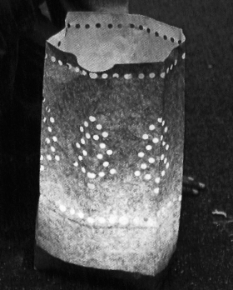
1. Celebrate the Winter Solstice with Lights
Marking the beginning of Winter with a simple celebration of lights. Make Luminarias. Take a brown paper lunch bag and trace a simple pattern in pencil on one side. Punch out your design with a hole punch. Fill each luminaria with about 2 inches of sand and sink a votive candle or tea light in the center. Place the luminarias along a walk, patio, or deck. Have a grown-up light them and then bask in the glow.

2. Make a homemade gift for someone:
Some quick gift ideas
Cover pencil boxes, cans, oatmeal boxes, etc. with contact paper to make attractive "catch-alls" (Corkboard and butcher—block patterns are really nice:)
Mix a few drops of perfume food coloring to desired effect, and epsom salts to make inexpensive bath crystals. Put in attractive jars or plastic bags and tie with bright ribbon.
Make fudge, cookies, etc. and rut in tin foil or plastic bags for a family gift.
Make a coupon book for parents. For example-Good for one room clean-up
- Good for one lawn mowing
- Good for eating all my vegetables at one meal
- Good for one quiet evening of no television.
Pine cones are always a welcome item at Christmas time. They can be used in a variety of ways. Take 'petals' apart and make a picture. Spray with glue and sprinkle on glitter. String with long red ribbon for a wall hanging. Let your mind go - see what you can make. (Note — if you can’t get to the woods and pick any, some hobby stores sell them)
Take current year’s school picture and decoupage on a small piece of wood.
Take cuttings off your plants (or friends if they are going to thin their plants) and plant in foam drinking cups for living gift. Good plants for this are creeping charlies, pothos, coleus. Let boys see how the roots develop before planting.
Have each mother contribute her favorite recipe and have boys make a special den recipe book.

3. Make Homemade Ornaments
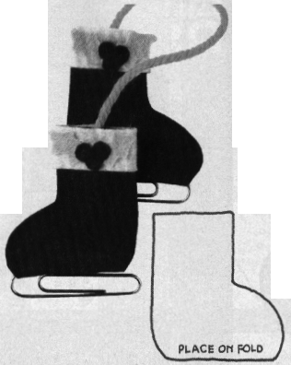
ICE-SKATES ORNAMENT
To make ice-skates ornament, you will need: red, white, and green felt scraps; two 2” (5 cm) paper clips; 8” (20 cm) piece of red or green yarn; craft glue; scissors; and hole punch.
1. Enlarge ice-skate pattern trace onto red felt, and cut out
2. Fold one piece of skate so that straight tops meet, tuck 1” (2.5 cm) of yarn inside, then glue tops together, and let dry. Repeat for other skate.
3. Cut white felt to fit completely around top of each skate, then glue in place (see illustration).
4. Punch holly berries out of red felt. Cut holly leaves out of green felt.
5. Glue holly leaves and berries to white felt trim (see illustration).
6. Slip paper clip through open fold on bottom of skate.

Glittery Lacy Ball Ornament
You will need: cotton embroidery thread, a bowl, glue, water, glitter, and a rubber balloon.
1. Blow up the balloon.
2. Mix equal parts of glue and water in a bowl.
3 Soak the embroidery thread in the
mixture.
4. Wrap the thread around the rubber balloon (see illustration) a number of times, first running the thread between your thumb and pointer finger to strip off excess liquid.
5. Sprinkle glitter on the wet thread that is wrapped around the balloon.
6. Let the thread dry thoroughly in a warm, dry place. (If the rubber balloon shrinks before the thread is dry, the thread balloon will be lopsided.)
7. With help from an adult, if needed, pop the rubber balloon and carefully
remove it.
8. If the thread balloon is too weak, try again with heavier thread or a little more glue in the
mixture.
9. You can make several thread balloons and attach a string to each one; then you can hang them up as ornaments.

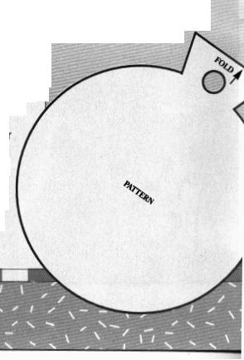
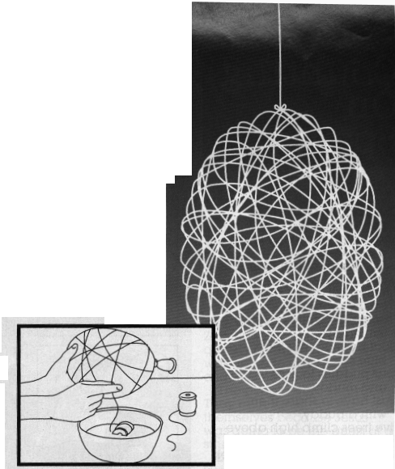

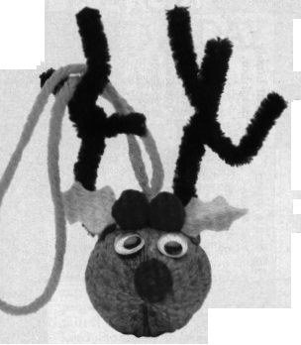
RUDY WALNUT ORNAMENT
To make this ornament, you will need: two 2” (5 cm) pieces of thick black pipe cleaner, 6” (15 cm) piece of thick black pipe cleaner, 7” (18 cm) piece of yarn, walnut, strong glue, small red pompom two plastic eyes, and desired trim.
1. Wrap a shorter piece of pipe cleaner around each end of longer piece, about 1” (2.5 cm) from end.
2. Fold yarn in half, forming loop, and lay along seam of walnut.
3. At midpoint of nut and at right angle to nut seam, place strip of glue across string; then attach pipe cleaner along glue strip.
4. Glue on eyes and pompom nose. Add trim.

ORNA-MINT
To make this ornament for a gift or to decorate a package or a tree, you will need: a pencil, tracing pa per, scissors, colored construction paper, a hole punch, an 8” (20 cm length of ribbon, tape, and a wrapped chocolate mint patty.
1. Trace the ornament pattern on this page and cut it out.
2. Fold the construction paper in half; place the traced pattern or the construction paper with the top of the ornament on the fold, then trace the pattern. Cut it out, leaving the top fold uncut.
3. Punch a hole near the top of the ornament. Thread the ribbon through the hole and tie the ends together.
4 Tape the mint inside the ornament.

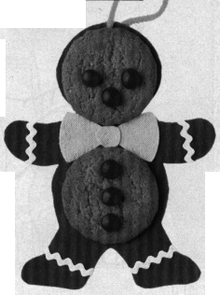
GINGERBREAD MAN ORNAMENT
To make gingerbread man ornament for tree, you will need: brown and green felt scraps, 4” (10 cm) piece of white rickrack, 8” (20 cm) length of red or green yarn, craft glue, scissors, hole punch, two gingersnaps, and small, red cinnamon candies.
1. Draw gingerbread body on brown felt, and bow tie on green felt. Cut out, then punch hole where shown.
2. Glue gingersnap head and belly in place.
3. Cut pieces of rickrack, and glue in place (see illustration).
4. Glue bow tie to gingerbread man’s body, and cinnamon candies to gingersnaps (see illustration).
5. Thread yarn through hole, then knot it. Gingerbread man is ready for hanging.

4. MAKE YOUR OWN CHRISTMAS TREE
To make a surprise present for someone special, you will need: newspaper, potato, pencil, small evergreen branches (the longest about 12” [30 cm]), small knife, clippers, plastic lid, and decorations.
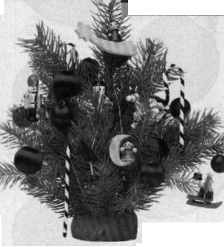
1. Spread newspapers on table before you start.
2. Cut potato in half lengthwise, and lay it
cut-side-down on plastic lid.
3. With pencil, poke hole in top of potato, and stick longest branch in hole.
4. Poke hole on each side of potato, and place 6” (15 cm) branches in holes to form triangle outline of tree (see illustration).
5. Add more branches, placing longer ones near center of tree and shorter ones around them.
6. When all pieces are in place, use clippers to trim branches that stick out too far.
7. Decorate tree with tiny ornaments and small bits of tinsel or with small candy canes and little red bows.
One of the good things about this Christmas tree is that you’ll never need to water it. The greens stay fresh for weeks because the potato acts like a water-filled sponge.

5. Make a HOLIDAY WREATH
For this simple wreath, you will need: a white paper plate, a pencil, scissors, a red or
green crayon or marker, green and red wrapping tissue, glue, and red ribbon.
1. Draw a large circle in the center of the paper plate, cut it out, and discard it (see illustration). Color the front side of the plate wreath green or red.
2. Note: The number of leaves and berries needed depends on the spacing and the size of the paper plate. Fold the green wrapping tissue l times before cutting it into 2 1/2” (6.5 cm) squares for the leaves. Cut from the red wrapping tissue as many 2” (5 cm) squares (berries) as needed.
3. Lightly crumple the leaf squares into loose balls and glue them on the wreath until it is covered. Crumple the berry squares into loose balls, space them around the wreath, then glue them in place.
4. To hang, loop the red ribbon through the wreath, and tie it in a bow or a knot.

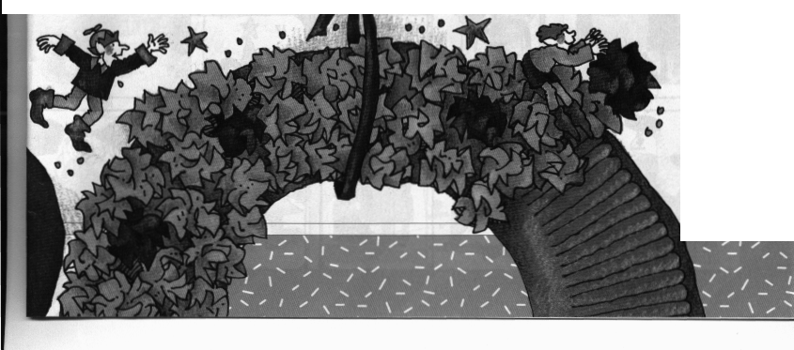

6. Make your own cards:
EMBOSSED CHRISTMAS GIFT TAGS OR CARDS
To make each tag or card, you will need: 4” (10 cm) square piece of poster board (can be scaled to any size tag or card you want), tape, 4” x 8” (10 cm x 20 cm) piece of construction paper or other thick paper, pencil-size dowel sharpened to a dull point, and pencil.
1. On poster board, draw simple pattern.
2. Cut out pattern. (You may wish to cut into middle from edge and then tape cut edge.) Discard piece cut out.
3. Fold construction paper in half to form card.
4. Position pattern on front of card, and lightly tape into place.
5. Unfold card and lay on table with poster-board pattern on bottom. With sharpened dowel, carefully push construction paper into pattern below it.
- Untape pattern. Your gift tag or card is ready to write in. Design variety of patterns. Each will make several cards before edges wear down.

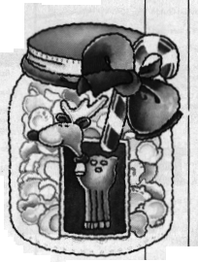
7. Make a Delicious Gift:

Fruity Popcorn
8 cups popped corn
1/3 cup melted butter
1 package any flavor gelatin

1. Place popcorn in clean sack.
2. Pour butter over popcorn, close sack, and shake well.
3. Sprinkle gelatin over popcorn, close sack, and shake well.

Christmas Gift Jar for Fruity Popcorn
To make this gift jar. you will need: any clean, clear glass jar with wide mouth (mayonnaise jar is good), Christmas wrapping paper or old Christmas cards, scissors, green or red felt (optional), pencil, glue, and ribbon or bow.
1. Cut out pictures from wrapping paper or cards; glue to sides of jar.
2. Trace around lid onto felt, then cut out and glue to top of lid (optional).
3. Fill with Fruity Popcorn or other treats; tie with ribbon or put bow on top.

Cubs in the Kitchen
Easy French Toast
1 1/4 cups egg nog
8 slices bread
Pour egg nog into shallow bowl. dip bread into egg nog. Cook bread in hot greased skillet or griddle until golden brown on both sides. Serve with syrup or powdered sugar.

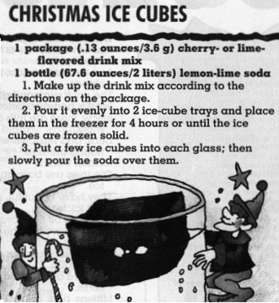
Wassail
1/2 cup sugar
4 cups boiling water
3 whole allspice
6 whole cloves
1 tablespoon ground ginger
1 piece stick cinnamon 1” (2.5 cm) long
1/3 cup orange juice
2/3 cup lemon juice
1. Pour sugar into 2 cups boiling water; boil 5 minutes.
2. Add spices; cover and let stand 1 hour.
3. Add remaining water and fruit juices; mix well, then strain.
4. Reheat to boiling. Serve warm.

Yum Yums
1 package caramels
1 package marshmallows
1/2 box crisp rice cereal
1. Unwrap caramels and place in heavy saucepan. Melt caramels over low heat, stirring constantly.
2. Pour cereal into deep bowl.
3. Stick fork into marshmallow, dip marshmallow into caramel sauce, then into cereal. Place finished candies on waxed paper.
4. Eat at room temperature, but refrigerate to keep fresh.

FIDDLE STICKS
1 can chocolate frosting
1 small box pretzel sticks
1. Line cookie sheet with waxed paper.
2. Spoon frosting into saucepan and stir over low heat until frosting is melted.
3. Dip two-thirds of pretzel stick into melted frosting, then place on waxed paper. Repeat with remaining pretzels. Let stand until dry.

Gelatin Christmas Trees
1 small package lime gelatin
1 cup boiling water
1 envelope unflavored gelatin
1/2 cup cold water
2 cups fruit cocktail,
including juice
9 pointed paper cups
cottage cheese, sour cream, or whipped cream
1. Dissolve lime gelatin in boiling water.
2. Soften unflavored gelatin in cold water; add to first mixture and stir well.
3. Mix in fruit cocktail. Cool to room temperature.
4. Rinse paper cups with water and stand in glasses, pointed side down.
5. Pour cooled gelatin mixture into cups. Chill until firm.
6. To serve, carefully unwrap paper cup, place gelatin tree pointed side up on salad plate, and surround with cottage cheese, sour cream, or whipped cream.

Graham Cracker House
For each house you will need:
1 graham cracker square plus
1/2 square that has been cut diagonally,
frosting, small candies
1. Using frosting, glue long side of half cracker to top of whole cracker (see illustration).
2. Decorate house, using frosting and small candies.

Holiday Popcorn
8 cups popped popcorn
1/4 cup butter/margarine
3 tablespoons light corn syrup
1/2 cup sugar
1 package (3 ounces/85 g) cherry gelatin

1. Grease a 10” x 15” x 1” (25 cmx 38 cmx 3 cm) jelly-roll pan and set aside.
2. Put the popped popcorn into a large bowl.
3. Place the butter and corn syrup in a saucepan and cook over medium heat until blended. Stir in the sugar and gelatin and bring to a boil, then reduce the heat and stir and simmer for 5 minutes.
4. Quickly pour the mixture evenly over the popcorn and stir with a wooden spoon to coat. Spoon the coated popcorn into the greased pan and spread it evenly. Let it cool; then break it into clusters.

Field Trips/Activities
Activities to start new traditions:
See the Nutcracker: Check local newspaper for local productions
Go Ice Skating Outdoors: An outdoor rink is usually available end of November through first part of January. Look for Kids 8 & under skate free coupon in newspaper.
Drive through Lights: Alameda County Fairgrounds has numerous light displays and scenes made with lights. Drive through 2 miles of fun and listen to Christmas music on the local station.
Go to CRIPPS - mas Place. CRIPPS Drive in Fremont and surrounding streets have lots of lights and yard displays. Park and walk or drive through.
Get the den together and sing at a senior residence. When we brought them treats and cub-made corsages they wanted us to sing too. We were terribly off and one resident said so to another. The second resident told the first to hush and they begged us for more.
Decorate an outdoor tree for the animals. Some suggestions would be to decorate with birdseed ornaments, strings of popcorn and cranberries, and peanut butter and birdseed pinecones.
Go caroling. Then celebrate the end of the cold evening with hot chocolate and fresh cookies.
Doorbell Ditch: Make treats for secret friends. Leave them on their doorstep, ring the doorbell and run. Hide where you can see their reaction. Be sure to leave a note that the goodies are from a friend so they don’t suspect them!

