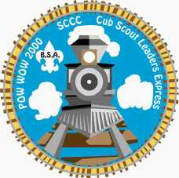
Pow Wow 2000
Santa Clara County Council

29 January 2000
Cub Scout Desiderata
Go placidly amid the noise and excitement of your meeting,
And remember that this is one sign of good Scouting.

As far as possible without surrender be on good terms with all your fellow leaders.

Plan your programs carefully and cheerfully; And listen to others,
Even the youngest Wolf Cub; He will give you many moments of Joy.

Avoid loud and aggressive gatherings of Scouters, except when you're part of one.

If you compare your pack with others, do not become vain or bitter;
For success can only be judged by the smiles on their faces.

Enjoy your achievements as well as your plans.

Keep in mind the Aim of the movement, however hard to understand at times,
It is a real possession in the changing fortunes of time.

Exercise caution with your pack funds; For a Cub works hard for his dues.

But let this not blind you to what Scouting is all about..
Baden-Powell wrote it himself; Camping and the Outdoors.

Be yourself. Especially, have fun.

Neither burn out too soon;
For in the face of all aridity and disenchantment those boys are depending on you.

Take kindly the counsel of your Commissioner and DE; they will help you all that they can.

Nurture strength of spirit in case of a failure but do not blame yourself... you have done your best,
And what you think of as failure may be super fun to your Cubs.

Beyond a wholesome discipline, be gentle with yourself.

You are the most important person in Scouting;
We need more adults like yourself to help the youth of this world.

And whether or not it is clear to you, you are molding the future of this country.

Therefore, be at peace with God, whatever you conceive Him to be,
And whatever your labors and aspirations, in the noisy confusion of your meeting
Keep peace with yourself.

With all its hard work and sometimes frustration, it is still a wonderful movement.

Be cheerful -- Strive for good Scouting ...

Author unknown...part of the handouts given out at a Scouter's Five seminar held by Brant District in March 1993.
Table of Contents

Title Page Title Page

Introduction 1
To the Pow Wow 2000 Book 1
The SCCC-L and Scouts-L E-mail Lists 2
The Cub Scout Program 3
Introduction To Cub Scouting 3
What is Cub Scouting? 3
A Little History 4
Aims of Scouting 4
Purposes of Cub Scouting 4
Methods of Cub Scouting 5
Duty to God and Country 6
Family Involvement 6
Cub Scouting -- A Parent’s Call to Action 7
The Pack 7
The Den 8
Grade and Age 8
The Pack Leadership 8
The Pack Committee 8
Chartered Organization Representative 9
Pack Committee Chairperson 9
The Cubmaster 9
The Den Leader Coach 10
The Den Chief 10
Den Chief Training 10
Den Chief Awards 11
Management of Boys 12
Tiger Cub Leaders Resources 16
The Tiger Cub Program 16
Ideas for Tiger Cub Big Ideas 18
Big Idea 1 -- Getting to Know You 18
Big Idea 2 -- Family Entertainment 23
Big Idea 3 -- Discover Nature and Energy 24
Big Idea 4 -- Prepare for Emergencies 26
Big Idea 6 -- Know your Community 31
Big Idea 7 -- Helping others 32
Big Idea 8 -- Go See It 33
Big Idea 9 -- Getting There 34
Big Idea 10 -- Something Special All Your Own 36
Big Idea 11 -- Making Your Family Special 38
Big Idea 12 -- Make Your Own 40
Big Idea 13 -- Caring for Your Home and Household 41
Big Idea 14 -- Family Games, Tricks, and Puzzles 41
Big Idea 15 -- Fitness and Sports 43
Big Idea 16 -- Tell It Like It Is 44
Big Idea 17 -- Cub Scouting Here We Come 45
Sample Meeting Outline For Tiger Cubs 49
Wolf and Bear Den Leader Resources 53
Just An Hour a Week 53
Hints and Tips For New Cub Scout Leaders 53
Program Resources for Cub Scout Leaders 54
Training Resources for Cub Scout Leaders 54
Anatomy Of A Den Leader 55
Cub Scout Academics and Sports Program 56
Concepts and Guidelines 56
The Purposes of Cub Scouting 57
Cub Scout Academics Program 57
Art 58
Chess 58
Citizenship 59
Communicating 59
Computers 60
Geography 60
Heritages 61
Mathematics 61
Music 63
Science 63
Weather 64
Wildlife Conservation 65
Cub Scout Sports Program 65
Sports Pins 66
Archery 66
BB-Shooting 66
Badminton 66
Baseball 67
Basketball 67
Bicycling 68
Bowling 68
Fishing 69
Golf 69
Gymnastics 70
Marbles 70
Physical Fitness 70
Skating 71
Skiing 72
Soccer 72
Softball 73
Swimming 73
Table Tennis 73
Tennis 74
Ultimate 74
Volleyball 75
Webelos Leader Resources 77
Where to Get Resources for the Webelos Program 77
A guide for new Webelos Leaders 78
The Webelos to Scout Transition 81
Webelos Activity Badge Ideas 83
February 2000 -- Scholar 83
February/March 2000 -- Engineer 87
March 2000 -- Handyman 90
April 2000 -- Sportsman 95
April 2000 -- Athlete 99
May 2000 -- Outdoorsman 101
May 2000 -- Family Member 106
June 2000 -- Naturalist 108
June 2000 -- Forester 111
July 2000 -- Aquanaut 115
July 2000 -- Geologist 119
August 2000 -- Traveler 124
August 2000 -- Artist 128
September 2000 -- Communicator 131
October 2000 -- Fitness 133
Den Activities 135
October/November 2000 -- Citizen 137
November/December 2000 -- Craftsman 143
November/December 2000 -- Scientist 146
January 2001 -- Readyman 151
January 2001 -- Showman 153
Pack Leader Resources 157
Cub Scoutspeak 157
Planning Pack Meetings 160
Gathering Activities 162
Pack Meeting Ideas 165
Leader Recognition 165
Where to Find Cubmaster Resources 166
What Do Real Scouters Say About Pack Meetings? 167
Cub Scout Activity Guide 171
Planning Den and Pack Activities 171
Tours: Planning A Den Or Pack Tour 172
Camping And Camps 173
Recruiting 175
School Night for Cub Scouting 175
Pack Newsletters 177
Pack Newspaper 177
How To Make Your Own Newspaper 177
Pack Administration 177
Financial Planning Information 177
Knots 179
The Adult Leader Awards 179
District Roundtable Meeting Locations and Times 185
Field Trips and Outings 187
SAN JOSE AND VICINITY 187
THE PENINSULA 193
SANTA CRUZ 195
GILROY - WATSONVILLE-MONTEREY 196
ALAMEDA AND CONTRA COSTA COUNTIES 196
SAN FRANCISCO 198
NORTH BAY 200
OUTSIDE THE BAY AREA 201
Year 2000 Program Themes 207
February 2000 -- Turn Back the Clock 207
Pre-Opening 207
Ceremonies 207
Audience Participation Stories & Skits 208
Applauses 210
Games 211
Songs 211
Crafts 214
Cubs in the Kitchen 217
Field Trips/activities 218
March 2000 -- Cub Grub 219
Pre-Opening 219
Ceremonies 220
Audience Participation Stories & Skits 222
Run ons/jokes 224
Applauses 225
Games 225
Songs 226
Crafts 227
Fun Recipes 229
Cubs in the Kitchen 230
Field Trips 230
April 2000 -- Bugs and Things 231
Pre-Opening 231
Ceremonies 231
Audience Participation/Skits 232
Run-ons/jokes 235
Applauses 236
Games 236
Crafts 238
Cubs in the Kitchen 244
Field Trips/Activity Suggestions 244
Field Trips 245
May 2000 -- Cub Scouts, Here We Come 246
Theme Related 246
Pre-Opening 246
Ceremonies 247
Skits 250
Run-ons/Jokes 252
Applauses 253
Games 253
Songs 254
Crafts 255
Cubs in the Kitchen 260
Field Trips 261
June 2000 -- Space: The New Frontier (Space derby) 263
Pre-Opening 263
Ceremonies 263
Audience Participation/Skits 265
Run-ons/jokes 269
Applauses 269
Games 270
Songs 273
Crafts 275
Cubs in the Kitchen 284
Field Trips 285
July 2000 -- From Sea to Shining Sea 286
Pre-Opening 286
Ceremonies 287
Skits 290
Run-ons/Jokes 292
Applauses 292
Games 292
Crafts 294
August 2000 -- Toughen Up 300
Pre-Opening 300
Ceremonies 300
Audience Participation/Skits 302
Run-ons/jokes 305
Applauses 305
Games 306
Songs 309
Crafts 310
September 2000 -- Getting to Know You 320
Pre-Opening 320
Ceremonies 320
Songs 322
Games 323
Crafts 323
Skits & Run-On's 324
Cubs In The Kitchen: 325
Applauses 326
Field Trips 326
October 2000 -- Our Gifts and Talents 327
Pre-Opening 327
Ceremonies 327
Songs 328
Games 328
Crafts 329
Skits & Run-On's 329
Cubs In The Kitchen 331
Applauses 333
Field Trips 333
November 2000 -- Turn on the Power 334
Pre-Opening: 334
Ceremonies 334
Songs 335
Games 335
Crafts 336
Skits/Run-ons 339
Cubs In The Kitchen 340
Applauses 341
Field Trips 341
December 2000 -- What Do You Do at Holiday Time? 342
Pre-opening 342
Applauses 347
Games 347
Crafts 353
Cubs in the Kitchen 359
Field Trips/Activities 361
January 2001 -- When I Grow Up 361
Pre-Opening 361
Ceremonies 361
Songs 363
Games 363
Crafts 363
Audience Participation Story 366
Activities 366
Cubs In The Kitchen 368
Applauses 369
Field Trips 369
Crafts 371
Leather Work 371
Finishing 371
Lacing 371
Leather Craft Projects 372
Bolo Tie 372
Wristband 372
Molding With Plaster 372
Basic Woodworking 374
Neckerchief Slides 377
Tiger Crafts 382
Various Cub Craft Projects 383
Simple Feeders 383
Modeling Dough 386
Ceremonies 387
Pack Meeting Ceremonies 387
Opening Ceremonies 387
Closing Ceremonies 393
Tiger Ceremonies 398
Tiger Cub Opening Ceremonies 398
Various Tiger Ceremonies 398
Tiger Closing Ceremonies 402
Bobcat Ceremonies 405
Advancement Ceremonies 406
Webelos Ceremonies 412
Arrow of light Ceremonies 416
An Arrow of Light Ceremony from the Greater St. Louis Area Council 416
Miscellaneous Ceremonies 417
World Conservation Award Ceremony 417
Songs, Sparklers & Pizzazz 419
What is Pizzazz? 419
Become a Song Leader 419
Tiger Songs 420
Den and Pack Songs 421
Patriotic Songs 437
Cheers and Applauses 439
More Applauses 447
Den Yells 449
Run-ons 451
Skits 457
Tiger Skits 457
Cub Scout Skits 457
Stories 463
The Art of Story Telling 463
Preparing to Tell a Story 466
Example Stories 467
The Lost Hunter 471
Audience Participation Stories 474
The Brutal Miner 475
A Space Adventure 476
Johnny Fixes It Good! 477
The Case of the Missing Watson 478
Tommy Joins A Cub Scout Pack 479
Thanksgiving Sparkler 480
Moaners and Groaners Stunt 480
Games 483
Finding other Games Resources 483
On the Web 483
Game Books 483
Organizing and Playing Games 483
Tips and Miscellaneous Items 485
Tiger Games 487
Quiet Games 488
Non-Competitive Games 490
More Games 492
Cub Scout Cooking 497
Outdoor Cooking 497
Fun in the Kitchen 499
KITCHEN EXPERIMENTS 499
FUN FOOD 500
Cub Scout Character Development 503
Developing the Character of the Cub Scout 503
An Introduction to Spiritual Development 503
Spiritual Development Activities 504
Wisdom (To develop an inner discipline and training.) 504
Work (To be involved in corporate activities.) 504
Wonder (To understand the natural world around us.) 505
Welcome (To help create a more tolerant and caring society) 505
Worship (To discover the need for prayer and worship) 506
Prayers 508
Songs 513
Inspirational Readings and Short Subjects 516
Graces 525
The Scouts Own 531
An Introduction to the Scouts Own 531
An Outline Scouts' Own For a Formal Situation 532
Some Ideas on Scouts' Owns 532
Some Scouts Own Examples 533
Summaries of Some of World Religions 540
Hinduism 540
Judaism 540
Christianity 541
Islam 541
Sikhism 542
Buddhism 542
Reference Material 543
Pow Wow 2000 Classes 545
Rockets Teacher's Guide with Activities 545

Introduction

To the Pow Wow 2000 Book

WELCOME! Now that you have enjoyed the fun of Pow Wow, learned a whole bunch, and met new Scouter friends, its time to get to work. Here is your workbook for 2000. Yes, a workbook -- something to mark up, take apart and pass around, copy, cut up. Use it as a tool to help your Den and Pack program. After all, you’ll get another one next year!
Your editors know that you look forward to the Pow Wow Book each year, and depend on new material and resources to help your programs. We have sought out material from a variety of sources -- old Pow Wow books and other documents, original material from Scouters around the world, web sites and sources outside Scouting. We know that some material will be familiar to you, but you should also find a lot of fresh ideas -- crafts, skits, songs, and lots more.
Organization this year is different from previous years. You will find sections on monthly themes and sections on monthly Webelos Activity Badges as in the past, which contain activities, ceremonies, skits, games and songs. You will also find separate sections on Games, Stories, Songs & Pizzazz, Skits and more. New to the Pow Wow Book is a section on Developing Cub Scout Character. Scattered throughout the book you will find descriptions of where to find additional resources -- lists of books and Internet web sites. The Internet is becoming one of the most important resources for Scouters, and you need to be aware of what material is available.
It is appropriate that for the new century we produce the Santa Clara County Council Pow Wow Book on CD. If you did not get a CD, contact the council office or the Scout Shop. Not only is the 2000 book on the CD, but also the 1999 Book and lots of other Games, Skits, Campfire planning, Scouts Own and Cooking resources.
We want to thank a whole bunch of people for their significant contributions to this book: A special thanks to Marcia Morrow and Joann Liddle who created the Monthly Themes section. Thanks to Phil and Sakiko Wehrman, who compiled the last two Pow Wow books, provided the 1999 book for the CD, and the Outings & Field Trips section for this book. Thanks to Chris Reisel from the far off land of Colorado, for creating the Baloo’s Bugle (http://www.usscouts.org/Bugle) from which we gathered lots of things. Thanks to all the many Cub Scout contributors to the US Scouting Service Project web site, the participants on Scouts-L and the local Scouters who responded to our plea for HELP!!! And thanks to the various people who proof read the Pow Wow 2000 Book.
Finally, we wish to dedicate this book to the memory of Jack Mortensen. In the few short years that we knew him, he had a profound affect on our dedication to Scouting. Through his quiet example in the way he dealt with boys and adults, he crystallized what has become for us our slogan, “What we do, we do for the Scouts.”
Gary & Kyna Hendra

The SCCC-L and Scouts-L E-mail Lists
We invite you to subscribe to SCCC-L, an auto-forwarding e-mail list for the Santa Clara County Council. All who subscribe to the list will get the “informational bulletins” (this is CUB SCOUTS – you didn’t really think I’d use the “A” word, did you?) which are periodically sent out. All subscribers can also post questions to the list (which will go to every subscriber to the list) and hopefully get quick answers.
To subscribe, send a single word in the body of an e-mail message
SUBSINGLE
To the listserver SCCC-L-Request@lists.best.com. Posts to the list are sent to SCCC-L@lists.best.com

You are also invited to subscribe to the Scouts-L Youth Groups Discussion List, which is a TEN-YEAR-OLD list of Scouters from around the world – the Roundtable that Never Ends. There are currently nearly 4000 subscribers to Scouts-L, so it is a good pool of information – as well as a great place to bounce questions and ideas. To subscribe, send
SUBSCRIBE SCOUTS-L <YOUR FIRST NAME> <YOUR LAST NAME>
To the listserver listserv@listserv.tcu.edu . You do need to use your full real name when you subscribe. Only the listowner and list-moms will ever see the name you used to subscribe, but the list rules require that a real name (not a nickname or handle) be used when subscribing.



Introduction

The Cub Scout Program

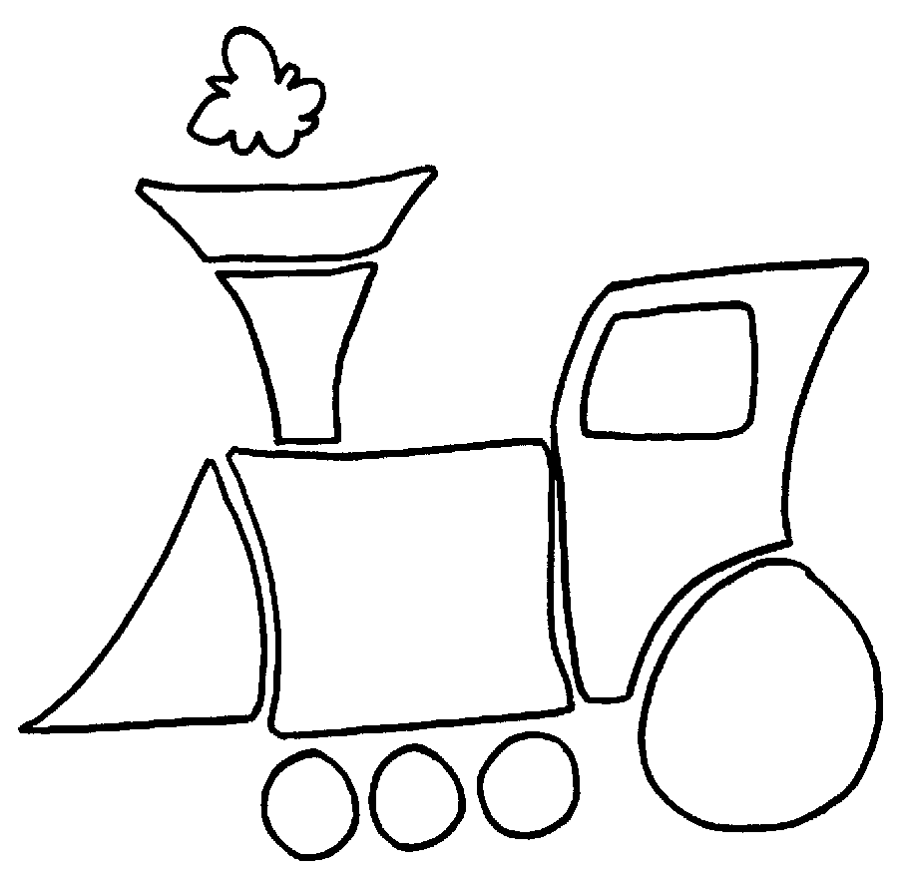
Tiger Cub Leaders Resources

Wolf and Bear Den Leader Resources

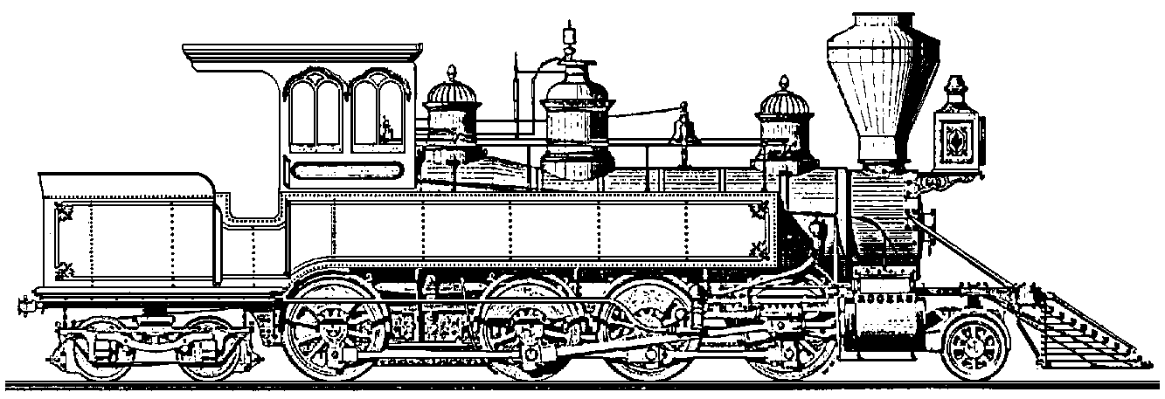

Webelos Leader Resources



Pack Leader Resources
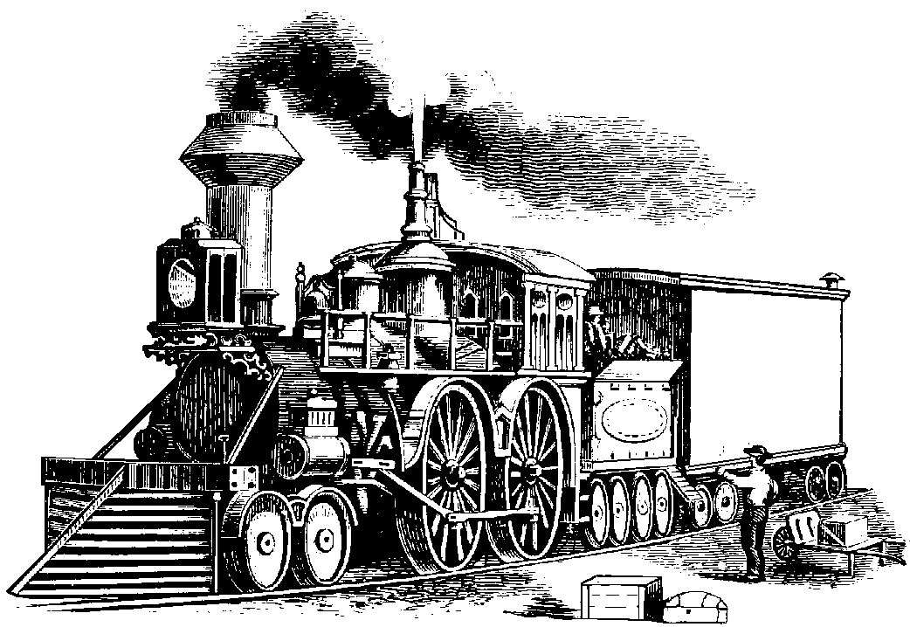

Field Trips and Outings

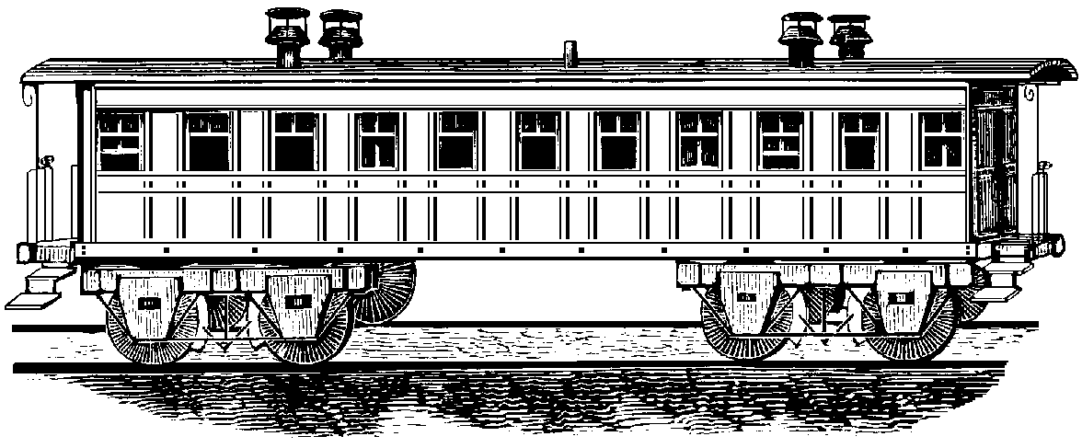

Year 2000 Program Themes
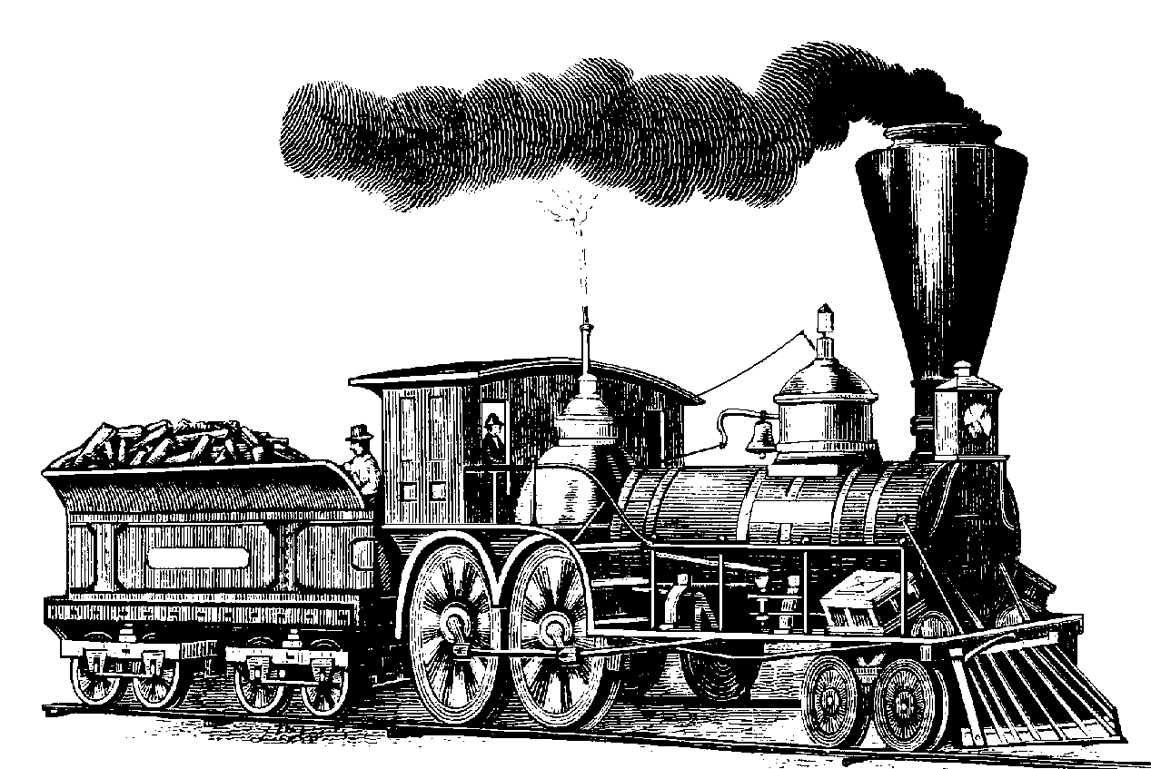

Crafts

Ceremonies



Songs, Sparklers & Pizzazz

Skits
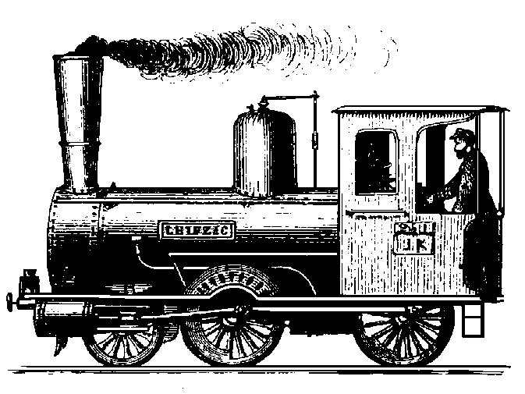

Stories

Games


Cub Scout Cooking
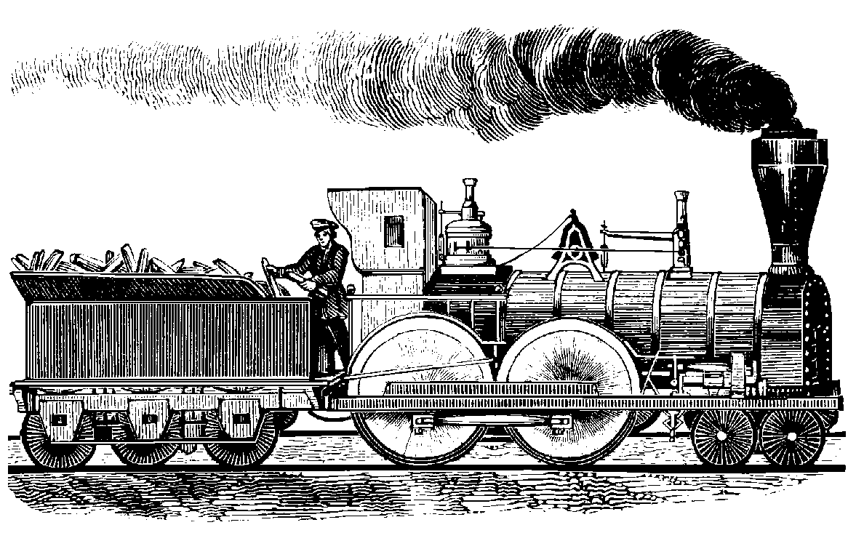

Cub Scout Character Development

Pow Wow 2000 Classes

