July 2000 -- From Sea to Shining Sea

Pre-Opening
Presidential Firsts
1. Who was the first and only president to serve more than two terms?
a. Herbert Hoover b. Franklin Roosevelt c. Ronald Reagan d. Dwight Eisenhower

2. Who was the first president to occupy the White House?
a. George Washington b. John Adams c. Woodrow Wilson d. Zachary Taylor

3. Who was the first president to speak over the radio?
a. Grover Cleveland b. William Taft c. Franklin Roosevelt d. Ulysses Grant

4. Who was the first president to born in a log cabin?
a. Andrew Jackson b. Dwight Eisenhower c. Theodor Roosevelt d. Abraham Lincoln

ANSWERS: 1.B 2.B 3. C 4. B 5. A

Presidential Nicknames
1. LONG TOM A. EISENHOWER
2. SILENT CAL B. TAYLOR
3. JEMMY C. CLEVELAND
4. OLD HICKORY D. PIERCE
5. OLD ROUGH AND READY E. BUCHANAN
6. HANDSOME FRANK F. JEFFERSON
7. IKE G. MADISON
8. OLD BUCK H. JACKSON
9. GROVER THE GOOD I. COOLIDGE

ANSWERS: 1. F 2. I 3. G 4. H 5. B 6. D 7. A 8. E 9. C

In the grid below, cross out every letter that rhymes with “Three”. The remaining letters will spell out three states
O P E I O W A G
E K Z E V C Z D
T C L D B P E T
G C T A G G C Z
V O P E H P Z D
D H Z G V O P E
E I P G E D M C
P O Z D Z G E A

Ceremonies
Flag Ceremony

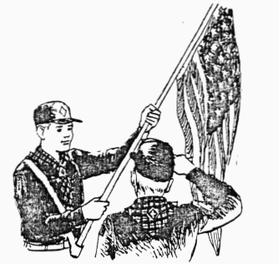
PLANNING A FLAG CEREMONY:
A group planning a flag ceremony needs to decide these things:

Who will carry the flag?
Who will be the guards?
Who will give directions for the ceremony?
What song shall we sing?
Who will start the song?
Do we want a poem or quotation? (use one of the ones below!!)
Who will say it?
After the Pledge of Allegiance, shall we say the Cub Scout Promise and Law of the Pack?
In what order shall we do these things?

STANDARD FLAG CEREMONY
PERSONNEL: Flag bearers for American flag and Pack flag; Color guards for American flag and Pack flag; Speaker. (if there is an uneven number of color guards, the American flag has precedence and should have the most guards)
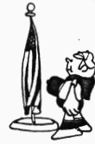
EQUIPMENT: American flag; Pack flag; flag stands; recorded music if desired.
ARRANGEMENT: Flag stands are in place at front of room or on stage. Flag bearers and color guards are in position in rear of room. Speaker may be in rear of room or in any convenient place nearby. Cubmaster usually call the meeting to order and Introduces the Den who will perform the ceremony. At this point the speaker advances to the front.
SPEAKER: ATTENTION! WILL THE AUDIENCE PLEASE RISE? (They do)
COLOR GUARD, PRESENT THE COLORS!
(Speaker’s commands should be given sharply and loudly) Color guard advances from rear of room with flag bearers in front, followed by color guards. The U.S. flag should always be on the marching right in the procession. As procession begins the speaker gives his next command.
HAND SALUTE! (He salutes and audience does likewise) Speaker’s eyes follow American flag until it is in position in front of room. Flag bearers and color guards take positions in front of room near flag stands. They stand at attention, facing the audience The flags are held vertically.
PLEDGE OF ALLEGIANCE, REPEAT! (He begins Pledge with audience joining in)

ARRANGEMENT FOR FLAG CEREMONY
If flags are to be posted on the stage, the American flag will be posted on the audience’s left. Since it should be on the marching right in the procession, it will be necessary for the flags to cross in the front of the room. (See diagram below) The American flag should cross in front of the Pack flag.
If flags are posted on audience level, the American flag will be placed on the audience’s right. In this case, the flags do not cross. When colors are retired at end of meeting, the same positions are used as shown below, except in reverse order. (See diagram)

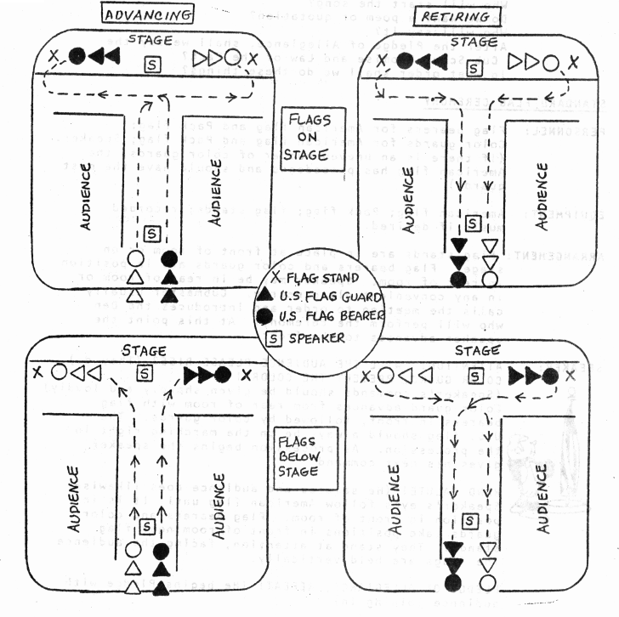

Below are four essays which can be used as openings and part of a flag ceremony.

I am Your Flag
I am the symbol of the living America, the badge of its greatness, the emblem of its destiny.
I am faith. It is I who keep men mindful of their priceless heritage, life, liberty, and the right to pursue happiness.

I am hope. I represent the land of promise wherein, already, man's loftiest dreams have approached closer to realization than ever before on this earth.
I am life. Each strand and fiber of my being is a memorial, dedicated to the sacrifices of all those strong men and steadfast women who have lived and died in the nation's service, that it might live forever.
I am tolerance. So long as I shall wave, all people under my protection may freely worship, think, write and speak, undaunted by the shadow of fear.
I am justice, tempered with mercy. For I am friend to the oppressed and downtrodden of every land.
I am a sign of the future. I wave over schools throughout the nation and in them the nation's future is molded.
I am the flag of the United States... the last... the best hope for peace on earth.

I Am Your Flag
by Marine Master Sargeant Percy Webb
I am your flag.
I was born June 14, 1777.
I am more then just cloth shaped into a design.
I am the refuge of the World's oppressed people.
I am the silent sentinel of freedom.
I am the emblem of the greatest sovereign nation on earth.
I am the inspiration for which American Patriots gave their lives and fortunes.
I have led your sons into battle from Valley Forge to the dense jungles of Vietnam [deserts of Iraq].
I walk in silence with each of your honored dead to their final resting place beneath the silent white crosses - row upon row.
I have flown through peace and war; strife and prosperity; and amidst it all,
I have been respected.
I am your flag.
My red stripes symbolize the blood spilled in defense of this glorious nation.
My white stripes signify the yearning tears shed by Americans who lost their sons and daughters.
My blue field is indicative of God's heaven, under which I fly.
My stars, clustered together, unify fifty states as one, for God and Country. "Old Glory" is my nickname, and I proudly wave on high. Honor me, respect me, defend me with your lives and your fortunes.
Never let my enemies tear me down from my lofty position, lest I never return.
Keep alight the fires of patriotism; strive earnestly for the spirit of Democracy.
Worship Eternal God, and keep his commandments; and I shall remain the bulwark of peace and freedom for all mankind.
I AM YOUR FLAG!
I AM YOUR FLAG!

I Am Old Glory
I am old glory; for more the 9 score years I have been the banner of hope and freedom for generation after generation of Americans. Born amid the first flames of America's fight for freedom, I am the symbol of a country that has grown from a little group of 13 colonies to a united nation of 50 sovereign states. Planted firmly on the high pinnacle of American Faith, my gently fluttering folds have proved an inspiration to untold millions. Men have followed me into battle with unwavering courage. They have looked upon me as a symbol of national unity. They have prayed that they and their fellow citizens might continue to enjoy the life, liberty and pursuit of happiness, which have been granted to every American as the heritage of free men. So long as men love liberty more than life itself, so long as they treasure the priceless privileges bought with the blood of our forefathers; so long as the principles of truth, justice and charity for all remain deeply rooted in human hearts, I shall continue to be the enduring banner of the United States of America.

Old Glory on the Moon
by Mary V. DeMaio

This poem was written back in 1971 inspired by sight of the American Flag on the moon.

"Remember me? I'm Old Glory,
Don't have to tell my story.
It's written all over me.
I am your family tree.

"I never dreamed that one day soon,
I would be planted on the Moon.
So on my 14th day of June
Let's all celebrate with a boom.

"If each and every one of you
Have love for my red, white and blue,
Then proudly show my colors true
And let me hear you say 'I do.'

"Way up on high I have no show
And all alone I cannot grow
But 50 stars will always glow
In hopes of spreading peace below."

Advancement Ceremony
Equipment: A large map of the area served by your pack, on paper, or cardboard. Map should be hung for audience to see. Badges and arrow points are taped to streets in approx. area of homes of advancing boys.

Cubmaster: This month the boys have been discovering America and while doing so some boys have earned badges and arrow points. On this map of our neighborhood, I find a Bobcat badge for a boy who lives at _________. Will that boy and his parents please step forward.. (When they’re on stage) “This is _____ who has earned his Bobcat.” (Cubmaster gives badge to parents who then give badge to the boy.)
(Repeat for any Wolf or Bear advancements)
Congratulations Boys!! You are doing a great job!

Skits
The Great Seal
Scene: Group of Cub Scouts are talking.
1st Cub: Bet you never heard of the Great Seal of the United States.
2nd Cub: You lose. I certainly have heard of it.
1st Cub: Okay. I'll bet you don't know where to find a picture of it.
2nd Cub: You win. Where?
1st Cub: On a dollar bill. Look. (Holds up dollar bill.)
2nd Cub: You mean the picture of George Washington?
1st Cub: No, turn the bill over and look at the two circular designs.
2nd Cub: That's the Great Seal? Why are there two designs?
1st Cub: That's the front and back of the Great Seal, like the front and back side of a coin.
3rd Cub: What do the designs mean?
1st Cub: First there is the eagle. That's our national symbol. The shield over the eagle's breast has 13 stripes.
4th Cub: For the 13 original states?
1st Cub: Right!
5th Cub: (Looking at bill.) What's the eagle holding in his beak?
1st Cub: It's a ribbon with the words "E pluribus unum" which is Latin for "one from many".
4th Cub: Meaning one nation from many states?
1st Cub: Right!
3rd Cub: What's the eagle holding in his claws?
2nd Cub: I know. There is an olive branch, the symbol of peace, with 13 leaves.
4th Cub: And he's holding 13 arrows in the other claw, which means that we intend to defend our freedom.
1st Cub: Do you know why the eagle is facing right?
2nd Cub: It means that peace is right. Peace is first.
3rd Cub: What does the pyramid mean?
1st Cub: The pyramid is a symbol of strength and lasting power. But notice that it's flat on top - unfinished. That means the nation is unfinished. We still have a big job ahead.
4th Cub: What is that triangular eye above the pyramid?
5th Cub: I think it represents God watching over us.
3rd Cub: Gosh, I never realized there was so much crammed into the Great Seal.
1st Cub: And I'll bet you never realized it was right on a $1 bill.

Constitution Skit
Scene: Philadelphia, 1787
Characters: Narrator, 4 Cub Scouts in colonial dress, some extra Scouts.
Narrator: "While it's true that our constitution was written by truly great men, it still took 11 years to finish. Let’s look in on some of these men as they go about their work. Here comes Ben Franklin and Samuel Adams."
Sam: "Let's have pizza tonight."
Ben: "I don't like pizza. How about tacos?"
Sam: "But I don't like tacos. Let's have hamburgers."
Ben: "We always have burgers."
(The two walk off stage still arguing.)
Narrator: (flustered) "Simply a difference of opinion, ladies and gentlemen. Don't worry, they'll work it out. Look there's Thomas Jefferson and John Adams."
John: "I tell you the Yankees are the best!"
Tom: "No way, it's gonna be the Braves this year."
Narrator: "Wait a minute you two, are you talking about baseball."
Tom and John: "Yes!"
Narrator: "Baseball hasn't been invented yet!"
John and Tom: "OH!" and then walk off arguing about football.
Narrator: "I don't know what's going on here. Wait, they're gathered together! Now what are they arguing about?"
(The four Scouts plus the extras are gathered around a table.....)
Tom: "At least we agree on something...The Constitution of the United States!"

Hans And Franz
Props: Box with a lever sticking out of it. Costumes of weight lifters. Cover over sign on box that says "Voting Booth".
Hans: I'm Hans.
Franz: And I'm Franz.
Both: And we're here to (clap) pump you up! (Point to audience.)
Hans: We have a lever to pull here today.
Franz: Ya, and we aren't no weakling men, we will have no trouble pulling it.
Hans: Hear us today, remember us next week, and understand what we do next year. Let's pull the lever, Franz. (Both try but cannot pull the lever.)
Boy 1: (Walks on stage, pulls lever down and pushes back up.) Having some trouble pulling the lever down?
Franz: No problem, we were just checking the tension.
Hans: Ya, we'll show you now! (Try again and fail.)
Boy 2: (Walks on stage and pulls lever and pushes it back up.)
Franz: Hey, how did he do that?
Boy 3: It's easy. Anyone can do it.
Hans: You tink so?
Franz: Third time's a charm. (Try again and again cannot do it.)
Boy 3: (Walks on and pulls lever and pushes back.) This is easy, but pulling the lever has little to do with strength. You see (removes sign cover) all you have to be is a registered voter to do it.

Run-ons/Jokes
Cub 1: Where was the Declaration of Independence signed?
Cub 2: At the bottom.

Where do vampires get their pencils?
From Pennsylvania, of course.

What state has a sea?
Connecticut. It has three “c” in all.
What state has four eyes?
MIssIssIppI.

What did Tennessee See?
The same thing as Arkansas.

What did Delaware?
It must have been her New Jersey.

What did IDAHO?
I don’t know but ALASKA!

What does Arizona have that no other state has?
That’s easy. The letter “Z”.

What state love scompany?
Missouri. Misery always loves company.

Cub 1: Can you name the capital of every state?
Cub 2: Sure. Washington D.C.

Applauses
MOUNT RUSHMORE: shout Washington, Jefferson, Lincoln, Roosevelt!
CONSTITUTION: (Shout) “We the people, APPROVE!”
AMERICA APPLAUSE: Shout U.S.A. and thrust right hand with doubled fist skyward, then shout, “Hooray, onward and upward!!”
PAUL REVERE APPLAUSE: Pretend to be riding a horse while moving up and down saying, ”The British are coming! The British are coming!”
LIBERTY BELL CHEER: Ding, Ding, Ding, Dong!

Games
City Town Country
Players sit in two lines team A and Team B, each line numbered 1 to N. Player 1 in team A says to player number 1 in team B the name of a city, town or Country.
We will suppose for example that he says 'GERMANY". Player 1 in team B must now say a town city or country, beginning with the last letter of Germany. Let us suppose that he says "YORK". Player 2 in team A now has to say a city, town or country beginning with the letter K. This goes on all the way down the line. If a player fails to give a correct answer or duplicates a previous answer, then a point is awarded to the other team. When the end of the line is reached play begins at player number1 again.

United States
Provide each player with a card and pencil and announce that ten minutes will be allowed for the player to list as many states as they can. Even fairly young boys are familiar with most of the states in the union and enjoy this contest. If the group is older you can ask them to name the capitals.

Flag Folding Relay
Divide the boys up into two teams. Have two 3’ by 5’ (approximately) flag. Give one to each team. On signal first boy hands the star side of the flag to the boy behind him and folds the flag. When it is folded, the second boy unfolds the flag and hands the star side of the flag to the boy behind him while he now folds the flag. Play continues until each boy has folded the flag. First team to have each member fold the flag wins.

Stars and Stripes (Like Duck, Duck, Goose)
Boys sit in a circle with one boy standing. The standing boy walks around the outside of the circle and taps each sitting cub on the floor and calls each one of them either a star or a stripe. If the boy is a stripe, he must get up run around the circle being chased by the 1st boy and sit back in his spot in the floor without being tagged by the 1st boy. If he gets tagged, he now walks around the circle naming everyone and play begins again.

50 States
Mark the names of the states on paper plates. Spread out the paper plates on the floor . At the signal everyone scrambles. A state is called and that plate is removed. If someone is standing on that plate they are removed too. Last person left on the last plate is the winner. For a shorter version use less states, but keep track of the ones used.

5 State Rummy
Make Cards by photocopying a small map of the U.S. divided into states. Make 50 copies. Color a different state on each one, put the name of the state on the card and then glue to 3”x5” cards. Pass 5 cards out to each player. Player left of dealer begins and draws top card. He may either keep or discard the card. If he keeps it he must discard another card in his hand. The next player may now choose between the discarded card or to draw a new one. The object is to get 5 states that touch each other. When someone gets 5 touching states they must read off their winning combination. This is a great way to learn the states!!!

Pack Meeting 5 State Rummy
Put the names of the 50 states on pieces of paper. Each person as they enter gets a paper pinned to his back. They must determine who they are by asking questions that can be answered by a yes or no only. Once they find out who they are they must try to find someone who also has found out who they are if their states touch. When 5 people make a connecting chain they win.

Songs
This Old Flag
(Tune: This Old House)
This old flag is my protection;
This old flag is my birthright.
This old flag is full of beauty
May it fly both day and night.
It’s an honor to salute it,
And, with pride, we hold it high.
We will keep it flying o’er us,
Like a symbol in the sky.

Ain’t gonna allow no one to tramp it,
Ain’t gonna allow no one to ‘buse it,
Ain’t gonna allow no one to shun it,
Ain’t gonna allow no one to use it,
Ain’t gonna allow no one to down it
For some other flag to use.
Going to keep that old flag flying,
And we dare you to refuse.

You’re a Grand Old Flag
You’re a grand old flag, Thou you’re torn to a rag
And forever in peace may you wave
You’re the emblem of
The land I love,
The home of the free and the brave.
Every heart beats true
Under the red white and blue,
Where there’s never a boast or a brag
But should auld acquaintance be forgot,
Keep you eye on the grand old flag!

If You Love This Land Of Ours
If you love this land of ours, Clap your hands (do motions)
From sea to shining sea, Clap your hands
If you love it’s rocks and rills
And its woods and purple hills
If you love this land of ours, Clap your hands

(Repeat doing “stomp your feet”, “shout Hooray” and on the last verse “do all three”)

I’m Proud to Be An American
(Tune) My Bonnie Lies Over the Ocean

America lies ‘tween two Oceans
It’s such a great place to see
America is a grand nation
That’s why I’m proud to be....

Chorus:
Ame-ri-can Ame-ri-can, I’m proud to be an Amer-i-can
Ame-ri-can, Ame-ri-can, I’m proud to be American.

America has fifty sta-tes
As different as any could be
And though we’re unique and different
We’ve strength in our di-versity
(Chorus)

America stands as a banner
Round the world of what is just
And why is clear in our motto
It’s because In God We Trust.
(Chorus)

More songs from the Cub Scout Song Book
America
The Star Spangled Banner
God Bless America
America, the Beautiful
Battle Hymn of the Republic
Make America Proud of You
This Land is Your Land
The State Song

Crafts
Flagstand
Have a den make a flag stand for your flags, or have each boy bring a flag from home and make a stand for it. All you need for this is a block of wood, a drill, sandpaper and paint. Drill a hole the size of the flagpole. Sand the wood, paint it and you’re done!

Yarn And Nail Flag
Materials:
Red, White and Blue cotton rug yarn or knitting yarn
Plywood, 13 by 18 inches
1/2 inch headless nails or brads
50 1/2 inch gummed silver stars

Sand edges of the plywood. Along each short side, draw a line about 1/2 inch from the edge as a guide for placing the nails. In the upper left corner, mark off 7 by 8 inch area for the blue field.
Place 52 nails along each short side of the plywood (about 1/2 inch) apart and 28 nails along the right side of the field for starts.
Tie red yarn to the first nail in the bottom and wind the yarn back and forth across the base and around the nails, tying it off on the fourth nail up. Repeat with white yarn, then red, and so forth, alternating red and white every four nails. When you reach the field, use the nails at the right side.
For the field, tie at the first nail in the upper left corner and wind blue yarn continuously to the bottom row. Put the gummed stars on the blue field.
The flag can be finished by gluing metallic braid around the edges.
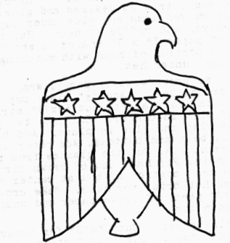
Eagle Tie Slide
Materials: White styrofoam meat trays, Colored glue mixture, (Brown, Blue and Red,) scissors, yarn, or garbage bag ties, masking tape or glue.
Cut 1 eagle for each tie slide needed (using pattern) from meat trays, Paint eagle with brown glue mixture, star background with blue, every other stripe with red glue mixture. When dry either glue or tape yarn or bag tie to the back of Eagle to complete the slide. (a cut of 1/2 inch long of 3/4 inch PVC pipe can be glued to back in place of yarn if desired.)
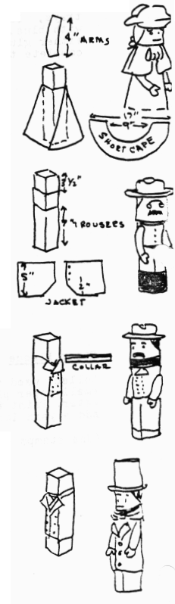
Famous President figures
The body of each figure is made from a wax paper box set on end. Cover 3 1/2 “ at upper end of box with flesh colored construction paper for face. Features, beards, mustaches and hair are cut from colored paper.
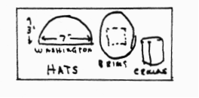
Washington: Cut an 8 1/2" x 12” piece of blue construction paper for long cape. Wrap around body and trim at front edge at angle so it flares slightly. Short shoulder cape is made from an arc—shaped piece (as shown) about 17” across. Wrap around body, trim as desired and glue. Cut slightly curved arms and glue under cape. Add white gloves and ruffle at neck. Hat is two pieces of paper 3” x 7” shaped as shown. Cover exposed portion of head with matching paper Add Cotton hair under hat.
Roosevelt: Use brown .wrapping paper. Wrap 7"x10" piece high around body. Add 1 1/2" black paper strip for boots. For jacket, cut 5”xlO” strip and cut a 2” slit in center. Cut into two pieces as shown. Overlap and glue in place. Add black paper collar, belt and buttons. Add paper arms with black gauntlets. Cut the glasses from paper. Add thread chain. For hat, cut 6” brown circle. Trace around head portion of box at center and cut out. Push hat brim over head. Make crown from a 3 1/2" x 10" piece of brown paper and shape by folding down top.
Grant: Use blue paper. Cut 7”xlO” for trousers and wrap around body. Cut 3" x 10" strip of white for collar. Fold down 1/2" strip along one long side and cut collar notches at center. Wrap around body and fasten. Jacket is 4 1/2" x 10" strip wrapped around body, with lapels folded down and glued. Add gold paper buttons and chevrons. Glue arms with white gloves in place. hat is same as Roosevelts, with 5 1/2" blue circle for brim and 3 1/2" x 10" blue tube for crown.
Lincoln: Use black paper for clothing. Make trousers same as Grant. For collar, wrap 4”xlO” strip of white around neck. For vest use 5”xlO” strip with ‘V’ at center, wrapped around body and glued. Coat is 7”xlO” piece wrapped around and folded back and trimmed for lapels. Add Black tie, coat buttons and arms with white gloves. Cut 5 1/2" black circle for ha: brim. Cut 3 1/2" x 10" pieoe of back, roll into tube for hat.

Eagle Jigsaw Puzzle
Materials:
Lightweight cardboard
Scissors

Below is the emblem of the United
States, the eagle; and the letters “U . S. ".
The letters are divided into 16 parts numbered from 0 to 15.
Paste the letters “U.S.” on a piece of cardboard, then cut them along the dividing lines to get the 16 pieces for the jigsaw puzzle.
The trick is to place the 16 pieces on the eagle picture below in such a way that the eagle’s silhouette is completely covered Solution below:
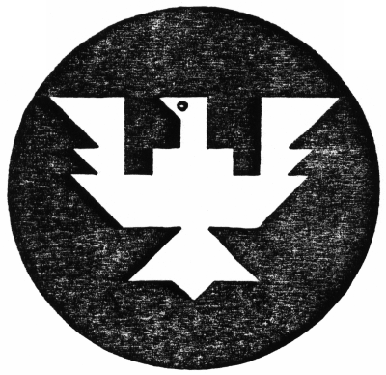
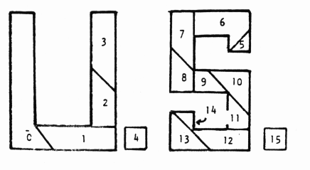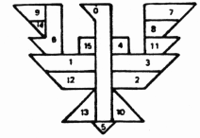
Cubs in the Kitchen
All American Hot Dog In A Blanket
3 Tablespoons softened margarine
6 slices bread
6 slices cheese
6 hot dogs
toothpicks
Spread margarine on one side of each slice of bread. Place buttered side of breaddown on baking sheet.
Top each bread slice with cheese. Then put hot dog diagonally across cheese slice.
Fold opposide diagonal corners over hot dog and secure with toothpicks.
Bakeat 375 degrees for about ten minutes or until golden brown.

Texas Two Bean Salad Toss
Small head lettuce, rinsed and chilled
1 can (16 oz) green beans, drained
1 can (15 1/2 oz) red kidney beans, drained
Italian salad dressing
In a large salad bowl, tear lettuce into bite size pieces. Add beans and toss. Serve with Salad dressing.

California Grilled Fruit Kabobs With Fondue
1/2 cup honey
1/2 cup butter or margarine
Assorted fruit such as grapes, cherries, apricot halves, banana chunks, applie slices, pineapple, or whatever you like.
1 cup chocolate chips
1/2 cup evaporated milk
In a small saucepan stir the honey and butter until the butter melts and the mixture is well blended. Keep just warm.
In another saucepan stir the chocolate chips with the milk until the chocolate is melted and the mixture is well blended. Keep just warm.
Arrange the fruit on skewers and cook over hot coals brushing from time to time with the honey mixture until lightly browned.
Dip the grilled fruit into the chocolate fondue and enjoy!

“Hamburger” Cookies
1/4 cup shredded coconut
green food coloring
24 vanilla wafers
12 small chocolate mint patties (round)
Put the coconut in a small container that has a lid. Add a few drops of the food coloring, put on the lid, and shake until the coconut turns green.
Put twelve wafers flat side up on a baking sheet
Place a mint on top of each wafer
Bake the wafers at 325 degrees for one minute
immediately sprinkle each wafer with coconut (lettuce). Top with remaining wafers, flat side down, and you will have hamburger looking cookies!!!

Field Trips
Here is a list of “Annual” Events that happen in July. Try visiting a few to investigate this great land we live in!!
Old Time fourth of July Celebration, Columbia State Park. Sonoma County Fair; Santa Rosa. Bach Festival, Carmel. California Rodeo, Salinas. Nihon Machi Street Fair, Japantown, San Francisco. Asian Festival, Oakland Museum. Hoopa Fourth of July Celebration, Hoopa. Pony Express Celebration, Pollack Pines. Napa County Fair, Calistoga. Willits Frontier Days, Arcata Salmon Festival. Mendota Sugar Festival. Folsom Rodeo. San Mateo County Fair. San Francisco Fair and Exposition. Hangtown Festival, Placerville. Sacramento Water Festival. Alameda County Fair, Pleasanton. San Antonio Mission Fiest, Jolon. Springfest, San Mateo Fairgrounds. Old Auburn Flea Market. Italian Picnic and Parade, Sutter Creek. Klamath Salmon Barbecue. Shasta Bridge Jamboree, Redding. Solano County Fair, Vallejo. Novato County Fair. Pony Express Days, McKinleyville. Garberville Rodeo and Western Celebration. Bear Flag Day, Sonoma. Tuolumne Jubilee, Tuolumne City. Kit carson Days, Jackson. Butterly Days, Mariposa. Cornish Miner’s Picnic, Grass Valley. Fiddler’s Jamboree, Railroad Flat. Bonanza Days, Gilroy. Redwood Acres Fair, Eureka. Western Daze, Fairfield Western Weekend, Novato. Vaquero Days, Hollister. Hose Show and rodeo, San Benito. Old-Fashioned Fourth, Mount Shasta. Old-Fashioned Fourth, Crescent City. Grand Comedy Festival, Eureka. Fortuna Rodeo. Fiesta Rodeo de San Juan Bautista. Scotts Valley Days, Gold Rush Jubilee, Callahan, Siskiyou County. Feast of Lanterns, Pacific Grove. Orick Rodeo, Waster Lily Festival, Smith River. Gasket Raft Races. Turtle Races, Cloverdale. Nightboast Parade, Lakeport and Clearlake Highlands. Marin County Fair, San Rafael.

State Capitol Sacramento
Tenth and Capitol, Capitol Mall. (916) 445-4209. Daily 9-5 Free. Hear Politics in action and take a tour. Then spend the rest of your day at Sutter’s Fort State Historic Park (2701 L Street at 28th Street, Sacramento (916)-445-4422 daily 10-5 adults $1 under 18 yrs 50 cents.) or see some of the sights in OLD SACRAMENTO call (916) 443-7825.

Campbell Historical Museum. (408) 866-2119. Depicts life in the 1920’s and 1930’s. Learn about Campbell history.

Mission Santa Clara De Asis at Santa Clara University, 500 Camino Real, Santa Clar. (408) 554-4023. Self guided tours.

San Jose Historical Museum 750 Ridder Drive. (408) 920-5000. Free. Tours are 10:00 – 11:30 for 3rd grade and up. Reservations needed as this is very popular.

Sunnyvale Historical Museum. 235 East California (corner of Sunnyvale and California) in Sunnyvale,. (408) 749-0220. Tues & Thurs 12:00-3:30; Sun 1:00-4:00 and by appointment. Free. This small museum captures the past with artifacts and pictures of pioneers.,

