June 2000 -- Space: The New Frontier (Space derby)

Pre-Opening
Hidden Planets
The names of all nine plants are hidden in the letters below. Can you find them? Look up, down, sideways, and diagonally. Be careful--some words overlap, and some are written backwards.

L M V E N U S 0 The nine planets are: Mercury, Venus, Earth, Mars,
R 0 E E A R T H Jupiter, Saturn, Uranus, Neptune, and Pluto.
E S M R K A F P
T A 0 A C N L R This is how you memorize the order of the plants:
I T A P R U U R "My Very educated Mother dust Served Us fine pizzas
P U P L T S R E
U R M 0 0 0 N Y The first letter in each word gives the first letter in the
J N E P T U N E names of the planets in order from the sun.

Space Unscramble
These scrambled words are related to outer space. Unscramble the letters to make sense.
1. ANTRSU 7 .RIBTO 13. RATSTONAU
2. TTLSHUE 8. NISEVURE 14. RTIJUPE
3. OSMOCS 9. OOMN 15. TALEPN
4. CCIEENS 10. UCYRMER 16. ESUVN
5. TECRKO 11. PELTSCOEE 17. LAGAYX
6. TOMCE 12. TRIGAYV 18. OPTUL

1. Saturn 2. Shuttle 3. Cosmos 4. Science 5. Rocket 6. Comet 7. Orbit 8. Universe 9. Moon 10. Mercury 11. Telescope 12. Gravity. 13. Astronaut 14. Jupiter 15. Planet. 16. Venus 17. Galaxy. 18. Pluto.

S-A-T-E-L-L-I-T-E
The word SATELLITE contains many smaller words. SAT and LET are two that are easy to find. There are at least twenty-five other words of three letters or more orbiting around here. How many words can you find in SATELLITE?

Planets - Pre-Opening Game
Have name tags made up using the nine planets. As the people arrive, they are to find as many of their planet as possible and remember who the others are. The winner is the one who can remember the most names.

Ceremonies
Opening
Staging - Record player; record such as Star Wars, 2001--A Space Odyssey, etc.; American flag; spotlight (or flashlight)
CUBMASTER: Will everyone please be seated. (Room is darkened, music starts - allow to play 2-3 minutes.) Let our flag be illuminated. (Music lowered.). Just as we have saluted this flag for over 200 years, with the help of good citizens and good leadership, so shall we continue to salute. Cub Scouting is one means by which we can insure our future as a great nation so that in the year 2000 and beyond, we will all still be pledging our allegiance to this great emblem of our society. Please join me now in the Pledge of Allegiance.
All stand and pledge. (On completion, turn on lights.)

Advancement Ceremony
PREPARATION - Ceremony board resembles chart of sun and planets with Cub as sun and Cub ranks as planets. A small blue and yellow cardboard rocket should be made for each boy getting a badge and placed on or under his rank. If a loop of masking tape is placed on the back of each rocket, the rocket can be moved by the Cubmaster to the new rank as the fathers are presenting the badge. (Use Cub Scout insignia stickers.)

CUBMASTER: Will the den chiefs please bring forward the Cub Scouts who are ready for advancement.
⁽Den chiefs bring boys forward and yell their names.)
Cub Scouts, we are happy to see you have taken another flight forward in our Cub Scout galaxy. Please face your fellow Cub Scouts and Den Chief (name) will lead them in a rocket cheer.
(Den chief leads rocket cheer.)
Den Chiefs, will you please bring the parents of these Cub Scouts forward.
(Den chiefs bring parents forward, placing each Cub Scout between his parents.)
These Cub Scouts have done a fine job in our pack. They are progressing through the Cub Scout galaxy. This would not be possible if it were not for the interest and help of their parents. I’m proud of the parents in our pack. As I move your rocket forward on our galaxy, your father will present your with your badge.
(Cubmaster calls off names as he moves rockets to appropriate ranks on ceremony board while fathers present badges. Cubmaster congratulates boys and parents with Cub .Scout handshake.)

Opening
The Cubmaster shows a model rocket or a futuristic model car and says:
Cub Scouts, here is a great looking car (or rocket). It is the builder’s vision of what cars may look like in the future. We can’t be sure that he’s right. But we can be sure that the world is going to need good men in the future. And we can be sure that we will all be good men if we remember to follow the Cub Scout Promise. Let’s remember that as we stand and repeat the Promise.
(Lead audience in Cub Scout Promise)

Closing Thought
The words “Aim for the Stars” have an important meaning to Cub Scouts. Think of Thomas Edison who tried and failed hundreds of times before he perfected the electric light bulb. He never quit trying. A Cub Scout who tries to do his best and keeps trying is preparing himself for greater responsibilities when he becomes a man. What you do and how well you do it becomes your launching pad to “aim for the stars”

Closing
CUBMASTER: We have talked this evening about what life will be like in the future. Let’s take a few minutes for the present time. A person’s perception of time keeps shifting. As the very old can tell you, time goes more swiftly the longer you live. An old man may look at a forest and remember when, in his childhood, that land was a plowed field. Time becomes telescoped, not by failing faculties, but by overlapped images. Each age offers a different vision which you can capture, borrow, and savor. The point is this - somewhere along the way, each individual needs to recognize that there is such a thing as personal time. Immediate events ranging from toothaches to far-reaching political crises cannot be set aside. But we really have a great deal of leeway in choosing what we do with our time. If you have been thinking about getting outdoors more often, have you set aside the time?

Closing Thought
Cub Scouts and their families form a large circle and hold hands. An adult or den chief reads the following prayer which was broadcast to earth by astronaut Frank Borman while on a moon-orbiting mission:
“Give us, 0 God, the vision which can see Thy love in the world in spite of human failure. Give us the faith to trust Thy goodness in spite of our ignorance and weakness. Give us the knowledge that we may continue to pray with understanding hearts, and show us what each one of us can do to set forward the coming of universal peace.”

Closing Thought
We are members of a team of men and women and young people from many nations who have ventured into space seeking the star of peace throughout the world. Many of our U.S. astronauts were Scouts. The ideals of Scouting - character development, citizenship training, and personal fitness - which they developed as Scouts have helped them in the tremendous task undertaken.

Audience Participation/Skits
A Trip To The Moon
Divide the audience into seven groups. Assign a character role to each. Have them rehearse their parts once. As each character is mentioned, the group stands up, shouts the proper response, and sits down. Read the story.
CAPTAIN Audio “Moon or bust!”
LIEUTENANT CHEERIO “Rockets away!”
ROCKET SHIP “ZZZZZoooommmmMMMM”
EAGLE “Creeee, creee”
SATELLITE “Whirl, whirl”
RADIO “Bleeurp, bleeurp”
SHOOTING STAR “Bang! Bang!”
Everyone was watching as some men came out of the control tower. They were CAPTAIN AUDIO and LIEUTENANT CHEERIO who were headed for their ROCKET SHIP. This was the first time that any one had tried to reach the moon in a ROCKET SHIP. CAPTAIN Audio climbed into the cockpit and strapped himself into his seat. LIEUTENANT CHEERIO climbed into his place next to CAPTAIN Audio and checked the RADIO. It was filled with static. CAPTAIN AUDIO fired the rockets to make the ROCKET Ship leave the ground and head toward the moon.
As they reached outer space, they heard a strange noise on the hull of the ROCKET Snip. It was a lonely EAGLE, hanging on for the ride. Lieutenant Cheerio snapped on the RADIO to tell the people on earth about the EAGLE, but all he got was static. Further on, the ROCKET SHIP passed a SHOOTING STAR and a Satellite that was whirling in its orbit. As they circled the SATELLITE, CAPTAIN AUDIO and LIEUTENANT CHEERIO waved, while the EAGLE climbed onto the SHOOTING STAR that was headed in the same direction. He was tired of riding on the smooth side of the ROCKET SHIP. The pilot tried to tell earth, but his Radio still sent nothing but static.
Soon they could see the surface of the moon very clearly.
LIEUTENANT CHEERIO warned CAPTAIN Audio to steer clear of
the SATELLiTE ahead, hut to their surprise it turned out to be the EAGLE riding on his SHOOTING STAR. They got closer and closer. Slowly they let the Rocket ship down for a landing. When it touched, out climbed CAPTAIN AUDIO and LIEUTENANT CHEERIO. Next to them landed the EAGLE on his SHOOTING STAR that they had mistaken for a SATELLITE. A strange creature approached them and they all realized it was the “man in the moon.” As Captain Audio reached out to shake hands with the creature, it said, “Sorry, but we are not made of green cheese, we are made of static.” At this point, the creature slowly sank out of sight.

Mission Control To Astronauts
CHARACTERS: One (or more persons as Mission Control; 5 Astronauts
SETTING: Mission Control is in one location—talking to astronauts in space capsule.

1ST ASTRONAUT: Mission Control. Mission Control. Do you read me?
M. CONTROL: This is Mission Control. We are ready to give you the new orders for today.
2ND ASTRONAUT: We read you loud and clear. What are your orders?
M .CONTROL: Telemetry is green for all systems. You are approaching us over the coast of California. Your speed is 17,500 miles per hour.
3RD ASTRONAUT: We read you, Mission Control.
M. CONTROL: You will need to adjust your trajectory 10 degrees.
4TH ASTRONAUT: OK. Mission Control. At 2100 hours we will adjust 10 degrees.
M. CONTROL: The rear camera is getting too much light. Can you adjust the shade over it?
5TH ASTRONAUT: Roger. We’ll see what we can do. Any other orders?
M. CONTROL: Yes, today is the day you change your underwear. Conrad, you change with Bean. Bean, you change with Shepherd, Shepherd, you change with Erwin. Erwin, you change with Armstrong. Armstrong, you change with Conrad.
CURTAIN

Rollicking Robots Of 2000 A.D.
CHARACTERS: Den Chief Announcer; Robot Narrator; 6 Robots
DEN CHIEF ANNOUNCER: Den * presents “The Rollicking Robots of 2000 A.D." (Robots enter slowly in a line and than turn and face the audience)
ROBOT NARRATOR: We’re the very latest triumph of engineering skill;
We can walk, we can talk, we can raise an arm at will;
We’re really rather handsome, all gleaming steel and chrome,
Oh everyone should have a little robot in the home!
You’ll never have to feed us. Our wants are very few...
A sip of battery juice and a nut and bolt or two.
Our actions are dependable, just like a metronome.
Oh everyone should have a little robot in the home!
(Each boy takes his turn, stepping forward, bows and speaks)
ROBOT *1 When Junior has some homework that no can explain. We’re just the ones to help him. .with our electronic brain.
ROBOT *2 Those nights when Father moans and groans about his tax, We’l1 do the calculations. . if he’ll feed us the facts.
ROBOT *3 We can help with mother’ s gardening when she’ s setting out her plants; Our feet are built for digging holes or stamping out red ants.
ROBOT *4 If sister fears she’ll oversleep, ‘cause she stayed out late last night; just set us for the proper time. We’ll wake her up all right!
ROBOT #5 We’ll be glad to mind the baby when he’s crawling on the floor, And shock him. .oh so gently, if he’s heading for the door.
ROBOT *6 To cheer you up, we’ll bring you music, straight from our transistors; And even go into a dance, while rattling our resistors.
(Robots Dance: Three slide steps to left; three slide steps back to position.
Three bounces forward; three back to position.
Swing left arm and right leg forward, and back.
Swing right arm and left leg forward, and back.
Repeat, then bow.)
ROBOT NARRATOR: We hope we have convinced you of our many splendid uses,
And we faithfully promise not to blow out any fuses.
We’ll be always at your service with our every volt and ohm.
Now don’t you think that you should have a robot in your home.?

Den Meeting Of The Future
Cast: Den leader (wearing long blue cape with blue tie ribbon)
5 boys wearing elbow length blue capes with blue ties.
Props: As indicated In script.

DEN LEADER: I see you boys have brought some special things to today’s den meeting. (She points to first boy and asks him to show what he brought)
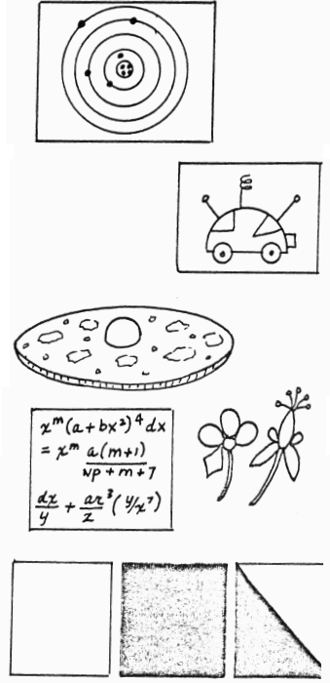
1ST BOY: We visited the planets Mars, Jupiter and Saturn this weekend. (He holds up poster showing solar system and points out these planets)
2ND BOY: I’ve completed by space scooter. Here’s a picture of it. (Holds up picture of space scooter)
3RD BOY: I’ve completed my cooking project. I made a flying saucer pizza for today’s refreshments. I brought the recipe in case you’d like it. (He hands recipe card to den leader and shows his pizza which is a large, round cardboard cut-out with half a Styrofoam ball glued in center)
4TH BOY: I’ve grown a chemical garden. I’ve brought some of my flowers to show you. (Holds up poster board with chemical formula on it, then shows some large crepe paper flowers in wild colors)
5TH BOY: I finished my photography project. I took three pictures of the moon in different lighting. Want to see? (Holds up blank white poster, then black poster, then poster which is half black and half white)
DEN LEADER: It looks like you boys have really been working hard this past week. Here are your progress beads. (Hands each a croquet ball)
ALL BOYS: On Jupiter, Mars, and all the rest .. we’re the best, we’re the best! Yeah Den 2100! Yeah, Den 2100!
(Boys all wave goodbye to leader and exit)

Voyage Into Space
CHARACTERS: Navigator, Four space travelers, Stranger, Announcer
As props for skit, use space helmets and spaceship control panel. Set up the panel, along with other paraphernalia to represent the inside of a spaceship. The travelers wear sweat shirt and pants tucked Inside boots or dark stockings. Space helmets are arranged on the floor and there are jackets or coats in readiness.
ANNOUNCER: Tonight, through the use of a special crystal ball, we bring you a report of a great future moment In history. The first manned voyage to Mars. Inside the historic ship, departure time has come.. (Curtain opens on interior of space ship. Offstage, countdown is heard... then a mighty swoosh. Travelers fall down.. . gradually revive and get up)
1 Well, at last we’re off !
*2 Think of It! The first manned voyage to Mars!
NAVIGATOR: (going to control panel) I guess it’s all up to me, now.
ANNOUNCER: (after long pause) Time passes. . .the ship prepares to land.
*4 Millions of miles from home! (*2 looks out window)
NAVIGATOR: How’s that for navigation! Way ahead of schedule, too.
*1 (speaking to *2) What do you see out there?
*2 Looks like barren country, all right, Where’s the map of Mars? There’ s something over there that looks like canals.
*3 Come on. Let’s get on our helmets and spacesuits. It’s day now and the temperature is probably 200 degrees. (They don space helmets and jackets and start out door. *4 call back to others)
*4 Look at that creature out there I It’s jumping way into the air!
NAVIGATOR: That’s because there is no gravity here. We’ve always been told that creatures like that couldn’t exist on Mars.
ANNOUNCER: (after they ex it and long pause) Time passes. . .the men return.
#1 (as they enter spaceship) Whew! It sure was hot out there!
*2 Those weighted boots worked well. It was easy to walk on the ground
*3 If you ask me, those designers over did it. I could hardly lift my feet.
*4 Me too. They weighed a ton. Let’ s rest awhile before we go out again. (There is a knock. All look puzzled) What. .was.. .that?
NAVIGATOR: Well, it can’t be the wind. There’s no atmosphere here. (He cautiously open the door. Stranger enters, dressed in rough clothing cap and jacket... . speaks with heavy cockney accent)
STRANGER: I say there.. . you blokes in trouble?
*1 How can you stand it out there without a space suit or helmet?
#2 (to *3) He must be a superior being from another planet.
*4 Heavens, man. What are you doing on Mars?
STRANGER: I say, the ‘eat must-ye made ye balmy, guv’nor. This ‘ere ain’t Mars. Hit’s the central plains of Australia. Didn’t ye see that bloomin kangaroo jumpin’ ‘round out there? (Travelers faint from shock)
CURTAIN

The Super Scientific Space Study
CHARACTERS: Two Astronauts, COUNTDOWN and BLASTOFF: 2 LITTLE GREEN MEN:
SPACE CAT and SPACE MOUSE
COSTUMES: Astronauts may wear space helmets made from cardboard or ice cream cartons. Little green men may wear crepe paper tunics with green face make-up. Space Cat and Space Mouse wear signs or sack masks.
PROPS: Backdrop of space ship. Large poster of apiece of green Swiss cheese. Large green mass for Space Mouse to carry
(As scene open, Countdown and Blastoff have Just stepped from their space ship)
COUNTDOWN: Well, Blastoff. here we are! On the Moon, at last!
BLASTOFF: Right, Countdown. We finally made it! Now let’s get on with our experiments. You pick up some Moon rocks and I'll Start Off our Super Scientific Space Study. (Blastoff starts off in one direction, Countdown in the other)
(From behind a large cardboard cutout of a Moon Rock, Step two boys dressed as Little Green Men. They speak only by saying Beep Beep, Beep very rapidly.)
1ST GREEN MAN: (to other) Beep Beep Beep Beep (points and shakes finger at Blastoff)
2ND GREEN MAN: (pointing to Countdown) Beep Beep Beep Beep (gestures wildly) (Countdown and Blastoff see the green men at the same time)
COUNTDOWN: Do you see what I see, Blastoff?
BLASTOFF: I certainly do. Let’ a try to talk to them. Maybe they can help us find our Super Scientific Space Data. (they walk over to green men)
GREEN MEN: (together) Beep Beep Beep Beep
BLASTOFF: I don’t think they understand at all. Say, I've heard that one picture is worth a thousand words. Let’ s try that ! (From behind space ship he takes a poster, now showing it to audience, but revealing it to green men. At once they smile and nod.
1ST GREEN MAN: Here Kitty Kitty Kitty. (From stage left the boy dressed as Space Mouse runs across stage holding large green mass. He is chased by Space Cat. They exit)
COUNTDOWN: Well, I guess that settles it. Now we can tell Earth that the moon really is made of Green Cheese. (Blastoff smiles — turns poster around to show large picture of cheese to audience. Astronauts shake hands with green men, smiling and exit)

No Rocket Scientist
Setting: Rocket pilot in cockpit on one side of stage. Ground control with computer on other side.
Rocket Pilot: Mayday! Mayday! Engine on fire. Mayday!
Ground control: We read you. Hang in there. We're going to try and lock in on you with our computer.
Rocket Pilot: Well, hurry up! I can't hold on much longer. I'm surrounded by flames.
Ground Control: O.K. This is critical. Before you eject -- state your height and position.
Rocket Pilot: Oh, I'm about 5 foot 6, and I'm sitting down. Bye! (Pretends to push eject button and jumps out of cockpit.)

Run-ons/jokes
As Darth Vader and Luke Skywalker cross lightsabers in yet another battle,
Darth Vader says, "I know what you're getting for your birthday."
"No!" Luke says. "That's impossible! How could you know that?"
"I felt your presents."

Why does E.T. have big eyes?
Why?
You would too if you saw his phone bill!

What did Obi-Wan Kenobi say to Luck Skywalker at dinner?
What?
Use the fork, Luke.

What is an astronaut's favorite key on a computer keyboard?
What?
The space key.

I'm going to cross the galaxy with a toad.
Better not!
Why not?
Don't you know what you'll get?
What?
Star Warts!

If there are 26 letters in the alphabet and you count only 24, where did the
other two go?
I don't know, where?
E.T. phoned home.

Applauses
MAN IN THE MOON APPLAUSE: Circle face with hands and say, “I eat green cheese!”.

APOLLO APPLAUSE: Count down, 10, 9, 8, 7, 6, 5, 4, 3, 2, 1... Blast Off!” With hand, gain orbit and say, “Beep, Beep, Beep”.

LIGHTS IN THE SKY YELL: “Twinkle, Twinkle”.

UFO APPLAUSE: Hold index finger to forehead and shout, “Take me to your Leader”.

ROBOT APPLAUSE: Walk stiff—legged and stiff—armed saying, Does Not Compute, Does Not Compute”.

Sky Rocket Applause: Make a motion of striking a match on your pants, lean over to light your rocket. Make a “SH, SH” SH” sound, point from the floor to the sky as if you were following it in flight with your finger. Clap hands and say, “BOOM” spread arms wide and say “ahhhhh” Flutter fingers to represent falling debris. Then place right hand over eyes and peer out, exclaiming, “Isn’t it lovely?”

SATELLITE: Put your right hand over your head, making a circular motion with the right hand, opining and closing the right fist, while saying, “Gleep, gleep”

Games
Rockets And Interceptors
Materials: 1 Bucket or large tin, Large number of colored balls or plastic clothes pegs all the same color, Skittles or rope to mark off the target area
This is played by two teams. The attacking team are called the rockets and the defending team are called the interceptors. The target area is marked off and the bucket or large tin is placed in the center. Only rockets are allowed to go inside the target area. Up to four interceptors are allowed to hover around the target area. The rockets have a base at which they pick up their warheads. Each rocket can carry only one warhead to the target area. If a rocket is tagged by an interceptor before going inside the target area, they must hand over their warhead and return to their base. 20 warhead units in the bucket or tin destroy the interceptor target area. All the colored balls count for 1 warhead unit. The five white balls are special multi warheads and count as 5 warhead units for each white ball. If the interceptor target area is not destroyed after 20 minutes then change over the teams so that everyone has a turn at attacking and defending. This game is best played where there is a bit of cover for hiding and creeping up on the target, or at night when visibility is reduced.

Round the Moon
Active, indoors/outdoors
Equipment: 1 chair per Den.
Formation: relay.

All the Dens line up at the end of the room. Each Cub places his hands on the waist of the Cub in front so the Sixes form a 'rocket'.
One chair is placed at the far end of the room opposite each Den, these are the 'moons'. When the leader calls 'Go', the Dens run the length of the room, round their 'moon' and back into orbit. As they pass base, the 'rockets' drop a section each time and the Cubs sit down there one by one, until finally the 'nose cone' returns home. The first team to be sitting down is the winner.

Rocket Relay
Active, outdoors/indoors.
Equipment: 1 chair per Den.
Formation: Relay.

The Dens line up with a chair at the head of each, facing away from the Den. The chairs are 'launching pads' and the first Cub or 'rocket' stands on the chair awaiting the countdown.
When the leader reaches zero, the 'rocket' blasts off round the room, touching all four walls, and returns to the 'launching pad' where the next 'rocket is waiting to be launched. The first 'rocket' lets off the second and returns to his Den.

Cloud Watching
Have the cubs lie back on a lawn and stare at the passing clouds. Identify as many shapes as you can. See who can identify the most cloud shapes.

Starship Captain
All the cubs sit in a circle but one who leaves the room. The remaining cubs choose their Starship Captain. The other cub returns to the room and stands in the middle of the circle. The Captain initiates a series of movements such as claps, stomps, facial expressions, and so forth. Everyone copies the Captain without giving away who it is they are copying. The person in the middle tries to figure out who is the Starship Captain. He gets three tries and then the cubs switch places while someone else goes out and a new Captain is chosen.

The Borg
Set up a rectangular area of space. The cubs line up at one end of the rectangle. The Borg stands in the middle and cries out “I am Borg. Resistance is futile”. The Cubs try to run or sneak across to the other side of the rectangle. If the cubs get tagged, they become part of the Borg Collective and must create a chain to the original Borg and keep their feet planted and try to catch more cubs. The last cub to get tagged becomes the main Borg and the play starts over.

Robot Arm
You're the operator of the space shuttle's robot arm. The arm will do everything you tell it, but it can't see or think for itself. Your job, pick up the three space disks and return them to your position. Use voice commands like 'forward, left, right, and down' to direct the robot arm. Keep the tether rope tight to prevent the robot arm from overshooting the targets. This is a timed event.

Space Construction
Your team of construction mechanics are on the moon. You need to build the tallest radio tower you can, using the standard space-blocks. The structure must be free-standing and self-supporting. DO NOT DAMAGE THE BUILDING MATERIALS while constructing your tower!

Space Exploration
Space explorers need to be highly trained observers. In this training exercise, you need to scour the marked-off section of rough terrain, and discover the interesting samples. There will be bonus points for discovering samples whose color is different from your assigned color.

Zero gravity
Select one cub to be the earthbound mortal who cannot fly into space. Other Cubs, with their magic zero gravity shoes, are safe as long as they can balance on a stone, hang from a tree, hug a lighthouse - anything to stay off the ground. The earthbound 'It' may guard closely any Cub who is losing his grip and is soon to fall back to earth. Anyone tagged while on the ground loses his magic shoes and becomes 'It'.

Space Ships
Type: Pack Game
Equipment: Chalk

Mark out a large area as shown below. The Nose-cone is out of bounds, and anyone who touches it is eliminated, as is anyone who steps outside the space ship. The leader shouts out a section of the space ship. Players must get there as fast as possible, the last few being eliminated. Other special commands can be 'Emergency' when players sit down with heads between knees;
'Prepare for Take-off;' when players lie face downwards facing the nose-cone;
'Prepare for landing'; when they lie down facing the stern.
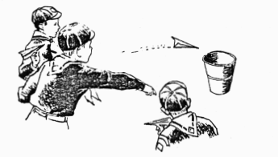
Airplane Toss
Each Cub Scout folds his own paper airplane from a sheet of paper. Let the boys have a few minutes to fly their planes to get used to their own. Then have contests, such as: Greatest distance flight, most accurate flight to airport (box) , flight through hoops the greatest distance, staying airborne the longest, etc.

Blast Off
Cub Scouts sit in chairs scattered around the room. Each is given the name of a planet - Venus, Saturn, Mars, Earth, etc. One boy is selected to be Mission Control. He stands and says:
“Countdown .. 10, 9, 8, etc.” as he walks around the room. Then he calls out the names of various planets. When a boy hears the name of his planet he gets up and walks behind Mission Control. When most of the boys are out of their seats, Mission Control shouts:
“Blast Off”. At this time, all boys -those seated and those following Mission Control must find new seats. The last Cub Scout to find a seat is the new Mission Control.

Walk On The Moon
‘Astronauts’ line up behind a starting line about 15 feet away from a turning line. Each boy has two pieces of shirt cardboard (or other cardboard) . On signal , each boy places his cardboard pieces on the floor, one in front of the other, and puts one foot on each. To move toward the ‘moon’, he picks up the rear cardboard, moves it in front of the other piece and then steps forward. In this way, players continue to move until one - the winner has reached the moon (turning line) and returned to earth (starting line). This race can be performed by teams or individuals. Astronauts can wear space helmets for effect.
Astronaut Training
This is a good physical fitness relay. Two beanbags, two jump ropes and two rubber balls are needed. Divide the players into two teams. They stand behind starting line. At a turning line 15 feet away are a jump rope, bean bag and ball. On signal, first player runs to turning line, takes jump rope, jumps 10 times, tosses bean bag in air 10 times and bounces ball on floor 10 times. He runs back to his team, touches next player who repeats the action. First team to finish is the winner.

Moon Rocks
This is a good den game. Each boy is given 10 dried beans or small pebbles and is told to ask other players questions about space or astronauts. Any player who answers with a ‘yes’ or ‘no’ must pay the questioner with a pebble. The game continues 5 minutes as boys try to win ‘moon rocks’ from each other. Boy with most pebbles at end of game is winner.

Songs
World Of Tomorrow
(Tune: My Bonnie Lies Over the Ocean)

Last night as I lay on my pillow,
And drifted off slowly to sleep,
I thought of the world of tomorrow
These thoughts through my mind did creep.

A computer will do all my homework,
A robot will do all the chores,
If I spend the whole day just playing,
I fear that I may become bored.

Chorus
Bring back, bring back,
O bring back the old days to me, to me.
Bring back, bring back,
O bring back the old days to me.

My jet powered bike will be speedy,
I’ll fly in my spaceship to Mars,
But what if I get lost in space,
And can’t find my way through the stars?
(Chorus)

My parents will have their own rocket,
We'll travel through space very quick,
I’m not sure I’ll like that fast travel,
I may even get space sick.
(Chorus)

Our family might move to Venus,
I don’t know what we would find there,
I ‘d sure miss my friends back on Earth,
There’re the best friends I’ll find anywhere.
(Chorus)

Dehydrated food for breakfast,
Dehydrated food for lunch,
Oh what I would give for a Big Mac
And potato chips that I can crunch.
(Chorus)

There Was An Astronaut
(Tune: Bill Grogan’s Goat)

There was an astronaut they say,
Was oh so brave, blasting off one day.
His wife said: “This lunch please take”
But the brave astronaut, his head did shake.
"I cannot take any extra gear, I’ll not get hungry, don’t you fear.” With these last words, he smiled and waved,
With many unknowns yet to be braved.

His wife she worried both day and night,
To think he’d starve on his first flight.
But this brave astronaut, so smart,
Knew something important from the start.
Upon the moon, where he did land,
He enjoyed a lunch that was so grand.
And he felt smart and very pleased
When he remembered the moon’s green cheese.

In The Future Summertime
(Tune: In the Good Old Summertime)

In the future summertime,
In the future summertime,
Blasting off for summer camp
On Mars will be so fine.
Hot dog pills and instant meals
Before us when we dine.
The food’s all dehydrated
In the future summertime.

In the future summertime,
In the future summertime,
Our Cubmaster’s an android,
His brain’s electrified,
His uniform is spiffy,
It’s one big neon sign.
When R2 leads our pack meeting
In the future summertime.

In the future summertime,
In the future summertime,
Hiking the canals of Mars
Through the manmade pines
We’ll cover one mile with each step.
It’s hard to keep in line,
When there is no gravity
In the future summertime.

Millions Of Stars
(Tune: 99 Bottles of Beer)

There are millions and millions of stars in the sky
There are billions of stars in the sky
One goes dim and then goes out
There are still billions of stars in the sky

There are nine planets going around our Sun
There are nine planets going around
Some have rings and others have moons
There are nine planets going around our Sun

The Galaxy has lots of meteors going around
Lots of meteors going around
Once in a while they visit the Earth
The Galaxy has lots of meteors going around.

The constellations are pretty at night
Very pretty indeed
Leo, Orion, Big Dipper and Bootes
The Constellations are pretty at night.

I would like to go flying in space
It looks like a very nice place
Once around then homeward bound
I would like to go flying in space.

All Around The Enterprise
(Tune: Pop! Goes the Weasel)

All around the Enterprise
The Captain and his crew
Check things out on different worlds
Beam me down, Scotty!

While warping around the Galaxy
The crew meets many life forms
Some are friendly, some are not
Beam me up, Scotty!

Life On Other Planets
(Tune: On Top of Old Smokey)

I visited Pluto,
My fortune to seek,
While there my spaceship,
Started to leak.

It dripped on past Jupiter,
To Venus and Mars,
But when I reached Saturn,
I had to trade cars.

While stopping on Mercury,
I found no one there
So I put it in high gear,
And headed nowhere.

The Daring Spaceman
(Tune: When Johnny Comes Marching Home)

I am a daring astronaut, hurrah, hurrah.
I’m getting ready to blast off, hurrah, hurrah,
The rocket takes me high in space, My capsule is a most comfortable place, To a space adventure, I am on my way.

I’m orbiting now around the moon, hurrah, hurrah,
I think I’ll land there very soon, hurrah hurrah,
I pitch and yaw and roll through space,
I ‘ye not seen these sights any other place.
I’m a daring spaceman. Won’t you come with me?

Let’s fly to other planets now, hurrah, hurrah,
Come fly with me, I’ll show you how, hurrah, hurrah,
We’ll stop at Mercury, Venus, Mars, At Neptune we’ll take a good look at
the stars,
What a lovely sight .. the wonderful world of space.

Crafts
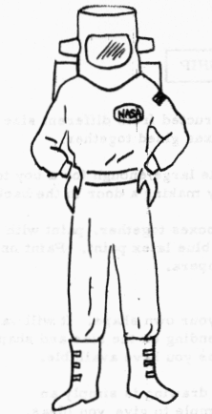
Astronaut (Costume For Skits)
The basic costume can be a pair of coveralls dyed electric blue, silver, or other bright color. Or, you can use a sweat shirt and sweat pants combination, or even old ski-type pajamas dyed or spray painted.
Helmet Can be made from ice cream carton -
(See illustration below) Or use an old football helmet, paint, and add a plastic visor.
Boots Use ski boots or galoshes wrapped in foil.
Gloves Spray paint old work gloves silver.
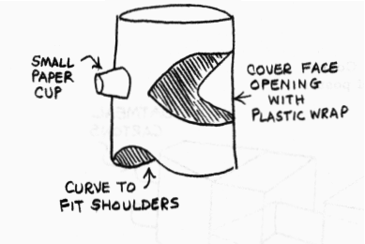
Run insulating wires of various colors down outside of arms and legs. The life support system can be a box mounted on a hiking pack frame and decorated with old radio parts and painted dials.
NASA emblem and American flag patch can be glued to costume.

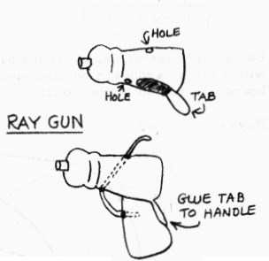
Ray Gun
Use two oval-shaped plastic detergent bottles - one for the barrel and one for the handle. On the narrow side of the ‘barrel’ bottle, cut a narrow oval tab near bottom, as shown. Insert neck of ‘handle’ bottle into opening and glue tab to side of handle. For trigger, cut a flexible strip of plastic and insert through holes (as shown) with one end sticking out of top of gun and other end bending back into handle. Paint as desired.
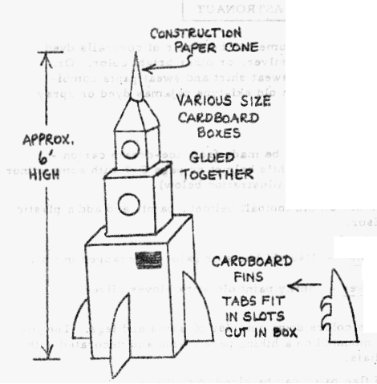
ROCKET SHIP
This is constructed from different size cardboard boxes glued together..
It can be made large enough for a boy to get inside, by making a door in the back.
After gluing boxes together, paint with gray or light blue latex paint. Paint on trim with tempera.
Design your own shape. It will vary depending on the size and shape boxes you have available.
The drawing is simply an example to give you ideas.

Moon Rover
Use an old coaster wagon for the base. Cover with a large cardboard box and pieces of poster board curved and shaped to fit.
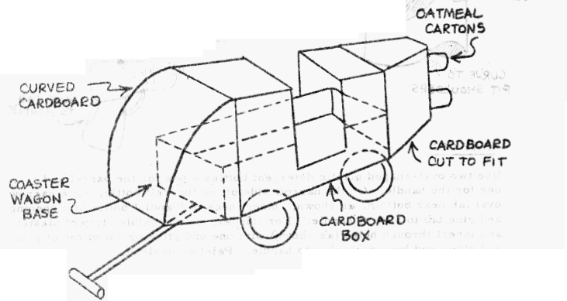
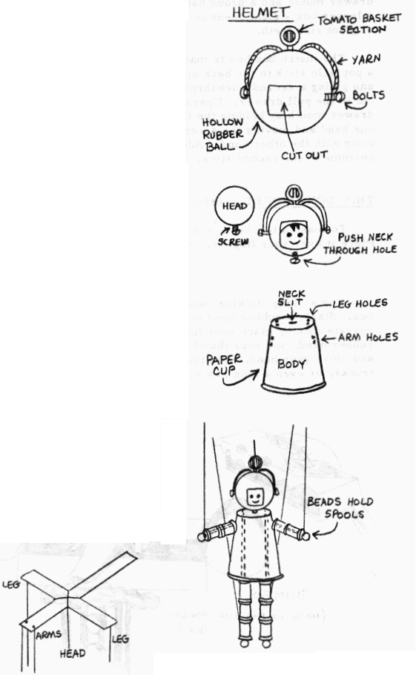
Astronaut String Puppet
With his protective headgear and space suit, this astronaut is ready for any faraway planet!
HEAD- To make helmet, cut large front opening in a hollow rubber ball (about 2 1/2" diameter). Attach short nuts and bolts at side of helmet, and tomato basket section at top. Tie yarn ‘tubing’ to bolts and insert into holes punched near top of helmet.
Select a solid rubber ball (about 1” diameter) that will fit through helmet opening. This will be the head. Paint flesh color and add features. Insert a long screw into bottom of head for neck. Put head in helmet, pushing screw through a small hole cut in bottom of helmet.
BODY - Remove handle from a hot-drink cup. Paint as desired. Punch two pairs of holes on opposite sides for attaching arms. In bottom of cup (which is top of space suit) punch two pairs of holes for attaching legs and cut a small slit at center for inserting neck, as shown.
Paint ten spools in desired color for arms and legs - three for each leg, two for each arm. To assemble, pass string through holes in spools, then through large beads (for hands and feet), then back through spools. Put ends of string through holes in body and tie firmly.
To attach head to body, carefully insert head of screw through slit in top of suit, taping on outside, if necessary, to hold firmly. Punch two holes in top of helmet and attach a string; also tie strings to hands and knee joints. Tie free ends of strings to a cross of stiff cardboard or wood. This cross is held by the puppeteer to manipulate the puppet.

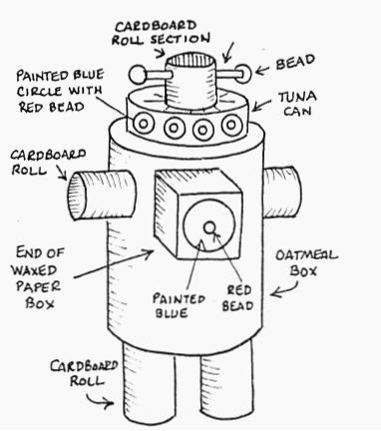
Odds ‘N Ends Robot
1. Remove lid from tuna can. Glue open side down to top of oatmeal box.
2. Cut a cardboard bathroom tissue roll into 3 equal parts. Reserve two for arms. In third, punch a hole through the center. Glue this piece to top of tuna can. Push a straw through holes and glue beads on ends of straw.
3. Glue other two sections of cardboard roll to sides of oatmeal box for arms.
4. Use two more cardboard tissue rolls for legs. Glue to bottom of oatmeal box, in position so that robot will stand.
5. Cut off one end of a waxed paper or aluminum foil box. Glue this to center of oatmeal carton.
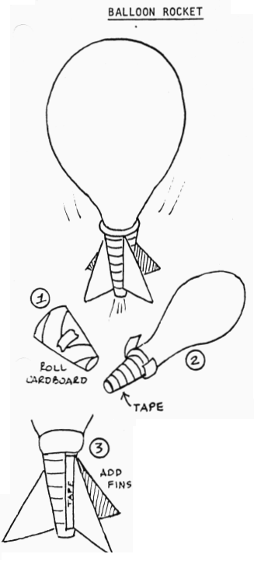
- Spray paint robot silver. When dry, paint blue circles on tuna can and robot’s front. Then glue red beads in center of blue circles.

Balloon Rocket
1. Roll a 4” x 5” piece of stiff paper into a shape like an ice cream cone. Use tape to hold in place. This is the rocket engine. Cut larger end to fit tightly inside balloon neck.
2. Tape balloon and engine together. Wrap tape around engine to close up air leaks.
3. Blow up balloon. Let it go straight up. Trim off the top of the engine a little at a time until the balloon rises straight and steady.
- Tape paper fins in place to help the balloon fly steady.

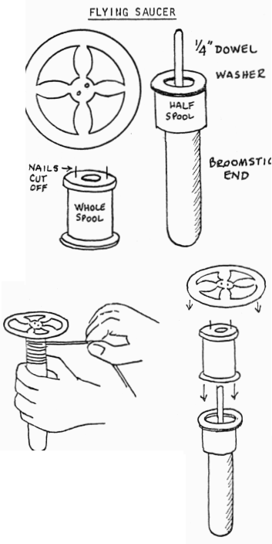
Directions for Flying Saucer
1. Cut off bottom of bleach bottle or use heavy plastic lid for saucer. It should be approx. 6” dia., with outside rim 3/8” wide. Blades are 1 1/2" at wide point, 1/2” where they join center. Center is 1” dia. Drill center holes for nails.
2. Drive 2 nails in whole spool. Clip of nail ends.
3. Saw other spool in half. Insert dowel. Glue dowel in half spool and half spool to cut-off broom handle. Slip washer over dowel.
4. Wrap about 1 ft. of cord around spool as shown, and tug cord toward you. The flying saucer will take off in a whirl.
Space Sculptures
Start each boy with a block of wood (about 4” x 4”) which has a nail in the center. Provide other materials such as tacks, nails, screws of various types, cardboard, etc.
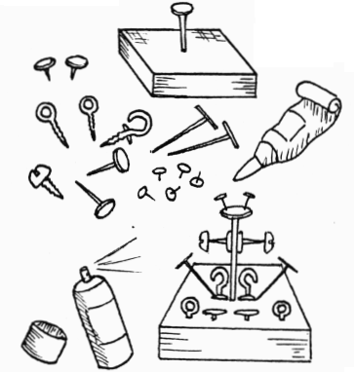
Create space models - figures, buildings, appliances, or anything else the imagination inspires.
Sculptures can be sprayed silver or gold. You may even wish to add some glitter.
This could be a pack competitive event - similar to the Genius Kit -with each boy being provided the same materials in a sack and judged on his creation.

Moon Station Or Space City
The den could make a moon station or space city for display at pack meeting.
Start with a wood, cardboard or plaster base. Make buildings from match boxes, wood cubes or other materials.
Your space city could have a solar energy collector for power, housing, rocket ports, etc. You could add a large plastic or glass dome (such as a round bowl turned upside down) to control the air circulation.
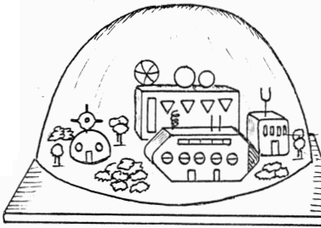

String- a-Constellation
Using various sizes of nails or tacks and some string, you can make an attractive display board of the major constellations.
Paint corrugated cardboard for a backing. Insert the tacks in position for stars and run string from one to the other, outlining each constellation. Paint the heads of the tacks silver for smaller stars; cover heads with gummed stars for larger ones.
Another idea is to have each member of your den string the constellation that is his birth sign. Then, he may paint the figure of his sign around the stars.
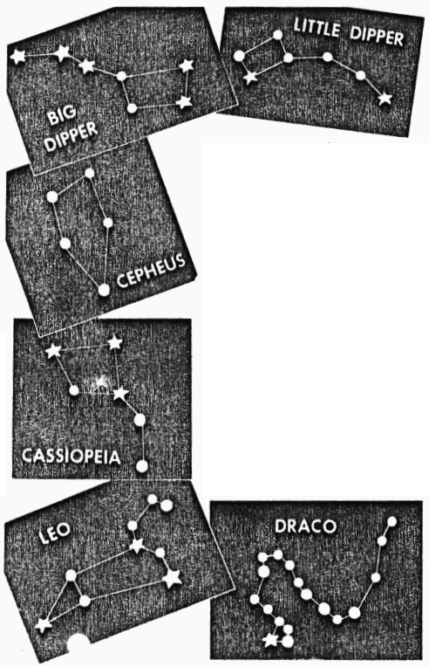
Moon Buggy
Provide each boy with a ‘Big Mac’ carton (empty) and an assortment of materials such as pipe cleaners, golf tees, buttons, screws, wire, cardboard, paint, etc.
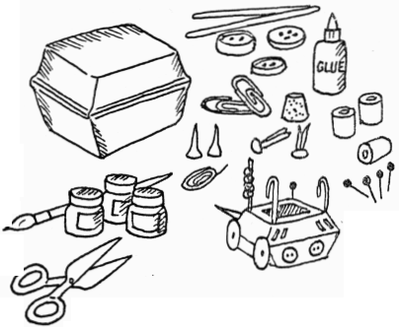
Let each boy custom-design his own Moon Buggy or Mars Rover. They will have a lot of fun using their imaginations in creating this world of tomorrow vehicle.

Oatmeal Box Planetarium
Remove the lid and bottom from a large oatmeal box, forming a large tube. Cut a circle from the lid of the box so that a 1/2” to 3/4” rim remains. This will form a frame for your constellation displays. From dark paper, cut circles that will fit inside the rim. With a sharp round instrument, perforate holes in the circle that correspond to the pattern of the stars of the constellation which you wish to display. Try to avoid ragged edges.
To use the planetarium, beam a flashlight into the box at an angle, so that it will reflect from the sides and shine through the holes in your circles. You may reflect your patterns onto a wall in a darkened room, or into a cardboard carton. If you use a carton, paint the interior of it a dark color so that the “stars” will show up distinctly.
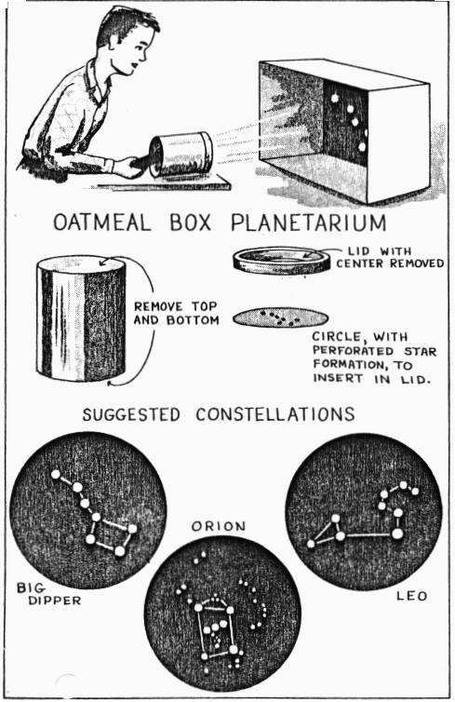

Cubs in the Kitchen
Alien Meltdown
Snip one marshmallow into a triangular head and another into a torso with arms. Insert mini chocolate chip eyes. then assemble the Alien on a cookie for his “flying saucer”. Place him in the microwave for about ten seconds on high and you’ve got alien meltdown!! Cool, eat and enjoy.

Fried Saturn Rings
Tart Apples Butter/Margarine Brown sugar
Core the apples, peel only if the skin is tough. Slice into 1/2 inch thick rings. Sauté in butter until barely tender. Turn over and cook until tender. Sprinkle brown sugar and cover until sugar melts.

Asteroids
1 Cub sugar
1/4 cup margarine
1/4 cup milk
1 1/2 cups quick oatmeal
1/4 cup chopped nuts
2 1/2 tablespoons creamy peanut butter
1/2 teaspoon vanilla
Combine sugar, margarine and milk in sauce pan, boil 1 minute. Pour hot mixture over oatmeal and peanut butter. add nuts and vanilla. Mix, drop by teaspoon onto wax paper. Let cool until firm.

Fast Space Age Soup
1 can (14.5oz) chopped tomatoes
3 cans (14.5) chicken broth
1/3 cup alphabet noodles
1/2 cup quick cooking pearl barley
8 oz frozen baby carrots
1 pkg(10 oz) frozen corn
1 pkg (10 oz)frozen cut green beans
1 tsp dry oregano
1/4 tsp pepper.
Mix tomatoes, chicken broth, noodles and barley in a pan. Bring to a boil over high heat stirring occasionally. Slice the carrots and add with corn and green beans. Season with oregano and pepper. Reduce heat and simmer for 10 minutes or until the barley is cooked.

Outta This World Fruit Salad (makes enough for company)
1 can peaches
1 can fruit cocktail
1 can mandarin oranges
1 can pineapple tidbits
1 pint sour cream
2 cups marshmallows
2 cups coconut

Mix together and let sit overnight in refrigerator. Very good.

Field Trips
Lawrence Livermore National Laboratory
Visitors Center: Grenville Road between East Ave and Highway 580, Livermore. (510) 422-9797. Mon - Fri 9-4:30, weekends 12-5. Closed holidays. Answers to computers, Star Wars & other science questions. Hands-on exhibits, displays, films, audio tapes and a multimedia show. Also learn about lasers, fusion energy, biomedical and environmental research, energy and resources.

Chabot Obervatory and Planetarium
4917 Mountain boulevard, near MacArthur Freeway and Warren boulevard, Oakland. (510) 531-4560. Fri and Sat 7:30 p.m. Adults $1.50, children $.50. Reservations advised. The Chabot Science Center is open irregularly 6 or 7 days a week, so call ahead. Science demonstrations, planetarium program, and observation of the heavens through a large telescope. Also learn how astronomers explore the universe. Locate the Big & Little Dippers during the planetarium show.

Lawrence Hall of Science
Centennial Drive, University of California, Berkeley. (510) 642-5132. Mon-Saturday 10-4:30. Sunday noon-5. Adults $3.50; students, seniors, and children $2.50. Variety exhibits, science workshops, test of knowledge, computers to play with. Hold Planetarium shows, the Science Discovery Theater, films, and special events. The replica of the Challenger shuttle craft on the grounds is also a challenge to explorers.

The Exploratorium
Palace of Fine Arts, Lyon Street. (415) 563-7337. Winter: Wed-Fri 1-5, weekends 10-5, Wed 7-9:30 p.m. Summer Wed 11-9:30, Thu & Fri 11-5. Sat & Sun 10-5. Closed Thanksgiving and Christmas. Adults $5.50 (good for 6 months) Seniors $2.25(lifetime) ages 6-17 $1 (6 month pass).
Hands on science.

Children’s Discovery Museum
180 Woz Way San Jose 95110. (408) 298-5437. Website www.cdm.org Tues-Sat. 10-5, Sun 12-5. Adults $6, ages 2-28 $4. Parking $2. Theater specials, story telling and programs. Spectacular hands-on exhibits and games capture the imagination of children instantly. Cameras, still and video are welcome. the museum, can be reached by the lightrail. Get off at the Technology Center stop.

Mionolta Planetarium
De Anza College, 211250 Stevens Creek Boulevard and Stelling Road, Cupertino. (408) 996-4814. Call for times and prices since they change with each class section. Them main projector spreads the night sky across a 50-foot dome, and 24 sound speakers and 150 other projectors produce dazzling effects: you can fly to the moon to look at the brilliance of the stars as they were seen by the astronauts, then travel back in time to see how the stars looked when humans first saw them .

Foothill Electronics Museum
Foothill College. El Monte Road at I-280, Los Altos Hills. Free. Extensive display of early electrical and electronic devices in the west. Young scientists will be intrigued by exhibits of the first radio broadcasting station, the first Silicon Valley electronics firm, the first TV picture tube, a ten foot robot and hands-on demonstrations of electricity and magnetism.

