Save It For Us

April 2001

CONTENTS

THEME RELATED 1
DEN AND PACK ACTIVITIES 1
“WE SAVED IT” PARTY 1
PUBLIC AWARENESS PROMOTION 1
FIELD TRIP IDEAS 1
PARTICIPATION AWARDS 1
CONSERVATION SERVICE PROJECTS 2
CLEANUP AND LITTER CONTROL 2
RECYCLING 2
PLANTING AND PLANT CARE 2
ANIMAL CARE 3
SKIT BOX 3
ONLINE RESOURCES 3
PREOPENING 4
RECYCLE SCRAMBLER 4
RECYCLING QUIZ 4
FAMILY PLEDGE TREE 4
CEREMONIES 5
SAVE IT FOR US OPENING 5
CONSERVE OPENING 5
“NATURE IS GOD’S HANDIWORK”
OPENING 5
THIS IS AMERICA 6
KEEP OUR LAND BEAUTIFUL OPENING 6
“I WILL USE” CLOSING 6
GOD’S HANDIWORK CLOSING 7
BE CAREFUL--CLOSING 7
“MAKE A DIFFERENCE”--CUBMASTER’S
MINUTE 7
“WHAT SHALL WE GIVE OUR CHILDREN?” 8
“GROW AND FLOURISH” ADVANCEMENT 8
TREE ADVANCEMENT 8
RECYCLE, RECYCLE, RECYCLE 9
FUN WAYS TO SAY THANK YOU 9
YOU CAN HELP CONSERVE ENERGY AND
PROTECT THE ENVIRONMENT 9
AUDIENCE PARTICIPATION 10
A LESSON FOR THE BIG BUGS 10
SKITS 11
SUPER SCOUTS TO THE RESCUE! 11
KEEP AMERICA BEAUTIFUL 12
GAMES 13
NATURE AND CONSERVATION TRAIL 13
ENERGY WASTER’S HUNT 14
BAG PLAY 14
NEWSPAPER SOFTBALL 14
ORANGE JUICE LID FLIP AND MATCH 14
SODA BOTTLE BOWLING 14
“OOPS” A GAME WITH SUPER SCOOPS 15
TRASH BAG RACE 15
RECYCLED LID FRISBEE TOSS 15
PAPER CLIP PICK UP 15
SONGS 16
POINT WITH PRIDE 16
THE WORLD AROUND US 16
PICK IT UP 16
TRASH CAN SONG 16
PICK UP THAT TRASH 16
PICK UP LITTER 16
CLEAN THE WORLD 17
RECYCLING 17
RECYCLE IS THE THING TO DO 17
RECYCLE SONG 17
CRAFTS 18
GENIUS KITS WITH RECYCLED ITEMS 18
HANDY BACKPACK 18
PICNIC UTENSIL CADDY 19
PICNIC CATCH-ALL 19
BAG SAVER 19
COOKIE CUTTER BIRD TREATS 20
TIN CAN PICTURE FRAME 20
TWO MORE PICTURE FRAMES 20
CD CASE FRAME 20
TISSUE BOX FRAME 20
DOORKNOB MESSENGER 21
BOYS’ LIFE FILE BOX 21
EGG CARTON NURSERY 21
PAINT POTS 22
TALKING EARTH PUPPET 22
WASTE BASKET NECKERCHIEF SLIDE 22
SAVE IT FOR US NECKERCHIEF SLIDE 23
GRASS NECKERCHIEF SLIDE 23
RECYCLED BANK FOR YOUR RECYCLING 23
CUBS IN THE KITCHEN 24
SQUIRREL FOOD 24
SNOW ON THE MOUNTAIN 24
CHOCOLATE QUICKSAND 24
RAIN FOREST PUNCH 24

DEN AND PACK ACTIVITIES

“WE SAVED IT” PARTY
Have a small party using mostly recycled or reusable items for plates, cups, napkins, table decorations, and room decorations. How about using clean plastic yogurt cups, butter tubs, and peanut butter jars for plates and cups? Cut napkins out of old fabric, fray edges and decorate with permanent markers. Decorate the table and the room with recycled materials and nature items from the backyard. Play games using recycled materials--make a top from a margarine tub lid and a toothpick or an airplane with recycled paper. Recycle the materials when you are done with them. Make nature crafts with the items from the backyard or make a genius kits (see the “Crafts” section).
Whatever you do, recycle all the material after the party.
Involve the boys when planning the party. They’ll have many great ideas too.

PUBLIC AWARENESS PROMOTION
- Arrange a natural resources awareness program. Invite natural resource professionals such as wildlife biologists, soil conservationists, foresters, or conservation officers to speak to your pack.
- Make Outdoor Code posters to put up in school and explain the Code to others.
- Make anti-litter posters. (Make sure you take them down after a certain period.)
- Make a conservation display for the pack meeting.
- Have a “Fight Litter” parade with boys carrying signs urging the public to “stash the trash” or “don’t be a litter bug.”
- Develop a plan to educate the public about the dangers to wildlife posed by the litter problems.
- Collect all the trash in a selected area and exhibit the trash at the pack. (Discard the trash properly later.)
- As a den or pack, visit a public utility to learn about the wise use of resources, and become involved in programs offered by utilities to help consumers conserve resources.
- Make litterbags for the cars of pack families and neighbors. Distribute litterbags at a cooperating service station or store for those who want them. An example of a litterbag is shown on page 3-31 in Cub Scout Leader How-To Book. Stencil designs on the bag. (Make sure these bags don’t get thrown away and become litter themselves.)

FIELD TRIP IDEAS (For details, see the FIELD TRIPS section)
The Recyclery (BFI), San Jose
Environmental Studies/Area, De Anza College
Baylands Nature Interpretive Center, Palo Alto
Coyote Point Museum for Environmental Education, San Mateo

PARTICIPATION AWARDS (For details, see the PARTICIPATION AWARDS section)
Cub Scout Academics: Citizenship
Cub Scout Academics: Wild Life Conservation
Cub Scout World Conservation Award
Conservation Good Turn

CONSERVATION SERVICE PROJECTS

When choosing a conservation project, consider the following factors:
- WHAT. Following agencies may be able to suggest projects and how to carry them out: Your pack’s chartered organization, city and county park departments, school officials, local offices of the state conservation or fish and wildlife services, soil conservation agencies. Ask at the Council Service Center what your pack can do for the Chesebrough Scout Reservation. Also see Wolf Cub Scout Book, Bear Cub Scout Book and Webelos Scout Book for ideas.
- WHY. Choose a project that’s meaningful for Cub Scouts. It should positively affect the boys as well as the environment. They should understand WHY and HOW the project is important.
- WHO. Involve as many people, adults and children, in the den/pack as you can. Is most of the work within the scope of boys’ abilities? If leaders and parents do most of the work, the boys will learn little and will have too much time for goofing off.
- HOW LONG. Can you complete the project within two hours or so? The attention span of Cub Scout-age boys will not last much longer.

The following are some Good Turn project ideas for dens and packs.

CLEANUP AND LITTER CONTROL
- Clean up trails or campsites at the Chesebrough Scout Reservation. (For information on Chesebrough, see MISCELLANEOUS section.)
- Spring cleanup. Rake the yard, wash windows and screens, wash walls etc. for your chartered organization or church.
- Clean up a neighborhood park, empty lot, school yard, or church yard.
- Adopt a park, creek, or lake and keep it litter-free on a long-term basis.
- Participate in a beach or waterfront cleanup. Record the items collected and determine the possible harmful effects to wildlife.
Notes on litter pick-up: Provide each person with rubber gloves and tell them to use gloved hands to pick up trash. Please remind the boys not to pick up any drug paraphernalia if they encounter it.

RECYCLING
- Organize or participate in a recycling program in your neighborhood.
- Visit a recycling center and learn about recycling.

PLANTING AND PLANT CARE (get permission from the land owner)
- Take part in a community tree-planting program.
- Start a pack tradition by having an annual tree-planting event by Webelos Scouts.
- Plant grasses, trees, shrubs, and ground cover to stop soil erosion.
- Build Brush Piles: With advice from a conservation agency, build brush piles to provide cover for birds and small mammals in a wild area.
- Vacant Lot Beautification: With permission of the owner, clean out trash and weeds from a small lot and plant flowers or shrubs.
- Plant Food Shrubs: With advice from a conservation agency, plant shrubs that produce food and cover for birds and mammals.

ANIMAL CARE
- Build and set out birdhouses, feeding stations or bird baths. See Bear Cub Scout Book and Cub Scout Leader How-To Book for some designs.

SKIT BOX

Build a pack skit box with all kinds of recycled materials. Have a scavenger hunt around the house and use your imagination. An old sheet can be a robe, ghost, wall or; laid on the floor, it can pretend to be snow or a river. Scrap foil pieces can make good buckles, accessories and swords. Old wigs can be lots of fun. And old swimming cap can be a bald head, a mop can be witch’s hair, and paper curls on a knit cap can be a girl. Boys have great imagination. Combine it with those wonderful recycled materials. Have a skit day or costume day.

ONLINE RESOURCES

- Environmental Protection Agency: http://www.epa.gov
- Forest Service Natural Resources and Conservation Education Program:
http://www.fs.fed.us/outdoors/nrce
The Conservation Education Program helps people understand and appreciate our country’s natural resources and how to conserve those resources for future generation.
- National Wildlife Federation Backyard Wildlife Habitat Program: http://www.nwf.org/habitats
Program for people who garden for the benefit of wildlife.
- The Nature Conservancy: http://www.natureconservancy.org
Provides educational resources about threatened ecosystems and species.
- The Natural Resources Conservation Service: http://www.nrcs.usda.gov
A federal agency working with citizens to conserve and sustain natural resources.
- Oregon Zoo: http://www.oregonzoo.org/ScienceResearch/whatyou.htm
101 things you can do for conservation, help save animals their habitats
- Environmental Defense: http://www.earth2kids.org/
Special kids section of the Environmental Defense. Teacher talks and resources

IT DOESN’T TAKE MUCH. EVERY INDIVIDUAL ACTION TO PROTECT AND HEAL THE ENVIRONMENT MAKES A DIFFERENCE.

IT DOESN’T TAKE MUCH. EVERY SMILE TOWARD A CHILD MAKES A DIFFERENCE.

RECYCLE SCRAMBLER

Unscramble the names of products or materials that can be recycled.

SASGL
ERAPP
MUNALIMU
MTAEL
OODF
TPANLS
WTERA

Answers: glass, paper, aluminum, metal, food, plants, water

RECYCLING QUIZ

Which items should be placed in a recycling barrel?

- School newspaper
- Magazines
- Radio batteries
- Grass, leaves, wood
- Light bulb
- Used paper towel
- Photographs or negatives
- Empty can of green beans
- Picture frame glass, mirrors, crystal
- Cereal box without wax/plastic liner
- Milk carton
- Empty mustard jar
- Plastic bottle with ketchup inside
- Juice box
- Plastic bottle with no recycling symbol
- Diapers
- Potato chip bag
- Newspaper
- Dry, empty plastic milk or water jug
- Records or cassettes

Answers: True-1, 2, 8, 9, 10, 11, 12, 14, 18, 19
False-3, 4, 5, 6, 7, 13, 15, 16, 17, 20

FAMILY PLEDGE TREE
(Pack pre-opening activity)

Cut colorful leaves from construction paper. (This can be done by the boys in a den meeting.) Have each member of the Cub Scout’s family write conservation pledges on them. Examples: “I pledge to turn off the lights when I leave the room.” “I pledge to make sure newspapers get recycled.” Display the pledges by taping them to a poster board drawing of a tree trunk. The more pledges, the bigger the tree. Remove leaves and give to family members to take home after the meeting, so they can be reminded of their pledge.

SAVE IT FOR US OPENING

C.S.#1: God created the earth and everything on it. (Holds up picture of the earth)
C.S.#2: We will protect the earth and take good care of it. (Holds up picture of beautiful scenery)
C.S.#3: We won’t litter the roads, fields, streams, or meadows. (Holds up a piece of trash, puts it in a trash bag)
C.S.#4: We will practice conservation and not be wasteful. (Holds up newspapers tied in a stack and ready to recycle)
C.S.#5: We will work together to make our environment more beautiful. (Holds up a potted plant)
C.S.#6: As we give the Pledge of Allegiance, please remember the beauty of our great country, the United States of America. Please stand and join me in the Pledge of Allegiance.

CONSERVE OPENING

Eight Cub Scouts hold cutouts of cars made from poster board and painted in bright colors. As each boy speaks his line, the car is turned over to show the large letter printed on back to spell out the word CONSERVE.

C Cars and buses and such were invented by men.
O Oil fields were discovered also by them.
N Nobody really worried about the amount of fuel this would take.
S So on no transportation did they put the brake.
E Eventually, the amount of fuel used grew astonishingly.
R Raising in everyone’s mind a great big doubt.
V Very soon the world’s traffic was put to the test
E Everybody to conserve fuel must now do their best!

“NATURE IS GOD’S HANDIWORK” OPENING

N N is for naturalist, all of us who love and seek to preserve nature.
A A is for animals, who make their homes in the great wilderness of our world.
T T is for the trails we hike, admiring the earth’s beauty.
U U is for undisturbed; clean air, clean water, and beautiful trees.
R R is for richness. The breathtaking view of snow-capped mountains.
E E is for Earth. This is the only home we have. Only we can preserve it.
All: Nature is God’s handiwork.

CHEERS

RECYCLE CHEER: Shout, “REDUCE, REUSE, RECYCLE!”

ANTI-LITTER CHEER: “Every litter bit hurts!”

THIS IS AMERICA

C.S.#1: A land of mountains, lakes and streams.
A land of prayers and hopes and dreams.

C.S.#2: Mountains high, rivers wide.
Sunsets seen from the ocean side.

C.S.#3: Busy cities, country towns.
Movies stars and circus clowns.

C.S.#4: A shady lane, a babbling brook.
A crowded street, a quiet nook.

C.S.#5: Quarries, pastures, fertile lands.
Forest green and desert sand.

All: America. Let us all strive to save it.

KEEP OUR LAND BEAUTIFUL OPENING

Part of our American heritage is learning how to care for our beautiful land so it will be here for future generations to enjoy. In Cub Scouting, we learn to prevent those things which will destroy our land. As we salute the emblem of America, let’s vow to keep our land beautiful and free.

Please stand and join me in the Pledge of Allegiance.

“I WILL USE” CLOSING

This closing can be done in three ways. A Cub Scout or leader can read the entire narrative. Copies of the ceremony can be handed out to the audience and they can read it in union. Or, have five Cub Scouts each read a line.

This is my country. I will use my eyes to see the beauty of the land.
I will use my ears to hear its sounds.
I will use my mind to think what I can do to make it more beautiful.
I will use my hands to serve it and care for it.
And with all my heart I will honor it.

APPLAUSE

FLOWER APPLAUSE: Like a flower blooming, slowly rise part way out of your chair. Look around, then stand up quickly and yell, “SPROOOONG!”

GOD’S HANDIWORK CLOSING

Props: Posters of scenes in nature for each Cub Scout to hold as he reads.

C.S.#1: We’ve learned a lot about taking care of this wondrous planet of ours.
C.S.#2: We will protect and clean up the air so we all can enjoy the stars.
C.S.#3: We won’t litter our fields and streams or throw our trash on the roads.
C.S.#4: We will enjoy all the sun’s beams and protect the homes of the toads.
C.S.#5: Nature is truly a wondrous thing. God’s handiwork is everywhere--
C.S.#6: In flowers and trees and butterfly wings, in clean water, clean fields and clean air.

BE CAREFUL--CLOSING

Props: Apple; Pocketknife

Cubmaster:
Earth Day comes in April and it reminds us to be careful with our home planet. There is also an old song about “April showers bring May flowers.” Together, these remind me of how precious and valuable water is, and how important it is to use it wisely.

Imagine that this apple is the whole world. Three quarters of the world is covered with water, and only one quarter is covered by land. (Cuts one-fourth section off of apple and places it down on the table)

Out of the three quarters covered in water, only about three percent is fresh water and the rest is salt water, mostly in the oceans. (Cuts off thin sliver from apple, and places larger piece down on the table. Holds the thin sliver up for all to see)

Of this 3% slice, about two thirds of that is generally not available. Most of that is frozen in the North Pole and South Pole, and other hard to reach places. (Cuts off two-thirds of the thin sliver and puts larger piece down)

Only this thin sliver is left. All the fresh water that is available to life on the surface of the land. This is all the fresh water we have. What would happen to us if we ruin this thin sliver by pollution? (Eats thin sliver in one bite)

We would be gone just like that. Be careful with the world. We need to save it for all these young people here tonight.

“MAKE A DIFFERENCE”--CUBMASTER’S MINUTE

We have learned a lot this month about taking care of the environment that we live in. Let us put to use the conservation techniques that we have learned this month. Let us treat the environment responsibly. Take one or two things that you have learned this month and put them into practice in your families. Each of us can make a difference. Do a good turn daily, especially in the area of conservation.

“WHAT SHALL WE GIVE OUR CHILDREN?”

An awareness of:
The open, sheltering sky--
The supportive rich earth--
The giant trees and tiny flowers in all their seasons--
The sun-warmed sands--
The blue, froth-crested waters--
The stars twinkling down--along with the animals, insects, bird songs, rainbows, clouds, sunshine, twilight, sunsets, moonlight and firelight.

“GROW AND FLOURISH” ADVANCEMENT

This month the Cub Scouts have been learning about taking care of planet Earth. If the environment is taken care of properly by us, it will continue to be a beautiful place. It will grow and flourish.

Tonight, we will honor some Cub Scouts, who, being nurtured by their parents and their den leaders, have grown and flourished. These boys have leaned a lot, and in the process, have earned some special awards.

Will these Cub Scouts come forward with their parents? (Name Cub Scouts who have earned awards. Cubmaster announces the rank advancement, presents the awards to the parents, and the parents present the awards to their sons. Awards can be attached to seed packets, or seedlings that will encourage the Cub Scouts to grow and flourish, and take care of the earth.)

TREE ADVANCEMENT

Props: Picture of a giant Redwood tree. Artificial tree with cut-out leaves. Awards are attached to leaves.

Cubmaster: The tallest and biggest trees all began as little seedlings. It takes many years for them to grow from seedlings into giants. Each of you Cub Scouts is like these trees for you are growing into great men. (Take awards off tree, mentioning positive benefits of trees: i.e., strong, sturdy, enduring, etc.)

CHEER

RECYCLE CHEER: Give everyone an empty soda can and have everyone stomp on it and throw into a trash can OR
Use imaginary can with motions.

RECYCLE, RECYCLE, RECYCLE

Suggestions:
Make award cards out of recycled paper or card stock. Print the recycle logo on the award card along with the boy’s name.

Hang all the award cards on a display board divided into “Paper” “Plastic” “Cans” and “Glass.” Place all of the Bobcats, Wolfs, Bears and Webelos under separate headings.

Talk about the need to recycle the items we use and how manufacturers use the products we recycle to make other useful products. When we recycle, we conserve natural resources like trees and water. As each boy and his parents are called up, let him know that he is a resource that can be recycled, in a manner of speaking, because the things he learns as he advances in Scouting will be and should be used over and over in his life.

FUN WAYS TO SAY THANK YOU

Broom: For someone who sweeps all the mistakes away.
Bundle of Newspaper: “Thanks a bundle.”
For the newspaper drive chairman
Crushed Pop Can: “Thanks for having a crush on Scouting.
Glove: For a helping hand.
Two-liter bottle: “You do the work of two leaders!”
Yellow tulip: For someone who don’t hesitate to spring into action.

YOU CAN HELP CONSERVE ENERGY AND PROTECT THE ENVIRONMENT

Fill in the blanks.

- Always turn the TV __________ when you’re finished watching it.
- Use a __________ or washable cloth to clean up messes instead of __________.
- Save all your newspapers, __________, and bottles. Help your parents recycle them.
- Don’t leave the refrigerator door __________. Get what you need quickly and __________ the door.
- Color on __________ sides of your paper.
- Save energy by turning off the __________ when you leave an empty room.
- Pick up garbage you see on the ground and __________ it away in a __________ can.
- Don’t leave the water __________ when you brush your teeth.
- You are __________. You can __________ save the environment.

Words: help cans throw open both paper towels lights
important garbage sponge shut running off

A LESSON FOR THE BIG BUGS

BEES: “Buzz, Buzz”
ANTS: “Hup, Two, Three, Four”
MOSQUITOES: “Bite-e-Bite”
FROG: “Croak, Croak”
WOODS: All sounds together

This is a story about Billy and his family and their adventure in the WOODS. One fine spring day, Billy’s family decided to go for a picnic in the WOODS, where they could enjoy the outdoors. They packed a nice picnic basket and headed out on their walk.

As soon as they got to where they were going, they found a nice place to set up their picnic. Billy and his brother went to the stream where they looked at a FROG. They heard some BEES over by the wild flowers, and watched some ANTS walking on the ground. Being close to the water, they were also being bothered by some MOSQUITOES.

When they went back to the picnic area, they told their parents about the WOODS. How they saw a FROG and how the MOSQUITOES were bothering them. They said that the BEES didn’t bother them and that the ANTS were really hard workers. Dad listened closely as he unwrapped another sandwich and carelessly threw his paper off to the side. Billy’s little sister had just finished a soda and dropped the can by a tree. Mom threw her paper napkin on the ground and jumped up in disgust. “That is it!” she said. “I think the ANTS are taking over the picnic.”

Dad stretched out for a nap and had just dozed off when Billy’s sister started to scream. She had been stung by a BEE. While Mom took care of her, Dad tried to go back to sleep. But he couldn’t because the MOSQUITOES were pestering him. Finally he decided that they had better go home.

Billy protested. “Why do we have to go?” “Well, Billy,” Dad replied, “we don’t seem to be wanted here in the WOODS. We sure haven’t been treated very well. The MOSQUITOES are eating me alive. The ANTS took over the picnic. And a BEE stung your sister.”

“Well,” said Billy, “maybe the WOODS are trying to tell us something and the MOSQUITOES, and the ANTS, and the BEES are trying to tell us something.” “What is that?” asked Dad. “Well,” said Billy, “just look around us and you’ll see we haven’t been very nice visitors to the WOODS. Look at all the trash we’ve thrown around. Seems to me we’re the worst bugs of all--litterbugs!”

So the family started cleaning up the mess they’d made and afterwards they felt better. They took a nice walk through the WOODS, listening to the sounds. They actually enjoyed the buzzing of the BEES, the croaking of the FROG, and the ANTS at work.

When they returned home, they were tired, but happy that they had learned an important lesson that day. The worst kind of bug is a litterbug!

SUPER SCOUTS TO THE RESCUE!

Props: Uncle Sam costume; bush, bench, etc. for park setting

Narrator reads his piece and others act their parts. Narrator may be more than one boys.

Narrator:
Good evening, ladies and gentlemen. Tonight we recognize one of our most famous American characters, Uncle Sam. [Uncle Sam enters and stands, smiling.] He stands for everything that is clean and good in our country, America the Beautiful.

But what have we here? [Two or more polluters in street clothes enter carrying McDonalds bags. While talking to each other; pulling cups and wrappers out of the bags, pretending to eat and drink, and then throw their wrappers and cups on the ground.]

Messy Murray and Polluting Pete (and their friends) are out for a day in the park, without a care in the world. Look at the many ways they violate our environment. [Uncle Sam begins to wheeze, cough and, while holding his chest, slowly sinks to the ground.]

Their thoughtlessness is polluting our water and air, hurting animals, and making our city and neighborhoods look bad. They are choking Uncle Sam to death! Is there any hope?

(Pause)

Yes! Considerate Carl and Amazing Andy to the rescue! [Carl and Andy in complete Scout uniforms, and their helpers if needed, run onto the stage and strike classic hero’s poses.]

Our Super Scouts will be nature’s life savers of tomorrow! First, they must get the polluters attention. [The heroes walk over and tap the polluters on the shoulder.]

Then they must educate them. [They point around at the trash and shake their fingers at the polluters.]

And then they must act. [Grabbing the polluters by the collar, the heroes encourage the polluters to pick up their trash.]

But is it too late??? [Slowly Uncle Sam begins to get to his feet.]

No! In the nick of time, thanks to Considerate Carl and Amazing Andy, our environment is coming back to life and our polluters, Messy Murray and Polluting Pete, have been converted to Super Scouts who are doing their part to clean up America.

[The polluters finish picking up their trash, shake hands with the Scouts, and walk off the stage together.]

KEEP AMERICA BEAUTIFUL

Scene: Flower and grass wave gently in the breeze. Trash can is sleeping. Litterbug is laughing and throwing pop cans and bottles on flowers, and candy wrappers and newspaper on grass.

Flower: Oh, what hit me? My petals are crushed.

Grass: You should complain. They buried me.

Pop can: You think I like being thrown around? I could be recycled for money!

Bottle: Does anyone realize my potential? I could be a flower vase!

Litter Bug: (Laughs) I love a dirty world. Ugly is so fun!

Newspaper: I should be nicely bundled.

Candy Wrapper: Just look at me. I was meant to be sweet and bring happiness.

Cub Scout: (Sees trash can sleeping) Wake up trash can, LITTERBUG WAS HERE!

Trash can: Help, help! You would think I was on a diet. No one will ever feed me! All I ever do is wait and wait and wait and...

Cub Scout: Litterbug is one bug RAID won’t kill. It takes everyone’s help to get rid of this pest. (Picks up trash and puts in trash can--moves behind the trash can)

Litter Bug: Foiled by a Cub Scout again! (Runs off)

Flower & Grass: Thank you! We thought we’d never get help!

Cub Scout: It takes everyone’s help to have and keep a beautiful world.

Costume suggestions:
Pop can, Bottle, Newspaper--Attach items (for bottle use plastic) on clothing.
Flower--Green shirt, paper petals attached to yellow cap.
Grass--Green shirt and pants

Skit in Cub Scout Leader How-To Book:
“Energy Savers” p. 4-8
“Litterbugs Beware” p. 5-4 puppet play

NATURE AND CONSERVATION TRAIL

This is a fun game for a pack outing. The course given here is just a sample, adjust the number of stations or types of activities according to your situation and needs. This game can be played on a den outing as a group activity, NOT as a contest. Pack or den, make sure there are enough adults to ensure the safety of the children.

Start dens at 5 minute intervals or start each den at a different station so that there are no delays. (But remember, this is not a race.) Give each den a scorecard on which judges, at each station, record their scores. Ahead of time assign scores for each correct answer at each station.

START: “Go east to the largest tree you can see and look for a note at its base.”

STATION 1: “Is this tree an oak, pine, redwood, or madrone? Tell the judge and give him your scorecard. Then go north to the pond and look for a note on the south bank.”

STATION 2: “Within 10 paces of this spot is an insect cocoon. Find it but do not touch it. Show the judge where it is. If you know what the insect is, tell the judge.” (Score 5 points for finding the cocoon, 10 for identifying the insect correctly.) “Then go to the big rock at the edge of the woods and find a note on it.”

STATION 3: “Hidden within 10 paces of this spot are three pieces of scrap that can be recycled. What are they?” (Hide an aluminum can, glass bottle, sheet of newspaper, an old sock, a deflated balloon, and an old shoe.) “Now go north to the flagpole and find a note at its base.”

STATION 4: “Tell the judge all the ways you can think of to save electricity in your house.” (Judges should be liberal in judging answers.) “Now go east to where you can see a small area staked out on the ground.”

STATION 5: “This area is called a Square Foot Claim. Tell the judge all the nature objects you see in it--plants, insects and other animals as well as signs of animals such as feathers, skin and burrows” (A square foot of ground has been marked off.) “Now go south to the tallest tree in that direction and find a note under it.”

STATION 6: “What kind of tree is this?” “In this tree is a bird’s nest. Point it out to the judge. What kind of bird made the nest? Now go back to the pond and look for a note on the east bank.”

STATION 7: “Look carefully in the water. What do you see?” (e.g. mass of frogs’ eggs) Now take your scorecard back to START.

ENERGY WASTER’S HUNT

Before your den meeting starts, go and plant energy wasting items for the boys to find, such as; water running, lights on, refrigerator door slightly ajar, recycle items in the trash and so on. Give them a piece of paper and give them a limited time to go around the yard and the house. When they finish, review their list and discuss how energy was being wasted. Then, as a group, go around and correct the situations.

BAG PLAY

Divide the group into two or three teams. Give each team a bag filled with an assortment of scrap items found around the house and backyard. For example, the bag could contain a clean empty yogurt cup, a plastic bottle, a piece of rope, a twig, and some newspaper. Each team has ten minutes to put together a game using the items in their bag. Each team can then demonstrate their game and everyone can play.

NEWSPAPER SOFTBALL

You will need a rolled up newspaper, 4 bases and 2 cans. Divide players into two teams. Place two cans on either side of home plate and the rolled newspaper across the two cans. The first batter stands behind the newspaper and kicks it. The game is on. All the rules of softball are followed except for the method of putting the ball into play.

ORANGE JUICE LID FLIP AND MATCH

This is a “Concentration”-like game. You will need several metal lids from juice cans, various stickers or permanent marking pens. Have the Cub Scouts make identical designs on pairs of can lids.

Mix up the lids, and place them face down (orderly rows tends to make it a bit easier). The first player turns two lids face up, trying to make a match. Matches are removed from the playing surface and held by the person who turned them up, then that player tries again, until he turns up two unmatched lids. Unmatched lids are turned face down again, and the turn passes to the next player.

When all the lids have been removed, the winner is the player with the most lids in his possession.

SODA BOTTLE BOWLING

Gather 10 empty 2-liter soft drink bottles. Fill each with a few inches of sand or water. Set up the “pins” in the traditional triangular shape, and take turns bowling with a soccer ball or something similar. (It would be a good idea to do a trial run, insuring the ball is heavy enough to push over the pins with a given amount of sand inside.)

“OOPS” A GAME WITH SUPER SCOOPS
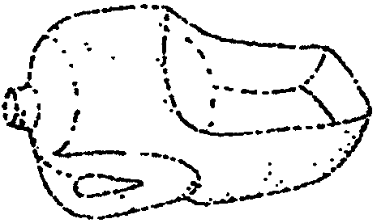
Give empty plastic bottles a purpose! Cut off the jugs as shown. You can then use the scoops for tossing and catching balls or bean bags. Gallon orange juice containers are more durable than milk or water jugs.

Everyone has a jug to toss with. The player doing the tossing calls out the name of the player he is tossing to. The player whose name is called must catch the ball. If he fails to catch it, he collects one letter of the word “OOPS.” When a player has collected all four letters, he must drop out of the game.

TRASH BAG RACE

Divide boys into teams of two. Give each team a trash bag and 2 blindfolds. Have one boy in each team remove his shoes and socks. Both boys are blindfolded. Scatter cotton balls about the floor. The object is for one boy to pick up the cotton balls with his toes and place them in the trash bag that the other boy is holding. This game will teach teamwork and is also a good time to talk about disabilities.

RECYCLED LID FRISBEE TOSS

Collect a variety of plastic lids from containers such as margarine tubs, yogurt containers, coffee cans, etc. With a permanent marker, mark half the lids with one letter and the other half with another letter (for example “C” and “S” for Cubs and Scouts, “B” and “G” for Blues and Golds). Divide the group into two teams. Give each team a set of lids. Using tape or string, mark two target circles about 15 feet away from a base line. Each team must stand behind the base line and sail their lids, frisbee style, into their target. A point is awarded for each lid that lands in the target. A point it taken away if a lid lands in the opposing target.
VARIATION: Hang old Hula hoops from a tree as target.

PAPER CLIP PICK UP

Scatter paper clips on a flat surface. Give each player one paper clip opened to form a hook. On signal, players try to pick up as many paper clips as they can. Keep adding paper clips onto the hook. If they drop any paper clips, they have to start over again. See how many they have after a certain amount of time. Old paper clips on a non-slick surface will be easier for beginners.

Games
See Cub Scout Leader How-To Book for:
“Little Scavenger Hunt”

POINT WITH PRIDE
(Tune: Yankee Doodle)

America is beautiful,
With views beyond compare;
So let’s always stash our trash,
And show her that we care.

Come on guys, let’s do our part,
And clean our countryside;
And everywhere that we will go,
We can point with pride!

THE WORLD AROUND US
(Tune: She’ll Be Comin’ Round the Mountain)

If you’re living in the country on a farm,
You’ll enjoy to the fullest nature’s charm.
Trees and birds, and bees and flowers,
Animals, skies, and grass and showers.
You can be outside for hours on a farm.

If you’re living in the city, visit zoos.
Parks, museums, gardens, aviaries, too.
We can all get back to nature,
But protect it for our future.
Live in harmony and be sure that we do.

PICK IT UP
(Tune: Row, Row, Row Your Boat)

Pick, pick, pick it up.
Help to keep things clean.
Cub Scouts and their families...
A conservation team!

TRASH CAN SONG
(Tune: I’m a Little Teapot)

I’m a hungry trash can, as you can see.
I like to eat up litter with a 1, 2, 3.
That will keep our world as clean as can be,
For plants and animals and you and me.

PICK UP THAT TRASH
(Tune: Home on the Range)

On give me a street
That looks very neat,
Where no paper and trash fly about.
For when I do see
All that mess and debris,
It makes me just want to shout out...

CHORUS
Pick, pick up that trash.
Don’t you care how our streets appear?
Oh, can’t you be good
And do as you should
To keep our neighborhood clean?

So during the day
At work or at play,
We should all do our duty so well,
And when on the ground
Someone throws their trash down,
Do your part and clean up where you dwell.

CHORUS

Let’s all of us vow
Right here and right now
That we’ll keep it clean every day.
And when we should find
The litterbug kind,
We’ll look at him and we’ll say...

CHORUS

PICK UP LITTER
(Tune: Are You Sleeping?)

Pick up litter, as you’re walking
Down the street, down the street.
Put it in a trash can
That’s one way that we can
Keep things neat, keep things neat.

CLEAN THE WORLD
(Tune: Yankee Doodle)

You’ve heard your mom say
Clean your room,
It looks just like a pig pen.
Well, now the cry is clean the world
So it stays nice to live in.

Keep the air and water clean,
Gather up the litter.
Use things over and over again
Then all of us are a winner.

RECYCLING
(Tune: Are You Sleeping)

Please recycle, please recycle
Do it now, do it now
If you don’t, we’ll all suffer
And you’ll feel so foolish
Start right now
Start right now

Please recycle, please recycle
Do it how? Do it how?
You can plant a tree and
Ride the bus and carpool
Do your part
Start right now.

RECYCLE IS THE THING TO DO
(Tune: Mary had a Little Lamb)

Recycle is the thing to do
Thing to do
Thing to do
Recycle is the thing to do,
It makes our lives so nice.

Paper, plastic, glass and cans
Glass and cans
Glass and cans
Paper, plastic, glass and cans
We recycle all these things

Our world becomes a better place
Better place
Better place
Our world becomes a better place
With help from you and me

REPEAT FIRST VERSE

RECYCLE SONG
(Tune: This Old Man)

Newspaper, magazine,
Make recycling your routine

CHORUS
We should all recycle
To give the earth a chance.
We want to save this great expanse.

Plastics lids, milk jugs, too,
Recycle bin’s the place for you.

CHORUS

No soda cans in the trash,
You can turn them in for cash.

CHORUS

GENIUS KITS WITH RECYCLED ITEMS

A genius kit is simply a collection of odds and ends. Each Cub Scout is given an identical kit. He creates something using his genius and imagination. This can be a pack or den activity. This is a great activity for a son and parent team. Make sure the results are shown off at the pack meeting. Give awards for most imaginative, best workmanship, most realistic, most useful, most conservation-minded, etc.

Create genius kits with recycled items. Here’s a sample:
Paper towel tube, four feet of string, 3 milk jug caps, one empty water bottle, 2 empty film canisters, 4 popsicle sticks, one meat tray, one empty can, one margarine tub, 4 old buttons, 2 berry baskets.

Genius project rules
1. Use only the materials supplied. You do not have to use them all.
2. Cut them up or shape them any way you wish.
3. Use any tools you want. Make anything you like.
4. Attach your name and the title of your creation.

HANDY BACKPACK

An old pair of jeans and some rope can make a handy backpack for your day hike!
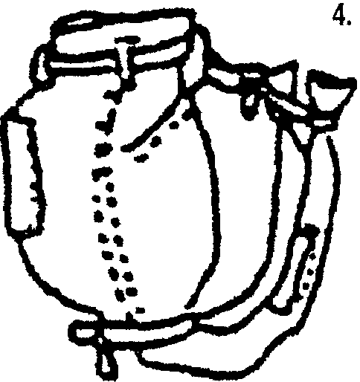
- Start with one pair of jeans.
- Fill trunk area with supplies. Tie off legs, leaving extra rope hanging down.
- Pull the top closed with rope strung through the belt loops.
- Tie leg bottoms to front belt loops. Use these as the arm straps.

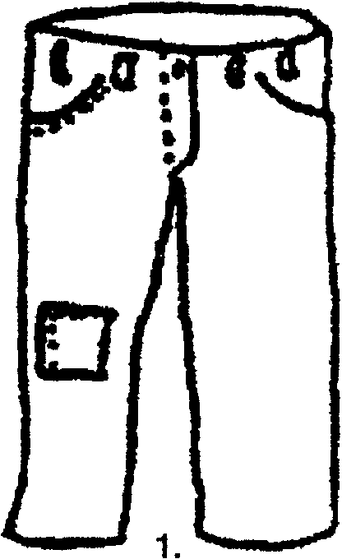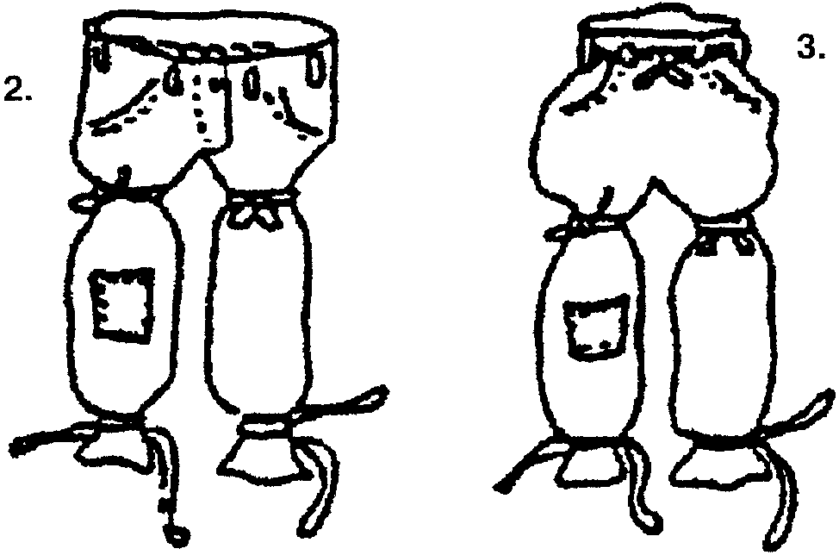

PICNIC UTENSIL CADDY

Materials: Three same size empty cans; Colored paper or contact paper; Markers; Household paint or acrylic (optional); Stickers; Colorful string; Glue; One chenille stem

- Cover each can with colored paper or contact paper. If you prefer, paint the cans.
- Decorate with markers and stickers.
- Tie cans together with string, after having glued them together.
- Add chenille stem for handle.

PICNIC CATCH-ALL
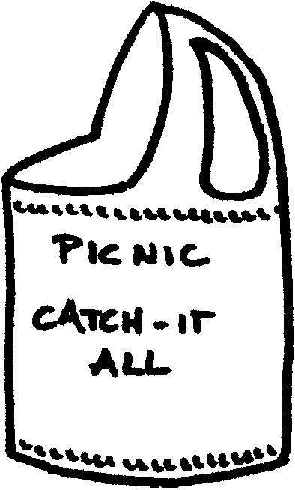
Make a picnic catch-all that can hold napkins, silverware, barbecue utensils, ketchup/mustard bottles, or whatever tends to rattle around in the picnic basket and get lost.

Materials: One-gallon plastic jug with a handle; Contact paper; Permanent markers and Stickers; Scissors (and sharp knife for an adult)

- Rinse out the jug very well.
- Cut out the area below the pour spout and opposite the handle so that you have an opening about 6-8” wide at the bottom and about 4-7” deep from the top. (Adult will need to help the boys by starting the hole with a sharp knife.)
- Cover the entire jug with contact paper. Decorate with markers and stickers.

BAG SAVER

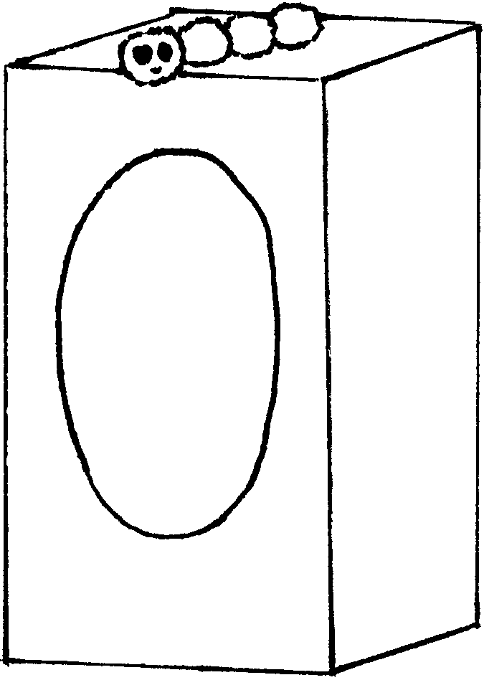
Materials: Large empty tissue box; Brown paint; Paintbrush; Green pompoms; Wiggle eyes (optional)

- Stand the box on one end. Paint the side and top brown, like the trunk of a tree. You may need more than one coat of paint. Let dry.
- Make a caterpillar with pompoms and wiggle eyes.
- Glue the caterpillar on top of the box.
- Stuff the box with plastic produce bags or grocery bags so you can save them to use again and again.

COOKIE CUTTER BIRD TREATS

Materials: Cookie cutters; Bread; Peanut butter; Birdseed; Sunflower seeds; String

- Use the cookie cutter to cut shapes out of the bread.
- Poke a hole through the top of each shape for hanging.
- In a 250-degree oven, dry the bread shapes for 10 minutes.
- Spread peanut butter on the dried shapes.
- Decorate with birdseed and sunflower seeds (sun flower seeds can be eyes, nose, etc.)
- Thread a string through each hole.
- Hang your bird treats on a tree outside.

TIN CAN PICTURE FRAME
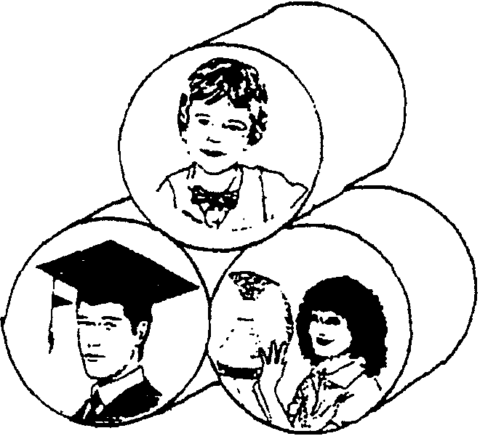
Materials: 3 empty tuna or cat food cans; Glue; Silver or gold spray paint; Pictures; Gold braid, chenille or lace

1. Glue cans in a pyramid as shown.
2. Paint and let dry.
3. Cut pictures to fit bottoms of cans.
4. Glue pictures to bottoms of cans.
5. Trim each picture with gold braid, chenille or lace.

TWO MORE PICTURE FRAMES

CD CASE FRAME

Tape picture inside the lid of the CD case. Close the case.
On the outside of the case around the picture, glue bits of recycled materials such as puzzle pieces, old buttons, shapes cut out of scrap craft foams, etc.

TISSUE BOX FRAME
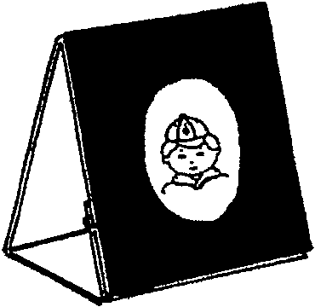
- Cut off two opposite sides of a square boutique tissue box at the X marks.
- Open up the box to form a strip. Strip may be left as is, covered with fabric or gift wrap, or covered with paper and decorated.
- Re-fold along all the lines.
- Glue or tape section “E” to the back of “A.”
- Tape photo or drawing behind the opening.
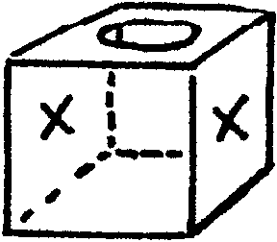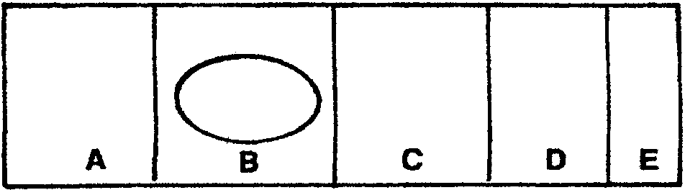

DOORKNOB MESSENGER
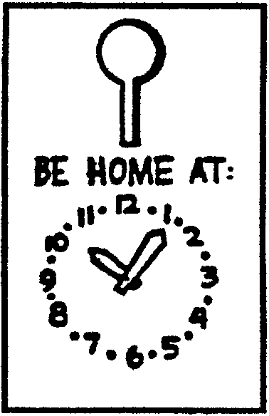
- From a large plastic bottle such as bleach bottle, cut a 4 1/2” x 8” rectangle.
- Cut 3” long “keyhole” to fit over doorknob.
- The two hands for the clock may be cut from a contrasting color plastic bottle.
- Punch holes in square end of hands and attach to doorknob hanger with paper fastener.
- Draw clock numerals and other decorations with permanent markers.

BOYS’ LIFE FILE BOX
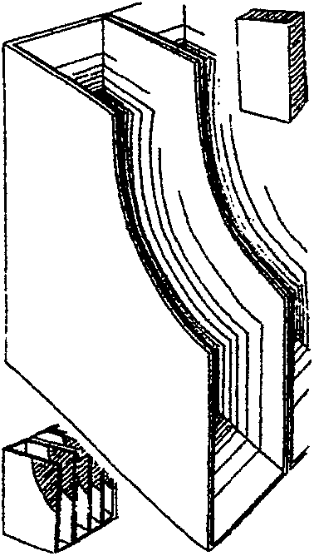
Can’t remember where you stashed your latest edition of Boys’ Life? Get in the habit of filing them away on your bookshelf in this handy recycled creation.

- Collect three or more cereal boxes of the same size.
- Cut away the opened tops and one long side of the cereal boxes.
- Glue the boxes together.
- The outside of the boxes may be covered with wrapping paper or adhesive Contact paper.
- Cut away the corners of the glued boxes in curved lines.
Stack magazines inside.

EGG CARTON NURSERY

Materials: Clean egg shell halves; Egg cartons; Potting soil; Seeds

1. Place empty eggshell halves in the cups of an egg carton.
2. Fill the shells with potting soil and carefully plant one or two seeds in each one.
3. Add water a little at a time, enough to moisten the soil. Take care not to drown the seeds.
4. Keep the egg carton closed so that the seeds will stay warm and sprout more quickly. Water the soil as needed to keep it moist. (Use hand spray bottle.)
5. After seeds have sprouted and grown into seedlings, plant the eggshells outside, crushing the eggshells slightly before putting them in the ground.

PAINT POTS

Reuse old plastic containers as flower pots or catch-all containers for small objects.

Materials: Empty cottage cheese containers, yogurt cups or margarine tubs; Acrylic paint; Sponge

- Wash all containers thoroughly with warm soapy water and rinse. Dry with a clean cloth. They must be clean or acrylic paint will not stick to them.
- Paint on the base coat using acrylic paint and a sponge brush. Allow to dry.
- Repeat until container is well covered.
- Decorate containers by painting a design. (flowers, dots, swirls etc.)

TALKING EARTH PUPPET

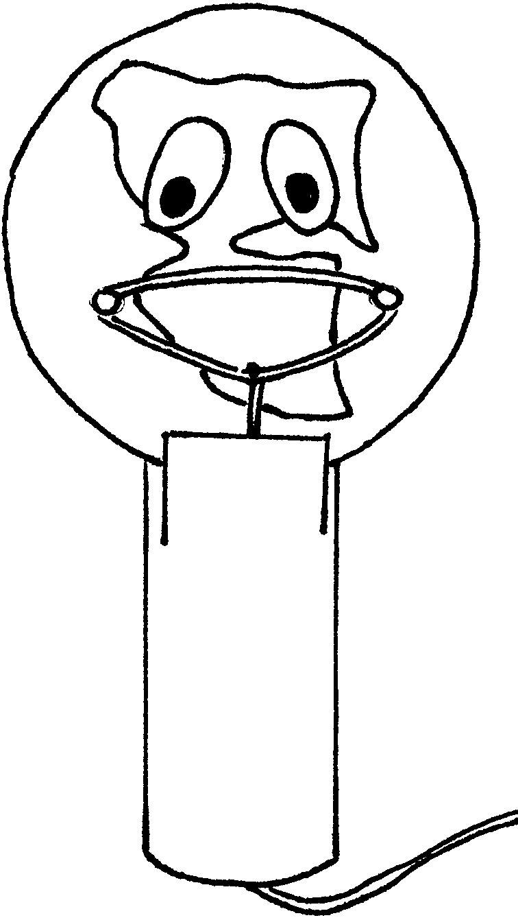
If the Earth could talk, what would it tell us? Write a puppet show that tells how you love and care for the Earth. Perform it at the pack meeting. Or use the puppets for the opening ceremony.

Materials: 1 heavy paper plate (or 3 thin ones glued together); Blue paint; Construction paper (white, black, brown); Paper towel tube; Blue yarn; Large rubber band; 2 paper fasteners; Paintbrush; Scissors; Glue

- Paint the bottom of the plate blue. Let it dry.
- Cut land forms from brown paper and glue them to the plate to make the Earth.
- Cut eyes from white and black construction paper and glue them in place.
- Poke the fasteners through the bottom of the plate far enough apart so that the rubber band will hook over each fastener to form the mouth of the puppet.
- Tie a long piece of blue yarn to the bottom of the rubber band.
- Cut two slits in the top of a paper towel tube and slide the bottom of the Earth puppet into the slits so that you have a holder for the puppet.
- Drop the mouth string through the tube so that it hangs out the other end.
- To move the puppet’s mouth, just pull gently on the end of the yarn.

WASTE BASKET NECKERCHIEF SLIDE
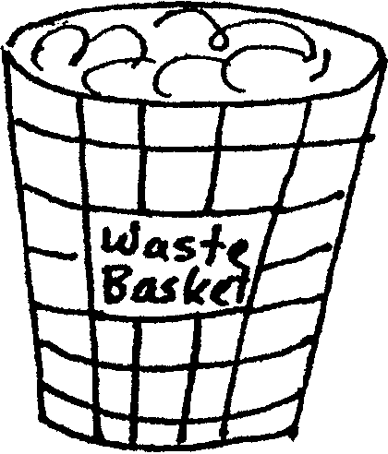
Materials: Plastic condiment cup; Permanent marker; Paper; Glue; 1/2” PVC pipe

Draw lines on cup for wire basket. Crumple paper and glue inside cup. Glue PVC pipe section on back.

SAVE IT FOR US NECKERCHIEF SLIDE

- Copy the pattern onto card stock.
- Color with markers and cut out.
- Laminate or cover with clear Contact paper.
- For a more “natural” look, glue the above onto a wood disk
slightly larger than the earth.
- Glue on slide back.

GRASS NECKERCHIEF SLIDE
(revised since 1999)

Materials: Film canister; Potting soil; Grass seeds; 1/2” PVC pipe; Small piece of paper and permanent markers; Craft glue; Clear Contact paper (optional)
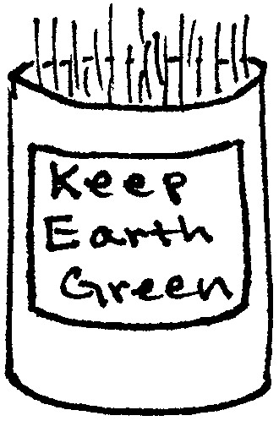

Wash the film canister thoroughly and dry.
Write your message or draw an earth-friendly picture on a small piece of paper and glue the paper onto the front of the canister. If desired, cover the paper with a piece of clear Contact paper.
Attach a section of PVC pipe to the back of the canister. Let dry.
Fill the canister 2/3 full with potting soil. Scatter seeds and water. (Place more seeds in the canister than you would use for the same size patch on your lawn--boys will put in a lot, anyway.)
Keep the canister slide in a sunny place.
Keep your seeds watered, taking care not to flood it. Spray bottle works well.
The slide will take 7-10 days to be ready. If grass gets too long, trim it.
The grass will last a few weeks in the canister.
After wearing it for a while, transplant the grass in your yard.

Don’t worry about dirt falling out of the canister when the slide is worn by an active Cub Scout. This slide was kid-tested. After the grass is grown, the dirt and grass will stay firm in the canister.

RECYCLED BANK FOR YOUR RECYCLING

Material: Empty can with a plastic lid; Mod Podge or white glue; Old magazines; Sharp knife

- Wash and thoroughly dry the can and the lid.
- Make a slit for your money in the plastic lid (adult supervision or adult help is needed).
- Write a conservation message on the lid with permanent markers, acrylic paint, or puff paint.
- Clip pictures of beautiful nature scenes from old magazines.
- Glue them on the outside of the can like a collage. Let dry.
- Cover the whole surface with Mod Podge or diluted white glue (Mod Podge works better). Let dry.
- Save your coins from recycling in this bank.

SQUIRREL FOOD

A great healthy after school snack.

2 bags corn nuts
1 bag dried fruit
Nuts of choice
Sesame seeds
Pretzels
Cheetos

Mix together as much as necessary. Store in airtight container.

SNOW ON THE MOUNTAIN

6 1-1/2 oz. milk chocolate bars
1 cup shredded or flaked coconut
Box of graham crackers

Melt chocolate bars in a greased pan. Dip a spoonful on each cracker and sprinkle with coconut.

CHOCOLATE QUICKSAND

There is really no need to measure the chocolate for this--just squirt to taste.

1 banana, peeled
1 cup vanilla or chocolate ice cream or frozen yogurt
1/2 cup milk
1/4 cup chocolate syrup

In the morning, slice the banana, place it in a plastic lunch bag and freeze.
After school, place all the ingredients in a blender and process until smooth.

Makes 1 1/2 cups

RAIN FOREST PUNCH

2 cups orange juice
2 cups lemon-lime juice (Sprite or 7-up)
2 cups pineapple juice
Lemon sherbet (optional)

Mix all, except sherbet, together in a punch bowl. A spoonful of sherbet may be added to each cup of punch.

