Summer Songfest

August 2001

CONTENTS

THEME RELATED 1
ANNUAL PACK PLANNING CONFERENCE 1
DEN AND PACK ACTIVITIES 1
FREE CONCERTS 1
PARTICIPATION AWARDS 1
CAMPFIRES 1
HELPFUL HINTS FOR SINGING 2
ONLINE RESOURCES 2
PREOPENING 3
GETTING TO KNOW YOU - MIXER 3
CEREMONIES 4
STAR-SPANGLED BANNER OPENING 4
THE FLAG ON THE MOON 4
AMERICA THE BEAUTIFUL CLOSING 5
OUTDOOR CLOSING 5
MUSICAL NOTES ADVANCEMENT 6
SING-ALONG ADVANCEMENT 6
STARS OF THE SHOW ADVANCEMENT 8
NEW FAMILY INDUCTION - CAMPFIRE 9
ACKNOWLEDGE SOMEONE’S EFFORT 9
FUN WAYS TO SAY THANK YOU 9
AUDIENCE PARTICIPATION 10
THE WONDERFUL CELLAR BAND 10
SKITS 11
THE SOUND 11
THE HOMEMADE BAND 11
GAMES 12
CHANGE THE SINGER 12
WHICH SONG ARE YOU SINGING? 12
ABC SONG? 12
LISTEN AND SING 12
ALPHABET SONGS 13
ONE WORD AT A TIME 13
MUSIC MAGIC 13
SONG STUMPERS 13
MUSICAL CHARADES 13
I CAN CARRY A TUNE...IN A PAPER BAG 14
DUTCH BAND 14
NAME THE TUNE 14
KEY WORD 14
SONGS 15
MALO, MALO, MALO 15
THE QUARTERMASTER’S STORE 17
AIN’T THAT FUNKY, NOW? 18
I’D LIKE TO TEACH THE WORLD TO
SING 19
CUB SCOUT ORCHESTRA 19
OLD MCDONALD HAD A BAND 19
CRAFTS 20
MUSICAL BOTTLES 20
SNARE DRUM 20
SODA STRAW OBOE 20
HUMMER 20
KAZOO 21
BANJO 21
GUIRO 21
CRAFT FOAM NOTE NECKERCHIEF SLIDE 21
SOUND BOX 22
DRUM BOX 23
LAGERPHON 23
MILK CARTON GUITAR 23
CUBS IN THE KITCHEN 24
ZIP-LOC FUDGE 24
ZIP-LOC ICE CREAM 24
CUB SCOUT HOMEMADE ROOTBEER 24

ANNUAL PACK PLANNING CONFERENCE

It’s time to plan the pack’s program for the coming year. Pick up your unit’s Program Packet at this month’s Roundtable. New council calendars are included in the packet and are also available at the Scout Service Center. Cub Scout Program Helps 2001-2002 should become available at the Scout Shop sometime during the summer.

Plan the pack activities for the whole year, including next summer (see National Summertime Pack Award in the PARTICIPATION AWARDS section). The boys are registered for 12 months of Cub Scouting fun. The year-round program is also one of the optional requirements for the Cub Scout Pack National Quality Unit Award

DEN AND PACK ACTIVITIES

Incorporate a lot of songs in your meeting. The more you sing, the more fun you have. Maybe you will continue having more songs in your meetings in the future. Songs give the meetings more sparkles. A group who sings together stays together too! Have fun.

Make some homemade musical instruments to accompany your singing. Some examples are listed in Cub Scout Leader How-To Book (pp. 3-48 to 3-51), Bear Cub Scout Book (Elective 8), Cub Scout Program Helps 2000-2001 (August), and the craft section of this month.

With the boys, make your own songs for the pack or den. Use a simple and familiar tune.

FREE CONCERTS
Many of our local communities offer free concerts in their parks during the summer months. Check out if anything is happening near you that might be enjoyable for your boys—especially a performance that would include a variety of instruments.

PARTICIPATION AWARDS (For details, see the PARTICIPATION AWARDS section)
Cub Scout Academics: Music

CAMPFIRES

Have a family picnic and campfire, and take along whatever instruments you may have (include home-made ones too). If this will be the first sing-along for your group, be sure to print up the words to some favorite songs so everyone can participate. By the way, you don’t have to have a real fire to have a campfire program. What’s important is your spirit, imagination and a well planned program.

Even the boys who are too shy to sing at a pack meeting often join in a sing-along at a campfire. Campfires are great fun for Cub Scouts and their families. A well-planned campfire is an exciting and inspirational way to end an evening of pack activities.

CAMPFIRES (continued)

For information and suggestions for the campfire program, see Cub Scout Leader How-To Book, pp. 8-43 to 8-48. Campfire Program Planning Sheets are found on pages 17-31 and 17-32 in the Cub Scout Leader Book. For Campfire Safety, see Cub Scout Leader Book, page 12-7.

HELPFUL HINTS FOR SINGING

Don’t be afraid. SMILE AND HAVE FUN! In Cub Scouting your enthusiasm counts as much as (and often more than) your ability. Sing out. Ask someone to help you. Songs are great enthusiasm builders! You’ll have more fun and be more effective as a Cub Scout leader if you can be a kid yourself for a little while.

If your den or pack doesn’t like to sing or would like a change of pace, how about chanting the words to a beat? Could be fun (and varying the tempo could add to the fun!)

Add motions that will fit the words. It’ll add an extra dimension to the sing-along. Involve others, especially Cub Scouts, in creating actions.

Use instruments. Any parents in your pack or den who can play a guitar, harmonica, etc? Or better yet, use homemade instruments and “bang” and “strum” then as you and the group sing. It’s a lot of fun. Add a lot of hand clapping, foot stomping, and knee slapping. Pretty soon it won’t matter if the song is sung a bit off-key. Everybody will have a great time.

Remember you are not singing for somebody or to impress others. You are singing WITH everybody and to have FUN!

Singing Together = Joy + Happiness = Smiling Faces

For more hints, see the beginning part of the Cub Scout Songbook.

ONLINE RESOURCES

- The National Association for Music Education: http://www.menc.org
- Public Domain Music site: http://www.pdinfo.com
Alphabetical list of more than 3,000 songs
- Campfire sing along index: http://home.achilles.net/~cco/dir-cam.htm
- Australian Scouts: http://members.iinet.net.au/~oneilg/scouts/songs/index.html
Songs and skits links

GETTING TO KNOW YOU - MIXER

Copy the statements below and give one to each person as they arrive at the meeting. During the meeting, award those who have largest number of spaces filled with small prizes.

Find people who can complete the following sentences. The person’s name can only appear once on the quiz (you can’t put your name).

_______________ was born in the same state as I was.

_______________ knows how to play a musical instrument.

_______________ has the same middle initial as I do.

_______________ sings in a choir.

_______________ has a birthday in the same month as I do.

_______________ knows the words to “America the Beautiful.”

_______________ wears the same size shoe as I do.

_______________ can whistle.

_______________ likes the same sports as I do.

_______________ has a harmonica.

_______________ has the same favorite color as I do.

_______________ takes piano/key board lessons.

_______________ has the same hair color as I do.

_______________ knows the Cub Scout motto as I do.

_______________ likes the same kind of music as I do.

STAR-SPANGLED BANNER OPENING

The following may be read by the Cubmaster or by several Webelos Scouts (they learn about the anthem for their Citizen Activity Badge):

How many times have you heard the “Star-Spangled Banner” sung at the opening of a ball game? We stand, sing along mumbling, or listen to the featured singer. Then we applaud at the end, take our seats and look forward to the game without another thought about the song.

But, have you ever really thought about the history and words behind the “Star-Spangled banner”? The song actually started out as a poem by Francis Scott Key. He wrote that poem during the battle for Fort McHenry at the mouth of the Chesapeake Bay during the War of 1812. He was being held prisoner at the time, on a British warship.

When Key wrote this poem, he did not know how the battle would end. He was not sure that his country would survive the war. He did know that the flag flying over the fort would be the symbol of his country’s continued survival.

When he wrote about the “rocket’s red glare,” he was struggling to see through the dark to see which flag was flying over the fort. It was dawn’s early light that finally showed him, his beloved country survived to fight another day.

Would you please rise and join me (us) in singing our National Anthem?

THE FLAG ON THE MOON

(For the August pack meeting, your pack may be meeting outdoors. This ceremony is appropriate for an opening or closing. Follow the Pledge with a patriotic song.)

Cubmaster:
Cub Scouts and families, you don’t see a flag before you, but there is a flag that we can all salute. Many years ago, a former Boy Scout planted a US flag on the Moon. It is appropriate to stand and salute this flag even though it can only be seen through our imaginations. Please join me now in the Pledge of Allegiance.

APPLAUSES

AUDIENCE APPLAUSE: Stand, clap hands and shout “Bravo! Bravo! Encore!”

TRUMPET APPLAUSE: “Da-da-da-da-data-da--CHARGE!”

OPERA SINGER APPLAUSE: Clasp hands in front of chest and belt out a loud “LAAAAAAA!”

AMERICA THE BEAUTIFUL CLOSING

Arrangement: Play a recording of the song, “America the Beautiful” softly in the background.

Cubmaster:
I’m sure we are all familiar with this song, “America the Beautiful.” We thrill to see America’s spacious skies, its amber waves of grain, and purple mountains majesty. We often think of this song as a song of praise for America’s physical beauty.

Have you ever sung the other verses to this song? They tell us a little something about the history of America. “Oh, beautiful for pilgrim’s feet...” celebrates the people who bravely left their homelands to settle this country. “Oh, beautiful for heroes proves...” helps us to remember all those who fought and died so that we can be free. “Oh, beautiful for patriot dream that sees beyond the years...” reminds us that America was founded on a dream and continues to grow and prosper with that dream. These verses remind us of the beauty and strength of character of Americans who came before.

Next time you hear, or sing, this song, listen to the words. Listen to the praises for the great men and women who built this beautiful America. Pledge to be an American who helps to “crown thy good with brotherhood...” Remember the beauty of America--its physical beauty and the beauty of all of its people.

(Sing all four verses of “America the Beautiful,” if desired.)

OUTDOOR CLOSING

Let’s remember the food we’ve shared,
The games we’ve played, the songs we’ve sung,
Let’s remember all of these things.

Let’s remember the skits we’ve played,
The hikes we’ve hiked, the problems we’ve shared,
Let’s remember all of these things.

Let’s remember the games we’ve played,
The friends we’ve made, the fires we’ve burned,
Let’s remember these things.

Yes, let’s remember all of these things,
I now declare this council fire closed,
It’s memories stored forever in our hearts and minds.

MUSICAL NOTES ADVANCEMENT

Props: White poster board, with lines for musical score (no notes, just lines and a treble clef), propped up; Black paper notes with double sided tape or loops of tape on the back. Have the Cub Scouts’ names in bright colors on the face of each (Gold or silver marker works well).

Cubmaster:
There are many beautiful songs in the world. When you are happy, you can’t help but burst out in a song.

The most beautiful music to me is the sound of a happy child, when he is proud of his accomplishments. Please join me in singing the praises of the following young men. (Calls out names of first group of boys to earn rank)

These boys have earned their (Bobcat, Wolf, Bear, Webelos) rank.

Their hard work and endeavor leaves a song in my heart. This patch is for their uniform to show the world what they have accomplished. The pin is for the parents, to show how much their support means to him. (Gives patches to the parents to present to their sons, pins to the Scouts to present to their parents)

Boys, as you receive your badge, please add your note to our musical score. (Boys stick their musical notes on the board)

(Cubmaster repeats as necessary for all ranks.)

SING-ALONG ADVANCEMENT
(by Debbie Summerhalder, Utah National Parks Council)

This ceremony is unusual in that it is all sung. We’re not asking the Cubmaster to perform a solo unless he really wants to. You can copy the words to this song and give it to the boys and families as they come to pack meeting. As a group, sing through each verse twice, the first time for practice and the second time with gusto. When you sing the verse the second time, escort the parents and boys who have earned the awards to the front. Or, copy the words and give them to each den several weeks before the pack meeting. Let each den practice the verses that pertain to them and they stand and perform those verses at the pack meeting. The other verses can be sung by the audience. Have fun!

Tune: She’ll Be Comin’ Round the Mountain

Oh, we’re havin’ a pack meetin’ here tonight.
Yes, we’re havin’ a pack meetin’ here tonight.
Cubs and leaders are a comin’
Parents, friends, even some cousins,
They’re a comin’ to the pack meetin’ tonight.

SING-ALONG ADVANCEMENT (continued)

Oh, the Bobcats are meowin’ here tonight. (Meow!)
Yes, the Bobcats are meowin’ here tonight. (Meow!)
Learned the Promise, Law, and Motto,
Sign, salute, handshake, you oughta
Give a cheer to the Bobcats here tonight! (Hooray!)

Oh, the Wolves are a howlin’ here tonight. (Howl, howl!)
Yes, the Wolves are a howlin’ here tonight. (Howl, howl!)
Twelve achievements they’ve completed
Earned their Wolf rank, here they’re seated
Give a cheer to the Wolves here tonight. (Hooray!)

Oh, they earned some arrow points we are told,
Gold and silver arrow points we are told.
E-lectives they have done,
And they’ve had a lot of fun,
Give a cheer to the Wolves here tonight. (Hooray!)

Oh, the Bears are growlin’ here tonight. (Growl, growl!)
Yes, they’ve finished twelve achievements, all right! (Growl, growl!)
Self and Others, Country, God
Earned their Bear rank, give a nod
And a cheer to the Bears here tonight! (Hooray!)

Oh, they earned some arrow points we are told,
Gold and silver arrow points we are told.
E-lectives they have done,
And they’ve had a lot of fun,
Give a cheer to the Bears here tonight. (Hooray!)

Oh, the Web’los are a shoutin’ here tonight. (Webelos!)
Yes, the Web’los are shoutin’ here tonight. (Webelos!)
Loyal Scouts who’ve done their best,
Earned their rank and passes the test,
Give a cheer to the Webelos here tonight! (Hooray)

Oh, they earned some activity badges we are told.
Pin ‘em on their Web’los colors, big and bold.
Fitness, Citizen, and Showman, (substitute the names of badges
Geol’gist, Scientist, now you know man, earned here if you would like)
Give a cheer to the Webelos here tonight! (Hooray!)

Oh, we’re havin’ a pack meetin’ here tonight.
Yes, we’re havin’ a pack meetin’ here tonight.
What a super job we’ve done,
We’re a great pack, everyone
Say hooray for the Cub Scouts here tonight. (HOORAY!)

STARS OF THE SHOW ADVANCEMENT

Attach each award to a paper star. All stars will be hung on a door, either real or made from paper.

Cubmaster:
Welcome to our musical tonight! Our first act is starring a group of young men who have been practicing and memorizing their lines just for tonight. They finally got their act together and are ready to receive the great honor of their BOBCAT BADGE. Will the following stars and their “agents” (parents) please come forward? (Name boys who are receiving award.)

Your performance in the den has been great. The Den “Stage Manager” (leader) says you are ready to become stars. Now comes the first of many performances in your Cub Scout career. I will present the badge to your agents, who will present it to you. (Do so.) Congratulations! You may go hang your Bobcat Star on the dressing room door.

Our next act has been practicing for almost a year, and they are terrific! Will the following stars and agents come forward? (Name the Wolf candidates.) These stars had to learn 12 acts in the Wolf book script. They finished rehearsing their scenes and are ready to receive the Wolf Badge. (Present badges, boys place stars on the door.) Some of these stars have learned extra lines and songs. They will now receive their arrow points. (Present award, hang star on door.)

Our third act is really terrific! Will the following stars and their agents come forward to our stage? (Name the Bear candidates.) These stars have also learned 12 acts, but these acts come from a more difficult script called the Bear Book. Their rehearsals are done, and they are ready to receive the Bear Badge. (Present award, hang star on door.) Some of these stars have learned extra lines and songs. They will now receive their arrow points. (Present award, hang star on door.)

And now, ladies and gentlemen, we have a stupendous act which takes much skill and requires work and patience. These performers have been practicing years to attain stardom. Will the following Stars and their agents please come to the stage? (Call up Webelos and parents) These stars have attained the rank of Webelos. They have worked hard with their directors, the Webelos leaders. We honor their great achievements tonight. (Present award, hang star on the door) They must continue to practice for only one more award, the prestigious Arrow of Light award. We’ll watch breathlessly as they continue to pursue their shining careers.

Congratulations, all!

APPLAUSES

LAWRENCE WELK MEETS FRED FLINTSTONE APPLAUSE: “A one anda two anda Yabba Dabba Do!”

DRUM APPLAUSE: Slap your legs and go “Rat-a-tat-tat” three times and then slap your stomach twice and say, “Boom, boom.”

NEW FAMILY INDUCTION - CAMPFIRE

Props: Appropriate Cub Scout book, a stick of wood for everyone, campfire (may be a prop).

Asst. CM: We have some boys and their parents requesting to join our pack.

Cubmaster: Bring them to our pack fire. (Boys and parents come to the campfire.) Please join me in the Cub Scout sign. (Do the sign) Please give the Cub Scout Motto. DO YOUR BEST. I know you will all DO YOUR BEST in Cub Scouting. To help you get started on the road to the Bobcat Trail, we will give you your Wolf book (or Bear or Webelos, depending on the age of the boy). (Give book to parents who in turn present it to their sons)

Before you is the fire of friendship which means that every Cub Scout and parent in the pack is a friend to all. I will now ask you to place a stick of wood upon the fire as a promise to DO YOUR BEST and be a friend to all. Then I will ask everyone here to place a stick upon the fire showing their continuing friendship to all. Now you shall place your token on the fire. (New families and continuing families place twigs on fire) Welcome to Pack _____.
(Sing “Cub Scout Friendship” song, listed in this month’s “Songs” section.)

ACKNOWLEDGE SOMEONE’S EFFORT

Cubmaster (or Den Leader):
Songs and music are a combination of sounds that produce a harmonious result. In our pack (or den), we have a nice variety of talents that blend together well. Today/tonight, I wish to recognize __________________. His/her contribution (perhaps in organizing or participating in a particular summer event) added a very special note to (explain).

Have the individual stand and be applauded. Present the honoree with a large cardboard cutout of a music note or a kazoo (perhaps homemade—see “Crafts”).

FUN WAYS TO SAY THANK YOU

Match/Lighter: “You’re matchless!”
Musical note (put a large musical note cutout in a small bucket) or Toy musical instrument:
“You carry a tune very well.”
“You bring music to our heart.”
“A note of thanks for ___.”
For the pack song leader.
Music notation (sharp): “Thanks for being such a SHARP leader.”
Old record: “You’ve set a record for success.”

See Cub Scout Ceremonies for Dens and Packs for:
“America--The Song” p. 5-2
“Outdoor and Campfire Ceremonies” Chapter 11

THE WONDERFUL CELLAR BAND

(DUSTY OLD) CELLAR: “Cree-eek, Ah-choo!”
EMPTY GLASS JUG: “Boop, boop!”
RUSTY SAW: “Whaaag, whaaang”
BEAT UP TRASH CANS: “Crash Bang”
FADED OLD HAT BOX: “Rat-a-tat”

Once upon a time, as many stories begin, in a DUSTY OLD CELLAR there lived a group of very good, very old and very out-dated friends. There was an EMPTY GLASS JUG, a RUSTY SAW, two BEAT UP TRASH CANS, and a FADED OLD HAT BOX. Now these old friends had been in the DUSTY OLD CELLAR for a very long time. And except for being moved about from time to time, they were left alone to rust or turn to dust. Needless to say, they were very lonely.

One day, the EMPTY GLASS JUG, in a deep low voice said, “It’s too quiet here. I wish something would happen.” “Now really, JUG,” said the RUSTY SAW, “what could possibly happen here?” “Why,” said the FADED OLD HAT BOX, “I’ve been sitting on the CELLAR shelf for 20 years and all I’ve seen is two mice and a daddy-long-legs spider.” “The EMPTY GLASS JUG is just getting older and emptier,” said the BEAT UP TRASH CANS. “Don’t pay him any mind.”

Suddenly there was the sound of footsteps on the CELLAR stairs. Four young boys, all dressed alike, came cautiously down the DUSTY OLD CELLAR steps. They were talking in hushed voices. “Are they twins?” asked the FADED OLD HAT BOX. “I think they’re elves,” said the RUSTY SAW in a lofty voice. “Nonsense,” said the EMPTY GLASS JUG. “They’re Cub Scouts,” said the BEAT UP TRASH CANS. By now, the old friends were very curious and excited. They listened as they boys talked.

“Boy, it’s spooky down here in the DUSTY OLD CELLAR,” said Jimmy. “Don’t be a fraidy cat,” said Mike. “Aw, let’s go,” said Jack. “No, wait,” said Billy. “I’ve got an idea. We have to do a stunt for the den meeting, don’t we?”

“Yea, that’s right,” the other three chorused. “Well,” said Billy. “Let’s have a band--a CELLAR band.” “A band!” they yelled. “Sure,” said Billy, “I’ll play that RUSTY SAW. Jimmy, you take that EMPTY GLASS JUG. Mike, the FADED OLD HAT BOX will make a neat drum. And Jack, those BEAT UP TRASH CANS’ lids will be great cymbals.”

Well, of course, you know the rest. Den 3 made new friends with old friends, right there in the DUSTY OLD CELLAR, with an EMPTY GLASS JUG, a RUSTY SAW, a FADED OLD HAT BOX, and two BEAT UP TRASH CANS, and for all we know, they still may be playing.

Cub Scout Leader How-To Book
“A Musical Story” p. 6-4

THE SOUND

Props: Noisemakers such as drum, bell, whistle, kazoo, guitar, etc., carried by each Cub Scout; a triangle or dinner bell.

(C.S.#1 comes on stage.)
C.S.#1: I’ve just got to find THE SOUND. I’ve got to!
(C.S.#2 comes on stage, carrying his noisemaker)
C.S.#1: Have you got THE SOUND?
C.S.#2: Sure. (he demonstrates sound)
C.S.#1: No, that’s not the right sound. That’s not it at all.
(Each Cub Scout comes on stage and is asked by C.S.#1 about his sound. Each demonstrates. C.S.#1 rejects all sounds. suddenly, there is the sound of a triangle or dinner bell being rung offstage, or a boy wearing a cook’s hat enters ringing the triangle.)
C.S.#1: (excitedly) That’s it! That’s THE SOUND!
Others: What is it? What is THE SOUND?
C.S.#1: Why, it’s the sound that’s calling me to dinner. What better sound than that?

See Cub Scout Leader How-To Book
“The Music Makers” P. 4-9

THE HOMEMADE BAND

Cub Scouts sing the following song to the tune of “She’ll Be Comin’ Round the Mountain” while doing what the line says. From second verse on, keep adding the sounds. So for the third verse, after the gonger gongs, then the clapper claps and the chimer chimes.
Suggestion for the instruments (also see the “Crafts” section):
Chime with wooden spoon and pan lid.
Clap two flat pieces of wood.
Gong a spoon against a pie pan.
Scrape a rasp with ridged foil or vegetable box.
Bongo a can with plastic lid.
Clonk two yogurt or similar plastic jugs.
Rattle a can with plastic lid, with dry peas inside.

I’ll be chim-ing on my chim-er when I come; I’ll be chim-ing on my chim-er when I come.
I’ll be chim-ing on my chim-er, I’ll be chim-ing on my chim-er,
I’ll be chim-ing on my chim-er when I come.

I’ll be clapping on my clappers...
I’ll be gong-ing on my gong-er...
I’ll be scrap-ing on my scraper...
I’ll be bonging on my bongo...
I’ll be blowing comb and paper...
I’ll be clonking on my clonker...
I’ll be rattling on my rattle...

CHANGE THE SINGER

Choose a familiar song. Divide up your group, and direct one team to start singing until you indicate they should stop, then the second team takes up singing where the first team left off. Alternate back and forth between the teams.

Start easy, for example:
Team 1: Twinkle, twinkle, little star
Team 2: How I wonder what you are
Team 1: Up above the world so high
Team 2: Like a diamond in the sky
Then make it a bit more complex/fun:
Team 1: Twinkle, twinkle
Team 2: Little star, How I
Team 1: Wonder what you
Team 2: Are. Up above the world
Team 1: So high, like a
Team 2: Diamond in the
etc.

WHICH SONG ARE YOU SINGING?

Divide the group into two teams. Either assign each team a song or let them choose one. First team starts singing its song. At the leader’s signal, first team stops and second team starts its song. Alternate back and forth between the teams. The longer the segment for one team, the harder for the other team to resume their song. Can they keep in tune? How about three songs?

ABC SONG?

Practice the tune for the Alphabet song. Once the players know it, change the words to sing a nursery rhyme. For example, sing “Mary Had a Little Lamb” to the tune of the Alphabet song.

LISTEN AND SING

Make a list of songs and their first lines. Divide the group into two teams. The leader will read the first line of a song to one of the teams. They have just three seconds to sing the next couple of lines to it. Score five points if they get it. If the team cannot sing it, give the other team a chance to sing it. If they do, they get the five points.

ALPHABET SONGS

Choose a letter of the alphabet. Starting at that letter, a player names a well-known song whose title begins with that letter. Proceed through the alphabet until someone is stumped. Start again with another letter. For example, the letter chosen is “C” The first player says, “Clementine.” The next player says “Down in the Valley” for “D” and so on. Eliminate the letters Q and Z to make it a little easier. Also eliminate the word “the” from the beginning of titles. “The Battle Hymn of the Republic” is considered a “B” song for “Battle Hymn of the Republic.”

ONE WORD AT A TIME

Place the names of several well-known songs in a hat. Sit the boys in a circle, have one draw a name from the hat and read it aloud. He then says or sings the first word of the song. The boy to his right then says or sings the second word of the song. The boy to his right then says or sings the third word of the song, and so on around the circle. (Don’t be surprised when the boys start singing together.) If someone is stumped, he may pass one time during the song. If he is stumped again, he chooses a new song from the hat and starts the game again.

MUSIC MAGIC

Choose a small object to hide. Select one person to be “It.” “It” leaves the room, out of sight. Hide the small object and the group in the room starts singing a song. When “It” hears singing, he comes back and looks for the object. As he nears the object, the group sings louder; as he moves away they sing softer.

SONG STUMPERS

One player sings the first line of any familiar song. The others, one by one, try to complete the verse. The first one to succeed becomes the new leader. If no one can do it, the leader completes the first verse of the song and begins another.

MUSICAL CHARADES

Prepare eight to ten slips of paper with names of popular songs. Place them in a bowl. Boys take turns pulling a song from the bowl and then must act out the title as in the game of Charades, until someone guesses the song title. The player who guesses the title correctly then becomes the next person to act out a song title. This game can also be played in teams.

I CAN CARRY A TUNE...IN A PAPER BAG

Write the words to a well-known song title on 3 x 5 cards—one card per word. Make two sets and place them in a large bowl/box. Create two teams, each composed of the same number of players as there are words in the song title. (For example, teams for “Twinkle, Twinkle Little Star” would have 4 players each.) Give the first player on each team a paper bag. Players take turns racing to the bowl or box, each taking one of the words of the title, placing it in the bag, then returning to his/her team and passing the bag to the next player. The first team to have all the title words (and ONLY the title words) in their bag wins. (Obviously, you could complicate the game by adding cards with non-title words, or combining “Row, Row, Row Your Boat” cards with “Twinkle…” cards.)

DUTCH BAND

The leader assigns the name of a musical instrument to each player, including himself, and names a popular tune. The leader starts to “play” his instrument, making the proper sounds and gestures, and all others join in with their instruments. At any time, the leader may switch to the instrument of another player. That player immediately must switch to the leader’s former instrument or pay a forfeit. Make rapid changes.

NAME THE TUNE

Divide the group into two teams. First team hums the first line of a song (they must know the title of the song too). The second team tries to name the song.

KEY WORD

This is like an audience participation stunt. Choose a favorite song. Tell the group whenever they hear a particular word, they should clap as they sing it. For example, with “My Bonnie,” you might clap each time you sing “Bonnie.” Other actions you can do each time you hear a certain word are sit down/stand up, stomp your feet, jump or hop. You might divide the people into smaller groups with different key words and/or different actions. Have Fun!

APPLAUSE

MUSICAL APPLAUSE: Announce the name of a well-known song such as “Yankee Doodle” or “Dixie” and ask everyone to clap to its rhythm. For a different finish, tell everyone to miss the last note. Someone is sure to forget.

MALO, MALO, MALO

Story telling at campfires is great fun and becomes one of the favorite memories for the boys. Try this one at your next campfire.

This is a little story to go with the song on the following page.
It is a good idea to have an adult memorize the story (or at least the overall concept) so that it can be told as you move around the campfire. You would also want to be able to make the appropriate movements while telling the story.

The Origin of the Ancient Native Chant, Malo, Malo, Malo

In the early 13th century, the last 12 surviving natives of the Kumi Islands had to leave their island home for reasons now lost in ancient lore. They left in their boats in autumn when the sea swell is high and the storms are fierce.
They had not been able to bring any provisions or water. They had worn weak when the storm hit. They struggled to save themselves. When it was over, only six had survived, and now even their paddles were gone. All were desperate.
But Malo, their chief, was different. Malo knew he had the strength to endure their misfortune, for he had experienced personal tragedy and had overcome it. As a boy, he had fallen from a coconut tree, splintering his knee. It healed with an odd shape and that made it possible for him to read the stars and guide their boats.
So, Malo urged his men onward. He convinced them to paddle with their arms while using their knees to beat a rhythm. Paddle first on the right--beat their knees--then on the left--beat their knees--then right--beat their knees--then left--beat their knees--paddling one side and then the other.
Finally, they developed a chant to keep their rhythm. Nine days of torturous effort passed. The men were close to exhaustion when Chief Malo sighted land. Their spirits were lifted. They began to paddle harder! Right--knees--left--knees--right--knees--left--knees.
As they continued their approach to the island, the stiff currents caused them to have to work harder still. The right--hit their knees--the left--hit their knees--then the right--hit their knees--then the left--hit their knees.
Then their boats hit the beach!! They climbed out to see where they had landed. When they realized they had landed back on their own Kumi Island, they looked at Chief Malo. The chief could not understand it--he had used his knee to guide them!
And then they cried out in disbelief—“ZA--WRONGA--KNEE!!”
This is great for a campfire, because you should be sitting or standing in a circle. Sometimes it is fun to have the boys hum the tune while an adult tells the story. You could also have them mimic your movements, thus getting them accustomed to doing them before the singing begins. Once mastered, this becomes a frequently requested favorite!

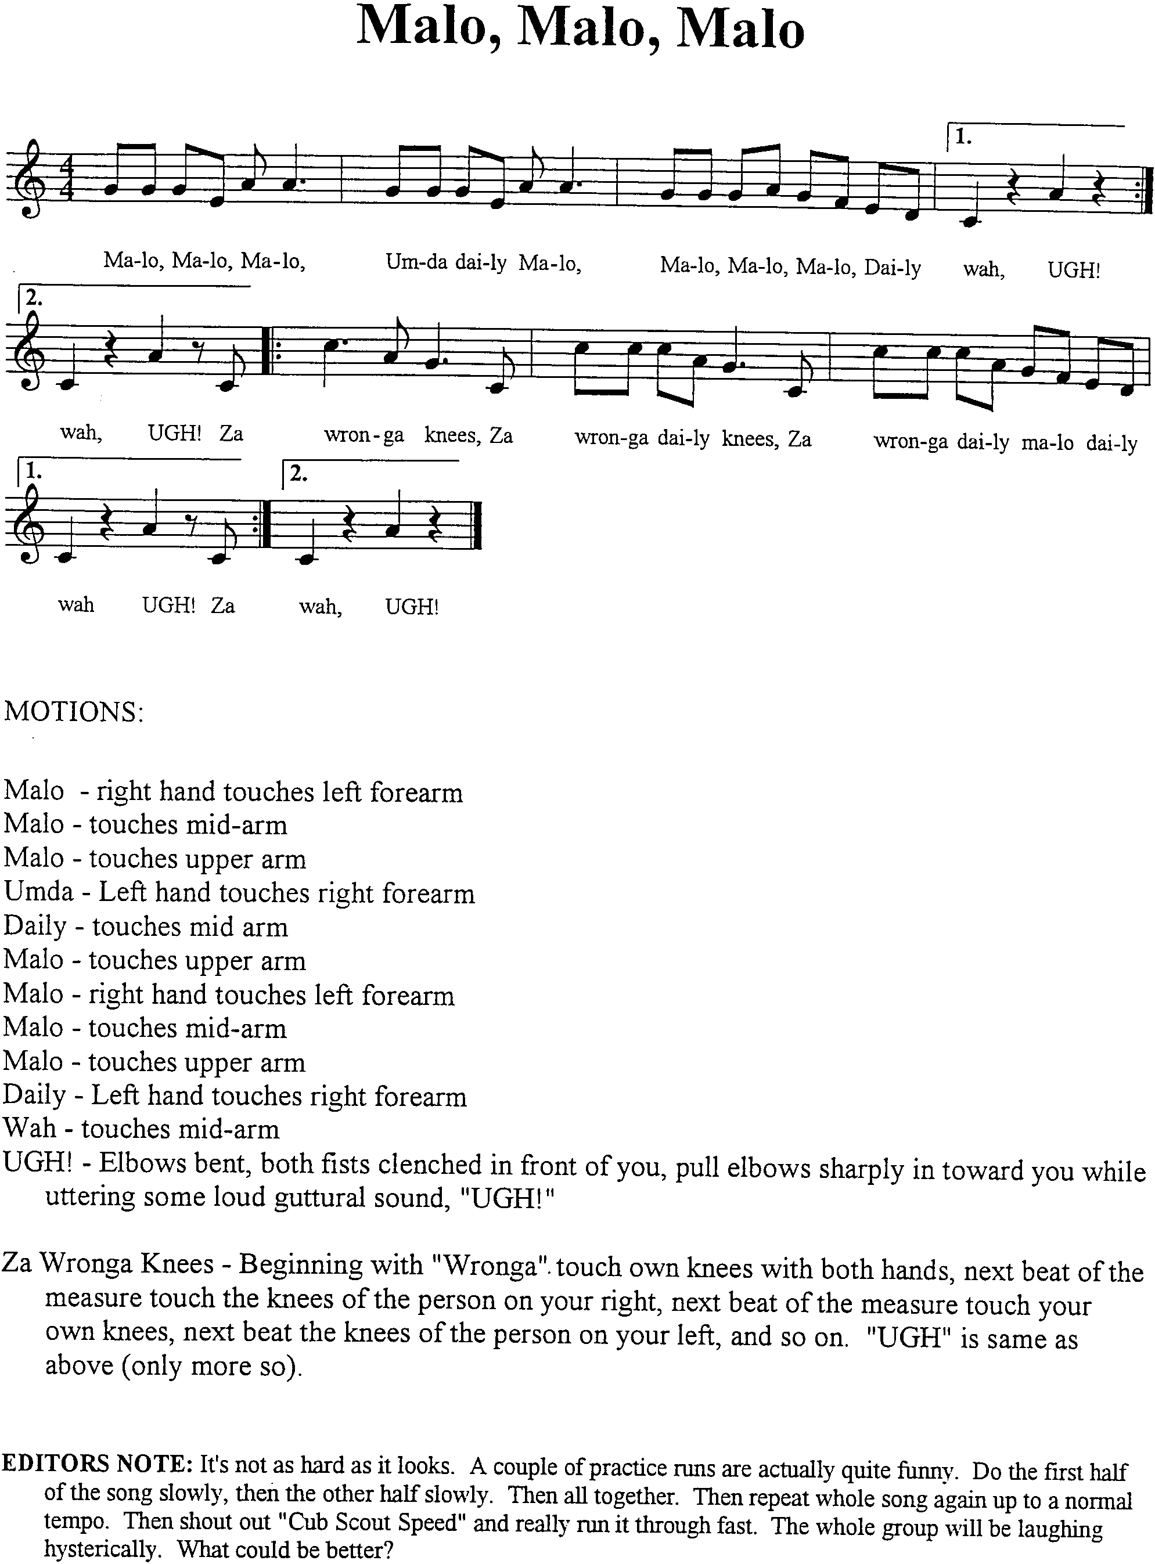

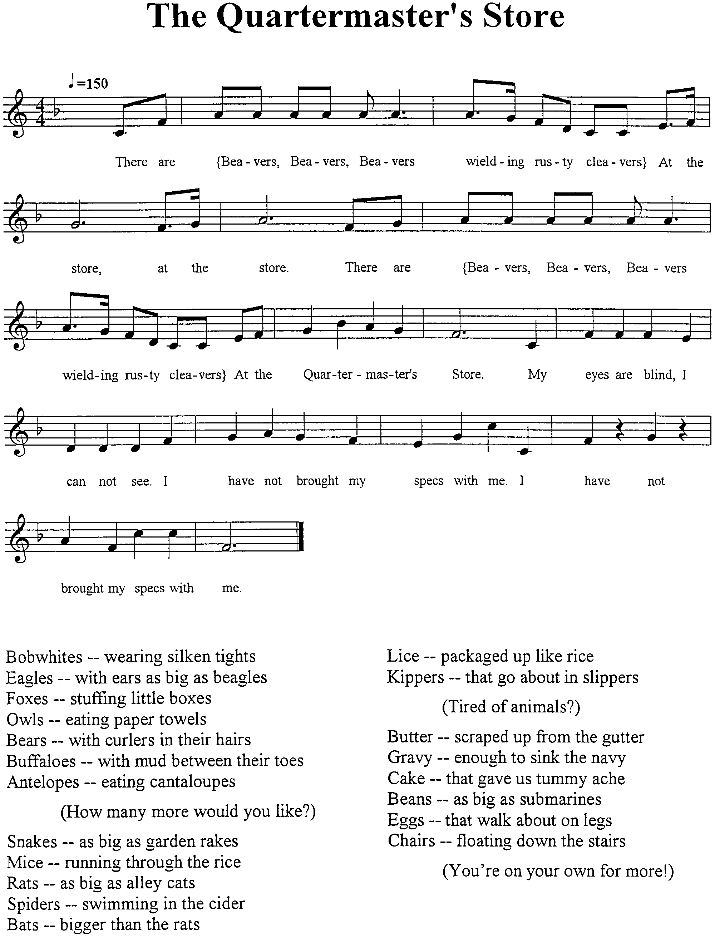

AIN’T THAT FUNKY, NOW?

(This is an “unsung” song. Just chant and enjoy.
Action: While chanting “Hump, tee-Dump...” pat thighs, then clap hands while turning heels out, alternating sides. Continue during nursery rhymes; at end, say, “Whoaaaa! Ain’t that funky, now?” putting hands in air and doing a “Funky” step.)

CHORUS: Hump, tee-Dump, Hump, Hump tee-Dumpty, Dumpty (repeat until you get ready for the next nursery rhyme)

Humpty Dumpty sat on a wall,
Humpty Dumpty had a great fall,
All the King’s horses and all the King’s men
Said, “Whoaaa! Ain't that funky, now?"

CHORUS

Mary had a little lamb
Whose fleece was white as snow.
And everywhere that Mary went,
All the children said, “Whoaaa! Ain't that funky, now?"

CHORUS

Jack and Jill ran up the hill
To fetch a pail of water
Jack fell down and broke his crown,
And Jill said, “Whoaaa! Ain't that funky, now?"

CHORUS

Little Miss Muffit sat on her tuffit
Eating her curds and whey.
Along came a spider and sat down beside her,
And said, “Whoaaa! Ain't that funky, now?"

CHORUS

Little Jack Horner sat in a corner,
Eating his Christmas pie,
He stuck in his thumb and pulled out a plum,
And said, “Whoaaa! Ain't that funky, now?"

CHORUS

(ask audience to come up with other nursery rhymes and continue)

I’D LIKE TO TEACH THE WORLD TO SING

I’d like to build the world a home
And furnish it with love,
Grow apple trees and honey bees,
And snow white turtle doves.

I’d like to teach the world to sing
In perfect harmony,
I’d like to hold it in my arms,
And keep it company.

I’d like to see the world for once,
Walk hand in hand in hand,
And hear them echo through the hills
For peace throughout the land.

It’s the real thing,
What the world wants to say,
That’s the way it will stay.
With the real thing.

CUB SCOUT ORCHESTRA
(Tune: London Bridge)

Use homemade instruments.

We came to our Cub Scout pack.
Cub Scout pack
Cub Scout pack
We came to Pack _____
To play our Kazoo
(play the song with kazoo)

Verse 2: Drums
Verse 3: Tambourines
etc.

OLD MCDONALD HAD A BAND

Old McDonald had a band, E B E B A.
And in his band he had a guitar, E B E B A.
See Cub Scout Songbook for:
“Cub Scout Orchestra”
Fun Songs, Action Songs
With a _____ here, and a _____ there,
Here a _____, there a ____,
Everywhere a ____, ____.
Old McDonald had a band E B E B A.

MUSICAL BOTTLES

Materials: 8 empty 20-ounce bottles; Water

Number bottles 1 through 8. Fill each bottle with the amount of water listed below (water can be colored with food coloring, if desired). You have created a major scale. Line up the bottles and blow across the lip of the bottle to make a sound.

To make your bottle playing a little easier, use a piece of flexible plastic tubing. Hold one end in your mouth and move the other end from bottle to bottle.

--------------------------The Major Scale--------------------------

1 DO 7 ounces
2 RE 9 1/2 ounces
3 MI 12 1/2 ounces
4 FA 14 ounces
5 SO 16 1/2 ounces
6 LA 17 1/2 ounces
7 TI 18 1/2 ounces
8 DO 19 ounces
Row, Row, Row Your Boat
1 1 1 2 3
3 2 3 4 5
8 8 8 5 5 5 3 3 3 1 1 1
5 4 3 2 1

SNARE DRUM

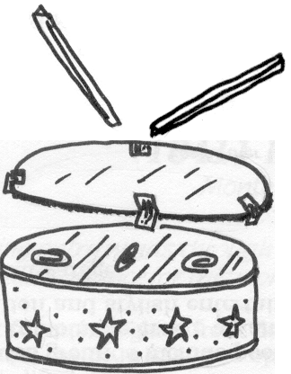
Materials: A metal container (such as a cookie tin or a popcorn can!)—no lid required; A few metal paper clips; Cardboard; Scissors; Masking tape; Decorations (Contact paper, colored/white paper, stickers, markers); Sticks/chopsticks/wooden spoons or pencils.

- Remove container lid. Place container on cardboard, trace around base and cut out the circle.
- Turn container upside down and put 3-4 paper clips on the bottom.
- Tape cardboard over the bottom (enclosing the paper clips).
- Decorate the sides of the tin, if desired, using paper to cover any seasonal designs.
- Play the drum with sticks, chopsticks, etc.

SODA STRAW OBOE

Flatten one end of a large soda straw about 3/4” from the end. Cut the corners of the flat end off diagonally with scissors. Blow gently through the flattened end. To make a higher note, cut off the other end of the straw. The more you cut off, the higher the note.


HUMMER


Cover one end of a cardboard tube with waxed paper. Hold the waxed paper in place with a rubber hand. Touch your lips gently against the waxed paper and hum. If desired, make a few holes on the paper tube.

KAZOO

Materials: 2 tongue depressors (or similarly sized pieces of sturdy cardboard); 3 large, wide rubber bands

- Stretch one rubber band along the length of one of the tongue depressors.
- Take the second rubber band, wrap it a couple of times around one end of the second tongue depressor, then place it atop the first tongue depressor, and finish wrapping the rubber band around both.
- Wrap the third rubber band around the other end of first one tongue depressor, then both.
- To play, hum/blow into the gap between the two tongue depressors.

BANJO

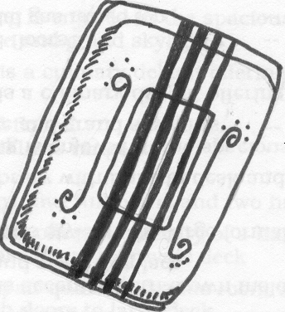
Material: 2 same-sized styrofoam meat trays; 4 rubber bands of various widths (and long enough to span the length of the trays); Scissors; Glue; Decorations (stickers, pencils/ball-point pens)

- Cut a 2” x 4” rectangular piece from the middle of one tray.
- Glue the two trays together along the rims (face to face).
- Stretch the rubber bands lengthwise around the trays, over the rectangular opening. (The thinner rubber bands will produce higher sounds.)
- Decorate the banjo with stickers or use pencil or pens to “carve” designs.
- Strum along rubber bands to play.


GUIRO

A Guiro is a Brazilian instrument made of wood with rows of notches cut or carved around its center part. A small scraping stick is rubbed against the sides to produce a rough-edged sound.

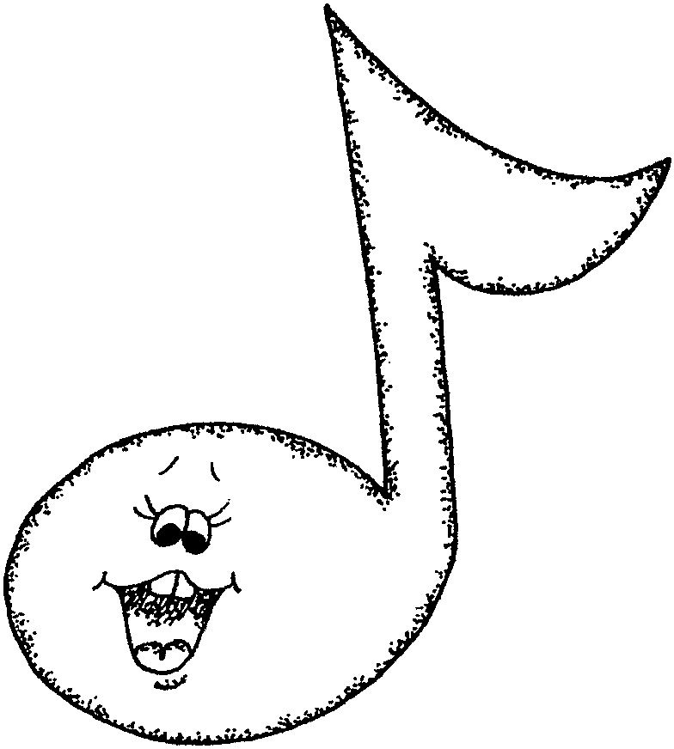

You can make your own guiro with corrugated paper. Since the paper already has ridges on at least one side, you have a ready-made guiro just waiting to be assembled! Take a 6” x 12” piece of corrugated paper. Roll it into a cylinder and secure the edges with staples or tape. Make sure the ridges go in the direction shown. To play the guiro slip your hand into the corrugated “sleeve.” The use a small stick or pencil to scrape against the sides.

CRAFT FOAM NOTE NECKERCHIEF SLIDE

Cut the pattern out of any color craft foam you want.
Draw a face with a fine-tipped permanent marker (Sharpie).
For eyes, either draw them with a black marker and a white pastel pen,
or glue wiggle eyes. Use red Sharpie for the tongue.
If desired, outline the note with marker, gel pen, glitter glue or puff paint.

SOUND BOX

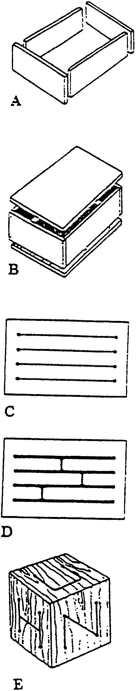
See also the “Drum box” on the following page.

This instrument is based on an ancient Aztec drum used in initiation rites and ceremonies.

Materials:
- Two slabs of softwood or hardwood, 1/4” thick. Wooden roofing shingles have been used with success. A hardwood top will produce a sharper tone than softwood which produces a mellow, less resonant sound. The larger the sound-box, the more resonant the tone and more definite the pitch. Tone depends also on thickness and length of tongues. Use thicker tops for larger boxes.
- 1/2” stock for sides of sound-box
- Glue
- 1” finishing nails or clamps, rubber bands, and weights.

Tools: Saw; Keyhole saw or jigsaw; Drill with a 1/4” bit; Hammer (if nails are used); Finishing materials.

ASSEMBLY
- Cut wood to be used for the sides to desired length (Fig. A).
- Glue and nail (or clamp) sides to the bottom slab (Fig. B) being careful to get a tight and solid fit since the instrument will be struck with mallets. Let dry.
- The top may be glued onto the box at this point and then tongues cut (Fig. B) (this procedure is best if you want to tune each tongue as you cut) or the tongues may be cut first then glued to the sound-box.
- On the top piece of wood, drill a row of 1/4” holes across the top about 1” in from the edge, leaving about 1” between holes (Fig. C). Arrange the holes so as to result in three tongues on each end (though more or less tongues may be desirable).
- Repeat this process across the opposite edge.
- Using a keyhole saw or jigsaw, join the holes opposite each other with a saw cut (Fig. C).
- Then create a series of “Hs” or tongues of wood by cutting at right angles to the previous cuts (Fig. D). The resulting tongues should be of unequal lengths for different tones.
- Glue top to sound-box if this has not been done previously, making sure to get a good tight bond since the instrument will be struck.
- Sand off excess edges and round the corners.
- Finish with varnish, oil, or lacquer. Follow the manufacturer’s directions.

See also Cub Scout Leader How-To Book (pp. 3-48 to 3-51)
and Bear Cub Scout Book (Elective 8) for more musical instruments.

DRUM BOX

Materials: 4 rectangular pieces of wood, all the same size, about 1/2 to 1” thick; Nails; Wood glue; Keyhole hand-saw, skill saw or jigsaw; Hammer; Drill

- Put the pieces of wood together to form a box with two open ends (Fig. 1). Use a little glue and nails.
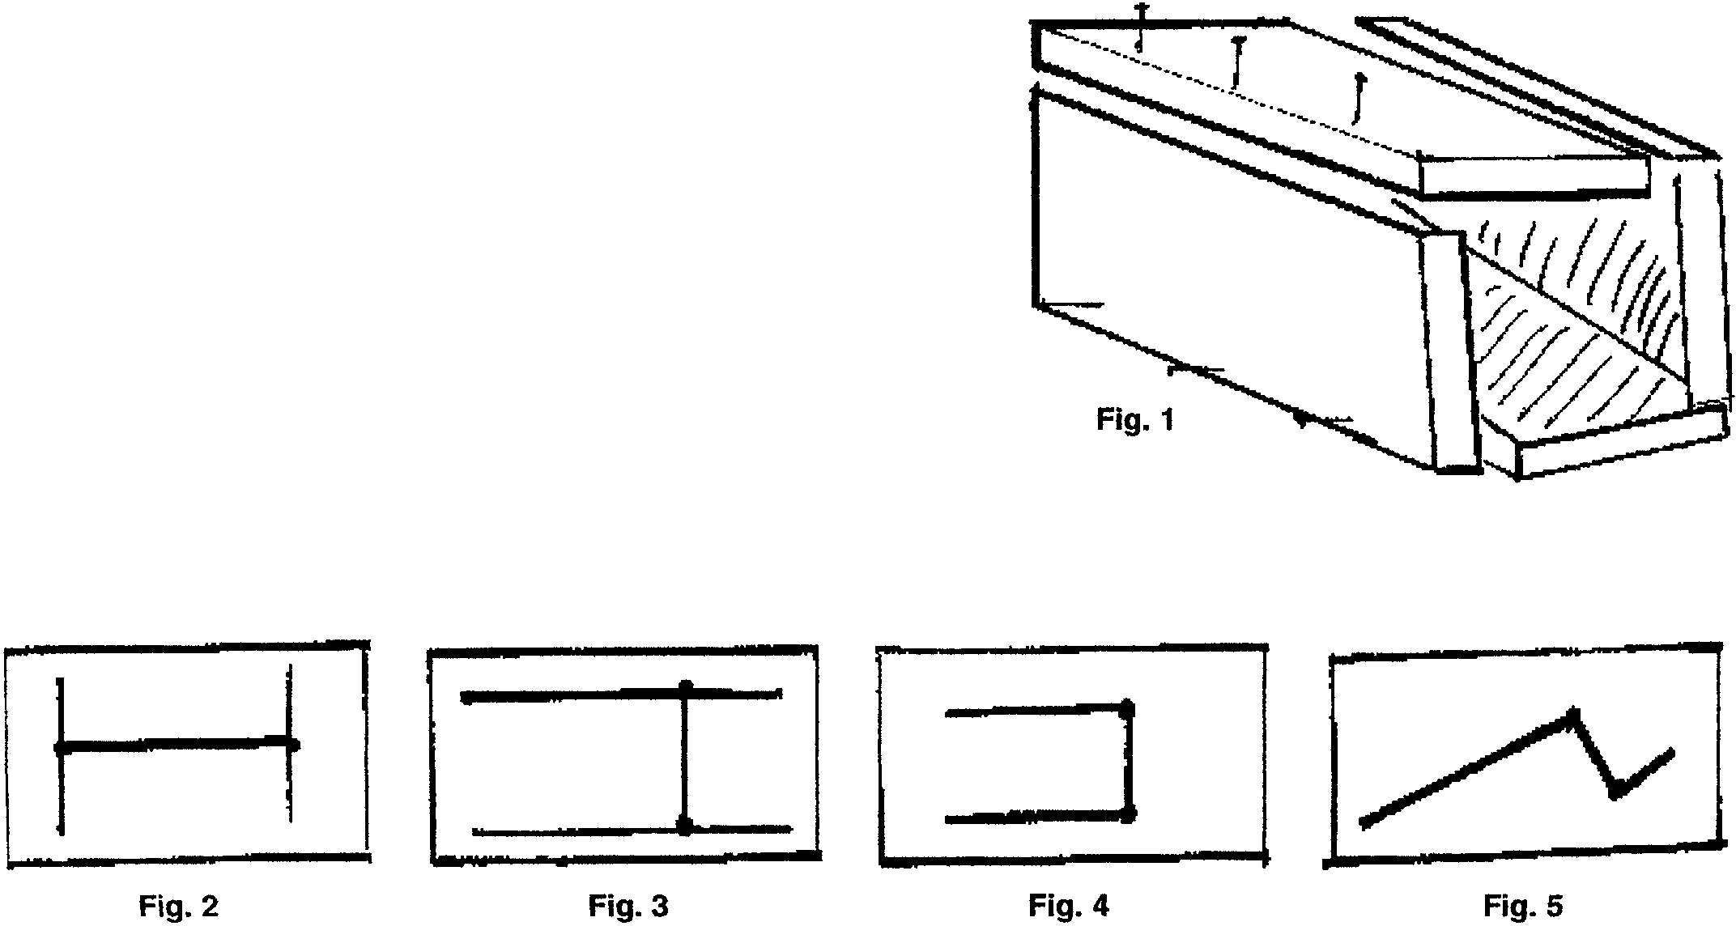
- On each surface of the box, draw patterns as shown in Figures 2-5. The patterns do not have to be exact. You may want to make the patterns before
you construct the drum.
- Use a drill to start each slot, completely through the wood.
- Sand the slots to remove splinters and rough edges.
- Test each side of the drum. Each will have a different sound.
Use your knuckles, a big spoon, or a stick for a beater.
- If one side does not sound good, change the slot by cutting it bigger, 1/4” at a time.

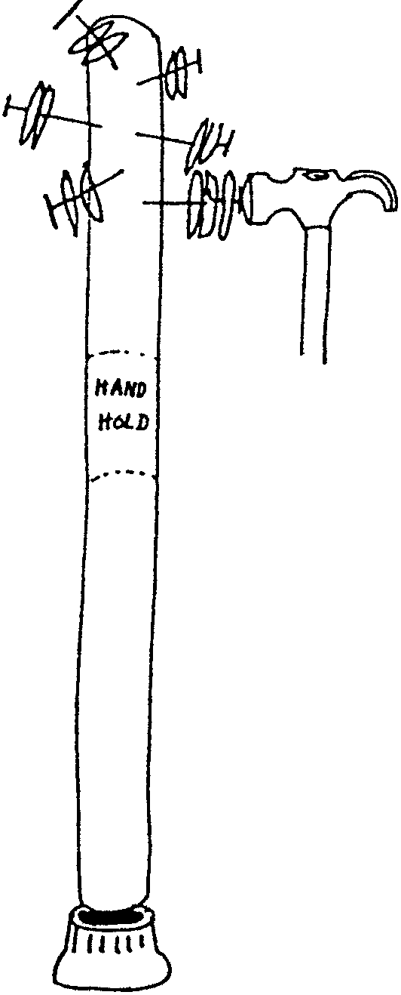

LAGERPHON

Materials: Broomstick; Nails; Bottle caps; Rubber chair coaster.

- Use a thick broomstick and some thin nails with heads.
- Flatten bottle caps with hammer.
- Make big nail holes in bottle caps so caps will clap and slide on nail easily.
- Slip 2 or more caps on each nail; then hammer into broom stick.
- Leave a section free of nails for the hand hold.
- Put a rubber chair coaster or crutch cap on the end so you can tap stick on the ground.

MILK CARTON GUITAR
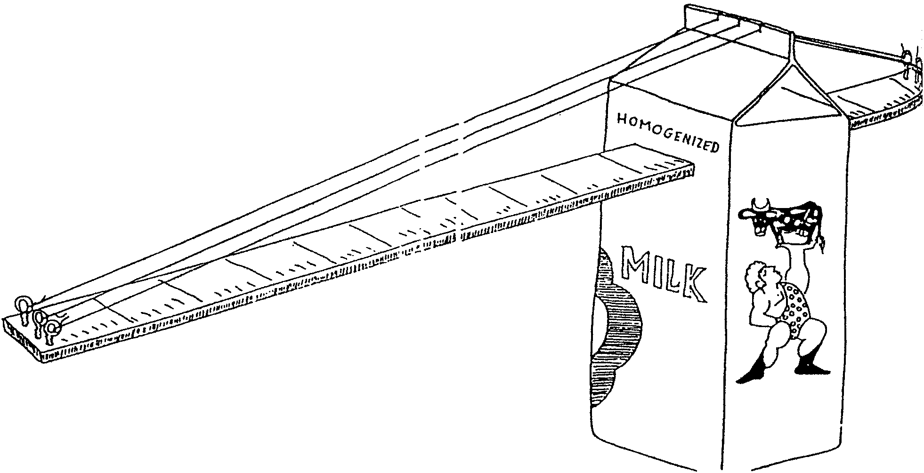
Materials: A yardstick; Milk carton; 6 screw eyes; Some fishing line

- Cut slots about 1” from the top. Insert the yardstick
through the carton.
- Cut slits on top of the milk carton for
the strings.
- String fishing line from one end of the yardstick to the other.
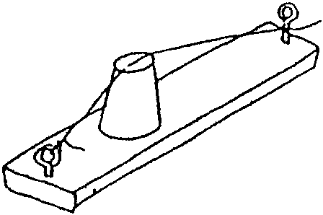
- The screw eyes provide you with a way to tighten the string.
- To play: strum or tap.

A simpler guitar may be made with a board, a cup and two screw eyes.

ZIP-LOC FUDGE

Zip-Loc Sandwich bag (For active hands, use a quart freezer bag)
4 Tablespoons powdered sugar
1 Tablespoon butter (1/8 stick)
2 teaspoons cream cheese
Few dashes of vanilla
1/2 to 1 Tablespoon cocoa

Put all ingredients in the bag, squeeze out air, zip, and “smoosh” ingredients together until well blended. If desired, add mini M&M’s, raisins, peanut butter, etc.
This is a single serving recipe.

ZIP-LOC ICE CREAM

Place in a quart Zip-Loc freezer bag:
1/2 cup milk or cream
1 Tablespoon sugar
1/4 teaspoon vanilla

Seal bag. Place the bag inside a gallon Zip-Loc freezer bag with:
2 handfuls of ice
6 Tablespoons rock salt

Shake, rattle and squeeze for about 5 minutes. Dig in!!

If desired, you can add other flavorings like chocolate syrup, frozen or fresh strawberries, or slices of canned peaches.

CUB SCOUT HOMEMADE ROOTBEER

1 bottle Root Beer extract
5 gallons water
5 pounds sugar
5 pounds dry ice

30 minutes standing time

Use a 10-gallon container. The mixture will EXPAND.
Make a syrup out of 1 gallon warm water and sugar.
Add 4 more gallons of water. Stir.
Add root beer extract. Stir.
Add dry ice and leave uncovered for 30 minutes.

