Participation Awards

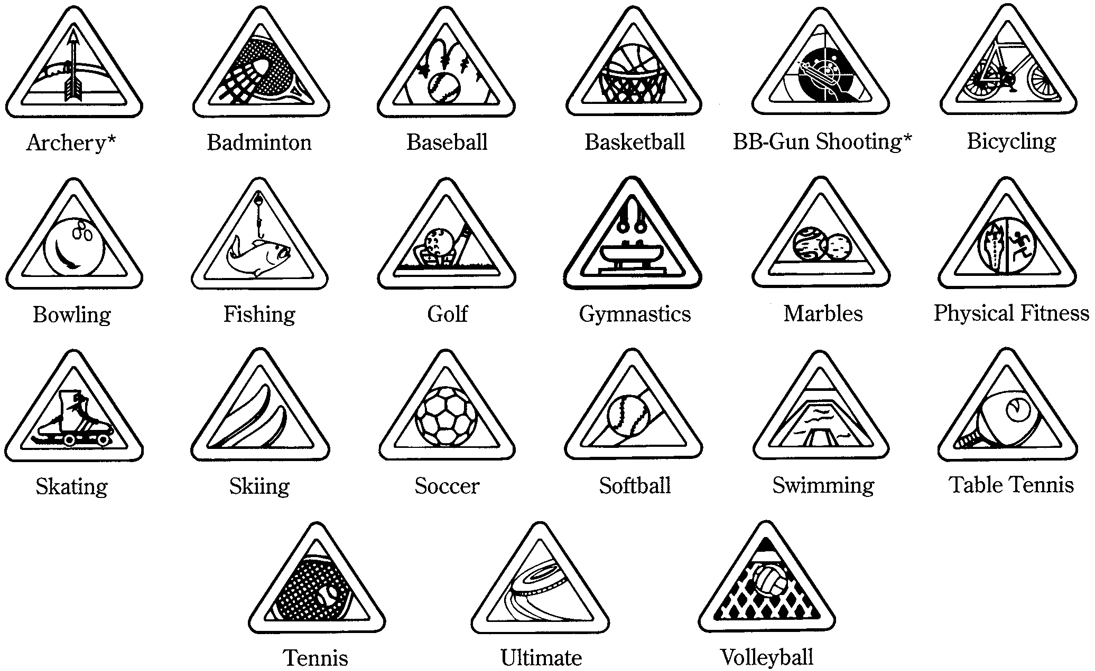





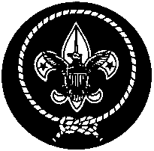


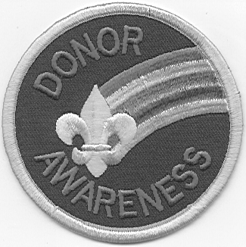
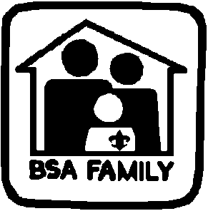

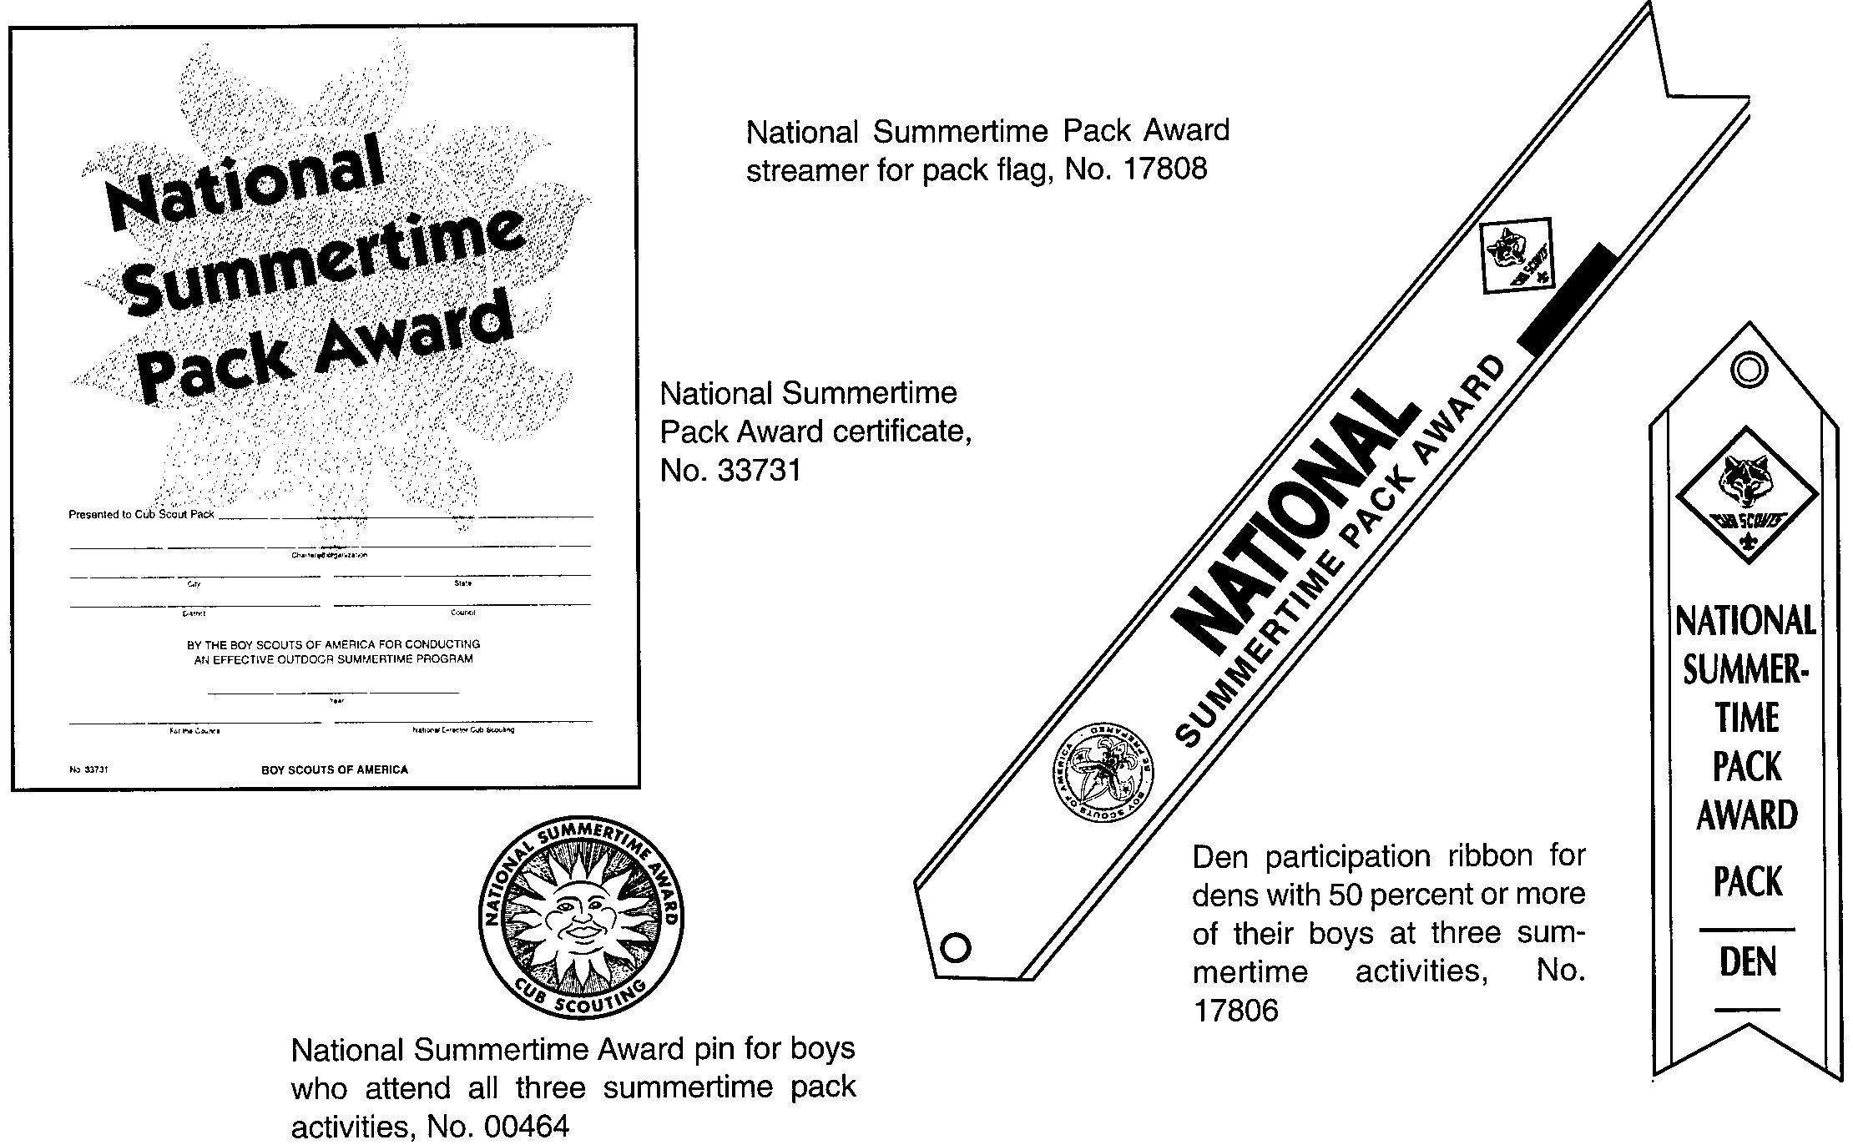

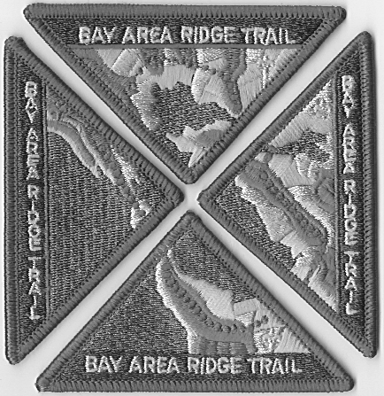

PARTICIPATION AWARDS FOR
CUB SCOUTS, DENS AND PACKS

BSA Family Program 1
Cub Scout Academics and Sports Program 2-3
Religious Emblems Program 4-5
Cub Scout World Conservation Award 6-7
Conservation Good Turn 8
International Activity Patch 9
Donor Awareness Patch 9
BSA Crime Prevention Program 10-11
Earthquake Awareness Program 12
Bay Area Ridge Trail 13
Trail Trekkers 14

National Den Award 15
National Summertime Pack Award 16
Cub Scout Pack National Quality Unit Award 17
Commissioners Challenge Award 18

BSA FAMILY PROGRAM

Cub Scouting is a family-based program. The family’s involvement is a key ingredient to a successful program. The purposes of Cub Scouting’s BSA Family Program are to strengthen families and encourage family involvement in Scouting. It is designed to help all families--whether traditional two parent, single parent, or non-traditional--and all family members may participate. A family can earn the BSA Family Award using the Cub Scouting’s BSA Family Activity Book (No. 33012) as a guideline. A Cub Scouting family may choose to participate in this program on its own, or the pack may choose to introduce the program to families through an orientation.

To earn the BSA Family Award, a family must complete 10 activities within a 12-month period. There are five categories:
- Learning Through Fun and Adventure.
- Strengthening Family Relationships
- Developing Character
- Teaching Responsibility
- Handling Difficult Situations
Each category has several topics. For each topic several activities are suggested. These activities could include going on field trips; telling stories; doing arts and crafts projects; playing games, participating in family discussions, or making lists, charts, and scrapbooks. A family completes one activity each for two topics in each category.

Family members may earn the BSA Family Award several times. A family may choose the same or different activities as they work on the award for another 12-month period.

Score Sheet for Family Award is included in the Cub Scouting’s BSA Family Activity Book. Certificates, patches and pins are available at the Scout Shop.

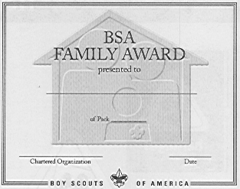

Pack leaders are encouraged to become familiar with the BSA Family Program and promote it within the pack. For more information, please refer to Cub Scout Leader Book, pp. 15-2 to 15-5.

Present the award to the family in a pack meeting. (See Cub Scout Ceremonies for Dens and Packs, “BSA Family Award” p. 10-4). If this is not possible, the award may be presented by a member of the pack committee in an appropriate setting mutually agreed upon.

CUB SCOUT ACADEMICS AND SPORTS PROGRAM

The Academics subjects and Sports activities allow boys to learn new techniques, increase scholarship skills, develop sportsmanship, and have FUN. Boys participating in the program will be recognized for enjoying teamwork, developing physical fitness, and discovering and building new talents. The Cub Scout Academics and Sports program encourages a boy to do his best.

The Cub Scout Academics and Sports program is based on the following concepts and guidelines:
- The program supplements the existing advancement and recognition program for Tiger Cubs, Cub Scouts, and Webelos Scouts; it does not replace it. The program is one element of Cub Scouting, as are den and pack meetings, day camp, and other activities.
- All registered Tiger Cubs, Cub Scouts, and Webelos Scouts have an opportunity to participate in the Academics and Sports program.
- Participation may take place at home, with the family, or within a den, a pack, or the community.
- Adult participation by a parent or adult relative, if possible, is strongly recommended for Cub Scouts and Webelos Scouts, and is required for Tiger Cubs.
- Emphasis is placed on introducing a boy to a sport or academic subject, allowing him to participate in it and encouraging him to do his best. The Academics and Sports program focuses on learning and skill development, not winning.
- The primary focus of the program is on scholarship and sportsmanship.
- Each Tiger Cub, Cub Scout, and Webelos Scout will be presented with the appropriate recognition item for completing the requirements, whether he does so as an individual Scout, with his family, with his den or pack, or in his school or community.
- The Academics portion of the program covers a variety of subjects. (See below)
- The Sports portion of the program includes summer and winter sports, indoor and outdoor sports, active and less-active sorts, and team and individual sports. (See below)
- Cub Scouts with disabilities may select their own activities and design their own fitness or academic program with the help of a physician, teacher, or parents.

Each activity has two levels of involvement: first, the belt loop, and second the pin.

The Belt Loop: There are three specific requirements for each belt loop. As a Cub Scout completes these requirements, he is encouraged to do his best to learn about the activity.

The Pin: Once the boy has earned the belt loop, he may choose to stop; however, some boys will want to continue with the activity. A Tiger Cub, Cub Scout, or Webelos Scout may complete additional requirements to earn a pin.

For more information and requirements for specific academic subjects or sports, please refer to Cub Scout Academics and Sports Program Guide.

CUB SCOUT ACADEMICS

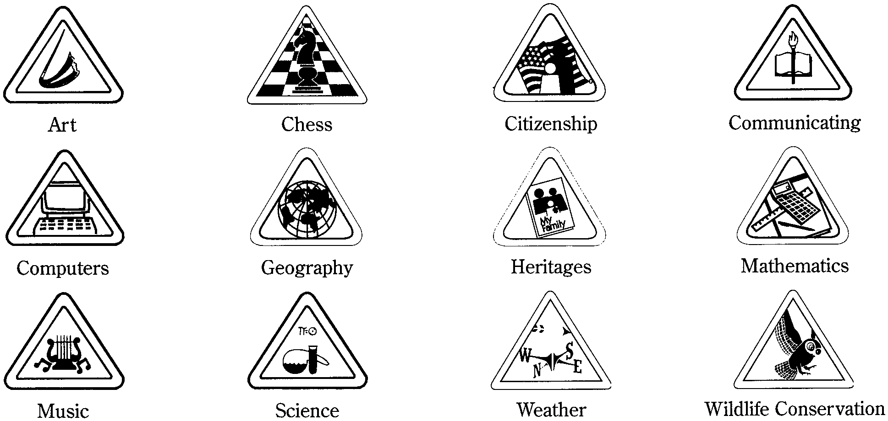

CUB SCOUT SPORTS

* Loops and pins for archery and BB-gun shooting can be earned only in council-sponsored camps.

Present the award with an appropriate ceremony. See Cub Scout Ceremonies for Dens and Packs, “Academics and Sports Awards” p. 10-3.
RELIGIOUS EMBLEMS PROGRAM

Tiger Cubs promise to love God, Cub Scouts promise to do their best to do their duty to God, and Boy Scouts repeat their oath to do their best to do their duty to God. And the Scout Law states that a Scout is reverent. From its beginning the Scouting movement has encouraged its members to be faithful in the practice of their religions. The BSA does not define what constitutes belief in God or the practice of religion. Rather, it provides a program and ideals that complement the aims of all religions.

Most of the major religious bodies in the United States have programs to recognize Cub Scouts who demonstrate faith, observe their creeds or principles, and give service. The religious emblems are not Scouting awards. They are presented by religious groups to boys who work with their religious leader or counselor on a program of requirements that often takes a year or more to complete.

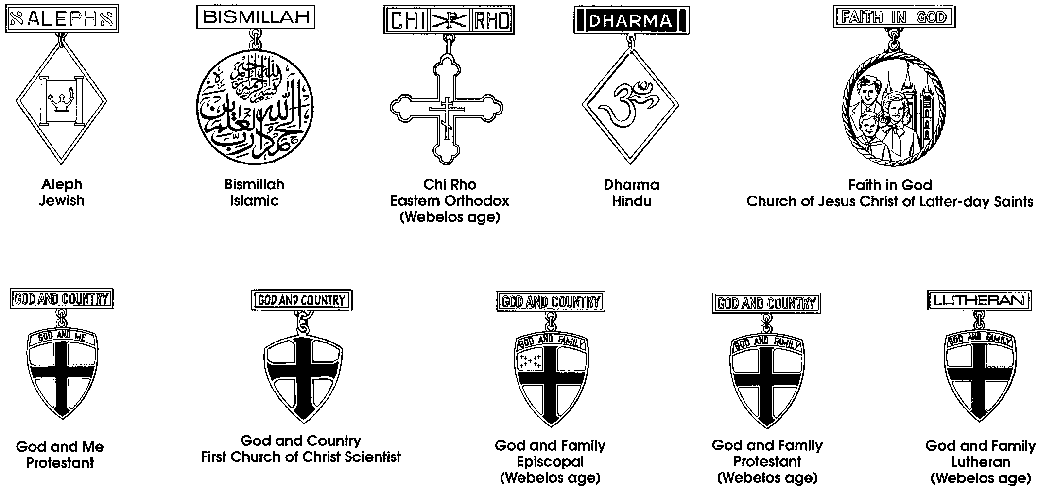
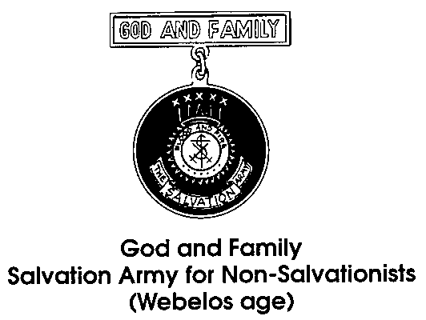
A list of religious emblems available to Tiger Cubs, Cub Scouts, and Webelos Scouts can be obtained form the council service center or Scout shop.

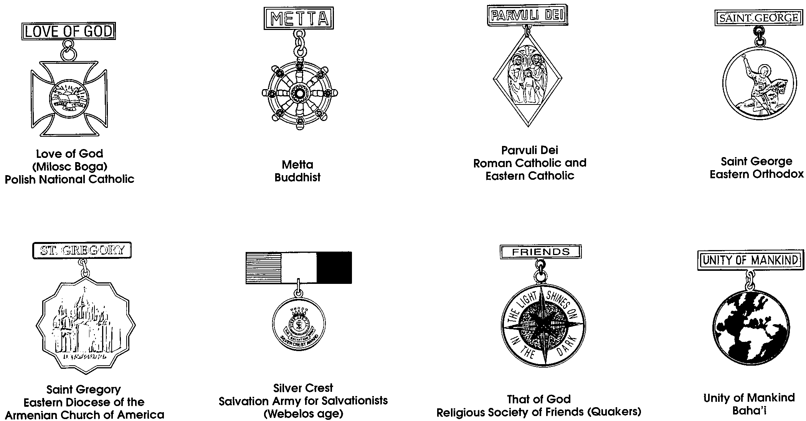
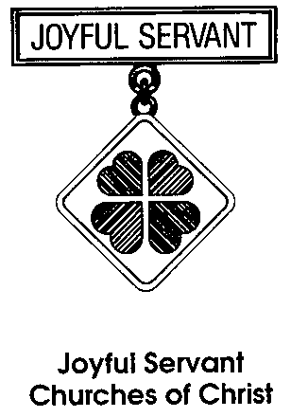
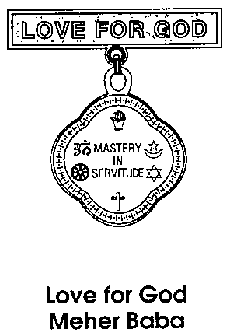

The emblem should be presented in a meaningful ceremony, preferably in the boy’s religious institution. Some emblems come with a sample presentation ceremony. The boy’s achievement should be recognized at the pack meeting as well.

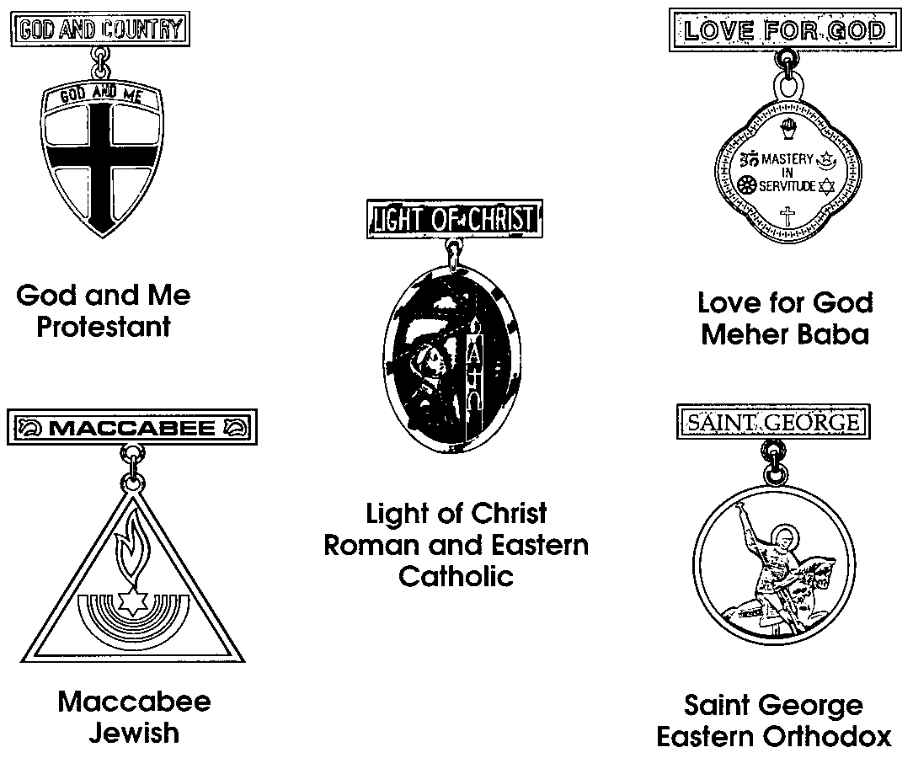

Religious emblems that Tiger Cubs may earn.



BAHA'I
Don Burt (408) 997-2621

BUDDHIST
Rev. Gerald Sakamoto (San Jose Betsuin Buddhist Church) (408) 293-9292
George Imokawa (408) 984-1035

CATHOLIC
Ann Resch (408) 227-8587
Jose Saleme (408) 255-9966
Frank Diaz (408) 779-0823
Jerry Panec (Stanford District, Pacific Skyline Council) (650) 967-0983

JEWISH
Ann Tavan (408) 867-5797

LDS
Max Parker (Local Ward Bishop) (408) 264-4024

PROTESTANT DENOMINATIONS
Contact your Council District Executive for assistance.
CUB SCOUT WORLD CONSERVATION AWARD

The World Conservation Badge was launched in 1974 and is now in use in over 40 countries. This is essentially an activity or involvement badge, awarded to Scouts at different levels (Cub Scout, Boy Scout). It is designed to encourage more conservation awareness and action among Scouts and greater participation in conservation projects.

Wolf, Bear and Webelos Scouts who have participated in either a den or pack conservation project and have completed certain requirements can earn the World Conservation Award. This award is earned only once as a Cub Scout.

A Cub Scout may earn this award as a Wolf, Bear or Webelos Scout. Requirements are different for each rank. They are listed in the boy’s handbooks, Wolf Cub Scout Book (p. 216), Bear Cub Scout Book (p. 259), and Webelos Scout Book (p. 436). Here is the summary:

- Wolf Cub Scouts complete Wolf Achievement 7 (Your Living World). They should complete all elective projects in two of the following:
Elective 13 (Birds)
Elective 15 (Grow Something)
Elective 19 (Fishing)

- Bear Cub Scouts complete Bear Achievement 5 (Sharing Your World with Wildlife). They should complete all elective projects in two of the following:
Elective 2 (Weather)
Elective 12 (Nature Crafts)
Elective 15 (Water and Soil Conservation)

- Webelos Scouts earn the Forester, Naturalist and Outdoorsman activity badges.

- In addition, ALL Cub Scouts also need to take part in a den or pack conservation project appropriate for their age groups.

Application for this award may be obtained at the Council Service Center. It is also reproduced on the following page.

Present award in an appropriate ceremony. See Cub Scout Ceremonies for Dens and Packs, “World Conservation Award “ p. 10-4

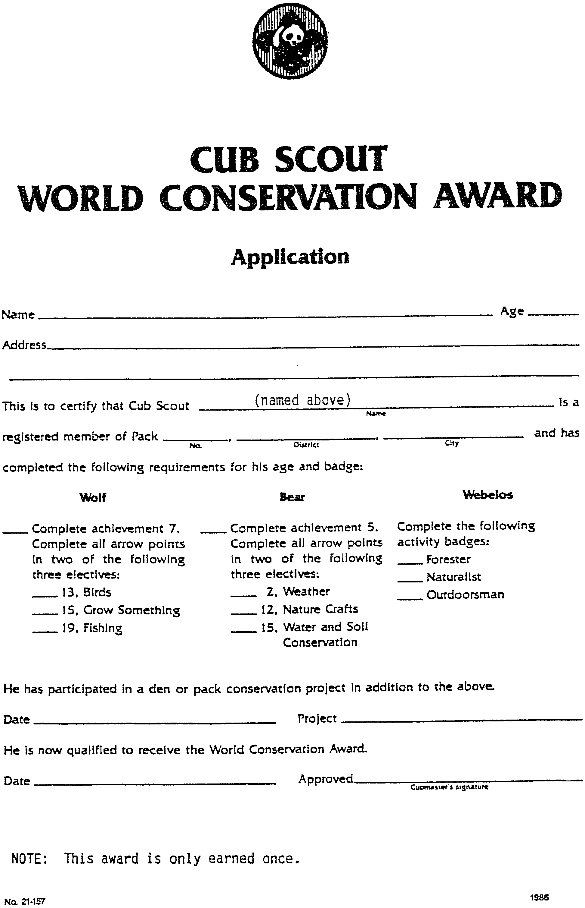
CONSERVATION GOOD TURN

The Conservation Good Turn is an opportunity for Cub Scout packs to join with conservation or environmental organizations (federal, state, local, or private) to carry out a Conservation Good Turn in their home communities.

Cub Scout conservation projects should involve the entire Cub Scout pack, each den, adult leaders, and family members. Hands-on projects help Scouts realize that EVERYONE can do things to care for the environment. Scouts participating in the Conservation Good Turn can also meet some advancement requirements. For suggested projects, see APRIL “Theme Related” section in this book.

- The pack contacts a conservation agency and offers to carry out a Good Turn project.
- The agency identifies a worthwhile and needed project that the pack can accomplish.
- Working together in the local community, the pack and the agency plan the details and establish the date, time, and location for carrying out the project.

At the completion of the conservation project, submit an application to the council service center for a Conservation Good Turn certificate. A Conservation Good Turn patch is also available for purchase at the Scout Shop to recognize individual youth and adult members who participate in a meaningful conservation project.

Brochures and application form (reproduced below) are also available at the council service center.

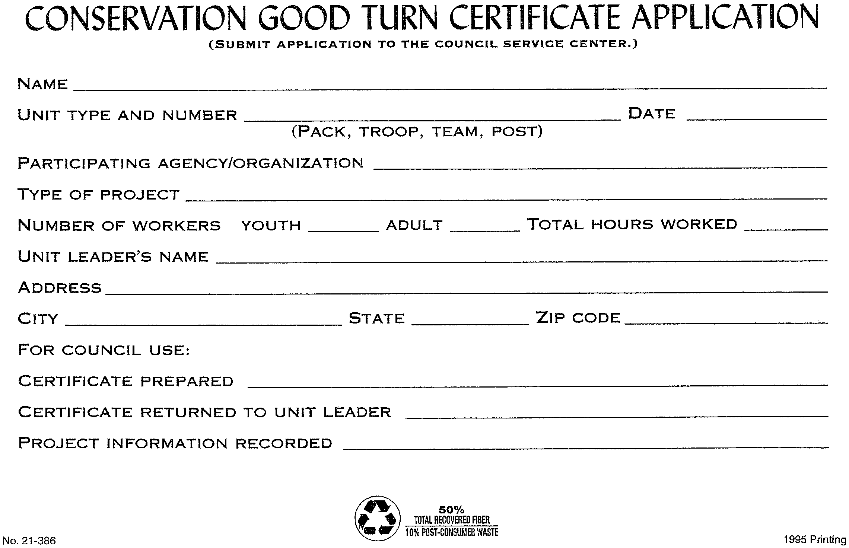
INTERNATIONAL ACTIVITY PATCH

The International Division of the BSA suggests that at least four of the following nine items be completed before the patch can be worn. Some of the requirements are more suited for Boy Scouts, but requirements 1, 2, 7, 8, and 9 may be completed by Cub Scouts as a den or pack. Requirement 4 may be completed in conjunction with a local Boy Scout troop. Some councils also have requirements specific to that area. There are no local requirements for the Scouts in the Santa Clara County Council.

- Host a group of foreign students at a dinner, a meeting, or a campout weekend where activities are planned so that you learn about their country/countries.
- Plan and execute an international dinner.
- Participate in an international Scout jamboree/camporee.
- Host a group of Scouts on tour in your area.
- Visit a local Scout group while your Scout group is touring another country.
- Participate in Jamboree-on-the-Air.
- Experience with your group the World Friendship Fund campfire program.
- Donate to the World Friendship Fund.
- Visit a foreign embassy or consulate and learn about its function.

There is no application form for this patch. Upon completion, purchase the patches at the Scout Shop and present them at a pack meeting with an appropriate ceremony.

DONOR AWARENESS PATCH

Thanks to modern medical techniques, many people can benefit from the transplant of organs and tissues. A transplanted cornea, for example, can give sight to a blind person. Liver, heart, and lung transplants can save many lives, and new transplant opportunities are being developed all the time.

The purpose of this patch program is to heighten awareness of organ donation. Cub Scout families, dens or packs can have an activity to heighten this awareness. Read about organ donation or have a guest speaker at the meeting. You may want to contact a local donor organization.

There is no application or brochure for this patch program. After an awareness activity, purchase patches at the Scout Shop and present them at a pack meeting.

BSA CRIME PREVENTION PROGRAM

Reproduced below is the Crime Prevention Guidelines. Requirements for the Crime Prevention award are listed on the application form on the following page.

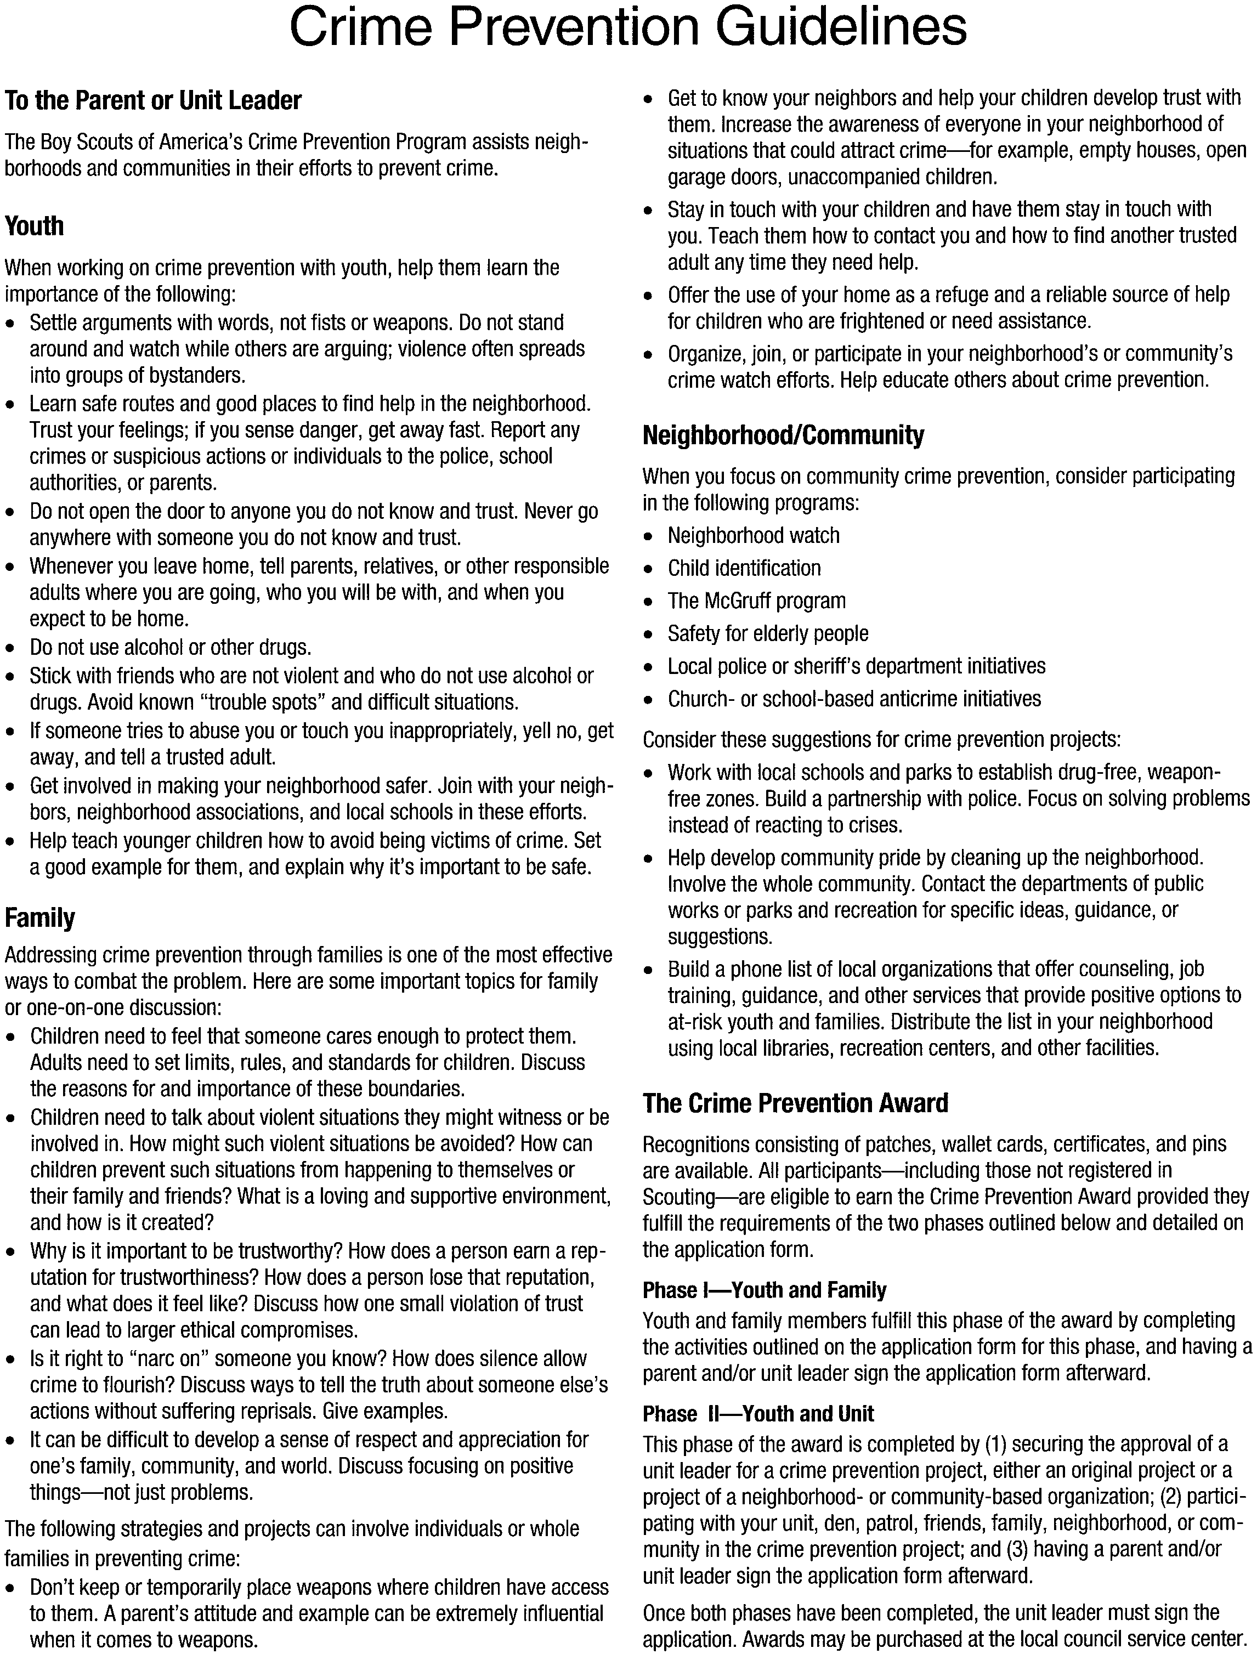
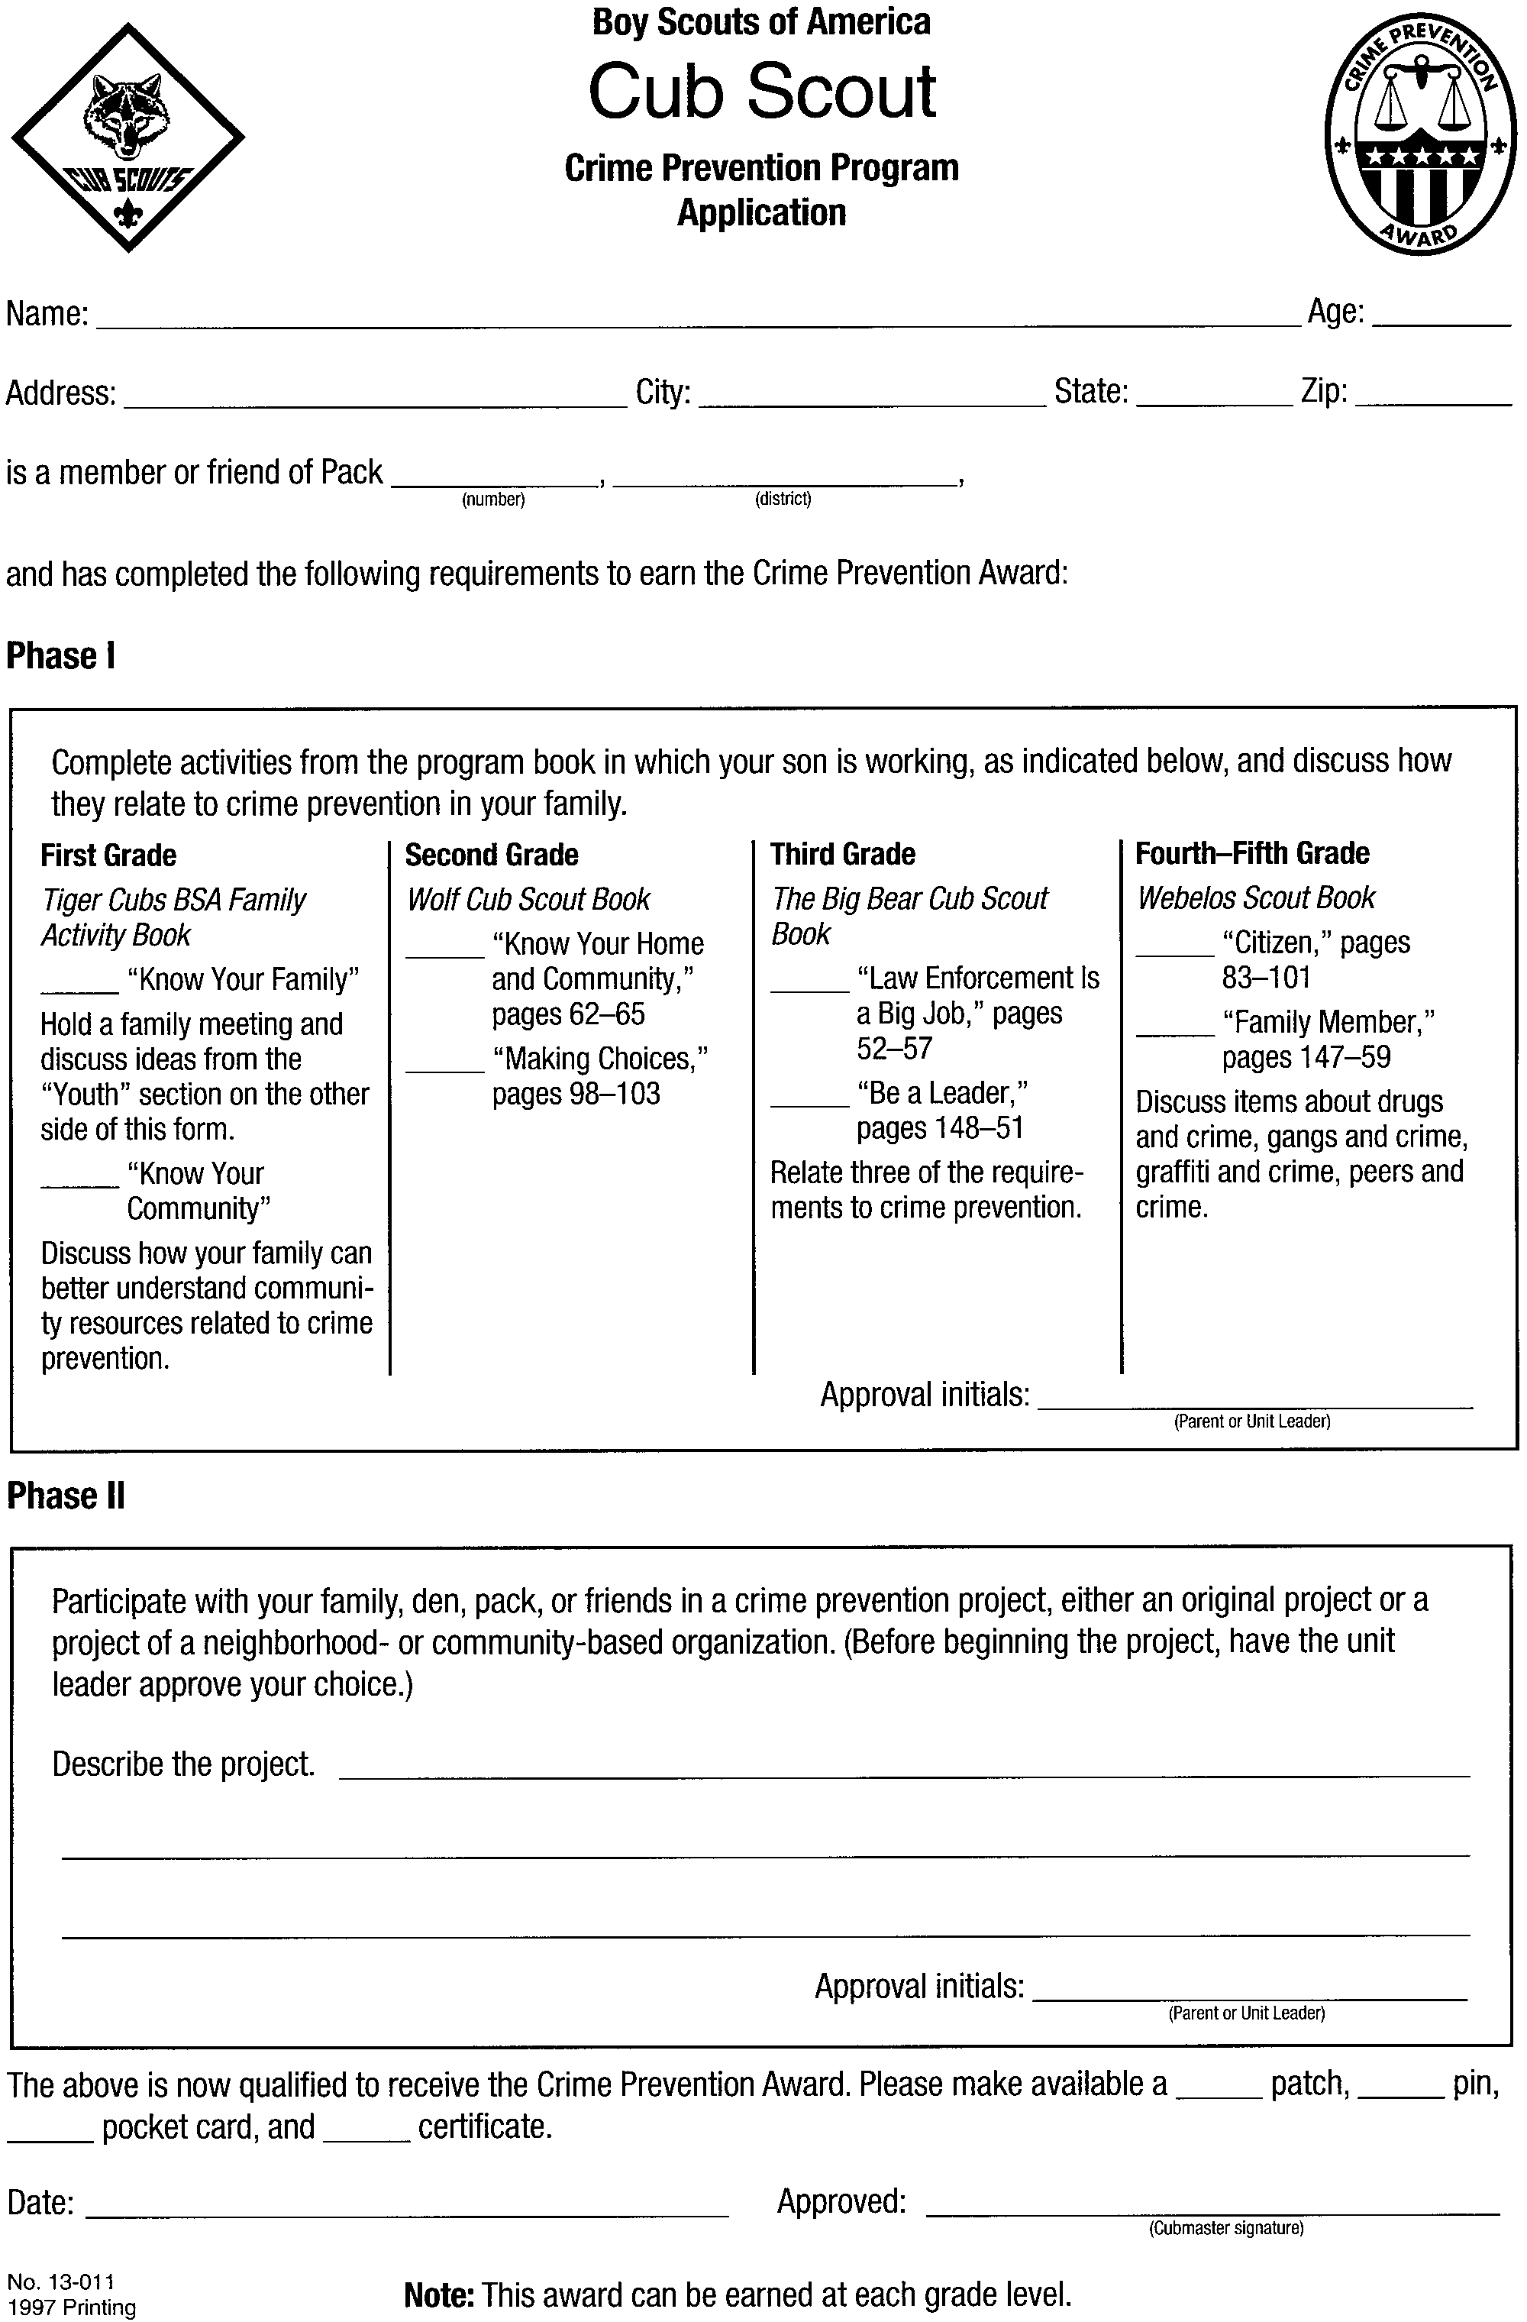
EARTHQUAKE AWARENESS PROGRAM

This is a program specific to Santa Clara County Council. The objective of the program is to learn more about the threat of an earthquake, how to be prepared for an earthquake and how to help others if an earthquake occurs.

The program is designed for three age groups: Cub Scouts, Webelos Scouts, and Boy Scouts. For each age group there is a set of requirements for the boys to complete to earn the patch. It is recommended that the boys earn all three patches as each level is progressively more difficult and challenging.

The leader’s guide for this program is available for 50 cents at the front office of the council service center. This 22-page leader’s guide includes earthquake project requirements for Cub Scouts, Webelos Scouts and Boy Scouts; information on the causes of earthquakes: how to be prepared for an earthquake; what to do during the quake; what to do afterward; field trip ideas; and additional resources. Also attached at the end of the leader’s guide is a patch order form to be filled out upon completion.

The patches are available at the Council Scout Shop.

Cubs Webelos Boy Scouts

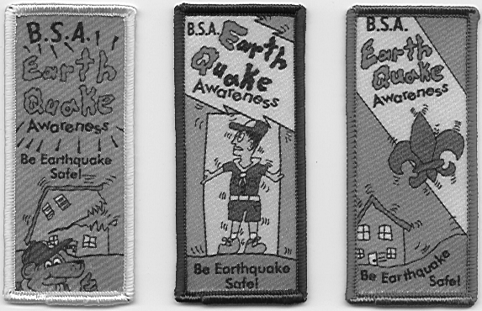
BAY AREA RIDGE TRAIL

This patch program was created by the High Adventure Team of the Santa Clara County Council.
It is open to school classes, Girl and Boy Scout groups, church youth groups and other youth organizations.

The Bay Area Ridge Trail today is represented by more than 35 public trails totaling over 200 miles in length. Someday this Trail will be a continuous public trail system for hikers, mountain bikers and horseback riders along the ridges circling San Francisco Bay. The trails vary from short, easy walks to challenging hikes.

The patch program comes in four segments representing four quadrants of the Bay Area. A segment is earned by hiking or biking a section of the Ridge Trail in each of the quadrants. To qualify for a segment, a Cub Scout must hike or ride at least one mile. Alternatively, a segment can be earned by performing trail maintenance or construction under the supervision of the public land agency responsible for that part of the trail. Youths under 11 years old must work one hour.

For more information on the trails and patch orders, please ask at the front desk of the Council Service Center. Trail information is also available at http://www.ridgetrail.org. Patches are available at the Scout Shop.

TRAIL TREKKERS

This program is for Cub Scouts and is offered by the San Francisco Bay Area Council.
The Trail Trekker Program offers seven day hikes and one night hike which can be completed by Cub Scout age boys (from 6 to 11 years) and their families. The hikes are located throughout the Bay Area:

Coyote Hills Coyote Hills Regional Park, Fremont
Flag Hill Sunol Regional Wilderness, Sunol
Hoot Owl Sycamore Grove Regional Park, Livermore (night hike)
Little Yosemite Sunol Regional Wilderness, Sunol
Redwood Creek Redwood Regional Park, Oakland
Rodeo Lagoon Golden Gate National Recreation Area, Marin
Sycamore Grove Sycamore Grove Regional Park, Livermore
Wildcat Peak Tilden Nature Study Area, Tilden Regional Park

There is a patch for each hike. Patches may be awarded to all successful hikers, (Cub Scouts, family members) after completing the requirements for each hike. There is also the basic Trekkers patch.

For more information, refer to the program guide available at the San Francisco Bay Area Council located at 8480 Enterprise Way, Oakland, CA 94621-1393 (phone: (510)-577-9000).

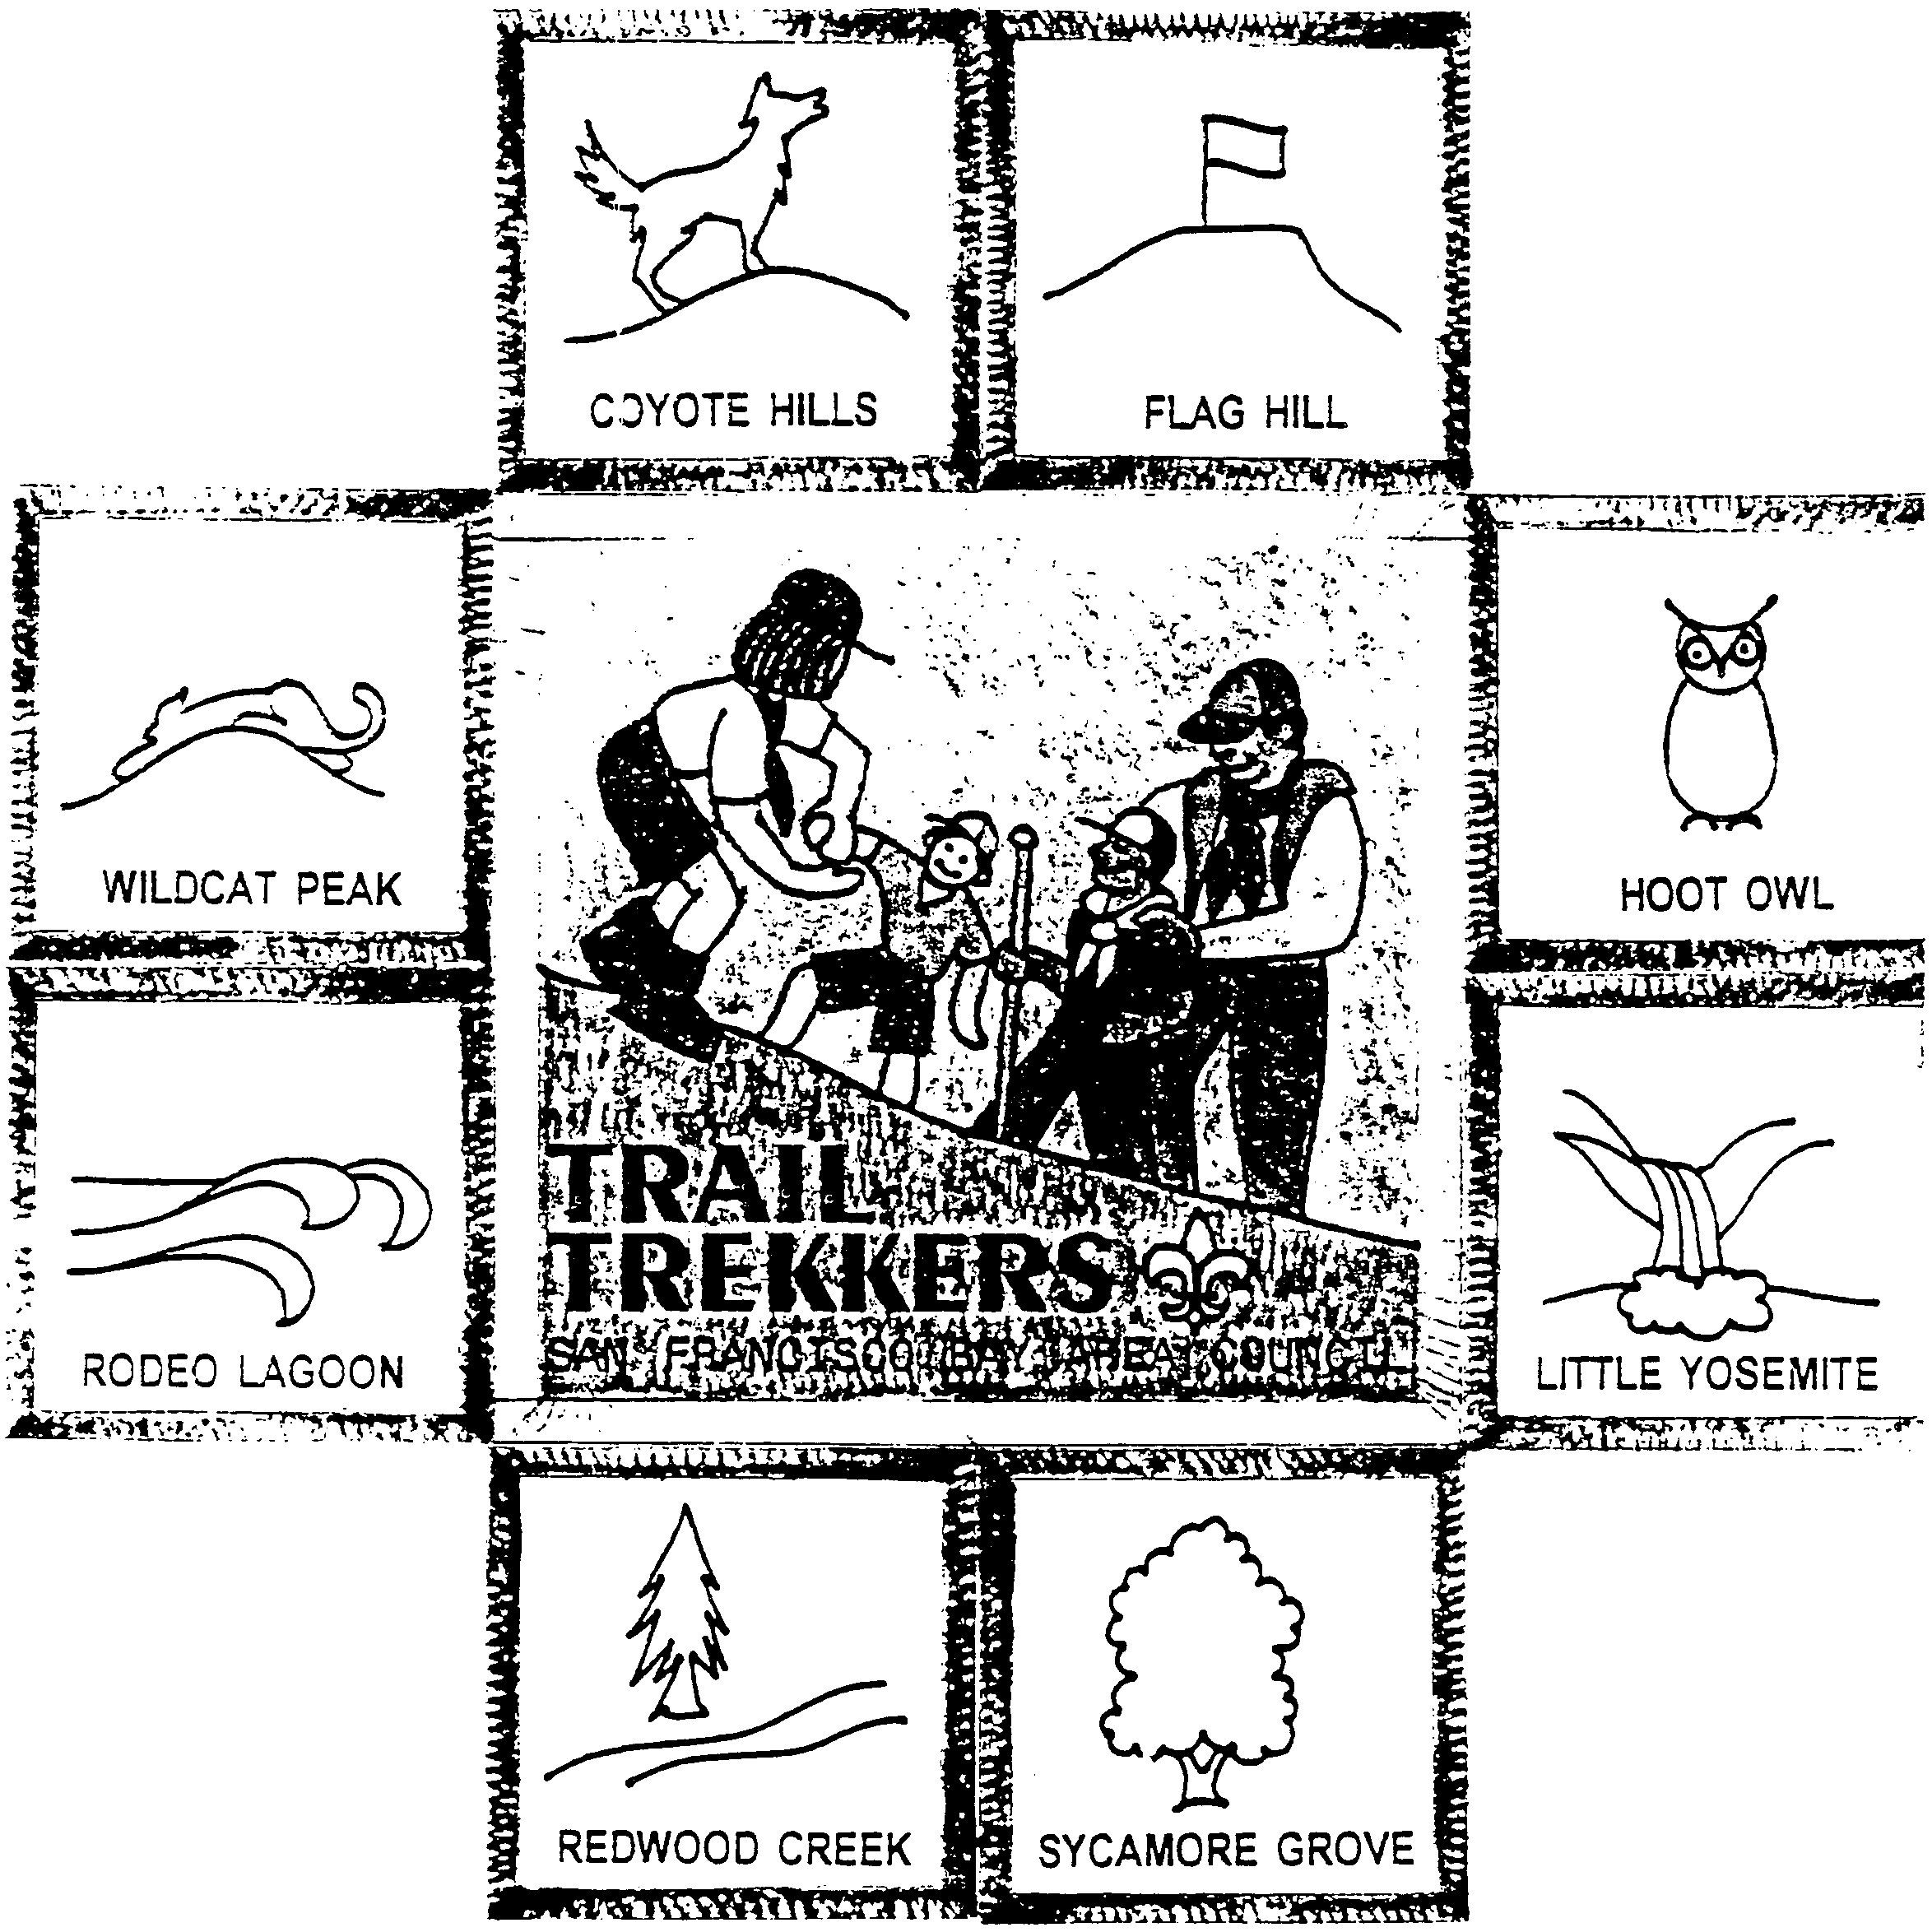

Note: Rim of the Bay Patch Program, also by San Francisco Bay Area Council, is recommended for Boy Scouts, not Cub Scouts.
NATIONAL DEN AWARD

This award recognizes dens that conduct a quality year-round program. The award is earned by dens as a team, not by individual members of the den. The recognition is a ribbon for the den flag or den doodle. A list of requirements (Cub Scout Leader Book, pp.9-17 to 18) is also reproduced.

Present the award with an appropriate ceremony. See Cub Scout Ceremonies for Dens and Packs, “National Den Award,” p. 10-4.

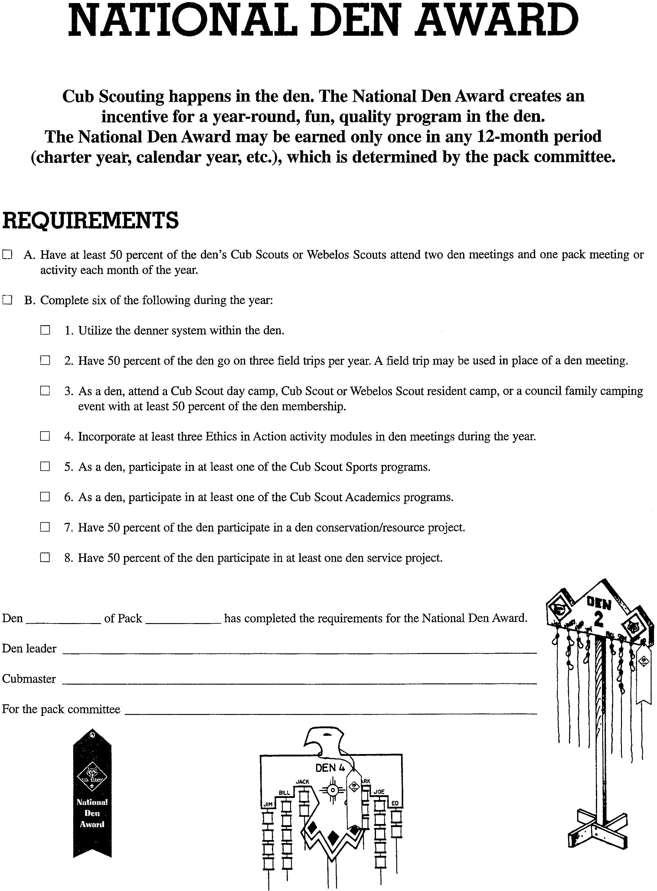NATIONAL SUMMERTIME PACK AWARD

For some packs the May pack meeting is the last meeting of the Scouting year, with a break during summer. Plan pack activities for the three summer months, have fun and earn the National Summertime Pack Award.

A boy registers for a year and deserves a full year of Cub Scout fun and activities. Having a summer program keeps a pack healthy, parents interested, and Cub Scouts eager to re-register for another year. You will find it easier to resume the weekly program in September if you have kept in touch with the boys (and the boys with each other) during the summer. Also the pack summertime program is one of the optional requirements for the Cub Scout Pack National Quality Unit Award.

Recognition for this award includes a certificate for the pack, streamer for pack flag, den participation ribbon for dens with 50 percent or more of their boys at three summertime activities, and a pin for boys who attend all three summertime pack activities.

Application form, activities planning guide and activities planning chart are found in the Cub Scout Leader Book, pages 17-22 to 24.

Present the award with an appropriate ceremony. See Cub Scout Ceremonies for Dens and Packs, “Twelve Months of Scouting,” p. 10-5.

CUB SCOUT PACK NATIONAL QUALITY UNIT AWARD

The Quality Unit Award recognizes outstanding Scouting units that conduct quality programs for their youth. For a Cub Scout pack to qualify for this award, it must achieve six of ten requirements, four of which are required.

Required categories are:
Training The Cubmaster and at least 50 percent of the den leaders and Webelos den leaders complete Fast Start and basic training for their current position.
Two-Deep Leadership The pack has one or more registered, trained, and active assistant Cubmasters. One registered adult is assigned responsibility for Youth Protection training.
Outdoor Activities The pack participates in one or more of the designated outdoor events.
On-Time Charter Renewal


Optional categories include:
A Year-Round Program
Tiger Cub Dens
Service Project
Advancement
Boys' Life Subscription
Membership Retention and Increase

The application form for the Quality Unit is included in the Unit Recharter Kit.

The qualified units receive recognition dated for the year of the month immediately following the recharter renewal. Since in our council the units are rechartered in December, after rechartering in December 2001, the qualified units will receive the 2002 recognition.

When a pack qualifies for this award, it receives a streamer for the pack flag. A Quality Unit plaque is available through the Scout Shop.

Individual Scouts and adult leaders of the packs are eligible to wear the individual Quality Unit patch on their uniform. This is worn on the right sleeve 4 inches down from the shoulder seam. Only the most recently earned patch may be worn. Also available for individuals is a quality pin to be worn on civilian clothing.

Present the award with an appropriate ceremony. See Cub Scout Ceremonies for Dens and Packs, “Quality Unit Award,” p. 10-5

For more information, contact your District Executive.
COMMISSIONERS’ CHALLENGE AWARD

