Ceremonies

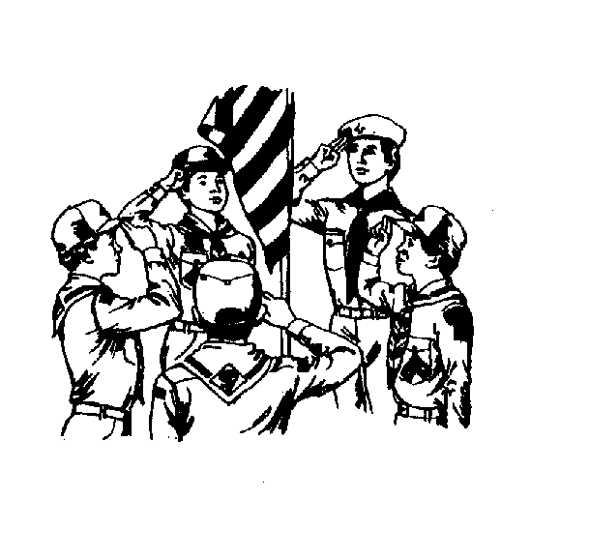

CONTENTS

GENERAL CEREMONY GUIDELINES 1
CEREMONY RESOURCES 1
THE ALL PUREPOSE, ALL OCCASION, DO ANYTHING GENERIC
CEREMONIES CREATOR 2
GENERAL ADVANCEMENT CEREMONY 4
H-A-P-P-Y ADVANCEMENT (BOBCAT, WOLF, BEAR) 5
INDUCTING THE NEW FAMILY 6
TIGER CUB GRADUATION CEREMONY 7
CUB SCOUT AND PARENT PROMISE--TIGER GRADUATION 8
“BOBCATS” INDUCTION 9
BOBCAT CANDLELIGHT INDUCTION CEREMONY 10
ARROW OF LIGHT CEREMONY 11
ARROW OF LIGHT CHARGE 12
ARROW OF LIGHT CEREMONY 13
SEVEN VIRTUES IN JARS ARROW OF LIGHT CEREMONY 14
ARROW OF LIGHT AND GRADUATION--CROSS OVER 15
WEBELOS SCOUT GRADUATION 16
ARROW PREPARATION FOR ARROW OF LIGHT CEREMONY 17

Each den and pack meeting should start and end with a ceremony. In addition, a pack meeting should include any rank advancement and other recognition ceremonies when applicable. Theme related ceremonies--opening, closing and advancements--are included in the monthly theme sections of this book. In this section we listed a sampling of more general, non-theme related ceremonies as well as the generic ceremony creator.

GENERAL CEREMONY GUIDELINES

In planning a ceremony, the following guidelines will make it easier:
- Have the Cub Scouts participate as much as possible, both in the ceremony and preparing the props.
- Keep some elements as a surprise for the audience. It maintains interest and keeps it fresh.
- Keep it short, but don’t rush a Cub Scout through without giving him his moment in the spotlight.
- Opening ceremonies can include, or lead into, a flag ceremony, but can also remain separate.
- Scale the Cub Scout’s level of participation to his skill level. Don’t set up a shy Tiger Cub for failure by having him read a long passage.
- Ceremonies should reflect the theme and the Scouting Spirit.
- Ceremonies using candles are impressive. Follow safety procedures.
- If you meet in a building that does not allow open flames, make candles as a craft project and shine a flashlight on the candle at the appropriate time. You can also attach “flames” made out of tissue paper to your flashlights. Some Maglight flashlights are made so that you can take the tops off to make them look like candles.
- A Cubmaster’s Minute is just that--A MINUTE!
- KISMIF - Keep it Simple, Make it Fun.

CEREMONY RESOURCES

- Cub Scout Ceremonies for Dens and Packs
- Cub Scout Program Helps 2000-2001 and 2001-2002
- Previous editions of Program Helps
- Previous editions of Pow Wow books
- Online resources include: www.usscouts.org/ceremony
www.usscouts.org/bbugle

Other online resources can be accessed from these sites.

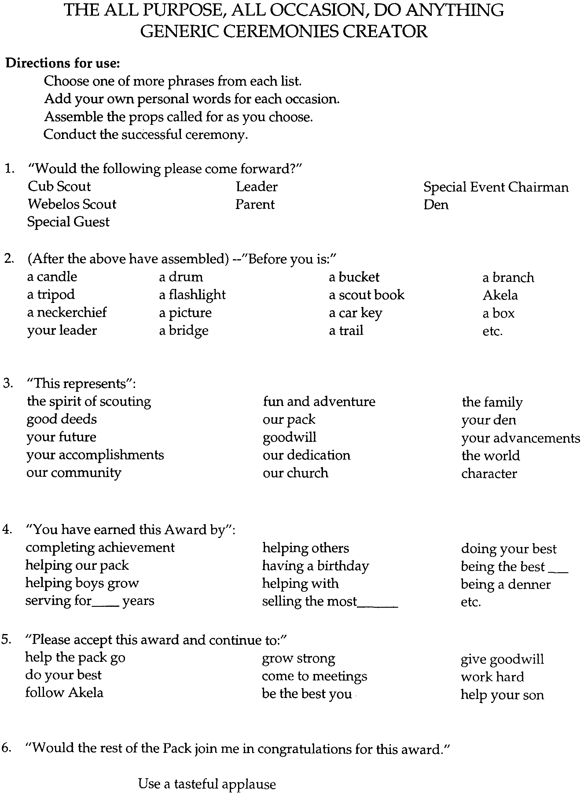

GENERAL ADVANCEMENT CEREMONY

This ceremony works well for most rank advancements. You may have difficulty if the group is very large so adjust your candleholder to the number of Cub Scouts likely to be advancing.
Props: A large candleholder sized to hold five candles of the same size, with one much larger candle next to it. A board with holes drilled in it for candle bases works well, or a stable log (cut a flat side on the bottom) lends a more rustic appearance. Candles are described below.
A frame for holding smaller candles -- a good setup looks like a small staircase, with holes drilled on the “steps” to fit the base of a small (about 5”) candles. You need four steps (one each for Bobcat, Wolf, Bear, and Webelos Scout). You may add an additional step for Tiger Cubs to include them as well, but remember there is no actual Tiger rank to award.
Arrangement: Place candleholder with unlit candles, badges and pins on the table. Dim room lights.
Cubmaster:
I call your attention to the large gold candle in the center. It represents the Arrow of Light, Cub Scouting’s highest award. (Lights gold candle)
The green candle is for Webelos Scouts, soon to be Boy Scouts. (Lights green candle from gold candle and places it in holder)
The red candle is for Bears. (Lights red candle from gold candle and places it in holder)
The blue candle is for Wolves. (Lights blue candle from gold candle and places it in holder)
The white candle is for Bobcats. (Lights white candle from gold candle and places it in holder)
The orange candle is for Tigers, at the start of the Cub Scout Trail. (Lights orange candle from gold candle and places it in holder)
The flame atop each candle represents the Spirit of Scouting and, when lit, signifies that a Scout has attained that rank.
Will the following Cub Scouts and their parents please step forward? (Calls first set of boys, in order of rank; Bobcat, Wolf, Bear, and Webelos Scout)
(To the parents) Please light a candle for your son as a symbol of the encouragement and support you will be giving him as he moves along the Cub Scout Trail. (They do, using the correctly colored candle for the rank)
(To the parents) Will you accept the responsibility to participate in Den and Pack activities, to help your son with advancement and support the Pack? (Parents respond)
Please give the candle to your son to hold in his left hand. Cub Scouts, please raise your right hand in the Cub Scout sign and repeat with me the Cub Scout Promise. (CM and Cub Scout repeat the promise)
Now place your candles in the holder. Parents, this patch is for the Cub Scout’s uniform to show the rank he has earned . This pin is for you, to keep as a reminder of your help and support. (Have parents present the patch to the sons; have boys present the pins to parents)

H-A-P-P-Y ADVANCEMENT (BOBCAT, WOLF, BEAR)

Personnel: Cubmaster (CM) and assistant Cubmaster (ACM)

CM: Oh, I am just so-oooo happy!

ACM: Why are you just so-oooo happy?

CM: Because!

ACM: Because?

CM: Yes, because I am happy when other people are happy!

ACM: And why are other people happy?

CM: Because they learned something that was fun.

ACM: What did they learn?

CM: They learned skills, crafts, games and many other things and they had fun doing it.

ACM: Who are these people and where did they have all this fun?

CM: They are Cub Scouts and they learned and had fun in den and pack meetings. Tonight we have several happy Cub Scouts because they have earned the Bobcat badge, the first badge in Cub Scouting.

ACM: Will the following Cub Scouts and their parents join us? (Reads names)

CM: While these Cub Scouts have had many happy days and fun while doing these crafts and learning the skills, they did not just play. This award requires work and determination. Parents, it is my honor to give you these badges to present to your sons.

CM: There are several Cub Scouts a little bit happier with us because they have earned the second rank in Cub Scouting, the Wolf Rank.

ACM: Will the following boys and their parents come forward? (Reads names)

CM: These Cub Scouts also have had many fun-filled days. Their work was a little harder than the Bobcat, as the Wolf badge requirements are more difficult. Parents, please present these badges to your sons.

(Repeat similarly for Bear rank)

CM: These boys will have many more fun-filled days ahead in Cub Scouting. Congratulations!

INDUCTING THE NEW FAMILY

Equipment: Wolf, Bear, Webelos and Boy Scout handbooks; Two blue, two yellow and one white candle; Cardboard letters C U B S.
Personnel: Den chiefs, den leaders or committee members for the voices.

Cubmaster:
Friends, we welcome you to our ceremony for new Cub Scout families. Before you burn five candles; two are blue, two are gold, and the center one is white. In front of the colored candles are the letters C U B S. These four letters spell “Cubs,” but each letter by itself stands for something special.

Voice 1: The “C” stands for Courtesy. A Cub Scout is courteous. He is courteous to older people, his friends, his teachers and especially his parents. He is courteous in all that he says and does.

Voice 2: The “U” stands for unity. When a boy joins a pack. His parents join too. He does not work alone but with other boys. He learns to get along with others.

Voice 3: The “B” stands for Bravery. The Cub Scout is courageous enough to stand up for the things that he thinks are right - honesty, equality, fair play, thereby making the world a better place in which to live.

Voice 4: The “S” stands for Service. A boy not only does service to himself while he is in Cub Scouts, but he also serves others. He strives to help spread good will in every way he can.

Cubmaster:
Cub Scouts, you see before you four books; the Wolf book, the Bear book, the Webelos book and official Boy Scout Handbook. They stand for the steps that a boy climbs as he goes higher and higher in Cub Scouting and finally moves upwards into Boy Scouting. The white candle in the center stands for God, just as God should stand in the center of our lives.

You have come here tonight seeking admission to the friendship and fun of Cub Scouting. We wish you a great Cub Scouting adventure with your dens and parents.
Welcome to our pack.
(At this point, have all the boys and families in the pack form a line and shake the hands of the new boys and parents joining the pack.)

TIGER CUB GRADUATION CEREMONY

Props: Orange candle with drip guard for each boy, unlit
Table with: Lighted blue candle at one end
Lighted yellow candle at the other end
Unlit large white candle in the center
Two lighted orange candles, smaller than the blue and yellow ones, in front

Cubmaster:
Cub Scouting is an organization that is very special and unique. It is one to which many parents devote their time and talents in order to provide a program which will aid and guide their son’s growth. As parents work to strengthen Cub Scouting, so Cub Scouting helps to strengthen families.

Tonight, we honor a very special part of our Scouting family. Will the Tiger Cubs and their families please come forward? (As they approach, give each boy a candle; have boys and partners stand behind the table facing the audience)

I call your attention to the three candles on the table. The blue and gold stand for Cub Scouting. Blue stands for loyalty, truth, and the blue sky. The gold, like that of the neckerchief you will wear, stands for sunlight, good cheer, and happiness. The white candle represents how all of us, parents and Scouts, play a vital role in the Cub Scout program.

Adult partners, would you please assist your Tiger Cub in lighting the candle he is holding as a symbol of the encouragement you will be giving him as he moves along the Cub Scout trail?

(Begin lighting the boys’ candles with the lit orange candle by having the Tiger Cub coach move down the line to light the boys’ candles)

Tigers, please hold the candle in your left hand and raise your right hand in the Cub Scout sign. Now join with me in repeating the Cub Scout Promise. (Cubmaster leads Promise)

And now, with your partners guiding your hands as they will do to help you in Cub Scouting, I ask that you join your individual flames and together light the white candle of Cub Scouting.

Congratulations! You are now Wolf Cub Scouts of Pack _____, ready to begin the next step on the Scouting trail. I am delighted to present to you your Tiger Cub emblem to be worn below the right pocket of your new Cub Scout uniform, your graduation certificate, and your Tiger Cub service star. (Cubmaster presents emblem, Tiger Cub coach presents certificate and star. If bridge is used in ceremony, Wolf den leader may meet them on the other side)

CUB SCOUT AND PARENT PROMISE--TIGER GRADUATION

Props: Certificate of Graduation, Tiger Cub One-year pin
Personnel: Cubmaster, Tiger Cub Coach, graduating Tiger Cubs and their partners

(Tiger Cub Coach escorts boys and partners to ceremonial area.)

Cubmaster:
Today these Tiger Cubs and their partners are taking their first big step on the Cub Scouting trail. Will the Tiger Cub Coach please present the Tigers and their partners? (Tiger Cub Coach gives each boy’s and partner’s name.)

As Tiger Cubs, you searched, discovered, and shared. Now as Cub Scouts you will be facing new challenges, learning new skills, and striving to become better citizens. Your partners’ role will be changing, too, but its importance will not. We ask you, partners, to continue to support your boy by helping him and our pack, perhaps as a leader.
Now we ask you to join me in giving the Cub Scout Promise. (Use repeat-after-me method)

Now, partners, we ask you to raise your right hands and repeat the Cub Scout parents’ promise. Please repeat after me: I promise to work with my boy / and to support him / as he strives to advance in Cub Scouting. / I will work with him / and I will do my best / to help the pack grow for all the boys. / I will accept responsibility within the pack / to ensure a strong program.
(Give partners the certificates and one-year service pins to present to their boys.)

“BOBCATS” INDUCTION

Props: Candelabra with seven candles; candleholder for a large, single candle; large cards, each with one letter of BOBCATS on one side and the line given below on the other; Bobcat badges
Personnel: Cubmaster, Bobcat candidates, and their parents

(Call forward the Bobcat candidates one at a time with their parents. Ask each boy in turn to speak or show one of Cub Scouting’s ideals or symbols: Cub Scout Promise, Law of the Pack, motto, sign, salute, handshake, meaning of Webelos.)

(When all are assembled, each candidate in turn lights one candle on the candelabra with the larger candle and then shows his letter and reads his line. The lines are:)

Bobcats are what we want to become.
Our best is what we promise to do.
Beginning our journey in Scouting is fun.
Caring, sharing, helping others too.
Akela is who we will follow and obey.
Tomorrow’s future is here today.
So now we see how the spirit of Scouting can grow;
from one to another it is passed along,
and others who see will surely know,
that a Scout is trustworthy, loyal, and strong.

Cubmaster:
Thank you, new Bobcats. Now we will ask your parents to repeat with me the Parent’s Promise. (Lead this Promise.)
As the parent of a Cub Scout,
I will do my best
To help my son
Live up to the Cub Scout Promise
And obey the Law of the Pack.
I will work with my son
On his advancement and projects.
I will attend the monthly pack meetings
And help to make the pack go.

(The Cubmaster then gives the Bobcat badges to the parents to pin on their son’s shirt.)

BOBCAT CANDLELIGHT INDUCTION CEREMONY

Props: Candleholder for three candles; a blue, a yellow, and a white candle (the white one taller that the other two); Bobcat badges

Cubmaster:
Tonight we are happy to welcome our new Bobcat Cub Scouts and their parents to our pack. Will they please come forward?

This large white candle represents the Cub Scout program and all it stands for. (The Cubmaster lights the white candle)

The blue candle stands for our Cub Scouts. (Lights the blue candle with the white candle.)

The candleholder looks a little unbalanced, doesn’t it, with just the one candle lit at the end? In the same way, Cub Scouting is unbalanced if the parents do not do their part. In fact, Cub Scouting and our pack could not exist without parents doing their part in it. So let us light our parents’ candle. (Lights the yellow candle with the white candle)

That’s much better, isn’t it? In fact, it’s a beautiful picture.

In the same way, our pack presents a beautiful picture when boys and parents join together for fun and learning in Cub Scouting.

Will all of the parents in our pack, please rise and join the new Cub Scout parents in repeating after me: “We promise to assist our sons / in earning their Cub Scout badges./ We will be faithful in attending pack meetings / and will assist in every way possible / as we help our sons to do their best.” Thank you. You may take your seats.

Now, parents of our new Bobcats, please pin your son’s badge on his uniform. (They do so.)

Welcome to our pack, both boys and parents! Will all Cub Scouts here tonight rise, make the Cub Scout sign, and join us in repeating the Cub Scout Promise?

ARROW OF LIGHT CEREMONY

Props: One 3 foot length of rope for each boy, Arrow of Light Awards

Cubmaster:
Our Cub Scouts are guided to Cub Scouting’s highest rank by the Arrow of Light. The seven rays of the Arrow of Light represent wisdom, courage, self-control, justice, faith, hope, and love. Will these boys and their parents please come forward.

The Arrow of Light is important. It is the only Cub Scout badge that can be worn on the Boy Scout uniform. But more important than the badge itself is what you have learned, the work you have done to help others and the fun you have had earning it. (Hand the Arrow of Light card and rope to the parents.)

Parents will you please place the Arrow of Light on our son’s uniform and hand him the rope. (When all the parents are done, excuse them to sit down)

(Ask each boy to share a memorable event or activity they have participated in as a Cub Scout or for any advise they would give younger boys. After each boy replies, tie his rope to the rope of the boy before him. The first boy will tie his rope to the last boy’s rope to make a circle. The boys should be standing on the outside. Tell them that this represents the circle of brotherhood which is Scouting.

Congratulations. You have now completed your journey in our pack. As you continue your journey through Boy Scouting strive to serve as the shining example your Arrow of Light represents.

ARROW OF LIGHT CHARGE

Props: Arrow for each candidate. (See “Arrow Preparation” at the end of this section)

In Boy Scouting, when an Eagle Court of Honor is held, a charge or challenge is made to the new Eagle Scout. It is now my privilege to administer a similar charge to you. You have achieved the highest rank in Cub Scouts.

I charge each of you to continue to live by the ideals you have learned in Cub Scouts, especially the Cub Scout motto: “Do Your Best!”

I charge each of you to look at the Arrow of Light badge and think about what it represents.
The sun shedding its light on all that we do. A reminder that you should be a light for those around you.
The seven rays of the sun representing the seven days of the week. A reminder that you should do your best everyday.
The arrow which is symbolic of everything which is straight and true. Just as you should be straight and true in your lives.

I challenge each of you to follow where that Arrow of Light points:
Forward on the Boy Scout trail.
Upward to higher challenges.

I charge each of you to soar to the great heights of an Eagle, just as this arrow will fly straight to its target.

Now as a symbol of your achievement, I give to each of you this arrow.

Congratulations and good luck. Parents, guests, and Cub Scouts of Pack ___, would you please join me in applause for this boy (these boys) for achieving the highest rank in Cub Scouting.

ARROW OF LIGHT CEREMONY

Props: Display board made from a cardboard box, with the Arrow of Light segments (arch, rays, arrow) cut in it. It should be cut out so that the cut out segments may be stuck back in place. Paint the box and the segment blue. A small light is placed inside. The cutout area is covered with yellow crepe paper from inside. The segments are removed one at a time as the ceremony is presented.

Cubmaster:
The arch is the sun rising at daybreak, starting another week in Scouting.

The first ray--is Sunday, a day of worship and development of the boy’s spiritual life.

The second ray--is Monday, a day for improving understanding within the family

The third ray--is Tuesday, a day of developing habits and attitudes of good citizenship.

The fourth ray--is Wednesday, a day for strengthening the ability to get along with other boys and respect other people.

The fifth ray--is Thursday, the day for personal achievements and developing new interests and skills.

The sixth ray--is Friday, the day to work on good sportsmanship and pride in growing strong in mind and body.

The seventh ray--is Saturday, the day for fun and finding new things to do.

This gives us the seven rays of the sun to brighten our week.

The arrow is to remind us to continue to go straight up the pathway in Scouting and in life

Putting all these things together, we have the Arrow of Light, the highest award in Cub Scouting!
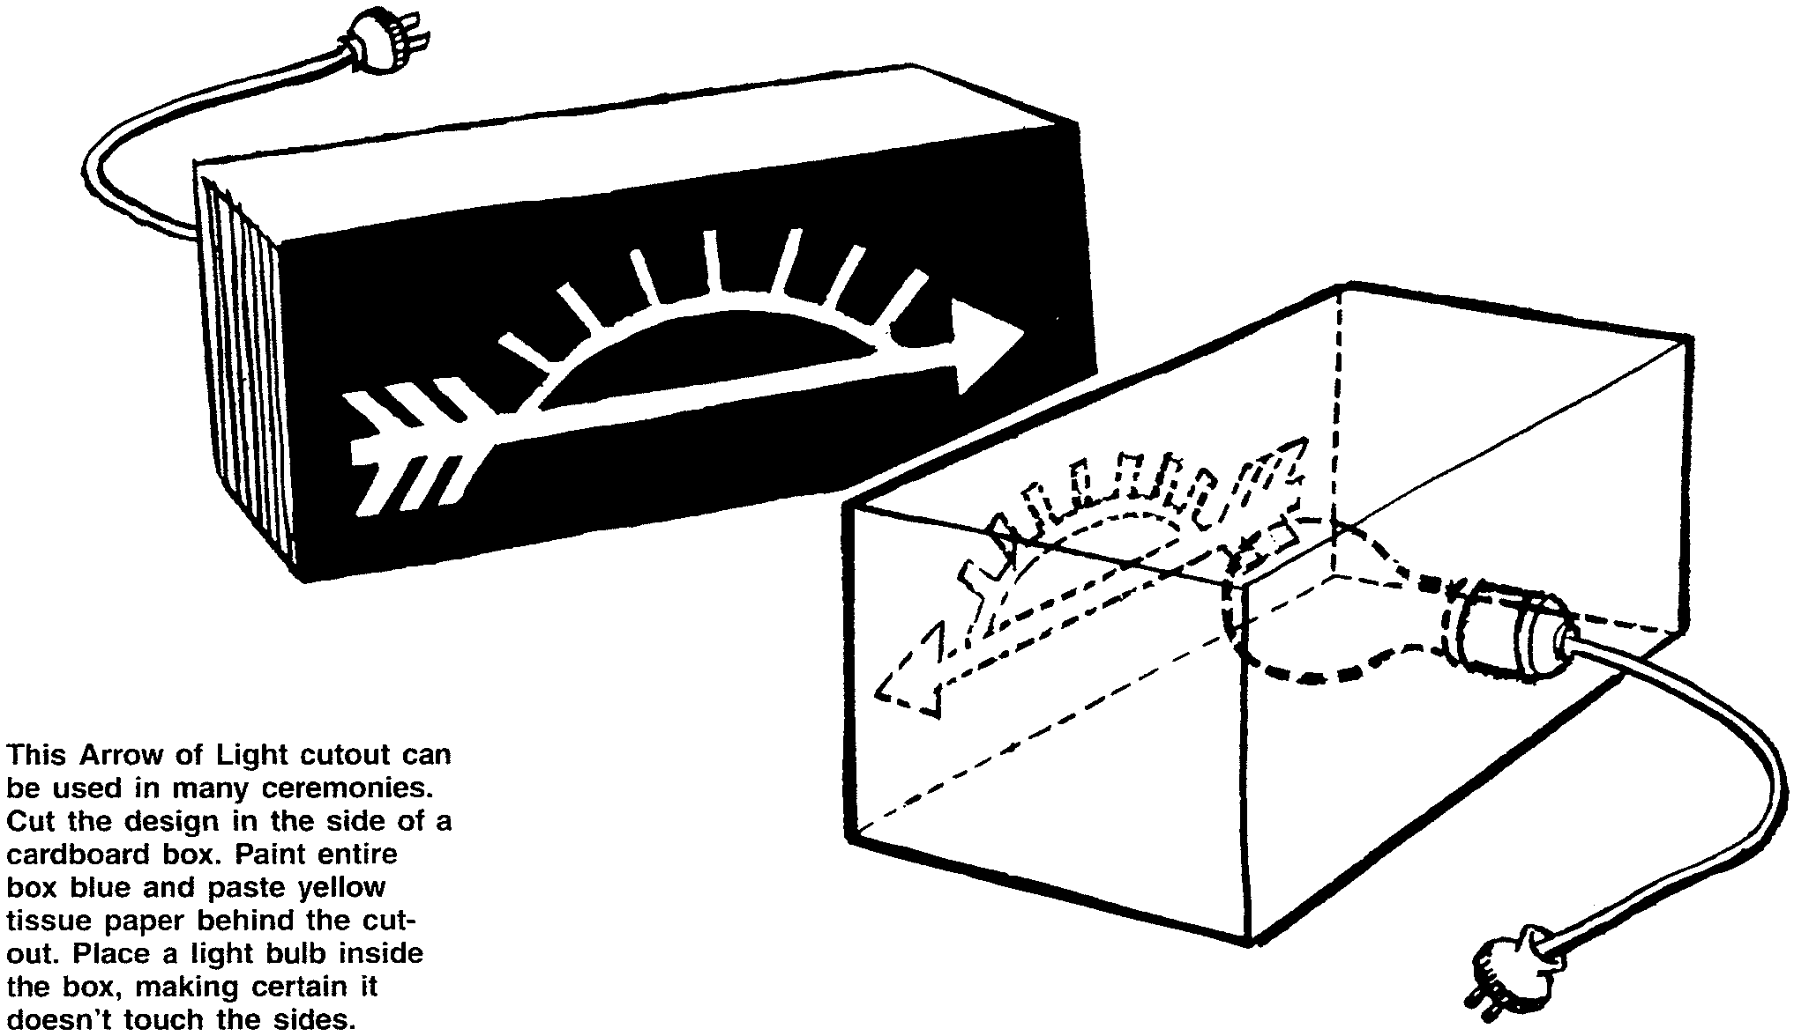
(Congratulate the boys and present them with their Arrow of Light Badge.)

SEVEN VIRTUES IN JARS ARROW OF LIGHT CEREMONY

Props: Seven jars of colored water labeled: Yellow--Wisdom, Blue--Courage, Purple--self-control, Green--Justice, White--Faith, Orange--Hope, and Red--Love; Large pot with smaller one inside with dry ice; Arrow; Award

Arrangement: Place the arrow and Arrow of Light award in the larger pot, outside of the smaller pot, unseen. Place jars of colored water to one side of the pot. As each color is mentioned, pick up the jar and pour it into the smaller pot.

Cubmaster:
Will __________ please come forward with his parents? This boy has fulfilled the requirements to receive his Arrow of Light Award.

I want you to understand the meaning of the Arrow of Light symbol. The rays in the Arrow of Light represent the seven virtues of life. I have taken the colors of seven objects of nature to represent these virtues of life.

Here, we have the yellow from the sun which stands for wisdom. With this wisdom you will be able to live better.
Here we have some blue from the sky to stand for courage. With this courage you will be able to do things that are hard.
Here we have the purple from a lilac flower to stand for self-control. With this you know your limits and will know when to stop.
From the trees we take the green for justice. With this virtue, you will be fair and a good sport to others.
The next virtue is Faith, and we are taking the white from the snow to represent it. May your faith in God continue throughout your life.
We take the orange from a brilliant sunset to represent Hope. With hope you can look forward to things your believe will happen.
The last virtue is taken from the red of a wild rose, for love. There are many kinds of love--love of family, home, fellowman, God and country. With love you can a lead a full and happy life.

If you will use these virtues in your life, you will be able to do great things and be happier.

As we mix these together we find an arrow that will help you remember these virtues. I am proud to present to you this arrow with these symbols on it and also your Arrow of Light award.

Congratulations!

(Note: To make the white water, add a little white poster paint. You can make purple by using red and blue food coloring or grape punch powder).

ARROW OF LIGHT AND GRADUATION--CROSS OVER

Props: Four 4”x4”x5’ posts, five 2”x12”x5’ planks--Paint one plank blue, one gold, one red, and one BSA green. leave one unpainted. Paint the posts brown.

Ask the Webelos Den Leaders to place one of the posts on the ground in a N-S direction. Then ask the Scoutmaster to place a second post on the ground about four feet away and parallel in a N-S direction. Say that this is symbolic of the foundations of Scouting that these leaders have laid down.

Then ask each of the den leaders to place an E-W post over the N-S post about three to four feet apart, saying by building on Scouting’s foundations these leaders have set the stage for bridging the boys from Cub Scouting to Boy Scouting.

Have Webelos Scout #1 and his parents bring the unpainted plank forward and place it across the E-W posts. State that this represents the boys as they arrived in Cub Scouting full of potential but unfinished.

Ask Webelos Scout #2 and parents to bring the blue plank forward and place it snugly against the unfinished plank. Say this represents the Wolf and Bear years, where with the help of their parents, the Scouts became true blue friends.

Next Webelos Scout #3 comes forward with his parents and places the gold plank next to the blue one to represent their golden years in Cub Scouting and as Webelos learning important skills culminating in the Arrow of Light.

Webelos Scout #4 comes forward with his parents and the green plank. Announce that this represents their new beginning as Boy Scouts who will soon be green Tenderfoot Scouts, anxious to begin the Boy Scout trail to Eagle.

Finally Webelos Scout #5 and parents put down the red plank. Comment that this plank is red like the predominant color of the Eagle badge and represents the beginning of their journey to become Eagles.

Webelos Scouts are assembled at the unfinished board side of the now completed bridge and presented graduation certificates and a patch board of their Cub Scout badges and awards. (a piece of plywood cut into the shape of the Scout emblem and covered with blue felt on which are placed their Cub Scout awards, etc.)

When these presentations are over, the Scoutmaster invites each boy in turn to cross the bridge. Once over, he is welcomed into the Troop. He is presented with his Troop neckerchief.

WEBELOS SCOUT GRADUATION

Props: Graduation Ceremony Board; have blue candle in center flanked by six yellow candles; single white candle in candlestick; graduation certificates; troop neckerchiefs

Personnel: Cubmaster, Webelos den leader and den chief, Scoutmaster and senior patrol leader of the troop receiving the graduates; graduates and their parents.
(If you don’t have a den chief, have the graduates take turn lighting candles.)

Cubmaster calls forward the graduates and their parents, who form a semicircle behind the ceremonial table. As he mentions each step in Cub Scouting and Boy Scouting, den chief lights one of the yellow candles, using the while candle in the candlestick.

Cubmaster:
Today is a red-letter day in the life of our pack because _____ of our Webelos Scouts are starting on the Boy Scout trail. We regret losing them, but at the same time we rejoice in their progress.

They began as Bobcats. (Den Chief lights a yellow candle) Over the next two years, they progressed through Wolf and Bear. (Lights two candles)

About two years ago, they moved into Webelos dens and earned the Webelos badge. (Lights candle). Not so long ago, they qualified for the Arrow of Light, the highest award in Cub Scouting. (Light candle)

Now they are about to take the big step into Boy Scouting. We all wish them much success in the troop. (Light the last yellow candle)

One candle remains to be lit. It represents the world brotherhood of Scouting. We are all a part of it. I will ask one of the graduates to light this blue candle on behalf of us all. (Graduate lights blue candle.)

(The Cubmaster gives a graduation certificate to each boy. The Scoutmaster welcomes the graduates into his troop. He and the senior patrol leader remove the boys’ Webelos neckerchiefs and replace it with their troop’s neckerchief.)

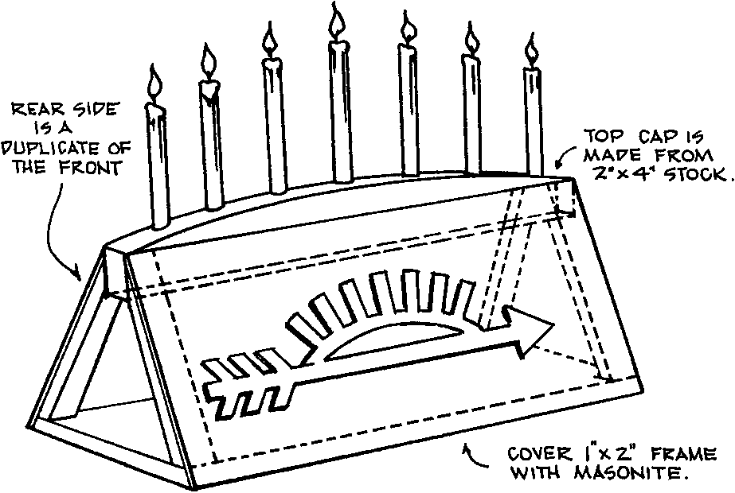

ARROW PREPARATION FOR ARROW OF LIGHT CEREMONY

An arrow symbolizing the Cub Scout’s accomplishments may be a part of the Arrow of Light ceremony or may be given at the time of graduation. Following is a suggested pattern for constructing the arrow. There is no set standard, so feel free to be as creative and unique as you wish. Each arrow should uniquely reflect the Cub Scout’s accomplishments, but all arrows in a group together should be similar in design. The arrows can be constructed by the pack, the den, or by the parents.

Arrows can be made from dowels or purchased at the Scout Shop or any sporting goods store. Simple wooden target arrows are the least expensive and most adaptable. Some people prefer the faux flint type of arrow head, and they certainly look most impressive. Keep safety in mind; and the blunt tips of practice arrows would be perfectly fine. Please note that sharp hunting-type arrowheads are inappropriate because they can be extremely dangerous.

To add decorations, try winding different colors of embroidery thread around the shaft. Make a colored band at least one-half inch wide. Space out the bands so the total number of bands is evenly distributed depending on how much the Cub has accomplished. Suggested colors are:
Tiger Cub Orange band
Bobcat Badge Black band
Wolf Badge Yellow band
Wolf Gold Arrow point Gold band
Wolf Silver Arrow Points Silver bands (as needed)
Bear Badge Light blue band
Bear Gold Arrow Point Gold band
Bear Silver Arrow Points Silver bands (as needed)
Webelos Badge Dark blue band
Compass Points Emblem Red band
Compass Points Gold band (up to three)

Some people will add a thin band for each Webelos Activity Badge. If you do that, then all bands will need to be very narrow in order to fit. Quick drying glue will allow you some working time and hold the thread snugly on the wooden shaft.

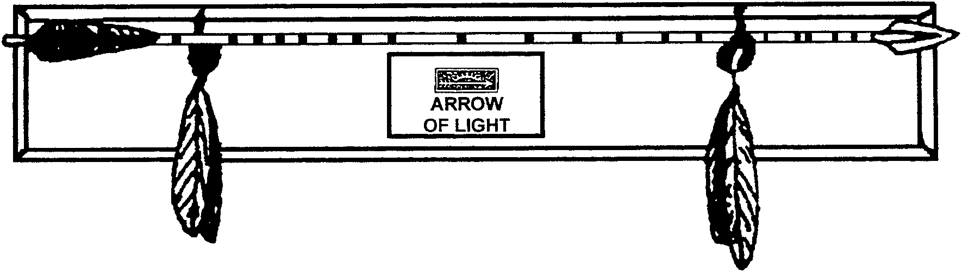
Feel free to add any additional decorations you wish, such as feathers, leather pouches, beads or leather strands. The whole assembly can be mounted onto some sort of plaque after the ceremony. A simple holder can be a board with cup hooks. Extra touches could include a painting or wood burning of the Arrow of Light emblem on the board. The Cub Scout’s name and ceremony date, pack number, den name, etc. can all be added. An engraved metal plate dresses up the plaque nicely. Be as elaborate or as simple as you wish. Just remember that it is the, rite of passage, ceremony to honor the boy that is the important factor, not the flashiness of the props.

