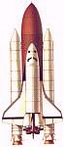
POW WOW 2001 -
"Fun With Rockets"

Date: January 27, 2001
Course Sessions: 2 (9:30-10:20)
3 (11:00-11:50)
5 (2:00-2:50)

Location: Herman Intermediate School
5955 Blossom Avenue, San Jose, CA.

Instructor: Wesley Wong
Cubmaster, Pack 328
wesley.wong@honeywell.com

Website: www.pack328.org/rockets/rocketderby.htm

Objective: Learn how to make safe, simple non-fuel type rockets (paper, pencil, water rockets) to incorporate in your den or pack program.

On-line Resources:

- http://quest.arc.nasa.gov/space/teachers/rockets

- http://www.lerc.nasa.gov/Other_Groups/K-12/TRC/Rockets/RocketActivitiesHome.html

- http://home.integrityonline.com/passerotti/

- http://www.geocities.com/CapeCanaveral/Lab/5413/science.html

- http://edtech.kennesaw.edu/web/solar.html

- http://www.water-rockets.com/javasim/index.html

Class Outline
I. Introduction (5')
- Distribute Handouts
- Sign-in Sheet
- Brief history of Rockets

II. Rocket Principles (3')
- Newton's 3 Laws of Motion
- Rocket Pinwheel
- Rocket Car

III. Incorporating into Den or Pack Program (3')
- Wolf, Bear, Webelos Achievements
- Space Theme
- Rocket Derby

IV. Rocket Safety (3')

V. Types of Rockets & Construction Tips (10')
A. Paper Rockets
B. Pencil Rockets
C. Alka-Seltzer Rockets
- Basic Film Canister
- Canister with Fins & Nosecone
- Double canister
D. Water Rockets
- Basic Water bottle
- Water bottle with fins & nosecone
- Paper Tube rockets
- Florescent Tube rocket
- Launch Pads

VI. Rocket Construction (15')
- Form 6 groups of 5 people each
- Each group builds one type of rocket (pencil, seltzer, soda)

VII. Rocketeer Patch (1')

VII. Launch Rockets outside. (10')
Den & Pack Activities with Rockets

Den Activities:
Wolf Elective 5g: Make a model rocket.
Bear Achievement 21f: Make a model of a rocket.
Elective 1d: Build a model of a rocket or space satellite.

Webelos Scientist 5: Show the effects of air pressure.
6: Show the effects of water & air pressure.
7: Build and launch a model rocket.

Pack Activities:
- Space Theme - Scout-O-Ramas
- Space Derby or Rocket Derby - Camporees
- Pack picnic or barbecue

Safety Tips for Rocket Construction & Launch

Construction Safety Precautions:

- Always use glue in a well-ventilated area.
- Cover the work area with paper or a cloth in case glue drips.

Pressure Testing Water Rockets:

- Never use glass bottles for water rockets.
- Always fill rocket completely with water when pressure testing. This will reduce the explosive hazard of the compressed air.
- Pressurize slowly, and if possible open the air pressure valve so that the air bubbles slowly into the rocket. Then back away and wait for the pressure to stabilize in the rocket with no more bubble action.

Launch Safety Precautions:

- Never launch a rocket over 400ft without FAA clearance.
- Never launch in a crowded area.
- Choose an open field that is clear of obstructions such as trees and wires.

- Never stand directly over the launch pad while setting rocket on pad or during launch.
- Have each student or student group set up their own rocket on the launch pad. Other students should stand back several meters. It will be easier to keep observers away by roping off the launch site.
- Only permit the students launching the rocket to retrieve it.
- The student pressurizing the rocket should put on eye protection (safety goggles).

- Launch under low pressure first.
- Launch under zero or gentle breeze conditions.
- Place the launcher in the center of the field and anchor it in place with the spikes or tent stakes.
- When pressurization is complete, all students should stand in back of the rope for the countdown. Launch the rocket when the recovery range is clear.

Rockets Teacher's Guide with Activities

National Aeronautics and Space Administration
Office of Human Resources and Education
Education Division

This publication is in the Public Domain and is not protected by copyright. Permission is not required for duplication.
EP-291 July 1993

Acknowledgments:
This publication was developed for the National Aeronautics and Space Administration with the assistance of the many educators of the Aerospace Education Services Program, Oklahoma State University.

Writer:
Gregory L. Vogt, Ed.D.
Teaching From Space Program
NASA Johnson Space Center Houston, TX

Editors:
Carla R. Rosenberg
Teaching From Space Program
NASA Headquarters Washington, DC
Roger Storm
NASA Glenn Research Center Cleveland, OH

How to Use This Guide
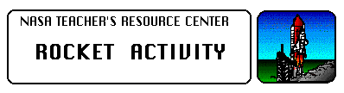
Rockets are the oldest forms of self-contained vehicles in existence. Early rockets were in use more than two thousand years ago. Over a long and exciting history, rockets have evolved from simple tubes filled with black powder into mighty vehicles capable of launching a spacecraft out into the galaxy. Few experiences can compare with the excitement and thrill of watching a rocket-powered vehicle, such as the Space Shuttle, thunder into space. Dreams of rocket flight to distant worlds fire the imagination of both children and adults.

With some simple and inexpensive materials, you can mount an exciting and productive physical science unit about rockets for children, even if you don't know much about rockets yourself. The unit also has applications for art, chemistry, history, mathematics, and technology education. The many activities contained in this teaching guide emphasize hands-on involvement. It contains background information about the history of rockets and basic rocket science to make you an "expert."

The guide begins with background information sections on the history of rocketry, scientific principles, and practical rocketry. The sections on scientific principles and practical rocketry are based on Isaac Newton's Three Laws of Motion. These laws explain why rockets work and how to make them more efficient.

The background sections are followed with a series of physical science activities that demonstrate the basic science of rocketry. Each activity is designed to be simple and take advantage of inexpensive materials. Construction diagrams, material and tools lists, and instructions are included. A brief discussion elaborates on the concepts covered in the activities and is followed with teaching notes and discussion questions.

Because many of the activities and demonstrations apply to more than one subject area, a matrix chart has been included on this page to assist in identifying opportunities for extended learning experiences. The chart identifies these subject areas by activity and demonstration title. In addition, many of the student activities encourage student problem- solving and cooperative learning. For example, students can use problem solving to come up with ways to attach fins in the Bottle Rocket activity. Cooperative learning is a necessity in the Altitude Tracking and Balloon Staging activities.

The length of time involved for each activity and demonstration will vary according to its degree of difficulty and the development level of the students. Generally, demonstrations will take just a few minutes to complete. With the exception of the Altitude Tracking activity, most activities can be completed in less than an hour.
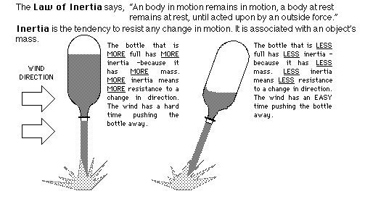
A Note on Measurement
In developing this guide, metric units of measurement were employed. In a few exceptions, notably within the "materials needed" lists, English units have been listed. In the United States, metric- sized parts such as screws and wood stock are not as accessible as their English equivalents. Therefore, English units have been used to facilitate obtaining required materials.

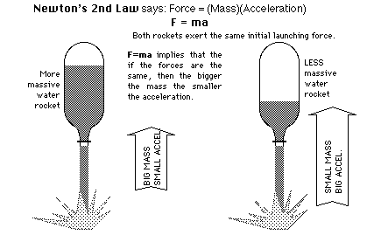
Rocket Principles

Newton's First Law
This law of motion is just an obvious statement of fact.

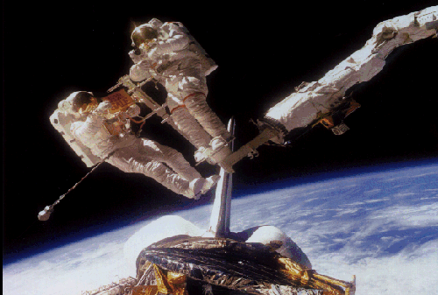
Newton's Second Law
This law of motion is essentially a statement of a mathematical equation. The three parts of the equation are mass (m), acceleration (a), and force (f).

Newton's Third Law
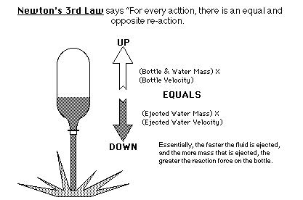

Putting Newton's Laws of Motion Together
An unbalanced force must be exerted for a rocket to lift off from a launch pad or for a craft in space to change speed or direction (First Law). The amount of thrust (force) produced by a rocket engine will be determined by the rate at which the mass of the rocket fuel burns and the speed of the gas escaping the rocket (Second Law). The reaction, or motion, of the rocket is equal to and in the opposite direction of the action, or thrust, from the engine (Third Law).



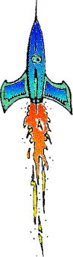

Rocket Car
TOPIC: Newton's Third Law of Motion
OBJECTIVE: To construct a car to demonstrate how rockets move by means of action and reaction.
DESCRIPTION: A small car is propelled by the action/reaction force generated by a balloon.
CONTRIBUTED BY: Gregory Vogt, OSU
EDITED BY: Roger Storm, NASA Glenn Research Center

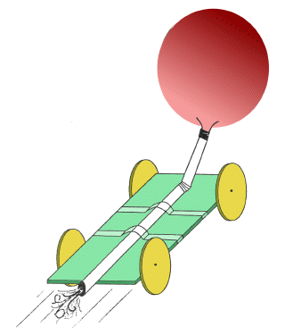
MATERIALS and TOOLS:
- 4 pins
- Styrofoam meat tray
- Cellophane tape
- Flexi-straw
- Scissors
- Drawing Compass
- Marker pen
- Small party balloon
- Ruler
- Emery Board

PROCEDURE:
- Using the ruler, marker, and drawing compass, draw a rectangle 3 by 7 inches and four circles 3 inches in diameter on the flat surface of the meat tray. Cut out each piece. Use an emery board to make the wheels as round as possible.

- Push one pin into the center of each circle and then into the edge of the rectangle as shown in the picture. The pins become axles for the wheels. Do not push the pins in snugly because the wheels have to rotate freely. Test them to be sure they rotate freely. It is okay if the wheels wobble.

- Inflate the balloon a few times to stretch it out a bit. Slip the nozzle over the end of the flexi-straw nearest the bend. Secure the nozzle to the straw with tape and seal it tight so that the balloon can be inflated by blowing through the straw.

- Tape the straw to the car as shown in the picture.

- Inflate the balloon and pinch the straw to hold in the air. Set the car on a smooth surface and release the straw.

DISCUSSION: The rocket car is propelled along the floor according to the principle stated in Isaac Newton's third law of motion. "For every action there is an opposite and equal reaction." The balloon pushes on the air and the air pushes back on the balloon. Because the balloon is attached to the car, the car is pulled along by the balloon.

Rocket Pinwheel
SUBJECT: Rocketry
TOPIC: Action-Reaction Principle
DESCRIPTION: Construct a balloon- powered pinwheel.
CONTRIBUTED BY: John Hartsfield, NASA Glenn Research Center
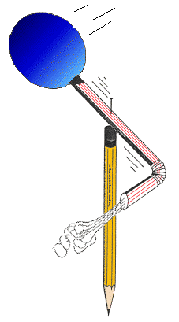
EDITED BY: Roger Storm, NASA Glenn Research Center
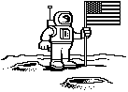
MATERIALS:
- Wooden pencil with an eraser on one end
- Sewing pin
- Round party balloon
- Flexible soda straw
- Plastic tape

METHOD:
- Inflate the balloon to stretch it out a bit.

- Slip the nozzle end of the balloon over the end of the straw farthest away from the bend. Use a short piece of plastic tape to seal the balloon to the straw. The balloon should inflate when you blow through the straw.

- Bend the opposite end of the straw at a right angle.

- Lay the straw and balloon on an outstretched finger so that it balances and mark the balance point. Push the pin through the straw at the balance point and then continue pushing the pin into the eraser of the pencil and finally into the wood itself.

- Spin the straw a few times to loosen up the hole the pin has made.

- Blow in the straw to inflate the balloon and then let go of the straw.

DISCUSSION: The balloon-powered pinwheel spins because of the action-reaction principle described in Newton's Third Law of Motion. Stated simply, the law says every action is, accompanied by an opposite and equal reaction. In this case, the balloon produces an action by squeezing on the air inside causing it to rush out the straw. The air, traveling around the bend in the straw, imparts a reaction force at a right angle to the straw. The result is that the balloon and straw spins around the pin.

Paper Rockets
SUBJECT: Rocketry
TOPIC: Stability
DESCRIPTION: Small flying rockets to make out of paper and propel with air blown through a straw.
CONTRIBUTED BY: Gregory Vogt,OSU
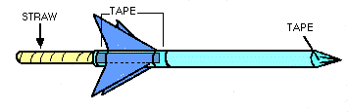
EDITED BY: Roger Storm, NASA Glenn Research Center
MATERIALS:
- Scrap bond paper
- Cellophane tape
- Scissors
- Sharpened fat pencil
- Milkshake straw (slightly thinner than pencil)

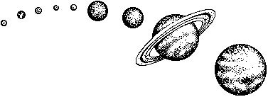
PROCEDURE:
- Cut a narrow rectangular strip of paper about 5 inches long and roll it tightly around the fat pencil. Tape the cylinder and remove it from the pencil.

- Cut crown points into one end of the cylinder and slip it back onto the pencil.

- Slide the crown points to the pencil tip and squeeze the points together and tape them together to seal the end to form a nose cone (the pencil point provides support for taping). An alternative to the crown points is to just fold over one end of the tube and seal it with tape.

- Remove the cylinder from the pencil and gently blow into the open end to check for leaks. If air easily escapes, use more tape to seal the leaks.

- Cut out two sets of fins using the pattern and fold according to instructions. Tape the fins near the open end of the cylinder. The tabs make taping easy.

FLYING THE PAPER ROCKET:
Slip the straw into the rocket's opening. Point the rocket towards a safe direction, sharply blow through the straw. The rocket will shoot away. Be careful not to aim the rocket towards anyone because the rocket could poke an eye.

DISCUSSION: Paper rockets demonstrate how rockets fly through the atmosphere and the importance of having fins for control. For experimental purposes, try building a rocket with no fins and one with the fins in the front to see how they will fly. Practice flying the rockets on a ballistic trajectory towards a target. Also try making a rocket with wings so that it will glide.

Pencil Rockets

SUBJECT: Space Flight
TOPIC: Rockets
DESCRIPTION: Rockets, using pencils for their bodies, are launched with a rubber band-powered launch platform.
CONTRIBUTED BY: Gregory Vogt, OSU
EDITED BY: Roger Storm, NASA Glenn Research

MATERIALS and TOOLS:
- 2 Pieces of wood 3'X4"Xl" in size
- 2 Cup hooks
- 1 Wooden spring clothes pin
- 1 Small wood screw
- 1 Screw eye
- 2 Metal angle irons and screws
- 4 Feet of heavy string
- Iron bailing wire (18 gauge minimum)
- Several rubber bands
- Several wooden pencils (unsharpened)
- Several pencil cap erasers
- Cellophane or masking tap
- Heavy paper
- Saw
- Wood file
- Drill (3/16 inch diameter)
- Pliers

PROCEDURE
Launch Platform

- Join the two pieces of wood as shown in the diagram to form the launch platform. Use a metal angle iron on each side to strengthen the structure.

- Screw in the cup hooks and screw eye into the wood in the places indicated in figure 1.
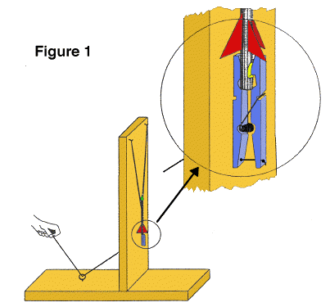

- Temporarily separate the wooden pieces of the clothes pin and file the "jaw" of one piece square as shown in figure 2. Drill two holes through the other wood piece as shown. Drill one hole through the first wood piece as shown.
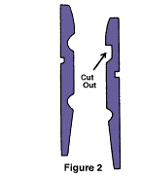

- Drill a hole through the upright piece of the launch platform as shown and screw the clothes pin to it so that the lower hole in the pin lines up with the hole in the upright. Reassemble the clothes pin.

- Tie a knot in one end of the string and feed it through the clothes pin as shown in figure 1, through the upright piece of the platform and then through the screw eye. When the free end of the string is pulled, the clothes pin will pen. The clothes pin has become a rocket hold-down and release device.

- Loop four rubber bands together and loop their ends on the cup hooks. The launch platform is now complete.

Rocket
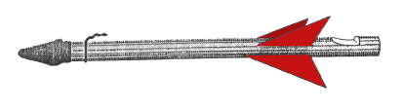
- Take a short piece of bailing wire and wrap it around the eraser end of the pencil about one inch from the end. Use pliers to twist the wire tightly so that it "bites" into the wood a bit. Next, bend the twisted ends into a hook as shown in figure 3.

- Take a sharp knife and cut a notch in the other end of the pencil as shown in figure 3.

- Cut out small paper rocket fins and tape them to the pencil just above the notch.

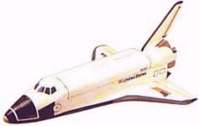
- Place an eraser cap over the upper end of the rocket. This blunts the nose to make the rocket safer if it hits something.

The rocket is now complete.

LAUNCHING PENCIL ROCKETS:
- Choose a wide open outdoor area to launch the rockets.

- Spread open the jaw of the clothes pin and place the notched end of the rocket in the jaws. Close the jaws and gently pull the pencil upward to insure the rocket is secure. If the rocket doesn't fit, change the shape of the notch slightly.

- Pull the rubber bands down and loop them over the wire hook. Be sure not to look down over the rocket as you do this in case the rocket is prematurely released.

- Stand at the other end of the launcher and step on the wood to provide additional support.

- Make sure no one except yourself is standing next to the launch pad. Count down from 10 and pull the string. Step out of the way from the rocket as, it flies about 75 feet up in the air, gracefully turns upside down and returns to Earth.

- The rocket's terminal altitude can be adjusted by increasing or decreasing the tension on the rubber bands.

DISCUSSION: Like the flight of Robert Goddard's first liquid fuel rocket in 1926, the pencil rocket gets its upward thrust from its nose end rather than its tail. Regardless, the rocket's fins still provide stability, guiding the rocket upward for a smooth flight. If a steady wind is blowing during flight, the fins will steer the rocket towards the wind in a process called 'weather cocking.' On NASA rockets, active controls steer during flight to prevent weather cocking and to aim them on the right trajectory. Active controls include tilting nozzles and various forms of fins and vanes.

Alka-Seltzer Rockets
(By Mike Passerotti)

Purpose
To design a paper rocket propelled by Alka-Seltzer and water to demonstrate Newton's third law of motion.

Background
The paper rocket in this activity is propelled according to the principle stated in Isaac Newton's third law of motion: "For every action there is an opposite and equal reaction." Gas pressure builds inside the film canister due to the mixing of Alka-Seltzer and water. This action continues until enough pressure builds to blow apart the canister from its lid. The reaction is the launch of the rocket.

Materials
card stock printed pattern; empty film canister with lid that snaps inside; markers, crayons, or colored pencils; tape; glue; scissors; Alka-Seltzer tablets; water; metric tape measure or meter sticks; straw; (Optional launch pad: wood block, coat hanger or other stiff wire)

Preparation
Review and prepare materials. It is most important to use film canisters with lids that snap inside. Do not use lids that close around the outside of the canister.

Construction
- Cut the fins out. Cut the nose cone and body out as one piece.
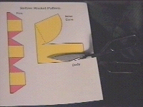
- Tape the body onto the film canister, roll the paper around the side, and tape the end down. The lid end of the film canister goes down.
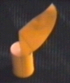
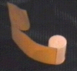
- Roll the nose cone around in the shape of a cone and tape it together. Straighten the nose cone point to the center of the rocket and tape it to the sides.
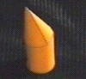

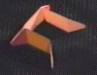
- Fold the fins so that the colored side is out. Tape or glue the fin halves together to form a complete circle.

- Fold the fins so that the colored side is out. Tape or glue the fin halves together to form a complete circle.
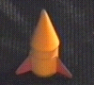
- Cut a 1 inch piece of straw and tape it to the body.

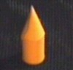
Launch Time
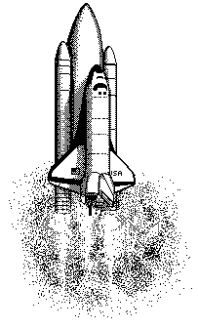
This is an outdoor activity. If gusty winds are a problem, then place a quarter in the canister to keep the rocket from falling over. Launching near a wall where a metric tape has been hung or where meter sticks have been stacked may make it easier to judge how high the rocket goes. You may want to wear safety glasses during this experiment as a general safety precaution. Everyone should stand away from loaded rockets when they are on the launch pad. It may take 15 to 20 seconds to build up enough pressure to launch, so a loaded rocket should not be approached prematurely. These rockets can shoot 5 meters or more into the air. No sharp objects should be placed on top of the nose cone or elsewhere on the rocket.

Make a launch pad with a block of wood and a straight piece of wire. Drill a hole for the wire and insert the wire straight up to guide the rocket at lift off.

Wrap-up
One way to record the results of different "fuel" mixtures is to make a simple graph of height vs. amount of water. Such a graph gives a clear, visual record of the observations and can be used as evidence to support interpretations.

Design and launch other rockets powered by two, three or more film canisters.

Design a two-stage rocket.

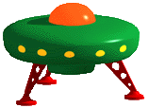

Soda Bottle Rockets
(By Mike Passerotti)

Materials
2 soda bottles; card stock printed pattern; markers, crayons, or colored pencils; tape; glue; scissors; water; wood block approximately 4" long piece of "2 by 4" lumber; one wood screw; one rubber automotive valve stem; bicycle tire pump.

Preparation
Review and prepare materials. Build the launch pad by cutting 2 1/2" off the cap end of the bottle. Cut a 3/8" slot down one side of the bottle for the tire pump hose. Drill or punch a hole in the bottom of the bottle. Screw the bottle to the block of wood.

Construction
1. Print the patterns. Cut the fins out. Cut the nose cone out.
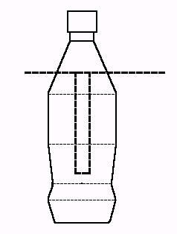
2. Roll and tape the nose cone. Tape the nose cone to the bottom of the whole soda bottle.
3. Fold the fins at all the dotted lines. Glue or tape two of the fins together. Wrap the fins around the middle of the whole soda bottle and glue or tape the last fin together.

Launch Time
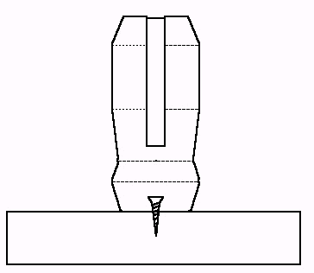
This is an outdoor activity. If gusty winds are a problem, then abort the launch. Everyone should stand away from rockets when they are on the launch pad. These rockets can shoot 100 feet or more into the air. No sharp objects should be placed on top of the nose cone or elsewhere on the rocket.
Fill the soda bottle a little less than half way with water. Shove the large end of the tire valve stem into the neck of the bottle. Attach the bicycle pump hose to the valve stem. Lower the bottle into the launch pad so that the hose slides down into the slot, the valve stem points down and the bottle rests on top of the cut bottle.

Pump up the bottle until it pops off the valve stem and flies to new heights.

Wrap-up
One way to record the results of different "fuel" mixtures is to make a simple graph of height vs. amount of water. Such a graph gives a clear, visual record of the observations and can be used as evidence to support interpretations.
Design and launch other rockets. Design a two-stage rocket. Design recovery mechanisms such as parachute, ribbon or propeller.

Soda Bottle Launch Pad
(By Mike Passerotti)

You can use a bicycle pump, soda bottle, one screw, a piece of 2x4 scrap and an automotive tire valve stem to create a launch pad.

- Take an empty soda bottle and cut it as shown below, cut the top off and cut a slot wide enough for the bicycle pump hose and deep enough to slide in the rocket, valve stem and bicycle pump hose fitting (the rocket should rest on the cut end of the soda bottle launch pad:

- Screw the soda bottle to a scrap piece of 2x4 as shown below.

- Shove the tire valve stem into the neck of your soda bottle rocket.
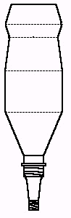
- Attach the bicycle pump to the valve stem.

- Slide the soda bottle rocket with hose attached into the launch pad. See the finished pad ready to launch below:

- Pump it up until it pops!

Altitude Tracking
TOPIC: Altitude tracking
OBJECTIVE: To use geometry to find the altitude of model rockets
DESCRIPTION: In this activity, students construct simple altitude tracking devices that are used to measure the angle a rocket reaches above ground, as seen from a remote tracking site. The angle is drawn on a graph and the altitude is read from a scale.
EDITED BY: Roger Storm, NASA Glenn Research Center
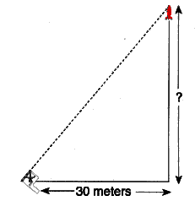
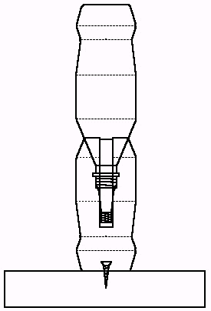

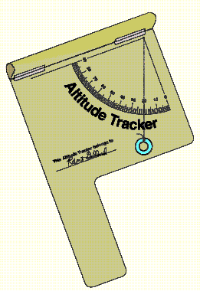
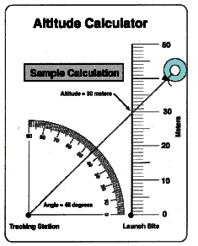
Materials and Tools:
- Altitude Tracker patterns
- Thread or lightweight string
- Scrap file folders or poster board
- Glue
- Cellophane tape
- Small washer
- Scissors
- Meter stick or steel tape measure (metric)

Procedure: Constructing the Altitude Tracker
- Copy the Altitude Tracker pattern on white or colored paper. Cut out the outline and glue the pattern to a piece of scrap file folder or poster board. Do not glue the hatched area to the folder or poster board.

- Cut off the excess file folder or poster board.

- Roll the hatched area at the top of the pattern into a tube and tape the upper edge along the dashed line at the lower edge. Shape the paper into a sighting tube.

- Punch a tiny hole in the apex of the protractor quadrant.

- Cut out the Altitude Calculator and punch a hole at the apex of its protractor quadrant. Glue the Altitude Calculator to the back of the tracker so that the two holes line up.

- Slip a thread or lightweight string through the holes. Knot the thread or string on the calculator side.

- Hang a small washer from the other end of the thread as shown in the diagram of the completed tracker.
Procedure: Using the Altitude Tracker
- Select a clear spot for launching water or bottle rockets.

- Measure a tracking station location exactly 30 meters away from the launch site.

- As a rocket is launched, the person doing the tracking will follow the flight with the sighting tube on the tracker. The tracker should be held like a pistol. Continue to aim the tracker at the highest point the rocket reached in the sky. Have a second student read the angle the thread or string makes with the quadrant protractor.
Procedure: Determining the Altitude
- Use the Altitude Calculator to determine the height the rocket reached. To do so, pull the thread or string through the hole in the tracker to the Altitude Calculator side until the washer stops it. Lay the string across the protractor quadrant and stretch it so that it crosses the vertical scale. (See sample calculation.)

  - Read the altitude of the rocket. The altitude is the intersection point of the string and the vertical scale to that number. Add the height of the person holding the tracker to determine the altitude the rocket reached.
Discussion:
This activity makes use of simple trigonometry to determine the altitude a rocket reaches in flight. The basic assumption of the activity is that the rocket travels straight up from the launch site. If the rocket flies away at an angle other than 90 degrees, the accuracy of the procedure is diminished. For example, if the rocket flies toward a tracking station as it climbs upward, the altitude calculation will yield an answer higher than the actual altitude reached. On the other hand, if the rocket flies away from the station, the altitude measurement will be lower than the actual value. Tracking accuracy can be increased, however, by using more than one tracking station to measure the rocket's altitude. Position a second or third station in different directions from the first station. Average the altitude measurements.

Teaching Notes and Questions:
- This activity is simple enough so each student can construct his or her own Altitude Tracker. Permit each student to try taking measurements while other students launch the rockets. To assure accuracy in taking measurements, practice measuring the height of known objects such as a building or a flagpole. It may also be necessary for a few practice launches to familiarize each student with using the tracker in actual flight conditions.

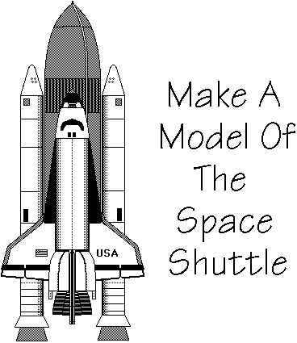
- Why should the height of the person holding the tracker be added to the measurement of the rocket's altitude?

- Curriculum guides for model rocketry (available from model rocket supply companies) provide instructions for more sophisticated rocket tracking measurements. These activities involve two station tracking with altitude and compass direction measurement and trigonometric functions.
Additional Activities
- Construct models of historical rockets. Refer to the reference list for picture books on rockets to use as information on the appearance of various rockets. Use scrap materials for the models such as:
- Mailing tubes
- Tubes from paper rolls
- Spools
- Coffee creamer packages (small plastic containers that look like rocket engine nozzles)
- Cardboard
- Egg-shaped hosiery packages (for nose cones)
- Styrofoam cones, spheres, and cylinders
- Glue
- Tape

- Use rockets as a theme for artwork. Teach perspective and vanishing point by choosing unusual angles, such as a birds-eye view for picturing rocket launches.

- Research the reasons why so many different rockets have been used for space exploration.

- Design the next generation of spaceships.

- Compare rockets in science fiction with actual rockets.

These instructions are from the following web site:
http://www.geocities.com/Heartland/6459/shuttlecraft.html

You Will Need:

Three cardboard tubes from paper towels
An empty oatmeal container without the lid, trim off the lip at the top
Light gray, dark gray, and black construction paper
Two bathroom size Dixie cups
Dark gray non-toxic paint
A measuring tape
Masking tape
Scissors
Tacky glue
A few small pebbles, rice, or dry beans
Optional: A large rubber band

Procedure:

Step One - Cut the Dixie cups in half. Discard the top portion of the cup. Paint the outsides of the bottom of the cups with the gray paint. Let the cups dry completely.

Step Two - Measure the circumference (width around) of the tops of the cardboard tubes and the oatmeal container. Measure and cut out two circles from the light gray construction paper for the small tubes and one from the dark gray construction paper for the oatmeal container. The diameter (largest part) of the circle should be the same measurement as the width around the tubes and the oatmeal container. NOTE: This part of the project is a little complicated for very young children and could very easily be done in advance by an adult.

Step Three - Cut the circles in half. Fold three light gray halves into cone shapes and glue. Fold one dark gray half into a cone shape and glue. Let the glue dry. While the glue is drying, cut one of the cardboard tubes in half.

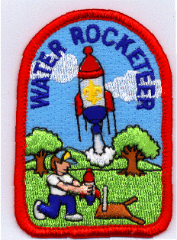
Step Four - Glue the painted Dixie cups to the inside of the bottoms of the two longer cardboard tubes. Let dry. Put some pebbles, rice, or dry beans in the tubes to weigh them down a little so that they can support the weight of the oatmeal container and the shuttle.

Step Five - Use masking tape to attach a cone to the top of the cardboard tubes and to the top of the oatmeal container. Cover the tape and the plain sections of the tubes and the oatmeal container with glued on construction paper. Let dry.

Step Six - This part is a little tricky. Glue the oatmeal container in between the two long tubes and about two inches up from the bottom. Use lots of glue. You can use a large rubber band to hold the pieces together while they dry. You will also need to put something under the oatmeal container while it dries to keep it in place.

Step Seven - Finish up your shuttle. Print and cut out the wings and the tail (vertical stabilizer) sections. Glue one wing to either side of the shuttle. Glue the engine section to the bottom of the shuttle. Glue the two tail sections together and glue to the shuttle. Let the glue dry.

Step Eight - Glue the shuttle to the oatmeal container. Use black construction paper to add details (See picture above) if desired. Enjoy!

"THE NEW OFFICIAL
WATER ROCKETEER PATCH"
A fun new addition to the water rocket world
designed by MATT WEINTRAUB
Water Rocketeer Patch is available from Cub Scout Pack 272.

Purchase these beautifully sewn WATER ROCKETEER patches. The patches measure about 2" wide by 3" tall.

The price is only $2.50 per patch, plus shipping. For more details, see the following web site:

http://www.h2orocket.com/topic/patch/patch.html

More On-Line Resources:

- Rockets Away program: (also includes page for ordering commercial laund pad): http://www.ag.ohio-state.edu/~rockets/index.html
- http://www.h2orocket.com/index.html
- http://www.geocities.com/CapeCanaveral/Lab/5403/

NOTES:

NOTES:

