Works of Art

December 2001
CONTENTS

THEME RELATED 1
DEN AND PACK ACTIVITIES 1
THE WISH TREE PROGRAM 1
PARTICIPATION AWARDS 1
FIELD TRIP IDEAS 1
ONLINE RESOURCES 1
ART BOOKS FOR KIDS 2
FIVE CHRISTMAS COMMUNITIES
IN THE U.S. 2
PREOPENING 3
PACK GATHERING GAME: HOLIDAY NAME THAT TUNE 3
DO YOU KNOW THE NAMES OF THE
EIGHT REINDEER? 3
CEREMONIES 4
WORKS OF ART OPENING 4
HOLIDAYS OPENING 4
THE FOUR GIFTS OPENING 4
HOLIDAY SPIRIT OPENING 5
HOLIDAY CANDLE CLOSING 5
THE SEVEN DAYS OF KWANZAA CLOSING 6
“IMAGINATION”--CUBMASTER’S MINUTE 6
“ENCOURAGEMENT”--CUBMASTER’S
MINUTE 6
CHRISTMAS CELEBRATION
ADVANCEMENT 7
WORKS OF ART ADVANCEMENT 8
FUN WAYS TO SAY THANK YOU 8
AUDIENCE PARTICIPATION 9
WHY SANTA HAS A BEARD 9
CHRISTMAS WITH THE RIGHT FAMILY 10
SKITS 11
ART SHOW 11
ARTISTIC GENIUS 11
THE DRAWING 12
ME TOO 12
GAMES 13
TREE DECORATING 13
SHADOW BUFF 13
OUTLINES OR WIGGLES 13
OUT-OF-SIGHT SHAPES 13
PRESENT WRAPPING 13
HOLIDAY PICTIONARY 14
SCATTER THE STARS 14
PACK OF TOYS 14
HOLIDAY CHARADES 14
KWANZAA GAME 14
REINDEER BUTTING GAME 15
FIND THE THIMBLE 15
SONGS 16
AT THE MUSEUM 16
HOLIDAY UP AND DOWN 16
HOLIDAY GREETINGS 16
CHRISTMAS SONG 16
GIVING TIME 16
MENORAH LIGHT 16
DOWN IN THE BASEMENT 17
IN THE GOOD OLD WINTERTIME 17
A SCOUT’S CHRISTMAS 17
CRAFTS 18
WINDOW ART 18
COFFEE FILTER SNOWFLAKES 18
PEBBLE PAPERWEIGHT 18
FLOATING CANDLE 19
MULTICOLOR CRAYONS 19
SWITCH PLATE ART 20
MARBLE PAINTING 20
HOMEMADE STICKERS 20
GEOMETRIC FOAM FRAME 21
PEANUT BUTTER SCULPTURE 21
KOOL-AID ENHANCED PLAYDOUGH 21
USES FOR OLD GREETING CARDS 22
CANDLE HOLDER 22
KWANZAA KINARA (CANDLEHOLDER) 23
CD CHRISTMAS WREATH 23
CANDY WREATHS 23
CRANBERRY ORNAMENT 23
DREIDEL PHOTO MAGNET 24
BORAX CRYSTAL SNOWFLAKE 24
REINDEER ORNAMENT 25
SNOWMAN PIN OR NECKERCHIEF SLIDE 26
PALETTE NECKERCHIEF SLIDE 26
REINDEER NECKERCHIEF SLIDE 26
CUBS IN THE KITCHEN 27
ART YOU CAN EAT 27
CHOCOLATE MARSHMALLOW
SCRATCHBOARD 27
SNOWFLAKE COOKIES 28
SNOWBALL COOKIES 28
PIXIE STIX “SAND ART” 28

DEN AND PACK ACTIVITIES

This month’s theme is ideal to work on art-related achievements and electives. Make some holiday ornaments, toys and gifts for the family, friends, nursing homes and shut-ins.

THE WISH TREE PROGRAM
As a den or pack, do some “Works of Heart.” Participate in the Wish Tree Program, the Santa Clara County Council’s special Christmas service project. Make up gift packages for the families, children and single men and women living in the Emergency Housing Consortium in Santa Clara.

A Christmas Wish Tree will be set up at the Council Service Center at the beginning of December for anyone who would like to pull a gift tag. Flyers will be available at the Roundtable and Council Service Center in November.

Gifts are needed for different age groups (Infant, Toddler, Girls 4-10, Boys 4-10, Girls Jr. High & High School age, Boys Jr. High & High School age, Ladies petite-3x, and Men small-3x sizes). Some of these items can be new or used (in good condition).

Some ideas for the gifts are toilet kits, school kits, books, T-shirts or sweats, Baby gift pack, and winter clothing. You will need to wrap your gifts.

PARTICIPATION AWARDS (For details, see the PARTICIPATION AWARDS section)
Cub Scout Academics: Art

FIELD TRIP IDEAS (For details, see the FIELD TRIPS section)
Triton Museum of Art, Santa Clara
San Jose Museum of Art
De Saisset Museum, Santa Clara University

ONLINE RESOURCES

- The Art Room: http://www.arts.ufl.edu/art/rt_room/@rtroom_home.html
This site is designed to help children explore the world of art through a virtual learning environment.
- Art Lessons & Games: http://www.artswire.org/kenroar/links/artgames.html
Contains lots of links to art sites.
- Geometry Through Art: http://mathforum.com/~sarah/shapiro
This site has art lessons integrated with math.
- Graphics Den: http://www.actden.com/grap_den/index.htm
Includes art lessons and a gallery for older students.
- Highland Tessellations: http://www.mcs.net/~highland/tess/tess.html
Lessons & samples of tessellation a la M.C. Escher.
- How to Draw a Cartoon Character: http://www.garyharbo.com/activity.html
- Kinder Crafts, Crafts for Kids: http://www.zoomschool.com/crafts
Tons of craft projects for preschool, kindergarten and elementary school children, using materials found around the house.

ART BOOKS FOR KIDS

- 52 Great Art Projects for Kids/Includes Pompom Pipe Cleaner Creatures, Fingerprint Cartoons, and Shadow Puppets, by Lynn Gordon; Chronicle Books.
- Adventures in Art: Arts & Crafts Experiences for 8-To 13-Year Olds, by Susan Milord; Williamson Publishing.
- Alphabet Art: With A-Z Animal Art & Fingerplays, by Judy Press; Williamson Publishing.
- Art for the Fun of It: A Guide for Teaching Young Children, by Peggy D. Jenkins; Prentice Hall Direct.
- Art Fun (Art & Activities for Kids), by Kim Solga (Editor); North Light Books.
- Art School, by Mick Manning; Kingfisher Books.
- Cooking Art: Easy Edible Art for Young Children, by MaryAnn F. Kohl; Gryphon House.
- Good Earth Art: Environmental Art for Kids, by MaryAnn F. Kohl; Bright Ring Pub.
- Hand-Print Animal Art, by Carolyn Carreiro; Williamson Publishing.
- Scribble Art, Independent Creative Art Experiences for Children, by MaryAnn F. Kohl; Bright Ring Pub.
- Make Sculptures (Art & Activities for Kids), by Kim Solga; North Light Books.
- Holiday Art Projects.

Being a Cub Scout Leader---It’s a work of heart

FIVE CHRISTMAS COMMUNITIES IN THE U.S.

Christmas, Gila County, Arizona
Christmas, Orange County, Florida
Christmas, Lawrence County, Kentucky
Christmas, Bolivar County, Mississippi
Christmas, Roane County, Tennessee
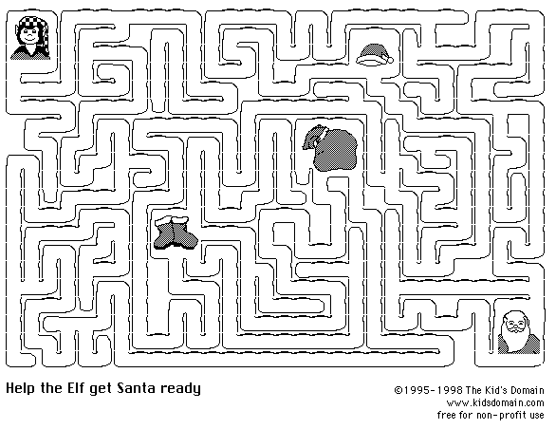

PACK GATHERING GAME: HOLIDAY NAME THAT TUNE

As families arrive, invite them to play this game. On a tape recorder, record a few bars of several pieces of music associated with Christmas, Hanukkah, or Kwanzaa. Include some difficult selections as well as old favorites and children’s songs. Tell them to write down titles of the tunes they recognize. During the pack meeting, ask everyone to stand. Ask those who identified fewer than five selections on the taped music to sit down. Then ask those who got fewer than six, seven, eight, etc., to sit down until only one or two families are standing. In their honor, have your song leader lead the audience in the most familiar number of the tape.

DO YOU KNOW THE NAMES OF THE EIGHT REINDEER?

Now Dasher! Now Dancer! Now Prancer and Vixen!
On, Comet! On Cupid! On Donner and Blitzen!
To the top of the porch! To the top of the wall!
Now, dash away, dash away, dash away, all!
-From A Visit From St. Nicholas, by Clement C. Moore

(Rudolph was a later addition...)

WORKS OF ART OPENING

W Wonders of White Snow
O Ocean waves, small and large
R Rolling hills and Rocky mountains
K Kangaroos, Kookaburras, Katydids, Koalas and other Kritters
S Shining Stars in the Sky

O Opals, Onyx and other gems
F Fruits, Flowers and Forests

A Aurora Borealis in Alaska
R Refreshing Rainfalls and Radiant Rainbows
T Towering Trees and Tiny Thornbushes

These are all God’s Works of Art!

HOLIDAYS OPENING

H Happy smiles will come your way...if
O Other people you help each day.
L Living your life by the Golden Rule
I Instead of being mean and cruel.
D Daily doing one good deed
A Always aware of another’s need.
Y You will be a better soul
S Should “Do Your Best!” become your goal.

THE FOUR GIFTS OPENING

Cubmaster: Christmas is a wonderful time to show love to others through giving gifts. It is also a time we can look at the many gifts we have already been given and enjoy each day. I have four gifts wrapped up that represent some of the gifts that each of us receive by living in a free country.
(Four Cub Scouts unwrap the gifts and read, in turn, the statements found inside.)
C.S.#1: The gift of freedom--Freedom to worship as we choose and to express ourselves and our ideas without fear.
C.S.#2: The gift of beauty--We live in a country full of beauty and wonders. From mountains to plains, from valleys to seas, it is ours to enjoy as we freely travel its width.
C.S.#3: The gift of opportunity--We are free to become whatever our ambitions and desires lead us to. Our limits lie only within ourselves.
C.S.#4: The gift of pride--We can be proud of a country where we are blessed with freedom and justice. We can be proud each time we see “Old Glory,” our country’s flag, unfurled. We can be proud to be an American.
Cubmaster: With these gifts in mind, will you please stand and pledge your allegiance to our country and our flag.

HOLIDAY SPIRIT OPENING

Props: Log candle holder with 3 candles, unlit

C.S.#1: We have been busy getting ready for the holiday season. This month there are three major holidays celebrated by different religions or cultures. They are Hanukkah, Christmas and Kwanzaa.

C.S.#2: Hanukkah is the Jewish Festival of Lights or Feast of Dedication. The Hebrew word Hanukkah means dedication. It is a celebration of God’s deliverance of the Jews in 165 BC. The Hanukkah holiday begins on the 25th day of the Hebrew month of Kislev, and lasts 8 days. It usually falls in the month of December and is celebrated by the lighting of candles in a special candle holder called a menorah. I light the first candle for Hanukkah. (Lights first candle)

C.S.#3: Christmas is the celebration of the birth of Jesus Christ. Although the actual date of his birth is not known, early church fathers in the fourth century fixed the day as December 25. The Christian priests saw the choice as meritorious, using an old customary and popular feasting date but changing the rough pagan ways into a more civilized commemoration. The word Christmas is taken from Old English, “Christes maesse” which means Christ’s mass. I light the second candle for Christmas. (Lights second candle)

C.S.#4: Kwanzaa is an African-American holiday based on the traditional African festival of the first crops. The word Kwanzaa comes from the phrase “matunda ya kwanzaa” which means first fruits in Swahili. It begins on December 26, and lasts for seven days. The holiday centers on the seven principles of African-American culture. These principles are: Unity, Self-determination, Collective work and responsibility, Cooperative economics, Purpose, Creativity, and Faith. I light the third candle for Kwanzaa. (Lights third candle)

C.S.#5: With the spirit of the holiday candles now burning, let us now begin our own celebration of our accomplishments this month.

HOLIDAY CANDLE CLOSING

Cub Scouts leave the room and march back in by dens. Extinguish the room lights and have each denner hold a single candle as the dens return. When dens have reached their places, the Cubmaster says:
“This is the season of lights. It is the time when the days are shorter and the nights are long. But somehow the world seems brighter. Thousands of homes have candles to light the way for the Christ Child. Other thousands have candles burning to commemorate the miracle of the oils of Hanukkah. Thousands more will be lighting the candles to celebrate the seven principles of Kwanzaa. Even the stars in the winter sky seem brighter.
The most brilliant glow comes from the spirit of goodwill that you live all year round in the Cub Scout Promise and Law of the Pack. Please stand and repeat them with me.

THE SEVEN DAYS OF KWANZAA CLOSING

Props: 7 candles (1 black, 3 red, 3 green), Index cards
Personnel: 1 leader, 7 boys
Arrangement: Line up the 7 boys with candles in the following order: Black, Red, Green, Red, Green, Red, Green

LEADER:
Kwanzaa is a holiday celebration of the African-American community, and is observed from December 26 through January 1. Each of the seven days of Kwanzaa is dedicated to a principle. Each day a new candle is lit: Unity (black candle), Self-determination (red), Collective Work and Responsibility (green), Cooperative Economics (red), Purpose (green), Creativity (red), and Faith (green). Rituals include fasting, feasting, self-examination and discussion of these principles. Let us dedicate ourselves to these principles and the Cub Scout promise during this holiday season.

Note: Light each candle as it is mentioned, or have the name of the candle on an index card and have each boy read the card in turn. Colored felt or poster board can be used instead of the candles.

“IMAGINATION”--CUBMASTER’S MINUTE

In the children’s book “Little Prince,” an accident forced the pilot to land in the Desert of Sahara. There the pilot met a mysterious little boy. The boy wanted him to draw a picture of a sheep. The pilot told the little boy he couldn’t draw. But the boy insisted. So he drew a sheep. No, the boy said that sheep was very sick. The next sheep was rejected because it was a ram, not a sheep. The third one was too old. He wanted a sheep that would live a long time. So the pilot, being desperate, drew a box saying, “This is only his box. The sheep you asked for is inside.” The boy said, “That is exactly what I wanted! Do you think that this sheep will have to have a great deal of grass?” See, the boy could see in the picture what he wanted to see. We grown-ups often forget the imagination of the children.

“ENCOURAGEMENT”--CUBMASTER’S MINUTE

One of the definitions of art is “Creativity of man as distinguished from the world of nature.” Chances are, most children have been exposed to art and were not aware of it. They have used many of the tools of art, like paint, crayons, pencils and clay. By the time a boy enters elementary school, he has drawn countless pictures and shapes. He need not have a talent for art to enjoy it. A child’s first paintings and pictures are not indicative of his future talents. It is up to the adults around him to provide encouragement and guidance, so that every child can reach his full potential and develop his talent.

CHRISTMAS CELEBRATION ADVANCEMENT

Props: Christmas tree; Awards wrapped with Christmas wrap (one color for each rank); Container with regular Christmas lights.
Use homemade wrapping paper. CM could comment on it and also on the “artistic” way the lights are strung, etc.

Asst. CM: These seems to be presents for the Tigers. Will the Tiger Cubs and their parents please come forward?

CM: You have worked very hard and had lots of fun on your Big Idea (mention or ask what it is). When you open your present, you will find something to help you remember what you did. Now take this light and help decorate our tree, please.

Asst. CM: Wow, look at these presents. I see the names of the (Bobcats or Wolves). Will the following boys and their parents, please come forward?

CM: This is the next step in celebrating Cub Scouting. You have had exciting times. When you open your presents, you will also find something to celebrate your new rank. Will you help us light the tree? (Give the boys their lights)

Asst. CM: Boy, oh boy, check these presents out. Rats, these aren’t for me. They have the names of Bears on them. (Call the names of the boys and their parents)

CM: You have really been good this year because the Bears look to be larger than the rest. I would really appreciate if you would add to the string of lights on the tree.

Asst. CM: You know, something here should be for me. I was really good. Wait a minute, I found a present in a large basket, could it be for me? Oh, the names are for the Webelos (this will probably be activity badges). (Call the boys and parents forward)

CM: This is the largest amount of presents yet! I am really proud that you are trying so hard to achieve your goal towards the Arrow of Light. And speaking of light, will you help decorate the tree by adding your lights?

CM: You can see the holiday is really shining. Look at all the light! The boys have celebrated not only Cub Scouting but the holiday. Let’s celebrate this occasion by singing “O Christmas Tree.”

APPLAUSE

RUDOLPH APPLAUSE: Put your thumbs to your head with fingers forming antlers. Wrinkle your nose and say, “Blink! Blink!”

SANTA APPLAUSE: Hold hands on stomach and say, “HO, HO, HO.”

WORKS OF ART ADVANCEMENT

Props: Display of Cub Scouts’ art (preferably done by the candidates). Copy of large Cub Scout emblem, cut up into pieces like a jigsaw puzzle (one piece for each participant). On the back, write a number and attach a piece of double sided tape or looped tape. On a large poster board, lightly trace the outline of the emblem and each puzzle piece, with corresponding number.
Note: If you have many candidates, prepare a puzzle for each rank emblem, rather than using the Cub Scout emblem.

Cubmaster:
(Points to the art display) As you can see from all the artwork displayed here, our Cub Scouts are very creative. We need some help from these creative young men to finish another work of art for us tonight. They have been working hard to complete their rank requirements, and are now ready to help fill in our picture. Will the following boys please come up with your parents to receive their (name of rank) rank?

(CM hands the boy his rank and a puzzle piece. With his parents, the boy places the puzzle piece on the board. Continue for each rank and have each boy add to the picture until it is complete)

Our budding young artists together have completed our portrait of the Cub Scout emblem. Congratulations to them for their success.

FUN WAYS TO SAY THANK YOU

Paint brush: “What you have done for the pack is truly a Work of Art!”
Candle: “For someone who really lights up the pack.”
“For your warm glow.”
“Because you light the way.”

Heart: “For your work of heart!”
Huge letters H E L P written on a nice sheet of paper:
“You have been a great help. Thank you!”
Pencil: “Write (right) on!”
Framed picture: “For doing a picture perfect job.”
Popcorn: “Thank you for popping fresh ideas!”
For the pack’s popcorn sales chairman.
Scissors: “Because you’re a cut above the rest.”
Tape or Glue: “Because you stick to it.”
“You help hold us all together.”
Yardstick or ruler: “You measure up”
“For un-measurable service.”

See Cub Scout Ceremonies for Dens and Packs for:
Advancement for all ranks “Yule Log” p. 8-12

WHY SANTA HAS A BEARD

SANTA: Hold hands on stomach while saying, “Ho-ho-ho!”
NORTH POLE: Fold arms, hugging self tightly while saying, “Brr-rr-r!”
SLEIGH: Wave arms across front of body while saying, “Swoosh-h-h!”
WORKSHOP: Hold hands over ears while saying, “Bang, bang, clatter, clatter!”

You’ve all heard many stories about SANTA and his WORKSHOP at the NORTH POLE. You have also heard stories about his SLEIGH and reindeer. But there is a story about SANTA that very few people know, so if you will listen very closely, I’ll tell you about how SANTA decided to grow a beard.

As you know, the weather is very cold at the NORTH POLE where SANTA has his WORKSHOP. He works very hard throughout the year with his little elves making toys for his Christmas Eve visit. Like everyone else, SANTA needs relaxation, and a chance to get away from it all. His way to relax was to take a leisurely ride in the SLEIGH.

With such cold weather at the NORTH POLE, SANTA always had to bundle up tightly before taking a SLEIGH ride. Once he forgot to bundle up as tightly as usual and he failed to wrap his heavy wool scarf around his face as he went SLEIGH riding. When SANTA got back from his ride and walked into the WORKSHOP where Mrs. Claus and the elves were happily working, he had the most beautiful white icicles hanging down the sides of his face and chin, just like a beard.

When Mrs. Claus looked up and saw him, she squealed with delight, “Why, SANTA you look absolutely marvelous with your sparkling white icicle beard.” Well, when SANTA saw how delighted his wife was, he was very flattered and decided right then and there to grow a long, flowing white beard and mustache. And that is what he did!

By doing this, SANTA caused two things to happen. He made himself so handsome that whenever Mrs. Claus passed by him in the NORTH POLE WORKSHOP, she gave him a big smile. This made SANTA blush so much, that to this day, he is still blushing. That’s why his cheeks always look rosy. And now he doesn’t have to wrap a scarf around his face when he goes SLEIGH riding at the NORTH POLE, Mrs. Claus has even started going on SLEIGH rides with SANTA because she is so happy that he grew his beard.

APPLAUSE

ELVES APPLAUSE: “Saw, saw, saw” (make motions like sawing). “Tap, tap, tap” (make motions like hammering). “Paint, paint, paint” (make motions like painting). “Merry Christmas!”

GOOD-BYE SANTA APPLAUSE: Pretend to throw a pack onto your back and say, “Merry Christmas to all and to all a Good Night!”

CHRISTMAS WITH THE RIGHT FAMILY

Prepare a few gift boxes containing candy or small party favors. At the end, distribute the contents to all players. Read the story below slowly enough for the gifts to be passed. Every time the word “RIGHT” is read, the gifts are passed to the persons on the right. Every time the word “LEFT” is read, the gifts are passed to the persons on the left.

Christmas was almost here, and Mother RIGHT was finishing the Christmas baking. Father RIGHT, Susan RIGHT, and Billy RIGHT returned from their last minute Christmas errands. “There’s not much LEFT to be done,” said Father RIGHT, as he came into the kitchen. “Did you leave the basket of food at church?” asked Mother RIGHT. “I LEFT it RIGHT where you told me to,” said Father RIGHT. “I’m glad my shopping is done,” said Billy RIGHT, “I don’t have any money LEFT.” The hall telephone rang, and Susan RIGHT LEFT to answer it. She rushed back and told the family, “Aunt Tillie RIGHT LEFT a package for us RIGHT on Grandma RIGHT’S porch.” “I’ll go over there RIGHT now and get it,” she said as she LEFT in a rush. Father RIGHT LEFT the kitchen and brought in the Christmas tree. By the time Susan RIGHT returned, Mother RIGHT, father RIGHT and Billy RIGHT had begun to trim this year’s family RIGHT’S Christmas tree. The entire RIGHT family sang carols as they finished the decorating. Then they LEFT all the presents arranged under the tree and went RIGHT up to bed, hoping they had LEFT all the gifts in the RIGHT place and had selected the RIGHT gift for each member of the RIGHT family. Now I hope you have the RIGHT present for yourself, because that’s all that’s LEFT of our story, except to wish you a Merry Christmas. Isn’t that RIGHT?

APPLAUSE

SLEIGH APPLAUSE: Bob up and down in chair like riding in a sleigh and say “Ting-a-Ling” three times.

SLEIGH APPLAUSE II: “Jingle, Jangle, Jingle, Jangle”

SANTA CHIMNEY APPLAUSE: “Oooh; Ouch; Rattle; Bang; Craaaassshhh! Ho, ho, ho, Merry Christmas!”

Audience Participation in Cub Scout Leader How-To Book
“The House Where Santa Claus Lives” p. 6-4

ART SHOW

Props: Trace or draw the outlines of famous people or portraits. Instead of drawing a face, cut out a hole to fit a face. Use various pictures. (Present several ideas and let the boys choose. If boys don’t object, include Mona Lisa or Whistler’s mother.) Prepare the Mount Rushmore outline for the final piece. The part for the announcer may be divided among a few boys.

Announcer:
Tonight we would like to share with you some of the greatest works of art in all history. We have arranged for a brief showing, through the generous underwriting of an anonymous donor. We hope that tonight’s art show will be especially enlightening.

First we have a portrait of George Washington.
(A Cub Scout walks past holding up a cardboard portrait with his face showing through the cutout)

Next we have Vincent Van Goth’s self-portrait.
(A Cub Scout walks past with a cardboard and a cloth bandage wrapped around his ear)

Here is the original portrait done for Mickey Mouse.

(Keep going)

Finally tonight, we have the original models for that great presidential sculpture on Mount Rushmore.
(Four boys walk out together looking through the Mt. Rushmore cutout)

ARTISTIC GENIUS

Cast: Three or more judges; Painters
Props: Canvasses; Easels (chairs); Sign announcing “Art Competition Today”

Plot: An art show, where judges are inspecting several canvasses on display. They comment on the brightness, color, technique, and brush strokes of each. They select one for first prize, and comment about the genius, imagination, and beauty of the picture. The artist is summoned, and the winning picture is shown to him. The painter exclaims, “Oh, my goodness, that got in by mistake! That is the canvas I clean my brushes on!”

Variation: To extend the skit and bring in more players, the judges can award second and third places to other artists with ridiculous names. You can add silly painting subject matters, etc., for the winners to describe their winning canvasses. Let your Cub Scouts make the competing canvasses (use newspaper, painted completely white. Let dry, allow boys to create masterpieces, then wrap over appropriate size piece of cardboard and tape on the back.)

THE DRAWING

A Cub Scout is seated and sketching in a book (or on canvas on an easel). Boys come in one at a time and ask, “What are you doing?” The Cub Scout answers, “Drawing.” All the boys stand around and watch after they have asked the question. The first boy then asks, “What are you drawing?” The Cub Scout answers, “A crowd.”

ME TOO

Cub #1: What do you want for Christmas?
Cub #2: I want a new bike and a computer.
Cub #3: I want Santa to take away my baby sister!
Cub #4: I want a pocketknife.
Cub #5: I want a big turkey dinner and a visit to Grandmother’s house.
Cub #6: I really want a color TV in my room. If I don’t get one, I’ll hold my breath.
Cub #4: Yeah! I want a color TV too. I’ve been good this year and I deserve one.
Cub #3: Are you sure you wouldn’t settle for a new baby sister?
Cub #5: I think we should all hold out for what we want this year. No more clothes and stuff.
Cub #2: Sounds good to me.
Cub #6: We’ll all show them that they can’t push us around. (To Cub #1) What do you think?
Cub #1: Well, all I want during this holiday season is Peace on Earth and Goodwill towards All Men.
(A moment of silence as the boys ponder what has been said)

All together: ME TOO!

CHEERS

SNOWBALL CHEER: Leader throws a wad of white paper into the air. As it hits the ground, all say “Happy Holiday!”

WORKS OF ART: Pretend to paint, step back, spread arms, and say “Oooooooooo, Ahhhhhhhhh, Magnificent!

Puppet Play
Cub Scout Leader How-To Book
The Animals’ Christmas Story” (a shadow puppet play) p. 5-22

TREE DECORATING

You will need chalk and chalkboard, or a large sheet of paper and felt tip pens. Set chalkboard at one end of the room. Divide group into an equal number of teams with at least 6 members on each team. If the teams are smaller, players can have two runs. On signal the first player runs to the chalkboard and draws a base for the tree. Then runs back and the next player add branches. The third player adds a set number of candles. The fourth player adds a set number of ornaments. The fifth person adds a star to the top. The last player writes “Merry Christmas” underneath. The first team to complete the tree wins. Adjust the list of drawings according to the number of boys.

SHADOW BUFF

You need at least 4 players. You will need a blank wall for a screen and a bright light that can cast a focused beam. The object of the game is to identify the other players by their shadows.
Choose a player to be “It.” “It” sits on the floor in the middle of the room, facing the blank wall. The light is placed behind “It,” shining on the wall, and the other lights are turned off. One by one, the other players pass behind “It” and in front of the light. Looking straight ahead at the shadow on the wall, “It” tries to call out the name of the player crossing behind him. Players may disguise their shadows in any way to confuse “It.” The player whose shadow is identified correctly becomes the new “It.”

OUTLINES OR WIGGLES

Give everyone a pencil and paper and ask them to draw a wavy or zigzag line. Have boys exchange papers and make the line into a picture. The one with the funniest, most holiday-like, or best picture is the winner.

OUT-OF-SIGHT SHAPES

This is a pantomime game in which an invisible piece of space can be squeezed, squashed, twisted, or rolled into any imaginable object. To begin the game, have all the boys stand in a circle. The leader quietly pulls a chunk of invisible space out of his pocket and begins to shape it into a large pretend object, such as a fishing pole, baseball bat, or dog. The leader then passes the object to a neighboring boy, who transforms it into another form and passes it along. Each boy should take about 30 seconds to transform the shape. When the object gets back to the leader, he gently squeezes it into its original shape and puts it in his pocket. You may want to give the boys categories of objects such as holiday decorations or holiday gifts.

PRESENT WRAPPING

Divide the groups into teams of two boys. Prepare for each team; a box, wrapping paper, tape, and scissors. Each boy in the team has one hand behind his back and together they wrap their present. The team who wraps their present first, with quality, is the winner.

HOLIDAY PICTIONARY

This is a game for at least 4 players, grouped into teams. You will need a large pad of paper (newsprint), markers, and index cards. Write ahead of time, on the index cards, holiday-related words (one word per card). The object of the game is for the teams to try to guess as many words as possible. Choose a player from 1 team. That player is given a word to draw. The team that guesses the word first gets a point. Choose another player from the other team to draw the next word. Continue play until all players get a chance to draw. To add a challenge, try drawing while blindfolded, and award bonus points for correct guesses.

SCATTER THE STARS

Divide the players into teams. Give each team about a dozen star-shaped confetti pieces. One team throws their stars onto a black surface (like construction paper) like a constellation. The other team comes up with a name for the constellation. They need to explain which part of the constellation is represented by each star. To make it challenging, they can come up with a story about the constellation.

PACK OF TOYS

Players arrange their chairs in a large circle facing inward. Each player is given the name of a toy. “It” walks around the inside of the circle and says, “Santa packed his bag and in it he put ______.” The player whose toy is named gets up and follows “It” around the circle. After several players are following “It,” he suddenly calls, “And the bag broke!” All scramble to sit down, including “It.” The boy left without a chair becomes the new “It.” If the group is large, assign a toy to more than one boy.

HOLIDAY CHARADES

Divide the den into teams of two. Give each team a slip of paper with an idea related to the holidays (decorating tree, lighting the holiday candles, for example). In turn, each team acts out its charade while the others try to guess what it is.

KWANZAA GAME

On 3x5 cards write the definitions of each of the seven Kwanzaa principles. In advance of the game, the children must learn the principles. (See “The Seven Days of Kwanzaa Closing” above.)
To play, give a card to a player and give him a few minutes to figure out a question based on his principle to ask the others. (Examples: “I strive for and maintain oneness with my family, community, nation and race. Who am I?” “We build and maintain our own stores, shops, and other businesses and we profit from them together. Who am I?”)
The answer to the first example is Umoja (unity); second example, Ujamaa (cooperative economics).

REINDEER BUTTING GAME

Divide the group into teams. Each team is given an orange and lines up relay fashion. On signal, the first boy in each den puts the orange on the floor and butts it with his head to a turning line and back. He may not touch the orange with his arms or hands, only with his head. The next member repeats the action, and so on until all have raced. First team finished wins.

FIND THE THIMBLE

You will need a thimble or a small holiday ornament. While everyone is out of the room, one player places the object in an unexpected location, but in plain view. The other players then return to search for the object. Whenever a player sees the object, he sits down where he is – being careful not to reveal the object’s location. After everyone has spotted the object, choose a new player to hide the object.

The best thing to spend on a boy is your time!

CHEERS

DREIDEL CHEER: Spin a dreidel on a table or desk. When it lands, all yell “Happy Holiday!”

CHRISTMAS BELLS: Hold a rope or handkerchief in your hand; the left side of the audience says “Ding” on the down stroke; the right side of the audience says “Dong” on the upstroke. Vary the speed and direction.

Games
Cub Scout Leader How-To Book
“Art Consequences” p. 2-25
“Five Dots” p. 2-26
“Wiggles” p. 2-26
“Hanukkah Peanut Hunt” p. 2-29

AT THE MUSEUM
(Tune: Yellow Rose of Texas)

When I see a fuzzy picture,
A-hanging on the wall,
They say it is a masterpiece,
I cannot tell at all.

I squint and clean my glasses,
I look and gaze some more.
But it still looks the same to me,
Just as it did before.

HOLIDAY UP AND DOWN
(Tune: A Hunting We Will Go)

(Begin this song sitting down.
Stand up at the word UP;
sit down at the word DOWN.
At HALFWAY, stand halfway up!)

At holiday time we try,
To always bring good cheer,
We’ll keep it UP and do our best,
To not let DOWN next year.

So we will keep it UP,
And try to not let DOWN,
But if HALFWAY we keep it UP,
Will we be UP or DOWN?

We’ll try to wear a smile,
And keep it UP you see.
For when we’re DOWN, we wear a frown,
And a grump’s not fun to be!

HOLIDAY GREETINGS
(Tune: Are You Sleeping?)

Christmas greetings,
Kwanzaa greetings,
Hanukkah, it’s that time,
Holidays are super,
Presents super duper
Candles glow, candles glow.

CHRISTMAS SONG
(Tune: Rudolph)

Here’s to the Cubs in our den,
As they follow, help and give;
All of the boys in our den
Know just how a Cub should live.

Now it’s time for Christmas,
We’ve been very helpful boys,
We’ve gathered lots of old things,
Fixed them up like brand new toys.

Saved our pennies every meeting,
Bought a lovely Christmas tree,
Trimmed it up to take to our
Den-adopted family.

Bright and early Christmas morn’,
When they see our shiny toys,
We’ll be happy that we shared
Our Christmas joy with other boys.

GIVING TIME
(Tune: Jingle Bells - chorus)

Giving time, sharing time
Fun for everyone
Cub Scouts know that Christmas is
The time for deeds well done.

Giving time, sharing time
Let us all take part
Join with Cub Scouts all around
And give gifts from the heart.

MENORAH LIGHT
(Tune: Three Blind Mice)

Menorah Light, Menorah Bright.
See how it shines, see how it shines.
The candles shine with a light so bright,
See how it brightens the darkest night,
Have you ever seen such a sight in your life,
Menorah Bright!

DOWN IN THE BASEMENT
(Tune: Up on the Housetop)

Down in the basement Cub Scouts pause,
They are helping Santa Claus.
Toys and games and goodies too,
Make children happy, yes, they do.
Ho, ho, ho, who wouldn’t go,
Ho, ho, ho, who wouldn’t go,
Out helping Santa, click, click, click,
Try a goodwill project quick, quick, quick.

We are Cub Scouts and we’re happy boys,
At Christmas time we share our joys,
We’ll give some help to our Mom and Dad,
And try to help make everyone glad.
Ho, ho, ho, who wouldn’t know,
Ho, ho, ho, we know it’s so.
Now that we’re Cub Scouts, we will be
Happy and loyal and trustworthy.

IN THE GOOD OLD WINTERTIME
(Tune: In the Good Old Summertime)

In the good old wintertime,
In the good old wintertime,
I love the snow, the rain, the sleet,
This season you can’t beat.

I’m frozen in, I’m frozen out,
It is without a doubt,
The coldest time of all the clime,
In the good old wintertime.

See Cub Scout Songbook for:
“Santa’s Coming”

A SCOUT’S CHRISTMAS
(Tune: Jingle Bells)

Dashing through the den,
With a rope held by each end,
Tying a bowline knot,
Then showing what I’ve got.

Whittling with my knife,
On a practice Dial bar.
I can hardly wait,
Scout camp can’t be far.

Bait a hook,
Learn to cook,
Bike rodeos.
Neckerchief slides,
Canned food drives,
Learning to take photos.

Pancake mix,
Carving sticks,
Keeps us on the run.
Our families,
Make all these,
Memories so much fun.

Dashing through the camp,
Putting up the tents,
Popping all the corn,
Blowing that morning horn.

Of Scout camp we all dream,
We’ll soon be old enough,
Tigers, Bobcats, Wolves, and Bears,
We’re made of real tough stuff!

Half-hitch knots,
Setting up cots,
Playing fun new games.
Hammers and nails,
Compass and trails,
Arrow points are the thing.

Santa’s coming,
We’ve been good,
As good as we can be.
Load our stocking,
With a pocket knife,
Boy Scouts, we want to be!

WINDOW ART

Decorate a window or sliding glass door with washable paints!

Materials: Clear dishwashing liquid; Premixed tempura paints

- For each color of paint, mix approximately 1 tablespoon of dishwashing liquid with ½ tablespoon of paint. Mixture should have consistency of house paint. Use only clear dishwashing liquid, otherwise the paint color will change. Use foil-lined muffin tins or plastic containers for holding the different colors.
- Using a different paintbrush for each color, paint on the window or sliding glass door. Try to avoid painting the sills and woodwork – masking tape can be applied beforehand.
- To remove the dried paint or fix a mistake, wipe off paint with a moist paper towel.

COFFEE FILTER SNOWFLAKES

These are real pretty as sun catchers on a window.

Materials: Round coffee filter; Water-base markers; Spray bottle; Scissors.

1. Smooth out the filter.
2. Fold and cut as you would make a snowflake.
3. Paint all edges with markers, both folded section and cut section.
4. Spray lightly with water (filter is still folded). Colors will bleed and blend together.
5. Unfold carefully. Dry on a paper towel on a flat surface.
6. Iron, if desired.

PEBBLE PAPERWEIGHT
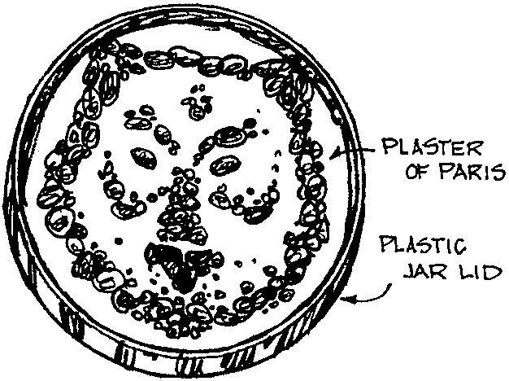
Materials: One large jar lid; Plaster of Paris; Pebbles, marbles and/or shells; Food coloring or liquid paint (optional)

1. Prepare plaster according to the manufacturer’s instruction. The plaster may be colored with a small amount of food coloring or liquid paint.
2. Fill the jar lid nearly to the top with the plaster.
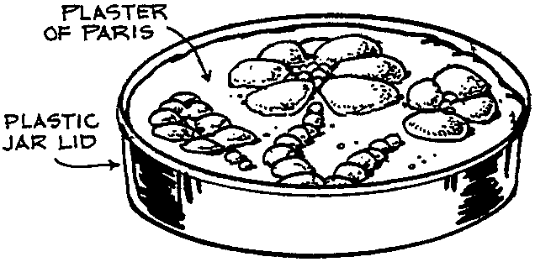
3. Form the design with pebbles, marbles and/or shells. Take care not to bury the items in the plaster.
4. Let dry until plaster has set.

FLOATING CANDLE

Make round or shaped floating candles for the holidays. Each candle will burn about 3 hours.

Materials: Wax; Candle wick; Paper clips; Foil cupcake cups; Empty can with the label removed; Candle coloring or crayon (optional)

1. Break up the wax and put pieces in the empty can. Fill a small pot with about two inches of water, put the can in the pot and the pot on the stove over low heat. Turn off the heat when the wax is just melted. If you want colored candles, add candle coloring or a small amount of crayon in the melted wax. If you add too much crayon, your candle will smell strongly of crayon when it is burned.
2. Dip a short piece of wick alternately in the melted wax and cold water a few times to make it stiff. (For Wolves, you may want to prepare stiff wicks ahead of time.)
3. Attach a paper clip to the stiffened wick and stand the wick in the middle of a foil cup.

4. Fill the cup 3/4 full with melted wax.
5. If desired, you can shape the wax-filled cup into a heart or star by simply “pinching” the foil cup when the wax is partially set.
6. Leave the foil on the candle. It’ll reflect the flame and create a nice effect.

Note: This project does not require a large amount of wax. Ask your den parents for candle stubs. Candle wax is available at a craft supply store. It costs about $2 a pound and comes in one pound or ten pounds blocks.

MULTICOLOR CRAYONS

Draw pictures with these round multicolor crayons. Make some for little children.

Materials: Old crayons; foil cupcake cups; Muffin tin

1. Peel paper off the crayons.
2. Line the muffin tin with foil cups. Place crayons in the cups, about two layers. Mix four to six colors (too many colors will melt into one muddy color).
3. Place in the 200-250 oven. Melt the crayons. It will take about 8-10 minutes. Don’t let it burn.
4. Take out the muffin tin carefully--you don’t want to slosh the colors. Top of the crayon may look muddy but don’t worry. Let it cool.
5. Peel away the foil cups.
6. Use the new crayons whole or break them into 2-3 pieces. Have Fun!

SWITCH PLATE ART

Create your own colorful and festive switch plate! This makes a great gift too.

Materials: White light-switch plate (available at a hardware store, inexpensive ones are less than 25 cents each); Acrylic paints

- Provide smocks or paint shirts for the boys, and cover the work area with newspaper. The easiest method of painting is the splatter technique. This is best done outside because of the flying paint.
- Dip paintbrush deeply in paint and then, holding the tip of the handle, wave the brush down and sideways above the switch plate. Motion of the brush should be quick and short. Repeat this process with different colors until the switch plate is completely covered.
- Try painting another switch cover with a repeating pattern, such as dots, stripes, circles, spirals, or triangles.

MARBLE PAINTING

Create a work of art with marbles. Make your own greeting cards!

Materials: Paper; Paper plates; Tempura paints; Marbles; Plastic spoons.

- Cut a sheet of paper to fit on a sturdy paper plate.
- Pour small amount of tempura paint into individual containers for each color, or use a foil-lined muffin tin.
- Drop marble into one color paint and roll it around with the spoon.
- After the marble is well coated with paint, transfer it onto the paper plate with the spoon.
- Grip the edge of the paper plate, and move the marble around the plate until the paint wears off. Try using two or more marbles at the same time.
- To keep the colors from mixing in the containers, use a different marble for each color.
- Remove the artwork from the paper plate and hang to dry.

HOMEMADE STICKERS

Materials: White glue; White vinegar; Photos or pictures cutout from magazines.

- Combine 2 parts white glue with 1 part white vinegar.
- Cut out a portion of a photo or picture from a magazine that you wish to turn into a sticker. Apply the glue to the back of the photo or picture.
- Let the glue dry.
- When you are ready to use the new sticker, moisten the backside that contains the glue. If you do not like the taste of vinegar, use a sponge to moisten the sticker.

GEOMETRIC FOAM FRAME

Put your picture in the frame and give to parents or grandparents as a holiday gift!

Materials: Lucite photo frame; Pre-cut foam shapes (available at craft stores); Glue gun.

Hot glue the foam pieces all around the edge of the lucite frame, so that the pieces overlap each other. Layer the smaller pieces on top of the larger pieces.

VARIATIONS: Instead of foam shapes, try puzzle pieces, old buttons, old game pieces, new crayons, etc.

PEANUT BUTTER SCULPTURE

Make a sculpture out of peanut butter dough.

Ingredients: 1 cup smooth peanut butter; ½ cup honey; 2 cups of nonfat dry milk.

- Mix the peanut butter and honey in a mixing bowl. The mixture will be sticky, but the dry milk will make it less sticky.
- Slowly add half of the dry milk (one cup). Continue to add the rest of the dry milk until you get a soft pliable dough that is easy to shape.
- Shape the dough into a sculpture, such as an animal, star, or face. Sculpture can be decorated with M&Ms, chocolate chips, and coconut.
- The boys may be tempted to eat the dough that is decorated with the candy. The dough is safe to eat, though it may be very sweet because of the honey. To tone down the sweetness, use plain peanut butter made without sugar.

KOOL-AID ENHANCED PLAYDOUGH

This beautifully-colored, scented, (but non-appetizing), playdough is very pliable and easy to roll or sculpt. This makes a great gift for young children. (Idea: Kim Lindemann)

2 cups flour 1 1/2 cups boiling water
4 teaspoons cream of tartar 3 - 4 Tablespoons vegetable oil
1 cup salt Kool Aid

- Add one package of Kool Aid mix, oil and food coloring to boiling water. (Adult supervision advised) Try a variety of Kool Aid flavors and colors.
- Combine remaining ingredients, and mix well. As you knead it, the dough will get smoother.
- Store in airtight container.
- Add a little alum to the dry ingredients to preserve the playdough for a longer time.

USES FOR OLD GREETING CARDS

Some of the holiday greeting cards are so pretty it’s a shame just to throw them away. Recycle them. Make them into new gift tags, greeting cards and holiday collages, or decorate a candle holder (see next item).

GIFT TAGS: You will need cards with nothing written on the reverse side of the picture. Choose the part of the picture you like. Cut around it in the shape of a tree, star, heart, circle, square, or any shape that appeals to you. Cut in straight lines, wavy lines, etc. Use pinking shears or craft scissors (which cut different curvy lines), if they are available. Punch a hole. Write “To: __” and “From: __” on the back. Attach to the gift with ribbon.

GREETING CARDS: Cut shapes as above, without punching holes. Cut colored card stock paper in half. Fold into half to form a card. Glue an ‘old greeting card shape’ on the outside. If desired, make a lot of dots by punching holes in scrap cards. Glue the dots around your glued piece.

COLLAGE: Choose cards that have your favorite things (like animals) or favorite holiday activities. Cut them out and make a collage.

CANDLE HOLDER

Materials: Small jar; Old holiday greeting cards; Rubber bands; White glue; Paintbrush; Salt in shaker (or fine “pearl” glitter); Ribbon; Votive candle or Tea candle.

- Cut out a small picture or two from old holiday greeting cards.
- Glue the picture onto the jar--use white glue or tacky glue, not a glue gun. Make sure the picture is positioned away from the mouth of the jar. Put a rubber band around the jar to hold the picture in place until the glue dries.
- Remove the rubber band. Using a paintbrush, cover the outside of the jar, including the picture, with glue. Avoid painting the bottom of the jar.
- Sprinkle salt (or glitter) over the jar. Do this over a piece of foil, styrofoam tray, or wax paper.
- Set jar on foil to dry.
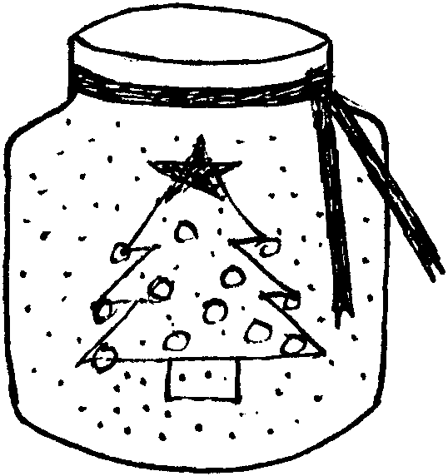
- Tie ribbon around the rim of the jar. Curling ribbon works well but make sure curls are away from the candle flame.

KWANZAA KINARA (CANDLEHOLDER)
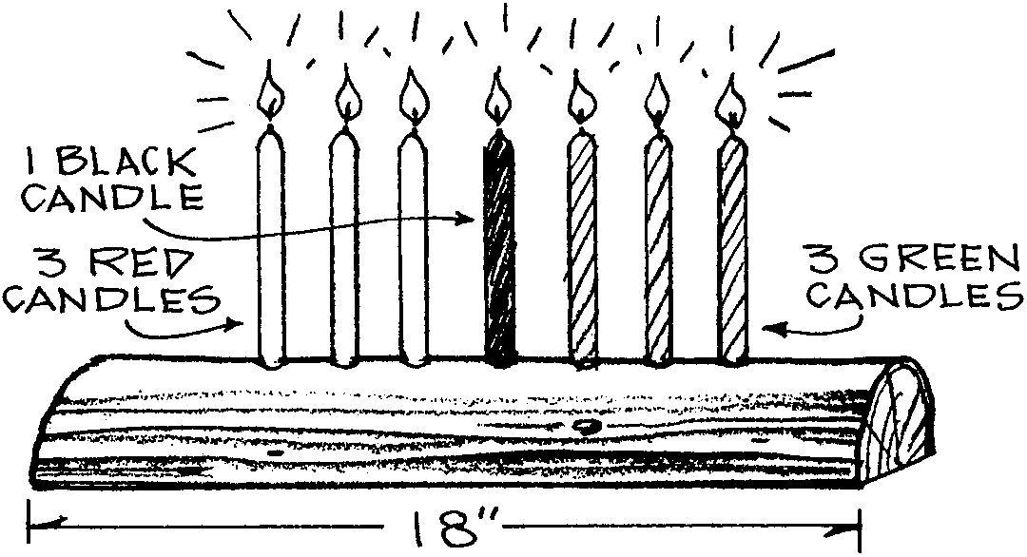
On December 26, the first day of the African-American festival called Kwanzaa, the black candle in the center is lit. One additional candle is lit each day until all are burning on January 1. Make a kinara (kee-NAH-rah) by drilling holes for the candles in a split log that is about eighteen inches long.

CD CHRISTMAS WREATH

Materials: An old, scratched, recycled CD-ROM; Mylar confetti or holographic stickers; Mylar or metallic ribbon; White glue; Glitter; Velcro with self-adhesive back

- Glue star, tree or whatever shape mylar confetti you want to the "shiny" backside of the CD.
- Swirl patterns and dots of white glue and sprinkle with glitter.
- Tie a bow out of reflective mylar ribbon and glue to the CD.
- Use a piece of self adhesive Velcro to attach the CD Christmas wreath to a computer, door, or wherever!

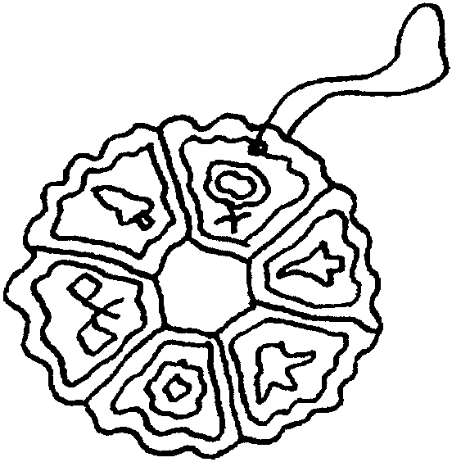
CANDY WREATHS

Spray a baking pan with non-stick cooking spray. Arrange Brach’s Cut Rock Candies in a circle on the baking pan. The sides of the candies should be touching. Place pan in a preheated 325º oven for five to six minutes (or until individual pieces begin to melt together). Remove pan from the oven and poke a hole at the top of the ornament using an awl, nut pick or nail. Allow the wreath to cool. Remove wreath from the pan. In a well-ventilated area, spray wreaths with clear polyurethane finish and allow to dry. Thread a small ribbon or cord through hole for hanging.

CRANBERRY ORNAMENT
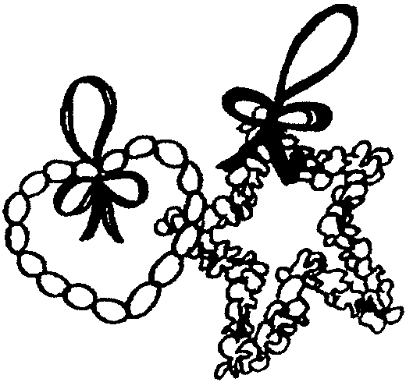
Simply string cranberries on medium gauge wire. Bend the wire into simple shapes like a bell, heart or star. Add ribbon loops and bows to each ornament as desired. Hang as it is or dry the ornament. To dry, hang the ornament in a well ventilated place. It will retain the dark red color.

DREIDEL PHOTO MAGNET
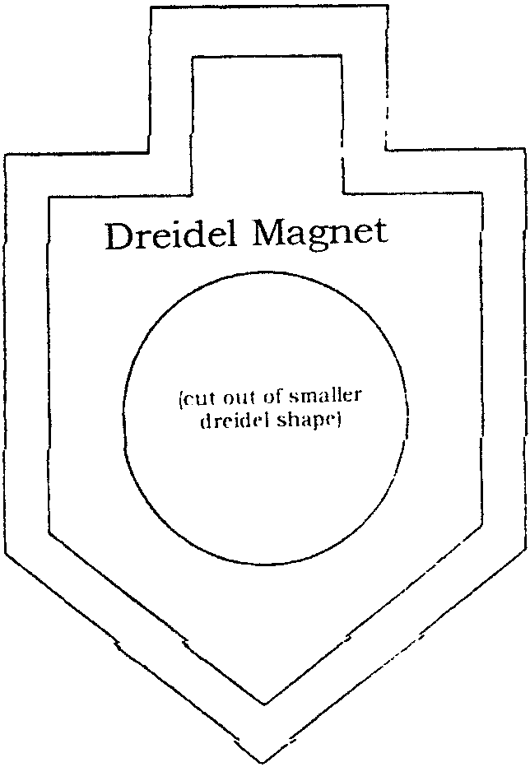
Material: Two colors of craft foam; Photo, about 2” square; Adhesive-backed magnet; Thick craft glue; Scissors. Optional: Thin clear plastic (e.g. sheet protector, report cover); Craft foam scraps; Hole punch; Pinking shears

1. Trace and cut out patterns. Enlarge as desired. Back piece does not have a hole cut out.
2. If desired, protect the photo with clear plastic. Cut the clear plastic slightly larger than the hole of the front piece. Glue it to the back of the front piece.
3. Glue the photo on the front piece so that the picture shows through the opening.
4. Center and glue the small dreidel shape onto the large dreidel shape. Allow to dry.
5. Optional decorating ideas: Use pinking shears to cut the edges of the dreidel if desired. Decorate with small circles cut with a hole punch.

BORAX CRYSTAL SNOWFLAKE

Materials: String, wide mouth pint jar, white pipe cleaners, blue food coloring (optional), boiling water, borax (20 Mule Team Borax laundry booster – not Boraxo handsoap), pencil.

- Cut a white pipe cleaner into 3 equal lengths.
- Twist the 3 sections of pipe cleaner together in the center to form a six-sided star shape. If your points are not even, trim the pipe cleaner sections to the same length.
- Attach string along the outer edges to form a snowflake pattern.
- Attach a piece of string to the top of one of the pipe cleaners and tie the other end to a pencil (to hang snowflake)
- Fill a wide mouth jar with boiling water.
- Mix borax into the water one tablespoon at a time. Use 3 tablespoons of borax per cup of water. Stir until dissolved. (Some powder settling to bottom of jar is OK).
- Add a little blue food coloring if you wish to give snowflake a bluish tint.
- Insert the pipe cleaner snowflake into the jar so that the pencil is resting on the lip of the jar and the snowflake is freely suspended in the borax solution. Leave in solution overnight.
- Remove snowflake from solution. Snowflake should be covered with shiny crystals.

NOTE: This may look like rock candy, but remind the boys that these are NOT EDIBLE.

REINDEER ORNAMENT

Materials: Brown card stock or heavy construction paper; Lightweight cardboard; 2” x 2” heavy duty aluminum foil; Red permanent marker; 2 candy canes; Ribbon or yarn; Ornament hook. (You may want to substitute wiggle eyes for cardboard ones, and a red pompom for the foil and cardboard.)

- Cut the pattern out of card stock or construction paper.
- Fold the pattern along the dotted lines and glue the tab to the inside of the opposite side. Now you have a pocket.
- Cut the circle pattern out of lightweight cardboard.
- Crumple the foil piece into a ball.
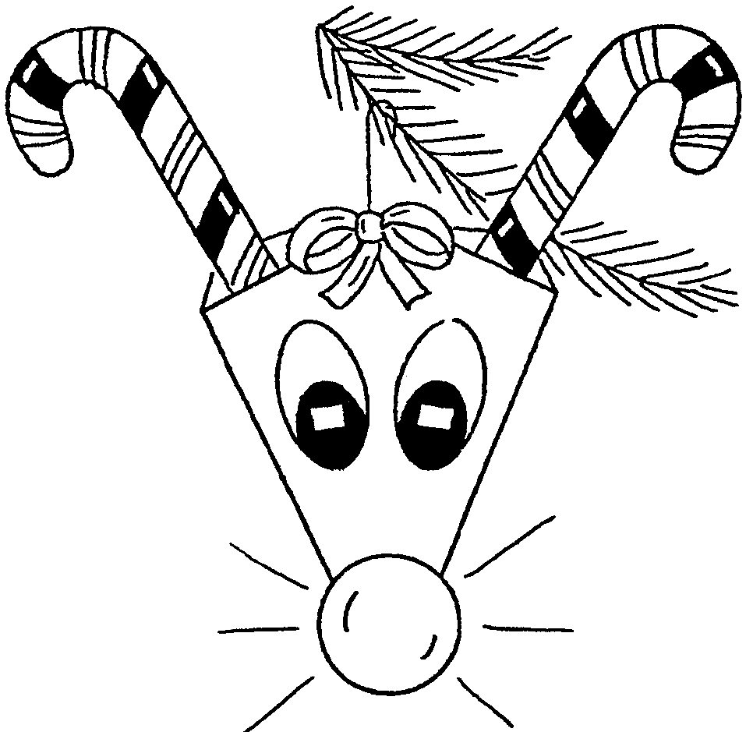
- Unwrap the foil and cover the circle with the wrinkled foil.
- Color the foil with the permanent marker.
- Cut out the eyes. Glue the eyes and the nose on the face.
- Tape the candy canes to the inside of the pocket.
- Punch a hole on each side of the pocket. Run a piece of yarn or ribbon through the holes. Tie a bow.
- Hang the reindeer with an ornament hook by the yarn.

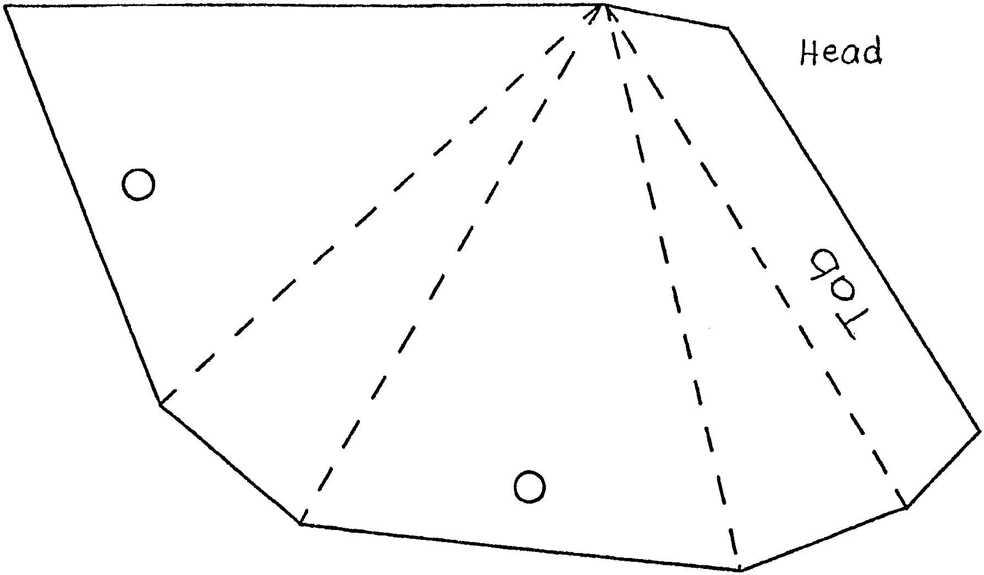

SNOWMAN PIN OR NECKERCHIEF SLIDE

Materials: Large white buttons with two holes; Pin-back pins (or a small piece of cardboard and 1/2” PVC pipe); Felt; Cloth ribbon; Glue gun
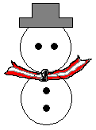

- Lay out two buttons face down, one above the other. Align the holes of the top button horizontally to form eyes. Align the holes of the bottom button vertically.
- Attach a pin-back pin onto the back of the buttons using a hot glue gun. If you are making a neckerchief slide, attach a small piece of cardboard as a backing and then a section of PVC pipe.
- Cut out felt into the shape of a hat, and glue onto the front.
- Tie a ribbon between the two buttons for the scarf.

PALETTE NECKERCHIEF SLIDE

Materials: 1/4” x 2” x 2” pine, plywood or masonite; Drill and 1/4” bit; Sandpaper; Toothpicks (flat or round); White acrylic paint; Acrylic paint or fabric paint in various colors; 1/2” PVC piece

Note: For younger children, use stiff cardboard or foam core instead of wood, or prepare the wood pieces for them.

1. Cut artist’s palette from wood.
2. Drill 1/4” hole as shown.
3. Smooth all edges and paint white.
4. Use half of a toothpick for the paintbrush. Dip tip in paint and allow it to dry.
5. Glue brush on palette as shown.
6. Drop some thick drops of acrylic of fabric paint onto the palette to look like the artist’s paint. Let it dry.
7. Glue a section of PVC pipe on the back.

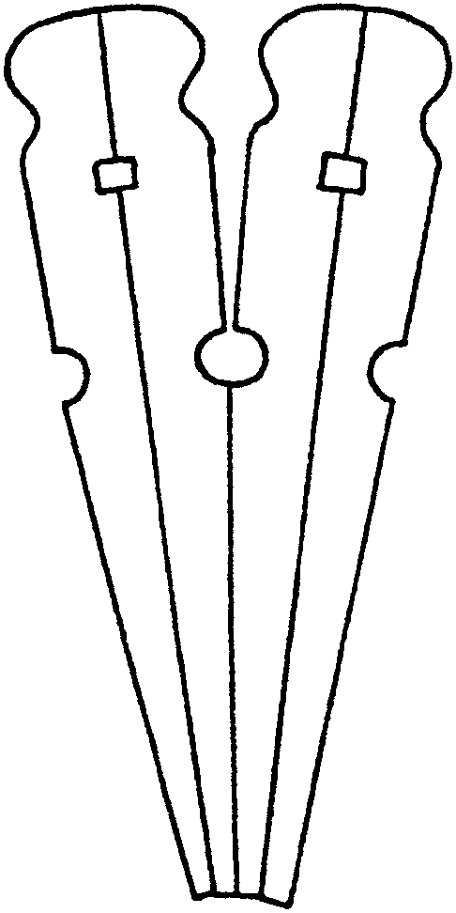
REINDEER NECKERCHIEF SLIDE

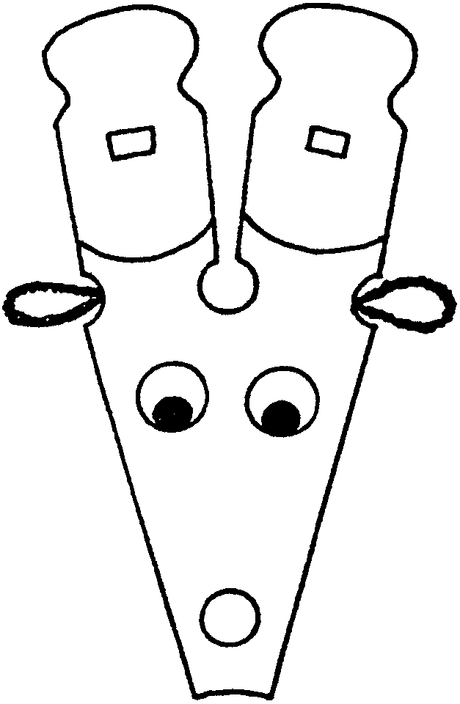
Materials: 2 spring type clothespins (smaller ones fit the boys better); Brown Chenille; 2 wiggle eyes (10mm); 1 small red bead or pompom; 1/2” PVC pipe; Brown paint; Glue

- Separate the clothespins. Glue flat sides together. Make two.
- Glue two pegs together to form the head and antlers.
- Paint the head brown, leaving the area above the line unpainted.
- Cut two 1” pieces of chenille and bend in half to form ears. Glue the ends into the rounded notches on each sides of the head.
- Glue eyes and nose.
- Glue a section of PVC pipe on the back.

ART YOU CAN EAT

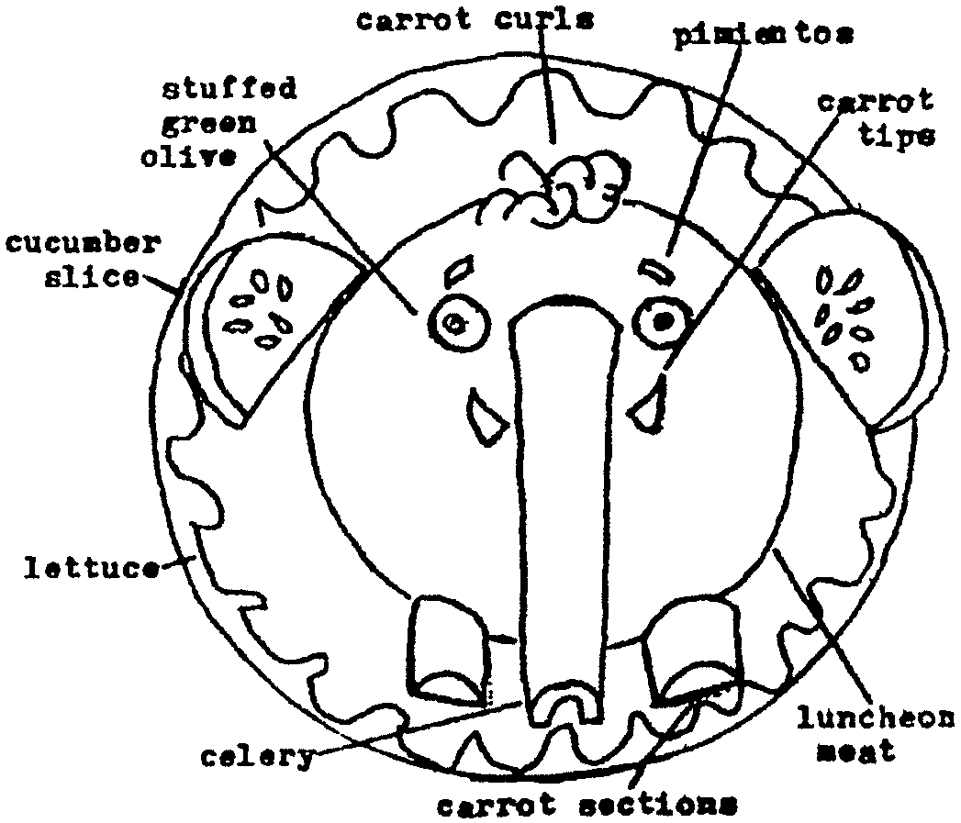
Use your imaginations. The refrigerators and cupboards are full of materials for you - the artist - to use. The creations here will give you some ideas. If you don’t have the ingredients shown, try others. Celery or cauliflower, for example, can take the place of broccoli “trees.” Arrange your ingredients on a plate. Use toothpicks to attach small things. Then surprise your family with a snack, a salad, or a cold dinner that’s a work of edible art!
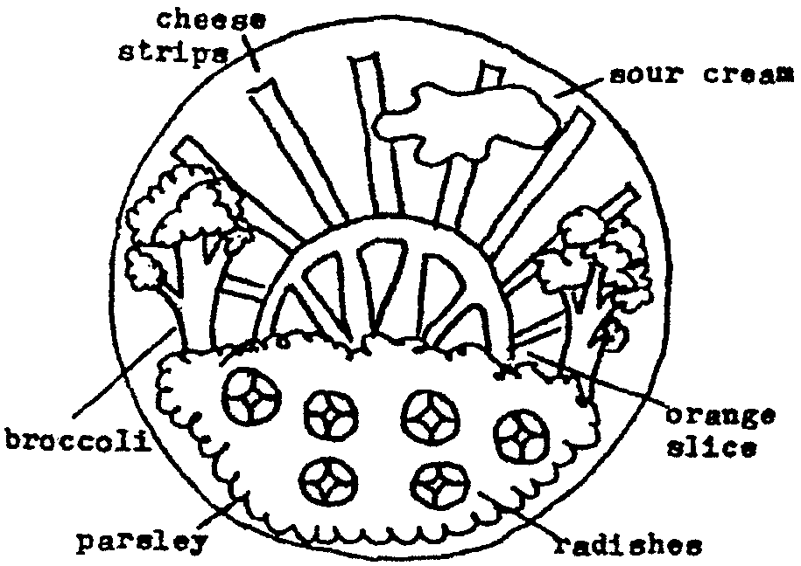

CHOCOLATE MARSHMALLOW SCRATCHBOARD
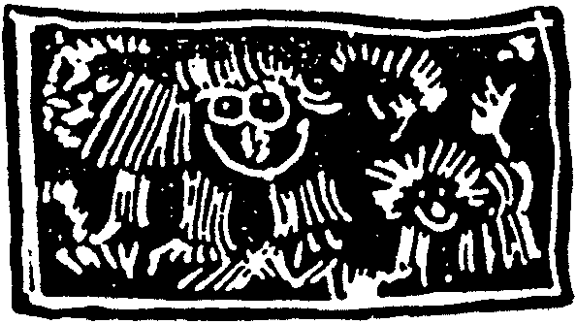
2 oz. Semi-sweet chocolate
1 Tablespoon butter
Large flat vanilla wafers or graham crackers
Marshmallow topping

- Place the chocolate and butter in the top of a double boiler. Heat over boiling water until mixture flows easily. Don’t overheat, as the solid part of the chocolate may separate from the fat.
- Spread the cookies with marshmallow topping. Make the surface as even as possible and bring the marshmallow right to the edge.
- As the cookies stand, the marshmallow topping will flow to become smooth and shiny.
- Use a pastry brush to paint the melted chocolate-butter mixture on the marshmallow. Try to make the chocolate smooth and even with as few strokes as possible. Keep the chocolate-butter mixture over warm water so it remains spreadable.
- Refrigerate the cookies until the chocolate is firm--about 20 minutes.
- Use the point of a knife or skewer and scratch a design in your cookie. They will show the white marshmallow through them.

SNOWFLAKE COOKIES
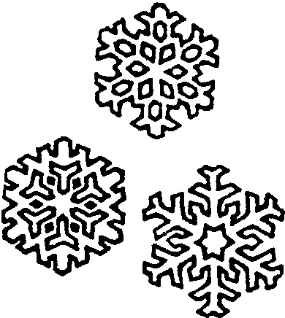
Decorate cookies with “snowflake” stencils.

Prepare or buy large smooth-surface cookies. If you are baking your own, gingerbread recipe works well.
Cut wax paper about the size of the cookie. Fold and cut as you would make “snowflakes.” Open, press with hand to make it flat. Place the stencil on a cookie. Sift powdered sugar over the cookie.

SNOWBALL COOKIES
(recipe by: Sharon Mehl)

1 c Butter or margarine
1/2 c Sugar, powdered; sifted
1 teaspoon Vanilla
2 1/2 c Flour; sifted
1/4 teaspoon Salt
3/4 c Pecans, chopped

- Cream the butter in large bowl.
- Add sugar, cream until light.
- Stir in vanilla.
- Sift flour and salt; mix in.
- Stir in nuts.
- Shape into balls.
- Place on ungreased cookie sheet. Bake 15 minutes at 350.
- Roll in powdered sugar straight out of oven. Roll again when cool.
Makes about 36 cookies

PIXIE STIX “SAND ART”
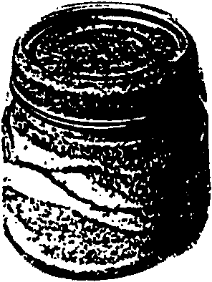
Take Pixie Stix and clean small jars (like baby food jars).

Pour Stix into jars to make different colored layers like sand art. The sticks allow children to pour mounds or make indentation very easily. You do need about five sticks of each color per layer. Give it as a gift.

