Passports to Other Lands






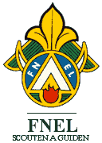
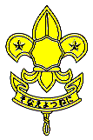

February 2001

CONTENTS

THEME RELATED 1
DEN AND PACK ACTIVITIES 1
MAP OF THE WORLD 1
“ADOPT” A COUNTRY 1
COUNTRY FAIRE 1
SPECIAL GUESTS 1
WORLD FRIENDSHIP FUND 1
PEN PALS 2
FIELD TRIP IDEAS 2
PARTICIPATION AWARDS 2
BLUE AND GOLD BANQUET 2
BLUE AND GOLD REFERENCE 2
ACTIVITIES FOR CHILDREN 3
THANK YOU’S 3
AFTER THE BANQUET 3
WORLD BROTHERHOOD OF SCOUTING 3
ONLINE RESOURCES 4
BROTHERHOOD 4
PREOPENING 5
THE CUB SCOUT GAME 5
NATION SCRAMBLE 6
DO YOU KNOW WHERE? 6
FRIENDS AROUND THE WORLD! 7
FOLLOWING DIRECTIONS 8
GUESS THE NATION 8
HOW MANY COUNTRIES CAN YOU NAME? 8
CEREMONIES 9
“HELLO” OPENING 9
GIFTS OF SCOUTING--OPENING 9
PASSPORT TO OTHER LANDS OPENING 10
BUILDING A BETTER WORLD OPENING
OR CLOSING 11
ALL OVER THE WORLD CLOSING 11
“GOODBYE” CLOSING 12
A SMILE 12
DO YOUR BEST 12
PASSPORT ADVANCEMENT 13
THE WORLD OF SCOUTING
ADVANCEMENT 14
ADVANCEMENT CEREMONY IDEAS 14
PASSPORT LEADER RECOGNITION 15
FUN WAYS TO SAY THANK YOU 16
AUDIENCE PARTICIPATION 17
STRETCHER 17
MY AUNT CAME BACK 17
SKITS 18
THIS IS MY LAND 18
AROUND THE WORLD 19
GAMES 20
SEVENTY-ONE YEARS AND COUNTING! 20
WORLD BROTHERHOOD TUG 20
PICK-UP STICKS--VIETNAM 20
AUSTRALIAN CIRCLE GAME 20
PALITO VERDE (GREEN STICK)--
COLUMBIA 20
LA PALMA--BOLIVIA 21
KABBADI--INDIA 21
KAAB--SAUDI ARABIA 21
NUMBER GAME--SWEDEN 21
NSIKWI--AFRICA 22
BIVOE EBUMA (CLAP BALL)--CAMEROON 22
GREAT BRITAIN 22
CHEF MANDA (THE CHIEF ORDERS)--
BRAZIL 22
SONGS 23
IT’S A CUB WORLD 23
CUB SCOUT HARMONY 23
SCOUTING AROUND THE WORLD 23
CUB SCOUT FRIENDSHIP 24
THE PROMISE AND LAW 24
DEEP IN THE HEART OF CUB SCOUTS 24
THE GRAND OLD BLUE AND GOLD 24
SCOUTING GOES ‘ROUND THE WORLD 24
CRAFTS 25
PASSPORTS 25
NECKERCHIEF INVITATIONS 26
SCOUTING AROUND THE WORLD
INVITATION 26
WORLD WISE CUB SCOUT 27
FRIENDSHIP NUT CUP 28
FLAG CENTERPIECE 28
WORLD SCOUTING FAMILY TREE
CENTERPIECE 28
PYRAMID PLACE MARKER/PHOTO
DISPLAY 29
TRAVEL BROCHURE CENTERPIECE 29
OTHER BLUE AND GOLD IDEAS 30
FLAG HOLDER CENTERPIECE 30
CUB SCOUT CAP NECKERCHIEF SLIDE 31
CUB SCOUT TREAT SLIDE 31
CUBS IN THE KITCHEN 32
FRIENDSHIP TEA 32
GERMAN EGG PANCAKES 32

DEN AND PACK ACTIVITIES

MAP OF THE WORLD
Have a large world map ready at the pack meeting. As people arrive, give each person star stickers and ask them to mark places they have been or a place where they know someone is living or is from. They may want to include the place where their ancestors came from. During the meeting, comment of the map--how many countries we are connected with, etc.

“ADOPT” A COUNTRY
During the month each den learns about one country. What are the traditional clothes? Is it possible to make something similar to their clothes? If so, wear it at the pack meeting or in a skit. If not, draw or cut out pictures and display them at the pack meeting. Try some of the food. Learn a few phrases in the language. Read one or two traditional children’s stories from that country. Is there any video the den can watch about the country? Learn some games and songs. The library is a great resource for these activities.
- Also, is there a Scouting organization in that country? If so, learn their Cub or Boy Scout Promise. Reproduce their Scouting logo.
- Prepare the Blue and Gold Banquet table decoration using the country’s colors, flags, folk crafts, and writing system. Find pictures of that country in old magazines, cut them out and use them as part of the decorations.

COUNTRY FAIRE
Have several “booths” at the pack meeting featuring the country’s food, games, songs (either learn or listen), and/or crafts. If dens have adopted countries, each den can sponsor a booth. Or have a Country Faire committee to organize this. Posters and maps may be obtained through the country’s Council General, travel information center, or travel agents.

SPECIAL GUESTS
Have a guest from another country. Is anyone in your den from another country?
Ask the guest to talk about a child’s life in the country he is from.
Can he bring some traditional toys from that country?
Can he teach your den some traditional games?
Can he teach your den some words in his native language? (Wolf Elective 22)
Can he teach the boys to write their names (phonetically) in that language?
(Children are fascinated to see their names written in foreign letters.)
Have a guest who has been to another country or has hosted Scouts or students from another country.
Ask the guest to bring some souvenirs and photos to show to the boys.
The guest could tell the boys some of his experiences in a different culture (keep it positive).
Make sure the boys thank the guest. Would he like to come to your Blue and Gold Banquet?

WORLD FRIENDSHIP FUND
Collect money or have a fundraising project such as recycling and contribute toward the World Friendship Fund. The World Friendship Fund is administered by the Boy Scouts of America to help struggling Scouting associations in other lands. For more on this see Cub Scout Program Helps 2000-2001, page 4-FEB-2001 and Cub Scout Leader Book, p. 6-4.

PEN PALS
Write to people in another country as a den. Write a little about the den (Bear Achievement 18), pack, school, or friends. Maybe exchange a few postcards.
There is no pen pal program offered by BSA but do you know someone living in another country? Your relative? Ask teachers if they know school kids in other countries. Ask Boy Scout troops. Know anyone that attended the council’s International Rendezvous (happens every two years)? Do you know anyone who has hosted international Scouts or students? Can they give you the names of people who are willing to write back to the boys?

FIELD TRIP IDEAS (For details, see the FIELD TRIPS section)
Your local library
Airport

PARTICIPATION AWARDS (For details, see the PARTICIPATION AWARDS section)
Cub Scout Academics: Geography
Cub Scout Academics: Heritage
BSA Family Program
International Activity Patch

BLUE AND GOLD BANQUET

BLUE AND GOLD REFERENCE
Cub Scout Leader How-To Book
“Anniversary Week Activities,” pp. 9-49 to 9-51
Boy Scouts of America was incorporated on February 8, 1910.
BSA launched its Cub Scout program on February 10, 1930.
In 2001, the Scout Anniversary Week is from February 4 to 10.
Scout Sunday is February 4.
Scout Anniversary day is February 8.
Scout Sabbath is February 10.
“Fellers Cake Bake,” p. 9-51
This is a popular Blue and Gold Banquet activity.
“Blue and Gold Banquet” pp. 9-52 to 9-62
Information on preparation, ceremonies, skits, games, crafts and other activities.
Cub Scout Ceremonies for Dens and Pack
“Silver or Gold Pack Anniversary Ceremony at the Blue and Gold Banquet,” p. 10-5
“Blue and Gold Pack Closing Ceremony,” p. 6-3

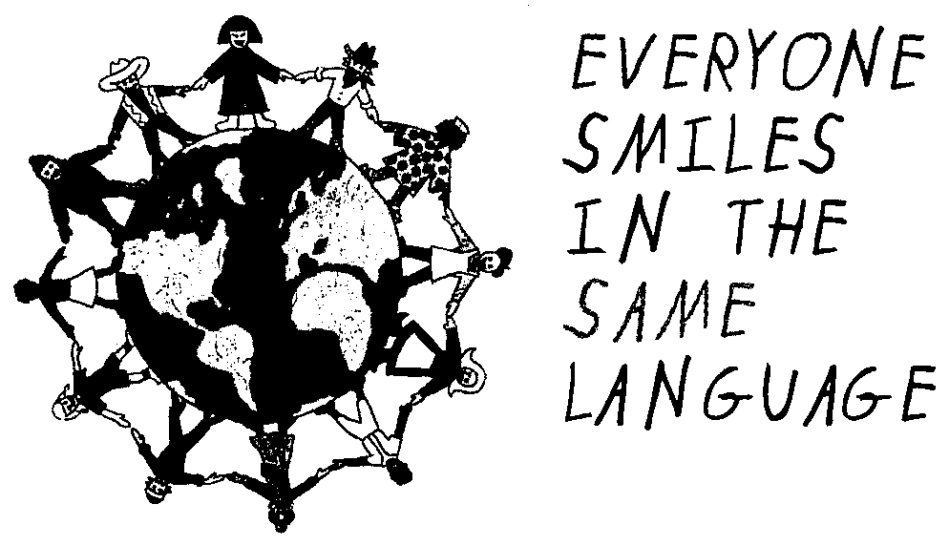

ACTIVITIES FOR CHILDREN
Often it takes some time for the banquet to get going. Prepare plenty of games and puzzles for younger children to occupy their time. Activity books and crayons for younger children, word search and word unscrambling for older children, mazes of varying degrees of difficulty are some ideas.

THANK YOU’S
It is important to thank leaders, parents, and friends of Scouting who help dens and the pack. The surest way to get support is to express appreciation for their help. And show the appreciation in front of their sons and families. The boys will be proud to see their parents, uncles, aunts or siblings recognized in front of all. Involve the boys in presenting the token of appreciation. Make each presentation short and simple. Remember KISMIF--Keep It Simple, Make It Fun.

AFTER THE BANQUET
After the banquet, be sure to send thank you notes. Do the evaluation and write down suggestions for the next year. Keep all the information, from planning to evaluation in one binder so it can be passed on to next year’s committee.

WORLD BROTHERHOOD OF SCOUTING

- There are more than 28 million Scouts, young people and adults, male and female, in 216 countries and territories (updated October 10, 2000).
- There are 186 countries where Scouting exists.
In 151 countries there are internationally recognized National Scout Organizations.
These are members of the World Organization of the Scout Movement (WOSM)
- There are 26 main territories where Scouting exists, often as overseas branches of larger Scouting organizations.
- There are only seven countries where Scouting does not exist at all.

The World Organization of the Scout Movement (WOSM) is an international, non-governmental organization composed of its recognized national Scout organizations. The United States and 150 other countries are members of the WOSM (see “Online Resources” below).
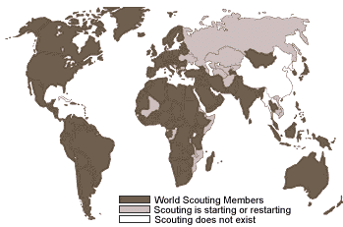

ONLINE RESOURCES

- World Organization of the Scout Movement (WOSM)--Information on 151 national Scout organizations: http://www.scout.org/wso/links.html
- Index to site by country: http://www.ussouts.org/worldscouting
- Scout oaths and laws from around the world, both Cub Scout and Boy Scout:
http://www.geocities.com/Heartland/Flats/3201/sctlnk1.html
- Lord Baden-Powell award site--Links to websites from around the country and world: http://www.geocities.com/Yosemite/Trails/2016/
- http://usscouts.org/worldscouting/
- How to say & pronounce “hello” in various languages: http://www.ipl.org/youth/hello
- National Anthems: http://www.emulateme.com/anthems/
- National Geographic--Maps and facts (flag, population, etc.) about countries: http//www.nationalgeographic.com/resources/ngo/maps/atlas

BROTHERHOOD
by Bob Greer

Last night I watched the sunset
when my day was almost done,
and thought about another boy
whose day had just begun.

I’ll probably never know him,
since we’re half-a-world apart.
How different we must be
if my day ends as his day starts.

On the far side of the sunshine,
on the other end of day,
lives a boy who seems a stranger
in a hundred different ways.

Still I think we might discover
if we look beneath the skin,
that instead of being strangers,
he and I are more like twins.

His skin’s another color,
and he walks another shore.
The flag that he salutes
is not the flag that I adore.
But listen to his heartbeat.
Oh, just listen to his dreams.
You’ll know that deep inside
we aren’t as different as we seem.

I think I’ll write a message.
I might send it on the wind--
so when he hears it blowing,
he will know he has a friend.

I think that I can touch him,
if I reach out with my heart.
How different can we be
when we’re just half-a-day apart?

On the far side of the sunshine,
on the other end of day,
lives a boy exactly like me
in the most important ways.

Yes, I know we will discover
when we look beneath the skin,
that instead of being strangers,
he and I are really twins.

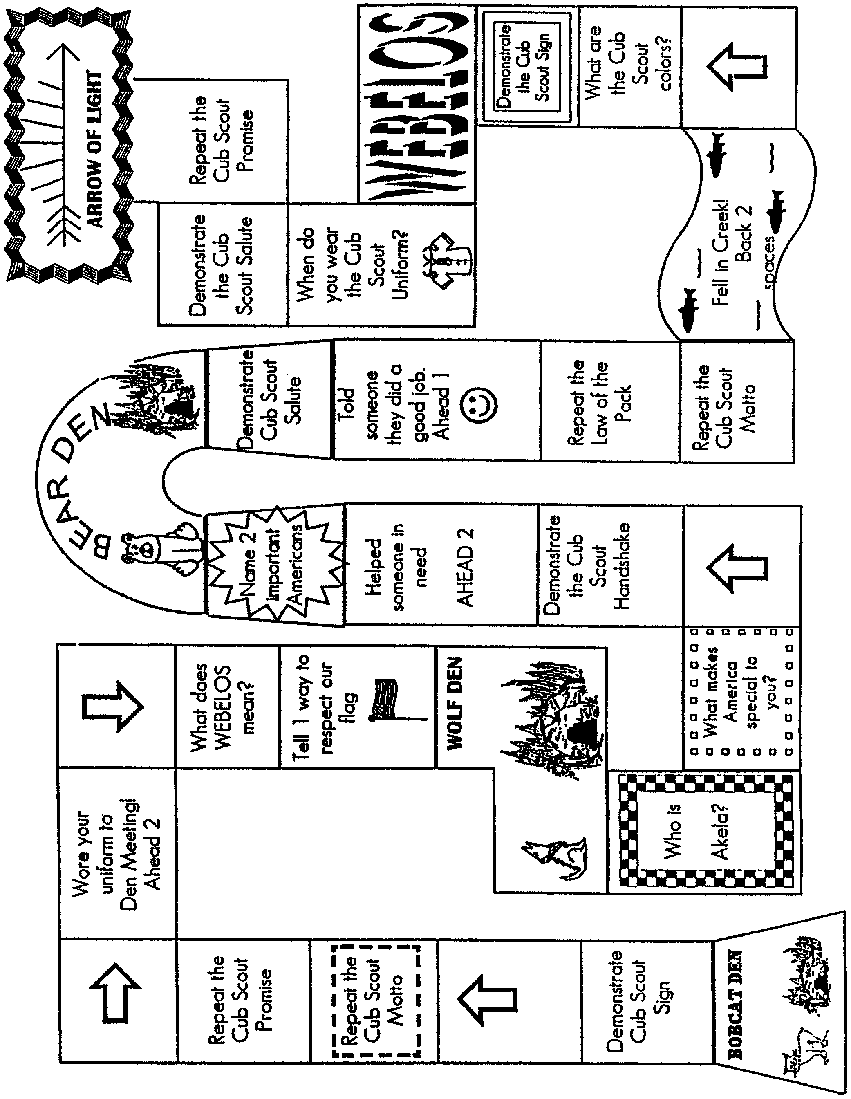
THE CUB SCOUT GAME
Instructions:
1--Everyone puts a marker on start. 2--Roll a die to see who goes first. 3--First player rolls a die and moves that many spaces and does the requirement.

START HERE

NATION SCRAMBLE

Unscramble the names of these countries. Work with your family or friends.

- CRFNEA
- GASDMACAAR
- EMGARYN
- GNAEDNL
- SARUSI
- NRUAHGY
- NLODAP
- APNJA
- EKOAR
- EMRKDNA
- LIFNADN
- RINLDAE
- CNOLASTD
- WRENLZISDTA
- RUALAISAT
- IPNELIHPISP
- MERACIA
- ZRLIBA
- PISNA
- EWN LNDZAAE

Answers: 1-France; 2-Madagascar; 3-Germany; 4-England; 5-Russia; 6-Hungary; 7-Poland; 8-Japan; 9-Korea; 10-Denmark; 11-Finland; 12-Ireland; 13-Scotland; 14-Switzerland; 15-Australia; 16-Philippines; 17-America; 18-Brazil; 19-Spain; 20-New Zealand

DO YOU KNOW WHERE?

PASSPORT CLUE LAND

- Boy Scouting originated in this country Japan
- Easiest continent to make ice cubes on Egypt
- Last Summer Olympics were held here China
- Our neighbor to the North England
- They grow lots of coffee here Canada
- Shoes made of wood and lots of tulips India
- Three big pyramids and a sphinx Australia
- Pokemon was invented here Antarctica
- See the Great Wall Holland
- Taj Mahal and lots of curry Colombia

Answers: 1-England; 2-Antarctica; 3-Australia; 4-Canada; 5-Colombia; 6-Holland; 7-Egypt; 8-Japan; 9-China; 10-India

CHEERS

BLUE AND GOLD CHEER: Divide the room in half. As you point, to one side they say “Blue” and when you point to the other side they say “Gold.” When you point to both sides, they both say “Blue and Gold” Vary the speed and direction you point.

CUB SCOUT FAMILY CHEER: “We are One Big Happy Cub Scout Family!” Divide the room into three groups. Assign and practice (pointing at different group and varying the order): Group 1--“One”; Group 2--“Big”; Group 3--“Happy”; All--“Cub Scout Family”. Then Cubmaster says “We are” and point to Groups 1, 2, 3 and All.

FRIENDS AROUND THE WORLD!

Can you find the names of eleven countries by reading vertically, horizontally, diagonally, backward or forward?

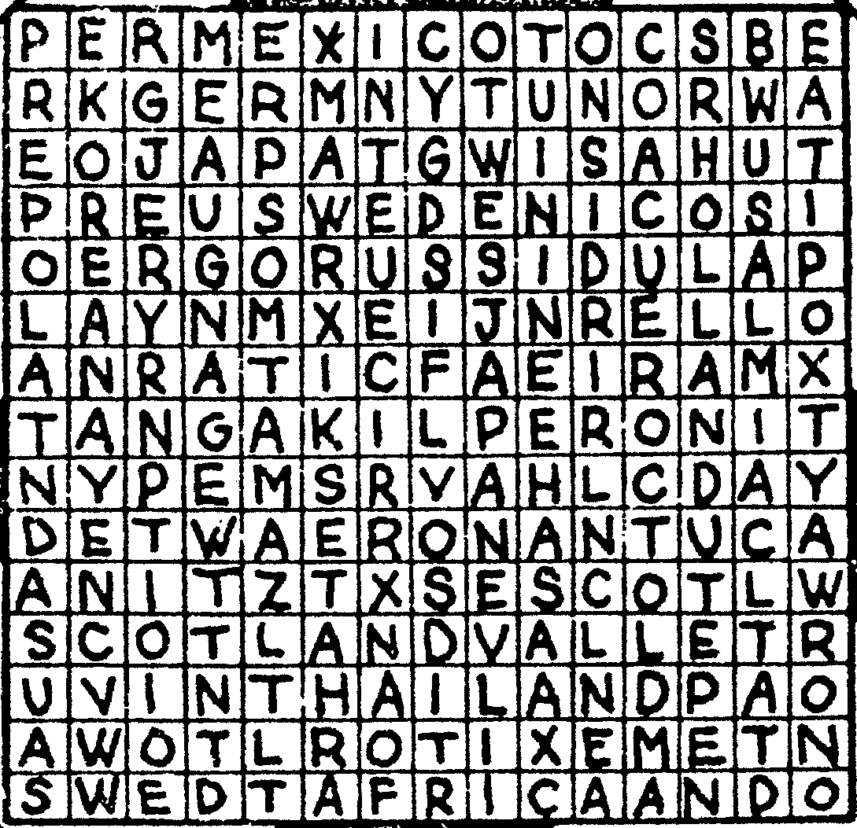

Words: Africa, Germany, Holland, Japan, Korea, Mexico, Scotland, Sweden, Switzerland, Thailand, USA

CHEERS

WORLD BROTHERHOOD CHEER: Divide the room in half. One side will shouts “World” and the other shouts “Brotherhood.” All together “That’s Scouting!”

LEANING TOWER OF PISA CHEER: Have the group stand and on the count of three, lean to the left.

OFFICIAL APPLAUSE AND CHEER: Left hand raised, group claps. Right hand raised, group cheers. Raise both hand, they do both

FOLLOWING DIRECTIONS

- If you ever saw a cow jump over the Moon, write “V” in spaces 2, 3, 18, and 19. If not, write “L” in these spaces.

- If “X” comes before “H” in the alphabet, write “Z” in space 16. If it comes after “H,” write “W.”

- If 31,467 is more than 12 dozen, write “G” in spaces 8 and 12.

- If you like candy better than mosquitoes, place “O” in spaces 13 and 14. If not, consult a psychiatrist at once.

- Close one eye and without counting on your fingers, write the fifth letter of the alphabet in space 11.

- If Shakespeare wrote “Twinkle, Twinkle, Little Star,” put “O” in spaces 9 and 17. Otherwise, put “I.”

- If white and black are opposites, write “V” in space 10. If they are the same, write nothing.

- If 16 quarts make 1 pint, draw an elephant in space 7. Otherwise, write “S.”

- If summer is warmer than winter, write “U” in space 5 and “A” in space 1.

- If you think this IS foolish, write the third, second and fourth letters of the alphabet in spaces 4, 6 and 15 respectively. Now read the message. IT MAKES SENSE!

___ ___ ___ ___ ___ ___ ___ ___ ___ ___ ___ ___ ___ ___ ___ ___ ___ ___ ___
1 2 3 4 5 6 7 8 9 10 11 12 13 14 15 16 17 18 19

GUESS THE NATION
(pack gathering activity)

Have small flags representing at least 12 different countries. Number each flag, and have participants try to guess the name of the nation it represents. You may need to give participants a list of country names or hints to help them out a bit.

HOW MANY COUNTRIES CAN YOU NAME?
(Pack gathering activity)

As families arrive, give each family a sheet of paper and ask them to write as many countries as possible. Family members are encouraged to work together. During the meeting, honor those who knew the most with a cheer.

“HELLO” OPENING

Adjust the languages and number of Cub Scouts accordingly.

“Welcome to our meeting. In the world, you can find Scouts in 186 countries and 26 territories. There are many languages spoken in those countries but you can always hear a Scout greeting you with a “hello” and a big smile.

C.S.#1: In Spanish, it’s Hola (OH-lah).
C.S.#2: In French, it’s Bonjour (bohn-ZHOOR).
C.S.#3: In German, it’s Guten Tag (GOOT-en Tahg).
C.S.#4: In Mandarin, it’s Ni hao (nee-HOW).
C.S.#5: In Russian, it’s Zdravstvuite (ZzDrast-vet-yah).
C.S.#6: In Swahili, it’s Jambo (JAM-bo).
C.S.#7: In Arabic, it’s Al salaam a’alaykum (AHL sah-LAHM-ah ah-LAY-koom).
C.S.#8: In Hindi, it’s Nahmaste (nah-mah-STAY).
C.S.#9: In Hebrew, it’s Shalom (Sha-LOHM).
C.S.#10: In Hawaiian, it’s Aloha (ah-LOW-ha).

“No matter where you go or how you say it, you can count on being greeted by a Scout who says ‘Hello!’”

GIFTS OF SCOUTING--OPENING

Arrangement: Each Cub Scout has a candle and lights it as he speaks.

This is my Scouting light. It is my enthusiasm. As light brings out the sparkle in diamonds, enthusiasm brings out the sparkle in Scouting.

This is my Scouting light. It represents what I know I can do. And I’ll do my best to do my duty to God and my country.

This is my Scouting light. As we face each other tonight, let us look at the light and silently thank God for the brotherhood of Scouting we share here tonight.

This is my Scouting light. I shall pass this way but once so if there is any good that I can do, let me do it now for I shall not pass this way again.

This is my Scouting light. Let each one of us take time to look back at where we’ve been and have pride in that past. Let us look forward to where we’re going and have hope for that future.

Would you please stand and join us in the Pledge of Allegiance?

PASSPORT TO OTHER LANDS OPENING

Arrangement: Cubmaster and a group of Cub Scouts enter. Cubmaster is holding several travel brochures. Each Cub Scout has one brochure with his lines written on it. The color guard should be just outside the door.

CM: Our pack has been studying all about other countries this month and now we need to plan our pack trip. There are so many neat countries to visit, I just don’t know where to begin. (Looks at brochures in his hands)

C.S.#1: We could go to Mexico--The motto for Cub Scouts there is “Always My Best.”

C.S.#2: Or we could go to Japan--Scouts there start as Beaver Cubs and aim towards Fuji Scout, like climbing their highest mountain.

C.S.#3: It says here that the Egyptian Scout and Guide Federation includes four associations: Air Scouts, Sea Scouts, Boy Scouts and Girl Guides.

C.S.#4: Scotland is part of the Scout Association in the United Kingdom which includes Scotland, England, Ireland, and Wales. Their program is called Scoutreach.

C.S.#5: Here it says that in Canada there are two Scouting organizations--one for the English speaking Scouts and one for French speaking Scouts.

C.S.#6: The program emphasis in the Scout Association of Australia is on adventure, camping, bushcraft, and FUN!

C.S.#7: Scouting was founded in Kenya in 1910. They do community service projects which include planting trees and campaigning for literacy.

CM: Wow--we sure are lucky to belong to such a world-wide organization. We have over three million members in the Boy Scouts of America. Let’s stand as we post the colors of our country.

(Proceed with the flag ceremony)

APPLAUSES

SPANISH FLAMENCO APPLAUSE: Stand with left hand on hip and right hand held above head in the manner of a flamenco dancer. Simultaneously snap fingers on our right hand and stamp your feet in a fast tempo while turning slowly. Continue until you have made a complete circle. Every quarter turn, yell “Ole!”

HOLLAND WINDMILL APPLAUSE: Hold both arms out straight at shoulder level. Standing on one foot, spin around while rotating arms in circle. Make a loud shoosh sound like the wind.

BUILDING A BETTER WORLD OPENING OR CLOSING

Arrangement: Eleven Cub Scouts, each holding a card with a letter on the front and his line on the back. Each speaker holds up his letter as he says his line. Last line is delivered by all or by their leader.

Take a B for brotherhood, boosting for each other’s good.

Take an E for every land to share in earth’s riches everywhere.

Take a T for trustfulness, trusting more, and fearing less.

Take a T for teamwork, for joining hands to get things done.

Take an E for equal chance for each person to advance.

Take an R for real respect regardless of race, creed or sect.

Take a W for will to work for peace with faith and skill.

Take an O for opportunity to keep our speech and action free.

Take an R for reverence for a guiding Providence.

Tale an L for love to spread around when need and bitterness are found.

Take a D for dignity of man devoted to a bigger plan.

(All hold letters up)

There you have it--this is how to build a BETTER WORLD, right now!

ALL OVER THE WORLD CLOSING

Prop: Globe of the world

Cubmaster:
(Pointing at Northern California on the globe) This evening our pack has used our passport to explore other lands. Did you know that all over this world, (spin globe) Cub Scouts just like us are taking part in Scouting activities too? Well, it’s true. The Scouting movement began in England and now exists in almost every nation. Their Cub Scouts are much like us. They have the same ideals, the same Promise, and the same brotherhood of service. So let’s think of our brother Cub Scouts around the world as we join in the Cub Scout Promise. (Lead Promise)

“GOODBYE” CLOSING

Adjust the languages and number of Cub Scouts accordingly.

“We close our meeting tonight as we opened it, by visiting the many places around the world where you can find Scouts. We have seen many places, where some things are different and some things are familiar. A Scout will always bid you a fond farewell after spending time with you, like this:”

C.S.#1: Adios (Spanish)
C.S.#2: Au revoir (French)
C.S.#3: Guten Nacht (German)
C.S.#4: Zai jian (Mandarin)
C.S.#5: Do svidanja (Russian)
C.S.#6: Kwaheri (Swahili)
C.S.#7: Salaam (Arabic)
C.S.#8: Pirmelange (Hindi)
C.S.#9: Shalom (Hebrew)
C.S.#10: Aloha (Hawaiian)
All: Good Night!

A SMILE

We have learned much about other countries this month. People who live in other lands have different customs, different styles of dress and different languages than we do. But there is a universal language understood by everyone in the world. It is a smile.

A smile costs nothing but creates much. It happens in a flash but the memory sometimes lasts forever. It cannot be begged, bought, borrowed, or stolen, but it is something that is of no earthly good unless it is given away. So, if you meet someone who is too weary to give you a smile, leave one of yours. No one needs a smile quite as much as a person who has none left to give.

As you travel through this world, whether you are in a foreign land or your own neighborhood, remember to smile. Remember...”A Cub Scout gives good will.”

DO YOUR BEST

All over the world, Cub Scouts promise to do their best. Let’s stop for a minute and carefully consider those words. “Best” describes effort and action above our usual performance. “You” are the only person who can possibly know whether or not you have done your best. Every time you repeat the Promise, YOU agree to do your best to do certain things. “Your Best” is just that--the very best. Think about the meaning of the promise and decide that you will always do your very best, no matter what the job facing you might be. Now please stand, make a Cub Scout sign and repeat the Cub Scout Promise with me.

PASSPORT ADVANCEMENT

Props: Passports made from folded construction paper, or printed computer form. Include a space for the Cub’s vital information (name, pack number, den number, parents, birth date, etc.). Include a place for a snapshot to really dress it up. Leave a column for using rank stickers to “stamp” his passport with the ranks he has already achieved. Have stickers available to add his new rank in his passport, to “stamp” his arrival at this new rank destination. You can add to the display by building a booth marked “CUSTOMS” for the boys to receive their stamps.

CM: Here at the Customs office we see many travelers on their way along the Cub Scout Trail. They come from many countries and speak many languages, but they all have an interest in the world around them. Let me see who we might have here today.

Asst. CM: Will the following Cub Scouts and their parents please step forward?
(Calls out names of first set of Cub Scouts)

(Assistant Cubmaster hands each Cub Scout his passport and tells him to go one at a time to the customs window)

CM: Ah! Who do we have here? (Cub Scout tells his name)

CM: May I see your passport please? (Cub Scout hands passport to CM)

CM: I see you have been very busy along the Cub Scout Trail. This shows you have been to Tiger and Bobcat. (Reads off ranks as appropriate)
For the past few months you have been traveling on the Wolf trail. Your paperwork appears to be in order. I’ll add this Wolf stamp to your passport. (Places sticker into passport)
This patch and card are for your records. (Hands rank patch and card to Cub)
This pin is for your parents, so perhaps you can help me place this onto their ribbon.

(Repeat for each Cub Scout)

(At the conclusion of the ceremony:)
CM: Well, this has certainly been a long line of boys traveling through my Customs office today. I am always amazed at all the sights they have seen and the places they have been. But you can’t imagine all the amazing things they will encounter as they continue on the Cub Scouting Trail. Someday, I hope to see these boys get their passports stamped for Eagle. Cub Scouts, be sure and invite me to be there when you do.

Congratulations!

THE WORLD OF SCOUTING ADVANCEMENT

Arrangement: Cover the award table with a yellow or blue table cloth. Display a globe and a small set of flags from various countries.

Cubmaster:
Every minute of every day of every year there are thousands of boys enjoying the fun and excitement of Cub Scouting somewhere in the world. The Cub Scout uniform varies from country to country around the world but they all have one thing in common: They promote Scouting and its ideals.

Just as Cub Scouts wear different uniforms in different countries, they are also awarded different badges of rank. In Japan, Cub Scouts earn the Rabbit, Deer and Bear Badges. In Australia, the badges are Bronze Boomerang, Silver Boomerang and Gold Boomerang. South African Cub Scouts work toward the Cheetah, Leopard, Lion and Leaping Wolf Badges.

As you know, the first rank badge in the United States is Bobcat. Tonight we honor (names of Bobcats) who have earned this badge as they start their Cub Scout trail. Would the Bobcats and their parents please come forward?

The second badge on our Cub Scout trail is Wolf. Tonight we have (names) who have earned this badge. Would the Wolves and their parents please come forward?

As the boys learn new skills, the next badge they earn is Bear. Would (names) and their parents please come forward?

The next rank being presented is the Webelos badge. Webelos Scouts are preparing to become Boy Scouts. Would (names) and their parents please come forward?

These Cub Scouts, like Cub Scouts all over the world, have worked together and developed new interests which will make them better citizens of our country and of the world. Let’s give them a big hand to show how proud we are of them.

ADVANCEMENT CEREMONY IDEAS

- As the each boy receives his award, take a Polaroid photo for his pack passport.
- Cubmaster dresses up like a mailman or parcel delivery person. He wheels in a large wagon full of parcels from foreign lands, addressed to the boys who will be receiving awards. The boys get to open their parcels and see what friends in foreign lands have sent them.
- Attach awards to different flags. Mention something wonderful about that country and relate it to the wonderful things the boys do while working on their advancement.

PASSPORT LEADER RECOGNITION

A “thank you” at the Blue and Gold time is a nice “mid-term” shot in the arm for den leaders, who at this point are starting to get tired and may be wondering if anyone realizes all the hard work they’ve been putting in. Make each den leader a passport award book, with a special thank you note inside. If you choose to give a small token of appreciation, like a Cub Scout bookmark, movie rental coupon, or a free Cub Scout car wash, clip it inside the passport (coordinate with the den parents). Gifts are not necessary, however. Just show your sincere appreciation of their work.

Cubmaster or Committee Chair:
What is a passport? It’s a document that countries require you to have before you cross their borders. You might say a passport unlocks the mystery and adventure that awaits you, as you explore new lands.

In our pack every boy has a passport. I’ll bet you didn’t know that. But it’s true. Each one of you has a passport. Your passports opens the doors to the fun and adventure and excitement that we have year after year in Cub Scouting.

Our passport to fun and excitement is our den leaders. They are truly the lifeblood of our pack and without them, we could not experience the fun and learning of Cub Scouts. So, let’s take a moment to say thanks to our leaders. We’ve prepared these passports for you as a way of showing our appreciation for all the sacrifices you’ve made to make our Cub Scouting experience better.

Den 1 boys and parents, please stand.

Den parent or a Cub Scout:
(Name of the den leader), thanks for being such a great leader, we’d like you to have this gift/certificate to say thanks for all the things you do to make this den and our pack great.
Let’s give our den cheer for (name of the den leader).

(Repeat for each den)

NOTE: This ceremony can easily be adopted for parents appreciation. Boys can make an appreciation passport for their parents for helping them on their Cub Scouting Trail.

WELCOMES

WELCOME WAVE: As the group does the wave, they say, “Welcome!”

HELLO AND WELCOME: Divide the room to North, South, East and West. North faces East and says “Hello” Then East faces South and says “Hello,” South faces West and says “Hello,”, and West faces North and says “Hello.” When this is done, everyone shouts “Welcome to Pack _____!!”

FUN WAYS TO SAY THANK YOU

Chef’s hat: For someone who really cooks with ideas.
Globe: For someone who is the world’s best _____.
“We think the WORLD of you!”
Heart: For someone who is all heart.
For someone who shows great heart by _____.
Heart (felt cutout): “You have our heart felt thanks.”
Heart (gold): For someone who has a heart of gold.
Heart and Soul (footprint): “Thanks for putting your heart and soul into our pack.”
Measuring Spoon or cup: “You really measure up.”
Pitcher: “Thanks for pitching in.”
Soup can: “You did a ‘soup’er job. Thank you!”
Whisk: For someone who is un“beat”able at “whisking” away our troubles.
Wooden spoon (painted blue and gold):
For Blue and Gold Banquet chair.

See Cub Scout Ceremonies for Dens and Packs for:
Opening:
“Baden-Powell” p. 5-6
“Spirit of Baden-Powell” p. 5-10
“Story of the Blue and Gold” p. 5-10
Closing:
“Blue and Gold” p. 6-3
“World Globe” p. 6-8
Advancement:
“History of Cub Scouting (all ranks)” p. 8-9
“Meaning of the Blue and Gold (all ranks)” p. 8-10
“Silver or Gold Pack Anniversary Ceremony” p. 10-5
“Spirit of Scouting (Arrow of Light)” p. 8-13

CHEERS

BSA: Divide group into three sections, giving each a letter to yell.

BANQUET CHEER: C’mon Gold! C’mon Blue! C’mon Cubs! C’mon through chow, chow, chow, chow!

STRETCHER

Everyone stand.
Now, hands on your hips, hands on your knees,
Put them behind you, if you please.
Touch your shoulders, touch your nose,
Touch your ears, touch your toes.
Raise your hands high in the air,
At your sides, on your hair,
Above your head as before
While you clap, one-two, three-four.
Now hands upon the empty space,
On your shoulders, on your face.
Then you raise them up so high.
And make your fingers quickly fly.
Then you stretch them out toward me,
And briskly clap them one, two, three.

MY AUNT CAME BACK

Action: Leader chants and adds motions. Group repeats each line and does motions. Once an action is started it is continued throughout the “song.”

My aunt came back, from old Japan,
She brought to me, an old silk fan. (fan with one hand)

My aunt came back, from old Algiers,
She brought to me, a pair of shears. (cut with fingers of other hand)

My aunt came back, from Holland too,
She brought to me, a wooden shoe. (stamp one foot repeatedly)

My aunt came back, from old Hong Kong,
She brought to me, the game Ping Pong. (move head from side to side)

My aunt came back, from the New York Fair,
She brought to me, a rocking chair. (rock back and forth)

My aunt came back, from Kalamazoo,
She brought to me, some gum to chew. (chew)

My aunt came back, from Scouting too,
She brought to me...(leader points to group) Some boys like you!

THIS IS MY LAND

Arrangement: Four Cub Scouts dressed in costumes of South America, Japan, Africa and the Netherlands. Each holds a picture or map of his land with narration written on the back. A fifth boy, dressed as Uncle Sam, carries the US flag. In turn boys come on stage and read their parts.
South America: I am South America, a big continent known for its exotic foods, rain forests, and minerals. Most of my people speak Spanish or Portuguese. Some of them wear sombreros and serapes. South America! This is my land.
Japan: I am Japan. People come from all over the world to see my cherry blossoms and to try to use chopsticks. I am noted for making cars, cameras and video games. Japan! This is my land.
Netherlands: I am the Netherlands, but some people call me Holland. I am known for my windmills, my beautiful tulips and delicious cheese. Netherlands! This is my land.
Africa: I am Africa, the second largest of the six continents. I am many things--gold, diamonds, oil, exotic animals, deserts and jungles. Africa! This is my land.
America: I am the United States of America. People come to me from all over the world to find freedom. My customs are those of every land. I aim to offer equal opportunity to everyone. I am the home of the brave and the land of the free. America! This is our land.

APPLAUSE

ITALIAN APPLAUSE: Bravo! Bravo!

QUESTIONS

What is it that always increases the more Cub Scouts share it?
Happiness

What should a Cub Scout keep after he gives it away?
A promise

Why are Cub Scouts so chubby?
Because Scouting rounds a kid out.

AROUND THE WORLD

Cub #1: I’m off to Rangoon on a red balloon,
And I hope that I’ll get there before the monsoon.
Cub #2: I’ve packed my bag with important things,
Marbles and bubble gum, pencils and strings.
Cub #3: I had to get ready in such a rush
That I almost forgot my comb and my toothbrush.
Cub #4: I’m off to Rangoon, and I’m taking my kite,
I don’t think I’ll be back before Saturday night!
Cub #1: I may stop in France, but I really don’t know.
You can’t always tell a balloon where to go.
Cub #2: As I pass over London, I’ll wave to the Queen,
And I’ll listen for bagpipes above Aberdeen.
Cub #3: I must stop in Holland to get wooden shoes.
They’d be very handy, no shoestrings to lose.
Cub #4: I’ll see if the Black Sea really is black,
I’ll tell you about it when I get back.
Cub #1: I’m off to Rangoon! I’ll have lunch in Japan.
It’s hard to use chopsticks but maybe I can.
Cub #2: In Egypt I’ll go on a long camel ride,
I’m sure a greased pyramid makes a fine slide!
Cub #3: In China I’ll sail on a sampan or junk,
In India I’ll measure an elephant’s trunk.
Cub #4: I’m off to Rangoon, and I’m holding on tight,
And I’m not coming back until Saturday night!

RIDDLES

Cub 1: If a waiter were carrying a turkey on a dish and let it fall, what three national calamities would occur?
Cub 2: I don’t have a clue.
Cub 1: The downfall of Turkey, the breakup of China and the overthrow of Greece.

Cub: Dad, do you believe in free speech?
Dad: Sure I do. Why?
Cub: Oh, good. I just made a call to Japan.

SEVENTY-ONE YEARS AND COUNTING!

2001 marks the 71st anniversary of Cub Scouting in the United States. Let’s start counting!
Have boys sit in a circle and start counting. When a player comes to “seven” or a number with a seven in it, he must instead say “blue.” When he comes to “one” or a number with one in it, he must say “gold.” So they start out counting with “gold.” 14 would be “gold-four” and 27 will be “twenty-blue.” 71 would be “blue-gold.”

WORLD BROTHERHOOD TUG

This is a teamwork game. Players should be similar in size. Start with a smaller group; gradually increase the size as the boys get used to this game. A group of boys sit in a circle holding onto a rope placed inside the circle in front of their feet. The ends of the rope are tied together to make a huge loop. The object of the game is for everyone to stand up tugging the rope. If everyone pulls at the same time, the entire group should be able to come to a standing position.

PICK-UP STICKS--VIETNAM

You will need ten chopsticks or popsicle sticks, and small bouncy balls.
Lay the sticks on the floor in a straight line, one below the other. Throw the ball in the air and pick up one stick. Catch the ball in the same hand after you let it bounce once. Keep the stick in your hand and pick another up in the same way. Repeat until all of the sticks have been picked up. Lay them out again and as the ball is thrown up and allowed to bounce, pick up two sticks at a time. Continue with three, then four, and so on until you attempt to pick up all ten at one time.
This game can be played by two or three players. One player keeps playing as long as he doesn’t drop sticks of misses catching the ball. When he makes a mistake, its the next player’s turn.

AUSTRALIAN CIRCLE GAME

A player stands in the center of a circle, holding a tennis ball. He tries to throw the ball to someone in the circle who might drop it. Another ball is also being passed around the circle from one boy to another. The player in the center may throw his ball to anyone, but he usually throws it to the boy about to receive the ball being passed around the circle. If either ball is dropped, the one who dropped it changes places with the boy in the center.

PALITO VERDE (GREEN STICK)--COLUMBIA

“It” carries green stick or other object. All other players form a large circle, facing inward with their hands behind their backs. “It” walks around behind them and suddenly places the green stick in a player’s hands. That player chases “It,” who tries to run around the circle and get back to the vacant spot without being tagged. If he is touched by the green stick before he reaches safety, he is still “It” for the next round. If he reaches the spot safely, the player with the stick becomes the new “It.”

LA PALMA--BOLIVIA

The Indians of Bolivia used the tailbones of a donkey or llama for this game. You can use a stick. Set the stick up on end in a hole in the ground. Draw a straight line away from the stick and at 3’ intervals, drive a peg into the ground; use about 6 pegs. You will need a supply of tennis balls. Boys then take turns throwing the ball to hit the stick from the first peg. Those who do, move on to the next peg. Those who don’t, stay at peg number one until they hit the stick. Boys must throw in their correct order throughout the game. The first boy to complete the six throws from the pegs wins. This can also be done on a best time basis.
VARIATIONS: For younger children, make the distance between pegs shorter and allow them an option of rolling the ball. Or use a larger ball.

KABBADI--INDIA

Divide the group into two teams. Teams face each other behind lines drawn on the ground about six feet apart. The game begins when a boy from one team (A) crosses the line to tag a member of the other team (B). If he tags the boy before getting caught and held by the other members of team (B), the victim must join team (A). If the chaser is caught and held by team (B) before he makes the tag, he must join that team, (B). The chaser must hold his breath all the time as he runs. To prove his is holding breath, he repeats over and over, Kabbadi, kabbadi, kabbadi (pronounced “cubbidy”) without taking in breaths. The teams take turns sending out chasers. The team with the most members at the end of the allotted time is the winner.

KAAB--SAUDI ARABIA

In Saudi Arabia this game is played with the knee bones of sheep. Instead, use washers with identifying colored dots on each. Players should have at least ten washers each. Stones or marbles may also be used. To play the game, draw two lines on the ground, about 6 feet apart. Each player places one of his “bones” on one line. Standing on the other line, each player now takes turns and attempts to toss one of his remaining “bones” at the ones on the ground. If the player hits one of the bones he may pick up that bone. If he misses the “bone,” his remains as a target for the other players. He also loses his next turn. The game is played until all the bones have been hit or all the players have lost their “bone” supply.

NUMBER GAME--SWEDEN

Choose one player to be “It.” All other players scatter across the playing field and each one draws a circle around himself at about arm’s length, with a stick or chalk. Each player stands within the circle he has drawn. “It” gives a different number to each player who stands in a circle. “It” calls out two of the numbers he has given. The players with those two numbers must change circles. “It” tries to get to one of the circles first. If he fails, he must call out two other numbers. If he succeeds, the players left without a circle becomes “It” for the next game. The same procedure is followed for the new game.

NSIKWI--AFRICA

You will need a tennis ball and an empty plastic bottle for each player (all the same size). Divide the players into two teams. Teams sit in lines, facing each other. Make sure there is about ten feet between the teams. The players place the empty bottles in front of them Each player then tries to knock down the bottle of the player opposite him with the tennis ball. A point is scored for each knockdown. After a designated time period, add up the points of the boys on each side.

BIVOE EBUMA (CLAP BALL)--CAMEROON

Divide den into two teams. The teams line up facing each other about six feet on either side of a center line, and toss a rubber ball back and forth. When the ball is caught, the catcher must clap his hands and stamp his feet once. If a player forgets to clap and stamp, a point is scored against his team. Keep the ball moving fast.

GREAT BRITAIN

Dens in relay formation. About fifty feet in front of each den, place a judge holding a bag of small objects. On signal, the first boy of each line runs to the judge, gets an object, examines it and hands it back to the judge. Then he runs back, tells the next in line what he saw. The second player runs down, sees a second object, runs back and tells the next in line what he saw and what he was told by the first Cub. The next Cub runs down and so on. The last Cub does not go back to the den but writes, on a piece of paper, as much as he can remember of what he has been told.

CHEF MANDA (THE CHIEF ORDERS)--BRAZIL

Played like Simon Says. The chief stands in front of the group. When he says, “The chief orders you to laugh,” all must laugh. If he says, “He orders you to laugh,” no one should laugh because all valid orders must start with “The chief...” A player who makes a mistake is eliminated or loses one point.

See Cub Scout Leader How-To Book for:
“Japanese Tag”
“Dutch-shoe Relay”

IT’S A CUB WORLD
(Tune: It’s a Small World)

CHORUS
It’s a Cub’s world, after all,
It’s a Cub’s world, after all,
It’s a Cub’s world, after all,
It’s a Cub’s world, after all.

There’s a world of Scouting,
a world of fun,
There’s a world of sharing
for ev’ryone,
From Tibet to Peru,
Mozambique, Timbuktu,
It’s a Cub’s world after all!

CHORUS

It’s a Cub Scout’s promise
to help and care,
In our homes, our country,
and ev’rywhere,
In Brazil, Turkey, Spain,
Liechtenstein, the Ukraine,
It’s a Cub’s world after all!

CHORUS

Though Cubs may be diff’rent
around the earth,
By the Cub Scout Promise
they prove their worth,
Bhutan to Japan,
Pakistan, Newfoundland,
It’s a Cub’s world after all!

CHORUS

There are Cubs in England
and Italy,
There are Cubs in France
and Germany,
When the Cub flag’s unfurled,
All around the world,
It’s a Cub’s world, after all.

CHORUS

CUB SCOUT HARMONY
(Tune: I’d like to Teach the World to Sing)

I’d like to teach the world to sing,
In Cub Scout harmony.
The Blue and Gold would be the thing,
That everyone would see.

Each Tiger, Wolf and Bear ‘n’ Webelos,
Is doing all he can,
To “Do His Best” with all the rest,
Of Cub Scouts in the land.

We’re the Cub Scouts!
Let the whole world see.
They’ll see you and me,
In the Cub Scouts

SCOUTING AROUND THE WORLD
(Tune: Battle Hymn of the Republic)

Around the world as far away
As England or Peru,
Wherever there are kids who
Like to play a game or two,
You’ll find some boys who do their best
In everything they do,
The best in all the world!

CHORUS
Scouts are having fun all over!
Scouts are having fun all over!
Scouts are having fun all over!
The best in all the world!

These boys all hike and fish and camp
Wherever they may be.
They ride their bikes and sing fun songs
The same as you and me.
We’re each a tiny parcel
Of the Scouting family
The best in all the world

CHORUS

CUB SCOUT FRIENDSHIP
(Tune: Edelweiss)

Friendships near, friendships far,
Friendships made here in Cub Scouts.
Find a place in your heart,
For the memories you’ve made here.
Think of them and you’ll laugh and smile,
Laugh and smile forever.
Friendships near, friendships far,
Friends and memories of Cub Scouts.

THE PROMISE AND LAW
(Tune: Auld Lang Syne)

I promise to do my best
To do my duty to God.
And to my country to be kind,
And obey the Law of the Pack.
The Cub Scout follows Akela.
The Cub Scout helps the pack go.
The pack helps the Cub Scout grow.
The Cubs Scout gives goodwill.

DEEP IN THE HEART OF CUB SCOUTS
(Tune: Deep in the Heart of Texas)

Where Tigers growl,
And Wolf cubs howl,
Deep in the heart of Cub Scouts.

Where Den Leaders walk,
And Cub masters talk
Deep in the heart of Cub Scouts.

The Blue and Gold
Stands big and bold,
Deep in the heart of Cub Scouts.

See Cub Scout Songbook for
Blue and Gold songs,
Cub Scout songs, and
Banquet songs

THE GRAND OLD BLUE AND GOLD
(Tune: Battle Hymn of the Republic)

There’s one event in Cub Scouts
That we all look forward to
It’s when we get together and
We chew and chew and chew
The food is great and nourishing
And good for young and old
At the grand old Blue and Gold

CHORUS
Gee, it’s great to be in Cub Scouts
This is what it’s all about
Makes you feel so kind and loving
At the Grand old Blue and Gold

The boys are all in uniform
They look so neat and smart
And all the decorations
Play a most important part
You get so darned excited
That you can hardly wait to start
At the grand old Blue and Gold

CHORUS

The master of ceremonies
Is a very upright man
He tells you jokes and makes you laugh
He does the best he can
The boys do skits and sing some songs
And leaders they are grand
At the grand old Blue and Gold

CHORUS

SCOUTING GOES ‘ROUND THE WORLD
(Tune: Three Blind Mice)

Scouting goes, Scouting goes
‘Round the world, ‘round the world
Switzerland and India,
Philippines and Austria,
Peru, Japan, America
‘Round the world.

PASSPORTS

Passport can be used as a Blue and Gold decoration, a favor that everyone signs as a memento of the evening, an individual den doodle by stamping the pages when boys do particular things, a place marker, or an invitation. If you have a Country Faire (see Theme Related above), have each country ‘stamp’ the boy’s visa.

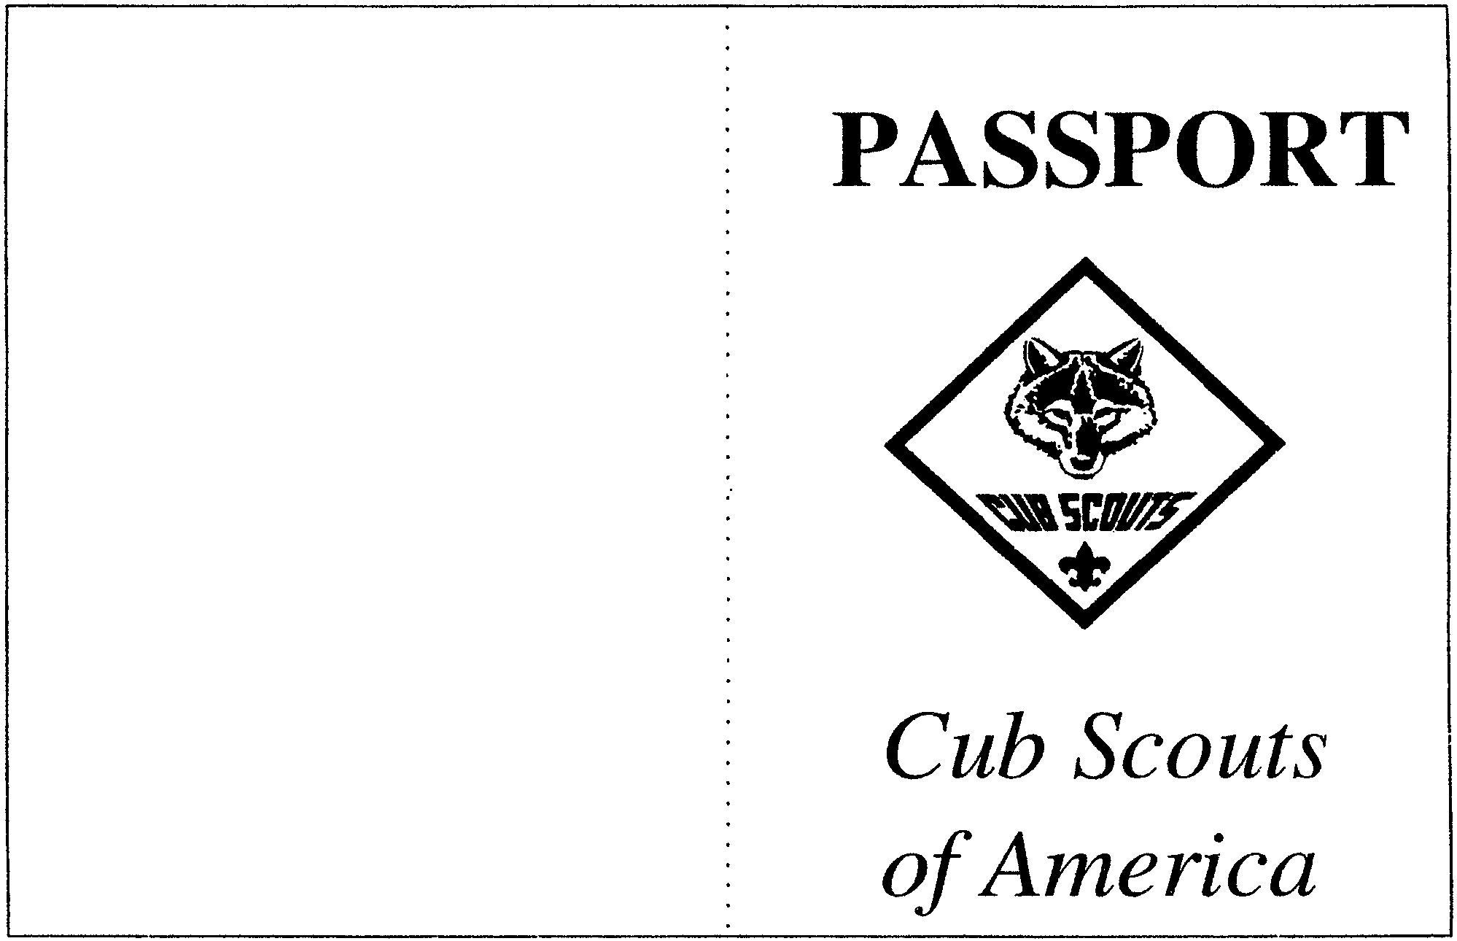

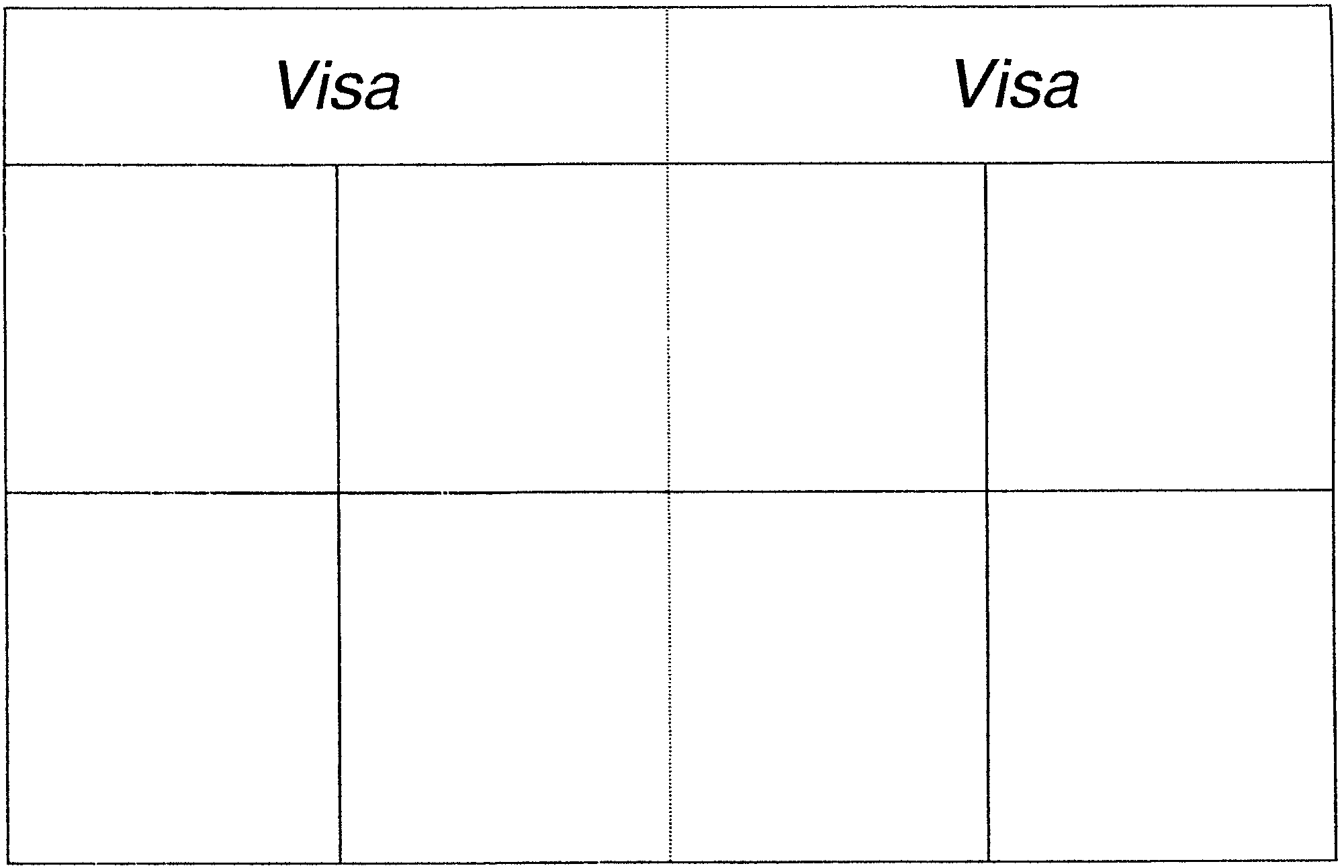

NECKERCHIEF INVITATIONS

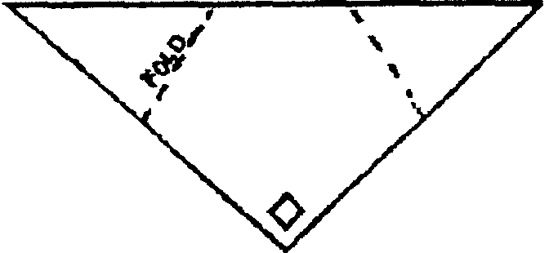
Materials: Yellow, blue or red construction paper (the same color as their neckerchief); Pens or markers.

Cut paper into triangle shape.

Draw the plaid or other markings the same as the boy’s neckerchief.
Fold the invitation as shown.
On the inside, write the information needed:
TIME:
PLACE:
DATE:
RSVP:
SPECIAL INFORMATION:

SCOUTING AROUND THE WORLD INVITATION

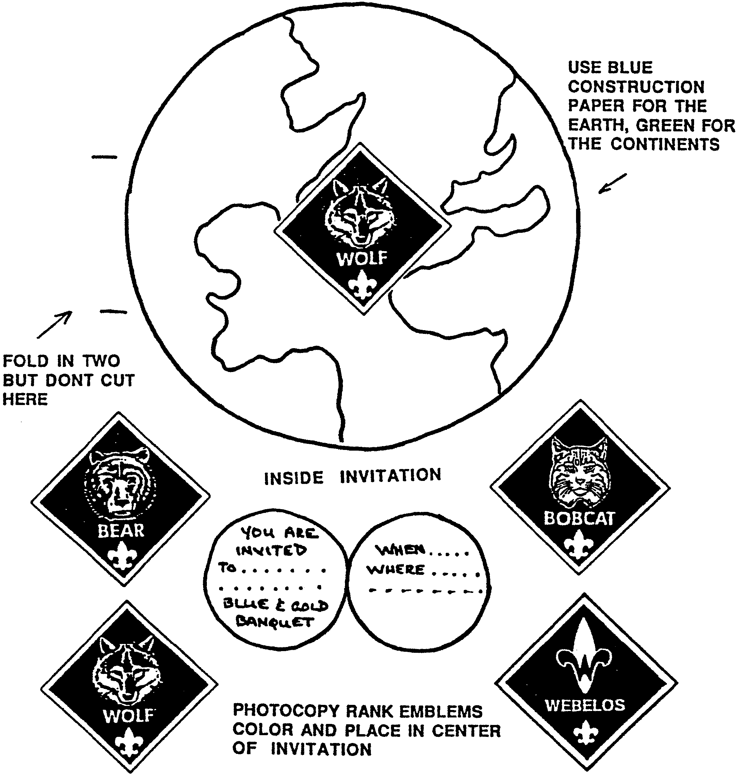

WORLD WISE CUB SCOUT

This may be used as a hanging ornament or a centerpiece--make 2-3 and have them lean against each other.

Trace patterns on white poster board and cut out. With markers or crayons, color the Cub Scout. Trace and color the globe. With paper fasteners, attach the head, arms and legs to the globe at the Xs. For the hanger, cut a 7” piece of string or yarn. Make a loop and glue to back of the head.

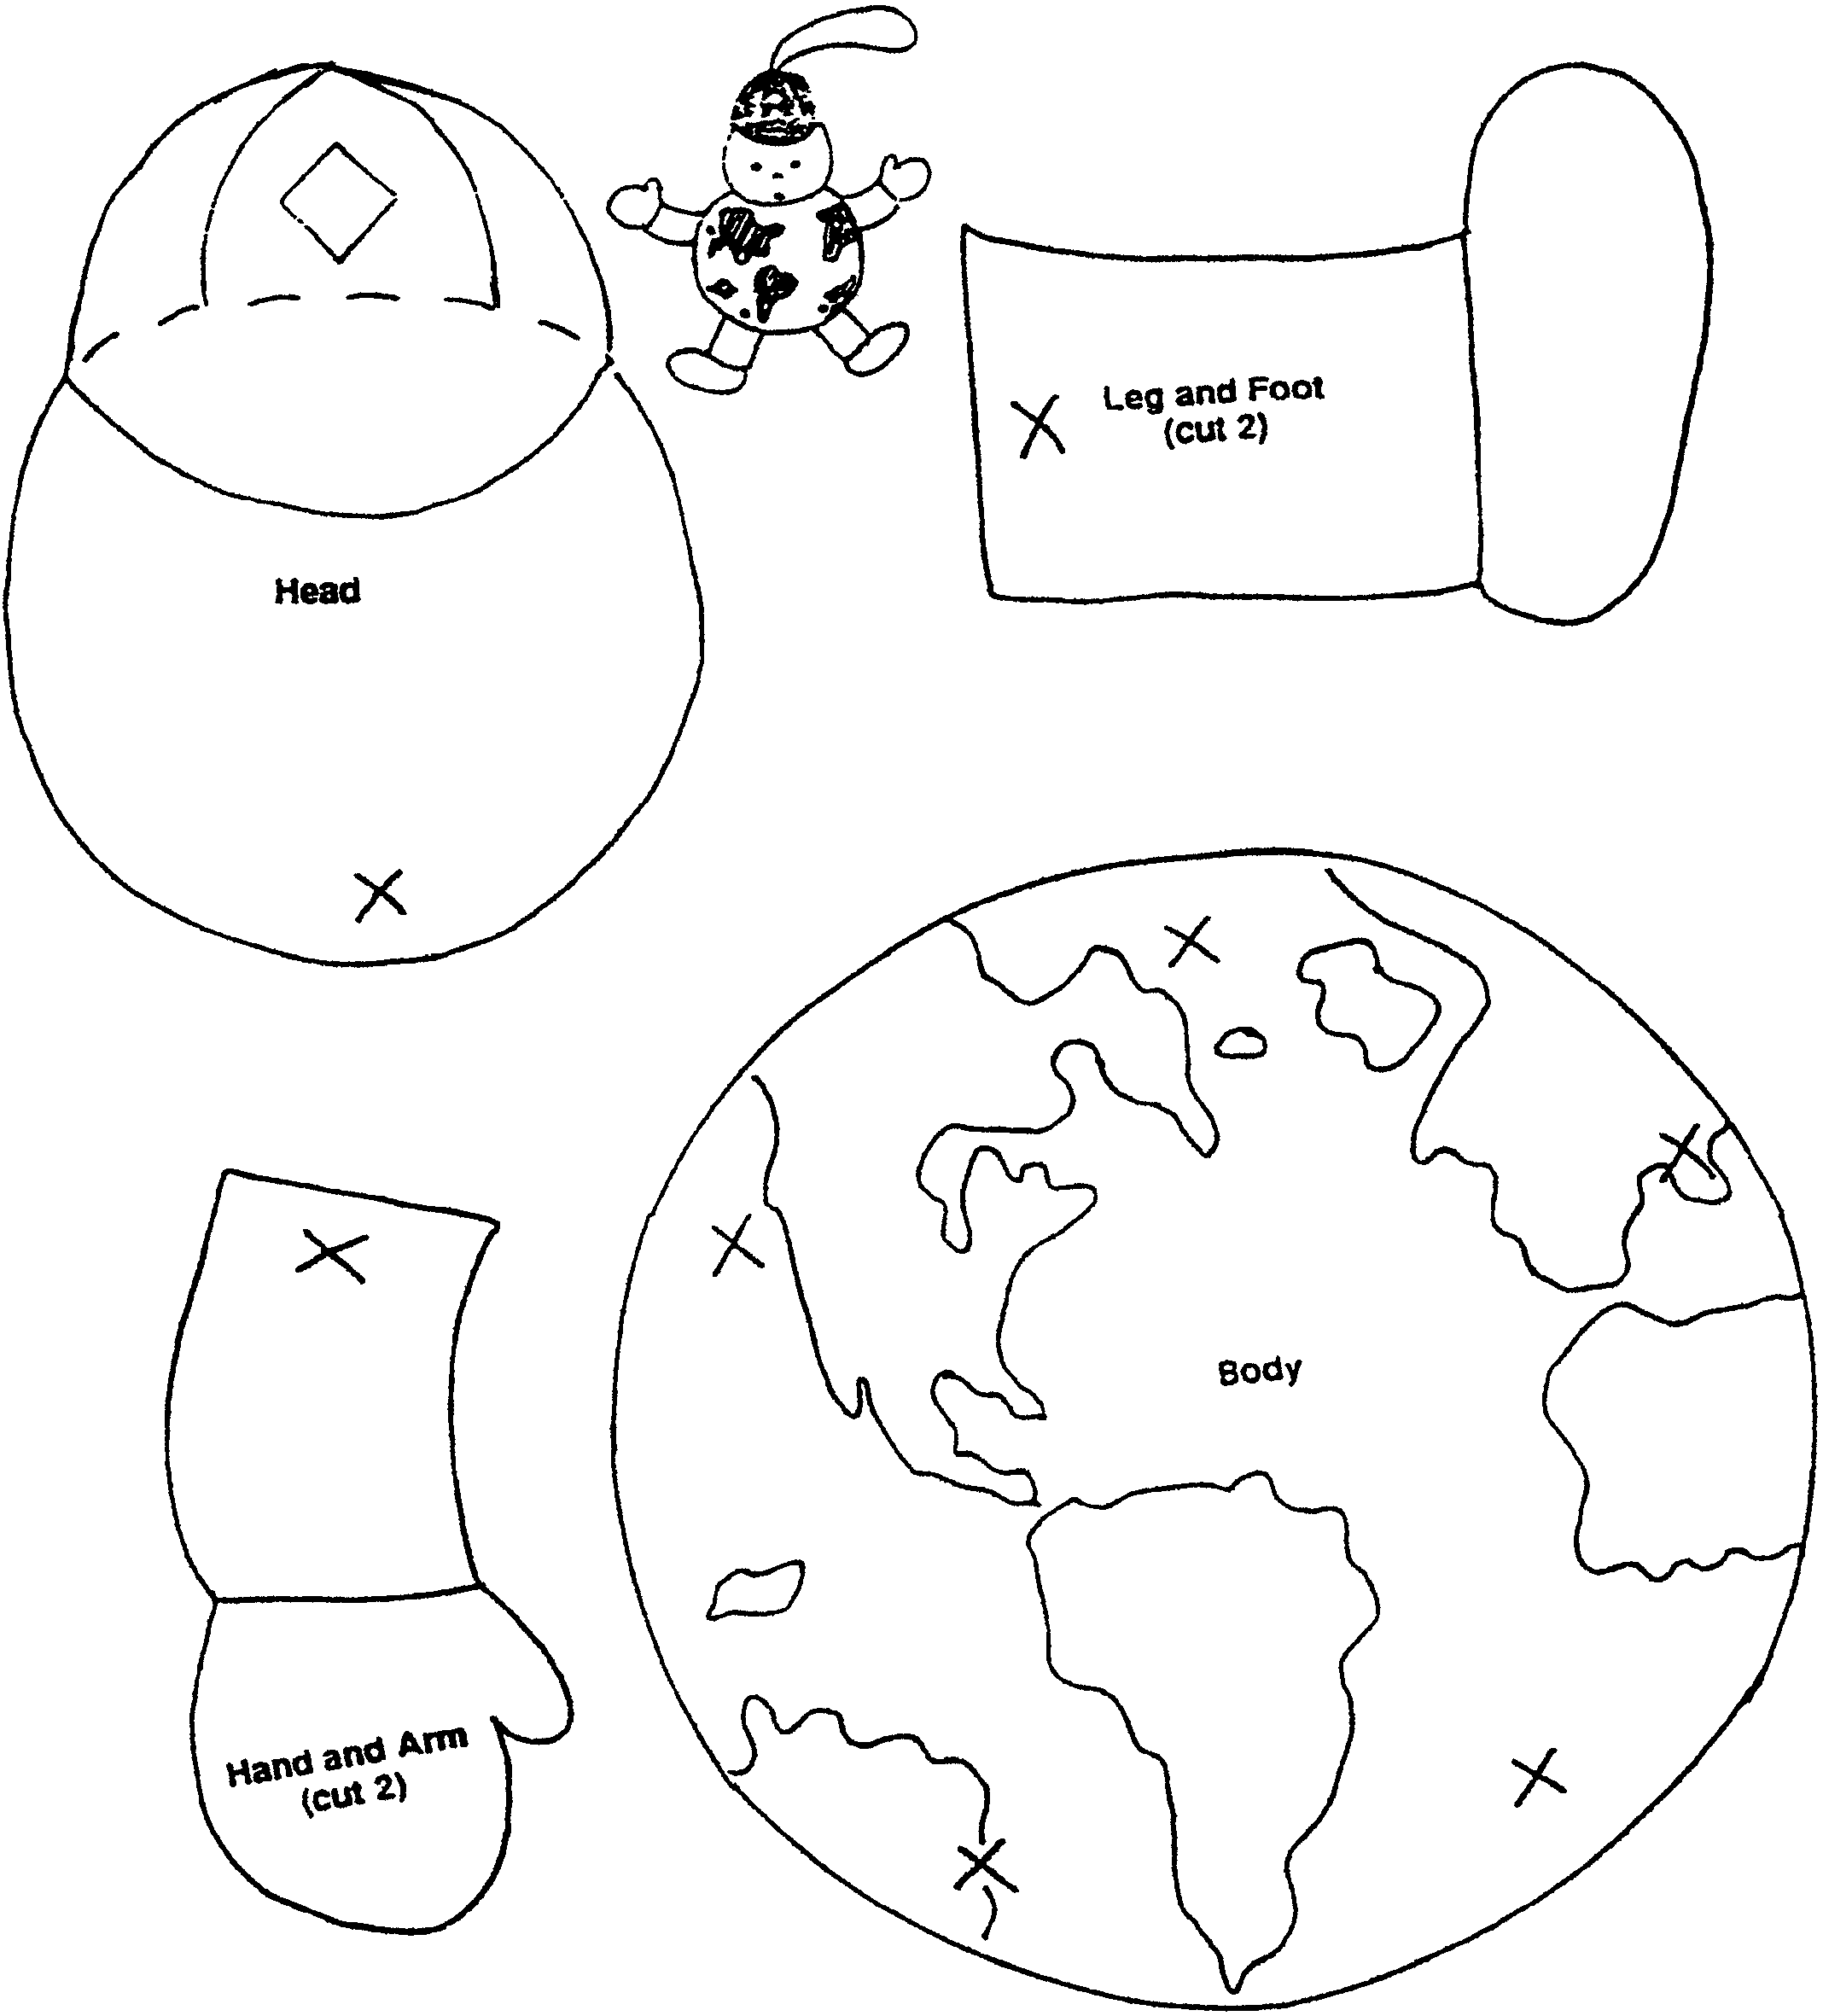

FRIENDSHIP NUT CUP

Pleat 2-1/2” strips of blue paper into 1-1/2” pleats. Cut outline of Cub Scout, leaving arms joined to from a chain. Open out, add faces and neckerchiefs. Glue around a yellow nut cup.

NOTES: This Cub Scout cutout pattern may be used for other table decorations as well:

- Paste a few Cub Scouts on a place mat.
- Cut a “string” of 3 or 4, tape hands at both ends together and stand it up as a place marker.
- Make smaller Cub Scouts, two attached. Glue on stiff paper and make a pin for parents or make a neckerchief slide.
- Put these Cubs around another centerpiece.

FLAG CENTERPIECE
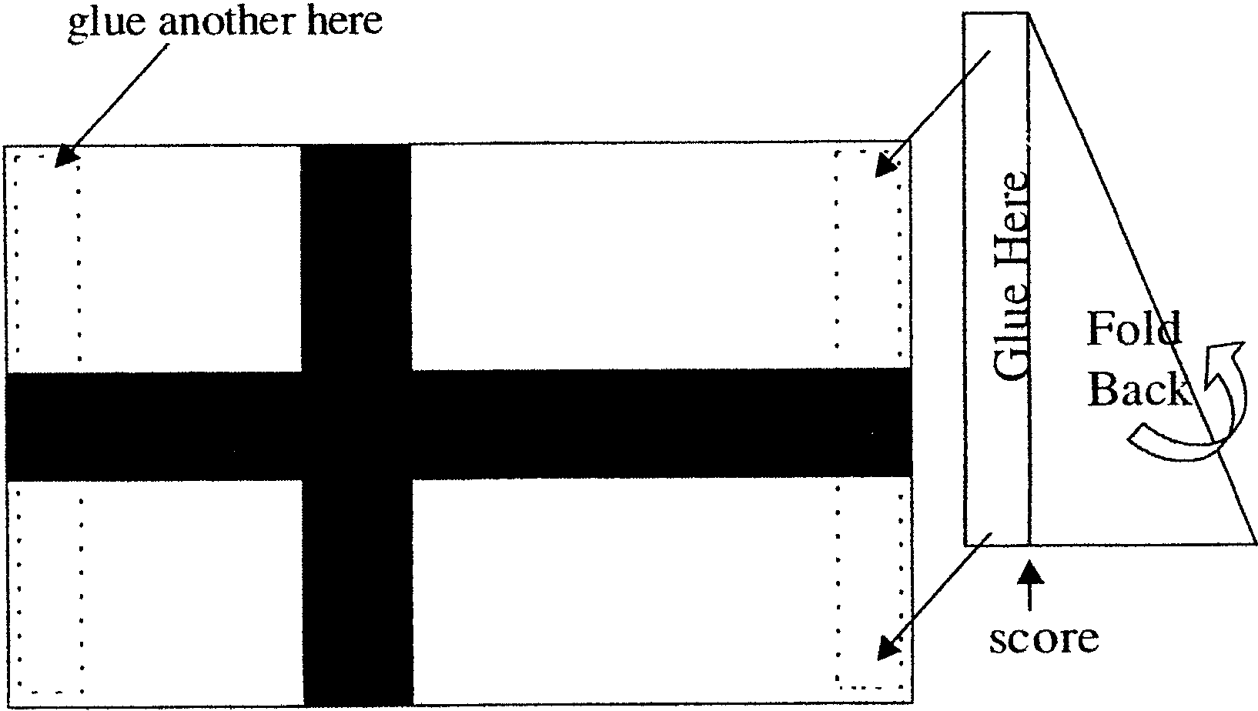
- Using a large piece of cardboard, have the boys color the flag.
- Write 2 or 3 interesting facts about that country on the back of the flag.
- Make an “easel” for the flag with pieces of cardboard so that it can stand up on the table.

WORLD SCOUTING FAMILY TREE CENTERPIECE

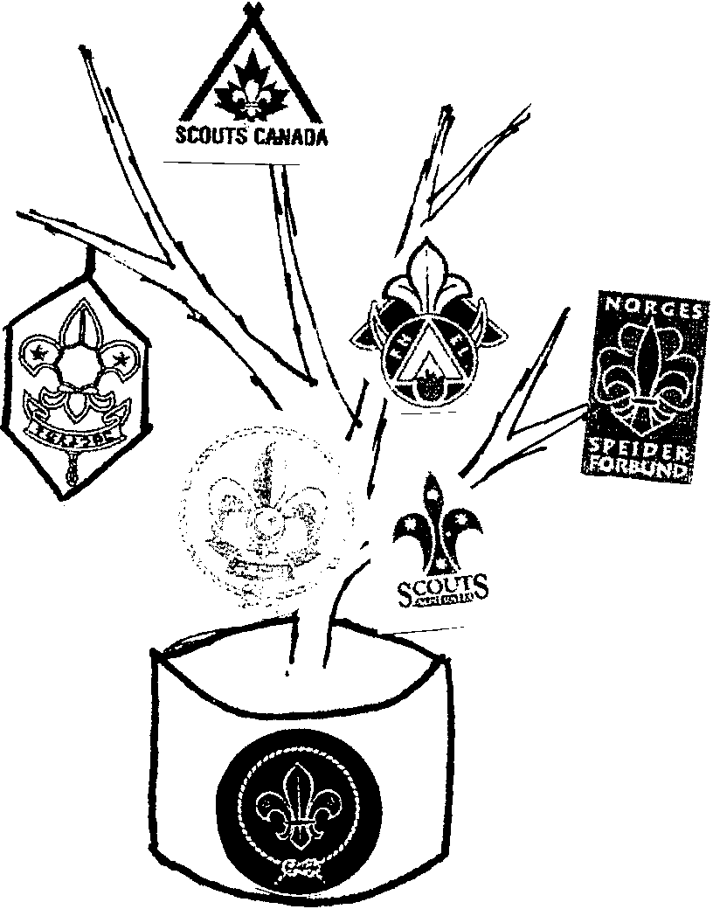
Fill a can (e.g. Coffee can) with plaster of paris and insert a branch.
Cover the can with blue or gold paper.

Obtain copies of several Scouting emblems from different countries. (Assign one of the boys to do this) Don’t forget the BSA emblem.

Cut out the emblems and paste on card stock that is the dominant color of the nation’s flag. Decorate the cardstock backing, if desired, with features from the flag or things that represent the country.

Tape or glue the emblems on branches.

Draw the earth or World Brotherhood emblem and glue it on the can.

PYRAMID PLACE MARKER/PHOTO DISPLAY
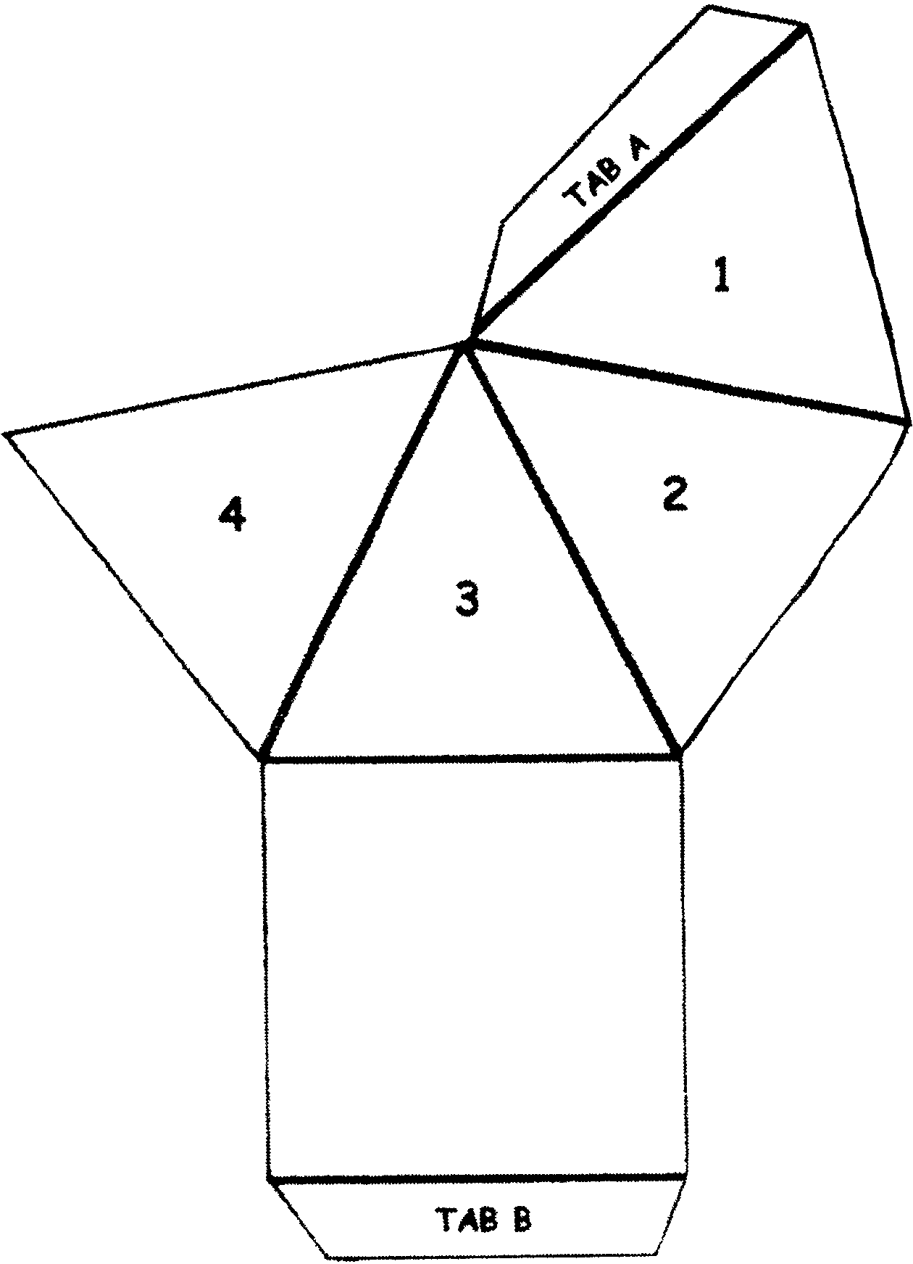
Use this to mark a place at the table. Write the name and Den number
on two of the sides, and glue photos on the remaining two sides.

Materials: Tag board or cardstock (any color); White glue;
Scissors; Photos (of the boy, den meeting etc. School photo
works well.)

- Copy the pattern on tag board. Enlarge if
desired. This pattern is for
2” triangles around a 2” square.
- Cut out the pattern, including
the tabs.
- Fold on the lines to make a pyramid.
- Write the name and Den number.
Glue photos. Let dry.
- Glue Tab A under section 4 and Tab B
under section 1. Hold together with a
rubber band until dry.

TRAVEL BROCHURE CENTERPIECE

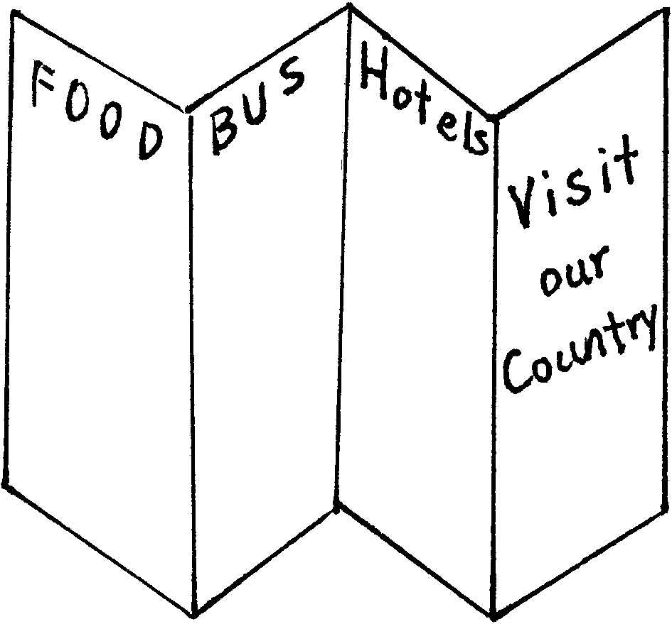
- Brochure is made with 8 1/2” x 14” paper--use thin but stiff paper like tag board or poster board.
- Fold the paper so that it makes a brochure.
- Choose a country.
- Clip pictures of that country from old magazines.
- Glue the pictures on the brochure, interspersing them between description of the country (library is a great resource for this). Make up some hotel information, airplane and train schedules, restaurant guide, etc.
- Stand the brochure as a centerpiece so everyone can see it.

OTHER BLUE AND GOLD IDEAS

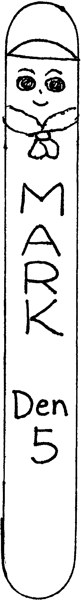
INVITATION: Plane shapes, Boat shapes
NAPKIN RINGS:
- Thread several blue pony beads onto yellow chenille stems. Shape the chenille by wrapping around cardboard tube. Tuck the ends.
- Paint a section of cardboard tube (paper towel, wrapping paper tube) blue. Paint small pebbles gold. Glue the pebbles onto the tube section.
CENTER PIECE
- Wrap a styrofoam ring (any size) entirely with yellow streamer. Cut short section of blue streamer (a little longer than the diameter of the tube of the ring) and wrap them around the ring every 2-3 inches. Stand toothpick flags (cocktail flags) of various countries on the ring.
PLACE MARKERS
- Use large craft stick. Neckerchief is chenille (glue it on the back of the stick). Use pony bead for a slide. Hat is folded, glued paper. If you cut this stick where the neckerchief is attached, it makes a nice slide for the boys.
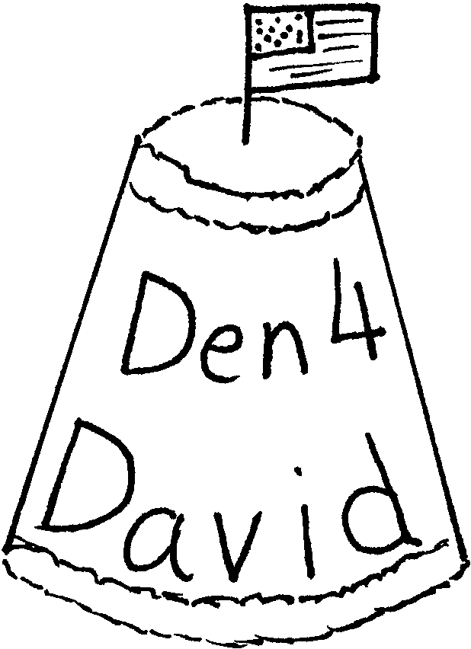
- Cut one paper cup open. Discard the bottom rim and top (this is the pattern for the place markers). Trace this pattern on blue or yellow construction paper. Write name and den number. Glue the construction paper on another paper cup. Glue chenille stems on top and bottom (color of the chenille is opposite of the construction paper). Place a small cocktail flag of the country of your choice on the top (=bottom) of the cup.

FLAG HOLDER CENTERPIECE

Materials: Scrap wood for the base (or 9” section of 1x4); Small wooden spools for the stand; Paint (blue, yellow); Stiff paper; Marker or crayons; Stick (diameter of the hole in a spool)
Note: Replace spools with small wood blocks if desired. Drill holes in them for the flag poles.
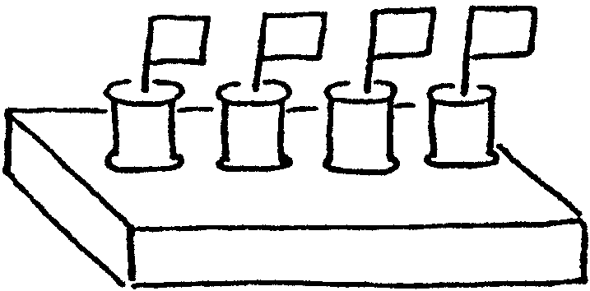
- Sand the wood for the base. Paint blue. Let dry.
- Paint the spools yellow. Let dry.
- Glue the spools onto the base, spaced evenly down the middle of the board.
- Make flags of different countries with stiff paper and markers or crayons.
- Attach the flags to sticks. Insert them into the spools.

CUB SCOUT CAP NECKERCHIEF SLIDE

Partially fill an egg carton cup with plaster of Paris. When plaster is nearly set, insert a ring (toy “wedding” ring) for the neckerchief. Cut cap’s bill from stiff blue paper and glue on. Paint cap to match boy’s rank.
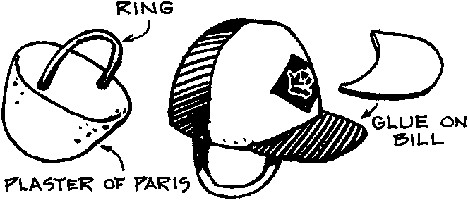

CUB SCOUT TREAT SLIDE

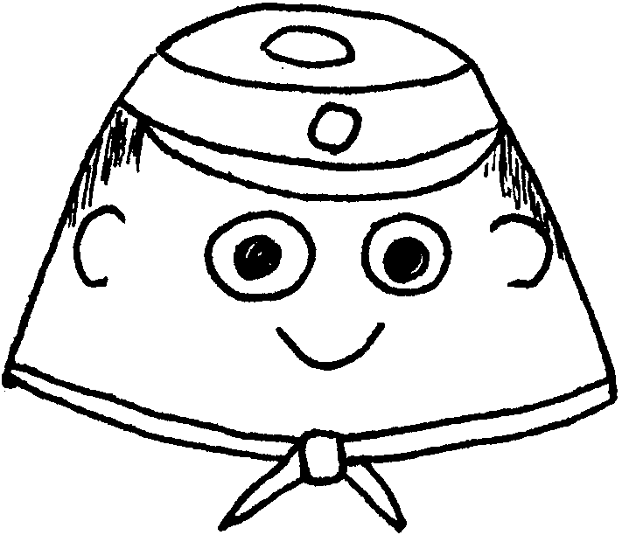
Material: One Jell-O dessert cup (empty and clean); Acrylic Primer; Acrylic paints (blue, flesh); Acrylic matte varnish; Blue craft foam; 1/4 ribbon (Neckerchief color); Gold pony bead; Black fine-tip permanent marker; wiggle eyes (or white and eye-colored paint)

- Cut a small hole (about 1/2”-3/4”) in bottom of the cup for the neckerchief to go through. (Adult assistance necessary).
- Use a damp sponge to paint cup with primer. Let dry.
- Sponge paint face color. Let dry.
- Paint base of cup blue for hat. Paint a small diamond with yellow in front (skip this if it is too detailed for the boys).
- Glue wiggle eyes or draw eyes. Draw rest of the face (nose, mouth, ears and hair) with marker.
- Glue brim on hat.
- Glue ribbon around top of cup to form neckerchief, leaving about an inch on each side.
- Slide gold bead onto the ribbon. Use a dab of glue to keep it in place.

BE THE BEST OF WHATEVER YOU ARE

If you can’t be a highway then just be a trail,
If you can’t be the sky be a star;
It isn’t by size that you win or you fail---
Be the best of whatever you are!

-Douglas Malloch

FRIENDSHIP TEA

1 cup orange-flavored instant drink powder
2/3 cup instant tea powder
1 teaspoon ground cinnamon
1/2 cup sugar
1/4 teaspoon ground cloves
Whole stick cinnamon (optional)
Lemon slice (optional)

Combine drink powder, tea powder, ground cinnamon, sugar and cloves. (You can store this up to 4 months in a Zip-Loc bag.) Stir before using.
Makes 2 cups, enough for 12 servings.

For each serving:
- Stir 1 rounded tablespoon of mix into 2/3 cup water in a microwave safe mug.
- Heat uncovered on high power for 1 to 2 minutes or until hot.
- If desired, serve with a cinnamon stick and a lemon slice.

GERMAN EGG PANCAKES

For one serving:
1 teaspoon flour
2 teaspoon milk
2 eggs
1 teaspoon butter
1 teaspoon sugar or jam
Lemon wedge (optional)

- In a bowl, mix the flour and milk to form a smooth paste.
- Add eggs and beat until the batter is thoroughly mixed.
- Heat butter in a medium sized frying pan over medium heat.
- When the butter starts to bubble, pour in the batter. It should cover the entire pan.
- Cook for four to five minutes, until the top of the batter looks dry. Remove from heat.
- Sprinkle the sugar evenly over the entire pancake and squeeze the lemon slice over the same area.
- Lift half pancake with a spatula and fold it over the other half. Eat hot.

