Did You Get My Message?

January 2002

CONTENTS

THEME RELATED 1
DEN AND PACK ACTIVITIES 1
AMERICAN SIGN LANGUAGE 1
DEN SECRET CODE 1
HAVING A PROBLEM WITH INVISIBLE INK? 1
FIELD TRIP IDEAS 1
PARTICIPATION AWARDS 1
DEN NEWSLETTER 2
DEN SCRAPBOOK 2
PINEWOOD DERBY 2
CUB SCOUT LEADERS POW WOW 2002 2
PREOPENING 3
CRISS CROSS COMMUNICATOR 3
TONGUE TWISTERS 4
CEREMONIES 5
PLEDGE OF ALLEGIANCE 5
GOOD CITIZEN--FIRST OF THE YEAR OPENING 6
U ARE IMPORTANT 6
NEWS BULLETIN OPENING 6
LISTEN CLOSING 7
MESSAGE OF PEACE AT THE BEGINNING OF YEAR CLOSING 7
“THE BUS”--CUBMASTER’S MINUTE 7
IDEAS FOR OPENING AND CLOSING 8
THGIL FO WORRA OT TACBOB ADVANCEMENT 8
ADVANCEMENT IDEAS 8
ADVANCEMENT WITH TWO-WAY RADIOS 9
REPORTER ADVANCEMENT 10
FUN WAYS TO SAY THANK YOU 10
AUDIENCE PARTICIPATION 11
HOW TO BUILD A COMPUTER 11
A TRIP TO REMEMBER 12
SKITS 13
PAINTING 13
SECOND LANGUAGE 14
LISTEN AT THE WALL 14
GNIKLAW 14
CATCHING VIRUSES 14
GAMES 15
SILENT COMMUNICATION 15
THIS IS MY NOSE 15
SLIP OF THE TONGUE 15
PASS THE WORD 15
PIG LATIN 16
COPY CAT 16
CHAIN WORD 16
SAY IT AGAIN 16
TELEPHONE NUMBER GAME 16
GOING TO THE BEACH 17
BRAILLE CARDS 17
SONGS 18
THE MORE WE COMMUNICATE 18
E-MAIL DELIVERY 18
VOLUNTEER SONG 18
A SMILE IS QUITE A FUNNY THING 18
CRAFTS 19
MEMO HOLDERS 19
LETTER OPENER 19
RUSTIC LETTER HOLDER 20
PAPER CLIP PALS AND PUSHPIN PALS 20
SECRET WRITING WITH INVISIBLE INK 21
COMPUTER MONITOR PICTURE FRAME 21
CD GAME SPINNER 22
WOODEN PENCIL HOLDER 22
NOTE PAD 23
WORD GAME 23
CLIP BOARD NECKERCHIEF SLIDE 23
CUBS IN THE KITCHEN 24
EDIBLE PINEWOOD DERBY CARS 24

DEN AND PACK ACTIVITIES

Discuss in the den how we communicate with each other. How many ways can the boys think of? There are writing, talking, singing, drawing, taking photographs, using secret codes, body language and facial expressions, and using special gadgets like phone and computers, to name a few. Pick a few and use them to communicate a simple message to each other.

AMERICAN SIGN LANGUAGE
Learn American Sign language. Have someone who knows the sign language come and teach the boys. As a den, learn the Cub Scout Promise in Sign Language (Cub Scout Ceremonies for Dens and Packs, p. 5-11, Webelos Scout Book, p. 193) and do it in front of the pack.

DEN SECRET CODE
What better fun could there be than to make up your own personal den code or language that only you and your buddies know? Boys need a lot of practice to use their codes efficiently. Then they can demonstrate the code at the pack meeting. Boys’ Life magazine contains a code-breaker section several times each year.

HAVING A PROBLEM WITH INVISIBLE INK?
In Elective 1 in the Wolf Cub Scout Book are suggested two types of invisible “ink.” To read the secret message, boys are supposed to heat it by holding it over a light. This method takes time and it rarely works well (though better with a high wattage bulb). A hair dryer does not work. And a candle is too dangerous. We found the best way is to use an iron (with adult supervision!). The iron should be set to low or medium.

FIELD TRIP IDEAS (For details, see the FIELD TRIPS section)
San Jose Mercury News
Intel Museum
San Jose Post Office
The Tech Museum of Innovation
9-1-1 dispatch center (call your fire department for information)
Local library

PARTICIPATION AWARDS (For details, see the PARTICIPATION AWARDS section)
Cub Scout Academics: Computer
Cub Scout Academics: Communicating

Laughter is the shortest distance between two people.

DEN NEWSLETTER

The den’s newsletter can be whatever the boys want to make it. Ask each boy to write at least one story for the paper. Here are a few possible topics:
A report on a recent den field trip.
Brief impression of a recent den or pack event.
Directions for playing the writer’s favorite game.
A report on an interview with the den leader.
A one- or two-paragraph description of each den member written by himself.
An interview with the den chief, who tells why he likes Boy Scouting.
A story on what the den plans to do for the Blue and Gold Banquet.

If you have an artist in the den, he may want to draw a cartoon or some other illustration. A boy interested in photography might choose to take photos of den activities.

Recruit boys and parents who have access to a computer to help produce some or all of the newsletter electronically using graphics and word processing programs.

DEN SCRAPBOOK

Start a den scrapbook. Use the scrapbook to record the den activities. Take it to the pack meeting to share with others in the pack. The scrapbook may include writing, photographs, drawings or paintings. Each boy may want to write a short paragraph about the den or about himself.

PINEWOOD DERBY

January is traditionally the month for the Pinewood Derby in our council.
For suggestions and ideas, please see Cub Scout Leader How-To Book, pp. 9-39 to 9-44.
For derby songs, “Pinewood Derby Song” and “Racer’s Lament,” see Cub Scout Songbook.

CUB SCOUT LEADERS POW WOW 2002

Have you registered for this year’s Pow Wow? It’s scheduled for Saturday, January 26. Registration forms have been mailed to all registered Cub Scout leaders. They are also available at the Council Service Center or through the council web-site: www.sccc-scouting.org.

CRISS CROSS COMMUNICATOR

Place the different ways to communicate into the diagram so that they interlock as a crossword. When you are done, all the words will have been used exactly once. You may want to communicate with your friends and work together!

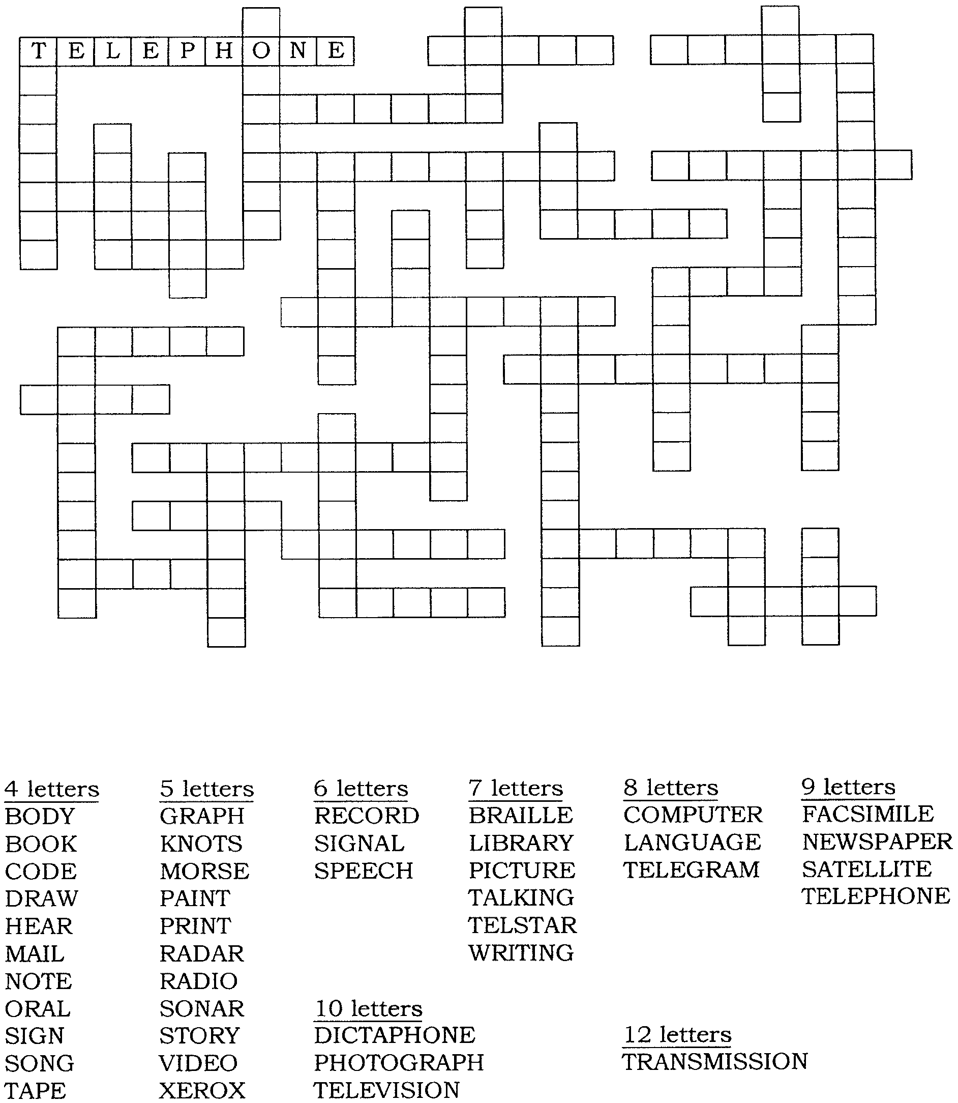
Answer on p. January-24

TONGUE TWISTERS

How many times can you repeat these short twisters before you make a mistake?
Aluminum linoleum. Truly rural.
Soldiers’ shoulders. Please freeze cheese.
Three free throws. Ruth’s red roof.
Supper at sixish. Fred’s fruit float.
Ellen’s elegant elephant. Fluffy finches flying fast.

Now for a little longer lines.
Dan’s dog digs ditches in the dirt.
Eight apes ate eight apples.
A big black bug bit a big black bear, making the big black bear bleed blood.
Shallow ships show some signs of sinking.
Seven shy sailors salted salmon shoulder to shoulder.
Freddie’s friend Eddie phoned for Freddie to fetch fruit from the farm of the famous
French farmer.

Try making up your own too. Work with friends and family.
One wise whistling wizard.
Two tooting tuba-tuners.
Three twirling tricky tree toads.
Four friendly French flamingoes.
Five freezing fleeing foxes.
Six sharp sleepy sharks.
Seven short striped snakes.
Eight eager able eagles.
Nine itching inching inchworms.
Ten tiny timid tigers.

Now the twister verses.
Peter Piper picked a peck of pickled peppers;
A peck of pickled peppers Peter Piper picked.
If Peter Piper picked a peck of pickled peppers,
Where’s the peck of pickled peppers Peter Piper picked?

Billy Button bought a buttered biscuit.
Did Billy Button buy a buttered biscuit?
If Billy Button bought a buttered biscuit,
Where’s the buttered biscuit Billy Button bought?

She sells sea shells on the seashore.
The shells she sells are sea shells, I’m sure.
And if she sells sea shells on the seashore,
The I’m sure she sells seashore shells.

PLEDGE OF ALLEGIANCE

Webelos den is in front. One of then asks the audience to rise and repeat the Pledge of Allegiance. The Webelos Scouts in front repeat it in sign language.
(Have the boys practice well at the den meeting. This can be part of the Citizen or Communicator Activity Badge. If you know someone who knows sign language, ask that person to coach the boys.)

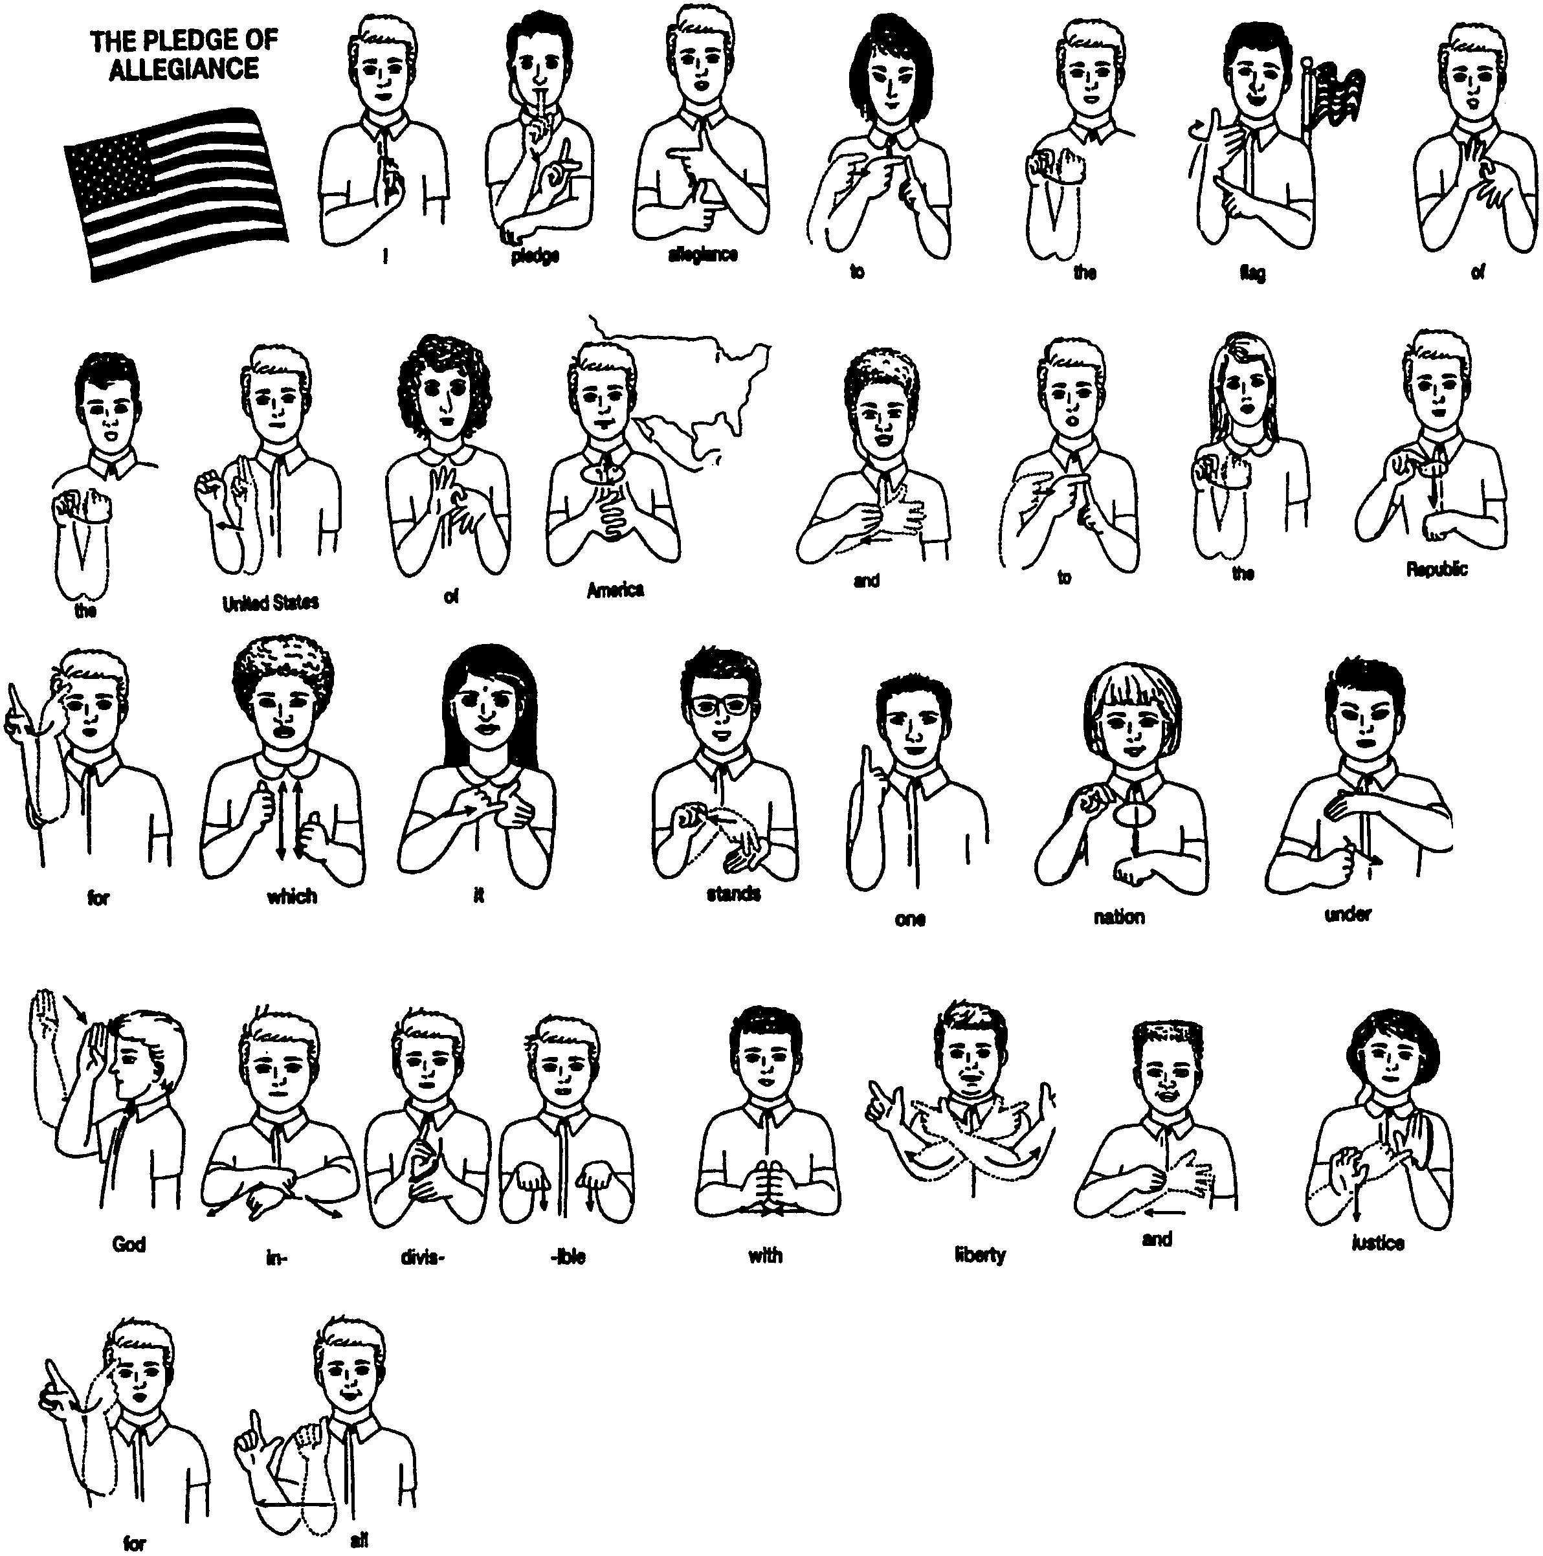

GOOD CITIZEN--FIRST OF THE YEAR OPENING

C.S.#1: We’ll learn to be good citizens and, hopefully, we’ll see,
That laws are made for all of us, so each one can be free.

C.S.#2: To do all this, the Cub Scouts need leaders--good ones, that is true;
That means we need the help of all of you, and you, and you. (Point)

C.S.#3: And now to start the year off right, in good and proper manner,
We’d like you all to rise and sing our own “Star-Spangled Banner.”

U ARE IMPORTANT

Each Cub holds up a sign with his word(s) on it, with the “U” missing from the word.

C.S.#1: We cannot spell C B SCO TS (Cub Scouts) without U.
C.S.#2: We cannot spell YO TH (Youth) without U.
C.S.#3: We cannot spell AD LT (Adult) without U.
C.S.#4: We cannot spell S CCESS (Success) without U.
C.S.#5: We cannot spell F N (Fun) without U.
C.S.#6: We cannot spell O TDOORS (Outdoors) without U.
All: Clearly, Scouting needs U!

NEWS BULLETIN OPENING

Arrangement: Cub Scout is doing the news broadcast. Other boys run in to interrupt him.

C.S.#1: Now the weather...
C.S.#2: We would like to interrupt the program with this exciting news--Boy earns Bobcat Awards!!
C.S.#1: Now the weather...
C.S.#3: News Bulletin! Boy earns the rank of Bear!
C.S.#1: NOW the weather...
C.S.#4: This news just came in. Boy becomes a Wolf!
C.S.#1: Should we do the weather?
C.S.#5: As you can see, today’s news is all about the good things that boys in our town are doing.
C.S.#1: Will you please follow me in the Law of the Pack?

APPLAUSE

DYBS APPLAUSE: DYBS means “Do Your Best, Scouts” and is pronounced like dibs. Everyone yells DYBS when leader raises fist in air and brings it down hard.

LISTEN CLOSING

Props: Cards, with the large letters L-I-S-T-E-N on the front and the text on the back.

C.S.#1: In this age of busy life and fast communication, we sometimes forget one of the most important parts of communication...
C.S.#2: L Let’s all take a minute before we hurry on our way.
C.S.#3: I If you remember this message, it will help you every day.
C.S.#4: S Sometimes people find it hard to communicate with those around.
C.S.#5: T They can solve this problem with one word we’ve found.
C.S.#6: E Everyone, stop and read our message now.
C.S.#7: N Needless to say--to communicate--we’ve just told you how!
All: LISTEN!

MESSAGE OF PEACE AT THE BEGINNING OF YEAR CLOSING

(You may wish to use pictures mounted on poster board and have the lines written on the back.)

Cubmaster: It has been said that there are six kinds of peace. A person who possesses all six will never want or need anything else. The six kinds of peace are:
C.S.#1: The peace that comes from goodwill among nations. (holds up a globe or photo of earth)
C.S.#2: The peace that comes when neighbors help each other. (carries a rake)
C.S.#3: The peace a person draws from nature. (carries a potted plant)
C.S.#4: The pace that exists within a family. (brings out a family member)
C.S.#5: The peace between a person and his God. (brings out an appropriate religious symbol)
C.S.#6: And finally the peace that a person finds within himself. (holds up a mirror)
Cubmaster: To all your many friends, may such peace be yours throughout this year.

“THE BUS”--CUBMASTER’S MINUTE

To end this evening I would like to tell you a story. A crowded bus stopped to pick up a bent old woman. With great difficulty she struggled up the steps with a large basket of freshly washed laundry. “You’ll have to put your basket in the rear of the bus,” said the driver impatiently. “But I don’t dare. They don’t belong to me,” said the woman. The driver was firm. “You and that basket are in the way. Either stow it or get off.” The old woman was almost in tears when a Cub Scout in uniform stood up. “You sit here, ma’am,” he offered. “I’ll take your basket to the back and watch it until your stop. The woman was doubtful but the driver was about to put her off. A second lady, sitting nearby, said to the old woman, “That boy is all right. Can you see his uniform? I’ll vouch for him.” The old woman was soon seated and the basket of clothes was carried to the rear of the bus. At her stop, the boy gently set the basket down by her, then returned to the bus and continued on his way. “Who’s the kid?” the bus driver asked the second woman. “I don’t know the kid,” came the reply, “but I do know the uniform, and you can trust it every time.”

Let’s think what kind of message we are sending when we wear our uniform.

IDEAS FOR OPENING AND CLOSING

- Do the ceremony in sign language. Have a Cub Scout act as in interpreter. For the Cub Scout Promise in Sign Language, see Cub Scout Ceremonies for Dens and Packs.
- Webelos Scouts can do part of the ceremony in Morse Code. Have an interpreter. For Morse Code, see “Communicator” in the WEBELOS SCOUTS section of this book. Webelos Scouts can send a short message using flashlights or by making noise like a telegraph machine.
- Use the Cub Scout closing in sign language in Wolf Cub Scout Book (p. 31).

THGIL FO WORRA OT TACBOB ADVANCEMENT

The Cubmaster calls forward the advancing Cub Scouts and their parents.
Then on a large sheet of paper he writes:
THGIL FO WORRA OT TACBOB (backward of “Bobcat to Arrow of Light”)

Can any of you Cub Scouts tell me what I have written in secret code?

(When the boys have figured it out, Cub master continues)
That’s right. It is the Cub Scout advancement trail, from Bobcat to Arrow of light. There is no secret how you move along that trail. You do it by working hard and passing certain requirements that are lots of fun and teach you many new skills. You need the help and encouragement of your parents, too, and that’s why we always invite them to join you when you receive your new badge. Now I will give your new badges to your parents and ask them to pin them on your uniform. (Distribute awards one at a time announcing the name of each recipient).

ADVANCEMENT IDEAS

- Use a secret code in the ceremony. Names of the boys receiving awards or their rank may be written in secret code.
- Use message written in invisible ink. Use a candle to make the message appear (light bulb takes too long. Message should be short and written big so the audience can see it. Practice ahead of time. For suggestions for the “ink,” see the “Crafts” section for this month.
- Pack advancement chair may be “radio announcer” who calls the boys up before the Cubmaster with appropriate announcement and calls for applause.
- Cubmaster talks in Pig Latin. Assistant Cubmaster introduces Cubmaster as a guest from a far-away nation of Cubland. He says that this guest will give awards this month. Cubmaster talks slowly and the assistant repeats in “normal” English. Let the boys catch on. (Pig Latin is listed in the “Games” section of this month.)

APPLAUSE

BIG THUMB APPLAUSE: Hold your hands in front of your, make a fist, hold your thumb up and say “Great Job!”

ADVANCEMENT WITH TWO-WAY RADIOS

Arrangement: Cubmaster and assistant Cubmaster have two-way radios. Cubmaster stands at the front of the room while the assistant is outside in a hallway. Assistant plays the part of the Great Spirit.

CM: I understand we have several boys who are ready for advancement. Will the den leaders please bring these boys and their parents forward? (Call out boys names)

Each advancement represents an important step in Cub Scouting. I feel we should consult with the Great Spirit of Cub Scouting. We shall attempt to communicate by the radio.

This is Akela calling the Great Spirit. Do you read me? Over.

GS: I hear you, Akela. Why do you call me? Over.

CM We wish to consult with you about a boy who wishes to become a member of our pack. Over.

GS: I have watched him. He has studied the requirements and is ready to join you. He will be a great addition to your pack. Over.

CM: The Great Spirit has spoken. It is with pleasure that I present you with the Bobcat badge.

(The above communications are repeated for other rank advancements until all are presented. Have the Great Spirit say something positive about each boy.)

GS: Akela, (pause) Akela.

CM We hear you Great spirit. Over.

GS: Have each boy advance his name on the pack rank ladder. Congratulations to each of you. Over and out.

CM: Over and out, Great Spirit.

I already knew that.
But I knew it better after you showed me.

REPORTER ADVANCEMENT

Setting: TV News Anchor desk (table) with Anchorman seated. Camera can be added off on the side taping the presentation.

Anchorman (Cubmaster):
Good evening and welcome to tonight’s broadcast of Channel (pack number), CUB Evening News. I am your newscaster, T.L.Meanething (pronounced “tell me anything”). We have exciting news this evening. We have learned that there are several awards to be presented. Will the following boys and their parents please come forward? (Call forward Cub Scouts receiving Bobcat, Wolf, Bear and Webelos badges)

You have just finished journalism school and like the Bobcat, you have taken your first step towards an exciting career. I encourage you to continue going forward in your endeavors.

The next awards go to our Cub Reporters, the Wolves. They are learning the trade of reporting. Though they still have a long way to go, they’ve made a great start.

Our next awards go to our Ace Reporters, the Bears. These guys know how to find and tell stories of interest, but still need help along the way.

Finally, these awards are for our Editors, the Webelos. These young men have learned not only how to find and report good stories, but also what it takes to make these stories exciting and different. As all good Editors, they are always preparing themselves for the next big assignment.

Congratulations to you all.

That’s all the news we have for you in tonight’s program. Thank you for tuning in. This is T.L.Meanething signing off.

FUN WAYS TO SAY THANK YOU

First Class envelope: “You did a first class job!”
Newspaper: “Thanks a bundle!”
Pencil: “You’re sharp and to the point!”
Toy telephone or two tin cans connected by a string:
For keeping everyone informed of changes.
For someone who coordinates the pack phone tree.

See Cub Scout Ceremonies for Dens and Packs for:
“Cub Scout Promise in Sign Language” p. 5-10
“Radio Station C-U-B-S” (Advancement) p. 8-6

HOW TO BUILD A COMPUTER

DOODADS: “Clickety, clack, clickety, clack.”
DINGFORD: “Whiz, bang, boom.”
FREEDISTANT: “Whoosh, whoosh.”
HYGORICKY: “Snap, crackle, pop.”
SCATUREEKUS: All sounds together.

Very few families can get along without a computer. While they can be purchased already assembled in a wide range of shapes, sizes, and colors, they are relatively easy to put together yourself. Just follow these directions and you’ll have yours put together in no time at all.

The DOODADS of the computer kit are enclosed in a plastic gizmo and stapled with a yellow assembly DINGFORD to a FREEDISTANT. The assembly DINGFORD may be placed upon any corrugated doomaflatchy or use the FREEDISTANT to assemble your DOODADS. Carefully remove the plastic gizmo of the DOODADS from the FREEDISTANT and lay out the DOODADS on a clean acka-mar-ackus. Learn the name of each part of the DOODADS by comparing them with the assembly DINGFORD and assemble the DOODADS in the correct order. You will also need a drill with a 3/16 “gizflunky for the HYGORICKY” and a pair of pliers. Using a watchafiggle, carefully punch a 1/8” whatnot through the assembly DINGFORD and FREEDISTANT where each HYGORICKY goes. These whatnots are openings for the hoosis HYGORICKY used to fasten the DOODADS together. Now hammer the frammis to the hootenany and under the HYGORICKY, as shown in the DINGFORD. If the order is reversed, the computer will not operate properly and SCATUREEKUS will result.

THAT’S NOT MY JOB

This is a story about four people named Everybody, Somebody, Anybody and Nobody.

There was an important job to be done and Everybody was sure that Somebody would do it. Anybody could have done it, but Nobody did it. Somebody got angry about that, because it was Everybody’s job. Everybody thought Anybody could do it; but Nobody realized that Everybody wouldn’t do it. It ended up that Everybody blamed Somebody when Nobody did what Anybody could have done.

Get the message?

A TRIP TO REMEMBER

Type or write the expressions below, one per card or strip of paper. Give one expression to each participant (or first 24) and make sure they can read them aloud. Then read the story below, pausing for boys to read a goofy expression at each blank. Start the boys from one side of the room to the other.

A loose tooth
Some red ants
2 snowballs
a limping dinosaur
a yellow parrot
a purple crayon
a bar of soap
a butterfly net
a sharp tack
a fat onion
a tall pine tree
4 sour pickles
a broken radio
a red kite
a bald eagle
a telephone
3 raisins
a bike horn
3 boiled eggs
a swarm of bees
a pound of feathers
a used firecracker
a rattlesnake
4 hot rocks

One day my mom and dad decided to take me to the store for a surprise. We got into our car and my dad placed _____ into the ignition. We drove down the street towards _____. My mom said, “Look, son, it looks like our neighbors have _____ planted in their front yard. “It looks more like _____ to me.” Grumbled my dad.

Just then _____ fell out of the sky, landing in the road in front of us. We swerved, nearly hitting _____. “Wow, that was close,” Dad said. “It’s getting so the roads aren’t even safe for _____ anymore!” Finally we arrived at the mall. There in front was a clown juggling _____ and _____ and _____, all the while he rode a _____.

As we went into the mall, I asked my mom if I could get _____. “No, son,” she said, “Remember, you already spent your allowance on _____. We’re here to pick out your birthday present.” “Neat! What is it?” I cried. “Well,” said my dad, “We feel you’re old enough to have your own computer.” I was happier than my wildest dreams.

As we walked down the mall, my mouth started watering, as I could smell _____. We stopped for a treat, and my dad had _____. While dad and I ate, mom looked at a window display of _____ and _____ artistically arranged around _____

Finally we entered the computer store. “May I help you?” asked the manager. “Why, yes,” said my dad. “We’re looking for a deal on a computer with a _____.” “Hmmmm,” said the manager, “We just sold out of those, but take a look at this model. It comes standard with _____ and _____, and if you buy it today, I’ll even throw in _____!” My dad said, “We’ll take it!”

All the way home, I thought about my new computer. My friend, Jeff, would be so jealous, since all he had on his computer was _____. My mom and dad helped me set up my new computer in my room, right next to my _____. What a great birthday!

PAINTING

Cub #1: You know the den leader’s birthday is coming up.
Cub #2: Yeah. We should do something for her.
Cub #3: Yeah. She’s so much fun. Let’s give her a present.
Cub #4: I don’t have any money. Do you?
Cub #5: No. But we could earn some money.
Cub #1: Good idea! Let’s go ask Mr. Smith. He’s real nice.
(Boys walk up to house and knock on door)
Cub #1: Hi, Mr. Smith. We are trying to earn money to buy a present for our den leader.
Cub #2: Do you have any jobs we could do to earn extra money?
Mr. Smith: Why, you boys came at just the right time! I was just about to go around back and paint my porch. Do you think you can handle a job like that?
All: Sure!
Mr. Smith: OK, then. You’ll find everything you need around back. Just knock on the front door if you have any questions.
All: Thanks, Mr. Smith!
(Boys walk backstage behind house. They return one at a time at ask questions then walk back)
Cub #1: (Knocks on door) Is this the paint you wanted us to use, Mr. Smith?
Mr. Smith: Yes, that’s right. Thanks for checking with me.
Cub #2: (Knocks on door) We saw these old shirts in your garage, Mr. Smith. Is it OK if we wear them so we won’t get paint on our uniforms?
Mr. Smith: Good idea! Glad to see you boys take such pride in your uniforms.
Cub #3: (Knocks on door) Mr. Smith, do you have some newspaper we could spread out in case we drip paint?
Mr. Smith: Sure--here you go! You boys certainly are being careful.
Cub #4: (Knocks on door) Is it OK if we close the windows so we don’t splatter paint inside?
Mr. Smith: Sure--go ahead. You boys think of everything!
Cub #5: (Knocks on door) Did you want us to paint the door, too, Mr. Smith?
Mr. Smith: Sure--the door could use a fresh coat of paint!

(Boys all return together to knock on door)
Cub #3: We’re all done now, Mr. Smith.
Cub #4: Would you like to come around back and see how we did?
Mr. Smith: Oh no, that won’t be necessary. I know you Cub Scouts always do your best! Here’s some money for each of you for your hard work
All: Wow! Thanks, Mr. Smith!

(Boys begin to walk away, then one turns back)
Cub #5: Thanks again Mr. Smith. Oh, and by the way. You don’t have a “Porche” You have a Ferrari!

SECOND LANGUAGE

Arrangement: One den member wears a sign reading “Mother Mouse.” Another has a sign reading “Cat.” All others wear signs reading “Mouse.”

(Mother mouse is taking her children for a walk)
Mother Mouse: Come children it’s a beautiful day for a nice walk...
(Other mice respond. All making small talk while crossing the stage.)
(Suddenly Cat jumps into the path in front of the mice)
Mother Mouse: (in a loud voice) Bow wow wow! Bow wow wow!
(The cat screeches in fear and runs off.)
Mice: Oh, Mother, we were so scared!
Mother Mouse: Let that be a lesson to you, children. It pays to learn a second language.

LISTEN AT THE WALL

(Cub #1 walks along a wall just listening, listening. Others come along and see him.)
Cub #2: What do you hear?
Cub #1: (Dramatically) Listen!
(Others listen. But they don’t seem to hear anything.
Cub #3: I don’t hear anything!
Cub #1: (More dramatically) Listen!
(Others listen)
Cub #4: (In a disgusted voice) I don’t hear anything.
Cub #1: (With a faraway look) You know, it’s been that way all day.

GNIKLAW

You can use this as a run-on or add a few lines and boys to make a short skit.

One Cub Scout walks backwards past another Cub Scout.
The standing boy asks, “What are you doing?”
The boy walking backward answers, “Gniklaw (walking backwards)”

CATCHING VIRUSES

(Boy comes on vigorously waving a butterfly or fisherman’s net.)
Cub #1: Hey, what are you doing?
Cub #2: I’m catching computer viruses.
Cub #1: What’s that you’re using?
Cub #2: It’s an INTER-net

SILENT COMMUNICATION

How well do you communication nonverbally? Ask the den to line up according to a criterion given to them. For example: Line up shoulder to shoulder in order of height, with the shortest boys on the line’s left; Line up in order of alphabet (first name, last name, Dad’s first name), age, number of siblings, etc.

THIS IS MY NOSE

Divide the group into pairs. Pairs stand in line, facing each other. One of the pairs stars out by saying, “This is my nose” and touching something other than his nose, for example his head. The second player will touch his own head and says, “This is my (anything other than head),” for example his knee. The first player now touches his knee, and so one. The object of the game is to keep this going as long as possible. The pair that makes a mistake or gets stuck, stops playing and steps back. See which pair can remain in line longest. To make it more challenging, have the boys specify right or left (right knee or left knee, for example) and/or make it against the rule to repeat the same words.

SLIP OF THE TONGUE

As boys arrive at the meeting, give each a handful of dried beans. Each boy tries to win beans from the others by getting them to say either “yes” or “no” to questions. A player who says “yes” or “no” must give up one bean to the questioner. The winner is the boy with the most beans at the end.

PASS THE WORD

Distribute members of the den some distance away from one another. Den leader whispers a message to one of the players, who then goes to the next player and whispers the same message to him, and so on. The last player to receive the message repeats it out loud. How close was it to the message that started the game? You will probably find that the message has been garbled. Point out that this shows how hard it is to communicate clearly and why both speaker and listener must concentrate on the message.

VARIATIONS: Make the distance between the players longer. Add time as another dimension--see how fast and how accurately they can deliver the message The longer the distance and the more breathless (and less articulate), the more forgetful the boys become. Another way to make this more challenging is for each player to eat a cracker or two before he delivers the message. If you have a large number of people, as at the pack meeting, divide people into groups and see which group is fastest and most accurate. Include family members too.

PIG LATIN

Move the first consonant sound (could be more than one letter) to the end of the word and add “ay” to it. For example, “pig Latin” becomes “igpay atinlay” and “cub scout” becomes “ubcay outscay.” For words that start with vowels, add “ay” at the end; so “achievement” becomes “achievementay.”

COPY CAT

Boys stand in a circle. Without letting anyone else know, every player secretly picks another player to watch. Each player copies the movements of the watched player, exaggerating them very slightly. If no one seems to be moving, have boys spin around once. While the group is still moving a bit, boys should begin to mimic. The movements of the group will eventually become larger and larger and usually everyone will end up doing the same thing without ever knowing who started it.

CHAIN WORD

The players sit in a circle, and the first player is given a beanbag. He says a word, such as “school” and tosses the beanbag to a player on the other side of the circle. This player must immediately say a word that is commonly associated with that word, for example “homework” Next player must come up with a word associated with homework, for example ‘book” The word-calling and beanbag-tossing continues until a player cannot come up with a word or says a word that clearly is not commonly associated. Start again. See how long you can go on as a group. Restrict to one word, later only nouns.

SAY IT AGAIN

This is a tongue twister game. Each player takes a turn saying a twister over and over again until he makes a mistake. The player who repeats the twister the most times is the winner. For tongue twisters, see the “Preopening” section for this month.

TELEPHONE NUMBER GAME

This is based on a secret code from the telephone face plate. Write a message using telephone numbers as in the example. It’s tricky because a digit may represent any one of three letters (or four--newer phones have “p, q, r, s” for 7 and “w, x, y, z” for 9). First boy to decode message is the winner.
Example: 282 726887 36 84347 2378 is CUB SCOUTS DO THEIR BEST

GOING TO THE BEACH

The leader starts off by asking the question. “I’m going to the beach. Everyone needs to come along. I’m bringing LOTION. What are you bringing?” Each boy answers in turn what he will bring to the “Beach.” The trick is that their answer must begin with the first letter of their first name. Do not give away the secret. Let the boys figure it out as they continue to guess. Soon they will catch on, but they should not reveal the secret when they guess it. Example: Leader’s name is Leslie.
Leader: I’m going to the beach and I’m bringing Lotion.
Teddy: I’ll bring a chair.
Leader: No you can’t bring that.
Frank: I’ll bring a Frisbee.
Leader: Good, you can bring a Frisbee. I’m also bringing a Ladder.
Johnny: I’ll take dog, Rex.
Leader: No, sorry, Rex can’t go.
Teddy: Can I bring a Towel?
Leader: You can bring a towel. I’m bringing a Ladle.

BRAILLE CARDS

In the Braille alphabet, a pattern of raised dots represents each letter of the alphabet. A person can “read” through his fingertips by feeling the raised letters. Here is an alphabet written in Braille. The colored dots represent the raised dots. If you poke a pin point through the back of each of the colored dots, you can “raise” the letters. Try feeling the pattern with your fingers. Now try to write your own coded message in the Braille alphabet.

For younger children, have the boys glue seeds or lentil beans onto index cards. Write the letter on the back for reference. Use the cards to make massages. Try it blindfolded.

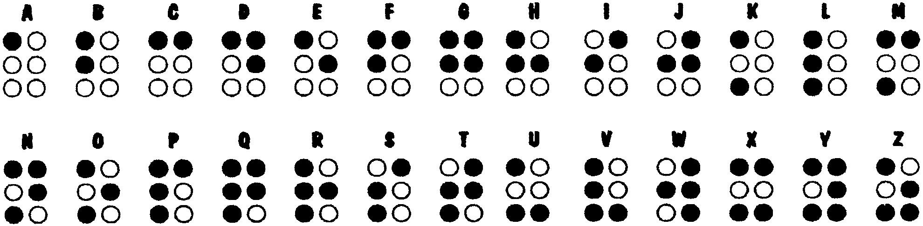

See Cub Scout Leader How-to Book for
“Send a Sun Message” p. 8-28

THE MORE WE COMMUNICATE
(Tune: The More We Get Together)

The more that we communicate,
Communicate, communicate,
The more that we communicate,
The happier we’ll be.

Then you know what I know,
And I’ll know what you know.
The more that we communicate,
The happier we’ll be.

By telephone or e-mail,
By signal code or snail mail,
The more that we communicate,
The happier we’ll be.

E-MAIL DELIVERY
(Tune: She’ll Be Coming Round the Mtn)

I'm sitting down in front of my computer
Turn it on
I'm sitting down in front of my computer
Turn it on
I'm sitting down by my computer
I’m sitting down by my computer
I’m sitting down in front of my computer
Turn it on

I'm sending you an e-mail on your line
Type, type
I'm sending you an e-mail on your line
Type, type
I'm sending you an e-mail
I’m sending you an e-mail
I’m sending you an e-mail on your line
Type, type

Through the information highway it will come
Zip, zip

It's waiting in your mailbox just for you
Delivery

Load it up so you can read it
Loading up

Give a shout if you're a Cub Scout
Yip hurrah!

VOLUNTEER SONG
(Tune: I’ve Been Working on the Railroad)

I’ve been thinking of the parents
All the live long day.
I’ve been thinking of the parents
To help me find the way.
Helping out can be so easy,
Come on and do your best.
Volunteering is so easy,
All you say is yes.
Volunteer, let’s go,
Come on, don’t say no.
Helping out just like the rest (the rest)
Volunteer let’s go,
Come on, don’t say no.
Your help makes this pack the best
(shout - THE BEST)

A SMILE IS QUITE A FUNNY THING
(Tune: Auld Lang Syne)

A smile is quite a funny thing,
It wrinkles up your face,
And when it’s gone you never find
Its secret hiding place.

But far more wonderful it is
To see what smiles can do,
You smile at one, he smiles at you,
And soon one smile makes two.

He smiles at someone, since you smile,
And then that one smiles back,
And that one smiles until, in truth,
You fail in keeping track.

And since a smile can do great good
By cheering hearts of care,
Let’s smile and not forget the fact
That smiles go everywhere.

MEMO HOLDERS

CRAFT STICK
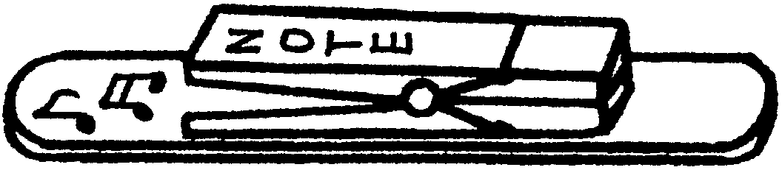
Materials: One large craft stick (tongue depressor); 1 spring-type clothes pin; Markers; Glue; Strip magnet.

Glue a clothespin near the end of the craft stick. Decorate with markers. Attach magnet.

PAINT STICK
Materials: One paint stick (for quart or gallon can, about 14” long); Several spring-type clothes pins, Paint; Permanent markers; Glue; Strip magnet.

Paint the paint stick. Use any wood paint or acrylic paint.
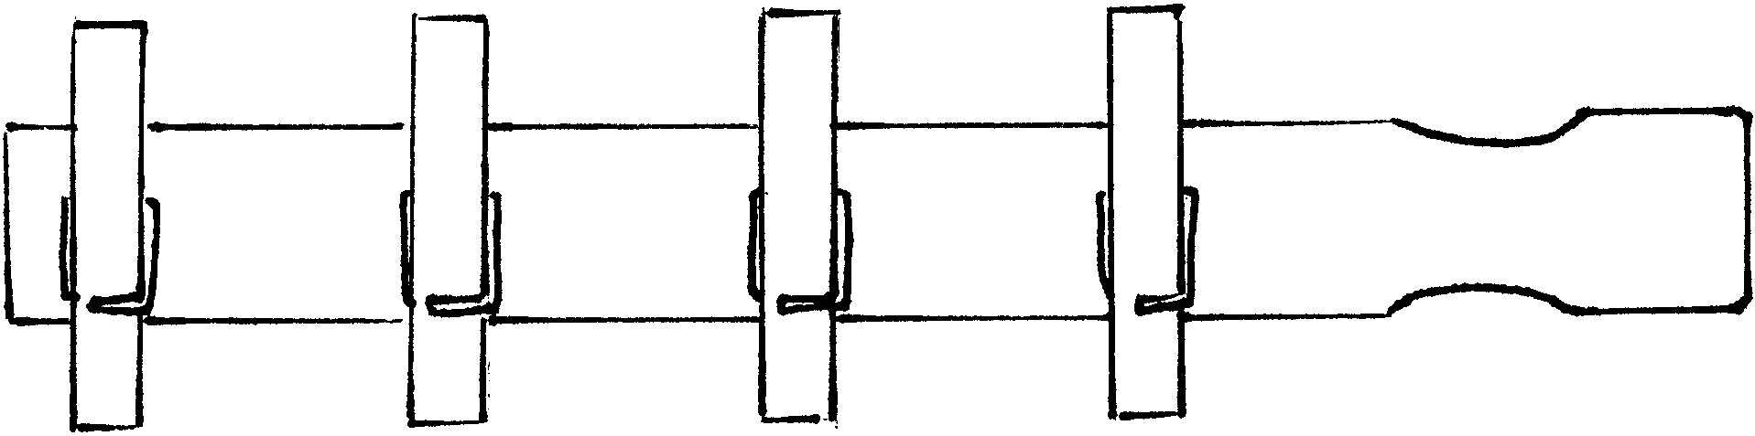
Attach clothespins. If desired, paint or decorate the clothespins before you glue them on the paint stick.
Decorate with markers
Attach magnet strips on the back of the paint stick.

LETTER OPENER

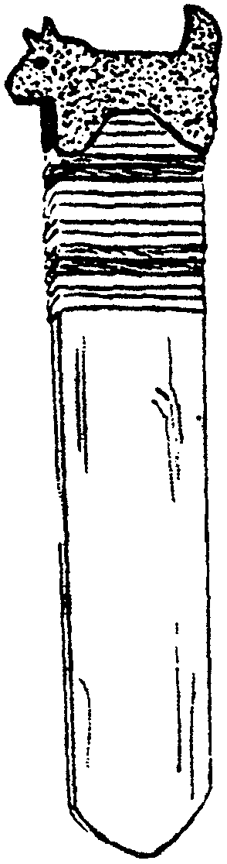
Materials: One craft stick (tongue depressor); Sandpaper; Yarn; Raffia; Twine; Plastic lacing; Small piece of cardboard; Permanent marker; Shellac (optional).


- Sand one end to a point--not too sharp!
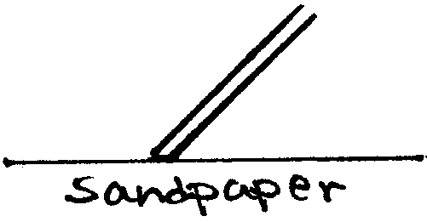
- Sand both edges until they are angled and smooth enough for opening letters. Sand as illustrated. (It’s easier if you move the craft stick over
sandpaper than the other way.)
- Wrap the handle end with yarn, raffia, twine, plastic
lacing, or other material. Wrap about an inch and
fasten the end. Put a dab of glue on each end to
prevent unraveling.
- Fold the cardboard, draw a small, simple design. Cut both layers. Glue them over the top of the handle, one on each side of the stick.
- Draw design on the stick with markers.
- Finish with a coat of shellac (adult assistance necessary).

RUSTIC LETTER HOLDER
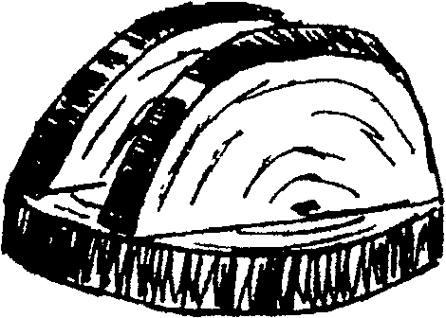
Material: Two good sized log slices about 1” thick; Felt piece; Saw; Glue.

- Sand the surface of wood pieces well.
- Use one for the base. Glue a piece of felt to the bottom.
- Saw the other piece in half and glue the straight edges of these halves across the base, leaving space between for letters.

PAPER CLIP PALS AND PUSHPIN PALS

Materials:
- Large paper clips (2”) or Pushpins (the larger the better, but regular ones work fine)
- Thin wood shapes (Woodsies, available at craft stores) or Craft foam shapes. Wood shapes work better if you are using regular size pushpins. On the other hand, craft foam is easier to cut with scissors. You may want to combine them too.
- Permanent markers (Sharpies), regular tipped and fine-tipped.
- Wiggle eyes (optional).
- Glue: Tacky glue or white glue AND Glue gun with low temp glue sticks
- Toothpicks.

- Arrange pieces to your liking. (Children have great imaginations. Provide them with various shapes and let them go to work.) Keep your design simple. In the examples below, to make the bill of the cap, glue a small piece of foam or draw with marker.
- If you are using wood shapes, color them with permanent markers--less messy and faster to dry then regular paint. Optionally you can color the assembled pieces later.
- Glue pieces together. Use tacky glue and toothpicks rather than glue gun.
- Add details with markers.
- Using a glue gun, attach your creation on a pushpin or paper clip.
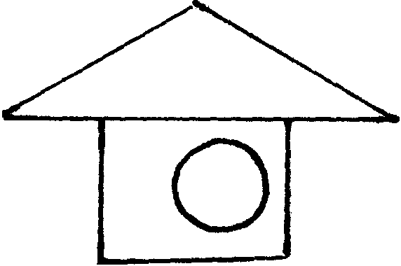
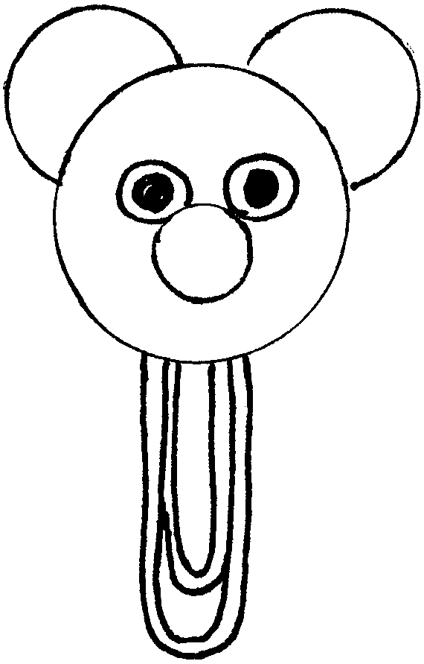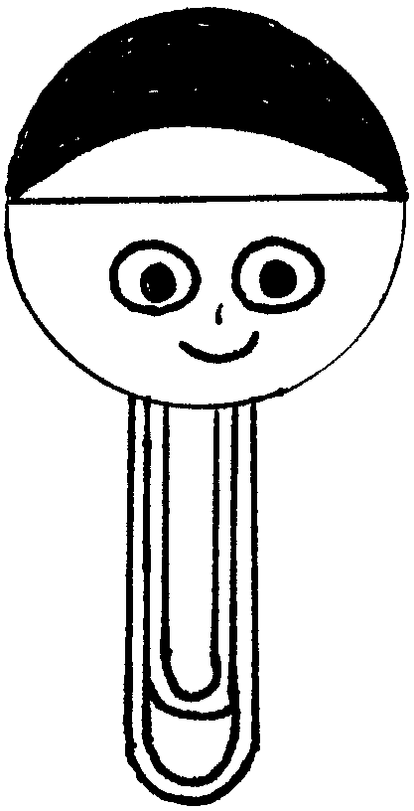

SECRET WRITING WITH INVISIBLE INK

This group of invisible inks does not need any other chemical, liquid, or gas, as a developer. Merely heating the message will cause the writing to appear.

Vinegar: Use directly. Makes an excellent ink.
Milk: Use directly. Avoid cream, as fat stains may result.
Sugar: Use a diluted solution. One teaspoon to a glass of water is sufficient.
Honey: A teaspoon of honey in a glass of water. Results are similar to sugar.
Soda pop: These drinks contain sugar and work like sugar solutions.
If the color shows when writing, dilute with water.
Lemon, Orange, Grapefruit Juices:
The juices of these three citrus fruits all work well.
Onion Juice: This gives excellent results and isn’t as bad to use as you might think.
Apple Juice: This worked also, though not as well as citrus juices.

CAUTION: Developing with heat sensitive inks requires caution since the paper will brown or char, and might burst into flame. It is suggested that you use an iron. It you are using an electric light bulb, use a 100-watt bulb. Either iron or light bulb, adult supervision is necessary.

COMPUTER MONITOR PICTURE FRAME

Materials: Craft foam; Clear plastic (sheet protector or report cover); Tacky glue; Strip magnet.

- Cut craft foam using the pattern below. Cut one ‘background,’ one ‘keyboard,’ one ‘frame,’ and one ‘side’ in different colors.
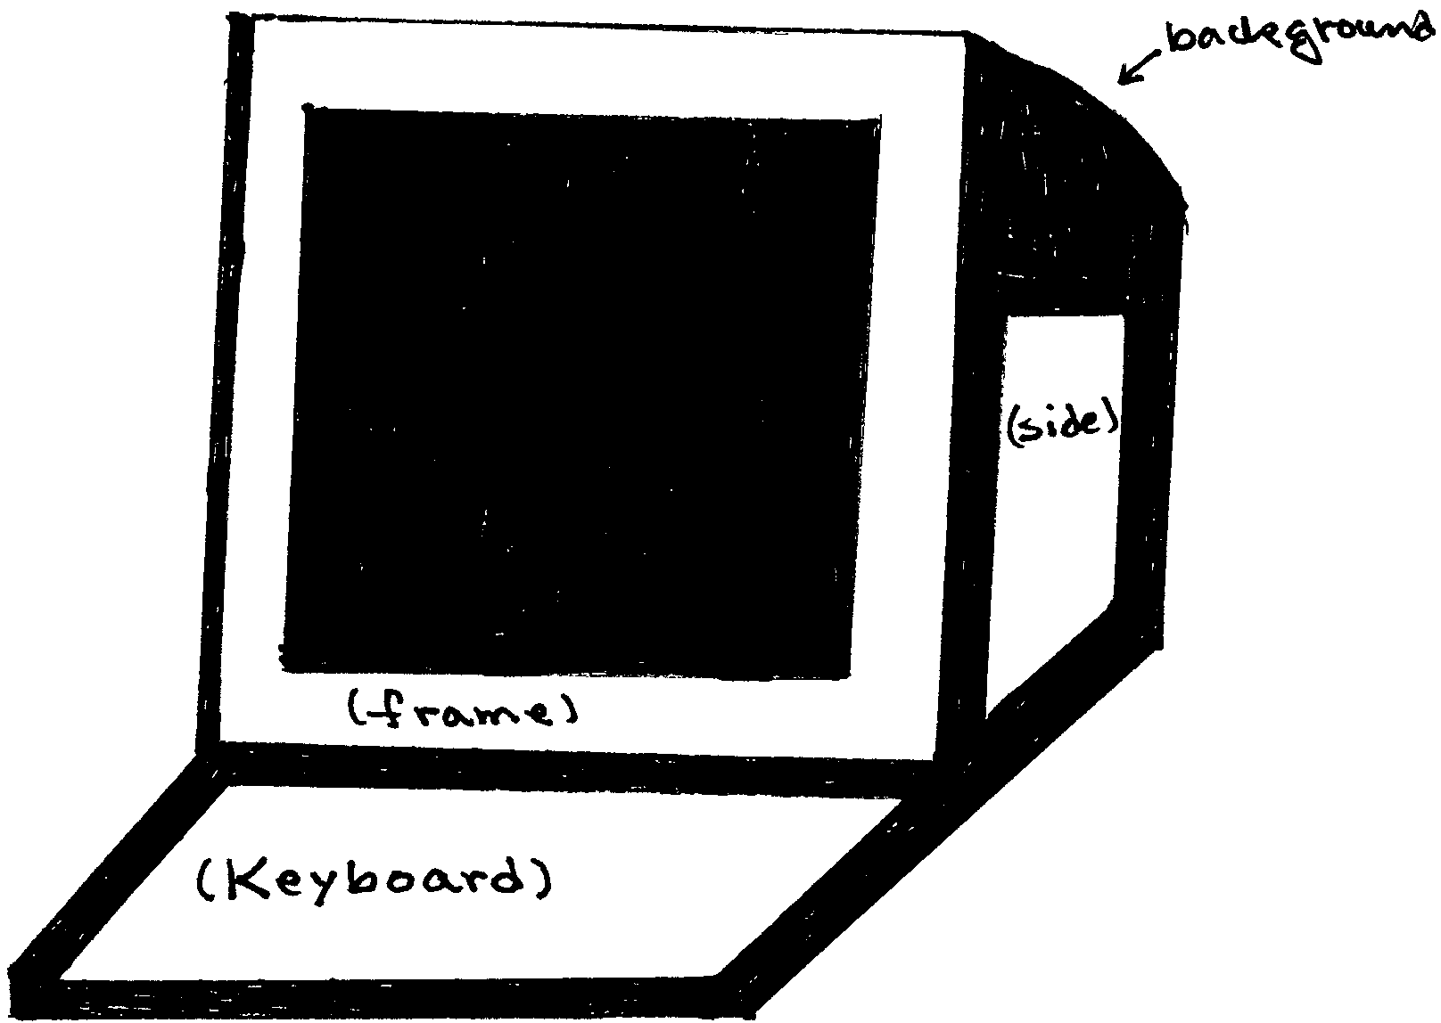
- Cut the clear plastic to fit the frame. Glue to the frame.
- Cut the photo to fit the
frame.
- If you want an option of
changing photos, glue the
frame to the backing only
on the bottom and sides,
taking care to apply glue
only on the outer edges
of the sides. Slip the
photo into the frame. OR
- Glue the photo to the
inside of the frame.
Glue the frame to the
backing.

CD GAME SPINNER
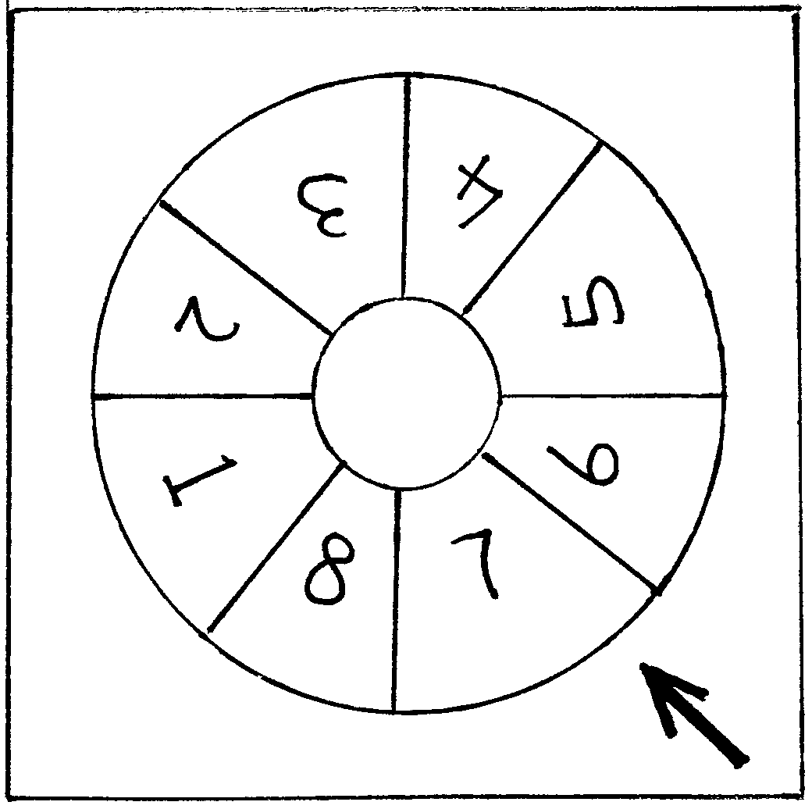
Many of us receive free CDs in the mail. Here’s one way to recycle them. Use this spinner in place of a die in any game.

Material: One CD; One CD holder or jewel case; Permanent markers; Stickers.

The spinner is the mirror side of a CD.
Mark the CD with permanent markers. Decorate it with stickers.
Draw an arrow on the CD case.
To spin: If you are using a CD holder that came in the mail, put the CD back in the holder, press the center where CD is locked and spin the CD at the same time. If you are using a jewel case, place the CD in the case but do not lock it in, and spin gently.
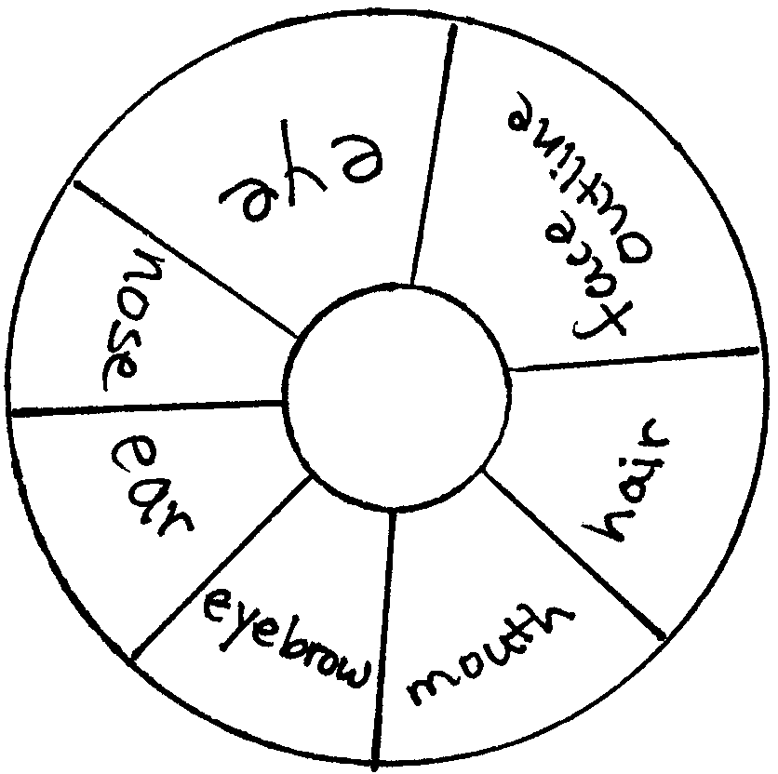
Suggestion for a game using the spinner:
Section the CD and in each section draw a part of a face--mouth, nose, eye, ear, eyebrow, and maybe sections for face outline and hair.
To play: First player spins the spinner and draws on a sheet of paper the part of the face indicated by the arrow on the spinner. Next player spins and add his feature. Third player does the same. If the spinner stops at the feature already drawn, the player has to pass his turn. See what kind of face the den can create.

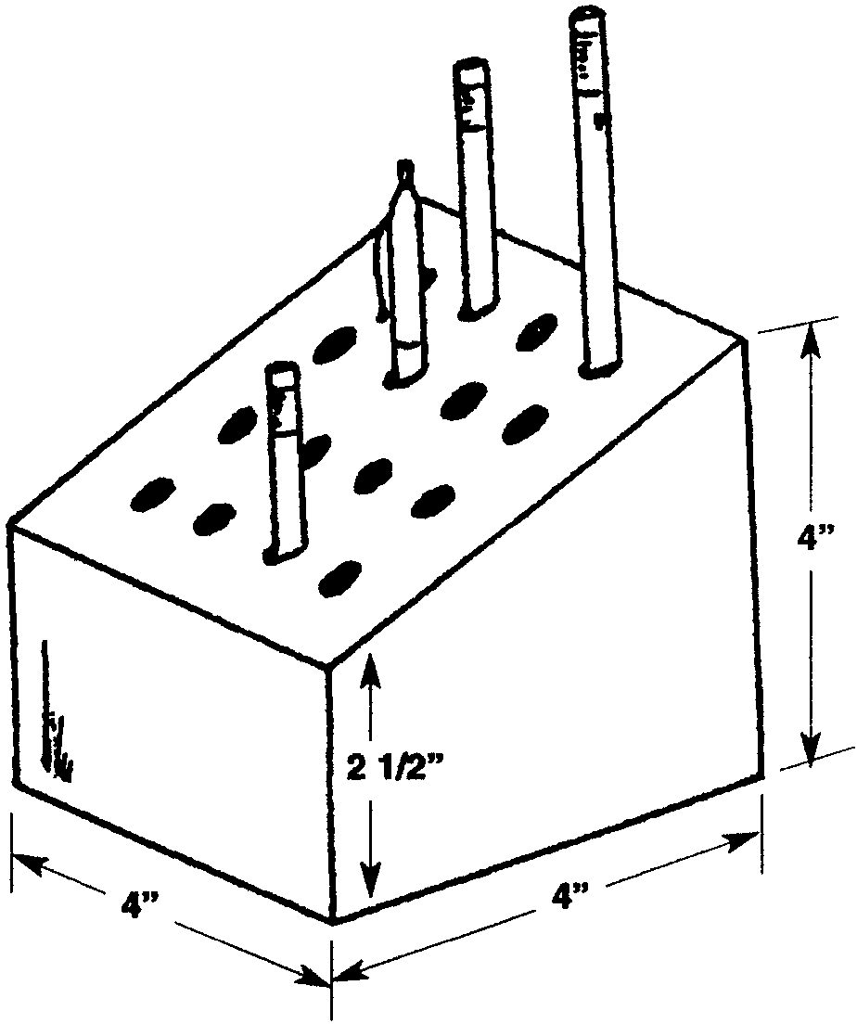

WOODEN PENCIL HOLDER

Materials: 4” square block of wood; 4” x 4” piece of felt; Glue; Paint or stain; Drill; Saw
Note: Above dimension is just a suggestion. Adjust this project to the material available to you.

- Cut the wood as shown in the drawing.
- Drill 16 holes equally spaced apart.
- Sand the surface smooth.
- Paint or stain all surfaces except the bottom.
- Glue a piece of felt to the bottom.

NOTE PAD
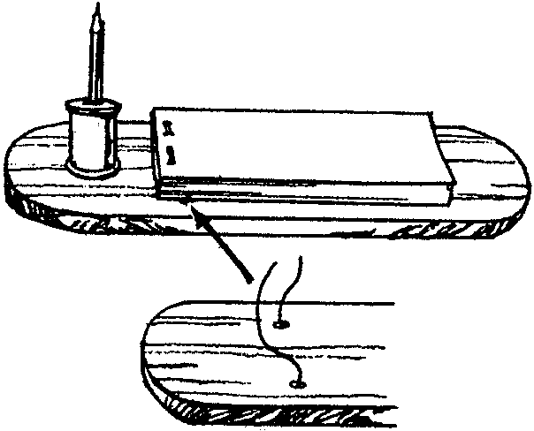
Material: Scrap wood (1/4” or so thick); Spool (or drill a hole on a similar size wood piece); Paint; Scrap felt piece; Wire or string; Paper (or ready-made note pad).

- Cut base from scrap wood.
- Sandpaper smooth.
- Drill two small holes through base for wire or string to hold note pad.
- Thread the wire or string through the holes. Tie on the back, making sure it is tight.
- Paint the base and spool as desired.
- Glue felt to underside of base.
- Glue on the spool.
- Cut paper and staple together and slip bottom sheet under wire.

WORD GAME

Materials: 3 1” wood blocks; 12” elastic cord; 2 pony beads; Black permanent marker; Drill with 3/8” bit.

Drill a 3/8” hole in center of each block. With marker, write the following letters on the remaining 4 sides of each block as follows:
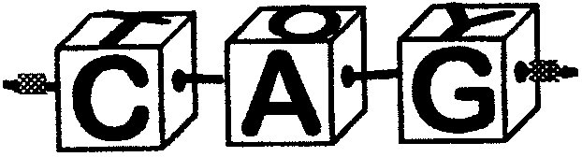
BLOCK #1: C B P T
BLOCK #2: A I E O
BLOCK #3: G T P Y

Tie elastic cord onto one pony bead. Thread through blocks in order above. Pull snug and tie other pony bead to end to secure. See how many words you can make.

CLIP BOARD NECKERCHIEF SLIDE
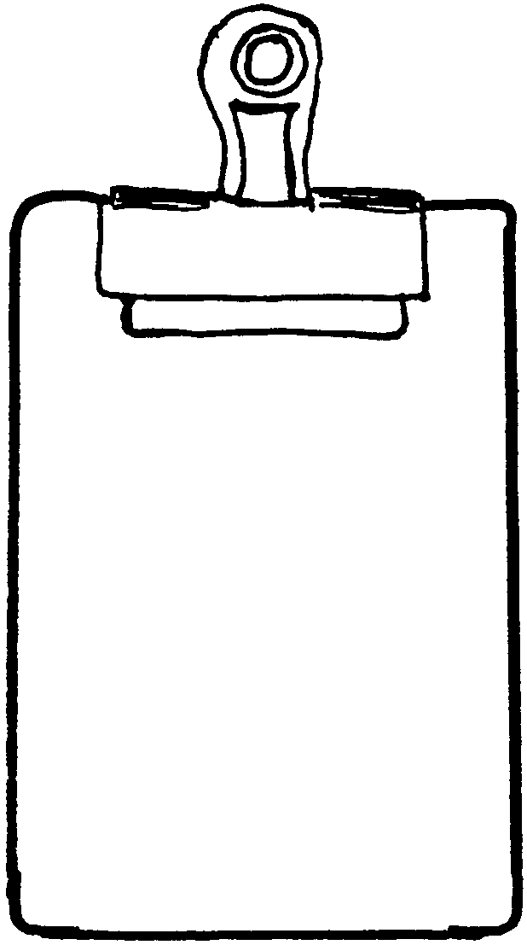
This little clip board and a few sheets of paper can come in mighty handy!

Materials: Approx. 2” x 3” piece of wood or masonite; Varnish or acrylic paint; 1/2” PVC pipe; Large paper clip (as shown) or black binder clip; Paper or small pad of Post-it.

- Sand and round the corners of the wood piece.
- Varnish or paint it.
- Glue a section of PVC pipe on the back.
- Attach a few sheets of note paper with a paper clip.

EDIBLE PINEWOOD DERBY CARS

Hoagie bun (one for each car)
Cucumber
Carrots
Pretzels
Pitted ripe block olives
Pimento-stuffed green olives
Cherry tomatoes
Assorted vegetables such as broccoli, zucchini, red, green and yellow sweet peppers
Vegetable dip (any flavor) 1/4 cup per car

Use a fork to scoop out the center of the top of the bun, leaving about two inches on the sides and one inch at the ends.
Cut four 1/4” thick slices of cucumber for the wheels. Cut two thin carrot sticks, each about 4” long for the axles. (Save remaining carrots and cucumbers for dipping.)
About 1 to 2 inches from each end of the bun, push a drinking straw through the bun where the wheels will go to make holes for the axles. Next poke the straw through the center of the cucumber slices. Throw away the straw.
Slide the carrot sticks through the bun for axles. Attach the cucumber slices to the axles for wheels.
Cut black olives into thick round slices. Push a whole green olive carefully onto the end of a toothpick, pimento side facing out. Push a slice of black olive onto the toothpick behind the green olive. Push the end of each toothpick into the front of the bun for headlights. Make two for each car.
Fill the bun with your favorite vegetable dip. Use a pretzel for a windshield or steering wheel. Add two cherry tomatoes for driver and passenger.

