American ABC’s

July 2001

CONTENTS

THEME RELATED 1
DEN AND PACK ACTIVITIES 1
USA MAP 1
SOUVENIR DISPLAY 1
PACK PICNIC 1
PARTICIPATION AWARDS 1
FLAG ETIQUETTE 1
PREOPENING 2
CUB SCOUT ABC’S 2
DO YOU KNOW YOUR STATES? 3
STATE FLAGS 3
CEREMONIES 4
AMERICAN ABC’S OPENING 4
ABC OPENING 4
AMERICA OPENING 5
AMERICA IS A BEAUTIFUL WORD 5
A PICTURE OF OUR COUNTRY OPENING 6
ABC CLOSING 6
“COMMON THINGS” CLOSING 7
“ECHO”--CUBMASTER’S MINUTE 7
ABC ADVANCEMENT 7
HANDS ACROSS AMERICA
ADVANCEMENT 8
HAPPY BIRTHDAY AMERICA
ADVANCEMENT 9
FUN WAYS TO SAY THANK YOU 9
AUDIENCE PARTICIPATION 10
SCOUTING ACROSS AMERICA 10
A FIFTY STATE TOUR 11
SKITS 12
AMERICA 12
THE HELPFUL SCOUTS 13
ABC GUM 13
GAMES 14
ROMP ACROSS AMERICA OBSTACLE
COURSE 14
UNCLE SAM 14
UNCLE SAM HAT TOSS 14
FIREWORKS RACE 15
AMERICAN ABC 15
WHERE HAVE YOU BEEN? 15
FIFTY STATES 15
BUILD A LOG CABIN 15
WHERE IS IT? (MAP-READING RACE) 16
WORD LIGHTNING 16
AMERICAN HERITAGE 16
SONGS 17
AN ALPHABET OF NAMES 17
YOU ARE MY HOMELAND 17
THE USA FOREVER 17
VACATION TO NATIONAL SITES 17
TRIP ACROSS THE USA 18
HURRAH FOR THE FLAG 18
CRAFTS 19
FLAG MOBILE 19
MAP FRAME 19
PARADE SPIRIT STICK 20
UNCLE SAM PONY BEAD PATTERN 20
UNCLE SAM POP-UP PUPPET 21
LIFESAVER FIRECRACKER 21
PAPER FIRE CRACKERS 21
TRAVEL ACTIVITY KIT 22
USE OF OLD POSTAGE STAMPS 22
UNCLE SAM NECKERCHIEF SLIDE 23
FIRECRACKER NECKERCHIEF SLIDE 23
SHRINK ART USA SLIDE 24
CUBS IN THE KITCHEN 25
ABC PRETZEL 25
FIRECRACKER FIZZLES 25
AMERICAN CHOCOLATE COOKIES 26
CHOCOLATE FROSTING 26
FROZEN POPS 26

DEN AND PACK ACTIVITIES

USA MAP
Post a map of the USA on the wall. Have red, white, and blue round stickers ready. As people arrive at the pack meeting, give each person a sticker. Ask them to write their name on the sticker and put it on the place they would most like to visit (a place they haven’t been yet). During the meeting, between programs (between ceremony and skit, for example), call out a few names and ask them why they want to visit the places they picked. Repeat throughout the meeting. (Have one or two adults knowledgeable in US geography stay with the map to assist people in finding their places.)

SOUVENIR DISPLAY
Have a souvenir show. A lot of people save souvenirs from the places they have visited. They might be T-shirts, caps, mugs, maps, ticket stubs, brochures, post cards, etc. They might want to include a few photos. The places may be as far as the East Coast or as close as San Francisco. And don’t forget San Jose. Families can also make collages of places they might go someday.

PACK PICNIC
Summer is a great time to have a picnic. Have a pot-luck picnic. Each family adopts a city or state and brings food from that place. A potato dish for Idaho, fried chicken for a southern state, cheese for Wisconsin (or California), pineapple for Hawaii, etc. Play some games (“Romp Across America” in the Games section, for example). For suggestions on Pack Picnic and related activities, see Cub Scout Leader How-To Book, pp. 9-4 to 9-12.

PARTICIPATION AWARDS (For details, see the PARTICIPATION AWARDS section)
Cub Scout Academics: Citizenship
Cub Scout Academics: Geography

FLAG ETIQUETTE

Have you ever been confused about flag etiquette at a pack or den meeting? Flag etiquette is included in Cub Scout Ceremonies for Dens and Pack (Chapter 4). If you want to have a good book on the flag history and etiquette, Your Flag is a comprehensive book that is easy to use. It is published by the BSA and the new revised version will be available at the Scout Shop some time in 2001.

CHEERS

ABC CHEER: Divide the audience into three groups. They each say, “America,” “Beautiful,” and “Country.” Point to different groups. Vary speed.

USA-BSA CHEER: Two groups. One group yells, “USA!” The other group yells, “BSA!” Repeat three times. Then both groups yell together, “That’s us!”

CUB SCOUT ABC’S

Do you know your ABC’S?

A Name of an important Cub Scout leader
B The first rank for all boys who join Cub Scouting
C A leader of the pack
D A Boy Scout who helps in a den
E Highest rank in Boy Scouts
F Something Cub Scouts learn to respect
G This means cheerfulness and kindness, part of the Law of the Pack
H A journey on foot that Cub Scouts like to do
I You must wear correct uniform to pass this
J The book that tells about Mowgli and Baloo
K The 30-foot python who saved Mowgli
L Something we do when we’re happy
M “Do Your Best”
N Part of the Cub Scout uniform
O An important part of Scouting--hiking, field trips, etc.
P Cub Scouts race home-made cars
Q What everyone is when the Cub Scout sign is given
R A Webelos activity badge
S A kind of arrow point
T The youngest group in the pack
U What we wear to show we’re in Cub Scouting
V What all adult leaders are
W What a fourth grade Cub Scout is called
X You can make this instrument from metal tubes
Y Another name for a den cheer
Z A place Cub Scouts like to go for a field trip

Answers:
Akela; Bobcat; Cubmaster; Den Chief; Eagle; Flag or Family; Goodwill; Hike; Inspection; Jungle Book; Kaa; Laugh; Motto; Neckerchief; Outing; Pinewood Derby; Quiet; Readyman; Silver; Tiger Cubs; Uniform; Volunteers; Webelos Scout; Xylophone; Yell; Zoo

APPLAUSES

GEORGE WASHINGTON APPLAUSE: “That was great! I cannot tell a lie!”

ABE LINCOLN APPLAUSE: “That was great--honestly!”

DO YOU KNOW YOUR STATES?

- Which state has a ton?
- Which state starts with a pen?
- Which state has an Indian?
- Which state has a tuck in the middle?
- Which state has a ham?
- Which state is cut on the end?
- Which state has a tan?
- Which state has color?
- Which state has ore in it?
- Which state is an island?
- Half of which state is land?
- Which state starts with ten?
- Which state greets you with “Hi”?
- The first thing you see in two states is a “Miss”.
- Which state has a lab?
- Which two states are asking questions?
17. Name four new states.

Answers:
1-Washington; 2-Pennsylvania; 3-Indiana; 4-Kentucky; 5-New Hampshire; 6-Connecticut; 7-Montana; 8-Colorado; 9-Oregon;
10-Rhode Island; 11-Maryland; 12-Tennessee; 13-Ohio; 14-Mississippi & Missouri; 15-Alabama; 16-Alaska & Nebraska;
17-New Hampshire, New Jersey, New Mexico & New York

STATE FLAGS

What flag has 13 stripes and 50 stars? The answer, of course, is “Old Glory.” Now do you know what is on the flags of the states? If you don’t know some of these, before you look at the answers, see Achievement 2 of Wolf Cub Scout Book. All state flags are shown there.

There’s a... on the flag of...
- Anchor a. Alaska
- Bear b. California
- Big Dipper c. Hawaii
- Buffalo (bison) d. Indiana
- (The flag is) non-rectangular shape e. Ohio
- Osage shield and peace pipe f. Oklahoma
- Palmetto tree g. Rhode Island
- President’s likeness h. South Carolina
- Torch i. Washington
- Union Jack j. Wyoming

Answers: 1-g; 2-b; 3-a; 4-j; 5-e; 6-f; 7-h; 8-i; 9-d; 10-c

AMERICAN ABC’S OPENING

Prop: Tape or CD of “America, the Beautiful”

Play the music for a while and turn it down so the audience can hear the boys.
As one Cub Scout says the alphabet one by one, other Cub Scouts read off a name from the list.

A Anchorage, Alaska
B Boston, Massachusetts
C Cherokee, Kansas
D Dover, Delaware
E Everglades, Florida
F Freedom, California
G Gallup, New Mexico
H Hartford, Connecticut
I Independence, Missouri
J Jefferson, Iowa
K Knoxville, Tennessee
L Lincoln, Nebraska
M Montgomery, Alabama
N Neptune, New Jersey
O Oshkosh, Wisconsin
P Providence, Rhode Island
Q Quartzite, Arizona
R Revere, Minnesota
S Sleepyhollow, Wyoming
T Tornado, West Virginia
U Ulysses, Pennsylvania
V Vermillion, South Dakota
W Washington, DC
X Xenia, Ohio
Y Yakima, Washington
Z Zapata, Texas

From A to Z, Scouts do things all over our great land.

ABC OPENING

C.S.#1: (Holding a card with a large “A”) America
C.S.#2: (Holding a card with a large “B”) Beautiful
C.S.#3: (Holding a card with a large “C”) Country
C.S.#4: Salute to the flag of America, our Beautiful Country.
Please join me in repeating the Pledge of Allegiance.

(Optionally sing “America, the Beautiful,” “America,” or “God Bless America”)

AMERICA OPENING

Props: Prepare signs with pictures of--a grain field or a letter A or both; mountain and/or letter M; newspaper and/or letter E; plains and/or letter R; picture of George Washington, Abe Lincoln, JFK and/or letter I; scene of people in any city and/or letter C; pretty picture of American and/or letter A. On back, put the words the boys need to read.

A - is for Amber waves of grain.
M - is for Mountains majestic.
E - is for Everyone’s freedom.
R - is for Rich, fruited plains.
I - is for “I love my country.”
C - is for Country of the free.
A - is for America the Beautiful. Please join me in singing “America, the Beautiful.”
After the song, please stand to pledge to the symbol of this great country.

AMERICA IS A BEAUTIFUL WORD

Each boy holds a card with a letter of “America” on it (use lower case for “merica”). Flip cards over and show a picture with the same letter illustrating the description below.

C.S.#1: What do you see when you look at the word AMERICA? What mental picture do the seven letters create in your mind?

C.S.#2: The “Capital A” suggests our magnificent snow-covered mountain peaks, and the teepees of the original Americans.

C.S.#3: The “m” symbolizes the broad shoulders of our pioneers, shoulders-to-the-wheel pushing our frontiers westward; broad shoulders swinging axes, building a nation.

C.S.#4: The “e” might be the lariats of the cowboys riding the plains, lariats of Jesse Chisholm or Charles Goodnight.

C.S.#5: The “r” is a man with outstretched arms in friendship and cooperation toward all that love freedom, justice, and peace.

C.S.#6: The “i” represents the individual American with his right to life, liberty and the pursuit of happiness.

C.S.#7: The “c” is a bent bow from which an arrow has just sped toward the heart of mankind’s greatest ideals.

C.S.#8: The final “a” is a man on his knees in prayer, symbolizing a nation that recognizes its Creator and gives thanks for His blessings.

All: Yes, America is a beautiful word.

A PICTURE OF OUR COUNTRY OPENING

Arrangement: Flag is positioned behind a closed curtain. Patriotic music may be played as the narrator speaks these lines.

Behind this curtain is a canvas...a canvas begun long ago, but not yet finished.

It is a picture of our past, and there is something of John Paul Jones, Davy Crocket, Washington, and Jefferson in it. Lee and Grant are there too, and Abe Lincoln.

There are those who gave their lives at Gettysburg, Flanders, Salerno, Korea and Vietnam, and when you look at the picture, you will see these men as clearly as if they marched across the stage.

It is a picture of our land. We see the rich blessings of oil and wheat, timber and granite. It is a picture of great cities and throbbing industries, busy seaports and millions of farms.

It is a picture of our people...280 million of them. They are a part of the picture we are helping to paint. To this picture, we would add the portraits of boys, growing into men, who will live useful lives and who will add to that history of noble actions which is our American heritage.

Cub Scouts and families, the picture of our country! (Curtain opens to reveal the US flag)
Please recite with me the Pledge of Allegiance.

ABC CLOSING

Props: Letters A, B and C on large cards.

C.S.#1: A is for Akela, our leader.
C.S.#2: B is for “Be Prepared,” the lesson for all Scouts.
C.S.#3: C is for Cub Scouts, where we have fun.
C.S.#4: Please join us in repeating the Law of the Pack.
(Raises hand in Cub Scout sign)

CHEERS

FIREWORKS CHEER: “pssss...SSSSS (grows louder) BOOM!”

STATUE OF LIBERTY CHEER: Stand and raise imaginary torch and say, “Welcome to America!”

“COMMON THINGS” CLOSING

The things I prize of great worth
Are just the common things of earth;
The rain, the sun, the grass, the trees,
The flowers, the birds, the glorious breeze.
Clouds that pass, the stars that shine,
Mountains, valleys, all are mine.
Rivers broad, and open sea
Are riches none can take from me.
And God is here on every hand,
Upon the sea, upon the land.
So day by day, my thanks I give
That with these common things I live.

“ECHO”--CUBMASTER’S MINUTE

Recently I heard a story of a family on vacation. They were traveling by car on a grand tour across the country. At one point they stopped at a scenic overlook, which stood at the edge of a steep-walled canyon. Some people at the overlook were having fun, yelling into the canyon and listening for the many echoes coming back.

The youngest member of the family had never encountered an echo like that before, where more than one reply came back. He kept shouting all different kinds of words to the canyon and laughing at the response. Finally, he turned to his father and exclaimed, “Whatever I put in, even more comes out!”

Scouting is like that. You will get back out of it what you put in. Sometimes it will come back to you many times over. We are all on a wonderful adventure together in Scouting.

ABC ADVANCEMENT

Around the room, hang pictures of American landmarks. Place a corresponding letter next to the pictures. For example, for the letter “A” you could use a picture of Alaska or Arizona. For the letter “M” you could use a picture of Mount Rushmore. Tape the boys’ awards behind the picture that corresponds with their first initial. So, Willy’s awards would be taped behind the picture of the Washington Monument. Ask each boy (maybe with help from his parents) to identify the landmark that corresponds with their first initial, then carefully remove the picture to find their awards. The boys can take their picture home to remind them of this ceremony. Good sources for pictures are old calendars or old National Geographic magazines.

VARIATION: Hang photos or self-portraits of each of the boys with the pictures of the landmarks. Tape the awards behind the photo. Explain that these boys in the pack have reached landmarks in their Cub Scouting career--rank advancements, arrow points, activity badges, etc.

HANDS ACROSS AMERICA ADVANCEMENT

Props: Large map of the US mounted on cardboard. Cut out boy paper dolls and string across the map. Awards are mounted on the paper dolls. Each boy earning an award should be prepared with a picture of one of his favorite places in America. It can be a place he visited on vacation, where he used to live, where he would like to live or of where he now lives.

Cubmaster:
This month we have been learning about the beauty and variety in our nation. We have several boys who have earned awards as you can see by our interesting map.

(Name of boy), you have earned your Bobcat Rank this month. Would you please come forward and show us the picture of one of your favorite places? (Boy comes forward, shows picture and says where it is and why he likes it. Cubmaster then invites parents to come up while he takes the picture and posts it on the map. Present award to parents to give to boy. Continue with other awards in the same way.)

Now that we have added pictures of all these beautiful places, our map is much more than just a piece of paper on the wall. Now, it is special to each of us. There are beautiful things about every and any place we might live. It is up to us to find that beauty. But the most beautiful part of any place is the people who live there. We must also look for the beauty in others. If we can do that, wherever we live will be our favorite and the most beautiful place to be.

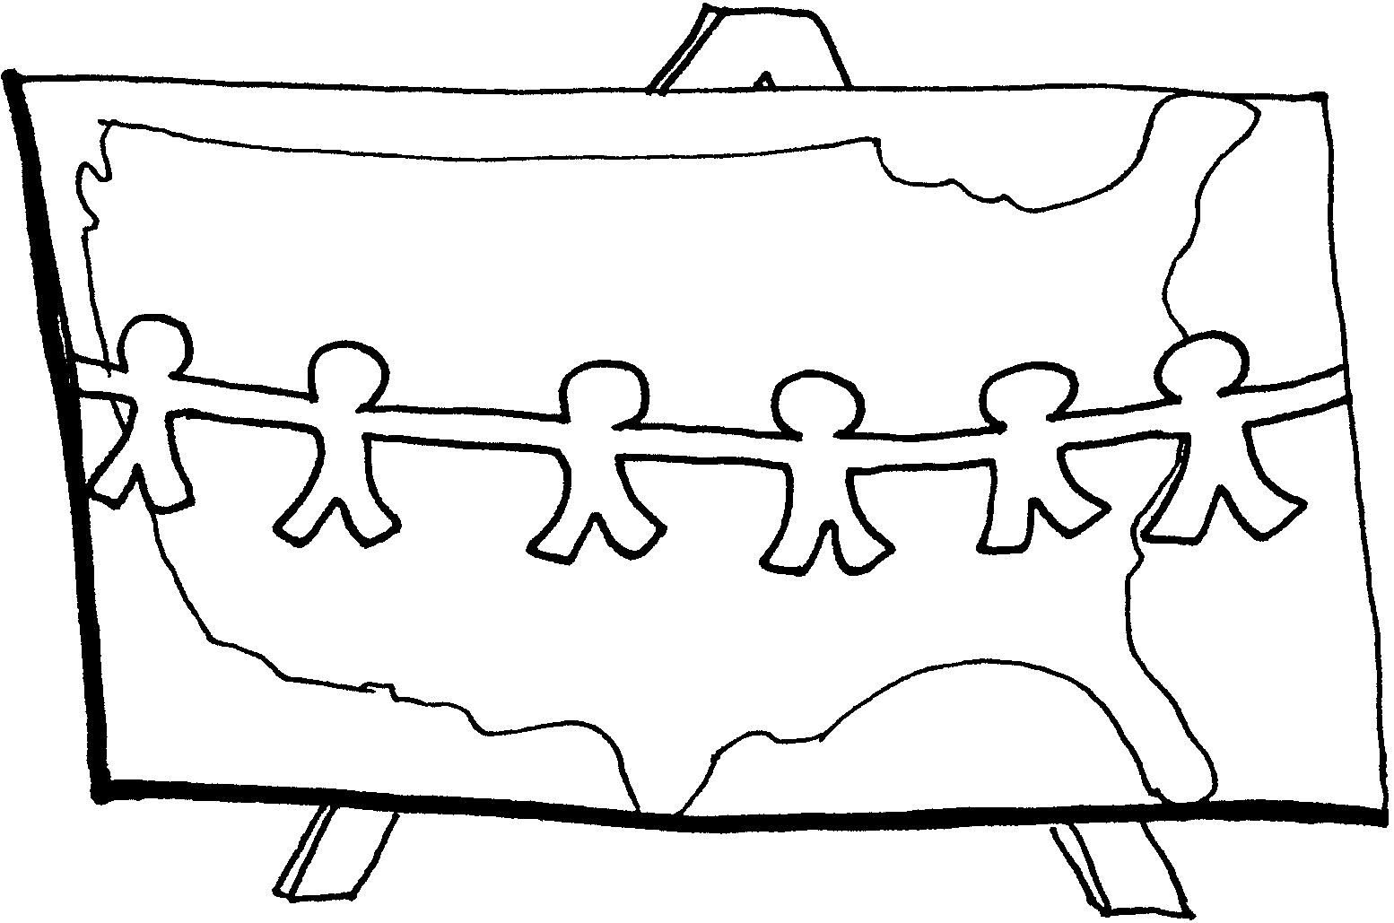

HAPPY BIRTHDAY AMERICA ADVANCEMENT
(Outdoor ceremony)

Props: Sidewalk chalk; Map of USA for reference; Shoe boxes or other containers to hold awards; List of questions about places in USA. (Have boys draw a large outline of USA using chalk for pre-opener; then, just before the ceremony, have the Cubmaster place boxes, containing awards, around the “country.”)

Cubmaster:
Happy Birthday America! How lucky we are to be able to celebrate our country’s greatness and enjoy the freedom this land gives us. Have you noticed that this land is a very big place and before we can present our Cub Scouts with their awards, we need to find where their awards are hiding...
“Where in America are our Cub Scout awards?” (Ask questions and let Cub Scouts retrieve boxes when they answer the questions correctly. Present awards when all the boxes are retrieved. You may want to put down a few empty boxes to keep it interesting.)

Sample questions:
- A lady stands tall in this state, holding up a light to the world. (New York)
- This state is made up of several islands, has active volcanoes and has lots of sunshine. (Hawaii)
- This city is at the “end” of the muddy Mississippi River and is famous for its Mardi gras celebration. (New Orleans)

FUN WAYS TO SAY THANK YOU

Firecracker: For someone who did a bang-up job.
Ice Cream Cone: For someone who can really lick any job.
“I scream without your help!”
Star: “You are the star of our pack.”
“You are one in a million.”
“You really shine at what you do for the pack!”
Top Hat: “We tip our hat to you!”

For Flag Ceremonies, see Cub Scout Ceremonies for Dens and Packs.

See Cub Scout Ceremonies for Dens and Packs for:
“A-M-E-R-I-C-A”
“America--The Song”

SCOUTING ACROSS AMERICA

CHICAGO: “The windy city” CUB SCOUT(S): “Do your best”
TEXAS: “Howdy, y’all” INDIANAPOLIS: “Vrroooommm!”
HAWAII: “Aloha” COLORADO: “Climb the Rockies!”
ALASKA: “Brrrr” CALIFORNIA: “The Golden State”

Boy Scouting was brought to American in 1909 by a CHICAGO businessman. CUB SCOUTS started in 1930, and the program quickly spread throughout the states.

You can picture the boys in TEXAS being helpful to their neighbors. Imagine HAWAIIAN CUB SCOUTS having a spectacular regatta or the CUB SCOUTS in INDIANAPOLIS having super speedy Pinewood derby cars.

In COLORADO, the hiking is fantastic, and in ALASKA, skiing belt loops abound. The blue & gold of CUB SCOUTS is seen in CALIFORNIA’S blue skies and historic gold strike.

All across our great nation, from CHICAGO to COLORADO, INDIANAPOLIS to ALASKA, and TEXAS to CALIFORNIA and HAWAII, CUB SCOUTS are all doing the same things: Learning new skills, doing good deeds, and having FUN!

Audience Participation suggestion:
Sing “The State Song” (Cub Scout Songbook) or “An Alphabet of Names” in the “Songs” section below.

See also “The Transcontinental Train” in SEPTEMBER section.

8

The word LISTEN contains the same letters as the word SILENT.

APPLAUSES

SKYROCKET APPLAUSE: Have everyone pretend to strike a match and pantomime lighting a rocket. Watch the rocket go up and say, “Ssssssss, BOOM, Ahhhhhhhh.” Flutter your fingers to represent falling debris. Then place your right hand over your eyes and peer out exclaiming, “Isn’t that lovely!”

AMERICA APPLAUSE: “A-M-E-R-I-C-A! Cub Scouts! Cub Scouts! U-S-A!”

A FIFTY STATE TOUR

Instruct audience members to stand as their home state is mentioned. They should stand up and yell, clap, holler, etc. To make it even more interesting, ask audience members to stand and shout when any state they have ever lived in is mentioned.

Let’s take a little tour of our fifty states, and see if we have right here,
Somebody from every single one, who will stand up and for their state cheer.
If you live in CALIFORNIA and from that state just happen to be,
People will look at you funny, for to be a native is a rarity!
If in the state of GEORGIA you were certainly born,
Then you can’t be from IOWA the state with all that corn.
The state of COLORADO is green beyond compare,
But people are just as proud to be from DELAWARE.
If you want some wheat, to KANSAS you should go,
While those from MISSOURI everything you must show.
TEXAS brags about the fact it is so big,
While MICHIGAN is proud when out the groundhog does dig.
WISCONSIN has its cows, and a lot of cheese,
While MASSACHUSETTS has a nice cool sea breeze.
People from TENNESSEE stand up and cheer with joy,
And let us hear it now if you’re from MINNESOTA or ILLINOIS.
FLORIDA, about its oranges really likes to boast.
While WASHINGTON gets lots of rain out on the western coast.
Way down in Dixie land ALABAMA and LOUISIANA be,
While ‘way across the ocean is our beautiful HAWAII.
Then there’s old NEW YORK with WASHINGTON DC close by,
And let’s not forget ARIZONA with its mountains high.
NEVADA and NEW MEXICO both lie in the west,
While some prefer OREGON and claim it as the best.
OHIO and INDIANA are neighboring states we know,
And further west you’ll find the state of IDAHO.
NORTH DAKOTA and SOUTH DAKOTA share a boundary line,
And OKLAHOMA and ARKANSAS are two states that do fine.
MAINE lies way up to the north with lots of ice and snow,
And if you want to see cowboys, to WYOMING you should go.
UTAH and MONTANA are two states in the west,
While CONNECTICUT and RHODE ISLAND are smaller than the rest.
MARYLAND and PENNSYLVANIA share together a boundary,
While VIRGINIA and WEST VIRGINIA are side by side, you see.
While NORTH CAROLINA and SOUTH CAROLINA and KENTUCKY, all three
Are states in the east, and to the south is MISSISSIPPI.
Then let’s not forget NEBRASKA in the middle of our land,
And ALASKA with the snow so grand.
VERMONT and NEW HAMPSHIRE are neighbors in the northeast,
And then we have tiny NEW JERSEY, last but certainly not least.
And if by chance you were born in a foreign land,
Then now is the time for you to all stand.
So, no matter where you were born, no matter which the state,
Still the place of your birth with each one will always rate!

AMERICA

Arrangement: 6 out of 7 Cub Scouts wear costumes depicting themes related to the appropriate state. All seven carrying a letter spelling out AMERICA.

RHODE ISLAND: Small in size, large in heart,
Freedom of worship gave us our start;
One of the original thirteen,
Home of Roger Williams and Nathaniel Greene;
Many Americans daily are fed,
By our state bird, the Rhode Island Red.

MISSISSIPPI: Look away, look away, Dixieland
Many brave men at Tupelo and Vicksburg took their stand:
Magnolias still bloom and mockingbirds still sing,
But the Natchez Trace with voices no longer ring.

COLORADO: First came the real mountain men, the trappers and traders,
Then gold seekers and railroaders;
Finally coal miners gave way to skiers and oil,
John Denver sought and Robert Redford seeks to save our soil.

IDAHO: The River of No Return halted Lewis & Clark temporarily,
Traders, farmers and shepherds followed their trail merrily;
Today, tourists gaze in awe at the wonders they saw,
And even eat our famous potatoes raw!

ARIZONA: Navajo, Hopi, Apache, were led by Cochise and Geronimo:
Our large Indian population continues to help us grow;
Copper, cotton, cattle, citrus and climate are the “Cs”
That have proven to be economic keys.

ALASKA: “North to Alaska” was the cry,
Gold fever was the reason why;
Seward’s Folly was no more,
But it was 1959 before America officially opened its door;
The Alcan highway was the first link,
The pipeline added strength.

(Boys look for the missing letter)
E: Isn’t this neat?
Without me there is no America.
I represent Everyone.
And that’s what makes America complete!
(Boys line up in proper order AM_RICA then E comes on last.)

THE HELPFUL SCOUTS

(Cub Scout #1 is on the floor looking for something. A group of Cub Scouts come in.)

Cub #2: (Talking to the group of Cubs he came in with) He must have lost something.
Cub #3: Cub Scouts are always helpful.
Cub #4: We should help him search.
(All the Cub Scouts get down on the floor and act as if they are looking for something that is lost.)
Cub #2: (Stops looking and turns to the group of Cub Scouts) What are we looking for?
Cub #3: I don’t know, do you know? (Looking at Cub #4)
Cub #4: I don’t know either. Let’s ask him. (Points to Cub #1)
Cub #2: (They all go over to Cub #1) We could help you a lot more if we knew what you have lost.
Cub #1: I haven’t lost anything. I am practicing finding things for when I grow up. I have found a rock, a pencil, a penny, a key, and lots of other things.
Cub #3: Why are you trying to find things for when you grow up?
Cub #1: Because when I grow up. I want to be a FOUND-ING father, also.

ABC GUM

“The Other” can be a boy or a grown up.

Gum Chewer: Would you like a piece of ABC gum?

The Other: Sure! (Holds out his/her hand, palm up)

Gum Chewer: (Reaches into his mouth, takes out the gum, and prepares to hand it to the other) Here you go—it’s Already Been Chewed!

The Other: (Quickly brings hand down) “Yuck—no, thanks!

CHEER

MOUNT RUSHMORE CHEER: “Hurry, Hurry, Hurry!”

RUN-ON

Cub 1: Do you know which state is the happiest?
Cub 2: I don’t know.
Cub 1: Maryland. (Merry land)

ROMP ACROSS AMERICA OBSTACLE COURSE

Set up an obstacle course containing these activities:

Fly to the East Coast Each runner walks on flight path (line or rope on ground) with arms out like airplane wings.
Statue of Liberty Each runner shapes a “torch” with a small amount of foil, steps on a rock (or wooden box or stepping stool), and poses like the statue.
Go West Young Man Each runner is given a pretend horse and runs a course that is marked by orange cones.
Crossing the Mississippi A wading pool with several rocks or stepping stones strategically placed inside. Add just enough water so the tops of the rocks are above water. The runner crosses the pool by stepping on the rocks.
Colorado Mines Large cardboard boxes set up in a maze for the runner to crawl through.
Logging in Washington A wading pool with 4”x4” boards inside symbolizing logs. The runner walks on the logs.
Gold Rush in California A wading pool filled with sand and water; there just might be a chance of finding gold! (Paint pebbles gold and put them in the sand.) The runner finds one gold nugget and runs to the goal.

UNCLE SAM

You will need 4-5 different color flags (pieces of cloth). Boys wear the flags tucked into their belts at their back. One player is “Uncle Sam.” He stands in the middle. Other players stand at one end of the playing area. The players chant, “Uncle Sam, Uncle Sam, may we cross over to your great land?” Uncle Sam answers, “Yes, if your are wearing (blue).” Players wearing that color flag get a free pass to the other side. Then on the signal “Go” from Uncle Sam, the rest of the players try to run to the other side, without getting their flags pulled by Uncle Sam. Flagless players become Uncle Sam’s helpers. Begin again, but this time, Uncle Sam calls out another color. Keep going until all the players are caught but one. This player becomes the new “Uncle Sam.”

UNCLE SAM HAT TOSS

Divide the boys into teams. You will need a hat for each team. It is the hat of Uncle Sam. Each boy flips the hat up in the air and tries to catch it on his head. Each player gets five chances, and then passes the hat to next person in line. Choose someone to keep score for the game. A player earns 10 points for having the hat land on his head, and two points if it hits his head but bounces off. At the end of the game add up the number of points for each team.

FIREWORKS RACE

For each player, you will need a balloon filled with water and a 30-inch string. The players tie one end of the string to the balloon’s neck and the other end to their ankle. On signal, all players move toward a finish line 20 feet away, dragging their balloons behind them. A player whose fireworks explode (balloon breaks) is eliminated.

AMERICAN ABC

Divide the group into teams. Write the alphabet on index cards, one letter per card. Shuffle them well. Provide each team with a US map. The leader reads a letter on an index card and each team looks for a place on the map whose name starts with that letter.

WHERE HAVE YOU BEEN?

Starting with the first letter of the alphabet, each player must say a name, that starts with that letter, and tell a story of where he has been and what he brought back from there. For example: “My name is Alex and I have been to Alaska. I brought back some Apple pie,” or “My name is Bill and I have been to Boston. I brought back some Black Berries.”
Variation: Each player must repeat what two previous players said as well as his own. So the boy who says his line for E will have to repeat for D and C.

FIFTY STATES

Write the names of the states on paper plates or sheets of paper. Also prepare a set of index cards with the names of the states. Spread out the paper plates on the floor. On signal everyone scrambles and stands on a paper plate. Draw an index card. The state on the index card is called aloud and that plate is removed. If someone is standing on that plate, he is removed too. Last person left on the last plate is the winner.
VARIATIONS: For a shorter version, use less states. Use city names whose names starts with each letter of alphabet (for sample lists, see “American ABC Opening” in this section or Cub Scout Program Helps 2000-2001, p. 3JUL2001)

BUILD A LOG CABIN

You will need a box of flat toothpicks and two small-necked bottles. Divide the group into two teams. Give each player ten toothpicks. Place a bottle in front of each team. On signal, each player, one at a time, is to place a toothpick on the top of the bottle. The winner is the team that can place the most toothpicks on top before it falls down.

WHERE IS IT? (MAP-READING RACE)

Divide den into two teams and give each team an old US map and a crayon for each player.
While the maps are still folded, read off the name of one city or prominent location (national park) per player. Provide the state too (for example, Yellowstone National Park, Wyoming). On signal, both teams open their road maps and each player tries to find his place on the map. When he does, he circles it with the crayon. The first team with all places located wins. Now can they find the shortest way to connect these locations?

WORD LIGHTNING

Have a stack of cards with a letter of the alphabet on each (skip x, q, and z). Shuffle the cards and place them face down. Players sit in a circle. The leader takes the top card and reads the letter. The first player has exactly one minute to recite all the words he can think of that begin with the letter called. The leader keeps track of the time, while the other players count the number of words. Proper names are not allowed, and the same word may not be repeated. The player who compiles the longest list of words in the allotted minute, wins the game. This game is not as simple as it sounds, because it is often surprisingly difficult to think of familiar words when under pressure.

AMERICAN HERITAGE

Make posters of well-known buildings or symbols and put them up around the room. Number each poster. Give each person a piece of paper that has all of the poster numbers. Ask them to identify each poster and write the proper name by its corresponding number on the sheet of paper. Suggestions are: American flag, White House, Lincoln Memorial, Statue of Liberty,
Mt. Rushmore, etc.

Also see Cub Scout Leader How-To Book for:
“Alphabet Game” p. 2-27

RUN-ONS

Cub 1: I visited a state that uttered an exclamation before and after it greeted me.
Cub 2: What state is that?
Cub 1: O-hi-o.

Cub 1: Do you know a state that has a path to follow and an area surrounded by water?
Cub 2: I have no idea.
Cub 1: Rhode Island. (Road)

AN ALPHABET OF NAMES
(Tune: If You’re Happy and You Know It)
This is an audience participation song.

If your name starts with A, turn around.
If your name starts with B, touch the ground.
If your name starts with C,
then stand up and touch your knee,
Clap your hands if your name starts with D.

If your name starts with E, wink your eye.
If your name starts with F, try to fly.
If your name starts with G,
blow a kiss up here to me.
If your name starts with H, say “Hee, hee!”

If your name starts with M, make a smile.
If your name starts with N, shake a while.
If your name starts with O,
put an elbow on your nose.
If your name starts with P, say “I know!”

If your name starts with Q, raise your hand.
If your name starts with R, you should stand.
If your name starts with S,
you should pat your head, I guess.
If your name starts with T, say “Oh, yes!”

If your name starts with U, touch your eye.
If your name starts with V, pat your thigh.
If your name starts with W, with X or Y or Z,
Than stand up and take a bow and say
“That’s me!”

YOU ARE MY HOMELAND
(Tune: You are My Sunshine)

You are my homeland,
You are a great land.
You make me happy,
You make me free.
Your flag I’ll honor,
And pledge allegiance.
The U-S-A is good to me.

THE USA FOREVER
(Tune: Dixie)

Come all who live in the USA,
Join in our song and sing today,
Work away, work away,
For the land of the free.
United, firm with every state,
To make a nation good and great,
Work away, work away
For the land of the free.

CHORUS
The USA forever, Hooray, Hooray!
The stars and stripes shall wave above
The USA forever.
Hooray, hooray, the USA forever.
Hooray, hurry, the stars and stripes forever!

The North and South, the East and West,
We love them all, for all are best,
Work away, work away,
For the land of the free.
United States and hearts and hands,
Will make the greatest of all the lands.
Work away, work away,
For the land of the free.

VACATION TO NATIONAL SITES
(Tune: Twelve Days of Christmas)

On the first day of vacation my family visited
Old Faith-fu-ul in Yel-low-stone

(2) The Grand Canyon
(3) The Statue of Liberty
(4) Mount Rushmore
(5) The Golden Gate Bridge
(6) Washington Monument
(7) Arlington Cemetery
(8) The Florida Everglades
(9) Mount Washington
(10) Arches National Park
(11) The Blue Ridge Mountains
(12) The Liberty Bell

(With the boys in your den, change this song to include sites the boys know)

TRIP ACROSS THE USA
(Tune: Yankee Doodle Dandy)

I’ve always thought good citizens
Should try to see their country
But the Army don’t appeal to me
And I don’t have much money
So I built a vehicle
With imagination
Then I sat and mapped my route
To go and see the nation!
First I started in L.A.
In my new homemade jalopy
It had five wheels and a big seat
So I could bring my puppy!
In Utah, all the wheels went flat
But the engine was still roaring!

So I chopped some trees and
made some wings
And then went off soaring!
We flew over the rocky mounts
And right into Wisconsin!
But then I heard a sputtering sound
And landed in Lake Huron!
I had to think of something now
We were sinking quickly!
We had to get to the East Coast
This was not time to feel sickly!
I learned in Scouts that wood floats
I’d made the wings of elms
So I cut a piece and changed thing so
That now I had a helm!
We made it all the way to shore
And I got to work
Since there was snow I’d hitch my pup
To pull me on to New York!
I’m proud to say I’ve seen my country
Sea to shining sea!
From car to plane to boat to sled
Just my trusty pup and me!
It’s been an interesting trip
But now I have new plans
Next I’ll work and build a sip
And then set sail for France!

HURRAH FOR THE FLAG
(Tune: Stars and Stripes Forever)

Hurrah for the flag of the free,
May it wave as our standard forever,
The gem of the land and the sea,
The banner of the right.
Let despots remember the day
When our fathers with mighty endeavor,
Proclaimed as they marched to the fray,
That by their might, and by their right,
It waves forever!

See Cub Scout Songbook for:
“Dixie”
“Yankee doodle”
“The State Song”
“America”
Patriotic Songs section
“America”
“The Star-Spangled Banner”
“God Bless America”
“America, the Beautiful”
“Battle hymn of the Republic”
“Make America Proud of You”
“Columbia, the Gem of the Ocean”
“This Land is Your Land”

FLAG MOBILE
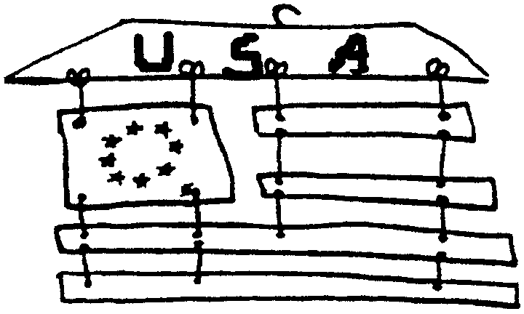
Materials: Colored poster board; String; Coat hanger

Using pictures of US historic flags as models, cut pieces from colored poster board. Draw or otherwise decorate pieces as needed. Punch appropriate holes. Start from the top and tie first row onto coat hanger. Assemble flag by continuing downward, typing on the remaining flag pieces.

MAP FRAME

Use a map from your vacation. I have seem this frame made with strips from wrapping paper or children’s drawings.

Materials: Stiff Cardboard; Map; Pencil
Note: For younger children, you may want to use a clear acrylic frame.

FRAME BASE:
- Cut a piece of stiff cardboard to the size of the frame you desire. Plan to have 1” edges.
- With pencil and ruler, outline the inside opening (i.e. one inch from the borders).
- With a craft knife cut three edges, leaving the top of the opening uncut. (Adult supervision necessary. For younger children, prepare ahead up to here.)
- Score lightly the top edge so it will bend. This piece will be the back stand of the frame.

FRAME DECORATION:
- Cut map into 1” x 2” strips.
- Wrap each strip around pencil, glue in place, and remove from the pencil. Make enough tubes to decorate frame edge.
- Glue tubes side by side around the edge of frame.
- Place your favorite photo in the frame. (Protect the picture with clear plastic such as a sheet protector or report cover.)
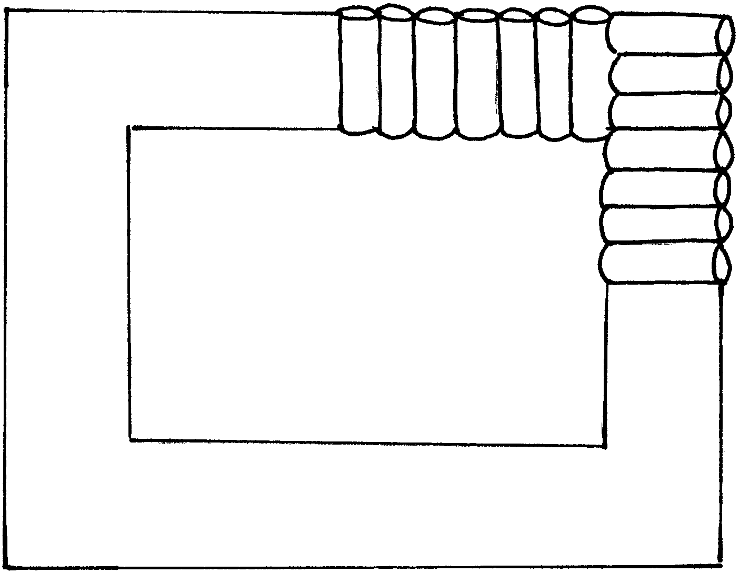

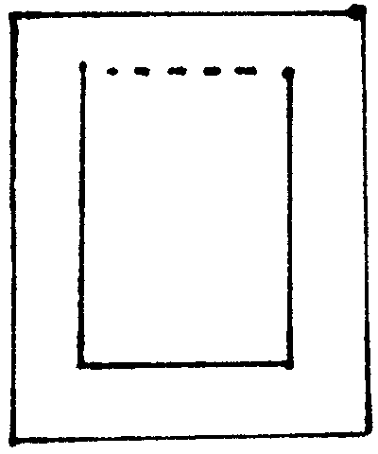


PARADE SPIRIT STICK
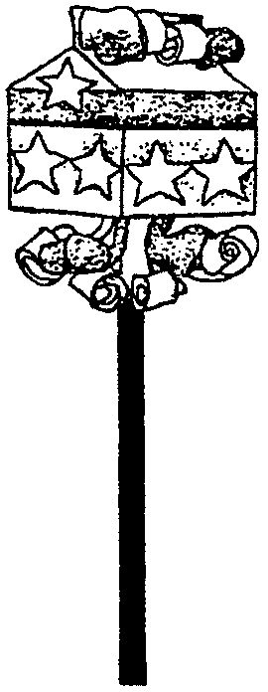
Whether your Cub Scouts are watching or participating in a 4th of July parade, they will enjoy making this patriotic spirit stick.

Materials: One empty and clean 1/2 pint milk carton; Pebbles and/or bells; White paper or Con-tact paper; Paint or markers; Glitter; Dowel; Construction paper

- Place several small pebbles, or some metal jingle bells, inside a half-pint milk carton. Staple it shut.
- Cover the carton by gluing on a piece of white paper or use Con-tact paper.
- When dry, use paint, markers, or glitter to decorate the carton.
- Paint a dowel rod and push it into bottom for a handle.
- Glue around the edges to hold the dowel in place.
- Curl 1/2” wide strips of construction paper by wrapping around pencils or dowel rods.
- Glue to the top and bottom of carton.
- You can also add ribbon streamers with bells, if desired.

UNCLE SAM PONY BEAD PATTERN

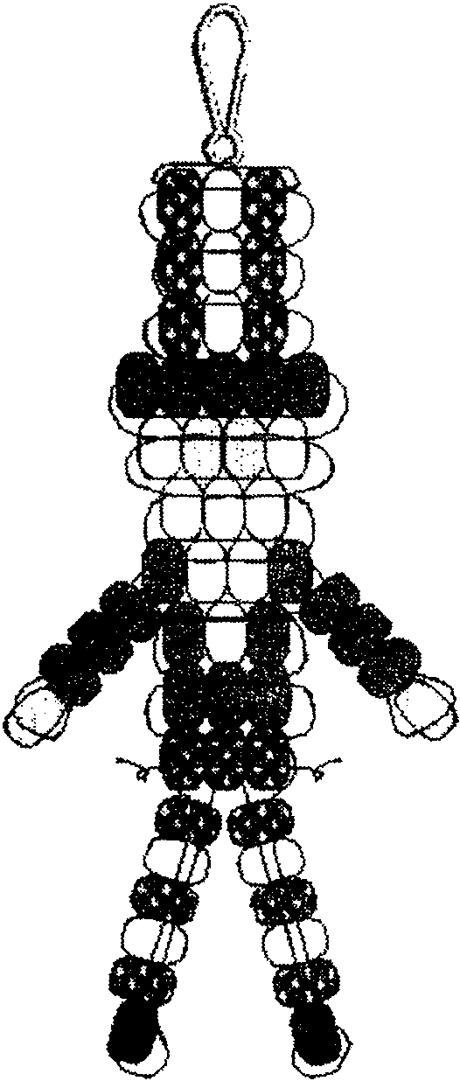
Materials: Pony beads--18 blue, 15 red, 15 white, 4 ivory, 2 black; Ribbon (1/4” width, 2 yards); Lanyard hook

- Fold your ribbon in half to find the center.
- Use a half hitch or a larks head to secure it to the lanyard hook.
- Lace beads using pattern as guide.
- Finish by tying off with a double knot.

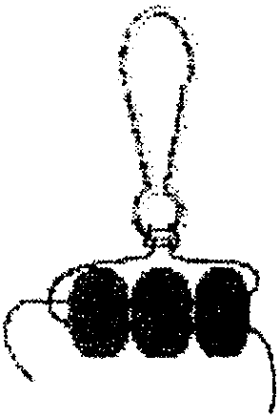
UNCLE SAM POP-UP PUPPET
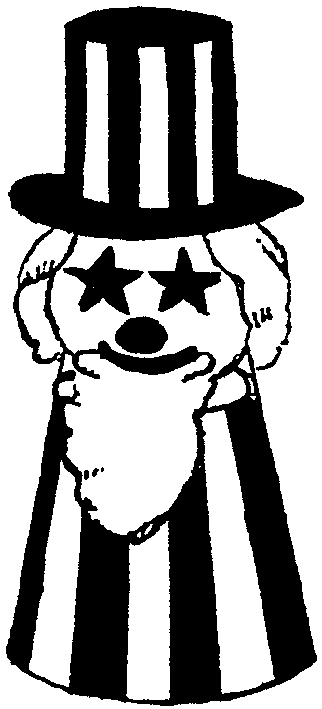
Materials: Styrofoam cup; Popsicle stick or dowel; Styrofoam ball; Paper towel tube; Construction paper (red, white, blue); Cotton ball etc. for decoration

- Glue red, white and blue paper strips to a plastic foam cup.
- Insert a popsicle stick or dowel into a styrofoam ball.
- Decorate ball as desired to make head--cotton for beard and hair, stars for eyes.
- Cut a paper towel roll. Make it into a hat using construction paper. Glue hat to head.
- Make a slit in the cup and insert stick.
- Raise and lower Uncle Sam’s head by moving the stick up and down.

LIFESAVER FIRECRACKER

Make this into a slide, magnet or pin. This makes a fun gift too.

Materials: Pipe cleaner; Roll of Lifesavers; Masking tape; Markers; Foil stars (stickers or confetti)

- Cover roll of Lifesavers with strips of masking tape.
- Color with markers and add stars.
- Poke a piece of pipe cleaner into the top of the package for a wick.
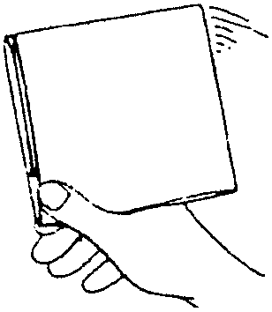

PAPER FIRE CRACKERS

Using a plain piece of notebook paper, you can make a paper fire cracker that can give you a loud bang. It’s all in the wrist!

- You will need a sheet of notebook paper, stiff wrapping paper or printer paper.
- Cut out a square about seven or eight inches.
- Fold the sheet in half so that the bottom edge of the sheet comes within a half inch of the top edge. Crease the fold well.
- Fold the sheet in half again from side to side so the flap is on the inside. Crease the fold well.
- Hold the paper tightly between your thumb and index finger at the open corner where the paper is only two layer thickness. You may want to decorate it with markers.
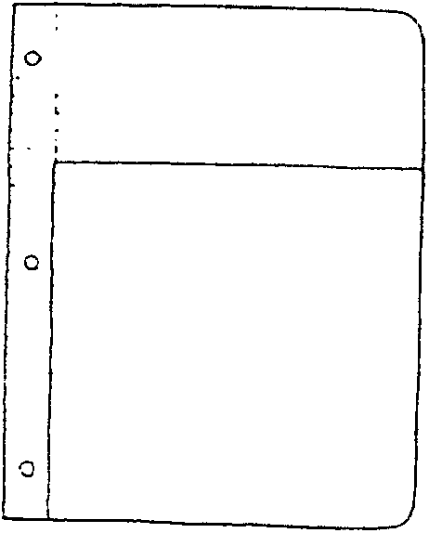
- To make the firecracker bang, quickly flick your arm and wrist downward. The inside paper flap will pop out and make a loud snap. Just refold and go again.



TRAVEL ACTIVITY KIT

Turn an old lunch box into a treasure chest! This is great for any trip, across the town or across the country.

1. If desired, remove the design or cover with Con-tact paper.
2. Decorate the outside of the lunch box with stickers, old postage stamps, magazine cutouts, map pieces, etc.
3. Optionally give a coating of Mod Podge (waterbase sealer, safe for children to use).

Some ideas for the contents (ask children too--they are the ones using the kit):
A copy of the road map, with route marked
A small lined spiral pad and pencil
An unlined pad of paper and colored pencils for drawing memorable sights
A deck of cards
Miniature magnetic checkers
Tiny game books (crosswords, word searches, etc.)
Sealable plastic bags to store items

Also make a list of 50 states (printout), so the children can check off a state if they see a license plate from that state. They can write the date and place they saw it as well. This list can be kept in the car all the time. You will be surprised how many out-of-state cars are in town during the vacation time. We are living in a place people love to visit!

USE OF OLD POSTAGE STAMPS

Save those postage stamps and use them on craft items.
Boys can cover a small box with stamps or decorate frames for vacation photos. (See “Map Frame” above for the frame patterns)

- Carefully remove stamps from postcards, etc. (If it’s a lick-type, stamps come off easily when you soak them in water.)
- Glue on to the item you want to decorate.
- Using a paintbrush, cover the entire surface with Mod Podge or slightly diluted white glue. If you want to add glitter, mix it into the glue solution.

UNCLE SAM NECKERCHIEF SLIDE

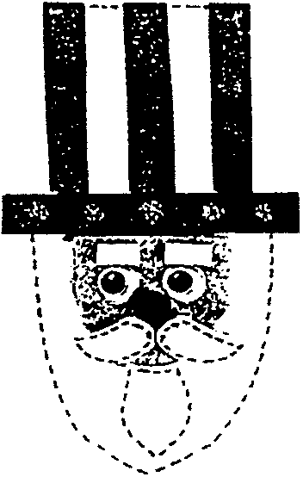
Materials: Scraps of red, white and blue craft foam; Scrap of flesh-color felt; Two wiggle eyes (7mm); Small red pompom (5 mm); Gold glitter paint or glitter glue; Black fine-line permanent marker; Glue; Pink powder blush; Q-tip; 1/2” PVC pipe

- Cut out patterns.
- Use markers to draw dashed lines along edges of beard, mustache and goatee. (You may want to tell the boys to make dots instead of dashes)
- Glue stripes on hat base and glue hat brim on too.
- Glue flesh face pattern on under brim.
- Add eyes and pompom nose.
- Glue on mustache, goatee and eyebrows.
- With q-tip dipped in powder blush, give him rosy cheeks.
- With gold glitter squeeze paint, add small stars (dots) onto hat brim.
- Let dry. Add slide back.
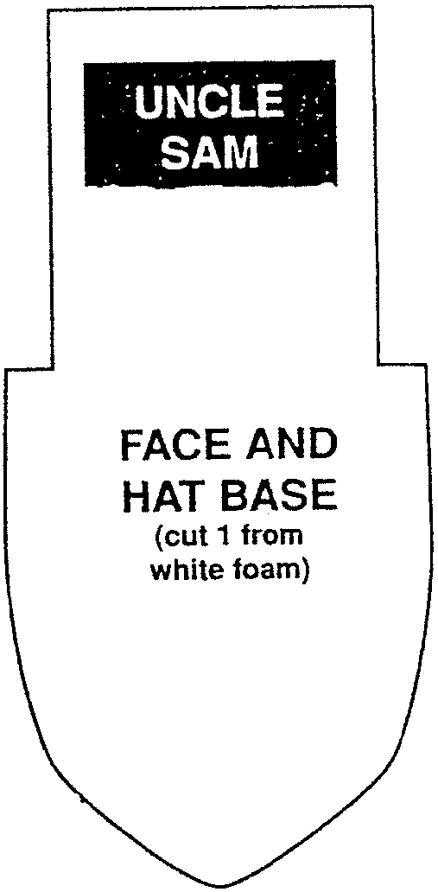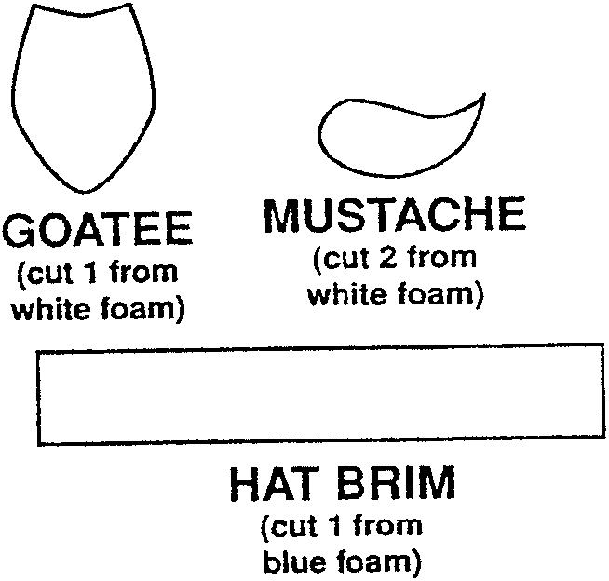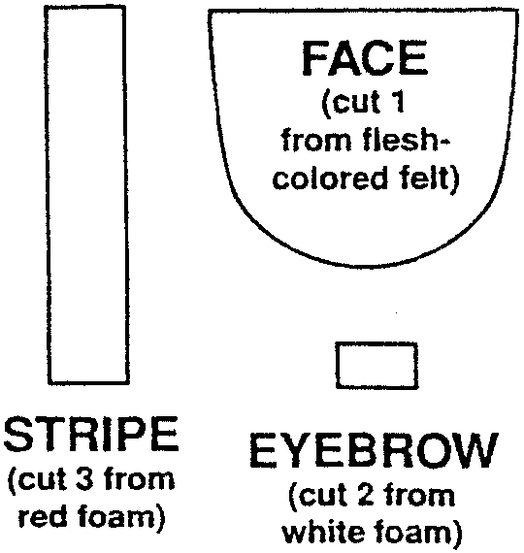

FIRECRACKER NECKERCHIEF SLIDE
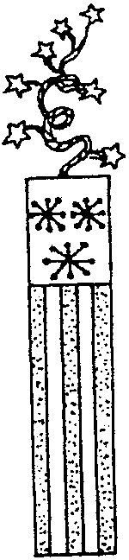
Materials: Half a craft stick (tongue depressor) with 2 straight ends; 2” of gold mini star garland; Acrylic paint (bright red, navy blue and white); 1/2” PVC pipe

- If desired, paint PVC section blue.
- Paint stick white.
- Draw red stripes and paint top navy blue.
- With a toothpick draw stars on the blue with white paint. (If desired, dot ends of stars with a stylus.)
- Curl garland around a paintbrush handle or pencil.
- Glue garland on back of stick.
- Glue PVC section on back.

SHRINK ART USA SLIDE

Trace USA shape onto opaque Shrink plastic. With permanent markers, color the top left corner blue. Make 7 red stripes. Cut out the shape (don’t worry about cutting the details too much). Shrink the plastic. Glue a section of 1/2” PVC pipe on the back.

Shrink plastic is available at craft shops. Follow the manufacturer’s directions to shrink it.

You can also use No. 6 type plastic--many plastic food lids are of Type 6. Shrink these in a 275º to 300º oven or toaster oven. Watch carefully. It will start shrinking in 25-30 seconds. Take it out. You may have to flatten with a potholder. If your pieces are not completely flat, you can put them back into the oven.
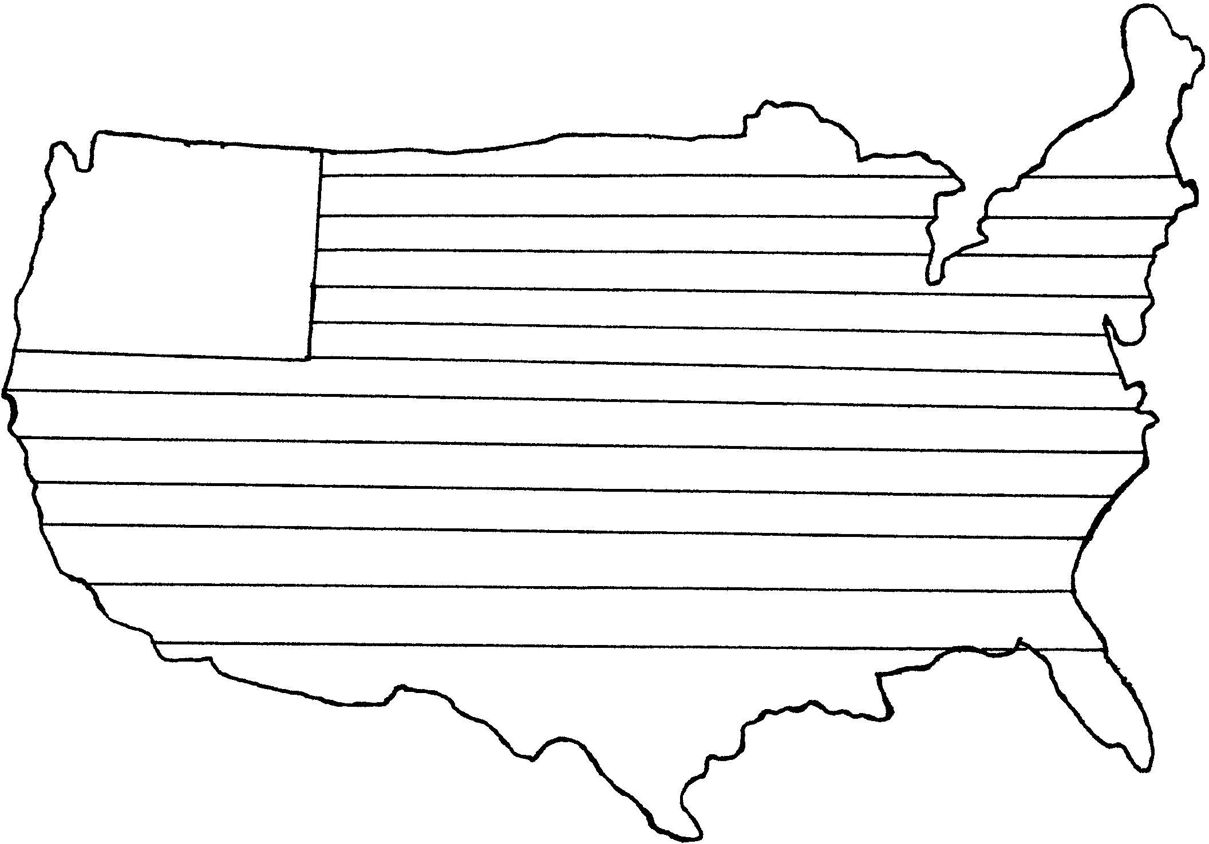

ALPHABET

Here’s a sentence with every letter of the alphabet in it.
“The quick brown fox jumps over the lazy dog.”

ABC PRETZEL

1 cup all-purpose flour
1 package dry yeast
1 teaspoon sugar
1 teaspoon salt
1 cup water

2½ cups all-purpose flour
egg
course salt

- Mix together the flour, dry yeast, sugar, salt and water until smooth.
- On pastry board, pile up 2½ cups all-purpose flour.
- Push in the top and fill the hole with the wet mixture.
- Blend with your hands and then knead for 20 minutes.
- Put the dough in a large oiled bowl.
- Cover with a damp dishtowel, set in a warm place and let rise for 1 hour (it will not double in size)
- Punch down the dough and divide it into 12 pieces.
- Roll each one into a 15” long snake and then form the snakes into letters.
- Place the letters on a greased cookie sheet, 1 inch apart.
- Brush with beaten egg and sprinkle with coarse salt.
- Bake for 12 minutes in a pre-heated 400º oven.
- Serve warm.

FIRECRACKER FIZZLES

Rounded ¼ cup Red Hots candy or some other small round red, cinnamon-flavored candy
½ cup water
4 tablespoons instant nonfat dry milk, divided in half
1½ cups cold soda water or seltzer, divided in half
½ teaspoon vanilla extract, divided in half or 2 small scoops vanilla ice cream

- Pour rounded ¼ cup of Red Hots and ½ cup water into a pot. Simmer the water and candy until the candy dissolves. It only takes a few minutes. Let the liquid cool before you use it.
- Divide the candy and water mixture between two drinking glasses. Add two tablespoons dry milk to each glass. Stir until it dissolves.
- Slowly add ¾ cup cold soda water or seltzer to each glass. Stir carefully. The soda will fizz up.
- Stir in ¼ teaspoon vanilla extract or add a small scoop of vanilla ice cream to each glass.

Makes 2 Firecracker Fizzles.

AMERICAN CHOCOLATE COOKIES

1 cup brown sugar
½ cup shortening
1 egg
1 teaspoon vanilla
½ cup milk
2 oz. semi-sweet chocolate
2 cups flour
½ teaspoon baking soda
¼ teaspoon salt
CHOCOLATE FROSTING (see below)

- Mix sugar, shortening, and egg until creamy.
- Add vanilla and milk and stir well.
- Melt chocolate in a double boiler or in microwave oven.
- Meanwhile, blend the dry ingredients, then gradually blend into the sugar mixture.
- Add melted chocolate and stir well.
- Drop by rounded spoonfuls onto a greased cookie sheet.
- Bake at 350 for 10-13 minutes.
- Frost when cool.

CHOCOLATE FROSTING

½ cup chocolate chips
¼ cup milk
2 Tablespoons margarine
2 cups powdered sugar
Crushed peppermint candies (optional)

- In a medium saucepan, combine the first three ingredients.
- Cook over a low heat, stirring constantly until the chocolate melts.
- Add powdered sugar, stirring until the mixture is smooth.
- More milk may be added for a thinner frosting.
- Frost cookies.
- If desired, decorate with crushed peppermint candy.

FROZEN POPS

¾ cup orange or grape juice
1 cup yogurt
½ teaspoon vanilla

After mixing all ingredients together, pour into paper cups and place in freezer. When mixture is partially frozen, insert popsicle sticks.

