Wet and Wild

June 2001

CONTENTS

THEME RELATED 1
WATER SAFETY 1
DEN AND PACK ACTIVITIES 1
BEACH OUTING 1
WATER SAFETY TRAINING 1
PARTICIPATION AWARDS 1
WATER CARNIVAL 1
FISHING DERBY 2
RAINGUTTER REGATTA 2
PIRATE PICNIC 2
SOUTH BAY FISHING IN THE CITY 2
WHERE TO FISH IN THE SOUTH BAY 2
ONLINE RESOURCES 2
PREOPENING 3
WET AND WILD WORD SEARCH 3
GIANT OCTOPUS MAZE 3
SOGGY SCRAMBLE 3
CEREMONIES 4
WET ‘N’ WILD OPENING 4
WATER OPENING 4
“WATER”--CUBMASTER’S MINUTE 4
“HORIZONS”--CUBMASTER’S MINUTE 5
I AM YOUR FLAG CEREMONY 5
WET AND WILD KIDDIE POOL
ADVANCEMENT 6
FISHING ADVANCEMENT 6
SWIMMING HOLE ADVANCEMENT 7
SHARK WATERS ADVANCEMENT 7
MAGIC H2O BOBCAT INDUCTION 8
MAGIC H2O BOBCAT INDUCTION 8
FUN WAYS TO SAY THANK YOU 9
AUDIENCE PARTICIPATION 10
GETTING IN THE SWIM 10
A WISH COMES TRUE 11
SKITS 12
A BUCKET OF WATER 12
WET AND WILD RUN ONS 13
GAMES 14
“BOYS IN THE WATER” GAMES 14
WHEELBARROW RACE 14
TWO-HANDED PULL AND GLIDE
RACE 14
PADDLEWHEEL PUSH 14
KIM’S GAME UNDERWATER 14
WINDY RELAY 14
TUG-OF-WATER 14
DUCK TAG 14
WATER VOLLEYBALL 14
SHALLOW-WATER SCAVENGER
HUNT 15
WATER BASEBALL 15
WATER BASKETBALL 15
LOG CHUTE 15
HUMAN BOAT RACE 15
“PLAY WITH WATER” GAMES 16
SEASHORE OBSTACLE COURSE 16
WATER RELAY 16
OBSTACLE COURSE 16
SPONGE THROW 16
LITTLE SQUIRT 16
WATER BALLOON VOLLEYBALL 17
WATER THE ELEPHANT 17
SINK THE SHIPS 17
SONGS 18
OH WE LIKE TO PLAY IN THE WATER 18
A SWIMMING WE WILL GO 18
WATER SAFETY 18
TALL AND WIDE 18
WATER WATER EVERYWHERE 18
GIANT SOAKER 19
OLD SWIMMING HOLE 19
DO YOU KNOW HOW TO SWIM? 19
THE FISH WENT SWIMMING 19
CRAFTS 20
HULA HOOP SPRINKLER 20
SAILBOAT SUN CATCHER 20
FILM CANISTER BUBBLE BLOWERS 21
FISH 21
ZANY SUNGLASSES 22
SUBMARINE 22
SEASHELL CANDLES 22
PAPER CUP 23
WAVE BOTTLE 23
DEHYDRATED WATER NECKERCHIEF
SLIDE 24
TIC TAC CONTAINER AQUARIUM SLIDE 24
LIFE PRESERVER NECKERCHIEF SLIDE 24
LIFE PRESERVER NECKERCHIEF SLIDE 25
WILD SEA KRITTER NECKERCHIEF
SLIDE, PIN OR MAGNET 25
CUBS IN THE KITCHEN 26
WATERMELON ON A STICK 26
CREAMSICLE ICE CREAM 26
PIZZA BOATS 26
FRUIT CANOES 26

WATER SAFETY

Water activities are always popular with the boys. Before you take your pack or den out for any water-related activities, please read:
Safe Swim Defense
Home Swimming Safety Rules
Water Rescue
Safety Afloat
in Cub Scout Leader Book, chapter 12, pp. 2-5.
See also “Aquatic Safety” in Guide to Safe Scouting.

Safe Swim Defense and Safety Afloat are also available in pamphlets at the Scout Shop. The pack may want to purchase them for its leaders.

Most cities offer recreation swimming at their pools with qualified lifeguards on duty. Call your city’s Parks and Recreation department or Community Service office for specific locations, hours and fees. Some YMCA branches contract pools (usually at high schools) for non-members outside of their normal facilities for more affordable fees during summer. Call the YMCA near you for more information.

If you are planning to take a large group of children, contact the pool ahead of time to ensure they have adequate lifeguards on hand.

DEN AND PACK ACTIVITIES

BEACH OUTING
Have a family outing at the beach. Build sand castles. Have a sand sculpture contest. See who can dig the deepest and widest holes (please fill the holes later). See who can find the most unusual shells or rocks. Go and explore tide pools. Measure the tide’s advance or fall--stand a stick at the wave limit on the beach and check it every hour or so. Have fun wave jumping--make sure there is adequate adult supervision. Play games (for example see the ‘Play with Water’ Games in this month’s “Games” section). Make tin can ice cream (Cub Scout Leader How-To Book, p. 8-42).
Make sure everyone uses sunscreen.

WATER SAFETY TRAINING
Have a water safety session with pack or den. Teach boys and parents the water safety rules. Show safe swimming demonstrations.

PARTICIPATION AWARDS (For details, see the PARTICIPATION AWARDS section)
Cub Scout Sports: Fishing
Cub Scout Sports: Swimming

WATER CARNIVAL
For suggestions, see Cub Scout Leader How-To Book, p. 9-15.

FISHING DERBY
For suggestions, see Cub Scout Leader How-To Book, p. 9-16.

RAINGUTTER REGATTA
For suggestions, see Cub Scout Leader How-To Book, pp. 9-47 to 9-48.

PIRATE PICNIC
For suggestions, see Cub Scout Leader How-To Book, pp. 9-9 to 9-10.

SOUTH BAY FISHING IN THE CITY

South Bay Fishing in the City is a program put on by the County Parks and Recreation Department. It creates opportunities for fishing, outdoor recreational experiences and aquatic education for children and their families. It holds monthly Community Kids Fishing Events from March to November. For more information call (415) 892-0460.

If you want to take your pack or den fishing and need fishing rods for the children, you can borrow them free through this organization. Tackle boxes are also available for a small fee. Call (415) 892-0460 or County Parks and Recreation at (408) 358-3741.

WHERE TO FISH IN THE SOUTH BAY
The following are the parks in the South Bay where fishing is available. Call for directions and fees for vehicle entry. To obtain a flyer with a map (“Fishing in the City: Where to Fish”), call Santa Clara County Parks and Recreation Department at (408) 358-3741.
- Stevens Creek Reservoir 867-3654
- Lake Ranch, Sanborn Park 867-9959
- Lexington Reservoir 353-6291
- Vasona Lake 356-2729
- Los Gatos Creek, Perc Ponds 356-2729
- Sandy Wool Lake, Ed Levin Park 262-6980
- Cottonwood Lake, Hellyer Park 225-0225
- Lake Cunningham 277-4319
- Grant Lakes 274-6121
- Parkway Lakes 629-9111
- Chesbro Reservoir 779-9232
- Sprig Lake, Mt. Madonna Park (ages 5-12 only) 842-2341
- Uvas Reservoir 779-9232
- Coyote Creek 779-3634
- Anderson Reservoir 779-3634
- Coyote Lake 842-7800

ONLINE RESOURCES

- USA Swimming: http://www.usswim.org
- http://www.usscouts.org/macscouter/games/v1_water.html
Lots of water games and how to play them

WET AND WILD WORD SEARCH

There are all kinds of fun words hidden in this bucket of water. Look for them up and down, forward and backward.
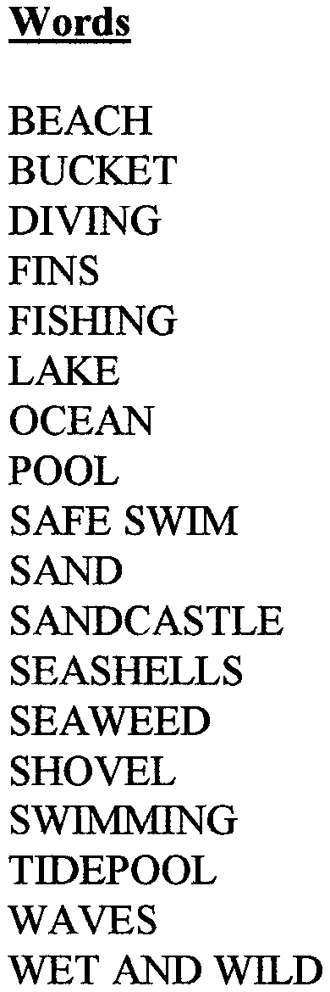

W R S W I M M I N G I P U T X C
F S T B T I D E P O O L V S
H E E C S D S R T V O E N M
W A K U S E A S H E L L S D
O W C D N F N L H K T T J N
E U I I W D E E C D S L
E B V F I S H I N G A Z
D L I W D N A T E W C A
P A N A S H O V E L D Q
K G T C C S M F G N
E Q E X N F I F S A
E E R D A X W G N S
N D S F E L S W I W
R T H C A E B S
T S A O K F J R
P N H M W A R D
G W A V E S N Y

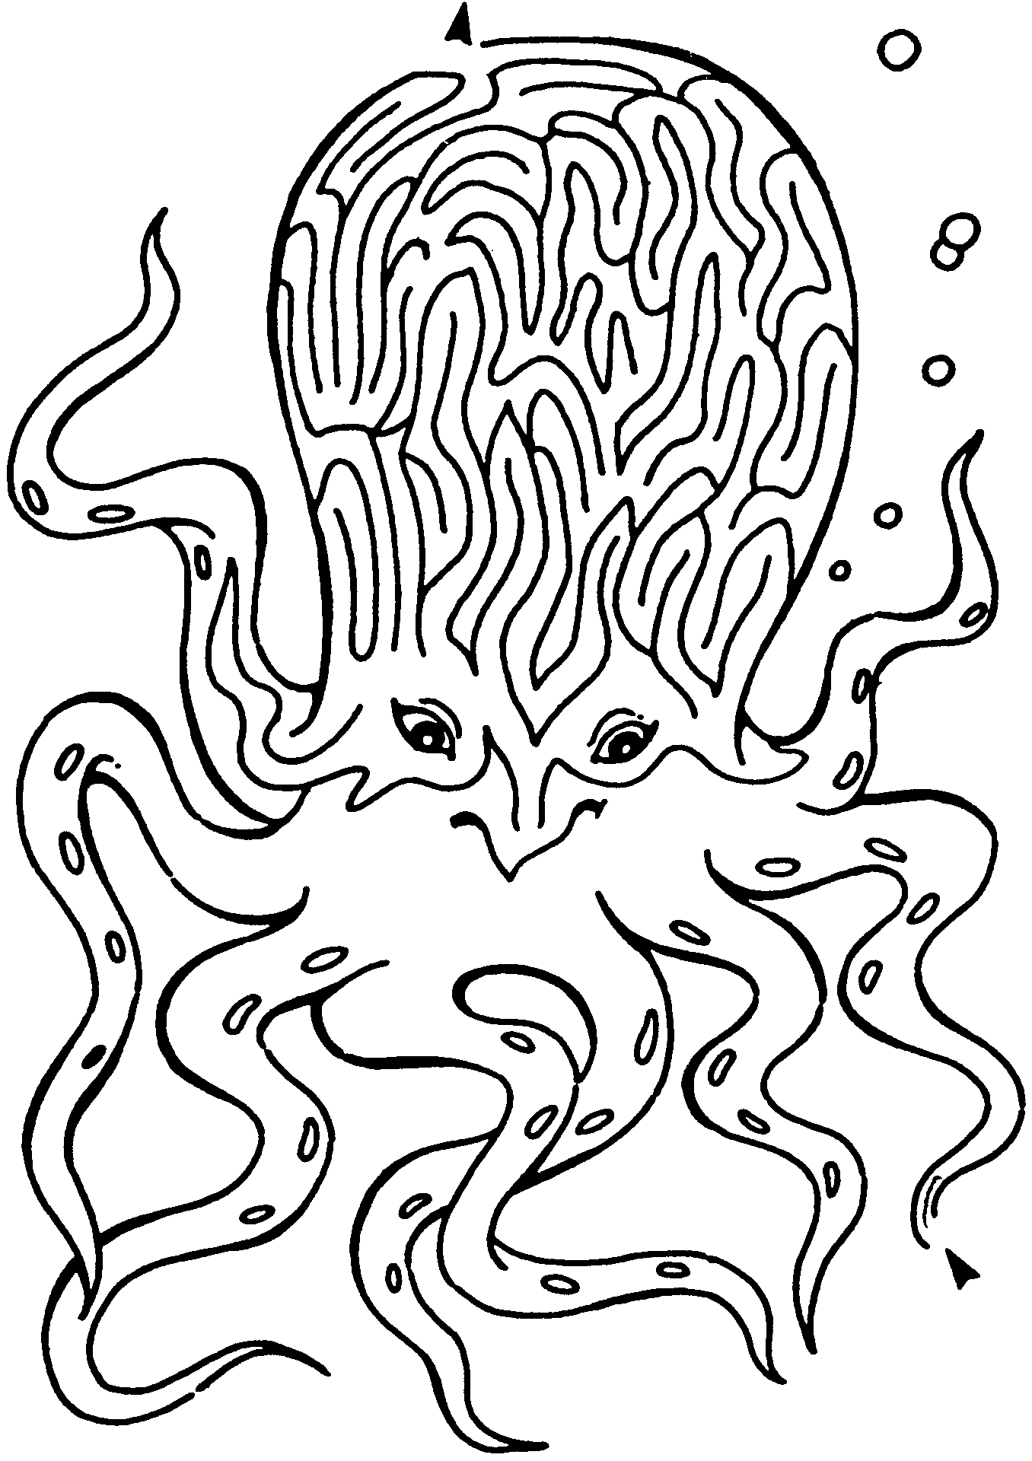
GIANT OCTOPUS MAZE

SOGGY SCRAMBLE

Unscramble these things that can make you wet.

- oshe
- vweas
- retwa tolsip
- pcu
- relknirps
- ketbuc
- selddup
- wrtea llbanoo
- fctaeu
- smmwngii loop

Answers: 1-hose; 2-waves; 3-water pistol; 4-cup; 5-sprinkler; 6-bucket; 7-puddles; 8-water balloon; 9-faucet; 10-swimming pool

WET ‘N’ WILD OPENING

Each Cub Scout holds a sign with a letter and his line on the back for him to read. You will need a small squirt gun or water pistol for each boy. Boys hide them until the end.

W Welcome to our Pack Meeting!
E Everyone ready
T To have some fun?

‘N’ Now it’s time to begin.

W Water is our theme tonight.
I It’s everywhere, you see.
L Lucky you are here tonight (today) because
D Drenched you will be!

(Boys pull out squirt guns and squirt the audience.)

WATER OPENING

W We love to get wet and play in water.
A Animals, people, and plants all need water to survive.
T Take time to use water wisely.
E Everyone is responsible for keeping our water clean.
R Rivers, streams, lakes and oceans are some of our national treasures.

Please rise and join us in honoring our country by saluting the flag and saying the Pledge of Allegiance.

“WATER”--CUBMASTER’S MINUTE

Tonight, we have had a lot of fun with water. We need to stop and think for a moment about that great natural resource, water.

Humans need water to survive. Animals like otters and beavers live in the water. And where would all the fish be without water? Plants need water to survive, too. It’s great to have fun swimming and playing with water. But we must remember to use water wisely and to keep our lakes, rivers, and oceans clean. A good Cub Scout makes the world a better place by leaving it cleaner than he found it.

Let’s do our best to conserve water and keep our world clean. Then we will have water to drink and to have fun with for years to come.

“HORIZONS”--CUBMASTER’S MINUTE

We speak of horizons...not one, but plural...horizons. Did it ever occur to you that there are more than one? When you have worked and planned to reach your horizon, you stop to rest and look up to see before you is another horizon, just as far away as the last. When that horizon is within your grasp, wonder of wonders, still another is waiting. Few men ever reach all horizons. Some never even reach the first, and still others never start. Look at what they miss. All they ever see is the small area around them. This is not the Cub Scout way. Cub Scouts must reach a series of horizons on the climb to the Arrow of Light. Small horizons, granted, but they lead to the farther horizons of Scouting and manhood. Boys, keep working to reach those far horizons. Parents and leaders, let’s boost the boys on their reach for those horizons; they may let us come along.

I AM YOUR FLAG CEREMONY

Arrangement: Five Cub Scouts post the colors and then gather around the flag in a semi-circle, facing the audience. The audience should remain standing.

Cub 1: I am the moon. Explorers came to me from your country many years ago. They left a beautiful flag that flies above my surface forever.

Cub 2: I am Mount Everest, one of the tallest mountains on earth. Americans have climbed my peak and their flag now waves from the top of the world.

Cub 3: I am your hometown. The American flag waves proudly over my homes, schools, businesses and government buildings.

Cub 4: I am your flag. I was created to be a symbol of freedom at a time when our country needed to unite to gain that freedom. I have watched my country grow through war and peace. I have wept for those who have fallen, and rejoiced for those who have succeeded. I am the symbol of unity, strength, and freedom.

Cub 5: I am a Cub Scout. I am just learning about my nation and what freedom is all about. Teach me about our flag, show me how to respect and care for it. Help me to become a better American. Please join me in repeating the Pledge of Allegiance.

JUNE 14 IS FLAG DAY

WET AND WILD KIDDIE POOL ADVANCEMENT

Fill a child’s wading pool half full of water. Place awards in Zip-Loc bags (regular or freezer, not sandwich bags) and place them in the swimming pool. Make sure there is air in the bags so that they will float. The Cubmaster should dress with swim goggles, flippers, a snorkel, and maybe bright colored shorts (over his uniform).

Cubmaster:
Tonight’s theme is Wet and Wild and we are going to have some fun getting wild and crazy with water. I can see our pack has been wild and crazy this month by earning lots of awards. Would the following boys come forward? (He names all the boys who are receiving awards)

As you can see right here in this pool, there are lots of awards to hand out tonight. But it looks like they may be hard to get. I guess all awards are hard to get--but that is the fun of earning them. I am dressed to go swimming, but since I am too large for this pool, I’m going to need some help. (Cubmaster then instructs boys to “bob” for awards. Each boy will bob for a bag, then open it and read the awards. The awards are then given to the appropriate boy.)
NOTE: Be sensitive that you are not asking any boy to do anything that he will feel uncomfortable with. The bobbing is an option. Give them the option of reaching in to get a bag.

FISHING ADVANCEMENT

Props: Fishing pole with a spring-type clothespin on the end of the line. A blanket or tablecloth to cover the table, where an assistant can hide. Cut out fish-shapes on construction paper and pin the rank awards to them.

Cubmaster:
The summertime is one of my favorite times of the year. School is out so families can travel more and see many places. A lot of time we go swimming or to the beach just to be around the water and have a good time.

My favorite pastime during the summer is to go fishing. I have a special place that really gets the best fish, and always makes me happy. Let me show you the best way to go fishing. (Picks up fishing pole and drops the line behind the table where the assistant is hiding.)

This is my special demonstration fishing pole. I always catch something special with it. (Assistant will place rank card with patch onto clothespin and tug gently on line)

Look! I caught something right here! I told you this pole was special. Look at this. A Bob-Cat fish! Will (name of Cub Scout) please come forward?
(Repeat for the boys in the same rank)

These boys have each earned the rank of Bobcat. This is a special award as it marks the beginning of the trail toward the Arrow of Light. Congratulations!

(Repeats process for other ranks: Wolf-fish, Bear-fish, Webelos-fish, and Tiger-fish if you include the Tiger paws)

SWIMMING HOLE ADVANCEMENT

Cubmaster:
Here we are at the ole swimming hole. Learning to swim is a lot like Cub Scouting. First we learn how to float, then we learn how to paddle around, but we still aren’t strong swimmers. Eventually, with hard work, we learn to swim further and faster.

In Cub Scouting, the boys first earn their Bobcat badges. They’ve made their first splash in Scouting. (Call the new Bobcats and their parents forward)

The next step is the Wolf badge. The Cub Scout must work harder to complete the requirements but he has learned to paddle around the Cub Scouting pond. (Call the new Wolves and their parents forward)

The Bears have learned to swim a little further and a little faster. They have mastered the kick that will propel them through the Cub Scout program. (Call the new Bears and their parents forward)

Now we come to our strongest swimmers, the Webelos. These boys have completed many practical tasks and learned many new skills to advance this far. They are almost ready to leave our little Cub Scout swimming hole and jump into the deeper pool of Boy Scouting. (Call the Webelos and their parents forward)

Congratulations to each of these boys. The requirements for these advancements are not easy and each worked hard to earn his rank. Thank you to each of these boys’ parents. Without your help and support, your sons would not be able to advance.

SHARK WATERS ADVANCEMENT

Cut shark fins from black poster board and staple to the side of a 2x4. Spread a blue tarp on the floor and crumple it to look like waves in the ocean. Put shark fins around on the tarp between the waves. Make a narrow bridge across the water by putting a 6’ length of 2”x4” on top of a block at both ends. Nail together so its firm. Place the bridge over the tarp. The boys receiving their awards must walk across the bridge without falling into the water. You can liken the sharks to problems that may be of concern to families in your area (such as drugs, gangs, violence, etc.) The bridge helps the boys to be safe from these problems, just like Cub Scouting helps them to be safe. Mom and Dad can hold the boy’s hand as he crosses the bridge, just as they help him along the Cub Scout trail.

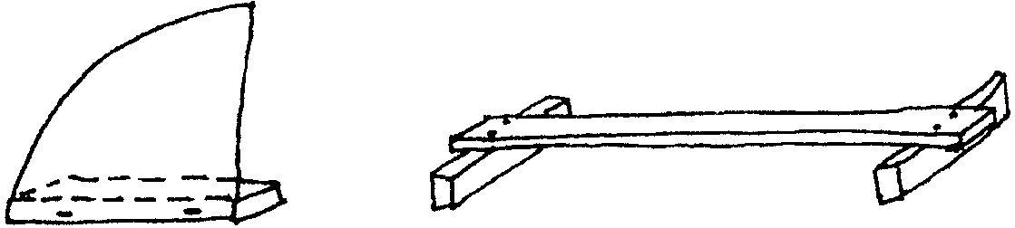

MAGIC H2O BOBCAT INDUCTION

Equipment: A large bucket; A small clear container; Water; Blue food coloring; Bobcat award; Zip-Loc bag; Large piece of cloth; 3 ping pong or tennis balls; A permanent marker.

Preparation: Before the meeting, fill the small container with water and add a few drops of blue food coloring. Place the awards in the Zip-Loc bag, making sure there is air in it so it will float. Place the bag in the water container, then place the water container inside the bucket. Be sure the container is in the back of the bucket. Cover top of bucket with cloth. With the marker, write a large letter “H” on two of the ping pong balls, and a large “O” on the remaining ball.

Cubmaster:
I’m sure that you have learned a few things about water in school and at your den meetings this month. Let’s see--water is wet, it tastes good on a hot summer day, and it is fun to play in. Did you learn that water is made up of two atoms of hydrogen and one atom of oxygen? That’s what we mean when we talk about good old H2O. (Holds up ping pong balls with letters on them)
These balls represent the atoms needed to combine to produce water. But they also represent something else. They represent three things that need to combine to have a Bobcat in our pack. (Calls up parents and family of boy receiving Bobcat)
The first “H” in our Bobcat combination stands for Home. (Hands ball to parents) Home is where our Bobcat learns to get along with others and have fun with his family. Home is where this Bobcat passed off the requirements to earn his Bobcat award, with the assistance of his family.
The second “H” stands for Help. His parents help him, but he also has very special helpers who meet with him each week and provide new and exciting things to do. These are his den leaders. (Calls up den leaders; hands ball to them)
The final and most important ingredient in our combination is “O.” Our “O” stands for “Oh, boy!!” (Calls up boy who is receiving award and hands ball to him) “Oh, boy, it’s time for the den meeting.” “Oh, boy, let’s go to the pack meeting. I’m sure that Cubmaster will do something crazy this month!” Oh, boys are the most, very important people, in our pack.
What happens when we combine all of these forces--the Home, the Help, and the “Oh, Boy!” Let’s see. Will you all place your atoms in the bucket? Do it gently now, we don’t want any catastrophes tonight! (Cubmaster lifts cloth in front of the bucket and the participants place balls in bucket.) Will everyone join me in saying the Cub Scout Motto magic words? (Cubmaster waves arms over the bucket like a magician.) Do your best! (He peaks under cloth) Hmmmm...doesn’t seem to be working. Maybe we need to say it a little louder so the forces have the power to combine. Let’s try again. DO YOUR BEST!! (Cubmaster reaches into bucket and removes container with water)
Wow! That was great! Our two H’s and an O combined to form this water. But wait, there’s something floating on top. (Asks Bobcat recipient to remove the bag) When you combine the Home, the Help, and the “Oh, boy”, you get a brand new Bobcat. Always remember to use these ingredients as you travel down the Cub Scout trail. All three combined together can be really magical! (Asks boy to hand bag to parents, who open the bag and present the award to him) Congratulations to all of you. Let’s give _____ a cheer! (Lead an appropriate “water” cheer)

FUN WAYS TO SAY THANK YOU

Anchor: “With you as anchorman, our pack is sure to stay afloat. Thanks!”
Buoy: “Thank you for helping us to stay on course.”
Faucet handle: “You’re turned on to Cub Scouting!”
Lifesavers: “You have been a lifesaver in our pack by (deeds). Thanks!”
Sailboat: For the pack Raingutter Regatta Chairman.
Ship: “Once you learn to do your best, the rest is easy sailing. Thanks!”
Ship’s flag: “You serve us with flying colors. Thanks!”
Sun: “You are a bright light in our pack!”
For the Summertime Activity Chairman.
Toy shovel: “You really dug into the job. Thanks!”

See Cub Scout Ceremonies for Dens and Packs for:
Closing “Ripple Effect” p. 6-6
Advancement
“Swimming” p. 8-7
“Fishing for Advancement” p. 8-4

THE HEART OF A MAN TO BE

Put me in touch with the heart of a boy,
Let me study his doubts and fears,
Let me show him a way of life,
And help him avoid its tears.

For the heart of a boy in its buoyancy
Is one that is pure and free.
So put me in touch with the heart of a boy,
The heart of a man to be…

- Dr. Henry Van Dyke

GETTING IN THE SWIM

JOEY: “A Cub Scout!”
MRS. ROGERS: “Den 1, lots of fun!”
CUB CAMP: “Oh boy, oh boy!”
SWIM/SWIMMING: “Splash, splash!”

“Oh boy, oh boy!” exclaimed JOEY, “I get to go to CUB CAMP this year!”

“How nice,” said MRS. ROGERS, JOEY’S den leader. “I know you’ll have a lot of fun.”

“You bet, MRS. ROGERS. I get to make all kinds of crafts and work with wood, but best of all I get to SWIM every day in the big pool,” said JOEY.

“But JOEY, you have a SWIMMING pool at home, don’t you?” asked MRS. ROGERS.
“Sure, I do,” replied JOEY.

“Then why are you excited about going to CUB CAMP to SWIM?” MRS. ROGERS asked.

“Well,” said JOEY, “At CUB CAMP I’ll get to SWIM with a whole bunch of guys and we can play games and have fun in the pool.”

“Can’t you do those things in your SWIMMING pool?” inquired MRS. ROGERS.

“Oh no!” JOEY replied. “When you SWIM or play games in the pool, an adult should be there to see that no one gets hurt. My mom stays busy watching my baby brother, so she doesn’t have much time to watch us. At CUB CAMP they have lifeguards to watch us SWIM and play games.”

“Yes,” said MRS. ROGERS, “and also to see that the games don’t get too rough. You know, JOEY, that unless care is taken, boys can be badly hurt playing in a SWIMMING pool.”

“Oh sure, MRS. ROGERS, but at CUB CAMP they use the buddy system. Each boy has a buddy that he watches out for,” said JOEY.

“Now that’s a real good system,” replied MRS. ROGERS. “Maybe it would be a good idea to use it in your SWIMMING pool at home. And JOEY, I will speak to your mother. Maybe she will let the whole den come over and SWIM this summer. If so, I will go along and be the lifeguard for you.”

A WISH COMES TRUE
(For Raingutter Regatta)

CUB SCOUT: “Hip, hip, hooray!”
BEACH: “Land ho!”
PIRATE: “Walk the plank!
PARROT: “Blow me down!”
BOTTLE: “Yo, ho, ho and a bottle of Sprite!”
GENIE: “Poof!” (Swing arms above head)
REGATTA (everyone): “Ship ahoy!”

Early one day, a CUB SCOUT stood on the BEACH with his sailboat. He was ready to race in the REGATTA and was hoping no PIRATE would steal his ship. Scanning the BEACH, the CUB SCOUT spotted a large green BOTTLE lying in the sand. A PIRATE with a PARROT also saw the BOTTLE.

The CUB SCOUT and the PIRATE with the PARROT on this shoulder reached the BOTTLE at the same time. Both grabbed for it, but the PIRATE slipped, the PARROT flew off, and out came a GENIE from the BOTTLE.

“Grant me a wish,” cried the CUB SCOUT. “No, grant me one,” yelled the PIRATE. The GENIE did not know what to do.

Suddenly the PARROT landed on the shoulder of the PIRATE and said, “Polly wants a cracker.”

“Your wish is my command,” said the GENIE. He granted the PARROT’S wish, then disappeared into the BOTTLE, which rolled down the BEACH and into the sea.

And thus we learn that we must first make a wish before it can come true. Good luck to everyone at our REGATTA!

CHEERS

DIVER’S CHEER: Pretend to jump of the diving board and say “Kersplash! PERFECT!”

THE WAVE: “For a SWELL job!” Rise and raise arms above head then sit back down, as done at sports events. When the wave reaches the last person, it can come back the other way.

A BUCKET OF WATER

Scene: A forest clearing, with a bucket of “water” and a dipper

(Boys #1 and #2 enter)
Boy #1: I’m thirsty!
Boy #2: So am I! There’s some water. Let’s get some.
(Pretends to dip water from bucket)
Boy #1: (Smells the water) I don’t think that water is good. No thanks.
Boy #2: I don’t want any of that stuff!
(Both boys walk off holding their noses.)

(Enter Boys #3 and #4)
Boy #3: Water! Let’s have a drink!
Boy #4: (Looks at the water) I can’t drink that! Look at it!
(They look at it and shake their heads as they walk off)

(Enter Boys #5 and #6)
Boy #5: I’m soooo thirsty!!! (Looks at the water) I don’t think this is drinkable.
Boy #6: It sure isn’t. It stinks!!
Boy #5: Well, we should throw it out since it’s so bad.
Boy #6: (Picks up the bucket and tosses the contents into the audience. Use rice, popcorn, or salt water taffy)

APPLAUSES

ICE WATER APPLAUSE: Pretend to wipe sweat from brow with bandanna. Pick up pitcher and pour yourself a glass of ice water. Throw head back as you drink water, then say, “Ahh...that was COOOOOL!”

SURF BOARD APPLAUSE: Pretend to be riding a surf board, run it onto the beach, jump off, spread arms wide, and say, “Success!”

WET AND WILD RUN ONS

Cub 1: What did the water say to the sponge?
Cub 2: Quit soaking.

Teacher: What is the formula for water?
Student: H-I-J-K-L-M-N-O.
Teacher: Whoever told you that?
Student: You did! You said it was H to O.

Cub 1: Why did the boy throw water out of the window?
Cub 2: He wanted to see a waterfall.

Coach: Swimming is one of the best ways to keep your body slim and trim.
Boy: That’s funny. I’ve never seen a slim, trim whale.

Cub 1: Where do ships go when they are ill?
Cub 2: To the “docks!”

Cub 1: Why is the ocean so grouchy?
Cub 2: Because it has crabs all over its bottom.

Cub 1: What gets wetter and wetter the more it dries?
Cub 2: A towel.

Cub 1: What kind of cats breathe under water?
Cub 2: Octo-pusses!

Cub 1: What kind of fish come out only at night?
Cub 2: Starfish.

Cub 1: What kind of fish goes with peanut butter?
Cub 2: Jellyfish.

Cub 1: When is a crab like a cranky monarch?
Cub 2: When it’s a king crab.

Cub 1: What did the mother sardine say to her son when they saw a submarine?
Cub 2: “Don’t be afraid. It’s just a can of people.”

“BOYS IN THE WATER” GAMES
Involve parents in these games as participants, judges or safety supervisors.

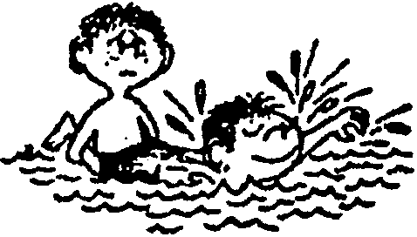
WHEELBARROW RACE
Boys don’t have to be swimmers to compete in this race. In waist deep water, pick a buddy and “wheel” him across the pool. To make it more fun, switch positions and go back. This is a good activity to practice the arm motions used in swimming.

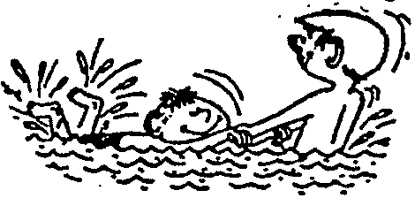
TWO-HANDED PULL AND GLIDE RACE
Boys don’t have to be swimmers. This game is good practice for the kicking skills required for swimming. One person “pulls” the other across the pool as he kicks. When you reach the other side, switch positions and race back.

PADDLEWHEEL PUSH
Play in waist-deep water. Opponents grasp opposite ends of a kickboard. On signal, both boys start kicking, trying to force opponent backward.

KIM’S GAME UNDERWATER
This is a good game for beginning swimmers because it will help them get used to the water. In waist-deep water, scatter a dozen small objects on the bottom--a bolt, nut, fishing sinker, paper clip, golf ball, etc. The players wade to the spot, put their heads underwater, open their eyes, and look at the objects. The players then return to shore and make a list of all objects they remember seeing. (Make sure all objects are retrieved.)

WINDY RELAY
Play in waist- to chest-deep water. Divide players into two teams and give each team a table tennis ball. On signal, first player on each team walks or swims to a turning line and back while blowing the ball ahead of him. He may not touch the ball with any part of his body. Next player repeats the action, and so on until all have raced.

TUG-OF-WATER
Play in water that is chest deep for Cub Scouts. Divide the group into two teams. Use a stout rope, with a colored ribbon tied to its center. Have a judge (adult or den chief) stand at the center mark. The winner is the team which pulls the other team past the center mark.

DUCK TAG
A good game for nonswimmers to overcome any fear of water. Play in waist-deep water like regular tag, except that a player is safe if he ducks completely under water when “It” is near. A player does not have to stay under water more than two seconds; “It” must go after someone else when his quarry ducks under water.

WATER VOLLEYBALL
You will need a volley ball net and a beach ball. Play in waist-deep water. Follow volleyball rules. It is tougher to move in the water than in the gym.

SHALLOW-WATER SCAVENGER HUNT
Scatter several different objects in waist-deep water--flat stones, golf balls, filled water bottles, for example. Prepare more than one for some of the objects. Then line up the players along the shore or edge of the pool. Call out one object that is in the water. All the boys enter the water and try to find the object and bring it to the leader.

WATER BASEBALL
You will need an 18” beach ball and one large plastic bat. If you don’t have a plastic bat, try to hit the ball with an extended arm.
Divide boys into two teams. Decide the bases and designate with floats or mark the sides of the pool. Play as regular baseball. The leader determines the outs and plays. Ball is out when it is caught before it hits the water. Play to a certain score or up to six innings.

WATER BASKETBALL
You will need an 18” beach ball and two trash cans or baskets.
Divide boys into two teams. Pass the ball to the center of the pool where two boys will “jump ball.” Pass the ball to other team members while opposing team tries to get the ball. Score two points each time ball is thrown into basket. The leaders determine fouls. Score one point for a free shot following a foul.

LOG CHUTE
The boys line up in the shallow end of the pool. All move their arms underwater in one direction to get a current going. When the water is flowing rapidly in one direction, players take turns floating along the current like logs on a river. They take their place at the end of the line and begin moving their arms to keep the current flowing.

VARIATION for swimmers--River Rapids Challenge: This is played like log chute, except players swim against the current. This activity can alert boys to the power and danger created by current, undertow, rip-tide, etc.

HUMAN BOAT RACE
Divide boys into two teams. Assign each team a leader. Each boy has his hands on the shoulders of the boy ahead of him. The leader is facing the team and he holds hands with the first boy. On signal, each boat moves forward by the boys paddling together toward the other side of the swimming area. Working as a team, they turn around and go back. The winner is the team that finishes first.
NOTE: If the boys are all swimmers, play this in a deep water. If there is one beginner, play in a shallow water. If there is a non-swimmer, walk in shallow water instead of paddling.

“PLAY WITH WATER” GAMES

SEASHORE OBSTACLE COURSE
Create your own obstacle course on the beach. Involve boys in planning the course. Have everyone participate in running the course! Here’s some ideas.
Beach Ball Toss
Toss a beach ball into a hole dug some distance away.
Hurdle Jump
Hop over a series of small sand mounds.
Jump Over a Hole
Jump over a hole or a series of holes dug in the sand.
Hole Hop
This is like a tire-hop. Instead of tires, players run through a series of small, shallow holes staggered from each other, placing one foot in each hole.
Tightrope
Walk over a long seaweed or rope laid out on the sand.
Wet Sand Carry
Players run to the water front (not into the water), scoop wet sand and bring it back.

WATER RELAY
This is a fun game to play at the beach. Involve parents and family members as well. Divide the players into two teams. The players on each team kneel close together in single file. Blindfold all players and give each one a paper cup. A bucket full of water is placed in front of the first player in line. An empty bucket is with the last player. On signal, the first player dips his cup into the full bucket, reaches over his shoulder with it, and tries to pour the water into the cup of the player behind. The second player does the same, and so on down the line. The last in line pours the water from his cup into the empty bucket. Meanwhile, the other players are continuing to pass water down the line. After a specified time, measure the depth of the water in the rear bucket. The winning team is the one with the most water.

OBSTACLE COURSE
Set up an obstacle course. Give each boy a No. 10 tin can filled with water. In turn, the boys proceed around the course, holding their water cans on their heads. The winner is the one with the most water left in his can at the end. (For suggestions in setting up an obstacle course, see Cub Scout Leader How-to Book, pp. 9-24 to 9-26.)

SPONGE THROW
You will need cloth for blindfolds and two sponges. Blindfold two players and have them sit in chairs facing each other, about 2 feet apart. They hold a wet sponge each. The remaining players one by one pass between the two seated players as quietly as possible. When one of the seated players says “Freeze,” the walkers must stop. The one who said, “Freeze” then throws (still blindfolded) his sponge at a walker. If hit, places are exchanged.

LITTLE SQUIRT
Divide group into teams of two players. Give each player a plastic water bottle with a squirt top. Fill bottles with water. In front of each team, place a cup with a ping-pong ball in it. On signal, each team squirts water into the cup. First team whose ball floats out of the cup wins.

WATER BALLOON VOLLEYBALL
Divide the players into teams of two. Place the teams on opposite sides of a volleyball net or a string about seven feet above the ground. Give each team a balloon filled with water and a towel. They put the balloon in the middle of their towel, grasp the towel by the corners, and lob the balloon over the net. An opposing team tries to catch it and throw it back. Play just for fun with no scoring.

WATER THE ELEPHANT
Divide the group into teams. You will need two 2-liter plastic bottles for each team. Each team lines up in a relay fashion. Place an empty water bottle per team some distance away from the starting line. First player of each team has a filled water bottle. On signal, he runs to the empty bottle and transfer water from his to the empty bottle. He leaves the now empty bottle and brings back the filled one and gives it to the second player. The team that finishes first with most amount of water wins.

SINK THE SHIPS
EQUIPMENT: 6 empty small milk cartons; Duct tape; Small wading pool or wash tub; Old tennis ball (or any small, soft ball); Black permanent marker.
PREPARATION: Wash out the cartons and let them dry. Tape the ends shut. With the black marker write numbers on cartons--Some cartons should be worth 9, 8, 7, and others 1,2,3, for example (write numbers on all sides for easy identification). Fill the pool with water. Float the cartons in the water. Mark a throwing line about 10 steps back from the pool.
HOW TO PLAY: Players stand behind the line and take turns throwing the ball at the floating milk cartons. They try to make a ship duck under the water. Every time a player hits a carton, he gets the number of points written on it.
VARIATION: If the boys have too easy a time with they, try making the throwing line 15 or 20 steps from the pool.

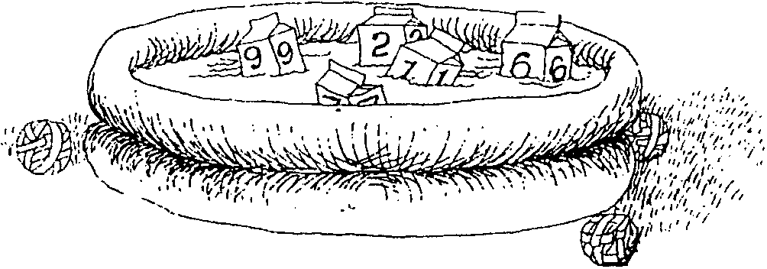

See Cub Scout Leader How-To Book for:
“Water Balloon Toss” p. 9-6
“Dip, Drip, and Dump” p. 9-6
Water Games pp. 2-44 to 2-47

OH WE LIKE TO PLAY IN THE WATER
(Tune: For He’s a Jolly Good Fellow)

Oh, we like to play in the water
We like to play in the water
We like to play in the water,
And get each other wet,
And get each other wet,
And get each other wet,
Oh, we like to play in the water
And get each other wet.

VARIATIONS:
And get our mother wet,
And get our brother wet,
And get our Cubmaster wet.

A SWIMMING WE WILL GO
(Tune: A-Hunting We Will Go)

A-swimming we will go,
A-swimming we will go,
Gather all the Cub Scouts,
A-swimming we will go.

A-stroking to and fro,
Beware the undertow.
Safety first--wise word to know,
A-swimming we will go.

WATER SAFETY
(Tune: Clementine)

In the ocean, in the home pool,
In a lake or in a tub,
Where there’s water, there is danger,
Even in a shower scrub

If you plunge down to the bottom
Of the ocean, cool and green,
You must take some swimming lesson,
For you’re not a submarine.

TALL AND WIDE
(Tune: Deep and Wide)

Tall and wide, tall and wide,
The waves are crashing, tall and wide.
Tall and wide, tall and wide,
The waves are crashing tall and wide.

Hand motions:
tall - hands in front, one up, one down
wide - arms spread out in front of you
waves - ripple hand in front of you
crashing - clap hands together
Repeat song, each time leaving off an additional one of the four words, doing only the hand motion in its place.

WATER WATER EVERYWHERE
(Tune: Row, Row, Row Your Boat)

Water, water everywhere,
But not a drop to drink.
Pull the plug and watch it swirl
Slowly down the sink.

Water water everywhere,
There’s puddles on the floor.
Watch the crazy Cubmaster
Go sliding out the door.

Water, water everywhere,
Make a regatta boat.
Put it in the raingutter
And watch it float and float.

Water, water everywhere,
Rain is falling down.
Catch some raindrops in your mouth
And watch your tonsils drown.

Water, water everywhere,
And now our song is done.
Hit us with some water balloons,
Getting soaked is really fun!

GIANT SOAKER
(Tune: Are You Sleeping)

Giant Soaker, Giant Soaker,
Super deluxe water gun,
Saw it at the store,
As I walked in the door.
I want one, I want one.

Giant Soaker, Giant Soaker
Sure looks fun, that water gun.
Squirt it at my brother,
Maybe squirt my mother.
Watch them run! Watch them run!

Giant Soaker, Giant Soaker
Here I come, here I come.
I’m bringing all my money
To buy that shiny funny
Water gun, water gun.

Giant Soaker, Giant Soaker,
Now I’m wet, dripping too.
Aimed it at my brother
Didn’t know my mother
Bought one too, she soaked me through.

OLD SWIMMING HOLE
(Tune: Turkey in the Straw)

An old swimming hole and a swing in a tree
Was the water fun that used to be.
But it’s cement ponds and squirt guns too
And water balloons for boys in blue.
Water polo and basketball too,
Raingutter regatta to name a few.
It may not be the old swimming hole
It’s much more fun for us to behold.

See Cub Scout Songbook for:
“Row, Row, Row Your Boat”
“The Swimming Hole”

DO YOU KNOW HOW TO SWIM?
(Tune: Do Your Ears Hang Low?)

Do you know how to swim?
Do you know how to float?
Can you lay on your back
And make like a boat?
Can you dive off a board
And not lose your shorts?
Do you know how to swim?

THE FISH WENT SWIMMING
(Tune: The Ants Go Marching)

The fish went swimming one by one,
Hurrah, hurrah!
The fish went swimming one by one,
Hurrah, hurrah!
The fish went swimming one by one,
The little one swam toward the sun
And they all went swimming deep in the sea
To be happy and free
Swish, swish, swish....

(2 x 2)
The little one stopped to see the view
(3 x 3)
The little one swam wild and free
(4 x 4)
The little one swam to the ocean floor
(5 x 5)
The little one watched some people dive
(6 x 6)
The little one did some gliding tricks
(7 x 7)
The little one asked, “Are there seas in heaven?”
(8 x 8)
The little one saw a line with bait
(9 x 9)
The little one made a “No Fishing” sign
(10 x 10)
The little one went back to “school” again

HULA HOOP SPRINKLER

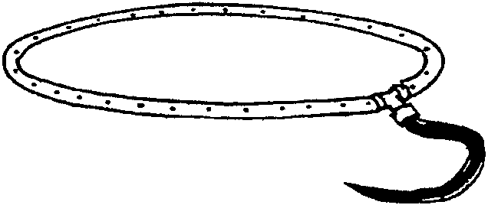
With your den, make one and have FUN! Put this sprinkler on the ground or hang it upside down. Boys can decorate it with permanent markers.

Materials: Hula hoop; Hammer; Long nail; PVC fitting; Hose; Hose connector; Hose washer.

- With a hammer and nail, punch holes all around one side of the hula hoop, about 1 or 2 inches apart, being careful not to hammer through to the underside.
- Cut through the hoop and attach each open end to the PVC fitting.
- Hook it up to your garden hose with the connector and washer.
- Now you are ready to get WET and go WILD!

SAILBOAT SUN CATCHER

Material: Transparent pony beads (red, yellow, turquoise, clear with blue flecks); Cotton cord or rug yarn; Dowel.

- Tie a piece of cord to a dowel. The cord has to be long enough for 18 beads plus knots on both ends.
- Following the pattern vertically, string transparent pony beads onto the cord.
- Make a big knot at the end so the beads do not fall off.
- Repeat for each vertical line of beads.
- Hang the sun catcher in a window to see the light show.

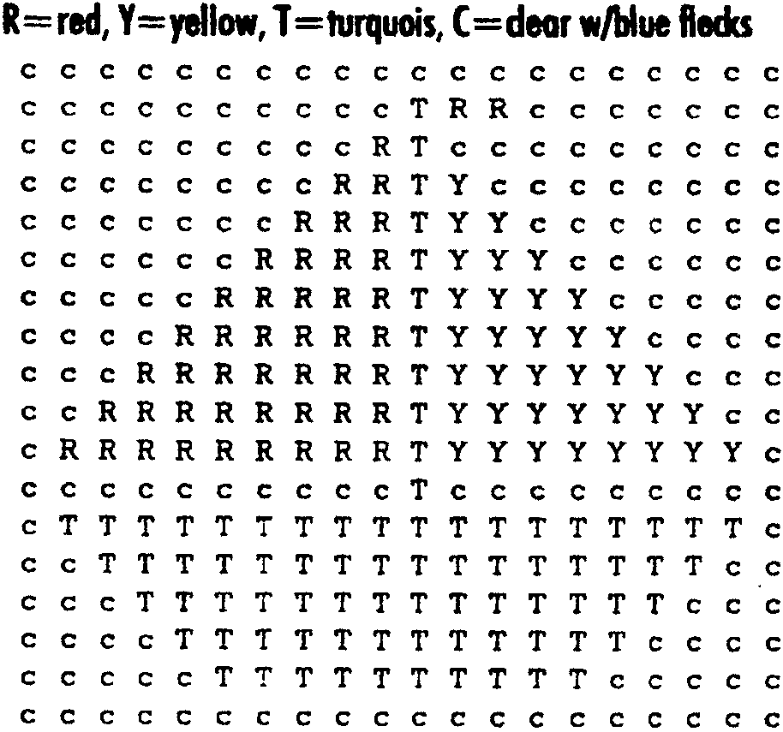

FILM CANISTER BUBBLE BLOWERS

Materials: A film canister; A pony bead; 1/2” x 1 3/4” rectangle plastic canvas; String or cord (to hang the blower around the neck); Glue gun; Bubble solution (see below)

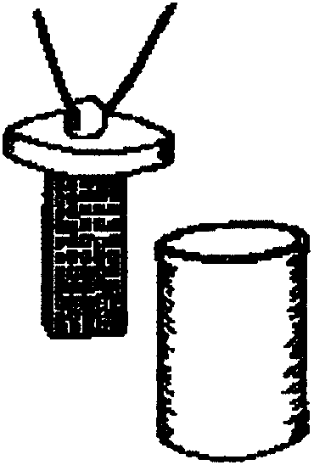
- Glue long ends of plastic canvas to make a tube (don’t use too much glue).
- Glue the tube to the inside of the lid.
- Glue the side of the bead to the top of the lid.
- Thread the string through the bead. Tie ends to form a necklace.
- Fill the film canister with your favorite bubble solution.
- Dip the plastic canvas into the bubble solution.
- Blow. Enjoy!
- Store around your neck with lid tightly closed.

SUPER BUBBLE SOLUTION
In a jar, gently stir together 2 1/2 cups of water, 1 cup of Dawn or Joy dishwashing liquid and
1 tablespoon of glycerin (optional, available in most pharmacies or candy supply stores).

FISH

Make a few and hang them outside.
Make a fish mobile--make a few in different sizes and hang them from a coat hanger.
Make a den school of fish--attach each boy’s fish to a pole and take it to the pack meeting.

- Fold a piece of construction paper in half lengthwise.
- Draw a half fish shape along the fold as shown.
- Pencil in a curve 1/2” inside the fish shape, following the outline of the fish.
- Draw vertical lines 1/2” apart from the fold to this pencil line.
- Cut out the outline of the fish along your outside lines.
- Then cut along the vertical lines, from the fold, being careful not to cut through the 1/2” border.
- Unfold and bend every other strip the opposite direction.
- Decorate as desired. (Or for a different effect, decorate the paper before you draw your fish on it.)

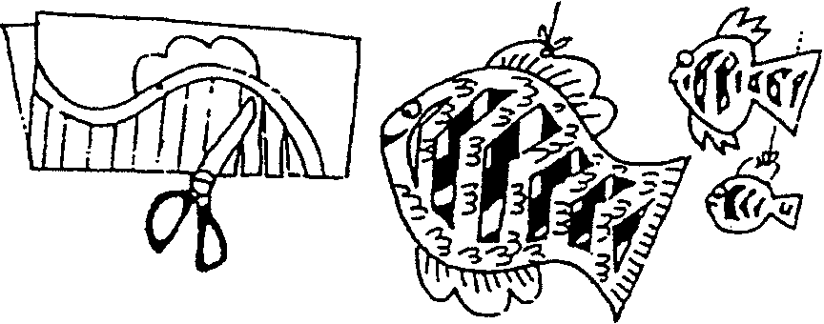

ZANY SUNGLASSES

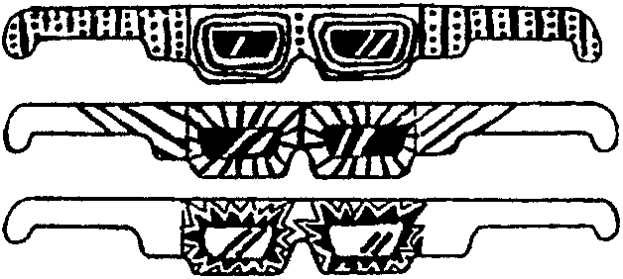
Materials: Poster board; Cellophane; Markers; Scissors; Glue.

- Enlarge patterns to appropriate size.
- Trace pattern onto poster board and cut out glasses.
- Decorate as desired with permanent markers, glitter glue, small stickers, etc.
- Cut cellophane to cover eye opening and glue to inside of glasses.

SUBMARINE

Materials: One 2-liter plastic bottle; Duct tape; 12” piece of plastic tubing; 24” piece of plastic tubing; Clay.

1. Remove cap from bottle.
2. Cut around bottle 2” from bottom. (Need adult’s assistance)
3. Push both pieces of tubing into the bottle through the neck and secure with clay (seal well). Bend the short piece around and tape it to the outside of the bottle.
4. To make it float properly add a large wad of clay inside the bottle, on one side. Be careful not to plug tubes.
5. Replace bottom of bottle, tape in place.
6. Place submarine in water. Blow into long tube to make it rise and suck air out to make it sink.

SEASHELL CANDLES

Fill pot with about 1” of water and put it on the burner of a stove. Put the wax in a tin can and set the can in the pot of water. Wax is very flammable, so it’s very important to never put it in a pot directly over the heat. If you want to color the wax, add crayons to the tin can.

Lay several sheets of newspaper on the countertop near the stove. Set the shells on the newspaper. Prop them up using wads of newspaper so that they don’t tip when your pour the wax. Slowly and carefully pour the melted wax into each shell. Let the candle cool for about 5 minutes, until they begin to look frosty on top. Poke a birthday candle down into each candle. If the birthday candle is too tall, remove immediately and trim. Re-insert it back into the candle and continue to let it cool.

PAPER CUP

You can make a paper cup from a square sheet of paper. Butcher paper works well. Use it at your picnic for water or a scoop of ice cream!

- Fold the paper in half diagonally.
- Fold the left corner over to the right side.
- Fold the right corner over to the left side.
- Fold down the top front flap.
- Flip the cup over and fold down the other top flap.
- Open your cup, fill it with water and take a sip!
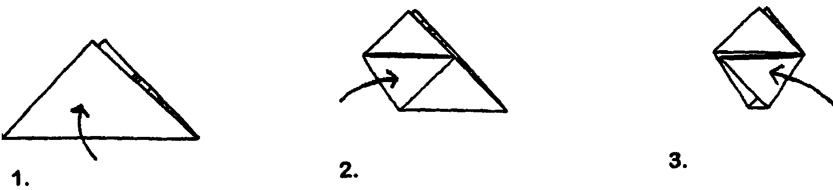
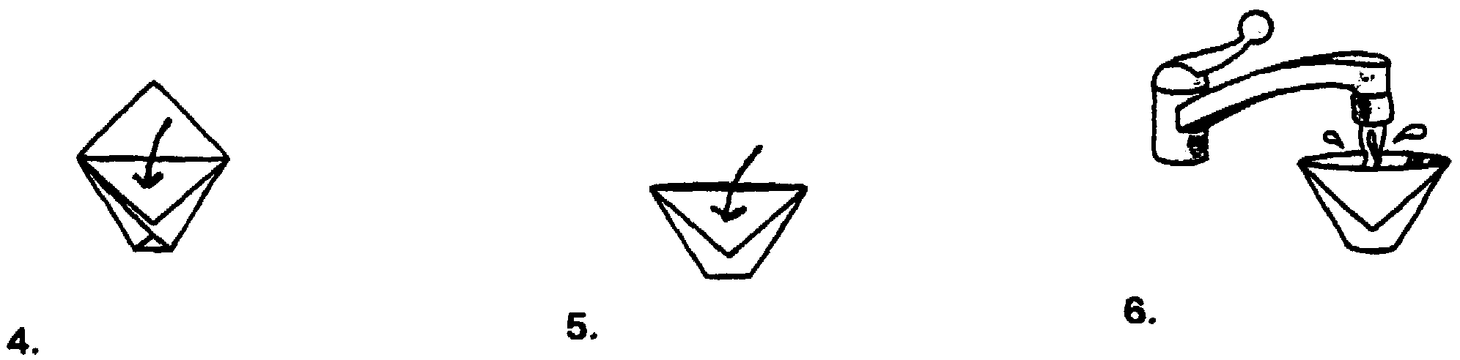

WAVE BOTTLE


Material: Salad oil; Water; Clear 2-liter bottle; Food coloring.

- Fill bottle one third full of oil.
- Fill the rest of the bottle with water (it must be full to the top).
- Add a few drops of food coloring.
- Screw cover on TIGHT.
- Hold the bottle on its side and gently rock back and forth. You should see small waves form and ‘break’ inside the bottle.

DEHYDRATED WATER NECKERCHIEF SLIDE

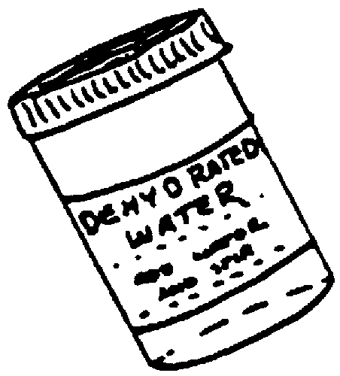
Use a clear film canister (Ask for them at photo shop or drug store which handles film developing).
Make and attach a label that says:

DEHYDRATED WATER
Directions:
Just add H2O
Stir until clear

Use hot glue or epoxy to attach a PVC pipe loop or a pipecleaner ring to back of the canister.

TIC TAC CONTAINER AQUARIUM SLIDE

Materials: Empty Tic Tac container; Tiny fish stickers (or make your own tiny fish); Blue cardstock paper; Markers; 1/2” PVC pipe.

- Remove label from container. Take off white lid.
- Cut the cardstock to fit inside the container. Draw background on the cardstock , plants, rocks, etc. (see example). Place several fish stickers.
- Slide the background into the container.
- If desired, put small fish tank rocks in bottom.
- Glue fish stickers to inside of front to give a dimensional look. Use tweezers to do this.
- Replace white top and glue on a PVC pipe section to the back.

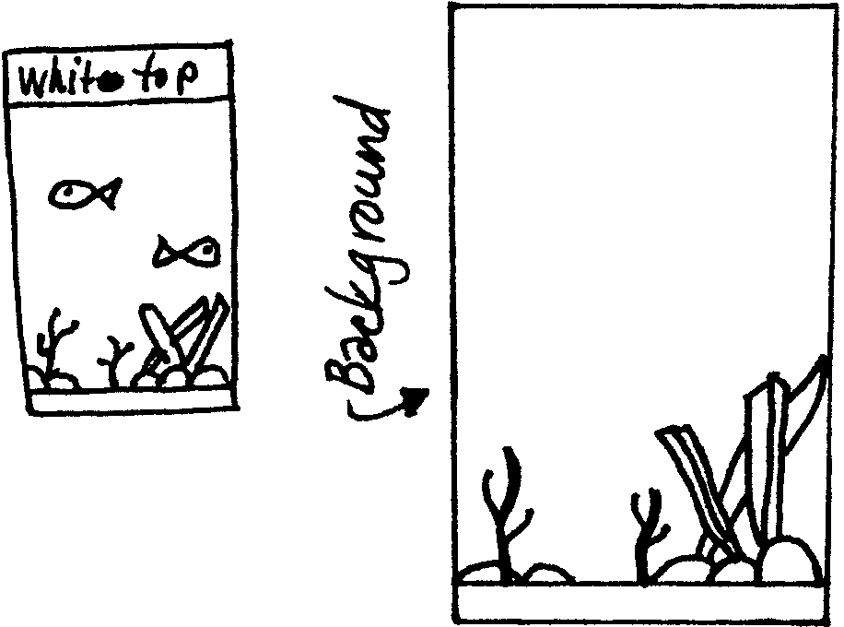
LIFE PRESERVER NECKERCHIEF SLIDE

You will need: 1 ring, made of foam or styrofoam (2" across, 1/4" thick, 1" hole in center); 6" white string; 3" pipe cleaner for backing; Red tape, 3/8" wide; White paint.

Paint ring and allow to dry. Wrap string around outside of ring, and secure with red tape in four locations, forming a cross. Bend pipe cleaner and poke in back of ring to form slide-back (you may want to secure the pipe cleaner ends with glue).



WILD SEA KRITTER NECKERCHIEF SLIDE, PIN OR MAGNET

Materials: Wooden or craft foam shapes (ovals, squares, stars, teardrops, etc.); Acrylic paints, puff paint and/or permanent markers; Wiggle eyes; Glitter; Glue; 1/2” PVC pipe, strip magnet or pin back.

1. Arrange pieces to form crazy sea creatures.
2. If you are using wood shapes, paint the wood. (Permanent markers are easy to use and boys don’t have to wait for it to dry.)
3. Glue the pieces. Let dry.
4. Decorate with glitter, fine-tip markers, wiggle eyes, etc.
5. Glue on a section of PVC pipe, magnet or pin back.

WATERMELON ON A STICK

Watermelon pieces, seedless
Orange juice
Water
Paper cups
Popsicle sticks

1. Mix in a blender, one cup each of seedless water melon pieces, orange juice, and water.
2. Pour into paper cups and place in freezer. Insert popsicle sticks when partially frozen.
3. When completely frozen, remove the treat from cup and ENJOY!

CREAMSICLE ICE CREAM

1 small can orange juice concentrate, semi-defrosted
½ gallon ice cream, vanilla flavored, semi-soft

Mix together until almost blended. Should be streaked. Refreeze until consistency of frozen ice cream. YUM!

PIZZA BOATS

2 pita bread rounds
1 cup pizza sauce
Grated Parmesan cheese
2 cups shredded mozzarella cheese
Sliced pepperoni

- Cut each pita bread round in half.
- Spread ¼ cup pizza sauce inside each pocket.
- Sprinkle Parmesan cheese on sauce.
- Stuff each pocket with ½ cup mozzarella cheese and pepperoni.
- Place pockets on baking sheet and bake at 400º for 5 minutes or until cheese melts.

FRUIT CANOES
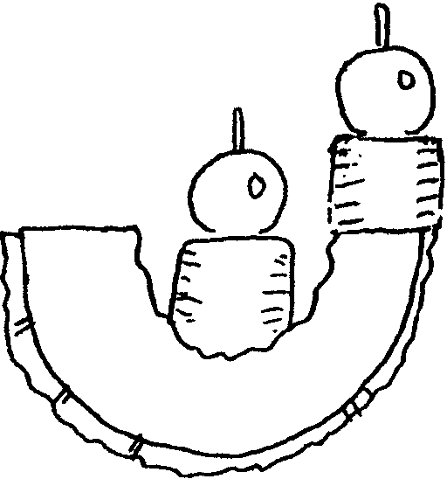
1 cantaloupe
2 large bananas
12 grapes
Toothpicks

Cut cantaloupe into six wedges. Slice each banana into six chunks. Spear grape with toothpick, then add banana chunk below it. Stick two of these “passengers” into each cantaloupe canoe.

