Man’s Best Friend

March 2001

CONTENTS

THEME RELATED 1
DEN AND PACK ACTIVITIES 1
PET DAY 1
VIRTUAL PET SHOW 1
GOOD TURN 1
GUEST SPEAKER 1
FIELD TRIP IDEAS 1
PARTICIPATION AWARDS 1
ONLINE RESOURCES 2
THE DOG’S COLD NOSE 2
PREOPENING 3
PETS WORD SEARCH 3
PET FROG MAZE 3
BINGO’S BINGO 4
CEREMONIES 5
FRIEND--OPENING 5
MAN’S BEST FRIEND OPENING 5
THE WONDERFUL ZOO OF LESTER
MCGOO--OPENING 6
FRIENDS--CLOSING 7
“PUPPIES FOR SALE”--CUBMASTER’S
MINUTE 7
HELPING OTHER PEOPLE CLOSING 8
MAN’S BEST FRIEND ADVANCEMENT
IDEAS 8
BEST FRIENDS ADVANCEMENT 9
WILD “ANIMALS” ADVANCEMENT 10
FUN WAYS TO SAY THANK YOU 11
AUDIENCE PARTICIPATION 12
THE LOST LIZARD 12
FREDDIE’S DILEMMA 13
SKITS 14
INVISIBLE PET 14
BONE 14
LOST DOG 15
THE LOST PET 15
GAMES 16
DOG TEAM RELAY 16
ANIMAL RELAY 16
POOR KITTY 16
PET HIDE AND SEEK 16
PET BIRD 16
PET MIX-UP 17
BOBCAT’S MEOW 17
GUESS-A-PET 17
I ADORE MY PET GORILLA 17
CAT AND DOG RELAY 17
DOG AND BONE 18
I’VE LOST MY DOG 18
STREAMER BALL 18
DOG HOUSE 18
SONGS 19
MAKE-YOUR-OWN DEN PET SONGS 19
THERE IS A CUB SCOUT WHO HAS
A PET 19
I LOVE MY PET 19
BEAN-DOG SONG 20
WHEN THE DOGS COME RUNNIN’ IN 20
JOHNNY HAD A LITTLE DOG 20
WRONG END 20
MAN’S BEST FRIEND 21
FROGGIE 21
CRAFTS 22
PAGE PETS 22
INVISIBLE DOG LEASH 22
GOLF BALL DOG PAPERWEIGHT 22
PET BLOCK 23
CAT GRASS 23
CRITTER CRATES 24
FRIENDLY NOTE HOLDER 24
FRIDGE FRAMES 25
TOYS FOR YOUR PET 25
PINE CONE POOCH TIE SLIDE 26
DOG BISCUIT NECKERCHIEF SLIDE 26
CUBS IN THE KITCHEN 27
GOODIES FOR BOYS TO EAT 27
BIRD NESTS 27
PINK FLAMINGO 27
BANANA DOGS 27
GOODIES FOR PETS 28
CAT CRACKERS 28
DOGGIE BITES 28
DOG-FOOD CAKE 28
CAT ‘PURR’ITOS 28

DEN AND PACK ACTIVITIES

PET DAY
If the pack elects to have a pet show, it is best done in a special meeting separate from the pack meeting, or arrange to have pets to be taken home after a brief show-and-tell. Having animals in a place that is strange to them with a lot of people and other animals they are not familiar with does not create an agreeable situation for men and beasts, and it can be unkind to the animals.

VIRTUAL PET SHOW
Instead of having a real pet show, boys bring drawings or photos of their pet (see Bear Elective 11). Set up an area in the room where the boys can display their “pets.” People can go around the area looking at the virtual pets. Each boy stands next to his pet’s photo and talks about his pet. They can also bring one or two of their pet’s favorite toys, food, or maybe a taping of the pet’s voice. Those boys who do not have pets may create imaginary ones (pet dinosaur? pet gorilla?) and have a showing with drawings and other paraphernalia.

GOOD TURN
Collect old blankets, dog biscuits, and toys for the Humane Society of Santa Clara Valley. Call and ask what items they could use most.

GUEST SPEAKER
Ask a veterinarian come to your pack meeting and talk about the importance of caring for your pets properly.
Sam’s Downtown Feed Shop (Animal care)

FIELD TRIP IDEAS (For details, see the FIELD TRIPS section)
Zoos: Happy Hallow Park and Zoo, Oakland Zoo, San Francisco Zoo
Youth Science Institutes: Alum Rock Park, Sanborn-Skyline County Park, Vasona County Park (all listed under Youth Science Institute in the FIELD TRIPS section). These are junior museums, informative and fun for the children. If you want a special talk with docents, call ahead.
Veterinarians: Ask veterinarians if your den could visit them.
Sam’s Downtown Feed Shop, San Jose
Aquarium
Pet supply shops: Ask your neighborhood pet supply shops if your den could visit them.

PARTICIPATION AWARDS (For details, see the PARTICIPATION AWARDS section)
Cub Scout Academics: Art
Use your pet as a subject for your various art works.

ONLINE RESOURCES

- The American Pet Association: http://www.apapets.com
An independent, national humane organization dedicated to promoting responsible pet ownership through action, services and education
- The American Society for the Prevention of Cruelty to Animals: http://www.aspca.org
- Humane Society of the United States: http://www.hsus.org
- Nike Animal Rescue Foundation (N.A.R.F): http://www.narfrescue.org
A rescue society for dogs, cats and horses.
- American Veterinary Medical Association: http://www.avma.org/care4pets/
About pets and pet care.
- Bug Club: http://www.ex.ac.uk/bugclub/bugpets.html
About bugs, bug pet care sheets on how to care for your bug pets.
- The Electronic Zoo: http://www.netvet.wustl.edu/e-zoo.htm
- Animal Network: http://www.animalnetwork.com
- Animal Encyclopedia: http://www.birminghamzoo.com

THE DOG’S COLD NOSE

Did you ever wonder why a dog has a cold nose? Here’s one theory given by Arthur Guiterman. (This poem can be used as part of ceremony--example of helpfulness--or as a skit.)

When Noah, perceiving ‘twas time to embark,
Persuaded the creatures to enter the ark,
The dog with his friendliness truly sublime,
Assisted in herding them. Two at a time.
He drove in the elephants, zebras and gnus,
Until they were packed like a boxful of screws.
The cat in the cupboard, the mouse on the shelf,
The bug in the crack; then he backed in himself.

But such was the lack of available space
He couldn’t tuck all of him into the place;
So after the waters had flooded the plain
And down from the heavens fell blankets of rain
He stood with his muzzle thrust out through the door
The whole forty days of that terrible pour!
Because of which drenching, zoologists hold,
The nose of a healthy dog always is cold!

PETS WORD SEARCH

Find all these pets.

K R A B B I T D C
T O N I C P H E A
U H X R Z R A T H
R K P D O G M F O
T Q E L F I S H R
L V T O C G T J S
E W S N A K E M E
R O C K T S R V Z

BIRD
CAT
DOG
FISH
HAMSTER
HORSE
PETS
RABBIT
ROCK
SNAKE
TURTLE

PET FROG MAZE

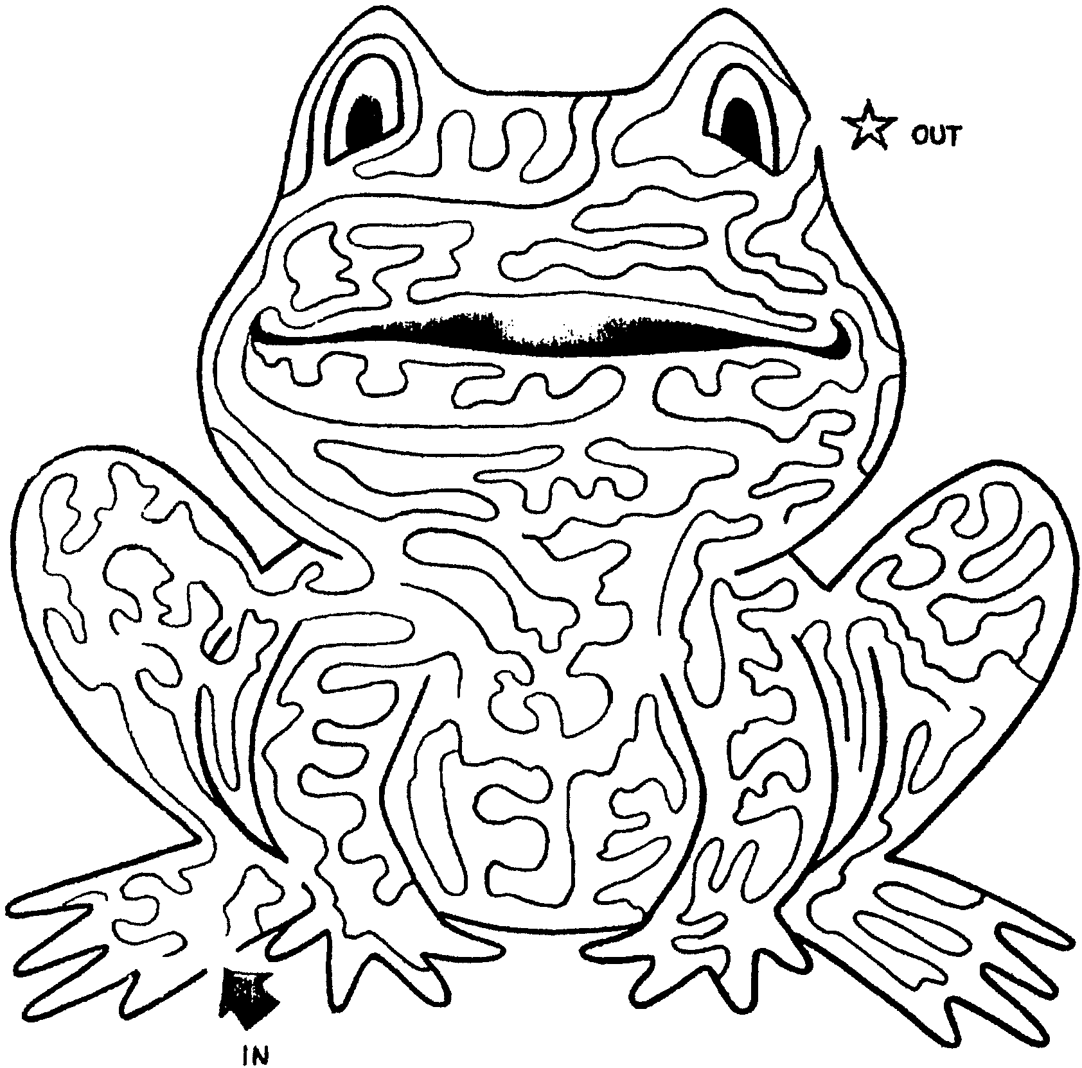

BINGO’S BINGO
(pack pre-opening game)

Find someone to sign or initial the squares below.
Each person can sign your sheet only once, and you can’t sign your own.
Get five in a row vertically, horizontally, or diagonally for a bingo.
When you have a bingo, shout “Bingo!”
Then continue getting more people to sign. How many more bingos can you get?

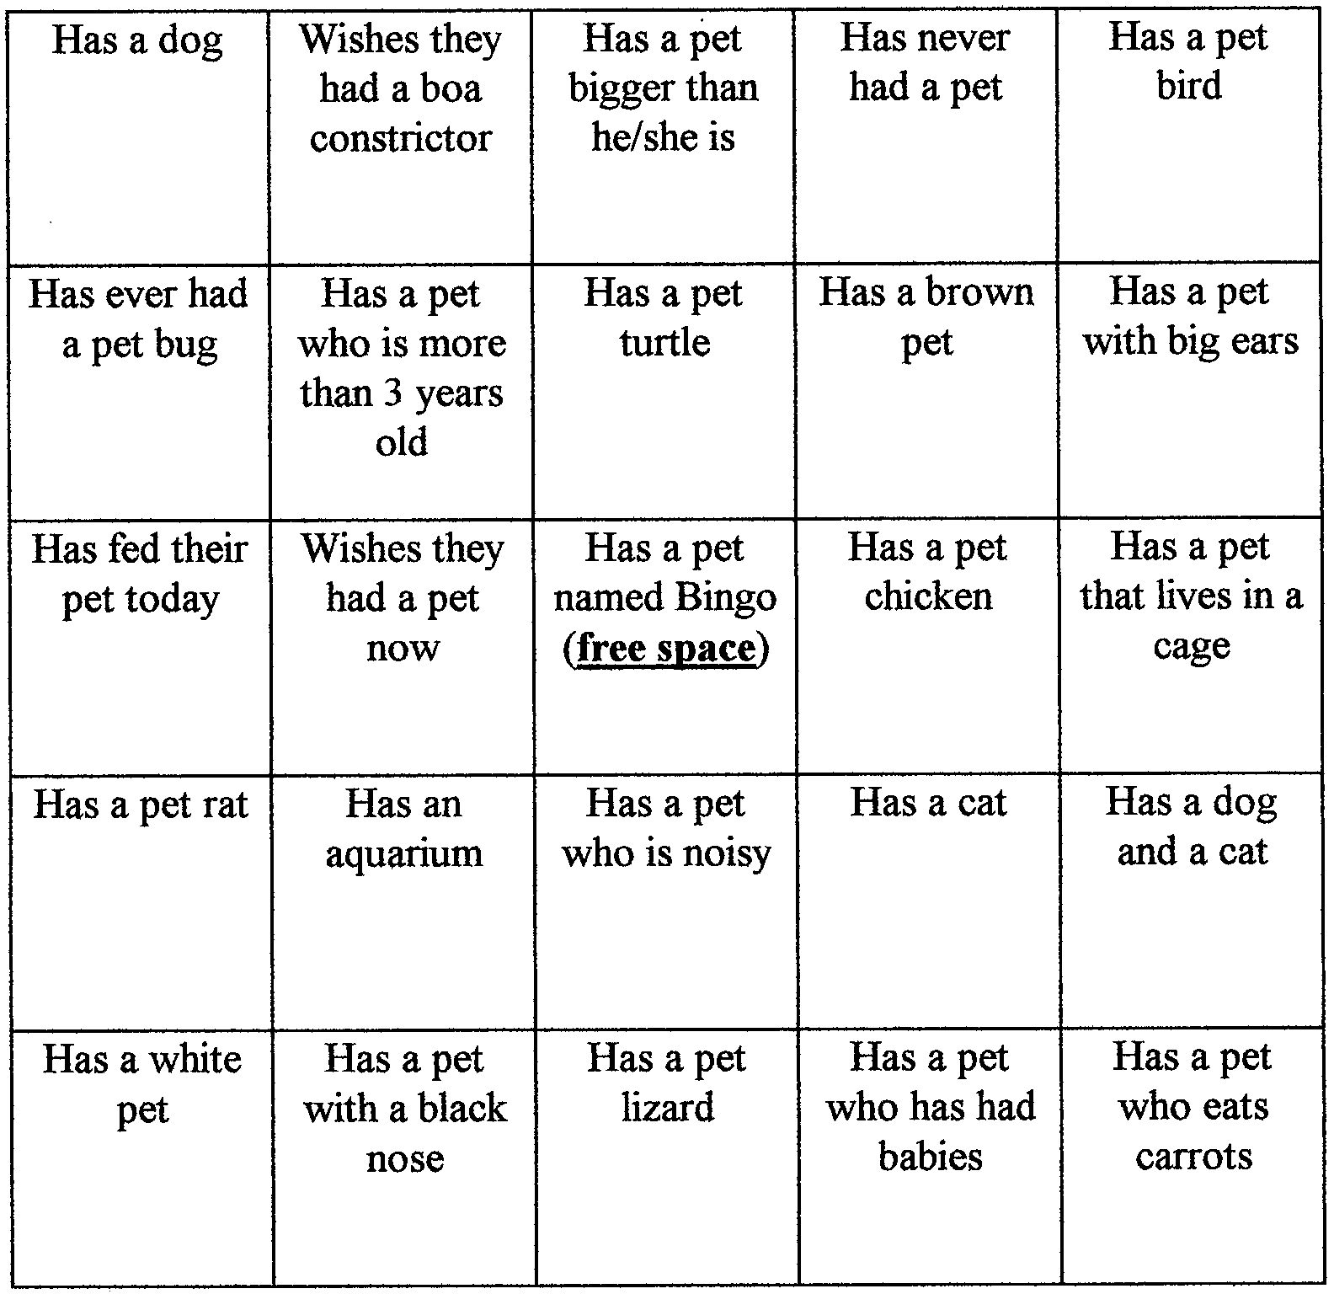

As people arrive, give a copy of this bingo with the instructions above. Note who got the first bingo. During the meeting recognize that person as well as the one who has the most bingos and the person who got the most squares filled.

FRIEND--OPENING

Props: Cue cards with the lines printed on one side, large letter visible for the audience on the other side. Cub Scouts will hold cards down at their sides until time to read the card, then hold it up so the audience can read the big letter while he reads his line.

F A Friend just like Family, I welcome you into my home.
R I learn Responsibility by taking care of you.
I I look forward to seeing you.
E You are always Excited to see me, and I am Excited to see you.
N You stay Near me, even when I am busy with other things.
D Day and night, my best friend is my pet.

MAN’S BEST FRIEND OPENING

Arrangement: Each Cub Scout holds a picture of the animal he is talking about. If desired, other animals can be added or substituted to make the ceremony more personal.

Leader: When you hear the term “man’s best friend,” you think of dogs. Tonight we’d like to tell you about some other of man’s best friends.

C.S.#1: A cat can be a friend. My cat likes to curl up on my lap and purr. He likes to swat at his toy mouse and chase after a piece of string that I pull.

C.S.#2: A fish can be a friend. You might think that all a fish can do is swim around in his tank, but my fish makes me smile when he makes funny faces.

C.S.#3: A rabbit can be a friend. I like to watch my rabbit wrinkle up his nose, munch on carrots and hop around.

C.S.#4: Some of our animal friends are out of the ordinary. You could have a pet that is a slithery snake, or a little white mouse, or a high-hopping frog.

C.S.#5: Of course, we can’t forget our friends the dogs. My dog is my friend because he loves to run and play with me. We both love to dig in the dirt and snooze in the shade. I always know he is happy to see me when he wags his tail.

Leader: Tonight, we will celebrate all kinds of pets. Let the festivities begin!

THE WONDERFUL ZOO OF LESTER MCGOO--OPENING
(by Debbie Summerhalder, Utah National Park Council)

This is written in the style of Dr. Seuss. It can be read by one leader, divided into parts and read by two or more leaders, or even read by Cub Scouts. For a fun twist, ask the boys to draw pictures of the “animals” prior to the pack meeting, then display them at the appropriate point. (This can be used as a puppet play--either omit the last two lines or rewrite them. Using their imagination, boys can make stick puppets.)

I know a boy named Lester McGoo,
Who has so many pets, his yard looks like a zoo.

Now Lester doesn’t have mice, dogs, or cats,
Or birds or fish or anything normal like that.

His pets are exotic, different, never before seen.
You might think you were in a very weird dream!

There’s a Blabber-labber-loo, spotted orange and green,
With the longest neck that you’ve ever seen.

The Zizzer, the Zazzer, the Zuzz and the Zee
Have tails filled with eyes, and they’re looking at me.

There’s a Burple that’s purple, a Zed that is red,
And the black Koo-ba-lack has a horn on his head.

There are tall Glubes and short Lubes and miniature Knubes,
Smiley faced Waller-lubes who are really cool dudes.

Now I haven’t the time to tell of the Zorks,
The Quoobers, the Darnoos or the Goo-ga-ma-rorks.

So after this meeting, visit Lester McGoo,
You’ll be awed and amazed at his very odd zoo.

Tonight we’ll have fun learning all about our pets,
We’ll sing and play games and have fun, you can bet!

But don’t be surprised if, peeking through the door,
You see Lester McGoo and his blue Scout-a-roar!

FRIENDS--CLOSING

C.S.#1: My best friend is my pet dog. I walk him, feed him, water him, and brush his fur to keep him clean. My folks take him to the vet to get his shots. He thanks me by being my friend by saying “Bow-wow-wow-wow” (Continues to bark)

C.S.#2: I learn responsibility by taking care of my cat. I care for her. I like to hear her purr when I pet her. She thanks me by saying, “Meow-meow-meow” (Continues to meow)

C.S.#3: I care for my friend, the snake. I keep him in his cage and watch him slither around. He doesn’t make much noise but when he does it sounds like “Hiss-sssss-sssss” (Continues to hiss)

C.S.#4: I care for my bird, and my bird is my friend. I clean his cage everyday and hear him say, “Tweet-tweet-tweet-tweet” (Continues to tweet)

C.S.#5: I care for my hamster. I feed him and watch him running in his wheel, squeaking like this all night long “Squeak, squeak, squeak” (Continues to squeak)

Cubmaster: These Cub Scouts learn to be friends by being a friend to a pet. There are many different kinds of pets out there, just like there are many different types of friends. By being kind and responsible for our pets, we learn to be kind and responsible to our friends, too.

“PUPPIES FOR SALE”--CUBMASTER’S MINUTE

A man was putting up a sign which read: “Puppies for Sale.” And before he had driven the last nail, there was a small boy standing at his side. That kind of sign seems to attract small boys. The youngster wanted to know how much the puppies were going to cost. The man told him they were very good dogs and that he did not expect to let any of them go for less than $35 or $40. There was a look of disappointment and then a question: “I’ve got $2.37, if I give you all of it, could I just look at the puppies?”

The man whistled and called, “Lady!” Out of the kennel and down the lane came the mother dog followed by five little balls of fur, with one lagging considerably behind. The boy spotted the laggard right away and pointing to it, asked, “What’s wrong with him?” The reply was that the veterinarian had said there was no hip socket in the puppy’s right hip and that the animal would always be lame. The boy’s immediate response was, “Then that’s the one I want to buy! I’ll give you $2.37 down and 50 cents a month until I get him paid for.” The man smiled and shook his head. “That’s not the dog you want. That dog will never be able to run and jump and play with you.” The boy, very matter-of-factly, pulled up his little pants leg and revealed a brace running down both sides of his badly twisted right leg and under his foot with a leather cap over the knee. “I don’t run so well myself,” he said, “and he’ll need someone who understands him.”

HELPING OTHER PEOPLE CLOSING

When we say the Cub Scout Promise, we promise to help other people. Some dogs are known for their ability to help people. Tonight, I’d like to tell you about one of these dogs.

Long ago, the only way to travel from country to country in Europe was through dangerous mountain passes. Many people died when they became tired, fell asleep and then froze in the snow. Blizzards and avalanches also killed many.

Some monks who lived near one of the mountain passes between Switzerland and Italy used a special dog to go out and search for travelers who were in trouble. This dog was the Saint Bernard.

The most famous of all the St. Bernards was named Barry. Barry lived about 175 years ago. This brave dog helped to save the lives of forty people. He once saved a little boy who was trapped on an icy mountain ledge. The boy was asleep and freezing. Barry covered him with his warm body and licked his face to wake him up. When the boy awoke, he climbed onto Barry’s back, and was carried to safety by the big dog.

Now, we do not have to perform such brave deeds. Remember, every time you help someone, you are making the world a better place, and living the Cub Scout Promise. Let’s do our best in this coming month to help everyone we meet.

MAN’S BEST FRIEND ADVANCEMENT IDEAS

Attach awards to stuffed or plastic animals. If you have enough animals for the boys receiving the awards, use one toy per boy; otherwise, use one toy per group (Bobcat, Wolves, Bears). Mention the the good qualities of each of the animals. Mention how these qualities are valued among friends, both humans and animals. Example: Dogs are loyal and will be there for you; Birds can sing and make you happy; Goldfish are quiet so they are good listeners!

If all the boys in the pack are receiving some kind of awards, prepare part of the award at the den meeting. Gather old calendars and magazines that have pictures of dogs. Ask boys to find and cutout a picture of a dog that looks like his dog, or that would be his dog if he had one. Have them glue or tape the pictures to cards. Ask them to write a few words to explain why they consider that dog their friend. Make sure to include their names. Attach their awards to the cards. At the ceremony, comment on the dog and the boy’s description. Talk about the ways people make friends with dogs, other animals, and humans.

BEST FRIENDS ADVANCEMENT

Cubmaster: You know, I think that old saying about a dog being man’s best friend is true. My best friend is my dog.
Asst. CM: Goldfish are nice!
Wolf Leader: Not me. My best friends have been Bobcats. But now they all want to be Wolves.
Cubmaster: Wolves!
Asst. CM: I said, goldfish are nice.
Wolf DL: I have a list of my friends here now. They worked so hard that now their wish can come true and they will be Wolves.
Cubmaster: Let me see that list. Will the following Cub Scouts and their parents please step forward? (Calls out list of names)
Cubmaster: Having completed all the requirements and doing your best, I hereby present to you this patch and card to show that you have now become Wolves. (Presents awards and shakes hands)
Cubmaster: Now Wolves, please present these pins to your parents as a token of your appreciation for their support in helping you fulfill your wish. (Hands pins to the boys, who present pins to the parents)

Bear Leader: My best friends all want to become Bears.
Cubmaster: Bears!
Asst. CM: Goldfish are nice.
(Cubmaster repeats process for Bear Scouts)

Webelos DL: My best friends all want to become Webelos.
Cubmaster: Webelos? What kind of pet animal is a Webelos?
Webelos DL: A wild one.
Asst. CM: I still think goldfish are nice.
Cubmaster: (Takes list of Webelos Scouts from den leader and repeats process)

Cubmaster: In conclusion, this special award goes to our Assistant Cubmaster, the Friends of the Goldfish award! (Hands him a bag of Goldfish crackers)
Asst. CM: My favorite!

APPLAUSES

CAT’S MEOW APPLAUSE: Groups yells, “You’re the cat’s MeeeeOOOOOOW!!!” to a person receiving the applause.

CAT STRETCH APPLAUSE: Have the group start in their chairs, move hands and arms slowly upward until they are as far above their heads as possible, then stretch out their legs as far as possible, then stand and arch their backs and say “Purrrrrfect!”

WILD “ANIMALS” ADVANCEMENT

Props: Large cutouts of each rank badge or pictures of the real animals mentioned.

(This ceremony should be conducted by the Cubmaster in a story telling fashion, not just reading the ceremony.)

Bobcats
Tonight, I would like to introduce you to the Bobcat. The Bobcat is a small animal, about 3 and 1/2 feet long, or shorter. The Bobcat is hard to find, especially between the hours of 3 and 5, when it’s time to take out the trash, cut the grass, or take a bath. It hides behind trees, under beds, or behind an imaginary tank or truck waiting for the enemy to pass.

The Bobcat feeds on hamburgers, hot dogs, tacos, cakes, candy and hunts for food wherever he can find it. Most of their waking hours are spent on the hunt for these staples of life.

Bobcats can be found in trees, in mud puddles, under piles of leaves, on the roof, or wherever girls aren’t. They can be found as far away as the school playground, or as close as the neighbor’s yard, running through the sprinklers. The Bobcat’s ability to run, jump, and hide is legendary. Television, movies, Walt Disney, or Pokemon have been known to be able to lure this wild creature in close for the catch.

Many a mighty hunter has been foiled in their efforts to tame this strange creature. But we have in our pack a wild animal tamer beyond compare. It’s called a den leader. With their love, understanding, and LOUD voice, they are able to tame this crafty Bobcat into the controllable creature he is today. Now, prepare to be amazed by this unpredictable Bobcat. I present to you our Bobcat, tamed, washed, hair combed and as lovable as he can be, probably with a frog in his pocket and a smile on his face. (Call Cub Scouts and their parents forward and present their awards)

Wolf
Now let me tell you about another animal that roams within our pack. This animal is of the four-legged meat-eating variety. It belongs to the dog family, but is wild. Its reputation of fierceness is well known. This animal, the older brother of the Bobcat and the younger brother of the Bear, runs in packs. Let me introduce you to the Wolf.

When a Wolf pack sets out on a hunt, it is in search of food. The local 7-11 store, McDonald’s or Taco Bell are favorites of this cunning creature. Have you heard the expression “wolfing down his food”? Watch one of these young Wolves as he eats his dinner and you’ll see where that expression came from.

Most Wolf pups are not too ambitious. Running, jumping, and playing are his favorite pastimes. Brushing fangs, grooming hair or tidying up their den are distasteful to the young Wolf.

The average Wolf is about four feet long, not counting the cowlick on his head. Most weigh about 50 pounds, give or take a pizza or two, plus cakes, candy, gum, that frog in his pocket and his Game Boy attached securely to his hand.
WILD “ANIMALS” ADVANCEMENT (continued)

The Wolf, like his relative the dog, can be trained if his training starts early in life. Tonight we would like to present to you some Wolves who started their training early, have finished 12 achievements, and have proven themselves ready to go on to greater things. With pride, I present to you... (call Cub Scouts and their parents forward. Present awards)

Bear
Now, the next member of our Pack animal family is a large furry animal found mostly in northern countries. This animal will eat almost anything. Hamburgers, tacos, hot dogs, a day-old half-eaten donut, and large amounts of bubble gum are some of his favorites. Ladies and gentlemen, may I present the BEAR!

Bears may seem clumsy, but their ability to run or climb trees, especially when asked to help Mom or Dad, disproves this. I’ve seen some bear cubs who could outrun a motorcycle, going uphill, while drinking a soda and eating a triple decker ice cream cone.

A Bear lives at home in a comfy cave, but can be found almost anywhere. Look for him up a tree, in the river or running away from a lawn mower. It likes to sleep late Monday through Friday, but likes to get up before dawn on Saturday and Sunday.

Young Bears are called Cubs. They are playful and full of mischief; but, if one is trapped young enough, it can be trained to do such wonderful things as combing his hair, brushing his teeth, or with luck, leave the TV long enough to eat dinner.

The only bears found in this neighborhood are called Bear Cub Scouts. Our Bear Cub Scouts have been taught many wonderful things about God, Country, Family and Self and are very well trained. They can tell us about wildlife, work with wood, cook some goodies, build muscles, tie knots, and most of all, make us proud.

So it is with great pride that I share with their parents, (name the boys) who have completed their 12 achievements and have earned the rank of Bear. (Award badges)

FUN WAYS TO SAY THANK YOU

Dog bone: “Bonafide” Award (spray small chew toy or bog biscuit gold, maybe with a slide backing)
Paw print: For someone who lent a “Paw.”

Frisbee (Ultimate): For being the “Ultimate.”

THE LOST LIZARD

CUB SCOUT: “I’ll do my best.”
LIZARD: “Scurry, scurry.”
CAP: Pantomime putting on cap
COAT: Pantomime putting on coat

(The audience is told to follow the narrator in pantomime besides doing their assigned parts.)

Once there was a CUB SCOUT who had a pet LIZARD which he kept in a box. One day the CUB SCOUT looked in the box and the LIZARD was gone. “I guess I’ll have to put on my CAP and COAT and look for my LIZARD,” he said. So the CUB SCOUT put on his CAP and his COAT and he put the box in his COAT pocket and went outside to look for the missing LIZARD.

First, the CUB SCOUT looked under the porch (pantomime looking under porch). No LIZARD. Next, the CUB SCOUT looked behind a tree (pantomime). No LIZARD. Then the CUB SCOUT looked in the bushes (pantomime). No LIZARD.

Just as the CUB SCOUT was losing hope of finding his lost LIZARD, the March wind came around the corner of the house and blew the CUB SCOUT’S CAP off. Holding his COAT tightly around him, with the box in his COAT pocket, the CUB SCOUT ran down the street after his CAP (pantomime).

The CUB SCOUT chased his CAP past the fire hydrant to the street corner. After looking carefully both ways (pantomime), the CUB SCOUT ran across the street after his CAP. The wind was blowing strong, so the CUB SCOUT held his COAT tightly around him as he chased the CAP into the park.

Finally the March wind put the CAP down on a rock, and the CUB SCOUT caught up with it. And when the CUB SCOUT picked up his CAP, what do you think he saw? There on the rock, under the CAP, was his lost LIZARD! He picked up the LIZARD, put it in the box, put the box in his COAT pocket, put his CAP on his head and went straight home.

When he got inside the house, the CUB SCOUT took off his COAT and his CAP and took the LIZARD out of the box. To his surprise, he discovered that this wasn’t his missing LIZARD after all. Sitting quietly on his desk, the CUB SCOUT found his own LIZARD.

“Oh well,” said the CUB SCOUT. “I’ll take the new LIZARD to the den meeting this afternoon. Mrs. Smith will put him in our den zoo. Won’t she be proud of me?” And with that, the CUB SCOUT put both LIZARDS in the box and went outside to play...after putting on his CAP and COAT, of course.

FREDDIE’S DILEMMA

FREDDIE: “What’ll I do?”
MOTHER: “Make a magnet, son.”
FIDO: “Ruff, ruff!”
DANNY: “I love science.”

Once there was a Cub Scout named FREDDIE, and he had a problem. His pack was having a Science Fair and he couldn’t decide what to do. He talked it over with his MOTHER. His MOTHER said FREDDIE should make an electromagnet. But FREDDIE thought that was a dumb idea. FREDDIE talked it over with his dog FIDO. FIDO wanted him to make dog biscuits, but FREDDIE thought that sounded yucky.

So FREDDIE set out to find a really neat project. FIDO went along. FREDDIE didn’t even tell his MOTHER where he was going. He went to DANNY’S house. DANNY was a member of FREDDIE’S den and he was always doing something crazy.

When he got to DANNY’S house, DANNY was busy in the basement. “Come on down,” called DANNY. “I’m working on my science fair project, and I could use your help.”

“What are you doing?” asked FREDDIE as he looked around at a strange group of boxes, wires, and electrical stuff spread all over the basement. “Does your MOTHER know what you’re doing, DANNY?” “My MOTHER quit snooping around in the basement when she found the giant mouse I made last summer,” said DANNY.

“What is all this?” asked FREDDIE. DANNY explained that he had made a time machine, and it really worked! “I already sent a toy car, a piece of chocolate cake, and my cat, and they all disappeared. I’m trying to talk my little brother into giving it a try,” said DANNY.
“Where do they go?” asked FREDDIE. “I don’t know,” said DANNY. “So far, nothing’s ever come back. Hey, maybe FIDO would like to take a little trip.”
“Oh, no!” said FREDDIE. “It’s time for us to go.”

FREDDIE and FIDO ran for home. His MOTHER was glad to see them and asked if FREDDIE had decided what to do for the science fair. “You bet,” said FREDDIE. “I’m going to make an electromagnet. Come on, FIDO. Let’s get started.”

APPLAUSES

RABBIT APPLAUSE: Place hands on head to resemble rabbit ears. Wiggle your nose and your tail. Hop three times.

SAINT BERNARD CHEER: Point up the mountain and yell, “To the rescue!”

PARROT APPLAUSE: Make wings with your arms, flap and say, “Polly wants to say, You’re GREAT!”

INVISIBLE PET

Cub #1: (Dragging a leash behind him) Come on boy, let’s go.
Cub #2: What are you doing?
Cub #1: I’m taking my dog for a walk.
Cub #3: I don’t see any dog, just a leash that you are dragging along.
Cub #1: That’s because it is an invisible dog.
Cub #2: Invisible dog?!
Cub #1: My mom says I can have a real dog if I learn to be responsible and take care of it. I have to feed him, and walk him and just be his friend. If I do that, then my folks will take him to the vet and get all his shots.
Cub #3: So you are just practicing on a pretend dog at first?
Cub #1: I am now. The pretend elephant was just WAY too much work!

BONE

Scene: All the Cubs except one are on the stage. The last Cub will enter at the end of the skit. Adjust to the size of your den.

Cub #1: Hey, did you hear?
Cub #2: No, what?
Cub #1: (Name of the last Cub) found a dinosaur bone in his backyard.
Cub #3: How do you know it was from a dinosaur?
Cub #1: He said it was from Rex, you know, like in Tyrannosaurus Rex.
Cub #4: How did he find it?
Cub #1: He was digging around in the yard.
Cub #5: Did he call the TV news people?
Cub #2: How big of a bone was it?
Cub #3: We better ask him what happened.
(The last Cub enters)
Last Cub: Hi guys, what’s up?
Cub #4: Tell us about your bone.
Cub #5: Yeah. Is it from a Tyrannosaurus Rex dinosaur?
Last Cub: Oh, that bone. No, it wasn’t from a Tyrannosaurus Rex. It was from Rex.
Cub #1: What other dinosaur is a Rex?
Last Cub: Not a dinosaur. It was my dog Rex! He sure was upset I dug up his bone!

APPLAUSES

PARAKEET AND CANARY APPLAUSE: Divide the audience into two groups, the Parakeets and the Canaries. When you point to the parakeets, they sing “Cheep.” When you point to the Canaries, they sing “Chirp.” When you point to both, they must sing together. See what happens when you go fast or slow.

LOST DOG

Cub #1: (Unhappy with a sad look on his face)
Cub #2: Hey, what’s wrong?
Cub #1: I lost my dog.
Cub #3: Maybe he’ll come home.
Cub #1: No, he won’t. He’s lost.
Cub #4: Why don’t you put an ad in the paper?
Cub #2: Yea, in the lost and found section.
Cub #1: No. It wouldn’t do any good.
Cub #3: Why not?
Cub #1: Because my dog can’t read!

THE LOST PET

Boy: (Enter crying, dragging a dog leash) Waaaaa! Waaaaa!
Man: Little boy, what’s the matter?
Boy: My pet ran away! Waaaaa!
Man: Don’t cry, little boy. I’ll help you find it. What color is your pet?
Boy: Yellow, with black stripes. Waaaaa!
Man: Don’t cry, little man, I’ll have your pet back in no time.
(Search about the stage, muttering to self) Yellow with black stripes...hmmmm...
Boy: I want my pet! Waaaaa!
Man: Maybe he wandered down the street. You just wait here while I go look for him.
(Exit, quickly put on a ragged coat, muss up hair. Enter, running, shouting)
Why didn’t you say it was a TIGER! (Exit, running)

RUN-ONS

“End each run on with ‘Hot Diggity Dog!’”

Boy: Mr. Pet Store owner, I want to buy a dog. How much are these puppies?
Owner: They are $5.00 a piece.
Boy: OK, but I wanted a whole one.

Cub #1: What invention are you working on?
Cub #2: It may sound silly, but I believe it’s a winner.
Cub #1: Really, what is it?
Cub #2: I’ve invented a dog food that tastes just like a mailman’s ankle.

Announcer: We interrupt this program for a spot announcement.
Dog (offstage): Arf, Arf, Arf!
Announcer: Thank you, Spot.

DOG TEAM RELAY

Divide the group into teams of 5-7 boys. One boy is to sit on a paper sack. The remaining boys make up the dog team. The boys must first tie square knots joining several small pieces of rope to form one large one. The combined pieces should be long enough to go around the dog team. The first team to finish wins.

ANIMAL RELAY

Divide the group into teams. Prepare slips of paper with different pets on them. Fold them and place them in a container (like a Cub Scout hat). Make one set for each team. First player runs to the container, picks a slip of paper, and reads it aloud. He then runs back acting like the pet written on the paper.

POOR KITTY

Arrange the players in a circle with one blindfolded player in the center. Have the players quietly move around the circle. The blindfolded player approaches the circle and secures a player from the circle. The player, in a disguised voice, says “Poor Kitty” and then imitates a “meow” of a cat. If the blindfolded player correctly identifies the person, the two trade places. If he fails to identify the person, he releases the person and the game continues.

PET HIDE AND SEEK

Before Cub Scouts arrive, hide peanuts throughout the room. Divide the group into two teams and ask each team to choose an animal name (Dogs, Cats, Birds, etc.) Select a captain to hold a paper lunch bag. On signal, team members begin to hunt for peanuts. When a player finds one, he must make the sound of the team’s animal instead of picking up the peanut. This signals the team captain to verify the find and place the peanut in the bag. Only the captain may touch the peanuts. The team with the most peanuts wins and everyone shares in the bounty.

PET BIRD

Go for a walk with your pet bird! Divide group into teams. You will need a 12” ruler and a fluffy feather for each team. Teams line up relay fashion. Place the feather at the end of the ruler. Players hold the rulers in front of them and walk or run out and around a chair which is placed about 15-20 feet away, then back to the team. If a player loses the feather, he must replace it on the ruler before he continues.

PET MIX-UP

This is played with all the players blindfolded. Divide players into different teams of pet animals. Players are then scattered around the room at random. On signal, the players begin to make their animal calls trying to find their teammates. Players may not make any other noise except the noise that the animal makes. When they find their team members, they link elbows. The first team to find all their members is the winner.

BOBCAT’S MEOW

The players stand in a circle with their hands on their hips. This game is similar to Simon Says. The leader explains that the players must do as he says. Bobcats--meow, Wolves--howl, Bears--growl, but Webelos are very quiet. The leader tries to catch any player who does not follow him. For example, the leader says “Bobcats meow” and players meow; “Bears growl” and players growl; “Webelos meow” and players stay quiet. If anyone meows, he is out of the game and sits down. The last player standing is the winner. The leader leads the meows, howls and growls with vigor and lots of animation so the game is lively and lots of fun.

GUESS-A-PET

All Cub Scouts are instructed to think of unusual pets (one or two per boy). The first boy gives three clues about his animal for others to guess. The Cub Scout who correctly guessed the pet will give clues to HIS pet. Make sure all boys have a chance to introduce their “pets.”

I ADORE MY PET GORILLA

This is an alphabet game. Boys take turns completing the sentence, “I adore my pet gorilla with an A because he is _____,” adding words from A to Z. The first player using the letter A could say, “I adore my pet gorilla with an A because he is athletic (or arty).” The next might say, “I adore my pet gorilla with a B because he’s bouncy.” Older boys can test their memories by repeating each word in alphabetical order. “I adore my pet gorilla because he is athletic, bouncy...” This could become a real tongue twister.

CAT AND DOG RELAY

Divide the group into teams. Prepare one stick, about 4 feet long, for each team. Within teams, pair off boys and line them up relay style behind a starting line. A turning line should be drawn approximately 30 feet away. Give the first pair a stick. They stand back to back and straddle the stick holding it with both hands in front. On signal, the first pairs move towards the turning line with one person going forward and the other backwards. At the turning line, they stop and go back without turning around. They run back to the starting line to give the stick to the next pair.

DOG AND BONE

One Cub Scout is the dog and is located in the middle of the circle. The other boys are in a circle around the dog. Choose some quiet material to be the bone. As the dog hides his eyes, one of the boys creeps up and quietly takes the bone back to his spot in the circle, hiding it behind his back. The dog is then told to find the bone by calling the name of the person he thinks has the bone. He gets three tries. If he guesses correctly the person caught becomes the dog. If he does not correctly identify the person, he remains the dog for the another round.

I’VE LOST MY DOG

Players stand in a circle facing inwards. The leader stands in the center. He addresses one of the players, saying, “I’ve lost my dog.” The player asks, “What is it like?” The leader describes any other person in the ring--trying also to make the description fit a dog. When the questioner guesses the identity of the person described, the one described leaves his place and is followed round the circle by the questioner. Both race in the same direction, each returning to his place. The last to get back becomes the leader.

STREAMER BALL

Let’s pretend we are playing fetch with our pets. Be ready to run!
You’ll be amazed at the height and distance you can get with a streamer ball. Any number of people can play this game. You will need a large playing field, a tennis ball and one nylon stocking. (Cut the leg off of a pair of panty hose to use for the stocking.) Place the tennis ball in the toe of the stocking and tie a knot in the end to secure it.
The streamer ball is whipped underhand or thrown by swinging it over the head and releasing in the desired direction. The underhand method is most accurate. Throw for distance or compete for accuracy by setting up a variety of targets at different distances. You can also use the streamer ball to play catch.

DOG HOUSE

Make a doghouse with a cardboard box. Play a game of rolling cans (“cans of dog food”) or balls.
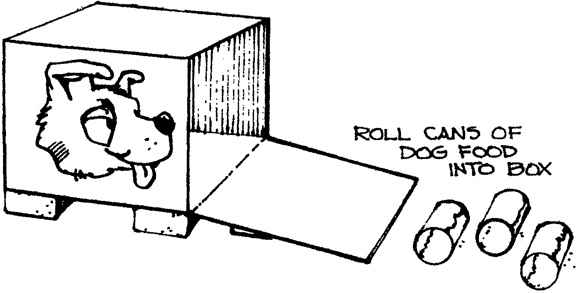

Games
See Cub Scout Leader How-To Book for:
“Cat’s Tail”
“Bird, Beast, or Fish”

MAKE-YOUR-OWN DEN PET SONGS

THERE IS A CUB SCOUT WHO HAS A PET
(Tune: Bingo)
Making a song is fun, especially if the song has something to do with you personally.
Boys who do not have pets can make up songs about their virtual pets.

For lines 3, 4, & 5, adjust the number of words so that each line has five “beats” as in
B-I-N-G-O. Make other adjustments as needed.

There is a Cub Scout has a pet
And (name of the pet) is its name O
A (adjective), (adjective), (adjective), (type of animal)
He/she likes to (tell what the pet likes to do best)
He’s/she’s (Cub Scout’s name) (best) friend
And (name of the pet) is its name O

Example:
There is a Cub Scout has a pet
And Sparky is its name, O
A big, black, furry dog
He likes to catch Frisbees
He’s Bob’s best friend
And Sparky is its name O

There is a Cub Scout has a pet
And Squeaky is its name-O
A friendly, tickly hamster
He likes to run and run around
He’s David’s best friend
And Squeaky is its name, O

I LOVE MY PET

For this song, each Cub Scout may pick a different pet to sing about. They may hold up their pets picture during the song.

I love my hamster, oh yes I do.
I love my hamster, and you will too.
I love my hamster, oh it’s so true.
I love my hamster, yes I do.

BEAN-DOG SONG
(Tune: Little Brown Jug/
I’m a Nut)

My dog Jelly like to roam,
One day Jelly left his home,
He came back all nice and clean
Where oh where has Jelly bean?

Jelly bean, Jelly bean,
Where, oh where has Jelly bean?
Jelly bean, Jelly bean
Where oh where has Jelly bean?

Replace the words with different
kinds of beans. After a couple of
verses, let the audience supply
the name of beans.
Pinto
Garbanzo
Lima
Coffee
Pork and
String
etc.

WHEN THE DOGS COME RUNNIN’ IN
(Tune: When the Saints Go Marchin’ In)

Oh when the dogs come runnin’ in,
Covered with mud from toe to shin,
My mother gives me a mop and a bucket,
When the dogs come runnin’ in.

‘Cause they trample mud on floors and sheets.
And it would be an awesome feat,
If I could get them to use the door mat,
When the dogs come runnin’ in.

See Cub Scout Songbook for:
“Be Kind to Your Web-Footed Friends”
“Where Has My Little Dog Gone?”
“I Have a Dog”
“Pet Rooster”
“Rags”
“Bingo”

JOHNNY HAD A LITTLE DOG
(Tune: Mary Had a Little Lamb)

Johnny had a little dog,
Little dog, little dog.
Johnny had a little dog,
Who’s fur was bright as gold.

And everywhere that Johnny went,
Johnny went, Johnny went,
And everywhere that Johnny went,
The dog was sure to go.

It followed him to pack one day,
Pack one day, pack one day,
It followed him to pack one day,
Which was against the rules.

It made the Cub Scouts laugh and play,
Laugh and play, laugh and play.
It made the Cub Scouts laugh and play
To see a dog at pack.

And so the leader turned it out,
Turned it out, turned it out.
And so the leader turned it out
But still it lingered near.

Why does the dog love Johnny so,
Johnny so, Johnny so,
Why does the dog love Johnny so,
Because he is a Cub.

WRONG END
(Tune: My Bonnie)

Oh, rabbits have bright, shiny noses,
I’m telling you this as a friend.
The reason their noses are shiny,
The powder puff’s on the wrong end.

Wrong end, wrong end.
The powder puff’s on the wrong end, wrong end.
Worn end, wrong end,
The powder puff’s on the wrong end.

MAN’S BEST FRIEND
(Tune: Head, Shoulders, Knees & Toes)

Boxers, dachshunds, St. Bernards...St. Bernards!
Boxers, dachshunds, St. Bernards...St. Bernards!
Poodles, collies, terriers galore!
Who could ask for anything more...anything more!

Spaniels, setters, Labradors...Labradors!
Spaniels, setters, Labradors...Labradors!
Beagles, greyhounds, shelties galore!
All that barking makes a roar...makes a roar!

Now my house is filed with dogs...filled with dogs!
Now my house is filled with dogs...filled with dogs!
Drools and lots of licking on my face!
All my dogs now own the place...own the place!

FROGGIE
(This is an “unsung song.” Have the audience stand up. The leader begins by slapping his thighs with hands and then clapping his hands. Do this for a few times so the audience gets in the tempo. For each line, the leader chants, the audience echoes.)

This is a repeat after me song. (Audience echoes: This is a repeat after me song.)
Dog! (Audience echoes: Dog!)
Dog, Cat!
Dog, Cat, Mouse!
Froggie!
Itsy bitsy teeney weenie little greenie froggie.
Jump, jump, jump little froggie,
Little greenie froggie eatin’ all the bugs and spiders.
Fleas and flies are scrumpdillyishus.
Ribbit ribbit ribbit ribbit ribbit ribbit CROAK!
(Pause)
FASTER! (Speed up the tempo and repeat the song, with the audience echoing.)
(pause)
CUB SCOUT SPEED!! (Speed up the tempo)
(pause)
SUPER CUB SCOUT SPEED!!! (Audience echoes: SUPER CUB SCOUT SPEED!!!)
Dog, Cat, Ribbit, Croak! (One slap for “Dog, Cat,” one clap for “Ribbit, Croak”)

(You may want to add a “Grown-up Speed” before increasing the tempo. The grown-up speed is a v-e-r-y s-l-o-w one)

PAGE PETS

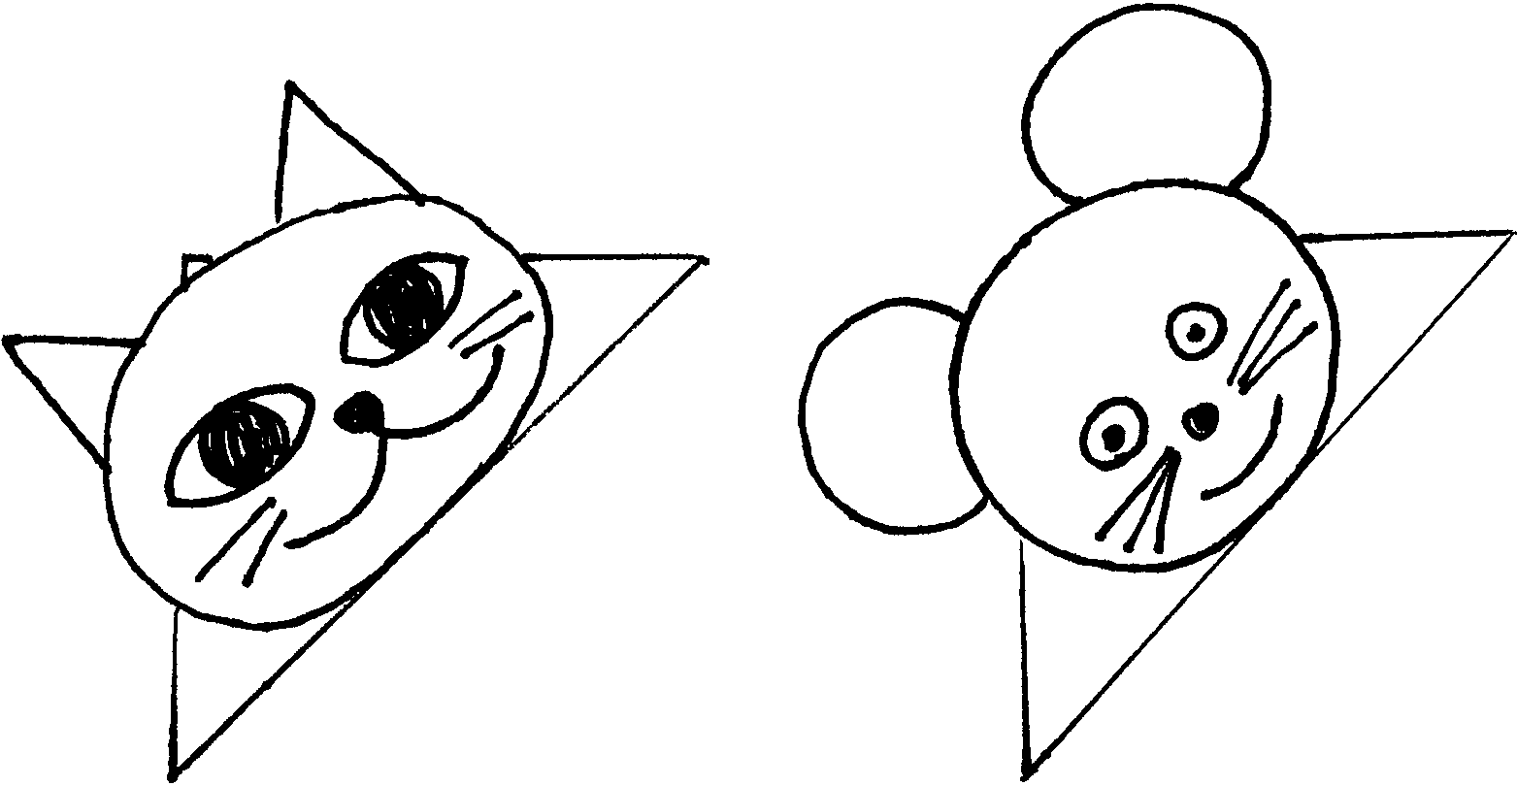
Materials: Used envelope; Colored paper; Marker; Scissors; Glue

1. Clip a bottom corner from an envelope, new or used.
2. Draw the head of your favorite pet on colored paper and cut it out.
3. Glue the head onto the envelope corner.
4. Add eyes, nose, mouth, ears and other features with a marker or cut from colored paper and glue on.
Place page pet on the corner of the page where you stopped reading.

INVISIBLE DOG LEASH

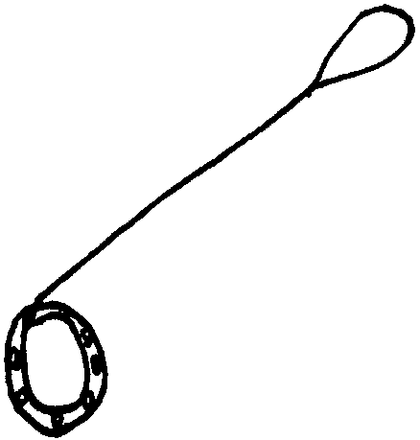
Materials: Wide mouth canning jar ring; Ribbon (1/4” or wider); Sturdy wire (16 gauge makes a stiffer leash but is harder to work with. 19 gauge makes a less stiff leash, but is easier to work with.); Material to decorate the collar; Low temp glue gun

- Cover the canning jar ring with ribbon to make a collar. Use hot glue to hold the ends of the ribbon to the ring.
- Decorate the collar with rhinestones, glitter paints, etc.
- Cut wire so it will extend from your hand to about 5” from the floor. Add 3” for twisting the ends under.
- Fasten the wire to the collar by twisting it around the top and tucking the cut ends under so it can’t be seen.
- Twist the other end of the wire into a loop (for your hand) and tuck the sharp edge inside. Gently shape the wire so it curves down a bit.
- If desired, wrap ribbon around the wire.

When you walk your invisible dog, hold the wire in front of you as you walk, so the dog appears to be wearing the collar.

GOLF BALL DOG PAPERWEIGHT
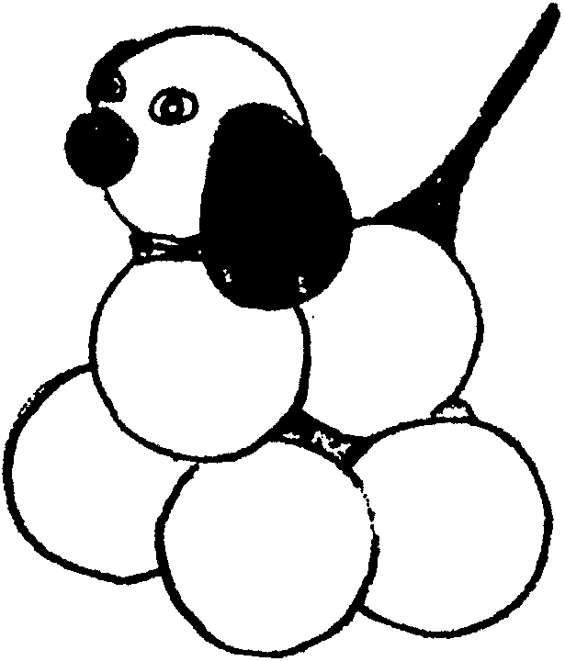
A sporting paperweight or just something cute to give...

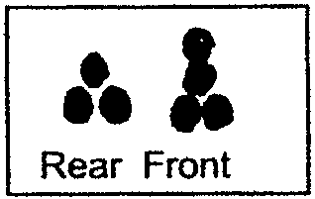
Place seven golf balls on a table and glue into two groups.
Let dry, then glue front and back together.
Add felt ears, wiggle eyes, nose and inverted golf tee for a tail.

PET BLOCK

Create your own pet block.
Be creative. It doesn’t have to look like a dog or cat, or rabbit or rat. How about something like one of the creatures in the Lester McGoo’s zoo (in the beginning of this month’s ceremony selections)? Give it a name too. Have Fun!
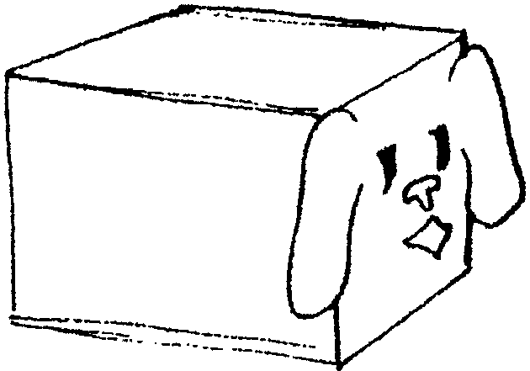
Take a block, any size. You may want to sand it to make it smooth--you don’t want your pet to have ruffled fur. Color it and draw designs on it. Either draw a face directly on the block or cut out features and glue them on.
Use scrap felt, craft foam, wood pieces, color paper, feather, wiggle eyes, pompoms, etc. Designs may be drawn with markers, glitter glue, acrylic paint (tempera color rubs off and makes a mess on the surface it touches, like a wall), puff paint, etc.

Instructions for training your Pet Block
Your pet block is very sensitive, and will reflect your emotions, so you must be very careful to smile when you are near it. Like any friends, the more you smile at it, the friendlier it gets. While training it, you must be firm but gentle. It will respond to love and kindness.
To train your pet block, you must begin with the most basic commands, and then advance to the more difficult ones.
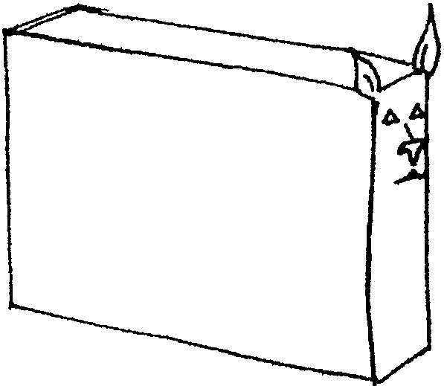
- STAY -- Place it where you want it and give the command “Stay!” If it moves, return it to the same place and give the command again. Repeat as many times as necessary.
- SIT -- Place it in the sitting position and give the command “Sit!” If it moves, repeat as necessary.
- ROLL OVER -- Give the command “Roll Over!” while rolling your pet block over. This is very difficult and may take some time for it to learn this trick.
Your pet block may be trained as a guard block or watch block. Big pet blocks are natural guard blocks--they are really happy when you give them a chore of guarding the open door. They will make sure the door will stay open. Smaller blocks are more adapt as watch blocks. Place them on a pile of paper--they’ll make sure all the papers stay underneath.
Pet blocks are usually very quiet. In fact they are the only type of pets your den leaders will allow you to bring to your den meetings. They will sit quietly and watch you during the meeting.
Pet block owners may get together to form pet block clubs and have pet block shows if desired. Enjoy your new friends.

CAT GRASS

Make this for your cat or give it to someone who has a cat. “Cat grass” seeds are available at any pet supply store.
Decorate a flower pot with paint. Draw pictures of a pet or a paw print. You may want to write the pet’s name too. Let dry. Fill the pot with moist potting soil. Sprinkle with cat grass seeds. Cover the seeds with small amount of soil. Moisten again. Place the pot in a warm, sunny place. Add water daily to keep soil moist. The grass will sprout in just a few days. When the grass is about 4 inches tall, it’s ready.

CRITTER CRATES
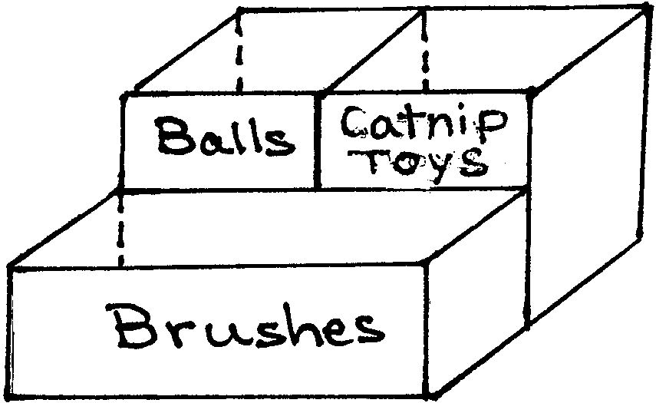
Combine several containers to make an organizer for your pet’s needs.

Choose boxes whose shape and size are best suited for your pet’s supplies. Is it better to have small compartments? Or larger ones? Or combinations of different sizes?
Milk cartons, cereal boxes and tissue boxes are good choices for most household pets.
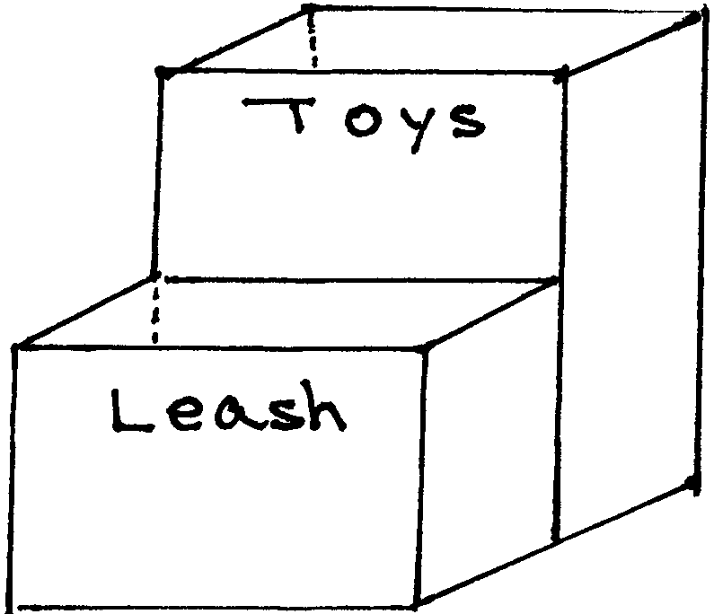
Make sure the boxes are the same sizes so there is no gap between them when you tape them together.
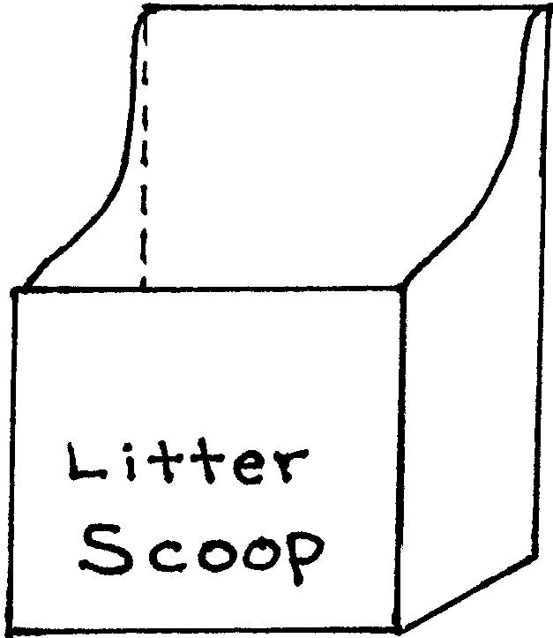
Cut the boxes into the size you want.
Glue and tape them all together (glue alone will not be enough)
Cover the whole thing with paper or Contact paper.
Label each compartment.
Decorate with stickers, magazine or calendar cutouts of the type of pet you have.
Line the box with plastic bag if using it as a litter scoop holder.

FRIENDLY NOTE HOLDER
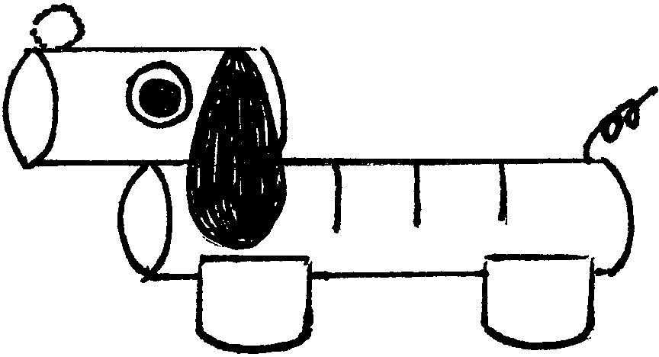
Materials: Paper tubes (two paper towel tubes work well); Scrap of felt or construction paper for the ears; Two wiggle eyes; Chenille stem for the tail; 1 pompom for the nose; Paint for the dog (brown, gray, etc.)

Using a serrated knife, make 3-5 slits on the tube that is to be the dog’s body. Don’t saw more than half way through.
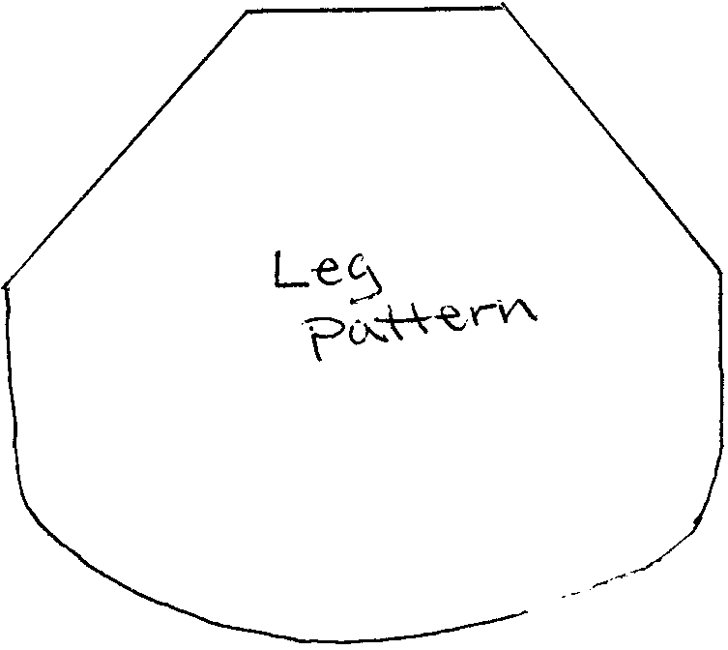
For legs, cut four 1”-1 1/2” sections of tube. First cut the tube lengthwise, then cut cross wise. Using the pattern as a guide, trim legs.
Glue dog together, using the illustration as a guide.
Paint the dog. Let dry.
Attach tail, ears, eyes and nose as indicated.

FRIDGE FRAMES

Make a frame for your favorite pet photo and hang it on your fridge.

Basic Materials: 4 large craft sticks (tongue depressors); White Glue; Mod Podge (waterbase sealer-glue-finisher, available at craft store. For smaller surface, you can substitute with diluted white glue)
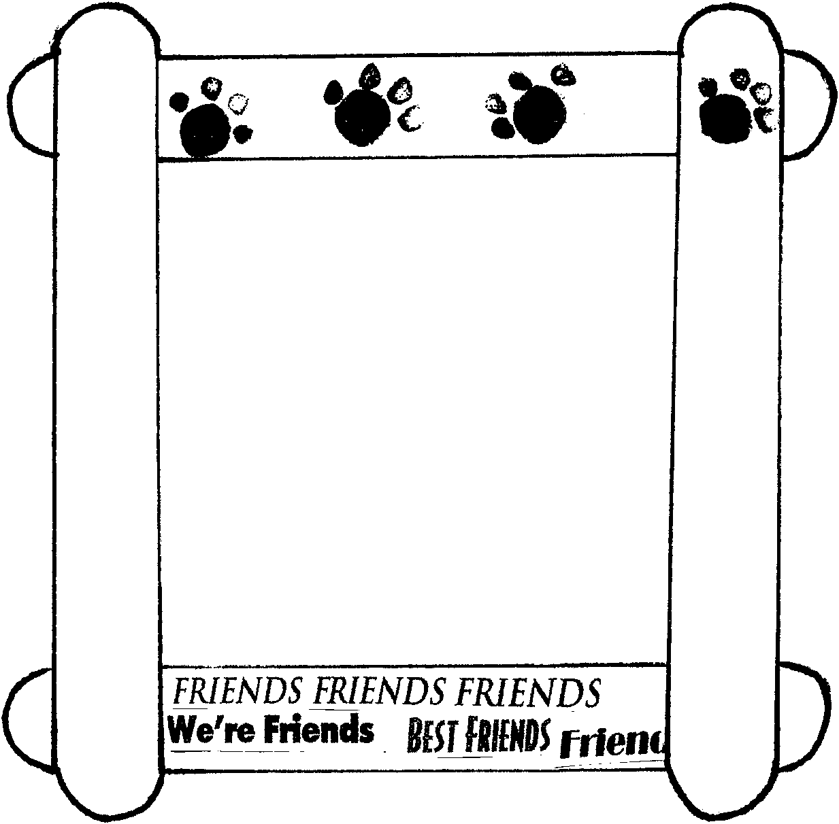
- Glue craft sticks together to form the frame. Let dry.
- Decorate the frame with:
- Gold fish crackers or animal crackers
Paint the crackers with Mod Podge or white glue (don’t dilute).
Let them dry thoroughly.
If you use white glue, the cracker will first get squishy but it will dry hard.
Glue the crackers to the frame.
- Bird seed
Spread white glue on the frame, and sprinkle bird seed. Let dry.
Paint over the seeds with white glue or Mod Podge.
- Paw print
First paint the frame with one color. Let dry.
Make paw prints with pencil erasers dipped in black paint.
- Words “Friends,” “Dog,” “Cat,”
From old magazines, clip out the words you desire.
You can also print out on your computer the desired words in different fonts, sizes and colors.
Glue the words on the frame (with glue or Mod Podge).
Cover the entire surface, including the words with Mod Podge.
3. Stick 2 magnet strips on the top and bottom of the back of the frame.
4. Center the photo and use masking tape to attach it to the frame.

TOYS FOR YOUR PET
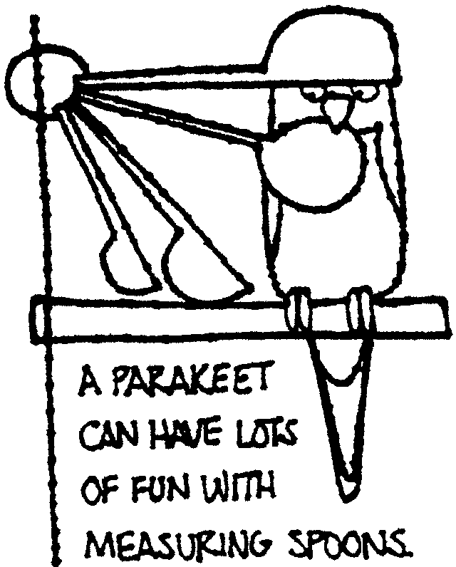
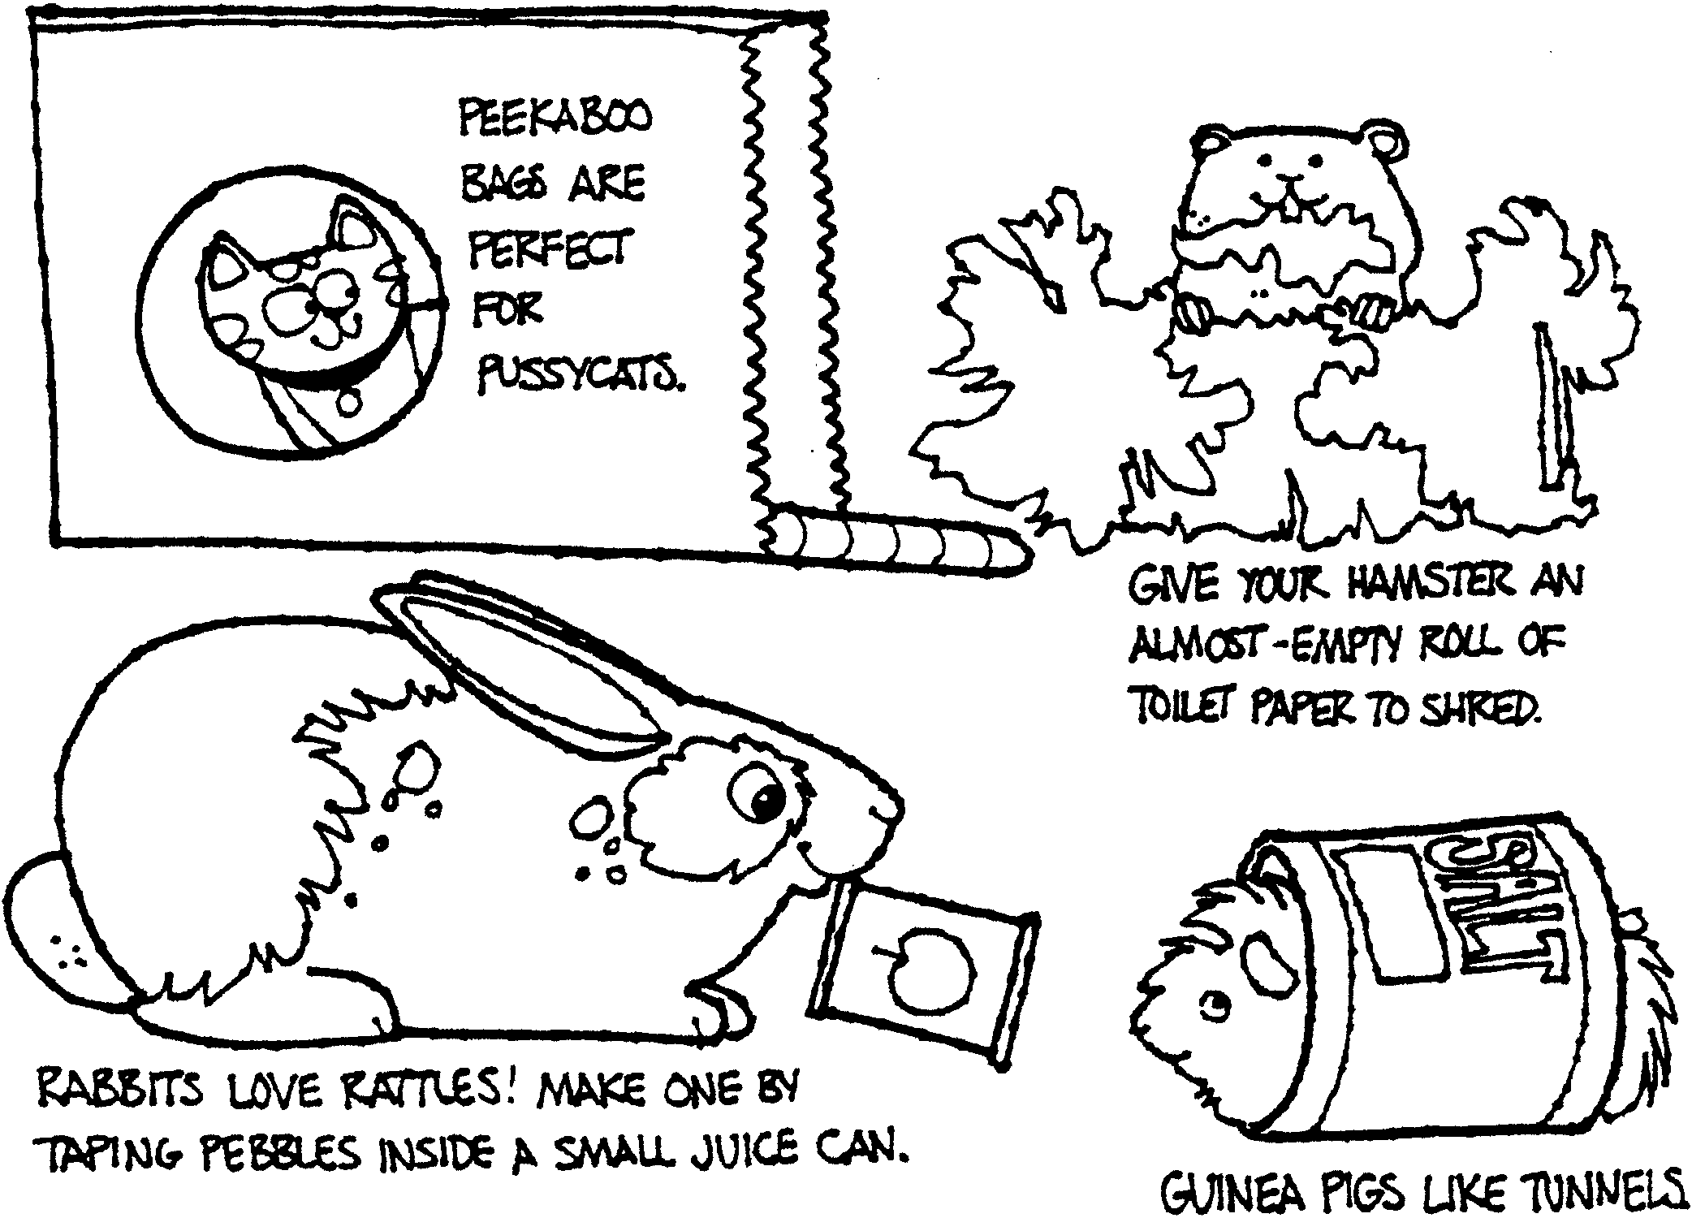

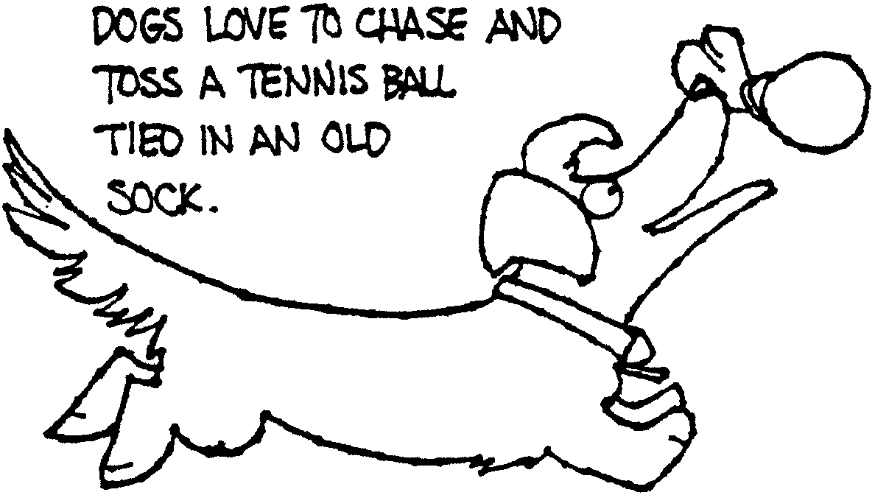

PINE CONE POOCH TIE SLIDE

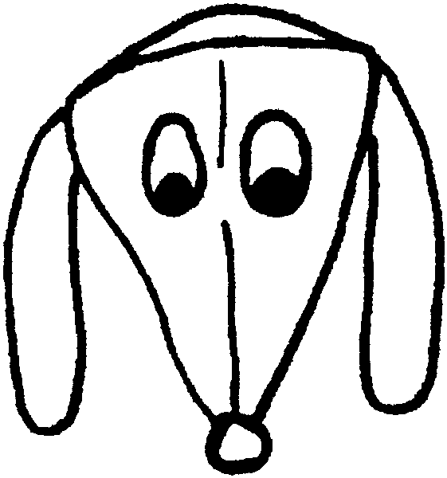
Small pointed ears, properly placed, would turn this pooch into a wolf.

Materials: Petal from a large pine cone; Brown felt or craft foam; Small black pompom; Wiggle eyes;1/2” PVC pipe

With the wide end of the pine cone petal at the top, glue small black pompom on the pointed bottom for a nose.
Glue on the eyes.
Cut large floppy ears and glue in place.
Hot glue to a section of PVC pipe.

DOG BISCUIT NECKERCHIEF SLIDE

Materials: Small dog biscuit; Pompoms; Felt; Wiggle eyes; Seed beads; 1/2” PVC pipe

SLIDE 1
- Cut two ears out of felt and glue on the biscuit.
- Glue on wiggle eyes.
- Place two 1/4” or 1/2” pompoms side by side just below the eyes.
- Glue on a seed bead for the nose.
- Glue on 4 small pompoms for the dog’s feet.
- If desired, fashion a collar and tag using scrap felt.

SLIDE 2
- Fashion dog’s head with wiggle eyes and felt ears.
- Glue the head on the biscuit.
- Glue on a pompom for a tail.

Slide 1 Slide 2
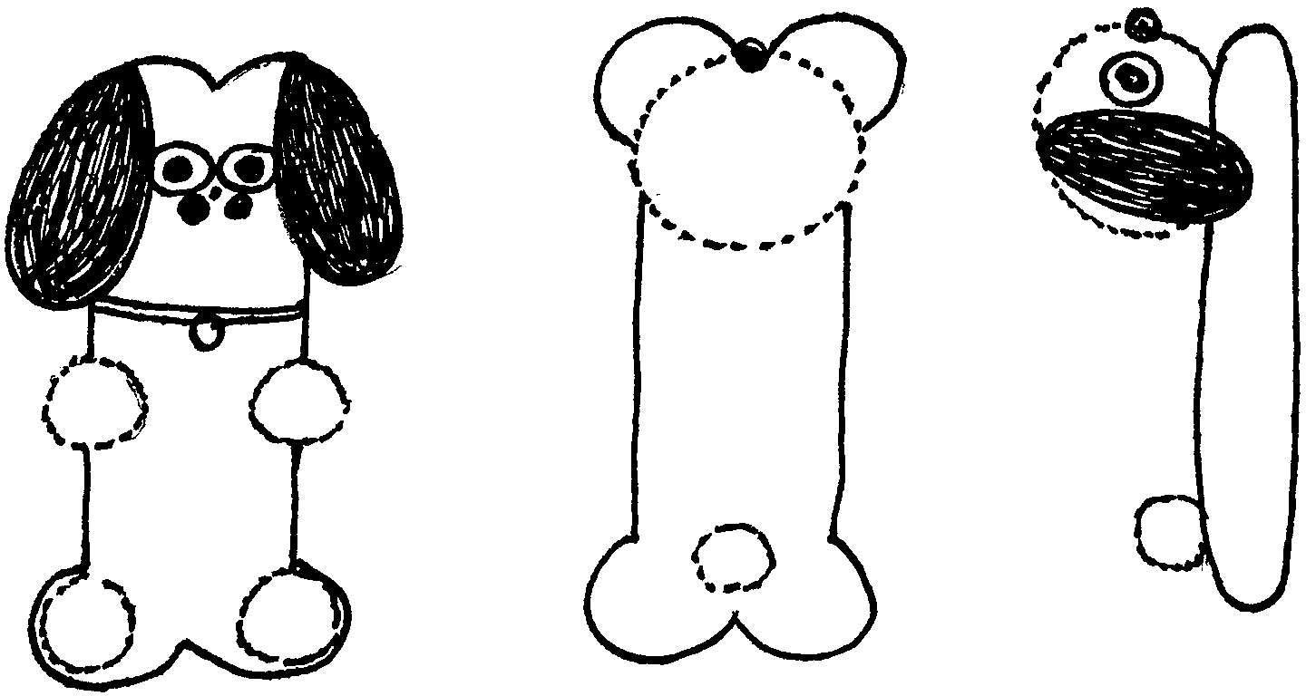

GOODIES FOR BOYS TO EAT

BIRD NESTS
1 package (3 oz.) orange-pineapple flavor Jell-O
1 cup boiling water
1 can unsweetened pineapple juice
1 cup small seedless green grapes, no stems

- Dissolve gelatin in boiling water in a small bowl, stir in pineapple juice.
- Pour into an 8 x 9 x 2 inch pan.
- Chill several hours, or until firm.
- Pull fork through gelatin to break up into flakes or press through a coarse sieve; spoon into rings on serving plates to form nests.
- Pile grapes in center.

PINK FLAMINGO
1 banana
1/2 cup fresh strawberries
3/4 cup pineapple juice

Blend until smooth in a food processor or blender.

BANANA DOGS
3/4 cup peanut butter, any style
2 tablespoons honey
4 hot dog buns, split
2 small bananas
1 tablespoon lemon juice

- Put peanut butter and honey in a small mixing bowl. Stir.
- Spread 3 tablespoons of peanut butter-honey mixture on one hot dog bun. Prepare 3 other hot dog buns the same way.
- Peel and halve the bananas length-wise.
- With a pastry brush, coat the 4 banana halves with lemon juice. This will help keep the banana from turning brown. Place one banana half in each hot dog bun.
- Wrap each sandwich in clear plastic wrap.

GOODIES FOR PETS

CAT CRACKERS
6 oz. can of tuna in oil (don’t drain)
1 cup cornmeal
1 cup four
1/2 cup water

Preheat oven to 350 degrees. Measure all ingredients into a large bowl. Use your hands to mix thoroughly. Roll out to 1/4” thickness on a floured surface. Cut into small pieces. Place on a greased cookie sheet. Bake for about 20 minutes, until just golden. Let cool. Put crackers in Zip-Loc bag and store in refrigerator for up to one week.

DOGGIE BITES
2 6-oz. jars beef and vegetable baby food
1 cup wheat germ
2 cups nonfat dry milk

Preheat oven to 350 degrees. Measure all ingredients into a large bowl. Mix together with a fork. Drop by small spoonfuls onto a greased cookie sheet and flatten slightly. Bake about 12 to 15 minutes, until slightly browned at the edges. Let cool. Store in a Zip-Loc bag in the refrigerator for up to one week.

DOG-FOOD CAKE
This is for your dog’s birthday.

2 16-oz. cans of dog food 1/4 cup chopped carrots
1/2 cup cooked white rice 1 box of dog bone biscuits
1/2 cup dry dog food

Place the dog food in a bowl. Add the cooked rice and mix thoroughly. Spoon this into a springform cake pan. Use the spatula to even out the food and make it smooth. Place the plate on the top of the cake pan, hold the two together, and quickly turn this upside down so that the plate is now on the bottom. Tap around the sides of the cake pan to loosen the dog food. Unlatch the cake pan and carefully remove it from around the dog-food mixture. Remove the bottom of the pan, which is now resting on the top of the cake, by using the spatula to gently pull the bottom away from the dog-food mixture. Apply the dry dog food and carrots to the sides and top of the cake. Place the cake in the refrigerator until it is time to serve.

Serve a portion appropriate to the size of the dog. Place one dog bone biscuit on top.

CAT ‘PURR’ITOS
Ingredients: Bologna; Dry cat food; Turkey

Spread out a piece of bologna.
Mash your cat’s favorite dry cat food.
Sprinkle cat food and bits of turkey on the bologna.
Roll, slice and hold together with toothpick until just before you serve.

