Happy Trails

May 2001

CONTENTS

THEME RELATED 1
MEETINGS DURING THE SUMMER 1
CUB SCOUT TRAIL 1
OUTDOOR SAFETY 1
HUG-A-TREE AND SURVIVE 2
DEN AND PACK ACTIVITIES 2
FAMILY CAMP 2
PARTICIPATION AWARDS 3
ONLINE RESOURCES 3
DEFINITION OF A CUB SCOUT 3
PREOPENING 4
MAY DAZE 4
A LOOK OUTSIDE 4
TREE TRICKS 4
FOREST MAZE 5
CEREMONIES 7
HAPPY TRAILS OPENING 7
ON THE TRAIL 7
“NATURE IS...” CLOSING 8
MOUNTAIN PEAK CLOSING 8
“SCOUTING TRAIL”--CUBMASTER’S
MINUTE 9
“OUR WORLD”--CUBMASTER’S MINUTE 9
“CHANGING AND GROWING”--
CUBMASTER’S MINUTE 9
HAPPY TRAILS ADVANCEMENT 9
PICNIC ADVANCEMENT 10
THE RAIN, THE TREE, THE ROCK AND
THE SUN 10
FUN WAYS TO SAY THANK YOU 11
AUDIENCE PARTICIPATION 13
THE HAPPY HIKERS 13
A TRUE STORY ABOUT A FAMOUS BEAR 14
SKITS 15
LOST IN THE WOODS 15
THE MARKED TRAIL 16
MAGIC COMPASS 16
HIKING--THE SCOUT WAY 16
GAMES 17
HIKE IDEAS AND HIKING GAMES 17
NATURE CRIBBAGE 19
PASS AND TOUCH GAME 19
RIVER JUMPERS 19
WINDY LEAVES 19
NATURE’S MARBLES 20
FOREST SCAMP 20
PARTNER TAG 20
STEPPING STONE RELAY 20
SONGS 21
DOORWAYS TO ADVENTURE 21
TAKE ME OUT TO THE FOREST 21
CUB SCOUT GO HIKING 21
OLD MA NATURE 21
OUT IN THE FOREST 21
THE OUTDOORS 22
NATURE 22
GREAT WONDERS 22
FOUR CUB SCOUTS 22
UP THE CUB SCOUT MOUNTAIN 22
CUB SCOUT ADVANCEMENT 22
CRAFTS 23
FILM CANISTER FIRST AID KIT FOR
BELT 23
NATURE T-SHIRT 23
LEAF PAINTING 24
LEAF PRINTING 24
LEAF RUBBINGS 24
LEAF SPLATTER PAINTING 24
LEAF “COPYING” 25
WALNUT PHOTO CASE 25
WILDFLOWER CANDLES 26
PINECONE GARDEN 26
INDIAN PEBBLES (Game) 27
TRACK NECKERCHIEF SLIDE 27
CUBS IN THE KITCHEN 28
GORP (GOOD OLD RAISINS AND
PEANUTS) 28
ENERGY BARS 28
BANANA CHIPS 28
HOTDOGS A LA BEDROLL 29
HAPPY HIKER JOY JUICE 29

MEETINGS DURING THE SUMMER

Plan pack activities for the next three months, have fun and earn the NATIONAL SUMMERTIME PACK AWARD too. A boy registers for a year and deserves a full year of Cub Scout fun and activities. Having a summer program keeps a pack healthy, parents interested, and Cub Scouts eager for regular meetings in September. You will find it easier to resume the weekly program in September if you kept in touch with the boys (and the boys with each other) during the summer, even though you won’t be seeing them more than once a month.

Summer is an ideal time to do something with the pack that’s hard to do during the school year. Plan a field trip to a place that’s open only weekdays. Plan an outing to the beach. Have a pack picnic, pack sports day, family camp, etc. Participate in the Council’s Cub Scout day camp, resident camp or family camp.

Earning the National Summertime Pack Award is one of the optional requirements for the Cub Scout Pack National Quality Unit Award. (See PARTICIPATION AWARDS section for the National Summertime Pack Award.)

CUB SCOUT TRAIL

In many packs boys graduate to the next level in May or June. What does a new Wolf or Bear want to do? He wants to start working on his achievements right away. Summertime is a perfect time for the family to work together. Encourage parents to help their sons with advancement and have fun while doing so!

OUTDOOR SAFETY

1. Always carry permission slips and emergency contact numbers for all boys.
2. Check out the area in advance. If possible, go on the same trail you are planning to take the group.
3. Have adequate leadership and supervision.
4. Use the buddy system at all times. Make sure the group stays together.
5. Always have a first aid kit handy. Make sure the kit is updated and resupplied regularly. If possible, have an adult trained in first aid and CPR attend your outing.
6. Have a plan for personal or natural emergencies. Know where emergency care can be obtained quickly.

For more safety information, please see Guide to Safe Scouting.
Cub Scout Leader How-To Book “What to do if Lost” p. 8-2

HUG-A-TREE AND SURVIVE

Do boys know what to do when they are lost in the woods? Even if they know, learning again does not hurt. And this is a fun and friendly way for children to learn.

Hug-a-Tree was started in San Diego as the result of an actual lost-child incident. Its purpose is to teach children some basic survival skills--how to remain calm and comfortable when lost, and how to be found easier and quicker. The concept is adaptable for many situations, in the woods or in the neighborhood.

A volunteer presenter from Hug-a-Tree and Survive can come to your pack meeting. It’s a very good program and free! Call (831) 475-0432 to arrange for a South Bay presenter.

Many of the presenters are also volunteers for the California Rescue Dog Association. When contacting local presenters, ask if they are CARDA members and, if so, if they could bring their dogs. The boys will love it and so will the parents.

DEN AND PACK ACTIVITIES

This month’s den and pack activities focus on outdoors. Take time to enjoy the natural environment around you. Be prepared. Do some research about the plants, the trees and the animals that live in the area. Learn about the environment before you go so you can share the knowledge with the boys. Ask parents’ help. There are many parents who know about plants, trees and animals.

FAMILY CAMP
Set up your camp, then go on a hike and play games. Cook the meals with the boys. Campfire is a highlight of a campout. Have a great sing-along, stories and skits. Advancement and other recognition ceremonies are always impressive at the campfire. Then go on a short walk. The same trail looks so different at night. Look up and see if you can identify some stars, planets or constellations. Keep your light to a minimum (attach 2-3 layers of red cellophane on your flashlight with a rubber band to dim the light). Next morning, go on a sunrise hike and watch the sun rise. You’ll be surprised how the boys are touched by this wonder. Ask the ranger for the best location. Check the newspaper for the sunrise time. Don’t make it a long hike. It’s hard enough to wake up early--we don’t want the boys to be too unhappy before this beautiful event.

See Cub Scout Leader How-To Book for:
“Family Camping” pp. 8-35 to 8-37
“Outdoor Cooking” pp. 8-37 to 8-43
“Campfires” pp. 8-43 to 8-48

For Outdoor and Campfire Ceremonies, see Chapter 11 in Cub Scout Ceremonies for Dens and Packs.

PLACES TO CAMP:
Chesebrough Scout Reservation (See MISCELLANEOUS for information)
There are 5 County Parks where group camping is available
Mt. Madonna, Sanborn-Skyline, Joseph D. Grant, Uvas, Ed Levin

PARTICIPATION AWARDS (For details, see the PARTICIPATION AWARDS section)
Bay Area Ridge Trail
Trail Trekkers
National Summertime Pack Award
National Den Award

ONLINE RESOURCES

- Santa Clara County Parks:
http://claraweb.co.santa-clara.ca.us/parks/index.html
Information on all the Santa Clara County Parks
- Hug-a-Tree and Survive: http://www.rcmp-ccaps.com/hugcolour.htm
Hug-a-Tree and Survive Coloring Book.
- California Poison Control System: http://www.calpoison.org/public/home.html
Poisonous plants and animals.

DEFINITION OF A CUB SCOUT

A Cub Scout is -- a piece of skin stretched over an appetite. A noise covered with smudges.

He is called a tornado -- because he comes at the most unexpected times, hits the most unexpected places, and leaves everything a wreck behind him.

He is part human -- part angel -- and part barbarian.

He is a growing animal of superlative promise -- to be fed, watered, and kept happy -- a joy forever -- a periodic nuisance.

The problem of our times -- the hope of the nation. Every new Cub Scout born is evidence that GOD is not yet discouraged with man.

There are no “Seven Wonders of the World” in the eyes
of a Cub Scout; there are seven million.

MAY DAZE

Think of a word that rhymes with “May” for each line of this poem.

The first is something that a horse eats.
To do the second, stay out of the street.
The third we do the last thing at night.
The fourth is a mixture of black and white.
The next is something that rides on the snow.
The sixth is where we sometimes go.
The seventh you get for work you have done.
The eighth is something that comes from the sun.
The ninth is the noise a donkey makes.
The tenth is used to carry cakes.
The 11th is turned on a potter’s wheel.
The 12th is the opposite of night.

Answers: 1-Hay; 2-Play; 3-Pray; 4-Gray; 5-Sleigh; 6-Away; 7-Pay; 8-Ray; 9-Bray; 10-Tray; 11-Clay; 12-Day.

A LOOK OUTSIDE

Combine words in the second column with those in the first column to make seven words of things you might see outside.

- Butter walk
- Tree bug
- Side fly
- Lady shine
- Milk hopper
- Sun weed
- Grass top

Answers: 1-Butterfly; 2-Treetop; 3-Sidewalk; 4-Ladybug; 5-Milkweed; 6-Sunshine; 7-Grasshopper.

TREE TRICKS

Change one letter in each of these words to find the name of a tree.

1. Mine 2. Fit 3. Pillow 4. Bench 5. Oar
6. Elk 7. Asp 8. Jolly

Answers: 1-Pine; 2-Fir; 3-Willow; 4-Beech; 5-Oak; 6-Elm; 7-Ash; 8-Holly.

FOREST MAZE

Help Smokey find the forest fire!

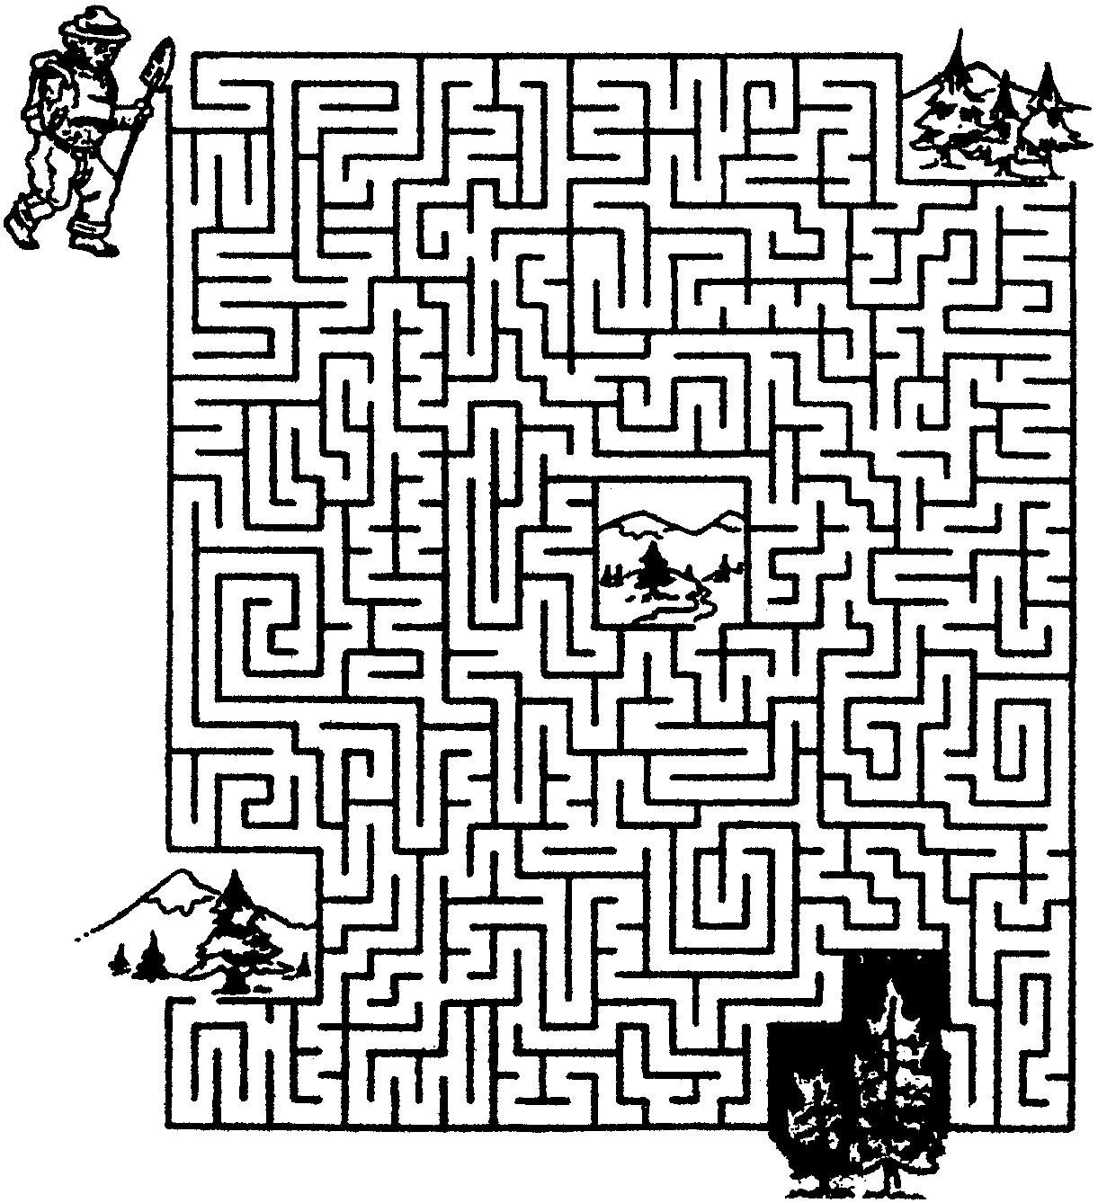
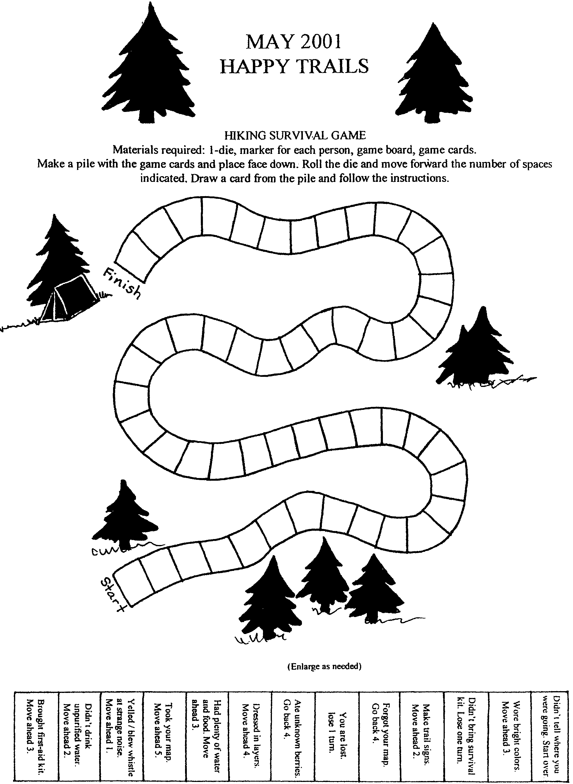

HAPPY TRAILS OPENING

Props: A compass and map. Several paper paw print cutouts large enough to be seen by the audience. Scatter the paw prints on stage before the meeting.

Setting: Cub den wanders around together as a group, following the first Cub Scout with the map and compass.

C.S.#1: Where are we? Where should we go now?
C.S.#2: I think we’re lost.
C.S.#3: Wait a minute! I think I found something.
All: What is it?
C.S.#3: (Holds up paw print for all to see) Tiger Tracks!
All: Tigers! Oh No!
(Resume wandering)
C.S.#4: Here are some more tracks. (Holds up paw print) It looks like Bobcats!
C.S.#2: Do you think they are hungry?
C.S.#1: I see Wolf tracks. (Holds up many paw prints) There must be a whole Den of them around here somewhere.
All: Oh, no!
C.S.#5: The only thing I am afraid of is Bears.
C.S.#1: Look. Bear tracks!
C.S.#5: I see footprints. Must be from the Webelos tribe. They are a wild bunch.
All: Tigers, Bobcats, Wolves, Bears, and Webelos!
What will we do? What will we do?
Den Leader: (Walks on-stage) Okay boys, come on. Time to start the meeting now.
All: Saved by our Den Leader again.

ON THE TRAIL

O Observing the Outdoor Code
N Noticing everything around me

T Tracking those footprints
H Hiking with my friends
E Eating Gorp

T Treating the outdoors with respect
R Reading trail signs
A Always staying on the trail
I Identifying that strange bug
L Leaving it as I found it

“NATURE IS...” CLOSING

Each line is spoken by a Cub Scout holding the item in italics.

C.S.#1: Nature has Beauty.
The leaf is beautiful. Look at its shape and delicate veins.

C.S.#2: Nature is Useful.
This wood gives us a fire for warmth, gives a home to our friends the animals, and provides us with shelter.

C.S.#3: Nature has Magic.
It’s magical that this small seed can grow into a large apple tree and bear fruit we can eat. (Also hold an apple)

C.S.#4: Nature is a Teacher.
Ben Franklin discovered electricity in nature. (Kite)

C.S.#5: Nature has History.
This rock holds a fossil that tells us about this earth from which we came.

C.S.#6: Nature is Fun.
Nature has something to offer everyone. (Fishing pole)

C.S.#7: Nature is Life Itself. (Very simply, drink a glass of water)

C.S.#8: Nature is the Future of Mankind. Let us work hard to preserve it.

MOUNTAIN PEAK CLOSING

C.S.#1: When we go out hiking we sometimes climb very high. So high, in fact, we come to the top of a mountain. The top of a mountain is called a mountain peak.

C.S.#2: Climbing to a mountain peak is a great accomplishment. When we gaze over the horizon we get a reward for the rigorous work.

C.S.#3: On the mountain peak, we can see other mountains. We can sometimes see towns and cities in the distance.

C.S.#4: This vision gives us a different perspective of the world. A Navajo legend says we are also better able to understand the sky, sun, and moon on the mountain peak.

C.S.#5: To attain the height of a mountain peak we must expend great effort, but we also get a great reward. Please stand and repeat the Cub Scout Motto.

“SCOUTING TRAIL”--CUBMASTER’S MINUTE

There are many trails in life. Some lead to happiness, some lead to despair, some simply lead us around in circles. Scouting provides a guide through all these trails. When we follow the Scouting trail, we find it always leads to happiness. We also find a lot of good friends along the way, Scouts of all ages. Stick with Scouting, and your pathway will be clear.

“OUR WORLD”--CUBMASTER’S MINUTE
(After an outing)

As we go back to our homes, I would like to ask that the parents keep these thoughts in mind. Counsel your sons that they may have eyes to behold the red and purple sunsets; that they may have sharp ears to hear the voice of their God. Guide them to have hands that respect the things God has made. Help them be wise and see the lessons hidden in every leaf and rock. Help them seek strength, not to be superior to others, but to be helpful to others. Help them along the Cub Scout Trail to do their best.

“CHANGING AND GROWING”--CUBMASTER’S MINUTE

About this time of the year, many things are unfolding. One of these great events is the caterpillar that wants to grow up and be something beautiful. He seals himself up in a cocoon and awaits the changing into the beautiful butterfly. Tonight we want to remember that like the caterpillar, our Cub Scouts are also changing and growing. And so they, too, represent the coming of summer.

HAPPY TRAILS ADVANCEMENT

Props: Dark felt fabric stretched over a frame or large box; Rank symbols drawn on poster board (about 8” square) with velcro piece glued to the back; Several smaller paw prints (at least one per Cub Scout), with velcro backing. (If desired, replace felt and velcro with poster board and tape.)

Cubmaster:
We face many choices in life like trails in the woods. It is our task to choose those Happy Trails in life--success, achievement, caring for others, self-confidence, working with others. We also choose to avoid the unhappy trails, like drugs, anger, and hatred. Please join me in recognizing some young men who have worked hard to follow these happy trails.
The first portion of the Cub Scouting trail leads to Bobcat. The following boys have earned their Bobcat rank. (Call out names as Assistant Cubmaster places the Bobcat symbol on the felt. Have each boy place his paw print towards the Bobcat symbol. If there are no Bobcats, then simply place the Bobcat symbol with a few paw prints and proceed to Wolf) Congratulations, Bobcats.
After Bobcat, comes Wolf. These Cub Scouts continued on the trail and have now become Wolves. (Proceed for each rank, connecting the rank symbols with the paw prints)

PICNIC ADVANCEMENT

Props: Picnic basket; Paper plates, Cups, Utensils, etc.--items needed for a picnic.

Cubmaster:
We have several Cub Scouts to honor today for the hard work they have done since our last meeting. With the paper plates, we have the Bobcats. (Call boys and parents forward. Pull from a picnic basket Bobcat badge attached to a paper plate--one plate per recipient. Present awards and give congratulations. Present other badges, activity badges, and arrow points attached to plastic forks, spoons, paper cups, etc.)

You have seen all of the things that help make a picnic meal fun, except the food. These young men and their parents represent the things that makes the pack grow and thrive. They are as important to a pack as food is to a picnic. Let’s wish them well as they continue on their trail in Cub Scouting.

THE RAIN, THE TREE, THE ROCK AND THE SUN

Props: Approximately 6” cutouts for each Cub Scout to be awarded
Raindrop for Bobcat
Tree for Wolf
Rock for Bear
Sun for Webelos

Cubmaster:

In Cub Scouting, Bobcats are like the raindrops. They are fresh and new and bring with them a clean excitement. Their enthusiasm helps keep us alive. Congratulations, (name) on earning your Bobcat rank. You are as welcome as rain. (Present award)

(Name) has earned his Wolf rank and we see he continues to grow. Just like a tree, he has matured and branched out to reach new heights. Stronger than he once was, he can more easily withstand the winds of danger. His roots are becoming more firmly embedded in the healthy soil of Cub Scouts. (Present award)

The Bear is the rock of Cub Scouting. (Name) has earned his Bear rank. He is now solid and immovable in his commitment to the promises he makes in Cub Scouting. Just as a rock, a Bear is unchanging through bad weather as well as good. (Present award)

The brightness of the Webelos is like that of the sun. His knowledge of Cub Scouting ideas is warm and welcome. By earning his Webelos rank, (name) has continued to shine day after day and helped others to grow. Congratulations, and shine on!! (Present award)

FUN WAYS TO SAY THANK YOU

Big stone: “Because you leave no stone unturned.”
Camp Chair: “Thank you for chairing the event _____.”
Compass: “Thank you for leading the way.”
Flashlight: “You have been a shining example.”
“Because you light the way.”
“You light up our pack.”
Footprint: “Thank you for hiking that ‘extra’ mile!”
Hat: “Hat’s off to you.”
Knot: For someone who has it all tied together.
Right shoe/ footprint: “Thank you for getting us started on the right foot.”
“Thank you for putting your best foot forward.”
Rock: “You positively rock!”
Shoe: “You keep us in step.”
Shoelace: “You tie it all together!”
Stick: “Thank you for sticking by the pack.”

Pack Family Tree:
Cut a slice of wood from a log. Glue on several nuts in the shell (acorns, almonds, peanuts, etc.). Glue tiny wiggle eyes on the nuts. Either burn a message in the wood, or use a permanent marker to write your massage, including, “You’re the nicest nut in our Pack Family Tree!”

See Cub Scout Ceremonies for Dens and Packs for:
Closing: “Compass” p. 6-3
“Compass Prayer” p. 6-3
“Nature Visitors”
Induction: “On the Cub Scout Trail (For New Bobcats and Families)” p. 7-2
Advancement: “Mountain Climbing (Bobcat, Wolf, Bear, Webelos Scout)” p. 8-5
Graduation Wolf to Bear “Bear Trail Adventure” p. 9-4
Webelos Scouts to Boy Scouts “Cub Scout Trail” p. 9-5

APPLAUSES

COMPASS APPLAUSE: Take your compass out of your pocket. Hold it in front of you to get your bearings. With your other hand, point to the person/group you are recognizing and shout, “WAY TOGO!!”

WHITTLING STICK APPLAUSE: Pick up a tall stick off the ground, take out your pocket knife, and start making notches in the stick, going higher and higher. When you get as far as you can reach, say, “Top Notch!”

THE HAPPY HIKERS

We are going on a hike. Listen carefully and do what I do.

(Begin hiking in place) Here we go on a hike through the woods and over the mountains. Come on along with me. (Smile, wave to audience, hike in place) We’re coming to a steep hill. (Bend over as if climbing) Now we’re on top. What a lovely view. (Look around in appreciation) Now we’ll have to go down. (Slip and slide down hill) Wheeee, we’re out of breath. (Hold hands on chest, breathe heavily)

Now we’re passing through a meadow. (Hike in place) What’s that I see? (Stop, peer to one side) It’s a rabbit! And a meadowlark. (Look up) And a bumblebee! (Run swiftly in place waging arms as if fighting off a bumblebee)

We’re happy hikers. (Hike in place) We’re happy because of the beautiful mountains we see (shade eyes with hand and smile) and because of all that clean fresh air we are breathing (breathe while expanding chest) and especially because we got away from that buzzing bumblebee. (Smile, turn heads slightly to rear and wave goodbye to the bumblebee)

Now we’re getting tired. (Slow pace, walk droopily) There’s what we need! (Point) A creek. I can cool my face and arms. (Smile, pick up hiking pace, kneel down at river, scoop water over face and arms) Ahhhh, how refreshing. Let’s be on our way. (Hike in place) Now let’s try to jump over the creek without getting our feet wet. (Take big step, get feet wet, shake them off) Oh well, don’t feel too bad about not making it. It was a wide creek. At least we have cool toes.

(Hike in place) Look what’s up ahead...a fork in the road. Hope we take the right road (still hiking in place) No, it’s really the left road...oh well. Let’s see what happens. (Hike in place, turn to right, then to left) Now we’re lost. I guess the right road was the right road after all. (Hike in place) Now we’re on the right road again.

We’d better stop for lunch. (Stop, reach into pocket, bring out imaginary sandwich, munch briefly take handkerchief from pocket, wipe mouth, replace handkerchief, resume hiking in place) Ummmmmmm, that feels better.

Look, there is a lovely lake. (Points) Let’s swim across. (Making swimming motions) That’s better than trying to hike across. (Resume hiking) Look at that crooked trail ahead. (Points) It’s nothing but twists and turns. (Continue hiking, twisting and turning as you hike) I’m glad that’s over...I was getting dizzy.

Looks like we have come to the end of the trail. (Stop) What do we do now? (Resume hiking in place) Hike some more? Are you tired? Do you want to stop? So do I. (Sit down, wipe brow and slump in chair)

CHEER

END OF HIKE CHEER: Throw hands up in the air, yell, “We made it!”

A TRUE STORY ABOUT A FAMOUS BEAR

BIG TREE: “I am so big!”
MIDDLE SIZED TREE: “See my pretty leaves”
BABY TREE: “I’m just a bush.”
CAMPER: “I love this beautiful forest.”
FIRE: “Crackle, crackle, crackle”
SMOKEY BEAR: All say, “Only you can prevent forest fires.”
BABBLING BROOK: Assign one person to get up and run through the group.
FOREST: All trees say their parts.

Once upon a time, in a beautiful lush green FOREST, there stood three trees, the BIG TREE, the MIDDLE SIZED TREE, and the BABY TREE. A BABBLING BROOK coursed its way through the FOREST.

A CAMPER made a FIRE for his breakfast without clearing the area for ten feet and then went for a hike without making sure the FIRE was dead out. The FIRE threw some sparks into some dried grass. It started smoldering. The BABBLING BROOK was not close enough to put out the sparks. In a short time, the dry FOREST was ablaze.

The animals heard the sounds of the FIRE, smelled the smoke and tried to flee. A bear cub couldn’t see where his mother had gone. So, he did what she had taught him when there was danger. He climbed the BIG TREE.

The FIRE roared by. It burned the BABY TREE and the MIDDLE SIZED TREE. It singed the BIG TREE with the bear clinging to its trunk.

After the FIRE, a ranger found the baby bear still in the BIG TREE and got him down. He was singed and scared. The ranger healed his burns and raised him. He called him SMOKEY BEAR. He became the symbol to remind CAMPERS and hikers to be careful with FIRE and protect the BIG TREE, the MIDDLE SIZED TREE and the BABY TREE so we can enjoy the FOREST with the BABBLING BROOK running through them. Remember, says SMOKEY BEAR...

RUN-ONS

Boy: What are these holes in the trees?
Leader: They’re knotholes.
Boy: If they’re knotholes, then what are they?

An exhausted hiker stumbled into another hiker in the woods.
“Am I glad to see you.” Said the hiker, “I’ve been lost for two days.”
“Don’t get too excited,” said the other hiker, “I’ve been lost for two weeks.”

LOST IN THE WOODS

Characters: Six Cub Scouts in uniform and a Martian. Adjust the number of Cub Scouts according to the size of the den.
Props: Lights, sound effects of a crash.
Scene: Wooded area, where several Cubs are sitting around.

Cub #1: Gee, I’m tired. I really think we’re lost.
Cub #2: Yea, I wish we had stayed with _________(Den Leader’s name).
Cub #3: She was going too slow, looking at all those boring leaves.
Cub #4: Do you think we’ll ever get out of these woods? We could be here forever.
Cub #5: Don’t be silly. They’ll organize a search party for us soon.
Cub #6: I sure hope so. I’m getting hungry and it’s getting dark.
(Stage lights begin to dim and a light appears from offstage.)
Cub #1: Hey look! See the lights!
Cub #2: Yea, I see it. Looks like they’ve got a helicopter out looking for us. That’s neat. Just like on TV.
All Cubs: (Jumping up and down, yelling and saving their arms)
Over here! Over here! Come help us! We’re lost! Over here!
(More lights appear from offstage. A loud crash is heard.)
Cub #3: They’ve landed! Someone is coming through the trees over there. (Points offstage)
(Martian enters)
Martian: Could you tell me how to get back to Mars? I was out exploring with my den leader, and I got lost!

(The skit can end here. For those who wish the boys get home safely, add:)
All Cubs: Well, we are lost too.
Martian: What should we do?
Den Leader: Here you are. I was looking all over for you.
Cub #4: We sure are glad to see you.
Cub #5: Now we can go home.
Cub #6: What about him? (Points to the Martian) He’s lost too.
Den Leader: No problem, just follow my directions; First go to our moon, turn left and go a couple of light minutes, then turn right followed by an immediate left. You’ll find your home.
Martian: Hey. That sounds right! Thanks.

RUN-ONS

What’s the best way to avoid infection from biting insects?
Stop biting insects.

What is the best way to start a fire with two sticks?
Make sure one of them is a match.

THE MARKED TRAIL

Scene: All are approaching a mountain trail for a day hike.

Den Chief: This sure is a good day for a hike.
Cub #1: Sure is.
Cub #2: Just right for walking in the woods.
Cub #3: (Speaking to lagging Cub Scouts) Hurry up, or you’ll get lost.
Cub #4: We don’t want to miss a thing.
Cub #5: I’m glad our den chief knows the trail.
Cub #6: Why, do you think we could get lost?
Cub #7: No, the trail is marked. Saturday hikers always mark the trail.
Cub #8: Just like the pioneers and Indians, right?
Den Chief: Not exactly; they drop candy wrappers, tissues, bandaids and soda cans.

MAGIC COMPASS

Den 1 is hiking.

Cub #1: Hope we don’t get lost! I only have 3 sandwiches.
Cub #2: Don’t worry I have my magic compass.
Cub #3: Hope we can find some clean water, because I’ll get thirsty.
Cub #2: Don’t worry I have my magic compass.
Cub #4: Sure hope there are plenty of places to rest, because I get real tired.
Cub #2: Don’t worry I have my magic compass.
Cub #5: Hope we don’t run into any lions.
Cub #2: Don’t worry I have my magic compass.
Cub #6: Hope we get to see a deer.
Cub #2: Don’t worry I have my magic compass.
Cub #7: I think we probably will because we just passed that same salt lick four times.
Cub #2: (Throwing compass to the side) So much for my magic compass!

HIKING--THE SCOUT WAY

Den Chief: Okay, guys. Is everybody ready to go hiking?
(Boys start hiking up their socks)
Den Chief: What are you doing? I said HIKING! Are you ready to go HIKING?
Boys: Yes, we’re hiking up our socks, our shorts, you know....
Den Chief: No, no, no... Hiking. Hiking, don’t you know -- hiking!
Boys: Oh, yea!
(One boy takes football from behind his back; boys line up to begin play)
Boys: Hike one...hike two...hike three...
Den Chief: No, no, no! HI-KING, HI-KING. Come on, guys. Get with it!
(One boy walks by with crown on head)
Boys: Hi, King!
Den Chief: No, no, no! Hiking, walking, Scout stuff. You know -- hiking!
Boys: Oh, why didn’t you say so? (Walk off stage hiking with den chief)

HIKE IDEAS AND HIKING GAMES

Hikes do not mean you have to go to the hills or woods; you can have fun hikes anywhere, even in the middle of a big city. Some ideas are listed in Cub Scout Leader How-To Book “Nature Rambles, Hikes, Hunts, Games, and Field Trips” pp. 8-3 to 8-6. Here are more ideas. Try a few ideas on one outing, playing each for a short distance. Let boys choose some ideas too.

ALIEN HIKE: Advance preparation is needed. You will need to set up about 10 odd sites for them to discover. Examples: Put a pinecone on an azalea bush, a rose in an apple tree, a large maple leaf in a fir tree, etc.
BIG GAME HUNT: Make a list of animals, insects, and birds you might see on the way. After a while, see how many the boys have actually spotted. Can they name the critters?
BIRD WATCHING HIKE: Describe the birds they see; size, coloring, beak type, and where they are. Take a bird identification book or someone who knows birds.
BLINDFOLD HIKE: Divide boys in pairs. Have one blindfolded. The other leads him a short distance, quietly and slowly. Encourage the blindfolded boy to listen, smell and feel the surroundings. Trade places.
COIN TOSS HIKE: In a backyard or playground, toss a coin every 25 or 50 steps. If it’s heads, go to the left, if tails, to the right. If the hike is longer, make sure everybody stays together.
COLLECTING HIKE: Make a bug collecting jar, and have the boys collect one specimen of each insect they see. In the jar, have plants and water for the bugs. Have an insect identification book and see how many can be identified. Turn the insects loose after the hike.
COLORS HIKE: Give each boy a list of colors to try and locate on the hike. The items can be collected or simply noted, depending on the area you are in.
COME TO YOUR SENSES: Hike, stopping often to see, hear, feel, smell, and, with caution, taste things along the way. Feeling is a special delight. Touch the bark of trees, moss, flower petals, etc.. Sniff the air for new smells. Listen for sounds.
CRAFT HIKE: Collect nature items to work with later in crafts projects. Rocks can be turned into animals, leaves can be used for leaf paintings (see “Crafts” below), dried weeds, flowers, pods, seeds and the like can be glued into nature pictures. (Check with the park first to see if you can take anything out of the area.)
CURIOSITY HIKE: Find some odd or curious object along the way, such as bark, stone, stick, etc. By using your imagination, tell what the object represents.
DETECTIVE HIKE: Spot and list all evidence of man in nature (litter, footprints, fire scars, chopped trees, etc.). What litter you may find, pick up and dispose of properly.
DISCOVERY HIKE: Find something soft on your trail. Find something wet, something very old, something a little scary, and something edible. Find a terrific place to sit. Find a footprint or paw print.
EVENING HIKE: Find North by stars. Learn to recognize some constellations. Tell stories about them. Try flashlight signaling.
HOME HIKE: Look for nature’s homes, like nests, holes, spider webs, etc. (Don’t disturb them! Don’t put your hand in a place you can’t see, either.)
MAP HIKE: Make a sketch of your route as you proceed.
MEMORY HIKE: This is partially played after a hike. During the outing, tell the boys to observe everything very carefully so they can make a list of all that they have seen. Just after the outing, hand out paper and pencils and have the boys make their lists. See who was most observant.
MINI-HIKE: Give each boy a magnifying glass. Have them hike on their knees, looking closely at flowers, spider webs, rocks, seeds, and grass. They will see things they didn’t know existed.
MONOGRAM HIKE: Find three or more objects beginning with your initials.
NEIGHBORHOOD SAFETY TOUR: Walk around the neighborhood looking for safe/unsafe things. Could be combined with a tour of the fire station.
ONCE AROUND THE BLOCK: Hikers go “once around the block (or a short distance),” then their observations are tested. Who has seen the most round things? What kinds of trees were seen? What did you see that was orange? etc.
PUDDLE HIKE: Hike in gentle rain or just after. Have boys wear appropriate rain gear. Notice how insects and animals take cover.
RAINBOW HIKE: Find and list as many colors in nature as possible. Especially good after a rain. Could combine with a Puddle Hike.
SEALED ORDERS HIKE: Divide into groups. First group lays a trail using notes that give directions on where to go and what to do on the way.
SHADOW WALK: Walk only in the shadows. They may require some jumping. (Don’t plan this walk at noon since that is when shadows are shortest!)
SILENT HIKE: Practice walking as quietly as possible, in a single file.
SMELL WALK: Sniff your way around the block. Write down the odors you recognize. (Did the smell make you Hungry? Happy? Alert? Afraid? Angry? Nervous? Sad?)
SOCK WALK: This is best done when weeds have ripe seeds. Pull old large wool socks on over the shoes and walk through the weeds in a field. Take off the socks and examine them with a magnifying glass to see what seeds were picked up. How are they attached to the sock? You might try planting the seeds to see what kind of plants come up. If the sock is really old and not reusable, put it on a meat tray, keep it moist and see what happens.
SOUND HIKE: Hear and identify all sounds heard along the way.
STATISTICAL BLOCK HIKE: On a hiking trail, count the number of pine trees, flowering bushes, poison oaks, birds, signs of erosion, and small animals. In the city on a walk around the block, count the number of swings, garbage cans, bus stops, public telephones, fire alarm boxes, parked cars, traffic signs, and bicycles. Also count the piles of litter, and organize a den cleanup squad.
STOP AND SPOT HIKE: While hiking the leader stops and says, “I spot a _____,” naming a familiar object. Everyone in the group who sees the object raises his hand. This is a good observation game. Let each of the boys take a turn being the leader.
STOP, LOOK AND LISTEN HIKE: Every 100 steps, stop and write down all things you see and hear. This is fun in either town or country.
STRING ALONG: If your hiking route takes you through a park, playground, or vacant lots, take along a three-foot length of string. Every now and then, make a circle on the ground with the string. See how many different things you can find in the circle. Now stretch the string in a straight line. How many different things does it touch?
TEXTURE COLLECTING: Using one color crayon, fill a piece of newsprint paper with rubbings found on a hike. Try rocks, streets, sand and grass. Make a nature rubbing collage. Try drawing a picture with large spaces beforehand and filling in with rubbings.
TRACKING AND TRAILING HIKE: A variety of trail signs are laid down by the first group which indicates a trail for the second group to follow.
TREASURE HIKE: A trail laid with treasure at the end.
TREE HIKE: See how many different kinds of trees you can find. Get descriptions of bark, seeds, leaves, etc.
WATER HIKE: Follow a stream or brook. Look for all sorts of water life such as “skater” bugs, tadpoles, fish, etc.
A WONDER-FULL HIKE: At each destination point or rest stop, each hiker tells of the “most wonderful” thing he saw on the way. Stops can be as frequent as you desire.

NATURE CRIBBAGE

Prepare for this hike game by making a list of nature objects the boys are likely to see in the woods or a park. Give a point value to each item: for example, squirrel, 3 points; ant, 1; banana slug, 5; grasshopper, 3; steller’s jay, 2; oak tree, 1; redwood tree, 3; dandelion, 1; woodpecker, 10; poison oak, 3; and so on.

Just before starting on the hike, each boy collects 21 pebbles, seeds or acorns and puts them in his pocket. On the hike, the first player to spot one of the items throws away the number of pebbles equal to the point value of that item. The first boy to get rid of all his pebbles wins.

PASS AND TOUCH GAME

Players form a circle facing inward, with their hands behind their backs. They pass a series of nature objects (leaf, stone, twig, shell, feather, pine cone, etc.) from hand to hand around the circle. Each boy tries silently to identify the object by feel. After several items have been passed, see who can say (or write) the most items correctly.

RIVER JUMPERS

How often have you told your boys “Don’t get your feet wet!” In this game, you will find out just how far your boys can jump without getting their feet wet. Play this game on a grassy area and use two pieces of rope to form a “river.” All of the players stand on one side of the river and try to jump across without “getting their feet wet.” The river should start out fairly narrow and progressively get bigger (by about 6” each time). Then have the Cub Scouts try to jump back. As the boys jump back and forth, players are eliminated as their feet “get wet” (land inside the rope river). The last player with “dry feet” is crowned “Champion of the River.”

WINDY LEAVES

Divide the boys into two teams. Line them up on opposite sides of a chalk line. Place a dozen or so leaves on the line. On signal, both teams try to blow the leaves to the other side. At the end of two minutes, the winning team is the one with the least amount of leaves on their side of the chalk line.

NATURE’S MARBLES

Ever try playing marbles with nuts? Find roundish nuts, such as hazelnuts or round acorns. You can also try using small round pebbles. Use the Cub Scout Sports program “Marbles” section and Wolf Cub Scout book (Elective 4) to find games to play with your marbles. Using these marbles takes luck--you’ll have fun trying to make these marbles go where you want them to.

FOREST SCAMP

All but two players form a circle, hands clasped with each other. The space inside the circle is the forest. The scamp is inside the circle. The forest ranger is on the outside of the circle. He calls, “Who let you into my forest?” The scamp replies, “I let myself into your forest.” The forest ranger then chases the scamp, who dodges in and out of the circle. The forest ranger must follow every place the scamp goes, going through the same opening and doing the same things. When the scamp is caught, he becomes the forest ranger and has the privilege of choosing the next scamp. The scamp may do anything to make it more difficult for the forest ranger to catch him, such as jumping over clasped hands, playing leapfrog with one of the players, or going through on his hands and knees.

PARTNER TAG

Divide the players into pairs. All pairs, except one hook arms as partners. Of the two who are separate, one is “It,” the other is the runner. The runner may save himself by locking arms with either member of any pair he chooses. When the runner has chosen a partner, the third member becomes the new runner and the game carries on. For large groups, have more than one runner and chaser.

STEPPING STONE RELAY

Divide the group into teams. Give each team two sheets of paper. On signal, the first player on each team lays down one sheet of paper and steps on it with both feet, then he lays down the second sheet and steps on it with both feet. He must then pick up the paper from behind him, place it in front of him and step onto it. This process will continue until the player has reached a designated line or marker. He then runs back to his team and the next player will repeat the process.

DOORWAYS TO ADVENTURE
(Tune: My Bonnie)

Let’s follow the trail to adventure,
The trail every good Cub Scout tries.
With all of God’s beauty around us,
The trees, and the streams and the skies.

CHORUS
Cub Scouts, Cub Scouts,
Adventure is part of Cub Scouting fun
Cub Scouts, Cub Scouts,
O, won’t you come have fun with us?

Let’s open the door to adventure,
With achievements, electives and fun.
Cub Scouting is such an adventure,
It’s exciting for everyone.

CHORUS

And after we’ve had fun Cub Scouting,
Another door lies straight ahead.
We’re prepared for the Scouting adventure,
And so we have nothing to dread.

CHORUS

TAKE ME OUT TO THE FOREST
(Tune: Take Me Out to the Ball Game)

Take me out to the forest,
Let me hike in the wild,
Show me a skunk and a few bear tracks,
I won’t care if I never come back!

But it’s look, look, look at your compass,
If it rains, then it pours,
And it’s ouch, clap, sting and you’re bit
In the great outdoors!

CUB SCOUT GO HIKING
(Tune: The Ants Go Marching)

Cub Scouts go hiking one by one
Hurrah, Hurrah.
Cub Scouts go hiking one by one
Hurrah, Hurrah.
Cub Scouts go hiking one by one,
The little one stops to say “it’s FUN”
And they all go hiking,
Down the trail
To explore the woods
Boom, boom, boom...

2x2 to tie his shoe
3x3 to climb a tree
4x4 to close the door
5x5 to peek in a hive
6x6 to pick up sticks
7x7 to look at heaven
8x8 to shut the gate
9x9 to tell the time
10x10 to say THE END

OLD MA NATURE
(Tune: Auld Lang Syne)

From east to west,
From north to south,
Ma Nature’s backyard lies.
Discover things you’ve read about,
Just use your ears and eyes.

OUT IN THE FOREST
(Tune: Rock-a-Bye Baby)

Out in the forest, under the trees.
See the Scouts hiking, finding species.
Oh, don’t touch that bush or
You might get some spots.

THE OUTDOORS
(Tune: Twinkle Little Star)

Outside in the forest green
There’s so much to be seen
When the sun is shining bright
Nature shines with all its might
I’m so lucky ‘cause you see
My den likes to hike with me.

NATURE
(Tune: Clementine)

Oh, the beauty, of the woods,
It’s so lovely to see
That I can’t wait for the next chance
To be near a forest tree

Oh, it’s nature, Oh it’s beauty
Scouting fun for us to do
We are hiking we are singing
We will have such fun with you

GREAT WONDERS
(Tune: My Bonnie)

The forest is full of great wonders,
The forest is full of great things.
The forest is a place for such beauty,
It really makes me want to sing.

Trees, birds, plants, worms,
They’re all for me to discover,
Trees, birds, plants, worms,
I am a nature lover.

FOUR CUB SCOUTS
(Tune: Three Blind Mice)

Four Cub Scouts, Four Cub Scouts
See how they go, See how they go.
They all went after their Bobcat pin
The Wolf and the Bear were the next to win
And they went on to the Webelos den
Our four Cub Scouts.

UP THE CUB SCOUT MOUNTAIN
(Tune: Clementine)

Rocky Mountains, Appalachians,
And Sierras climbing high.
Cub Scouts climbing up the mountain,
Striving hard to reach the sky.

First the Tigers, with their partners,
Learning as they climb along.
Then the Wolf den hits the Cub trail,
Hear them as they sing their song.

Now the Bears are climbing upward,
Heading up the trail they chose.
As they climb their hearts are set on
The next hike as Webelos.

Webelos set their mark higher,
Headed to the Arrow of Light.
Now they dream of Scouting’s Eagle
As they sleep at camp tonight

CUB SCOUT ADVANCEMENT
(Tune: Itsy Bitsy Spider)

Eensy weensy Bobcat,
A Wolf he did become.
Then as a Bear, he really had some fun.
When a Webelos he was really outta sight
And he topped off his achievements
With the Arrow of Light.

See Cub Scout Songbook for:
“The Grand Old Duke of York”
“I Love the Mountains”
“I’m Happy When I’m Hiking”
“The Happy Wanderer”
“We’re on the Upward Trail”
“‘Round the Campfire”
“Cub Scout Vespers”
“Scout Vespers Song”
“This Land is Your Land”

FILM CANISTER FIRST AID KIT FOR BELT

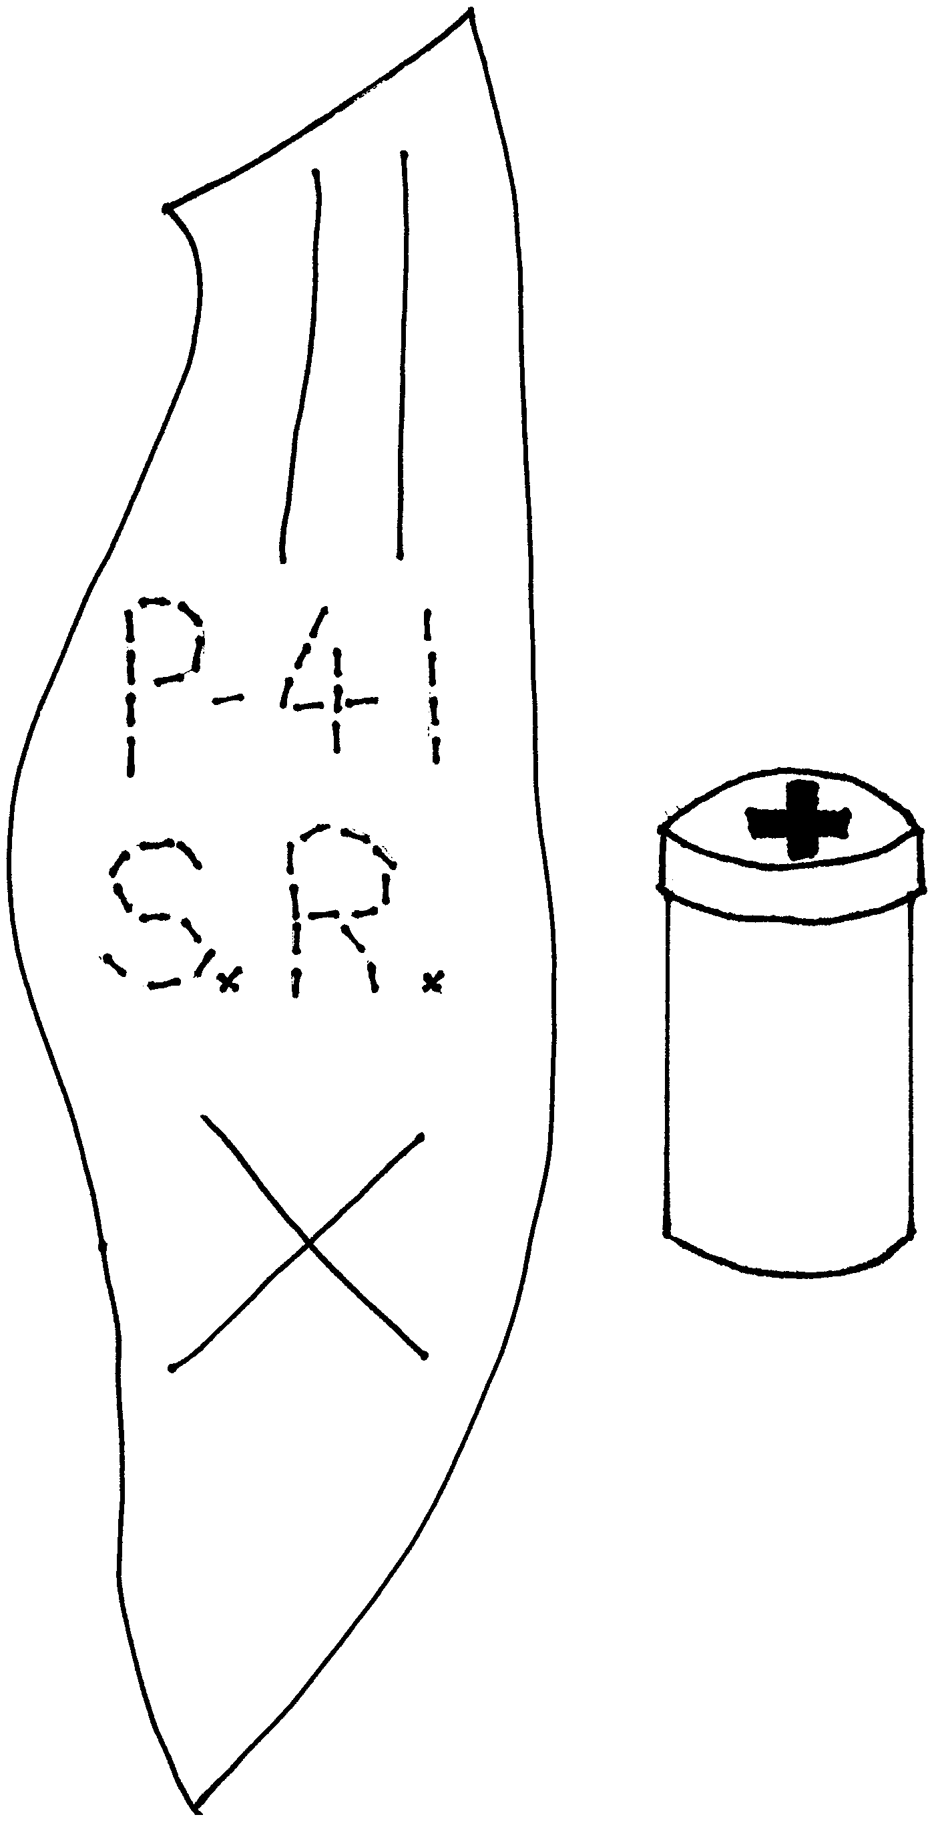
Use scrap leather or heavy scrap vinyl. The film canister must be the type with the lid larger than the canister part. Draw a red cross on the lid and place some first aid kit items in the container (Band-Aids, antibacterial towelette, safety pins, coins for phone, for example). Cut the leather in an elongated shape. Cut slits for belt and an X for the film canister (with an adult’s help), making sure the X is not too large--much easier to fix too small of an X. Decorate the leather scrap with acrylic paint, permanent markers, or puff paint. Or stamp designs using a mallet and screwdrivers, nail, nuts, bolts or any other metal object with an interesting shape. Cub Scouts can “write” their name and den number by using a blade and phillips screwdrivers. Make sure you have a piece of wood under the leather to protect the working surface. When the leather is decorated, insert the film canister into the X opening and hang the kit from your belt.

NATURE T-SHIRT

Design a T-shirts with leaves! Do this outdoors!

Materials: Solid-colored T-shirt (dark colors work best); Nature objects (leaves, ferns, flowers, with distinctive shapes); Bleach in a spray bottle; Rubber gloves; Bucket; Water

- Cover the work surface (hard, flat surface). Lay the shirt flat on the work surface.
- Arrange leaves, flowers and other objects in a simple design on the shirt.
- (Close adult supervision necessary or adults do this part) Wearing rubber gloves, spray the shirt lightly with bleach around all the edges of the design. Let the shirt set until you see the color start to change (about one minute). Carefully remove and dispose of the flowers and leaves.
- Submerge the shirt in a bucket of water and thoroughly rinse it. This stops the bleach from eating through the fabric.
- Put it through the washer and dryer and your shirt is ready to wear.

LEAF PAINTING

These work great on note cards, wrapping paper, decorating trays, gardening pots, and drinking glasses.
Make several note cards and use them to write den thank you notes to people who helped on a den hike.

LEAF PRINTING

Materials: Leaves; Acrylic paint; Paper; Brayer (or rolling pin or spoon)

- Brush a little acrylic paint on the underside of the leaf, where the veins are more pronounced in order to make a better print. Use the paint sparingly.
- Carefully place the painted leaf where you want the image printed. Cover the leaf with a piece of paper.
- Roll a brayer, a rolling pin, or a spoon over the paper with firm strokes. Remove paper and presto!
- Optional. Repeat with different leaves and different colors.

LEAF RUBBINGS

Materials: Leaves; Lightweight paper; Crayons

- Place the leaves top side down (the top side is the smoother and without raised veins or stem).
- Place a sheet of paper over the leaves.
- Remove paper covering from an old crayon and rub over the surface of the paper with the side of the crayon. The veins and shapes of the leaf will appear.
- Try using different crayon colors for different leaves or for the different parts of a single leaf.

LEAF SPLATTER PAINTING

Materials: Flat leaves; Old toothbrush; Paint

- Cover the work surface and the Cub Scouts. Or do this outside (still cover the Cub Scouts).
- Place a leaf on a sheet of paper. (You may have to pin it down)
- Dip the toothbrush in paint (not too much paint) and draw your thumb or a popsicle stick across the brush. The paint will make fine splatter marks on leaves and paper. Do with several different color paints over the same leaf.
- Try arranging more than one leaf on the paper.

For a different method of Splatter Painting, see Cub Scout Leader How–To Book
“Splatter Prints” p. 3-52.

LEAF “COPYING”

Materials: Leaves of any kind; Carbon paper; White paper; Iron

- Cover a table with newspaper.
- Put the leaf, vein side down, on a piece of carbon paper, with the carbon side up.
- Cover the leaf with a second piece of newspaper.
- Turn the iron on low heat. Gently iron the leaf.
- Lift the newspaper and remove the carbon paper.
- Place leaf on a piece of white paper, vein side down. Cover with newspaper and iron again.
- When you remove the newspaper and leaf, there will be an imprint of the leaf on the white paper.

WALNUT PHOTO CASE

Great gift for Mother’s Day.

Materials: Walnut shell halves; Photographs or pictures; Pencil; Scissors; Glue; Felt or fabric

- Divide a walnut very carefully into two perfect halves. If you place the walnuts into boiling water for a few minutes, the membrane between the two halves softens and the walnut is easy to pry open with a butter knife. (The meat can be saved for cooking.)
- Place the flat rim of the shell over the part of the photograph you want to show in your case. (The photo should be placed face-down.)
- Trace around the shell pressing the pencil deep into the photo (Fig. A)
- Repeat with another photo or picture.
- Cut out the photo along the pencil line.
- Squeeze glue around the rim of the shell (Fig. B).
- Place the backs of the cut photos onto the glued shells, matching the shapes of the photos to shells. Let them dry.
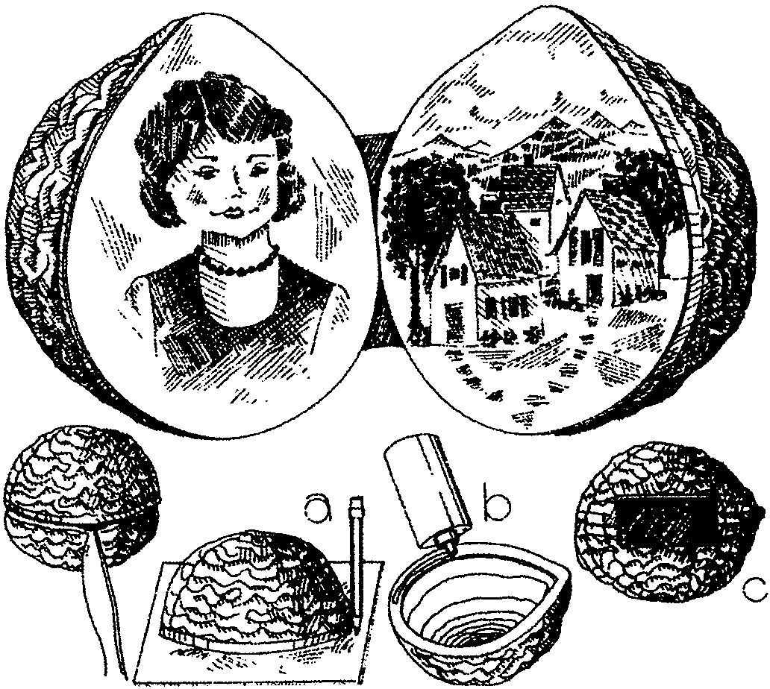
- When the photos have dried, put the two halves together as they were before the walnut was opened.
- Cut a small rectangle out of felt or fabric for a hinge.
- Glue the fabric over both shell halves on one side (Fig. C). Let dry. Open the case to show off your photos.

WILDFLOWER CANDLES

Materials: Candle wax (left-over candle stubs, or store-bought chunk--you don’t need much); Fat white candles (do not use skinny ones); Pressed wild flowers; An old can with label removed; An old soft paintbrush; A pot of water

- Collect some wild flowers and press them. Put the flowers between two sheets of paper towel and stack a big book on top, or use a flower press. They’ll need to dry several days.
- Gather your materials. Make sure the flowers are flat and rather dry.
- Melt candle wax. Put water in the pot, and put the wax in the can. Put the can in the water. Boil the water in the pot. Watch the wax carefully.
- Place a fat candle on the work surface and place a wild flower on the candle.
- Dip the paintbrush in the melted wax.
- Quickly but carefully brush a thin layer of wax over the flower to glue it to the side of the candle. If your paintbrush hardens, dip it in the warm wax.
- Continue placing the flowers and painting them down. The wax will cool quickly and will harden as it cools.

PINECONE GARDEN

Materials: Pinecones; Grass seeds; Small flower seeds; Nail; Circular scrap of wood; Saucer or shallow plastic container

- Nail a big, loosely-shaped pine cone to a scrap of wood. One nail should do it.
- Set the pinecone and wood in a saucer of water.
- Plant grass and small flower seeds between the pinecone’s sections. No soil is necessary.
- Keep saucer filled with water.
- Watch for sprouting seeds and soon you will have a little pinecone garden.

INDIAN PEBBLES (Game)

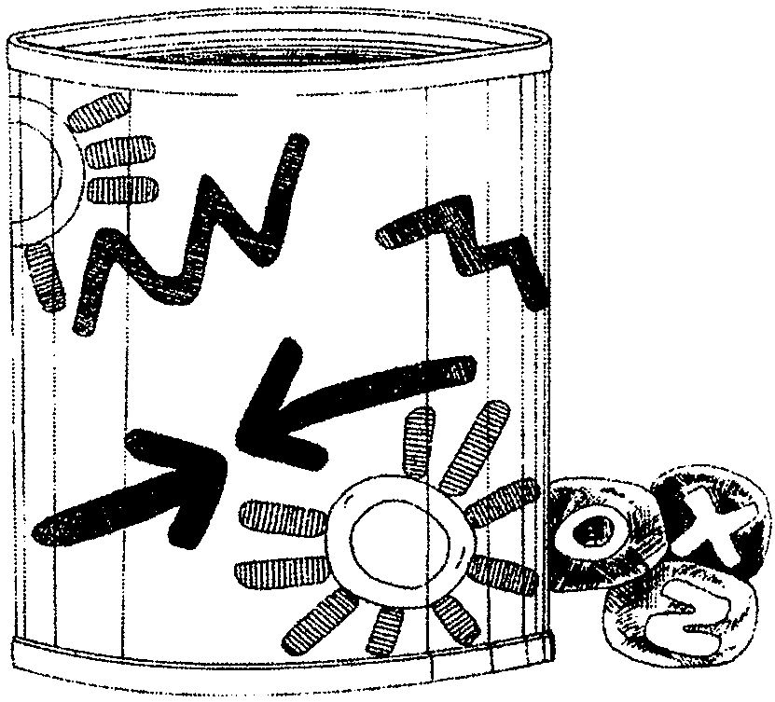
Materials: 15 smooth pebbles or small stones; Permanent marker; Scissors; Colored construction paper; Large can; Markers or crayons; Tape

- Wash and dry the pebbles.
- With the permanent marker, paint an X on five of the stones, an O on five of the stones, and a Z on five of the stones. Let the stones dry.
- Cut a piece of construction paper as high as the can and long enough to wrap around it. Draw designs on the paper with the markers or crayons.
- Wrap the paper around the can, and tape the paper ends together.
- Place the pebbles in the can.
- To play the game, each player in turn puts his hands in the can and pulls out one pebble. When all the pebbles are picked from the can, the one who has the most of one kind of letter wins the round. Repeat several times.

VARIATION: In place of letters, draw designs on the pebble, or use different colors.

TRACK NECKERCHIEF SLIDE

Materials: Model magic or clay that hardens; Q-tip; Toy “wedding” ring or 1/2” PVC pipe.

Mold clay into circle and flatten. Press footprint into clay with plastic-wrap covered Q-tip or other small round-tipped tool. Push ring into back of mold. Let dry.



GORP (GOOD OLD RAISINS AND PEANUTS)

1 cup raisins
1 cup peanuts
1 cup M&Ms
1 small package red hots
1 cup sunflower seeds
1 cup finely chopped dried fruit of your choice; dates, apricots, banana chips (see below), figs, etc.

No sugar or flavoring is needed. Mix together. Spoon into baggies and enjoy on your hikes. (Makes about 5 cups)

ENERGY BARS

3 cups dried apples
2 cups dried apricots
1 cup pitted prunes
1 cup pitted dates
1 cup raisins
1 cup sunflower seeds (shelled)
1/4 cup creamy peanut butter
1/2 cup melted margarine
1/2 cup honey
1/2 cup shredded coconut
1/4 cup sesame seeds
Flour
Plastic wrap

- Chop each piece of fruit separately in a blender.
- Put the pieces in a mixing bowl.
- After all the fruit has been chopped and tossed into the bowl, add the raisins, sunflower seeds, peanut butter, melted margarine, honey, coconut and sesame seeds. Mix them all together, using your hands if you need to.
- Shape the mixture into small rolls with your hands and roll them in flour.
- Wrap each roll in a small piece of plastic wrap and store in a covered container.

Make them ahead of time and freeze until you’re ready to go on your hike.

BANANA CHIPS

You need 2 ripe bananas (no bruises!)
Slice the bananas into thin rounds. Spray a cookie sheet with cooking spray. Spread the banana slices in a single layer on the cookie sheet. Cook slices in a 150-degree oven for 2 hours with the oven door open about 1 inch. Turn the slices over with a fork and bake for about 2 more hours. You will know they are done when they are hard and you can’t bend them. Store these treats in a plastic bag or covered container.

HOTDOGS A LA BEDROLL

1 can refrigerator biscuits
5 hot dogs
1 2/3 cups shredded cheddar cheese

- Separate the dough into two biscuits for each hot dog.
- On a piece of wax paper, press and flatten two biscuits together until the dough is large enough to wrap around a hot dog.
- Sprinkle 1/3 cup grated cheese over the flattened dough.
- Put a hotdog on top, and wrap the dough around it. Seal the edges of the dough by pinching them together.
- Insert a roasting stick or skewer into each hot dog and cook over coals.
Or cook on cookie sheet in a 375 degree oven until brown.

HAPPY HIKER JOY JUICE

Make this the night before your hike. This makes enough for a big thirsty crowd.

1/2 gallon apple juice
1 orange, sliced
1/2 lemon, sliced
1/2 lime, sliced
Add, if you like:
A sprig of mint
1/2 teaspoon cinnamon
1/4 teaspoon nutmeg

- Put the apple juice in a large pitcher.
- Add the slices of orange, lemon, and lime.
- Add the mint and spices, if you like.
- Chill it in the refrigerator for a few hours or overnight.
- Serve it at home with ice in a tall glass, or put it in water bottles and take along on a hike.

