Miscellaneous



CONTENTS

CUBSTRUCTION: LEADERS AT WORK 1
CUB SCOUT LEADER BASIC TRAINING INFORMATION 2
DISTRICT ROUNDTABLE 2
DISTRICT ROUNDTABLE MEETING LOCATIONS AND TIMES 3
DISCOUNTS AND DONATIONS 4
DISCOUNTS 4
DONATIONS 4
WEB SITES FOR CUB SCOUT LEADERS 5
SOME SCOUT-RELATED SITES: 5
OTHER SITES: 6
CHESEBROUGH SCOUT RESERVATION 7
BOBCAT TRAIL GAME 8
DISCIPLINE--DEN AND PACK 9
DEALING WITH DISCIPLINE 9
DEN DISCIPLINE IDEAS 9
Helping Your Pack Grow! 11
Planning Your Recruiting Night 11
Presenting Your Recruiting Night 11
Follow-Up 12
TIGER TO WOLF PARENT SURVEY 13
PARENT/GUARDIAN SURVEY FOR HELP IN WOLF ACTIVITIES 14
WOLF TO BEAR PARENT SURVEY 15
PARENT/GUARDIAN SURVEY FOR HELP IN BEAR ACTIVITIES 16
BEAR TO WEBELOS SCOUT PARENT SURVEY 17
PARENT/GUARDIAN SURVEY FOR HELP IN WEBELOS ACTIVITIES 18

Mark your calendar now for the upcoming Pow Wow in 2002!

CUBSTRUCTION: LEADERS AT WORK

Saturday, January 26, 2002



Registration forms will be available at the November Roundtable
Check the council’s web page http://www.sccc-scouting.org

For information contact Sakiko Wehrman
at (408) 296-6376 or pwehrman@ihot.com

CUB SCOUT LEADER BASIC TRAINING INFORMATION



Have you taken the Cub Scout Leader Basic Training? How about other leaders in your pack? The training prepares the leaders to deliver a quality, fun-filled program.

Every boy deserves a trained leader, and every leader deserves to be trained. Leaders who understand the whys and hows of the program are more effective in their roles. They know how to use available resources to provide an exciting and worthwhile program for boys. Trained leaders have confidence in carrying out their responsibilities and, along with the boys, have more fun.

Basic training is designed to give job-related information to all adult leaders and interested parents. The training includes sessions on youth development and boy behavior, resources, program planning, activities, purposes of the program and many other basic topics as well as specialized sessions for Cub den leaders, Webelos den leaders, Tiger Cub coaches and pack leaders.

If you have changed your leadership position since you took the basic training, you need to attend the specialized part of the basic training to prepare you for the new position.

The training is offered a few times a year in each district. A leader may attend one in any district. Check the Council’s calendar, Santa Clarion or the council’s website (www.sccc-scouting.org) for more information. The training schedule is also given at the District Roundtable.

Be sure to recognize the newly trained leaders. See Cub Scout Ceremonies for Dens and Packs
“Leader Training--The Pack helps the Cub Scout Grow” p. 12-4
“Leader Training Award” p. 12-5

DISTRICT ROUNDTABLE

Cub Scout leader Roundtables are held monthly on a district basis. Den and pack leaders join for FUN and FELLOWSHIP while LEARNING new tricks, stunts, games, ceremonies, crafts, and skits related to the theme and Webelos activity badges for the following month. Bring your ideas and problems to share. Meet other leaders. Information on the upcoming district and council events is given at Roundtable meetings. For specific locations and times for your district, see the maps on the following page.
District Roundtable Meeting
Locations and Times

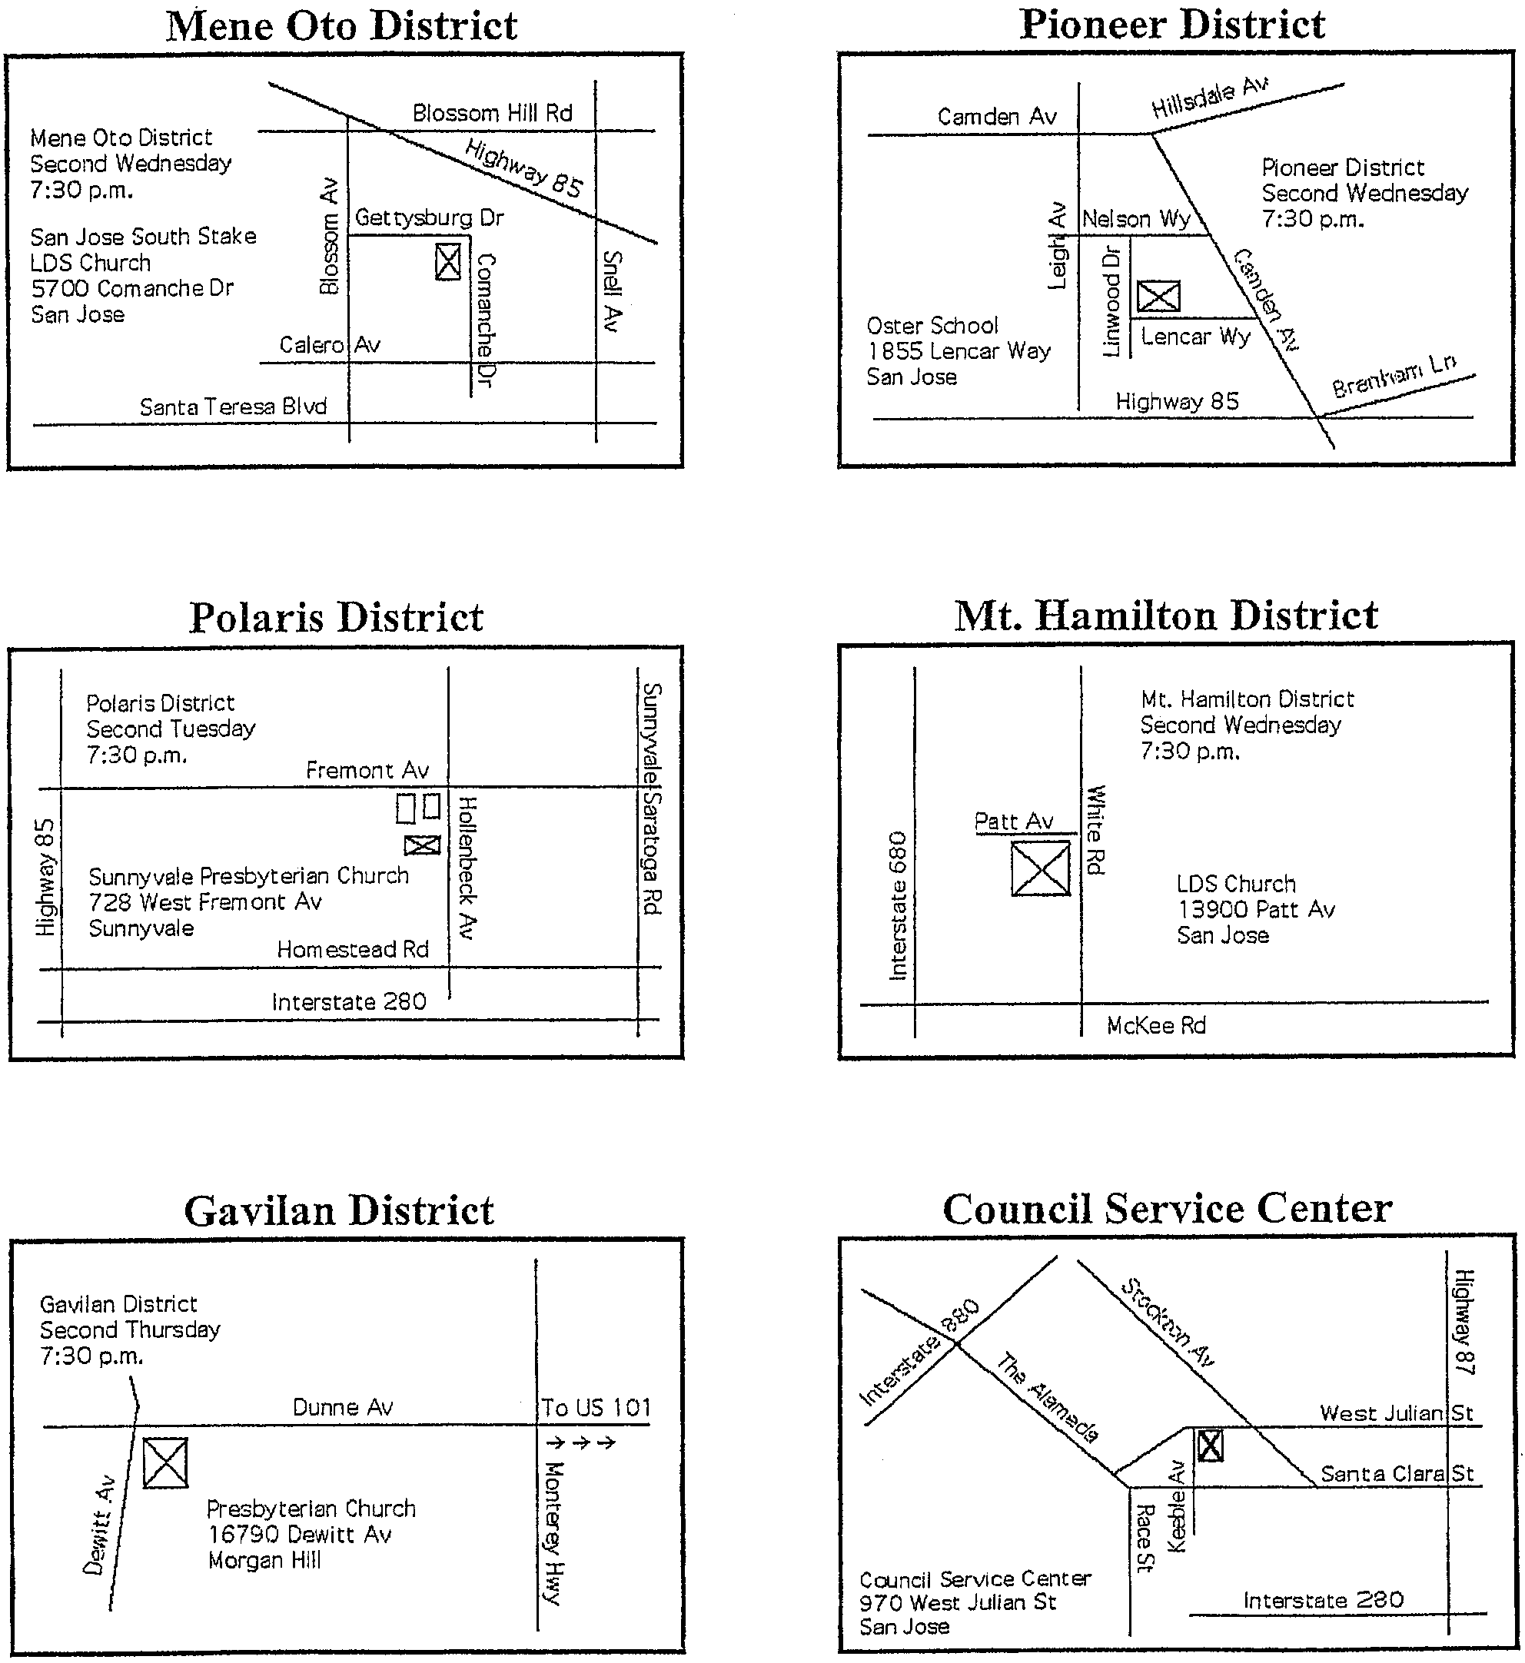

DISCOUNTS AND DONATIONS

DISCOUNTS
There are many stores in the Valley that give Scouters a 10-15% discount. They usually do not advertise the fact; so you have to ask them. Next time you shop for your den or pack, ask if the particular store gives any discounts. Ask this before they ring up your purchase.

Always carry your BSA registration card. You may be asked to show it to receive a discount. Some stores (like D&J Hobbies) require non-profit organizations to keep a letter requesting a discount and a list of possible shoppers on file at the store.

Some camping equipment stores (like Mel Cotton’s) give a discount to Scouts and Scouters on items for their personal use.

DONATIONS
Many supermarkets, discount shops, hardware stores and restaurants make generous donations to packs and troops. Again, ask.

For most donations, you will need to make a written request on the pack’s letterhead, at least 2 weeks in advance. (Ask a parent in your pack who is handy with computers to create a pack letterhead.)

Maximum amount of donations commonly given is $25 worth of goods. Many establishments have a limit on their monthly contributions to non-profit organizations. They receive a lot of requests for donations from schools in fall and late spring. Cub Scout packs have a better chance of receiving donations during winter and summer. Some packs regularly have some of the food, drink and table cloths donated for their Blue and Gold Banquets. Packs can use a donation of drinks for their summertime picnics. Be sure to thank the business for their generosity.

If you need a large quantity of scrap leather for your pack, call Salz Tannery in Santa Cruz. For their address and phone number, see the FIELD TRIP section at the end of this book. They are very generous. They also have a great tour.

WEB SITES FOR CUB SCOUT LEADERS

SOME SCOUT-RELATED SITES:

http://www.sccc-scouting.org
Santa Clara County Council page

http://www.bsa.scouting.org
National BSA page

http://www.scoutingmagazine.org
Scouting magazine

http://www.boyslife.org
Site from the magazine Boys’ Life, for all boys (and leaders).

http://www.scoutstuff.org
BSA Supply Division

http://www.scouting.org/international
BSA International Division

http://www.scout.org/wso/links.html
World Organization of the Scouting Movement (WOSM), information on 151 national Scout organizations

http://www.ussouts.org
US Scouting service site, contains Baloo’s Bugle Virtual Roundtable and other great resources! Links to everything!

http://www.scouter.com/
Links to more than 12,000 sites, pack and troop websites, scout skills

http://www.scoutorama.com
Mostly Boy Scouts activities, includes outdoor cooking, also Scouting links

http://www.macscouter.com
Ceremonies, clip art, games, bookstore, kids’ page and more

http://www.geocities.com/Yosemite/9152/
Virtual Cub Scout Leaders Handbook, listings for articles to help cub leaders

http://www.edinburgh-scout.org.uk/games/
Bonaly Scout Center, Edinburgh, Games galore!

http://www.earlham.edu/~peters/knotlink.htm
Everything you wanted to know about knots

http://www.digisys.net/scoutbks
Scouting books
http://www.thepatchplace.com
The Patch Place

http://www.digitalscoutpatches.com
Digital patches

http://www.patchsales.com
Patchsales

OTHER SITES:
These sites are not necessarily Scout-oriented, but can be a great resources to you.

http://www.nps.gov
National Park Service site

http://www.cal-parks.ca.gov
California State Park Service site

http://claraweb.co.santa-clara.ca.us/parks/index.html
Information on all the Santa Clara County Parks

http://www.openspace.org
Mid Peninsula Regional Open Space District parks

http://www.pdinfo.com
Public Domain Music site, alphabetical lists of more than 3,000 songs

http://home.achilles.net/~cco/dir-cam.htm
Campfire singalong index:

http://www.melborponsti.com/speirs/index/html
A great collection that includes sections on Dutch oven cooking and Gross but Fun foods

http://www.homeschoolzone.com/pp/
Craft projects organized by age, season, medium

http://www.craftsetc.com
Site for arts and crafts supplies

http://www.pack-o-fun.com
Crafts and more from the publishers of Pack-O-Fun Magazine

http://www.familyfun.com
From Disney, the publishers of Family Fun Magazine. Crafts, games, food, costumes, etc.

http://www.michaels.com
Michaels Arts and Crafts

CHESEBROUGH SCOUT RESERVATION

Chesebrough Scout Reservation is our Council’s camp located on Highway 9. It is a great place for overnights for Webelos or pack families.

There are hiking trails and areas to play sports. Flush toilets are available at Redwood and Madrone campsites and also at the Shingle Mill site.

The fee for the weekend (Friday through Sunday) for packs in the council is $4.50 per person (youth and adult). Part of the fees may be waived by performing a service project at Chesebrough. The project must be approved ahead of time by the Chesebrough committee.

There is an extra cost for the use of a structure (such as kitchen, pole barn).

For more information, ask at the front desk at the Council Service Center
or contact Les Schreiber (408) 446-0288 lesschreiber2@aol.com
J. Anderson (Council Program Director) at (408) 280-5088 x25

Reservation forms are available at the Council Service Center.

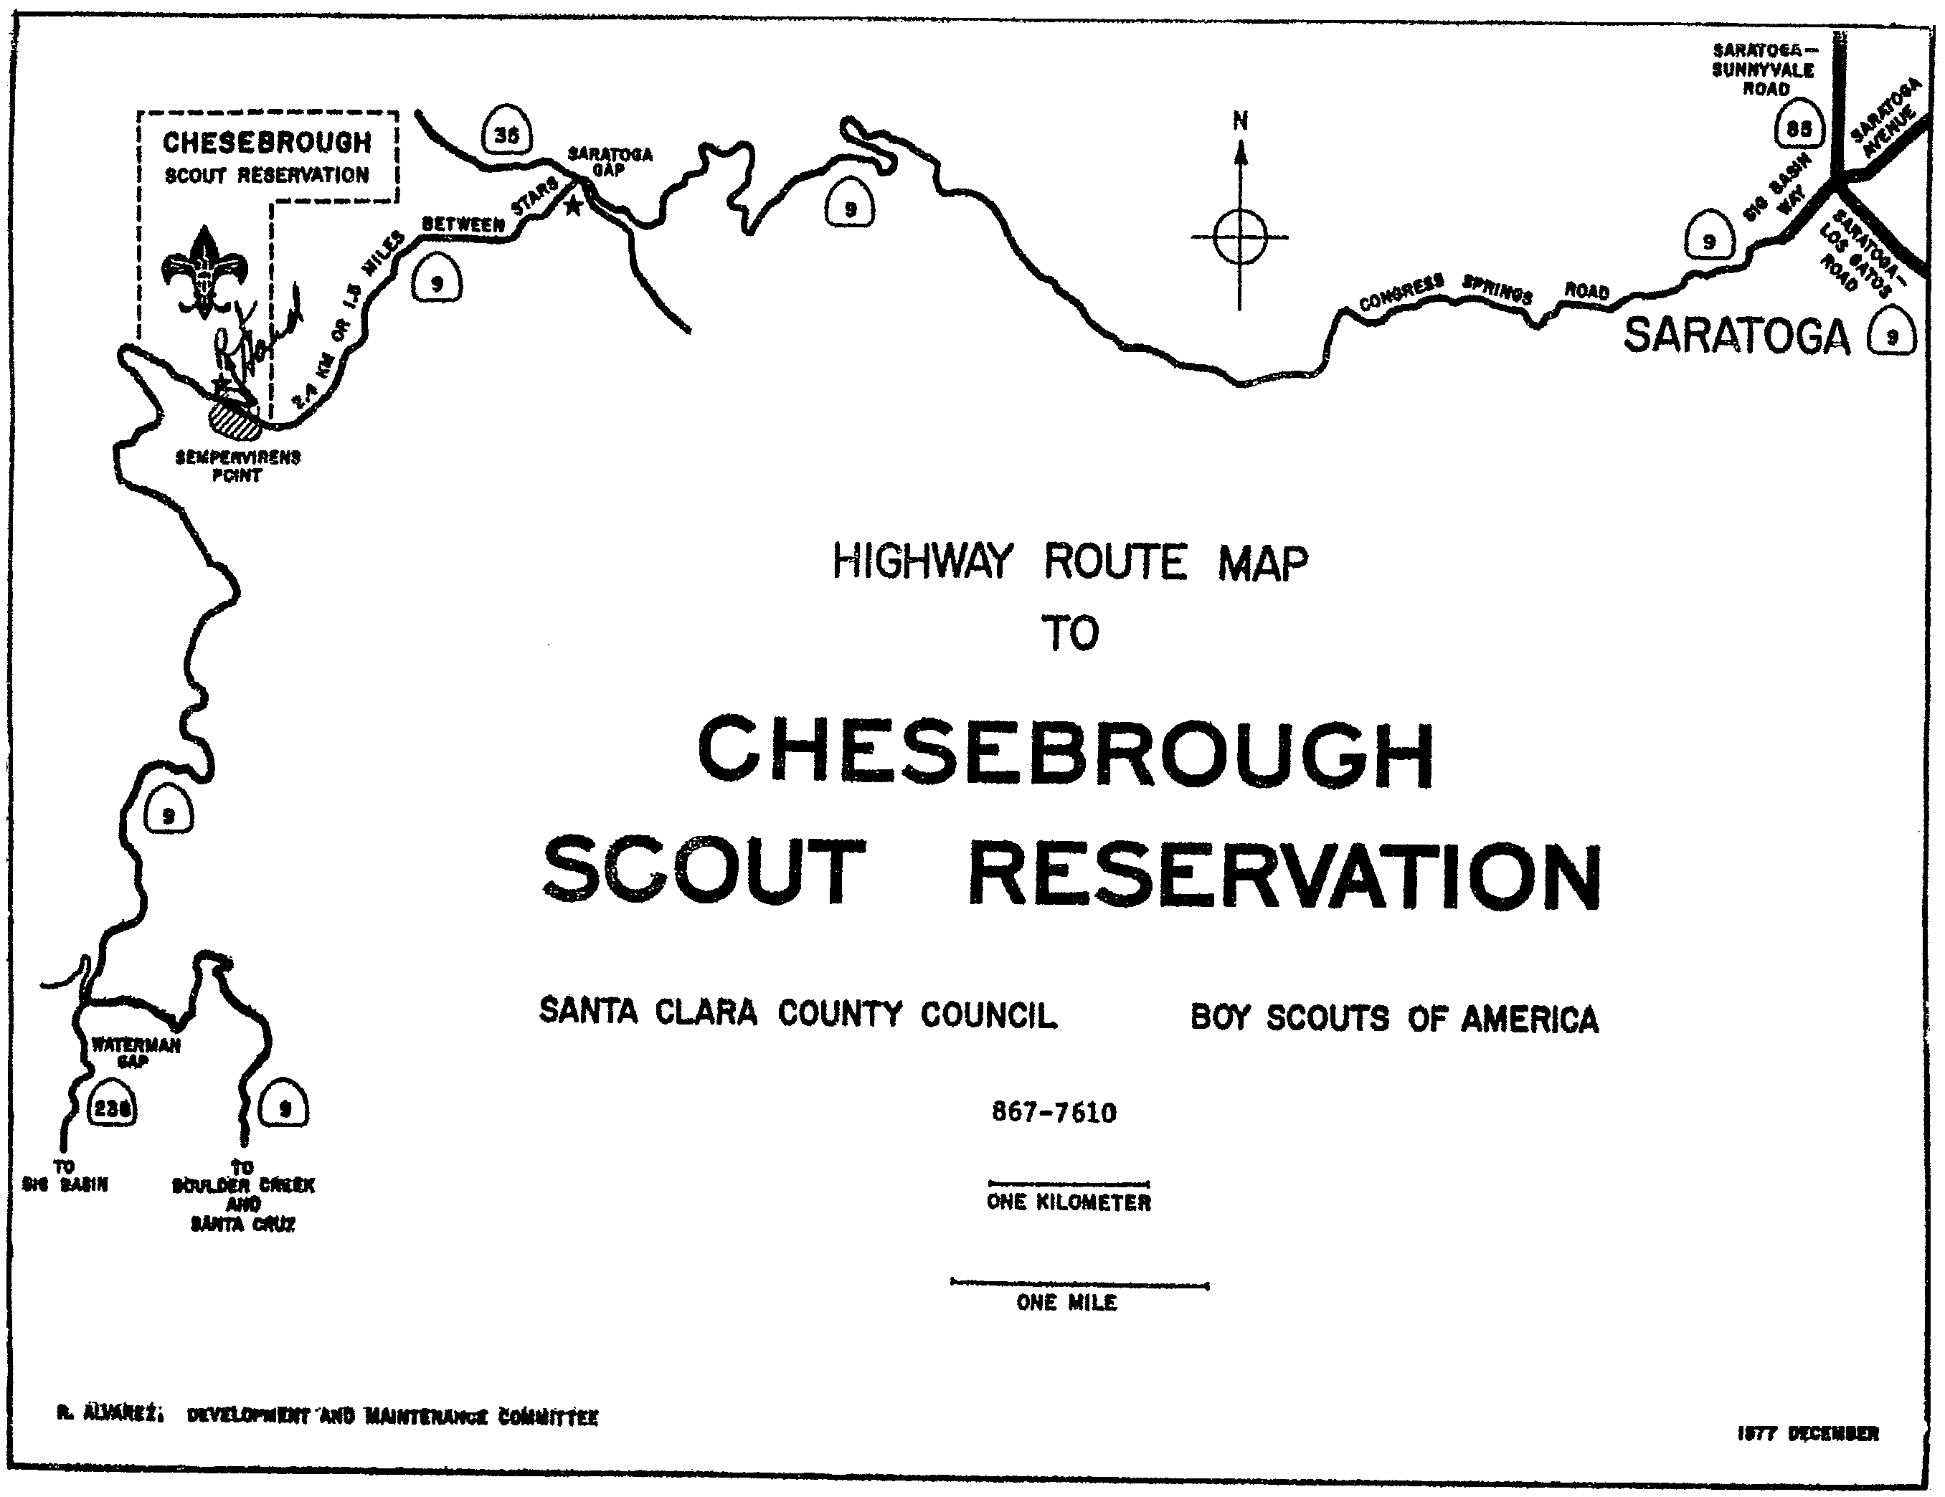

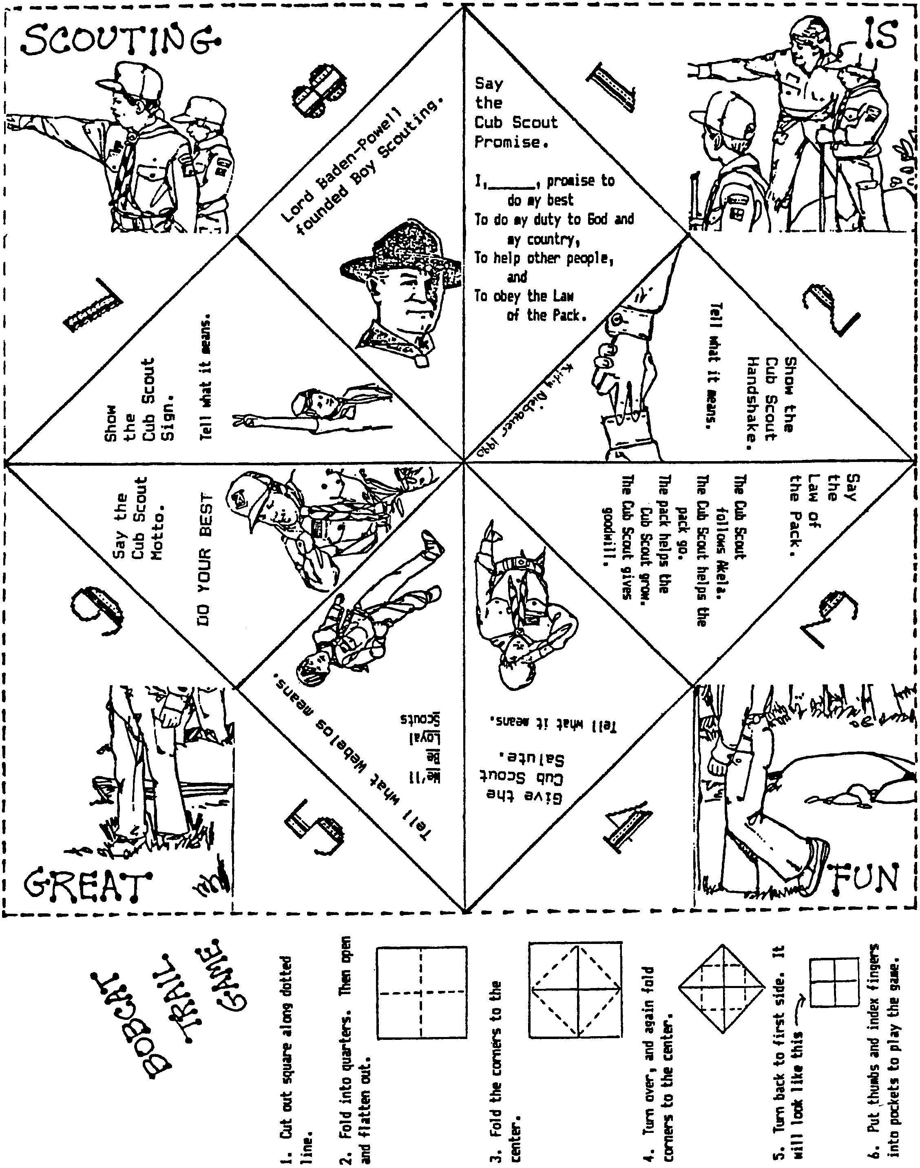

DISCIPLINE--DEN AND PACK

Please also refer to “Discipline” on pages 2-7 and 2-8 in the Cub Scout Leader Book.

DEALING WITH DISCIPLINE
Few adult leaders would be in Cub Scouts if it were not enjoyable. However, considering the boys’ ages and stages of development, getting the most from them while maintaining good discipline can be difficult. Here are some tried-and-true methods of maintaining discipline.
- Discuss your “ground rules” at the beginning of the year. Cub Scouts need to know there is a time to be serious.
- Deal with problems as they happen and be ready to step in when things appear to be getting out of control.
- Use the Cub Scout sign to get attention and as a signal for quiet.
- NEVER shout to get attention.
- Plan your den meetings so the boys know what to expect--opening, song, craft, game, closing, snack. Keep the meeting moving so there is no time for mischief.
- Give the boys responsibility and let them know you expect them to meet it.
- Get the boys into uniform. Be a good example by wearing your uniform at all Scouting events.
- Try to see things through the boys’ eyes.
- Get to know each boy and something of his home life.
- Never inflict punishment while angry.
- Do not create impossible goals for the boys.
- Be totally fair. Do not “pick out” or “pick on” any boy.
- Always be ready to listen to a boy’s complaint.
- Give the boys some choices in den activities.

DEN DISCIPLINE IDEAS

Remember that discipline is not punishment. Discipline is setting boundaries and sticking to them. Reward the positive behavior. Here are several ideas. You may want to combine a few of them.
- Cub Scout Sign: If you use the sign consistently and follow it with something exciting, the boys will respond to it.
- Den Code of Conduct: Have your boys decide for themselves what rules they think would be appropriate for a den meeting. You’ll be surprised, and the boys will often be harder on themselves than you would be. Once they have “ownership” of the rules, they will be more apt to follow them as well as make sure their den mates follow them! Update the Code periodically.
- Talking Feather: The feather gives the holder the right to speak. When he has said what he wanted to, he can pass the feather on to another. This will help the boys to learn to not speak when someone else is speaking and to be courteous. When a boy does not talk out of line, he may put a bead on a string. When a sufficient number of beads have been earned he is rewarded.
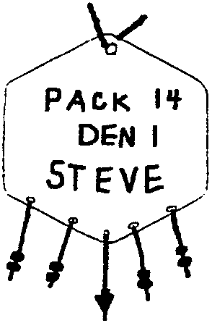
- Beads: Beads can be strung on string or attached to a piece of leather or vinyl. The boys can earn beads for positive behaviors such as attending a den meeting, coming in uniform, appropriate behavior throughout a den meeting, etc.
- Pizza Party: Make medium and small slices of pizza, depending on the behavior of the boys, let them place a slice of pizza in the pan. When they have filled the pan they have earned the pizza party.
- Pepperoni Pizza: Similar to the idea above. Cut out a pizza-size circle from cardboard. Cut out smaller circles for pepperoni. At the end of a den meeting, have a short discussion on the way the den meeting went. Focus on the den behavior and discourage negative personal comment (encourage personal praise, though). As a den, decide on how many pepperonis they should place on the den pizza. Have a guideline ready for the number of pepperonis (e.g. Super great behavior=3, Good behavior=2, etc.) When the number of pepperoni slices reaches the set goal, have a pizza party.
- Ice cream cone: Have a copy of a cone on a poster board. As the boys behave, they can add a scoop of ice cream to the cone. You set a given number of scoops that must be met before they can earn a real ice cream cone.
- Marble jar: As the boys behave, they can put a marble in a jar. When the jar is full, the boys would be rewarded accordingly. Choose the jar so that the goal is attainable within a reasonable amount of time.
- One Minute Game: When the boys are out of control and not paying attention, have them stop and try to guess (as close as possible) when “one minute” has passed. The boy or boys with the best guess would get a bead for their necklace or den doodle.
- Den Doodles: Add a “behavior string” to your den doodle alongside the ones showing advancement. Boys add beads to their “behavior strings” for good behavior. For den doodle ideas, see Cub Scout Leader How-To Book (pp. 3-13 to 3-14) and Cub Scout Ceremonies for Dens and Packs (chapter 2).
- Good Behavior Chart: Design a chart, or let the boys help design it and then check off something within the artist section for their particular trail. Have some stickers for the boys to add by their name each time they behave. Maybe have a section on the wearing of the uniform, bringing their book, and being on time; and let them mark their own name on the chart. As soon as a boy has earned a set number of stickers he is then rewarded. It might be a good idea to do this on a monthly basis to keep them on the right track. Instead of stickers, you may want to use stamps.

Helping Your Pack Grow!

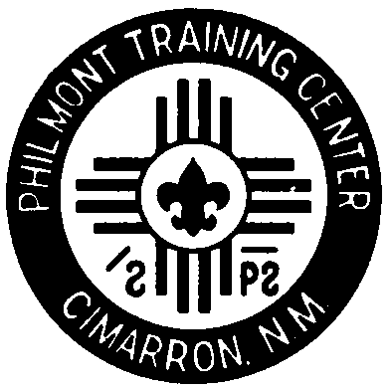
Fun Recruiting Ideas

By:

Dick Noack

Planning Your Recruiting Night

1. Believe fervently that all boys deserve to be Cub Scouts.

2. Plan all logistics carefully:

- Location

- Conflicts

- Timing – just before summer is best

- Publicity

- Target Grade Levels

3. Enlist Cub Scouts and parents to help present program.

Presenting Your Recruiting Night

1. Arrive early and set up

- Showcase Cub Scouting

2. Greet/meet all who attend

- Gather contact information

- Introduce those who may not know the others

3. Start on time

Presenting Your Recruiting Night (continued)

4. Show the parents that Cub Scouting is worthwhile

- Show the boys that Cub Scouting is fun

5. Demonstrate the methods of Cub Scouting

- Seat by age-appropriate dens

- Mix fun with learning

6. Sign everyone up!

- Have them fill out registration forms

- Collect fees or arrange for when they can be picked up

Follow-Up

1. Keep all promises

2. Get the boys registered as soon as possible

3. Communicate, Communicate, Communicate

4. Form neighborhood dens early

5. Quickly identify potential den leaders

6. Provide a great summer program

- Invite all the new families to a Pack activity within a few weeks of the Recruiting Night

7. Make your yearlong program shine

8. Plan a parent’s meeting at the end of summer

