Hometown Heroes

November 2001

CONTENTS

THEME RELATED 1
DEN AND PACK ACTIVITIES 1
SPECIAL GUESTS 1
THANK YOU’S 1
SCOUTING FOR FOOD 1
VETERAN’S DAY 1
FIELD TRIP IDEAS 1
PARTICIPATION AWARDS 1
DISTRICT DINNER 2
FRIENDS 2
PREOPENING 3
FIREMAN LADDERS 3
CEREMONIES 4
HOMETOWN HEROES OPENING 4
AS A GOOD CITIZEN OPENING 4
HERO CLOSING 4
HOMETOWN HEROES CLOSING 4
HOMETOWN HERO CLOSING 5
“FEELING OF GOODWILL”--CUB-
MASTER’S MINUTE 5
“BE PREPARED”--CUBMASTER’S MINUTE 6
HERO ADVANCEMENT 6
AND THE HEROES ARE--ADVANCEMENT 7
ADVANCEMENT IDEAS 7
DEN LEADER RECOGNITION 8
FUN WAYS TO SAY THANK YOU 8
AUDIENCE PARTICIPATION 9
CUBBY, THE FEARLESS VIRUS CATCHER 9
CLANCY TO THE RESCUE 10
SKITS 11
MAGIC OF A SMILE 11
THE UNKNOWN LEGEND 12
WHY ARE FIRE ENGINES RED? 12
GAMES 13
WHO AM I? 13
KEY TO THE CITY 13
FIREMAN RELAY 13
FIRE FIGHTERS RELAY 13
THE OTHER HERO 14
FIREMAN, SAVE MY CHILD 14
SEARCH AND RESCUE 14
DARTH VADER AND THE JEDI KNIGHT 14
SONGS 15
HOMETOWN HEROES 15
BE KIND TO YOUR CUB SCOUTING
FRIENDS 15
I AM PROUD 15
9-1-1 HELP 15
THE MAGIC OF SCOUTING 16
A SALUTE TO LEADERS 16
CUB SCOUT CITIZEN 16
I WISH I WERE A VOLUNTEER FIREMAN 16
CRAFTS 17
FLAG PLAQUE 17
STAR FRAME 17
HOMETOWN RELIEF MAP 18
BEST PARENT MEDAL 18
HERO’S MEDAL 19
THUMBS-UP COAT RACK 19
HEROES IN OUR TOWN 20
WINNER’S MEDAL 20
FIREMAN HAT SLIDE 20
CUBS IN THE KITCHEN 21
HOT “HERO” SANDWICH 21
RECIPE FOR A GOOD SELF-CONCEPT 21
FIRE HOSE 22

DEN AND PACK ACTIVITIES

Heroes to a child can be anyone, their teacher, den leader, coach, etc. Sometimes they admire television, sports and musical stars. At a den meeting, have your den dress up as their favorite hero. Allow the boys to tell a little about the heroes they have chosen.

A variation to the above is to have the boys come dressed as a super hero. Ask each of them to describe the good deeds he would be able to do if his character were a real person. Then have a real hero speak to the boys about what he did to become a hero. He or she can be a firefighter, a Scout who saved a life or completed a conservation or service project, a police officer, or a clergyman. Help the boys realize they can be heroes in a very real sense, by obeying the Cub Scout Motto and living up to the Cub Scout Promise and the Law of the Pack.

Don’t forget moms and dads and grandparents. According to some research, “mothers and fathers are at the top of the list as heroes for their children.” (Scouting Magazine, Jan-Feb 2001)

Who settled your town? Who was your school named after? What did he/she do? With the boys, do some research and find out!

SPECIAL GUESTS
Heroes come in all ages. Do you know any hero in the neighborhood? Do you know any Scout or Scouter who has received an award for heroism? Invite them to your den or pack meeting.
Firemen, policemen, search and rescue volunteers, and many others who are quietly helping people are heroes in our community. Ask them to come and talk to the boys about what they do.

THANK YOU’S
It requires a lot of hard work for the pack to have a quality program. Thank all the heroes in your pack for their help.

SCOUTING FOR FOOD
Be a hero and participate in the council’s Scouting for Food program!

VETERAN’S DAY
Honor the veterans in your community. Attend the Veteran’s Day parade in your community.

FIELD TRIP IDEAS
Fire stations in your area
Police departments in your area

PARTICIPATION AWARDS (For details, see the PARTICIPATION AWARDS section)
Cub Scout Academics: Citizenship

DISTRICT DINNER

November is the time for Adult Leader Recognition Dinner for all districts. It is an opportunity for units to recognize their outstanding leaders as Unit Scouters of the Year and to say “Thank You” to them in front of other leaders in the district. And those who have completed the requirements for the Leader Recognition Awards (Den Leader, Webelos Den Leader, Cubmaster, Den Leader Coach, Tiger Cub Coach, Cub Scouter) will receive their knots and certificates. The district will recognize its outstanding volunteers as they present them with the District Awards of Merit. The District Dinner is fun, the food is good and the company is great.

FRIENDS

Friends should be radical.
They should love you when you’re unlovable,
Hug you when you’re unhuggable,
And bear you when you’re unbearable.

Friends should be fanatical.
They should cheer when the whole world boos.
Dance when you get good news,
And cry when you cry too.

But most of all friends should be mathematical.
They should multiply the joy, divide the sorrow,
Subtract the past, and add to tomorrow.
Calculate the needs deep in your heart,
And always be bigger than the sum of their parts.

Be a hero--be a friend to a child.....

BE A HERO IN A CHILD’S LIFE.
PROVIDE A GREAT PROGRAM.
GET TRAINED!

FIREMAN LADDERS

Help! The Cub Scout is trapped on the top floor in Apartment #18. Start at apartment #1. Roll a die. Advance the number of apartments shown on the die. If you land on an apartment with a flame, you go up the fireman’s ladder, but you have to go down an escape slide. Each time you take a turn, answer a safety question. Use a button for your marker.

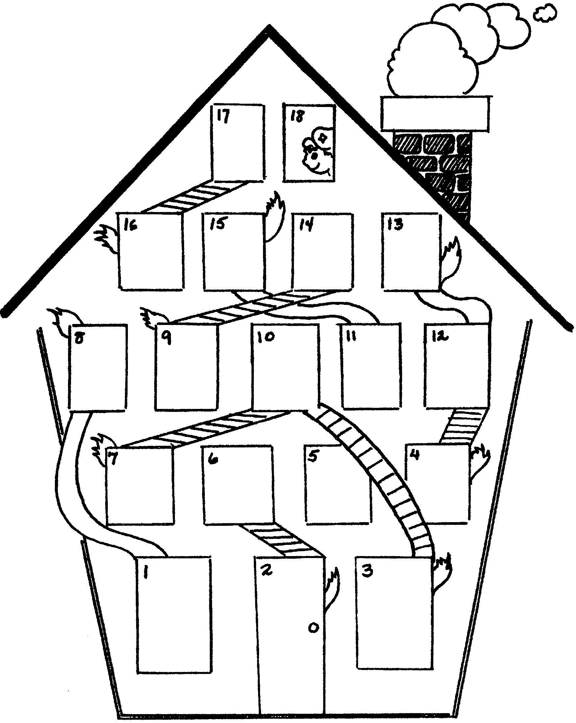

Leaders: Prepare safety questions from the boys’ Cub Scout Book. Write them on index cards.

HOMETOWN HEROES OPENING

C.S.#1: Sometimes a local hero is obvious, the policeman who risks his life to protect us from violence or the fireman who pulls people out of burning buildings.
C.S.#2: Other heroes that come to mind are the ambulance drivers, paramedics, doctors and nurses who save lives everyday.
C.S.#3: Some people around us seem like regular people, but they are heroes because they used to be soldiers in the military and served our country to keep us free.
C.S.#4: A hero is someone who does the right thing, even when they are afraid of failure. They do it because it should be done.
C.S.#5: Some heroes are harder to spot, but they are still there. My heroes include the people who donate blood, teachers who spend their time and energy helping kids, and kids who say “No” to drugs.
C.S.#6: Heroes are all around us. Please join in saluting all the heroes of our country, by repeating with me the Pledge of Allegiance to the Flag.

AS A GOOD CITIZEN OPENING

C.S.#1: As a good citizen I will try to be helpful and kind.
C.S.#2: I will strive to take good care of all property and practice safety and health rules.
C.S.#3: I will practice thrift and good work habits.
C.S.#4: I will show a respect for authority. I will be honest and dependable.
C.S.#5: Fair play and good manners will be my goal.
C.S.#6: I will take pride in achieving and be patriotic and loyal to my hometown and country.

HERO CLOSING

Props: Large cards spelling out H-E-R-O, with lines on the back for the boys to read.

H Help is on the way. A hero is someone who helps.
E Everyone can be a hero. You just have to be prepared and know that you can make a difference.
R Remember that even brave people can be afraid. It is acting even when you are scared that makes you brave.
O One person can make a difference. One person who helps can change someone’s world.

HOMETOWN HEROES CLOSING

C.S.#1: All of our Hometown heroes are hard working people. You won’t find a shirker in the bunch.
C.S.#2: All are Americans trying to improve this country of ours.
C.S.#3: As we leave here tonight, let us keep those hard working Americans in our mind.
C.S.#4: Do the same as they do--do more than your share.
C.S.#5: Help your parents whenever they ask and even when they don’t.
C.S.#6: Maybe someday, there will be a boy who will say you are his hero.

HOMETOWN HERO CLOSING

Cubmaster: This month we have learned some important lessons about being heroes. I challenge you all to “Do Your Best” to be someone’s hero. Take a moment to think about how we can live up to the words of Bill Elliot...

Do more than belong...participate
Do more than believe...practice
Do more than be fair...be kind
Do more than forgive...forget
Do more than dream...work
Do more than teach...inspire
Do more than live...grow
Do more than be friendly...be a friend
Do more than give...serve

“FEELING OF GOODWILL”--CUBMASTER’S MINUTE

A friend of mine once told me of being on a long business trip. His car broke down in the middle of nowhere and he was going to be late for a very important meeting. Just then a farmer came around the corner on a hay wagon, and pulled over to see what was wrong. The farmer and his son often fixed their own machinery and they were quickly able to get my friend’s car running again.

My friend offered to pay the farmer and his son for their help, but they refused. He insisted that they must take something because they had saved him so much by letting him get to his meeting on time.

The farmer replied that he and his son now had something far more valuable than the businessman could give them. They had helped someone when they did not have to. That gave them a warm feeling about themselves. If they took the money for an act of kindness, then it would simply be a job, and take the feeling of goodwill away.

Keep your feelings of goodwill by helping others. It will be the most valuable reward you will ever receive.

APPLAUSES

GRAND SALUTE: Stamp feet four counts, slap knees four counts, clap hands four counts, stand and give salute.

GRAND APPLAUSE: While sitting stomp feet four times, slap knees four times, clap hands four times, stand up and yell HURRAH!

“BE PREPARED”--CUBMASTER’S MINUTE

Being a hero does not mean that you must risk your own life. It can mean getting help, or making a phone call to 911 to get the police, or fire department, or an ambulance. The key is to use wisdom and judgment, but to do it quickly. Sometimes time is limited. You can save a drowning person by pulling them in with a life ring, and not become a victim yourself by jumping in after them. Many times an adult has been saved because a child knew to call 911 in an emergency and get help right away.

You never know when or where emergencies will arise. Cub Scouting teaches us to handle these situations. We don’t expect to get hurt, and don’t expect to need first aid, but we are prepared just in case. Do Your Best!

HERO ADVANCEMENT

Props: “Medals of Honor” made from construction paper and attached to loops of crepe streamer to be hung around the Cub Scouts’ necks. Label the medals “HERO.”

Cubmaster:
Often we hear of professional athletes being called “sports heroes.” That’s a colorful description, but all they are really doing is playing a game to entertain us. Some of these people really are heroes, but that comes from things they do off the playing field to help their communities.

A hero is a person who is not afraid to do what he believes is right. He is a person who wants to make things better for other people. He is usually prepared and trained to do the job. And he will do his best even if he is afraid because it is important to him to do what is right.

The following boys are heroes to me. They have chosen to work hard and prepare themselves in life by learning Cub Scouting ideals. They are learning to be independent and successful and happen to have a lot of fun along the way. Please join me in congratulating the heroes who have earned their Bobcat rank (call out names of boys and their parents) present rank awards and place medals around the boys’ necks. Continue in a similar manner for each additional rank.

APPLAUSE

GRAND HOWL: Cub Scouts form a circle around the person being honored. Each Cub Scout in the circle squats, touching the fingers of both hands (each one making the two-fingered Cub Scout sign) to the ground, between his feet. Then, like young wolves, the Cub Scouts raise their heads and give a long howl: “Ah-h-kay-y-la! Wee-e’ll do-o-o ou-u-u-ur best!” As the word “best’ is yelled, very sharply, everyone jumps to his feet, raises his hands high above his head, and gives the Cub Scout sign.

AND THE HEROES ARE--ADVANCEMENT

Props: Make award cards cut out of card stock or poster board in the shape of trophies or medals (see above) for each boy. Write each boy’s name on a trophy and attach his awards.

During the ceremony, talk about how the boys have helped other people during the month. How their helpfulness has touched the lives of many people and to those people they are heroes. Heroes are people who touch the life or lives of those around them just because it is who they are and what they do. Heroes aren’t usually famous people. In fact, most heroes are people we know and love, people who influence our lives everyday in every way. As each boy advances along the Trail to the Arrow, he performs acts of service and kindness. As each boy and his parents come forward, present his award with heartfelt thanks for his heroic deeds that have touched so many people.

ADVANCEMENT IDEAS

- Hang pictures of hometown heroes around the meeting area, one for each den. Pictures may be those of actual people or drawings of particular occupations such as firefighter, policemen, teacher, etc. Around each picture, hang photos of Cub Scouts and leaders. If photos are not available, use drawings or decorated cards with their names on them. Attach awards to each photo. If the boy did not earn an award that month, attach a card to the photo that tells something good he has done in the last month (check with den leaders and parents for information). When presenting awards, mention the boys’ hard work and their willingness to give goodwill--the same characteristics of those heroes.
- Look around your neighborhood and your resource people within your neighborhood. A fire station, a police station, school, church, recreation center, etc. can all be possibilities. Ask these people if they would attend your pack meeting and take part in your advancement ceremony. A Bobcat may receive his advancement form his school teacher. A fireman could present the Wolf advancements. The Bear rank could be presented by a policeman.

The only things we keep permanently are
those we give away
--Waite Phillips
(donated the Philmont Scout Ranch)

DEN LEADER RECOGNITION

This month’s theme is “Hometown Heroes.” As we found out, there are all kinds of heroes in our community--firefighters, policemen, teachers, doctors, and young Scouts, to name a few. In our pack we have heroes. They are den leaders, committee leaders and parent helpers. Tonight I would like to recognize one of our den leader heroes. This den leader has completed the requirements for the Den Leader Award. These requirements are not easy to do. You need extra special dedication to complete them. Will (Name of the leader), please come forward? We want you to know that we appreciate all the time and effort that you put forth. You are helping shape these boys’ lives and building the leaders of tomorrow. I would like to present to you the Den Leader’s Award Certificate and Square Knot that you can wear on your uniform. Congratulations and Thank You.

NOTES: Leaders Awards are given at the District Dinner (please see the “Theme Related”) but it should be re-presented or recognized at the pack meeting so the pack families and boys know the work that leader has done.

FUN WAYS TO SAY THANK YOU

‘all’ detergent box: “Thank you for giving your ALL!”
Band-Aids: For someone who fixes our pack’s problems.
For someone who gives first aid when we need it.
Fireman hat or badge: For someone who always comes to the “rescue.”
Keys on a key chain: “You are the key to our pack. Thank you.”
Wiggle eyes glued to ribbon: “Our eyes are on you.”
“We love looking at the result of your work!”

See Cub Scout Ceremonies for Dens and Packs for:
“Discover America”

APPLAUSE

FIRE ENGINE: Divide audience into four groups.
Bell -- “Ding, ding, ding.”
Horn -- “Honk, honk, honk.”
Siren -- “Rrr, rrr, rrr.”
Clanger -- “Clang, clang, clang.”

Point to different groups. Raise your arm to have everyone make their sounds at the same time.

CUBBY, THE FEARLESS VIRUS CATCHER

Practice motions and words with each group before beginning story. The leader who narrates the story should say key words with great drama and pause for each section to do their part.

MESSAGE: Swing one arm around rapidly in a circle, say “You’ve got mail!”
COMPUTER: Stand straight up, arms at side, say “Beep!”
SCHOOL: Arms overhead, swing back and forth, say “Ding-Dong!”
TEACHER: Cup hands around imaginary apple, say “Thanks for the apple!”
VIRUS: Arms out in front, wiggle fingers, say “Glub, glub!”
CUBBY: Stand and give Cub Scout salute, say “Do Your Best!”

One morning, a young boy named Josh got up early and checked his e-mail to see if he had a new MESSAGE. Josh turned on his COMPUTER and dialed his SCHOOL. The MESSAGE from his TEACHER came back immediately: “Emergency! Every COMPUTER in the SCHOOL has gotten a VIRUS!” The young man knew this was no ordinary disaster, so he turned off his COMPUTER and quickly changed into his special super hero costume. Josh became CUBBY, the Fearless VIRUS Catcher. As CUBBY got to SCHOOL, he spotted his TEACHER.

In his deepest voice, he said, “Good morning, ma’am, I received a MESSAGE that this SCHOOL has a COMPUTER VIRUS!”

“Why, it’s CUBBY!” she said, “The Fearless VIRUS Catcher! Right this way,” she said. The TEACHER rushed to the COMPUTER lab. CUBBY pretended he didn’t know his way around the SCHOOL, just to protect his secret identity.

CUBBY leaped into action! Neatly folding his cape, he turned into a stream of electrons and entered the nearest COMPUTER like a lightning bolt! Looking out through the monitor screen, CUBBY could see his TEACHER gasp in surprise. Over in the corner by the memory chips, slouched the nasty VIRUS! CUBBY grabbed the VIRUS by its tail and trapped it in his special Containment Unit. Immediately, he sent a MESSAGE to his TEACHER: “One COMPUTER freed, nine to go.”

The SCHOOL was going crazy, as word of the VIRUS hunt spread. From COMPUTER to COMPUTER he jumped, trapping each VIRUS, then sending a MESSAGE to his TEACHER: “Another COMPUTER saved!” Finally, CUBBY was down to his last VIRUS, but it was nowhere to be found. He crawled through the COMPUTER, searching behind the power supply, around the hard drive, and through the circuits. At last CUBBY spotted the VIRUS on a floppy disk in the disk drive.

Letting out a fierce yell, CUBBY jumped on the VIRUS and wrestled it into his special Containment Unit. Exhausted, CUBBY materialized in front of his TEACHER, dragging the smoking Containment Unit holding all the VIRUSES.

“I got the last one, ma’am,” he said proudly. “You truly are a super hero!” cried the TEACHER. “All in a day’s work,” said CUBBY, as he rushed off to change. A few moments later, Josh wandered into the room saying, “Hey, it looks like I missed all the excitement.” The TEACHER scratched her chin thoughtfully and wondered to herself, “I wonder why Josh is never around when CUBBY is chasing a VIRUS...”

CLANCY TO THE RESCUE

CLANCY: Feel your muscles, like a strong man
HORSES: Make horse noises, by slapping legs
YELL: Use your hand over your mouth
FIRE ENGINE: 1/3 of the group makes a high pitched Ssss
CLANGING
THE BELL: 1/3 of the groups says, “Clang, clang!”
HOSE: 1/3 of the group makes a sh sh sh sh sound like water from a hose
STEAM: Everyone makes high pitched Sssss sound

If you like HORSES, you would have enjoyed living back in 1899, when they had old fashioned steam FIRE ENGINE, pulled by HORSES, and driven by the greatest hero anywhere, CLANCY. Yesssir, CLANCY was our hero! Everyday when there was no fire, he would take the HORSES out for exercise, trotting them gently up and down the street. If there was a bunch of kids who wanted to see the HORSES, CLANCY would always stop and let the kids pet them.

Sometimes the alarms were in the daytime, but sometimes they were at night. When they were at night, one of the men would YELL up to the fellows above, and the men would get up, stretch, and slide down the pole. Then they would run to the FIRE ENGINE where the STEAM was up, and away they would go to the fire, CLANGING THE BELL, with CLANCY driving the HORSES.

One night most of the men were in bed; the others were playing checkers, when the alarm rang. Where was the fire? At the mayor’s big two story house.

The YELL man gave the YELL. The firemen got up, stretched, slid down the pole, jumped on the FIRE ENGINE and away they went, CLANGING THE BELL, with the HORSES running as fast as their legs would carry them. Would they be in time?

Quick as a flash, they were there. CLANCY stopped the HORSES and YELLED, “Keep the steam up, men!” Then they started the fire HOSE and began to squirt the water. CLANCY strained to see the upstairs window where the mayor’s wife and child were trapped. Flames were everywhere. CLANCY YELLED, “You’ll have to jump!” The mayor’s wife was afraid, so CLANCY threw her a rope and she came right down into the middle of the net.

The men kept fighting the fire. They put the HOSE on it and kept up the STEAM in the FIRE ENGINE. Before long the fire was out, so they turned off the HOSE and all got on the FIRE ENGINE and went CLANGING THE BELL back to the fire house. Yes, to CLANCY and the other men it was all in a day’s work. The sleepy firemen went back upstairs and quickly went sound to sleep (EVERYBODY SNORES).

MAGIC OF A SMILE

(Boy #1 is trying a magic trick. The other boys are watching. Boy #2 enters, watches, then asks:)

Boy #2: What are you doing?
Boy #1: I’m a magician!
Other Boys: Yeah, he’s doing magic tricks.
Boy #2: Oh, really? (Watches, then asks) Why are you doing magic tricks?
Boy #1: I like to do magic tricks because that makes people happy and when people are happy they smile and I like to see people smile.
Boy #2: I can make magic!
Other Boys: Oh, sure! No you can't.
Boy #2: Yes I can, but I need all of you to help with this magic trick. (Leaves)
Boy #1: I didn’t know he knew how to do magic tricks.
Boy #3: I’ll bet he doesn’t know any magic.
Boy #4: He probably won’t even come back.
Boy #5: He’s just showing off.
Boy #2: (Enters with gardening tools)
Other Boys: Gardening tools?
Boy #5: You call that magic?
Boy #2: No! But with your help and these tools we can make magic.
Other Boys: Oh, sure! Gardening tools aren’t magical. How can they make magic?
Boy #2: You said magic makes people happy, didn’t you?
Boy #1: Yes, but...
Boy #2: You said you like to make people happy so they will smile, didn’t you?
Boy #1: Yes, but...
Boy #2: Well, if we take these tools over to Mrs. Robinson’s and clean her front yard, I’ll bet she would be happy and she would smile the biggest smile you have ever seen.
Boy #3: Say, I think you have got magic. I’ll rake leaves.
Boy #4: I’ll go and get a lawn mower. I’ve always wanted to do magic tricks!
Boy #5: Me too! I’ll prune her shrubs. I really like Mrs. Robinson. I’d like to see her smile. (Boys agree and start to leave)
Boy #1: Hey, what about my magic?
Boy #3: We all want to try (boy’s name) magic.
Boy #1: Oh well, I guess I’ll go too. Hey, wait for me!

RUN-ON

Cub #1: I am one.
Cub #2: Two is company.
Cub #3: Three is a crowd.
Cub #4: (Silent)
Cub #5: (Silent)
Cub #6: What are four and five?
Cub #7: Nine.

THE UNKNOWN LEGEND

(Group of boys are standing around talking)

Cub #1: I hear the unknown legend is here! Have you seen him?
Cub #2: No. He couldn’t be as strong as Paul Bunyan.
Cub #3: Or as courageous as Casey Jones.
Cub #4: He can’t shoot as well as Davey Crockett.
Cub #5: Or be as wild as Pecos Bill.
Cub #1: Oh Yeah! He’s better than all those heroes put together!
All: Here he is (point to a Cub Scout leader).

Note: Don’t let the Cub Scout leader know about this ahead of time but make sure he’s in the room and paying attention to the skit.

WHY ARE FIRE ENGINES RED?

Cast: 7 Cub Scouts each with a picture of a fire engine to hold.

Cub #1: Why are fire engines red? Well, roses are red too.
Cub #2: And two and two are four. Four and eight are twelve.
Cub #3: There are twelve inches in a ruler. Now Queen Mary was a ruler.
Cub #4: Queen Mary was also a ship. Ships sail on the sea.
Cub #5: Fish swim in the sea. Fish have fins.
Cub #6: The Finns fought the Russians. The Russians were red.
Cub #7: Fire engines are always rushin’. And that’s why fire engines are red!

See also “Super Scouts to the Rescue!” skit in APRIL section.

RUN-ONS

Who can hold up traffic with one hand?
A policeman.

Leader: I wouldn’t want to be in your shoes!
Boy: Of course not, Mr. _____. They’re too small for you.

Cub #1: What thing in the whole wide world has the most importance?
Cub #2: (Thinking) I don’t know.
Cub #1: E, since it is first in everybody and everything.

WHO AM I?

Prepare slips of paper with names of heroes or helpful people from any category--people from your community, people in your pack, national and international heroes, or characters from popular books, TV, or movies. Tape or safety pin a slip on the back of each player, instructing them to mingle with the group and by asking questions, find out what character they are. Only questions calling for yes or no answers may be used. Explain that when the person has identified their character, they may remove the slip.

KEY TO THE CITY

Divide Cub Scouts into two teams. Divide each team into two groups. Two parts of a team face each other across the room or a playing field (allow some distance to run). Have two large keys cut out from cardboard. On signal, the first boys with the key will run to the first boy in the opposite line and hand over the ‘Key to the City.’ First team to have run all boys with the ‘Key to the City’ is the winner. Present that team with the ‘Key to the City’ and an applause.

FIREMAN RELAY

You will need a set of Dad’s old clothes, a bucket and a log for each team. Put blue or white crepe paper streamers 2-3 feet long in each fire bucket.
Players form two teams. First player puts on a “fireman’s suit” (old clothes) on top of his own. He runs to a spot about twenty feet away where a log represents a “fire.” He picks up a bucket, pours the “water” (streamers) on the fire, refills the bucket (replaces streamers), and runs back to his team. He takes off his “fireman’s suit” and gives it to the next player. The team that finishes first is the winner.

FIRE FIGHTERS RELAY

Divide the players into relay teams. One person from each team will stand on the opposite side of the play area--he is the fire fighter. On the start signal, “FIRE! FIRE!” the fire fighter from each team will run across the area to save his team members from the burning building. He will take one person by the wrist or hand and run with him to the original position. You could make the route an obstacle course where they must crawl beneath the smoke for a distance. When the fire fighter and the rescued person reach safety, the rescued boy becomes the fire fighter and goes to rescue another of the team members still at the opposite end of the room.

THE OTHER HERO

Players sit in a circle. One player is “It” and stands in the center. “It” points at any player and asks a simple question and immediately begins to count to 10, while looking only at the boy he points at. But the boy who is really supposed to answer the question is not the one “It” is pointing at, but the third player on the left of that boy. If he fails to answer the question, he goes to the center and becomes “It.” Remember, the questions must be simple, such as “How old are you?” “Where do you live?” “What’s your name?” etc. The boys are told at the beginning the rules of the game--it is always the third one on the left.

FIREMAN, SAVE MY CHILD

You will need a drinking straw for each player. Cut paper into squares of various sizes (2-4” square). The players are divided into two teams. Scatter paper squares on a table, about 15-20 feet away from the start line. Place a container for each team about 10-15 feet from the table (the course is like a triangle). On signal, the first player runs to the table with his straw, pick up a square by sucking up the paper against their straw. While holding the square this way, they then run to their respective container and deposit their paper in it. If they drop the square on their way, they must stop and pick it up, by sucking it up with their straw. Set a time limit and count the square pieces in the containers at the end.

SEARCH AND RESCUE

Divide the den into two teams. One member of each team sits on an old throw rug or folded paper grocery bag about 15 feet from his team. Each of his teammates has a piece of rope (the total of which should be 15 feet plus room for knots). On signal, the players tie their ropes together with square knots to form a rescue rope. When all ropes are tied, one player throws the rescue rope to the player on the rug and the team pulls him to safety. The first team to complete the rescue is the winner, provided that all square knots are tied correctly.

DARTH VADER AND THE JEDI KNIGHT

Divide the players into two groups. Choose one player from each group. One is Darth Vader and the other the Jedi Knight. The rest forms a “force shield” by holding hands and position themselves around Darth Vader or Jedi Knight. Darth Vader must try to reach through his protective force shield and tag the Jedi Knight, while at the same time the Knight is trying to tag Darth Vader. When one is tagged, choose new Vader and Knight.

HOMETOWN HEROES
(Tune: On Top of Old Smokey)

Right here in my hometown,
You see every day,
A group of great people,
Of whom you might say...

All are hometown heroes,
Not like Batman or Herc.
They might not be famous,
They just do their work.

The friendly policeman,
The librarian,
What have they in common?
They all are your friends.

BE KIND TO YOUR CUB SCOUTING FRIENDS
(Tune: Stars and Stripes Forever)

Be kind to your Cub Scouting friends,
That’s a pledge from one Scout to another.
Be kind to your leaders today,
‘Cause for helping, they don’t get pay.
Be kind to your neighbors and friends,
‘Cause by caring you follow Scouting’s letter.
Cub Scouting and friendship are grand
And as we grow, the world will know,
We’ve made things better.

I AM PROUD
(Tune: Yankee Doodle Dandy)

I am proud to be a Cub Scout
It makes me want to sing and shout
I wear a uniform of blue and gold
It’s really a sight to behold
You would like to be a Cub Scout
I know without a single doubt
I do my best to do my duty
That’s what Cub Scouting is about.

9-1-1 HELP
(Tune: My Bonnie)

Emergencies they will answer
They’re always a phone call away
They come when they’re needed most promptly
And for you they will surely stay.

CHORUS
Nine-one-one
Nine-one-one
We call on them when we need he...lp.

Nine-one-one
Nine-one-one
Their need is always felt.

Medics are your friends and my friends
They answer their calls so fast
They come when they’re needed so greatly
And always will stay to the last.

CHORUS

The firemen too answer calls
A fire is scary to see
But when they come oh so quickly
They put out the fire with glee.

CHORUS

We often need a policeman
And 9-1-1 will get one there
Be sure that you know your address
Of this you should always be aware.

CHORUS

THE MAGIC OF SCOUTING
(Tune: On Top of Old Smokey)

The Magic of Scouting
Is more than just play,
With the Law and the Promise
To show us the way.
It’s found in each pack and
It’s found in each den,
Where leaders and parents
Help boys become men.
So whether you’re Wolves, Bears,
Or those Webelos,
The Magic of Scouting
Will help you to grow.

(And leaders can continue with:)
So roll up your sleeves and
Get ready to work,
The memories you’re building,
Can alter the earth.

A SALUTE TO LEADERS
(Tune: Battle Hymn of the Republic)

We thank you, all our leaders,
But we know we bring you joy,
For each and every week we send
To you our quiet boys;
Alone they’re very silent
But together quite a noise,
And the packs go marching on.

CHORUS:
Thank you, all for being leaders,
Thank you, all for being leaders,
Thank you, all for being leaders,
Of our Tigers, Cubs, and Webelos!

The Cubs arrive here right on time,
In proper uniform.
Their hair is always combed real fine,
They all sit down and quietly wait,
Until the fall-in call,
And the packs go marching on!

CHORUS

CUB SCOUT CITIZEN
(Tune: Yankee Doodle)

Honest Abe was President,
He stood for truth and justice,
He knew that local citizens
Make this country what it is.

CHORUS
Here’s to all the citizens,
Scattered through the land,
For each make America
A nation that is grand.

Here’s to men in uniform
Our country they defend,
And each one is a citizen
Their duty never bends.
CHORUS

The rich, the poor, the young, the old,
As citizens are equal,
America still stands as one,
A country of the people.
CHORUS

And I am but a young Cub Scout,
But I have learned this lesson.
I’ll be a US citizen
I’ll try to be the best one.
CHORUS

I WISH I WERE A VOLUNTEER FIREMAN
(Tune: Oscar Meyer Wiener)

Oh, I wish I were a volunteer fireman,
That is what I’d really like to be.
‘Cuz if I were a volunteer fireman,
Everyone would look up to me.

I’d climb a ladder up high to save babies.
I’d battle fire, smoke and burning steam.
I’d wear my big, red fireman’s cap proudly,
And polish my badge until it gleamed.

I’d rescue cats from limbs in very tall trees,
And do inspections very carefully,
I’d teach the kids to all be fire detectives,
‘Cuz then my job would be so easy.

FLAG PLAQUE

Material: Log (with a diameter large enough for the flag); Sand paper; Varnish; Small American flag; Fabric (optional); Brace and bit; Coping saw; Hanger for the frame.

- Cut piece of log about 1” thick. You may want to cut it at an angle.
- Sand the piece well.
- Draw on it the shape of hole you want. (First practice on a piece of paper)
- Using an adjustable bit, cut a large hole.
- With a coping saw, enlarge the hole to the size and shape you want.
- Varnish the wood.
- Glue a piece of fabric background to the back of the log, if desired. You may want to leave it open.
- Make a small hole on the inside bottom of the hole for the flag.
- Glue a small American flag in the hole.
- Tack a frame hanger to the back for a hanger.
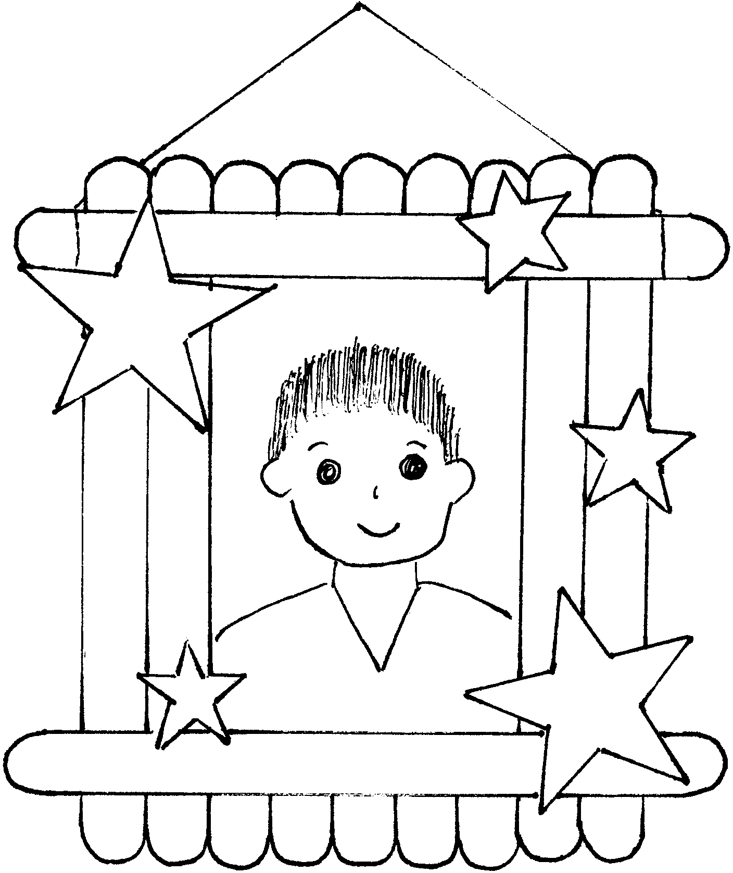

STAR FRAME

Materials: 13 popsicle sticks; Cardboard; Paint; Fine-point
permanent markers; Star shapes (wood or craft foam);
Clear plastic sheet (like report cover or sheet protector);
Photo of your hero; String; Glue

- Make a frame with 6 popsicle sticks, two on each side,
one on top and one on bottom.
- Cut cardboard to 2 1/2” x 3 1/2” Cover it with glue and
lay the remaining 7 sticks side by side, touching each other.
This is the backing.
- Paint the frame and backing (on the popsicle stick side)
any color you desire.
- If you are using wooden shapes, paint them.

- Draw design on the frame with markers. (First practice on paper and decide what you want to draw.)
- Glue star shapes onto the frame.
- Put the photo of your hero behind the frame to see if it fits. If it’s too big, trim the photo.
- Trace the photo on a clear plastic sheet. Cut the clear plastic. Tape it to the photo. This will protect the photo.
- Glue or tape the photo on the sides of the frame.
- Attach the backing.
- Tie string to the top horizontal popsicle. Hang the frame.

HOMETOWN RELIEF MAP

For a spectacular den display at the pack meeting, make a relief map of your town or community.

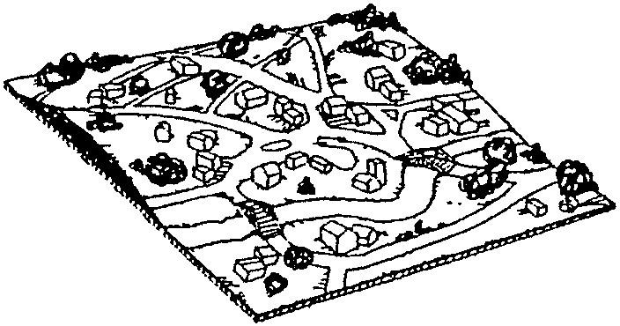
Mark all the buildings where you can find heroes--fire station, police department, hospital, school, den meeting place, local hero’s house, etc.

The base is a sheet of plywood.
The terrain is made from papier mache.
Buildings may be made from small boxes or bits of cardboard.
Bridges are constructed with toothpicks.
Trees may be made with pieces of sponges and toothpicks.


BEST PARENT MEDAL

Give this special award to your parent.

Materials: Frozen juice can lid; Colored paper; Crepe streamer; Markers; Small star stickers (optional); Scissors; Glue; Magnet strip

- Trace the can lid on a colored sheet of paper. Cut out the circle.
- Using a round container or cup slightly smaller than the lid, trace and cut a circle.
- Write your message on the smaller circle--like “HERO,” “BEST MOM,” “BEST DAD,” etc.
- Glue the smaller circle in the middle of the larger circle. Let dry.
- Cut crepe streamer about three times longer than the circumference of the lid.
- Fold crepe paper lengthwise, leaving about 1/4” on one side. (Don’t worry if it’s not too straight)

- Glue the folded side of the crepe paper on the juice lid, tucking paper so it fits in the circle. The edge of crepe paper should be sticking out from the lid.
- Glue circles on the lid and part of the crepe paper.
- You may want to decorate the circles with star stickers.
- Cut “ribbons” out of colored paper and glue on the back of the lid so the ribbon hangs down nicely.
- Attach magnet strip on the back.

HERO’S MEDAL
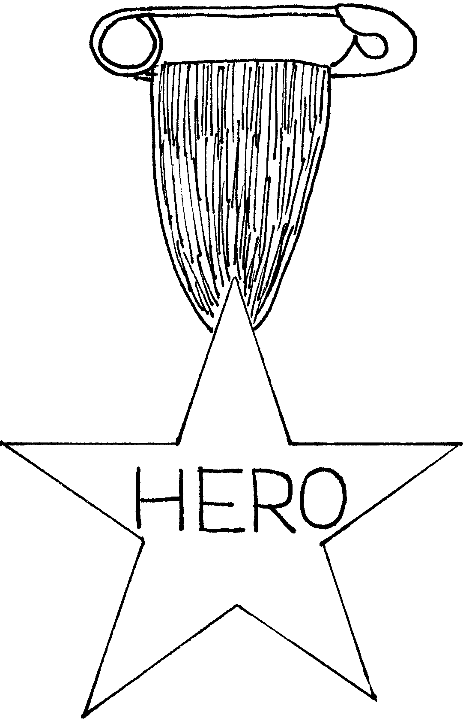
Materials: Stiff paper (cardboard, tag board); Wide ribbon (3-4” long); Large safety pin.

- Fold a regular piece of note paper and cut out a star shape. For instructions on how to make a star, see below. Use 8 1/2” x 11” paper and trim down to the size of your liking.
- Trace the star on cardboard and cut it out.
- Decorate the star with markers and stickers. Include the word “HERO.”
- Fold the ribbon in half and glue the ends to the back of the star.
- Slip a large safety pin through the fold in the ribbon.

1. Fold the paper in half crosswise.
2. With the fold at the bottom, bring the lower right-hand corner up to the halfway point on the left side. Crease well.
3. Fold the right-hand edge over to the left and crease.
4. Fold the remaining section on the left over to the right and crease.
5. Cut along the dotted line. The smaller portion is the star.






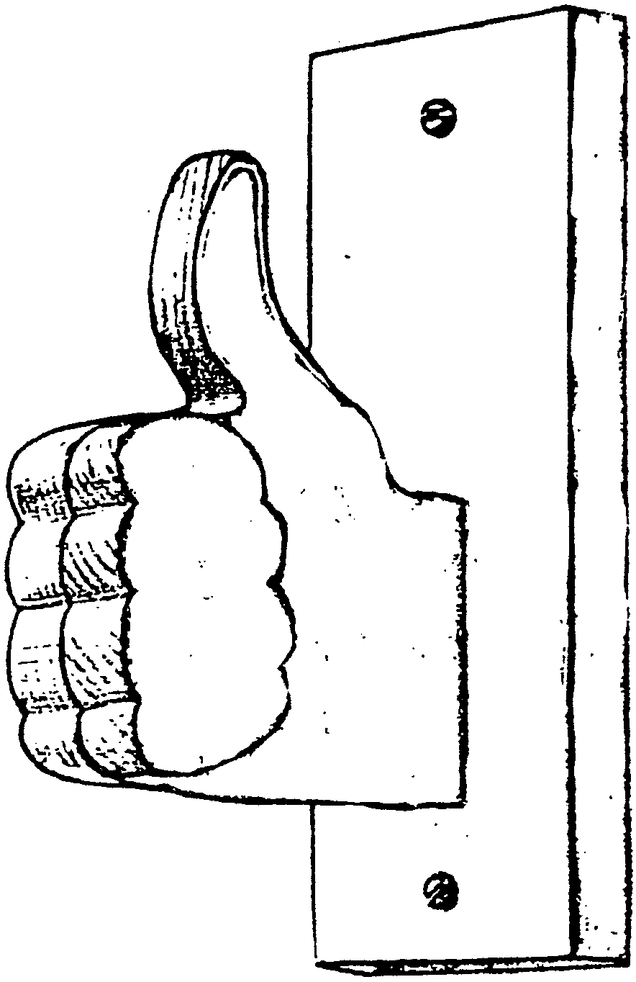

THUMBS-UP COAT RACK

Materials: Two scrap wood pieces (approx. 1” x 6” x 9”, 1” x 4” x 9”);
Two flathead wood screws; Two mounting screws

- Cut out the hand and fingers.
- Glue fingers to hand.
- Sand well.
- Attach the hand to the base with mounting screws.
- Finish any way you like.

(From Great Salt Lake Council Pow Wow book)

HEROES IN OUR TOWN

Make your favorite hero from a juice bottle. Cut a slit in the back to make it into a bank.

Materials: Small plastic orange juice bottle (12 oz. size or similar); Wiggle eyes; Red chenille stems (for mouth); Scrap craft foam (for hat); Small pompom for nose

Glue face on a bottle with special features to make him unique.

WINNER’S MEDAL

Materials: Plaster of Paris; 2-3” plastic bowl; Pop top ring; Acrylic paint; Ribbon

- Prepare a small amount of plaster and pour it in the bottom of the plastic bowl.
- Add pop top ring toward top. Let it set.
- Take the plaster out and let it dry thoroughly. (It’s best to wait until next den meeting)
- Paint the plaster with acrylic paint. Write any message. Decorate with markers, if desired.
- Put ribbon through the pop top.

FIREMAN HAT SLIDE

Materials: Shrink plastic (commercially made or No.6 type plastic); Fine tip permanent markers (red, black, yellow); Fine sandpaper; Slide back (1/2” PVC pipe)
Note: The instructions below should work with commercially made Shrink-it plastic but experiment ahead of time to make sure that the plastic shrinks to your desired size. Adjust the size of the original pattern accordingly.
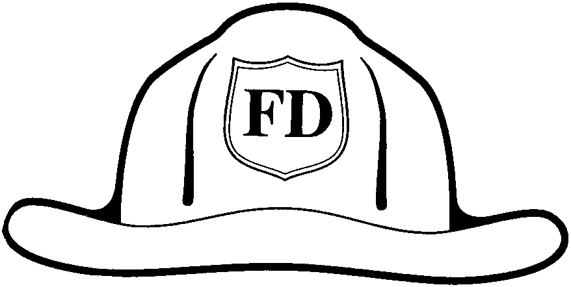
- Enlarge pattern on copy machine about 165%.
- Lightly sand one side of the plastic.
- Put the plastic over the pattern and trace the hat with black marker. Color hat with red.
- On a separate section of the plastic, trace hat badge with black marker, color with yellow marker.
- Cut both pieces out.
- Shrink according to package directions.
- When cooled, glue badge in place on hat. Glue on slide back.

HOT “HERO” SANDWICH

4 crispy fried bacon slices
1/2 cup mayonnaise or salad dressing
1 cup shredded Cheddar cheese
1/2 cup dry roasted peanuts
1/2 teaspoon celery salt
1 teaspoon Worcestershire sauce
2 green onions, chopped
4 English muffins or 8 slices of bread, toasted

1. Mix mayonnaise, Worcestershire sauce and celery salt in a bowl.
2. Stir in cheese, onions and peanuts.
3. Crumble bacon into mixture. Stir.
4. Fill each sandwich with 1/2 cup of the cheese mixture.
5. Place one sandwich on a paper napkin and microwave on high 20-25 seconds.

Makes 4 servings.

RECIPE FOR A GOOD SELF-CONCEPT

10 oz. Package BELIEF in yourself (marshmallows)
1/4 cup of PRIDE (margarine or butter)

(Melt margarine in large saucepan over low heat. Add marshmallows and stir until completely melted.)

Mix together with COURAGE to do your best (1 teaspoon vanilla)
Sprinkle the top with a little of your relationship with others.
Warm with positive thoughts and actions, then cook for many years.

Add 6 cups of I CAN (crispy rice cereal)

Press mixture into buttered 9” x 13” pan.

FIRE HOSE

1 1/2 cups apple juice
2 envelopes unflavored gelatin
3 oz. package any flavor Jell-O
Ice cubes

- Heat half the apple juice to boiling.
- Add the Jell-O and stir to dissolve.
- Soften unflavored gelatin in remaining apple juice and add to hot Jell-O.
- Stir to dissolve.
- Add ice cubes and stir until melted.
- Refrigerate 15 minutes.
- Spoon into a Zip-Loc bag.
- Cover cookie sheet with plastic wrap.
- Cut corner off plastic bag and squeeze out small amount of Jell-O in shape of a hose.
- Chill 2 hours. Eat!!

Last night my son confessed to me
Some childish wrong
And kneeling at my knee
He prayed with tears:
“Dear God, make me a man
Like Daddy - wise and strong,
I know you can.”

Then while he slept
I knelt beside his bed,
And prayed with low-bowed head:
“O, God, make me a child
Like my child here,
Trusting Thee with faith sincere.”
-Author Unknown

