Down On the Farm

October 2001

CONTENTS

THEME RELATED 1
GETTING TO KNOW THE PARENTS 1
DEN AND PACK ACTIVITIES 1
PACK HARVEST FAIR 1
HALLOWEEN 1
FIELD TRIP IDEAS 1
PREOPENING 2
DOWN ON THE FARM WORD SEARCH 2
ANIMAL COMPARISONS 2
CEREMONIES 3
FARMER’S WELCOME OPENING 3
A BETTER WORLD 3
CUB SCOUT HARVEST 3
“FORMULA TO GROW” CLOSING 4
THANK A FARMER CLOSING 4
THOUGHTS FOR CLOSING 4
“HARD WORK”--CUBMASTER’S MINUTE 5
“NURTURE YOUR SONS”--CUBMASTER’S
MINUTE 5
CUB SCOUTING’S SEEDS ADVANCEMENT 5
HARVEST BOBCAT CEREMONY 6
GROWING TREE ADVANCEMENT 7
ADVANCEMENT IDEAS 7
HALLOWEEN ADVANCEMENT CEREMONY 8
FUN WAYS TO SAY THANK YOU 9
LEADER’S HARVESTS 9
AUDIENCE PARTICIPATION 10
A TRIP TO THE FARM 10
FRACAS AT THE FARM 11
SKITS 12
TOSSED SALAD 12
THE GHOST 13
GAMES 14
VISIT TO THE FARM 14
BARNYARD FROLIC 14
MILKING CONTEST 14
BUTTER CHALLENGE 14
DRIVING THE PIG 14
BEAN PICK UP 15
CARRY THE EGGS 15
SHEAR THE SHEEP 15
EGG WALK 15
POTATO GAMES 15
POTATO PUSH 15
BOWLING FOR POTATOES 16
TATOR KING 16
ICY POTATOES 16
POOR SPUD 16
POTATO DUEL 16
LIFESAVERS CANDY GAMES 16
LIFESAVERS DISTANCE ROLL 16
GUESS-THE-FLAVOR RELAY 16
LIFESAVERS BARNYARD 16
SONGS 17
THE WORLD AROUND US 17
THE HALLOWEEN PUMPKIN 17
TWELVE DAYS OF HALLOWEEN 17
THIS CUB SCOUT 17
HALLOWEEN 17
OLD McDONALD HAD A FARM 18
CRAFTS 19
VEGETABLE PRINT GARDEN MARKERS 19
COW FRIDGE MEMO HOLDER 19
HARVEST PICTURE FRAME 20
VEGETABLE ANIMALS 20
MUSHROOM SPORE PRINTS 20
APPLE “STAR” WREATH 21
DRYER VENT PUMPKIN 21
CEREAL BOX GRAVESTONES 21
WALNUT CRITTER NECKERCHIEF SLIDES 22
SPIDER 22
MOUSE 22
RABBIT 22
CUBS IN THE KITCHEN 23
MAKE YOUR OWN CHEESE 23
PURPLE COW SHAKE 23
JELL-O POPCORN BALLS 24
HAYSTACKS 24
THE LIPS 24

GETTING TO KNOW THE PARENTS

October is a good time for den leaders to get to know the parents. School is now underway and the new Scouting year is in full swing. You’ve had a few den meetings and have begun to know the boys better. Now it’s time to know the parents. The more you know them and they know you, the easier your job as a den leader becomes. Parents are great resources. They can help at the den meetings as special guests or helpers. They can drive and help on field trips. And the more they know about the goings on in the den, the more they’ll be involved. Have a short meeting with the parents. It can be an ice cream gathering with families after the den meeting. This should not be too structured and is not meant as a parent-den leader conference.

DEN AND PACK ACTIVITIES

PACK HARVEST FAIR
Have a pack harvest fair, maybe combined with Halloween. Each den can prepare and run one or two carnival style games. Boys and parents take turns manning their “booth,” so that they have time to visit other dens’ games.
Games can include corn shelling, apple bobbing, milking contest (see “Games”), hog calling contest, etc. See also some of the games listed in “Fall Farm Frolic” in Cub Scout Leader How-To Book, pp. 9-26 to 9-28.

HALLOWEEN
- Have a field trip to a pumpkin patch.
- Jack-O-Lantern Contest. Have an inter-den contest. This is done at the pack meeting. Each den is given a pumpkin, paint, and decorating material. They paint a face on the pumpkin instead of carving, and then decorate with sticks, feathers, beads, construction paper, etc. When they are done, the boys must name the pumpkin and make a short story about it. At the end, each den introduces their pumpkin buddy to the rest of the pack.
- Haunted House--create a fun haunted house
Hang spider webs
Paint “eyes” with glow-in-the-dark paint on paper plates and hang them all around the room
Play a tape with ghost noises or spooky sounds
Create tunnels from large cardboard boxes or card tables and blankets for the boys and parents to crawl through. Have exploration holes in the side walls with strange items on the other side for the crawlers to try and identify by feel only (e.g. peeled grapes, a wig, cauliflower, bowl of cold spaghetti noodles, etc.).

FIELD TRIP IDEAS (For details, see the FIELD TRIPS section)
Prusch Farm Park, San Jose
Deer Hollow Farm, Mountain View
Ardenwood Historic Farm, Fremont
Gizdich Ranch, Watsonville
Happy Hallow Park and Zoo, San Jose

DOWN ON THE FARM WORD SEARCH

Q K P U M P K I N G D Y W W S Words
E R W C O E C E R E S R O H Z
BARN
CARROTS
CHICKEN
CORN
COW
FARM
FIELD
HARVEST
HAYSTACK
HORSE
IRRIGATION
LETTUCE
PIG
PLOW
PUMPKIN
SCARECROW
SHEEP
SQUASH
TOMATO
TRACTOR
VEGETABLES
WHEAT
A O A D N R A B E T A T E E Z
R L X K E V T Z D S J D R A V
J E C V K S S H E E P L T T B
S B O S C S Y R T I L E S L F
E R W T I F A R M I O I C I D
L A Z O H C H T B J W F A S I
B N C R C H F S V D K R R S I
A R Y R Y G L E T T U C E S K
T O M A T O D V C F L E C Q J
E C U C I D W R O T C A R T F
G T I R R I G A T I O N O R C
E U P I G Y Q H X F V W W O S
V P I E W H S A U Q S Q Y V D

ANIMAL COMPARISONS

We often compare people with animals of different kinds. The following are some of these comparisons. Fill in the blank with the name of the correct animal or bird.

- As sly as a ____________.
- As happy as a ____________.
- As black as a ____________.
- As mad as a wet ____________.
- As wise as an ____________.
- As stubborn as a ____________.
- As busy as a ____________.
- As crazy as a ____________.
- As strong as an ____________.
- As bold as a ____________.

Answers: 1-fox; 2-lark; 3-cow; 4-hen; 5-owl; 6-mule; 7-bee; 8-loon; 9-ox; 10-lion

FARMER’S WELCOME OPENING

(Cubmaster enters dressed in farmer’s clothes. He could wear overalls or jeans with a plaid shirt, a straw hat, etc.)

Welcome, everyone, to the farmyard of Pack _____. I’m Farmer _____, the boss around here. I’m really glad you could come visit us tonight.

You know, on the farm there is plenty of work to do. Everyone in my family is busy planting seeds, harvesting crops, feeding the animals, and just keeping the farm running. But we are never too busy to help out neighbors in need, or help out at the local church or even raise the flag down at the town square.

That’s one thing I like about the Cub Scouts. You are busy with school work, and earning all those fancy awards, and playing with your buddies, but you are never too busy to help when you’re needed. I like that line in the Cub Scout Promise that says “...to do my best, to do my duty to God and my Country...” You really know how to do your best and do your duty, both to God and your Country. Will you please rise and reflect on how you can continue to do your duty to God and this great country as we salute the flag and say the Pledge of Allegiance?

A BETTER WORLD

Arrangement: Each Cub Scout has a picture of an animal to go along with his saying.

C.S.#1: We are the future farmers of America and the world. And this is how we will shape tomorrow.
C.S.#2: (Rooster) I will crow for justice.
C.S.#3: (Pig) I will help root out crime.
C.S.#4: (Horse) I will say neigh to poverty.
C.S.#5: (Cow) I will moo-ve out discrimination.
C.S.#6: (Goat) I will o-baaaay the Golden Rule.
C.S.#7: (Goose) I will squawk out against hatred.
C.S.#8; (Spider) I will spin love into every heart

CUB SCOUT HARVEST

C.S.#1: To have a good harvest a farmer needs rich soil, the sun, water and hard work.
C.S.#2: A good Scouting program to a Scout is like a rich soil to a bountiful harvest.
C.S.#3: Loving assistance and guidance are the sun and water necessary for a plentiful harvest.
C.S.#4: Good leaders are the farmers, and Cub Scouts are the tiny seeds.
C.S.#5: The Tiger Cubs start out as tiny seeds but with assistance and guidance of the leaders, they grow to be Webelos Scouts--crops ready to harvest.

“FORMULA TO GROW” CLOSING

C.S.#1: Growing requires starting with a solid foundation of strong values and clear principles.
C.S.#2: Add a seed -- a young spirit eager to grow.
C.S.#3: Use lots of warm support and a safe protection.
C.S.#4: Feed frequently with fun activities.
C.S.#5: Water daily with encouraging words.
C.S.#6: This is the formula to grow a successful Cub Scout into a leader for tomorrow.

THANK A FARMER CLOSING

C.S.#1: When you eat breakfast tomorrow morning, thank a farmer. He grew the corn, wheat and rice in your cereal. He raised the dairy cows that gave you milk. (Hold up cereal box and milk carton)
C.S.#2: When you eat lunch tomorrow, thank a farmer. He grew the wheat for your bread, the peanuts for your peanut butter, and the fruits for your jelly. (Hold up a loaf of bread)
C.S.#3: When you eat a snack tomorrow, thank a farmer. He grew the apples for your juice, and the celery and carrots for you to munch. (Hold up an apple and carrot)
C.S.#4: When you eat dinner tomorrow, thank a farmer. He grew the potatoes for your mashed spuds and the lettuce for your salad. (Hold up potato and a head of lettuce)
C.S.#5: He may live down the street, in the next county, or across the United States. But wherever he may be, remember-
All: THANK A FARMER!

THOUGHTS FOR CLOSING

Plant three rows of squash.
Squash gossip.
Squash impatience.
Squash indifference.

Plant five rows of lettuce.
Let us be faithful to duty.
Let us be true to obligation.
Let us be loyal and unselfish.
Let us obey rules and regulations.
Let us love one another.

Plant three rows of turnips.
Turn up for meetings.
Turn up with a smile.
Turn up with new determination to make everything count for something good and worthwhile.

“HARD WORK”--CUBMASTER’S MINUTE

The early farmers had to manually do all the work, with the assistance of horses and oxen. They did not have the modern technology used today, like pesticides to control bugs that could destroy crops; irrigation systems to add water when drought strikes; or satellites that provide better weather forecasts. Even with all the modern technology available to farmers today, they still cannot control the weather or Mother Nature. All the farmers can do is work hard, prepare for anything that might happen, and do their best. Sounds like Scouting, doesn’t it? “Do Your best,” and “Be Prepared.” For farmers the result of hard work is the harvest. The result of hard work in Scouting? It’s self assurance, independence, and self respect.

“NURTURE YOUR SONS”--CUBMASTER’S MINUTE

Boys grow so fast that sometimes we say they grow like weeds. Weeds are plants that grow without any attention from us and become pests. Our valued plants are those that we pay attention to and nurture.

Trees grown in a forest with good soil and weather will grow to be strong and straight and tall. That same tree grown in a harsh environment with little care will grow to be misshapen and warped, but it will still grow.

Spend time with your sons and nurture them carefully, so that they reach their full potential like strong trees, and not become pests like weeds.

CUB SCOUTING’S SEEDS ADVANCEMENT

Equipment: Cloth or paper sack labeled “Johnny Cub Scout Seed” with advancement awards inside and an apple.

Cubmaster: Cub Scouts, I have here in my hand an apple. This and many more apples came from a tree that grew from a tiny seed.

A long time ago, right after the American Revolution, there was a man named John Chapman. We know him better as Johnny Appleseed. Johnny Appleseed wandered through Ohio and Indiana for 40 years planting apple orchards. For generations afterward those trees helped feed the people.

The badges we’re awarding tonight are like those seeds. They are symbols of growth for our Cub Scouts, who are themselves growing straight and tall like Johnny Appleseed’s trees. And like those trees, out Cub Scouts will help other people.” (Take badges from sack and give them to parents to pin on sons’ shirts.)

HARVEST BOBCAT CEREMONY

Props: Draw and cut out different vegetables, one for each Bobcat candidate. Attach rank awards to each vegetable and write the candidate’s name. Attach these paper vegetables to a poster board with rolled tape on backside. Prop the poster board up (for example, on an easel). Have an empty basket.
Cubmaster and assistant Cubmaster in farmer’s clothes.

Cubmaster: Well, it is harvest time again. There has been a lot of hard work going on, and now there is something to show for it.

Asst CM. What do you mean?

CM: I mean that after all the hard work these Scouts have done, it is time for them to reap their rewards. Will the following boys please step forward and harvest your Bobcat rank awards?

(Tell the candidates to pull their rank off the board, one boy at a time, and place the vegetable in the basket.)

CM: Will you boys please repeat with me the Cub Scout Promise? (They do so)
Congratulations to our newest Bobcats.

To touch the past, touch a stone.
To touch the present, touch a rose.
To touch the future, touch the mind of a boy.

Today’s oak is yesterday’s nut that held its ground.

GROWING TREE ADVANCEMENT

Props: Draw on a poster board plants at different stages: A seed labeled “Tiger”; a small sprout labeled “Bobcat”; a small shoot labeled “Wolf”; a larger plant labeled “Bear”; and finally a plant in full bloom labeled “Webelos.” Cover each drawing with a strip of paper loosely attached so that each strip can be easily removed at the appropriate time.

Cubmaster:
A young boy growing in our program starts out like a small seed. Parents are just like farmers, trying to help that seed grow to reach its full potential. It takes many resources and lots of time.

Some boys start Scouting as Tiger Cubs, small seeds all set to sprout. (Pull off paper covering Tiger seeds). They quickly grow when conditions are favorable. Some boys come to us a little later, already seedlings. The first growth measurement in Cub Scouting is at the Bobcat rank. (Pull off strip covering Bobcat sprout)

Will the following boys and parents please step forward? (Call out names of Bobcats. Hand out awards and congratulates each boy)

The next stage of development comes at Wolf, when the Cub Scout are now really starting to grow and take shape in Scouting. (Pull off strip covering Wolf)

Will the following Cub Scouts and parents please step forward and be recognized for reaching the next level?

(Repeat process for Bears. Close with comments about Webelos having reached full bloom in Cub Scouting. Their next task will be to start in Boy Scouting and grow to a whole new level.)

ADVANCEMENT IDEAS

- Attach awards to real vegetables.
- Attach awards to apples and hang apples from a tree. The tree can be home-made (branches and paper leaves) or drawn on paper (and attach apples with tape).
- Place awards in sealable plastic bags. Glue green chenille stems on the outside of the bag. Bury the bag in peat moss, which is in a planting tub or flat. Shape chenille stems to look like plants on the ground. Mention something like “you put in a lot of time and hard work for this harvest” and let the boy pull out the award. Cover the floor around the planting tub!

HALLOWEEN ADVANCEMENT CEREMONY

Attach awards to pictures or small party favors of the following items.
Bobcat--black cat
Wolf--full moon
Bear--jack o’lantern
Webelos--ghost

Cubmaster (dressed in a Halloween costume):
Tonight’s haunting festivities include some ghoulish awards. Will the following ghouls and their “mummies” and daddies come forward? (Name Bobcat candidates)

Something we see during this Halloween season is the black cat. These cats are quick and cunning and ready to learn new tricks. Our Bobcats tonight are quick and cunning like the cat, and they have learned some new things too. They have learned the eight things needed to become a Bobcat. (Present award to parents to give to boy)

Let’s have a black cat growl and meow for these boys! (Lead a growl and meow cheer)

Werewolves are a scary sight at Halloween. Will the following werewolves and their werewolf parents come forward? (Name Wolf candidates)

These werewolves have scratched and clawed their way to the rank of Wolf. As the moon becomes full, these guys know how to sink their teeth into their work. (Present award to parents to give to boys)

Let’s have a werewolf howl for our Wolves! (Lead a werewolf howl)

Ferocious jack o’lanterns glowing from our front porch remind us of ferocious looking Bears. Will the following ferocious Bears and their parents please come forward? (Name Bear candidates)

Just like these jack o’lanterns, bears may look scary, but they have a warm glow to them. (Present award to parents to give to boys)

Let’s get out our bear claws and give these boys three ferocious bear growls! (Lead cheer)

Ghosts are mysterious creatures. Will the following ghosts and their scary ghost parents come forward? (Name Webelos candidates)

Ghosts appear out of nowhere, just like these Webelos. They frighten us with their abilities to grasp new ideas, and move quickly to the world beyond. (Present awards to parents to give to boys)

These Webelos will soon be moving quickly to the mysterious world of Boy Scouting, but we love their Cub scout “spirit.” Please join me in a ghostly cheer for these Webelos. (Lead a ghost howl cheer)

FUN WAYS TO SAY THANK YOU

Apple (real or plastic): ”You’re the apple of our eye and such a polished leader!”
For someone with great appeal.
Berry: “Berry good job”
Can of nuts: “We’re nuts about you”
Gardening glove (optionally filled with cotton, glue to a scrap of wood):
“We know our boys are in good hands. Thanks!”
“Thanks for lending a helping hand!”
Packet of seeds: “Thank you for helping the pack grow.”
For someone who helped with recruiting members.
Pear: For a great pair (best husband and wife team).
Plastic egg: Good egg for helping the pack.
Spices: “You really add spice to our program.”
Thyme: “Thank you for all your time.”
Thyme (in a packet labeled “Spare Thyme”):
“Thank you for giving up all your spare time.”
Watering can: For helping the pack grow.
Broom: For someone who sweeps all the mistakes away
Ghost (gauze or tissue) For your “Spirit” of Scouting.
Skeleton: “Thanks for working yourself to the bone for us.”

See Cub Scout Ceremonies for Dens and Packs for:
Opening “Garden” p. 5-8
Closing “Apple Seeds” p. 6-3
Halloween “Halloween” p. 6-4

LEADER’S HARVESTS

Cub Scout leaders have many harvests:
When that shy lonely boy laughs aloud with a glowing face
When that trouble maker of the year comes up to you and gives you a big hug
When that boy says I want to be just like you when I grow up

When that little boys says “most of the funnest things I done, I did in Cub Scouts”
When that Webelos Scout shakes your hand and says “thank you” before he crosses the bridge
When that little Tiger Cub of many years ago stands in front of you, tall and proud, a new Eagle Scout
When you hear that the little Bobcat is now a den leader

A TRIP TO THE FARM

CUBMASTER: “Do your best!” (Cub Scout salute)
DEN LEADER: “Now, boys!” (Shake finger)
WEBELOS DEN
LEADER: “We’ll be (Stomp feet) Loyal Scouts! (Stomp feet again)”
SONG LEADER: “Encore, encore!” (Clap hands)
OLD CAR: “Chug a chug a chug a” (Shuffle feet)
COW: “Mooooooooo” (Interlock fingers, turn hands upside down with thumbs
extended)
PIG: “Oink, oink” (Push up the end of your nose)
SHEEP: “Baaaaaa” (Wag tail)

Once upon a time, a CUBMASTER, a DEN LEADER, a WEBELOS DEN LEADER, and a SONG LEADER were traveling across the countryside in an OLD CAR. As the night approached, they passed a farm. Grazing in the pasture were a COW, a PIG, and a SHEEP. Rain began to fall as darkness closed in around them. Suddenly the OLD CAR stopped dead. Unable to fix the OLD CAR, the CUBMASTER, the DEN LEADER, the WEBELOS DEN LEADER, and the SONG LEADER walked back to the farm where they had seen the COW, the PIG, and the SHEEP.

Greeted at the farmhouse door by the farmer, the CUBMASTER, the DEN LEADER, the WEBELOS DEN LEADER, and the SONG LEADER asked to spend the night. “Certainly,” said the farmer. “I myself have an OLD CAR and know how undependable they can be. But I only have room for three in my small house so one of you will have to sleep in the barn with my COW, my PIG, and my SHEEP.” “That’s okay,” said the CUBMASTER, “I will sleep in the barn.”

Ten minutes passed and there was a knock on the door of the farmhouse. When the farmer opened the door, there stood the CUBMASTER. “I’m sorry,” he said. “But the COW made so much noise I couldn’t sleep.” “I am used to COWS,” said the DEN LEADER. “I will sleep in the barn.”

Ten minutes passed and there was a knock on the door of the farmhouse. When the farmer opened the door, there stood the DEN LEADER. “I’m sorry,” said the DEN LEADER. “I am used to COWS, but the PIG made so much racket that I couldn’t sleep.” “Think nothing of it,” said the WEBELOS DEN LEADER. “I am used to COWS and PIGS. I will sleep in the barn.”

Another ten minutes passed and there was another knock on the farmhouse door. “I am used to COWS and PIGS,” the WEBELOS DEN LEADER said when the door opened. “But the SHEEP made so much noise that I couldn’t sleep.” “Then I will sleep in the barn,” said the SONG LEADER. “But before I go to sleep, I will practice the songs for the next pack meeting.”

The farmer went to bed for the night. Immediately, there was yet another knock on the door. He got up and opened the door. There stood the COW, the PIG, and the SHEEP.

FRACAS AT THE FARM

DOG: “Arf, arf!”
PIGS: “Oink, oink, snort!”
CHICKENS: “Bok, bok, bok!”
CAT: “Mee-ooww!”
HORSE: “Neighhhhhhh!”
HAY: “Aaa-choo!”
CUB SCOUTS: All say “Cub Scouts give goodwill!”

It was a quiet day on the farm. A gentle breeze was blowing, and the flowers in the garden nodded sleepy heads. The only sound to be heard was the barking of a DOG. Farmer Brown was loading up his wagon to go to the market. First, he loaded some HAY, then the PIGS, then the CHICKENS, and last he hitched up his HORSE. As he headed up the road, a neighboring CAT ran across right in front of the wagon, with the DOG in hot pursuit, barking like crazy. The noise and confusion startled the HORSE. He reared up, the wagon bumped, and the tailgate of the wagon went down. Out tumbled the PIGS and the CHICKENS. Then the wagon rolled clear over, dumping the HAY all over the road. The DOG then began chasing the PIGS. The frightened CHICKENS flew into the neighboring field, followed by the excited CAT. The panicked HORSE pulled the now empty wagon back toward the barn, and Farmer Brown just sat on the ground and sighed--a farmer’s work is never done.

Then a group of CUB SCOUTS came by with the den leader--they were visiting the farm to pick pumpkins for their Halloween pack meeting. They decided to help. Together, Farmer Brown, the CUB SCOUTS and their den leader collected the CHICKENS and the PIGS, calmed the HORSE and re-bundled the HAY. After their hard work, the CUB SCOUTS and their den leader enjoyed Mrs. Brown’s delicious pumpkin pie. Farmer Brown was so happy with the help from the CUB SCOUTS he gave them a bunch of pumpkins which made the CUB SCOUTS happy. Then they all went on Farmer Brown’s wagon for a HAY ride!

Audience Participation in Cub Scout Leader How-to Book
“The Airsick Witch” p. 6-8

APPLAUSES

HORSE APPLAUSE: Make the sound of a galloping horse by slapping your hands against your thighs.

BARN CAT APPLAUSE: You’re PURRRRRR-Fect!!

ROOSTER APPLAUSE: Stand up tall and crow, “Cock-a-doodle do!”

TOSSED SALAD

Characters: Farmer in the Dell--Cub Scout dressed in overalls, straw hat, plaid shirt, red hanky, holding a rake or hoe. On one hand is placed a very large green thumb made by stuffing a green balloon with cotton and placed over the thumb.
Cucumber, Tomato, Carrot, Celery, Onion--Cub Scouts holding very large cardboard cutouts of each vegetable they represent.

Farmer: I’m the Farmer in the Dell and you know me well ‘cause I grow good things to eat. That’s easy to be seen, ‘cause my thumb is green. (Holds out green thumb which has been hidden behind his back) And I have some friends I want you to meet.

Cucumber: I’m a long cucumber, cool and green and people like to eat me. I’m really tickled, ‘cause raw or picked, they say that I’m a treat.

Tomato: I’m a ripe red tomato, juicy and round, and you better not squeeze me, you betcha. ‘Cause if you do, I’ll squirt on you and I won’t be a tomato, I’ll be catsup.

Carrot: I’m a bright orange carrot, tall and wise. I’m a health food for lads and lasses. They say, and it’s true, I’m good for your eyes. Did you ever see a rabbit wearing glasses?

Celery: You know me, I’m one of the bunch, and I’m very good for your diet. But I always crunch, whenever you munch, so I’m not too good for your peace and quiet.

Onion: Whatever would a salad be, without poor little me, for that distinctive touch that adds so much, chop me up and see.

All together: Friendship, friendship, just a perfect blendship. When other salads have been forgot, ours will hit the spot.

RUN-ONS

Cub 1: What do you call a chicken who eats clay?
Cub 2: What?
Cub 1: A bricklayer.

Cub 1: What happens when all the ducks in the world begin jumping up and down?
Cub 2: Beats me.
Cub 1: Earth-quack!

THE GHOST

Have the den prepare the backdrop, which is a spooky-looking woods. You might have a few wispy-looking ghosts behind trees. Paint it on heavy cardboard or thin plywood.

The characters are all members of the den. They tiptoe on-stage in single file.

The first in line points to the woods and says in a stage whisper--, “That’s where I saw the ghost.” In turn, each boy in the line repeats the message to the next in a loud whisper.

The last boy in line whispers, “O-h-h-h, and where were you?” That message travels up the line to the first boy, who whispers, “Right here.”

That message goes back down the line, and the last boy whispers, “Oh-h-h, and where is the ghost now?”

In the same way, the following messages go up and down the line:
“Up there.”
“How far is that?”
“Five miles.”

When the “five miles” message reaches the last boy, he asks, “Then why are we whispering?” When that message gets back to the first boy in line, he whispers, “Because I have a cold!”

Halloween Skit
Cub Scout Leader How-To Book
“All’s Well That Haunts Well” p. 4-10

RUN-ONS

Knock, knock
Who’s there?
Cows to.
Cows go who?
No silly, cows go moo.

That last joke was so corny you could feed 200 chickens for five years!

Cub #1: What do you do with a green monster?
Cub #2: I don’t know.
Cub #1: Wait until he ripens.

VISIT TO THE FARM

Players stand in a circle. One person volunteers to be the Farmer and is blindfolded. He spins around slowly in the circle and then points at someone and names any farm animal. That person makes the sound of that animal, and the Farmer tries to identify who made the sound. If he is successful, the person named becomes the Farmer, and the old Farmer joins in the circle. Players who make farm sounds may disguise their voice any way they want to.

BARNYARD FROLIC

Give everyone the name of a common farm animal--chicken, duck, turkey, pig, cow, sheep, goat, etc. On signal, each begins making the sound of that animal and finds one another through identifying noises. Groups are to gather on one side of the room. As soon as a group is all together; they line up, one after another, and race to the other side of the room acting like that animal.

MILKING CONTEST
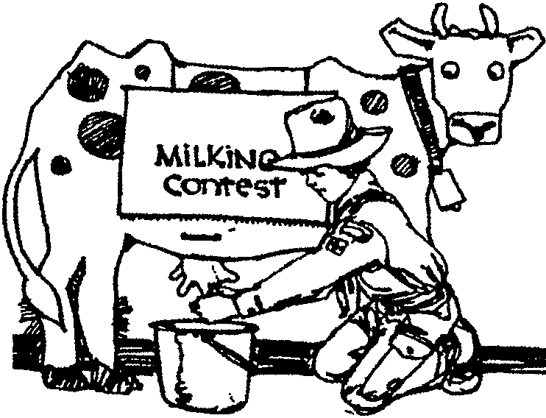
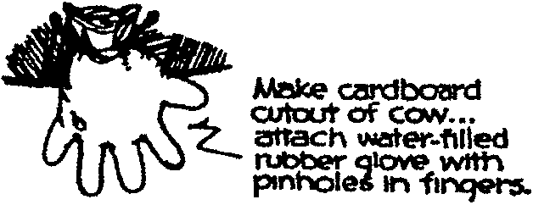
Make a “cow” like the one shown here. Set a time limit of 10 seconds for each “milker.” Award a quart of milk to the “milker” with the best record.

BUTTER CHALLENGE

Give each boy a baby food jar half full of heavy cream. The boys must shake their jar until the cream is churned into butter. The first boy to make butter is the winner. It would be nice to have some homemade bread to eat with the homemade butter. Remember to squeeze most of the buttermilk out of the butter and add a little salt.

DRIVING THE PIG

You will need a pole (about 3 feet long) and a plastic bottle (water or soda bottle) for each team. Put a small amount of water in bottles. Close the lid tight.

Divide players into teams. One player from each team uses their stick to push the bottle around a chair and back and then gives the stick and bottle to the next player. Continue until all the players have had a turn.

BEAN PICK UP

Arrange the players around a table or kneeling in a circle on the floor. Give each a saucer with two toothpicks and 12 beans. On signal, see who can be the first to lift out five beans.

CARRY THE EGGS

This is a cooperation relay race. You will need two spoons and two bowls per team and one hard-boiled egg (with shell on) for every 2 players. Divide boys into teams. Place equal number of eggs in a bowl for each team. Place another bowl for each team on the other side of the room. On signal, two players from each team grasp one egg with their spoons and move it to the other bowl. They then run back to their team and hand their spoons to next two players.

SHEAR THE SHEEP

Gather lots of old and oversized clothing items. Prepare two sets (for example; 2-3 pairs of pants, 2-3 shirts, a coat, old work boots, a belt, a raincoat for a team).

Divide players into two teams. Have a pile of clothes in front of each team. Have a turning point about fifteen feet away. On signal, each player must put on all the clothes (sheep grows his wool), race down to the turning point, come back and take the clothes off (sheep gets sheared). The next player does the same.

EGG WALK

Prepare two aluminum pie pans and 12 ping-pong balls. Divide players into two teams. Give each team a pie pan. Lay out a course and place six ping-pong balls on the course for each team. On signal, first player is to hold the pie pan on top of his head, pick up each ball and place it inside the pie pan. He is not allowed to touch the ping-pong balls in the pan, only the pan. If a ball rolls out, he must pick it up and place it back inside the pan before continuing the game. When all balls are picked up the player returns to his team. Second player takes the pan containing the balls, places it on his head and put the balls back on the course without dropping them. Continue in this manner until all players have had a chance to run.

POTATO GAMES

Notes: After the games cook the potatoes in a den cookout!

POTATO PUSH
Have the players push a potato along the ground in a figure eight course using only their heads (or noses, chins, foreheads). This can be done as a relay, or each person can be given a potato and they can all do it at the same time.

BOWLING FOR POTATOES
Cut off the ends off of 10 potatoes so each has a flat base. Stand them on end in bowling pin formation. Using a big potato for a ball, knock down as many ‘pins’ as you can. Score just like regular bowling.

TATOR KING
Get a sack of potatoes, and a box of toothpicks. See who can build the tallest freestanding tower using the potatoes and toothpicks.

ICY POTATOES
Fill a large washtub with chopped potatoes, ice, and one marble. The object of the game is to find the marble and pull it out of the tub with your foot.

POOR SPUD
Mark a large circle on the floor with chalk or twine. In the circle, place potatoes, one fewer than the number of players. Play music as boys march around the circle. When the music stops, all players try to grab a potato. The boy who didn’t get a potato either drops out and a potato is removed, or a point is scored against him. Continue for a specified time or until only one player remains.

POTATO DUEL
Each boy is given two spoons (sturdy plastic) and a small potato. Place the potato in one spoon and carry it in one hand. Hold the second spoon in the other hand. Using the second spoon as a mini-sword, the boy tries to knock the potato from his opponent’s spoon. He must also defend his potato from the other swordsman. This can also be played with several boys at once. It is against the rules to intentionally hit the other’s arm so the other would drop his potato.

LIFESAVERS CANDY GAMES

LIFESAVERS DISTANCE ROLL
The objective is to see who can roll a Lifesaver candy along the ground the farthest. The candy may not leave the ground and must roll on its edge.

GUESS-THE-FLAVOR RELAY
Put some Lifesaver candies in a bag and have teams line up relay style about 20 feet from the bag. Blindfolded players must crawl to the bag, remove one Lifesaver candy, and try to guess the color by taste. Players get only one guess. If they are wrong, they must return to their team for the next player to take his turn. A correct guess earns the player a second Lifesaver before returning to the next team member.

LIFESAVERS BARNYARD
Give Lifesaver candies to players so that there is an equal number of flavors distributed evenly. Then have players suck on the Lifesaver candy or just place it on their tongue. Without speaking, they must gather in teams of the same color by sticking out their tongues. The first team to group completely wins.

See Cub Scout Leader How-To Book for:
“Ghosts and Witches”
“Gardening”
“Witch’s Brew Relay”

THE WORLD AROUND US
(Tune: She’ll Be Comin’ Round the Mountain)

If you’re living in the country on a farm,
You’ll enjoy to the fullest nature’s charm.
Trees and birds, and bees and flowers,
Animals, skies, and grass and showers.
You can be outside for hours on a farm.

If you’re living in the city, visit zoos.
Parks, museums, gardens, aviaries, too.
We can all get back to nature,
But protect it for our future.
Live in harmony and be sure that we do.

THE HALLOWEEN PUMPKIN
(Tune: Yankee Doodle)

I’ll carve a fearful pumpkin face,
As well as I am able.
And when it’s done I’ll light it up,
And set it on the table.

I’ll fix it so the passerby
Will see and get the quivers.
For Halloween’s the time to play
You have the shakes and shivers.

TWELVE DAYS OF HALLOWEEN
(Tune: Twelve Days of Christmas)

On the 12th day of Halloween
My leader gave to me:

12 witches flying,
11 bears a-growling,
10 ghouls a-groaning,
9 ghosts a-booing,
8 wolves a-howling,
7 pumpkins glowing,
6 bobcats screeching,
5 scary spooks,
4 skeletons,
3 black cats,
2 glowing eyes,
And a bat hanging in a dead tree.

THIS CUB SCOUT
(Tune: This Old Man)

This Cub Scout, he caught one,
(hold up one finger)
He caught monsters on my thumb,
(touch thumb)
Molted, ghoulish ghost
(palm up, hit with fist)
Make they stay away,
(fling arms up)
This Cub Scout went home to stay.
(revolve arms in front of body)

2-on my shoe (touch shoe)
3-on my knee (touch knee)
4-on the floor (touch floor)
5-on the hive (brush at bees around head)
6-on my sticks (touch fingers)
7-up to heaven (point to heaven)
8-on my pate (touch head)
9-on my spine (touch back)
10-on a pen (pretend to write)

HALLOWEEN
(Tune: Farmer in the Dell)

Oh, the pumpkin patch is dark,
There’re goblins in the park,
Hi-ho, it’s scary-o
When Halloween is here!

See Cub Scout Songbook for:
“Old MacDonald Had a Farm”
“Bingo”
“Sweetly Sings the Donkey

OLD McDONALD HAD A FARM
(Tunes: Old McDonald Had a Farm; Home on the Range; Where Has My Little Dog Gone; Let Me Call You Sweetheart; Little Skunk’s Hole)

SONG MOTIONS (be creative, suggestions below)

Old McDonald had a farm, E-I-E-I-O clap hands and stomp right foot, crouch/stoop a little
And on that farm he had a tree make a treetop w/ hands
Well they chopped down the old pine tree make chopping motion with hands
Timber make a tree falling motion by moving a forearm
And they hauled it away to the mill make hauling motion like carrying a log on right shoulder and running in place
Tralalala playing piano moving hands toward the left

Old McDonald had a farm E-I-E-I-O
And on that farm he had a home make home with hands and arms
Home, home on the range move home to left and right in time with song
Where they chopped down the old pine tree
Timber and they hauled it away to the mill
Tralalala

Old McDonald had a farm E-I-E-I-O
And on that farm he had a dog
Oh where, oh where, Has my little dog gone put alternating hands to forehead shading eyes and look to
Oh where, oh where can he be left and right in time to song
He’s home, home on the range
Where they chopped down the old pine tree
Timber and they hauled it away to the mill
Tralalala

Old McDonald had a farm E-I-E-I-O
And on that farm he had a sweetheart put hands to heart area and sway left and right in time to
Let me call you sweetheart song
I love you, let me whisper in your ear
Oh where, oh where …

Old McDonald had a farm E-I-E-I-O
And on that farm he had a skunk pinch nose
Well, I stuck my head in the little skunks hole make hole with arms and stick head in it
And the little skunk said to me
Let me call you …

Old McDonald had a farm E-I-E-I-O
And on that farm he had an end
Eeee-I-Eeee-I-Ooooooooo spread arms

VEGETABLE PRINT GARDEN MARKERS

Use these markers at the head of each row of vegetable seeds that you sow. They are a weatherproof and attractive way to remind you what you planted where.

Materials: Vegetable (one each of the vegetables you plan to grow); Acrylic paint; Paper; Paper towel; 1/4”-thick plywood (about 4” x 5”); Varnish; Stick.

- Cut the vegetable in half lengthwise.
- Paint the flat surface thinly with acrylic paint. If your vegetable has both leaves and roots, paint each a different color.
- Press the vegetable down on some scratch paper. Press over it with a paper towel.
- Lift the vegetable and check the print. Experiment until you like the way the print looks.
- Now make prints on the plywood. Let them dry.
- Glue a stick to the back of each marker.
- Paint or spray with a varnish on all sides of the wood to protect them from the weather.

COW FRIDGE MEMO HOLDER

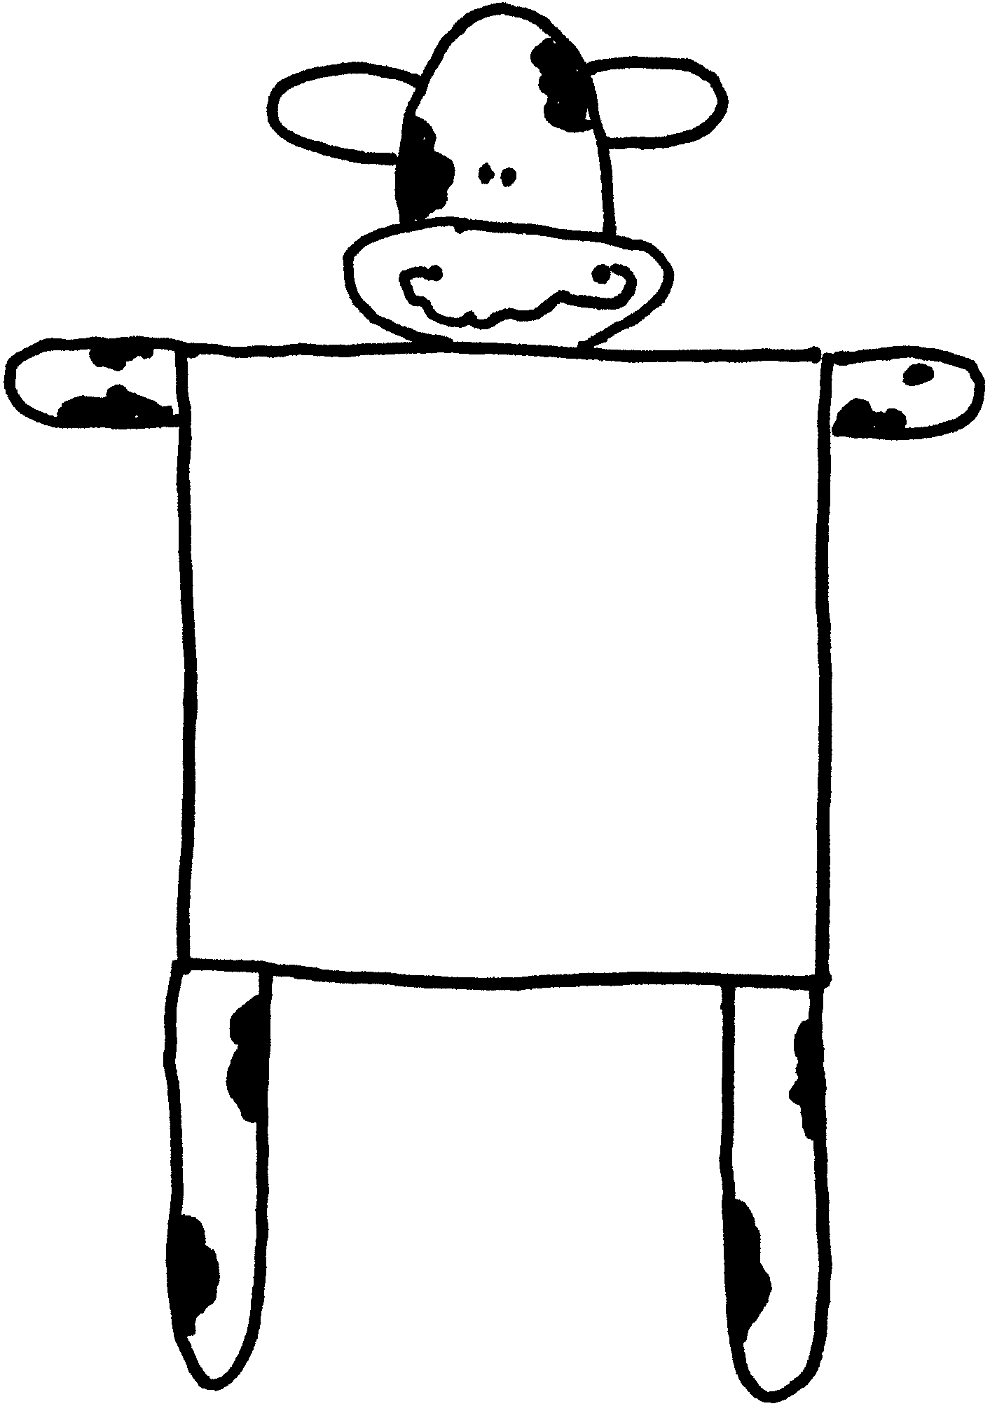
Materials: One 3” x 3” Post-it pad; Black permanent marker; Three popsicle sticks; One 2” oval wood shape; One 1 1/2” oval wood shape; Two 7/8” oval wood shapes; Two pieces of magnetic strip.

Note: For these wood shapes thin pieces called “Woodsies” work well. They are available at craft stores (usually assorted shapes and sizes in one bag). You can substitute with craft foam and cut your own or use craft foam shapes, also available at craft stores.

- Glue the snout and ears on the head.
- With a marker draw eyes, mouth and cow patterns on the head.
- Draw cow spots on popsicle sticks.
- Glue one popsicle stick (arms) to top edge of note pad.
- Glue the legs along each side, below the arms.
- Glue the head on the arm stick. You don’t have much room for glue but it works. If it doesn’t, apply a short piece of popsicle stick on the back of head AND the arm stick.
- Attach magnet strips on the back of legs.

HARVEST PICTURE FRAME

Materials: Empty cereal box; Green construction paper; Supermarket flyers with pictures of fruits and vegetables; Glue; Scissors; Stapler; Yarn.

- Open both top and bottom of the cereal box and cut the back off. Trim the four flaps that remain around the box front to equal widths.
- Cut a sheet of green paper to fit over the cereal box front and glue it in place.
- Fold the four flaps in over the green paper to form a frame and glue them in place.
- Cut out pictures of fruits and vegetables from the supermarket flyers and glue them around frame edges.
- Staple a piece of yarn to the top of the picture frame as a hanger.

VEGETABLE ANIMALS

Wouldn’t it be fun to play with animals made of vegetables knowing that when you are finished playing you could eat them?

Materials: Toothpicks; Chenille pieces; Popsicle sticks; Scrap paper; Thumb tacks; Nails; etc.

Be creative. First look at the vegetable and think what animal it can turn into. The challenge is that there is no glue--use small pieces of toothpicks to tack paper down. Here’s some suggestions:

CARROT DACHSHUND
Use two carrots, one smaller than the other. Small carrot is the head. Attach the head to the larger carrot, which is the body--the end with green top is the tail. Ears are paper. Legs are either toothpicks or nails.

POTATO RHINOCEROS
Look for a potato that looks like a rhino--the rest is easy! Use some tacks for eyes. Chenille can be a tail. Rhino’s short legs can be half toothpicks.

MUSHROOM SPORE PRINTS

Cut off each mushroom’s stem where it’s attached to the cap. Put the caps gill-side-down on construction paper. You can use different colors. Put a bowl or jar over each cap to keep drafts out. Leave the mushrooms covered overnight. The next day carefully lift each cap straight up off the paper. You’ll find something interesting. Use hair spray or fixative to keep the spore prints from smudging. Hold the spray can about one foot away from the paper.

APPLE “STAR” WREATH

Cut 6 apples horizontally into 1/8” slices. The core of each center slice will have a star design. To make one wreath, choose approximately 20 center slices with well-defined star designs. Squeeze the juice from a lemon into a bowl. Add one teaspoon of salt, and stir well. Soak the apple slices for 2-3 minutes in the juice, covering them completely and turning the slices once. Remove the apple slices and place them in a single layer on paper towels. Pat dry. Place slices in a broiler pan and place them in a warm oven (150 degrees) for 4-6 hours. Cool. Place an 8” metal ring inside of a 9” metal ring. Wrap together with masking tape. This makes a 1” wide wreath base. Glue the apple slices onto your wreath overlapping the edges. Brush or spray with acrylic spray and decorate the top with a big bow.

Eat the unused apple slices.

DRYER VENT PUMPKIN

Materials: White dryer vent; Orange spray paint; Brown lunch bag; Stapler; Decorating material (raffia, chenille stems, green and black paper or craft foam, markers, etc.)

- Count 17 rings on the dryer vent and cut with wire cutters (Adult assistance necessary or do this ahead of time).
- Bring the ends together and, making sure that the ends of the wire are tucked in, staple the two end wrings together just behind the wire a few times.
- Paint, making sure to cover the top and bottom. (Outfit the boys in safety goggles and paint shirts.)
- Cut the top half of the lunch bag off and twist to form the pumpkin stem. Glue it down into the center of the dryer vent.
- Decorate. Cut leaves from green paper or foam. Eyes and mouth may be fashioned with black paper or foam.

CEREAL BOX GRAVESTONES

Have fun decorating your yard with this craft!

Materials: Cereal boxes (different sizes); Black and white tempera paint; Paintbrush; 2 sponges; 3 cups for mixing paint; Thick black permanent marker; Plastic bags; Sand or rocks

- Fill plastic bags with sand or rocks and place inside boxes to keep them from blowing over. Seal the boxes.
- Mix paints to make a light gray, medium gray, and dark gray, as needed.
- Paint boxes with two or three coats of medium gray. Let dry.
- Use the sponges to dab on the light and dark gray paint to give gravestones a mottled look. Let Dry.
- Write names and dates with markers, such as “Dracula died here. 1768-1842.”

WALNUT CRITTER NECKERCHIEF SLIDES

Materials: Walnut shell halves; Scrap felt; Small florist wire; Chenille stems; Glue (hot glue works well); Paint; Beads; 1/2” PVC pipe.

Note: To get good walnut shell halves, place whole walnuts in boiling water and boil for a while. Carefully remove a walnut, blot dry, and gently pry halves open with a butter knife. Be careful not to burn yourself with the hot walnut. The boiling softens the membrane that connects the two shell halves. Walnut meats can be eaten, or reserved for baking.

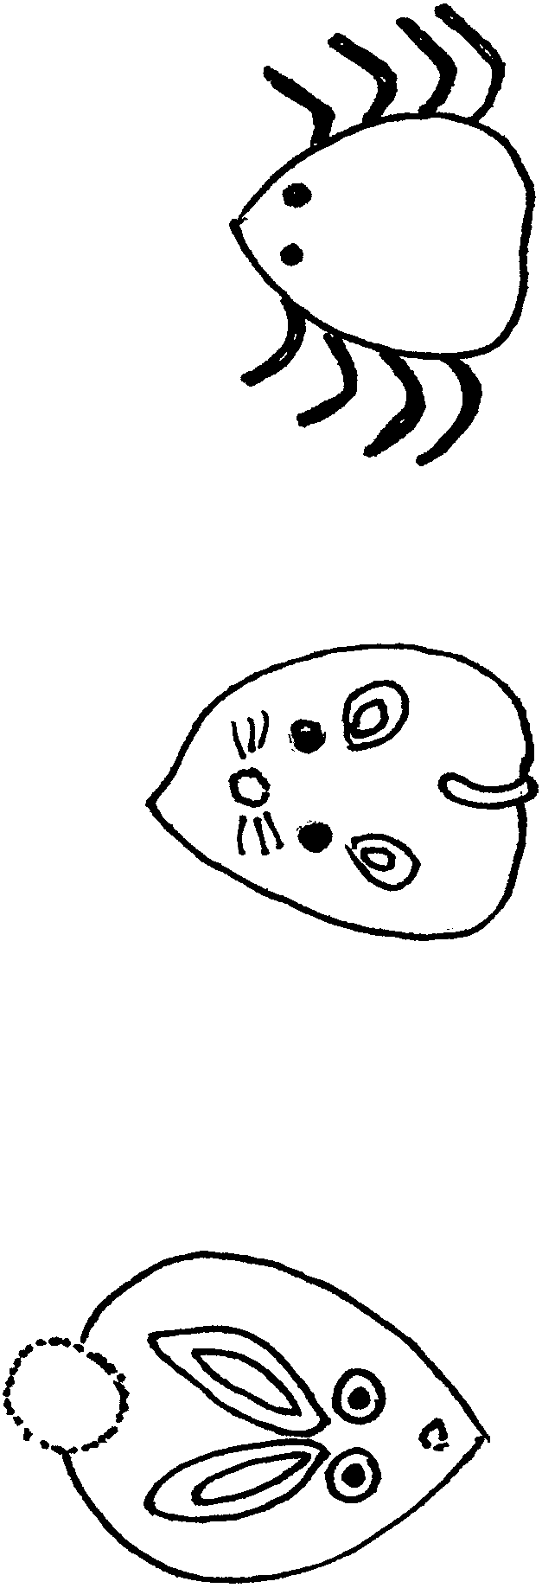
SPIDER
Paint shell black.
Cut a chenille stem into eight small legs.
Glue to the inside edge of the shell. Shape each leg.
Glue on red beads for eyes.
Glue a section of PVC pipe on the back.

MOUSE
Paint shell gray.
Glue black beads for eyes, and a small pink pompom for a nose.
Glue snippets of florist wire for whiskers.
Craft ears from ovals of gray felt. If desired, line with pink felt center.
Attach a gray felt or chenille tail.
Glue a section of PVC pipe on the back.

RABBIT
Paint shell white.
Glue on two wiggle eyes and a small pink pompom nose.
Make ears from long pink felt ovals. Line with white felt. Glue ears (apply glue to base and behind ears).
Glue on a pink (or brown or black) pompom tail.
Glue a section of PVC pipe on the back.

MAKE YOUR OWN CHEESE

Try this at the meeting. You can do up to step 7 and the boys can take home to finish.

4 cups of whole milk
4 teaspoons of vinegar, mixed with two tablespoons of water
Cheesecloth

- Heat four cups of whole milk in a saucepan until it almost starts to boil. Quickly turn the heat down to a simmer. Don’t let it boil over.
- Slowly add four teaspoons of vinegar mixed with two tablespoons of water. You will immediately see small white clumps (curds) appear on the surface.
- Keep on simmering, stirring occasionally, for about 10 minutes, until the curd completely separates from the whey (a pale greenish yellowish liquid). Turn off the heat.
- Pour the mixture into a colander lined with two layers of cheesecloth. Put a bowl beneath the colander to catch the whey. When it cools, see what whey tastes like (Remember Little Miss Muffet?).
- Rinse the curds with cold water, then drain them in the colander for half an hour.
- Pour the curds out onto a clean surface and knead them for two minutes to form a lump.
- Flatten the lump until it’s about half an inch thick and wrap it with the cheesecloth and a paper towel.
- Put a weight on it and let it sit for five hours.
- Unwrap the cheese, slice it and taste some on crackers or French bread or with a bite of fruit.

VARIATIONS: Try making a new batch, this time knead a little salt or some herbs and spices (oregano, basil or garlic) into the curds.

(Recipe from Explorations magazine.)

PURPLE COW SHAKE

3 cups vanilla ice cream or frozen yogurt
1 cup milk
1/3 cup thawed frozen grape juice concentrate (undiluted)
1 1/2 teaspoon lemon juice

Place all ingredients in a blender or food processor; process until smooth. Serve immediately.

JELL-O POPCORN BALLS

This is a fun project for Cub Scouts. The balls do not set hard for some time and can be worked with for about 1/2 hour after it is taken from the stove, thereby allowing plenty of time for them to cool before the boys can form the balls just right and have a lot of fun.

CAUTION: The syrup gets hot and is very sticky and could cause severe burns, so don’t let the young children cook, pour, or otherwise handle the syrup while it is hot.

Pop 6 quarts popcorn and put in a large container (a plastic dishpan is great).
Mix together in pan: 1 cup sugar
1 cup corn syrup
1 small package any flavor Jell-O

Cook while stirring until mixture reaches a full boil. Pour gradually over popcorn, stirring as you pour. Stir until the popcorn is more or less evenly coated. Form into balls. Let them set up on a buttered cookie sheet before wrapping.

Makes 16 to 32 balls depending on size desired.

HAYSTACKS

1 cup peanuts
3 cups Chinese fried noodles or pretzels
16 oz. milk chocolate
2 tablespoons shortening

- Melt chocolate and shortening together in microwave or over boiling water (double boiler).
- If using pretzels, break the sticks into bite size pieces.
- Mix all ingredients together in a large bowl.
- Drop by teaspoon onto wax paper.
- Let cool until chocolate is set.

THE LIPS

Green Apples
Peanut Butter
Mini Marshmallows

Cut green apples into 12 wedges. Cut off seed and center core from each wedge. Have boys “Glue” together two apple wedges with a little peanut butter, and then stick mini marshmallows onto peanut butter to make “teeth”. Then eat them!

