All Aboard!

September 2001

CONTENTS

THEME RELATED 1
NATIONAL SUMMERTIME PACK AWARD 1
DEN AND PACK ACTIVITIES 1
WELCOMING NEW FAMILIES 1
BOBCAT 1
SPECIAL GUESTS 1
FIELD TRIP IDEAS 1
PARTICIPATION AWARDS 2
DEN DOODLES 2
NEW LEADERS AND TRAINING 2
SUCCESS 2
PREOPENING 3
TRAIN MAZE 3
ALL ABOARD FOR TRAIN TERMS 3
ALL ABOARD 3
CEREMONIES 4
ALL ABOARD OPENING 4
ALL ABOARD OPENING 4
CUB SCOUT TRAIN OPENING 5
CUB SCOUT TRAIN CLOSING 5
“STAY ON THE RIGHT TRACK”--
CUBMASTER’S MINUTE 6
“RAILROAD”--CUBMASTER’S MINUTE 6
TRAIN ADVANCEMENT 7
ALL ABOARD ADVANCEMENT IDEAS 7
NEW ENGINEER (CUBMASTER)
INSTALLATION 8
ADULT LEADER INDUCTION CEREMONY 9
THIS IS CUB SCOUTING--FAMILY
CEREMONY 10
FUN WAYS TO SAY THANK YOU 10
AUDIENCE PARTICIPATION 11
THE TRANSCONTINENTAL TRAIN 11
CUB SCOUT RAILROAD 12
SKITS 13
UNION BOBCAT 13
THE TICKET LINE 14
TRACKS RUN-ON 14
GAMES 15
RUNAWAY CARS 15
CUB SCOUT EXPRESS 15
BAGGAGE CAR RELAY 15
CHANGE CARS 15
TUNNEL RELAY 15
LOOSE CABOOSE 16
TRAIN MEDLEY 16
RAILROAD STATIONS 16
SONGS 17
BILL GROGAN’S GOAT 17
I SEE 17
WELCOME SONG 17
TRAVELING SONG 17
CRAFTS 18
SCRAP WOOD TRAIN 18
TRAINS FROM THE FUTURE 18
CANDY ENGINE 19
ANIMAL CRACKER CIRCUS TRAIN 19
A VIEW FROM A TRAIN 20
LOCOMOTIVE NECKERCHIEF SLIDE 20
RAILROAD CROSSING NECKERCHIEF
SLIDE 21
CUBS IN THE KITCHEN 22
TICKET 22
FLAT CARS 22
HOBO POPCORN 22
HOBO STEW 22

NATIONAL SUMMERTIME PACK AWARD

Now that the summer is over and the pack has concluded its summertime activities, it is time to recognize its accomplishment.

If your pack qualifies for the National Summertime Pack Award, turn in the application as soon as the last event of the summer is done. This way, you can start off the new Cub Scouting year in September with the recognition for the boys, dens and your pack. It will show the families interested in Cub Scouting how active your pack is.

DEN AND PACK ACTIVITIES

Start out the year with the idea that the pack is like a train--everyone needs to work together to make it work, to stay on track and move on to new stations in Cub Scouting Fun.

WELCOMING NEW FAMILIES
Welcome new families aboard the Cub Scout Fun Express. See Cub Scout Songbook for welcome songs. Sing them at den and pack meetings to welcome new Cub Scouts and families. Example: “We’re Glad To See You Here,” “Hi, Cub Scout!,” “Cub Scout Welcome,” “Hello! Hello!”

BOBCAT
Wolf, Bear and Webelos den leaders--if there are new Cub Scouts in your den, have the continuing boys help the new Scouts in learning the Bobcat requirements. This increases the communication between continuing and new Scouts. It also teaches the continuing boys some leadership skills; it makes the new boys feel welcome.

SPECIAL GUESTS
If there is a parents in the pack who is a railroad enthusiast, ask him/her to come to a pack or den meeting and talk to the boys about railroading. Talk to the boys about train safety too.
In a den, if there is a parent who is a model railroad enthusiast and has some models to show, ask them to set it up at the meeting. If they have a more elaborate set at home, are they willing to have the den visit their house?
Ask a Railroading Merit Badge counselor or a Boy Scout who finished that Merit Badge to come and talk to the boys.

FIELD TRIP IDEAS (For details, see the FIELD TRIPS section)
South Bay Historical Railroad Society, Santa Clara
San Jose Trolley Barn, San Jose
Felton Train (Roaring Camp and Big Trees Narrow-Gauge Railroad and
Santa Cruz Big Trees & Pacific Railway), Felton
California State Railroad Museum, Sacramento
Ride Caltrain or BART: Go on a trip (and a picnic at a park?) on Caltrain or BART.
Lightrail: Ride Lightrail to downtown San Jose. In downtown ride a historical trolley.

PARTICIPATION AWARDS (For details, see the PARTICIPATION AWARDS section)

National Summertime Pack Award
National Den Award

DEN DOODLES

A Den doodle is a positive and visual incentive. Boys enjoy marking their progress on the den doodle and showing it off. Take the den doodle to pack meetings for families to admire. Involve the boys in designing and making the den doodle. Examples are shown in Cub Scout Leader How-To Book (pp. 3-13 to 3-14) and Cub Scout Ceremonies for Dens and Packs (chapter 2).

NEW LEADERS AND TRAINING

Welcome the new leaders. Show them that their commitments are very much appreciated. Give them a TRAINing ticket with information on the next training. Most of the districts hold their Cub Scout Leader Basic Training in October. Information should be available by now through Roundtable and also in the Santa Clarion. Encourage the pack and den leaders to take the training. Tell them how much fun it is. Show your enthusiasm. Attitude is catching. Meanwhile give them immediate help by providing them with the Fast Start video and the Viewer Guide.

After they take the training, recognize them at the pack meeting and thank them for taking their time to go through the training. You may want to give the trained leaders Train slides--glue a piece of 1/2” PVC pipe on the back of a small toy train (birthday candle holders for a birthday cake are inexpensive and work well).

All Aboard the Cub Scout Fun Train--Don’t miss your
Basic Training and Monthly Roundtable!

SUCCESS

To laugh often and much,
To win the respect of intelligent people and the affection of children,
To earn the appreciation of honest critics and
endure the betrayal of false friends,
To appreciate beauty,
To find the best in others,
To leave the world a bit better, whether by a healthy child,
a garden patch or a redeemed social condition,
To know that even one life has breathed easier because you lived.
This is to have succeeded.
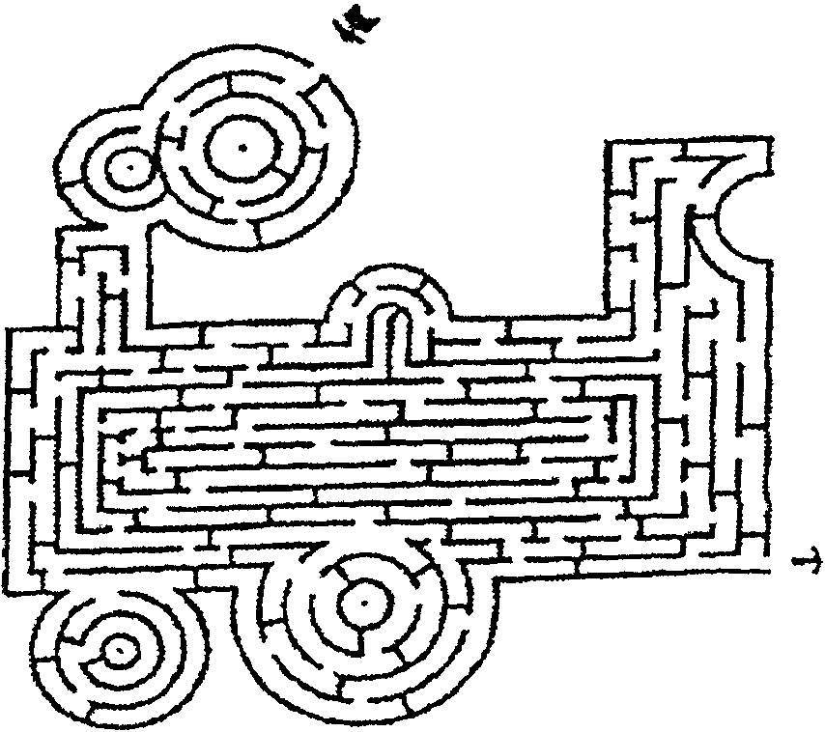

TRAIN MAZE

ALL ABOARD FOR TRAIN TERMS

Match the train term on the left with the definition on the right.

- Train a. I’m the place the driver sits.
- Locomotive b. I’m the last car of the train.
- Cab c. I’m on the front of the locomotive to push objects off the track.
- Rolling stock d. I’m a warning device at the side of the tracks.
- Caboose e. I’m pulled along a track by an engine.
- Signal f. I’m a heavy nail that holds the rail to the tie.
- Observation car g. I’m a car that cannot move by itself.
- Coach h. I have large windows to view scenery.
- Spike i. I’m a car that carries passengers.
- Cowcatcher j. I’m the engine of the train.

Answers: 1-e; 2-j; 3-a; 4-g; 5-b; 6-d; 7-h; 8-i; 9-f; 10-c

ALL ABOARD
(pack get-aquatinted game)

Ahead of time, cut strips of plain paper and make ticket books. Each ticket book should contain about 20 tickets. Make a cover to the book which says “All Aboard the Cub Scout Express Number (Pack number).” Staple together.

As people arrive, give each person a pencil and a ticket book. Direct them to go around and ask people to write their name one on each ticket. Later, tell people that the names on the tickets are their destinations and the person is the conductor of that station. Now they must find those stations and give that person their ticket. Cheer those who re-distribute their tickets quickest with an appropriate cheer.

ALL ABOARD OPENING

Props: Cards with letters (one per card); Engineer’s hat; Train cut-outs (optional)

Arrangement: Cubmaster wearing an engineer’s hat and the Cub Scouts assigned to do the opening form a train. Form a train either by lining up and holding onto the shoulders of the person in front, or by carrying train car cutouts. Boys are carrying their cue cards. They wait in the back of the room, out of sight.

Announcement (in back stage):
“7 o’clock (or time for the pack meeting to start) Cub Scout express Number (pack number), going to Cub Scout fun stations arriving in lane 1. Please stand back.”

(The “train” comes into the room going through the isles saying, “Chuga, chuga, chuga, chuga.” The Cubmaster goes “Toot toot.” The train stops. Cub Scouts face the audience and turn the cars so the audience can see the letters.)

Cubmaster: Are you ready for
C.S.#1: Activities
C.S.#2: Laughter
C.S.#3: Love

C.S.#4: Advancement
C.S.#5: Brotherhood
C.S.#6: Originality
C.S.#7: Adventures
C.S.#8: Recognition
C.S.#9: Delight

Cubmaster: All Aboard the Cub Fun Train! (Re-form the train)
Announcement: ALL ABOOOOOOOARD! (The train leaves the stage)

ALL ABOARD OPENING

A America is my home,
L Lovely to see.
L Let’s take a trip on a train, just you and me.

A “All aboard!” the conductor shouts.
B “Be prepared to see the sights.”
O Oceans, deserts, mountains so high,
A America’s beauties go sailing by
R Right down the tracks our train practically flies,
D Discovering America on rails and ties.

CUB SCOUT TRAIN OPENING

Props: Train Engine and cars are drawn and cut out of poster board. Engine has the Cub Scout emblem. Cars have Tiger emblem, Wolf emblem, Bear emblem, Webelos Scout emblem, and the Arrow of Light is on the caboose.

Arrangement: The Engine comes out first, then train cars come out one by one.

The Engine (Cubmaster): All aboard for Cub Scouting.
Tiger Car (Tiger Cubs): The first car to hook up is the Tiger car!
Wolf Car (Wolves): The next car to hook up is the Wolf car!
Bear Car (Bears): After that it’s the Bears!
Webelos Car (1st yr Webelos): Then comes Webelos!
Caboose (2nd yr Webelos): And the Arrow of Light completes the Cub Scout Train!

CUB SCOUT TRAIN CLOSING

Props: Train cars from “Cub Scout Train Opening” above.

Adult Leader: (Holding engine) Today I am a Scout leader, but when I was their age, I was a Scout. I came on board as a leader, to pass on to these boys the fun I had as a boy.

Den Chief: (Holding next car) Today I am a Boy Scout, but before that I was a Cub Scout. Cub Scouting was fun, and it prepared me to be more independent and confident.

Webelos Scout: (Holding next car) Today I am a Webelos Scout. I was a Wolf and Bear where I learned to have fun with my family. Now I am learning more fun things to do with my den.

Cub Scout (Wolf or Bear): (Holding next car) Today I am a Cub Scout. I came on board to have fun and do things with my family and friends.

Tiger Cub: (Holding Caboose) Today I am a Tiger Cub, and my fun has just started.

All: All aboard for never-ending Fun!

See Cub Scout Ceremonies for Dens and Packs for:
Induction “Family Induction Into the Pack (For New Families)” p. 7-2
“On the Cub Scout Trail (For New Bobcats and Families)” p. 7-2
“Recipe for Cub Scouting (For New Boys and Families)” p. 7-3
“This is Cub Scouting (For All Adults)” p. 7-3

“STAY ON THE RIGHT TRACK”--CUBMASTER’S MINUTE

There are many different trains--passenger trains, that carry you through this great country, freight trains that haul goods to consumers like you, and even tourist trains that show you what riding a train was like many years ago.

All of these trains are different, yet they have something in common--they all run on tracks. A train, as large and powerful as it is, can go nowhere without tracks to guide it.

Like these trains, we are all different. But we all need tracks to guide us along. These tracks are faith in God, love of family and service to others.

This month, Cub Scouts, let’s pledge to do our best to stay on the right track. Show your faith in God by living your religion. Show your family how much you love and appreciate them through your words and deeds. Give cheerful service to all you meet. Stay on the right track and you’ll go far.

“RAILROAD”--CUBMASTER’S MINUTE

The forerunners of the modern railroad were the wagonways built in England as early as the 1500’s. They were invented to haul coal, ore, and stone from the mines and quarries.

In 1767 cast iron rails were invented. The first railroad in America was built in 1826 in Massachusetts.

Fifty years later, during the Civil War, construction started on the Union Pacific Railroad. The builders started the railroad line at Omaha, Nebraska and another group started building eastward from Sacramento, California.

The last nail, “The Golden Spike,” driven at Promontory, Utah on May 10, 1869, connected the country from coast-to-coast.

Railroads were important to the growth of America. Each time an inventor made an improvement, the railroads became better. Just like the railroad inventors, we are constantly trying to improve ourselves and we become better with each change.

APPLAUSES

FREIGHT TRAIN APPLAUSE: Use a four-beat clap, making the first beat louder than the other three. Change speed and volume and add train whistles.

TRAIN APPLAUSE: Divide audience into two groups. When you point to each group, they clap. Go faster and faster, then pull the string and blow the whistle, “Toot, toot!” or “Whoo-oo!”

TRAIN ADVANCEMENT

Props: Train engine and card cut out of poster board. Mark each car, Tiger, Bobcat, Wolf, Bear, Webelos, and Arrow of Light. Attach awards on appropriate cars.

Cubmaster:
As your Cubmaster, I act as the Cub Scout Train’s engineer--leading you on to do your best.
Your den leaders are the train conductors providing ideas and direction.
Your parents are all the railroad workers, providing support and love.
You Cub Scouts are the train cars.
Together we travel from one station to another as you advance through the Cub Scout ranks.
First we have the Tigers. (Presents awards to Tigers)

(Proceeds as needed through Bobcat, Wolf, Bear and Webelos)

ALL ABOARD ADVANCEMENT IDEAS

- Prior to the ceremony, issue train tickets to the boys who will receive awards. Indicate on the ticket the boy’s name and the “car” he will be traveling on (Wolf, Bear, etc.). Use large cardboard cutouts representing various cars of a train. The Cubmaster acts as the conductor. With the den leaders carrying the cutout cars, the train proceeds around the room stopping at each den where the Cubmaster collects tickets. The Cub Scout receiving the award “boards” the train by getting in line behind the appropriate car. Go to the front of the room. Present the award. Include parents in this ceremony as well. If you have a large group of boys receiving the awards, run a separate train for each rank.
- Name stations after the rank the boys are receiving--like Tiger Cub Town, Bobcatville, Wolf City, Bear Junction, Webelosland. Boys and parents board the train and as the train reaches each station (moving literally or pretending) present the awards. For more fun, intersperse the stations with real towns near your home, passing through them because this is the Cub Scout Express Number (pack number).
- Attach awards to conductor’s caps (Cub Scout Leader How-To Book, p. 4-19) or engineer’s bandannas. Make each boy an honorary conductor or engineer on the Pack Railroad.
- Set up a model railroad with toy trains. Attach the awards to the train. Run it towards the boys who are waiting at various stations. Or if the track is shorter, do separate ceremony for each rank.

CHEERS

TRAIN CHEER: Divide the pack into three groups. First group yells, “ALL ABOARD!” Then second group yells, “CHUGA, CHUGA, CHUGA, CHUGA.” Finally third group yells, “TOOT, TOOOOOOT!”

LITTLE ENGINE CHEER: Start “I think I can, I think I can...” slowing down gradually. Then (reaching the summit) “YES! I KNEW I COULD, I KNEW I COULD!” (getting faster).

NEW ENGINEER (CUBMASTER) INSTALLATION

Arrangement: The new Cubmaster is asked to stand in the front of the room. Five committee members line up side by side behind, if possible, all wearing a conductor’s hat. Each committee member presents him with a giant train ticket with a word on it. The Committee Chair stands in front with the Cubmaster.

Committee Chair:
A Cub Scout pack is like a train. For a train to run well and stay on track, it needs an engineer, conductors and other support workers. It’s the engineer’s job to keep the train going in the right direction and to keep it on track. On the train called Cub Scout Express No. (pack number), that’s the Cubmaster’s job, with the support of the committee, other adult leaders and parents. Tonight, I’m pleased to introduce to the pack our new Cubmaster, (CM’s name). And we have some tickets to give him.

Com. Member #1: I present you with RESPONSIBILITY, for great will be your responsibility as our engineer.

Com. Member #2: I present you with KNOWLEDGE, for knowledge of the best procedures of Cub Scouting will help guide us to work with you for the success of the pack.

Com. Member #3: I present you with HARD WORK, for that is one of the foremost qualities of success.

Com. Member #4: I present you with ENTHUSIASM, for nothing great was ever accomplished without enthusiasm.

Com. Member #5: I present you with GRATIFICATION, for that will be the reward for your efforts.

Committee Chair: (Presents an engineer’s hat and a “Cubmaster” patch) It is a pleasure to present you with these symbols of your office as the Engineer of the Cub Scout Express No. (pack number).

Committee Chair: ALL ABOARD!! (They all line up behind the Cubmaster and exit)

CHEERS

LITTLE ENGINE CHEER 2: Start “I know you can, I know you can...” then “YES! I KNEW YOU COULD, I KNEW YOU COULD, I KNEW YOU COULD!!”

NEW PERSON CHEER: “Hi, there. Welcome, welcome, WELCOME!”
(Effective when given by continuing Cub Scouts and families after new families or leaders are introduced.)

ADULT LEADER INDUCTION CEREMONY

This ceremony should be conducted by the committee chair or the chartered organization representative, since they are responsible for providing the adult leadership for the pack.

Props: Large candle at the center of the table, several smaller candles, with paper skirt (cardboard or foil cupcake cups with a hole for a candle), to catch any dripping wax.

Committee Chair:
Every year in Cub Scouts the program is a little bit different. Some things stay the same, some things are similar, and some things are completely different.

When the Webelos Scouts graduate to Boy Scouts and leave the pack, often their parents also go on to be troop leaders and leave the pack. Every year brings a new leadership role to be filled. This allows continuity of some of the pack leadership and a constant influx of new ideas and fresh vigor.

Tonight we welcome the newest adult leaders to our pack. These people have agreed to help their sons by helping all the Cub Scouts in the pack. They recognize that their sons benefit when the pack provides all the Cub Scouts a fresh and vigorous program. Will the following people please step forward?
(Calls out names of new leaders, with job titles--den leader, committee member, etc. Hands badge of office and small candle to them as they step forward)

(Light the center candle; room lights are dimmed)
This candle represents the Scouting spirit, always burning in our hearts. Please step forward and light your candle from it, letting the Scouting spirit grow. (They do)

Your candle represents your commitment to Scouting, and lighting it represents your effort to spread the Scouting spirit. Do you promise to Do Your Best, to fulfill the duties of your office, and to keep the Scouting Spirit alive in your heart?
(They replay “I do” or “I will”)

Pack ____, I present to you the newest members of our leadership team. Congratulations!

WELCOME

WELCOME ABOARD: Motion with your hand and say “Welcome Aboard!

THIS IS CUB SCOUTING--FAMILY CEREMONY

Props: Candleholder, three blue and three yellow candles
Personnel: Six Cub Scout parents, Cubmaster
Arrangement: Lights out, Cubmaster with six candles on a table. The six parents each light a candle and give their part of the ceremony.

Parent #1: Some people think Cub Scouting is only for boys, but it isn’t. Cub Scouting is for the family.

Parent #2: Mothers and dads, as they work in Cub Scouting with their boys, are able to maintain their natural relationship with them, yet they come to see their boys in a new light. The Cub Scout advancement program ensures a closer boy-parent relationship.

Parent #3: Cub Scouts are considerate of others. They promise “to help other people” and to do their best. When parents sign their boy’s membership application, which is also a family contract, they take as their motto, “We will help our son do his best.”

Parent #4: Cub Scouting is the basic part of the many-phased Scout program which continues for boys and girls beyond high school age. Each part is packed with challenges most appropriate to the age involved and leads to the next phase.

Parents #5: Cub Scouting in all its phases operates to strengthen the home - not to weaken it. You and your family will strengthen your home only by living, playing and growing in it together.

Parent #6: Your boy has only a few more years of boyhood left before he looks away from home for his principal interests. What you do together today is important. Tomorrow may be too late.

Cubmaster: Will all parents pledge their support to Cub Scouting? Now join with the Cub Scouts in the Cub Scout sign and repeat the Cub Scout Promise with me. “I ____, promise to do my best...”

FUN WAYS TO SAY THANK YOU

Lantern: “Thank you for lighting our way.”
Railroad track: “Thank you for keeping us on the right track.”
Small train: “Thank you for being on board.”
For someone who just completed the Cub Scout Leader Training.
For seeing that everyone was trained.
Train ticket: “You’re just the ticket!”

THE TRANSCONTINENTAL TRAIN

TRAIN: “Toot! Toot!”
CONDUCTOR: “All Aboard!”
NEW YORK DOCTOR: “New York City!”
PENN STEEL WORKER: “Man of Steel!”
SOUTHERN BELLE: “Hi, Y’all!”
TEXAN: “Remember the Alamo!”
KANSAS FARMER: “The World’s Breadbasket!”

Just before the transcontinental TRAIN was ready to pull out of Grand Central Station, the CONDUCTOR held the door for one more passenger, a NEW YORK DOCTOR who hurried aboard. The TRAIN moved slowly between the tall buildings, out of New York, through New Jersey and on to Pennsylvania. The CONDUCTOR checked the ticket of the NEW YORK DOCTOR as the TRAIN pulled into the Pittsburgh Station. A Pennsylvania STEEL WORKER boarded the TRAIN and sat across the aisle from the NEW YORK DOCTOR.

The TRAIN wound through the Appalachian Mountains, by rivers and through forests down to Atlanta. The CONDUCTOR greeted a SOUTHERN BELLE who boarded the TRAIN. She smiled at the PENN STEEL WORKER, and sat behind the NEW YORK DOCTOR.

The TRAIN picked up speed as it left the mountains and crossed the delta lands of Mississippi. The CONDUCTOR paused to look out the window with the SOUTHERN BELLE, as the TRAIN traversed a long bridge over the Mississippi River. It arrived at the hot springs in the midst of the Ozark Mountains of Arkansas, as the NEW YORK DOCTOR and the PENN STEEL WORKER played cards.

The TRAIN crossed into Texas and stopped at Dallas, where a young TEXAN boarded the TRAIN, showed his ticket to the CONDUCTOR, tipped his hat to the SOUTHERN BELLE, and took a seat.

The TRAIN moved north through the rolling hills of Oklahoma and through the wheat fields of Kansas, stopping in Wichita where a KANSAS FARMER and his wife boarded the TRAIN. The KANSAS FARMER shook hands with the NEW YORK DOCTOR, and sat beside the young TEXAN, as his wife smiled at the PENN STEEL WORKER, and sat next to the SOUTHERN BELLE.

The TRAIN turned west, moved up steep mountain passes and through the snow-covered Rocky Mountains of Colorado and Utah. The CONDUCTOR checked his watch as the TRAIN sped out of the mountains and into the desert of the Great Basin in Nevada.

The TEXAN and the NEW YORK DOCTOR admired the large trees, as the TRAIN wound through the Sierra Nevada Mountains and the Redwood forests. The TRAIN pulled into its final destination of San Francisco, California, where the CONDUCTOR said goodbye to NEW YORK DOCTOR, the PENN STEEL WORKER, the SOUTHERN BELLE, the TEXAN, and the KANSAS FARMER.

CUB SCOUT RAILROAD

CUB SCOUTS: “Do Your Best!”
DEN LEADER: “Akela”
LITTLE RED ENGINE: “I think I can, I think I can”
ENGINEER: “Look out ahead!”
BRAKEMAN: “All clear behind!”
CONDUCTOR: “All aboard!”
FIREMAN: “Shovelin’ coal!”
TRAIN: “Clickety clack!”

On a bright day, some years ago, a den of CUB SCOUTS and their DEN LEADER decided to take a trip on a TRAIN that was going over the mountain to the next town. As the CUB SCOUTS and their DEN LEADER were helped on the TRAIN by the BRAKEMAN and the CONDUCTOR, they waved to the FIREMAN and the ENGINEER who were in the cab of the LITTLE RED ENGINE.

The CONDUCTOR and the BRAKEMAN shut the door, the FIREMAN checked the steam pressure of the LITTLE RED ENGINE and the ENGINEER opened the throttle, and the little TRAIN moved down the track.

All was going well, when the LITTLE RED ENGINE ground to a stop. The CONDUCTOR and the BRAKEMAN and the FIREMAN and the ENGINEER all stepped off the TRAIN to help push a stubborn cow off the track. With this little chore done, the CONDUCTOR stepped back on the TRAIN. The BRAKEMAN shut the door, the FIREMAN checked the steam pressure on the LITTLE RED ENGINE and the ENGINEER opened the throttle, but the LITTLE RED ENGINE would not budge, as the ENGINEER had stopped the TRAIN half way up the mountain. The load was too much for the LITTLE RED ENGINE. The CUB SCOUTS, eager to give goodwill, and the DEN LEADER, with the help of the CONDUCTOR, the BRAKEMAN, the FIREMAN and the ENGINEER, pushed the TRAIN with the LITTLE RED ENGINE to the top of the mountain.

And so ends our story of the CUB SCOUTS with their DEN LEADER and their trip on the TRAIN with the LITTLE RED ENGINE manned by the CONDUCTOR, BRAKEMAN, FIREMAN and ENGINEER over the mountain to the next town, where their friends met them. Everyone was happy because working together had brought them safely over the mountain.

RUN-ON

Cub 1: Hi there!
Cub 2: Hi there to you!
Cub 1: Where are you headed?
Cub 2: I’m looking for the president of this here railroad.
Cub 1: Do you think you’ll find him?
Cub 2: I don’t know, but I’m on the right track!

UNION BOBCAT

This skit would be ideal to involve the parents of a Wolf den.
Characters: 13 in total. Narrator-adult; Engineer-adult male (wearing an engineer hat and denim jacket); Fireman-adult female (wearing a denim jacket); Cubmaster-adult (carrying a card with “Wolf Station” printed on it. Nine Cub Scouts in uniform.
Props: The Engineer and Fireman move a cardboard steam locomotive during the skit. This can be made from a packing box. Paint it and write “Union Bobcat” on the side.
Each of the nine boys carries a large card with the following achievements printed, one on each card, and holds it up at the appropriate time:
Achievements 1-4 “Four curves” Achievement 9 “More Coal”
Achievement 5 “Cow” Achievement 10 “Mountain Pass”
Achievement 6 “Small Hill” Achievement 11 “Valley”
Achievement 7 “Narrow Bridge” Achievement 12 “Plain”
Achievement 8 “Flood”
The nine boys are lined up on the stage, with their cards in numerical order. As the Narrator reads the story, the Engineer and Fireman perform the action where indicated with underlines.
Narrator:
Ladies and Gentleman, this is the story of the train, the Union Bobcat. In this story, the Engineer represents the Cub Scout’s father and the Fireman, the Cub Scout’s mother.
Once there was a little engine, the Union Bobcat. He was just an ordinary engine that needed an engineer and a fireman to keep him on the right track, polished and fired up ready to go.
He started out one beautiful day on a new run. He’d never been on this one before, but he had heard the other engines brag about their experiences on it. In his heart he wished to do as well as the bigger engines.
The sun was shining when the little engine puffed slowly out of his roundhouse. The first few miles were smooth. He chugged around “Four Curves” with the Engineer using only a light touch on his throttle.
Suddenly, right in the middle of the track, he saw a “Cow” standing, slowly chewing her cud. The little engine braced himself as did the Engineer and Fireman. He slowed almost to a halt and lifted the cow gently, well almost gently, from the tracks.
On down the line he went, over a “Small Hill,” coming to a “Narrow Bridge.” Careful, he mustn’t slip. Oh! Oh! Beyond the bridge in the lowlands, the tracks were “Flooded.” Now any engine likes to see where it is going. Was the water too deep? The little engine shuddered. “I’m not a very good swimmer,” he said to himself. He stopped. The Engineer got out and walked ahead down the tracks. He came back, patted the little engine and said to the Fireman, “The water isn’t as deep as it looks.” He eased the engine right through the flood.
The little engine gave a sigh of relief, took a deep puff and stood still. He was tired from swimming. The Engineer got out, checked once more all over, scratched his head. Could it be the little engine was suffering from hypocoalemia? If so, he just needed “More Coal.” “Pour on the coal,” he said to the Fireman. “There’s a steep pass ahead and we’ll have to get a good head of steam up.” So the Fireman shoveled and shoveled and the Engineer coaxed and coaxed and at last the little engine was on his way.
UNION BOBCAT (continued)

Then the “Mountain Pass” loomed ahead. Could the little engine make it? He took a few puffs. The Fireman shoveled “More coal.” The Engineer kept a steady hand, and pulled the throttle. Faster and faster steamed the little engine on up the mountain. Slower and slower, higher and higher he went. “You can make it!” shouted the Engineer, “You can make it!” shouted the Fireman. “I can (puff, puff, puff) make it,” breathed the engine; up, up and over went the Union Bobcat! He made it!
The rest of the going was easy. The little engine coasted through the “Valley” and over the “Plain” to the end of his line, the Wolf Station.
“I’d never have made it,” he beamed with pride at his Engineer and Fireman, “if it hadn’t been for you!” “Rest up,” said the Engineer. “There are more suns ahead and more stations to reach--the Bear, the Webelos, and the Arrow of Light. But you’ll be older and more experienced. Just keep up a good head of steam and a determination to keep on the right track!”

THE TICKET LINE

Four people are standing in line waiting to buy a train ticket.

Person #1: Wow, I hear this train ride is great.
Person #2: I’ve been waiting six months to go on this train ride. I can’t wait for it to start!
Person #3: Hope the tickets aren’t all sold out.
Person #4: I wonder when the ticket window will open to sell tickets. I’ve been standing here for twenty minutes.
(Person #5 walks up to the front of the line. The four others get upset.)
Person #1: Hey, you can’t butt into line. We were here first!
Person #2: Back to the end of the line, buddy!
Person #3: The nerve of some people!
Person #4: We were here first!
(They push him to the end of the line. Person #5 tries again and again with the same result.)
Person #5: I give up! They can get someone else to open this ticket window!

TRACKS RUN-ON

2-3 boys enter as if following a trail.
They begin to argue over what kind of tracks they are:
“I say they are raccoon tracks”
“No, they’re wolf tacks”
“No, they’re badger tracks...”
The argument continues until they hear a train whistle.
Several boys linked together making “chuga choo” sounds with the boy in front holding a flashlight run on stage. Boys scatter to avoid the train.
“THEY’RE TRAIN TRACKS!”

RUNAWAY CARS

This is a tag game. “It” is the locomotive and all other players are runaway cars. When the locomotive tags a car, the boy tagged hooks onto the locomotive by holding on to his waist. The next one tagged hooks onto the last car in line, and so on until the train is completed.

CUB SCOUT EXPRESS

This is a game for 8 for more players. Divide the group into teams. Teams line up for relay. Establish a destination (turning point). The first Cub Scout in each line runs to the destination and comes back and touches the next player, who hitches on to the first player. Then they both run to the destination and return. The third boy hitches on and so forth. The last player is the caboose. He must hitch on backward.

BAGGAGE CAR RELAY

Before the game, lay out a winding course, similar to a train track, with a Train Station at one end, and a Depot Stop at the other end. Divide the group into teams. Line the teams up at the Train Station. Provide each team with a suitcase, packed with dad’s old hat, trousers, shirt, jacket or overcoat. On signal, the first player in each team carries the suitcase and races along the train track to the Depot Stop. He then dons the clothing, picks up the suitcase, and races along the track to the Train Station, where he removes the clothing and re-packs it in the suitcase. Continue till all players take their turn.

CHANGE CARS

Before the game, fasten pictures of different types of railroad cars, such as caboose, stock gondola, refrigerator car, flat car, tank car, tenders or locomotive, to the back of chairs. Cub Scouts check the name of the car on their chair and sit down. One boy is “It” and stands in the center of the circle of chairs. “It,” or the den chief, calls out the names of two cars. Cub Scouts in those chairs must exchange seats while “It” tries to gain possession of one chair for himself. The boy left without a chair is the next “It.”

TUNNEL RELAY

Line up dens for a relay and have the players stand with their feet apart. The last one in line crawls through the tunnel from one end to the other end stands up with his feet apart. He yells, “All clear!” and the next player follows in succession. The first team back to its original order wins.

LOOSE CABOOSE

One player is designated to be the loose caboose that tries to take the flag from the end of the train. The train is formed by 4-5 players standing single file, each holding onto the waist of the person in front of him. The last player in line has a flag hanging from the rear pocket or belt. DO NOT TIE IT TO THE BELT! The train tries to keep the loose caboose from pulling the flag from the last player’s pocket by twisting, turning, and moving around. If the caboose is successful in taking the flag or if the train breaks their hold on each other trying to avoid the caboose, the front player becomes the loose caboose. The other boy joins the end of the train. If you have more than one train in play, any loose caboose can chase any train. Be careful--hands should be placed on the waist. Tell the boys not to grab shirts, belt loops or pants pockets, as one good jerk could cause an accidental disrobing or destruction of clothing!

TRAIN MEDLEY

Divide the boys into two teams. Line up teams in shuttle formation; half on one side of the playing area, the other on the other side. The first boy on each team becomes the conductor and wears a whistle around his neck. On “Go,” each conductor blows his whistle and runs to the far end of the playing area, where one half of his team waits. Here he picks up the first “car” by bending down and placing his right hand between his legs, to join the left hand of the next player. Having attached the first car, the conductor blows his whistle and runs with his first car to the other end and picks up a third car. The relay continues until all boys on the team are part of the train. The conductor signifies a complete train by blowing his whistle three times.

RAILROAD STATIONS

You will need a box of toothpicks and sheets of red, white and blue paper (unequal number of each color with the total sheets equal to the number of players), and music “I’ve Been Working on the Railroad” (optional).

Place the sheets of colored paper around a large circle, one for each player. Have the players stand next to one sheet with one foot on the paper. Start the music or have the players sing the song. The players begin marching around the outside of the circle in time to the music. At the word “Stop” from the leader (or stop the music), each player must have one foot on a sheet of paper. If a player misses a sheet, those who are standing on the same color as the player are considered missed too and do not receive a toothpick each. Those whose colors are all occupied will receive toothpicks. Continue playing. At the end of a limited play, count the toothpicks each player has collected.

For more train-related games, see Cub Scout Leader How-To Book:
“Blind Train” p. 2-11
“Grand Central Station” p. 2-23
“Ghost Train” p. 2-24

BILL GROGAN’S GOAT
(This is an “unsung” song.
Leader chants a phrase and the
audience repeats.)

Bill Grogan’s goat
was feeling fine.
Ate three red shirts
from off the line.
Bill took a stick
gave him a whack,
And tied him to
the railroad track.
The whistle blew
the train drew nigh.
Bill Grogan’s goat
was doomed to die.
He gave three groans
of awful pain,
Coughed up the shirts
and flagged the train!

I SEE
(Tune: My Bonnie)

I see by your garb you’re a Cub Scout
You see by my suit I’m one too.
They see by our garb we love Scouting
Maybe they want to be Cub Scouts too!

Cubbing, Cubbing,
Cubbing is so very fun, you see.
Cubbing, Cubbing,
Cubbing is so very fun.

For more train-related songs,
see Cub Scout Songbook:
“Down by the Station”
“I’ve Been Working on the Railroad”
“The Runaway Train”
“Train Song”

WELCOME SONG
(Tune: Auld Lang Syne)

We welcome you to our Cub Pack,
We’re mightily glad you’re here.
We’ll start the air reverberating
With a mighty cheer.
We’ll sing you in, we’ll sing you out
For you we’ll raise a shout.
Hail hail the gang’s all here today,
You’re welcome to our Pack!

TRAVELING SONG
(Tune: Home on the Range)

Oh, give me a train,
Or a boat or a plane,
That will carry us Cubs far away.
To Paris or Rome,
Let us wander and roam,
And find new things to do everyday.

Relax on the trail,
Float over the waves all day,
Or glide through the clouds,
Far over the crowds,
But be home at five everyday.

On a broomstick we’ll ride,
In a rowboat we’ll glide,
Take a trip to the moon in a rocket.
And our trip will be fun,
But soon will be done,
If we happen to hit an air pocket.

Up, up and away.
Let us orbit the far distant sun.
Or deep on the floor
Of the sea we’ll explore,
For as Cub Scouts we’ll always have fun.

SCRAP WOOD TRAIN

Assemble some scraps of wood and a broom stick section (or some spools) to make a toy train.

Use a long board for the base of each car.
For the engine, shape the base board to a point. Use sections of a broom stick and a block.
Tank cars may be fashioned from sections of a broom stick and various size dowels.
Use blocks of wood for the refrigerator car, caboose, etc.
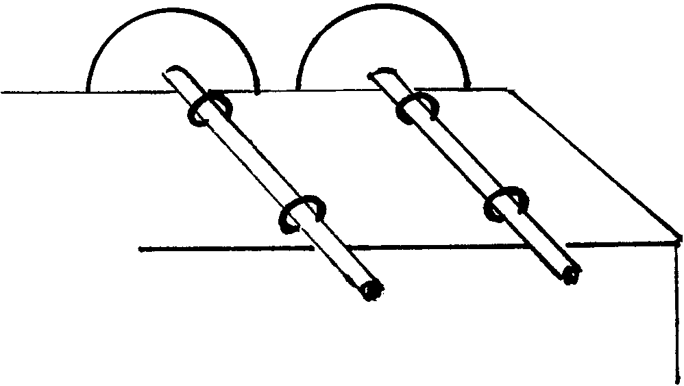
You can make movable wheels from small sections of a broom stick, 1/4” dowel axles and screw eyes. Drill a 1/4” hole in the middle of each wheel. Glue a dowel piece into one wheel. Place the dowel through two screw eyes attached on the bottom of the train (see illustration). Glue the other wheel onto the axle.

If you are making a train for a decoration, simply fasten the wheels to the base with nails.

It’s easier if you paint parts before attaching the wheels.

To link the cars together, add couplings made from paper clips or cup hooks.
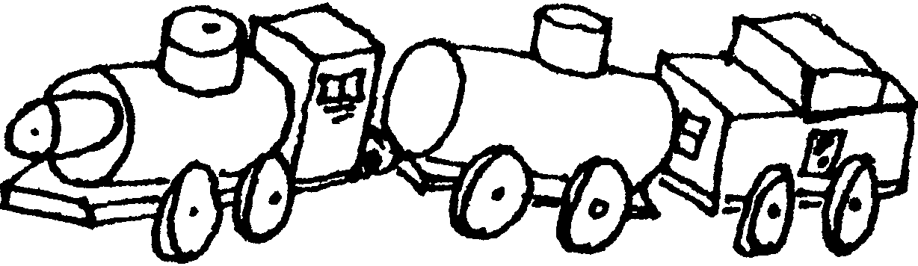

TRAINS FROM THE FUTURE

We can look in books to see pictures of trains from the past, and look on the tracks to see trains of today. But what will trains look like in the future?

Provide a large assortment of crafting materials (such as cardboard tubes, cardboard, craft foam, construction paper, pipe cleaners, juice cans, empty containers in different sizes and shapes, etc.) and glue and scissors.

Let the boys use their imaginations to create a train of the future.
Give it a name and describe some of its special features.

CANDY ENGINE

Material: Pack of gum; Roll of Life Savers; Two caramels; Four hard peppermint candies; One candy Kiss.

Be creative! You can substitute for any of the above with similarly shaped candies.
Try using fun size bars, peppermint patties, Tootsie Rolls, Rollo

Keep all candies in wrappers. Use a drop of tacky glue to attach each piece as shown.

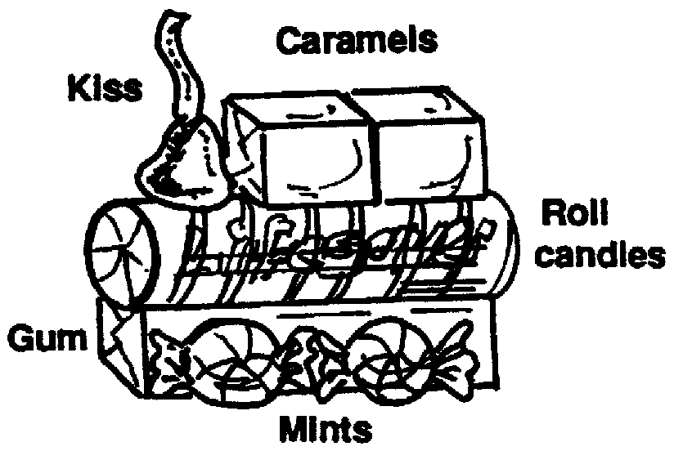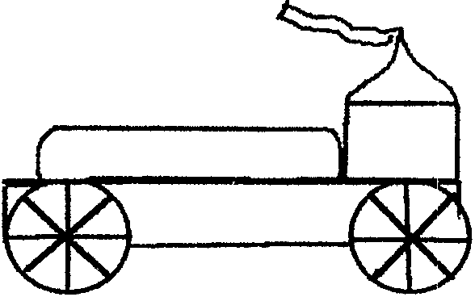

ANIMAL CRACKER CIRCUS TRAIN

Use this box to keep wrapped candy or small toys.

Materials: Animal cracker box; A drinking straw; Scrap cardboard; Two round toothpicks; Tape.

- Cut off the lid and top flaps at the folding line.
- Draw four circles about 1 1/4” diameter out of scrap cardboard.
- Make a small hole in the center of each wheel.
- Cut the 2 pieces of straw about 1 1/2” long.
- Tape the straw pieces to the bottom of the box.
- Put a toothpick through the straw. Attach wheels.

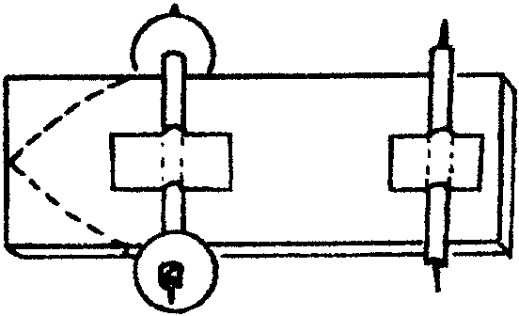

A VIEW FROM A TRAIN

Materials: White poster board (14” x 22” minimum); Colored pencils, markers, crayons; Large piece of corrugated box cardboard (20” x 28” minimum); Utility knife; Masking tape; Pencil; ruler.

Take a train ride without leaving the comfort of your den meeting. Make a scene that you could see from a train window. It can be as silly or serious as you would like. Use your imagination and creativity to see what kind of train ride you can design.

- Using a pencil, start sketching a view outside the train window directly onto the poster board.
- Color it with colored pencils, markers, or crayons.

- To make the window frame, measure a 20” x 28” rectangle on the corrugated cardboard.
- Cut it out carefully with the utility knife. (ADULT ASSISTANCE NECESSARY)
- Center the poster board scene exactly in the middle of the cardboard rectangle.
- Trace the outline of the poster board onto the cardboard. Remove the poster board.
- Draw a second outline 1/4” inside the outline on the corrugated cardboard. To do this easily, make a dot 1/4” inside each corner, then connect the dots with a ruler.
- Cut along the inside lines with the utility knife. (ADULT ASSISTANCE NECESSARY)
- Decorate the front of the frame if desired.
- Place the window frame on top of the drawing so that the drawing is “framed.”
- When it is positioned right, flip both boards over and tape your drawing securely to the back of the frame.
- Display at the pack meeting.

VARIATION: Make the drawing and frames half the size specified, and make several different windows that can be strung together to make an expanded train scene. This can be called “A Den’s Train Trip.”

LOCOMOTIVE NECKERCHIEF SLIDE

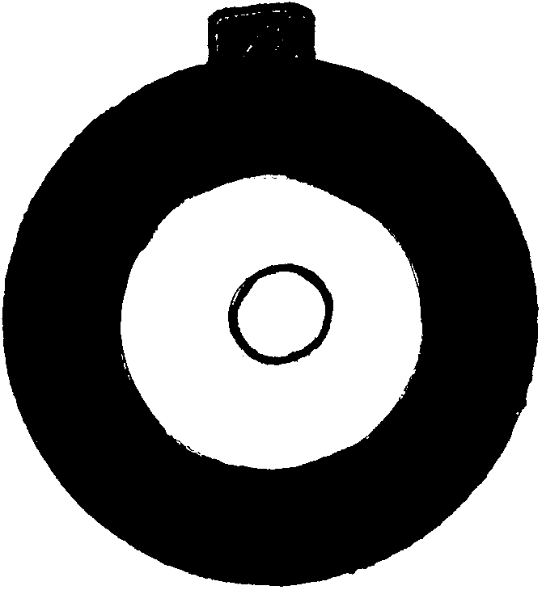
Materials: 1/2” section of a 1 1/4” dowel; 1/4” section of a 7/8” dowel; Pony beads (1 black, 1 clear); Paint (black, silver); 1/2” PVC pipe; Hot glue

- Sand dowel sections.
- Paint larger dowel black and smaller one silver. Let dry.
- Glue small dowel to the center of the larger dowel.
- Glue clear bead to the center of the small dowel (headlight on front of the engine).
- Glue black bead to top of slide.
- Glue a section of PVC pipe to the back of the slide.

RAILROAD CROSSING NECKERCHIEF SLIDE

SLIDE 1
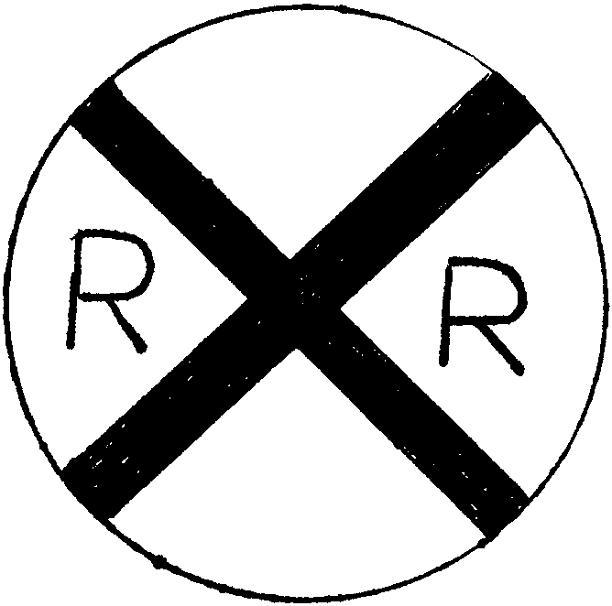
Material: A metal juice can lid; Scrap paper (yellow, black); Black marker; 1/2” PVC pipe; Glue (Tacky glue works best. Glue gun doesn’t work well on metal)

- Trace the lid on yellow paper. Cut out the circle. Glue the circle on the lid. Optionally, if you have paint that sticks to metal, paint the lid yellow.
- Cut two strips of black paper. Glue on the yellow circle.
- Write ‘R’s as shown.
- Glue a section of PVC pipe on the back.

SLIDE 2
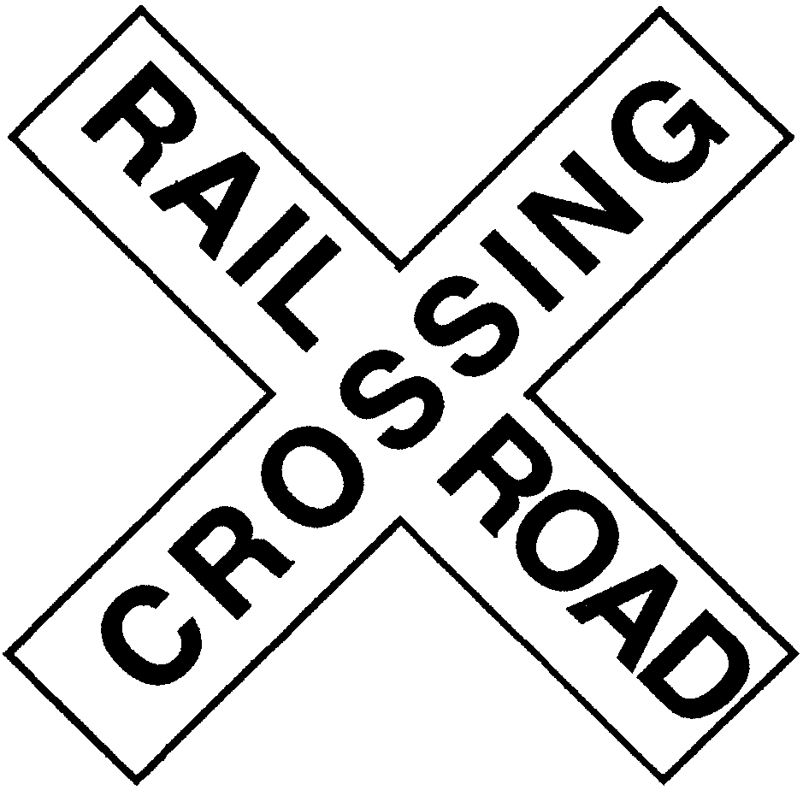
Material: Two large craft sticks (tongue depressors); White acrylic paint; Black permanent marker; Glue; 1/2” PVC pipe

- Cut the craft sticks to about 3”.
- Glue them like an X.
- Paint the X white. Let dry.
- With the permanent marker, write “RAILROAD” and “CROSSING” as shown.
- Attach a section of PVC pipe on the back.

TICKET

Toaster pastries such as Pop Tarts
Decorator frosting in ready to use squeeze tube
Cookie cutter

1. Toast the pastries according to the instruction on the box.
2. With the cookie cutter, cut a small piece off both ends of the pastry (to give it the look of a ticket).
3. With frosting write your favorite destination

FLAT CARS

Flat cars on a train carry farming equipment, construction equipment, and other heavy machinery. The den can come up with a list of other items that flat cars might carry while constructing this snack.

Celery stalk (about 4” long)
Peanut butter
4 round crackers
Raisins
2 pretzel sticks

1. Make little holes in the center of each cracker (adult help may be needed).
2. Attach the crackers to the ends of the pretzel sticks for the wheels and axles. (Broken crackers and pretzels can be used as cargo!)
3. Spread peanut butter on the celery sticks and decorate with raisins.
4. Set the celery on top of the axles.
5. Connect several flat cars to form a mini train. (You can place a candy engine in front)

HOBO POPCORN

In the center of a 6” square of foil, place 1 teaspoon cooking oil and 1 tablespoon popcorn. Bring foil corners together to form a pouch. Seal the edges by folding but leave room for the corn to pop. Tie each pouch to a long stick with string and hold the pouch over hot coals. Shake constantly until all corn has popped.

HOBO STEW

1 pound ground beef
1/2 cup chopped onion
A 10 1/2 oz can of condensed beef broth
2 cups (1 pound can) cream-style corn
3 large potatoes, pared and diced
1 teaspoon salt
Dash pepper

In skillet, brown ground beef and chopped onion.
Add beef broth, cream-styled corn, diced potatoes, salt and pepper. Mix well.
Cover and cook over low heat for 20 to 25 minutes, stirring occasionally.

Makes 4 or 5 servings.

