Tiger Cubs





CONTENTS

INTRODUCTION 1
WORDS OF ENCOURAGEMENT FOR
NEW TIGER PARTNERS 1
TIGER CUB AND HIS ADULT PARTNER 2
TIGER CUB DEN MEETING 2
SHARED LEADERSHIP 2
TIGER CUB RESOURCES 3
“GO SEE IT” TRIP IDEAS 4
LAW OF THE PACK MAZE--FOR
BIG IDEA 17 6
TIGER CUB WORD SEARCH 7
JUST A REMINDER 7
A-MAZE-ING TIGER 8
CEREMONY 9
TIGER CUB OPENING CEREMONY 9
SKITS 10
Skit – “THE ROAR” 10
Skit – “PUT A TIGER IN YOUR TANK” 10
Skit – “SEARCH, DISCOVER AND SHARE” 10
TIGER CUB SKIT 11
GAMES 12
TIGER PLAY 12
TIGER TAIL 12
WHO’S AFRAID OF THE TIGER? 12
HA HA HA 12
LOUD MOUTH 12
CHEERS 13
TIGER CUB CHEER: 13
TIGER CUB CHEER II: 13
TIGER CUB CHEER III: 13
TONY THE TIGER CHEER: 13
TIGER CHEER: 13
SONGS 14
CAN YOU FIND A TIGER CUB 14
HAVE FUN, TIGERS 14
OUR TIGER DEN 14
A TIGER CUB YOU’LL SEE 14
TIGER WITH ME 14
WHO’S THE TIGER IN THE PACK 15
I’M A HELPFUL TIGER 15
TIGER CUBS, TIGER CUBS 15
THE TIGER CUB SONG 15
TAPS FOR TIGER CUBS 15
I’M A LITTLE TIGER 16
TIGER CUBS ARE #1 16
TIGER CUB RAP 16
TIGERS WHISTLE WHILE THEY WORK 16
THIS YOUNG TIGER 16
THE TIGER WENT OVER THE
MOUNTAIN 16
TIGER IN MY TOWN 17
WE ARE TIGER CUBS 17
COME JOIN THE TIGERS 17
TIGER CUB VESPERS 17
TIGER CUB WELCOME SONG 17
WE ARE TIGERS 17
TIGER CUB MOTTO SONG 17
CRAFTS 18
TIGER PAWS FOR THE BLUE AND GOLD 18
CRAFT IDEAS FOR 17 BIG IDEAS 19

The Scouting career of Eagles begins in the Tiger Cub dens of today. Not all Tigers will become Eagles, and not all Eagles will start as Tigers, but we as adult leaders have the obligation to provide the best program possible, so little Tiger Cubs taking their first steps in Scouting may someday SOAR as the majestic Eagle.

WORDS OF ENCOURAGEMENT FOR NEW TIGER PARTNERS

Although this may be new to you, you are not alone. Others have done this (and survived). Use the resources available. That includes not only the great number of printed materials from BSA, but also the people in your pack who have “been there and done that.” Your Tiger Cub Coach is the first resource for you but certainly not the only one.

Observe what the boys like to do in meetings, and, as much as possible, plan to give them that. Don’t make every meeting the same, but leave out things that don’t seem to work well. Don’t be afraid to try new things for the boys to do. You are only limited by your creativity and the policies of BSA.

Speaking of policies, learn what BSA policies are or at least know where to find them. Although the BSA program is flexible enough to meet the needs of all who participate, the policies are not flexible. Your Tiger Coach or some one on your pack committee can help you with policies, but the best way to learn about the policies and program of BSA is to attend Cub Leader Basic Training in your district. You don’t have to be a registered leader to do so.

Always have a back-up plan. And don’t think you’re a failure if you use it. Maybe it rained on the day you wanted to do a treasure hunt in the backyard and you had to limit the hunt to your living room. The boys don’t really care as long as they are having fun. And Tigers have fun doing almost anything. Especially when they think you are having fun with them.

Perhaps, having fun is the key to a successful Tiger program for you and your son. If your son feels like you are enjoying his company, his friends and his accomplishments, there is no limit to what he can achieve. This is his first experience as a Cub Scout. A fantastic program is out there to make him a better adult while playing this “game with a purpose” called Scouting. Search your heart for the time to spend with him as a Tiger Cub. Discover all the Cub Scouting and boy Scouting program has to offer. Share all of your son’s fun and accomplishment with him for years to come. And remember:

IF YOU RUN WITH HIM AS A TIGER,
YOU CAN SOAR WITH HIM AS AN EAGLE.

TIGER CUB AND HIS ADULT PARTNER

The Tiger year is a terrific year. For many of these first grade boys, it is their first chance to belong to a group. The Tiger program requires that each boy bring an adult partner with him who will work with him on all activities. This partner can be a parent, aunt, uncle, grandparent, older sibling who is at least eighteen, or even a neighbor. The most important thing for this partner is that they care about the Tiger Cub and his well-being. The goal of the partner program is to foster strong relationships between the Tiger and his partner; the Tiger and the rest of the family; and the Tiger and other Tiger Cubs.

TIGER CUB DEN MEETING

During the first meeting of the Tiger den, the Tiger Cub coach should go over the format for Tiger den meetings. The parts of the meetings are: Gathering, Opening, Sharing, Discovering, Searching, and Closing. The opening can be as simple as saying the Pledge of Allegiance. Other openings can include saying the Tiger Promise, a poem centered on the Big Idea of the month, a song, or even a reading. Searching, Discovering, and Sharing can be combined as the main part of the meeting or activity. Always include any information concerning upcoming pack activities. Also remind the den of the next meeting time and place, and who will be responsible for that meeting. Closing is a time of reflection. It can be simple and short. It could be just a time to thank everyone for coming and participating in the day’s activity. Another item for closing could be the awarding of the instant recognition beads for completing a Big Idea.

SHARED LEADERSHIP

The Tiger program is designed to be a casual, relaxed program with shared leadership. There are no strict requirements needed to advance. Instead, the focus is on having FUN. To facilitate this idea, Tiger Cubs BSA Family Activity Book contains 17 Big Ideas. Each month, a different Tiger team (a Tiger Cub and his partner) assumes the responsibility of hosting one or more Big Ideas. As the host team for the month, a Tiger team is responsible for planning, running, and organizing that month’s Tiger Cub meetings.

There is NO Tiger Cub leader position; however, each Tiger Cub den should select one adult from within the den to act as Tiger Cub den coordinator. The Tiger Cub den coordinator can help maintain the smooth shared leadership in the den and facilitate the communication between the den and the Tiger Cub Coach. The Tiger Cub den coordinator maintains the Tiger Cub Resource Book and ensures that each month the host team is provided with activity ideas from the book.

The Tiger Cub coach is a pack committee member. Tiger Cub coach organizes and provides orientation for Tiger Cub dens, maintains contact with each Tiger Cub den through the Tiger Cub den coordinator, coordinates Tiger Cub participation in pack activities and the Tiger Cub graduation ceremony, and serves as a resource person for the Tiger dens.

TIGER CUB RESOURCES

Tiger Cub BSA Family Activity Book
Tiger Cub Resource Book
Cub Scout Ceremonies for Dens and Packs
Tiger den ceremonies, pp. 2-3 to 2-3
Pack Opening
“What is Tiger Fun?” p. 5-6
Induction (New Tiger Cubs and Adult Partners)
“Tiger Cubs on the Trail” p. 7-2
“Tiger Track Induction” p. 7-2
Graduation
“Akela Graduation for Tiger Cubs” p. 9-3
“Tiger Cub Colors” p. 9-3
“Mark of the Tiger” p. 9-3
Other Recognition
“Tiger Cub Totem Knot” p. 10-2
“Tiger Paw Totem” p. 10-2
“Tiger Tracks Recognitions” p. 10-3
“Tiger Track for Big Idea 3” p. 10-3
Cub Scout Leader Book
“Planning the Tiger Cub Den Program” pp. 7-13 to 7-14
Guide to Safe Scouting

NOTES: For more Tiger graduation ceremonies, please see the CEREMONIES section in the front of this book.

Tiger Cub Resource Book is an excellent book. It is a comprehensive book that contains Tiger Cubs BSA organization chart, sample meeting outline, activities from the seventeen Big Ideas, ceremonies and ideas for the Blue and Gold Banquet. Suggested activities for the Big Ideas include gathering activities, craft projects, recipes, games and songs. Each Tiger Cub den should have a copy of this book. It is one of the Tiger Cub den coordinator’s responsibilities to maintain this book and provide appropriate pages to the host team of the month. Tiger Cub activities should by no means be limited to the ideas in this book but it is a great start. We have tried to avoid duplicating activities listed in the Tiger Cub Resource Book.

An excellent resource for the Tiger den activities are former Cubs and their adult partners. Ask them what they did, what they enjoyed doing and what they wished they had done.
Remember KISMIF – Keep it simple, make it fun!

“GO SEE IT” TRIP IDEAS

For details about a specific place, please refer to the FIELD TRIP section.

Big Idea 1: Getting to Know You
Den picnic
Tiger game day

Big Idea 2: Family Entertainment
Local library
Local movie theater
Museum (Children’s Discovery Museum, Tech Museum)
Miniature golf

Big Idea 3: Discover Nature and Energy
Youth Science Institute
Fishing (for places to fish, see JUNE “Theme Related” section
Minolta Planetarium, DeAnza College

Big Idea 4: Prepare for Emergencies
Fire Station
Police station
Bike store (learn bike safety)
Swimming pool (talk to lifeguards)

Big Idea 5: Know Your Family
Grandparents
Place of employment

Big Idea 6: Know Your Community
Around the block hike
Grocery store
Restaurant
Museum
Zoo
Airport
City hall

Big Idea 7: Helping Others
Chartered organization
Retirement homes
Participate in Scouting for Food with the pack

Big Idea 8: Go See It
Children’s play
Puppet show (often at the local library)

Big Idea 9: Getting There
Train station
Train museum (see SEPTEMBER “Theme Related” section)
Airport
Sea port/pier/marina

Big Idea 10: Something Special, All Your Own
Ball game
Bike ride

Big Idea 11: Making Your Family Special
Den family picnic

Big Idea 12: Make Your Own
Hobby center
Home improvement center

Big Idea 13: Caring for Your Home and Household
Home improvement center
Recycle center (see APRIL “Theme Related” section)
Water treatment plant

Big Idea 14: Family Games, Tricks, and Puzzles
Toy store
Magic show

Big Idea 15: Fitness and Sports
Swimming pool
Roller/ice skating

Big Idea 16: Tell It Like It Is
Radio station
San Jose Post Office or local post office

Big Idea 17: Cub Scouting, Here We Come
Wolf den meeting

LAW OF THE PACK MAZE--FOR BIG IDEA 17

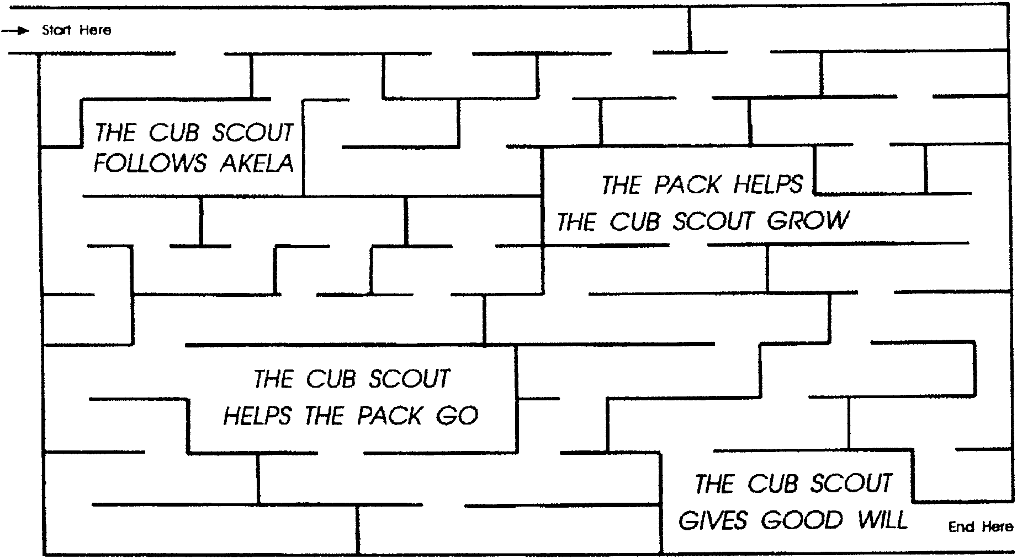

Use a pencil to find a path through the four parts of the law of the pack. Can you do it without a wrong turn?

1. THE CUB SCOUT FOLLOWS AKELA
Who is Akela? In Cub Scouting, Akela means “Good Leader” - your mother and father, your teacher, your Cubmaster, or other people who are willing to help you. Follow Akela.
2. THE CUB SCOUT HELPS THE PACK GO
When you become a Cub Scout, you must think of your fellow Cub Scouts. Help your pack go by coming to all meetings, following Akela and in every way making your pack better because you are in it.
3. THE PACK HELPS THE CUB SCOUT GROW
You are going to have lots of fun. You will learn things from other people, and you will learn to do things with them. If you help the pack go, the pack will help you grow.
4. THE CUB SCOUT GIVES GOOD WILL
You will find that if you smile at your friends, they will smile back at you. Look for things to do for others. Smile and help. These are two good Cub Scout words.

TIGER CUB WORD SEARCH
Big Idea
Search
Discover
Share
Promise
Tiger Cubs
Family
Adult Partner
Country
Motto

D W X C O U S Z V A H
O I Q B D W H F P D L
T O S B U N A E F U M
I S E C T I R S A L V
G O A O O C E I K T S
E S R A B V I M L P A
R M C F Q Y E O A A E
C A H U L W I R M R D
U Y R I N J P P B T I
B B M O T T O F S N G
S A K U T R E Q P E I
F C O U N T R Y F R B

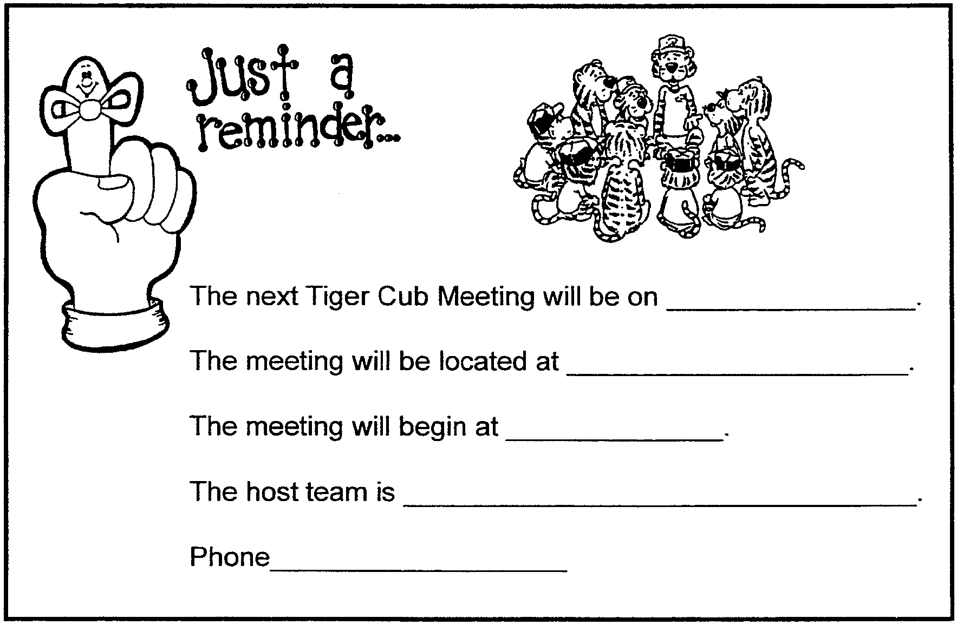

A-MAZE-ING TIGER

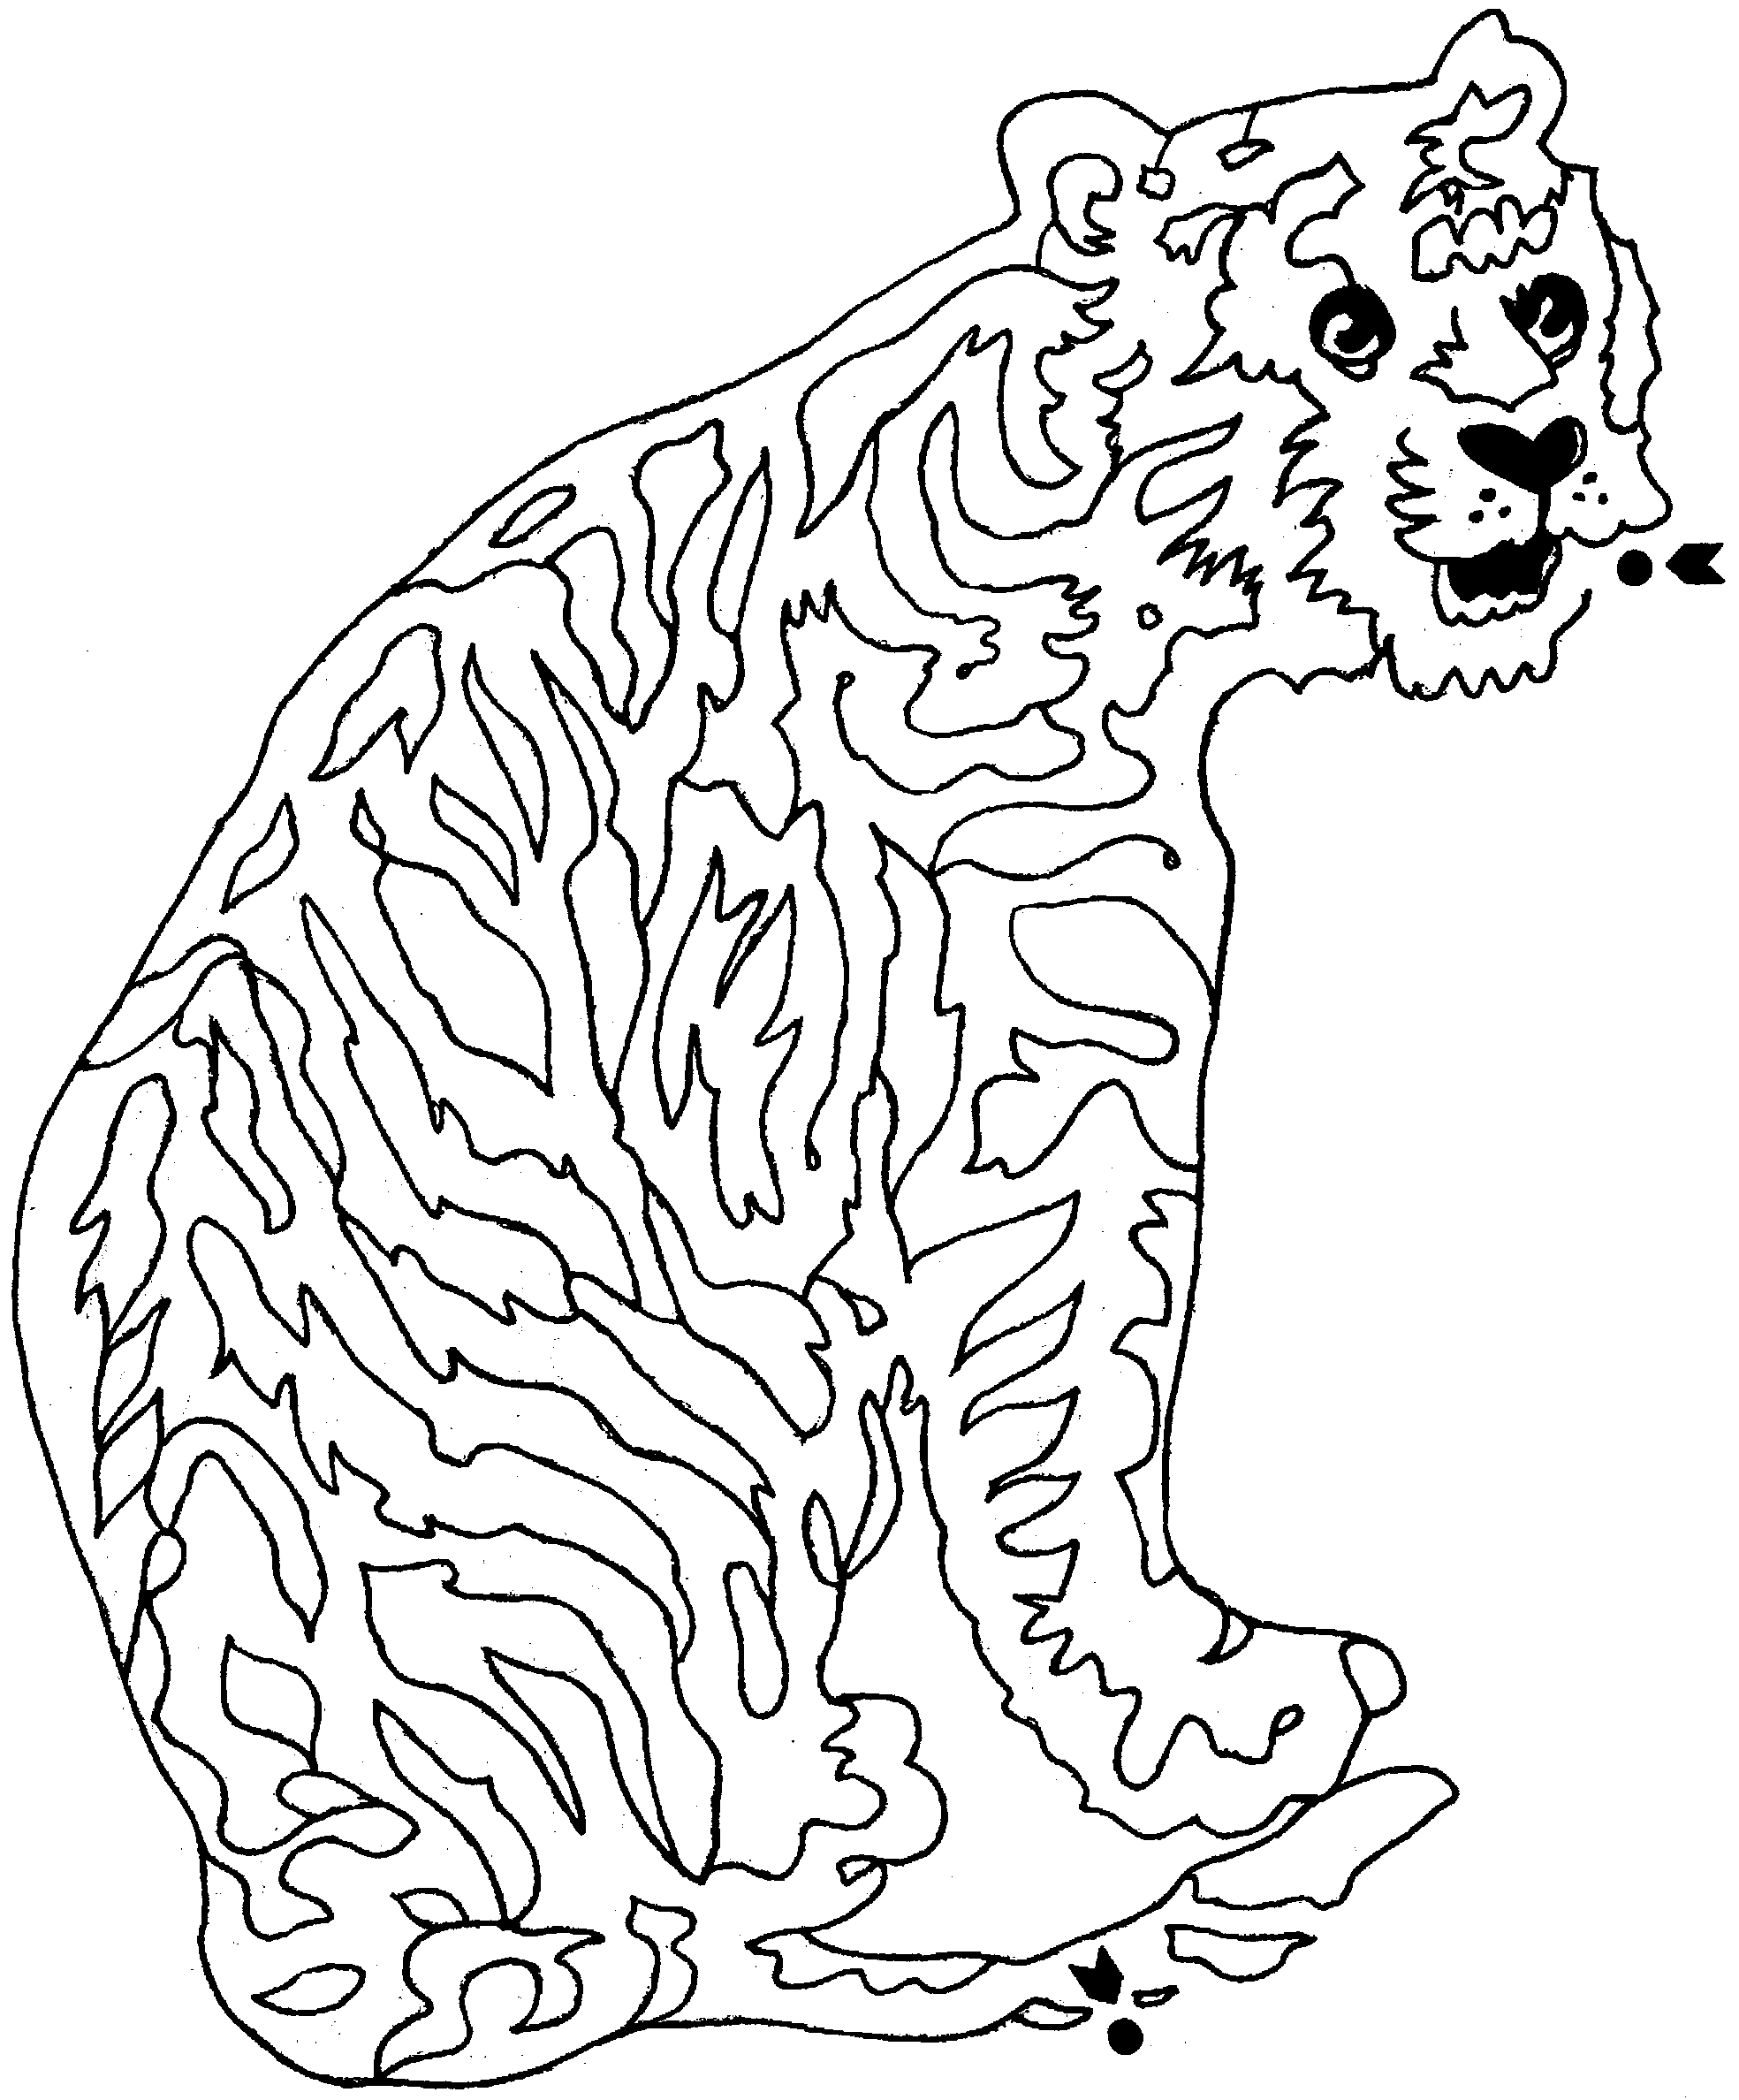

TIGER CUB OPENING CEREMONY

Each Tiger Cub holds a poster with a letter on it. After he shouts his letter, his adult partner reads the statement matching the letter.

T is for TEAM, the Tiger team, a boy and his adult partner having fun together.

I is for INTRODUCTION, showing us what Cub Scouts is all about.

G is for GOOD TIMES, having fun together as a den and with your family.

E is for EXPLORING, searching out new things to see and do.

R is for READY, ready for new adventures together as a team.

S is for SHARING, taking time to talk to each other about the fun things we have done.

Sing together to the tune of Jingle Bells:

Tiger Cubs, Tiger Cubs
We have lots of fun!
Big Ideas for everyone,
That’s how it is done.

Learn the promise and the motto,
“Search, Discover, Share.”
Oh, what fun it is to be
A Tiger Cub like me!

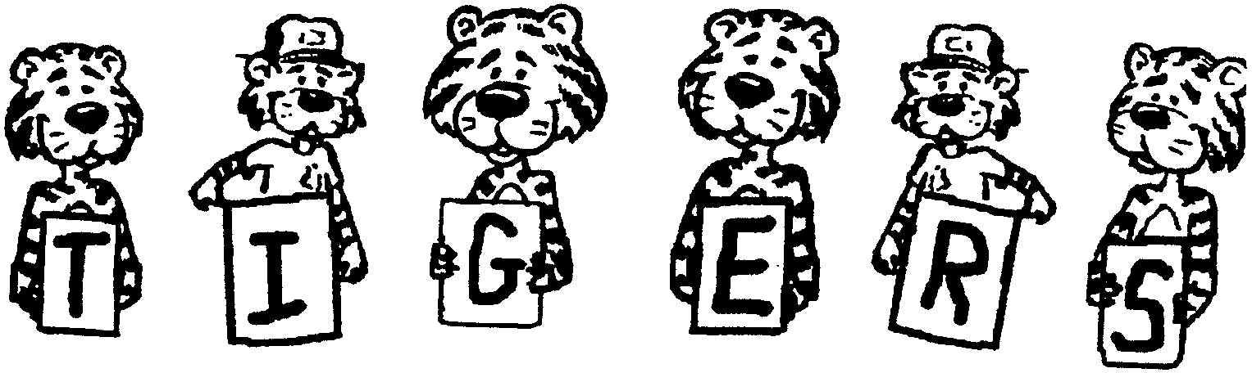

Skit – “THE ROAR”

One Tiger Cub goes to the front and stands alone. Each Tiger Cub enters and then the Tigers “roar” to one another. This is repeated until all the Tigers have entered. Then the Tiger cubs turn to the audience and all say together:

“We’re having a roaring good time!”

Skit – “PUT A TIGER IN YOUR TANK”

Props: A banner or sign saying “PACK MEETING”; Steering wheel cutouts, a tiger tail.

Arrangement: Have two Tiger Cubs holding the banner at one end of the stage.

Partner: All right Tiger Cubs, you’d better hurry up or you’ll be late for the pack meeting.

Tiger Cub #1: (Tries to start his engine by turning an imaginary key.)

Tiger Cub #2: (Does the same thing, only his car goes a couple of feet.)

Tiger Cub #3: (Does the same thing, only his car goes three to four feet.)

Tiger Cub #4: (Does the same thing with his car dying halfway across the stage.)

Tiger Cub #5: (Holding a tiger tail) (Starts his car up fast and making loud racing noises, ZOOMS to the Pack Meeting sign.)

Sign Holders: Hey, How did you get here so fast?

Tiger Cub #5: That’s easy. I’ve got a ‘Tiger’ in my tank.

Skit – “SEARCH, DISCOVER AND SHARE”

Tiger Cubs we are. (Point to Tiger on shirt with both thumbs)
Cub Scouts we will be. (Hold up Cub Scout sign)
After we SEARCH, (Point to Tiger with both thumbs)
Some help we’ll need
But not for long
We’ll DISCOVER right from wrong (Hold out right hand, palm up, first; then the left)
So look out Scouts (Make Cub Scout sign over right eye and look out)
Tigers are sharing your teepee (Bring Cub scout sign over Tiger on shirt, invert it
putting the Tiger in a teepee)

TIGER CUB SKIT

Tiger Cubs are milling around on the stage looking BORED.

Older boy: What are you Tiger Cubs doing up here?

All Tigers: (at once, each with own line)
We’re bored!
We don’t have anything to do!
Yeah.
There’s nothing to do!
Nothing’s goin’ on!

Older boy: Well, why don’t you go play in the street?

All Tigers: (yell together)
NAAAWWWW, TIGER CUBS DON’T DO THAAAAT!

Older boy: Well, why don’t you go outside and fight?

All Tigers: (yell together)
NAAAWWWW, TIGER CUBS DON’T DO THAAAAT!

Older boy: Well, why don’t you go throw stones at a neighbor’s dog?

All Tigers: (yell together)
NAAAWWWW, TIGER CUBS DON’T DO THAAAAT!

Older boy: Well, why don’t you rough-house and make a lot of noise?

All Tigers: (whisper together) Naaawwww, Tiger Cubs don’t do that.

Older boy: Well then, why don’t you all put on a skit?

(Tiger Cubs are silent and think real hard to themselves. Then after a few seconds)

All Tigers: (yell together) YEAAAAAH! That’s a great idea!

(Tiger Cubs all line up across the stage and BOW deeply to the audience)

TIGER PLAY

This game is similar to “Simon Says.” The players do what the partner says unless he or she doesn’t say “Partner Says.” A player who follows a direction when it isn’t preceded by “Partner Says” must step out of the game.
Example:
“Partner says: Growl like a Tiger.” -- Players growl like Tigers.
“Partner says: Paw at the ground.” -- Players paw at the ground.
“Twirl your Tiger whiskers.” -- Any player who followed this direction must step out of the game.
The game continues until one player, the winner, remains.

TIGER TAIL

This game is played like the old favorite, “Duck, Duck, Goose.” Everyone sits in a circle, except for “It.” “It” walks around the outside of the circle tapping each boy and saying, “Tiger, Tiger, Tiger, Tiger...Tiger Tail!” The boy tapped as the Tiger Tail must get up and race “it” around the circle back to the empty spot. The player who doesn’t get a seat is the next “It.)

WHO’S AFRAID OF THE TIGER?

This is an outdoor game for 10 or more players. Two goal lines are marked off about 30 feet from each other. All the players except one stand on one goal line. The extra player is the “Tiger.” He stands in the middle and faces the players. When he calls out “Who’s afraid of the Tiger?” the other players answer “No one.” then, they run as fast as they can to the opposite goal. The “Tiger” tries to catch as many players as he can. Those who are caught join him in standing between the goals and help the “Tiger” catch the others. The last boy to be caught is the new “Tiger.”

HA HA HA

Players sit or stand in a circle, and one player begins by saying “Ha,” as solemnly as possible. The next player says, “Ha Ha,” and the player after that, “Ha Ha Ha.” Play continues with each player adding a “Ha” during his turn. The players must all keep a straight face throughout the game.

Any player who laughs or giggles must leave the circle; however, he can now move around the circle trying to make the other kids laugh. He can make funny faces or noises, but cannot touch the other players. See who can keep a straight face longest through all the laughter.

LOUD MOUTH

This is also a noisy game but is played outside. All Tigers line up side by side. At the signal they are to shout as loud as they can and run as fast as they can. They run as long as they can shout. When they can no longer shout, they must stop. The Tiger who runs farthest wins.

TIGER CUB CHEER:

Repeat this cheer three times. The first time is spoken softly, the second a little louder and the third time is yelled loudly with a big Tiger growl at the end:
“The wonderful thing about Tigers...is that Tigers are wonderful things.”

TIGER CUB CHEER II:

“Tigers have the spirit.
Yes, we do!
Tigers have the spirit.
How ‘bout you?”
After the first yell, have the Tigers point to a group of Wolves, the second time, point to a group of Bears, and the third time point to a group of Webelos.

TIGER CUB CHEER III:

“We’re the Tigers,
And we’re proud to say,
We’ll be back next year as Wolves,
‘Cause that’s the Cub Scout way.”

TONY THE TIGER CHEER:

Roar like a tiger and say, ‘THAT’S GRRRRRREAT!”

TIGER CHEER:

Give me a T T
Give me an I I
Give me a G G

Give me an E E
Give me an R R

Put it together and what does it spell? Tiger!

What does it say? ROARRRRR!

CAN YOU FIND A TIGER CUB
(Tune: Do You Know the Muffin Man?)

Can you find a Tiger Cub,
A Tiger Cub, a Tiger Cub?
Can you find a Tiger Cub
With black and orange bold stripes?

Yes, we found a Tiger Cub,
A Tiger Cub, a Tiger Cub.
Yes, we found a Tiger Cub
With black and orange bold Stripes.

(Divide singers into two groups. The first group sings the first verse. The second group responds with the second verse. Repeat, singing faster each time.)

HAVE FUN, TIGERS
(Tune: Good Night Ladies)

Have fun, Tigers.
Have fun, Tigers.
Have fun, Tigers.
Search, Discover, and Share.

Merrily we do all three,
Do all three, do all three.
Merrily we do all three –
Search, Discover, and Share.

OUR TIGER DEN
(Tune: Camptown Races)

Our Tiger den can sing the best,
Join us, join us!
Our Tiger den can sing the best,
Join us, sing right now.

Going to sing all night,
Going to sing all day.
Our Tiger den can sing the best –
That’s the Tiger way!

(Replace “sing” with another action word, such as smile, hop, shout, clap.)

A TIGER CUB YOU’LL SEE
(Tune: Hey Look Me Over)

Hey look me over,
A Tiger Cub you’ll see.
But I’m growing quickly,
A Bobcat soon to be.
Next I’ll be a Wolf Cub,
Then a Bear to go,
And when I hit 4th grade,
I’ll be a Webelos.

So if you want to come with me,
There’s magic in the air.
Together we will learn to
Search, Discover, and Share.
There’s a lot to do
And we’ll share it with you!
We’ve really got the knack
Of having fun in our Cub Scout Pack.

TIGER WITH ME
(Tune: This Old man)

My ole Dad,
Can’t you see,
Wants to be a Tiger with me.
With an orange shirt and
a book in his hand,
We are searching all the land.

My ole Mom,
Can’t you see,
Wants to be a Tiger with me.
With an orange shirt and
a book in her purse,
We are discovering this earth.

Sisters and brothers,
Can’t you see,
Want to be Tiger Cubs with me.
With our go and see it,
We are on the run,
Tiger families are so much fun.

WHO’S THE TIGER IN THE PACK
(Tune: Mickey Mouse Club Song)

Who’s the Tiger in the pack
You know that’s him and me.
T-I-G-E-R-S, Tigers all are we.
Hey there, Hi there, Ho there,
We’re as happy as can be.
T-I-G-E-R-S, Tigers all are we.

Tiger Cubs, Go and See
Tiger Cubs, Go and See
We hold our Scouting values
nice and high
Come and join us, Tiger Cubs
They’re made for you and me
T-I-G-E-R-S, Tigers all are we.

I’M A HELPFUL TIGER
(Tune: Sugar in the Morning)

Helping in the morning,
Helping in the evening,
Helping at supper time;
That’s the Tiger spirit,
Be helpful all the time.
Listening to Akela
Following directions,
Doing the best we can;
That’s the Tiger way
So we lend a hand.

TIGER CUBS, TIGER CUBS
(Tune: Jingle Bells)

Tiger Cubs, Tiger Cubs
We have lots of fun
Big ideas for everyone
That’s how it is done.

Learn the promise and the motto
Search, Discover, Share.
Oh what fun it is to be
A Tiger Cub like me.

THE TIGER CUB SONG
(Tune: Yankee Doodle)

Tommy is a Tiger Cub,
A Tiger Cub is he,
Tommy, he can hardly wait
A new Cub Scout to be.

CHORUS:
Scouting is just great for boys,
Tigers the beginning.
With Boy Scouts throughout the land,
America is winning.

A Tiger is the first grade,
A Cub Scout-second ‘n third.
“Do Your Best” the Cub Scouts sing,
That is the Cub Scout word.
CHORUS

Bobcat, Wolf and Bear Cub, too
That Tiger he will fly,
On up to the Webelos den
Our Tiger’s quite a guy.

CHORUS

From Webelos to the Boy Scout troop,
Our Tiger he will go.
Scouting is a special way
To help a boy to grow.
CHORUS

From Tenderfoot to Eagle Scout,
Tommy will be prepared
From those good old Tiger days
When he Searched, Discovered, Shared.
CHORUS

TAPS FOR TIGER CUBS

Tiger Cubs
It is late
We have Searched
And Discovered
And Shared
It is late
Time to leave
Tiger Cubs

I’M A LITTLE TIGER
(Tune: I’m a little Teapot)

I’m a little Tiger
You can see
Let’s say the Motto
Won’t you please
It begins with Search
Discover and Share
Now you’ve learned it
Along with me.

TIGER CUBS ARE #1
(Tune: Caisson Song)

Tiger Cubs are number one,
Tiger Cubs have more fun,
With their partner they’ll
Search, Discover, Share
In doing so they’ll
Be prepared!
For on to Cub Scouts
They will go,
Tiger Cubs can help them grow!

TIGER CUB RAP

Now we’re the Tiger Cubs
And we want you to know
That the Tiger Cubs
Are the stars of the show.

We will Search
And Discover and Share
And with our families
We’ll learn to care.

We’ll always wear the orange
And black, don’t you know
So we will be noticed
When we’re on the go!

We’ll work hard
But we’ll have fun
And we’ll always say “Thank You”
When we’re done!

TIGERS WHISTLE WHILE THEY WORK
(Tune: Whistle While You Work)

Tigers whistle while they work! (whistle)
They pitch right in, and laugh, and grin
And whistle while they work.
Tigers hum a merry tune! (hum)
They hum all day at work and play
They hum a merry tune.
Before they become Cub Scouts
They have to know the rule
Of being courteous and kind
In both their home and school,
Tigers whistle while they work, (whistle)
They do their bit, they never quite,
Tigers whistle while they work.

THIS YOUNG TIGER
(Tune: This Old Man)

This young Tiger,
He’s number one!
With his partner,
He’ll have lots of fun.
With a Search, Discover and Share,
As a Cub Scout
He’ll be prepared!

THE TIGER WENT OVER THE MOUNTAIN
(Tune: For He’s a Jolly good Fellow)

The Tiger went over the mountain,
The Tiger went over the mountain,
The Tiger went over the mountain
To see what he could see.

And all that he could see,
And all that he could see,
Was the other side of the mountain,
The other side of the mountain,
The other side of the mountain
Was all that he could see.

TIGER IN MY TOWN
(Tune: Head and Shoulders, Knees and Toes)

There’s a Tiger in my town, in my town,
Wearing orange and running ‘round,
running ‘round,
Being helpful, cheerful, true,
And a friend to all of you, all of you!

WE ARE TIGER CUBS
(Tune: If You’re Happy)

We are Tiger Cubs,
Hooray Tiger Cubs!
We are Tiger Cubs,
Hooray Tiger Cubs!
We are happy and we show it
‘Cause we want the world to know it!
We are Tiger Cubs,
Hooray Tiger Cubs!

We are Tiger Cubs,
Hooray Tiger Cubs!
We are Tiger Cubs,
Hooray Tiger Cubs!
We will Search, Discover, Share
As our laughter fills the air
We are Tiger Cubs,
Hooray Tiger Cubs!

We are Tiger Cubs,
Hooray Tiger Cubs!
We are Tiger Cubs,
Hooray Tiger Cubs!
We will soon be Cub Scouts, too
And we’ll wear the gold and blue
We are Tiger Cubs,
Hooray Tiger Cubs.!

COME JOIN THE TIGERS
(Tune: Row, Row, Row Your Boat)

Come, come join the Tigers
Join our fun today.
For we Search, Discover, Share
That’s the Tiger way.

TIGER CUB VESPERS

Softly falls the light of day,
As our campfire fades away.
Silently each Tiger should ask,
Have I done my daily task?

Learned about the world today,
Helped my family some small way.
For my God and country cared,
As I Searched, Discovered and Shared.

TIGER CUB WELCOME SONG
(Tune: Auld Lang Syne)

We welcome you to our Tiger den
We’re mighty glad you’re here
We’ll start the air reverberating
With a mighty cheer.
We’ll sing you in, we’ll sing you out,
For you we’ll raise a shout.
Hail, hail, the gang’s all here
You’re welcome to our den.

WE ARE TIGERS
(Tune: Are You Sleeping)

We are Tigers,
We are Tigers,
On the go,
On the go,
Search, Discover and Share.
Search, Discover and Share.
As we grow,
As we grow.

TIGER CUB MOTTO SONG
(Tune: Frere Jacques)

Tiger Cubs, Tiger Cubs
Search and Discover
Discover and Share
Always on the go
Helping us to grow
Tiger Cubs, Tiger Cubs.

TIGER PAWS FOR THE BLUE AND GOLD

Cut out the outline from orange card stock paper, tag board, or construction paper. For the pads, cut pieces from black paper and paste them on the paw, or color with black crayon or markers.

PLACEMAT: Trace the tiger paw in the center of a sheet of orange construction paper. Make one for each family member. If desired, write the name of a family member in the heel of the paw.

PLACE MARKER or NAME TAG: Cut the outline of the paw from stiff paper, write the name on the heel, color the rest of the pad black. For a name tag, attach a safety pin.

NAPKIN RING: Cut the outline of the paw from orange construction paper. Cut out the heel of the pad. Color the rest of the pad black, or paste black paper. Insert a rolled napkin through the heel.



CRAFT IDEAS FOR 17 BIG IDEAS

Big Idea #1: Getting to Know You

Tiger Cub Folder. Have each Tiger decorate a plain white 3-holed pocket folder with things that they like (sports, pets, things they like to do, etc.). Use the Tiger Cub stamp or stickers you can purchase from the Council. Make sure their name is on the front of their folder. Inside the folder, staple or tape a Ziploc bag in which the scout can put a pencil. This folder can be used to take home any important notes and/or project. After decorating, the group can gather to discuss how they decorated their folder, thereby learning about each other along the way.

Promise Poster. Make a poster as a group with the Tiger Promise and Motto. Have each Tiger/Adult team contribute to the poster a drawing of something they’d like to do in Scouting.

Time Capsules. Cover an empty oatmeal container with paper and decorate as desired. Put items in container to represent a time in their lives. Can include such items as photographs, fingerprints, drawings, messages, etc. A Tiger/Partner capsule can be made. It is suggested that the capsule be used throughout Scouting and displayed at his Arrow of Light Ceremony AND his Eagle Court of Honor.

Big Idea #2: Family Entertainment

Bubble Prints. Fill plastic containers half full of water. Pour in plenty of food dye; the solution should be very intense. Squeeze in a little dish soap. Blow through a drinking straw into the solution until there is a 4-inch to 5-inch mound of bubbles. Lay a piece of white paper face down onto the mound of bubbles. Note: Fill several containers with different colors of dye, printing one color on top of another works well. Cubs can work into the bubble prints with pens or markers to create pictures.

Ice Cream in a Bag. Fill a 1 gallon size zip type plastic bag half full of ice, and add 6 tablespoons rock salt. Put ½ cup milk or half & half, ¼ teaspoon vanilla, and 1 tablespoon sugar into a pint size zip type plastic bag, and seal it. Place the small bag inside the large one and seal it carefully. Shake until mixture is ice cream, about 5 minutes. Wipe off the top of the small bag, then open carefully and enjoy!

Wax Paper Sun Catchers. Collect leaves, flowers, weeds and press them for a few days before the Tiger meeting in a large phone book. Tigers place leaves, flowers etc. on a sheet of waxed paper (about 12" square). The Tigers then make crayon shavings with an inexpensive plastic pencil sharpener. They sprinkle a few wax shavings between the flowers and leaves. Cover the wax paper with another sheet of wax paper. An adult then uses an iron on medium setting to fuse the two pieces of wax paper together and melt the crayon shavings (works best if you put a piece of brown paper sack under the bottom piece of wax paper and another piece of the brown paper sack between the top piece of wax paper and the iron.)

Big Idea #3: Discover Nature and Energy

Bird Brush. Use a clear scrub brush for this easy feeder. Melt some bacon grease or lard in a pan, then dip the brush into it. Sprinkle birdseed mix onto the bristles. As the fat congeals, the seeds will stick. Tie the brush to a tree in a safe spot.

Donations to a Bird's Nest. Everyone needs a home, including the birds that fly around your neighborhood. Here is a way to help them find materials for building their nests. Bend a wire hanger into a square or rectangular shape. Attach mesh material (such as an orange or potato bag from the grocery store) to it. If you use a potato sack, simply drape the bag over the hanger. If you use other material, tie it on with string or glue into place. Loosely weave yarn, fabric strips and string through mesh. In early spring, hang your nest building helper in a tree near your window. Watch as the neighborhood birds flock to it to choose the materials they need. Take a neighborhood walk after your hanger has been emptied. See how many nests you can find that contain your material scraps. Remember that a bird's nest is its home, so be careful not to trespass.

Ocean in a Bottle. Have each Tiger Cub fill a clear jar or bottle (you may prefer to use a plastic jar or bottle that will not break) about two-thirds full of water. Add a few drops of blue food coloring. Fill the jar to the top with mineral oil and screw the lid on tightly. Have each Tiger Cub hold the jar sideways; tipping it gently back and forth to create waves, just like the ocean.

Rain In A Can. Cut a strip of paper the width and diameter of a coffee can. Draw a picture of the ark. Make a ring with the paper and side into the can (picture facing in). Roll 3 marbles in blue paint and then drop them into the can. Add the lid and shake. Carefully remove the picture. The marbles will add the effect of rain on the drawing.

Rocks, Shells and Fossil Prints. Mix: 1/2 cup cornstarch, 1/2 cup salt, and 3/4 cup flour. Add warm water to make into a dough ball. The dough can be rolled, formed or used to press shells, rocks or other natural objects into. Let the dough air dry, turning each day until dry or microwave one minute on each side. It may be necessary to adjust the microwave according to the thickness of the dough and microwave temperature. Dry dough can be painted with tempera paint.

Big Idea #4: Prepare for Emergencies

Pringles Can Fire Extinguisher. Use either construction paper or wallpaper scraps (check your local wallpaper store for old books that they throw away). Wrap the paper around the can, mark and cut to size. Decorate if desired. Glue the paper onto the can. Decorate the lid with a silk flower and ribbon. Fill with baking soda. Keep it next to the kitchen stove. If there’s ever a kitchen fire, pour the baking soda on the flames to put them out.

Safety Posters. Have each Tiger/Adult team work on a poster together. Have each team work on a different safety theme: water safety, bike safety, fire safety, gun safety (i.e., “Stop, Don’t Touch, Leave the Area, Tell an Adult!!!), safety in the home, how to make an emergency phone call, how to deal with strangers, etc. Provide construction paper, markers and crayons, old magazines for pictures, scissors and glue. Each team can then give a short presentation about their poster.

Big Idea #5: Know Your Family

Family Pennant. This is designed to inspire team spirit. Cut one sheet of poster board into a triangular pennant shape. Allow fifteen minutes for each team to create a flag. Each pennant must contain a family name. Have the Tiger Cup Partner staple their poster pennants onto a
1/2" x 3' wooden dowel.

Family Totem Pole. Paint a cardboard tube from a roll of paper towels (or you could glue construction paper around a small coffee can). Draw pictures, or cut out from a magazine, pictures which represent your family’s favorite things (foods, animals, sports, hobbies, etc.) Glue pictures to the cardboard totem pole. Then glue the totem pole to a small box or lid for stability.

Family Tree. Have each boy write the name of each family member on a 1-1/2” piece of red paper cut out like an apple. Include parents, siblings, grandparents, aunts and uncles, etc. Tie each apple to a branch. This base of this branch (tree) can then be set in a small can filled with plaster and secured until the plaster sets.

Big Idea #6: Know Your Community

People Puppets. Make sock puppets or sack puppets of people that represent people in your community (i.e., policeman, mayor, scoutmaster) then present a play. Maybe you can give your play at the next pack meeting. You can find a whole section in the Cub Scout Leader How-To Book on puppets. This book is available from your Council office.

Big Idea #7: Helping Others

Christmas Cards. Make Christmas cards which can be taken to a local nursing home or hospital. Save old Christmas cards to cut and paste onto construction paper.

Bookmarks. Boys could also make book marks to give to a retirement home to illustrate the helping others concept. Use poster board cut to about 3" x 8" (use pinking shears for extra decorative effect). Punch hole in bottom to add tassel or ribbon ties. Decorate as desired.

Goodie Bags. Decorate paper lunch bags with markers and crayons. Fill with candy and messages of good cheer, and secure with a ribbon. Donate to a local hospital or nursing home.

Ornaments. Trace an old Christmas card around the outside of a clean plastic lid (from peanut butter, for example). Cut just inside the traced line so that the cutout fits inside the lid. Glue in place. Wrap ribbon around the outside of the lid and glue in place. Attach a hanger at the top of the ornament with glue.

Big Idea #8: Go See It

Go See It Collage. Have boys make a collage of things they would like to see. Give boys old magazines and cut out pictures in odd shapes and glue them (overlapping) onto poster board to make their collage.

Big Idea #9: Getting There

Litter Bag. Decorate a small paper lunch bag with crayons and markers. Have the adult partner assist in reshaping a wire clothes hanger to form a square frame for the bag. The bag can then be taped over the edges of the hanger, and hung from a window handle to collect litter in the car.

Paper Airplanes. No explanation necessary. Use your imagination in folding and decorating with crayons and markers.

Travel Bag. Have each Tiger Cub put their name on a gallon size Ziploc bag. The bag can then be decorated with markers and filled with crayons, markers, paper, a couple of hot wheels, a book, and other miscellaneous items to keep the kids busy during a long car ride. Consider adding a juice box and a small package of crackers, as well. Keep the bag in the car so it’s always available.

Big Idea #10: Something Special, All Your Own

Inch-Worm Bookmark. Using an 8” length of ¾” to 1” wide ribbon, fold over one end of about 2". Cut two small slits (1/4") in folded ribbon about 1/4" from each edge of fold (on fold). Insert a 4” length of pipe cleaner through slits. Fold each end to form antennae. Glue a small bead to the end of each antenna. Fold 2" tab of ribbon under to form a face, then glue. Glue on wiggly eyes and a ½” pompom nose. Fray opposite end of ribbon if desired.

Collection Display. Use an empty Christmas card box with a clear lid to create a display for a collection of rocks, marbles, etc. Paint or cover the outside of the box with construction paper and decorate as desired. Paint or cover the inside of the box with white. The collection items can then be glued onto the bottom of the box, and include a label for identification under each item. When complete, add the clear lid to protect your collection.

Tiger Bank. Cut a slit in the top of a large juice can. Cover with orange and black felt, black permanent marker, and wiggly eyes to resemble a Tiger. Refer to drawing in your Family Activity Book if you’re not a great artist!
Big Idea #11: Making Your Family Special

Coat Of Arms. Some families have crests or family designs that have been passed down from ancestors. These designs were an important way to show the family line. They also made everyday life more colorful. If your family does have a coat of arms, you can recreate it out of poster board. If your family does not have a coat of arms, you can design your own with the help of your family. Start designing your coat of arms with simple lines and two colors, one dark and one light. Use red, blue, black, green, or purple. You can use gold and silver or yellow and white also. Only bright colors are used. Once your basic design is decided, you can add simple things if you like, such as lions, birds, fish, eagles, etc. Cloth banners can be used with your coat of arms to hang on the wall of your room. Make your design first with pencil and paper. Cut out your shape using poster board or felt. Glue on small pieces to create your basic design and then continue with small cutouts of the additional designs. The size of the coat of arms or the banner is up to you. After the coat of arms or the banner is finished, mount it on a dowel rod for hanging.

Big Idea #12: Make Your Own

Handy Backpack. Turn a pair of jeans into a backpack for a day hike with your den. Start with a pair of old jeans. Fill trunk portion with supplies. Tie off legs leaving extra rope hanging. Pull top closed with rope through belt loops. Tie leg bottoms to belt loops. Use as arm straps.

Puzzle Pins or Scarf Slide. Choose appropriate puzzle piece for the pin you want. The back of the puzzle piece becomes the front of the pin. Basecoat your puzzle piece with white first. With a pencil draw the pattern on the puzzle piece. Paint the piece with the colors that you want to. After the paint has dried do the line work with a permanent marker (pumpkins for Halloween, candy canes for Christmas, or whatever will best suit the time of year you’re working on your project) and glue the pin onto the back of the puzzle piece. If you don't want to use them as pins glue a ring onto the back of the puzzle piece and use as a neckerchief slide.

Big Idea #13: Caring for Your Home and Household

Coupon Book. To emphasize that helping others includes those in their own family, have each Tiger Cub make a coupon book to give to their partners. Might be a good idea to swap partners for this activity. The Cubs can think of ways they can help their families, and write or illustrate one way on each “coupon.” The books are then stapled together and the boys can give these to their partners. The partner can “redeem” a coupon by giving one to their Tiger Cub. He agrees to perform whatever helpful task is illustrated on the coupon.

Big Idea #14: Family Games, Tricks and Puzzles

Checkers. Have each adult partner work with each Tiger Cub to mark off and color a piece of poster board to duplicate a checkers board. In place of checkers, use plastic pop bottle caps, which can be painted or colored with permanent markers. Each game set can be placed in a Ziploc bag for safekeeping.

Big Idea #15: Fitness and Sports

Balloon Tennis. Pull a wire coat hanger into a diamond shape and straighten the hook. Push the hanger into a nylon stocking, making sure it fits snugly into the toe. Pull the stocking tightly over the hanger to form a taut net. Gather the loose end by twisting it around the handle and taping it to the handle. Bend half the hook of the hanger back to the base of the diamond. Twist tape around the entire wire to form a handle and you are ready to play. Have a Balloon Tennis Race! Mark start and finish lines about 10 yards apart. Divide the group into pairs. Each should have two rackets and a balloon. When the leader says, "Go", partners begin walking, hitting the balloon back and forth while trying to maneuver to the finish line. Players have to direct their balloons while avoiding other balloon batters. The first pair of players to cross the finish line is the winner.

Big Idea #16: Tell It Like It Is

Coded Messages. Make a note for all of your Tigers written in code (something simple like: 1=A, 2=B, 3=C, etc.) Have them decode the message, and then respond to you in code, as well.

Postcards. Purchase blank postcards (try your office supply or computer supply center). Have Tigers and Adults trade with another team for this project. Have each Tiger decorate their postcard and mail it to their Adult Partner, thanking them for being their Scouting Friend.

Big Idea #17: Cub Scouting, Here We Come

Cub Scout Neckerchief Slide. The head is made from a small Styrofoam ball or wood bead. Paint a face on it. A hat can be painted on or made out of construction paper. Insert a pipe cleaner in the head to form the neck. Twist another pipe cleaner around it for arms. The uniform shirt can be made from blue felt. The neckerchief is yellow pipe cleaner or yarn twisted around the neck. Use another pipe cleaner looped tightly for the slide part. This is glued to the head.

Cub Scout Promise Plaque. Using craft sticks or tongue depressors, have the boys write the Cub Scout Promise. Allow 10 - 15 sticks per boy as their writing will be large at this stage and may only be able to get one word on each stick. Using a nail or a drill, make small holes through the end of the sticks and connect them in the appropriate order with yarn or twine.

Den Flag. The boys may want to create a den flag for their new Cub Scouting year. Talk to an experienced Cub Scout den leader from your pack for den flag ideas.

