Webelos Scouts

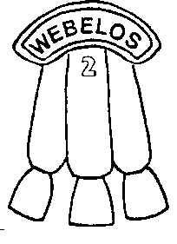


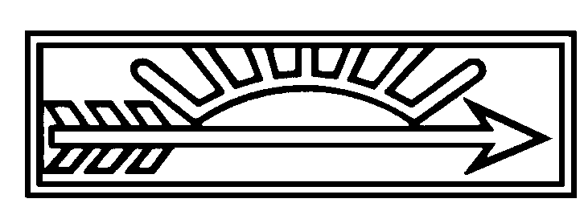
CONTENTS
LITERATURE FOR WEBELOS DEN LEADERS 1
AND SO A WEBELOS LEADER….. 1
AQUANAUT 2
MAKING AND USING LIFE JUGS 2
LIFE PRESERVER THROW 2
POOL PATROL 3
ARTIST 4
LINE DESIGNS 4
MIRROR, MIRROR, ON THE WALL 4
SNACK-FOOD SCULPTURE 4
COLORED CONCOCTIONS 4
CRAYON COPIER 5
REPRODUCING BY GRIDS 5
ATHLETE 6
DEVELOPMENTAL EXERCISES 6
TORTOISE AND HARE 6
TREES IN THE WIND 6
GORILLA WALK 6
INCHWORM 6
RABBIT HOP 6
SQUAT HOP 6
OLYMPIC GAMES 7
RUNNING RIGHT 7
PHYSICAL TRAINING EQUIPMENT 7
CITIZEN 8
CITIZENSHIP TEST 8
THIRTEEN ORIGINAL COLONIES WORLD SEARCH 8
STORY OF “THE STAR-SPANGLED BANNER” 9
COMMUNICATOR 10
CODES 10
RAIL FENCE CODE 10
SQUARE BOX CODE 10
MORSE CODE SIGNALER 11
CLOTHESLINE TALES 11
CRAFTSMAN 12
HOT PLATE 12
BOW DRILL 12
ELEPHANT PUZZLE 13
POTTERY FIELD TRIP 13
ENGINEER 14
TEST THESE GEARS 14
FOLDED PLATE ENGINEERING PRINCIPLE 14
BASKETBALL CATAPULT 15
CONSTRUCT A LEVER 15
FAMILY MEMBER 16
HOW WELL DOES YOUR FAMILY COMMUNICATE? 16
FAMILY FINANCES 17
HOME INSPECTION 17
WATER LEAK DETECTIVES 17
FITNESS 18
SUGGESTED DEN ACTIVITIES 18
SUBSTANCE ABUSE INFORMATION RESOURCES 18
TEST YOUR HEARTBEAT 18
THE FABLE OF THE SNAKE 19
FORESTER 20
IDENTIFICATION OF SOME COMMON TREES 20
GEOLOGIST 22
EARTHQUAKE ACTIVITIES 22
WHERE TO GO 22
PACIFIC PLATE AND NORTH AMERICAN PLATE 22
EARTHQUAKE EXPERIMENTS WITH SNACK FOOD 22
SCCC EARTHQUAKE PROGRAM 22
STALACTITE AND STALAGMITE 23
CREATE YOUR OWN STALACTITE AND STALAGMITE 23
ONLINE RESOURCES FOR GEOLOGIST BADGE 23
FIELD TRIP IDEAS 23
HANDYMAN 24
BICYCLE HANDYMAN IDEAS 24
BICYCLE HINTS 24
WORKSHOP ORGANIZER 25
AUTO REFLECTORS 25
HIDE AND SEEK--GAME 25
NATURALIST 26
SUGGESTIONS FOR THE LEADERS 26
NATURE GAMES 26
FIND ‘EM 26
TREE TAGGING 26
MEMORY HUNT 26
FOOD CHAIN 26
SQUARE FOOT CLAIM 27
MYSTERIOUS NIGHT BUG MIXTURE 27
MOSQUITO NURSERY 27
OUTDOORSMAN 28
A FEW TENT TRICKS 28
KNOW YOUR KNOTS 28
EASY RECIPES 29
HOT DOGS PLUS 29
KABOBS 29
BACON AND EGG IN A PAPER BAG 29
EGGS IN A BASKET 29
BUCKAROOS 29
STUFFED POTATOES 29
STUFFED APPLES 29
BREAD 29
HAMBURGER 29
READYMAN 30
FIRST AID OBSTACLE COURSE 30
READYMAN “HOLLYWOOD SQUARES” 30
FREE ADULT CPR TRAINING FOR LEADERS 30
BLANKET STRETCHER 31
CHECK, CALL, CARE 31
CALIFORNIA POISON CONTROL SYSTEM 31
SCHOLAR 32
THINGS YOU CAN DO BECAUSE YOU
ARE GOING TO SCHOOL 32
CHART OF YOUR SCHOOL SYSTEM 32
THE TWENTY FIRST CENTURY 33
CAREERS IN EDUCATION 33
RHYMING PAIRS 33
SCIENTIST 34
DO-IT-YOURSELF STEAM ENGINE 34
MAKE YOUR OWN CHEMISTRY SET 34
BASIC SUPPLIES 34
SAMPLE EXPERIMENTS 34
FOAM AND FIZZ 35
THE ACID TEST 35
MAKE YOUR OWN BORAX CRYSTAL 35
ONLINE RESOURCES FOR SCIENCE 35
SHOWMAN 36
STORYTELLING 36
GAMES 36
MOVIE STAR WALK 36
ACTING 36
SHOW BIZ BUZZ 36
MUSTACHES 37
SPORTSMAN 38
YOU MAKE THE CALL 38
DO YOU KNOW THIS SIGNAL? 38
OLYMPICS FOR A RAINY DAY 39
BASEBALL TERMS 39
VIDEO SPORTS SIGNALS QUIZ 39
TRAVELER 40
TRAVEL ACROSS THE COUNTRY 40
SCRAP MAP 40
DO YOU KNOW YOUR CARS? 41
MAP SYMBOLS RELAY 41
PLOTTING YOUR ROUTE 41

LITERATURE FOR WEBELOS DEN LEADERS

Webelos Scout Book
Webelos Leader Guide
Cub Scout Leader Book

Guide to Safe Scouting
Cub Scout Leader How-To Book
Cub Scout Academics and Sports Program Guide
Cub Scout Songbook (Webelos Songs)

Have you seen the Webelos Leader Guide? It has the same picture on the front cover as the Webelos Scout Book. The Webelos Leader Guide is filled with lots of things to do for each activity badge. Planning guide, Transition, Camping--it’s all there! It’s a very valuable resource for Webelos leaders. And it’s only $7.50 at the Scout Shop!

Have you been to the OUTDOOR WEBELOS LEADER TRAINING? It’s a weekend camping and training event to prepare Webelos leaders in planning and leading outdoor events for their den. No camping experience needed. They will teach you how to plan, how to camp and how to enjoy camping with the boys in this great hands-on training. This training is offered twice a year by the council. Find out about this training event in “Santa Clarion” or on the Council’s web-page www.sccc-scouting.org. Or ask at your District roundtable.

Have you taken the Cub Scout Leaders Training? Many of you have taken it as a den leader for Wolf and Bear Dens. To be considered a trained Webelos leader, you need to update your training and take the split session for Webelos Leaders. Check with your district training chairman for information about the split session. The district training chairmen are listed in “The Training Corner” of the “Santa Clarion”, or ask your District Executive.

AND SO A WEBELOS LEADER…..

And then one day around they came
A Webelos leader would you be.

I looked at them and shook my head
Said no it’s just not me.

The answer no they would not take
And asked me it once more.

Telling me how little time it took
For the boy I did adore.

Then when they’d gone and left behind
A badge, a flag and book.

I said how slick they were
And how I had been took.

It’s now a year of fun gone by
A different light I see.

Another son do wish I had so
A Webelos leader I could be.

AQUANAUT

Remember to treat each boy as an individual in his ability to swim. Some boys will be unable to swim or will be afraid of the water. The purpose of these requirements is for each boy to learn and to do his best, no matter what his swimming ability.

MAKING AND USING LIFE JUGS
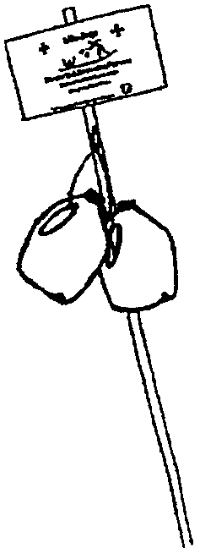
We all know that we should throw something (anything that floats or serves as a lifeline) to a person in trouble in the water. Often, things that float are not readily available. However, you can make your own set of life jugs and keep them handy when swimming or engaging in other activities near the water where someone might fall in.

To make one set of life jugs, you will need:
Two one-gallon plastic milk jugs with screw-on lids
One four foot rope
Poster board for a sign
A metal pole (works better than a wooden one)

To make the life jugs, place about an inch of water in the jugs for weight. This will make them go farther when you toss them. Place the lids securely on the jugs. Tie one jug securely at each end of the four foot rope.

Make a sign that explains how to use the life jugs. Put it on poster board or cardboard. If desired, cover with clear Con-tac paper to protect it from the elements. Attach the sign to the pole and hang the jugs on it (make sure the jugs are hung in such a way that it is easy for you to take them off).

Explain to the boys that the life jugs are a rescue tool and are not to be played with. Explain how they are used and demonstrate for the boys. Let the boys practice throwing them.

These jugs are the simplest of devices, but they work. They are inexpensive, easy to make, easy to see and grab, can be easily replaced if damaged, can even support an adult in the water, and are capable of saving lives.

LIFE PRESERVER THROW

This is an activity that can be done on dry land. Set up an area outdoors. Throw a weighted Styrofoam ring, attached to a rope, toward a target. Points are awarded for accuracy and distance. Points are deducted for hitting the target--you don’t want to render the drowning victim unconscious!

For water games, please see JUNE “Boys in the Water” Games.

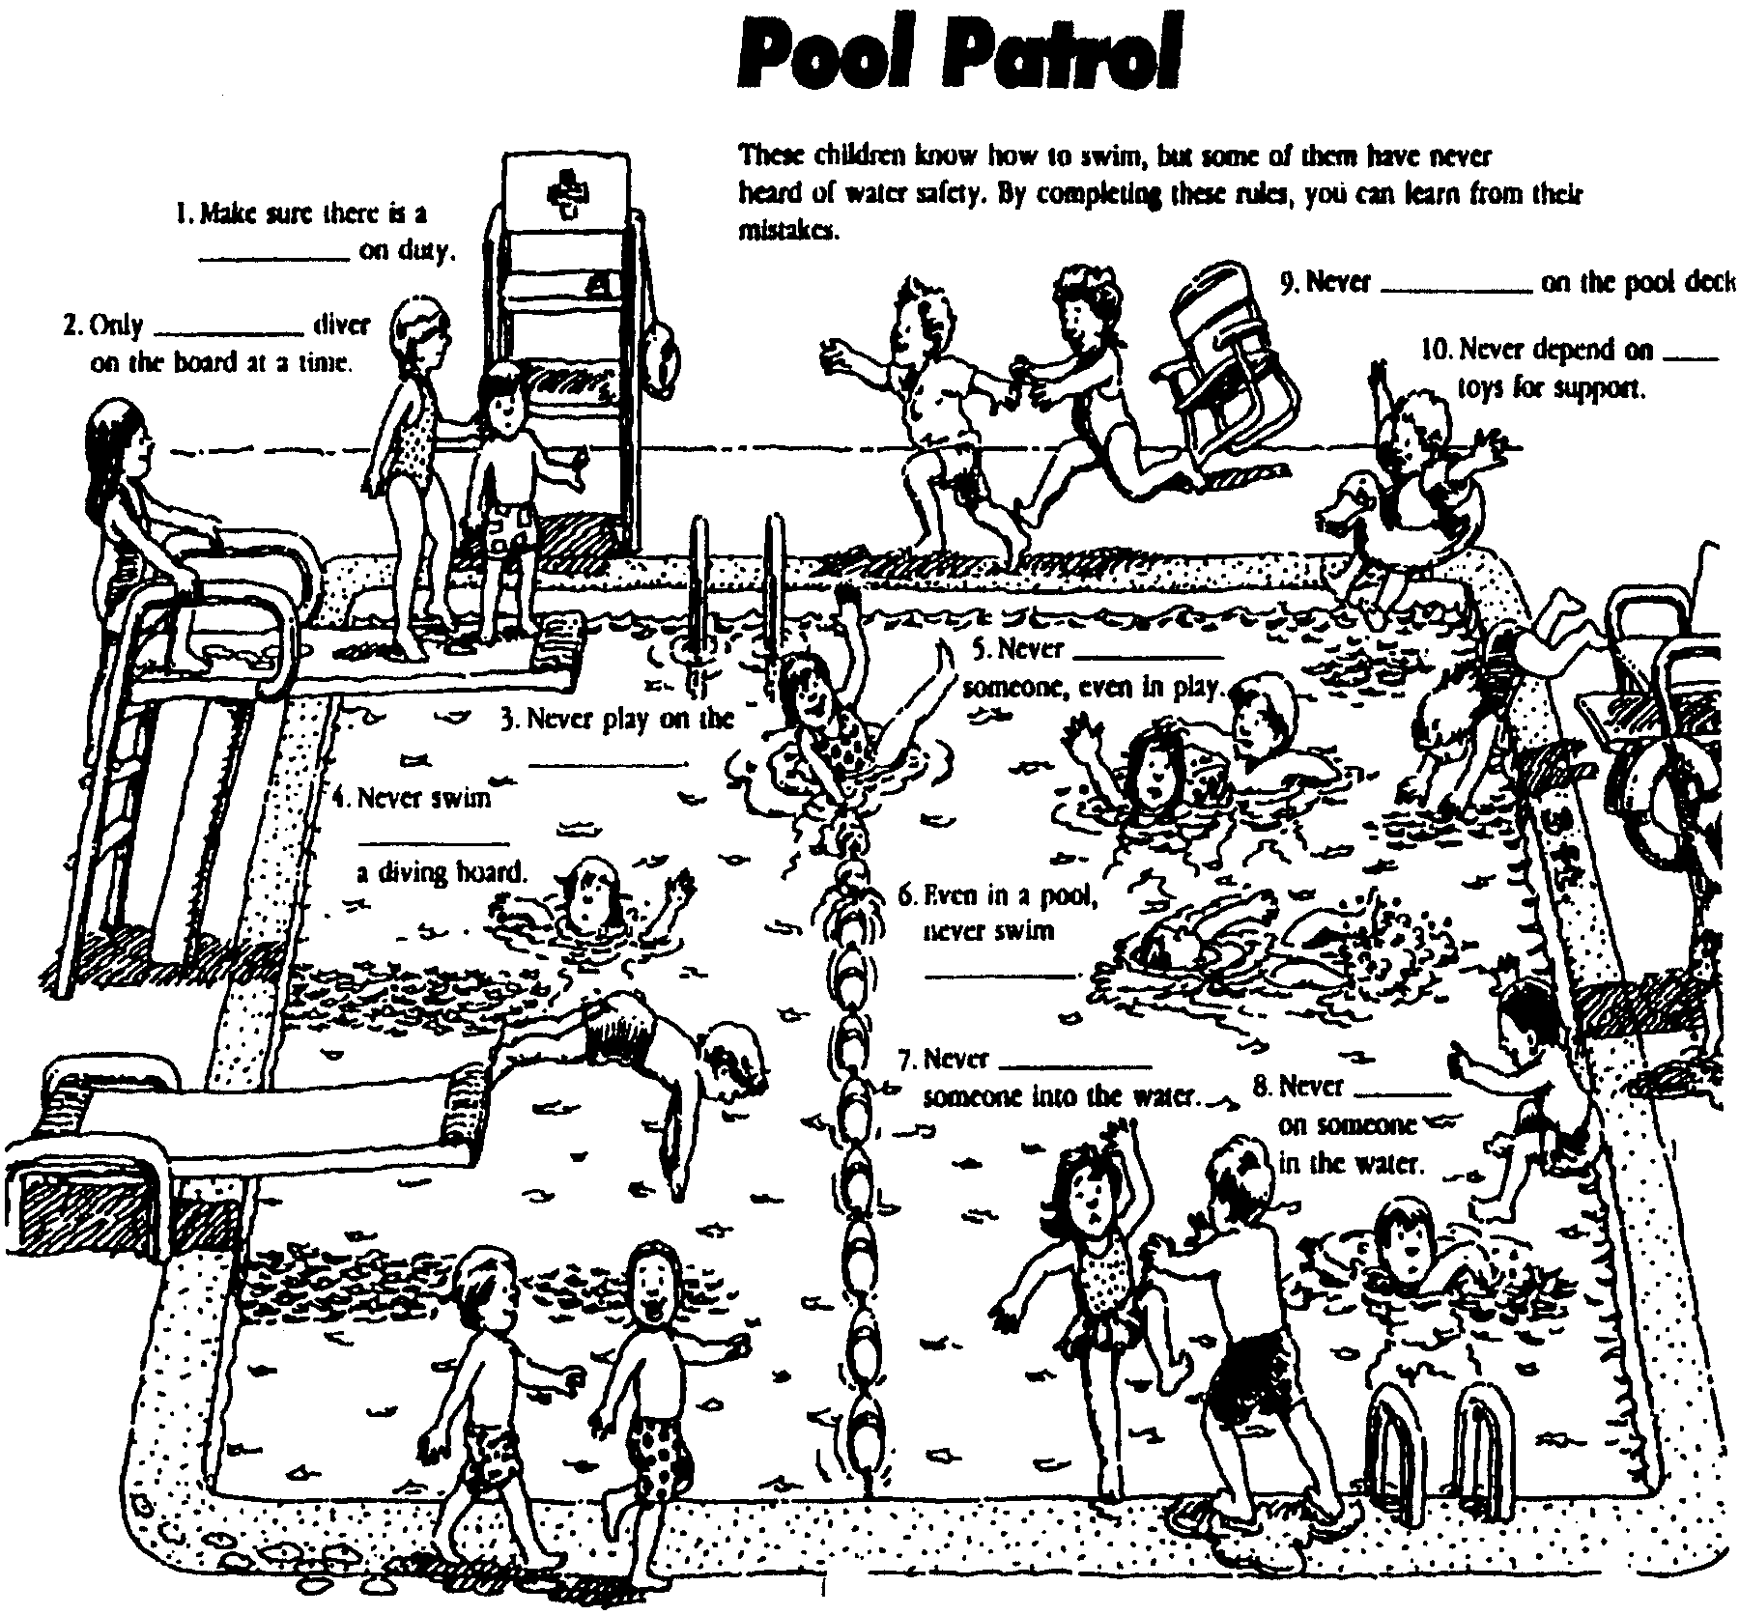

There are 12 rules being broken in this picture. There are clues for 10 of them. Super sleuth: Can you find all 12, including the two broken rules that have no clues?

Answers:
1-lifeguard; 2-one; 3-pool buoys; 4-around; 5-push underwater; 6-alone; 7-shove; 8-jump; 9-run; 10-floatation; 11-Never dive into shallow water; 12-Life preservers are for emergency use only (Leader may have to point to the life preserver as a clue).

ARTIST

LINE DESIGNS
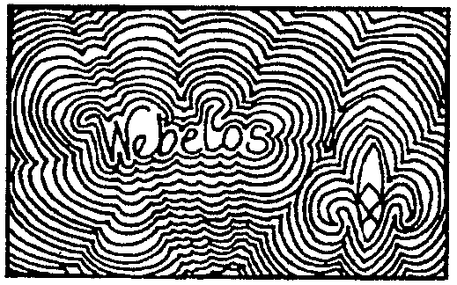
Write your name on a large sheet of paper. Print or use cursive writing. Use crayons or markers to trace around the shape of the name. Continue to outline the shape until the paper is filled. For variations, try using a color scheme such as complementary colors, primary colors, rainbow colors, etc. You may choose to vary the thickness of the lines or incorporate other shapes into the design.

MIRROR, MIRROR, ON THE WALL


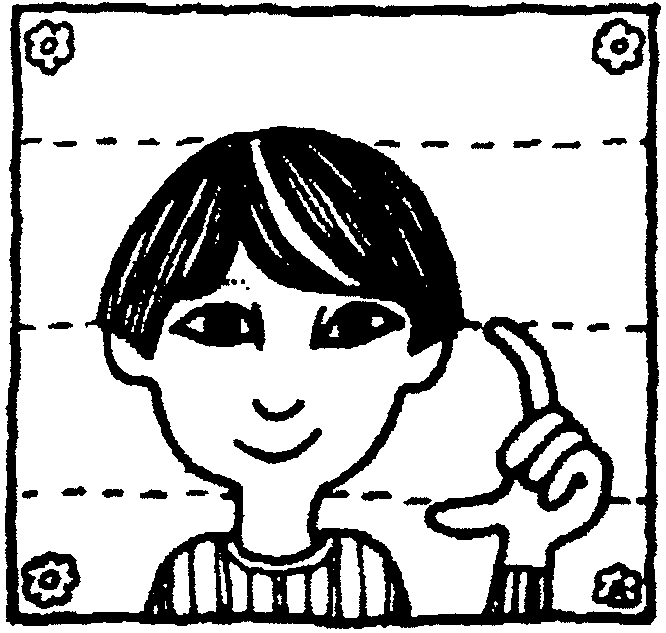
Learn to draw faces by drawing your own face while looking in a mirror. It will be helpful if you remember that a person’s eyes are actually in the center of the head. The distance from your chin to the top of your nose (between your eyes) is about the same as the distance from the top of your nose to the top of your head. Also, the eyes are about one eye’s distance apart.

SNACK-FOOD SCULPTURE

Sculpture materials: Bread sticks, pretzels, potato chips, corn chips, popcorn, crackers, cheese curls, etc.
Paste: Mix three 8-oz packages of softened cream cheese with 8 oz. sour cream. Blend in a package of dried onion soup mix.

Each player should have a paper plate and a plastic knife.
First lay out a framework for the sculpture. Bread sticks, pretzels, crackers and rippled potato chips are great for this. You may want to stand bread sticks as a skeleton and add lighter food to it. When you finish your snack-food sculpture, give it a title and display it (briefly). Then the snack-food sculptures can be eaten--artfully nibbled into nothingness.

COLORED CONCOCTIONS

Let Webelos Scouts practice mixing colors using different flavors of Kool-Aid in primary colors (add a drop or two of food coloring as needed). Have them make up names for their different “formulas,” design a menu, and serve their concoctions at the pack meeting.

CRAYON COPIER

Materials: Paper, Crayons, Pencil, Tape

Scribble with crayons until the paper is covered completely. Don’t get too concerned if there are small gaps of white space; the main thing is to provide a consistent coat of colors that will transfer to another sheet of paper. Place the paper, colored side down, onto a clean sheet of paper of the same size or slightly larger. You may need to tape the sheets in place to prevent them from shifting. On the clean side of the colored paper, have the boys draw a picture. When done, lift the paper up and the drawing will have transferred to the clean sheet.

REPRODUCING BY GRIDS

Before the copier was invented, how did the artists enlarge or shrink pictures and designs? They used a grid.

You can copy any picture by using a grid such as the one placed over Akela shown below. Choose a picture you want to reproduce (start with simple designs). Decide on a convenient size grid. Either draw the grid directly onto the picture or onto a piece of hard clear plastic placed over the picture. Draw lines at the same intervals horizontally and vertically. For a larger picture, you may draw lines at wider intervals. If using a plastic grid overlay, attach it securely to the picture being copied.

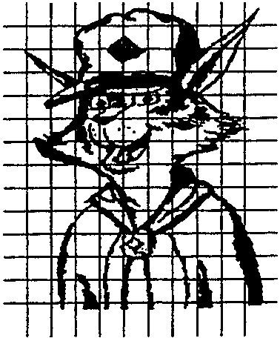
Now decide on a grid for the enlarged picture. Decide on the size and draw a grid, same number of lines as the grid for the original drawing, but bigger. Using the picture of Akela shown here, if you use one-inch squares, the finished drawing will be about 11 by 14 inches. Draw the enlarged grid onto a piece of paper, making lines dark. Overlay with a sheet of paper, making sure you can still see the grid. Regular white paper or tracing paper works well. Secure the grid on the back of the paper with tape.

Now copy the drawing from the smaller grid to the larger. For instance, the top of Akela’s right ear is about two squares down on the first grid column. Mark that point on your enlarged grid and continue to do so for the entire drawing.

You may reduce the size of a picture using the same concept used to enlarge it.

ATHLETE

Working on the Athlete Activity Badge could be coordinated with the Fitness Activity Badge. After the Webelos Scouts have done some exercises, sit down and discuss with them the need for a balanced diet and the effect it may have on their performance.

DEVELOPMENTAL EXERCISES

These exercises are aimed primarily at providing vigorous physical action for Webelos Scouts. However, they can be converted into contests, if desired.

TORTOISE AND HARE
Boys are in a circle, about three feet apart, and begin jogging slowly in place. When the leader calls “Hare,” the tempo is stepped up, knees are lifted high, and the arms are pumped vigorously. When the leader calls, “Tortoise,” the tempo slows to an easy jog. Make changes swiftly for more fun.

TREES IN THE WIND
Boys are in a circle facing counter-clockwise. They run slowly around the circle, bending left, right, forward, and back as though swaying in a breeze. On command, “Reverse,” they turn and run in the opposite direction.

GORILLA WALK
Boys’ feet are spread at about width of shoulders. They bend at the waist, grasp ankles with legs straight and walk forward, holding firmly to ankles.

INCHWORM
Boys assume push-up position. Holding their hands in place, they walk their feet up as close to the hands as possible. Then, holding their feet in place, they “walk” their hands out to push-up position again. And so on.

RABBIT HOP
Webelos Scouts stand in a straight line side by side, 3 feet apart. A finish line is designated 60 feet in front of the boys. Boys hop with both feet together--first to the right, then left, then straight ahead. Do it together--”Right, left, straight, right, left straight...” Vary the speed.
VARIATIONS: Hopping in other ways--one leg, squat position, hop with both feet together, land in a squat position, etc.

SQUAT HOP
Boys form circle facing inside. They squat on left foot with right foot toward the center of the circle (resting on ground). Arms are folded across chest. They then leap upward and change legs, landing on right foot and squatting. Left foot is now thrust forward and resting on the ground. Arms should remain folded after each hop.

OLYMPIC GAMES

Let the boys plan a Webelos Olympics. Allow them to decide which games and events they want to have, and encourage them to make any needed equipment. Let each boy run an event, preparing participation awards for each of his den members. They can make Olympic flags and an Olympic torch to display at the pack meeting.

RUNNING RIGHT

Developing good running habits should start when boys are young. Share these hints for “running right” with your boys. Practice them while doing their 600-yard run.
- Keep your head level and your eyes forward. This helps keep your balance.
- Relax your shoulders and let them rise and fall naturally as your arms swing.
- Let your chin drop occasionally to keep your neck from tensing.
- Run with your back straight. Avoid leaning forward.
- Bend your arms, but don’t lock them at the elbows. Hold your bent arms slightly above the waist and let them swing lightly up and across your chest.
- When jogging, stride as you walk--heel down first, then toes. As you speed up to run, you’ll almost automatically land toe first.
- Flex your knees and keep your stride reasonable.
- Loosely cup your hands.

MISTAKES FOR BEGINNERS TO AVOID:
- Failing to do warm up exercises before a run.
- Bending your head forward or looking up or down.
- Swinging your arms too high and too hard.
- Locking your elbows.
- Clenching your fist.
- Taking giant strides.
- Never letting your heels touch the ground.
- Failing to do cool-down exercises after a run.

PHYSICAL TRAINING EQUIPMENT

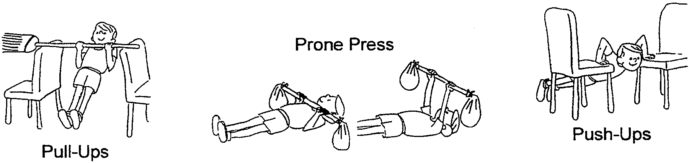

CITIZEN

Webelos Scout can lead the pack in singing the National Anthem or lead the opening ceremony that includes singing the Star-Spangled Banner. (See “Star-Spangled Banner Opening” in the August section)

CITIZENSHIP TEST

Divide the den into two teams. Teams face each other with a wide space between them. The leader asks each team a question about the Declaration of Independence, the Star Spangled Banner, the President, Vice President, Governor, or other fitting subjects. A correct answer entitles that team to move one step forward. An incorrect answer passes the question to the other team. The first team to cross the other team’s starting line is the winner.

THIRTEEN ORIGINAL COLONIES WORLD SEARCH

Do you know all thirteen original colonies? Find them without first looking at the list below.

F Q J G D D S H H D D K S B Y W R X Y G O J
V H C H U N K O S P L D V R G H A W C J J S
K D R K N S D H C S I V U P A S S A M N P J
U G M A E S F N O T N M S U L F V T A Y L V
F G P G W J E D N E W H A M P S H I R E A D

L B E C Y S F N N U I P O E I B G C Y S S L
G J T O O R R T E O D T U E R A W A L E D B
K D P E R E A C C X F Z Y L G J D S A G N H
L Y E O K G H P T I J D G V I R G I N I A D
F J N P I S I O I T G S F N Q W E R D H L C
V A N I L O R A C H T R O N S V B T U N S A
S C Y G F S V C U S R Y B J U K M I U G I I
Z A S T R C S T T E S U H C A S S A M I E W
C R Y A J N A X D E P P P V U E D E E L D D
I O L V P I R H K L B X C V B Y W Q P O O N
E H V S D J A N I L O R A C H T U O S I H U
P D A F G G H J G W H F H A V U R B Y U R K
M C N A M I S R A C C M A O N I K B F N R H
S B I L N E W J E R S E Y U Y G V A O O D S
D L A N D H O V B W C Y P E N Q G Q Y A K F
N X A F P C S A H Y V S B I M S O E P Z M J

Word List

CONNECTICUT
DELAWARE
GEORGIA
MARYLAND
MASSACHUSETTS
NEW HAMPSHIRE
NEW JERSEY
NEW YORK
NORTH CAROLINA
PENNSYLVANIA
RHODE ISLAND
SOUTH CAROLINA
VIRGINIA

STORY OF “THE STAR-SPANGLED BANNER”

Francis Scott Key was a lawyer in Washington DC. In 1814, during the war of 1812, Key was asked to go on a mission with Colonel J. S. Skinner. They were to sail under a flag of truce to ask for the release of an American prisoner, Dr. Beans, being held by the British Navy. The British agreed to free the prisoner, but would not let the Americans return immediately, because they were planning to attack Baltimore.

During the night of September 13-14, Key, Skinner and Dr. Beans stood on the deck of a ship anchored eight miles down-river watching the attack. They were well out of the fight, but near enough to see most of the action. During the night the bombs and rockets proved that the city had not surrendered, but now there was an eerie silence, broken only by an occasional distant gun. Key found himself torn with anxiety. He did not know the fate of the city or of Fort McHenry. He hated the war, yet here he was in the middle of it. He was first and last an American, and in these hours of suspense, he fervently, desperately, prayed that the American flag was still waving over the Fort.

The rest of the night the three Americans paced the deck, scarcely daring to think what daylight might bring. Again and again, they pulled out their watches, trying to judge when the dawn would come. At five o’clock, the first light of day tinged the sky. However, there was no sun. Rain clouds hung low and patches of mist swirled across the water. It was growing brighter all the time, and finally Key raised his spyglass and he saw it! Standing out against the dull gray of the clouds and hills was the American flag, still proudly flying above the Fort. Turbulent, fervent thoughts raced through his mind. These thoughts began to take poetic shape. Using the back of a letter that happened to be in his pocket, Francis Scott Key began to jot down lines and phrases.

Finally, on the evening of September 16, the Americans returned to Baltimore. There would be no sleep for Francis Scott Key that night. Vivid thoughts of the scenes he had witnessed raced through his poetic mind. He had tried to express his feelings--the thrill of seeing the flag at dawn--in a few lines scribbled down right after the attack. Later he added more lines. He called his poem “The Defense of Fort McHenry.” Almost from the start he thought of it as being sung to the tune of “To Anacreon in Heaven,” a popular song of that period. It would be weeks before it would become known as “The Star-Spangled Banner.”

The song caught Baltimore’s fancy right away. It was published in the newspaper and people were singing it. The Fort McHenry garrison adopted it--every man received a copy--and the tavern crowds took it up. The song quickly spread to other cities, as the whole nation rejoiced in the news from Baltimore. Everywhere, Key’s stirring lyrics struck the right chord--the rare sense of exultation people felt about this totally unexpected victory.

An Act of Congress made “The Star-Spangled Banner” the official United States Anthem in 1931. The flag that flew over the fort was originally 42 feet long, but was shortened by stress of battle and relic seekers. Each stripe measured nearly two feet in width, and the five-pointed stars were two feet from point to point. This flag has been restored and is now at the Smithsonian in Washington, DC.

COMMUNICATOR

CODES

Webelos enjoy being able to communicate in code--it’s like knowing a happy secret. Codes are used all over the world. When you send a telegram or a cable, you are sending a kind of code written in a short way to keep costs down. During wartime, codes are an important way for sending secret messages. Even the brands marked on cattle and markings on planes and ships are kinds of code. Codes usually have two parts. The first is making the code, known as “encoding” the message. The second part is called “decoding,” which tells the person who receives the encoded message how to read and understand it.

RAIL FENCE CODE
Suppose you want to send the message LOUIS LIKES BEAN SOUP. In the rail fence code, you encode by dropping every other letter down:
L U S I E B A S U
O I L K S E N O P
Then, take the bottom line of letters and put them next to the top line of letters. You’ll come up with the coded message: LUSIEBASUOILKSENOP. When your friend wants to decode the message, he just counts the number of letters in the message, divides it by two, and places the last half below and between the first half.
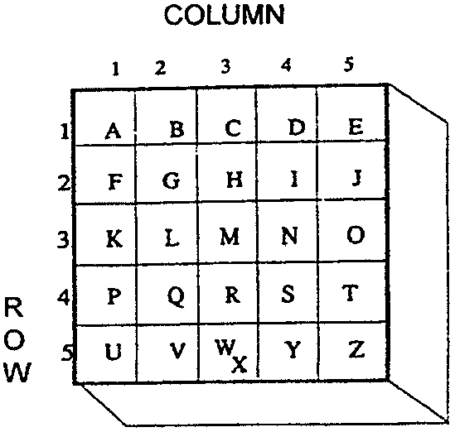

SQUARE BOX CODE
Draw a large square on a piece of paper with a pencil and a ruler. Divide the square into 25 smaller squares (5 x 5). You can fit the 26 letters of the alphabet into the 25 squares by putting two letters in one of the squares. W and X would be good ones to put in one square.

The code uses a number in place of letters. The code for A is 11 because A is in the first row (1) and the first (1) column. The code for R would be 43, because it is in row 4, column 3. Always use your row number first. Read across for rows, down for columns.

The message RUN FOR HELP would look like this: 43 51 34 - 21 35 43 - 23 15 32 41.

You may want to disguise the numbers in something like a “grocery list.” Be sure you use all the numbers in order.

Example:
Gentlemen:
Please accept my order for the following and deliver at once.
44 cans of your best sardines @ .15
34 boxes of soap flakes @ .14
23 large boxes of napkins @ .15
32 large cans of peaches @ .41

Message: Send help

MORSE CODE SIGNALER

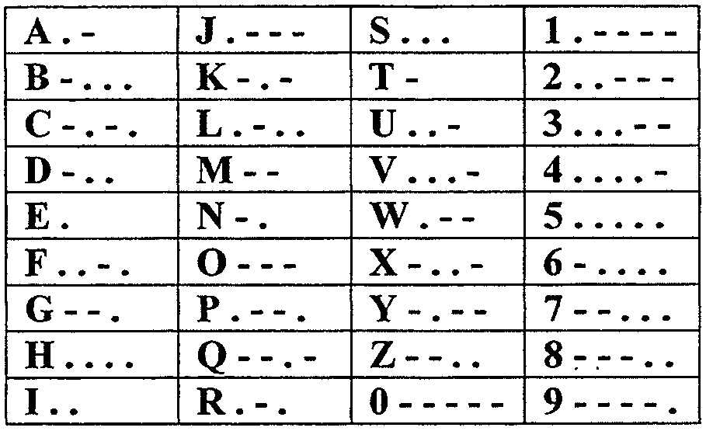
Materials: Long, business-size envelope
(4 1/2” x 9 1/2”); Piece of lightweight cardboard (4” x 10”); Black marker or crayon; Scissors

1. With the envelope front facing you, cut off the right end close to the end.
2. Mark the center point of the front of the envelope three inches from the left end.
3. Cut out a three-inch diameter circle centered on the point just marked, making sure you cut only through the front of the envelope.
4. Push the cardboard slide into the open end of the envelope until it stops.
5. With the black marker darken the entire left front of the envelope from the far left end for six inches to the right.
6. Remove the slide and completely darken it for 4 1/2 inches from the left end.
7. Seal the flap.
8. Replace the slide into the envelope.
9. On the rear of the envelope write the entire Morse code (or paste the chart). The signaler will be used vertically, with the hole on top of the envelope.
10. Hold the device with the hole facing the receiver.
11. Hold one upper corner of the envelope.
12. With the other hand, hold the bottom of the slide.
13. Pull the slide down so it uncovers the white portion of the inside rear of the envelope, thus making it appear as if you are shining a light toward the receiver.
14. For a dot, pull the slide clear of the circle for one second; for a dash, three seconds.

CLOTHESLINE TALES

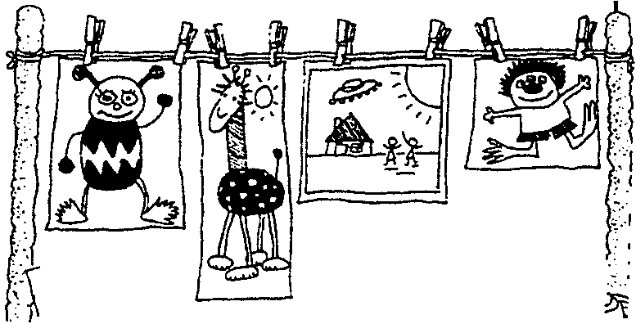
Give boys a general topic and have each one of them draw a picture about anything to do with that topic (such as “Space Aliens”). String a clothesline up between two trees. Have first boy come up, hang his picture, and begin to tell a story about his picture. After about a minute, stop him. Have next boy come and continue the story with his illustration. Continue until all boys have shared and a brand new story has been communicated to the den!

CRAFTSMAN
The Cub Scout Leader How-To Book (Chapter 3) is an excellent resource for ideas on wood projects, metal and tin craft, leather crafts and plastic crafts.

HOT PLATE

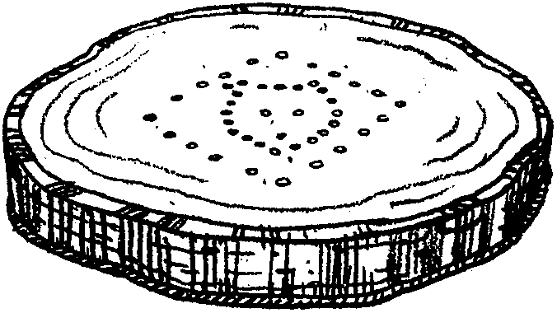
You will need: A cross-section of a tree trunk, at least 6 inches in diameter; sandpaper; felt; glue; nails and wood sealer

1. Sand the wood piece smooth.
2. Glue felt to bottom of the wood.
3. Draw a design on a piece of paper and center it on the top surface.
4. Make a permanent outline of the design by hammering nails at 1/2” intervals. To finish, spray or paint with a wood sealer.

BOW DRILL
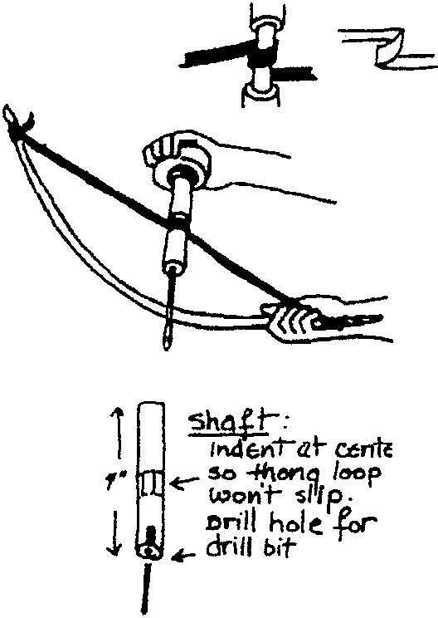
This drill may be used to start a fire as well as for drilling holes.

USE: A green twig for the bow
Stone or block of wood for palm piece (need indentation to hold shaft)
A 4” x 3/4” straight branch or dowel for shaft
Thong or gut string long enough to hold bow bent
Bit of flint or sharpened steel rod
SHAFT: Indent at center so thong loop won’t slip.
Drill hole for drill bit
TO OPERATE:
1. Tie thong to bend bow.
2. Loop thong around shaft indentation.
3. Bear down on palm piece with left hand (if you’re right-handed), or this may require some adult assistance.
4. Saw the bow back and forth to rotate drill shaft.
5. Keep tension in the thong to prevent it from slipping on the shaft.

ELEPHANT PUZZLE

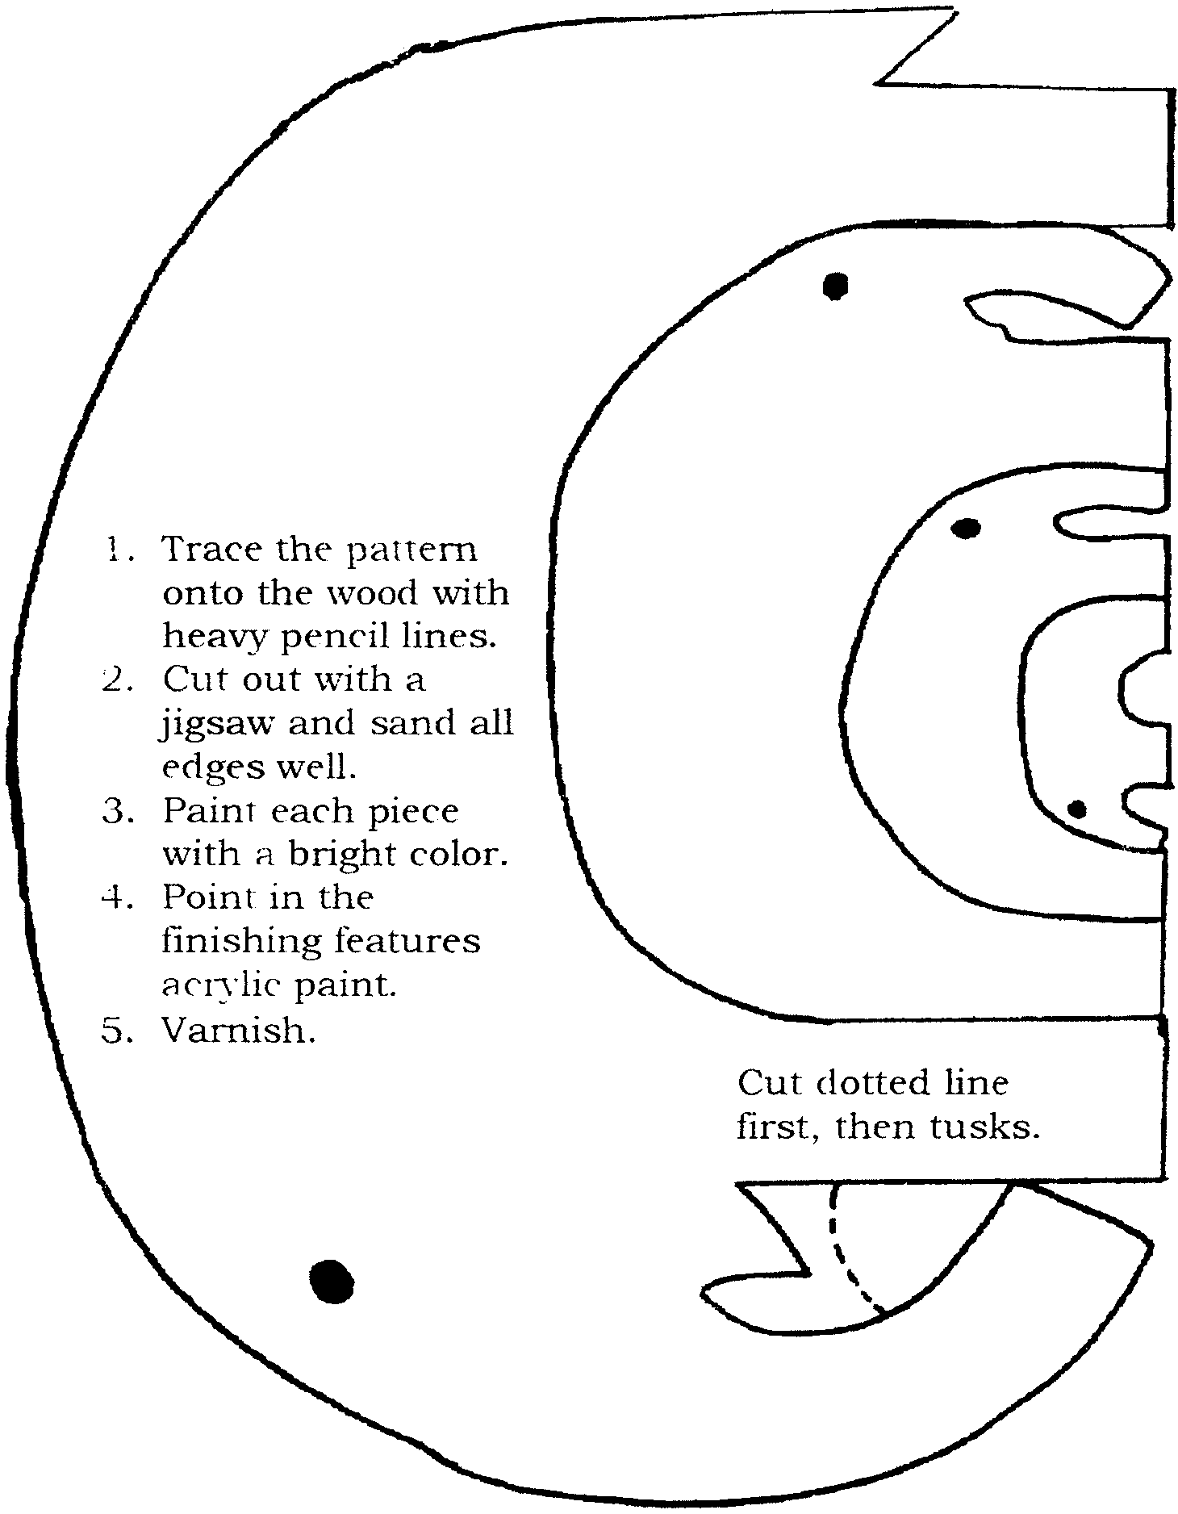
This puzzle is made from scrap wood. This makes a great gift for a tiny tot. Any thickness of wood may be used. Enlarge pattern as needed. Features may be painted on if desired.

POTTERY FIELD TRIP

Make real pottery and see how it is done in a real working studio.

Blossom Hill Crafts (15900 Blossom Hill Rd., Los Gatos. 356-9035)

Field Trips are usually scheduled after school time (3:30 – 5:30pm range)

Call to arrange times and for more info. Ask for Joanne Brice

This fantastic studio offers a special tour and a hands-on “ceramic” experience to Scout groups. Minimum age is 8. Minimum group size is 8 also. This can include the leaders as well as the boys. Maximum size of group is 30. Field Trip can take anywhere from

1 ½ - 2 hours.

Cost per participant is $7.50, as of July, 2000. This includes tour of studio, demonstration of wheel pottery throwing and a hands-on clay project made and decorated by the Scouts.

Cost includes clay, decorating tools and firing.
ENGINEER

TEST THESE GEARS
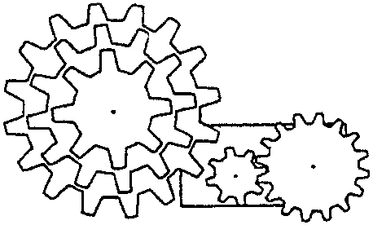
Enlarge and trace the gear wheels onto craft foam and cut out. Push a pin or small nail through the middle of the wheels and fix them to a sheet of cardboard so that they will turn easily. Arrange the smallest and largest wheels so that the cogs meet.

- How many times does the small wheel turn if you turn the big wheel once?
- Do both wheels turn the same way?

Then repeat your experiment with three gears in a row. Have the boys guess which way the third gear will turn before you try the experiment.

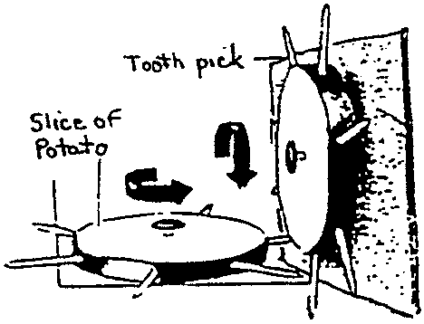
Gear wheels can also be used to change movement from one direction to another.
You will need: Two slices of raw potato, twelve toothpicks, two long thin nails.
1. Poke 6 toothpicks into the sides of each potato slice
2. Push one nail through the middle of each slice to act as an axle.
3. Pin one slice vertically onto a sheet of cardboard or bulletin board.
4. Hold the second wheel up by its axle in a horizontal position and use it to turn the vertical wheel.

FOLDED PLATE ENGINEERING PRINCIPLE

Materials: Sheet of paper; 2 blocks of wood or books; Pencil

1. To demonstrate the folded plate engineering principle, support a sheet of paper at the ends (between two blocks of wood or books).
2. Place a pencil in the center of the paper. The weight of the pencil will cause the paper to bow at the center.
3. Take the same sheet of paper and fold it one inch from the end, turn sheet over and fold back one inch.
4. Keep doing this until the sheet is completely folded, like a “fan.”
5. Support the paper at both ends so that all the folds rest on the supports.
6. Place the pencil in the middle of the paper. This time the weight is supported easily without bowing.
7. Now see how much weight this folded paper can take. Keep adding weight carefully.

BASKETBALL CATAPULT

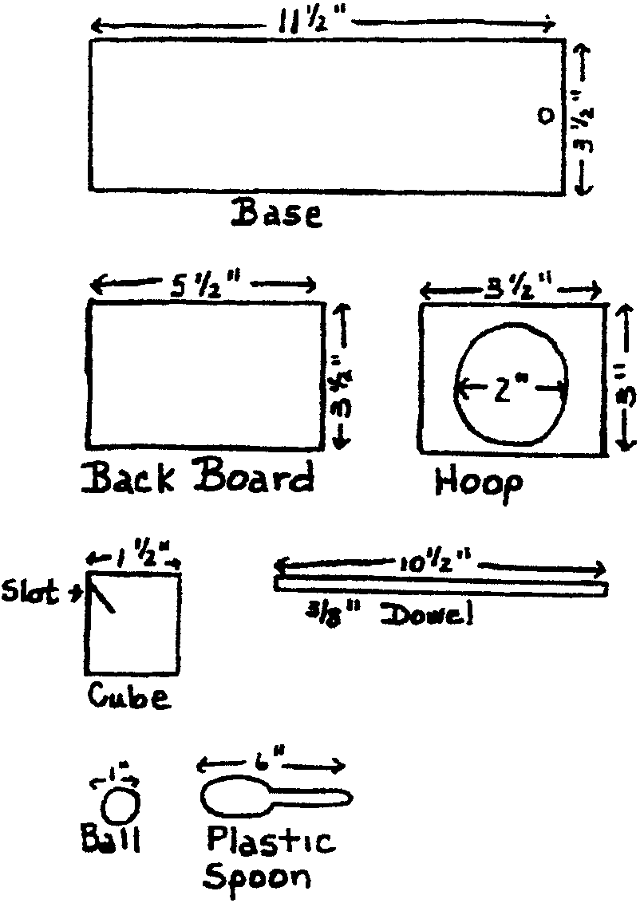
Materials: 1” x 4” board (base, backboard, hoop)
Wooden block (approx. 2” x 2”)
3/8” diameter wooden dowel
Plastic spoon; Heavy string; Ping pong ball

1. Cut base to 11 1/2” length and backboard to 5 1/2” length.
2. Drill holes 3/8” in diameter and 1/2” deep in base and backboard for dowel.
3. Cut a slot at a 15-degree angle in a cube block large enough for the handle of a plastic spoon.
4. Cut hole for the hoop first; then finish cutting the hoop piece. (If you prefer, you can substitute a short length of a 2” PVC pipe for the wooden hoop.)
5. Glue the hoop to the backboard. (If using PVC, glue or screw in to backboard.)
6. Glue the dowel into the pre-drilled holes in the backboard and base.
7. Glue the cube block to base and insert spoon into the slot.
8. Cut string and attach one end to dowel rod at base and other end to the ping pong ball. Let ‘er rip!
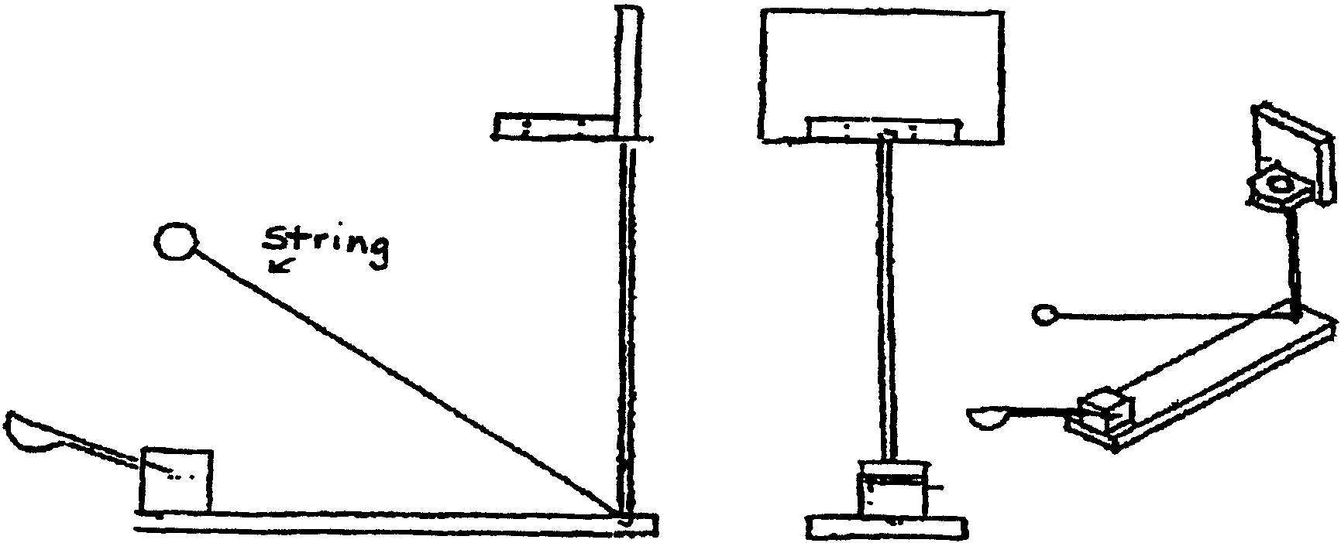

CONSTRUCT A LEVER

Materials: Small rock; Large rock or heavy object to move; Heavy wooden board or pole

1. Place the small rock near the heavy load. The small rock is the part of the lever called the fulcrum.
2. Push the board (or pole), as far as you can under your large rock (or heavy load).
3. Push the small rock, which you plan to use as the fulcrum, as far under the board as you can.
4. Push down on the board or pole. The load should begin to move.
FAMILY MEMBER

HOW WELL DOES YOUR FAMILY COMMUNICATE?
Answer these questions. Then take this home and go over them with your family.

1. Does your family eat dinner together?
(a) Almost every night. (b) Several nights a week. (c) Only on special occasions.

2. Is the TV off during dinner?
(a) Practically always. (b) Unless the game is on.
(c) And miss our favorite shows?!

3. Does your family eat breakfast or lunch together?
(a) Usually. (b) About half of the time. (c) In our dreams.

4. Do you know the best friends of each of your family members?
(a) They are like family. (b) We’ve met. (c) Friends???

5. How much time do you spend talking with family members (average)?
(a) More than 20 minutes per day. (b) 10 to 20 minutes per day.
(c) As little as possible.

6. Do you know what each of your family members fear?
(a) Yes. (b) I have a vague idea. (c) They are fearless.

7. When was the last time you told each of your family members that you loved them?
(a) Today. (b) Within the last week. (c) They know without me telling them.

8. Does your family make goals together?
(a) Yes. (b) Only for major things.
(c) Why? No one would follow through, anyway.

9. Does your family plan activities together?
(a) Regularly. (b) Quite often. (c) We don’t have time to do things together.

10. Do you know what makes each of your family members happy?
(a) Sure do! (b) Generally speaking. (c) There is no such thing.

Give yourself 10 points for every (a) answer, 7 points for each (b), and 3 points for each (c). Now tally your points and see how well you communicate with your family.
30-59: Examine your mission statement. 60-79: You have lift off. 80-100: Your communication is out of this world.

FAMILY FINANCES

Many Webelos Scout age children are not aware of how their families spend money. Food, clothing and entertainment are obvious. Suggest to the parents that they share the actual bills with their children and have them add up the total cost. They will be amazed. As the boys conduct the safety/energy checklist, encourage the parents to discuss the cost of keeping the house in good repair, the cost of water use, the cost of cooling and heating the house, etc. Then the boys will be better prepared to share in ideas for saving money and they will be ready to develop a family energy-saving plan.

HOME INSPECTION

Before your den meeting, rig a room with as many hazardous situations as you wish. Divide the den into teams of two boys. Instruct the boys to spot and write down as many safety hazards as they can see. Send one team at a time into the room and allow them three minutes, while the rest of the den works on another activity in the other room. Have a couple of adults present to act as a safety guard. Make the hazards as true to life as possible without creating a real danger.

As boys return to main room, ask them to remain quiet about what they have seen. When all have completed their observations, call all the boys together. Let each team share one or two hazards they saw. The leader can then mention any the boys did not see.

WATER LEAK DETECTIVES

Even a tiny leak can waste a lot of water. A leak that fills a coffee cup in 10 minutes will waste over 3,000 gallons of water a year. That’s equivalent to drinking 65 glasses of water a day!

- Learn how to read the water meter. If you have one, it will probably be on the outside wall of your house, or next to the street under a cement or metal cover.
- Pick a time when everyone is going to be out of the house, and no one will be using water--such as when the whole family is going shopping or to the movies.
- Before you leave, read the water meter and write down its setting. Then when you get back home, take another reading. If the numbers have changed, you’ve probably discovered a leak!

Checking your toilet can be another way to find a leak. In one year, a leaky toilet can waste over 22,000 gallons of water. That’s enough to take three baths everyday!
- Put several drops of food coloring in the tank
- Wait about 15 minutes. Make sure no one uses the toilet during this time!
- Now look in the toilet bowl. If colored water has moved into the toilet bowl, you have discovered a leak.

FITNESS

SUGGESTED DEN ACTIVITIES

- Have the boys read a story in a newspaper or magazine about a drug or alcohol related incident. Have them report back to the den and discuss what happened.
- Invite a nurse, doctor, or EMT to talk about the effects of tobacco, drug or alcohol abuse as well as the positive effects of eating a healthy diet.
- Invite a local sports figure or coach to come and discuss fitness with the boys.
- Let boys design posters on how to say no to drugs, cigarettes and alcohol. Display at a pack meeting.
- Show videos (approved by parents and pack committee) on drug and alcohol abuse.
- Invite a dietitian to come and discuss the benefits of a balanced diet.
- Take a field trip to a fitness or recreation center.
- Have the boys collect advertisements for tobacco and alcohol. Help the boys see that the activities in those ads have nothing to do with tobacco or alcohol. Have them read the warning labels on cigarette advertisements, note the size of the warning in relation to the ad. Can people do the activities depicted in the ads without smoking or drinking?

SUBSTANCE ABUSE INFORMATION RESOURCES

Awareness of substance abuse problems is a very important part of the Fitness activity badge. Remember to stress that prescription drugs administered by a doctor or parent are okay and emphasize that the problem is misuse or abuse of drugs for non-medical purposes. Many pamphlets and books, written on the level of Webelos age boys exist on this subject. Some resources are: community hospitals, local police station and DARE officers, libraries, and the Consumer Information Center (PO Box 100, Pueblo, Colorado, 81002).

TEST YOUR HEARTBEAT

Did you know that you can’t actually hear a heartbeat? The heartbeat itself is just a contraction of muscle and is perfectly quiet. What you can hear is the sound of heart valves snapping shut.
Here’s how to test your heartbeat:
Press the first two fingers of one hand over the radial artery in the opposite wrist. The radial artery is located under the depression just below the base of your wrist. Sit very quietly and move your fingers until you can feel the pulse of your blood. Using a watch or clock with a second hand, count the number of beats in 15 seconds. Multiply by 4. Now you know the number of beats per minute. Run, exercise, or jump rope for 10 minutes. Take your pulse again to see how much faster your heart is pumping.

THE FABLE OF THE SNAKE

This could be adapted for a pack meeting skit or puppet show.

Many years ago, Indian youths would go away in solitude to prepare for manhood. One such youth hiked into a beautiful valley, green with trees, bright with flowers. There he fasted. But on the third day, as he looked up at the surrounding mountains, he noticed one tall rugged peak, capped with dazzling snow.

“I will test myself against that mountain,” he thought. He put on his buffalo-hide shirt, threw his blanket over his shoulders, and set off to climb the peak.

When he reached the top, he stood on the rim of the world. He could see forever, and his heart swelled with pride. Then he heard a rustle at his feet, and looking down, he saw a snake. Before he could move, the snake spoke.

“I am about to die,” said the snake. “It is too cold for me up here, and I am freezing. There is no food, and I am starving. Put me under your shirt and take me down to the valley.”

“No,” said the youth. “I am forewarned. I know your kind. You are a rattlesnake. If I pick you up, you will bite me, and your bite will kill me.”

“Not so,” said the snake. “I will treat you differently. If you will do this for me, you will be special. I will not harm you.”

The youth resisted for awhile, but this was a very persuasive snake with beautiful markings. At last, the youth tucked it under his shirt and carried it down to the valley. There he laid it gently on the grass, when suddenly the snake coiled, rattled and leapt, biting the youth on the leg.

“But you promised...” cried the youth.

“You knew what I was when you picked me up,” said the snake as it slithered away.

And now, wherever I go, I tell this story. I tell it especially to the young people of this nation who might be tempted by drugs. I want them to remember the words of the snake: “You knew what I was when you picked me up.”
By Iron Eyes Cody
St. Joseph’s Indian school, Chamberlain, SD

JUST SAY NO

FORESTER IDENTIFICATION OF SOME COMMON TREES
AND BUSHES IN THE SANTA CLARA VALLEY
(Equip each boy with a centimeter ruler) by Nadine C. Barter Bowlus

1a. Leaves apparently absent CASUARINA OR HORSETAIL TREE
1b. Leaves distinctly present. Go to 2
2a. Leaves are needle or scale like. Go to 3
2b. Leaves are flat, broad. Go to 16
CONIFERS OR CONE BEARING TREES
3a. Needles usually in bundles of 2,3 or 5 4
3b. Needles single or scale like 9
4a. Needles in bundle of two or three 5
4b. Needles in bundle of five 8
5a. Needles 18 to 33 centimeters long 6
5b. Needles less than 18 centimeters long 7
6a. Bark is yellowish brown, needles dark yellowish green 15
6b. Bark is dark gray, rough, sparse gray needles DIGGER PINE
7a. Needles dark green and straight, bark black to grayish and very rough,
broad ovoid cones MONTEREY PINE
7b. Needles slender and yellow-green, cone is curved and knobby on one side,
cones are closed and often remain on the tree KNOBCONE PINE
8a. Cones, 28 to 51 centimeters long SUGAR PINE
8b. Cones less than 25 centimeters, clusters of 1 to 6 SILVER PINE
9a. Small scale like leaves, pressed close to branchlet 10
9b. Needles 1 centimeter or more long 13
10a. Ends of branchlets flat, one plane INCENSE CEDAR
10b. Ends of branchlets not flat 11
11a. Awl-like leaves that spiral around branch SEQUOIA REDWOOD
11b. Not as above 12
12a. Bluish, berry-like cone the size of a pea JUNIPER
12b. Brownish, round, compact cones 1 centimeter in diameter CYPRESS
13a. Needles extend in all directions from stem like a bottle brush DOUGLAS FIR
13b. Needles extend in a flat plane 14
14a. Needles have 2 gray stripes, branchlets alternate COAST REDWOOD
14b. Needles without gray stripes, deciduous, branchlets opposite DAWN REDWOOD
15a. Cones 7-13 centimeters, and prickles point out PONDEROSA PINE
15b. Cones 13-30 centimeters with inward pointing prickles JEFFREY PINE
BROAD LEAF TREES AND BUSHES
16a. Leaves are compound 17
16b. Leaves are simple 23
17a. Leaves have 3 to 5 leaflets 19
17b. Leaves have 5 or more leaflets 18
18a. Leaflets arranged along the sides of the petiole 20
18b. Leaves of 5 leaflets, all borne at the end of the petiole CALIFORNIA BUCKEYE
19a. Stems have thorns BLACKBERRY
19b. Stems without thorns, leaves shiny, deciduous POISON OAK
20a. Leaves (not the leaflets) occur opposite ELDERBERRY
20b. Leaves (not the leaflets) are alternate 21
21a. Feathery-appearing compound leaves with yellow flowers in the spring and
seed pods in the fall ACACIA
21b. Not as above 22
22a. Spines at base of leaf, fruit are pods BLACK LOCUST
22b. No spines, smooth, fruit are round BLACK WALNUT
23a. 3 to 5 triangular shaped lobes 24
23b. Leaf not as above 27
24a. Leaves opposite, 15-30 centimeters wide BIG LEAF MAPLE
24b. Leaves alternate 25
25a. Leaf surface pale green, underside lighter & hairy, bark cream & tan SYCAMORE
25b. Leaf surface and underside same color 26
26a. Leaf has 5-7 lobes, margins serrated LIQUID AMBER
26b. Leaf has 4 lobes, margins not serrated TULIP TREE
27a. Leaves thick, over 8 cm wide and 15 cm long MAGNOLIA TREE
27b. Leaves not as above 28
28a. Leaf when crushed gives off a strong menthol-like odor 29
28b. Leaf has no unusual odor when crushed 30
29a. Leaf light green, fruit a woody capsule EUCALYPTUS
29b. Leaf dark green, big round fruit, white flowers CALIFORNIA BAY
30a. It is too big to be a bush 37
30b. It is a bush 31
31a. Leaves less than 2.5 centimeters long 32
31b. Leaves more than 2.5 centimeters long 35
32a. Bark is red MANZANITA
32b. Bark is not red 33
33a. Three large veins of equal size on underside of leaf . CEANOTHUS
33b. Single main vein on underside of small leaf 34
34a. Hairy leaf, with yellow flowers SCOTCH BROOM
34b. Leaves not hairy, have toothed margin about 1/2 down and then a
smooth margin until leaf joins the stem, white flower COYOTE BUSH
35a. Leaves in a whorl of 3 and each is 8-13 centimeters long OLEANDER
35b. Leaves are single 36
36a. Long red stamens, leaf margins are smooth, fruit are woody
capsules that cluster around the branch BOTTLEBRUSH
36b. No showy stamens, leaf margins serrated, fruit red TOYON
37a. A tree that sometimes looks like a large bush 38
37b. Probably some kind of oak tree 39
38a. Narrow leaves with tiny leaflets at base, bark yellowish on young
trees and rough and dark on older trees WILLOW
38b. Leaves 5-8 centimeters wide, bark red MADRONE
39a. Leaf margins have pointed spines 42
39b. Leaf margins do not have hard pointed spines 40
40a. Petiole 2.5-8 centimeters long, 5-7 pointed lobes BLACK OAK
40b. Petiole less than 2.5 centimeters long . 41
41a. 7-11 deep lobes cut nearly to center VALLEY OAK
41b. Lobes are shallow, leaf is blue green above and a pale green color on the underside BLUE OAK
42a. Leaves stiff about 2.5 cm long , margins have sharp points,
leaves are humped or concave COAST LIVE OAK
42b. Leaves more than 8 cm long with straight veins. These veins end with a spine TANBARK OAK

GEOLOGIST

EARTHQUAKE ACTIVITIES

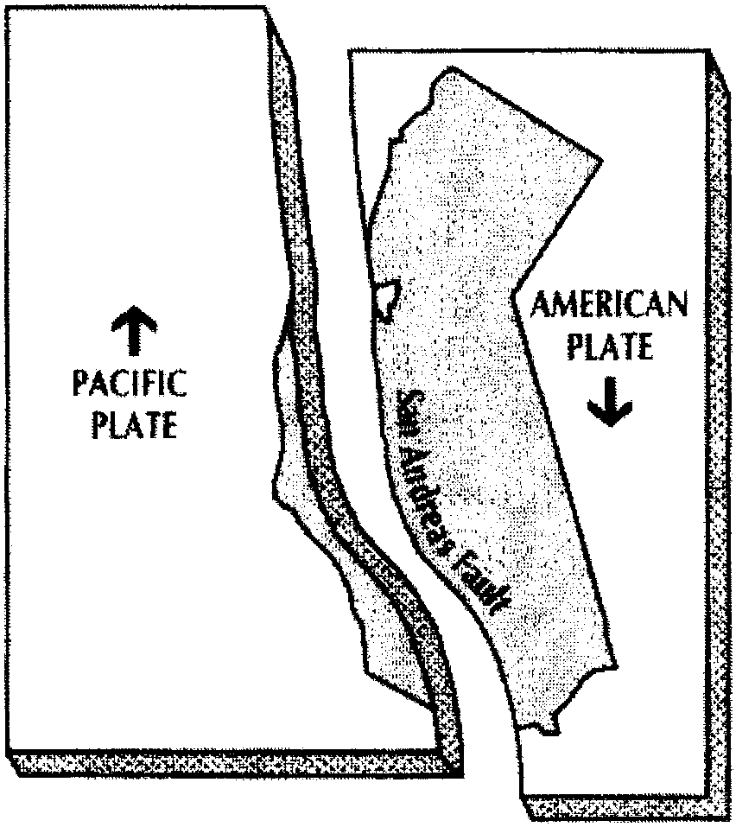
WHERE TO GO
LOS TRANCOS OPEN SPACE RESERVE
This is an ideal place to learn about earthquakes. There is a very good self-guiding trail (pick up the brochure in the parking lot). Tours given by volunteers are also available. Call the Mid Peninsula Regional Open Space District at (415) 965-4717 for more information. Los Trancos is located on Page Mill Road, 7 miles west of Highway 280 and 1 mile east of Skyline Blvd.

During the 1906 San Francisco earthquake, this area experienced a major movement on the San Andreas fault. The San Andreas fault trail (easy hike, about 1.5 miles) preserves excellent exposures of the deformation of the land due to slippage along the fault.

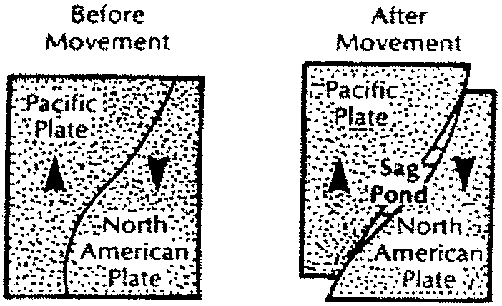

PACIFIC PLATE AND NORTH AMERICAN PLATE
The earth’s crust is divided into many plates that move and fit like a jigsaw puzzle. Two such pieces of the puzzle, Pacific Plate and North American Plate slide past each other. The San Andreas fault is a boundary between these two plates. In the Los Trancos reserve, explore the ground’s deformation due to the sliding along this fault and stand on both plates at the same time!

EARTHQUAKE EXPERIMENTS WITH SNACK FOOD
Take a Fig Newton and a fruit roll-up with you and do the following experiment on the trail. Enjoy the snack afterward!
FIG NEWTON:
Have each child bend a Fig Newton to form a fracture in the crust. The earth also has a crust that floats on a gooey material (the mantle). Is the crack in the crust smooth or bumpy? The cracks in the earth are also not very smooth, and when two plates attempt to slide past each other, friction resists the sliding and builds up lots of energy. When the friction is finally overcome, the fault (crack) moves rapidly and causes an earthquake.
FRUIT ROLL-UP:
Unroll the sheet of fruit roll-up. Cut a curvy line in the roll-up with your fingernail or a little knife. Now stretch the roll-up like the picture of the sag pond above. You can observe some parts that bunch up, forming a ridge, and some parts being pulled apart forming a sag pond. Tell everyone to pay attention to the ridges and ponds along the trail.

SCCC EARTHQUAKE PROGRAM
Learn about earthquakes and earn a patch! See the PARTICIPATION AWARDS section in this book.

STALACTITE AND STALAGMITE

Stalactites and stalagmites are formed in caves as a result of the dripping of mineral-rich water. As the water evaporates, the minerals form a layer, which builds a stalactite or a stalagmite. Stalactites are the ones found on the roof of a cave. Stalagmites are the ones projecting upward from the floor of a cavern.

Stalactite and stalagmite--here’s an easy way to remember which is which:
Stalactite “Hang tight to the ceiling”
Stalagmite “Might someday grow up to touch the ceiling”

CREATE YOUR OWN STALACTITE AND STALAGMITE
Into one cup of water stir 1/2 cup of Epson salts. After all of the salt is dissolved, pour half of the solution into a second cup. Set the two cups about four to five inches apart on a tray or piece of board. Insert a piece of heavy cord, or piece of cloth twisted until it is rope-like, into the solution in both cups. (The rope or cloth must be able to absorb the liquid.) The cord should droop slightly in the middle. In a short time, the liquid should begin to drip. Be sure that it drips very slowly. Soon you should be able to see a stalactite and/or a stalagmite form.

ONLINE RESOURCES FOR GEOLOGIST BADGE

http://rockhoundingAR.com/pebblepups.html
Rockhounding activities for Cub and Webelos Scouts
Also includes specific information on the Geologist Activity Badge
http://www.slip.net/~ccox/scvgms
Santa Clara Valley Gem & Mineral Society homepage
http://www.vcourseware1.calstatela.edu
You can see how scientists measure earthquakes.
Select Geology Labs Online/Virtual Earthquake

FIELD TRIP IDEAS

For details, please refer to the FIELD TRIPS section of this book.

Los Gatos Art and Natural History Museum
Downstairs has rocks, fossils and natural history exhibit of the area.
Youth Science Institute-Sanborn Discovery Center, Sanborn-Skyline County Park
U.S. Geological Survey
Los Trancos Open Space Reserve (see also above)
Santa Clara Valley Gem & Mineral Society has annual exhibits in February. It features gems, jewelry, minerals, fossils, dealers, demonstrations. Usually admission is free for Boy Scout groups or children under 12 accompanied by an adult. Check their website for more information. (See above)
HANDYMAN

BICYCLE HANDYMAN IDEAS

- Have the boys bring their bikes to a den meeting at a local park. Do requirements 5, 6 and 7. Then go for a bike ride to help earn the Bicycling Belt Loop.
- Have the boys help plan a mini bike rodeo for a park meeting where all the Cub Scouts are invited to bring their own bikes. Webelos Scouts can set up a “safety station,” where they check the condition of safety equipment on the bikes and go over safety tips with the younger boys. Ask a local bike dealer if someone can come and help with the safety check. Contact the police department to see if someone can come to register bikes in case of theft. In some areas, the police department will run a bike rodeo and safety program for you if the entire pack is involved.
- Ride to the neighborhood park and have a picnic.
- Go to a bike shop and have an expert demonstrate different types of bikes and show how to take care of a bike.

BICYCLE HINTS

Secure copies of bicycle maintenance manuals for each boy in your den. The American Automobile Association (AAA) offers many pamphlets and checklists free. Local bike dealers or repair shops may also be able to provide information.

FRAME
Watch for cracking of paint, which usually indicates a break in the metal frame. If a crack is apparent, have it brazed, welded, or repaired immediately. Care for your bicycle as thoroughly as an adult does a car - wash, wipe, wax, and polish often.

CHAIN
Keep it clean by washing it occasionally and removing grit and dirt. Oil and adjust properly to prevent it from coming off the sprockets. Light oil is best for lubricating.

WHEEL BEARINGS
To clean, loosen the cones and wash carefully with cleaning solvent, rolling them in the liquid until clean. Dry thoroughly, re-pack with bearing grease, and re-adjust the cones.

HANDLE GRIPS
Could cause you to take a “nose-dive” if not fastened tightly. If necessary, glue them on to avoid slipping.

HEADLIGHTS AND REFLECTORS
Keep these clean and, if you must ride at night, lighted. Motorists depend on you to have and use this equipment.

WORKSHOP ORGANIZER
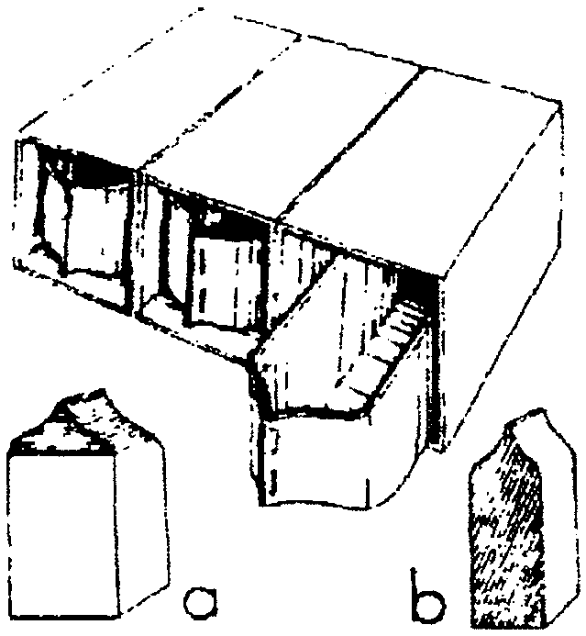
Materials: 3 quart-size milk cartons; 3 half-gallon milk cartons; Stapler; Scissors; Glue; Paint (Any paint that sticks to the surface. If such is not available, mix a small amount of kitchen cleanser with poster paint)

- Cut away one side of each quart-size carton to the peak. (See illustration)
- With a stapler close the open end of three quart-size milk cartons.
- Cut away the top of three half-gallon cartons--now you have tall rectangle boxes.
- Glue and staple the sides of the three half-gallon cartons together. (To make the outer case more secure, you may want to tape them together as well.)
- Paint the exterior of all cartons.
- Slip the quart-size cartons into the half-gallon cartons. The peaked side will serve as a handle.

AUTO REFLECTORS
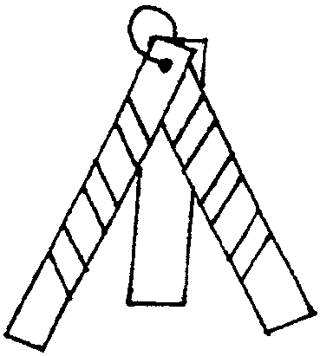
Changing a tire at night on the side of the road can be dangerous. You need reflectors of some type to warn oncoming traffic of your car. The boys can easily make such a device.

Materials: 1/4” plywood (cut 3 pieces, 2” x 8”); Drill; Reflector tape; Coat hanger


- Sand plywood pieces and drill a 1/4” hole in the top of each. Each reflector is made of three pieces of plywood.
- Cut the coat hanger into 6” pieces.
- Cut reflector tape into several 2-3” lengths and stick onto two of the three pieces in a diagonal pattern. Space the tapes evenly.
- Stack the two wood pieces with the tape on top of the plain wood piece. The top holes should line up. Push a piece of coat hanger wire through the hole and wrap the ends of the hanger to form a loose loop. Tape off the ends so that they will not be exposed.
- The reflector is formed by creating a tripod. The two legs with the reflector tape should face traffic at night. Place the reflector about 10 yards behind vehicle to warn oncoming cars. Make and carry more than one.

HIDE AND SEEK--GAME

Pretend you are a tiny speck and that you are hiding in the car. The others ask questions like, “Are you inside the car?” “Are you on the hood?” “Are you under the seat?” You answer yes or no. The person who guesses your hiding place can be the next one to pretend to hide. Encourage boys to use correct name for the parts.
VARIATION: Play this game pretending you are hiding somewhere on a bicycle.
NATURALIST

SUGGESTIONS FOR THE LEADERS

- There must be some fun, lightness and fellowship in the teaching of nature or it becomes dry as a bug on a pin!
- If you lack knowledge in nature, never be ashamed of it. Ask knowledgeable parents to help.
- Do every bit of nature you can out-of-doors rather than indoors.
- As far as you can, keep nature a study of “living things as they LIVE” rather than a study of dead things.
- Learn along with the boys. There’s always something new to learn.
- Be as enthusiastic about another person’s first banana slug even though it’s your 456th.

NATURE GAMES

FIND ‘EM
Each Webelos Scout is given a written list of things that may be spotted along a hike route, with a point score for each. First player to find one reports to the leader and is given the appropriate score. The players have to stay quiet and they do not touch any of the things they find.
Examples: Bird’s nest 20 points
Oak leaf 2 points
Steller’s Jay 10 points
Madrone tree 5 points
Dandelion 1 point
Poison oak 10 points
Any animal track 15 points

TREE TAGGING
Divide den into two teams. Give each team twenty strips of cloth and a felt-tip pen. Object of the game is for the teams to tag as many different kinds of trees as possible, making correct identification. Set the boundary and a time limit. At the end of the time, go over with the boys each tree they tagged and remove the cloth strips. The winners are the team with the most correct tags.

MEMORY HUNT
Divide den into two teams. Each team is seated facing the same scene. For two minutes, all team members study the view in front of them, trying to memorize all plants, trees, and animal life, including insects and birds. At the end of two minutes, both teams turn around and list everything they remember. Longest correct list wins.

FOOD CHAIN
This game requires a leader with some knowledge of plants and animals.
Find an insect nest or hive. Tell the boys to observe the insects and report what is below and above them in the food chain; in other words, what the insects eat and what other insects or animals prey upon them. This contest should last until the Scouts have discovered at least one food the species eat; it may continue as long as their interest lasts.

SQUARE FOOT CLAIM
Each Webelos Scout “stakes a claim” on a foot square piece of ground. He studies carefully for signs of life--grass, weeds, adult insects, larvae, feathers, worms, etc. Also don’t forget the animal or insect tracks. How many kinds of life can you find?

MYSTERIOUS NIGHT BUG MIXTURE

Nocturnal, active at night, bugs are very interesting, but you rarely get to see them. Their colors make them hard to find in the daytime so their predators won’t eat them while they rest. You can make some special food “paint” that will attract them during the night, so you can get a close-up look at these mysterious creatures.

1 or 2 very ripe bananas, peaches or 1 cup of berries
1 cup fruit juice
4 Tablespoons of sugar
Bowl; Fork; Paintbrush

Mash the fruit in the bowl with a fork. Add the sugar to the fruit and mix. Gradually add the juice to the fruit mix stirring well with each addition of juice. Paint mixture on tree trunk.
When it is night and fully dark, go out with a flashlight and check the trees to see what insects were attracted.

MOSQUITO NURSERY

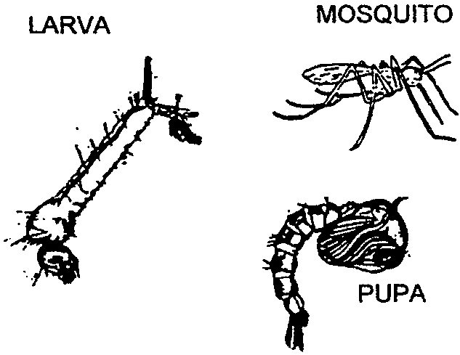
If you’ve left a bucket of rain water in your backyard for a time, you may notice some very strange creatures inhabiting it. They are most likely the larvae or pupae of mosquitos. Cover the bucket with a piece of clear netting and observe the changes that occur in this mosquito aquarium.

Mosquito larvae, often called wrigglers, are usually found hanging from the surface, breathing through the siphon attached to their posteriors. A tap on the water surface sends the larvae scurrying, but they will be back up shortly for air.

When the larvae pupates, a skeleton-like covering forms over the developing adult. The mosquito now looks like a comma and floats head up rather than bottom up, and the siphon is now found below the head area. The pupae will turn into an adult in 2-4 days.

OUTDOORSMAN

A FEW TENT TRICKS

Don’t touch the tent fabric (inside or out) when it’s raining and you want to stay dry.
The fabric of the tent is filled with air bubbles that cause it to shed water. When you touch it, these bubbles are broken, causing the water to come into your tent.

Stretch the tent tight when you put it up.
The wind constantly shifts a loose tent, which weakens the fabric.

Put up the rain fly even if there is no possibility of rain.
There is still dew at night. Also the rain fly will help protect the tent from UV rays.

Take your shoes off in the tent.
This will keep the tent clean and minimize the damage to the tent floor.

Open the tent flaps (leaving net closed) each morning.
Let it dry and air out.

Don’t fold up a tent when it is damp.
Damp fabric mildews. If you must fold it when it is wet, unfold it as soon as possible and dry it out. Don’t forget to dry the tent sack too.

Shake out all the dirt and bugs before folding the tent.
A small whisk broom is a handy tool for this. Fold the tent carefully and smoothly.

Don’t fold the tent against the tent poles or pegs.
Wrap the poles and pegs in cloth first, or put them in a bag.

KNOW YOUR KNOTS

Only six knots are required for this activity badge. Boys enjoy playing with rope but don’t like learning knots for the sake of learning them. Be sure to teach them in a practical situation so that they will know what to use them for. The uses of the required knots are listed in the Webelos Scout Book along with the instructions. Use a lot of knot tying games (Webelos Leader Guide) to make it fun.

Tying knots is a skill that lasts a lifetime. For more knots see The Boy Scout Handbook. A BSA publication Knots and How to Tie Them is a small booklet you can carry with you. This easy to follow, illustrated guide covers just about all the knots you’d need. And it’s a bargain at 75 cents.

EASY RECIPES

HOT DOGS PLUS
Slit side of a hotdog, insert wedge of cheese, and wrap with bacon. On sticks, broil over coals until cheese melts and bacon is crisp. Serve in a toasted bun.

KABOBS
On sharply pointed sticks, skewer 1 1/2” cubes of meat or hot dog pieces alternated with quartered onions and thinly sliced potatoes. Broil over coals until meat is browned and potatoes tender.

BACON AND EGG IN A PAPER BAG
Cover bottom of paper lunch bag with 2 strips of bacon. Drop over bacon one egg (can be scrambled). Roll sack down in 1-inch folds and shove sharp stick through paper bag. Place over coals and cook. The grease from the bacon keeps the bag from burning.

EGGS IN A BASKET
Place one slice of bacon in a “V” shape in skillet and fry. Place over bacon a slice of bread with approx. 2-inch round hole in the center (use cup or clean empty can to make the hole). Gently press edges of bread down. Break egg into center of bread. Cook on both sides.

BUCKAROOS
Spread minute or cubed steak with mustard and roll around a dill pickle wedge. Fasten with toothpicks. Wrap in foil, Cook over hot coals, turning often, until done.

STUFFED POTATOES
Core small potatoes. Insert a small sausage or hotdog. Plug the end with pieces of potato, wrap in foil and set in hot ashes to bake. These take 45-50 minutes to cook.

STUFFED APPLES
Core small apples without making hole go all the way through. Fill with raisins and brown sugar, or marshmallows. Wrap in foil and bake in coals for about 15 minutes.

BREAD
Try bread on a stick over coals. Mix Bisquick to the consistency of Play-Dough and roll into a “snake”. Wrap the bread dough snake around the stick and then join the ends to hold everything in place.

HAMBURGER
Take an onion and cut in half, remove the center to form a dish. (Save the portion of the onion removed for other meals.) Form the hamburger into a big meatball and place in the onion dish. Place the onion directly onto the coals. (Yes, that’s right, place the onion directly on the coals.) Be sure to season the meat as it cooks. Occasionally turn the meat within the onion dish. The dish makes the meat really tasty!
READYMAN

FIRST AID OBSTACLE COURSE

Before you run this race, go over each skill with the Scouts.
Set up an obstacle course containing these first aid situations. Have adequate supplies at each station. Judge for speed and efficiency.

1. Find your buddy (from here on, the race is run by two buddies)
2. Oops! Your buddy fell and cut his forearm badly. Apply bandage.
3. Drink plenty of water.
4. Oh no. Someone is badly hurt. (Have a person on the ground.) Call 911. (Use a toy telephone. Adult leader will be a dispatcher answering a call. Have a list of questions likely to be asked.) Also treat the victim for a shock.
5. Someone is choking. Do the Heimlich Maneuver. (Do not let them do this on a person. Use a bed pillow. Mark a belly button on the pillow and an adult can hold it upright.)

READYMAN “HOLLYWOOD SQUARES”

Play tic-tac-toe with question cards.

Use a large poster board to draw a tic-tac-toe board on. Number the squares. Use “Post-it” notes with “X” & “O” on them for each team. Divide den into two teams – X’s & O’s

Write Readyman questions on index cards. Include water safety, bike safety, fire safety and driving safety questions as well as first aid questions. Each question has a number corresponding to a number on the board. First team tries to answer question to get that square. If they can’t, then the other team gets a chance. Put X or O on square depending on which team answered correctly.

You will probably have mostly “cat” games, but the point is to teach them about these first aid issues with fun. Not who wins the game. After an answer, elaborate a bit on the answer.

FREE ADULT CPR TRAINING FOR LEADERS

Santa Clara Valley Chapter of the American Red Cross, along with other chapters in Northern California, offers free Adult CPR certification training in March every year. The information should be available by Mid-February. Get trained and be prepared.
Please note that while there is no age limit to participate in this training, Webelos-age boys are advised to take training specifically made for children their age. Inquire at your local Red Cross office.

BLANKET STRETCHER

You will need two sturdy staves and one large blanket.
- Spread the blanket flat on the ground. Place one stave across the blanket about two-thirds across.
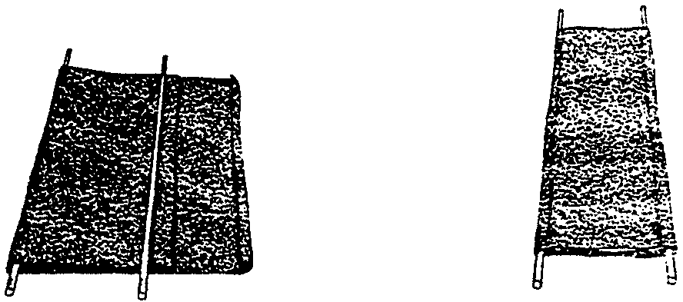
- Fold the smaller portion over this stave. Place the remaining stave across the blanket about 4 inches inside the edge just folded over.
- Fold the remaining third of the blanket. Ensure the staves extend past the end of the blanket as these are the carrying handles.

Have the Webelos Scouts practice creating this stretcher and then practice transporting a “victim.” Place a small, open container of water on the victim’s stomach. The idea is to move the victim, but to do it gently enough to keep water in the container!
Do this exercise over carpeted area or soft ground. Adults should supervise closely so the “victim” does not become a real one.

CHECK, CALL, CARE

Years ago, it was recognized that too many rescuers were being injured as they attempted to perform rescues. Their bravery and dedication to their goal of saving someone else often put them into grave danger. Grave danger was no slip-of-the-tongue--many died in their attempts, especially in water-related accidents.

Today’s procedures, as defined by the American Red Cross, specify three steps for rescuers to follow in their rescue attempts:

CHECK: Your questions must include “Is the scene safe?” “What happened?” “How many victims are there?” and “Can bystanders help?” If and only if the scene is safe for you to approach, check the victim for consciousness.
CALL: Call 9-1-1 if you notice an unsafe scene, emergency situation or life threatening condition. Be prepared to give the location, description of the emergency, and any other information you may find.
CARE: Care for the victim. If the victim is conscious, be sure to get their permission to treat. Check your first aid kit regularly for expiration dates and replace out of date contents.

CALIFORNIA POISON CONTROL SYSTEM

Find out about poison prevention, poisonous plants and animals, and other information regarding poisoning at http://www.calpoison.org/public/home.html
They also have phone stickers, plant guides, and question and answer books available for small fees. Also available are educational materials about poison prevention. Order on-line or through their non-emergency number 1-800-582-3387.
The poison control emergency number is 1-800-876-4766.

SCHOLAR

THINGS YOU CAN DO BECAUSE YOU ARE GOING TO SCHOOL

Don’t JUST make a list. It only takes a bit of creativity to turn this into a fun activity! Brainstorm with the boys and turn the responses into a skit or song to perform at the pack meeting. Below is an idea for a song to get you started. Rather than using this song as is, let your Webelos Scouts make up their own verses based on the things they say they have learned in school.

This particular song/skit is a variation of “A Cub Scout I Would Be.” The song is chanted. Boys line up on stage, each in turn taking the speaking part of a verse. After each verse, the speaking parts of all preceding verses are repeated, in reverse order, going down the line.

“A GOOD EDUCATION” (chanted)
All: A good education is as valuable as can be,
Because I’ve been in school...
W.S.1: I know my ABC’s A is for apple, B is for bear.

All: A good education is as valuable as can be,
Because I’ve been in school...
W.S.2: A newspaper I can read Sports page, weather...Where are the comics?
W.S.1: I know my ABC’s A is for apple, B is for bear.

This goes on until all Webelos Scouts are done with their speaking parts.
More suggestions:
W.S.3: Spanish I can speak. Hola...Muy bien...Adios, amigos.
W.S.4: Music I can sing. Doe, a deer, a female dear.
W.S.5: Computers are a breeze. Boot it up...click the mouse...surf on the ‘net.

CHART OF YOUR SCHOOL SYSTEM
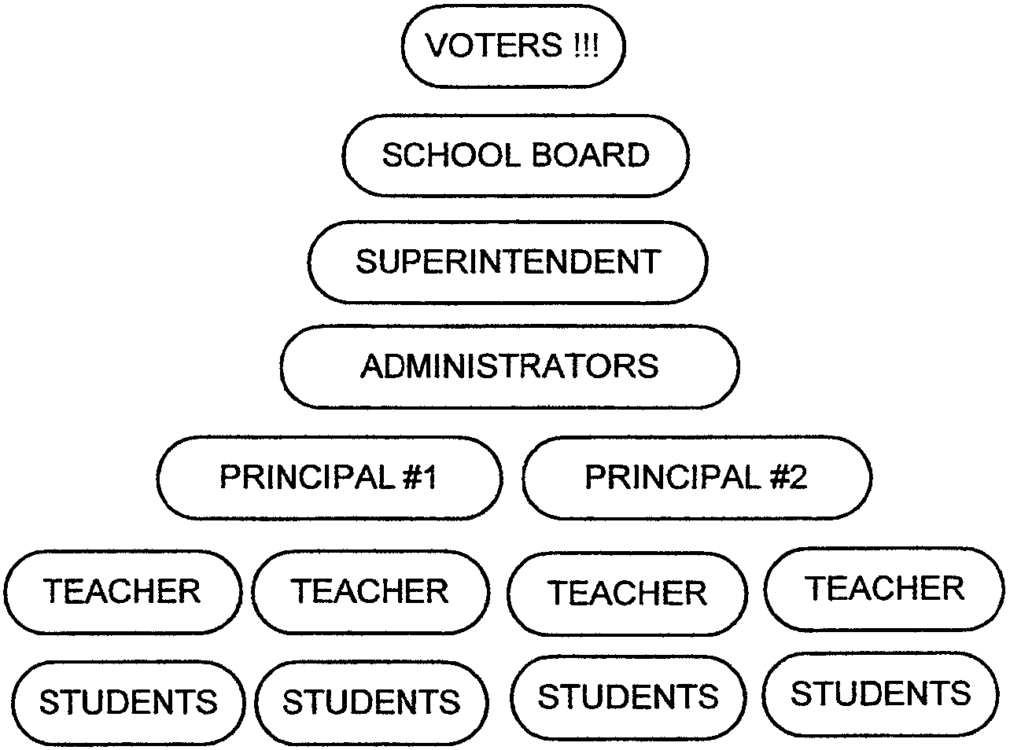
Prepare a wall-size organizational chart to display at the pack meeting. Start with students, progress upward through teachers, principals, administrators, superintendent and school board. End up with their parents--the voters!--on top. Embellish the chart with drawings.

THE TWENTY FIRST CENTURY

You will need lots of old magazines, construction paper, scissors, glue, markers and pencils.

Have the boys discuss what they think school will be like 25 years from now. Will the students all be at computers? Will they interact with their teachers from a TV hook-up at home? Will they travel to Mars for mathematics and Saturn for science? Will someone have invented a “smart pill” for each subject?

In the future, will we do away with some of the subjects that are taught now? Which ones? Can they imagine any new subjects that might be taught instead? Which ones?

After the discussion, divide the boys into two or three project groups to make posters of their view of education in the future.

CAREERS IN EDUCATION

You will need lots of old magazines, construction paper, scissors and glue.

Have each boy choose one of the following careers in education and think of what may be involved in that career. Then, using old magazines, have each boy make a collage of pictures that relate his ideas about the career. You may be surprised at a Webelos Scout’s perception of these jobs. When the collages are complete, discuss them and clarify any misconceptions. Display the collages at the pack meeting.

Guidance Counselor
Librarian
Social Worker
Kindergarten Teacher

High School Teacher
Health Services
Principal
Sports Coach
Elementary Teacher
College Professor

RHYMING PAIRS

For this quiz, answer with two words that rhyme with each other.

- Snoopy after earning Boy Scouting’s highest award.
- A scalding cooking vessel.
- Leader Benjamin’s groups of eight Cub Scouts.
- Boxing matches featuring the members of a troop.
- A crooked canvas shelter.
- A picture made by Cub Scouts passing a crayon on paper over a headstone engraving.
- A swimming partner with a bleeding cut.
- A camper’s wood chopper made of paraffin.
- Earth-boring animal befriended by a group of Boy Scouts.
- A militant effort to teach emergency medical treatment.
- Hiker’s foot gear stuffed with an orange, apple and banana.

Answers:
1-Eagle beagle; 2-hot pot; 3-Ben’s den; 4-Scouts’ bouts; 5-bent tent; 6-Cubbing rubbing;7-bloody buddy; 8-wax ax; 9-patrol mole;
10-first aid crusade; 11-fruit boot

SCIENTIST

DO-IT-YOURSELF STEAM ENGINE
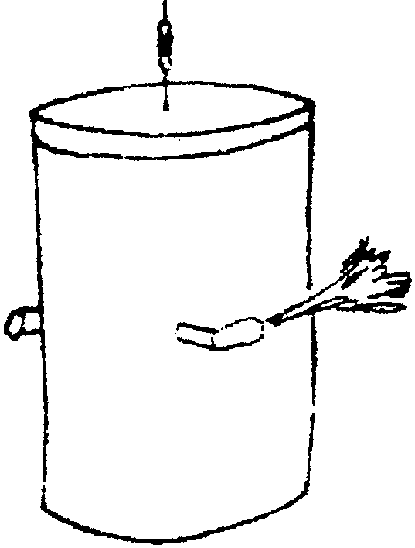
This steam engine can be assembled easily and provides a fun project for the boys. And better yet, it actually works!

Materials: One-pound coffee can with plastic lid, 3 flexible straws, Duct tape, Fishing line.

1. Drill three holes in the coffee can 3/4” from the top. These holes should be 120 degrees apart or 1/3 of the way around the can.
2. Cut the straws so that each side of the bend is about one inch. Push one end of the straw through each drilled hole, and secure in place with tape.
3. Fill the can with ¼ to ½ cup of water. Punch a small hole in the center of the plastic lid, pass fishing line through, knot the end and secure with tape.
4. Place lid back on the can and secure with tape.
5. Suspend the fishing line so that the can hangs free.
6. Build a small fire under the can to bring the steam engine to life. As the water boils, the steam escapes through the straws making the engine go around.

MAKE YOUR OWN CHEMISTRY SET

You don’t need to buy a set to have fun with chemistry. You and your den can do lots of great experiments with simple household products.

BASIC SUPPLIES
CHEMICALS: Vinegar, baking soda, baking powder, red cabbage, laundry detergent, white glue, lemon juice, yeast, hydrogen peroxide, food coloring, dish detergent.
EQUIPMENT: Clear plastic cups, Zip-Loc type plastic bags, droppers, straws, measuring spoons, small thermometer, coffee filters, protective wear for eyes and hands

SAMPLE EXPERIMENTS
GREAT GLOBS OF GLOOP (for 5 globs)
In a big bowl, mix 2 cups of white glue (Elmer works well) and 1 ½ cups water. You will use this for all five globs. In a small bowl, mix 1/3 cup water, 1 teaspoon of powdered laundry detergent and 4 drops of food coloring. Pour the contents of small bowl into middle of the glue mixture in the big bowl. Do not stir. The detergent solution will cause the glue mixture to congeal and form a glob. Scoop out the glob and put it back into the small bowl. Knead the glob for several minutes until all liquid is absorbed. Repeat for 4 more globs. Play with it to see what it’s like.

Note: While most any powdered laundry detergent works, borax works better. As with any chemicals, be careful when handling them.

FOAM AND FIZZ
Here’s an experiment that will allow you to pretend to be a mad scientist. Put about ½ teaspoon of baking soda in a narrow glass. Add 1 tablespoon of vinegar or lemon juice, and stand back! The mixture will fizz up and come bubbling out of the glass. This happens because vinegar and lemon juice are acids and baking soda is a kind of chemical called a base. Acids are sour-tasting chemicals. Besides lemon juice and vinegar, green apples, grapefruit, tea and yogurt contain acids. Your stomach produces an acid that helps digest food. Bases are bitter-tasting chemicals that often have a slippery feel. Soap is made from a base. Egg whites and ammonia are bases. So is your blood. Acids and bases are like chemical opposites. When they combine, they react to produce a gas, which is what makes the fizzy bubbles.

THE ACID TEST
Here is a way to tell whether an unknown chemical is an acid or a base. Tear up one or two leaves of red cabbage and put them in a Zip-Loc freezer bag. Add about 1/2 cup of warm water. Close the bag and squish the cabbage in the water until the water turns a medium to dark blue. This is the acid/base indicator solution. Divide the solution among several small clear plastic cups. Add a few drops of vinegar or lemon juice to one of the cups, and the solution will turn pink, indicating that it’s acidic. Add a little baking soda or powdered laundry detergent to another cup, and the solution will turn greenish blue, indicating the presence of a base. See what happens if you add vinegar to the indicator and then add baking soda to the same cup (careful!). What color will the indicator turn if you add some clear lemon-lime soda, such as Sprite or 7UP?
You can save the red cabbage indicator by making indicator paper. Soak strips of coffee filters in the red cabbage juice for a few minutes until they turn bluish purple. Lay them flat on a smooth surface. When dry, store in a Zip-Loc bag in a dry and dark place. Try dropping small amounts of different liquids onto a strip and note what happens.

For more ideas on how to use your home-made chemistry set, turn to Apples, Bubbles, and Crystals: Your Science ABCs by Andrea T. Bennett and James H. Kessler.

MAKE YOUR OWN BORAX CRYSTAL

You will need a large wide mouth glass jar (e.g. peanut butter jar). Shape a base for the crystals with a chenille piece. Take it out. Fill the jar with boiling water (adult supervision necessary). Mix borax into the water, a tablespoon at a time, until you notice powder settling on the bottom (it’s now called a super-saturated solution). Gently drop in the chenille piece. Set aside overnight. As the water cools and evaporates, borax molecules will stack together. You can see small crystals forming after a few hours. By morning the chenille base will be covered with crystals. Crystals will stop forming after about a day. Drain the jar and look at the crystals with a magnifying glass.

ONLINE RESOURCES FOR SCIENCE

WonderNet: http://www.acs.org/wondernet/
The Exploratorium: http://www.exploratorium.edu
National Science Teachers Association: http://www.nsta.org

SHOWMAN

STORYTELLING

Be an inventive and believable storyteller. Everyone will get a chance to tell the tallest tales in as sincere a manner as possible.
Materials: Small objects such as a key, a ring, a pencil, scissors, etc. for each player.

Players are seated in a circle and pass the small objects from person to person. When the leader says, “Freeze,” the players stop passing the objects. Each player must come up with an incredible or nonsensical story about the object he has in his hand. For example, for a key the player might say something like: “This key unlocks a treasure chest that holds gold coins and gem stones taken from the Emperor of China. A pirate named Patch buried it 3 miles below the surface of the San Francisco Bay near Alcatraz. He dug his hole that deep because at that time he was .....” or “This key saved the life of a man when it stopped a bullet while he was fighting in a war...”
Make the stories as outlandish as possible. When the storyteller gets stuck in his story, others can help him by asking questions, or maybe giving some suggestions. Give the boys some time to make up their stories. You may want to give them some patterns for them to follow like “WHO did WHAT, WHERE did this happen, WHEN was that, WHY, HOW did that happen.”

GAMES

MOVIE STAR WALK
This is best done in a large building with many obstacles. Divide the group into teams of six to eight people and tie them together at the wrist to form a “chain.” Use long balls of colored string or yarn to layout a course. Have each team follow their colored yarn wherever it goes without breaking their chain or the yarn. The first team with their yarn completely rolled up and their chain not unbroken wins.

ACTING
After discussing how things feel, everyone pantomimes an emotional reaction to feeling something and the others try to guess what he is feeling. Examples: Holding a snake, picking a prickly plant, hot sand on bare feet, something sticky.

SHOW BIZ BUZZ
Choose a number that the players cannot say aloud. For example choose number 5. Start off counting around the circle. When the counting reaches any number that includes a 5 or a multiple of 5, that player must name a television show instead of the number. Counting should be rapid. When a boy can’t think of a show, he is out. No show can be repeated. Start off with an easy number like 5. When they become good at it choose other numbers. You may want to change categories as well. How about movies, musical stars, musical instruments?

MUSTACHES

There is probably no other disguise that can change a person’s appearance so quickly as a fine mustache. Behind a mustache you can be anybody--politician, detective, television star, or even the bearded circus lady. Dressing up is great fun, and every child should have a special drawer or box of old shoes, out-of-style hats, dresses, jewelry--and mustaches. Actually, a mustache can be the whole costume, as most of the time you really don’t need an elaborate disguise. Still, if you think that the mustache alone isn’t convincing, a large bath towel and a few safety pins can help round out your image. It’s so fun to imitate life--being the “baddy” with a pencil-thin mustache curled up at the end, or maybe the “goody” with a big floppy mustache. You won’t really feel the magic of your mustache disguise until you see yourself in a mirror!

CONSTRUCTIONS
Use heavy paper to make your mustache. If you want, you can glue yarn, fuzzy fabric, etc. to your paper mustache.
The mustaches shown here are examples. You can try to copy them or make up your own. It’s easy to invent a mustache. Draw the mustache pattern on a sheet of heavy paper like poster board or file folder. Cut out the mustache, and try it on for size. Be sure to make the two little hook cutouts that attach to your nose. Experiment until you get the hooks just right so the mustache will stay in place. That’s all there is to it. Now why not have a mustache party or maybe a mustache day?

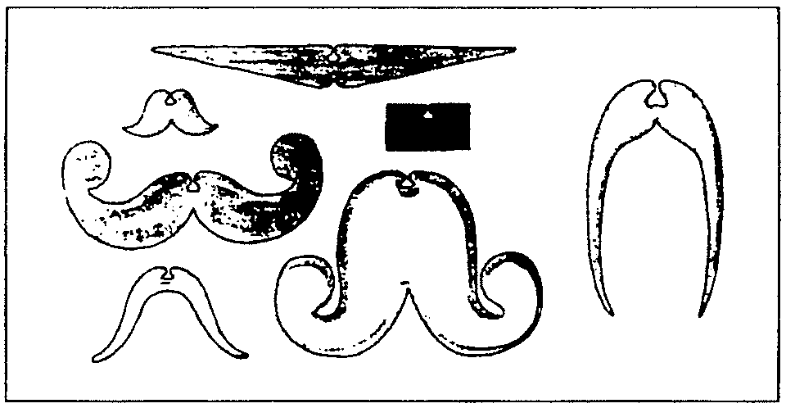

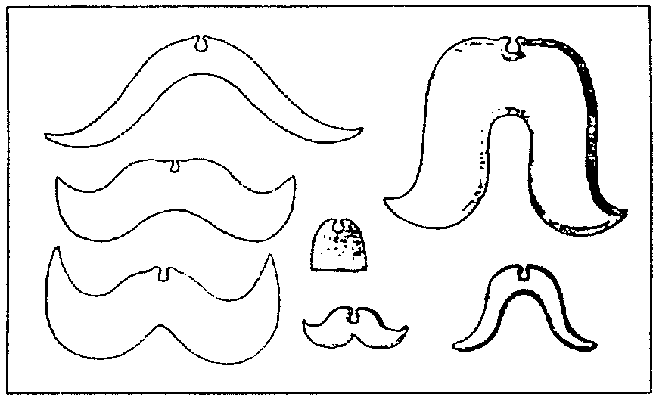
SPORTSMAN

YOU MAKE THE CALL

Dive the den into two teams. Write on index cards the name of a sport and a situation. The leader reads a card and teams answer. Play this like baseball. Each player has a chance at bat. When a player has a “hit” by giving a correct answer, the team will gain 1 point. If a player cannot answer the question or gives a wrong answer, that’s an “out” and the next player has a chance to answer the same question. Three “outs’ and the teams switch. Team members cannot help the player at bat but can send in a designated hitter, etc. Make up the rules with the boys.

Sample questions:
BASKETBALL Person dribbling ball stops, holds ball and then begins dribbling again.
FOOTBALL A defensive player runs into the punter on purpose and does not hit the ball.
SOCCER No defensive players are between an offensive player and the opposing goal and the offensive player does not have the ball.
TENNIS Player serving ball hits the ball too hard and it goes into the other player’s backcourt.
HOCKEY Player is hooked by the stick of an opponent.
BASEBALL Pitcher throws a pitch that arrives at the plate outside of the strike zone.
BASKETBALL Two players on opposite teams hold the ball simultaneously.
FOOTBALL A team takes more than the allotted time to begin a new play.
SOCCER An offensive player kicks the ball toward the goal but the ball goes over the goal and out the back of the field.
VOLLEYBALL While trying to return the ball, one player hits it two times in a row.
BASEBALL A player hits a high fly ball that bounces once and goes over the wall in left field.
BASKETBALL A player fouls another player as he is about to shoot the ball.
FOOTBALL An offensive player is interfered with while attempting to catch a forward pass.
SOCCER A defensive player, while defending his goal, loses the ball out of bounds along the back line.

DO YOU KNOW THIS SIGNAL?

Divide the den into two teams. One team chooses a sport and give one officials’ signal. The other team identifies it. If they cannot correctly identify the signal, the first team gains one point and gives another signal. If the second team can correctly identify the signal, then they gain one point and start giving signals.

OLYMPICS FOR A RAINY DAY

Shot Put: Each boy is given 10 navy beans, which he attempts to throw into a quart jar from a line on the floor.
Discus Throw: A paper plate is thrown from a line. Plate must be held flat in hand and not sailed with thumb and fingers.
Twenty Foot Relay: Roll lemons or hard boiled eggs down the course and back, tagging the next player. Use a stick to roll the object.
Fluff: Carry feathers on a plate. A player must pick up any that drop.
Bean Relay: Carry beans, one at a time, between match sticks or toothpicks to opposite end of the course (table).
Marble Bowling: Set up ten clothespins on table. Roll a marble toward them. Each player has two chances to knock down as many as possible.

BASEBALL TERMS

Each of the phrases listed below represents a term used in baseball.

- A summer pest - Fly
- Holiday dinner - Foul
- Used for pancakes - Batter
- Vessel for pouring - Pitcher
- A good foundation - Base
- To take unlawfully - Steal
- A brief visit - Short Stop
- A dinner necessity - Plate
- If you forget your door key - Out
- A disguise - Mask
- Twenty - Score
- Proprietor of dog pound - Catcher
- A valuable jewel - Diamond
- Given for charity - Ball
- Dangerous on highways - Curve
- An offering - Sacrifice
- To multiply by two - Double
- It flies only at night - Bat
- Unmarried - Single
- A famous Greek poet - Homer
- Used to gain relief in hot weather - Fan

VIDEO SPORTS SIGNALS QUIZ

Are you mechanically inclined? You may want to record several different ball games from the TV, then dub just the official signals onto another video tape. Play this and see if the boys can identify the signals on the video.

TRAVELER

TRAVEL ACROSS THE COUNTRY
Do you know the state names? Their abbreviations? State capitals?

AL Alabama Montgomery
AK Alaska Juneau
AZ Arizona Phoenix
AR Arkansas Little Rock
CA California Sacramento
CO Colorado Denver
CT Connecticut Hartford
DE Delaware Dover
FL Florida Tallahassee
GA Georgia Atlanta
HI Hawaii Honolulu
ID Idaho Boise
IL Illinois Springfield
IN Indiana Indianapolis
IA Iowa Des Moines
KS Kansas Topeka
KY Kentucky Frankfort
LA Louisiana Baton Rouge
ME Main Augusta
MD Maryland Annapolis
MA Massachusetts Boston
MI Michigan Lansing

MN Minnesota St. Paul
MS Mississippi Jackson
MO Missouri Jefferson City

MT Montana Helena
NE Nebraska Lincoln

NV Nevada Carson City
NH New Hampshire Concord
NJ New Jersey Trenton
NM New Mexico Santa Fe
NY New York Albany
NC North Carolina Raleigh
ND North Dakota Bismarck
OH Ohio Columbus
OK Oklahoma Oklahoma City
OR Oregon Salem
PA Pennsylvania Harrisburg
RI Rhode Island Providence
SC South Carolina Columbia
SD South Dakota Pierre
TN Tennessee Nashville
TX Texas Austin
UT Utah Salt Lake City
VT Vermont Montpelier
VA Virginia Richmond
WA Washington Olympia
WV West Virginia Charleston
WI Wisconsin Madison

WY Wyoming Cheyenne

SCRAP MAP

A map doesn’t have to be of a faraway place or a large land area. It can be of a neighborhood--your neighborhood!
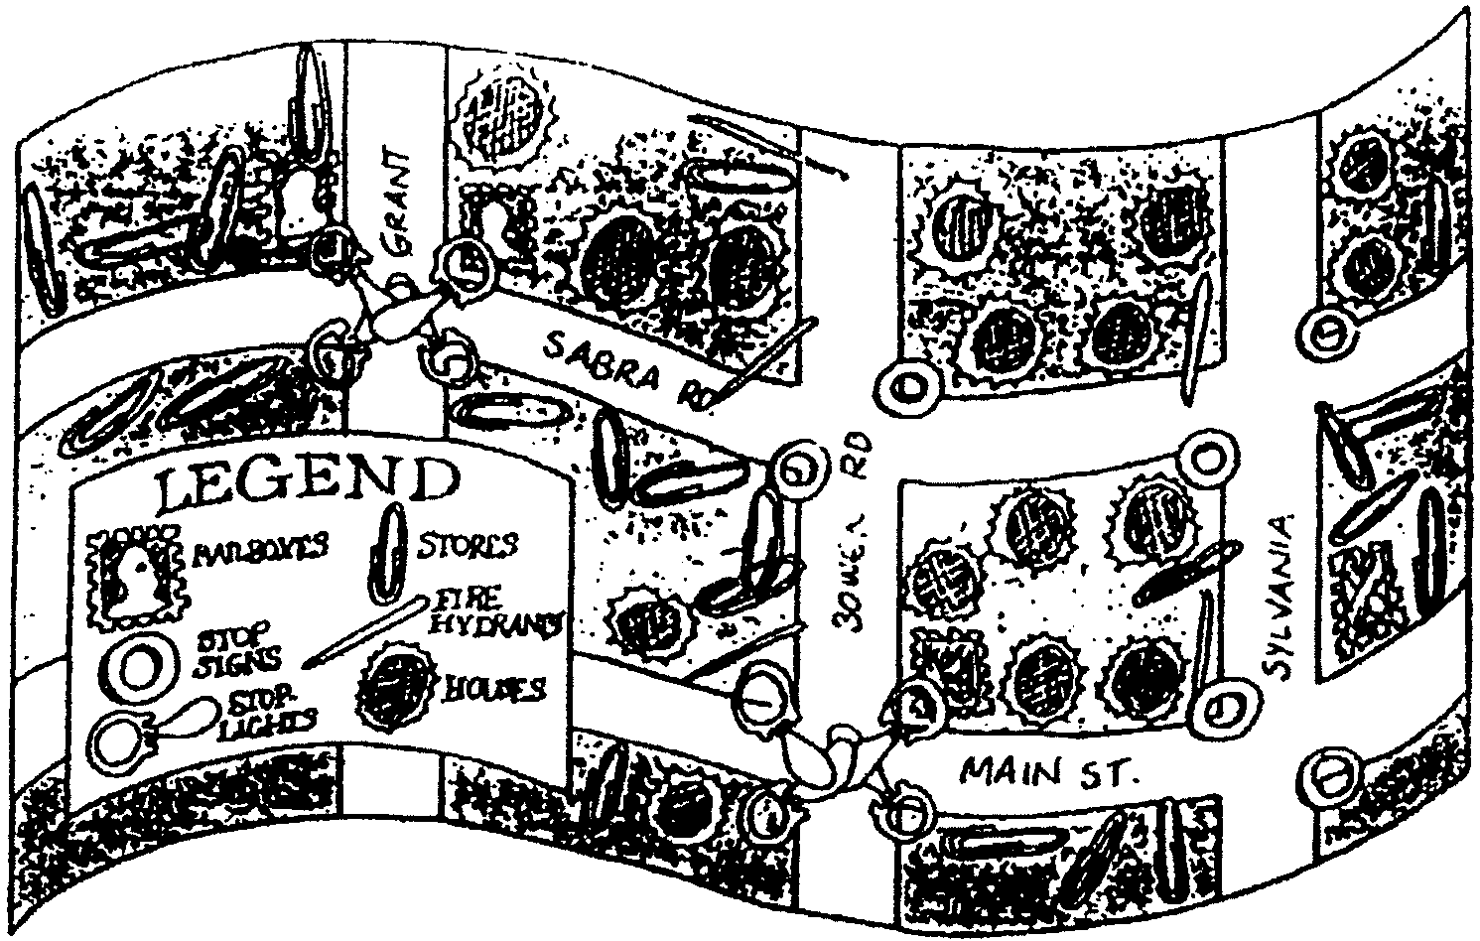
Make a map of your neighborhood. Use canceled stamps to show the location of mailboxes. Use washers to show where stop signs are. Use scraps as symbols for stoplights, houses, stop signs and fire hydrants.
Many maps have a legend. A legend is very important in helping someone read a map. It contains all the symbols used in the map and tells what they are. Make a legend in one of the corners of your map. Show the scraps used in the map and tell what each represents.

DO YOU KNOW YOUR CARS?

From these hints, can you name the cars?
- Our 16th president
- 1st colony in New England
- Indian Chief
- Theater where Lincoln was shot
- Mountain lion
- Spotted tropical cat
- Bright color
- Not rural
- Wild horse
- Roman mythical god
- Tall building in New York
- Large planet
- Army service vehicle
- Japanese warrior
- Constellation “Bull”
- Lake in the Sierras

Answers:
1-Lincoln; 2-Plymouth; 3-Pontiac; 4-Ford; 5-Cougar; 6-Jaguar; 7-Neon; 8-Suburban; 9-Mustang; 10-Mercury; 11-Chrysler; 12-Saturn; 13-Jeep; 14-Samurai; 15-Taurus; 16-Tahoe

MAP SYMBOLS RELAY

On separate 3” x 5” cards, paste or draw road map symbols taken from a standard road map. On smaller cards, write the proper meanings. Divide den into two teams. Make a jumbled pile of all the cards and meanings some distance from the first team. On signal (record start time), the first boy on the first team races to the pile and matches any symbol card with its proper meaning. He then runs back and touches the second boy on his team, who repeats the action. Continue until all symbols are matched with their meanings. Record the teams’ elapsed time. The second team then does the same. Add one second for each improperly matched set. Winning team is the one with the faster time.

PLOTTING YOUR ROUTE

Give each boy a state map. Tell them you are leaving this city and going to _______ (another city in the state), and have each boy plot the route. The object is to be the first to plot the most direct route to the point. After several attempts, have them plot an entire trip, with several designated stopovers.

