Circle the Wagons

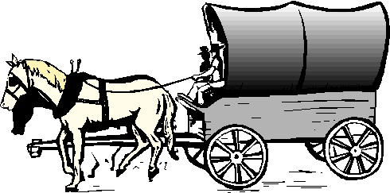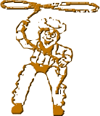

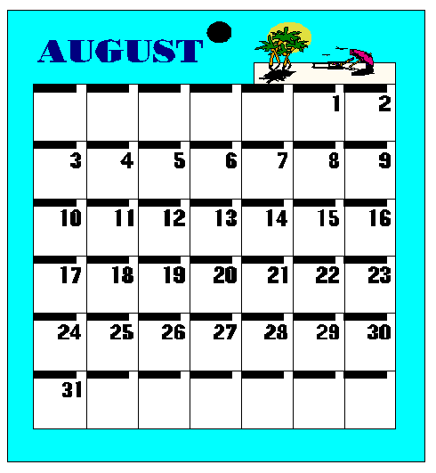

August 2003

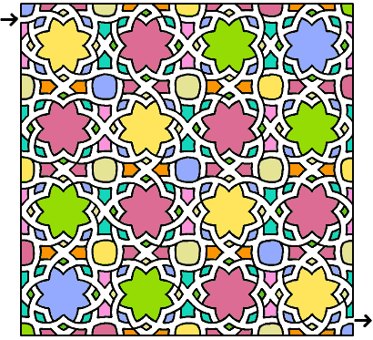

Opening/Closing Ceremonies

Cub #1: America and Cub Scouting is just one big adventure.

Cub #2: This is my country. I will use my eyes to see the beauty of this land.

Cub #3: I will use my mind to think what I can to do make it more beautiful.

Cub #4: I will use my hands to serve it and care for it.

Cub #5: And with my heart, I will honor it.

Cub #6: Many immigrants to America had a really big adventure getting here.

Cub #7: Once they settled in this country, they became loyal Americans.

Cub #8: Let us be like them—loyal Americans. Please stand and join me in the Pledge of Allegiance.

This Land of Mine

This is my land and I love it,
A country of lakes and of streams,
Of mountains and wind-swept prairies,
A land where the sunlight gleams.

It’s a land that was settled by heroes,
The venturesome, brave pioneers.
It stands as a symbol of freedom,
That will greater grow through the years.

This is the land that I cherish…
It stands as a guiding star…
For those who, tired and discouraged,
Have come here from countries afar.

It’s a land were the lowly and humble
Can dream and their dreams can come true,
Where we are proud of our starry emblem,
Of red and of white and of blue.

This is my land and I love it,
And wherever my thoughts may roam,
Always there comes that great feeling
Of pride that this is my home.
“Why I Love Her”
By John Wayne

(If possible, play an instrumental version of “America the Beautiful” in the background.)

You ask me why I love her?
Well, give me time and I’ll explain.
Have you ever seen a Kansas sunset or an Arizona rain?
Have you drifted on a bayou down Louisiana way?
Have you watched the cold fog drifting over San Francisco Bay?
Have you heard a bobwhite calling in the Carolina pines
or heard the bellow of a diesel at the Appalachian mines?
Does the call of the Niagara thrill you when you hear her waters roar?
Do you look with awe and wonder at a Massachusetts shore
where men who braved a hard new world first stepped on Plymouth Rock?
Do you think of them when you stroll along a New York City block?
Have you seen a snowflake drifting in the Rockies way up high?
Have you seen the sun come blazing down from a bright Nevada sky?
Do you hail to the Columbia as she rushes to the sea
or bow your head at Gettysburg in our struggle to be free?
Have you seen the mighty Tetons or watched an eagle soar?
Have you seen the Mississippi roll along Missouri’s shore?
Have you felt a chill at Michigan when on a winter’s day,
her waters rage along the shore in thunderous display?
Does the word “Aloha” make you warm?
Do you stare in disbelief when you see the surf come roaring in
at Waimea reef?
From Alaska’s cold to the Everglades…from the Rio Grande to Maine…
My heart cries out, my pulse runs fast…The might of her domain.
You ask me why I love her?
I’ve a million reasons why…
My beautiful America…beneath God’s wide, wide sky!

Cowboy’s Philosophy

CUB #1: We, the cowboys of the western plains are bound by our desire to live free.
CUB #2: We must, therefore, show respect for our fellow man,
CUB #3: Respect for his beliefs,
Respect for his belongings,
Respect for his privacy,
Respect for the ground he walks on and the air he breathes.
CUB #4: In doing so, we show respect for ourselves.
CUB #5: And secure freedom for all.

Advancement

Setting: Cubmaster is dressed in a western hat and bandana. Another pack leader is his deputy.

Cubmaster: Deputy, call the Younger Gang to come in now.

(Deputy calls names of Cubs receiving Wolf or arrow points.)

Cubmaster: Come in boys and receive your silver dollars (foil-wrapped coins) for your good work. Now, I want to see the Bearskin Boys.

(Deputy calls names of Cubs receiving Bear or arrow points.)

Cubmaster: You have earned a fair share of our bounty. I have chosen to reward you with diamonds. (These can be cardboard-shaped diamonds with awards taped to the back.) Now, I want to see the Webelos, to award them their share of the treasure.

(Deputy calls names of Webelos receiving activity badges.)

Cubmaster: The Webelos have traveled with the pack for many years, and their loyalty cannot go unrewarded. For you young men, I have bags of gold. (Made from scrap material, with awards inside.) Thank you all, for your hard work. You bring honor to our pack.

Audience Participation

A Scouting Story

HISTORY “Way Back” (point in opposite direction)
SCOUTS/SCOUTING “Be Prepared” (give Boy Scout sign)
CUB SCOUT “Do Your Best” (give Cub Scout sign)

This is a story you won’t find in any HISTORY book, but no doubt it will stir up memories for many of you who have had a similar experience. The story is about a CUB SCOUT named Freddy, and his first experience with hiking and camping. This is how it all started.

The birthday of SCOUTING was approaching, and Freddy’s CUB SCOUT Den Leader had read to the boys a story about the HISTORY of SCOUTING and how it all got started.

Freddy CUB SCOUT could hardly wait until he was old enough to be a SCOUT, so he asked his mother is he could plan a day of hiking around the neighborhood and park, and a night of camping in their backyard with some friends. Mom consented, so Freddy CUB SCOUT called his friends and they scheduled it for the following weekend.

When the day arrived, Freddy CUB SCOUT was very proud of himself. He knew he would someday be a SCOUT who would go down in HISTORY because he was so well-prepared when the day began. The lunches had all been packed and put in the backyard tent. When Freddy CUB SCOUT went out to the tent to get the lunches, he was shocked to find the paper bags were torn and scattered all over the backyard. Looking around, Freddy CUB SCOUT saw his dog, Scampy, munching on the last bite of the sandwiches and looking very content. “Oh, boy,” thought Freddy CUB SCOUT, “I thought I would
Make a well-prepared SCOUT, but I wasn’t prepared for this!”

After new lunches were made, the boys took their hike. It was a great success and Freddy CUB SCOUT felt sure that HISTORY had been made by the record time in which they ad accomplished everything that day. But, alas! When bedtime arrived, the tent slumped down in a heap because it hadn’t been put up right, and the sleeping bags were muddy from Scampy’s dirty feet, and the batteries in the flashlight were dead.

Freddy CUB SCOUT hung his head and said, “Boy, have I got a lot to learn about the SCOUTS. Gosh, I sure hope today’s events aren’t recorded in HISTORY!”

Run-ons

Cub #1: What is a twip?
Cub #2: A twip is what a wabbit takes when he wides a twain.

Cub #1: Why did the horse sneeze?
Cub #2: Because it had a little colt .

Cub #1: In what kind of home do the buffalo roam?
Cub #2: A very dirty one.

Cub #1: What is the saddest piece of clothing?

Cub #2: Blue jeans.

Cheers

Cowboy Cheer Put index finger in the air and make a circular motion as you say, "Yeehaw!"

COWBOY PHRASES

Try adding these zippy cowboy phrases to your next conversation:

- Above my huckleberry - Too hard for me to do
- All horns and rattles - Someone who is very angry
- Barkin' at the knot - Wasting your time, trying to do something useless
- Doesn't use up all his kindlin' to make a fire - Someone who doesn't waste words on small talk
- Don't go wakin' snakes - Don't make trouble
- He's a featherheaded loco! - He's a crazy fool!
- I'm busted! -I've spent all my money
- I'm sick of prairie strawberries every day! - Not baked beans again!
- Let's hit the trail - Time to get going!
- Looks like a goose-drowner - It's going to rain cats and dogs
- Mad as a peeled rattler - Very angry

Spin a Flat Loop

Before you try your first rope spin, there are a few “don’ts” to remember: Don’t spin ropes inside the house, unless you have a large play area where things aren’t likely to get bumped or broken. Don’t wear loose clothes that might interfere with the spinning rope. Don’t—actually, NEVER—put the lariat around anyone’s head or body, including your own. And, finally, don’t be discouraged if the rope doesn’t spin a perfect circle right away. Most kids can do a pretty good spin with less than an hour’s practice.

Get a piece of rope about 12 feet long and between ¼ and 3/8” in diameter. Use only a braided rope, often called sash cord. Don’t use a common “laid rope,” with spiral strands because it kinks and tangles too easily. A brand new rope will probably be too stiff and should be worked until the stiffness is gone. Just using the rope for awhile will usually soften it up.

At one end of the rope, tie a slip knot known as a “honda.” Be sure to snip off the tail or end of the honda knot to make it light enough for good spinning. Feed the other end of the rope through the honda, and pull the slip knot tight. Place a large flat washer over the free end of the rope, then tie the end of the rope with a simple overhand knot.
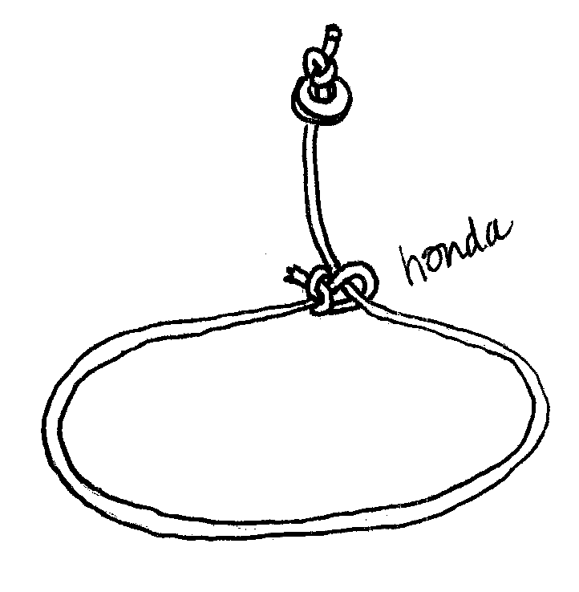
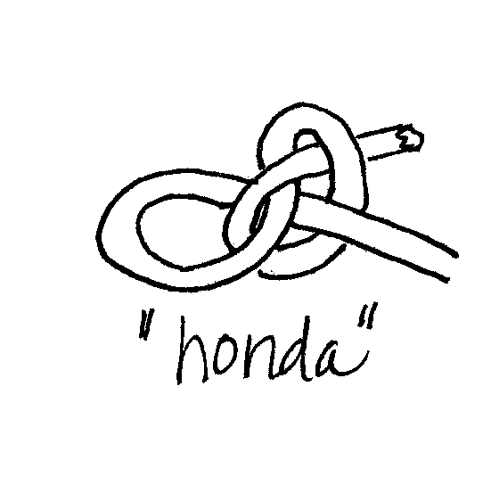

To adjust the rope for spinning, hold the lariat at the honda; the loop should hang down. The length of the rope from the honda to the washer and knot is called the “spoke.” When the loop is the proper size, the spoke should hang down from the honda halfway to the bottom of the loop. Adjust the rope so this is so. When you have the rope adjusted properly, be sure the skip knot is pulled tight so that the loop size won’t change.

The easiest spin to learn is the “flat loop.” Find a space where there is plenty of room, and stand with your feet slightly apart and your body leaning slightly forward at the waist. Hold the rope at the honda in your left hand (assuming you are right-handed; a left-handed scout may need to switch hands/directions). Place the knotted end of the spoke with the washer loosely between the second and third fingers of your right hand so that the knot faces the palm of your hand. Your right hand is called the “spoke hand.”
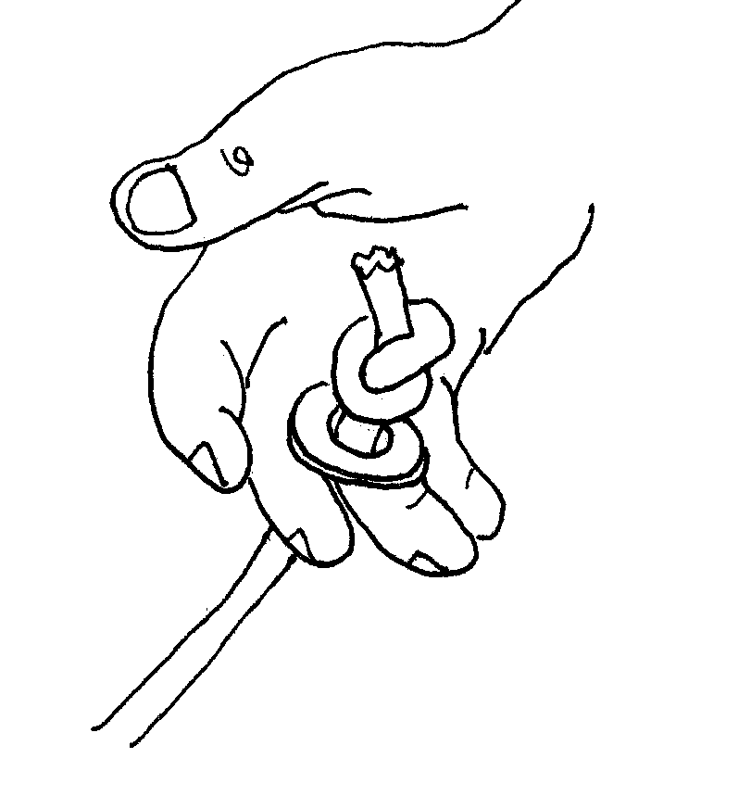

Bring the loop over to your right hand and let it lie loosely across the fingers of that hand. You’re now ready to throw out the rope and start spinning.

Throw out your right hand in a counterclockwise direction away from your body. At the same time, release the loop from both hands, while still loosely holding the spoke. Your right hand should continue to make counterclockwise movements while the loop spins parallel to the ground and the spoke slips and turns between your fingers. This slipping is important if you wish to avoid “wind up” and rope kinking. (Cowboys don’t use washers on their ropes, but this is a good way to learn.)

Keep trying to throw out the rope and get it spinning before the loop touches the ground. If the rope seems too big or clumsy, you can shorten it or try standing on something sturdy. Don’t try to make the rope spin too fast—the secret of good rope spinning is to “get the rhythm.” Of course, there are many other rope tricks you can learn, but the first step is to learn this flat spin—and to be able to get it going in both directions.

Skit

“Frontier Life”

A narrator tells a story of the harsh frontier life out on the prairie. Scouts perform various actions cued by the narrator, including a large group to act as a thundering herd of buffalo, and three act as “volunteers.”

The narrator begins by asking for three volunteers from the audience (pre-selected and cued). They are asked to come forward and lay down on their stomachs next to each other. The narrator then says, “Now to begin. Frontier life out on the prairie was very harsh. First, the wind swept across the prairie” (a scout comes out with a broom and sweeps the backs of the three volunteers while making wind noises).

The narrator continues with “The sun beat down” (another scout shines a flashlight on the heads and backs of the volunteers). “And the rain came down” (another scout sprinkles water on them). The narrator continues with the story, explaining how difficult it was to plant crops and build homes, etc, with each of the element actions being repeated in turn.

Finally, the narrator explains, “Worse than the wind, sun and rain was the constant fear of a buffalo stampede.” (On that cue, a large group of scouts charges across the stage toward the volunteers, who get up and run off stage in fear.)

Cowboy’s Dreams
(Tune: My Bonnie)

Last night as I lay on the prairie,
And looked at the stars in the sky,
And I wondered if ever a cowboy
Could drift to that sweet by and by.
Roll on, roll on,
Roll on, little doggies, roll on, roll on.
Roll on, roll on,
Roll on, little doggies, roll on.
The road to that bright happy region
Is a dim narrow trail, so they say;
But the broad one that leads to perdition
Is posted and blazed all the way.
Roll on, roll on,
Roll on, little doggies, roll on, roll on.
Roll on, roll on,
Roll on, little doggies, roll on.
They say there will be a great roundup,
And cowboys like doggies will stand,
To be cut by the riders of Judgment,
Who are posted and know every brand.
Roll on, roll on,
Roll on, little doggies, roll on, roll on.
Roll on, roll on,
Roll on, little doggies, roll on.
I wonder if ever a cowboy
Stood ready for that Judgment Day,
And could say to the boss of the riders,
I'm ready -- come drive me away.
Roll on, roll on,
Roll on, little doggies, roll on, roll on.
Roll on, roll on,
Roll on, little doggies, roll on.

Get Along, Little Dogies

As I was walking one morning for pleasure,
I saw a cowpuncher come riding along;
His hat was thrown back and his spurs were all jingling,
And as he approached, he was singing this song:
Yippee ti yi yay, get along little doggies,
Tis your misfortune and none of my own.
Yippee ti yi yay, get along little doggies,
For you know Wyoming will be your new home.

Tin Lantern

Materials:
Empty tin can (coffee can size is best, but any size will work)
Wire coat hanger, other wire or heavy twine
Candle (at least 1” shorter than the can)

Utensils:
Colored marker or crayon
Newspaper or towel
Nails
Hammer
Wire-cutting tool or scissors

Remove any labels from can and wash thoroughly. Using a colored marker or crayon, draw a punch-hole pattern on the can. Make a traditional design or invent your own.

Fill the can with water and put in the freezer until the water is solid ice (one or two days, depending on the size). The ice will keep the can from collapsing when you make the holes.

Remove the can from the freezer and place on several layers of newspaper or a folded towel. Using a hammer and nail, hammer holes in the tin can following the pattern you have drawn. You can vary the size of the holes by using different-sized nails. Make holes for the handle at opposite sides of the can rim. When all the holes have been punched, invert the can to remove the ice.

Use wire cutters or scissors to cut a length of wire or twine and attach across the can for a handle. (If using twine, be sure to lay it over to one side when the candle is lit.)

Drip wax from the candle into the bottom of the lantern and stand the candle in it, holding until set.

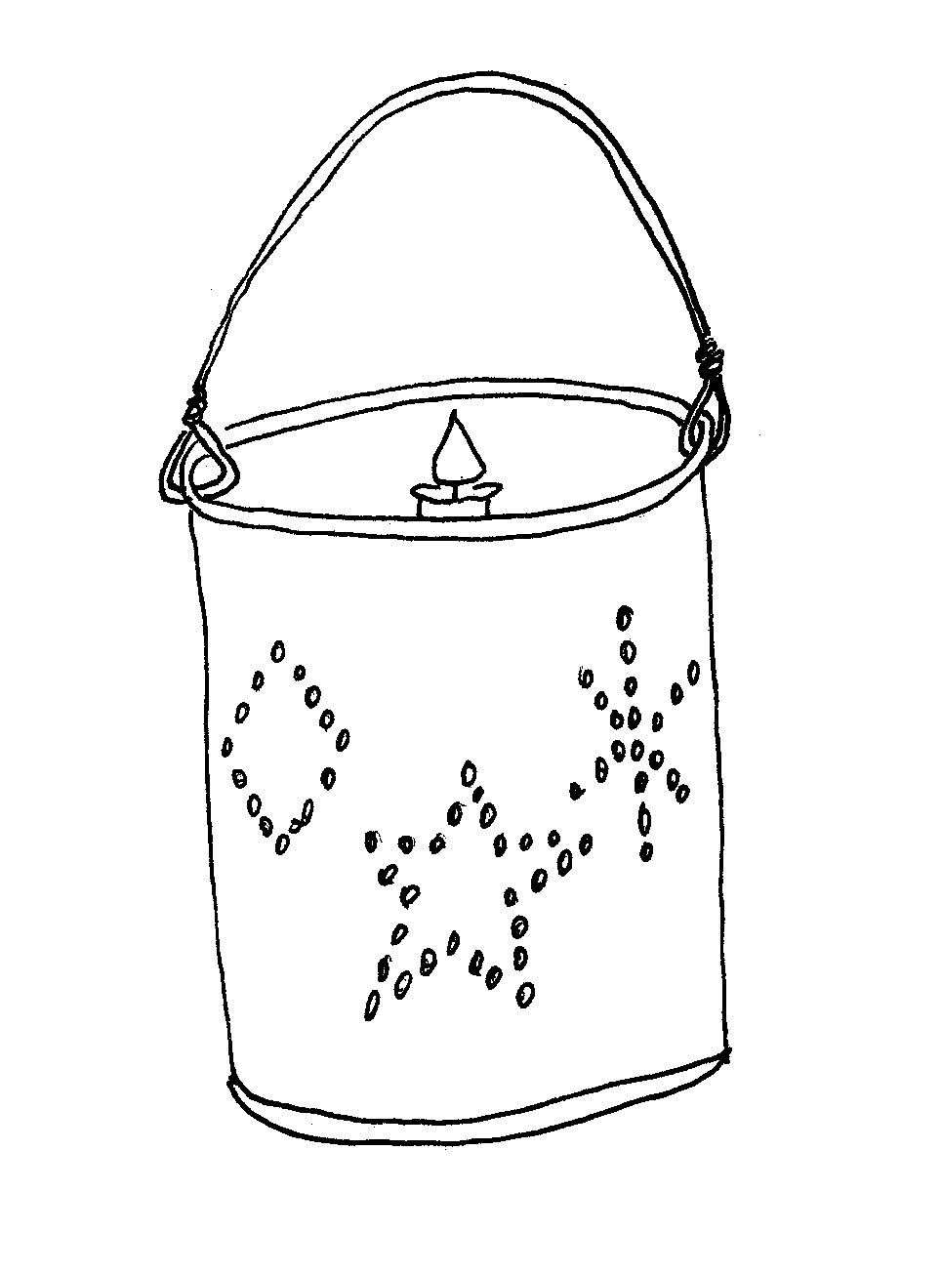
Corn Popper

Materials:
Piece of metal wire window screening, about 2’ square
Wire coat hanger

Tools:
Felt-tipped pen or crayon
Yardstick
Large scissors

Using a felt-tipped pen or crayon and a yardstick, draw an equilateral triangle (all 3 sides the same length) with each side about 18-24 inches long. Using a large pair of scissors, cut out the triangle, saving a piece of the scrap. Fold in about ½ inch along all 3 edges; you can do this with your fingers, using the yardstick as a guide, and being careful not to poke yourself on the prickly screen wires.

Lay the triangle flat, with the folded edges facing up, and, with the yardstick and marker, draw lines from the center of each side to the center of the next one, forming a smaller equilateral triangle in the center.

Carefully fold up each of the 3 corners of the large triangle, bending along the lines of the small triangle. Remove some of the wires from the screen scrap, and use them to fasten the sides together in a couple of places on each edge, but not too close to the top (since you’ll need to be able to pull the top back to get the popcorn in and out).

Form the wire coat hanger into a handle, and poke the hook end through 2 of the top triangle points.
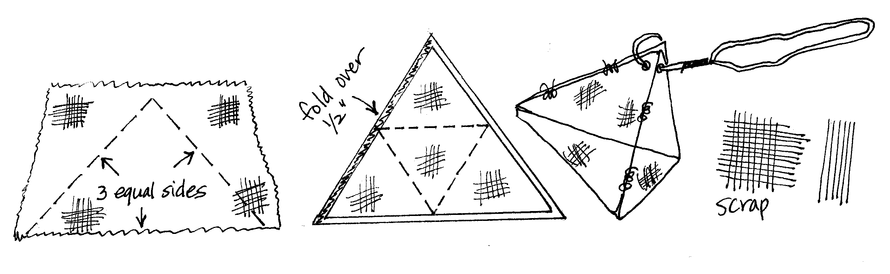
To make popcorn, pull back the 3rd triangle point and add enough kernels to cover about half of the bottom of the basket. Do not use any cooking oil. Place a potholder around the handle, and hold the basket a few inches above the heat source (stove burner or campfire flames). IMPORTANT: continually shake the basket gently to keep the kernels moving around so as to heat and pop evenly without scorching. In about a minute, the first kernel should pop, and within a few more seconds you will see most of the kernels explode in the basket. Continue shaking the basket so that the already popped corn won’t burn and the unpopped kernels will fall to the bottom of the basket.

When the popping has slowed down and almost stopped, take the popper from the heat. Using potholders, carefully remove the handle, and open all 3 points to pour the popcorn into a bowl. You may wish to add melted butter and/or salt or other seasoning.

Your popper will cool quickly and does not need to be washed. It also makes some of the best tasting popcorn you’ll ever eat!

Covered Wagon Model
(Adapted from FamilyCrafts.com)

Here’s a model of a covered wagon that you can make from materials found around the house.

Supplies:
- 1 empty pint size milk carton
- Construction paper
- 4 bottle caps, or lids from milk jugs (Pogs)
- Glue or tape
- Markers or paint

Directions:
- Cut the milk carton in half as shown by the dotted lines below. Keep the bottom half with the top point, and paint it brown (adding a little glue to the paint will help your paint adhere to the milk carton better). Set it aside to dry.

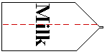

- Paint the 4 bottle or milk caps black or brown to make the wheels for the wagon. You can also cut small circles from black or brown construction paper and glue them to the outside of the caps. As a substitute for the bottle or milk caps, try to find some big buttons, or anything else that is small and round.
- Cut a piece of white construction paper about 8” x 5”. Glue or tape it over the opening you cut in the milk carton to make the cover for your wagon.
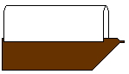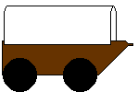

- Glue the wheels into place. (This is the tricky part, so be patient) If you are using the bottle or milk caps they will be heavy and you will have to work to find a good position to lay your wagon until the wheels dry. You will want most of each wheel attached to the wagon body with very little hanging over the bottom edge. If you want, glue on the wheels for one side at a time and let it dry lying on the side.
You can get a toy plastic horse for your covered wagon. Attach the horse to your covered wagon with string.
Pickle Games

Pickle Person Contest: Give each scout a giant dill pickle on a paper plate with yarn, beads, pipe cleaners, and other material for decorating the pickle. Stick the materials to the pickle with tacky glue. Have each scout write his name on the plate, and decorate the pickle to look like a person. Award prizes for the funniest pickle person.

Pickle Relay: Divide the group into two or more teams. Give each scout a toothpick. Each team is given a small sweet pickle and they must pass the pickle down the line using only their toothpick. No hands allowed!

Hot Cucumber: Play a game of “hot potato”, using a large cucumber.

Pickle Plunge: Have kids take off their shoes and socks, and dig pickles out of a tub of ice with their toes.

Go Hunt in the Hay

In a small pile of hay, hide pennies or little toys, which the kids must fell around for with their eyes shut.

Lasso Practice

Using a hula-hoop and a child’s wooden rocking horse, have cowboys try to “rope” the horse’s neck. You can also setup folding chairs around the room, and have the boys try to rope the backs of the chairs.

Shoot-out at the OK Corral

Spread small, inexpensive plastic bugs on the sidewalk and have kids shoot at the bugs with squirt guns. Anyone who moves a bug with the stream of water gets to keep it. Or, cut out silhouettes of animals from tissue paper, affix them to a fence and let each kid shoot one. The first one to put a hole through her target wins.

Throwing the Neckerchief

The players sit in a circle, and one stands in the center. A neckerchief is twisted and tied into a ball and is then thrown from one seated player to another, with the person in the middle trying to intercept and catch it. When he succeeds in doing so, he takes the place of the player who last threw it, and that player becomes the one in the center.

Earth, Air, Water

The players form a circle, and one stands in the center holding a neckerchief knotted into a ball. He counts up to ten, then throws the ball into someone’s lap, calling out either “Earth,” “Air,” or “Water.” If he cries “Earth,” the person in whose lap the neckerchief has fallen must instantly name some animal which lives on earth; if the word was “Water,” some fish must be named; and, if “Air,” some bird. If the ball-thrower counts to ten without his answering, he either leaves the circle or loses a point or becomes the thrower (whatever scheme is most fun for your group).

Haystack Sandwich

Ingredients:
- Sliced ham
- Sliced Swiss cheese
- Horseradish sauce or mustard
- Romaine lettuce
- Sliced tomato (about ¼ thick)
- Sourdough bread, sliced
- Thin slices of apple

Directions:
- Lightly toast the bread slices and spread the horseradish sauce (or mustard) on one side.
- Add ham, cheese, tomato, apple and lettuce. (Stack as how as you like)
- Top with another slice of bread.

Dried Apple Rings

Start with firm, ripe apples (as many as you like), with a strong, tart flavor. Peel and core them; then slice them across the core into rings about ¼” thick.

Dry the apples as quickly as possible before they spoil. String the rings on a length of twine and hang it between any 2 hooks in a warm, dry, airy place. Drying can be done indoors or out. If outside, be sure the weather is sunny and dry, and bring the apples indoors if it becomes damp or rainy and during the nighttime dew. If flies or insects try to feed on your drying apple rings, cover them with a piece of cheesecloth. Outdoor drying during warm weather may take only a few days, whereas it may take up to two weeks to dry the apples indoors.

For indoor drying, hand the string of apple rings in the driest and warmest place in your house. Depending upon the time of year, this might be in your kitchen, by a radiator or heater, or in the attic. Don’t try to dry the rings in the oven, since heating them too quickly causes an outside skin to form and prevents the inside from drying.

Dried apple rings are usually eaten as a sweet snack, but they can also be put into cereals, cakes and other baking recipes. They can be carried and stored safely without refrigeration, which makes them a perfect snack on hikes or long car rides. They can be stored (for years!) in a jar with a tight lid without losing their flavor.

Chocolate Orange Zest Cake
6-8 oranges
1 Chocolate Cake Mix (eggs, water and oil as required)
Icing (optional)
Foil

Use a lemon zester, grater or microplane to grate some of the orange peel. Cut a hat off the top of each orange, and remove the orange contents from within the peel, without ripping or poking a hole in the peel. (The orange fruit may be eaten as a snack or used for another purpose.)

Prepare the cake mix as directed, and add the orange zest (peel). Fill the orange ½ full with the mix. Cover with the orange peel hat, and then wrap it all in foil. Place on the fire pit grill, and let bake for approx. 10 minutes (may take more or less time, depending on heat conditions). Open carefully, and voila! You have a tasty treat. Put on some icing if you wish, but not necessary with the orange flavoring.

Double Berry Pie

Ingredients:
- 1 jar (16 oz.) blueberry jam
- ¼ tsp. ground cinnamon
- 2 cups fresh blueberries or raspberries
- 9-inch frozen pie shell, cooked & cooled

Directions:
- Using a microwave safe bowl, combine jam and cinnamon. Microwave on high for about 1 minute, until mixture liquefies (do not overcook).
- Stir in the fresh berries and spoon into pie shell.
- Place in refrigerator for a hour to chill.
- Serve with vanilla ice cream.

Crispix Ranch Mix

Ingredients:
- 8 cups Kellogg’s Crispix cereal
- 1½ cups bite-size cheddar cheese crackers
- 1 cup pretzel sticks (low-salt)
- 2 cups mixed nuts (unsalted)
- 2 tbs. vegetable oil
- 1 package (1 oz) dry ranch salad dressing

Directions:
  - Using a 2 gallon storage bag, combine the Crispix, cheese crackers, pretzels and nuts. If any of your boys are allergic to nuts, substitute with sunflower seeds or other snack food.
  - Pout oil over the mixture and gently toss until evenly coated.
  - Add the ranch dressing and gently toss again to coat.
  - Store in an airtight container until ready to serve.

