A Cub Scout Gives Goodwill

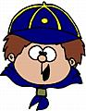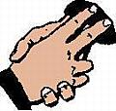

December 2003
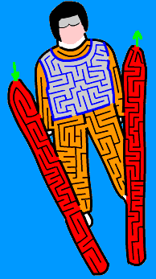

Opening

Building A Better World
11 Cub Scouts, each holding a card with a letter on the front and his line on the back. Each speaker holds up his letter as he says his line. Last line delivered by all.
B for BROTHERHOOD, boosting for each other's good
E for EVERY LAND to share in earth's riches everywhere
T for TRUSTFULNESS, trusting more and fearing less
T for TEAMWORK, for joining hands to put things through
E for EQUAL CHANCE for each nation to advance
R for REAL RESPECT in spite of race, creed, or sect.
W for WILL TO WORK for peace with faith and skill
O for OPPORTUNITY to keep our speech and action free
R for REVERENCE for a guiding providence
L for LOVE TO SPREAD around when need and bitterness are found
D for DIGNITY of man devoted to a better plan.
(All hold up letters)
There you have it - that is how you build A BETTER WORLD.

Goodwill Opening

“And the angel said, ‘Peace on earth, goodwill toward men.’ Cub Scouts give good will by being thoughtful and kind, and by doing good turns. In this Magical Holiday Season, may our good will shine as brightly as the Star in the East, so that other people will follow our example.

“And now, please stand and join me in the Pledge of Allegiance.”

Season of Lights Opening

Setting: Cub Scouts leave the room and march back in by dens. Dim the room lights and have each denner hold a single candle or small flashlight as the dens return. When the dens have reached their places, the Cubmaster makes the following remarks:

“This is the season of lights. It is the time when the days are shorter and the nights are long. But somehow the world seems brighter.

“Thousands of homes have candles to light the way for the Christ child. Thousands of other homes have candles burning to commemorate the miracle of the oils of Hanukkah. Even the stars in the winter sky seem brighter.

“But the most brilliant glow comes from the spirit of goodwill that you live all year round in the Cub Scout Promise and the Law of the Pack. Please repeat them with me.”

Closing

Beatitudes Closing

“As the Cub Scouts and Webelos of our pack have demonstrated the meaning of goodwill, I think it is appropriate to close with the ‘Beatitudes for Children,’ as a reminder that the children of today are our hope for tomorrow.”

Blessed is the child…
Who has someone who believes in him and has high hopes for him.
Who has someone to whom he can carry his problems unafraid.
Whose home is a haven of happiness.
To whom life is a book of knowledge and who is privileged to turn the pages one by one.
Who is allowed to pursue his curiosity into every worthwhile field of information.
Who has someone who understands that childhood’s griefs are real and bitter and call for loving empathy.
Who is led gently by the hand along the pathway of life by someone who is guide, companion and inspiration.
Who has about him those who believe in his divinity and not his depravity.
Whose love of the truth, the beautiful and the good has been nourished through the years.
Whose innate imagination has been turned into channels of creative effort.
Whose efforts to achieve have found encouragement and kindly commendation.
Blessed is the home or community or nation which sees in a child the hope of the future and dedicates itself to the realization of that hope.

“May we all in this season and throughout the years strive to Do Our Best to make every child feel blessed.”

Cubmaster’s Minute

A Good Turn

A Good Turn that we do in our daily lives are the things that make us useful. The Good Turn enables us to be useful in our home, school, church, community, and our country. The Good Turn raises us above the ordinary person. It makes our lives worthwhile.
Advancement

Holiday Advancement

(This requires a bit of advance preparation. All boys who are to receive awards need to be notified that they should bring a can or food or small gift to the meeting.)

You’ll need a Christmas tree.

Cubmaster/Santa: I came from the North Pole tonight to share in the spirit of giving. Everyone should be able to feel the rewards of this wonderful season. We have several boys here tonight to whom I would like to give something—something for which they have worked very hard and deserve to receive. They will also be giving of themselves to those who are less fortunate, which is the sign of a true Scout. (Call out boys’ names, one at a time, and present each with his award and an ornament. The boy places his ornament on the tree and his food or gift under the tree.)

Just look at the glow and feel the true spirit of giving. These Scouts have not only worked hard all month to earn their awards, but have shown that extra measure of kindness and giving in this season of goodwill.

Globe Advancement

Setting: Place a world globe on a table. Place candles around the globe, one for each rank to be given out. Dim the room lights. Assistant Cubmaster holds a lighted candle.

Cubmaster: We read in the newspaper every day about wars. Television shows us daily pictures of bombings and destruction in many parts of the world. This is a dark picture, and not what each of wants for ourselves and our children.

Scouting is one of the things that helps to bring people together because its ideals and goals are the same everywhere. We tend to think of Cub Scouting as just our Pack and our Den. But there are Cub Scouts like us in countries around the world.

____Name_____ holds a candle representing the spirit of Cub Scouting. As we present our advancement awards tonight, he will light a candle next to the globe fore each rank.

We have some boys who have passed the requirements for the rank of Bobcat. Will ___names____ and their parents please come forward? (Present badges to parents to pin on boys’ uniforms and parent pins to boys to give to parents. Light the Bobcat candle.)

(Repeat for each rank.)

Notice how the darkness surrounding the world has gone away as the light of the Cub Scout spirit has spread around the globe. If we all continue to work on our achievements and keep the Cub Scout Promise, we can keep the light bright and help our world to be a better place for everyone.

Audience Participation

The House Where Santa Claus Lives

Santa enters and tells the following story:

Old Santa has traveled many a mile to be with you. He has been impressed with your preparations for the holiday season and has had a look into all your homes. Tonight, Santa would like to tell you about a house you have never seen before. It is the house where Santa Claus lives. While I tell you this story, I will need your help for certain words. Every time these words are spoken, I want you to make certain signs. Let’s all practice them before we start the story.

HOUSE – Hands overhead in an inverted V.
SHED – Hands in front of chest in an inverted V.
SLED – Right hand moves in waving motion from right to left.
REINDEER – Both hands, palms forward and fingers spread, on either side of head.
PACK – Both hands over right shoulder, as if carrying a load.
LITTLE GIRLS – All girls, young and grown, stand up.
LITTLE BOYS – All boys, young and grown, stand up.
BOX – Show dimensions, length and width, with hands.
DOLL – Both hands, palms together, at right side of head, with head slightly tilted.
LION – Extend both hands in the shape of claws and give a deep growl.
SOLDIER – Give Cub Scout salute while standing at attention.
TRAIN – Draw a figure 8 in the air.
SANTA CLAUS – Pat stomach with both hands and say, “Ho, ho, ho.”

Now, let’s begin our story.

This is the HOUSE where SANTA CLAUS lives.
This is the SHED behind the HOUSE where SANTA CLAUS lives.
This is the SLED that is kept in the SHED behind the HOUSE where SANTA CLAUS lives.
These are the REINDEER that pull the SLED that is kept in the SHED behind the HOUSE where SANTA CLAUS lives.
This is old SANTA CLAUS who guides the REINDEER that pull the SLED that is kept in the SHED behind the HOUSE where SANTA CLAUS lives.
This is the PACK all filled with toys for good LITTLE GIRLS and good LITTLE BOYS that is carried by old SANTA CLAUS who guides the REINDEER that pull the SLED that is kept in the SHED behind the HOUSE where SANTA CLAUS lives.
This is the BOX that is in the PACK all filled with toys for good LITTLE GIRLS and good LITTLE BOYS that is carried by old SANTA CLAUS who guides the REINDEER that pull the SLED that is kept in the SHED behind the HOUSE where SANTA CLAUS lives.
This is the SOLDIER that shot the LION that frightened the DOLL that is in the BOX that is in the PACK all filled with toys for good LITTLE GIRLS and good LITTLE BOYS that is carried by old SANTA CLAUS who guides the REINDEER that pull the SLED that is kept in the SHED behind the HOUSE where SANTA CLAUS lives.
This is the TRAIN that carried the SOLDIER that shot the LION that frightened the DOLL that is in the BOX that is in the PACK all filled with toys for good LITTLE GIRLS and good LITTLE BOYS that is carried by old SANTA CLAUS who guides the REINDEER that pull the SLED that is kept in the SHED behind the HOUSE where SANTA CLAUS lives.

Now old Santa must be on his way. He has one parting thought for all of you. Keep the Cub Scout Promise and always do your best. If you do, you can make it Christmas every day of the year. Merry Christmas everyone!

(Note: The story can be presented without the aid of a costume. Presenter says, “I’m going to tell you a story about the house where Santa lives. There will be certain signs for you to make. Anyone seen not making the signs will have to come up in front and help me.”)

Run-ons

Cub #1: What would you get if Minnehaha married Santa Claus?
Cub #2: Minnehaha Hoho.

Cub #1: Why do mother kangaroos hate rainy days?
Cub #2: Because their children have play inside.

Cub #1: If a farmer raises corn in dry weather, what does he raise in wet weather?
Cub #2: An umbrella.

Cub #1: What is brown, has a hump, and lives at the North Pole?
Cub #2: A lost camel.

Cheer

"Shine Your Halo" Children open palm and move in a circular motion over their head.

A Gift of Goodwill

Personnel: Den Chief & 8 Cubs

Setting: A group of 8 Cub Scouts are gathered around. Each boy is wrapping a gift. Den Chief enters.

Den Chief: Hey, guys, let me see what each of you is wrapping.
Cub 1: Gloves for my dad.
Cub 2: An owl plaque for my mom.
Cub 3: Oreo cookies for my little brother…so maybe he’ll quit eating mine!
Cub 4: A doll for my sister.
Cub 5: Wind chimes for my mom.
Cub 6: Ink pens for my brother; he really likes to write.
Cub 7: A lamp for my mom.
Cub 8: A lacy handkerchief for my grandmother. She likes to wave goodbye.
Den Chief: Hey, you guys are really giving goodwill. (He laughs.)
Cub 4: We hope so.
Cub 6: Aren’t we supposed to do that all year?
Den Chief: Yes, but let me show you something unusual. (He takes a large piece of posterboard and a marking pen. He calls on each boy in order to name again the gift he is wrapping, and writes the first letter of each on the board (such as ‘G’ for gloves). The result spells out ‘Goodwill,” which he olds up for the audience to see.)
Cub1: Hey, that’s right! We’re giving goodwill separately and together! (Looks at Den Chief) Figure that one out!

Spread Some Holiday Cheer  (Tune: We Wish You A Merry Christmas)  (Pretend to ring bells.)  Let's all do a little ringing...  Let's all do a little ringing...  Let's all do a little ringing...  To spread holiday cheer.  (Clap hands.)  Let's all do a little clapping...  Let's all do a little clapping...  Let's all do a little clapping...  To spread holiday cheer.  (Twirl a string or rope)  Let's all do a little twirling...  Let's all do a little twirling...  Let's all do a little twirling...  To spread holiday cheer.  (Jump up and down)  Let's all do a little jumping...  Let's all do a little jumping...  Let's all do a little jumping...  To spread holiday cheer.  (Big smiles from everyone)  Let's all do a little smiling...  Let's all do a little smiling...  Let's all do a little smiling...  To spread holiday cheer.  Everyone quietly sits down.  Oh, Saint Nicholas  (Tune: Old McDonald Had A Farm)  Old St. Nicholas had a tree  (form tree with arms)  Ho, ho ho ho ho!  And on that tree he had some horns  (blow horns)  Ho ho ho ho ho  With a toot toot here and a toot toot there  Here a toot There a toot  Every where a toot toot  Continue.... substitute horns with:  lights-------flash flash  candy canes-------yum-yum  drums-------boom-boom  bells---------ring ring  birds------peep peep  stars------twinkle twinkle | Here’s A Little Candle  (Tune: Here’s A Little Teapot)  Here's a little candle dressed in white,  Wearing a hat of yellow light.  When the night is dark, then you will see  Just how bright this light can be.  Here's a little candle straight and tall,  Shining it's light upon us all.  When the night is dark, then you will see  Just how bright this light can be.  Here's a little candle burning bright.  Keeping us safe all through the night.  When the night is dark, then you will see  Just how bright this light can be!  Reindeer Poky  (Tune: The Hokey Poky)  You put your antlers in. You put your antlers out.  You put you antlers in and you shake them all about.  You do the Reindeer Poky and you turn yourself around.  That's what it's all about!  You put your hooves in....  You put your red nose in....  You put your fluffy tail in...  You put your reindeer body in...  Light The Candles Bright  (Tune: Farmer in the Dell)  Oh, light the candles bright,  And dance around the light.  Heigh-ho the derry-oh,  It's Hanukkah tonight.  Spin the dreidel round,  And watch it falling down.  Heigh-ho the derry-oh,  It's Hanukkah tonight.  Latke treats to eat,  And family to greet.  Heigh-ho the derry-oh,  It's Hanukkah tonight.

Cinnamon Cookie Cutter Ornaments

¾ cup water
1 cup cinnamon
4 tablespoons white (Elmer’s) glue
Combine all ingredients. Refrigerate for 2 hours. Knead in your hand until workable. Roll out on a board between 2 layers of waxed paper. Use cookie cutters to make shapes. Use an ice pick, toothpick or chopstick to make holes in the tops for threading a ribbon for hanging.

Candy-Cane Napkin Rings

Supplies: Red & white pipe cleaners (chenille stems)
Wire cutters or utility scissors

(Two pipe cleaners (1 red, 1 white) will make two napkin rings.)

To begin, twist one white and one red pipe cleaner together, being certain to evenly space the colors as you twist them. When they’re twisted into one piece, use wire cutters or scissors to cut them in half.

Shape each half into a circle and twist the ends together to form a ring. Slip a napkin through each ring, reshaping if necessary.
Indoor Snowman Making Contest

Divide the Pack into four or more groups, and give each group materials to make a garbage bag snowman (large white garbage bags, newspapers, tape, etc). See which team can make the best snowman in a given amount of time. The teams can make the snowmen anyway way they wish. Have the scouts fill white garbage bags with wrinkled newspaper. Place the filled bags on top of each other to make a huge snowman. Use construction paper, crayons, markers, ribbon, glue, tape, etc. to decorate the snowman.

Indoor Sled Race

Use large cardboard boxes. Divide the group into teams and have a relay race. Each team member takes a turn in the sled “box or piece of cardboard.” The other team members have to push or pull the person in the sled to a line marked across the room and back to the start. Another team member gets into the sled and the team does the same thing. Keep playing until one team has pushed all their team members across the room and back to the start line.

Cinnamon Rolls

2 cans crescent rolls ¼ cup sugar 1 cup powdered sugar
1 stick softened butter 1 teaspoon cinnamon 2 tablespoons milk
Unroll crescent rolls and make 4 rectangles from dough. Spread with butter. Combine cinnamon and sugar and sprinkle over dough. Roll each rectangle into a long roll, then cut each into 5 slices. Place slices cut side down in a lightly greased pan. Bake 20 - 25 minutes. Cool slightly, then drizzle with mixture of powdered sugar and milk.

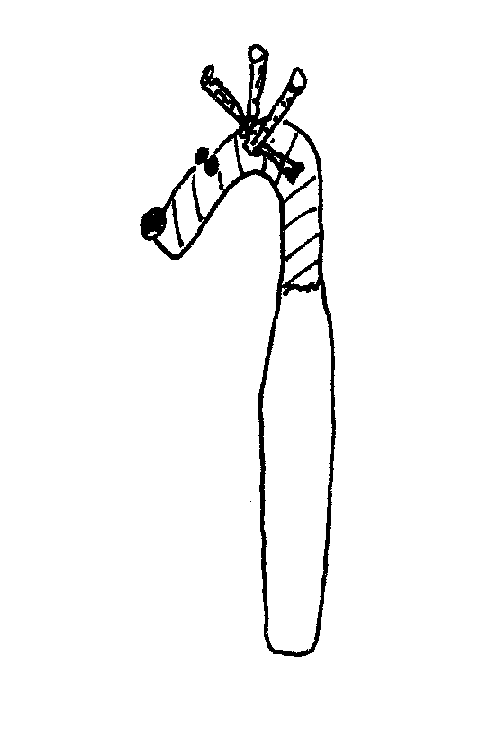

Candy Cane Reindeer

8 oz white candy coating
12 candy canes (6”)
12-20 regular size pretzel twists
12 red-hot candies
24 candy-coated milk chocolate balls
or miniature chocolate chips

In a microwave or heavy saucepan, melt candy coating. Stir until smooth; keep warm. Holding the curved end of a candy cane, use a spoon to drizzle coating over the straight part of the cane. Gently shake off excess. Place on waxed paper to dry. Break pretzels into pieces to resemble antlers.

For each reindeer nose, dab a small amount of the melted coating onto a red-hot. Press onto the end of curved portion of the candy can and hold for about 10 seconds. For the eyes, dab a small amount of coating on two chocolate balls or mini chips and attach to candy cane above nose.

Dab small amount of coating onto the candy cane where the antlers will be attached. Press pretzel pieces into the coating and hold for about 30 seconds. Place in mug or drinking; let dry for about an hour.

Tasty Menorahs

Ingredients: Bread, cream cheese or butter, carrot sticks, pretzel sticks, raisins
Spread bread with cream cheese or butter; arrange 8 pretzels as candles and carrot stick as large candle in center. Use raisins as flames at ends of carrot and pretzel sticks.

