Fiesta!

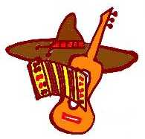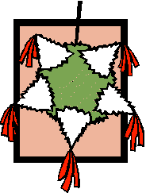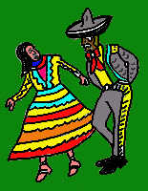

February 2004



Opening

F-I-E-S-T-A

You’ll need 6 cards with one letter on the front and the appropriate words printed on the back.

F Fun is in the air.
I It’s too exciting to sit in a chair.
E Eagerly we are led.
S Sombrero—it’s on my head.
T Tacos, tostadas, let’s not wait.
A All are good—let’s celebrate!

Closing

In Spanish, fiesta means a party with music, wonderful food, dancing, laughter and fireworks. In any language, it means fun. Let us take a moment to reflect on the fun and fellowship we share whenever we’re together, and resolve to continue to do everything we can to give our scouts the chance to have fun while learning and growing.

Advancement

“Fiesta Pinata Ceremony” (You’ll need a piñata, with the awards pinned or taped to it.)

Tonight, we are enjoying a real fiesta. Everyone is having fun, but there is a more serious not to the festivities. Tonight, we also come here to honor some of the boys in our pack. These boys have been working very hard during the past month. As you can see, here we have a piñata, a very special piñata with several awards attached.

First, let’s call up our new Bobcats (calls up boys and parents). You are just beginning the Fiest of Cub Scouting. I hope you will continue to have fun. (Presents award to parents, who give to boy. Remember to pin Bobcat badge upside down until the boy does a good turn. Give parent pins to boys to present to parents.)

Next we have some Wolf Badges and Arrow Points to present. (Call up boys and parents, again presenting badges to the parents to give to boys and parent pins to boys for their parents.) These Scouts are well on their way—olé!

Look, here are some Bear Badges and Arrow Points. (Call up boys and parents and make presentations and suitable comments.)

Oh, I see there are still some awards on our piñata. These must be for our Webelos Scouts. Webelos Leader(s), would you please come forward and award these pins and badges? (Webelos Leader(s) present awards with explanations, as needed.)

Now we have come to the end. There are no more awards left on our piñata. But, we have all had fun and learned much this month. Let’s give everyone who earned an award the Fiesta cheer: “Olé!”

Audience Participation

“Jose’s Dilemma”

Assign the parts to 5 groups; everyone will respond to FIESTA with “Olé.”
JOSE: I want to go MAMA: Take your sombrero
SOMBRERO: It’s too hot SISTER: Take me, Jose
BURRO: Hee-haw FIESTA (Everyone): Olé

Scene is a small town in Mexico, about 65 years ago.
JOSE was excited. It was almost time for the FIESTA parade. He was going with his MAMA and SISTER. His father had already taken the BURRO and cart with a load of goods for the market. “Hurry, JOSE,” called MAMA, “it’s time to go to the FIESTA. Get your SOMBRERO and meet your SISTER outside.” JOSE looked all over the house but he could not find his SOMBRERO. “SISTER,” he called, “have you seen my SOMBRERO?” JOSE’s SISTER replied that she had not.

JOSE searched some more. He must have his SOMBRERO to attend the FIESTA for the summer sun was very hot. “MAMA,” called JOSE, “have you seen my SOMBRERO?” “Hmmm,” said MAMA, “I think I saw your father put it on our BURRO when he left for market.” “Oh, no,” said JOSE, “the BURRO is wearing my SOMBRERO. I cannot go to the fiesta.” And JOSE sat down, very defeated.

“What’s the matter?” asked his SISTER. “It’s time to go the FIESTA, but the BURRO is in town wearing my SOMBRERO. I cannot go; the sun is too hot.” “I know what to do,” said his SISTER, and off she ran. Soon she returned, and in her hand was the answer to JOSE’s problem. It was yesterday’s newspaper. “Of course,” exclaimed JOSE, “I can make a paper hat just like we did in Cub Scouts last week!”

Soon the hat was made and JOSE, his SISTER, and MAMA left for the FIESTA. But, when JOSE got to town, he was quick to find their BURRO and trade the paper hat for his SOMBRERO, since it was more appropriate for the FIESTA.

Run-ons

Cub #1: What do you call a sleepy bull?
Cub #2: A bull-dozer.

Cub #1: How do you stop a bull from charging?
Cub #2: Take away his credit card.

Cub #1: What would you get if you crossed a lion with a woodpecker?
Cub #2: An animal that knocks before it eats you.

Cub #1: What is the best thing to do is you find a burro in your bed?
Cub #2: Take a siesta somewhere else.
Skit

Stunt

Broom Trick

You will need a broom to show this trick. Wrap one hand around the lowest part of the broom handle, as close as possible to the broom itself. Wrap your other hand around the handle, just above your first hand. Hold the broom out at about waist-high. Now have 5 friends put their hands around the handle above yours (the tallest boy should have his hands at the top of the broom handle), and tell them to pull the broom downward so that the bristles touch the floor. There are five against one.

Would you believe that, no matter how hard they pull and tug, they won’t be able to get the broom down? This is because you can easily deflect the downward force they exert by merely moving the broom slightly to left or right. In effect, they will be pushing the broom sideways—not downwards.

Here Is Our Piñata
(Tune: Sing a song of sixpence)

Here is our piñata
What a sight to see,
Filled with treats and goodies
Just for you and me.
When it's time to break it,
We'll circle all around
Then we'll scramble for the treats
That fall down to the ground.

Traditional Mexican song with translation

Para Quebrar La Piñata To Break the Piñata

Dale, dale, dale, Strike it, strike it, strike it,
No pieddas el tino Don’t lose your steady hand,
Mide la distancia, Measure the distance,
Que hay en el camino. That’s in the path.

To hear the music for this song, go to: http://www.mamalisa.com/world/mexico.html

Un Elefante Se Balanceaba  (Spanish)  Un elefante se balanceaba  sobre la tela de una arana,  como veia que resistia  fue a llamar a otro elefante.  Dos elefantes se balanceaban,  sobre la tela de una arana,  como veian que resistia  fueron a llamar a otro elefante.  Tres elefantes...  Cuatro elefantes...  etc.... | A Balancing Elephant  (English)  An elephant stood on the web of a spider.  She felt it was strong, it couldn't be tighter.  Along came her friend. She called to invite her.  Two elephants stood on the web of a spider.  Two elephants stood on the web of a spider.  They felt it was strong, it couldn't be tighter.  Along came their friend. They called to invite her.  Three elephants stood on the web of a spider.  Three elephants...  Four elephants...  etc....

Mexican Fish Yarn Painting

Cardboard
Pencils, crayons or markers
Yarn or embroidery floss of various colors, cut in 6” lengths
White craft glue

Draw a circle in the middle of your piece of cardboard. In the middle of the circle, draw the outline of a fish. Draw other fish, ocean creatures, seaweed and shapes in the area outside of the circle.

Spread glue on the body of the fish drawing in the center of the circle. Place pieces of yarn on the outside line of the fish body, then fill in the body with the yarn strands. Cover the tail in the same way. Next, spread glue around the fish inside the circle. Working out from the fish, cover the entire circle in yarn.

Then work on the shapes outside of the circle. Spread glue on each shape, then cover each shape with yarn. To complete your picture, work on the space in between each of the shapes until all of the space is covered with yarn.

Take a look at some Mexican yarn paintings online at: www.huicholartonline.com

Pufferfish Pinata

Supplies:
Newspaper Spoon
Large balloon Paint
Plastic bowl Paintbrush
White craft glue Pin
Water Candy/Toys

Small drill Blindfold
Wire or string Broom/stick

Note: this is a messy project, so prepare some workspace prior to starting.

Begin the project by tearing off long strips of newspaper, blowing up the balloon, and mixing the white craft glue in the bowl with some water to make a thin paste. (Try a mixture of half glue and half water to make the paste.)

Dip each strip of newspaper completely into the paste and place it on the balloon. Continue this process until you have covered the entire balloon except for a small hole in the bottom. Add 2 more layers, then let the newspaper dry overnight on your piñata.

At this point, your piñata looks like a ball, but here’s how to make it look like a spiny pufferfish. Tear the newspaper strips into smaller squares. Dip each square into the paste. Roll the small squares into cones and press them onto the piñata. These will be the spines of your pufferfish. Shape a tail with the newspaper, and glue it onto the piñata at the opposite end of the hole.

Allow the piñata to dry completely, then paint it.

When the paint has completely dried, pop the balloon with a pin and fill the piñata with candy and small toys. Plug the hole with a few crumpled sheets of newspaper. Complete the pufferfish by rolling up some of the newspaper to form two lips. Glue the lips over the hole. When dry, paint them.

Drill a couple of holes in the top of your piñata. Thread a wire or strong string through the holes and hang it overhead. (If possible, hang it over a beam or on a ceiling hook on a long rope so that it can be raised and lowered to adjust the height.) One at a time, have children, while blindfolded, take swings at the pufferfish to try and break the piñata and release the candy.

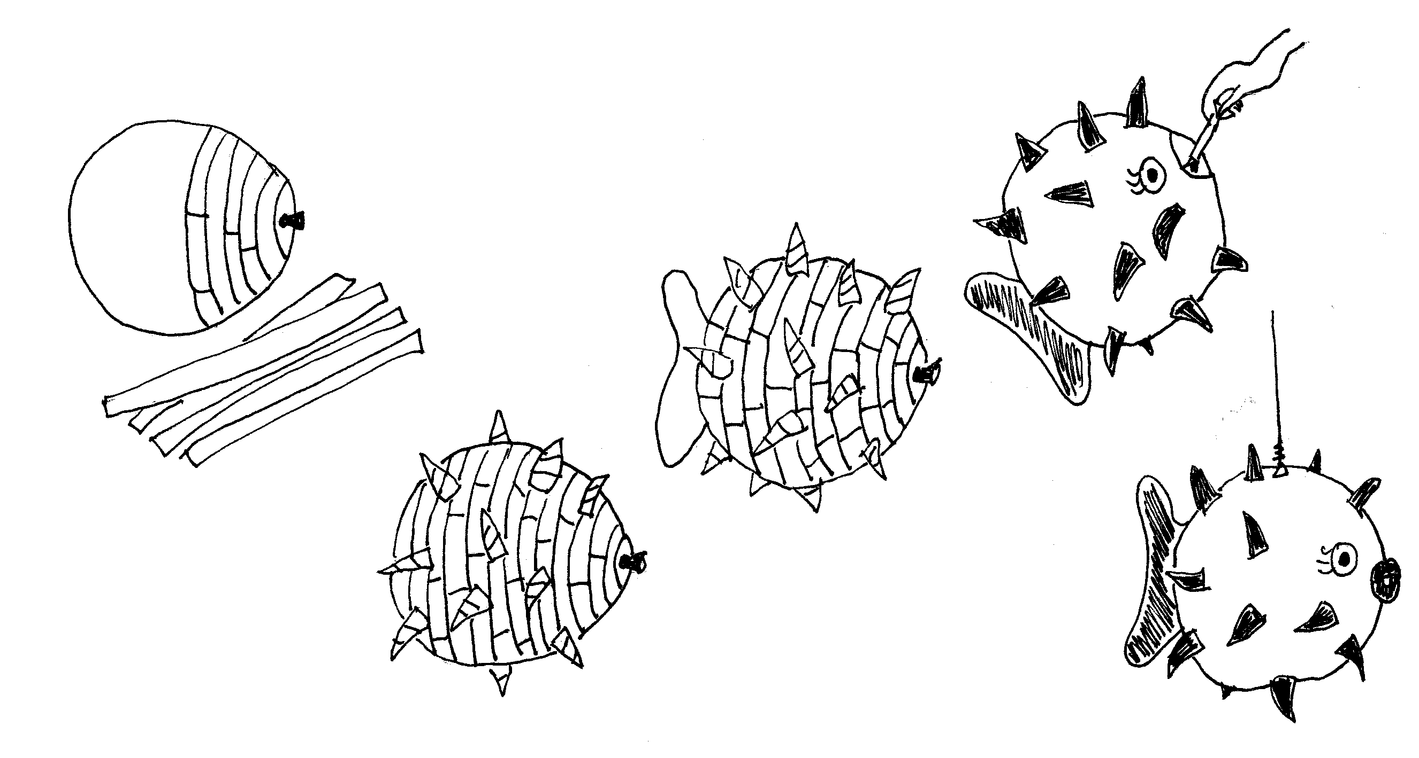

Paper Bag Pinata

Here’s a simple to make piñata that you can make from materials around the house.

Materials: A large paper bag, string, tissue paper, glue, scissors, crepe paper streamers, markers, paint and googly eyes (optional)

Directions:
- Fill the paper bag about ½ full with candy and small prizes.
- Roll the top of the bag down, staple the folded top shut and punch out two holes along the top.
- Cut the tissue paper into strips; add fringes to the strips if desired.
- Glue the tissue paper onto the paper bag, completely covering the bag.
- Decorate the bag with paper cut-outs, markers, paint, googly eyes (for a face), and any other material.
- Glue the crepe paper streamers to the bottom of the piñata.
- Tie a long string through the two holes at the top. The string will be used for hanging up the piñata.
- Hang up the piñata, and break it open with a soft bat.

Shoe Box Guitar

Here is an easy to make guitar from recycled materials.

Materials: An old tissue box or old shoe box, rubber bands, paper towel tube, scissors, pencil

Directions
- With adult supervision, cut out an oval-shaped hole in the top of the shoe box. Some tissue boxes already have an oval hole; remove the plastic that is inside the hole.
- Stretch 3 or 4 rubber bands length-wise around the box and over the hole.
- Place a pencil under the rubber bands width-wise on one side of the hole.
- Tape a paper towel tube to one end of the show box.
- Decorate the box guitar with markers or paint.

Paper Plate Maracas

A maraca is a Mexican rattle. The original maracas were made from hollow gourds filled with pebbles or seeds. A simple maraca can be made from one or two paper plates stapled together, filled with dried beans or popcorn.

Materials: One or two paper plates; dried beans, rice or poporn (un-popped); wide wooden craft sticks; markers, crayons or paint; stapler; glue

Directions:
- Place a handful or two of dried beans, rice, or popcorn on a paper plate.
- Turn another plate upside down and cover the first plate. Staple the plates together along the edge of the plates. You can also use a single plate by folding a paper plate in half, adding the beans, then stapling the edges shut.
- Staple two wooden craft sticks onto the paper plates, one on each side of the plates, to make a handle for the maraca. Glue the two sticks together.
- Decorate the maraca with crayons, markers or paint.

Festive Centerpieces

Supplies for each centerpiece:
24-27 colored candy sticks (at least as high as the can)
1 empty 16-28-oz can
1-2 rubber bands
20” ribbon (1-1.5 inches wide)

The number of candy sticks you’ll need will depend on the type you use and the size of the can. Place a rubber band around the can. Tuck candy sticks (still in their wrappers) behind the band, keeping the bottoms flush with the bottom of the can. Continue to add them around the can until it is completely covered. If you’re having trouble keeping the candy in place, add a second rubber band toward the bottom, then tuck the sticks beneath both bands. Remove one rubber band and center the other on the can before continuing to the next step.

Hide the rubber band with a ribbon that coordinates with your table decorations.

Fill the can about half full with water. (Be sure not to get water on the candy, or you’ll wind up with a sticky mess.) To complete the centerpiece, add fresh flowers.
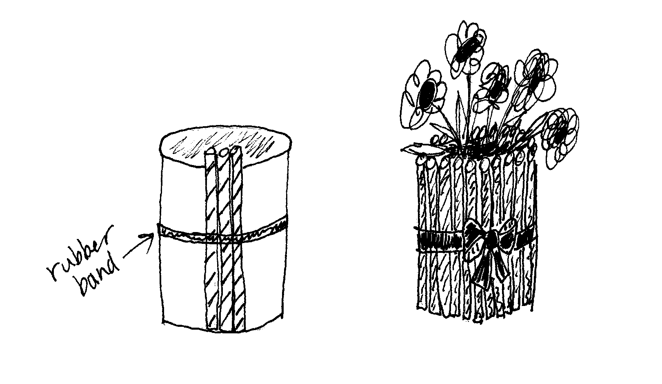

Endurance Hop

This is a relay race. You’ll need 4 different objects for each team (such as a ball, a basket, a hat and a beanbag).

Teams stand in adjacent rows along the starting line. The 4 items are placed 3 feet apart in a straight line in front of each team. Use tape to mark where each item belongs. At a signal, the first player hops to the first item, picks it up, then (without touching his other foot to the ground) proceeds to pick up the 2nd, 3rd and 4th items, then hops back to the starting line. If an item is dropped, player must stop and pick it back up. 1st player delivers all items to the 2nd player, who hops off the line to return the items to their 4 spots, then hops back to the start and tags the next player, who hops off to pick up the items.

Alternatively, players may leave the each item in the next item’s spot, and drop off the 4th item in the 1st item’s spot before returning to the line.

The first team to have all their players finish wins.

Balloon Volley

You’ll need one inflated balloon and one 4-5 ft stick, pole or broom for every 5 players.

Give each player a number from 1-5. Players 1 and 3 hold the stick at shoulder height. Player 4 holds the balloon. Player 5 stands between Players 4 & 1. Players move in a counterclockwise direction.

The game begins with Player 4 hitting the balloon over the stick to Player 2, and then moving to take Player 3’s position. Player 3 waits until Player 2 hits the balloon before advancing to take his position. Player 2, after hitting the balloon back over the stick, will take the place of Player 1, who then stands behind Player 5. Players continue to rotate one position to the right each time the balloon crosses over the stick. Players may hit the balloon as many times as needed to get it over the stick. Players holding the stick may move sideways, but may not catch the balloon or lower the stick to assist their teammates. Two players must be holding the stick before the balloon is hit over it. If the stick is dropped while the players are changing places and the balloon has been hit, the stick has to be picked up quickly before the balloon passes over it, or the team is charged with one point. The lowest point total at the end of 5 minutes is the new total to beat.

Gato Enfermo (Sick Cat)

One boy is the Gato Enfermo. He chases the other players, and each one he tags becomes another Sick Cat and must hold with his left hand the place on his body where he was tagged. All Sick Cats continue to chase. Last boy caught is the winner.

Chili Cheese Dip

1 can chopped tomatoes
1 can prepared chili
1 lb Velveeta, cubed

Melt ingredients together in double boiler over low heat. Serve with chips when cheese is thoroughly melted. Keep warm in fondue or crock pot.

Cheese Nachos

Turn snack time into a fiesta time by using brightly colored construction paper for placemats & arranging paper tissue flowers in the center of the table. Let the children help make cheese nachos by sprinkling grated cheese on top of tortilla chips. Then bake at 350 until the cheese has melted.

Mexican Pizza

Ingredients:
- 1/2 lb. ground burger
- 15 1/2 oz. can chili beans
- 8 oz. can corn, drained
- 2 T. chopped green chilies
- 1 12" boboli crust
- 3 green onions, chopped
- 1 cup shredded cheddar cheese
- 6 olives, sliced
- 2 tomatoes, chopped

Directions:
  - Brown burger, drain and combine with beans, corn and chilies.
  - Place crust on a pizza pan. Spread mixture over crust.
  - Top with cheese, onions, olives and tomatoes.
  - Bake 10-12 minutes at 425 degrees, until cheese melts and pizza is heated through.

Taco Pie

Ingredients:
- 1 pkg crescent rolls
- 1 pkg taco seasoning
- 1 pkg grated mozzarella cheese
- 1 pkg Doritos (plain)
- 1 small can tomato paste
- 1 pkg grated cheddar cheese
- 1 lb ground beef

Directions:
  - Press crescent rolls in pie pan to form crust.
  - Crunch Doritos into small bits and sprinkle a coat on crust.
  - Brown ground beef, strain and add tomato taste plus 1/2 cup water and taco seasoning.
  - Put into pan. Cover meat with sour cream.
  - Put cheese on top (both cheeses).
  - Sprinkle Doritos over top of cheese.
  - Bake in 350-degree oven for 30 minutes.

