Home Alone

January 2004

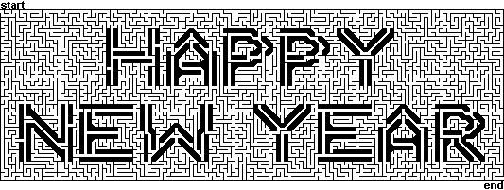
Maze from: http://www.mazes.com/happynewyear.html

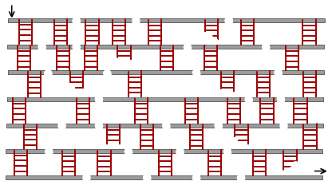

Opening

Arrangement: Pack flag is placed in center of stage. Ten Cub Scouts in uniform, in turn, come on stage, stand near the pack flag and recite one of the statements below. Upon finishing, each Cub Scout salutes the pack flag and steps back.

Cub 1: May I grow in character and ability as I grow in size.
Cub 2: May I be honest with myself and others in what I do and say.
Cub 3: May I learn and practice my religion.
Cub 4: May I always honor my parents, my elders and my leaders.
Cub 5: May I develop high moral principles and the courage to live by them.
Cub 6: May I strive for health in body, mind and spirit.
Cub 7: May I always respect the rights of others.
Cub 8: May I set a good example so that others may enjoy and profit from my company.
Cub 9: May I give honest effort to my work.
Cub 10: May I regard my education as preparation for the future.

Closing

Fire Safety

Cub Scouts, all during our meeting the candle representing the spirit of Cub Scouting has continued to burn. Now we'll blow it out, reminding ourselves that a flame must never be left burning when no one is around. But let us keep the light of Cub Scouting burning in our hearts. (Extinguish candle.)

Advancement

Akela’s Life Story

Equipment: Ceremony board or log with 3 small candles and one large candle; tom-tom; artificial campfire.

Setting: With the tom-tom beating, Akela enters and walks behind the fire. Akela gives the Cub Scout sign and the tom-tom stops.

Narrator: Akela was the big chief of the Webelos tribe; tall, stalwart, straight as an arrow, swift as an antelope, brave as a lion—he was fierce to an enemy, but kind to a brother. Many trophies hung in his teepee. His father was the son of the great yellow sun in the sky. He was called the “Arrow of Light.” His mother, from whom he learned those wondrous things that mothers know, was called “Kind Eyes.” He began to understand the signs and calls of the Webelos tribe. Then he was taken on little trips to the forest among the great trees and streams. Here, from the Wolf, he learned the language of the ground; the animal tracks and the ways to food.

Akela: (Lighting the small Wolf candle from the large candle) From this candle, representing the “Spirit of Akela,” we light the trail of the Wolf. From the signs along the Wolf trail, I see the following braves are ready for advancement in the Wolf Clan of Akela’s tribe. (Akela calls the names of the boys receiving Wolf badges (w/parents) and arrow points. They come forward and stand before the campfire. Akela presents awards, as appropriate.)

Narrator: Then, from the big, kindly bears, he learned the secret names of the trees, the calls of the birds, the language of the air.

Akela: (Lighting the Bear candle) With the “Spirit of Akela,” we light the Bear trail. From the signs along the Bear trail, I see the following braves are ready for advancement into the Bear Clan of Akela’s tribe. (Akela calls the names of the boys receiving Bear badges (w/parents) and arrow points.)

Narrator: But, before he could become a Scouting “brave” on his own, he had to prove himself by trying out new skills, performing certain tasks and passing tests of accomplishment.

Akela: (Lighting the Webelos candle) With the “Spirit of Akela,” we light the trail of the Webelos. From the signs along the Webelos trail, I see the following braves have shown their skill in…(he calls the names of the boys receiving activity badges and indicates which badges they earned). And, the following braves have demonstrated the skills and knowledge necessary to advance into the Webelos Clan of Akela’s tribe (calls names of boys who have earned their Webelos badges and invites their parents to come forward; presents awards).

From the four winds, Akela hears that you braves are doing well along the trails that will lead you into Boy Scouting and the highest trail of all, that of Eagle. Will all Cub Scouts stand and repeat with me the Cub Scout Promise? (Everyone exits to the sound of the tom-tom.)

Arrow of Light Ceremony

Cubmaster: (The lights are turned off; the room is dark.)
Light of Akela, shine for me. (Turn on a flashlight with red cellophane covering the lens.) Lead me to the honored one and his elders.” (With the flashlight, escort the boy and his parents to the front.)

(While the lights are off, 4 other Webelos Scouts come to the front.)

Cubmaster: Akela, send your helpers to light ___Name’s____ way.

(Each Webelos, in turn, turns on his flashlight and says his part, leaving the light on until the house lights come on.)

Webelos #1: ___Name___, tonight you will receive the highest honor in Cub Scouting, the Arrow of Light. Listen so that it may guide you along scouting’s path.

Webelos #2: The shaft of the arrow is straight and narrow, just as the path you should follow.

Webelos #3: The tip points the way you should go, to the right, a symbol that nothing should be left undone.

Webelos #4: The seven rays of the sun stand for each day of the week. To remind you that each day is a new day, a day to do your best.

Cubmaster: ___Name___, we ask you to remember these things and let the Arrow of Light light your path always. Do you promise to do this? (Have the boy say, “Yes.”) Akela, return our light. (House lights come on. Have mother and/or father present award to boy; have boy present parent’s pin.)

Silly Filly Inny for Home Alone

The leader passes around slips of paper with various brief phrases on them. Each member of the group draws a paper from the proverbial hat. The leader reads the story below. When there is a pause in the story… signified by ***, the leader points to one of the group members, and that person SHOUTS OUT his phrase. Of course, the phrase may or may not be exactly what was left out…in fact, that’s the fun of it!

Kitchen table Favorite cartoon Dining room table Soccer
Yummy cheese Upstairs bedroom Big bouquet Garage door
Cupboard door Math book Dad’s old computer Comfy couch
Old-fashioned oatmeal Cordless telephone Dairy farm Toy truck
Refrigerator Romaine lettuce English cucumber Garden shoe

2:30 p.m., and Johnny arrived home from school with his sister, Suzie. They put their backpacks on the ***, and prepared to make a snack. Johnny liked to have cheese and crackers, so he opened the refrigerator and took out a piece of ***, then opened the *** to get the crackers. Suzie preferred milk and cookies. She reached into the cookie jar and took out 4 *** cookies, before reaching into the *** for a glass for her milk.

They took their snacks into the family room, sat down on the *** and turned on the television to watch their ***. A half-hour later, Johnny knew it was time do his homework, so he turned off the TV, retrieved his backpack, and headed to his ***. Johnny took his *** out of his pack, and prepared to do his assignment. He had finished about half of the problems when the *** rang. “I’ll get it,” called Suzie. A few minutes later, she yelled, “Johnny, it’s Mom, and she wants to talk to you.”

Johnny picked up the phone. “Hi, Mom,” he said. She asked him if he would please make a salad for dinner, using the *** and the *** he would find in the vegetable drawer of the refrigerator. Johnny said he’d do it right after he finished his math homework. Mom had asked Suzie to set the table, and she was already putting the plates on the *** when Johnny hung up the phone and headed back to his room. Suzie went out to the garden to pick a *** of flowers for the table.

After Johnny had finished his homework and made the salad, he returned to his room and turned on his ***. He was hoping to receive an email message from his cousin, who lived on a ***. His cousin almost always had a story to tell him, since they had a lot of animals, and one of them was often getting into mischief. Today was no exception. It seems that a goat had escaped his pen and wandered into the backyard. It had chewed his mother’s *** and his brother’s ***. Johnny replied to the message with news of his *** team’s victory, writing that he had even scored a goal.

Just then, Johnny heard the *** open, and knew that one of his parents was arriving home. Although he and Suzie felt perfectly safe at home alone, he always felt better when his parents were home, too.

Run-ons

Cub #1: Did you hear about the kid that always wore two different colors of socks?
Cub #2: Yeah, his mother told him to never touch matches!

Cub #1: Doctor, doctor—my boy swallowed a pen!
Cub #2: Well, bring him into my office as soon as you can.
Cub #1: What should I do in the meantime?
Cub #2: Use a pen.

Stunt

This or That

A game that requires advance planning. Two players secretly agree on a code word, for instance, “that,” as one of them leaves the room. The other players select an object in the room, and ask the player to return. The player who remained in the room points to various objects, asking, “Is it this book?” “This flower?” “This picture?” “That basket?” To which the accomplice replies, “Yes!”

Brush Your Teeth
(Tune: Row, Row, Row Your Boat)

Brush, brush, brush your teeth,
Morning, noon and night.
See your dentist twice a year,
Keep your smile so bright.

Burn Care
(Tune: Mary Had a Little Lamb)

For minor burns, we are told,
Treat with water that is cold.
A light cover keeps out air,
A minor burn gets minor care.

Major burns need medical potion,
Never apply grease or lotion!
“A clean dry cloth” is what they say
And, “See a doctor right away!”
Thinking Safety
(Tune: Clementine)

In the kitchen, Dad was cooking,
Frying chicken in some oil.
Said he’d go out to do the shopping,
Just as dinner tried to boil!

Thinking Safety, I remembered,
Told him, “Dad! Turn off the heat!”
Using caution is more important
Than preparing supper meat.

At the table was a candle
Mom had lit to cheer the room.
Matches sitting on the counter
Made me feel a sense of doom.

Thinking Safety, I remembered,
Told her, “Mom, this I must teach,
Keep the matches and the lighters
Out of little sister’s reach!”

In the bedroom, brother studied,
Working oh so diligently,
Stereo, TV, heater, computer,
All plugged in same circuitry.

Thinking Safety, I remembered,
Told him, “Bud, that’s not too wise!
You should unplug some electronics
Before that one connection fries!”

Fire prevention can be easy,
Just have care at every turn.
Use your good sense and some planning
To prevent unwanted burn.

Bookmark

Make a bookmark in the shape of your choice.

Supplies: Heavy card stock
Decorative paper, such as wrapping paper or origami paper
Glue
Scissors
Utility (Xacto) knife

Using the decorative paper, cut out a shape you like (heart, triangle, Scout symbol). Glue the cutout onto the heavy card stock, allowing about ¼” of the card stock to extend beyond the borders. Then, cut the cardstock in the same shape, but about ¼” larger around all edges. Using the utility knife, trace around the bottom half of your decorative design, cutting through the card stock beneath. And voila!

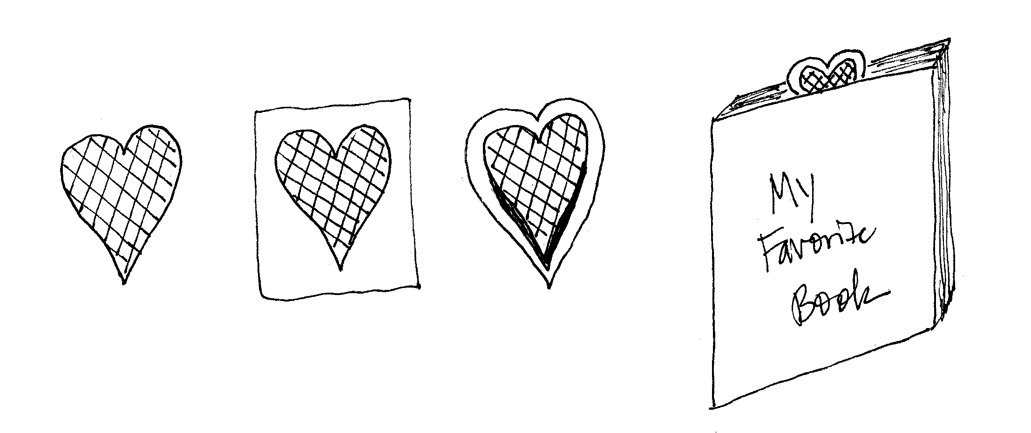

ACTIVITIES

Make a bird feeder
String raisins or popcorn together on a thread. You can also get a pinecone and fill in the petals with peanut butter and birdseed. When an adult gets home, hang your feeder on a branch outside a window...so you can watch the birds enjoy their meal!

Write in a journal
Get a special notebook or staple some paper together and write about the events of your day.

Write a letter to the president
If you've got a question or comment for the president, shout out to him! Address your letter to:
The White House
1600 Pennsylvania Avenue NW
Washington, DC 20500
Fax: 202-456-7705

Act out commercials or TV shows
Get permission to use a video or tape recorder and record your voice doing your favorite commercials or TV shows. Create your own talk show and interview your siblings, toys, or pets.

Pinewood Derby Car

If you haven’t already started work on your car, this is the month for the derby. Work on the design. Then, see what things you can do on your own to get it ready.

Chocolate Peanut Squares

4 oz semi-sweet chocolate
2 tablespoons crunchy peanut butter
3 cups rice crispies
Butter/margarine

Use a double boiler or a saucepan and bowl that fits (i.e., sits partially in the pan without touching the bottom, allowing contents of bowl to melt).
Place about 1-2” hot water in bottom pan, and place on stove burner over medium heat. Break chocolate into top pan/bowl and add peanut butter. Heat until chocolate melts. Stir to blend chocolate and peanut butter.

Remove top pan/bowl from saucepan and add rice crispies. Mix until crispies are covered in chocolate mixture. Spoon mixture into pie pan greased with butter or margarine. Allow to harden in refrigerator. Cut into squares and eat!

Fire Cracker Sandwich

Ingredients: Bread, Peanut butter, jelly or other favorite sandwich filling
Clear plastic wrap, Yarn or ribbon

Directions:
- Cut the crusts off the bread. Flatten the bread with a rolling pin. (The children just like to "smush" it with their hand.)
- Spread on your sandwich filling. Roll up.
- Wrap in a piece of plastic wrap. Twist the ends of the plastic wrap and tie with a piece of ribbon. It will look like a firecracker!

