A Hiking We Will Go

July 2003
Preopening

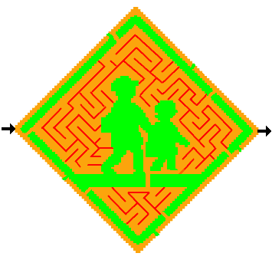

Nature Opening

A Tree is a Good Scout
By Lord Baden Powell

Did you ever pause to think about how helpful a tree is? It provides a nesting place for birds, shade from the sun, and protection from the rain. It discards its dead branches, providing wood for building fires and cooking food. A tree adds beauty to the countryside and to camping areas. We much admit that a tree gives a lot more than it receives. We can learn a lesson from the tree—by doing our best to always be helpful to others and by putting our fellow Scouts first and ourselves second.

Remember the lesson we learn from the tree—to give others more than we receive.

Pre-Hike Ceremony

Cub #1: We are going to see nature’s treasures.
Cub #2: We will help to maintain nature’s balance.
Cub #3: We will observe and learn from nature’s animals.
Cub #4: We will protect nature’s resources from harm.
Cub #5: We will follow the laws of nature.

Closing Ceremonies

Our World Closing

As we go back to our homes, I would like to ask that the parents keep these thoughts in mind. Counsel your sons that they may have eyes to behold the red and purple sunsets; that they may have sharp ears to hear the voice of their God. Guide them to have hands that respect the things God has made. Help them be wise and see the lessons hidden in every leaf and rock. Help them seek strength, not to be superior to others, but to be helpful to others. Help them along the Cub Scout Trail to do their best.

High Country Closing

Why are there mountains for you and me
Placed here and there, across our country?
For hiking – leaders climb and youth just run.
The scent of pine, wildlife, cool weather and fun
Await all who will do their best.
Views forever from north, south, east and west.
Mountains make outings special, too.
God made high places for me and for you!
Advancement

Nature Advancement Ceremony

Equipment: A tree branch standing in a coffee can filled with sand, pebbles, or plaster of paris to enable it to stand as a tree. Green paper leaves with Cub Scouts’ names, awards, badges and arrow points.

Personnel: Cubmaster, Webelos and Den Leaders, advancing Cub Scouts and their parents.

Cubmaster: This little tree is a symbol of the natural beauty of our land. The tree also represents Cub Scouting.

It takes a long time for a beautiful tree to grow. In the same way, a Cub Scout spends a lot of time and effort in advancement from rank to rank. So do his parents who help him.

Today, we will see how much prettier this Cub Scouting tree will be when we put some leaves on it. Each of these leaves represents the time and effort put into their advancement work by our Cub Scouts and parents.

(Call forward boys, their parents and Den Leaders by rank; give them their awards and have them place a leaf for each award on the tree. After all awards are presented and leaves added to the three, the Cubmaster resumes speaking.)

Each of you has helped to nurture this tree. Jus as trees endure for many years, so the values gained from working on achievements, electives and badges will last you a lifetime. May you always stand strong and tall like a tree—and be a beautiful resource for our land.
Audience Participation

Let's Take A Hike

The leader stands before the group and says: "Want to take a hike? Then just say what I say and do what I do. All set? Let's go!"

Let's pack. | (Motion of packing things and throwing pack over shoulder)
Out, through the door. | (clap hands together sharply to suggest door slamming)
Down the street. | (clap hands against knees in slow walk tempo)
Awfully big town! | (continue marching)
Out in the country at last! | (speed up walking)
Here's a river and there's the bridge. | (hands against chest in march tempo then again on knees)
Here's a field. Let's cut across it! | (swish palms against one another)
Oats! | (continue swishing)
No! Wheat. | (continue swish then back to march)
Here's another river. | (stop marching)
No bridge. We'll have to jump. | (fast tempo on thighs to indicate running then both arms up In the air and down again to indicate wide jump) (Keep on marching, hesitate, stop, march, stop. Put hand on forehead and look in different directions)
Oh! Oh! lost! There's a tree. Let's see if we can see anything from it. | (fast clapping to indicate running to tree, then climbing actions with arms, hand up to forehead and look around)
Still lost! Hey, there's a cave. | (fast clapping to indicate running to cave)
This side is cold. | (feeling side of cave)
This side is wet. | (feel other side)
There's a light. | (point with finger)
There's another light. Hey! They're eyes! It's a BEAR! | (do all the above quickly in reverse action to indicate running home.)
HOME AT LAST ..... HOORAY!

The Hike

For each keyword, the group assigned to it sings the first line of the appropriate song.*

BEAR: The other day, I met a bear (“The Bear Song,” p. 20)
BOYS: Tramp, tramp, tramp, tramp… (“I’m Happy When I’m Hiking,” p. 62)
FOOD: Food, glorious food!
HIKE: We’re on the upward trail (“We’re on the Upward Trail,” p. 67)
LEADERS: I’ve got that Cub Scout spirit (“I’ve Got that Cub Scout Spirit,” p. 52)

* (Page references from the Cub Scout Songbook printed in 1995….)

The BOYS in Pack 27 were all excited about the big HIKE. All month they had been preparing. Their LEADERS had helped the BOYS learn about the proper FOOD to take and what to wear, especially good HIKING boots. The BOYS were ready. They even knew what to do if they met a BEAR. Saturday was the big day. Each BOY knew what FOOD he was to bring.

On Saturday, the LEADERS and all the BOYS were up early because the HIKE was to start at dawn. The BOYS would HIKE for a couple of hours, then stop to fix their FOOD for breakfast, then HIKE on to the lake, where they would fish for their lunch. Everyone arrived on time, and soon the BOYS and LEADERS were happily HIKING up the trail. The sun rose quietly in the east, and the BOYS and LEADERS sang as they HIKED. Soon it was time to stop and prepare the FOOD for breakfast. The group stopped in a beautiful clearing and the BOYS opened their packs, while the LEADERS lit the backpack stoves. But it turned out that no one had remember to pack the FOOD for breakfast except Joe, and he had been assigned the salt and pepper! Oh well, at least they could season the fish they caught for lunch.

On up the trail they HIKED. They were getting deeper into the woods and the BOYS began peering into the trees, just in case there might be a BEAR. One BOY was sure he had seen a BEAR, but the LEADERS said it was probably just shadows. Soon they reached the lake. Oh boy, they could hardly wait to catch some fish and cook them for lunch. But, when the packs were opened, they made a sad discovery—no one had remembered to pack any fishing gear! Oh No!!! All the BOYS and LEADERS were hungry as BEARS!

What could they do? That’s when the LEADERS broke out the granola bars they had brought along for dessert. It wasn’t much, but at least it gave them enough energy to get back down the trail to the cards. It was lucky they didn’t see any BEARS, because the LEADERS and BOYS needed all their energy for the HIKE home. The first thing they did when they got back to town was to stop for FOOD at the nearest hamburger stand. And, you can be sure, the next time this pack planned a HIKE, all the BOYS and LEADERS remember the FOOD!

Run-ons

Cub #1: Why do bees hum?
Cub #2: Because they don’t know the words.

Cub #1: What kind of gum do bees chew?
Cub #2: Bumble gum.

Cub #1: What did the bee say to the flower?
Cub #2: “Hello, honey!”

Cub #1: What would you get if you crossed an insect and a rabbit?
Cub #2: Bugs Bunny.

Applause

Clean Air Applause: Take in as much air as you can through your nose, hold it, then exhale and say, “Ahhhhhhh!!”
The Caterpillar (Finger Play)

A caterpillar crawled to the top of a tree. | (Extend left arm. Wiggle right index finger up your arm.)
"I think I'll take a nap," said he. | (Pretend right index finger is talking.)
So under a leaf he began to creep. | (Wrap left hand around right index finger.)
He spun a chrysalis and he fell asleep.
For six long months he slept in his chrysalis bed,
Until spring finally came along and said,
"Wake up, wake up, you sleepy head." | (Shake left fist.)
Out of the leaf he did cry, | (Hook thumbs together. Extend fingers
"Look, I've become a butterfly!" | and wiggle like wings.)

Tree-To-Turf Time Machine

Equipment: 4 logs in various stages of decay from freshly cut to nearly soil. Time Machine (large cardboard box painted with a seasons clock that has a movable dial, plus other numbers, gadgets, and dials; closable front and back flaps). Costume for leader.

Divide the scouts into 3 groups: one to whistle like the wind, one to tap their fingers like the rain, and a third to chant the passing seasons “spring, summer, fall, winter.” As a costumer professor, explain that you have invented a remarkable time machine that will show what happens to a tree when it dies.

Open the flap of the Time Machine to reveal a recently cut piece of wood, then close it. Progress through the first 4 years, moving the seasons dial as Group 3 chants and the other groups make their sound effects. Then open the Time Machine (in which your hidden operator has switched logs) to see a log in initial stages of decay. Repeat this process for the passage of 4 more years, after which the secretly replaced log will look punky and soft, and then again for the last 4 years (total of 12 years), when the Time Machine log will be chunks of dirt. Afterwards, inspect and compare the 4 logs.

How Plants Work (Skit or Puppet Show)

Explain that leaves have many shapes and designs. The skit will show what leaves do for a plant. Prepare a poster with the song words.

Characters: Farmer, Spouse, Goldie Goldenrod, Chlorophyll (wear all green clothes)
Props: White balloon with CO2 written on it; Blue paper cut into a shape of water drop; Yellow paper into large shape of sun

FARMER: What’s for dinner today?
SPOUSE: Green beans.
FARMER: Beans again? We had beans last night.
SPOUSE: That was lima beans; tonight it’s green beans.
FARMER: Green, lima, what’s the difference? It’s still beans, and I’m sick of beans.
SPOUSE: Well, food is so expensive now. We can’t afford anything else.
FARMER: I’d rather stop eating if all I can eat are beans.
SPOUSE: Don’t be silly. You can’t stop eating. All living things need some type of food.
FARMER: You know, you’re right about that. Why, even plants need food. They’re lucky though. They don’t have to buy food, they make it. When was the last time you saw a plant going to the grocery store or stopping off at McDonalds?
SPOUSE: Hey, maybe we can make our own food. You know a lot about plants. Try to figure out how we can make food without buying anything. But hurry up, I’m getting hungry (leaves)
FARMER: Hmmm. If I’ve got to figure out how plants make food, I’d better go talk to my friend Goldie Goldenrod. (Goldie appears; Farmer walks over to her) Hello, Goldie. How are you?
GOLDIE: I’m fine, enjoying the nice sunshine. I wish it would rain a little, though. The soil is getting awfully dry, and I do need water as well as sunshine.
FARMER: So water and sunshine are all you need to make food?
GOLDIE: Not exactly. I couldn’t make food without the air around me and the chlorophyll in me.
FARMER: The what in you?
GLODIE: Chlorophyll. Why chlorophyll’s the most important thing we green plants have. Not only does it make us green, it helps us to make our food.
FARMER: Oh no, this sounds very confusing.
GOLDIE: A lot of people think it’s confusing, but it’s really not. That’s why Mr. Chlorophyll wrote this little song.
FARMER: What little song?
GOLDIE: You ready Chlorophyll?
CHLOROPHYLL: Chlorophyll’s the name, making food is the game.

(To the tune of “Oh My Darling”)
First I take some carbon dioxide
Which I get straight from the air. (CO2 balloon comes up)
And I mix it with some water
For the food I will prepare. (Water pops up)
Then I capture me some sunshine (Sun pops up)
And I mix the whole thing up.
And presto, there is plant food
Good for breakfast, lunch or sup.
So remember how important
These three friends all are to me.
With their help I find I’m able
To make plant food for Goldie.
GOLDIE &
FARMER: Bravo, bravo!
GOLDIE: You better go now Chlorophyll. Thanks for the show.
CHOLROPHYLL: Anytime, anytime. Hollywood, here I come. (leaves)
FARMER: That was great, Goldie. Now I know how you green plants make food. And I also know something else.
GOLDIE: What’s that?
FARMER: Since I don’t have any chlorophyll, I better start liking beans. (leaves)
GOLDIE: Liking beans? You know, sometimes I think plants are a lot easier to understand than people.

Two Skunks

Narrator: Once upon a time, there were two skunks named IN and OUT.
IN & OUT: (Each takes a bow as when his name is spoken.)
Narrator: When IN was out…
IN: (Walks stage left)
Narrator: OUT was in.
OUT: (Walks stage right)
Narrator: And, when OUT was out…
OUT: (Crosses the stage)
Narrator: IN was in.
IN: (Crosses to the other side)
Narrator: One day, Father Skunk, who was with in with OUT, said:
Father: I want you to go out and bring IN in.
OUT: (Goes off stage in search of IN, and quickly the two return)
Father: How did you find IN so quickly?
OUT: It was easy—IN-stinct!
The Butterfly
(Tune: Up on the Housetop)

First comes the butterfly who lays an egg. (Clasp thumbs and wiggle fingers.)
Out comes a caterpillar with many legs. (Wiggle index finger.)
Oh, see the caterpillar spin and spin, (Roll hands.)
A little cocoon to sleep in. (Insert right index finger in left fist.)
Oh, oh, oh, look and see. (Hands over eyes.)
Oh, oh, oh, look and see.
Out of the cocoon, my, oh, my,
Out comes a beautiful butterfly. (Clasp thumbs and make butterfly.)

The Ants Go Marching
(Tune: The Ants Go One By One)
The ants go marching up my pants.
Yucky! Ouchie!
The ants go marching up my pants.
Yucky! Ouchie!

The ants go marching up my pants.
I brush them away but they wanted stay.
And they all crawled up me,
biting me everywhere.

The ants go biting my right knee.
Yucky! Ouchie!
The ants go biting my left knee.
Yucky! Ouchie!

The ants go biting both my knees.
I yelled and screamed and started to sneeze.
But they kept on coming.
I really hate ants - they're yucky!

The ants go marching under my shirt.
Yucky! Ouchie!
The ants go marching under my shirt.
Yucky! Ouchie!

The ants go marching under my shirt.
Over my tummy and under my arms.
And I laughed so hard it hurt.
They're an awful nuisance, those ants.

The ants go marching out of my shirt.
I get an idea.
The ants go marching out of my shirt.
I get an idea.

The ants go marching out of my shirt.
I pick them up, then I swallow them whole.
It's a great way to get revenge!
"Yummy!" I cry.

Happy Trails
(Dale Evans)

Happy trails to you
Until we meet again;
Happy trails to you
Keep smilin’ until then.

Who cares about the clouds if we’re together?
Just sing a song and bring the sunny weather.

Happy trails to you
Till we meet again.

A Nutty Song
(Tune: Clementine)

I’m an acorn, small and round,
Lying on the cold, cold ground.
No one wants to pick me up,
‘Cause I’m just a little nut.

Seed-head Shooters

Some kinds of wildflowers have seed heads left at the tops of their stems when the petals have fallen off. Pull up a long-stemmed seed head and twist the stem around and over itself as shown.

Using the thumb and forefinger of one hand, grip the bent stem near the seed head, and, in a quick, snapping motion, attempt to pull the seed head through the bent stem loop. The seed head will shoot out (somewhere between a few feet and several yards, depending on the age of the stem and the skill of the shooter), and may hit a target.

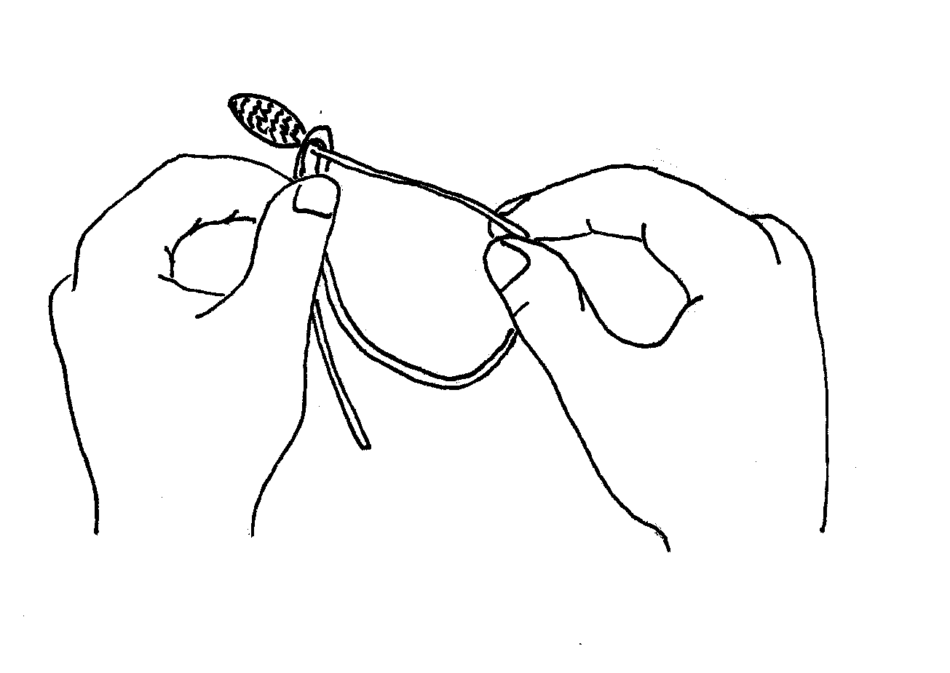

Grass-blade Whistle

Some people can do this, and others simply cannot, but everyone will enjoy giving it a try. Pluck a long, flat blade of grass and hold it tight and taut between the edges of both thumbs. The blade of grass should be in the middle of the gap between your thumbs.

Put your lips up against your thumbs and blow hard through the gap. If you do it just right, the noise will sound like anything from a noisy mouse to a squawking elephant.
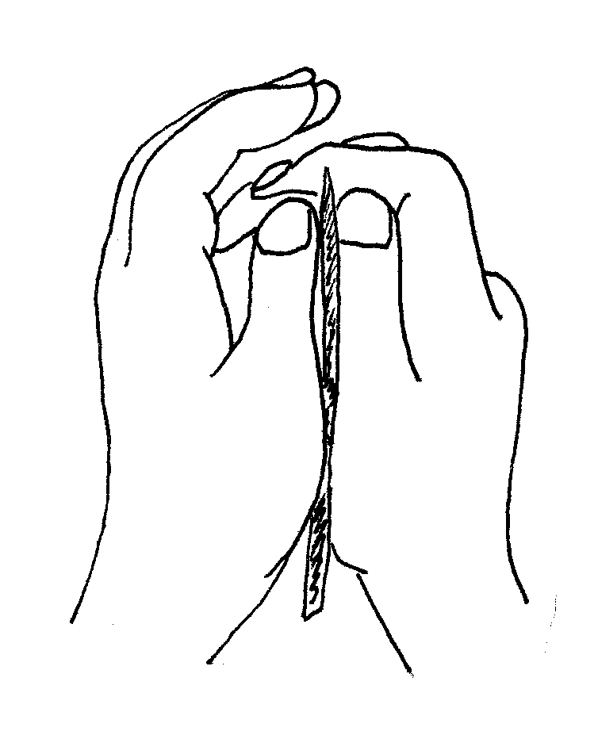
Footerflies

Have children take off their shoes, stand on a piece of paper, cross their legs, and trace around their feet.
They can cut out their feet, then decorate them with markers, paint, or collage materials.
(On a warm day, it's fun to let children step in paint with their bare feet to make butterfly footprints.)

Splatter Prints

Place leaves on a large sheet of paper, and either shake paint off a paintbrush or scratch paint with a toothbrush through a window screen over the leaves.

Pill Bugs Activity

Collect about 6 pill bugs and place them in a large jar darkened with black construction paper held on with rubber bands. Add several slices of apples and raw potato, which provide food and moisture. Ask the scouts to watch and record the activities of the bugs at different times of the day. Do they prefer light or dark? How much do they eat? Release the pill bugs back to their home within a week.

Forest Floor Mystery Bag Game

Equipment: Cloth bags filled with objects from forest floor: Wood, moss, leaves, bark, stick, bone, pinecone, rock.

Put several different objects commonly found on the forest floor into separate bags, and pass them, one at a time, halfway around a circle of scouts. Each scout feels the object and gives an adjective describing it. The other half of the circle tries to guess the bag’s contents. The last scout gets to reveal the object. Reverse the order so that everyone gets the chance to guess and to feel. Have the other scouts arrange the objects in the order of decomposition rates.

Forest Tag

Designate a fairly small area for the game. Choose one person to be “It.” That person tries to tag the others who can only save themselves by crouching before being tagged and naming a plant or animal that lives in the forest. As long as the same person is “It” there can be no naming repeats. If a person can’t think of a plant or animal, and is tagged, that person becomes “it” and all plants and animals can be used again.

Touch Wood

One player is “It.” The others place themselves in various positions, each touching something that is wood. They keep constantly running from one wooden thing to another. The player who is “it” runs after them, and the first player he tags who is not touching wood takes his place.

Hunker Hawser

Two players play against each other. Each player must have a pedestal, about 6 inches high; this could be a block of wood, Styrofoam, a tree stump or an overturned cooking pot. Players hunker down on their platforms, which are set about 6 feet apart, each holding one end of a rope about 1 inch in diameter and about 15 feet long. The excess rope lies coiled between them, but not for long. At the starting signal, the players begin reeling in the rope. The object is to cause your opponent to lose his balance by tightening or slackening the rope. Sound simple? “Oh, I’ll just give a good pull…” and, suddenly, your opponent relaxes his hold, and over you go in a spectacular backward somersault—defeated by your own energy! The more aggressive the players are, the more vulnerable they make themselves. Try best 2 out of 3.

Critter Hunt

The idea is to have the boys build a critter that can hide by camouflage. Have them look at the habitat within specified boundaries. Give each boy or team or 2-3 boys a potato or a vegetable painted white. Give them a list of minimum design elements (e.g., 4 legs, 2 wings and 2 feelers), supply them with materials (such as toothpicks, paint, leaves, moss, pine seed wings, seed pods, pipe cleaners, twigs, etc), and give them about 15 minutes to build their critters. Let each boy/team hide their critter separately, then let the whole group search for them. Last one found wins.

Life Preserver Sandwich

Ingredients: Bagel, Cream cheese, Blue food coloring, Fish Crackers

Directions:
- Add a few drops of blue food coloring to the cream cheese.
- Let the children spread the cream cheese on one half of a bagel.
- Decorate with 4 or 5 fish crackers.

Microwave Popcorn Balls

1 pkg. unbuttered microwave popcorn
½ cup (1 cube) margarine
1 bag mini marshmallows

Microwave popcorn, according to directions, then pour into bowl.
Put marshmallows and margarine in a separate bowl, and microwave until melted. Pour mixture over popcorn and form into balls.

A great, light-weight treat to take along on a hike!

Rocky Road Candy

16 oz milk chocolate
3 cups mini marshmallows
1 cup chopped walnuts or pecans
½ cup semi-sweet chocolate chips

In a double boiler, melt milk chocolate. Remove from heat. Stir in remaining ingredients. Drop spoonfuls onto waxed paper. Let cool until firm.

Dawn-to-Dusk Granola

½ navel orange 1/8 cup salad oil
¼ cup walnut pieces ¼ cup honey
2 cups rolled oats (not instant) ¼ tsp vanilla
½ cup wheat germ dried mixed fruit bits (about 3 oz)
¼ cup sliced almonds banana chips
1 Tblsp sunflower seeds raisins

Preheat oven to 325. Use small holes of grater or a microplane to grate peel of orange. Crush walnuts. Place orange peel, walnut pieces, oats, wheat germ, almonds and sunflower seeds in bowl, and mix with wooden spoon until well blended. Add oil, honey and vanilla, and mix with spoon until well blended. Spread granola on cookie sheet and bake for 10 minutes. Stir granola and return to oven. Bake for another 10 minutes, or until almonds are golden brown. Let granola cool, stirring occasionally. When granola is completely cool, stir in dried fruit, banana chips, and/or raisins to your taste. Store in refrigerator. Makes 8-10 servings.

