Fun in the Sun

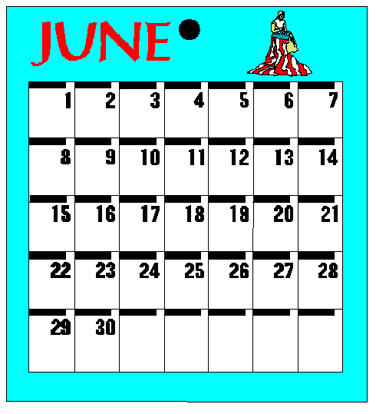

June 2003
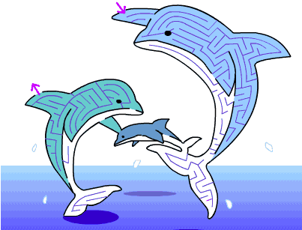

Maze from: http://web.kyoto-inet.or.jp/people/eisaku/e_maze

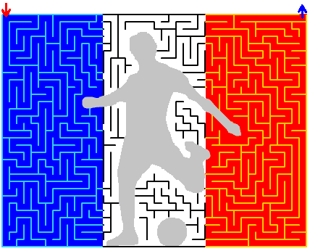

Backyard Fun Opening

Cub #1: We know a place where we can find,
Fun things to do of every kind.
Cub #2: We can spy a sneaky snake,
Fill an ant farm in a shake.
Cub #3: Chase the butterflies flying by,
Jump the fence—it’s not too high.
Cub #4: Hear the crickets serenade,
Sit on the grass drinking lemonade.
Cub #5: Games of all sorts we do play,
And this is the way we pass our day.
Cub #6: From spacemen to jungles we explore,
Cleanup here is not a chore.
Cub #7: We show our muscles with feats of skill,
And even for meals we don’t sit still.
Cub #8: The first one able to climb the tree,
Tells all the others what he can see.
Cub #9: The dirt and grime that’s left on me,
Shows how much fun it is to be,
All: IN OUR BACKYARD!

Three Pleasant Things Closing

Cub #1: Even though it’s time to bring this meeting to an end, let us tell you three pleasant things.
Cub #2: We are here.
Cub #3: We are here together.
Cub #4: We think well of one another.
Cub #5: If we would take the time to remember these three pleasant things whenever we are together, every meeting would be a success.

Advancement

School of Advancement

Equipment: Diagram made of poster board or a sheet colored blue imitating water gradually getting deeper, fish made out of cardboard, 4 different sizes.

Cubmaster: (Placing smallest fish in shallow water) A new swimmer starts out in shallow water, and the first step is to learn how to maneuver in the water, just as our beginning Scout is becoming familiar with Cub Scouting. The first part of becoming a Cub Scout is earning the rank of Bobcat. Would the following boys please come forward? (Award badges.)

(Placing next to smallest fish in slightly deeper water.) As our swimmer becomes stronger, he moves further into the water and discovers new territory. Just as our fish is developing, so is our Cub Scout. The next rank is that of Wolf. Would the following boys please come forward? (Award badges and/or arrow points.)

(Place 3rd fish further out in the water.) Our swimmer has learned and grown, and can now move further out into the water and can maneuver faster in the water. Just like the fish, the Cub Scout is learning and meeting more challenges and is becoming more acquainted with the pack. The next rank is that of Bear. Would the following boys please come forward? (Award badges and/or arrow points.)

(Place last and largest fish in deepest water.) Our swimmer has finally reached the stage where he can go into the deepest water and has learned quite a lot about the water and its characteristics. This stage of growth is like that of the Webelos. The Webelos has matured and learned much; he is getting ready to move into Boy Scouts. Would the following boys please come forward? (Award Webelos badge and/or activity pins.)

Just as the swimmer has develops and ventures into deeper and deeper water, our Scouts are learning and developing skills that will help them as they move into Boy Scouting and beyond.

Audience Participation

Den Picnic

Paul: “I love summer” Cat: “Meo-o-ow”
Cub Scouts: “We’ll do our best” Picnic: “Yum, yum, let’s eat”
Den Leader: “Signs up”

PAUL was really excited. This was the day that the CUB SCOUTS were coming to PAUL’s house for the den PICNIC. True, PAUL’s mother was the DEN LEADER and CUB SCOUTS came to his house every week for their den meetings, but today was extra special. PAUL had never had a picnic in his backyard before, and to have the CUB SCOUTS there, too, made it even more special.

PAUL went into his backyard to be sure everything was ready for the PICNIC. There he saw his CAT sleeping under the swing set. “Come on, CAT,” said PAUL, “you can help me get ready for the CUB SCOUTS.” CAT rolled over and purred. She liked helping PAUL, and she liked the CUB SCOUTS. They always played with her until the DEN LEADER put CAT outside, so the meeting could begin.

PAUL and CAT walked around the yard. All the leaves had been swept out of the yard; all the outside toys had been put away; there was plenty of room to play games and the PICNIC table was ready for the food. CAT jumped out of PAUL’s arms and started walking on the PICNIC table. “No, CAT,” said PAUL, “the CUB SCOUTS don’t’ want to eat where you have been walking. And, you know what the DEN LEADER will do.” CAT jumped down and went back to the swing set to sleep some more. She wanted to be wide awake and ready when the CUB SCOUTS arrived. PAUL went back inside to help with the food.

Soon it was time for the CUB SCOUTS to arrive. PAUL and the DEN LEADER had the food ready for the picnic. Just then, PAUL heard CAT at the door. “What’s the matter, CAT?” he asked, as he opened the door. But he didn’t have to wait for CAT’s answer. He could see the darkened skies outside and feel the strong wind that had sprung up so suddenly. Soon, great big drops of rain were splashing all over the PICNIC table. The doorbell was ringing as the CUB SCOUTS arrived for the den PICNIC. PAUL was horrified. How could the CUB SCOUTS have a PICNIC out in that rainstorm?

But the DEN LEADER knew what to do. She had been to basic training and learned that you must always have a “Plan B.” Soon the PICNIC was spread out on the kitchen table, and PAUL, the CUB SCOUTS and the DEN LEADER were eating happily. Even CAT was happy, as she rubbed against the CUB SCOUTS’ legs under the table.

Run-Ons

Cub #1: What did one hot dog say to the other?
Cub #2: Hi, Frank.

Cub #1: What kind of cheese do dogs like on their pizza?
Cub #2: Mutts-erella

Cub #1: Why didn’t the banana snore?
Cub #2: He didn’t want to wake up the whole bunch.

Cub #1: Why did the tomato blush?
Cub #2: Because he saw the salad dressing!

Lemonade Stand

Characters: Lemonade seller and 3 customers
Props: Lemonade stand or table with sign:
“Lemonade – All You Can Drink for a Dime”
Pitcher and glasses on the stand/table

Seller: Come and get your fresh, ice-cold lemonade. All you can drink for a dime!

1st Customer: All I can drink for a dime? Boy, am I thirsty! Here’s a dime. I’ll take a glass. (He takes a long drink, then turns to the audience, holding his throat.) This stuff tastes terrible! (Walks off, shaking his head.)

2nd Customer: All you can drink for a dime?

Seller: Yup.

2nd Customer: I’ll have a glass. (Takes a sip.) Yuck—this is the worst lemonade I’ve ever tasted. Did you stir it with your feet? (Exits.)

3rd Customer: Boy, am I thirsty. I’ll take a glass of lemonade. (Hands the seller a dime, and drinks a glassful.) Hey, that’s might good! I’ll take another glass.

Seller: That will be another dime.

3rd Customer: But your sign says, “All You Can Drink for a Dime.”

Seller: That’s right, and you’ve had all you can drink for a dime.
I'm A Fish  (Tune: I'm A Little Teapot)  I'm a little fishy, I can swim;  Here is my tail, here is my fin.  When I want to have fun with my friend,  I wiggle my tail and dive right in.  I Went Swimming In the Ocean  (Tune: I’ve Been Working on the Railroad)  I went swimming in the ocean,  On a summer day.  I went swimming in the ocean  And kicked, and splashed and played.  After lunch we looked for seashells  I found three or four  You can hold one up to your ear  And hear the ocean roar.  Hear the ocean roar  Hear the ocean roar.  You can hear the ocean Roar, roar, roar.  The Waves Are Moving  (Tune: When Johnny Comes Marching Home)  The waves are moving across the sea,  hurrah, hurrah, (Repeat)  The waves are moving constantly,  They move so fast across the sea.  Oh, the waves are moving so fast  across the sea. | It Is Raining  (Tune: Frère Jacques)  It is raining, it is raining;  On my head, on my head.  Pitter, patter raindrops;  Pitter, patter raindrops;  I'm all wet! I'm all wet!  The Dolphin Family  (Tune: Adams Family)  When they get into the notion  They jump out of the ocean  With tail fluke locomotion,  The Dolphin family  Swim in the sea, eee eee  Swim in the sea, eee eee  Swim in the sea. Live in a pod  Swim in the sea, eee eee  I bet you didn't suppose  Their blow hole was their nose  And in and out the air goes  The Dolphin family  Swim in the sea, eee eee  Swim in the sea, eee eee  Swim in the sea, Live in a pod  Swim in the sea, eee eee  Sand Is Gritty  (Tune: Frère Jacques)  Sand is gritty, Sand is gritty.  I like sand. I like sand.  Sand is many tiny rocks  Broken down from bigger rocks.  I like sand. I like sand.

Twelve Days of Summer Camp
(This is just a sample; feel free to make up your own lyrics!)

On the first day of summer camp my family sent to me,

A rubber raft in a pine tree
2 skinned knees
3 ballpoint pens
4 flashlights
5 bathing suits
6 bars of candy
7 welcome dollars
8 stamps for mailing
9 roasted marshmallows
10 noisy chipmunks
11 tubes of sun screen
12 giant mosquitoes

The Tree House
(Tune: Clementine)

In the backyard, in the backyard,
In a great big tall oak tree,
That is where we built our tree house,
Hidden, so no one can see.

Secret codes and secret meetings,
Just a few friends can belong.
No one knows our secret password,
Or our secret Cub Scout song.

If you’re old enough, you can join us,
In our tree house with the rest.
You can also be a Cub Scout
If you’ll always do your best.
Spray Bottle Painting

Provide the children with spray bottles filled with water paint or water colored with food coloring. Put up a large piece of paper or a sheet on a fence or easel and let the children spray with the bottles to create a painting or mural.

Seashell Candles

Materials:
Seashells Chopstick/toothpick Chopping block
Sand or rice Paraffin Potholder
Candle wick Knife Double boiler or microwave & glass measuring cup

Wash and thoroughly dry the shells. In order to stabilize the shells, lay them in a bowl of sand or rice. Tie a piece of candle wick around chopstick or toothpick (long enough to rest on bowl or shell edges); make sure the wick reaches the bottom of the shell. Cut paraffin into cubes using a sharp knife on chopping block. Place cubes in top of double boiler or, if using microwave, in a glass measuring cup. Place measuring cup in microwave and heat on high for about 6 minutes. If using a double boiler, heat over medium heat until wax is melted, about 5 minutes. Remove melted wax from microwave with potholder or from stovetop, and pour slowly into shell. When set, trim wick to about ½ inch.
Human Foosball

This can be played indoors or outdoors. For indoor play, use a rubber ball. For outdoor play, use a soccer ball. Form two teams & set them up as a foosball table. Players all hold hands in their respective rows. Now the only way they can kick the ball is by going side-to-side w/out letting go of the hands of the players in their row just like the foosball table.

Human Lemonade

Materials: 3 oz. paper cups, lemons, sugar, water, table (or 2)

Place the paper cups on a table in rows of 3 across. (Do this on both ends of the table, or set up a second table) In the first line of cups put a wedge of lemon, in the second put a teaspoon of sugar, and in the third put a half of cup of water. Divide the kids into two teams, on the “Go” signal, each kid runs down to the table picks up the first cup and has to bite into the lemon, then picks up the second cup and pours the sugar into their mouth, then picks up the third cup and pours the water in their mouth. They have to jump up and down three times to shake the lemonade up then run down and tag the next person in line. The first team to have all members make lemonade is the winner. This is a hilarious game to watch – be sure to have your camera ready!

Guess the Gargle

This is a simple game. All it requires is a glass of water. Secretly show a volunteer the name of a well-known song or tune, it can be anything, chart song, nursery rhyme etc. Get them to take a sip of water and they must gargle the tune and the others try to guess what it is.

Beach Ball Volleyball

Setup a volleyball court on the beach. Blow up a large beach ball (18” or larger). Each team tries to hit the ball over the net before it falls to the ground. Any number of hits is allowed. Score as in regular volleyball. For more fun, add another large beach ball or two.

Twist ‘n Turn Relay

Any number of teams containing an equal number of persons can play this game. You will need a baseball bat/stick/cane/umbrella for each team.

Line the teams up in adjacent rows behind a starting line. Give the baseball bat (or similar item) to the first member of each team. At a given signal, the fist players run to a designated line about 30 feet away. Each stands his bat upright with both hands, then places his head on top of his hands. The player walks around the bat 5 times, keeping his head on his hands all the while. After the player has made his 5 turns, he drops the bat and tries to hurry back to the next person on his team. This sounds like a simple process, but the turns will have made him a bit dizzy, and he will wander here and there. When he finally gets back to his team, the next person repeats the process. The first team to finish is the winner. (It is wise to have a few helpers standing by during this game to help guide the participants and keep them from bumping into each other.)

String Maze

Set up a maze with string tied around trees, over, under, and through garden furniture to dead ends, switch-backs, around-in-circles, and finally to the finish line. Use lots of string.

Each blindfolded player has to find his way to the finish line by feeling his way along the string. Have some string end at a knot on a tree (dead end), or have it go around a pole to the same starting point. This is fun to do and fun to watch. The winner is the player who comes out of the maze in the least time.

Eight on a Neckerchief

This is a good rough and tumble game. Divide your groups into dens/teams of 8 players each. Place a Cub Scout neckerchief on the floor. All eight team members have to stand on the neckerchief. This is accomplished by 3 or 4 boys getting their feet on it and holding onto each other. The others that cannot get both feet on the neckerchief have to hang on, climb on, or get one foot or toe on, and hold fast to the other Cubs to balance themselves. The winning den is the first one to accomplish this feat without falling over.

Spicy Ketchup

Homemade ketchup is darker in color and a bit spicier than the commercial variety, but this would make a fun contribution to a den or pack picnic!

4 medium-large ripe tomatoes
1 small onion, peeled
½ sweet red (or green) pepper
1/3 cup sugar
¼ tsp each paprika, salt, allspice, ground cinnamon
Dash of ground cloves, celery salt, dry mustard
Juice of ½ lemon

Fill a 2-quart pot with 1 quart of water. Add the tomatoes (whole) and bring to a boil. Turn off the heat and allow the water to cool. Remove the tomatoes, cut out the stem end and peel off the skins. Throw out the skins and the water.

Cut the tomatoes, onion and pepper into small chunks, and put them in a blender at medium speed (or food processor) for 15-30 seconds, or until the mixture is soupy.

Pour the mixture into the pot, and cook over low heat. Do not put a lid on the pot. While the mixture is cooking, add all the remaining ingredients except the lemon juice. Stir the mixture at least every 10 minutes, and cook for about 1½ hours or until the ketchup is as thick as you like it.

When the ketchup seems thick and ready, stir in the lemon juice and cook for another few minutes. Turn off the heat, and let the ketchup briefly cool, then pour into a jar or bottle and refrigerate.

