Pilgrims of Plymouth Rock

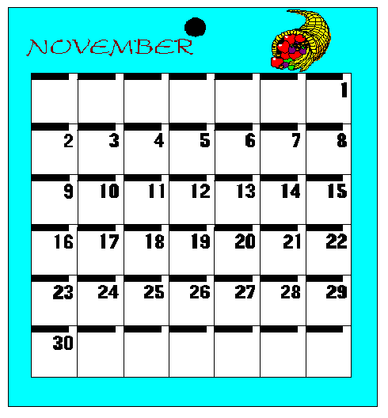

November 2003
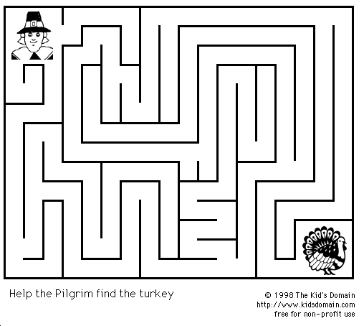

Thanksgiving Twenty Questions
One boy chooses a thanksgiving related person, place, or thing and says, "I'm thinking of something." The others try to guess what it is by asking no more than twenty questions that can be answered "YES", "NO", or I DON'T KNOW." The Scout who guesses correctly is next up.

Opening

The Cub Scouts are Coming

One Cub Scout at a time trots from the back of the room to the front shouting, “The Cub Scouts are coming! The Cub Scouts are coming!” Then two boys enter, carrying the United States Flag, and lead the pledge.

Harvest Feast

Fetch the wood and feed the fires,
Keep the kettles steaming:
Such as feast as this requires
More than wishful dreaming.
Stir the batter, Pilgrim daughter!
Son, another pail of water!
Pile the clams beneath the coals,
Make the meat-spit stable.
Bring the planks and set the poles
For the harvest table.
Pilgrim son, more wood, more water!
Help the pluck the turkeys, daughter!
Roast the ears of yellow maize,
Pile the nuts and berries
Next to grapes on pewter trays
Near the sun-dried cherries.
Guests are coming, son and daughter,
Over hills and running water!
Rake the coals and pile them up,
Praise the harvest weather,
Set the table, cup by cup,
Guest and host, together.
Draw the ties of friendship tauter
With Thanksgiving, son and daughter.

Closing

Cub Scout Native American Prayer

Morning Star, wake us, filled with joy,
To new days of growing to man from boy.
Sun, with your power, give us light
That we can tell wrong and do what is right.
South Wind, we ask, in your gentle way,
Blow us the willingness to obey.
North Wind, we ask, live up to thy name.
Send us the strength to always be game.
East Wind, we ask, with your breath so snappy.
Fill us with knowledge of how to be happy.
West Wind, we ask, blow all that is fair
To us, that we may always be square.
Moon, that fills the night with her light,
Guard us well while we sleep in the night.
Akela, please guide us in every way.
We'll follow your trail in work and play.

Thanksgiving Spelldown

Turkey sizzling,
Happy hearts,
Apple stuffing,
Nuts and tarts,
Kitchen smells
So nice and sniffy,
Guests arriving
In a jiffy,
Voices raised
In festive mood—
Not forgetting
Gratitude…

Just as sure as you are living
That’s the way to spell THANKSGIVING!

Cubmaster’s Minute

Reasons To Be Thankful

If you can see, if you can walk,
If you can hear when others talk,
If you have food, enough to eat,
But skip expensive cuts of meat,
If you've a coat for when it's cold,
Though maybe out of style or old,
If you have friends, the kind who care,
If you have health, though only fair,
And have some cash, but not a bank full,
You've got ample reason to be thankful.
Advancement

Setting: A table set with Thanksgiving items; a bag of corn kernels

Cubmaster: Ladies and gentlemen, tonight we are remembering the founders of our country and the native American Indians. The pilgrims came to this country for religious freedom, and when they got here, they found new friends. The sharing that occurred between these two different peoples was something to behold. We have all shared things in much the same way.

Would the following boys please come forward? (List those earning Wolf badges.) You boys have shared with each other the gift of working together in your dens and homes. For this, we give you your awards and a kernel of corn, as the Indians gave to the pilgrims.

Would the following boys please come forward? (List those earning Bear badges.) You have worked hard, and work was one of the things most respected by the pilgrims and Indians alike. The pilgrims even had a rule that if persons did not work, they would not eat. For your work, we give you your award along with a kernel of corn, just as the Indians gave the pilgrims.

Webelos Leader: Would the following Webelos please come forward? (List names.) You boys have been working for a long time and have learned many new skills working with metal, wood and leather. These are the same skills that the pilgrims had to learn to survive and help build this great country we live in today. We give you your awards and a kernel of corn to remember this special time of the year.

Audience Participation

I Had a Dream

I had a dream the other night (hands under head in sleeping motions)
And in my dream I saw (hands to eye)
An Indian brave with hunting bow (pretend to be pulling an arrow back in a bow)
Chasing a rhino slow (run in spot)
I shook my head, “It cannot be” (shake head)
For everybody knows (move hands out to side)
That rhinos are in Africa (point to other side of room)
And they certainly aren't slow." (shake index finger in no-no motion)

Run-ons

Cub #1: What would you get if you crossed a wolf and a rooster?
Cub #2: An animal that howls when the sun rises.

Cub #1: What side of a turkey has the most feathers?
Cub #2: The outside.

Cub #1: Why do dogs scratch themselves?
Cub #2: Because they’re the only ones who know where it itches.

Cub #1: What kind of bow can’t be tied?
Cub #2: A rainbow.

Turkey Riddles

- What kind of key won't open a door?
(A tur-key)
- Who complains after eating too much turkey at Thanksgiving dinner?
(The groan-ups!)
- Which part of a turkey plays in a band?
(The drumstick!)
- What side of the turkey has the most feathers on it?
(The outside.)
- Why did the mother turkey scold her little turkey?
(Because he gobbled his dinner!)
- Why do turkeys eat so little?
(Because they're always stuffed.)
- When is a turkey most like a ghost?
(When it's a-gobblin'.)

The Liberty Bell Speaks

Group: Speak out, oh bell called Liberty
The times you rang in freedom’s name,
So all of us may know
Beginnings long ago.

Group: When I was young, I rang a lot!

#1: I clanged alarms when England tried to force her taxes on us.
I thundered of tyranny upon us

#2: I roared with rage when Parliament forbade our people making
iron and steel, my lungs were breaking.

#3: I grieved for Boston when its port was closed to trade and shipping.
My faith was far from slipping.

#4: With all my strength and all my heart, I called for folks’ attendance
to hear the declaring of Independence.

#5: And then I fell on silent days, when I was put in hiding,
with British law presiding.

#6: But I was back to shout about Cornwallis’ surrendor.
I rang for freedom’s splendor.

#7: For years I rang for this and that—the Constitution signed at last,
but then I cracked…

Group: Your silent tongue could never speak again,
and yet your voice is loud and clear in all the minds of men!
“Proclaim liberty throughout all the land and unto all inhabitants thereof.”*

*These words are inscribed on the Liberty Bell
Our Pilgrim Forefathers
(Tune: Battle Hymn of the Republic)

They came as strangers to a wild land,
Brave and unafraid.
In spite of many hardships,
They still bowed their heads and prayed.
“We’re thankful for the growing crops,
“The beauty of our land,
“And freedom to live as we planned.”

Chorus:
Our Pilgrim fathers made us proud,
They accomplished what they vowed.
We still sing their praises loud,
And freedom marches on.

Squanto was an Indian,
Who helped the Pilgrims out.
He taught them how to plant their corn
And how to fish for trout.
They hunted in the woods for deer
And caught wild turkeys, too.
He was a friend so true.

Chorus

Bradford was the Governor.
He was just and fair.
He thought it was important
That each man received his share.
He planned the first Thanksgiving
Holiday to celebrate
A harvest good and great.

Chorus

Indian and Rabbits Game (for 2 players)

Materials:
Cardboard scrap
12 identical buttons (same size or color)
1 different button

Tools:
Scissors
Pencil or pen

Cut a square piece of cardboard, large enough to accommodate a row of the 5 identical buttons in both directions. Depending on the size of the buttons, find a large coin or other circular object to use as a pattern, and draw 5 rows of 5 circles each on the cardboard. Arrange the buttons on the circles as shown below. The one different button is the Indian and the rest are rabbits.

Object: The rabbits win if they corner the Indian so he cannot move, and the Indian wins if he captures all but one rabbit.

Rules: One player controls all the rabbits and the other controls the Indian. The Indian makes the first move. The Indian and the rabbit can move one space at a time, either up and down (vertically) or left and right (horizontally), to a vacant space. (Diagonal movement is not allowed.) The Indian captures rabbits by jumping over one into a vacant space, and may make successive jumps where possible. The rabbits cannot jump or capture the Indian.

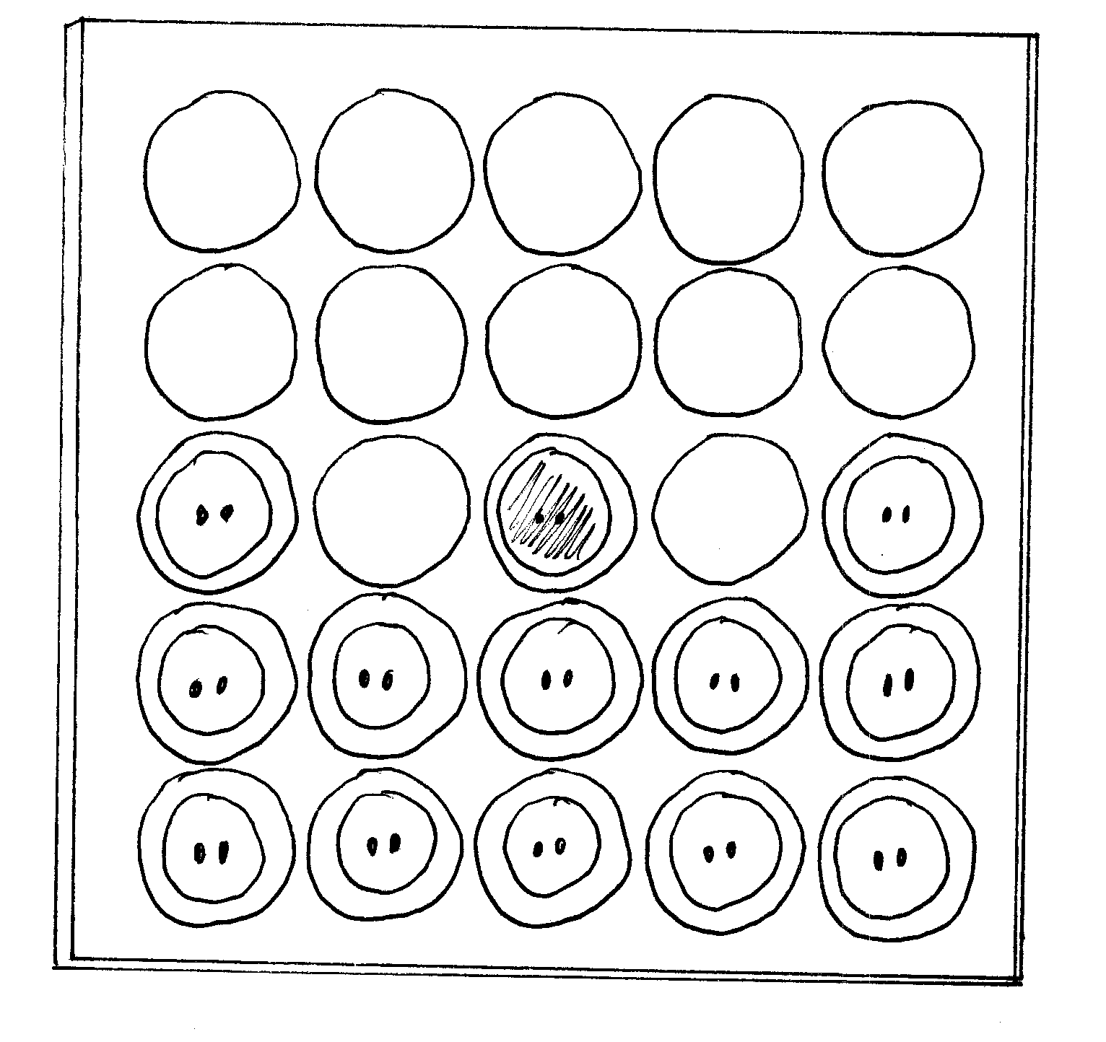
Friendship Bracelet

For each, you will need two pony beads and a leather lace.

Step 1: Cut lace 5” longer than measurement around wrist. Trim lace ends at an angle.
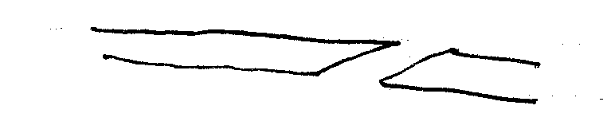
Step 2: Tie a knot in one end of the lace. Thread on 2 pony beads.
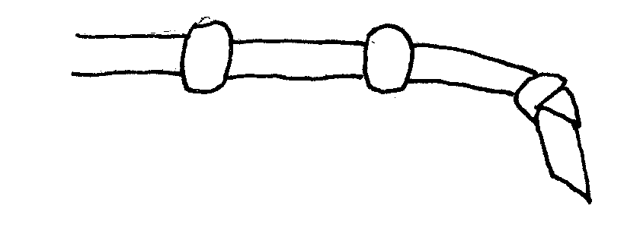
Step 3: Thread the other end of the lace through the beads from the opposite direction. Tie a knot in this lace end. Adjust size of bracelet by pulling on knotted lace ends.
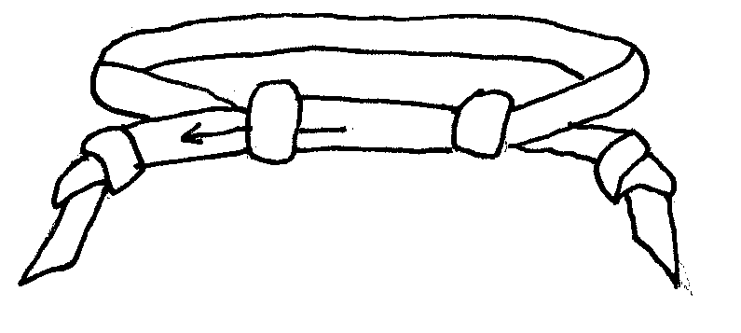

“Tied Up” Turkey

Have children bring in old ties from their fathers, grandfathers, or uncles. Make the shape of a turkey's body from poster board and place it in the middle of a bulletin board. Pin the ties around the turkey's body in a fan shape to resemble feathers. Hint: Fold the ties in half when you pin them to the bulletin board.

Leaf Turkey

Have children collect autumn leaves and dry them. (To dry leaves, place them between two sheets of paper. Put a heavy book on top and let them sit for several days to remove the moisture.) Children draw a turkey's body on a sheet of paper, then glue on the leaves for feathers.

Quick Thanksgiving Quilt

Give each child a 9-inch square piece of poster board that has been divided into a grid of nine squares. Have the child glue 3-inch squares of fabric, wallpaper or colored wrapping paper into the squares on their grid. Cut out Thanksgiving symbols and glue them into the center square. Encourage them to glue their squares into patterns. Tape all the 9-inch square boards together to form a group quilt. Display the quilt on the wall at your next Pack meeting.
Great Turkey Dressing

Divide into appropriate number of groups. Give each group a paper sack filled with the following: newspaper, 1 pr. pantyhose, 4 sheets tissue paper, 1 roll toilet paper, scissors and tape. Each team has 10 minutes to select and dress one member of their team (or a parent) as a turkey.

Indian Sit

Sit outside and have everyone close his eyes. Listen to the sounds for 5 minutes. Discuss.

Indian Stalking

Let the boys try to go through an area without making a sound.

Fox and Food

Materials: Handkerchief, stick, beanbag or other distinctive object.

Objective: Fox is to guard its food while predators try to steal it.

One person (fox) stands guard over food source (distinctive object). Everyone else (predators) form a circle around him and try to stead the food without being tagged by the fox. The fox can move as far from its food as he dares. When tagged by the fox, the predator is frozen in place unit the end of the game (when all are tagged or someone steals the food).

Variation: Blindfold the fox, forcing it to use other senses besides sight. Rather than tagging the predators, the fox has only to point directly at an intruder to freeze him.

Sugar Cone Cornucopias
(from Family Fun)

These miniature horns of plenty also double as edible name cards

Materials: Sugar cones, ribbon, decorator’s icing (in tubes), fruit-shaped candies or cereal

Directions:
- Tie a ribbon around the opening of each sugar cone.
- With the tube of store-bought decorator’s icing, carefully squirt the name of your guest along the side of the cone.
- Place the cone on a saucer. Then fill the cone with candies, such as raspberry jellies, fruit-shaped fruits, marzipan fruits, candy corm and citrus slices. You can also use fruit-shaped cereal, which is much less expensive. Let the goodies spill over the opening and around the cone.

