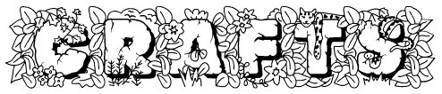



INTRODUCTION

Why do we do crafts in Cub Scouts?

We do crafts because crafts are fun!! The boys enjoy making things and getting a chance to be creative. Cub Scouts may be the only place they get to do crafts with all the cuts in the school budget these days. You should try to incorporate at least one craft a month. Each Cub Scout rank has achievements and electives that are for crafts.

But I am not crafty!

You don’t have to be crafty because we will give you lots of ideas in this Pow Wow book. There are also ideas in the BSA Program Helps and so many websites that contain step-by-step directions for crafts that it boggles the mind. I will list a few of my favorite websites below.

But aren’t crafts expensive and take a lot of tools?

No. You can reuse much of the household items that you throw away: toilet paper tubes, plastic bottles, shoeboxes, plastic containers, etc. I do crafts for Cub Scout Day Camps and my budget is 50 cents a day per boy. The only tools most crafts require are scissors and glue (although a low temperature hot glue gun is wonderful).

CRAFT TIPS

To make sure that the craft will be successfully done in the den you need to make a few samples of the craft ahead of time with the actual materials that the boys will use. This step is critical. I have had problems when I have switched the type of glue I used. I recommend that you use Tacky White glue rather than Elmer’s. It is thicker so it holds better and dries quicker.

It is also a good idea if you have your son help to make a sample ahead of time. Then you can judge how long the craft will take and if the craft is too complicated for your den. It also gives your son a chance to shine when he is able to help the other boys in the den. You can also judge how much help you need to provide your son as he does the craft so that you know if you need the parents to stay and help with the craft.

Make sure you have enough tools so the boys are not waiting around to use scissors or glue sticks. Adults only should use the hot glue guns.

The crafts that the boys like best are opened crafts. This means crafts that have no specific looking product. Whatever the boy creates is great.

CRAFT SUPPLIES

I have listed below my favorite places to buy supplies. I have also included some places that have been recommended to me. You can also buy pre-made crafts kits but generally I just use those for ideas.

RAFT (Resource Area for Teachers) is a great place for cheap materials and great ideas. Cub Scout leaders can become members for $5. Sign up at Pow Wow or contact your BSA district executive. For more information access their website at www.RAFT.net or call 408 451-1420.

Boleks is a great source for pony beads ($2.50 for 1000) in over 30 colors as well as faceted pony beads. I have also purchased wooden wheels, pompoms, pipe cleaners (chenille stems), and googly eyes. Shipping is a deal, $5 for purchases under $100 and free for over $100. I am a very satisfied customer of theirs. For an online catalog or to get a catalog sent to you and to order via email www.bolekscrafts.com or call 800-743-2723.

Discount School Supply is a great source for just about any craft item for school age children. I have ordered paints, fabric medium, etc. They have always been very fast in shipping out the items I have ordered. To order online www.discountschoolsupply.com or call for a catalog 800-627-2829

S&S Worldwide is a great source just about any craft item for school age children. They also have lots of fantastic kits that are not too pricey. I have ordered from them and had great service. To order online www.ssww.com or call for a catalog 800 243-9232.

Create For Less. I have never ordered from them but other Cub Scout Camp Program Directors have and recommend them as a source. To order on line www.createforless.com or call 866-333-4463.

Making Friends looks like a good site for materials. To order online www.makingfriends.com or call 800-559-1182.

Michaels is a local store that has a lot of material and kits.

The Scout Shop also has a limited supply of materials and kits.

RESOURCES

You don’t need to be crafty to do great crafts; there are lots of resources out there. I have listed a few below. Most of them are websites and a few are magazines.

Family Fun Magazine – My favorite for crafts, games, food, travel, etc for kids. They also have a website with lots of step-by-step craft ideas. www.familyfun.go.com. The crafts here are awesome.

Making Friends – Great crafts, in fact you will see a few of them in the next section. www.makingfriends.com

Kids Domain – Great crafts, in fact you will see a few of them in the next section. www.kidsdomain.com

Hands On Crafts for Kids – www.crafts4kids.com

Pack-O-Fun Magazine – This magazine has crafts specifically for Cub Scouts. www.craftideas.com/packofun

DLTK Printable Crafts for Kids – www.dltk-kids.com

Discount School Supply – www.discountschoolsupply.com

DEN CRAFT BOX

You can put together a den box for doing crafts. It should have children’s scissors, glue sticks, Tacky Glue, pipe cleaners, ½” rings of ½” schedule 40 PVC pipe, small sheets of sandpaper, (to rough up the pipe before gluing on a neckerchief slide), construction paper, fun foam, sharpie markers (you can get 14 colored packs at office supply places), pencils, white copy paper, low temp hot glue gun, and perhaps a few ready made crafts for the boys to do packaged in Ziploc baggies.

I hope I have inspired you to do crafts with your dens. You might say I am passionate about crafts. I have been a den leader for 5 years. My dens have done lots of crafts and they love them. I have also been the program director for Stevens Creek Day Camp for 2 years and the crafts director for an additional 2 years.

- Lisa Corley

Remember: It’s the process not the product that is important!

March 2004: Walk In My Shoes

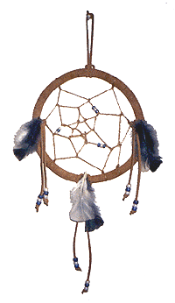
Dream Catcher
By Linda Musante. Reprinted with permission from Hands-On Crafts for Kids.
According to Native American legend, the Dream Catcher allows good dreams to pass through and slide down the feathers onto the sleeper. A bad dream becomes entangled in the web of the Dream Catcher.

Supplies: Tacky glue, 6” Metal ring, Assorted Pony beads (we used regular 6mm x 9mm and the new mini beads), 8 yards beige suede cord, Natural cotton twist cord (or twine), Feathers, Scissors, Ruler, 2 Clothespins

Directions:
- Wrap the ring: Spread glue on first inch of suede lacing and hold in place on the ring with a clothespin. Wrap the lacing around the metal ring, being careful not to twist the lacing. Glue the end to the lacing where they meet and hold with the clothespin until dry.  - Tie the webbing: Roll cotton cord loosely into a ball. Knot one end of cotton cord around the metal ring then seal the knot with glue. Tie approximately six half hitches every three inches around the ring. Pinch each completed knot as you begin the next. Add a half hitch next to the knot where you began. Then begin tying half hitches in the middle of the cord you already added. Continue until you complete a total of three more circles of half hitches. Weave in some mini beads if desired. Double knot the cord in the center of the webbing then seal knot with glue. Cut off excess cord. | 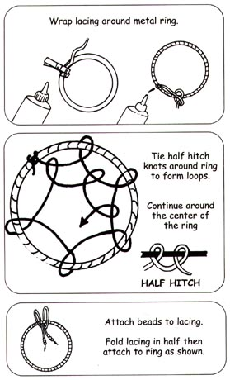
- Adding the hanger: Cut three 10” lengths and three 12” lengths of suede lacing. Knot ends together of one 10” length and insert one end of loop through metal ring at the top. Draw knot through loop and pull tight.
- Adding the dangles: Knot one end of each of the other laces. Thread an even number of beads onto each lace then knot other end. Slide the same number of the beads up to each knot. Fold lacing in half then attach the same way as the hanger.
- Glue on feathers if desired.

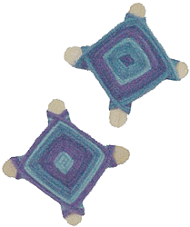
Mini God’s Eyes
(From www.makingfriends.com)

These make great neckerchief slides.

The Ojo de Dios or God's Eye is an ancient symbol made by the Huichol of Mexico. The central eye was made when a child was born. Each year, a bit of yarn was added until the child turned five at which point the Ojo is complete.

Supplies: Multi-colored yarn, Mini Craft Sticks, Tacky Glue or Glue gun with low temp glue sticks, ½” PVC schedule 40 pipe cut into ½” rings

Directions:
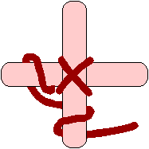
- Glue two mini craft sticks together forming and "X".
- Glue the end of the yarn to the middle where your sticks cross.
- Begin by wrapping the yarn over and around one leg of one craft stick, then over and around the next leg. Pull the yarn tight each time and push it toward the center. (Diagram shows backside of the God's Eye).
- Continue until the craft sticks are covered. Glue and trim.
- Use the glue gun to glue the completed God’s Eye onto the PVC ring.

African Mask/Shield
(From www.dltk-kids.com)

The finished mask is about 2½ feet tall. There are eyeholes so the kids can see (they can only see through one hole at a time) and it's a perfect size for protecting your body. If you are crafting with older children, have them examine some African masks on-line before they create their design.

Supplies: Corrugated cardboard (cardboard box), Scissors, Brown poster paint (or tempera), Decorator color of paint, Raffia (string or wool), Paper Mache (optional)

Directions:

- Decide on the design for your project. Keep in mind that you'll have to cut out the pieces, so you'll want to make them fairly basic shapes. Draw the design on a piece of paper. See the example on the right. | 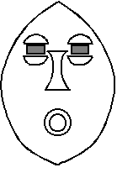
- Freehand draw the facial pieces onto corrugated cardboard (old boxes). Cut them out. If you want some facial pieces to stick out more:  - Trace the first piece  - Cut the shape out again  - Glue the shapes together  We did 2 layers for the mouth and 3 layers for the nose. | 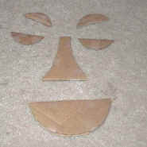
- Freehand draw the shield/mask shape on a large piece of cardboard. Cut it out. Cut out eyeholes. At this point you can just glue all of your pieces together.  - Paint the entire project brown.  - Decorate with stripes and polka dots in a different color, if you wish. | 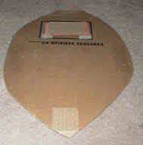
- Poke two holes on one side of the mask (about the center), one on top of the other about 4 inches apart. Do the same on the other side. A drill or nail/hammer works well for this.
- Thread raffia, string or wool through the holes, tying in front of the mask. Don't tie it tight -- leave a loop in the back as handles.

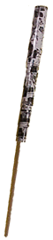 | Paper Chinese Yo-Yo  This is a good Den craft, or make at a Pack meeting for a gathering activity.  Supplies: 1/8” or ¼” Dowel, Roll of wrapping paper, Tape or glue  Directions:  - Cut a strip of wrapping paper 7' long by 4" wide.  - Glue or tape one end of the strip to the dowel at the end.  - Roll the paper tightly around the dowel.  - To use, hold the dowel and flick your wrist in an upward motion. Paper will yo-yo out and back in.

April 2004: Cubservation

Bird's Nest Neckerchief Slide
(From www.makingfriends.com)
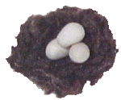
These miniature nests look real!

Supplies: Brown yarn, flour/salt dough, ½” schedule 40 PVC pipe, Tacky Glue, Scissors, Low Temperature Glue Sun and Glue, Poster Board

Directions:
- Cut poster board into circles about the size of a quarter.
- Cut the PVC pipe into ½” rings.
- Cut yarn into 1/4" pieces. For each bird nest you will need about 1 heaping tablespoon of cut up yarn.
- Mix in about 1/2 teaspoon of tacky glue.
- Roll yarn and glue mixture together to form a ball. Add more glue if necessary. Flatten ball a little. Press thumbs into the middle to make the nest shape. Set on top of a circle of Poster Board. Let dry overnight.
- Use small pieces of Flour/Salt dough to make tiny eggs.
- Use glue gun to attach them in dry nests.
- Glue a PVC ring on the back.
- Attach them in dry nests. Glue a PVC ring on the back.

Flour/Salt Dough

Ingredients: 4 parts flour, 1 part salt, 1 ½ part hot water (enough to make stiff dough)

Directions:
- In a bowl, mix hot water and salt until the salt is dissolved.
- Add the flour. Mix well, kneading with hands. It is now ready for molding. You can let your pieces either air dry or bake.
- To bake, place the pieces on a cookie sheet.
- Bake up to 1 hour, until the dough begins to brown. Works best with smaller pieces.

Milk Jug Bird Feeders
(From Kids Domain)

This is an easy project to do in your Dens. Keep this feeder filled and you will have regular visitors to your home. Parental supervision is recommended with the use of sharp scissors.
Supplies: Gallon milk jug with lid, Sharp pointed scissors, Pencils, Bird seed, String (optional)
Directions:
- Rinse out an empty plastic gallon milk jug with lid.
- Cut a window in the front of the jug, and make two small poke holes for the perches.
- Insert pencils for perches and fill the bottom of the jug with birdseed.
- You can rest the bird feeder on a ledge or punch holes near the top, add string, and hang from a branch.

Pine Cone Bird Feeder
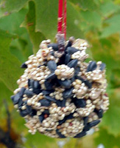
(From Kids Domain)

This is another easy Den project that is also good for the environment. This is a good project for the Webelos Naturalist activity pin.

Supplies: Pine cone, Paper plate, Butter knife, Smooth peanut butter, Birdseed, Ribbon or yarn, Scissors
Directions:
- Cut a long length of yarn or ribbon to hang the bird feeder.
- Tie the ribbon in a knot around the pinecone near the top (about 3 sections down).
- Tie a knot in the end of the ribbon.
- Use the knife to get a large clump of peanut butter on the paper plate.
- Use the knife to spread peanut butter inside the pinecone and around the edges.
- Sprinkle the birdseed over the pinecone.
- Roll the pinecone in the birdseed that is on the plate.
- Hang the bird feeder on the tree. Enjoy watching the birds eat their treat!

May 2004: My Home State

Hollywood Neckerchief Slide

This is a tube that will be covered in gold glitter to represent the glamour of Hollywood.

Supplies: 2’ long ½” diameter plastic tubes; 2” square pieces of 120 sandpaper; Gold glitter; White glue; Plastic bowls: one for glue and a couple for glitter; Wax paper; Crystal Clear spray enamel; Sharpie Marker

Directions:
- Have the boys need to write their names on the inside of the tube.
- Give each boy a piece of sandpaper and have him sand the tube. This will help the glitter to stick better.
- Boys use one finger to dip in glue and spread glue on the tube, which is on a finger of the other hand. Make sure the tube is completely covered but it is not too drippy.
- The boys then drop the tube into the bowl with glitter and GENTLY shake the bowl so that the tube gets completely covered with glitter.
- Let the tubes dry on the wax paper.
- After the glue has dried, spray the tubes from all sides with the varnish. When the varnish has dried, put all the tubes in a bag by den and deliver them to the den leaders or put in the den boxes.

Gold Pan Neckerchief Slide

Find a small pan about 2” wide. Paint some rocks gold and glue them into a pan. Then hot glue the pan onto a ½” ring of ½” schedule 40 PVC pipe.

IC Neckerchief Slide

Glue old IC’s (computer chips) onto a ½” ring of ½” schedule 40 PVC pipe. Bend the ends of the IC pins slightly to form an L so they will not stick into the boy.

Surfboard Neckerchief Slide

Cut out surfboard shapes from a foam board and have the boys decorate it with markers. Glue to a ring of ½” schedule 40 PVC pipe. You could even make a mobile with several boys.

June 2004: Cub Rock

Gliding Archaeopteryx

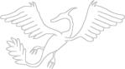 | Make a simple model of this prehistoric flying dinosaur with a plastic or wooden toy glider.  Supplies: Toy airplane glider, 12” pipe cleaner, craft feathers, masking tape, white glue, scissors, black marker.

Directions:
- If you are using a Styrofoam glider instead of one of cardboard or balsa wood, cover the top and sides of the glider with strips of masking tape to help the feathers stick
- Cut a 6” piece of pipe cleaner. Wrap it around the center of the glider behind the wings and let the two ends hang down to form the legs of the bird. Wrap a small piece of pipe cleaner around the bottom of each leg to form claws.
- Glue feathers all over the bird, making sure the bird is not too heavy or it won’t glide. Use only a thin coating of glue and just enough feathers to cover the glider/
- Cut two eyes from masking tape and stick one on each side of the front of the glider. Draw eyeballs with black marker onto the tape.

Pasta Fossil Plaque

Make a homemade fossil using dry pasta shapes for the bones.

Supplies: Potting soil, white glue, dry pasta in different shapes, Styrofoam tray, bowl & spoon, measuring cup, scissors, felt.

Directions:
- Mix one cup of the potting soil with enough white glue to hold the dirt together. Shape the dirt into a ball and set it on the Styrofoam tray. Press the ball down until it is flat and about ½ inch thick.
- The pasta shapes will be the bones. Arrange different pasta shapes to design your own fossil – be creative. When you have a design, carefully arrange it on top of the gluey dirt. Gently press the pasta into the dirt to make sure it will stay. Cover the pasta with a layer of glue. Let the dirt dry on the Styrofoam tray until it is hard. This could take two or three days.
- When the dirt is dry, cut a piece of felt to fit the bottom of the plaque. Glue the felt to the bottom of the plaque to keep it from scratching your table.

Granite Paper
When you look at rocks carefully, you will notice and appreciate the many beautiful colors and interesting shapes and textures. Make some sheets of paper that resembles granite.
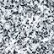
Supplies: Concrete block or any rough concrete surface (rough cement sidewalk will do), colored pencils or crayons, a piece of granite or a photograph of a piece of granite, plain white paper.

Directions:
- Brush off any loose pieces of concrete or other dirt from the concrete surface you wish to use.
- Choose three or four color of colored pencil or crayon that match the colors in the piece of granite or granite photograph. Lay a sheet of while paper on the concrete.
- While holding the paper firmly with one hand, gently and evenly color over the entire area with the colored pencil or crayon. Use a medium or light color for the first layer.
- Move the paper slightly so the little concrete bumps will be in different places and then color evenly with a different color pencil or crayon.
- Continue moving the paper and then holding and coloring it with different colors that you see in the rock that you are using as a model. Stop when the paper looks like granite.
- The granite paper can be used as a book cover, gift wrap, or note cards.

Garden Markers

Brightly painted stones make colorful garden markers.

Supplies: Smooth and flat potato-sized rocks, an old pie pan, acrylic paints, paintbrushes, and container for water

Directions:
- Wash the rocks and allow them to dry completely.
- Paint a picture of a different plant on each rock. Wash off the brush in the water between colors.
- Let the paint dry completely. Place the rocks around your garden.

July 2004: Fin Fun

Bubble Mill

Make a model windmill, and harness the power of the wind for maximum bubble blowing efficiency.

Supplies:
• 2 half-gallon plastic milk jugs, with caps  • 2 wooden paint stirrers  • 2 wine bottle corks  • 2 1/2-inch nail  • 3 14-inch lengths of 3/8-inch dowel  • 2-liter plastic soda bottle  • 2 1/2-gallon plastic water jug (or large pan) | • Ruler and pencil  • Hand drill  • Hot glue gun  • Pebbles  • 6 thick rubber bands  • Acrylic paint and brushes  • 4 plastic bubble wands

Directions:

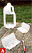 | - Cut four 5-inch-square propeller blades from the corners of the milk jugs (figure A). In each, cut a series of four 1 1/4-inch-wide slits on one side, roughly an inch apart (figure B). In Step 5, you will weave the glued-together paint stirrers through these slits.
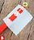 | - Glue the wooden paint stirrers together to form a plus sign (+). Drill a 1/8-inch hole through the center of the + (a parent's job). Paint the stirrers (and while you're at it, paint the three lengths of dowel). Let the paint dry.
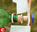 | - Cut a cork in half and press the nail through the center of one half. Twist the nail until it turns easily. Glue the pierced cork to the stirrers, using the nail to line up the holes in each. (Remove the nail before the glue dries.)
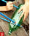 | - Poke a hole through the center of a milk jug cap with the nail. From a scrap piece of milk jug plastic, cut two 1-inch-diameter circles to serve as washers. Make a hole in the center of each with a hole punch or a craft knife. Thread the following, in order, onto the nail: milk cap, washer, propeller unit, second washer (figure C). Insert nail into uncut cork. Widen any tight holes if the propeller doesn't spin smoothly.
- Slide the four plastic propeller blades onto the stirrers (figure B). Slide the bubble wands between the paint stirrers and plastic blades so the textured circles rise just above the blades.
- Cut three pairs of X's (a parent's job) in the 2-liter bottle and insert dowels (figure D). The two front legs should form an upside-down V, while the back leg slopes away from the blades. Wrap rubber bands around the dowels on both sides of the bottle. Add pebbles for ballast. Insert cork with attached propeller.
- For the basin, cut the water jug 2 1/2 inches up from the bottom (or use a large pan). Fill with bubble mix. Adjust the mill's legs so the wands submerge as they spin.
Tips: For an economical bubble solution, mix together 6 cups water, 2 cups Joy or Dawn dishwashing liquid (these brands work best), and 1 cup corn syrup. Store the solution in a covered container.
Time needed: Under 1 Hour

Footprints in the Sand

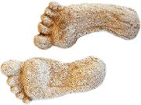 | Capture that barefoot-on-the-beach feeling -- and a record of your feet -- with this simple plaster-casting project.  Supplies: Plaster of Paris, small bucket, freshwater, 4-inch lengths of string (optional)

Directions:
- Choose a site to cast your molds -- the moist, hard-packed sand near the water's edge works best.
- Firmly press both feet into the sand. The prints should be about 1/2 inch to 2 inches deep. (If your child can't press down that hard, he can use his finger to dig down into the print, following its shape.)
- Mix up the plaster, according to the directions on the package, so that it has a thick, creamy consistency. Pour the wet plaster gently into the footprints.
- To make hangers, tie a knot about a half-inch in from each end of the pieces of string. As the plaster begins to harden, push the knotted ends into the plaster and let dry.
- After 20 to 25 minutes, gently dig the footprints out of the molds and brush away any excess sand. Set sole-side up in the sun for about an hour to let harden.

Jet Boat

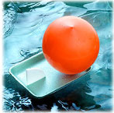 | Kids will love being the captain of this balloon-powered jet boat - perfect for racing in pools, ponds and bathtubs.  Supplies: Plastic pipe elbow, 1/2 inch in diameter, and its accompanying plastic nut (ask at your local hardware store); Two 5 1/2 x 8-inch Styrofoam food trays; Balloon; Rubber band

Directions:
- Thread the nut on the plastic pipe elbow. Then cut a hole in the bottom of one of the trays and push through the elbow's non-threaded end.
- Stretch the balloon over the threaded end. Next, secure the elbow underneath the tray with the rubber band, wrapping it around several times.
- Cut a rudder from the other tray, and insert it through a slit cut in the stern of the boat.

Tips: To operate the vessel, inflate the balloon by blowing into the elbow. Block the end of the pipe with your finger as you set the boat in the water, then release it and watch the boat zip away.

Hydro Bracelets

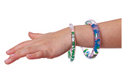
Hydro means water, and that’s just what makes the beads and glitter in these bracelets float and sparkle. If you're looking for a great summer craft, this is it. Buy extra supplies for your group (the supplies listed below will make three bracelets).

Supplies:
- 2 feet of clear plastic tubing with a ¼-inch inner diameter and
- 3 inches of clear plastic tubing with a 3/8-inch inner diameter (sold in most hardware stores)
- Ruler and scissors
- Tiny beads or glitter and water

Directions:
- To make each bracelet, cut an 8-inch-long piece from the 1/4-inch tubing and a 1-inch length from the 3/8-inch tubing (for a fastener). Slide both ends of the 8-inch tube into the fastener, as shown, and have your child try on the bracelet for fit. If it's too big, take it apart and trim it to size, remembering that it will need to slip over his hand.
- Remove one end of the bracelet from the fastener. Use a finger to stopper one end while your child drops in tiny beads or pieces of glitter -- or anything he likes that fits in the tube and can be submerged in water.
- When he's done, slowly fill the tube with water, leaving several inches of air so it has room to move. Carefully slide the free end into the fastener as far as it will go. This should create a snug fit that won't come undone without a good tug.

Wave Maker

Wouldn't it be nice to see ocean waves whenever you'd like? With a little oil, a little water, and a little imagination, you can do just that with the Wave Maker. Or for outside fun, mix up some Soupy Goop and roll it between your hands... you'll be surprised!

Supplies:
- Clear Plastic Soda or Water Bottle (2.0 liter size is preferable)
- Food Coloring (blue and green or colors of your choice)
- Vegetable Oil, colorless
- Tap Water
- Glitter or Metallic Confetti or small Trinkets (optional)

Directions:
- Fill bottle half way full with water and add about 4 drops of food coloring. Confetti of glitter can be added next if desired, a few pinches at a time.
- Using a small funnel, fill the bottle the rest of the way to the cap with vegetable oil.
- Add a dab of glue around the threads on the bottle top; screw the cap on tightly to seal.
- Colored plastic tape can be wrapped around the cap for extra sealing protection and decoration.
- Tilt and rock slowly from side to side to create action in your wave maker!

Note: This can also be made with rubbing alcohol and paint thinner (however, do keep in mind these liquids are dangerous if handled improperly; and, plastic confetti and trinkets are not recommended!)

Mini Water-Treatment Plant
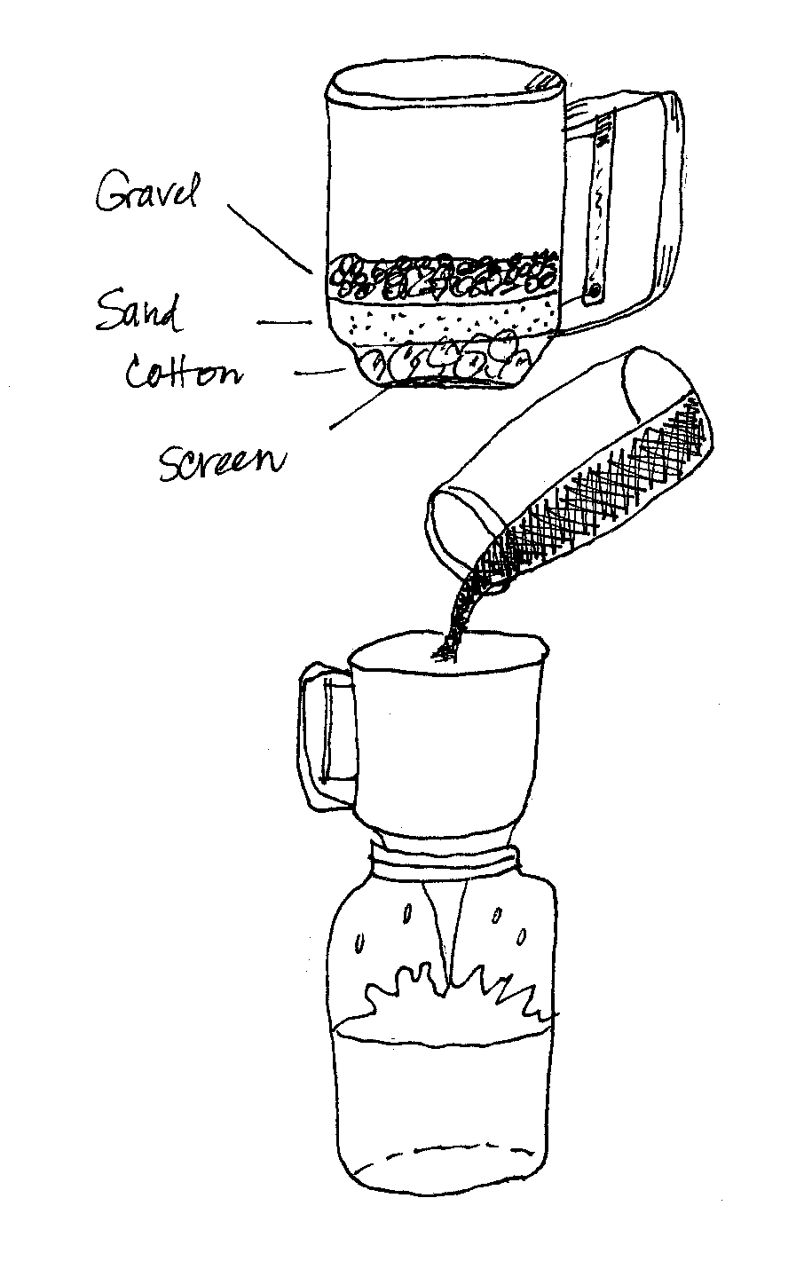
Make a model water filter.

Supplies:
- A container with a screen bottom
- (Make one or use a flour sifter)
- Absorbent cotton
- Coarse, clean sand
- Clean gravel
- Large glass jar
- Muddy water

Directions:
- Place a layer of cotton at the bottom of the screened container.
- Next, add a one-inch layer of coarse sand, then a one-inch layer of the gravel.
- Now, set the container over the jar and slowly pour the muddy water into the container. Discuss the results. (NOTE: Don’t drink the water! It may look clean, but it may contain bacteria.)

August 2004: Scouting the Midway

Ball Catchers
(From the Kids Domain)

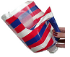 | Here is a good way to recycle your old plastic laundry detergent bottles or plastic milk jugs, and have lots of fun afterwards. The plastic bottles can be hard to cut, so help available for this step.  Supplies: 2 Plastic milk jugs or laundry detergent bottles, Sharp scissors, Colored electrical tape or "Painters" paint markers, Small rubber ball, or tennis ball

Directions:
- Wash and let dry the milk cartons well before starting. Note: It may be easier to cut the bottom off of the containers first.
- Use the sharp scissors to cut the milk carton or detergent bottle. First cut off the bottom, then cut a U shape under the handle. Make sure you don't cut into the handle so you can hold onto the bottle while catching the ball.
- Use the colored electrical tape or "Painters" paint markers to decorate the milk cartons.
- Have fun playing catch and toss.
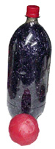
Bowling Game

Recycle those plastic soda bottles, and make an easy midway game.

Supplies: Ten Plastic bottles (2 liter or 20 oz.), clean and dry; Stickers or shredded tissue paper, shiny cloth or Easter grass; Lightweight rubber ball

Directions:
- Decorate bottles with stickers, or fill them with tissue paper (bunched or shredded), shiny cloth, or Easter grass.
- Setup the pins and bowl them down with the rubber ball.

Gone Fishing

Here’s an easy craft that makes a fun carnival game for those budding fishermen.

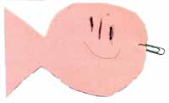 | Supplies: 2 Sheets of craft foam, Pen, Cardboard, Scissors, Metal paperclips, Ruler or stick about 12" long, String or Plastic lanyard (Rexlace), Magnet (rectangular or horseshoe shaped: need to be able to tie string to it)

Directions:
- Draw several fish outlines on a piece of cardboard. Cut out.
- Let the boys trace around the fish on the craft foam. Show them how to draw the fish close together to use all the craft foam.
- Cut the fish out. (They don't have to be perfect!)
- Draw faces on the fish.
- Open a paper clip end slightly. Poke it through the fish's mouth. Pull the fish all the way around the paperclip until it "drops" into the open area. Close the paperclip.
- Repeat for the rest of the fish.
- Tie a string on one end of the ruler or stick. (Note: Works great with a ruler that has a hole in the end!)
- On the other end of the string, tie on the magnet.
- Now go fishing!

Ball in Cup Game

This is an easy Den craft that you can use as a Pre-opening activity at the Pack meeting.

Supplies: Film canisters (ask for recycled ones from local Film Developer); flat stick or paint stirrers; Twine, string or yarn; hot glue gun & glue, Medium-sized Wooden bead

Directions:
- Glue the canister to an end of the flat stick (paint stirrers work well)
- Tie a piece of string (twine, yarn) to the stick. Tie the other end of the string to the wooden bead.
- Try to get the bead into the cup.

September 2004: Time In a Capsule

Alien Space Ships
(From Kids Domain)
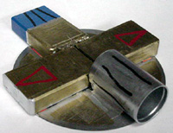
Here’s a craft you can make from all of your free or recycled computer CDs (AOL CDs?) to create space ships. Use plenty of "shiny" attachments, such as foil, old hubcaps, CDs, tin cans, etc. This would make a great Scout camp project to decorate for an alien or space theme.

Supplies: Old CDs (be sure to ask first), Aluminum foil, Old hub caps, Tin cans (clean), Tacky Glue or Silver Duct Tape, Wire (optional), Wire cutters (optional), String or fishing line, Scissors, Markers

Directions:
- Use CDs to build the base of the space ship on (shiny side out).
- Use glue or duct tape to adhere the pieces together. Use aluminum foil if you want a shiny ship.
- Use any supplies that you find, just be sure to have an adult present for safety.
- Decorate with markers if desired.
- Hang with string or fishing line.

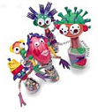Bottle Beings
(From Family Fun magazine, March 2001)

This project will let the boys use their creative juices. Fill a small bottle with colored sand (or pony beads, beans, etc) in layers and attach a Styrofoam ball for a head. The head can then be painted and decorating with a variety of items. Arms can be made out of curled wire and hands can be made out of fun foam or felt.

Supplies:
- Small plastic bottle
- Styrofoam ball – 3” diameter
- Colored sand (or pony beads or beans or shredded colored paper) to fill each bottle
- Low temp hot glue gun and low temp glue
- Fun Foam or felt
- Found items to decorate the head – milk bottle caps, sport bottle caps, telephone wire, toothpicks, bolts, plastic forks, plastic spoons
- Clear Packing tape to put the arms on the bottle
- Wire or pipe cleaners

Directions:
- Fill the bottle (empty, clean and dry) remove label with your choice of filling material – colored sand, pony beads or beans or shredded colored paper.
- To attach the head, push the head down on the water bottle to create a circle in the Styrofoam. Remove the material from this circle. Then use the glue gun to glue the water bottle top on the water bottle and then hot glue the head on the water bottle top.
- Then decorate the head using found items like plastic forks, plastic spoons, bottle tops, golf tees.
- For arms, curl colored craft wire (or a pipe cleaner) around a pencil. Then use a strip of packing or duct tape to attach the center of the curled wire to the back of the bottle.
- Cut out hands from fun foam or felt, and glue or tape them to the ends of the wire.

Cheap Colored Sand:
Make sand by mixing 7 tablespoons of powdered tempera paint per gallon of sand. Mix the tempera paint in the dry sand. Spray the mixture with water to bring the color out and thoroughly mix while spraying. Let the sand dry 2 to 3 days. Be sure to mix it once or twice a day so it doesn’t dry in big lumps. When it is thoroughly dry pour the sand into cleaned gallon milk/water jugs.

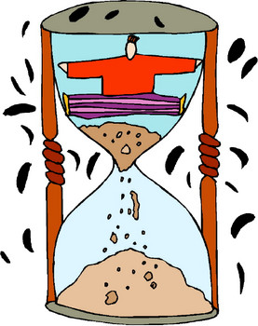

October 2004: It’s A Circus of Stars

Homemade Juggling Balls

Here are some homemade juggling balls you can make out of old tennis balls.

Supplies: 3 old tennis balls, Xacto knife, colored electrical tape, Sand or bird seed

Direction:
- Cut a 1½” slit in a tennis ball at the seam. Have an adult do this step.
- Open up the slit, and pour in the sand or birdseed until ball is completely filled.
- Cover the ball completely with the colored electrical tape.
- Repeat with the other two balls. Use the same color tape for all 3 balls, or different colored tape for each ball.

Newspaper Juggling Clubs
(Reprinted by permission from Infinite Illusions; www.infiniteillusions.com)

Supplies: 4 sheets of newspaper per club, A roll of 1” wide masking tape

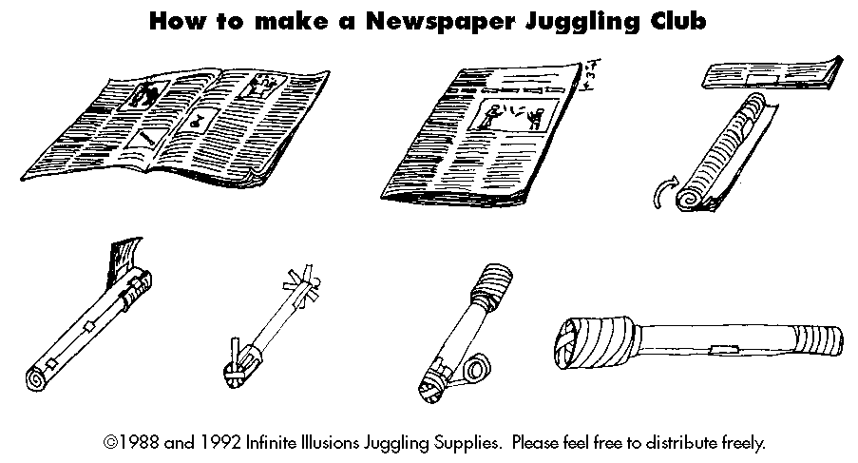

Rola-Bola
A Rola-Bola is a board resting on a piece of pipe, and you are supposed to be standing on it, juggling. Or doing something else of course, but that is up to you.

Supplies:
- Bola and Floor Board* - Two pieces of plywood about 3-feet by 1-foot and 3/4 of an inch thick. (*The floor board is optional but if you want to perform on grass or a rough surface it is necessary).
- Bumbers - Two pieces of wood 1 inch by 1 inch by a foot.
- Rola - a piece of PVC pipe 1 foot long and 6 inches in diameter.
- Griptape - Optional but advisable: some grip tape from a skateboard shop (one boards worth.)
Directions:
  - Attach the bumbers to the bottom of the bola at the sides.
  - Cut the grip tape in half and put each half at one side of the top of the board.
  - Try out your Rola-Bola. I advise beginners to put a chair in front of the Rola-Bola and hold on to it until a balance is learned.

Chinese Juggling Sticks
(From Kids Domain)

Chinese Juggling Sticks are commonly referred to as Devil Sticks. A large stick with pompons at the ends is juggled between 2 hand sticks. They originated in China a couple of thousand years ago. The pompons on the ends of Chinese juggling sticks look like flowers, therefore the name for this toy translates into flower stick. Devil Sticks do not have any pompons on the ends and are tapered in the middle.

Supplies:
- 1 (5/8" X 24") hardwood dowel
- 2 (3/8" X 18") hardwood dowels
- Colored electrical tape (1/2" wide) - The more colors used, the more colorful the sticks!
- 1 roll of rubber tape (available at electrical supply or hardware stores)
- Small standard roll of duct tape
- 3 (4" X 12") strips of felt that will match tape colors
- Fabri-Tac Permanent Adhesive or Tacky Glue

Directions:
- Find center of the large dowel by measuring.
- Wrap tape on either side of center and put a strip of colored tape around center.
- Take the same colored tape as in center and, beginning from the outside center, wrap it around the stick in candy cane fashion leaving space for the width of rubber tape to also be wrapped around in candy cane style. Wrap the rubber tape around in the same way, covering the dowel with alternating rubber and colored tape Do this on both sides.
- Wrap the duct tape on both ends in equal amounts for weight distribution (1/2 - 3/4 inch thick around both ends). Test weight distribution by balancing the center on a finger.
- Cut the felt or material rectangles into ½” wide by 3" long strips as shown below. A pair of pinking shears makes the ends look more decorative.


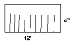

- Stack the 3 strips and wrap non-stripped end of the felt with Fabri-Tac Permanent Adhesive around the duct tape so that the strips flap in a flowery display.

For the hand sticks:
Alternate colored and rubber tapes around 2/3 of smaller dowels in candy cane fashion. Wrap extra rubber tape around the end and at end of candy cane design. For the other 1/3 of hand stick, cover candy cane style with your choice of colored tape. Wrap a couple of extra times around the end.

Heads Up Hats

This is a craft that you can play with. The game doesn’t even need rules--the equipment is so irresistible, kids immediately devise their own variations for the game. Each boy will need one hat and one small, soft object, such as a beanbag or Koosh ball.

Supplies: Two Paper Bowls (plain white – Chinette work best); 1” elastic band; Tacky glue or Hot glue; Stickers, markers, pompoms, feathers and other decorating materials; Stapler; Single hole punch

Directions:
- Have the boys decorate each bowl with markers and stickers. Remember that the bowls will be glued bottom to bottom.
- Punch two holes into the bottom bowl opposite each other in the side of the bowl.
- Fit the elastic through the holes and knot the elastic or staple it. Size the elastic to the boy so that it sits firmly on his head.
- Glue the 2 paper bowls bottom to bottom.
- Let the bowls dry until the next meeting.

At the next den meeting, have the boys play a game with their new hats. For one game, put kids in pairs about four feet apart. At the whistle, the first player to toss the soft object into his partner's hat, wins. For another variation, the first child to toss the object into her own hat wins. You will need to make the hats ahead of time.

Clown Hats

Here are some clown hats to make for your circus.

Supplies: Paper bags, standard grocery size or slightly smaller; Tape (double-sided and clear); Pom-poms, googly eyes, feathers, pipe cleaners, and other decorations; Crepe paper; Curling ribbon; Construction paper; Scissors; White Glue or Tacky glue; Stapler; Hole punch

Directions:
- Have each boy roll down the top of a bag to the outside until it reaches the hat size he wants to wear. Have him try it on for size, pinch or pull the brim to adjust the fit, then tape it in place.
- Have each boy decorate the hat using the craft materials. They can either be stapled or glued or taped on.
- The boys can make the hat as crazy or as simple as they want. The crepe paper or curling ribbon can be used to create streamers down the back of the hat.

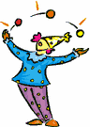

November 2004: Cub Scout Collectors

Ideas for Displaying Collections

- Shoe Box lids – Glue in items or use small plastic bags to hold the items.
- Meat Trays – Glue in the items and the cover with plastic wrap.
- Felt banner with dowels at the top and bottom is a great way to display pins or patches.
- Matt board – items can be glued on or you can use clear plastic coin envelopes.
- Egg Cartons – Can be painted and used to hold rocks or marbles or other like objects.
- Stands can be made from scrap wood glued together to display pinewood derby cars or rain gutter regatta boats.
- Michaels craft store has plastic divided boxes and wooden display shapes.

Film Canister Stamps

Your boys can make a variety of rubber stamps out of film canisters, and fun foam.

Supplies: Film canisters, Fun foam, Sandpaper, Scissors, Glue, Pen, Ink pads

Directions:
- Using a black film canister, trace around lid with a ballpoint pen on a small piece of fun foam.
- Draw a design within the confines of the circle.
- Cut out the design using scissors.
- Sand the lid of the film canister to prepare it for gluing, and then glue the design to the lid with white glue.
- Remind the boys that the design will print "backwards' and they should glue the drawn side to the canister if they want it to print the way it was drawn.
- When dry, get out the inkpads and stamp away!

Neckerchief Slide Tree

Here is an idea for storing and displaying all of those neckerchief slides you are making in our Den. Get 3’ tall wooden Christmas trees, which are made for mini lights. These go on sale after Christmas (90% off) for $1.00 each. Glue on clothes pins (about 30 on each tree) and then paint the trees.

Coin Collection Map

Here’s a project to help teach the boys about other countries, while learning about foreign coins. Have the boys bring to the den meeting, coins from their native countries or any countries they had visited. They should bring in one coin for every boy in the den. Tape a world map onto a large matte board. Point out the locations of the countries where the coins came from. Place the coins into plastic coin envelopes (get from a coin shop or hobby store). Then tape the coin to the corresponding location on the map that matches the country on the coin. Write the name of the country and the type of currency on file folder labels, and stick it on the map. This project also works well with foreign stamps.

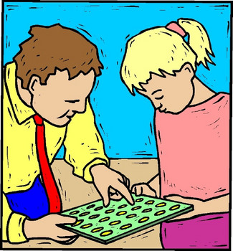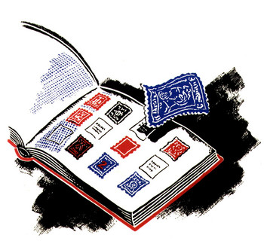

December 2004: Holiday Food Fare

Soda Bottle Snowman
(From www.make-stuff.com)

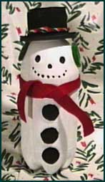 | This is an easy project for kids. Make a snowman out of old plastic soda bottles.  Supplies: 2 Liter plastic soda bottle, White and black acrylic paint, Sponge brush, Fine grain sand paper, Red and black felt, Pipe cleaners - Christmas colors, Craft glue, Plastic spray can lid (spray starch, or similar size), Plastic tub lid (butter tub or similar size)

Directions:
- Sand the surface of the bottle, spray can lid and tub lid. This will allow the acrylic paint to adhere to the surface.
- Paint the spray can lid and tub lid black. Paint the bottle white. Allow to dry.
- Cover the top and sides of the spray can lid and the top of the tub lid with black felt. Since you've painted them black, you don't need to be too precise with the felt. Center, and glue the spray can lid to the tub lid. You now have your snowman's hat. When the glue has dried, turn the hat over and cut a small hole in the bottom with an Xacto knife. Make the hole a little smaller than the circumference of the top of the hat.
- Fill the bottle about halfway with pebbles, sand or dirt. This will help keep your snowman from falling over.
- Cut a strip of red felt about 2 feet long and 1" - 1 1/2" wide. (If your felt came in 12" squares, just cut two strips and glue the ends together. Tie this around the bottle, about 3-4" down from the top. Secure with a dab of glue.
- Make earmuffs using 3 pipe cleaners. Two of them will be coiled to make the actual "muffs". The third will be the band attaching them. (Attach the pipe cleaners by twisting the ends together.) Drape the earmuffs across the back/top of the bottle. Secure with craft glue.
- Attach the hat to the bottle by running a bit of glue around the inside of the hole and then place the hat over the top of the lid. Decorate the hat with a pipe cleaner.
- Draw a face using a black marking pen or black paint. Draw buttons under the scarf, or glue on black felt circles.

Chef’s Hat

The boys are sure to enjoy wearing these hats as they prepare holiday food.
Supplies: White poster board, White tissue paper, Tape, Paper clips

Directions:
- Start with a band of white poster board 26” long and 3” high, and 3 sheets of 20” by 30” white tissue paper. Fold each sheet in half the long way.
- Gather and tape one of the short sides of each sheet along the hatband, overlapping the sheets slightly.
- Curl the band tape side out, place it around the boy’s head, and paperclip the ends. Gather the tissue at the top, taping it tightly together. Cut off the extra tissue, remove the paper clips, and turn right side out. Reattach the paper clips, puff up the tissue, and start cooking!

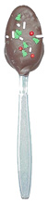
Chocolate Spoons

This project is easy and fast. Add a special touch to a dinner party or cheer someone up with a gift of this treat. Chocolate sure makes my day brighter! Adult supervision is recommended.

Supplies: Heavy plastic spoons, Milk chocolate, White chocolate, Chocolate sprinkles, Colored sugar, Wax paper, Plastic wrap, Ribbon

Directions:
- In microwave, melt half of white chocolate in one bowl. Melt half of milk chocolate in another bowl (of course you may melt chocolate on stove top).
- Dip half of the spoons in white chocolate and dip other half in milk chocolate. Dip them as far as the base of the spoons bowl. Place on waxed paper and let set completely.
- When chocolate is set dip the white spoons in milk chocolate, dip milk chocolate spoons in white. Dip only half way up the bowl of the spoon to create a layered effect. Place back on waxed paper to begin setting.
- Let chocolate set only partially (about 5 min.) Then gently dip spoons in chocolate sprinkles or colored sugar.
- Wrap soon in plastic wrap and tie with ribbon. You can add a little tag (i.e. "Stir me in your coffee").

Hard Candy Wreath

This craft is a little time consuming but with patience it looks great and is a fantastic gift for the holidays. This project can also be used as a Valentine Day project or Easter craft depending on the type of candy you use. Adult supervision is recommended.

Supplies:
- 1 coat hanger
- Approximately 30 pieces of assorted, wrapped hard candies, suckers, etc.
- Approximately 30 pieces of colorful curling ribbon, cut into 8” pieces
- Wire cutters
- Pliers to bend the hanger
- Masking tape
- A dull pair of scissors to curl the ribbon
Directions:
- Unbend the hanger and cut it in half (this will be enough for 2 kids).
- Bend the 1/2 hanger into a circle leaving about 4” at the top to make a hook. Twist the end to make it look like a circle with a hook on it.
- Cut your curling ribbon into 8” pieces.
- Fold your ribbon in half. In the middle of that ribbon tie one piece of candy. Tie it on the end of the candy where the paper twists.
- Now tie the candy with 2 knots tightly on to the hanger. Tie the candy right next to the wire to help cover it up.
- Use the scissors to curl the ribbon on each end.
- Repeat the process for all your candy pieces.
It might take a few more or less than 30 depending on the size of each candy. Suckers should be tied close to the head. You may add a ribbon on the top to cover the hook if you want. You can also tie on a pair of scissors so people can eat the candy when they visit.
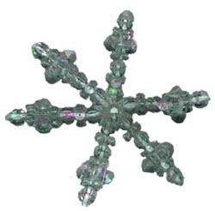
Beaded Snowflake
This makes a pretty beaded snowflake, which you can use as an ornament.
Supplies: 3 Chenille stems (6" in length), 8 Crystal paddlewheel or sunburst beads (18 mm size), 20 Crystal faceted beads (8 mm size), 18 Crystal tri-beads (11 mm size), Hot glue gun or craft glue, Wire cutters (to cut chenille stems)

Directions:
- Cut chenille stems to equal 6" in length.
- Twist them in the center once or put a spot of hot glue to hold them together, then spread out the arms gently, keeping it flat.
- String the beads on each arm in the following pattern:
1 faceted bead, 1 tri-bead, 1 faceted bead, 1 tri-bead, 1 paddle wheel,
1 tri-bead, 1 faceted bead
- Put a spot of glue under each last faceted bead. When dry clip off ends of chenille stem.
- Glue (hot glue is best) one paddle wheel in center of each side then one faceted in center of each paddle wheel that is in the middle.
- Make a hanger of fishing line or invisible thread.

January 2005: Cub Scouts Spread the News

Pressman’s Hat
(From www.br.theadvocate.com/education/newspaperfun)

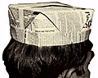
These are traditional hats that newspaper pressmen have worn for years.

Supplies: A full newspaper page for each boy.

Directions:

- Start with a newspaper sheet folded to page size. Turn it so the fold is closest to you.  - Fold top corners to center.  - Fold the remainder of the top sheet in half. Then fold it again, so that the bottom fold comes to the base of the triangle.  - Turn the paper over. Fold sides in to center.  - Fold in corners of bottom edge.  - Fold bottom edge up and tuck under flap.  - Fold pointed top down and tuck point under flap.  - Open, pulling gently until the opening edges meet in the opposite direction. Crease the outside edges.  - Fold outside corners down and tuck under flap.  - Open into hat shape. | 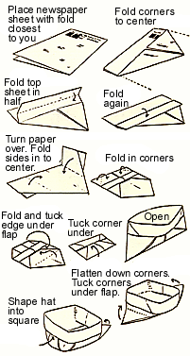

Reporter’s Index Card Book
(From MakingBooks.com)

This is a fold-up book you can make from index cards. You can use the small or large index cards. You can use all blank cards, all lined, or alternate. Books made from horizontal cards are easier to hang, but the cards can also stand vertically.

Supplies: 2 pieces of 2 3/4" x 17" cover stock, 8 index cards, 1 piece 24" yarn, Beads (optional), Glue stick and scrap paper, Hole punch

Directions:  - Put both pieces of cover stock together and fold a tab about 1/2-3/4" wide on one end. You have folded both pieces.  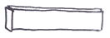  - Separate the pieces.  - Fold one piece in half so that the tab is on the inside the fold.  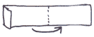  - Fold the top half back so that it meets the fold.  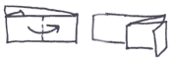  - Turn the paper over.  - Fold the other half back so that the edge meets the fold.  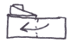  - Repeat the same process with the second sheet of paper.  - Place the two pieces of folded paper in front of you so that the tab is on the top and they look like two envelopes.  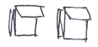  - Put glue on one of the tabs.  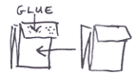 | 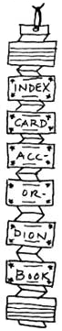
- Place the other piece on top so that the tab is on the top again. Smooth to adhere.
- Punch a hole in the center of the tab.
- Thread the yarn through the hole and pull it so that there is an even amount of yarn on each side of the accordion. Tie the two ends in a double knot at the bottom of the accordion. The yarn loop can hold the book closed and use it for hanging when the book is open. You can tie beads to the ends of the yarn for decoration | 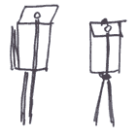
- Place one card on the center of each of the sections of the accordion. It should be centered from top to bottom and side-to-side. Use the glue stick to glue it on.

February 2005: It’s a Scouting Celebration

Blue and Gold Twirlers
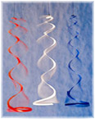

One way to show your Cub Scout colors is to hang an array of blue and gold twirlers at your Blue and Gold Banquet.

Supplies: Plastic coffee can lids, Marker, Scissors, String, Nail

Direction:
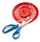
- Use a nail to poke a hole in the center of a plastic coffee can lid.
- With a marker, draw a spiral that starts 3/8 inch from the hole and gradually extends to the rim, then cut along the line with scissors.
- Knot an end of a piece of string, thread the other end up through the hole in the center, and the twirler is ready to hang up and spin.
- To spin, grasp each one at the bottom, twirl it around and around until the string is wound tight, let go and enjoy the show.

Blue and Gold Pin
(From Kids Domain)

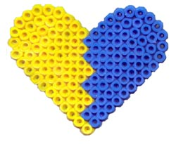 | This is an easy to make craft, and the Moms will be proud to wear it. Adult supervision is recommended to complete the project.  Supplies: About 60 Blue Perler Beads, About 60 Yellow Perler Beads, Perler heart-shaped form, Special ironing sheet (comes with the Perler beads), Iron and ironing board, Hot glue gun, Pin backing

Directions:
- Look at the picture above for an idea on how to lay out your beads on the heart-shaped form.
- Iron the beads per the manufacturer's instructions.
- Let cool completely.
- Carefully peel off the heart from the form.
- Hot glue the pin back to the side of the heart that has been ironed on.
- Give to the Moms to wear to the Blue and Gold Banquet, or any Pack Meetings.

Mini Music Shakers
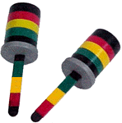
These are easy to make from empty film canisters and craft sticks.

Supplies: 2 empty film canisters; 2 Craft sticks; Colored vinyl tape; Black marker or paint; Rice, beans or beads; Scissors

Directions:
- Paint the craft sticks black.
- Decorate the sticks and the containers using colored vinyl tape.
- Cut a slit in the tops to hold the craft sticks securely.
- Fill containers half full with rice, beans or beads.
- Replace the tops. Push in the crafts sticks.

3-Dimensional Star Centerpiece

This 3-dimensional star decoration is made from 2 paper stars that are interlaced. These stars stand by themselves on a table, and make a great Blue and Gold Banquet table centerpiece.

 | Supplies: Stiff paper (like card stock, oaktag or thin cardboard) or Styrofoam meat trays; Scissors; Crayons or markers (optional)

Directions:
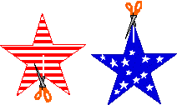
- Two paper stars are needed to make one 3-dimensional star. Either draw two identical stars on a piece of stiff paper or print out a star template.
- Decorate the two stars (if you like) on both sides, and then cut them out.

- Make one slit in each star. On one star, the slit goes from an inner corner to the center point of the star; on the other star, the slit goes from an outer corner to the center point.
- Slip the two stars together through the slits you just cut. For stability, you may have to tape the stars a bit where they meet at the slits.

