



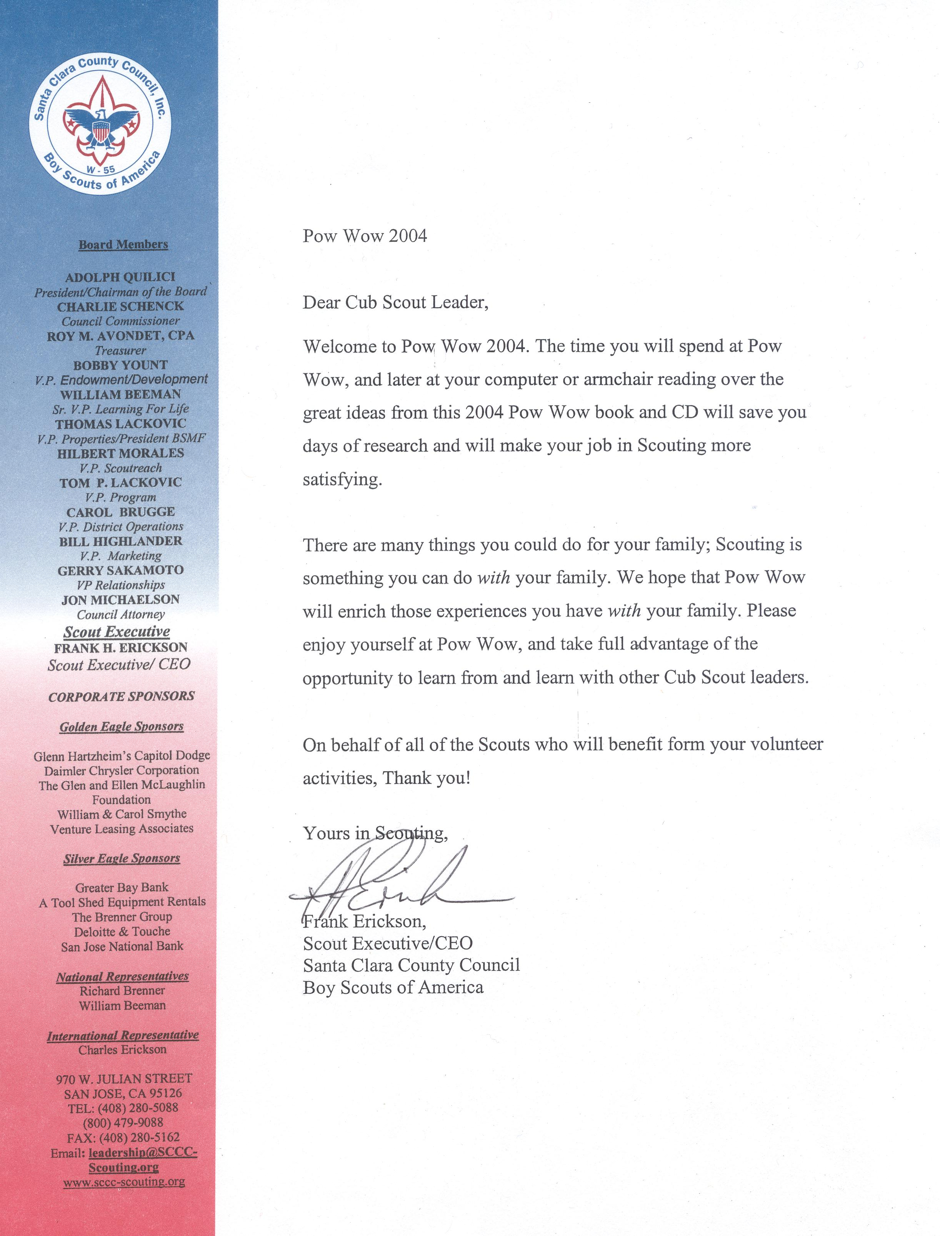
January, 2004

Dear Scouters,

I have contributed to the Pow Wow book, and mastered the Pow Wow CD for the past few years. With the wisdom imparted from Leslie and Sakiko, the previous editors, I thought I would take a stab at the editor’s job this year. You will notice that the format of this year’s book is different from previous years. We decided to move away from dividing the book by month, where all the information for that month’s theme was contained in its own chapter. Instead, we have separate chapters for the games, crafts, sparklers (songs, skits, run-ons), ceremonies, cooking, and pre-opening activities, along with chapters for Pack Leader (Den Leader and Cubmaster), and Webelos Leader resources.

Because of the popularity of the Internet, we have included many links to other resources on the web. A copy of the Pow Wow CD is included with this book, and should be used in conjunction with the printed book. The CD will allow you to link directly to the many good resources on the web.

Many thanks to the following people for their excellent contributions to the book:

- Leslie Gibbons, for her advise and Cooking and Ceremonies pages;
- Cindy Smith, for the Cooking pages;
- Lisa Corley, for the Crafts section, and the wonderful Den Leader and Webelos Tips;
- Sarah Rouse, for the Nature resources;
- The many instructors, who submitted their class notes and handouts!

My sincere appreciation to all of them.

I encourage the participants to take advantage of all the Scouting resources, and Cub Scout training available to help make doing a great job both fun and rewarding for the boys in your Packs and Dens. Thank you for your devotion to the Scouting program.

Sincerely,


Wesley Wong
wesley.wong@sbcglobal.net

BECAUSE OF MY SON

Because of my son – I found a job to do.
I became a Scouter, tried and true.

I understand boys better – because of my son.
It happened through Scouting – Gee, what fun.

Because of my son – I can be worthwhile.
Oh what a reward, to see a boy’s smile!

‘Tis endless, the pleasures gained from Scouting.
Because of my son – I attend each meeting and outing!

Because of my son – I’ve gained friends beyond measure.
‘Tis indeed blessed to hold, such a wonderful treasure!

Hours that were idle are now filled to the brim,
Because of my son – I enjoy life with him!

Because of my son – I’ve a new way of life.
I recommend Scouting for each husband and wife!

Don’t spend your spare time, doing nothing at all.
Because of my son – heed the Scouting call!

- Author unknown
TABLE OF CONTENTS

Page #

Part I Pow Wow Schedule 6
Introduction & Cub Scout Council Events 11

Part II Cub Leader Resources 15
Webelos Leader Resources 45
Pre-Opening Activities 63
Ceremonies 87
Sparklers (Songs, Skits, Run-Ons) 117
Crafts 153
Games 185
Cooking 217

Part III Field Trips 237

Part IV Class Notes
Jazzing Up Meetings with Songs and Pizzazz 273
Cubmaster Tips That Worked For Me 287
Duty to God 289
Leathercrafts 291
Knives 293
Rocket Fun 303
Using Themes in your Pack 317

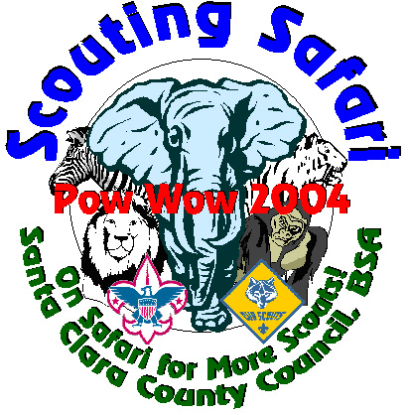
Scouting Safari
Pow Wow 2004

Schedule
January 24, 2004

7:15 a.m. to 8:00 a.m. Registration

8:00 a.m. to 8:20 a.m. Opening

8:30 a.m. to 9:30 a.m. Session 1

1.1 Boy Behavior
1.2 Cub Scouting for Boys with Special Needs
1.3 Den and Pack Ceremonies
1.4 Games to Play Outside (Outdoor Session)
1.5 Jazzing Up Meetings with Songs and Pizzazz
1.6 Nature for Wolf and Bear (Outdoor Session)
1.7 Outdoor Cooking with Cub Scouts (Outdoor Session)
1.8 Planning an Action Packed Program
1.9 Selecting Quality Leaders
1.10 The Scouting Adventure: How to make sure your Cub Scouts become Boy Scouts
1.11 Webelos Activity Badges 1

9:40 a.m. to 10:40 a.m. Session 2

2.1 60 Den Leader Tips in 60 Minutes
2.2 Boy Behavior
2.3 Cool Science for Cub Scouts
2.4 It’s Magic
2.5 Jazzing Up Meetings with Songs and Pizzazz
2.6 Nature for Webelos (Outdoor Session)
2.7 Outdoor Cooking with Cub Scouts (Outdoor Session)
2.8 Rocket Fun (Outdoor Session)
2.9 Supercharging Your Pack Committee
2.10 Terrific Tigers
2.11 Using Den Chiefs

10:50 a.m. to 11:50 a.m. Session 3

3.1 Calling All Cubs: Assuring Your Pack’s Survival by Recruiting Cub Scouts
3.2 Cub Scouting for Boys with Special Needs
3.3 Den and Pack Ceremonies
3.4 Games to Play Outside (Outdoor Session)
3.5 Nature for Wolf and Bear (Outdoor Session)
3.6 Outdoor Cooking with Cub Scouts (Outdoor Session)
3.7 Planning an Action Packed Program
3.8 Secrets of Super Cubmastering
3.9 Selecting Quality Leaders
3.10 The Scouting Adventure: How to make sure your Cub Scouts become Boy Scouts
3.11 Webelos Activity Badges 2

11:50 a.m. to 1:30 p.m. Lunch and Safari Adventure Interactive Sessions (see Next Page)

1:30 p.m. to 2:30 p.m. Session 4

4.1 60 Den Leader Tips in 60 Minutes
4.2 Boy Behavior
4.3 Calling All Cubs: Assuring Your Pack’s Survival by Recruiting Cub Scouts
4.4 Cool Science for Cub Scouts
4.5 Nature for Webelos (Outdoor Session)
4.6 Outdoor Cooking with Cub Scouts (Outdoor Session)
4.7 Rocket Fun (Outdoor Session)
4.8 Safe Scouting for Dens and Packs on the Go
4.9 Terrific Tigers
4.10 Using Den Chiefs
4.11 Webelos Activity Badges 1

2:40 p.m. to 3:40 p.m. Session 5

5.1 Boy Behavior
5.2 Calling All Cubs: Assuring Your Pack’s Survival by Recruiting Cub Scouts
5.3 Den and Pack Ceremonies
5.4 It’s Magic
5.5 Jazzing Up Meetings with Songs and Pizzazz
5.6 Planning an Action Packed Program
5.7 The Scouting Adventure: How to make sure your Cub Scouts become Boy Scouts
5.8 Webelos Activity Badges 2

3:45 p.m. to 4:00 p.m. Closing

Safari Adventure Interactive Sessions (Expanded Midway):

- Academics & Sports Program
- Adult Recognition
- BSA Film Fest
- Cub Scout Camping
- Den Gathering Activities
- Derbies
- Duty to God
- Games to Play Indoors
- LDS Church Sponsored Cub Programs
- Leathercraft
- Neckerchief Slides
- Our Flag
- Outdoor Resources
- Pack Ceremony Props
- Scouting Resources
- Scout-O-Rama
- Theme Crafts
- Tied Up in Knots
- Working With Wood

Scouting Safari Schedule
Pow Wow 2004 January 24, 2004

Class | Sessions
 | 1 | 2 | 3 |  | 4 | 5
60 Den Leader Tips in 60 Minutes |  | ❖ |  | Lunch and Safari Adventure Interactive Sessions | ❖
Boy Behavior | ❖ | ❖ |  |  | ❖ | ❖
Calling All Cubs! Assuring Your Pack’s Survival By Recruiting Cub Scouts |  |  | ❖ |  | ❖ | ❖
Cool Science for Cub Scouts |  | ❖ |  |  | ❖
Cub Scouting for Boys with Special Needs | ❖ |  | ❖
Dan and Pack Ceremonies | ❖ |  | ❖ |  |  | ❖
Games to Play Outside (Outdoor) |  | ❖ | ❖
It’s Magic |  | ❖ |  |  |  | ❖
Jazzing Up Meetings with Songs and Pizzazz | ❖ | ❖ |  |  |  | ❖
Keeping the Doors Open: Fundraisers & Finance
Nature for Wolf and Bear (Outdoor) | ❖ |  | ❖
Nature for Webelos (Outdoor) |  | ❖ |  |  | ❖
Outdoor Cooking with Cubs Scouts (Outdoor) | ❖ | ❖ | ❖ |  | ❖
Planning An Action Packed Program | ❖ |  | ❖ |  |  | ❖
Rocket Fun (Outdoor) | ❖ |  |  |  | ❖
Safe Scouting for Dens and Packs on the Go |  |  |  |  | ❖
Secrets of Super Cubmastering |  |  | ❖
Selecting Quality Cub Scout Leaders | ❖ |  | ❖
Supercharging Your Pack Committee |  | ❖
Terrific Tigers |  | ❖ |  |  | ❖
The Scouting Adventure Continues: How to make sure your Cub Scouts become Boy Scouts | ❖ |  | ❖ |  |  | ❖
Using Den Chiefs |  | ❖ |  |  | ❖
Webelos I Activity Badges | ❖ |  |  |  | ❖
Webelos II Activity Badges |  |  | ❖ |  |  | ❖

Online Pow Wow Books & Resources

Some Pow Wow books are available on the Internet, in either PDF format or MS Word format. Here are some of the Pow Wow books we were able to find, including the past six books from Santa Clara County Council.

Western Los Angeles County Council, 2001 Pow Wow Book, “Be The Difference”
http://cub.bsa-la.com/powwow2001/book/

Circle Ten Counci11999 PowWow Book, “Circle Ten Roundup”

http://www.macscouter.com/CubScouts/PowWow99/CircleTen/

Circle Ten Council, 1998 PowWow Book, “Cruise Into Cub Scouting”
http://www.macscouter.com/CubScouts/PowWow98/CircleTen/

York Adams Council, 1998 PowWow Book, “Under the Big Top”
http://www.macscouter.com/CubScouts/PowWow98/YorkAdms

Indian Nations Council, 1994 PowWow Book, “The Greatest Show On Earth”
http://www.macscouter.com/CubScouts/PowWow94

Santa Clara County Council, 1998 PowWow Book, “Teach Through Learning”
www.macscouter.com/CubScouts/PowWow98/SCCC

Santa Clara County Council, 1999 PowWow Book, “Flight to the Future”
www.macscouter.com/CubScouts/PowWow99/SCCC

Santa Clara County Council, 2000 PowWow Book, “Cub Leader’s Express”
http://www.macscouter.com/CubScouts/PowWow00

Santa Clara County Council, 2001 PowWow Book, “A Cub Scout Odyssey”
http://www.macscouter.com/CubScouts/PowWow01

Santa Clara County Council, 2002 PowWow Book, “Cubstruction: Leaders At Work”
http://www.macscouter.com/CubScouts/PowWow02

Santa Clara County Council, 2003 PowWow Book, “Lights, Camera, Cub Scout Action!”
http://www.macscouter.com/CubScouts/PowWow03

Otetiana Council, 2001 PowWow Book, “America’s Pride, America’s Future”
http://www.otetiana.org/forms/powwowbook2001.pdf (PDF File)

CubBobWhite’s Pow Wow Online Resources
http://powwow-online.net/

Council Cub Scout Events for 2004

Cub Scout Pow Wow Sat. Jan. 24
Cub Scout Leader Training Sat. Feb. 21
Youth Protection Training Tues. Feb. 24
Cub Scout Leader Training Sat. Mar. 13
Cub Scout Camp Sign-Ups Sat. April 3
Baloo Training Sat. April 3
OWL (Webelos Outdoor Leader) Training April 16-17
Water Rocket Derby Sat. April 24
Goodwill / Good Turn Days Feb. 1 – March 31
Cub Scout Leader Training Sat. May 8
Scout-O-Rama June 11-12
Family Camp I June 26-27
Family Camp II July 17-18
Cub Scout Day Camp June 28 – Aug 6
Webelos Resident Camp Aug. 12-16
Scouting For Food Nov. 17

- Note: Dates subject to change. Confirm dates with council office.

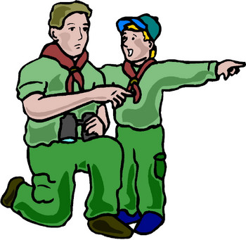
Santa Clara County Council Boy Scouts of America
Pioneer District


Cub Scout


Saturday, April 24, 2004
12:30 - 5:00 PM
Rainbow Park, San Jose
(Johnson & Rainbow, Across from Lynbrook H.S.)

WHO: Sponsored by Pioneer district. For all registered Cub Scouts (Tiger Cubs to Webelos) in Pioneer district, and other districts in council.

WHAT: Come and enjoy the fun and excitement of building and launching soda bottle rockets. We will supply the rocket kits and materials on the day of the event. The boys will build the rockets, then launch them with water and compressed air.

COST: Only $5 per scout, which includes a rocket kit and patch. All registrations must be returned by April 17, 2004. No late registrations or drop-ins accepted. Register early to reserve spot – Space Limited – Event sold out last year.

AWARDS: Medals will be awarded to the top 3 winners for
SCHEDULE: 12:30 - 2:00 pm Check-in, and Rocket Construction
2:20 - 2:30 pm Opening Ceremony
2:30 - 3:00 pm Tigers
3:00 - 3:30 pm Wolf
3:30 - 4:00 pm Bears
4:00 - 4:30 pm Webelos
4:45 - 5:00 pm Awards & Closing
each Cub rank. Winners are determined by flight
time from 2 launches. Ribbons will be awarded to
participating Packs.

CONTACT: For more information, please contact
Wesley Wong, at 408-377-2859 or
e-mail at wesley.wong@sbcglobal.net



PIONEER DISTRICT 2004 WATER ROCKET DERBY REGISTRATION Forms Due by: April 17, 2004
Saturday April 24, 2004 – Rainbow Park

Name: ___________________________________ Grade: ________ Pack: _________ □ Tiger □ Wolf □ Bear □ Webelos

Name: ___________________________________ Grade: ________ Pack: _________ □ Tiger □ Wolf □ Bear □ Webelos

Parent: ______________________________ Phone: _____________ Amount Attached: $5.00 X _____ = _____________
#Boys Total

MAIL REGISTRATION TO:
PLEASE MAKE CHECKS PAYABLE TO:
BSA - SCCC
(Write on check: Event Code # 303)

Santa Clara County Council, Boy Scouts of America
Pioneer Water Rocket Derby, Event Code # 303
970 W. Julian St.
San Jose, CA. 95126
Scout-O-Rama 2004

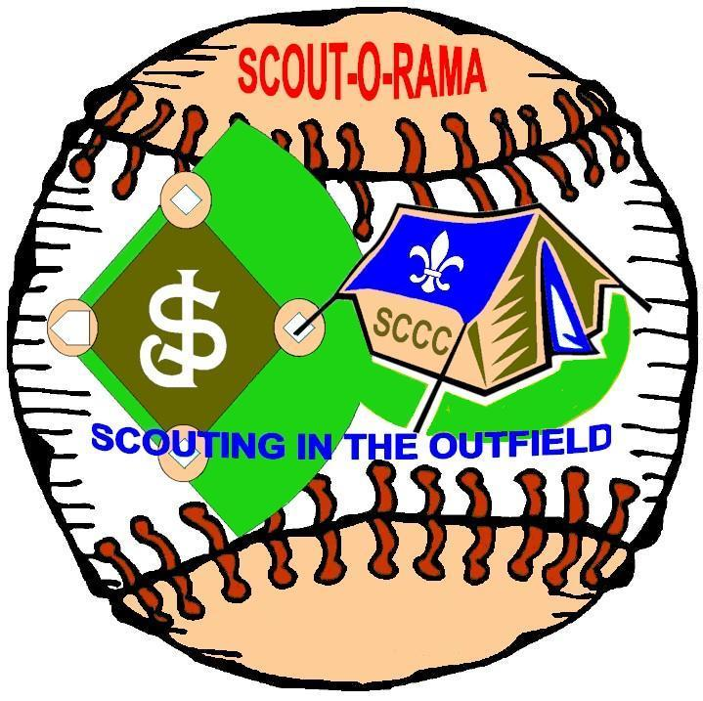

Friday, June 11th
San Jose Giants Baseball Game

Followed by
“Scouting in the Outfield” Overnighter

Saturday, June 12th
^{Scout-O-Rama}
With the units from the
Santa Clara County Council

Set the Guinness World Record
“The Most Knots Tied by a Group”

followed by
San Jose Giants Baseball Game

