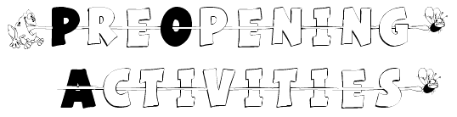



INTRODUCTION

Pre-opening or gathering activities are short (5-15 minutes) activities that keep the scouts and families busy before the meeting starts. An engaging pre-opening activity will keep the boys under control while you prepare for the den or Pack meeting. Puzzle sheets and pencil activities can be prepared and copied ahead of time; make sure you have enough drawing tools (pencils, pens, markers, crayons) on hand. Party mixers are good gathering activities, to help the families get to know each other better.
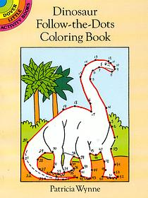
The Dover Activity books and Dover Little Activity books are good resources for pencil activities such as puzzles, mazes, dot-to-dots. Coloring sheets are good pre-opening activities for the little kids. You can make your own crossword puzzles, and word search puzzles with the construction kits that are available from the web.

LINKS

Icebreaker ideas from a birthday party site
www.coolest-kid-birthday-parties.com/icebreaker-game.html

U.S. Patent Office and Trademark Office Kids Page (Puzzles & Mazes)
www.uspto.gov/go/kids/ kidpuzzle.htm

Dover Little Activity Books: Mazes, Puzzles
http://store.doverpublications.com/by-subject-children-dover-little-activity-books-activity-books--mazes--puzzles.html

Crossword Construction Kit (For Windows; Free 30-day trial)
www.crosswordkit.com

TooHot Crossword puzzle Compiler (For Windows; Free and purchase versions)
www.tea.ch/en/description.php

Word Search Construction Kit 98 (For Windows; Free download)
www.pcwin.com/software/review.asp?ProgramID=1971

March 2004: Walk In My Shoes

Birth-month gathering

Have each person link arms with another person who has a birthday in the same month. The largest group after a designated time period, can sing Happy Birthday to the group who has their birthday on the month that the meeting is being held.

Who is born in the furthest place?

As people enter, have them sign in and write down their place of birth (City, State, Country). Then play 20 questions with the group to see if they can guess the birthplace that is the furthest away. Recognize that person with a round of applause.

Boy Scout Handshake Mixer

Upon arrival, each person is instructed to introduce himself and shake hands with all the others with his left hand and to use only his left hand for any activity until everyone is present.

Animal Noises

The players stand in a ring round the leader, who holds a stick in his hand. They then move around, but stop as soon as the leader knocks on the floor with his stick and then hands it to the player nearest to him and tells him to imitate the noise of some animal, for example, a dog, cat, etc. The leader tries to guess who the player is, and, if his guess is right, the player takes his place in the ring; if he guesses wrong, the players move round again, and the guessing is repeated.

Weight Guessing

A number of objects are placed on the table. As people enter, have them guess the weight of each object on a sheet of paper. The person with the closest weight for all the objects is awarded a prize. Suitable objects are a stone, shoe, cup and saucer, paperweight, poker, etc. Make sure the objects have been weighed and recorded beforehand.

April 2004: Cubservation

Water Conservation Puzzle

Water is a resource that we use every day, and we often take it for granted. At home, we use it for drinking, bathing, and cleaning. At work, we use it for growing food, generating power, heating and cooling. Water is even used at play – for fishing, swimming, and gardening. But water is a limited resource. Conserving water today will help ensure that we have plenty of water for tomorrow. Fill in the missing letters and transfer the letter to the corresponding space below to reveal the secret message.

- The sloping ledge formed underwater alongside most continents is the
C | O | N | __ | __ | N | E | N | T | __ | L |  | S | H | __ | __ | F.
1 | 2 | 3 | 4 | 5 | 6 | 7 | 8 | 9 | 10 | 11 |  | 12 | 13 | 14 | 15 | 16

- “Rivers of water” that flow through the ocean in certain directions are
__ | U | R | R | __ | N | T | __.
17 | 18 | 19 | 20 | 21 | 22 | 23 | 24

3. Marine organisms called | P | L | __ | N | K | __ | O | __ | are food for
 | 25 | 26 | 27 | 28 | 29 | 30 | 31 | 32
animals that live in the ocean.

4. | __ | __ | V | E | S | and | T | I | __ | __ | S | affect the shape of
 | 33 | 34 | 35 | 36 | 37 |  | 38 | 39 | 40 | 41 | 42
coastal areas.

- Two types of wetlands are
S | W | __ | M | P | __ | and | __ | A | R | S | H | __ | __.
43 | 44 | 45 | 46 | 47 | 48 |  | 49 | 50 | 51 | 52 | 53 | 54 | 55

6. | P | __ | L | L | U | __ | __ | __ | N | can ruin water.
 | 56 | 57 | 58 | 59 | 60 | 61 | 62 | 63 | 64

Secret Message:

__ | __ | __ | __ |  | __ | __ | __ | __ |  | __ | __ | __ |  | __ | __ | __ | __ | __
53 | 36 | 26 | 56 |  | 43 | 50 | 35 | 41 |  | 31 | 60 | 51 |  | 44 | 10 | 4 | 21 | 19

Answers: 1. CONTINENTAL SHELF, 2. CURRENTS, 3. PLANKTON, 4. WAVES / TIDES, 5. SWAMP / MARSHES, 6. POLLUTION
Message: HELP SAVE OUR WATER

Soil Conservation Puzzle

Soil is an important natural resource. It is composed of air, water, minerals and other organic materials. It takes from 100 to 1,000 years to make just one inch of soil – that’s why it is important to take care of it. Conservation is everyone’s job. We need to pitch in to save our soil since we all use it. Decode the words below to find out some uses for soil.

Code: A=X B=O C=J D=I E=Q F=R G=E H=N I=T J=W
K=A L=Z M=P N=V O=G P=U Q=Y R=M S=I T=C
U=B V=K W=D X=S Y=H Z=F

__ | __ | __ | __ | __ | __ | __ |  | __ | __ | __ | __ | __ | __ | __
O | F | K | L | S | H | O |  | K | H | S | R | K | D | X

__ | __ | __ | __ | __ | __ |  | __ | __ | __ | __ | __
H | K | I | P | F | G |  | K | F | G | K | X

__ | __ | __ | __ | __ |  | __ | __ |  | __ | __ | __ | __ | __ |  | __ | __ | __ | __ | __
W | K | S | F | Q |  | B | F |  | B | I | Y | G | F |  | Z | K | F | R | X

__ | __ | __ | __ | __
T | F | B | M | X
__ | __ | __ | __ | __ | __ | __ | __ | __ | __ | __ | __
T | B | H | X | I | F | P | T | I | S | B | H

__ | __ | __ | __ | __ | __ | __
O | K | F | W | G | H | X

Answers: GRAZING ANIMALS, NATURE AREAS, DAIRY OR OTHER FARMS, CROPS,
CONSTRUCTION, GARDENS

Recycle Maze 1
(From Washington County Recycling Program)

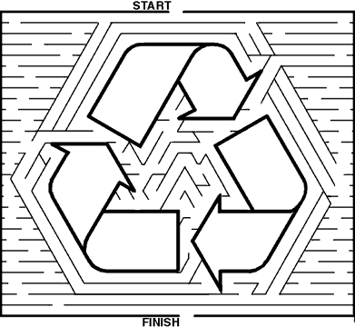

Recycle Maze I1
(From www.think-food.com)

Help Inky the inkjet cartridge find his way to the recycling bin.

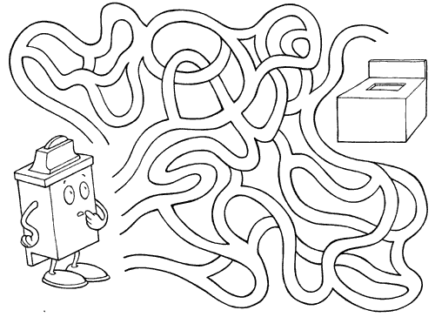

May 2004: My Home State
State Sports Teams

The following states have professional sports teams that represent that state:

Arizona (2) Colorado (2) Connecticut (1) Florida (2)
Indiana (2) Minnesota (5) New Jersey (2) New York (8)
Tennessee (1) Texas (1) Utah (1)

Complete the name of the professional sports teams below with the correct state:

_____________ | Avalanche (NHL) | _____________ | Nets (NBA)
_____________ | Cardinals (NFL) | _____________ | Pacers (NBA)
_____________ | Devils (NHL) | _____________ | Panthers (NHL)
_____________ | Diamondbacks (MLB) | _____________ | Rangers (NHL)
_____________ | Fever (WNBA) | _____________ | Rangers (MLB)
_____________ | Giants (NFL) | _____________ | Rockies (MLB)
_____________ | Islanders (NHL) | _____________ | Sun (WNBA)
_____________ | Jazz (NBA) | _____________ | Timberwolves (NBA)
_____________ | Jets (NFL) | _____________ | Titans (NFL)
_____________ | Knicks (NBA) | _____________ | Twins (MLB)
_____________ | Liberty (WNBA) | _____________ | Vikings (NFL)
_____________ | Lynx (WNBA) | _____________ | Wild (NHL)
_____________ | Marlins (MLB) | _____________ | Yankees (MLB)
_____________ | Mets (MLB)

Answers: Avalanche (Colorado), Cardinals (Arizona), Devils (New Jersey), Diamondbacks (Arizona), Fever (Indiana), Giants (NY), Islanders (NY), Jazz (Utah), Jets (NY), Knicks (NY), Liberty (NY), Lynx (Minnesota), Marlins (Florida), Mets (NY), Nets (New Jersey), Pacers (Indiana), Panthers (Florida), Rangers (NY-NHL), Rangers (Texas-NHL), Rockies (Colorado), Sun (Connecticut), Timberwolves (Minnesota), Titans (Tennessee), Twins (Minnesota), Vikings (Minnesota), Wild (Minnesota), Yankees (NY)

List Your American ABC’s
Give everyone a blank sheet of paper, and a pencil. See how many American people, places, and things they can list from A to Z.

Flag Pieces
Copy a sufficient number of pictures of the State flags and cut them into 2 or 3 pieces to accommodate the number of people you have attending a den or pack meeting. Mix and distribute the flag pieces as members arrive at the meeting. Have each person find the people who are holding the other pieces of their flag and introduce themselves to each other.

State Alphabet
How's your State Geography? See how many states you can name. The younger boys can have their parents or older siblings help out.
- Name 2 states starting with the letter A: ___________________________________
- Name 2 states starting with the letter C: ___________________________________
- Name 1 state starting with the letter D: ____________________________________
- Name 1 state starting with the letter F: ____________________________________
- Name 1 state starting with the letter G: ____________________________________
- Name 1 state starting with the letter K: ____________________________________
- Name 3 states starting with the letter M: ___________________________________
- Name 3 states starting with the letter N: ___________________________________
- Name 2 states starting with the letter O: ___________________________________
- Name 1 state starting with the letter T: ____________________________________
- Name 1 states starting with the letter U: ___________________________________
- Name 2 states starting with the letter W: ___________________________________
- Name 1 state you haven't already named: __________________________________

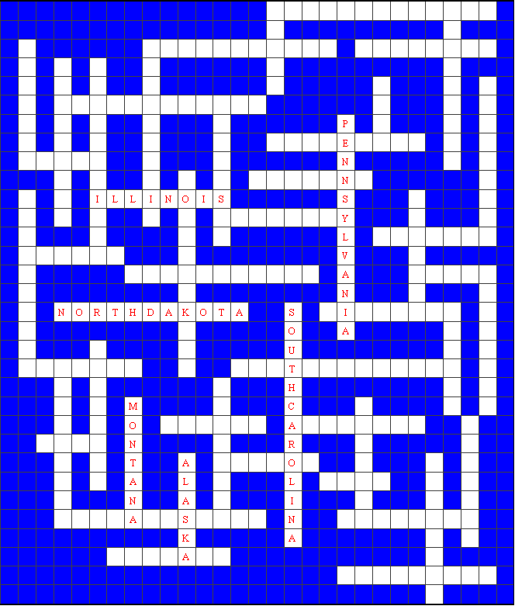
State Kriss-Kross
The names of the states have been grouped by length. Fit them into the correct spaces above.
4 Letter States:  UTAH  OHIO  IOWA  5 Letter States:  MAINE  IDAHO  TEXAS  6 Letter States:  NEVADA  OREGON | ALASKA  KANSAS  HAWAII  7 Letter States:  MONTANA  ARIZONA  ALABAMA  INDIANA  VERMONT  NEW YORK  FLORIDA | GEORGIA  WYOMING  8 Letter States:  OKLAHOMA  MARYLAND  COLORADO  NEBRASKA  MISSOURI  ILLINOIS  MICHIGAN  VIRGINIA | DELAWARE  KENTUCKY  ARKANSAS  9 Letter States:  NEW MEXICO  LOUISANA  WISCONSIN  TENNESSEE  MINNESOTA  NEW JERSEY | 10 Letter States:  CALIFORNIA  WASHINGTON  11 Letter States:  SOUTH DAKOTA  NORTH DAKOTA  MISSISSIPPI  RHODE ISLAND  CONNECTICUT  12 Letter States:  NEW HAMPSHIRE | PENNSYLVANIA  WEST VERGINIA  13 Letter States:  NORTH CAROLINA  SOUTH CAROLINA  MASSACHUSETTS

June 2004: Cub Rock

Dinosaur Maze

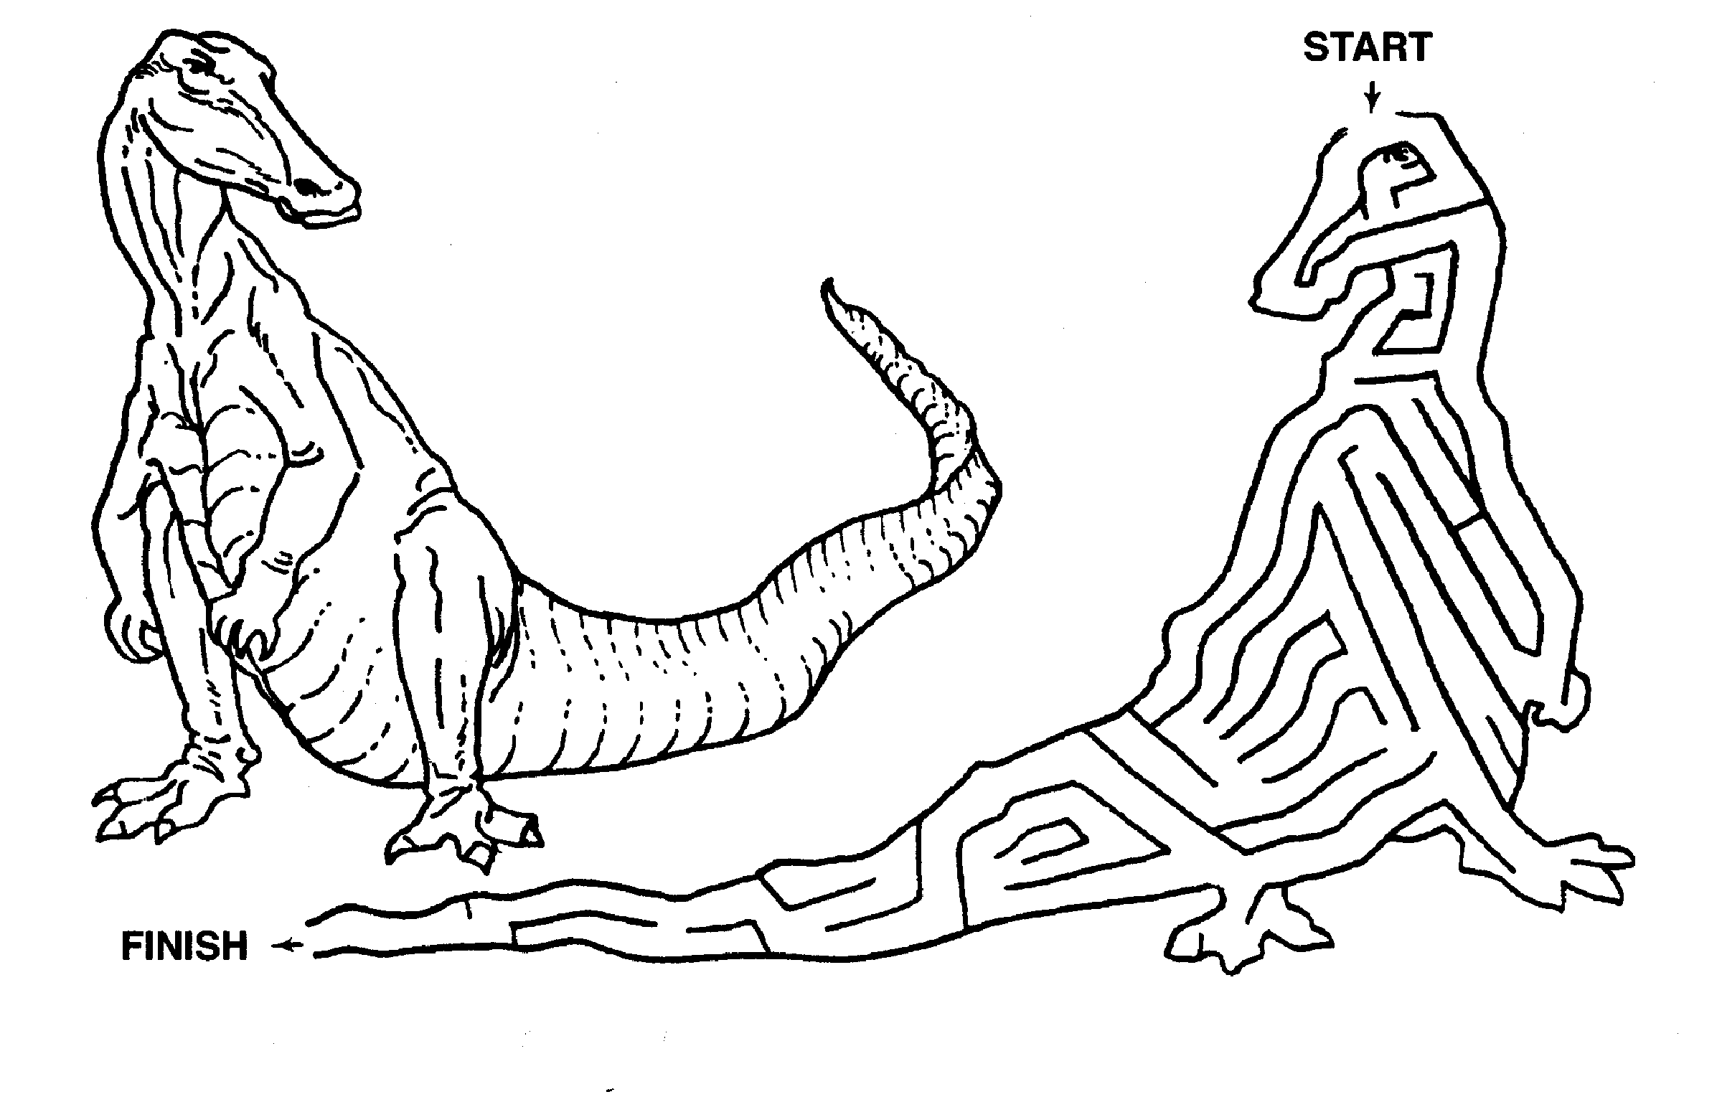
Birthstone Match-up

Match up the correct birthstone for each month.

____ | January | 1. Amethyst
____ | February | 2. Aquamarine
____ | March | 3. Diamond
____ | April | 4. Emerald
____ | May | 5. Garnet
____ | June | 6. Opal
____ | July | 7. Pearl
____ | August | 8. Peridot
____ | September | 9. Ruby
____ | October | 10. Sapphire
____ | November | 11. Turquoise
____ | December | 12. Topaz

Answers: Jan-5, Feb-1, Mar-2, Apr-3, May-4, June-7, July-9, Aug-8, Sep-10, Oct-6, Nov-12, Dec-11
Hidden Picture

Color the shapes in the puzzle below, which have letters that are in the word MINE, to reveal the hidden picture.

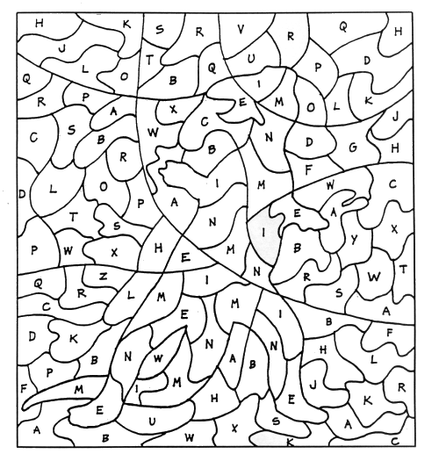

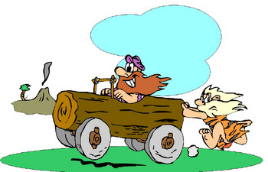

July 2004: Fin Fun

School of Fish

Pin pictures of fish on people as they arrive. Have cutouts of swordfish, tuna, trout, catfish, etc. On a signal, they are to see which “school of fish” can assemble first.

Mink in a Maze

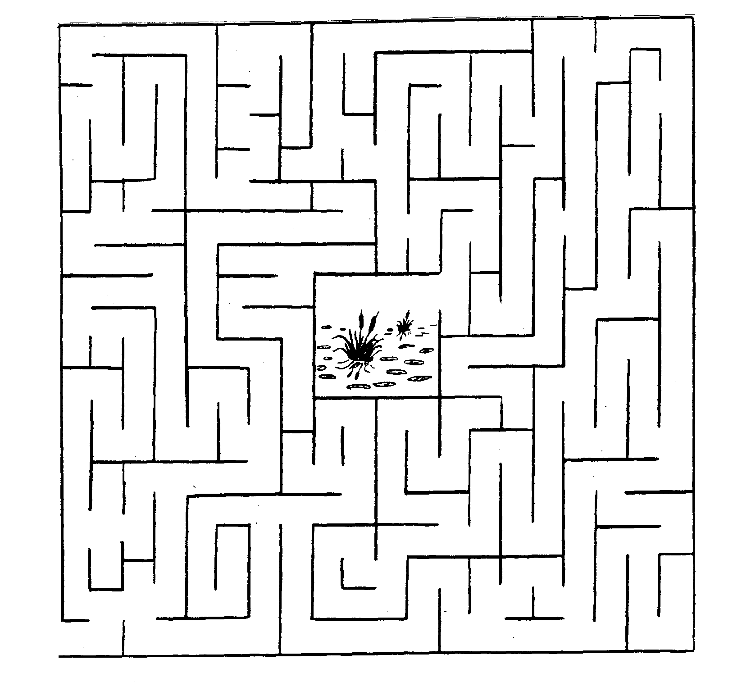

Every wild animal must live in its chosen habitat. The mink prefers a riparian habitat.

Can you help it find its way to the pond at the center of the maze?


Ocean Objects Word Search

Find these things that can be found in or on the ocean. Look up, down, across, backwards and diagonally:

BOAT OCTOPUS
BREEZE PELICAN
CORAL SALT
CRAB SAND
EEL SEA
FISH SHARK
FLOTSAM SHIP
FOG STORMS
GULL SUB
ICEBERG WAVES
LIGHTHOUSE WHALES

The remaining 13 letters, in order, spell the name of a beautiful sea.
L | M | F | N | A | C | I | L | E | P
A | I | O | F | I | S | H | E | S | I
R | C | G | E | D | E | M | E | I | H
O | E | T | H | T | L | A | S | E | S
C | B | O | A | T | A | S | R | U | B
S | E | V | A | W | H | T | P | D | R
H | R | R | A | N | W | O | S | N | E
A | G | U | L | L | T | L | U | A | E
A | B | A | R | C | E | F | B | S | Z
K | S | T | O | R | M | S | A | N | E

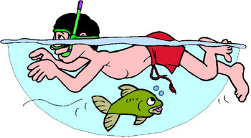

August 2004: Scouting the Midway

Fun Mazes

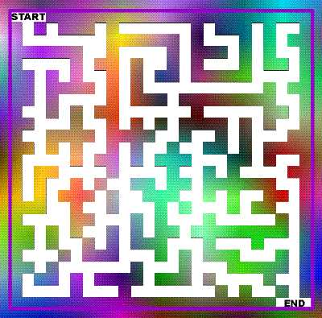
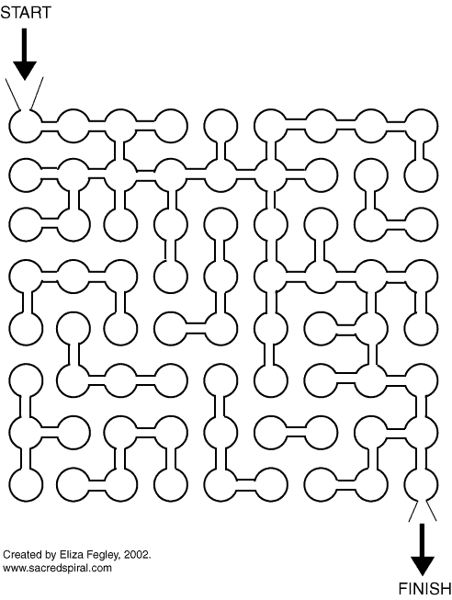

Pencil Puzzle 1
A B C D E F G H I J K L M N O P Q R S T U V W X Y Z
How many letters of the alphabet can you write (capital letters) without taking your pen off the page and not going along a line you have already drawn?
The answer to this depends on how you write your letters so there is no single answer.

Pencil Puzzle 2

Draw a square made up of dots like this one on your piece of paper.
Now, without lifting the pencil from the page, draw no more than four straight lines that will cross through all nine dots.

Answer: The answer you will usually find in books is shown to the right:
But there are a number of answers. No one said what size the puzzle was - if you draw it very small and then have a very thick pencil you might even be able to cross all the dots with one line!
And no one said the paper had to be kept flat - you could try folding it or rolling it up, which both give you another way of solving the puzzle.

Hopscotch Puzzle

Can you draw the hopscotch figure shown at the left without lifting your pencil off the paper or going along the same line twice?


Answer: It's necessary to begin at the point A (or B) and end at B (A respectively). Otherwise it can't be done.

Quick Magic Trick

Here’s a quick magic trick you can show to the boys as a pre-opening act.
Effect: Pour some water into a cup, blow on the cup and then turn it upside down where out pops some ice cubes.
You need a cup or glass that you can't see through. You also need a small sponge and some ice cubes.
Method: Prepare the cup by placing the sponge into the bottom of the cup. Then, drop a few ice cubes on top of the sponge and you're ready to go.
To perform, pour a small amount of water (about an inch) into the cup. The sponge will absorb the water. Blow into the cup, wave your hands over it and dump out the ice cubes. If you are using a disposable plastic cup for the trick, just throw it away at this time.
Watch the look of surprise on the boys’ faces.

September 2004: Time In a Capsule

Odd Bean

Supplies: 12 beans for every player plus some extra beans, small plastic bags

Before the meeting, put 12 beans in each plastic bag. Hand out a set of beans to each player as they arrive. Opening his bag of 12 beans, one player – say Greg – puts a few beans in one fist, reaches out to another player and asks, “Odds or evens?” If the other player – Jane guesses correctly that Greg’s closed fist has an odd number of beans in it, she collects those beans. If she guesses wrong, she has to turn over that many beans to Greg. The object of the game is to collect all the beans. When you want to stop playing, the winner is the player with the most beans.

Church Maze

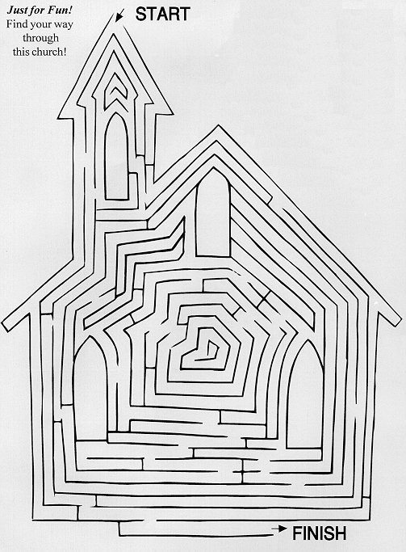
Historical Event Maze
(From www.tech-nology.com)

You have just invented the biplane. Find the path to the newspaper to report the story.

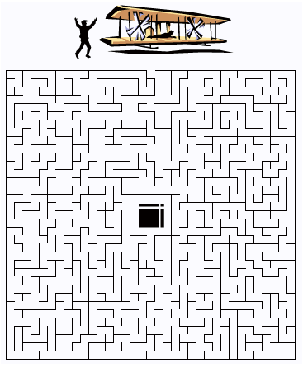

October 2004: It’s A Circus of Stars

Impromptu Kazoo Band
Have supplies (combs and waxed paper pieces) for the boys to use when they come in. Set aside a band practice area and have one of the parents or the Den Chief act as a conductor for the practice session. Make sure the conductor encourages and makes it lots of goofy fun so the boys don’t lose interest. You can also have some funny hats and rubber noses for the boys, so they can form a circus band.

Circus Word Search
Find these things that can be found at the circus. Look up, down, across, backwards and diagonally:

ACTS JUGGLE
BALLOONS MIDWAY
BIG TOP RIGGING
CALLIOPE RINGS
CAMELS SHOWS
CLOWNS TICKETS
ELEPHANTS TIGERS
HORSES TRAINER
SOUVENIRS TRAPEZE

S | C | A | L | L | I | O | P | E | F | F | S
J | H | X | S | A | C | T | S | S | T | O | T
S | Y | O | X | T | U | H | R | S | R | S | R
T | A | L | W | A | N | I | Z | J | A | R | A
E | W | M | A | S | N | A | Q | D | P | E | I
K | D | R | O | E | B | S | H | B | E | G | N
C | I | W | V | I | C | H | L | P | Z | I | E
I | M | U | G | L | Z | U | O | E | E | T | R
T | O | T | O | S | G | N | I | R | M | L | A
S | O | W | E | L | G | G | U | J | R | E | C
P | N | U | G | N | I | G | G | I | R | E | C
S | Q | Z | S | N | O | O | L | L | A | B | S
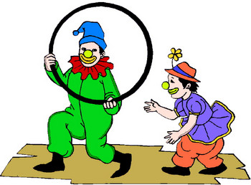

November 2004: Cub Scout Collectors

Beanie Bears Word Search

H | O | E | P | E | A | B | R | I | Y | A | N | R | H | A | L | O | T | W | O | U | P
R | W | R | S | P | A | E | C | U | B | B | B | A | L | M | O | C | U | B | B | H | M
H | E | I | K | I | P | P | G | N | I | N | N | I | G | E | B | E | H | T | S | O | E
A | H | N | C | V | A | L | E | P | R | B | C | A | L | M | O | R | E | U | C | P | T
L | S | R | I | M | B | W | L | A | G | E | R | L | L | T | P | E | C | B | A | E | C
O | A | E | K | Y | D | D | E | T | C | U | V | A | L | E | N | T | I | N | O | A | U
G | C | I | F | U | D | B | A | H | Y | E | G | S | S | N | N | E | R | F | U | A | B
A | Z | B | U | G | B | R | M | S | S | K | P | L | M | P | R | I | C | H | A | S | B
G | R | B | E | B | M | E | H | P | U | A | H | O | I | L | I | B | E | A | R | T | Y
A | G | U | I | A | L | A | U | L | N | T | C | O | L | C | A | B | T | C | T | C | V
R | A | C | K | D | N | A | P | G | Y | P | E | G | L | T | A | U | H | M | H | C | A
C | B | V | C | A | N | L | L | L | L | Y | R | N | E | P | M | C | P | B | E | U | L
O | R | C | A | S | S | E | E | M | E | E | N | I | N | A | R | I | Z | E | E | B | E
A | I | U | L | L | P | D | E | I | O | I | Y | K | N | Y | S | C | K | C | C | B | N
I | T | R | B | A | E | B | B | H | R | N | T | E | I | C | M | A | I | U | B | A | T
N | A | S | R | E | D | N | I | C | T | A | D | P | U | I | E | M | B | B | V | P | N
N | N | B | B | B | E | A | T | T | M | A | P | N | M | S | I | S | A | B | A | R | E
A | L | I | Y | L | R | U | C | I | C | L | U | B | B | Y | A | L | S | S | L | I | P
T | I | Y | R | O | L | G | I | S | N | G | E | R | M | A | N | I | A | A | E | N | O
I | B | I | R | O | H | S | I | G | N | A | T | U | R | E | N | B | L | U | N | C | H
R | E | U | L | R | E | P | E | K | I | U | A | L | M | O | D | L | Y | T | T | E | I
B | A | C | B | P | E | C | I | N | A | U | R | O | P | U | Z | Z | U | F | B | A | R

Find the Beanie Bears in the word search puzzle.

ALMOND  ARIEL  AURORA  BBBEAR  BLACKIE  BRITANNIA  CASHEW  CINDERS | CLUBBY  CUBBIE  CURLY  ERIN  FUZZ  GARCIA  GERMANIA  GLORY | HALO  HALOTWO  HOPE  KICKS  LIBEARTY  MAPLE  MEL  MILLENNIUM | PEACE  PECAN  PEKING  PRINCESS  SAKURA  SAMMY  SIGNATURE  SPANGLE | TEDDY  THEBEGINNING  THEEND  TY  VALENTINA  VALENTINO  USA

What Do People Collect?

Match these people with the things that they collect:

____ | 1. Rock Hound | A. Stamps
____ | 2. Folk Singer | B. Recipes
____ | 3. Numismatist | C. Timetables
____ | 4. Ham Radio Operator | D. Coins
____ | 5. Cook | E. Old Furniture
____ | 6. Lexicographer | F. Call Numbers
____ | 7. Philatelist | G. First Editions
____ | 8. Antiques Collector | H. Ballads
____ | 9. Railroad Buff | I. Obsidian
____ | 10. Book Lover | J. Words

Answers: 1-I, 2-H, 3-D, 4-F, 5-B, 6-J, 7-A, 8-E, 9-C, 10-G

Turkey Maze
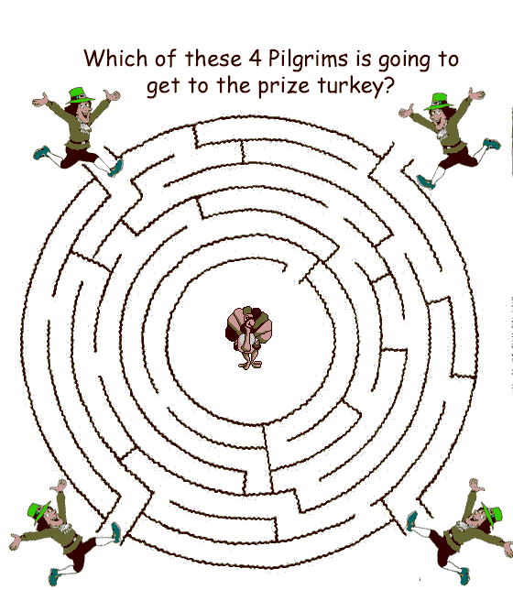

December 2004: Holiday Food Fare

Food Maze

Find the right path from the watermelon to the mouth.

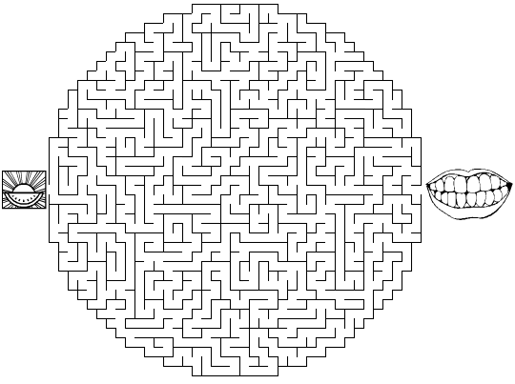

Holiday Word Search

P | I | N | E | W | R | E | A | T | H | S | B | A | L
R | O | O | B | I | E | A | N | G | E | L | P | N | O
E | S | S | U | N | D | V | T | M | R | A | C | T | F
S | Z | L | N | T | L | M | L | O | C | Y | O | L | R
E | V | R | X | E | I | O | E | O | U | D | Z | B | L
N | P | D | S | R | B | Y | R | S | P | K | Y | U | P
T | I | N | S | E | L | B | U | E | I | O | X | B | O
N | O | R | T | H | P | O | L | E | D | B | O | A | T

Find the following words: Sled, Pine, Wreath, Tinsel, Red, Presents, Winter, Angel, Antler, Eve, Moose, North Pole, Cupid, Cozy.
Ethnic Foods

Match up these ethnic foods with the correct region that food comes from.

____ | 1. Bread Pudding | A. Mexico
____ | 2. Tandoori Chicken | B. Israel (Jewish)
____ | 3. Sambal Balado (crispy crunchy beef) | C. France
____ | 4. Latkes (potato pancakes) | D. England (British)
____ | 5. Spaghetti Bolognese | E. Germany
____ | 6. Sushi | F. China
____ | 7. Enchiladas | G. India
____ | 8. Peking Duck | H. Italy
____ | 9. Coq Au Vin (chicken in wine) | I. Hawaii
____ | 10. Sauerbraten (sour roasted duck) | J. Indonesia
____ | 11. Souvlaki (lamb) | K. Greece
____ | 12. Macadamia Nuts | L. Japan

Answers: 1-D, 2-G, 3-J, 4-B, 5-H, 6-L, 7-A, 8-F, 9-C, 10-E, 11-K, 12-I

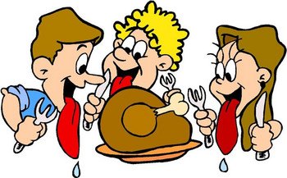

January 2005: Cub Scouts Spread the News

Noodlegrams
In a saucer place a tablespoonful or more of uncooked alphabet noodles. Each person must try to compose a ten-word message out of the alphabet noodles. This can be done in pairs or individually as a gather time activity.

How Many Words?
See how many words each person can find in the phrase “Cub Scouts Spread the News.”

Who Is It?

Give everyone a 3”x5” index card. Have them all write down 4 things about themselves that no one else in the room should know. Have them put their name on the top of the card for future reference. Collect the cards. Then pass out a piece of paper to each person. Read the cards one at a time and have everyone write down who they think the person on the card is. Then read off the correct results (the names from the top of the cards) while they check their lists. The person who gets the most right is the winner.

Amazing Numbers
Hand everyone a piece of paper and a pencil. Have calculators available for people to share. Calculate the following:
- Take the number of the month you were born
- Multiply by 4
- Add 13
- Multiply by 25, Subtract 200
- Add the day of the month on which you were born
- Multiply by 2, Subtract 40, Multiply by 50
- Add the last two digits of the year in which you were born
- Subtract 10,500
Notice anything amazing about your answer?
(Note: The answer should come out to their birth date of the form: MMDDYY)

February 2005: It’s a Scouting Celebration

Cub Scout Belt Loops Word Search

Q I F B X Y F V L S G Y U L T I M A T E V Z D
X L G B L N B A M O S O F T B A L L C Q N M V
M G S N B F X L A C B I L O S E L B R A M K A
S N S C I M U O H C K T M G O N U P X R D L W
I J G K T L L M T E Y X S F O U O C M K S A C
N Q X X A E C E O R B E Z O W B G C H R O B M
N G V M S T N Y B F G E Z B A N Y T G Z V Z S
E E X A J N I A C A E L Y S I F Y N E O W G B
T M L H I W S N T I K Z K T W T I G L G N A C
E Z A S H E B I G I B E O J C L Z L D I D S I
L K A T B R R C W Z T O Y Y W N E N M M C V T
B Y A A R E S S I B H W Q O U Y Q X I I A H I
A M L U H H V K A S X T B H B X I N T B V W Z
T L S H F L S L B L H S V A S W T Z Y X G W E
T B K R H K L B Q S B Q L O S O A U G N T T N
X R I R W Y N G Y U H L N R N N S Y I U G A S
O I I X A R C H E R Y G P M M I T H C Q X D H
F Y N D C J J O F L G O V Y C V S O J O T Q I
W A G V K S A Z L I L L G K O I E M X O B O P
S Z I J N H P A J J K F R N F A K E V X Q F W
R C N Z L Y H P A R G O E G R J Y I C J M H I
K K N P H Y S I C A L F I T N E S S C C O N U

Find the following Sports and Academic Belt Loops:

ARCHERY | BOWLING | GYMNASTICS | PHYSICAL FITNESS | SWIMMING
BADMINTON | CITIZENSHIP | HERITAGES | SKATING | TABLE TENNIS
BASEBALL | FISHING | MARBLES | SKIING | TENNIS
BASKETBALL | GEOGRAPHY | MATH | SOCCER | ULTIMATE
BB SHOOTING | GOLF | MUSIC | SOFTBALL | VOLLEYBALL
BICYCLING

History of Cub Scouting

Identify the correct decade (1930, 1940, 1950, 1960, 1970, 1980, 1990) in which the following events occurred in Cub Scout history:

_____ | 1. Tiger Cubs introduced
_____ | 2. First Pinewood Derby
_____ | 3. Cub Scouting officially approved in the U.S.
_____ | 4. Garfield the Cat named National Cub Scouting “spokescat.”
_____ | 5. First Blue and Gold banquet. Packs sell war bonds and war stamps.
_____ | 6. National Summertime Pack award introduced
_____ | 7. Five ranks established: Bobcat, Wolf, Bear, Webelos, Arrow of Light.

Answers: 1-1980 (1982), 2-1950 (1953), 3-1930, 4-1990 (1999), 5-1940 (1943), 6-1960 (1964),
7-1970 (1978)

