

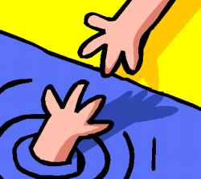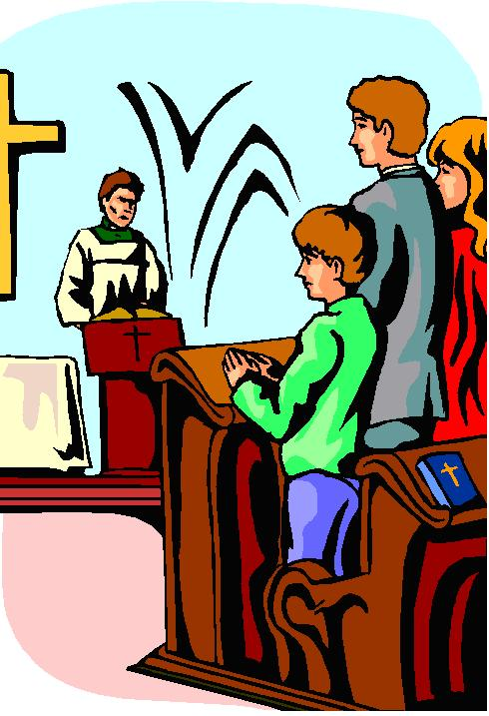

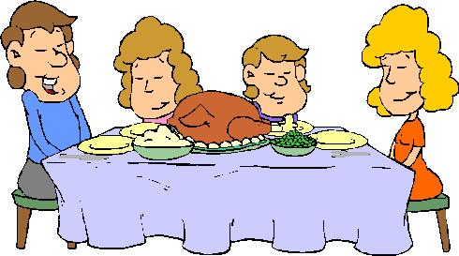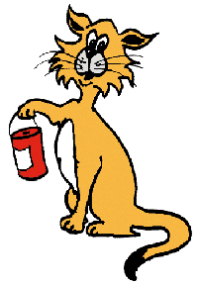

December 2005
DECEMBER 2005 - Faith, Hope, & Charity
This time of year is packed with family faiths, hopes for the future, duty to God, and charity to all. Service projects are a way to give thanks while helping those in need in our neighborhoods and in our schools. Share family or historic traditions with your den or pack. Celebrate the holiday season with foods and crafts that are appropriate to the various faiths. Build a glove or mitten tree during a pack meeting or organize a food collection where everyone brings something to share with the needy.

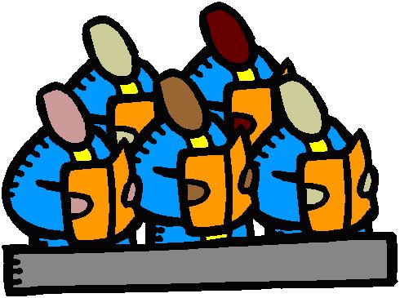

Free Stuff:

- Free Sample of Haagen Dazs Ice Cream
www.coolfreebielinks.com/s2004/ws1/HaagenDazs.htm
Everyone loves ice cream ... especially when it's Haagen Dazs! Take a survey, and get your free sample of Haagen Dazs ice cream!
- Free Sample of Kraft Mac & Cheese
www.coolfreebielinks.com/s2003/ws/2/KraftMacCheese.htm
Everybody’s favorite meal is yours for free. Get your Kraft Macaroni and Cheese sample today at no cost.
- Caribbean Cake Connoisseurs - Free Sample
www.rumcake.com/sample_request.asp
Home site of the world's most delicious fruit-based gourmet rum cakes! Fill out their form and get a FREE sample.
- Godiva Boutiques - Free samples page
www.godiva.com/boutique/happenings.asp
Check out Godiva Boutiques promotion schedule page for a list of free samples they are giving away at each store ... yummy!

Den Meeting/ Pack Meeting Ideas

- Visit a rest home, senior center, or a hospital. Take with you cards or holiday crafts that the Cub Scouts have made in den meetings or at home. You can sing to the group, or with the group. You could pop corn, put on skits or ask the patients to tell stories of their Christmas’ as children.
- All month each Scout is to do something (at least once a week) for others. At the Pack meeting, the Cub Scout does not tell whom he did it for, but only what he did.
- Have a food, clothes, or slightly used toy drive. Clean and fix the items and turn them over to a community leader that can give them to the needy.
- Make candy, cookies, or Christmas cards and take them to homes of the elderly in your area. You can also treat them to Christmas carols too.
- Going sleigh riding or ice-skating, if you have the equipment, in a safe area can be fun.
- Have a Pack movie night where you invite young families in your area to your Pack night. The Cub Scouts and leaders can tend to the young children for free while the parents have a couple hours off. Have a VCR with simple Christmas videos, popcorn and lots of manpower.
- String popcorn or cranberries and place them outside for the birds.
- Make homemade Christmas decorations. Decorate an elderly person’s home for the holidays.
- Write letters or cards to people in the armed services. Many of them have families.
- If you have a college nearby, invite the students to your Pack night during the holidays. Many of them are unable to go home for the holidays.

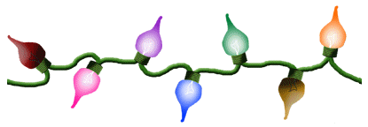
DUTY TO GOD

Resources

Baden-Powell, the founder of Scouting, believed that Reverence and Duty to God should be an important part of the Scouting Movement and of every Scout and Scouter.

“Our objective in the scouting movement is to give such help as we can in bringing about God’s kingdom on earth by inoculating among the youth the spirit and the daily practice in their lives of unselfish goodwill and cooperation.”

- Baden-Powell

RESOURCE | CONTACT INFO | MATERIAL
Your Council District Executive |  | “Duty to God” quick reference chart of Religious Emblems Programs.  The chart lists:  - Religious groups  - Contact info for emblems programs  - Age-specific program name  - Program material BSA supply # (if applicable)
BSA website | www.scouting.org/awards/religious/index.html | Describes purpose of Religious Emblems Programs with index to:  - Frequently asked questions  - How to get started  - Chart of programs
PRAY (Programs of  Religious Activities with Youth) | www.praypub.org  (800) 933-7729 | - BSA’s “Promoting Duty to God” video (interfaith resource promoting the religious emblems of all faiths)  - Religious Emblems Presentation scripts (to be used with the above video by unit leaders)

THE MOST FREQUENTLY ASKED QUESTIONS ABOUT
RELIGIOUS PROGRAMS FOR YOUTH IN SANTA CLARA COUNTY

1. Do I have to belong to a church?
These are programs of the churches of different faiths and therefore must be completed under the auspices of a church (even if the youth does not have membership in a particular church). A signature of a representative of the religious body is required on the program registration.

2. What youth agencies use these programs?
Boy Scouts of America, Camp Fire USA and the Girl Scouts of the U.S.A. use the programs. Depending on the faith, boys and girls may work on the same program; other programs may be specific for Boy Scouts, Camp Fire and/or Girl Scouts.

3. Do I have to belong to a youth agency?
For most faiths, religious projects are church programs so that members of Sunday School classes, Vacation Bible Schools, Confirmation classes and other church groups are welcome to use these programs. Check the project book for your faith for requirements.

4. Who may serve as counselor?
Usually the pastor along with the parents or a lay person designated by the pastor serve as counselors. Some faiths may require some form of counselor training.

5. Does each student need a workbook?
Yes. Students are required to keep a personal record of their progress.

6. If I have already earned one award for my own faith, may I earn another award for a different religion?
No. Youth should only pursue the religious project for their own faith.

7. If the religious growth program for my faith has more than one program (for different ages or grade levels), may I work on all of the programs?
Yes. Students can earn all segments of their religious growth series provided they are in the appropriate grade/age level when they work on the program. Since each segment is an independent unit, students do not have to start with the first program but rather would work on the program based on their grade/age.

8. Where can I get more information about religious programs for youth?
- Boy Scout/Cub Scout programs contact: Jose Saleme (408) 255-9966; josesaleme@comcast.net
- Camp Fire programs contact: Ann Resch (408) 227-8587; a.resch@att.net
- Girl Scout programs contact: Jeri Thorne (408) 287-4170 ext. 240; jthorne@girlscoutsofscc.org

(Rev 12-2004)

Stars of David Maze

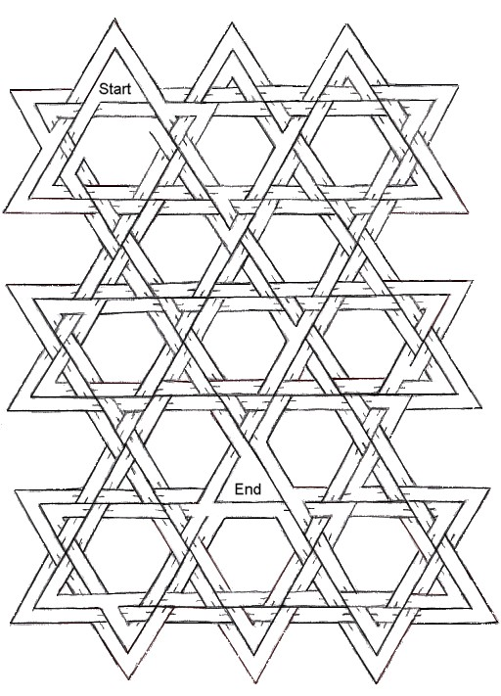

Find the correct path from Start to End.

Paths may go under bridges.

Biblical Names Word Search
From: www.free-online-word-search-puzzles.com

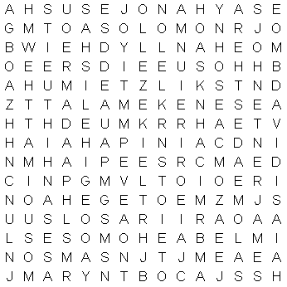

Find the following names from the Bible:

ABEL  ADAM  AMOS  BOAZ  CAIN  DANIEL  DAVID  ELISHA  ESAY  ESTHER  EVE | EZEKIEL  EZRA  HAGGAI  HOSEA  ISAIAH  JACOB  JAMES  JEREMIAH  JESUS  JOEL  JOHN | JONAH  JOSEPH  LUKE  LYDIA  MARK  MARY  MATTHEW  MICAH  MIRIAM  MOSES  NAHUM | NAOMI  NOAH  PAUL  PETER  RACHEL  RUTH  SALOME  SAMSON  SETH  SOLOMON  TAMAR


Plus and Minus

Add and subtract the letters as shown, then rearrange the letters to form a list of gifts you might find under the Christmas tree.

1. shook | +b –h | =
2. aglow | +n –l | =
3. paint | +r –p | =
4. steam | +g –t | =
5. weather | +s –h | =
6. strip | +e –I | =
7. solid | +l –I | =
8. canyons | +r –n | =
9. cruet | +k –e | =
10. chats | +w –s | =
11. rooster | +c –r | =
12. stares | +k –r | =
13. vogues | +l –u | =
14. dance | +y –e | =

Answers: 1-book, 2-wagon, 3-train, 4-games, 5-sweater, 6-purse, 7-dolls, 8-crayons, 9-truck, 10-watch, 11-scooter, 12-skates, 13-gloves, 14-candy

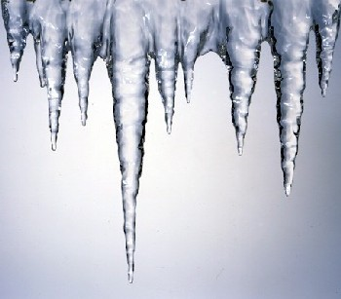

Icicle Hunt

You will need numerous pieces of string in various lengths. Hide the pieces of string around the room before the boys arrive. Have the boys hunt for the “icicles”. The leader ends the hunt after a given period of time. The winner is the boy whose icicles form the longest line when laid out end-to-end (not the player who collects the most pieces).

Quotations

Quotations contain the wisdom of the ages, and are a great source of inspiration for Cubmaster’s minutes, material for an advancement ceremony or an insightful addition to a Pack Meeting program cover.

“A. C. Benson used to say “There are four Christian values, not three: they are Faith, Hope, Charity – and humor”  - Lord Robert Baden-Powell  “Press forward with Hope; mix it with optimism and temper it with the sense of humor which enables you to face difficulties with a sense of proportions.” - Lord Robert Baden-Powell  “Without faith, nothing is possible. With it, nothing is impossible.” - Mary McLeod Bethune (1875 - 1955) Educator  “Hope is the thing with feathers  That perches in the soul  And sings the tune without the words And never stops at all.”  - Emily Dickenson | “Hope has been and always will be safe. It's inside every one of us.” - Xena  “Optimism is the faith that leads to achievement. Nothing can be done without hope or confidence.”  - Helen Keller  “Never deprive someone of hope -- it may be all they have.” - Unknown  “If you haven't any charity in your heart, you have the worst kind of heart trouble.” - Bob Hope  “Hope begins in the dark, the stubborn hope that if you just show up and try to do the right thing, the dawn will come. You wait and watch and work: you don't give up.”  - Anne Lamott Bird

Ceremonies

This is Christmas Opening or Closing
(Have a boy read one or two lines)

What is Christmas?
Christmas is you… your faith, your hope, your love.
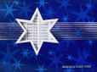
Christmas is a time of giving and sharing.
Christmas is a time of joy and happiness.
Christmas is a time of happy recollections of Christmases past.
Christmas is a time of celebration.
Celebrating the birth of Christ.
Christmas is a time to express our faith, our hope, our love.
Scan the sky on Christmas Eve and seek out that brightest star.
That star can lead you to a beautiful Christmas.
That star will keep Christmas in your heart always…
This is Christmas!

Hanukkah Opening
(Cubs with candles and letters recite the following)

H Stands for Hannah, courageous and true, who would not yield, so her sons they slew.
A Stands for Antiochus, Syrian King, who tried from Judea, Greek worship to bring.
N Stands for “NES”, that wonder so great, when oil in the cruse, instead of one day burned eight.
U Is for unfurling the Maccabee banner, by Judas who fought in so valiant a manner.
K Is for kindling of light and of hope, for those who in sorrow of darkness now grope.
K Is for keepsake of candles so bright that father, with “Brochos”, will light every night.
A Stands for all, living far and wide, who tonight are glowing with true Jewish pride.
H Stands for Hebrew, our language so old, in which the story of Hanukkah is told.

Helping Other People Flag Ceremony

After the flags have been posted, but before the pledge, have parents or Den Chief/Den Leader read the following off of cards you have prepared.

- Helping other people might be picking up a toy or a bottle that a boy dropped.
- Helping other people might be playing with a younger brother or sister while mom is busy.
- Helping other people might be telling a friend he did a great job when he did his best.
- Helping other people might be shoveling a walk of someone not able.
- Helping other people may be simple everyday things, even a smile, or difficult things like fighting for our country. The people throughout history that have kept our country free helped other people, you and me. As we pledge our allegiance to the flag, let us be glad that others have helped other people.

Cub Scout leads in the pledge.

Snowflake Advancement (By Karen Rogers)

(Awards could be attached to cut out snowflakes.)

One of the most beautiful objects formed by nature is a snowflake. It would take most of us a long time to “design” a shape as beautiful as a single snowflake. Yet, in an ordinary snowstorm, billions upon billions of snowflakes fall to the earth—and no two are exactly alike!

Tonight, we are gathered much like snowflakes, in that we are here because of beautiful objects, our sons, and their “designs” are each very different.

When water freezes, it forms crystals. This simply means that the molecules come together in a special arrangement, or geometrical form, which we call “a crystal.” As it freezes, the crystals that form are so small that they are invisible. But, when snow is being formed, these crystals are carried up and down in the atmosphere by air currents.

Let us look at our Bobcats tonight. We gathered them up and they are now being carried along the path of Scouting. Would ________ and his parents please come up to receive their honors?

As the crystals move up and down, a group of them begins to collect around something. It might be around a speck of dust, or around a tiny drop of water. The group of crystals gets larger and larger, so that soon there might be hundreds of crystals gathered around one nucleus.

Our Wolves and Bears are much like the crystals at this stage. They have gathered as groups together and around their Den Leaders. They have grown through their achievements and electives. Would _____ and their parents please come forward to receive their honors?

When such a group becomes large enough, it begins to float down toward the ground, and we call it “a snowflake.”

These, of course, are our Webelos, growing rapidly and maturing constantly. They are gaining ground towards their next step in Scouting, Boy Scouts. (Webelos presentation.)

I would like all the boys who received awards tonight to please stand. I’d like to summarize by saying this: Each snowflake begins as a molecule and grows to different sizes, depending upon the temperature, and colors vary, too. But, they all grow to descend upon us with “No two exactly alike.”

Cubmaster’s Minute

During the past month, we have had the opportunity to learn a little bit about the customs and practices of different faiths. And we see that we really have much in common with all of humanity. No matter what their ethnic or religious backgrounds, people all over the world have the same basic needs: love of family and need for fun. By learning about others, we can better understand ourselves. It is easy to see the differences when we study other cultures and faiths, and it is easy to say we accept them for what they are. But, perhaps it is even more important that we grant the same acceptance to those who are closer to us. Every person who was ever born is unique in abilities and personality. As we have developed tolerance and understanding of other nationalities and faiths, let us also value the uniqueness of each individual in our Pack. Each boy, each brother or sister, and each parent or leader is special in his or her own way. As we venture forward, may our new love and understanding of all humanity be extended always to everyone around us.

Christmas Closing

What Christmas Does to Me

Bring the candles, light the tree,

There’s something Christmas does to me,
It weaves a charm, it casts a spell,
It sheds a warmth I cannot tell.
It melts the years with magic art,
It makes me young again in heart;
I long to give where pity pleads,
I think of friends and human needs,
And thrill with joy as from afar
I hear a song and see a star.
Thank God! Whatever else may be –
For all that Christmas does to me.

Season of Lights Closing

This is the season of lights. It is a time when the days are shorter and the nights are long. But, somehow, things seem brighter. Shopping centers are bright with holiday lights. Thousands of homes have single candles to light the way for the Christ Child. Other thousands have candles burning to commemorate the miracle of the oils of Hanukkah. Even the stars in the winter sky seem brighter.
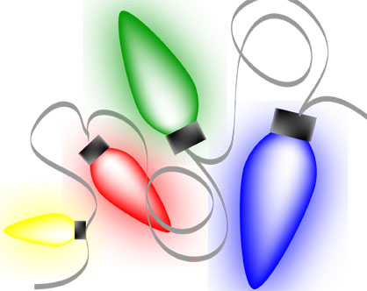

The most brilliant glow comes from the spirit of goodwill that you live all year in the Cub Scout Promise and Law of the Pack. Let us all stand and repeat them together.

Cub Scout Prayers

A Cub Scout Prayer:  O, Lord that I will do my best,  I come to Thee in prayer.  Help me to help others every day  And teach me to be fair.  To honor Mother and Father  And to obey the Cub Scout Law.  So, that I may be a loyal Cub Scout.  Amen. | Den or Pack Meeting Prayer:  We thank You God for our Pack and Dens and for all the boys and families who are touched by Scouting. Make us strong as we work together to help other people, and as we do our duty to You and to our country, Help us remember to live by the Law of the Pack and the Cub Scout Promise. Amen.

Run-Ons

- What do cats say on New Year’s Eve?
- Happy Mew Year.
- If the people of Israel are Israelites, and the people of Canann are Cannanites, are the people of Paris called Parasites?

- Once there was a race between a water hose, a tomato, and lettuce. Who do you think won? Well, last time I checked, the hose was still running, the tomato was trying to ketchup, and the lettuce was ahead.
- I was thinking about how people seem to read the Bible a whole lot more as they get older then it dawned on me . . . they were cramming for their finals. Or looking for loopholes.


Old Man: I am 97 years old, sir, and I haven’t an enemy in the world.
Minister: That is a beautiful thought.
Old Man: Yes sir. I’m thankful to say that I’ve outlived them all.

Applauses

Rudolf Applause: Put thumbs to your head with fingers up, forming antlers. Wrinkle your nose, saying, “Blink, Blink, Blink.”
Sleigh Applause: Say, “Ding-a-ling” three times.
Santa Clause: Reach out and hold stomach and say loudly, “Ho, Ho, Ho” three times.
Christmas Bells: Pretend to hold bell rope then get the left side of the audience to say, “DING” on the down stroke, and the right side to say, “DONG” on the upstroke. Repeat three times.
Snowball Cheer: Reach down and pick up some imaginary snow, and pack it into a ball. Pull arm back, throw, and yell, “Splaaaatttt”.
Elves Applause: “Saw, saw, saw” (make sawing motions). “Tap, tap, tap” (make hammering motions). “Paint, paint, paint” (make painting motions).

Skits

The Hunters


Scene: The pastor is speaking at the Wednesday-night church service, which coincided with the last day of hunting season.

Pastor: Who in the congregation had bagged a deer?
(No one raised a hand)

Pastor: I don’t get it. Last Sunday many of you said you were missing because of hunting season. I had the whole congregation pray for your deer.
Hunter: Well, it worked. They’re all safe.

Do A Good Turn

Cub 1: (comes on stage turning around)
Cub 2: (comes on stage doing forward rolls)
Cub 3: (comes on stage rolling over and over)
Cub 4: (comes on stage doing cartwheels)
Cub 5: What are you guys doing?
Cubs 1-4: Don’t you know a good turn when you see one?

Songs

We Wish You a Bobcat Christmas  We wish you a Bobcat Christmas,  We wish you a Bobcat Christmas,  We wish you a Bobcat Christmas,  And a Wolf Badge New Year.  Good Tidings we bring to all Bobcats true,  We wish you to earn your Wolf Badge,  And Arrow Points too. | Cub Scout Christmas  (Tune: White Christmas)  I’m dreaming of a Cub Scout Christmas.  Just like the ones I used to know.  Where boy’s faces glisten as parents listen  To see if Cubs their manuals know.  I’m dreaming of a Cub Scout Christmas.  With every project I admire.  May they gain in friendship and fun,  And may all their Arrow Points be won.

Hands Up, Elbows Bent

This is a good warm-up activity because it warms up your voice and body at the same time. Choose a person to lead the group in the song. Then choose a song that everybody knows. Everyone sings the first three lines of the song, then everyone yells, “Ooh ah ooh ah ooh ah yeah!” (Repeat)

Then the leader shouts out a direction. Everyone repeats the direction, and then sings the three lines of the song again, doing the direction. The second time the leader shouts out two directions, the third time three, and so on until the last verse when the leader says, “Sit down.” Here’s an example, with the song “Row Row Row Your Boat.”

All Sing: Row row row your boat
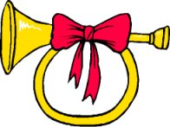
Gently down the stream
Merrily merrily merrily merrily
Ooh ah ooh ah ooh ah yeah!
Ooh ah ooh ah ooh ah yeah!

Leader: Hands up! (Puts his hands up.)

All: Hands up! (Puts his hands up.)
(Repeat song and Ooh ahs)

Leader: Hands up! (Everyone repeats, putting hands up)
Leader: Elbows bent! (Everyone repeats, bending their elbows)

Continue with the leader eventually saying the following in order:
Hands up
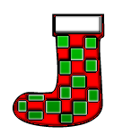
Elbows bent
Knees bent
Knees together
Chin up
Tongue out
Turn around
Sit down

Audience Participation

Auto-matic Laughs

Tonight I'm going to read you a little story about a couple who go shopping for a new car. But the story is really rather dull, so I'd like you to help me make the story livelier. I'd like you to join in when I read certain words. Whenever I say these key words, please follow these instructions...it'll help the story along a lot. (Give instructions)

Blue: All those with blue eyes pat the top of their head
Brown: All those with brown eyes pat the top of their head
Left: All those who are left-handed clap their hands
Right: All those who are right-handed clap their hands
New: All those under 20 years of age stomp their feet
Old: All those over 20 years of age stomp their feet
Man: All males stand up
Woman: All females stand up

One day a MAN and a WOMAN went to the store, looking for a NEW car. Their OLD one, which was muddy BROWN was not running well. It LEFT much to be desired in the way of speed and safety, and they wanted another one RIGHT away. They wanted a bright BLUE one.

As they walked into the dealership, the WOMAN noticed a BLUE sports car on the Showroom floor. "Look at that lovely NEW car RIGHT over there. Wouldn't it be perfect for us?" said the WOMAN.

"You may be RIGHT. It's a lot better looking than our OLD BROWN buggy.
Unfortunately, there's one problem. I've LEFT all my money at home," said the MAN.
"You LEFT it at home?" asked the WOMAN.
"Yes, it's RIGHT in the pocket of my NEW BROWN suit," said the MAN.
"Your NEW BROWN suit? Why, I took that suit to the cleaners just this morning, and I didn't notice any money in any of the pockets," said the WOMAN.
"But I'm certain I LEFT my money in the inside RIGHT pocket of my NEW BROWN suit," the MAN said as he scratched his head in wonder.
"Now wait a minute. Are you saying I'm not RIGHT? Are you saying I'm wrong? MAN! It's you who's mistaken," said the WOMAN.
"Let's not argue. We're here to look at cars, and that BLUE one in the corner is a RIGHT nice model. And just think. If we buy the NEW BLUE car, we'll never have to worry about our OLD BROWN one again!"

After looking at the price of the NEW BLUE car, and figuring out what they could get as a trade-in on their OLD BROWN one, the MAN and the WOMAN decided buying a NEW car would be the RIGHT move for them. But before they LEFT the store, they started questioning their decision. Would they be better off with their OLD BROWN car if the NEW BLUE one didn't run RIGHT? Or what about a NEW BROWN one? How long before they thought of the NEW car as an OLD car? And would they ever feel BLUE about trading in the BROWN auto? BLUE or BROWN, OLD or NEW, what was RIGHT and which car did they want to be LEFT with? The MAN and the WOMAN were so confused that they decided to sell their car and buy themselves bicycles. And that's just what they did. And they knew it was RIGHT...LEFT...RIGHT...LEFT...RIGHT...LEFT... RIGHT...LEFT.…

(The narrator continues alternating between right and left until the audience realizes they are applauding the end of the story.)

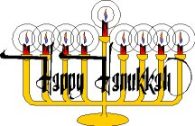

Cool Candles

Supplies: Plasticine or other modeling clay, a clean empty coffee can, water, a tea-candle (votive candle), a saucer

Directions:
- Shape the modeling clay into a round ball, with a diameter that is wider than the candle. Push the clay firmly into the bottom of the coffee can.
- Fill the coffee can with water and place into the freezer.
- When the water has frozen in the can, remove and run warm water on the side of the can to loosen the ice, turn upside down in a sink and gently shake the ice out.
- Remove the modeling clay from the ice block and return the block to the freezer.
- To use, place a tea-candle into the cavity left by the modeling clay. Place a saucer underneath the candleholder. Blow out the candle and return the candleholder to the freezer before you leave the room.

Cork Reindeer

Supplies: 7 corks all the same size, pipe cleaners, yarn, small pom-poms, small googly-eyes
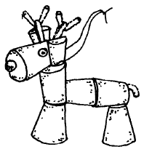
For the head and body, you’ll need six corks all the same size. You’ll need one more cork for the base of the antlers. If the corks don’t fit together well, cut away some cork until they do. Glue the body pieces together. Glue on the legs. Let dry completely. For the base of the antlers, cut last cork in two, and glue to side of head. Make antlers and tail from pieces of pipe cleaner. Glue to reindeer. Glue on googly-eyes and a pom-pom nose. Tie yarn harness around neck for a hanger.

Sticky Bread Dough

Here’s a fun dough that the boys can use to create ornaments, beads and sculptures.

Supplies: 4 slices of white bread (with the crusts removed), 4 Tbsp. of white glue, 4-6 drops of food coloring

Directions:
- Bread the bread into small pieces and place into a bowl.
- Add white glue and food coloring.
- Stir until blended together.
- Knead the mixture with your hands until it forms a soft dough.
- Sculpt with the Sticky Bread Dough, and allow the sculpture to dry overnight until it hardens.

Tips & Tricks:
  - Roll the Sticky Bread Dough out onto wax paper and cut different shapes with cookie cutters to make ornaments.
  - Use 1 Tbsp. of coffee instead of food coloring to give the Sticky Bread Dough and antique finish.

Pine Cone Christmas Tree

Supplies: Pinecone, beads, sequins, redhots, silver foil, glue, talcum powder, tweezer, cotton, silver doily or red paper plate

Directions:
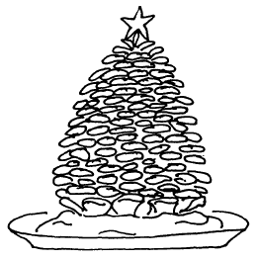
- Decorate the pinecone. Use beads, sequins, or redhots. Use them all, if you like. Glue them in place with the tweezers.
- Weave a few strands of silver foil through the petals. Glue a bright shiny star on the top.
- Put a mound of snowy, white cotton on sliver doily or a red paper plate. Sprinkle it lightly with talcum powder.
- Stand it on a shelf or small table for all to admire.

Freeze Pop Paint

Supplies: 2 tsp. powder tempera paint, 1/3 cup water, Wax coated paper cup, Craft stick, Plastic wrap

Directions:
- Mix powder tempera paint and water.
- Pour the mixture into a wax coated paper cup.
- Cover the cup with plastic wrap, and then insert a craft stick through the plastic wrap into the center of the cup.
- Place the cup in the freezer until solid.
- Remove the paper cup and plastic wrap from the Freeze Pop Paint.
- Dip the Freeze Pop Paint into water and paint on white paper.

Tips & Tricks:

- The Freeze Pop Paint may look tempting to eat, but use it for art, and not for a snack.
- Make the Freeze Pop Paint in a plastic ice cube tray instead of a wax paper cup.
- Use Freeze Pop Paint to create wrapping paper and greeting cards.

Penguin Pins

Supplies: Ice cream stick or craft stick; Black, white and orange acrylic paint; 3/8” red felt; Tiny white pom-pom; Tacky glue; Glue gun; Sunflower seed in shell; Paintbrush; 1”-long x ¼”-wide square of knit rib fabric; Pinback pin; Toothpick.

Directions:

- Paint seed orange and craft stick black. When dry, paint white oval on stick, from top to 1” above bottom.
- Glue seed nose 1” below top.
- Paint eyes ¼” below top and buttons with toothpick.
- Glue felt scarf around neck, snip fringe.
- For hat, glue ¼” and 1” edges of of rib fabric together’ gather and glue one end closed; turn. Fold under 1/8” at lower edge; glue onto stick.
- Glue pom-pom. Hot-glue pinback pin to back of stick.

Holiday Lanterns

This is a good project for a Webelos den, to practice their Craftsman skills. Use any size can, from dog food to juice size can. Fill each can with water to about ¼” below the rim, and place it in the freezer for about two days (so ice is very hard). Cut a piece of paper big enough to fit around your can and draw a design on the paper. Fasten the paper around the can with masking tape. Lay the can on an old, folded towel. Using a hammer and nail, punch holes into the can, evenly spaced on the lines of your design. When done, let ice melt to remove it.

If desired, a base can be made from a foil pie pan. Turn the pie pan upside down and, with the hammer and nail, poke a hole in the center. Also poke a hole in the bottom of the can. Use a small screw and nut to fasten the pan to the can. Tighten the nut on the screw inside of the can – the part of the screw left sticking up can be used to hold a candle in place. Place candle in the lantern.

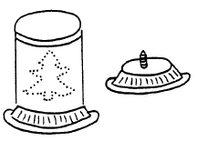

Thumb Catch

This is game of fast reflexes and can be played with a very large group.

Players stand in a circle and each player puts his left hand out to the left with his hand in a fist and his thumb facing down, and his right hand out to the right with his hand open and his palm up. Your left thumb should be directly above the player to your left’s palm, and your right palm should be directly beneath the player to your right’s thumb.

Have a person who is not playing count to three and say, “Go!” On the word “Go,” all the players should try to grab the thumb of the player on their right side and at the same time try to lift their own thumb fast enough to avoid being grabbed by the person on their left. Anyone whose thumb was grabbed is out and should leave the circle. Close the circle in and continue playing until there is only one player left.

Peepers

Making eye contact is usually a good thing, but in this game it is not.

All players stand in a tight circle, with their heads down, looking at the floor. One person leads the group and says, “One, two, three, peepers!” When the leader says this, all the other players have three choices:
- They can look at the person on their left.
- They can look at the person on their right.
- They can look at the person directly across from them.

If two players end up looking at each other, they are both out. The people who are out leave the circle. And the others close the circle in. Continue the game until one or two players are left.

The Bridge

This is a relatively calm game of agility, where cooperation is important among the players. Use a piece of chalk to draw a long line on the ground. Then draw a circle about 1 foot in diameter at each 6-foot interval along the line. Draw as many circles as there are players. Each player then squats in one of the circles. The two players at each end of the line get up and try to change places. Players can only step on the line or inside the circles. When they reach a player in a circle, that player helps them cross over him without stepping outside the circle. When the first two players have successfully traded places, the second players from each end get up to do the same. Continue playing the game until all the players have traded place.

Blindman’s Sort

Equipment: A blindfold, a stopwatch, a jar, a handful of chickpeas, lentils, and kidney beans
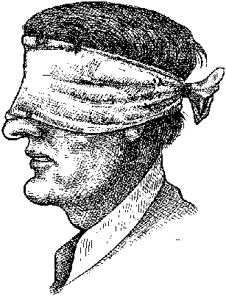
Playing this game requires a good sense of touch because it is played with the players blindfolded. Put the chickpeas, lentils, and kidney beans in the jar, then shake it so they get all mixed up. The player sits at a table blindfolded. At the signal, he turns the jar over and, guided only by touch, must try to sort the three beans as quickly as possible. The Den Leader can use a stopwatch to measure the time it takes the player to sort the beans. Player with the fastest time gets a prize.

Ring The Bell

A holly wreath is hung from the ceiling or doorway and a small bell is suspended in the center of the wreath. The players line up 6 to 8 feet away and try to hit the bell with cranberries or beans. Each player gets three turns and the one with the most hits is the winner.

Catching the Candy Cane
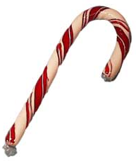
This requires six or more players. You will need a cane or a yard stick decorated to look like a candy cane. All the players except one stand in circle. The extra player stands in the center of the circle. He stands the stick up on the floor and holds the top of it with his fingers, so the stick won’t fall over. The players standing around the circle are assigned a number by counting off beginning with “one.” The boy in the middle then calls out a number and takes his hand off the stick. The player whose number is called must run up to the stick as fast as he can to grab it before it falls to the ground. If the stick (candy cane) hits the ground before the player can get to it, he must go back to his place in the circle. But if he gets to the stick before it falls, he changes places with the player in the middle. Then the new middle player calls out numbers and he holds the candy cane stick.

Hanukkah Peanut Hunt

Use unshelled peanuts for this game. Divide 20 peanuts into groups of four, marking on each with a marking pen one of these letters: H, A, N, U, K. Hide the lettered peanuts together with some unlettered ones around the room. On a signal, the boys search for the peanuts. End the game after 10 minutes. Score as follows: 10 points for the most peanuts; 5 for each lettered peanut; and 20 for anyone who can spell “Hanukkah” with his peanuts.
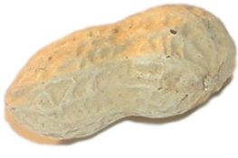

Snowballs

Ingredients:
- 3½ cups vanilla wafer crumbs  - ¼ cup butter or margarine, melted  - 3/4 cup sifted powdered sugar  - 1 cup chopped pecans  - ½ cup Dr. Pepper | For ICING:  - 2 cups powdered sugar (sifted)  - 2 Tbsp. butter or margarine (melted)  - 1/3 cup milk  - ¼ tsp. vanilla  - Flaked coconut
Directions:
    - Mix vanilla wafer crumbs, butter, sugar, pecans and Dr. Pepper.
    - Roll into very small balls. Place on wax paper.
    - For ICING: Measure sifted powdered sugar into mixing bowl. Add melted butter or margarine and milk. Beat in vanilla. Using a fork, dip balls in icing and then roll in flaked coconut. If icing becomes too stiff, add more milk to thin.
    - Place frosted snowballs on cookie sheet. Set aside about an hour before serving.

Chocolate Spoons

Chocolate spoons are great for eating ice cream and stirring hot chocolate.

Supplies: 1 cup milk chocolate chips, 12 plastic spoons, Wax paper

Directions:
- Pour chocolate chips into a microwave bowl and place in the microwave for about 5 minutes on medium setting. Remove from microwave and stir.
- Keep repeating step 1, until the chocolate chips are completely melted.
- Dip the end of the plastic spoons into the melted chocolate and place them on a sheet of wax paper to harden.
- Try rolling the Chocolate Spoons in nuts and sprinkles before they harden.

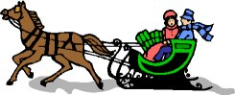

Starburst Apple English Muffins

Supplies: Cutting board, Paring knife, Toaster, Table knife, Small bowl, Spoon

Ingredients:
- 2 small apples  - 4 English muffins  - 8 Tbsp. light cream cheese | - 8 Tbsp. raisins  - 2 tsp. cinnamon  - 2 tsp. sugar
Directions:
  - With a paring knife, cut the apples in half. Remove the apple cores and seeds. Cut each apple half into ¼-inch slices.
  - Split open each English muffin to get 8 muffin halves. Toast the halves.
  - Use a table knife to spread 1 tsp. cream cheese on each muffin half.
  - Arrange 1 Tbsp. raisins around the edge of each muffin half.
  - Arrange sliced apples on top of each muffin in a starburst pattern.
  - In the bowl, mix the cinnamon and sugar with the spoon.
  - Sprinkle the cinnamon sugar over the muffins.

Making Ice Cream out of Snow

If you’re lucky enough to be snowed in, scoop up a bowl of fresh snow and make a batch of ice cream.

Ingredients:
- 1 pint whipping cream  - ½ cup sugar  - 1 tsp. vanilla extract | - ¼ cup chocolate syrup  - 1 sliced banana  - ¼ cup berries or a few Tbsp. peanut butter

Directions:
- Place all the ingredients in a blender. Blend on high for 3 minutes, or until the cream thickens.
- Fill a large mixing bowl with very fresh snow. Pour the ice cream mixture over the snow; fold in crushed cookies, candies, or chocolate chips.
- Eat fast: it tastes best fresh. Serves 4 to 6.

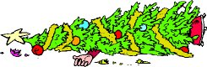

Puffed-Rice Christmas Tree

Ingredients:
- ½ cup margarine  - 16-oz pkg. Mini-marshmallows  - 6 cups puffed rice cereal | - 2 tsp. green food coloring  - 1 cup red cinnamon candies  - ½ cup silver cake decorating candies

Melt margarine over low heat in large saucepan. Add marshmallows and food coloring. Stir until marshmallows are completely melted. Add rice cereal. While mixture is warm, form small balls with buttered fingers. Place several balls in a circle. Layer balls on top of each other in smaller circles to form Christmas tree shape. Add extra filling between balls to give tree softer look. Decorate with cinnamon and sliver candies.

