

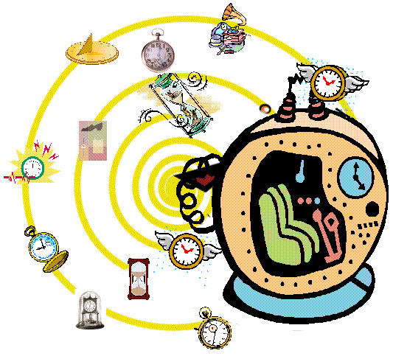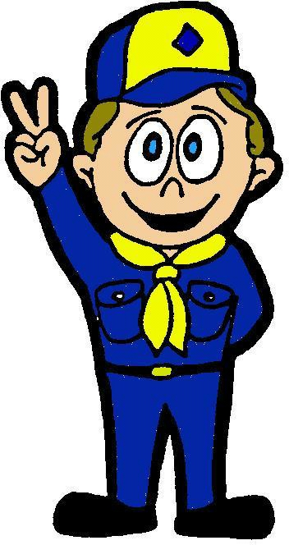

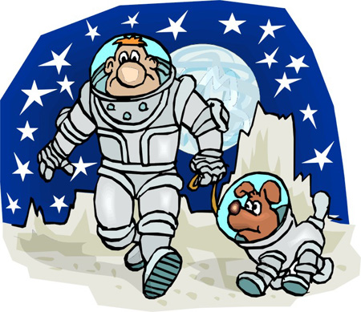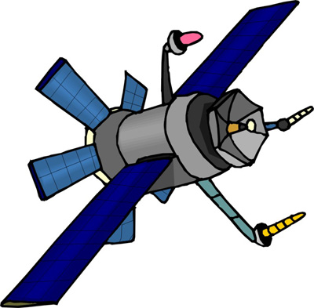

February 2006
FEBRUARY 2006 - Cubs in the Future
How will Cub Scouts celebrate the blue and gold banquet in the year 2106? What vehicle will take them? Will the stars be their guides? Make models of these new forms of transportation, a home or school of the future, and then use them as blue and gold banquet decorations. Create designs for future Cub Scout uniforms and awards. Build an exhibit of model campsites on a distant planet. Be creative with your futuristic menus. Top off the evening with intergalactic games.



Free Stuff:

- FREE Twister Stunt Car Toy
www.coolfreebielinks.com/s2003/ws/2/TwisterStuntCar.htm
The Twister Stunt Car flips, rolls, twists, turns, and spins all by wireless remote - it even lights up as it zooms around.
- Free America Stands United Decals and Patriotic Stickers
www.street-signs-usa.com/482/cat482.htm
Send them a L.S.A.S.E. and get a FREE decal or sticker. (Limit one)
- Free Decals From ROL Exhaust: www.rolmfg.com/Free/Decal.htm
Send them a 9" X 6" SASE (self addressed stamped envelope) with 45¢ and get a FREE car decal.
- FREE HotMat mouse pad: www.hotmat.com/register.htm
This site offers custom made mouse pads. Register for a free sample mouse pad.

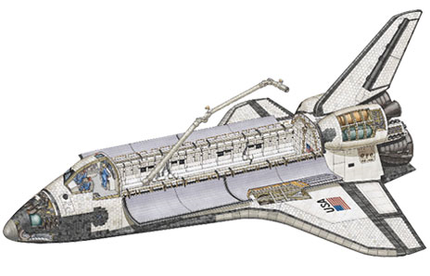

Rocket Maze
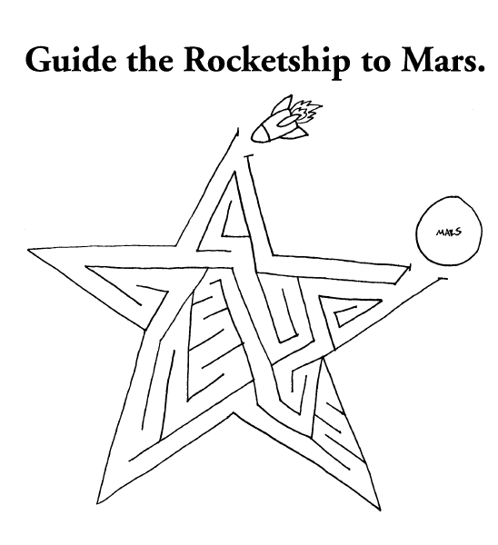

Connect the Dots
Connect the dots to reveal a vehicle of the future that is in use today.

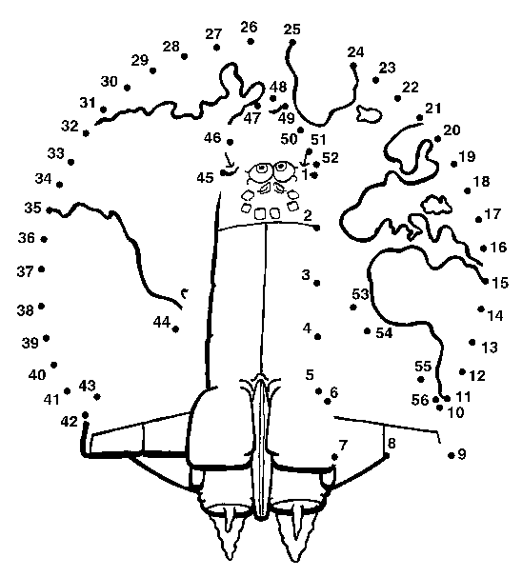

Robots Race

Supplies: 2 buckets to fit on Cub Scouts feet, Masking tape
Setup: With masking tape, map out a difficult course on the floor. Make many sharp turns in the course.

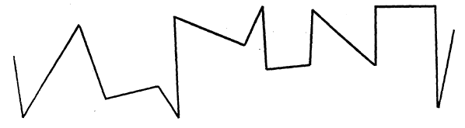

As the Cub Scouts move through the course they may not move their arms or smile (arms must remain next to their side). Remember, the Cub Scouts are Robots. Time each boy as he moves through the course. Take 5 seconds off for each time he moves his arms or smiles. To make the course more difficult, have the boys wear the buckets on their feet. The parents will also enjoy this activity as much as the boys.

Star Search Puzzle

For each of the terms listed below, write the correct word containing “STAR.”

1. Sea Animal ______________________ | 2. Bird ____________________________
3. Heavenly body ____________________ | 4. Outstanding young actress ___________
5. Used for washing clothes ____________ | 6. A song __________________________
7. Right hand side of boat _____________ | 8. To begin ________________________
9. To go hungry _____________________ | 10. To surprise someone _____________
11. To gaze ________________________ | 12. Use a telescope __________________

Answers: 1-Starfish, 2-Starling, 3-Star, 4-Starlet, 5-Starch, 6-Stardust, 7-Starboard, 8-Start, 9-Starve, 10-Startle, 11-Stare, 12-Stargaze



Quotations

Quotations contain the wisdom of the ages, and are a great source of inspiration for Cubmaster’s minutes, material for an advancement ceremony or an insightful addition to a Pack Meeting program cover.

“In the Troop you will have to think for yourself and stand on your own feet. You will have to stop yourself from following a crowd if you are not sure that crowd is on a Scoutly job; you will have to stop yourself from giving up a thing because it seems dull and hard. You will need real pluck and steadiness.”  – Lord Robert Baden-Powell  “The best thing about the future is that it only comes one day at a time.” - Abraham Lincoln  “These days people seek knowledge, not wisdom. Knowledge is of the past, wisdom is of the future.” - Vernon Cooper  “Your future depends on many things, but mostly on you.” - Frank Tyger | “I never think of the future. It comes soon enough.” - Albert Einstein  “In every conceivable manner, the family is link to our past, bridge to our future.” Alex Haley  “The future ain't what it used to be.”  - Yogi Berra  “Change is the law of life. And those who look only to the past or present are certain to miss the future.” - John F. Kennedy  “Never let the future disturb you. You will meet it, if you have to, with the same weapons of reason which today arm you against the present.” - Marcus Aurelius  “The past is history; The future is a mystery; This moment is a gift; That is why this moment is called the present; Enjoy it.” - Allan Johnson

Ceremonies

Spaceship Opening or Closing

Setup: 8 boys holding cardboard pieces, which make a spaceship cut into eight parts. Each piece is lettered, so that all together they spell “Cub Scout.” Each boy’s lines are written on the back of his card. Den Leader holds the cutout representing the fuse.

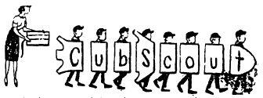

Den Leader: Cub Scouts of Den ______, drew up plans for a missile so they could take a safe trip into space. Now they are going to build the missile for you in case you want to go along with them on this journey into outer space, Here they come with their parts!

(Boys enter one at a time and repeat their lines in order)

Cub 1: C is the part we build on, and it stands for Courtesy in Scouting and all through life.
Cub 2: U is next. This stands for Unity, because united we are strong.
Cub 3: B is then added, and stands for Bravery in all our thoughts and all our deeds.
Cub 4: S is next and that stands for Safety. We learn it and use it.
Cub 5: C adds some more and it stands for Church – the one of your choice.
Cub 6: O is building it stronger, and stands for Outdoor Life which is full of fun and healthful
Cub 7: U is near the finish and stands for Usefulness to ourselves and others.
Cub 8: T is the nose of that guides us. It stands for Truth in all things.
Den Leader: Anyone knows the fuse is necessary to light and send this missile on its way. (Den Leader puts fuse to the first Cub) We are on our way. Everything’s O.K. Ready for lift off! Fire! (Cub Scout #8 leads and they walk off stage, still keeping the parts in the proper order.)

Passport Leader Recognition

Preparation: This ceremony has the most impact if it is kept a surprise, so the Cubmaster or Pack Chairperson should do the prep. Agree on a nice little something to give each Den Leader as part of the presentation (e.g., Cub Scout bookmark, discount movie coupon, or coupon to have the boys wash his or her car (this would require a parent coordinator in each den)). Make each leader a Passport award certificate book, and on the “visa” pages, write a special thank-you note or poem (see below) and attach the bookmark, coupon or other 2-dimensional gift.

Cubmaster: What is a passport? It’s a document that countries require you to have before you cross their borders. Without a passport, you can’t leave North America. You might say, a passport unlocks the mystery and adventure that awaits you, as you explore new lands.

In our Pack, every boy has a passport. I bet you didn’t know that. But, it’s true. Each one of you has a passport, without which the doors of Cub Scouting would be closed, and you would not be able to have all the fun, adventure and excitement that we have year after year.

Our passport to fun and excitement is our leaders. They are truly the lifeblood of our Pack, and without them, we could not experience the fun and learning of Cub Scouts. So, let’s take a moment to say thanks to our leaders. We’ve prepared these passports for you, to unlock excitement and fun as a way of showing our appreciation for all the sacrifices you’re made to make our Scouting experience better.

Den 1 boys and parents, please stand.

Asst CM: Thanks for being such a great leader. We’d like you to have this gift to say thanks for all the things you do to make this den and our pack great! Boys, let’s hear a big Tiger growl for ____________!!!

Cubmaster: Den 2 boys and parents, please stand.

(Repeat until last Den Leader has been presented his/her Passport.)

Cubmaster: Thanks, Leaders, for being our passports to the excitement and adventure of Cub Scouts! How about a big round of applause for all of our Leaders!!!

Achievement Time Ceremony

Personnel: Cubmaster plus Den Leaders whose scouts are receiving awards.
Props: At least one ladder (indicating the ranks on the ladder) or one ladder for each rank, progressing in height (step ladders will be safest); lights can be put on the ladders; appropriate insignias placed on different rungs or on each ladder.

Leaders stand next to the ladder representing their rank, or in rank order (if only one ladder is used).

Cubmaster will explain that to be good Cub Scouts – to “Do my best to do my duty to God and my country” – means that we will always strive to climb to higher goals.

Our goals are many in the Scouting program. Each group of boys is achieving at different levels. By the time a Cub Scout becomes eleven years old, we hope he will achieve the highest award in the Cub Scout program, the Arrow of Light.

It is necessary that we all start at the beginning and work ourselves up to that point. To be a success we must continue to set goals and work to achieve them.

Present awards. Comment that each Cub Scout has succeeded and progressed upwards on his ladder to achieve the award he is receiving. If used, turn on light for each rank in its turn.

May I Closing

Setting: Pack flag is placed in center of stage. 10 Cubs in turn come on stage, stand near the flag and recite one of the lines below. Upon finishing, each Cub salutes the flag, retires to the rear of stage and becomes part of a horseshoe shape.

1st Cub: May I grow in character and ability as I grow in size.
2nd Cub: May I be honest with myself and others in what I do and say.
3rd Cub: May I learn and practice my religion.
4th Cub: May I always honor my parents, my elders and my leaders.
5th Cub: May I develop high moral principles and the courage to live by them.
6th Cub: May I strive for health in body, mind and spirit.
7th Cub: May I always respect the rights of others.
8th Cub: May I set a good example so that others may enjoy and profit from my company.
9th Cub: May I give honest effort to my work.
10th Cub: May I regard my education as preparation for life’s future.
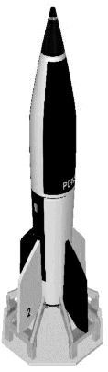

Models of the Future Closing

Cubmaster: Shows a model of a rocket and says:
Cub Scouts, here is a great looking model. It is the builder’s vision of what rockets may look like in the future. We can be sure that the world is going to need a few good men in the future. And we can be sure that we will be good men if we remember to follow the Cub Scout Promise. Let’s remember that as we stand and repeat the Cub Scout Promise (Leads the audience in Promise)



Run-Ons

- Why did the astronaut wear a football helmet when he landed on the moon?
  - Because he was making a touchdown.
- What do spacemen sit on?
  - Booster chairs.
- What does the loser get in an outer space game show?
  - The constellation prize.
- How do astronauts bring their food to work?
  - In a launch box.
- Why was the absent-minded astronomer looking for a switch?
  - He wanted to turn on the skylight.

Limerick
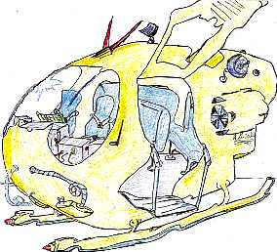

Time Traveler (by X.J. Kennedy)

A luckless time-traveler from Lynn
Leaned too close for a look and fell in
To a puddle of slime
On the first day of time
And so, naturally, couldn’t have been.

Skits

Roving Reporter

Reporter: Good evening, ladies and gentlemen. Here’s your roving reporter with another man-on-the-street interview. Tonight, we are going to talk about mountains. Here’s a man right here. How do you do, sir, can you tell me your impression of mountains?
First Man: High!
Reporter: Hi, yourself! Now tell me, what is your impression of mountains?
First Man: Like I just said, High!
Reporter: Oh. Ha, ha, ha, ha. My mistake. When you said, “High,” I thought you said, “Hi.” Get it? Oh well, let’s talk to someone else. Here’s a man. Tell me, sir, how do you feel about mountains?
Second Man: Well, I’ve never been there, of course, but if I had to feel about mountains, I’d do it like always, feel with my fingers.
Reporter: Ha, ha, ha, ha. Seems we have some jokesters about today. Well now, let’s try our questions on this little boy here. Tell me, sonny, have you ever gone over the top of a mountain?
Small Boy: Yes, sir, lots of times.
Reporter: My, I’m surprised to hear that. Must have been a hard trip for a youngster actually to go clear over the top of a mountain.
Small Boy: Oh! No, sir, we were in an airplane.
Reporter: (to himself) This is getting ridiculous, but I’ll try one more time. How do you do, sir, may I ask you a question?
Third Man: Why sure, what is it?
Reporter: Tell me, sir, what’s your impression of life in the mountains?
Third Man: Well, from what I hear, it’s a lot like an umbrella.
Reporter: An umbrella? I don’t quite understand what you mean.
Third Man: Yup, like an umbrella. Life in the mountains is either up or down.
Reporter: Sorry folks, some days you just can’t win.

Star Light, Star Bright

This is a humorous skit, which many boys enjoy putting on at a pack meeting. The costumes are large stars cut from cardboard or poster board, painted silver (of course) and hung over the shoulders (sandwich-board style) for front and back views.

The setting: Lights dimmed, and a voice recites:


Star light, star bright
First star I see tonight,
I wish I may, I wish I might,
Have the wish I wish tonight.

Then the narrator says (as lights are brightened):

Each night, thousands of people make that wish.
Have you ever wondered why it takes so long sometimes for the first star to appear?

(Offstage, voices are heard, loudly)

“I did it last night.”
“It’s hard work granting those wishes.”
“Why do I have to be first?”
“I always get stuck.”
“Why don’t you do it for once?”
(And so on…)

Blackout (or use a rolling blackboard to set up changes of scene) here and between each of the following scenes.

Scene 1: Stars getting ready to draw straws.
Scene 2: Stars pushing one reluctant star to the front.
Scene 3: Narrator saying, “I need a volunteer. Please take one step forward.” (All stars but one take one step backward!)
Scene 4: Stars getting ready to draw from a hat.
(And so on…)

Songs

Scouting ‘Round the World  (Tune: Row, Row, Row Your Boat)  Round, round, round the world,  Scouting takes you there.  Merrily, merrily, merrily, merrily,  Join us if you dare.  North to South and East to West,  We want to know it all,  So come along and sing our song,  We’re gonna have a ball!  Here in the States, we think it’s great,  To play the game baseball.  But way down south in Brazil,  Soccer’s best of all.  In Texas, steaks are chicken fried,  Potatoes, they’re fried, too!  The Chinese like to fry their rice,  And Gai Pan is Moo Goo!  The Eskimos wear lots of fur  Because it’s really cold.  Others wear no clothes at all…  Or so I have been told!   | Blue and Gold  (Tune: Clementine)  Boys: We’re the Cubbies,  Adults: We’re the Cubbers,  All: Here we are young and old,  Altogether we’re a Cub Pack  Having fun at Blue and Gold.  Boys: We’re the Bobcats  Wolf and Bear Cubs  And the Webelos Scouts are we,  Altogether we’re a Cub Pack  Having fun in harmony.  Adults: We’re the Mothers,  We’re the Fathers,  Helping Cubs as they go  Up the ladder of achievement  Climbing higher as they grow.  All: Let’s give thanks on  This occasion  To the mighty gold and blue  _________ is the number  Representing me and you.  Boys: We’re the Cub Scouts,  We’re the Webelos,  Adults: Proud parents are we.  All: Altogether we’re a unit  And the best they’ll ever be.
When Cub Scouts Achieve Their Rank  (Tune: When Johnny Comes Marching Home)  When the Cub Scouts all achieve a rank, Hoorah! Hoorah!  When the Cub Scouts all achieve a rank, Hoorah! Hoorah!  The Moms will cheer, and the Dads will shout,  The leaders they will turn about,  And we’ll clap our hands  When the Cub Scouts achieve a rank! |  | Star Wars Round  (Tune: Are You Sleeping)  R2D2, R2D2  3PO, 3PO,  Obi-Wan Kanobe,  Obi-Wan Kanobe,  Hans Solo, Hans Solo.

Space Travel Song  (Tune: Home on the Range)  Oh, give me a train, or a boat, or a plane,  That will carry us Cubs far away;  To Paris or Rome – Let us wander and roam,  And find new things to do every day.  Relax on the trail – float over the waves all day;  Or glide through the clouds – far over the crowds,  But be home before five every day.  On a broomstick we’ll ride, in a rowboat we’ll glide;  Take a trip to the moon in a rocket;  And our trip will be fun – but it soon will be done,  If we happen to hit an air pocket.  Up – up- and away – let us orbit the far distant sun,  Or deep on the floor – of the sea let’s explore,  For as Cub Scouts we’ll always have fun.  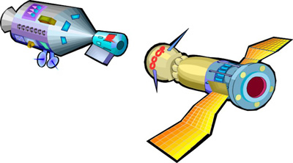 | The Astronaut’s Plea  (Tune: My Bonnie Lies Over the Ocean)  I went for a ride in a spaceship,  The moon and the planets to see.  I went for a ride in a spaceship,  And listen what happened to me.  Chorus:  Bring back, Bring back,  Oh bring back my spaceship to me, to me.  Bring back, Bring back,  Oh bring back my spaceship to me.  I went for a ride in a spaceship  The capsule was crowded and I  Developed a cramp in my muscles,  So I took a walk in the sky  (Chorus)  I went for a walk in my spacesuit.  The ship was controlled from the ground  And someone in charge down at NASA  Forgot I was walking around!  (Chorus)

Applauses

Bobcat Applause: Begin to make a growling sound but then change at the end to “Meow”.
Wolf Applause: Turn head towards ceiling and let out a howl.
Bear Applause: Start with low pitch growl and gradually get louder and louder. At end of growl do quick clawing motion with hand.
Arrow Point: Pretend to shoot bow and arrow. As you release the arrow say, “Twang.”
Webelos Applause: Make Boy Scout sign and say, “We’ll Be Loyal Scouts.”

Audience Participation
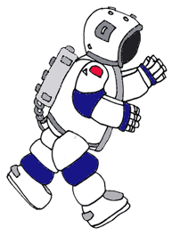

The Moon Trip
(Adapation of the Bear Hunt)

(Take a seated position facing the audience)
Would you like to go on a trip to the moon? OK, let’s go. Watch me, do exactly as I do and repeat everything that I say.

We’re going on a Moon Trip.
We’re ready for the count down.
10-9-8-7-6-5-4-3-2-1. Blast off! (Make a blasting sound as you thrust arm swiftly toward the sky)

We’re coming to the Milky Way – what a pretty display.
We can’t go around it.
We can’t go under it.
We can’t go over it.
I guess we’ll have to slide down it. (Put feet out in front of you and hold both sides of chair as if sliding down while saying, “Wheeee!”)

We’re coming to a shooting star – a great big star.
We can’t go around it.
We can’t go under it.
We can’t go over it.
I guess we’ll have to ride it. (Hold hands as if holding coil of rope and then throw out as if to lasso a point of the star and pull back hard while saying, “Zoom, Zoom, Zoom.”)

We’re coming to a meteorite – a great big meteorite.
We can’t go around it.
We can’t go under it.
We can’t go over it.
I guess we’ll have to dodge it. Ready, here goes! (Dodge from side to side while saying, “Whew-w-w”, wiping sweat from brow.)


We’re going to the moon – what a lonely place.
We can’t go around it.
We can’t go under it.
We can’t go over it.
I guess we’ll have to land on it. (Jerk back in seat as if jolted on landing, holding hands over eyes.)

It sure is dark out there. (Reach out in front of you as if grasping doorknob and ever so slowly, push rocket ship door open. When door is all of the way open, yell loudly, “Boo!”).

Let’s get out of here! (Quickly pull arm back as if shutting door and retrace all the motions hurriedly – dodging meteorite, riding shooting star, sliding down Milky Way, blast off. Hold arm over head in front of you, simulating a parachute, then looking down at floor say loudly, “SPLASH!” Motion opening space ship door, motion swimming to shore.)

I beat you home!
And now you’ve been on a trip to the moon.

Memory Book

Supplies: Cardboard, paper, string, paint, art tape, ruler, hole punch, pencil, scissors.

Directions:
- Cut out two identical pieces of heavy cardboard, any size you like. Use a ruler to make straight sides. These pieces will be the cover.
- Cut out several pieces of paper for the inside pages. (These pages should the same size or smaller than the cover.)
- Use a hole punch to make three holes in one side of one piece of cardboard. Then, lay the cardboard over the second piece of cardboard and use a pencil to mark where the holes go. Use a hole punch to make holes over the marks. Do the same for each of the inside pages.
- Carefully cut the side with the holes off of one piece of cardboard. It should be about ¾” wide. Use a ruler to make it straight and even. (These two pieces will be taped back together to make the front cover.)
- Paint both sides of all 3 cardboard pieces with a solid color of paint. Light colors seem to work the best. You may need to apply more than one coat to cover them completely. Let the paint dry between coats.
- You may want to splatter-paint the cover with contrasting colors or paint some sort of design on it. Let dry thoroughly.
- Use a piece of art tape to tape the ¾” strip of cardboard back to the large piece. Place them side by side; don’t overlap them. The splice will allow the cover to fold back when you open it.
- Use string to put the book together.

Clothespin Cub Scout

Make some clothespin Cub Scouts for individual favors or centerpieces for the Blue and Gold banquet. Get a package of old fashioned round-headed clothespins. Break head off large wooden matchsticks and glue sticks onto clothespins for the arms. Glue piece of heavy construction paper onto head of clothespin for bill of Cub Scout cap. Paint the whole thing blue. Then paint face and yellow Cub Scout neckerchief. Sand or saw off the bottom of the clothespin so that it will stand-alone or can be glues onto some cardboard.

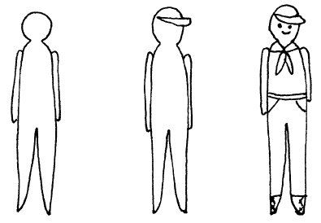

Fancy Folded Napkins

Have your den make some fancy napkins for your Blue and Gold dinner. Have lots of dinner sized blue and gold paper napkins on hand for them to fold enough for their families and guests. You can use the opposite color of dinnerware. Be Sure to Practice First!

Bishop’s Hat – Fold napkin into a triangle with center facing down. Next, fold right and left points to a point in the center. Fold top corner down to about one inch from the bottom. Turn folded point back again. Turn napkin over. Fold right and left points across, tucking one point inside the other. Stand napkin, folding bottom point under for balance. | 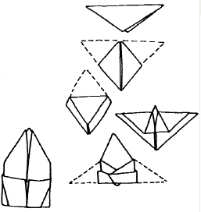
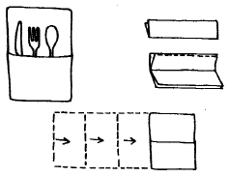 | Envelope – Fold napkin in half, lengthwise, with open ends at top. Fold front down to meet fold. Turn napkin face down and then fold over three times, from left to right. Slip silverware inside.
Candle – Fold napkin into triangle shape with the points at the top. Fold upper points down about halfway, then fold over again to make one long, narrow strip. Fold right corner over so tip extends to make “the flame.” Roll napkin tightly from right to left, tucking tail end of napkin into base and stand up. | 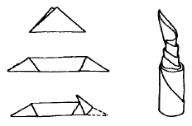

Moon Buggy  Give each boy a “Big Mac” carton (empty) and an assortment of materials such as pip cleaners, golf tees, buttons, screws, wire, cardboard, paint, etc.  Let each boy create his own Moon Buggy or Mars Rover. They will have a lot of fun using their imaginations in creating this world of tomorrow vehicle. | 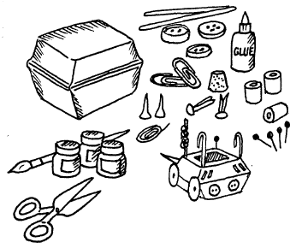
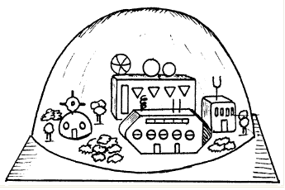 | Moon Station or Space City  The den could make a moon station or space city for display at the Pack Meeting. Start with a wood, cardboard or plastic base. Make buildings from matchboxes, wooden cubes or other materials. Your space city could have a solar energy collector for power, housing, rocket ports, etc. You could add a large plastic or glass dome (such as a round bowl turned upside down) to control the air circulation.
Balloon Rocket  - Roll a 4” x 5” piece of stiff paper into a shape like an ice cream cone. Use tape to hold in place. This is the rocket engine. Cut larger end to fit tightly inside balloon neck.  - Tape balloon and engine together. Wrap tape around engine to close up air leaks. Blow up balloon. Let it go straight up. Trim off the top of the engine a little at a time until the balloon rises straight and steady.  - Tape paper fins in place to help the balloon fly steady. | 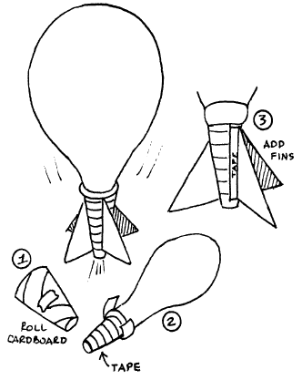

The Toilet Paper Web

Players stand in a circle as far apart as the room allows. One player starts by holding on to the first couple of sheets of toilet paper and tossing the rest of the roll across the circle to another player. The second player catches the roll and, careful not to break apart the toiler-paper streamer, holds on to the end sheets before tossing the roll on to a third receiver. Play continues with the roll being tossed across the circle from player to player without breaking the stream, creating a web of toilet paper. Once the roll is completely used, play continued with yet more rolls of toilet paper. If the web is sufficiently large and strong, it becomes a kind of parachute. Raise the web parachute up and down, walk or skip around in a circle holding on to it, toss lightweight toys or objects (ball, comb, small stuffed animal) into it and toss them up and down. Raise the web up high. Let go of it and let it fall on top of everyone. Or raise it up and take turns running underneath it, changing places in the circle with another player.

Edible Animals

This game from Kenya requires concentration to know when to jump or stay still.

Have the boys form a circle around the Den Leader, standing about 3 feet apart. The leader will call out the names of different animals: “cow!” “crocodile!” “pig!” “octopus!”
If the leader calls an animal that is edible, players should jump; otherwise, they should remain still. A player who makes a mistake by jumping when he should stay still, or by staying still when he should jump, is eliminated.

Quick Circles

This is a fun team game in which the boys must run fast around another team before returning to their place. Form two teams with the same number of players on each team. The teams stand in two circles about 30 feet apart, and each team member is assigned a number, starting with one. When the Den Leader calls out a number, the boys with that number run around the other team’s circle before returning to their spot. The player who arrives last to his circle is out of the game. A player who wins the race can bring an eliminated player back in. The game ends when players are too tired to play, or when all of the players on a team have been eliminated.

Blue And Gold Ball
The teams that consist of the youths and girls get into the circle. The teams are at some distance from each other. The youths and the girls take their turns in the circle. The leader is in the center of the circle. He/she has 2 balls in the hands (a blue one and a gold one). He/she throws the balls to the players and gets them back. The girls may catch only the gold ball, the youths only the blue one. The leader tries to confuse the players: he/she may throw 2 balls at once or pretend that he/she is going to throw the ball in one direction, while he/she is going to throw it in the opposite one. The player who makes a mistake pays a forfeit (fulfils the task) and is out of the game. The team in which more players remain wins.

Squirrels, Nuts, Cones
Divide players into groups of three. The first player in each team is "a squirrel", the second is "a nut", and the third is "a cone". Each team, which consists of "a squirrel, a cone", and "a nut" links their arms, forming a little circle. The leader is in the center of the playing ground. The leader cries: "Squirrels!" and all the players named as "squirrels" must exchange their places. While they are changing the leader tries to occupy any of the vacant places. If he/she manages to do it he/she becomes "the squirrel" and the former "squirrel", who has no place becomes the leader. At the command "Nuts!" or "Cones!" The players exchange their places accordingly. When the game is in full swing the leader may command: "Squirrels, nuts, cones!" Then all the players must exchange their places. Here you may stop the game.
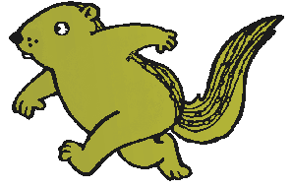

Planet Toss

The boys can learn the order of the planets and improve their tossing skills at the same time. Write the name of each planet in our solar system on separate paper plates. Number the plates: 1 for Mercury, 2-Venus, 3-Earth, 4-Mars, 5-Jupiter, 6-Saturn, 7-Uranus, 8-Neptune,, 9-Pluto. Keeping them in order, set the plates down in a line. Each player tries to toss pennies on the plates. Each time a penny lands on a plate, the player gets the number of points written on it.
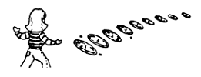

Stars Wars Frozen Tag

The person who is it uses a rolled up newspaper to touch the other players. After player is stunned, he must wait without moving until another player touches him, after which he must hold the spot where he was touched while playing. The last person frozen is it on the next round.
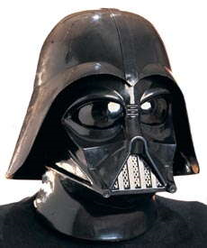

Who’s Darth Vader?

3 players leave the room – one of them returns with a blanket over himself. Those remaining in the room must guess who is under the blanket with one guess after asking boy under the blanket to breath like Darth Vader.

PB & J Surprise Muffins

Supplies: Muffin pan, 2 medium bowls, wooden spoon, wire whip, oven mitts, cooling rack, spatula

Ingredients:
- Vegetable oil cooking spray  - 2½ cups basic muffin mix  - ½ cup wheat germ  - 2 Tbsp. sugar  - 1 tsp. cinnamon | - 1 egg  - ½ cup peanut butter  - 1 cup water  - 1 tsp. vanilla extract  - ½ cup raspberry or strawberry jam

Directions:
- Preheat oven to 400°F.
- Spray muffin pan with vegetable oil cooking spray.
- Put muffin mix, wheat germ, sugar and cinnamon in a medium bowl. Stir well with the wooden spoon.
- In the other bowl, whisk together the egg, peanut butter, water, and vanilla extract.
- Add the egg mixture to the bowl with the muffin mix. Stir with the wooden spoon to combine until the dry mix is no longer visible.
- Place 1 heaping tablespoon of batter on the bottom of each cup in the muffin pan.
- Add 2 teaspoons jam on top of the batter in each cup. Cover the jam with the remaining batter so that the cups are about 2/3 full.
- Bake for 18 to 20 minutes, or until muffins are golden brown.
- Use the oven mitts to remove the muffin pan from the oven. Place the pan on the cooling rack and let cool for 5 minutes.
- Use the spatula to loosen the muffins and remove from pan.

Oreo Ice Cream Cake
Here’s a desert that all the kids will enjoy.
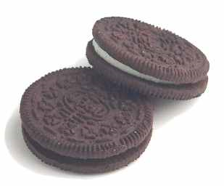
Ingredients:
- 1 bag of Oreo cookies
- 1 large container of Cool Whip
- 2 quarts vanilla ice cream
- Chocolate sauce

Directions:
- Crush Oreo cookies. Remove 1/2 cup and place the remainder in a 9x13 glass pan.
- Add softened ice cream.
- Freeze (about 1 hour).
- Add cool whip and 1/2 cup of Oreos. Freeze.
- Drizzle with chocolate sauce before serving.

Funny Fortune Cookies

When you eat at a Chinese restaurant, everyone enjoys reading the fortunes from the fortune cookies. Create your own homemade fortune cookies, and stuff them with your own funny messages.
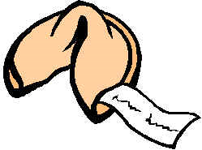

Supplies: Paper, pencil, measuring cups and spoons, mixing bowl, cookie sheets, muffin tin

Ingredients:
- 1 egg white  - ¼ cup sugar  - 1 Tbsp. water | - 2 Tbsp. melted butter  - ¼ tsp. vanilla  - 1/3 cup flour

Before baking the fortune cookies, have your scouts make up some fun messages or lighthearted fortunes and write them on thin strips of paper. You can also prepare the messages on a computer and cut them into small strips. Here are samples of some silly messages:
- The next time you sneeze, a pimple will appear on your nose.
- The odor from your feet will soon disappear.
- Your beautiful smile will attract many bugs.
- Sing a song and the bluebird of happiness will land on your head.

Directions:
  - Preheat oven to 350°F.
  - Mix egg white with sugar in a small bowl.
  - Mix in water, melted butter, and vanilla. Stir in flour.
  - Drop spoonfuls of the dough onto greased cookie sheets.
  - Spread the dough into very thin circles.
  - Place the cookies in the oven and bake 3 to 5 minutes until lightly browned.
  - Remove cookies from oven and place a paper fortune in the center of the warm cookies. Fold the sides in over the fortune, bend each cookie seam side out, and place inside a muffin tin to hold shape. Work quickly, because once the cookies harden, it is difficult to get the traditional folded cookie shape.
  - Let cool, and enjoy your funny fortune cookies.
  - If you are really ambitious, do this as a multi-den project, and make enough for your Blue and Gold dinner.

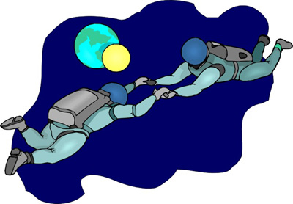
Dirt Cups

Ingredients:
- 2 cups cold milk
- 1 pkg. (4-serving size) JELL-O Chocolate Flavor Instant Pudding & Pie Filling
- 1 tub (8 oz.) COOL WHIP Whipped Topping, thawed
- 5 Chocolate Graham crackers, finely crushed
- 10 paper or plastic cups (6 to 7 oz.) or dessert dishes
- 10 Gummi Candy Worms

POUR milk into large bowl. Add dry pudding mix. Beat with wire whisk 2 minutes or until well blended. Let stand 5 minutes. Gently stir in whipped topping and 1/2 cup of the crumbs.

