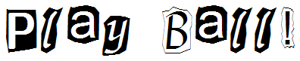

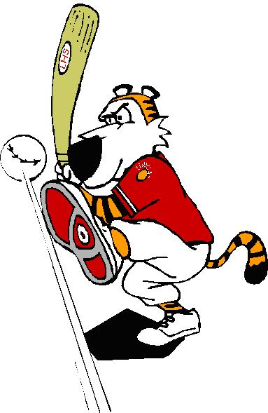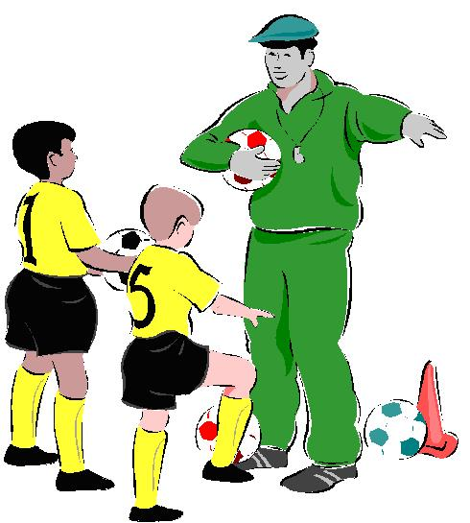

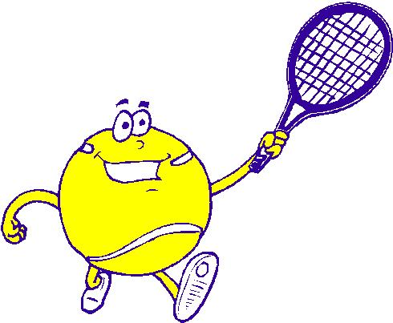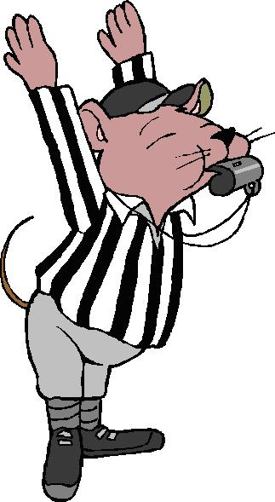

July 2005

JULY 2005 - Play Ball!

The season of fun in the sun is here! This is the time of year for sports, outdoor picnics, and exploring. Dens should play sports and learn about sportsmanship. "Do Your Best" counts. Cub Scouts can work on sports belt loops and pins as they participate with their den or pack. Put the "Outing in Scouting" and go to a baseball game as a pack. Use the big outdoors and the time of summer to enjoy all that it offers. Get the baseball gloves, balls, and bats out and have your own baseball game between the parents and the Cubs.

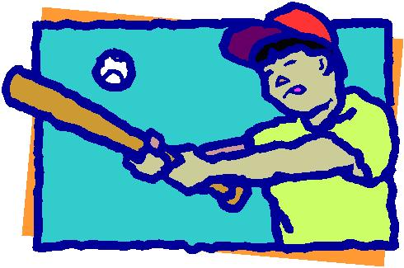
Websites:

- Sports Illustrated For Kids: www.sikids.com
A great website for kids on all the major sports. Includes statistics, games, surveys, and a fantasy league.

- Kids World: Sports & Recreation Sites: www.northvalley.net/kids/sports.shtml
This is a web portal to many sports and recreation websites suitable for kids.

- Exploratorium’s Science of Hockey: www.exploratorium.edu/hockey
Join the San Jose Sharks as they explore the science of one of the most exciting sports. Learn about the ice, the skills, the equipment, and more.
- Exploratorium’s Science of Baseball: www.exploratorium.edu/baseball
There are lots of activities to try, and a nice history of baseball equipment.
Free Stuff:

- FREE U.S. Women's Soccer Team Poster: www.cdc.gov/tobacco/sport_initiatives/sports_initiatives_posters.htm
Many free sports posters and videotapes from the Center for Disease Control to promote tobacco-free environment.

- Sample Bio Golf Tees: www.originalgreentee.com/sample.html
Free samples of biodegradable golf tees, made from wheat.

- Sports Cards Free Sample: www.carbrook.com/kidscards/freesample.htm
Receive free samples of personalized youth sports cards.

Sports Maze

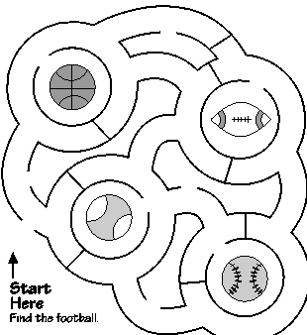

Sports Logic Puzzle

Four good friends have four different favorite sports. Read the clues to find out who prefers which sport.

 | Kickball | Basketball | Football | Soccer
Robert | . | . | . | .
Audrey | . | . | . | .
Danny | . | . | . | .
Betty | . | . | . | .
1. Audrey likes neither soccer nor football.
2. Danny used to like football and kickball best, but he has changed his mind.
3. Neither of the boys here likes soccer best.

Solution: Robert-Football, Audrey-Kickball, Danny-Basketball, Betty-Soccer

Football Team Match-up

Many football teams in the NFL are represented with animals in their names or logos. Match the location with the correct animal, and team logo.

____ ____ | 1. | Atlanta | A. | Bears | a. | 
____ ____ | 2. | Arizona | B. | Bengals | b. | 
____ ____ | 3. | Baltimore | C. | Broncos | c. | 
____ ____ | 4. | Carolina | D. | Cardinals | d. | 
____ ____ | 5. | Chicago | E. | Dolphins | e. | 
____ ____ | 6. | Cincinnati | F. | Eagles | f. | 
____ ____ | 7. | Denver | G. | Falcons | g. | 
____ ____ | 8. | Detroit | H. | Jaguars | h. | 
____ ____ | 9. | Jacksonville | I. | Lions | i. | 
____ ____ | 10. | Miami | J. | Panthers | j. | 
____ ____ | 11. | Philadelphia | K. | Rams | k. | 
____ ____ | 12. | St. Louis | L. | Ravens | l. | 
____ ____ | 13. | Seattle | M. | Seahawks | m. | 

Solution: 1-G/h, 2-D/j, 3-L/b, 4-J/m, 5-A/c, 6-B/l, 7-C/k, 8-I/d, 9-H/e, 10-E/g, 11-F/a, 12-K/f, 13-M/i

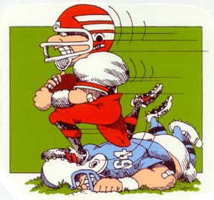

Quotations

Quotations contain the wisdom of the ages, and are a great source of inspiration for Cubmaster’s minutes, material for an advancement ceremony or an insightful addition to a Pack Meeting program cover.

“Play the game – don’t look on.”  – Lord Robert Baden-Powell  "Kids are always chasing rainbows, but baseball is a world where you can catch them." - Johnny Vander Meer, Reds pitcher 1937-49  "It's just throwing and catching and hitting and running. What could be simpler than that?”  – Paul Richards, Orioles manager 1955-61  "Every day is a new opportunity. You can build on yesterday's success or put its failures behind and start all over again. That's the way life is, with a game every day that's the way baseball is."  – Bob Feller | "My office is Yankee stadium. Yes, dreams do come true"  – Derek Jeter  "If you're not practicing, somebody else is, somewhere, and he'll be ready to take your job.  – Brooks Robinson  "I don't want to play golf. When I hit a ball, I want someone else to go chase it"  – Roger Hornsby  "Baseball players are smarter than football players. How often do you see a baseball team penalized for too many players on the field."  – Jim Boulton

Ceremonies
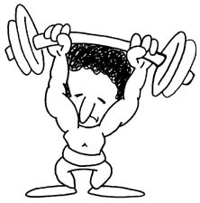

Strong Bodies Opening

Setting: 7 boys on stage, carrying various kinds of muscle-building equipment. They use the equipment and, in turn, speak their lines.

Cub 1: To keep your body strong and healthy is more valuable than being wealthy.
Cub 2: When you are fit, you feel so good and try to do the things you should.
Cub 3: It helps you lend a helping hand to need folks around our land.
Cub 4: Eating the right foods is always wise, and everyone needs some exercise.
Cub 5: Stand on tiptoes, one, two, three, touch your toes, don’t bend a knee.
Cub 6: Run awhile, then slow your pace; practice will help you win the race.
Cub 7: Scouting builds young boys into men, and this is where it all begins.

Induction Ceremony

Using the cover of a Sports Illustrated magazine, mount it on heavy paper and cut it into a puzzle. Have the new boy and his parents come to the front and ask them to put it together. Have them tape it up on the wall as they do it. When they are finished, compliment them on the good job they have done.

Cubmaster:
As we can see, this is a family that does things well together. They know how to get things done. They know how to help each other to accomplish goals! Cub Scouting is for the whole family. The accomplishments of one member depend a lot on the others in the family. Your success will always depend on how well you work together.

Present the boy with his neckerchief and his book and give them a cheer as they sit down.

Fitness Advancement Ceremony

Cubmaster:
Cub Scout age boys dream of being great athletes, spacemen, fireman, or other persons with outstanding physical power. They like to test and show off their muscles. These are part of the dreams of boyhood. Tonight, we have several boys who have achieved part of their goal to become stronger. Will the following boys and their parents please come forward? (Call names of boys and parents)

Boys, while you have worked on your advancement you have learned many things, which have made you stronger and bigger. To illustrate this, look at this plain stick. It represents a boy your age that has not been working in Scouting. He hasn’t had people like your den leader or parents helping him as you have. He has not learned all that you have learned. He stands alone weakly, and breaks easily, as evidenced by this one stick. (Break stick) See how easily it is broken.
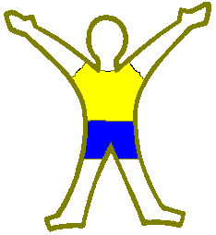

As you work and develop your skills, you will become stronger. (Show this by adding more sticks – it becomes harder to break.) Now, I am proud to present to your parents, and they in turn will present to you, your (Tiger, Wolf, Bear, etc.) badge.
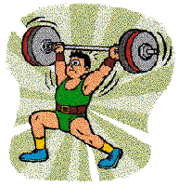
Congratulations.
(The award can be presented pinned to a small weightlifting bar made from a cardboard roll stuck into two round Styrofoam balls painted black.)
Scoreboard Advancement Ceremony

Props: Scoreboard and cutouts of running figures, invisible tape, straight pins, badges. Make scoreboard of poster or shelf paper and write in names of advancing boys. Draw some running figures, or cut out pictures of running figures from magazines or clipart.

Cubmaster:
Call forward advancing Cub Scouts and their parents. Line up boys on either side of scoreboard, with parents behind them.

You know, boys, Cub Scouting is a lot like sports. It’s fun, it’s full of physical activities, and you can win or lose. In Cub Scouting, you win by growing strong in mind and body, and by advancing in rank. Or you can lose by not joining in our Den and Pack activities and by not doing your best to pass achievements and electives.

You boys have all been winners this month. You’ve advanced in rank or earned arrow points, or both. Your coaches have been your parents. In Cub Scouting, we couldn’t get along without coaches. So I want to congratulate all of you, boys and parents. Now I’ll ask each boy to show his progress on our scoreboard by putting on the scoreboard a marker for each rank he’s earned and have his parents pin on his new badge.
In turn, advancing boys tape on a runner for each rank they’ve earned; parents pin on new badges. Webelos den leaders do the same for Webelos Scouts who have earned activity badges and Webelos badge.

Arrow of Light Ceremony (if needed):
We also have a boy who has earned the Arrow of Light, Cub Scouting’s highest award. (Call him forward with his parents) ________ has shown that he is ready for Boy Scouting by earning the Arrow of Light. He has earned at least seven activity badges and he has learned a lot about Scouting. He is in the ninth inning of his time in our Pack, and I’m very proud of him and the way he has progressed in the sport of Cub Scouting. Now, ______, will you please fill in your ranks on the scoreboard and have your parents pin the Arrow of Light? (They do so) I hope that every member of the Pack gets on the scoreboard in the coming year. It’s a good way to be a winner in Cub Scouting.

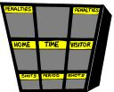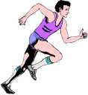

Run-Ons

- What does a baseball pitcher do on his birthday?
- He throws a party.
- What do you get when you cross a lizard with a baseball player?
- An outfielder that catches flies with his tongue.
- Why does it take longer to run from second base to third base than from first base to second base?
- Because there’s a shortstop between second and third.
- What kind of dishes to baseball players have?
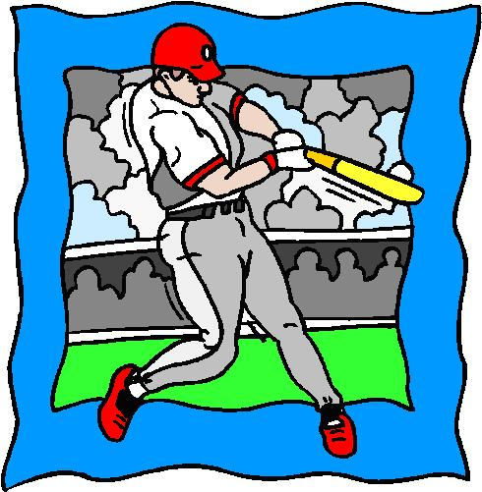
- Home plates.
- Why is the baseball championship not a laughing matter?
- Because it’s the World Serious.
- Why did the batter bring a screwdriver up to the plate?
- To drive a screwball, of course.
- Why did the pitcher toss coins up in the air?
- He wanted to throw his change-up.
- Who keeps the batter’s box neat?
- The cleanup hitter.
- What’s the difference between an umpire and a pickpocket?
- An umpire watches steals; a pickpocket steals watches.
- Why don’t the Dodgers play poker?
- The Cards are in St. Louis.
- What team goes best with milk?
- The Baltimore Oreos.
- On what team is it hardest to tell the players apart?
- The Minnesota Twins.
- If you were locked in a room with nothing but a baseball bat, how would you get out?
- Take three strikes and you’re out.
- What’s the difference between a ball and a prince?
- One is thrown in the air; the other is heir to the throne.
- Why didn’t the first baseman get to dance with Cinderella?
- Because he missed the ball.

- How do you go fishing for a basket?
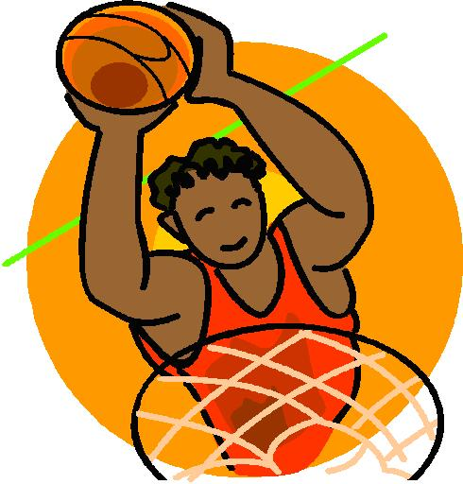
- With a hook shot.
- What do you call it when you throw a chicken through the hoop?
- A fowl shot.
- Why do basketball players have bad table manners?
- Because they’re always dribbling.
- Why are a golfer’s pants so neatly pressed?
- Because he always carries an iron.
- What kind of bandage improves your tennis serve?
- An ace bandage.
- Why are fish such bad tennis players?
- Because they’re afraid to get near the net.
- What can you server but not eat?
- A tennis ball.
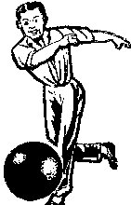
- What’s the only split a bowler doesn’t mind?
- The kind with a banana in it.
- Why did the bowler bring two balls to the alley?
- So he would always have a spare.
- Why couldn’t the fussy bowler find the perfect ball?
- Because they all had holes in them.
- Why is bowling called a quite sport?
- Because you can always hear a pin drop.
- Why is it always cool in a football stadium?
- Because it’s full of fans.
- Why is a football called a pigskin?
- Because most football players like to “hog” the ball.

Coach: Why do you think you’ll make a good football player?
Student: Because I’ve got athlete’s feet!

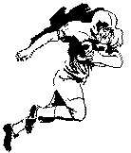 | Scout 1: I ran 95 yards for a touchdown, and they kicked me off the team.  Scout 2: Why did they do that?  Scout 1: Because I ran the wrong way!  Boy 1: I made a 90-yard run in football today.  Boy 2: Hey, that’s great!  Boy 1: Not so great. I couldn’t catch the guy in front of me who had the ball.

Mom: What are you doing home, Johnny? I thought you were at baseball practice.
Johnny: I was. But I hit the ball over the fence and the manager told me to run home!

Cub 1: I don’t play tennis because it’s too noisy.
Cub 2: Noisy?
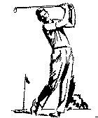
Cub 1: Yeah, everybody raises a racket.

Scout 1: I always wear two pairs of pants when I go golfing.
Scout 2: Why?
Scout 1: In case I get a hole in one!

Cub 1: My oldest brother makes about 15 baskets a day.
Cub 2: Is he a basket weaver?
Cub 1: No, he’s a basketball player!

Scout 1: I bet I can tell you the score of this soccer game before it starts.
Scout 2: Okay, smartie, tell me.
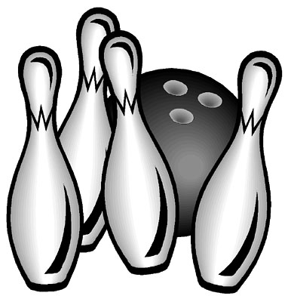
Scout 1: Nothing to nothing.

Cub 1: Did you hear about my pet dog?
Cub 2: What kind of dog is it?
Cub 1: It’s a “Blacksmith” dog.
Cub 2: What’s a “Blacksmith” dog?
Cub 1: You kick it in the rear end and it makes a bolt for the door.

Bowling Cheer: Pretend to throw the ball down the alley, and then yell, “Strike.”
Bowling Cheer II: Same as above, but yell “Oh no, not another gutter ball!”
Bowling Cheer III: Same as above, but yell “Three strikes in a row. What a turkey.”
Baseball Cheer: Pretend to throw a ball up and pretend to hit it with the bat. After you hit the ball, shout “Home Run!” or swing three times, and holler “You’re Out!”

Songs

Take Me Out to the Ballgame  Take me out to the ball game,  Take me out to the crowd.  Buy me some peanuts and Cracker Jack,  I don’t care if I ever get back,  Let me root, root, root  for the home team,  If they don’t win it’s a shame.  For it’s one, two, three strikes, you’re out,  At the old ball game.  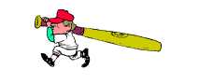  Perfect Posture  (Tune: Are you Sleeping?)  Perfect posture, perfect posture,  Never slack, never slack.  You must grow up handsome,  You must grow up handsome,  Brace that back, brace that back. | A Stretching We Will Go  (Tune: A Hunting We Will Go)  A stretching we will go,  Moving to and fro,  And when we are done  We’ve had some fun  And stretch our muscles, too.  Come on folks, let’s stand  And raise up high each hand.  Then spread them wide,  Now to your side,  As muscles you relax.  Now let us stomp our feet,  But please don’t take your seat.  Before you’re down,  Please turn around,  And then you’ll take your seat.  

Sports Card Collector Frame

Make a frame to display your collectible baseball card or any other kind of collectable card.

Supplies: CD Case, Construction paper, Glue, Tape, Baseball or other sport card

Directions:
- Cut a piece of construction paper into a square that will fit into the CD case. Place your card in the center of the square and trace around it. Cut out the rectangle you traced, cutting it about 1/4 inch smaller than the line you traced (figure 1). Put a dab of glue in each corner of your square, on the opposite side of your trace lines. Open the CD case and stick your square on the inside of the clear CD case cover.
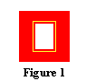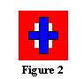

- Cut a strip of construction paper about 1 inch wide and 6 inches long. Cut another piece of construction paper about 1 inch wide and 4 inches long. Lay your card down between the trace lines in the center of your square. Lay the strips over the back of the card (figure 2). Tape the edges of your strips so they hold your card in place. Make sure the tape does not get on the card.
- Close the CD case. Add a magnet strip to the back and hang it on your fridge! You can even add stickers and other miscellaneous things to decorate your frame.

Football Player Plate
(from: About.com)

Supplies: 2 Paper plates, Crayons or markers, Tape

Directions:
- Draw a face in the center of one paper plate. Color the top edge and sides whatever color you want the football helmet to be. Like this: | 
- Take the other paper plate and draw and cut out a facemask like shown at the right. Discard all the pieces that are grayed out! | 
- Tape the facemask you cut out onto the bottom half of the paper plate you colored, and you have a football player in his helmet! | 

Baseball Fan
(from kidsdomain.com)
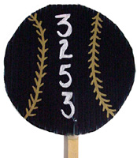
These fans are quick and easy to make. Bring them to the ballpark on a hot day, to keep you cool.

Supplies: Corrugated plastic (in your team’s color), Gold fabric paint, Sharp scissors, Popsicle stick, Pen or pencil, 5” Circular item for tracing pattern, Tacky glue

Directions:
- Using the circular object for a pattern, trace a circle on the colored corrugated plastic. Make the circle about 5" in diameter, although any size will do.
- Cut out the navy blue circle with the extremely sharp scissors.
- Using your sharp scissors, cut up a small way on the inside (be sure the "ribs" are vertical) of the corrugated plastic to make it easier to insert the Popsicle stick.
- Add tacky glue to the end of the stick and push up inside the baseball.
- Paint "stitching" on the baseball and add your Pack Number. Let dry.
- Take it out to the ballpark, show your Pack spirit, and keep cool!

Tips & Tricks:
- You can use hot glue if you want the project to dry immediately for the child to use. If using tacky glue, allow time to dry overnight.
- You can also use regular cardboard and paint it if you can't get corrugated plastic, but it won't be as durable.
- Several manufacturers make corrugated plastic. It is known as Stratocore or Coreplast, along with other names. If you purchase it from a signage store, it is cheaper as long as you make several projects out of it.

Golf Course Pencil Holder
(from kidsdomain.com)

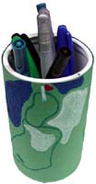 | This is an easy craft to create for any golf fan. Adapt this craft for any sport by changing the background and the ball shown.  Supplies:  - Scissors  - Empty juice can (plastic or cardboard)  - Green construction paper 4½ inches wide and 9 inches long  - Markers in blue, green, red, white, or your choice of colors  - Double stick tape

Directions:
  - Wrap the green construction paper around the juice can and attach using the double stick tape. Make sure you stick down the edges that meet really well.
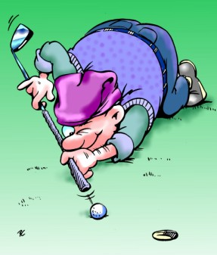
  - Using markers, draw a golf course on the green construction paper. Include holes, flags, small ponds, bushes, etc. You can even draw a picture of your Dad on the course if you want to. Give to Dad and let him enjoy!

Tips:
    - You can also use a frosting can if you don't have a juice can. You will have to measure and cut the green construction paper to a different size.
Olympic Torch
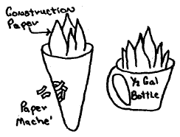

To make Olympic torch, cover a cardboard cone shape with papier-mâché. Spray paint dried mache torch. Add a flame made from red construction paper. A torch can also be made from the top section of a round bleach bottle. Cut off this section, spray paint, and add construction paper flame.

Physical Fitness Medals
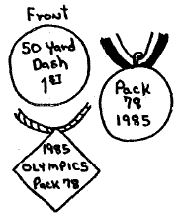
Winner’s medals can be made from various materials, including plaster, wood, plastic and cardboard. Plaster medals can be poured in plastic lid molds. Insert ring before plaster hardens, for stringing glue and gold ribbon through for wearing around the neck. Round medals can also be made from recycled juice can lids. Paint appropriate words on medal.

Diamond shape medals can be cut from cardboard or foil pans, and colored or imprinted with marking pens. When using the foil pans, tool the lettering first with a ballpoint pen, then fill in with permanent markers. These medals can also be attached to a ribbon for wearing around the neck.

Hawaiian-Italian Lawn Bowling
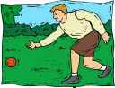

Equipment: Several candlepin (small) bowling balls or bocce balls, Target (almost any object will do)

You will need small bowling balls or bocce for this game. Find a target such as a flattened paper bag, a hula-hoop, or a box that is placed on its side. You will also need a hill. Stand at the top of the hill and try rolling the balls down to the center of the target. The tricky part of this game is that you cannot roll the balls straight down the hill. To make it more of a challenge, try rolling the ball in a loop.

Ball Roll

Equipment: A large heavy ball, chalk, a light ball for each player

Mark two parallel lines on the ground about 30 feet apart. Draw a small circle in the middle and place the heavy ball inside of it. Each team or pair of players, if playing in pairs, stands behind one of the lines on the ground. Each player gets one ball to start. The game begins with each player tossing his ball against the ball in the middle of the small circle, trying to get the heavy ball to roll onto the opposing team’s side. Players may pick up and use ball tossed by their opponents to continue playing. The first pair or team to make the ball roll onto the opposing side is the winner.

Raised Ball

Equipment: 2 beach balls, 1 broom for each player, 2 buckets, a piece of chalk

Draw a starting line and place the buckets about 30 feet away from it. Then form two teams and give a broom to each player. Both teams stand at the starting line. Players form a circle and, joining their brooms in the middle of the circle, balance a ball on their brooms. At the signal, each team moves toward their bucket, carefully balancing the ball on the brooms. If the ball falls, they must get it back on top of the broom without using their hands. The team that puts the ball into their bucket first is the winner.

Drag Ball

This is an unusual ball game in which the players are on all fours and cannot use their hands or feet to push the ball. Divide the players into two teams. Have the teams pick a side of the room, and then spread out on the floor whether kneeling or on all fours. Place a ball in the center of the room. Each team scores by getting the ball to touch the wall being defended by the opposing team. Players cannot push the ball with their hands or feet. They can only use their head, elbows and knees. The game ends when the players are too tired to continue.

Balloon Basketball
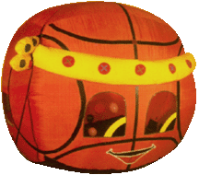
Equipment: A balloon, 2 wastepaper basket

Place two wastepaper baskets at either end of the room. Divide the players into two teams. Each team is assigned one of the baskets. To score, each team must put the balloon into the opponent’s basket. The game begins by tossing the balloon into the air in the center of the room. Players can only use their index fingers to touch and move the balloon. They are not allowed to hold onto it in any way. Score a point for each basket that team makes. The team that makes the point puts the ball in play in the center of the room.

Paired Soccer

Equipment: 2 soccer balls, 2 goals
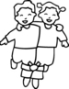

Players form into two teams. Two goalies are selected while the rest of the players divide into pairs, holding hands or shoulders. One pair from each team puts the two balls that will be used in the game. The pairs of boys will try to score into the goal of the opposing team. Before shooting the goal, both players in one pair must touch the ball. If one pair advances with the ball and someone else touches it, the two must touch it again before shooting at the goal. If they don’t do this, the goal is scored for the other team.

Kick Bowling (Soccer-Bowling)
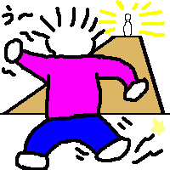
Equipment: 10 bowling pins (plastic, quart milk cartons, or Pringle’s potato chip canisters), 2 balls (softballs, large Whiffle-balls, small playground balls), chalk

Mark spots for the tenpins on the ground with chalk. Space the pins according to the size of the ball – the larger the ball used, the farther apart the pins should be spaced. Each bowler gets two balls per frame. Balls are kicked with the feet instead of being thrown by hand.

Kick Golf

Equipment: 18 #10 tin cans, tennis ball for each player, paper and pencil for scorekeeping

Set up 18-hole golf course by placing #10 cans on their sides at various spots around the selected area of play. Vary the distances between the holes. Number the cans to keep the order straight. The usual course has 2 3-kick holes, 2 5-kick holes, and the rest 4-kick holes. Trash cans, trees, etc., can be used as hazards and cannot be moved or removed by the players. A player may drop his ball one yard from such a hazard, but not closer to the next hole, by scoring an extra penalty stroke. Balls are advanced by being kicked.

A can may be turned with the open end toward each player in turn, though it may not be moved from its spot. Lowest scorer for each hole plays first on the following hole, second low plays second, etc. One player keeps record of strokes taken on each hole by each player, and totals all individual scores at the end of the 18 holes. Low total is winner.

Handball Tennis

The only racket in this game is the noise that the two teams will create as the game heats up. It is played on a handmade court with handballs or tennis balls, and requires speed, good hand-eye coordination, and cooperation among team members. Mark out an outline of a court measuring approximately 50 by 25 feet, with chalk and draw a line across the center of the court to divide it in half. Divide the players into two equal teams, each team occupying one side of the court. Players on each team count off to determine the order of serve, and spread themselves across their team’s side of the court.
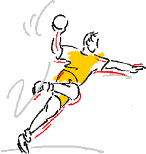

The first server serves the ball by bouncing it on the ground once and then hitting it with the palm of his hand into the opponents’ side of the court. The server get two chances to get off a good serve. If he misses both servers, the other team takes over the serve. Once the ball is served fairly, the receiving team tries to return it to the other side. The players on the receiving team may let the ball bounce on their side, as many times as they want before returning it, but once the ball is hit, it must travel directly to the other side without bouncing. The ball continues to be volleyed back and forth in this manner.

If a team’s player fails to return the bouncing ball across the centerline, they lose the volley. They also lose the volley if the ball rolls off their side of the court after bouncing once, if it comes to a stop on their side, or if they hit the ball off the court. If they are serving when they lose a volley, they must turn the serve over to the opposing team. If the opposing team is serving, that team scores a point – and gets to keep serving. So, a team can score only when it is serving. When a team regains the serve after losing it, a different player gets to be the server. That player continues to serve the ball until the team loses the serve again. The first team to score 21 points is the winner.

Around Ball

Fancy passing makes this a creative circle game. The game is played by two teams that are arranged in circles. Each team tries to be the first to move the ball around their circle five times. Adding difficult passing moves and stunts make the game more challenging. Children hone their passing and catching skills during this game; they also learn about teamwork and cooperation.

Divide the players into two equal teams and choose a captain for each team. Each team then forms a separate circle, with the distance between the players in the circles ranging from 3 to 6 feet, depending on their passing and catching skills. Each captain holds a playground ball. At the signal, the game begins with each captain throwing the ball to the player to his right. Players continue to pass the ball to the right as quickly as possible. When the ball has made a complete trip around the circle and is back in the captain’s hands, he shouts, “One!” and keeps on passing the ball. For each trip around the circle, the players must pass the ball in a different way. Passing the ball between the legs, behind the back, or with a single bounce from one player to the next are some examples. After the next round is completed, the captain shouts the next number. The first team to finish five rounds is the winner.

Newcombe

This is a simplified version of volleyball, in which the players throw and catch the ball rather than volley it. The ball and setup of the players is the same as in volleyball. The actions however are different. Instead of hitting the ball from player to player, it is thrown over the net and caught on the other side. This makes Newcombe a much slower game, and can be played with smaller children. Because the ball never needs to bounce, it can be played on grass or sand, as well as on pavement. Divide the players into two equal teams and mark out a court, using stones, sticks, or chalk. The court can be as large or small as you wish, to accommodate the number of players and their ages. A net is stretched across the middle of the court. A standard 7-foot high volleyball net may be used (and lowered for smaller kids). A tennis net will also work, as well as a rope or clothesline tied between two trees.
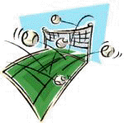

The teams spread out on opposite sides of the net, arranging themselves in two or three rows, depending on the number of players participating. The game begins when one player – standing anywhere in his team’s side of the court – “serves” the ball by throwing it over the net. The other team tries to catch the ball after it flies over the net. If the ball is caught, it is then thrown back over the net. The throw can be high or low, hard or soft, as long as it makes it to the other team’s side of the court without going out of bounds.

The teams continue throwing the ball back and forth over the net, hoping that the other team will miss or drop it. The ball may not be passed from player to player on the same team – the player who catches the ball must throw it back. The “volley” ends when one team drops the ball, fails to get it over the net, or throws it out of bounds. If the serving team commits the error, the opposing team gets to serve. If the non-serving team makes the error, the serving team scores a point. Whenever a team regains the serve, a new teammate gets to serve. The first team to score 21 points is the winner.

Around the World Basketball

The object of the game is to be the first player to make all the shots from the different spots. (You may want to modify the spots for your group’s skill level.) You will need a basketball court, a basketball and pieces of tape with the letters “A” through “R” written on them.
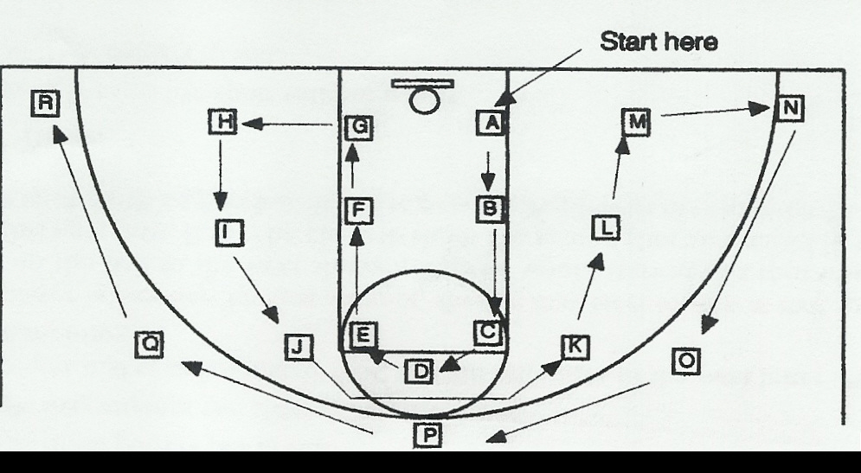

Choose the order of players by whatever system you choose. First player starts at “A” and, if he makes a basket, continues to “B” and “C” until he misses, at which point the ball is passed to the next player. When it is the first player’s turn again, he starts from the letter at which he last missed.

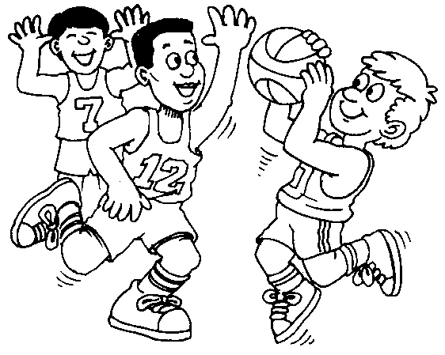

Nutty Honey Rollers

Supplies: Toaster oven, foil, oven mitts, timer, safety scissors, spatula, table knife, plate, measuring spoons

Ingredients:
- 1 soft tortilla  - 1 Tbsp. peanut butter | - 1 to 2 tsp. honey  - 2 tsp. raisins

Directions:
  - Remove the tray from the toaster oven. Cover the tray with foil and set it aside.
  - Preheat the toaster oven to medium broil.
  - Wash and dry the safety scissors. Use the scissors to cut the tortilla in half.
  - Use the table knife to lightly spread peanut butter on each tortilla half.
  - Lightly spread the honey over the peanut butter on each tortilla half.
  - Sprinkle 1 tsp. of raisins on each half.
  - Roll up the tortillas so they look like small, thick sticks. Place them on the foil-covered toaster oven tray.
  - Using the oven mitts, put the tray back in the toaster oven.
  - Broil the Nutty Honey Rollers for 3 to 5 minutes.
  - Wearing the oven mitts, use the spatula to remove the Nutty Honey Rollers from the toaster oven and put them onto the plate.
  - Let the Nutty Honey Rollers cool for 1 to 2 minutes before eating.
  - You can also substitute the ingredients with cinnamon and jelly, or jelly and cream cheese.

B’namich
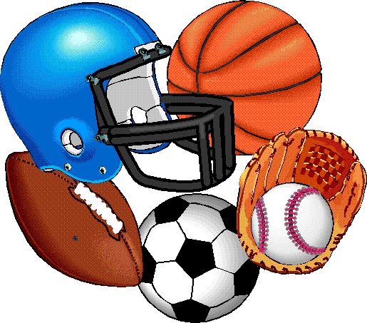

Here’s a peanut butter and banana sandwich – without the bread.

Ingredients
- 1 banana
- Peanut butter
- Raisins

Directions:
- Peel the banana. Use a table knife to cut the banana in half the long way on a cutting board.
- Spread one banana half with peanut butter and sprinkle it with raisins.
- Put the banana back together and cut it in half the short way.
- Eat your B’namich like a sandwich.

Squishwich

White beans and spaghetti sauce make a nice tasty squishy sandwich.

Supplies: Measuring cup, measuring spoons, small spoon, table knife, small sturdy resealable plastic bag

Ingredients:
- 1/3 cup canned white beans, drained  - 2 Tbsp. spaghetti sauce | - 2 slices bread  - 1 piece of lettuce

Directions:
  - Put the beans and the spaghetti sauce in the plastic bag. Push the air out of the bag and seal.
  - Pound and squish the sealed bag with your hands and fingers until the beans and sauce are well squished together.
  - Use the spoon to put the squished beans on one slice of bread. Spread the squished beans evenly over the bread with the table knife.
  - Put the lettuce and the other slice of bread on top of the beans. Cut the Squishwich in half and serve.
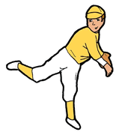

Curveball Crunch

Half the fun of going to the ballpark is snacking on popcorn and peanuts, but it can get expensive. This is tasty stadium treat to make at home.

Ingredients:
- 8 cups popped popcorn  - 3 cups mini pretzels  - 2 Tbsp. margarine or butter | - 1 cup roasted peanuts  - ½ cup brown sugar  - 1 Tbsp. maple syrup

Directions:
- Measure the popcorn, pretzels, and peanuts into a large mixing bowl. Meanwhile, make the toffee syrup by melting the margarine or butter in a saucepan over low heat.
- Use a wooden spoon to stir in the brown sugar and continue stirring until the mixture bubbles. Remove from the heat and stir in the maple syrup. (The toffee should be smooth.)
- Drizzle the toffee onto the dry mixture, tossing to distribute the glaze evenly. Once cool, immediately wrap portions in plastic. Makes 12 cups.

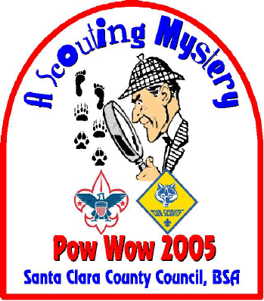

The Scouting Mystery

Clue #3

1. The main reason boys join Cub Scouts.

◻◻◻
14 15 16

2. The opposite of none.

◻◻◻
6 7 8
36 37 38

