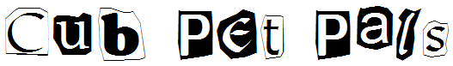

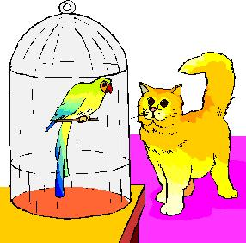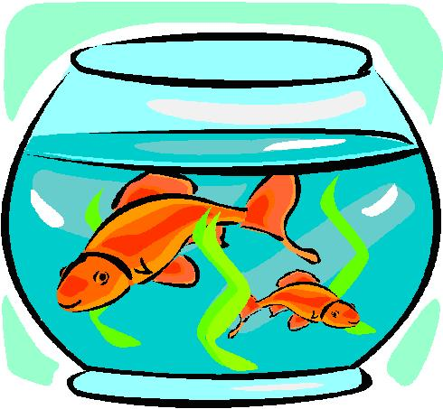

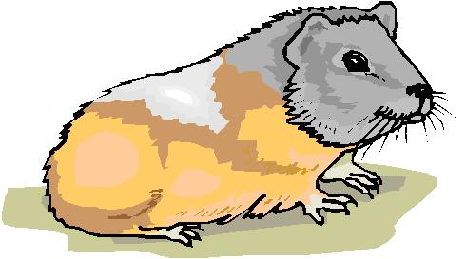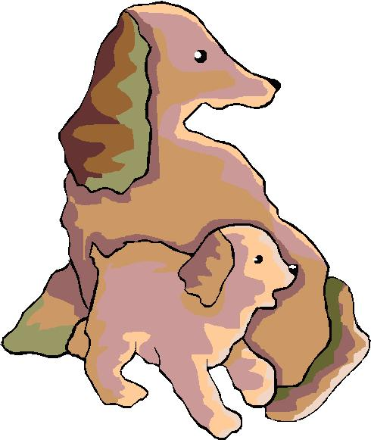

May 2005
MAY 2005 - Cub Pet Pals
It's not just our parents and siblings who live with us but our pets do as well. Learn to care for a pet and draw or take their picture to show at the pack meeting. The American Humane Association has designated the first full week of May as "Be kind to Animals Week." Discuss responsible care of pets. Visit a local pet shop and see different kinds of exotic pets. Make something for your pet like a toy or a new home at the den meeting. Remember, don't pet strange animals.

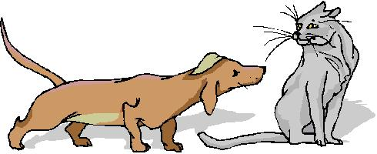

Websites:

- Humane Society Silicon Valley: www.hssv.org/
Great adoption stories to read about how people choose their pets. Rescue an animal. Article on Animal Behavior, dogs, cats and rabbits.
- San Francisco Aquarium Society: www.sfaquarium.org/
- Santa Clara Valley Canary & Exotic Bird Club: www.geocities.com/scvcebc/
- Bay Area Amphibian and Reptile Society: www.baars.org/index_noflash.html
- Pets: songs, crafts, activities on pets: www.enchantedlearning.com/themes/pets.shtml
- Craft Site directory for Pet lovers: www.craftsitedirectory.com/pets
- American Kennel Club: www.akc.org/
Learn all about pure bred dogs and the breeds recognized by the AKC. Find a dog show in your area.
- Doggie Fun: www.doggiefun.com
This site is a premiere resource for dog lovers. FREE contests, photo gallery, Canine Critique product testing, resources and more!

- Pets Welcome: www.petswelcome.com
Traveling with a pet has always presented a problem, especially when you have to find a place to stay for the night. Here's a great site that has a database of hotels and motels that will accept pets. Now you AND Rover can get a good nights sleep!

- PerfectPaws: www.perfectpaws.com/pup17.html
Got a new puppy and aren't sure how to train it? Here's a nice site with general information and tips to help you.
- Cat Fanciers Web Site: www.fanciers.com
This is the site for cat fanciers. It contains information about cat breeds, colors, cat shows, the welfare of animals, and lots of other cat-related topics.
- AVMA Care for Pets: www.avma.org/care4pets
The American Veterinary Medical Association offers a webpage on selecting a pet – and selecting a veterinarian to take care of it. Learn how to keep your pet healthy, discover the best way to travel with your pet, and pick up some safety tip on how to behave around animals.
Free Stuff:

- eatbiscuits.com - Free Bumper Sticker: www.eatbiscuits.com
FREE "Life is Short. Eat Biscuits!" bumper sticker. Put a little dog Zen/humor in your life with a daily "Biscuit" from The Zen of Calvin, a Dog's Guide to Living & Loving.

- Purapet Free Sample: www.purapet.com/online/mail/5mail.asp
Get a free sample from the manufacturers of the World's First Lightweight Instant Clumping Pet Litter.

- Fancy Feast Free Sample: www.fancyfeast.com
Register and get a coupon for a free sample of Fancy Feast cat food.
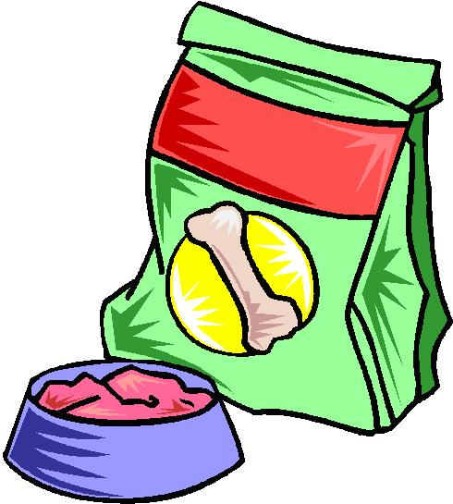

- Mighty Dog® free samples: www.mightydog.com/index.aspx
Sign-up to get a free sample can of Mighty Dog® brand dog food.
- Halo - Purely for Pets - Free Samples: www.halopets.com
Halo offers a full line of Grooming Aids, Vitamin Supplements, and Health Care Products for Cats & Dogs. Plus, Healthy all natural food for Birds. Fill out their form and get a FREE sample of either 7th Heaven Catnip or Vita Dreams Daily Greens.
- IMPROVE Dog Food Supplement - Free Sample: www.stopitch.com
IMPROVE is a dry, granular food supplement which has been formulated to help correct your dog's skin and coat problems. Fill out their form and get a FREE taste sample.
Humane Society

Contact the Humane Society Silicon Valley for tours and outreach shows. Visit their website: www.hssv.org/

American Kennel Club
Every year around the end of January/beginning of February, the Golden Gate Kennel Club hosts a huge dog show at the Cow Palace in San Francisco. You get to see many different breeds of dogs. You can talk to the dog’s owners and even pet the dogs. There is even an AKC Junior program for children. Visit their website: www.akc.org/.

Cat Fanciers Association
Every February/March there is a big cat show at the Cow Palace in San Francisco. The CFA Northwest region has a website at www.cfanorthwest.org.

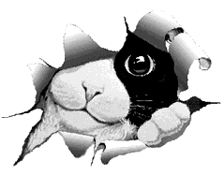

Hidden Picture Puzzle
From: www.justriddlesandmore.com

We found at least 8 animals in the picture below, how many can you find?
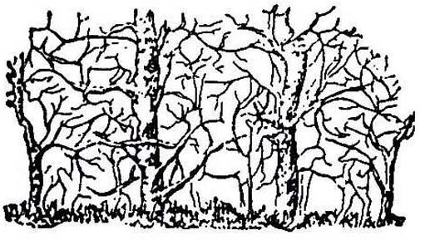
Pets in Spanish
Label the pets below with their Spanish names: 1) el perro, 2) el carpa dorada, 3) el gato, 4) el periquito, 5) el potro, 6) la tortuga, 7) el loro, 8) la marmota

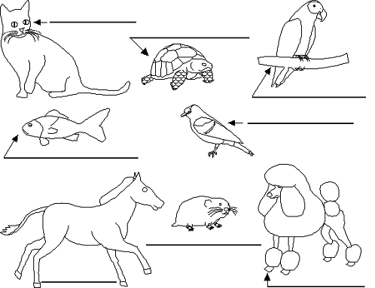

Answers: Cat: el gato, Turtle: la tortuga, Parrot: el loro, Goldfish: el carpa dorada, Parakeet: el periquito, Pony: el potro, Hamster: la marmota, Dog: el perro

A Dog's Life Word Search
From: www.puzzlechoice.com

Can you find the dogs hidden in the puzzle below?
They may be horizontal, vertical or diagonal, forwards or backwards.

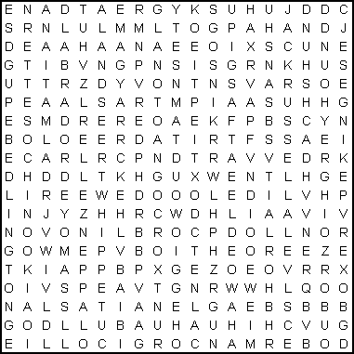

AIREDALE  ALSATIAN APPENZELLER  BASSET  BEAGLE  BEDLINGTON  BLOODHOUND  BORZOI  BOXER  BULLDOG | CHIHUAHUA  CHINOOK  CHOW CHOW  COLLIE  CORGI  DACHSHUND  DALMATIAN DOBERMAN GREAT DANE  GREYHOUND | HUSKY  JACK RUSSELL  LABRADO  LANDSEER  MAGYAR  MASTIFF  PEKINGESE  POINTER  POMERANIAN  POODLE | PUG  ROTTWEILER  SAMOYED  SANSHU  SETTER  SHEEPDOG  SPANIEL  TERRIER WHIPPET

Cat and Mouse Maze

Find the path from the cat to the mouse.

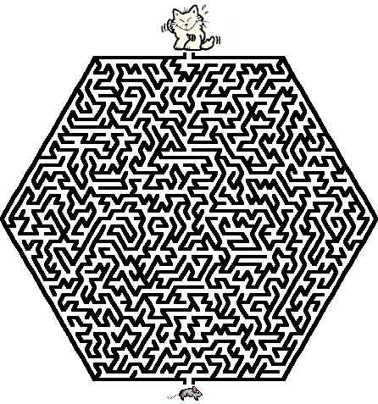

Quotations

Quotations contain the wisdom of the ages, and are a great source of inspiration for Cubmaster’s minutes, material for an advancement ceremony or an insightful addition to a Pack Meeting program cover.

“An animal has been made by God, just as you have been. He is therefore a fellow-creature.”  – Lord Robert Baden-Powell  “A boy can learn a lot from a dog: obedience, loyalty, and the importance of turning around three times before lying down.”  – Robert Benchley (1889 - 1945)  “If a dog jumps in your lap, it is because he is fond of you; but if a cat does the same thing, it is because your lap is warmer.” – – Alfred North Whitehead (1861 - 1947)  “I like pigs. Dogs look up to us. Cats look down on us. Pigs treat us as equals”.  – Sir Winston Churchill (1874 - 1965) | “It's funny how dogs and cats know the inside of folks better than other folks do, isn't it?” – Eleanor H. Porter (1868 - 1920), Pollyanna, 1912  “If you are a dog and your owner suggests that you wear a sweater, suggest that he wear a tail.”  – Fran Lebowitz (1950 - )  “We call them dumb animals, and so they are, for they cannot tell us how they feel, but they do not suffer less because they have no words.” - Anna Sewell (1820 - 1878), Black Beauty, 1877  “Outside of a dog, a book is probably man’s best friend; inside of a dog, it’s too dark to read.” – Groucho Marx

Cubmaster’s Minute

Life Lessons Learned from a Dog:
- If you stare at someone long enough, eventually you'll get what you want.
- Don't go out without ID.
- Be aware of when to hold your tongue, and when to use it.
- Leave room in your schedule for a good nap.
- Always give people a friendly greeting.
- When you do something wrong, always take responsibility (as soon as you're dragged shamefully out from under the bed).
- If it's not wet and sloppy, it's not a real kiss.

Dogs as Teachers
If a dog were your teacher you'd learn stuff like:
When loved ones come home, always run to greet them.
Never pass up the opportunity to go for a joyride.
Allow the experience of fresh air and the wind in your face to be pure ecstasy.
When it's in your best interest--practice obedience.
Let others know when they've invaded your territory.
Take naps and stretch before rising.
Run, romp, and play daily.
Avoid biting when a simple growl will do.
On warm days, stop to lie on your back on the grass.
On hot days, drink lots of water and flop under a shady tree.
When you're happy, dance around and wag your entire body.
Delight in the simple joy of a long walk.
Eat with gusto and enthusiasm. Stop when you have had enough.
Be loyal.
Never pretend to be something you're not.
If what you want lies buried, dig until you find it.
When someone is having a bad day, be silent, sit close by and nuzzle them gently.

Ceremonies

Opening and Closing - Noah’s Ark

Props: Make an ark out of a large sheet of cardboard set up so that the animals can enter and leave. Boys can also have pictures or stuffed animals of the animal they represent. Cubmaster or Den Leader playing Noah can be in a robe or other costume. He could also be holding a list to check off the animals as they arrive.

(Cubs enter two by two)

1st set of Cubs: We are the Tigers.
Noah: (checking list) Please enter. Take the last stall on the right. (Tigers enter)
2nd set of Cubs: We are the Bobcats.
Noah: Good to see you. You have the third stall on the left (Bobcats enter)
3rd set of Cubs: We are the Wolves.
Noah: Welcome. Second level, fifth stall on the left. (Wolves enter)
4th set of Cubs: We are the Bears.
Noah: Good. Come on in. Sixth stall on the left. (Beats enter)
Now all the animals are aboard and we are ready to start. Let the Pack Meeting begin!

(During the Pack Meeting at spaced intervals Noah comes out to send the birds to find dry land. The last bird does not return which leads right into the closing)

1st Interval, Noah: Fly away bird, find me dry land. (Pretends to send bird then waits a few moments) Oh, the bird returns. No dry land yet.

2nd Interval, Noah: Fly away bird, find me dry land. (Pretends to send bird. After a moment it returns) Oh, you have brought me a twig from a tree. Still too soon to land.

Closing, Noah: Flay away bird, find me dry land. (Sends bird, waits, bird does not return) Hooray, there is dry land. The ark is aground. Come animals, come out of the ark. It is time to start living on the ground again. (Animals come out of ark, stretching and scratching)

All animals & Noah: Ahh, look at the rainbow!
Noah: Thank you for joining us on our journey.

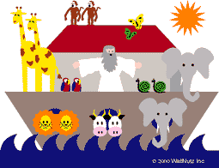

Noah’s Ark Advancement

Props: Robe and walking stick for Noah (Cubmaster) and similar costume for his assistant (Awards Chair or Assistant Cubmaster). Also needed is a 1’ x 6’ plank to cross over into the Ark.

Cubmaster: Well, we finally have completed building the Ark. I’m sure glad we didn’t have to build two of these. The weather shows it will only be a few hours before the rains start, so we better get busy rounding up all the animals for the trip. I must remember, though not to let the termites go with us!

Assistant: Noah, what animals do you want me to round up and bring aboard first?

Cubmaster: The first one will be the Bobcats. Will you please call them to the Ark?

Assistant: Will (read names) and their parents please come forward and cross over onto the Ark? (Cubmaster presents awards.)

Cubmaster: It’s time to bring aboard the Wolves. Will you please call them to the Ark? (Repeat for Bear, Arrow Points, Webelos Badge and Activity Badges) We have certainly called aboard the most important animals to the Ark. Of course, most of you recognize them as Cub Scouts. And just like the two of each species of animals that were on Noah’s Ark, Cub Scouts are famous for doing things in twos:

To do their best,
To do their duty to God and their country,
To help other people,
To obey the law of the Pack.

Congratulations to each Cub Scout who has earned and been presented an award tonight. We know that you have learned through your accomplishments more knowledge and character that will carry you through Boy Scouts and on to successful young men.

Mothers Day Closing Ceremony

I Love You, Mother (by Joy Allison)

“I love you, mother” said little John;

Then forgetting his work, his cap went on,
And he was off to the backyard swing,
Leaving his mother his room to clean.

“I love you, mother” said little Phil,
“I love you more than tongue can tell.”
Then he teased and pouted half the day
Till his mother rejoiced when he went to play.

“I love you, mother” said little Dan.
“Today I’ll help you all I can.”
To the cradle then he did softly creep
And rocked the baby till it fell asleep.

Then stepping softly he took the broom
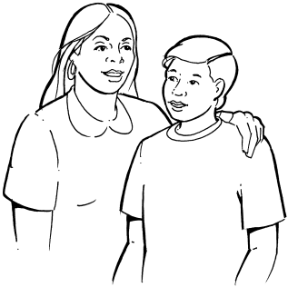
And swept the floor and dusted the room.
Busy and happy all day was he,
Helpful and cheerful as a boy should be.

“I love you, mother,” again they said,
Three little boys going to bed.
How do you think the mother guessed,
Which of them really loved her best?

Run-Ons

- When is the vet busiest?
  - When it’s raining cats and dogs.
- What happened when the dog ate his owner’s watch?
  - He got a lot of ticks.
- What is a baseball dog?
  - One that catches flies, chases fowls, and dashes for home when he sees the catcher.
- Why did the dog take a wishbone to bed?
  - Because he wanted to make his dreams come true.
- Where do you find a no-legged dog?
  - Right where you left him.

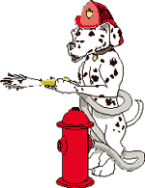
Two dogs meet each other in the park…
Dog 1: Hi, I’m Rover. What’s your name?
Dog 2: I don’t know, but I think it’s “Down Boy.”

Boy 1: Why to fire fighters use Dalmatians?
Boy 2: They use them to keep the crowds back.
Boy 3: No, they’re just for good luck.
Boy 1: They use the dogs to find the fire hydrant.

Boy: Doctor, can you treat my dog?
Doctor: I would, but I’m all out of dog treats!

Skits

Doggie Doctor

A person comes to the psychologist and says that he needs help; he thinks that he is a dog, holding up his hands like a dog begging. Throughout the skit, the person acting like a dog, does dog-like things, like scratching behind his ears, whining, etc. Doctor asks how long he has had this problem. Ever since he was a puppy is the reply. The doctor asks if he will lie on the couch but the person says that he can’t since he can’t get on the furniture. The doctor’s advice is to make sure that he gets all his shots and doesn’t go chasing any cars.

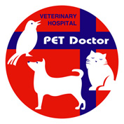

Puppy in the Box

Props: A cardboard box with holes, cup of water inside, and a stuffed dog (or rabbit, etc.)

Announcer: This scene takes place on the street outside a grocery store.
(Several participants are gathered around outside the store, chatting.)

Roger: (Enters holding the box) Hi guys, would you please hold this box for me while I go into the store? (Exits)
Martin: I wonder what's in the box?
Gerry: I don't know, but something is leaking out!
Bob: (Rubs finger against the bottom of box, then licks finger) Hmmm, it tastes like lemon soda.
Martin: (Also rubs box and tastes finger) No. I think it's more like chicken soup.
Roger: (Returns, looks in box) Oh, you naughty puppy!

Puppy in the Box (Version 2)

Cast: Owner, 1st Pedestrian, 2 Friends, box
Setting: Street Corner
Owner: (Walking up to #1) Would you hold my box? I have to go into a store for a moment.

#1: Sure! Be glad to.
#2: (Walks up.) Hey! What's in the box?
#1: I don't know. This guy comes up to me and hands it to me. Hey! It's leaking! Maybe it's ice cream and it's melting. Let's taste it. (Taste drip) Tastes like vanilla ice cream to me!
#2: (Tastes it.) Chocolate it is, my friend. Hey Joe! Try this -- what does it taste like?
Joe: (Tastes it.) Definitely pistachio.
#1: Naw! It's vanilla!
#2: I told you, it's chocolate!

(Owner comes back. )
#1: Mister -- what's in the box? Vanilla ice cream?
#2: Or chocolate?
Joe: It tastes like pistachio to me!
Owner: How foolish of you guys. That's my pet dog!

Lost Dog

Setting: Dave is crying
Dave: Boo hoo hoo!
Bob: Hey Dave, why are you crying?
Dave: (still sniffling) I lost my dog
Bob: Maybe he’ll come home.
Dave: No, he won’t come home. He’s lost.
Bob: Why don’t you put an ad in the lost and found column of the newspaper?
Dave: No. It wouldn’t do any good.
Bob: Well, why not?
Dave: Because my dog can’t read!

Smart Dog

Tom: That’s a nice dog you have.
John: Thank you. He’s nice and he’s smart.
DOG: Arf!
Tom: A smart dog, huh? What’s his name?
John: Snoop.
DOG: Arf!
Tom: What kind of dog is he anyway?
John: A police dog.
DOG: Arf
Tom: A police dog? He doesn’t look anything like a police dog.
John: Of course he doesn’t. He’s a police detective in disguise!
DOG: Arf!

Limericks

Be Kind to Dumb Animals (by John Ciardi)

There once was an ape in a zoo
Who looked out through the bars and saw – You!
Do you think it’s fair
To give poor apes a scare?
I think it’s a mean thing to do!

A Personal Experience  (by Oliver Herford)  A puppy whose hair was so flowing  There really was no means of knowing  Which end was his head  Once stopped me and said,  “Please, sir, am I coming or going?” | Shaggy Dog  There was a small maiden named Maggie,  Whose dog was enormous and shaggy,  The front end of him  Looked vicious and grim –  But the tail end was friendly and waggy.

Songs

The Wrong End  (Tune: My Bonnie Lies Over the Ocean)  Oh, rabbits have bright, shiny noses,  I’m telling you this as a friend.  The reason their noses are shiny:  The powder puff’s on the wrong end.  Wrong end – wrong end –  The powder puff’s on the wrong end –  Wrong end –  Wrong end – wrong end –  The powder puff’s on the wrong end!  I Have A Dog  (Tune: “Reuben, Reuben, I’ve Been  Thinking”)  I have a dog his name is Fido.  I have raised him from a pup.  He can stand upon his hind legs,  If you hold his front legs up! | Inchworm  Inch worm, inch worm  Measuring the marigolds  You and your arithmetic  You'll probably go far  Inch worm, Inch worm  Measuring the marigolds  Seems to me you'd stop and see  How beautiful they are  Two and two are four  Four and four are eight  Eight and eight are sixteen  sixteen and sixteen are thirty-two  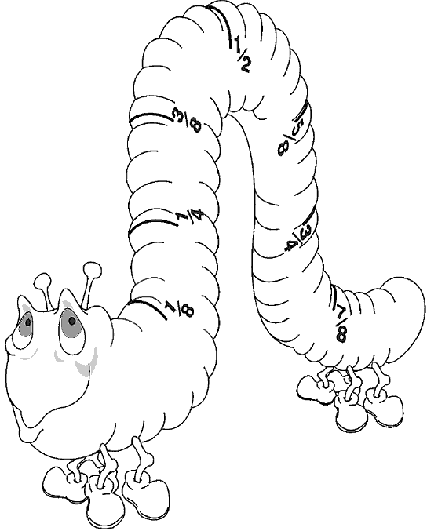

The Cat Came Back

Old farmer Johnson had troubles of his own
He had a yellow cat that wouldn't leave him alone
He tried and he tried to give that cat away
Gave him to a man going very far away

But the cat came back, the very next day
Oh the cat came back, they thought he was a gonner
But the cat came back, he just couldn't stay away, away, away
Gave it to a man going way out west
Told him to give it to the one he loved the best
First the train jumped the track, then it slipped the rail
No one is alive today to tell the sad detail
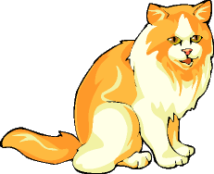
Gave it to someone going up in a balloon
Told him to give it to the man in the moon
Balloon came down about 90 miles away
But where the pilot is today I cannot say

Be Kind to Your Web Footed Friends  Be kind to your web-footed friends  For a duck may be somebody's mother  Who lives all alone in a swamp  Where it's very cold and damp  You might think that this is the end  Well it's not caus' I know another stanza  Be kind to your web-footed friends  For that cop may be Dick Tracy's brother  Who lives all alone on the beat  On a dark and dingy street  You might think that this is the end  Well, Why not! | Boa-Constrictor  I'm being swallowed by a boa-constrictor  I'm being swallowed by a boa-constrictor  And I don't like it one little bit  Oh, no, he's got my toe  O gee, O gee, he's up to my knee  Oh, my, Oh, my, he's reached my thigh  O fiddle, O fiddle, he's at my middle  Oh heck, Oh heck, he's up to my neck  O dread, O dread, He's got my GULP!!!

Applauses

Big Bear: Stand up. Pretend to be a bear standing on his hind legs and give a greate big “GROWL”.
Snake: Put hands together above your head. While standing, slither with your body in place and say, “SSSSSSSSSSSSS”.
Pet Photo Frame

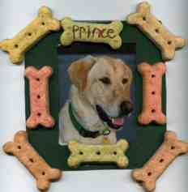 | Supplies:  - Dog biscuits, kitty treats or other favors to represent the animal you will feature in the photo (for a bird, how about small seed bells, or other bird toys)  - 1 picture of your favorite animal  - acrylic paint- any color  - fine tipped marker
- craft glue
- paint brush- use a small foam one as they don't leave brush marks
- 5X5 inch piece of cardboard or photo matting- cereal boxes work great
- craft knife
- sealer- Design Master Super Surface Sealer, clear Sealer and Satin Finish 383 works great
- ribbon or magnet

Directions:
- Center your picture on top of cardboard and trace around it.
- Use craft knife to cut out hole for picture.
- Paint the front of the frame in the color of your choice.
- Glue treats on to the frame.
- On one of the treats or an open space on the frame write the animal's name, plus the dates of birth and death if they are now little angels.
- Seal with sealer.
- On the back side of the frame glue or tape the picture in place.
- Add ribbon or magnet to the back to hang.

Bird Cookies

Make tasty cookie treats for your feathered friends.
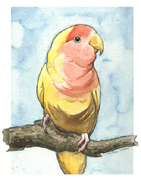
Supplies:
- 1 cup softened unsalted butter
- 3 beaten eggs
- 3½ cups fluor
- 1 tsp. baking soda
- Pinch of salt
- Mixed birdseed

Directions:
  - Stir flour, baking soda, and salt together in a large bowl.
  - Add butter and eggs. Mix until well blended.
  - Roll dough out on floured surface and cut different shapes with cookie cutters.
  - Make a hole in the top of each cookie with a drinking straw.
  - Press birdseed into each side of the cookies.
  - Bake in oven at 350 degrees for 10-12 minutes.
  - After Bird Cookies have cooled, tie a ribbon or string through the hole and hang on a tree branch.

Paper Animals

With a few folds, you can transform the drawn shape of any four-legged animal into a 3D miniature.

Supplies: Paper, Scissors, Markers, Tape
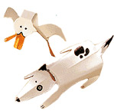
Directions:
- On a scrap of paper, draw the outline of an animal as if it were lying flat on the ground with head, legs and tail extended (a kind of road-kill effect).
- Cut out the shape, and then fold at the joints.
- Use a pen to draw in the whiskers, eyes, spots and other details.

Pencil Pup

Supplies: (4) pinch-style wooden clothespins, Wood Glue, Felt, Googly Eyes, Pom-pom, Markers, Pencil

Directions:
- To form the front end of the dog pinch open a clothespin and apply glue to the inner surface of the opened end. Then clamp the glued end onto a second clothespin, just behind the metal spring.
- For the dog's tail end, glue and clamp together the last two clothespins so that one holds the other wide open. When the glue is dry, fit the opened end of the back half onto the lower end of the front half. Apply glue to bond the two sections.
- From the felt, cut out floppy ears and circular paws. Then glue ears and paws, the googly eyes, and the pom-pom nose onto the dog.
- Add spots or other distinguishing details with colored markers. Finally, pinch open the dog's mouth and insert a pencil, balancing its weight equally on both sides.

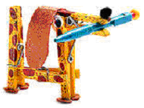

Pasta Pals

Supplies: Dry pasta, Pipe cleaners, Glue, Googly eyes, Scissors, Felt

Directions:
- Create the animal's torso by sliding a few pieces of pasta onto the center of a pipe cleaner. (Wagon wheels are perfect for a chubby belly; rigatoni for a lean one.)
- Bend the pipe cleaner on both sides of the torso to form a neck and tail. Add more pasta and fold the tips of the pipe cleaner to hold the pieces in place.
- Bend the neck (between pastas) into a right angle to form a face.
- To attach legs, ears, or horns, twist shorter lengths of pipe cleaner around the body and string them with macaroni. You can even glue on miniature soup pastas for a mane or fur.

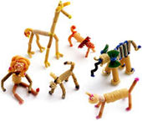

Hare Hop

Equipment: Per team: 1 pair of rabbit ears (made from cardboard, cotton and wire attached to a hat); 1 small balloon and 1 large balloon for each member; lots of string; 1 chair for each team.
Formation: Relay.

Divide the group into teams of six. Line up each team in straight lines at one end of the playing area. Place the chairs, one for each team, at the opposite end of the playing area.
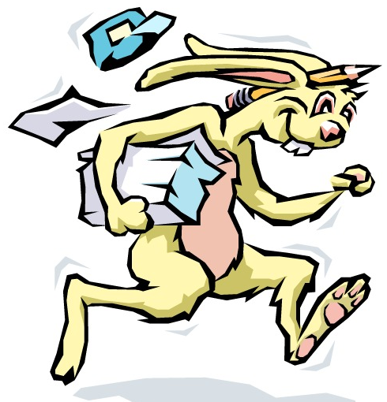

On 'Go', the first player of each team dons the rabbit ears, while his teammates blow up one small and one large balloon. One long piece of string is tied to the small balloon. The first player then ties the string around his waist, with the balloon hanging from behind, to represent his tail. He hugs the large balloon to his tummy, to represent the fluffy underside of a bunny. Then, with his ears and his two balloons, he hops down to the chair, hugs the large balloon until it breaks, and sits on his 'tail' until the small balloon breaks. When both balloons have burst, he hops back to the team where he gives the ears to the second player. The fun is helping each rabbit get 'dressed' and in cheering each bunny on. The relay ends when all bunnies have lost their tummies and tails.

Tadpoles
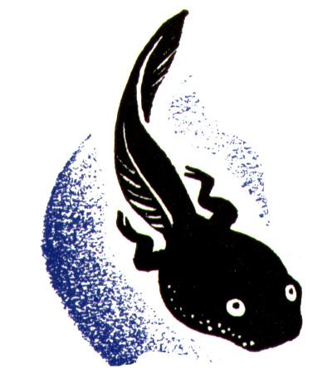

Equipment: 1 ball; whistle
Formation: Teams

The Pack divides into two teams. Team A stands in a circle with one Cub in the center, holding the ball. Team B stands in line, like the tadpole's tail, coming from the middle.
When the leader calls 'GO', the Cub in the center of the circle starts to throw the ball to his team, one by one. Meantime, the Cubs in Team B in turn run around the circle and back to their places. When the last Cub in Team B is back in his place, the leader blows the whistle and Team A stops. Team A says how many throws the Cub in the center has made and when the teams change places, Team B tries to beat Team A's score.

Cat and Mouse
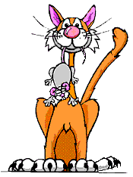

The Pack lines up in 4 or 5 lines, each line of Cubs joining hands across. One Cub is chosen as 'Cat' and another as 'Mouse', the 'Cat' chases the 'Mouse' up and down the lines. When the leader blows the whistle, the Cubs turn at right angles and form lines going down, by holding hands with the members of their new line. When the leader blows the whistle again, the lines form across once more. When the 'Cat' has caught the 'Mouse' a new pair are chosen.

Cat's Tail

Equipment: A supply of colored yarn, 2 colors, one for each team
Hide several pieces of cloth or yarn - a different color for each team. One Cub on each team is a 'cat without a tail'. At the signal, all Cubs search for tails of their color. As a piece is found, it should be tied to the belt of the cat who ties others to it as they are found. The winner is the side whose cat has the longest tail at the end of five minutes.

Poor Kitty

Equipment: 1 blindfold
Arrange the group in a circle with a blindfolded player in the center. Then have the players move around the circle very quietly. The blindfolded player should approach the circle in any direction and secure a victim who, in a disguised voice, says 'poor kitty' and then imitates the 'meow' of a cat. If the blindfolded player fails to identify his prisoner, he releases him and the game continues. If he succeeds, the two change places.

The Frog Hop
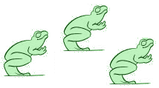
Draw a finish line about 25' from the start and line the players up about 3' apart. At "Go" they race by jumping first to the right, then to the left, then straight ahead. This procedure is followed until someone crosses the finish line.

Dog Chases Its Tail
This game mimics the silliness and futility of a dog chasing its tail. You need a bandanna. Have the players line up, holding each other around the waist. (Do not allow kids to hook fingers through belts or belt loops--this results in ripped clothing and hurt fingers.) Have the last player tuck a bandanna in his pocket, or under his belt or waistband, so that it hangs down like a tail. Next, the front of the line begins to chase the end of the line, attempting to grab the bandanna. Players in the middle can help or hinder the head or the tail, depending on their whims. If the line breaks, the player who let go must step out, shortening the line.
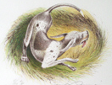

Poodle
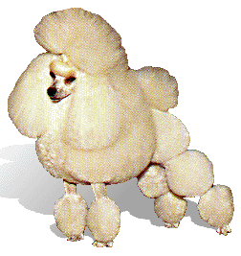
In this guessing game, the word "poodle" is substituted for a verb. To play, one boy picks a secret verb, then the other boys ask questions using poodle in place of the verb: "Can you poodle in a pool?" "Does poodling make you tired?" The child who correctly guesses the secret verb gets to choose the next one. Who knew verbs could be this much fun?

Doggie Where’s Your Bone

It is an inside game. A boy plays the part of the dog. He sits in a chair with his back to the den. An eraser or another object is put under the chair. That is the bone. While the dog is turned around with his eyes closed someone sneaks up and steals the bone and hides it somewhere on his person. Then everyone sings: Doggy, Doggy, where's your bone? Somebody's stole it from your home. Guess who! It might be you! Then the dog has three chances to guess who took it. Sometimes it is left under his chair. If the dog guesses right then he gets to do it again. If he guesses wrong then the boy who has the bone gets a turn as the dog.

Cats Get Your Corner
You pick someone to be it. The person that is "it" gets a ball (like a standard red kickball or maybe something softer like a nerf ball). All the cats pick a corner to stand in. The den leader acts as an umpire. When everyone has a corner then the ump yells "cats get a corner". Then everyone takes off running for the corner that is next. Everyone is supposed to run in the same direction so no one should run into each other. While the cats are running, "it" trys to hit them with the ball. If you get hit you stand in the middle. The cat that never gets hit wins and becomes the next “it”.

Cup of Fish
From: www.enchantedlearning.com

Supplies: Package of blue jello, gummy fish (or fruit-flavored sharks), clear plastic cups

Directions:
 | - Make the blue jello according to the directions on the box.  - Pour into the clear plastic cups.  - Let the cups cool about an hour in the refrigerator until partially set.
 | - When the jello is partially set, place a few gummy fish in each cup.  - Place cup back in the refrigerator until the jello is completely set.  - Eat and enjoy.

Variations:
- Frozen fish-popsicles (just freeze the jello in popsicle molds - add the gummy fish when they are partially set - unmold very gently when entirely frozen). These are really messy to eat and are best eaten outside.

- An entire punch bowl of fish jello (made like the cup o' fish)!

- Make an aquarium of fish in a rectangular glass container

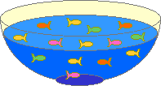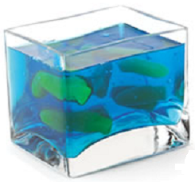

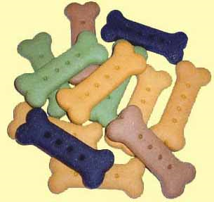

Nice Spice Dog Biscuits

These biscuits are really for your dog, not your Scouts.

Ingredients:
- 1½ cup unbleached all purpose flour  - 1½ cup whole wheat flour  - ½ cup cornmeal  - 2 Tbsp nonfat dry milk  - 1 tsp cinnamon | - 1 tsp nutmeg  - 1½ tsp allspice  - 1 egg  - 1 to 1¼ cup water

Directions:
  - Preheat oven to 350 F.
  - Stir all dry ingredients together in mixing bowl. Add the egg and slowly stir in the water with a wooden spoon. Keep stirring until dough becomes stiff.
  - Knead the dough until a smooth texture.
  - Roll out ¼ inch thick (flour the top and bottom of the dough), and cut out with a bone shaped cookie cutter (available from pet store).
  - Lightly grease a cookie sheet. Bake for 45 min to 1 hour.
  - Remove from oven and leave them overnight to let harden.
  - Store in plastic Ziploc bags.

Homemade Animal Cookies
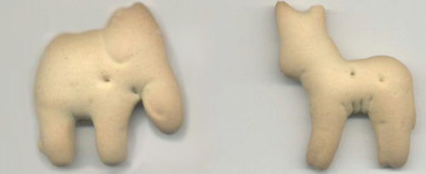
Supplies: Blender, large bowl, wooden spoon, table knife, pastry blender or 2 table knives, rolling pin, animal cookie cutters, cookie sheet, spatula, oven mitts, cooling rack

Ingredients:
- 1 cup rolled oats  - ¼ cup honey  - 1 tsp. salt  - 1½ cups all-purpose flour  - ½ tsp. baking soda | - ½ tsp. cinnamon  - ½ cup (1 stick) cold butter  - ½ cup buttermilk  - 2 Tbsp. extra all-purpose flour

Directions:
  - Pre-heat the oven to 400°F.
  - Put the rolled oats in the blender container. Cover and blend at high speed to grind the rolled oats into oat flour. (The oat flour will look powdery)
  - Place the oat flour in the bowl. Add the honey, salt, all-purpose flour, baking soda, and cinnamon to the bowl and stir well with the wooden spoon.
  - Cut the butter into 8 equal slices. Place the butter in the flour mixture.
  - With the pastry blender, cut the butter into the dry ingredients by using a back-and-forth motion until the bits of butter-flour mixture are the size of small peas.
  - Add the buttermilk to the bowl and mix thoroughly with your hands until the mixture forms a dough. Continue to mix together until smooth.
  - Allow the dough to sit for 5 minutes.
  - Sprinkle the extra 2 tsp. flour over a clean surface. With the rolling pin, roll the dough until it is ¼-inch thick.
  - Cut the dough with animal cookie cutters.
  - Use the spatula to place the crackers 2 inches apart on the ungreased cookie sheet.
  - Bake the crackers for 10 to 12 minutes or until they are lightly golden brown.
  - Remove the cookie sheets from the oven using oven mitts. Let the crackers cool for 5 minutes, and then use the spatula to move them from the cookie sheets to the cooling rack.

Brown Sugar Turtle Pralines

A praline is a rich, pastry-shaped candy made with sugar, cream, butter, and pecans. Make some turtle pralines that look like your pet turtle.

Ingredients:
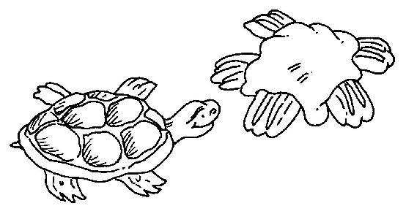
- 2 cups pecan halves
- 2 cups light brown sugar
- 1 cup light cream
- 2 Tbsp. butter

Directions:
  - With a paring knife, cut ½ cup pecan halves into quarters by cutting each pecan horizontally into two pieces. Set aside.
  - Use the wooden spoon to combine the light brown sugar and the cream in the saucepan.
  - Bring the sugar and cream mixture to boil over a medium heat, stirring constantly.
  - Clip a candy thermometer to the side of the saucepan. Continue to cook mixture until the thermometer reads 238°F.
  - Remove the pan from the heat. Stir in the butter. Stir in the remaining 1½ cups of pecan halves.
  - Beat the candy for 2 minutes or until it loses its shine.
  - Drop the candy by tablespoon onto waxed paper. Use the back of the spoon to shape the patties into a round shape.
  - Use the pecan quarters to decorate the candies to look like turtles. Put 2 pecan quarters at the front and 2 at the back for legs. Put 1 pecan quarter in between the front legs as a head.
  - Refrigerate the candy until cool, for at least 30 minutes, before serving. Makes about 24 candies.

Bird Poop

Ingredients:
- 5 cups of your favorite crunchy cereal  - 2 cups of skinny pretzels (break them in half if they are long) | - 3 cups of rice crisp cereal  - 1 bag of white chocolate chips  - 2½ cups of mini marshmallows

Directions:
- Mix all the dry ingredients in a large bowl.
- Melt the white chocolate in the microwave for about 1 minute.
- Pour the melted chocolate over the dry ingredients and spread on wax paper to cool.
- When your masterpiece is cool, break into chunks that look like icky bird poop.

Cat Cookies
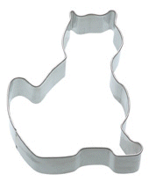

Ingredients:
- 1 package refrigerated sugar cookie dough
- 1 Tbsp. flour
- Red cinnamon candies

Directions:
  - Sprinkle flour on a clean, flat surface and roll out cookie dough. Cut out cookies in the shape of a cat head or body using a cookie cutter. Carefully transfer cookies to cookie sheet.
  - Bake according to package directions. Allow the cookies to cool on the cookie sheet for about 3 minutes then press cinnamon candies in place for the eyes and nose. Transfer to wire rack to continue cooling.

Lizard Skins

Ingredients:
- ½ cup Peanut butter  - 12 ounces Marshmallows  - 4 drops Green food coloring  - 16 Raisins | - 4 cups Rice Krispies; Cheerios or Corn Flakes  - Pam non-stick cooking spray

Directions:
- Heat peanut butter with marshmallows in a large saucepan over low heat until melted. Add green food coloring and mix in. Pour in cereal and stir quickly.
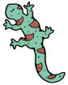
- Spray 8" pan with cooking spray then pour contents into pan.
- Allow to cool in fridge, then cut into long thin strips, about 1" x 4".
- Cut each raisin in half and stick on one end of each strip to make the lizard's eyes.

The Scouting Mystery
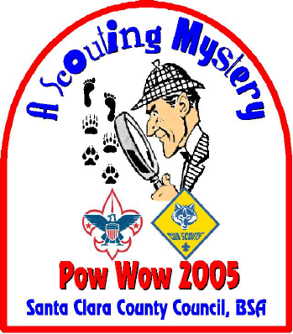

Clue #2

- A three lettered adverb that correctly completes this sentence:

◻◻◻ now brown cow?
27 28 29

2. Something a parent might say to hurry along dawdling kids.

“◻◻◻◻ on.”
31 32 33 34

