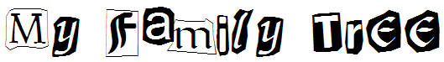

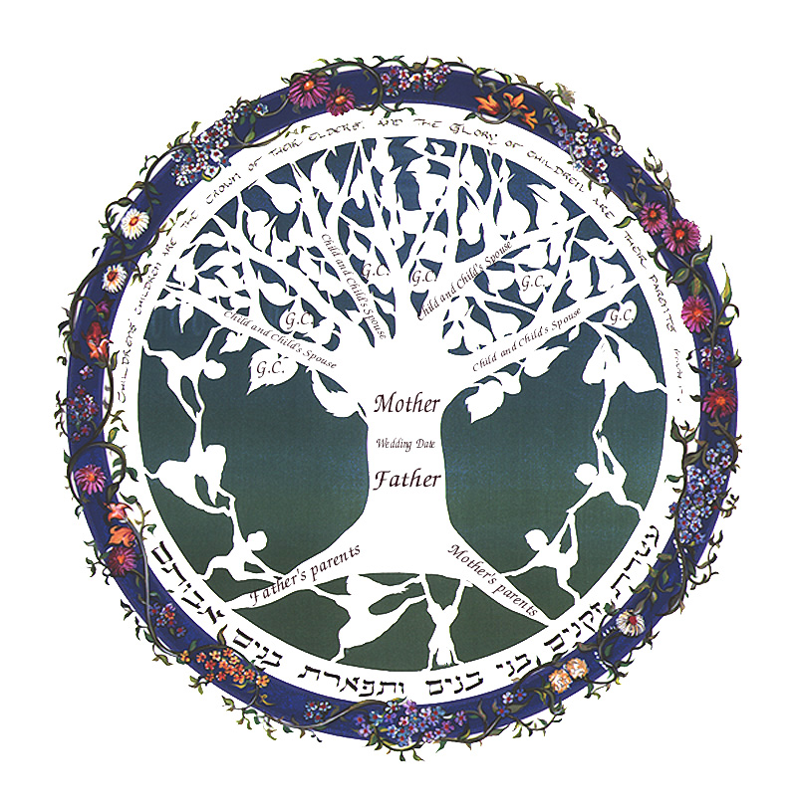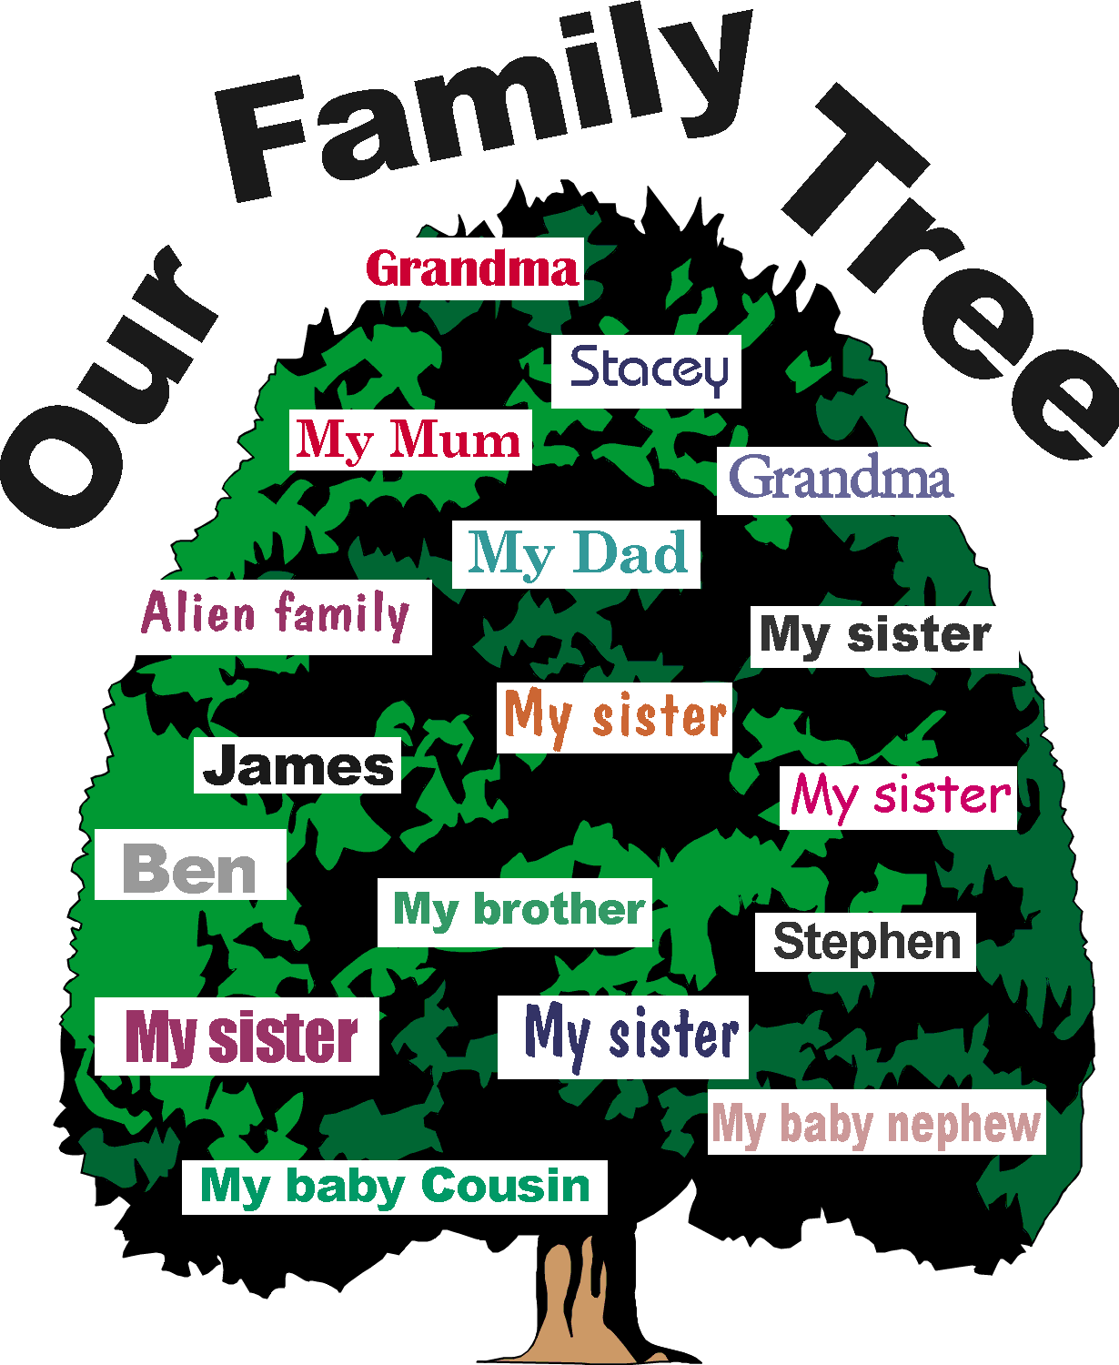

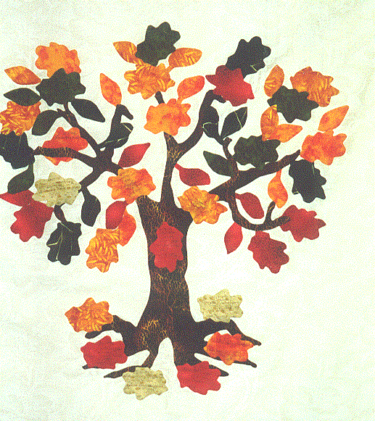

November 2005
NOVEMBER 2005 - My Family Tree
Is your family Irish or Italian, Hispanic or Greek? Learn where your ancestors came from and trace your family's heritage. Find out what they did and what their customs were. Every family is different, and everyone has something special to offer. Bring something from your family to the pack meeting for Show and Tell. Make projects about different countries to display at the pack meeting. Read stories from other lands and find out what types of games are played in those countries. Have snacks at your den or pack meeting from different countries. Have your Cub Scouts work on the Academics belt loop for Heritages or Language and Culture.

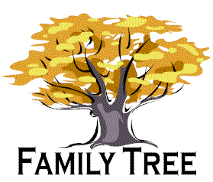

Websites:
- Geanealogy for Beginners, Teenagers and Kids: home.earthlink.net/~howardorjeff/instruct.htm
Practical advice, projects, and links guide you into the fascinating world of your family’s past. The links lead the way to other informative sites including some created just for kids.
- USGenWeb Kidz: www.rootsweb.com/~usgwkidz
This easy to follow website has a lot of good information on genealogical facts. There are printable forms and pedigree charts.
Free Stuff:
- Free Kids T-shirt and Stickers from Maytag®
www.maytagenergy.netfirms.com/club/join_club.htm
Kids - join the Maytag® Junior Apprentice Club to learn more about saving water and energy and get a Junior Apprentice kit, a T-shirt and a set of stickers with tips on how to conserve water and energy.

- Signature Brands Cake Mate Birthday Club
www.signaturebrands.com/cake_mate/cmbdayclub.html)
Register for the FREE Cake Mate Birthday Club and receive a special surprise from Cake Mate on your birthday!
- Overpopulation Bumper Stickers: www.geocities.com/tedtoal/index.htm
Get up to three free overpopulation bumper stickers by sending them a business sized S.A.S.E. (self-addressed stamped envelope)
The word genealogy can sound boring or even overwhelming to children and adults alike. The study of the family pedigree can play a very important part of teaching children about their family history, respect for their ancestors and pride of their heritage. Genealogy can be fun too. These activity suggestions can help you focus on family values and traditions.

VISIT A CEMETERY

Take your boys to a cemetery—perhaps where one of your or their ancestors is buried. Bring a family history book or old family letters or journal along with you and spend some time telling stories about the deceased person.

You could also use this time as a den service project to clean off the gravesite. You could bring flowers or send the flowers to a surviving spouse or child as a tribute and remembrance.

MAKE HEADSTONE ETCHINGS

Boys will also enjoy making an etching of the headstone. Many tombstones have interesting quotes or sayings. Hold a piece of paper over the stone and rub the side of a pencil lead back and forth across the paper with gentle pressure.

CREATE A HERITAGE ALBUM

Scrapbooking is a process that cannot be done overnight but you could start by making a page or two together. Children love this project but will get discouraged if you do not have everything needed to start and finish the project quickly. Ask the parents for help in providing photos and information for the boys. Be prepared with all of the materials needed ahead of time. You will need cardstock, glue sticks, page protectors, and maybe decorative scissors, themed embellishments like die cuts, paper punches or stickers. (As popular as scrapbooking has become, you could probably find someone in your pack who would be happy to help your den with this project.)

The boys may enjoy interviewing living family, showing them pictures and asking for details about their ancestors, which they could then write down and include in their albums. They could then take turns sharing their stories with the rest of the boys in the den.

GENEALOGICAL LIBRARY FIELD TRIP

Schedule a visit to your nearest genealogical library. If you cannot find one locally, check the yellow pages for The Church of Jesus Christ of Latter Day Saints. The LDS church owns the largest genealogical and family history center in the world and they open their centers to people of any denomination.

Files are archived in many different ways including computers and microfiche. Information is gathered from all over the world from other churches baptismal and christening records, census files, vital statistic records, immigration and military resources too. Information is quite accurate and has record of over 200 million people dating back earlier than the 1500's.

Call ahead of time and arrange a tour. Given basic family information, the guide can assist you in finding information about your specific family branch. If available, take along your family tree so you can fill in any missing blanks on birth dates, birth place or marriage information, etc.

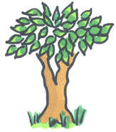

Hidden Picture Puzzle
From: www.justriddlesandmore.com

We found at least 10 faces in the picture below, how many can you find?

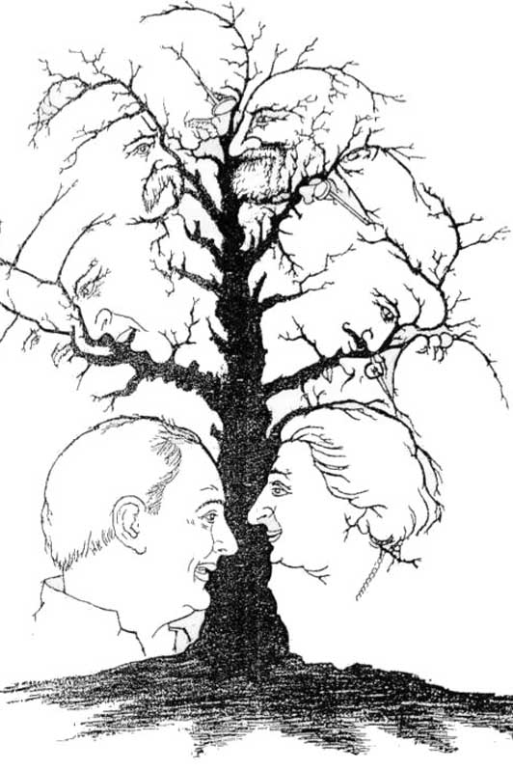

Birth Month Logic Puzzle
Four children have different birth months, but were all born in the same year. Find out who was born in each month.

 | September | October | November | December
Amy | . | . | . | .
Ben | . | . | . | .
Carol | . | . | . | .
Debbie | . | . | . | .

- Carol was born before Debbie.
- Debbie was born two months after Ben.
- Ben was born after Amy but before Carol.

Solution: Amy-September, Ben-October, Carol-November, Debbie-December

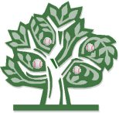

Pack Gathering Activity

Around the World in 5 minutes

Materials: 1 Passport Cover and 2 or 3 passport pages stapled and folded into a booklet. (One booklet per family.)

Leader: Have you ever heard the saying, “It’s a small world”? What does that mean? Usually, folks say this when two people have been to the same place or know the same people in a faraway location, reminding us that the world really isn’t as big as it seems at first. Let’s have some fun with the idea of our small world, by playing a game where we get to travel the world through the experiences of our fellow scouts and their families. I’ll pass out a Cub Scout passport to each family, and in the next 5 minutes, I want you to talk to as many other families in the room as possible who have been to another country. Ask each person you meet where they’ve been and something interesting they saw or learned in that country. When they’re done “taking you to that country,” have them sign their last name and write the name of the country in one of the squares of the passport. No fair using the same country twice. On your mark, get set, travel!

(Give 5 minutes for passport signing to take place. Give a few extra minutes if it looks like people are still going.)

Leader: Now, count up the number of countries you’ve been to by counting the number of boxes with signatures. Who has 5? How about 10? Awesome!!! (Keep going until you find the scout with the most signatures. Have a prize or treat to recognize him.)

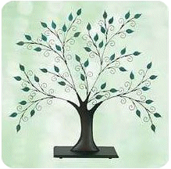

Name and Number

As each person arrives, put their name on one side of an index card, and a number on the other side. As everyone walks around with their name showing (on the index card that is taped to their shirt), they have to try to introduce themselves to as many people as they can. After a bit of mingling, tell everyone to turn over his or her name tags, so that the number on each card is showing rather than the name. Now give everyone a numbered piece of paper, and see who can fill in the most names next to the corresponding number.

Quotations

Quotations contain the wisdom of the ages, and are a great source of inspiration for Cubmaster’s minutes, material for an advancement ceremony or an insightful addition to a Pack Meeting program cover.

“Try to do things that will make your mother feel proud that you are her son, and never do anything that would cause her to feel grieved or ashamed. She has done much for you; do this for her.”  – Lord Robert Baden-Powell  “Acting is just a way of making a living; the family is life.” - Denzel Washington  “If you don't know [your family's] history, then you don't know anything. You are a leaf that doesn't know it is part of a tree.” - Michael Chrichton  “Govern a family as you would cook a small fish - very gently.”  - Chinese Proverb | “Where can a person be better than in the bosom of their family?”  - Marmontel Gretry  “I can get up in the morning and look myself in the mirror and my family can look at me too and that's all that matters.” - Lance Armstrong  “Your family and your love must be cultivated like a garden. Time, effort, and imagination must be summoned constantly to keep any relationship flourishing and growing.” - Jim Rohn  “Be more concerned with your character than with your reputation. Your character is what you really are while your reputation is merely what others think you are.” - Dale Carnegie



Ceremonies

Opening in Other Languages

Use the resources of the boys and their families to come up with costumes from various other countries. Each boy can represent a different country or you can have several boys represent the same country. Have all the boys in the den stand in front of the group when it is time to start. Each boy or group, in turn, should then say, “Good evening” or “Hello” in the language of the country they represent. And then teach the entire group how to say it. After each language has been practiced, the audience is divided into smaller groups, one for each country represented. The Den Chief, at a given signal, then leads the entire group in saying “Good evening/Hello” all at once in all the languages.

Family Tree Opening:

Cubmaster:
A family is like a strong and beautiful tree. The family’s faith in God are in its roots. The parents make up the trunk of our family tree, and the children are the branches. A poet named Helen Crawford made that comparison in a poem I would like to read to you. It’s called “The Family Tree” and it goes like this:

There’s one thing in God’s nature world that means a lot to me.
It symbolizes much of life; it is a lovely tree.
With roots so deep in God’s rich earth, it’s not disturbed by weather,
Like families with faith in God who live in peace together.
It’s trunk, the body strong and firm like parents everywhere,
To guide, control, direct, sustain the offspring which they bear.
The branches which like children spread in every known direction.
Until the fruits of their growth has reached it full perfection.
And so a tree appears to me the gem of God’s creation,
As it portrays our families which constitutes a nation.

Each of us can do our part to make our family tree stronger and more beautiful. How? By loving all the family members. Children can do it by obeying their parents, and parents showing love and fair play to their children. Let’s all resolve to strengthen out family ties.

Thanksgiving

Cubmaster:
They came as strangers to a wild land, and none of them knew what day would be their last.

Never in the old country had they known such winter; the wind so cold, the food so scarce; the enemy night so filled with dread. Never had they worked so hard, paying with aching backs of every shelter raised against the cutting wind. Everywhere they went, famine and death watched them with pale, expectant eyes. And, by the end of that bitter year, there was hardly one among them who had not lost to the cold earth someone he could not live without.

Then, these great men and women who had nothing, sat down to a hearty feast, filled with gratitude for what they had. We, who follow them, sometimes wonder why.

Did they know some secret of happiness, denied to us, that made them so glad for so little?

And then, we think back…back to some personal wilderness we have all been through in our time. Perhaps there was once a day when simply to feel the sun again, to smell another morning’s freshness, to hear a child laugh again, was miracle enough…a time when, just to find oneself alive was as a gift beyond belief. They had their lives; no one has more. They had freedom, too. They were where they chose to be. All the days ahead were theirs to use as they pleased. The owned themselves. No one owns more.

Remembering this, we join their feast, descendants of all the wise people whom trouble has taught to look at what they have and not at what they lack.

Family Fun Award Ceremony

Cubmaster:
Tonight, as we are gathered together, you can see that these snowballs in front of me have been gathered, too. These snowballs represent fun to children and adults alike! Picture with me if you will, the snow freshly fallen and the family rushing to bundle up warmly. Then all venturing out to the white laden ground to have some “family fun.” As the snow is bunched up and patted, the sound of laughter begins from the anticipation of the toss. This is sound of “family fun.”

Well, tonight, I’m going to let you come up and gather your snowball. Inside the snowball, is your son’s award. Picture with me if you will, all the work, the time and the fun it took to earn these awards. And picture if you will, all the “family fun.”

*The awards can be placed inside a Styrofoam ball that has been cut in half.

Family Closing

As I look out upon this audience, I can see many different families. Each family is unique in its interests and activities. But all of you have come together in this Pack to share a very important activity – participating in a program designed to give your son positive growth experiences in his life.

Run-Ons

- Know why a room full of married people looks so empty?
  - There’s not a single person in it.

Scout, holding a can of Crisco shortening, runs up to the front of the meeting and shouts, “I have it, I have it! My leader told me we were doing old grease this month. This is the oldest grease I could find!”

Poems:

What is a Family?
By: Mary Ann Haberman

What is a family?
Who is a family?
One and another makes two is a family!
Baby and father and mother: a family!
Parents and sister and brother: a family!

All kinds of people can make up a family.
All kinds of mixtures can make up a family.

What is a family?
Who is a family?
The children that lived in a shoe is a family!
A pair like a kanga and roo is a family!
The Family Tree

Remember me in the family tree
– my name, my days, my strife;
Then I'll ride upon the wings of time
And live an endless life.
A calf and a cow that go moo is a family!

All kinds of creatures can make up a family.
All kinds of numbers can make up a family.

What is a family?
Who is a family?
Either a lot or a few is a family.
But whether there’s ten or there’s two in your family,
All of your family plus you is a family!

Limericks  My Sister (by Margaret Mahy)  My sister’s remarkably light,  She can float to a fabulous height.  It’s a troublesome thing,  But we tie her with string,  And we use her instead of a kite. | Young Lady Named Ruth  There was a young lady named Ruth,  Who had a great passion for truth.  She said who would die  Before she would lie,  And she died in the prime of her youth.

Songs

Bring Back My Neighbors to Me  (Tune: My Bonnie Lies Over the Ocean)  One night as I lay on my pillow,  One night as I lay on my bed,  I stuck my feet out of the window,  Next morning my neighbors were dead.  Chorus:  Bring back, bring back,  Oh, bring back my neighbors to me, to me.  Bring back, bring back,  Oh, bring back my neighbors to me, to me.  One day as I sat in my rocker,  One day as I sat very still,  A firecracker killed off my neighbors,  And made me exceedingly ill.  (Chorus)  My neighbors looked into the gas tank,  But nothing inside could they see.  They lighted a match to assist them,  Oh, bring back my neighbors to me!  (Chorus) | It’s a Cub World  (Tune: It’s a Small World”)  Chorus:  It’s a Cub world after all.  It’s a Cub world after all.  It’s a Cub world after all.  It’s a Cub Scout World!  There are Cubs in England and Italy,  There are Cubs in France and Germany.  When the Cub flag’s unfurled,  All around this big world,  It’s for Cubs like you and me.  (Chorus)  There are Bears and Wolves and Webelos,  We wear different patches on our clothes.  But, I’ll tell you, it’s true,  We all wear gold and blue,  In our great big Cub Scout World!  (Chorus)  Akela guides us all, you see,  To learn and do and grow and be.  And we all meet the test  Cause we all do our best  In our great big Cub Scout World!  (Chorus)

Peanut Butter and Jelly

(Follow the actions –
Dig: pretend to dig.
Smash: squash something between your hands.
Spread: use one hand to spread peanut butter and jelly over the other hand.
Pick: pretend to pick berries.
The last time through the chorus, after eating the sandwich, mumble the words as though there is peanut butter stuck to the roof of your mouth.)

Chorus:
Peanut, peanut butter – jelly! Peanut, peanut butter – jelly!

First you take the peanuts and you dig ‘em, and you dig ‘em,
And you dig ‘em, dig ‘em, dig ‘em.
And you smash ‘em, smash ‘em, smash ‘em, smash ‘em, smash ‘em.
And you spread ‘em, and you spread ‘em,
And you spread ‘em, spread ‘em, spread ‘em.
(Chorus)

Next you take the berries and you pick ‘em, and you pick ‘em,
And you pick ‘em, pick ‘em, pick ‘em.
And you smash ‘em, smash ‘em, smash ‘em, smash ‘em, smash ‘em.
And you spread ‘em, and you spread ‘em,
And you spread ‘em, spread ‘em, spread ‘em.
(Chorus)

Then you take the sandwich and you bite it, and you bite it.
And you bite it, bite it, bite it.
And you chew it, and you chew it, and you chew it, chew it, chew it.
And you swallow, and you swallow,
And you swallow, swallow, swallow.
(Chorus)

Skits

Scene: A teacher asks the class what their fathers did.
Johnny: My father’s dead.
Teacher: Oh, I’m sorry, Johnny. In that case, what did he do before he died?
Johnny: He went blue and collapsed.

The Inheritance
µ §
Scene: A man in a bar sees a friend at a table, drinking by himself. The man walks up to his friend.

Friend: You look terrible. What’s the problem?
Man: My mother died in June, and left me $10,000.
Friend: Gee, that’s tough.
Man: Then in July, my father died, leaving me $50,000.
Friend: Wow. Two parents gone in two months. No wonder you’re depressed.
Man: And last month my aunt died, and left me $15,000.
Friend: Three close family members lost in three months? How sad!
Man: Then this month… Nothing! Not a single dime!

Signs of the Times

You know you’re living in 2005 when…
  - Your reason for not staying in touch with family is because they do not have e-mail addresses.
  - You have a list of 15 phone numbers to reach your family of three.
  - Your daughter sells Girl Scout Cookies via her web site.
  - You chat several times a day with a stranger from South Africa, but you haven’t spoken with your next-door neighbor yet this year.
  - You pull up in your own driveway and use your cell phone to see if anyone is home.
  - Every commercial on television has a web site address at the bottom of the screen.
  - Your grandmother asks you to send her a digital photo of your newborn so she can create a screen saver.
  - You just tried to enter your password on the microwave.
  - You consider second day air delivery painfully slow.
  - You get an extra phone line so you can get phone calls.
  - You buy a computer and 6 months later it is out of date and now sells for half the price you paid.



How Did You Get Here

Narrator introduces the skit by saying, “Transportation played a very important part in the settling of America. How did you get here?”

Any number of Cubs can participate by dividing the lines accordingly.

Cub #___: If the Pilgrims came over on the Mayflower, how did the Scouts get here?
Cub #___: I don’t know. How?
Cub #___: On Handy Crafts. (As he says this, a Cub comes on stage with a sample of a handicraft project and sign identifying it.)
Cub #___: If the Pilgrims came on the Mayflower and Scouts came on Handy Crafts, how did the doctors get here?
Cub #___: On Blood Vessels. (Cub dressed as a doctor enters.)
Cub #___: How did the students get here?
Cub #___: On Scholar Ships. (Cub enters, carrying a load of books.)
Cub #___: How did all of the ordinary people get here?
Cub #___: On Citizen Ships. (Cub enters, carrying a “Don’t Forget to Vote” sign,)
Cub #___: I know how the barbers got here.
Cub #___: How?
Cub #___: On Clipper Ships. (Cub enters, dressed as a barber, with towel and razor.)
Cub #___: How did all the movie stars get here?
Cub #___: On a Show Boat. (Cub enters, well dressed, wearing sunglasses.)
Cub #___: I’ll bet you can guess how all the hot heads got here. (Cub runs on stage, shaking his fist and pretending to quarrel with everyone.)
All: On Steam Ships, of course! (They bow as the curtain closes.)

Applauses

Fan Applause: Pretend to open up fan and fan your face with it and say, “Fannnn-tastic!”

Holland Windmill: Hold both arms out straight at shoulder level. Standing on one foot (or both feet), spin around while rotating arms in a circle. Make a loud whoosh noise like wind.

Family Cheer: All sing while swaying back and forth: “We are family. We are family”
Oh Brother Cheer: Divide group in two. One side says, “Oh, brother” then the other side replies “Oh, sister!” Go back and forth several times getting louder each time.

Homemade Scratch-and-Sniff Stickers

Supplies: Paper or plain labels, generic unsweetened powdered drink mix, water, paintbrush, plastic film canisters

Directions:
- Start with plain address labels or even plain paper.
- Purchase generic unsweetened powdered drink mix of different flavors, for different scents.
- Mix together one tablespoon of powdered drink mix with one tablespoon of very warm water. Stir well until the powder is dissolved.
- Use the mixture with a regular craft paintbrush to paint a design on the plain label or paper. Let dry overnight.
- The next morning, scratch the dried paint with your finger to release the smell.
- Mix up several different flavors and store in empty film canisters.
- Paint different stickers and try to guess the smell.

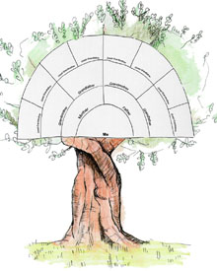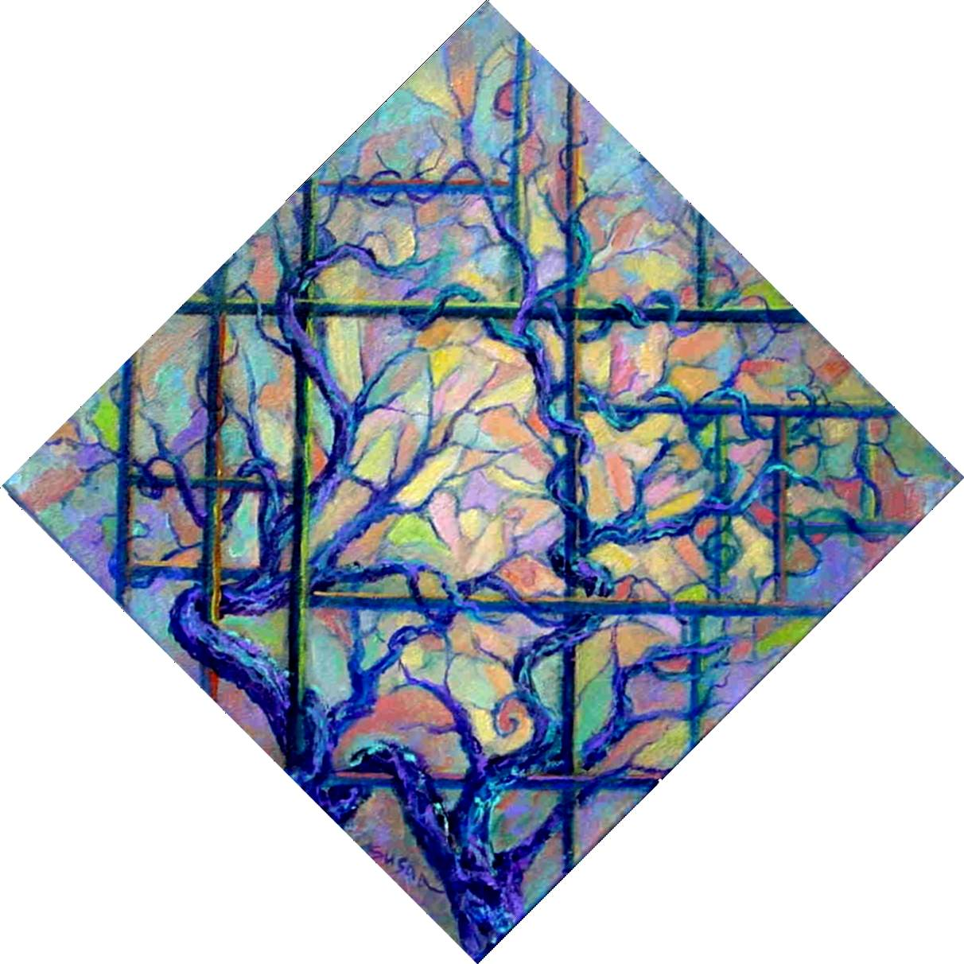

Shield/Coat of Arms

(Consider making a miniature variation, which could be made into a neckerchief slide….)

Supplies: Pattern paper; heavy cardboard; tacks; foil; glue; colored paper; wire/string.

Directions:
- First, make a paper pattern for the shield by folding a piece of paper in half lengthwise, then drawing half a shield, as shown. Cut out and open. Draw lines on the pattern to divide it into four sections; or, draw a band diagonally across the shield.
- Using the pattern, cut the shield from corrugated cardboard. From foil, cut another shield, about an inch larger on all sides. Glue it to the cardboard form, folding the excess foil around to the back, and gluing it in place.
- Place the pattern on the shield and trace the dividing lines or sash. Remove the pattern and insert tacks along the lines.
- Make designs from the colored paper (perhaps scout-related, perhaps symbolic of the boy’s heritage) and glue or tack them in place.
Attach wire or string to back for hanging.

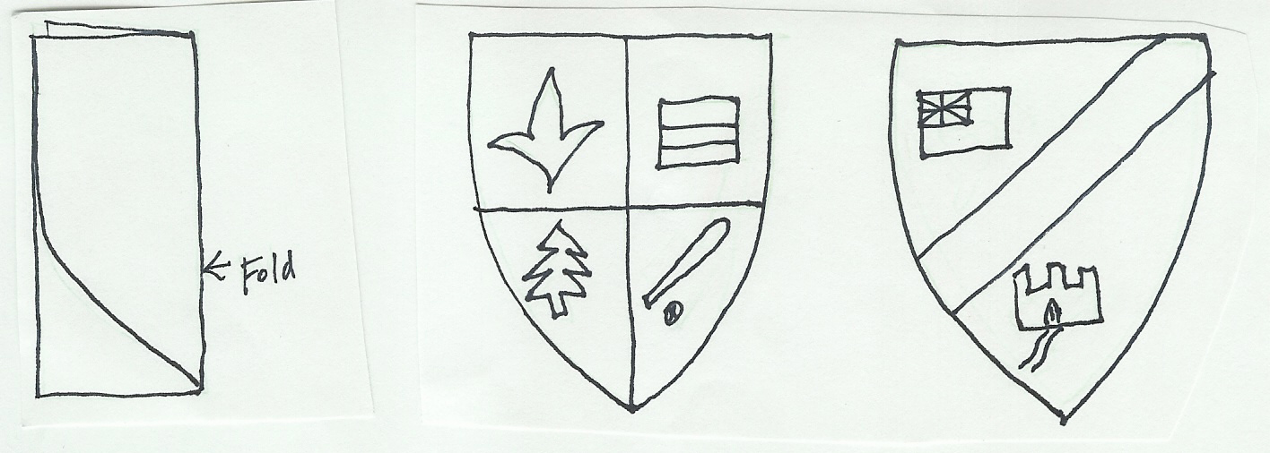

Japanese Fish Kite

Although it is popularly called a kite, this is more like a windsock. In Japan, a carp-shaped kite is flown at the Children’s Day Festival (formerly, Boys’ Day) on May 5. It is hoped that the boys will take on the worthy characteristics of the fish—overcoming difficulties while swimming upstream. These kites are made of cloth or paper.

Supplies: Lightweight paper or tissue paper; yarn or string; crayons, paint or markers; dowels or tomato stakes; scissors; glue; hole punch.

Directions:
Fold the paper in half lengthwise. Decide if the fold line is to be the top or the bottom of the fish. Draw a fish shape. Cut it out.
Open the fish and fold back about 1 inch at the mouth. Glue it down.
Decorate the fish, as you like.
Glue the sides of the fish together, leaving mouth and tail open.
Make a hole on each side of the reinforced area of the mouth. Attach yarn or string.
Gently squeeze the mouth to round it.
Attach the fish to a dowel or tomato stake.

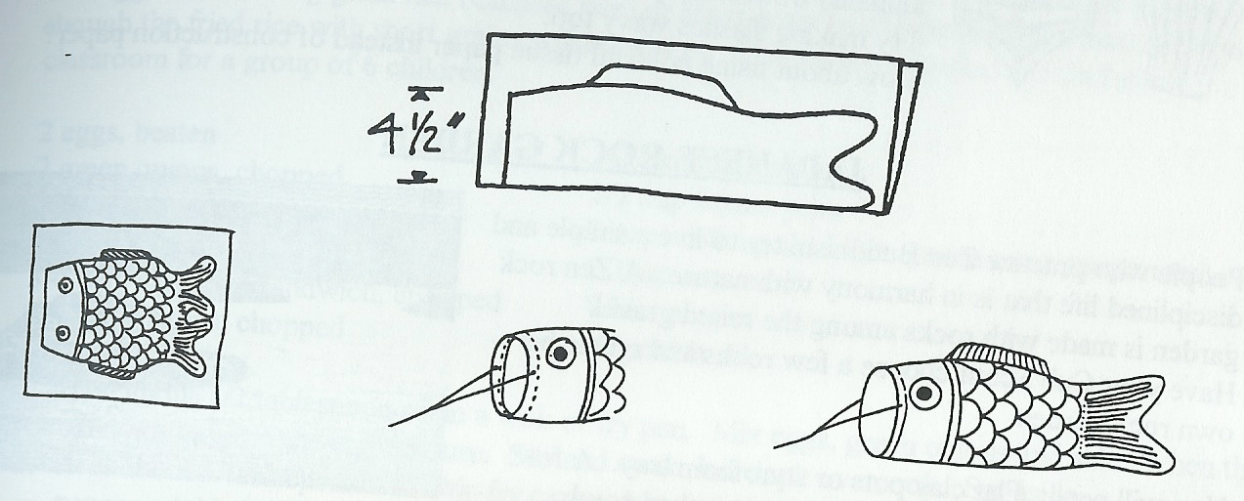
Funny Faces

You can create some very funny faces with this game. You can even turn these faces into funny characters that you can name and use in a skit.

Equipment: Pictures of faces from magazines, scissors, paper, glue or tape, markers or crayons, 5 small bowls
µ §
Each player cuts out from magazines or draws on separate pieces of paper the following:
Pair of eyes
Pair of ears
Nose
Mouth
Hair

Put all the eyes facedown in one bowl, all the ears in another, and so on, so that there is a different bowl for each part of the face. Each player takes a blank piece of paper and draws the shape of a face on it. Then each player chooses one piece of paper from each of the bowls. Glue or tape the parts of the face onto the face you have drawn and see what kind of funny face is created. Give your funny face a name, and introduce your funny face to the rest of the group.

Name Writing

This is a good warm-up game because you use different parts of your body in funny ways.

Get the boys to stand in a circle. Then all write their names in the air, as big as they can, with their right hands. Next, all write their names in the air with their left hands. Next, all write their names in the air with their right feet. Continue with other body parts, including the left foot, right elbow, left elbow, right knee, left knee, head, nose, right ear, left ear, right shoulder, left shoulder, stomach, right hip, left hip, and buttocks.

Blind Reunion

Players try to reunite with team members without crashing into others.

Equipment: 1 box or paper bag per player large enough to fit over the head

Players divide into teams of three, four, or five depending on how many players there are; there must be at least three teams.
Each team devises a small cadence by stomping with their feet, which will be their recognition signal. Each team’s cadence should be different. Then each player gets a box.
Everyone scatters around the room. At the signal, players place their box loosely over their heads so that they cannot see.
Players tap the cadence of their team to be recognized by their teammates. When two or more players of a team reunite, they can stomp together until the whole team is reassembled.
If two players from different teams bump boxes, they must touch one of the walls of the room before they can continue to search for their teammates.
The first team to come together in the noisy room is the winner. However, the game continues until all of the teams have reunited.

Fifty
µ §
This is an easy children’s game that is played with a pair of dice. The goal is to be the first player to reach 50 points, by rolling doubles. Each player rolls one die before the game, and the player with the highest roll goes first. That player then rolls both dice. The player scores only if doubles (identical numbers on both dice) are thrown. All doubles except 3s and 6s score 5 points. Double 6s are worth 25 points. Double 3s are unlucky, as they wipe out the player’s entire score, and he must restart from 0. Keep track of players’ score on a score pad. Play continues with each player taking one roll per turn. The first player to score 50 or more points is the winner.

Chicago

Here is another easy dice game. The object of the game is to roll the 11 possible combinations of the two dice in sequence (2, 3, 4, 5, 6, 7, 8, 9, 10, 11, 12). The first player throws the dice with the goal of getting two 1s. If successful, he is awarded 2 points. After each player has had one chance to roll for the 2, the round ends – and then everyone tries to roll for the 3, then the 4, and so on. Each time a player rolls the appropriate combination, he is awarded that number of points. Any combination that adds up to the desired total counts for that roll; for the round of 7, a roll of (6 and 1), (4 and 3), or (5 and 2) are all good. At the end of the game, everyone adds up his points. The player with the highest total is the winner.

Dakpanay

This is a tag game from the Philippines. Make three small circles on the ground (use hula hoops?), each with room for one or two players to stand in. Also make one large “rest circle.” One player is the Chaser, the rest are circle players. The Chaser must stay outside all circles; the others run from one circle to another. As soon as the Chaser tags a circle player (while outside a circle), that circle player becomes the new Chaser.

Calling the Chickens

This is a tag game from China. One player is blindfolded and plays the part of the owner of a flock of chickens. The blindfolded player calls to the others, “Come home, my little chickens, come home.” Then all the other players must run forward, and each one must touch the blindfolded player without being tagged. The first chicken to be tagged becomes the next owner.

Multiples

This is a tag game from Taiwan. This is a game for older children. Players sit in a circle and agree on a figure between 1 and 10. They then start counting aloud around the circle, starting with 1. If the agreed figure is 7, each time the number being called includes seven or a multiple of 7, the player keeps quiet and clasps his hands together. Every time anyone makes a mistake, a point is counted against him. When the boys become good at this game, add one or two other numbers, so they will have to stay alert to not get caught with numbers four, six and eight going at once. For one number, the player clasps hands. For the second number, he will put both hands above his head. For the third number, he can nod his head. Most players will find thinking of two numbers at once difficult enough.



The Little Holes

This is a tag game from Mexico. (Similar to horseshoes.) Two small holes (hoyitos) about the side of a dollar and one or two inches deep are dug fifteen to twenty feet apart on a level stretch of ground. Stones are used as counters. Two players, or two pairs of players, take part. Standing by one of the holes, each of the two players, alternately, pitches four counters at the opposite hole, one stone at a time. Every counter entering the hold counts five points; those lying closer to the hole than the opponent’s count one point each. The players then reverse the throwing of the pieces, from the second hole to the first. The game is played for a total of 21 points. When partners play, each pair of opposing players remains by the same hole, instead of going from one to the other, but they change places at the beginning of a new game. (Note: make sure the players can tell their counters apart.)

Peanut Butter and Jelly Shake

Try this healthy alternative to soda pop.

Supplies: Small microwave-proof bowl, small blender, tall drinking glass or cup, straw

Ingredients:
1 Tbsp. peanut butter
1 cup skim or low-fat milk
1 cup nonfat or low-fat strawberry frozen yogurt
1 Tbsp. strawberry jam

Directions:
Put the peanut butter in the small bowl and microwave it until it has softened (a few seconds).
Place milk, frozen yogurt, and strawberry jam in a blender.
Run the blender until the mixture is well mixed and frothy.
Pour into a tall glass and swirl in the peanut butter using the straw. Serves 1.

Peanut Butter Noodles

Ingredients:
½ cup unsweetened peanut butter
¼ cup read wine vinegar
¼ cup soy sauce
4 cups cooked pasta, such as spaghetti or spirals
½ cup water
2 Tbsp. sugar
2 cloves garlic, peeled
2 cups frozen green vegetables, such as chopped broccoli or peas, thawed

Directions:
Put the peanut butter, red vinegar, soy sauce, water, and sugar in the mixing bowl. Stir well with the large spoon until all the lumps in the peanut butter are broken up.
Place the peeled garlic cloves into the plastic bag. Push the air out of the bag and seal it.
Use a rolling pin to smash the garlic until it is well smashed. Use a small spoon to add the smashed garlic to the mixing bowl. Stir well with a large spoon.
Pour the peanut butter mixture into the skillet. Cook over medium heat for 1 minute, stirring constantly with a wooden spoon.
Add the thawed frozen green vegetable and the cooked pasta to the skillet. Cook, stirring constantly for 3 to 5 minutes more.
Remove skillet from heat, and serve the awesome Peanut Butter Noodles. Serves four.

Edible Thanksgiving Turkeys

Ingredients:
1 Bag candy corn (beak and eyes)
1 Bag caramel candy squares (body)
1 Bag Dove chocolate (base/feet)
1 Bag striped chocolate cookies (tail and feathers)
Thanksgiving cup cake liners

Unwrap a piece of Dove chocolate to use as the base of the turkey. Place on a microwavable plate. Unwrap a piece of caramel and stick on top of the Dove chocolate bar for the turkey's body. Take a piece of candy corn and push down on top of the caramel (pointed end out). This makes the turkey's beak. Take another piece of caramel and push down on top of the first caramel. This is the head of the turkey. Break off the little white ends of 2 candy corns and push in the top caramel for the eyes. Take one striped chocolate cookie and apply to the back of the body to form the feathers.
Put the turkey in the microwave for a few seconds to about 8 seconds just so that the candy and cookie can fuse together. (Watch this! Not too much time, or it will melt.) Place in freezer for a few minutes to help the turkey "set up" quicker. Serve in a Thanksgiving cup cake paper.

Chicken Nachos

Ingredients:
22 tortilla chips
1/2 cup cooked shredded boneless chicken breast
1/4 cup chopped green onions
1/4 cup Nacho Dip (mild or spicy)
Chilies (optional)

MICROWAVE DIRECTIONS: Spread tortilla chips on flat microwave-safe plate. Sprinkle chicken and onions over chips. Place nacho dip in small microwave-safe bowl. Microwave on HIGH (100%power) 30 seconds; pour over chips, chicken and onions. Microwave on HIGH 30 seconds more or until nacho dip starts to bubble. Serve hot. Garnish with chilies, if desired.

CONVENTIONAL DIRECTIONS: Preheat oven to 325 degrees. Spread tortilla chips on baking sheet. Sprinkle chicken and onions over chips. Heat nacho dip in small saucepan over medium heat until warm; pour over chips, chicken and onions. Bake about 5 minutes or until nacho dip starts to bubble. Serve hot. Garnish with chilies, if desired.

The Scouting Mystery

Clue #4

1. Something your mother might have said to you when you were younger:

“What’s (((((__((
18 19 20 21 22 23 24 25
in there?”

2. Contraction for the words “are not.”

((((((
45 46 47 48 49 50

