December 2007 Theme -- “Celebrations Around the World”

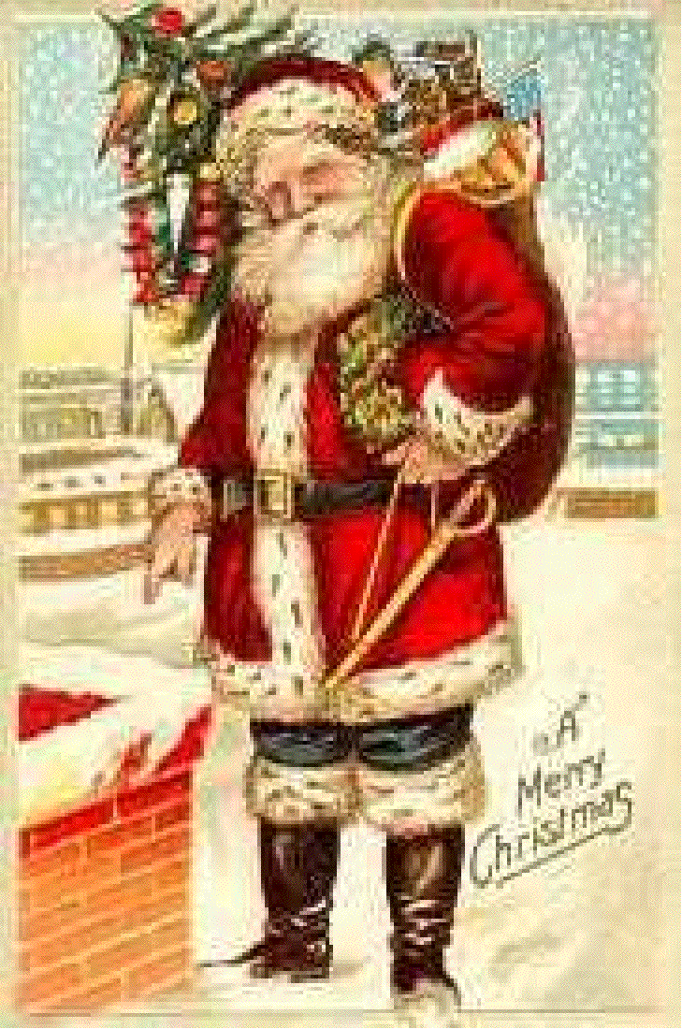
December is marked by days of celebration and observance for many cultures and faiths around the world. Christmas, Chanukah, Ramadan, Rohatsu and Kwanzaa all occur this month. Find out how the celebrations in another country are similar and different than those in the USA. Compare your own family's customs and traditions with others in your community. Invite an adult from another nation to come to your pack meeting to tell how their family celebrates. Why not start a new tradition of service in your pack as a way to honor the holidays this month? Work on the Heritages belt loop and pin.

Webelos Activity Badges for December 2007: Craftsman and Scientist

Starting in November 2007 you will find the latest edition of Baloo’s Bugle at http://www.usscouts.org/bbugle/bb0711/index.html. The following resources are supplements to your monthly Program Helps.

Chanukah
On the 25th of Kislev are the days of Chanukah, which are eight... these were appointed a Festival with Hallel [prayers of praise] and thanksgiving. -Shabbat 21b, Babylonian Talmud
Chanukah, the Jewish festival of rededication, also known as the festival of lights, is an eight day festival beginning on the 25th day of the Jewish month of Kislev.
Chanukah is probably one of the best known Jewish holidays, not because of any great religious significance, but because of its proximity to Christmas. Many non-Jews (and even many assimilated Jews!) think of this holiday as the Jewish Christmas, adopting many of the Christmas customs, such as elaborate gift-giving and decoration. It is bitterly ironic that this holiday, which has its roots in a revolution against assimilation and the suppression of Jewish religion, has become the most assimilated, secular holiday on our calendar.

The Story
The story of Chanukah begins in the reign of Alexander the Great. Alexander conquered Syria, Egypt and Palestine, but allowed the lands under his control to continue observing their own religions and retain a certain degree of autonomy. Under this relatively benevolent rule, many Jews assimilated much of Hellenistic culture, adopting the language, the customs and the dress of the Greeks, in much the same way that Jews in America today blend into the secular American society.
More than a century later, a successor of Alexander, Antiochus IV was in control of the region. He began to oppress the Jews severely, placing a Hellenistic priest in the Temple, massacring Jews, prohibiting the practice of the Jewish religion, and desecrating the Temple by requiring the sacrifice of pigs (a non-kosher animal) on the altar. Two groups opposed Antiochus: a basically nationalistic group led by Mattathias the Hasmonean and his son Judah Maccabee, and a religious traditionalist group known as the Chasidim, the forerunners of the Pharisees (no direct connection to the modern movement known as Chasidism). They joined forces in a revolt against both the assimilation of the Hellenistic Jews and oppression by the Selucid Greek government. The revolution succeeded and the Temple was rededicated.
According to tradition as recorded in the Talmud, at the time of the rededication, there was very little oil left that had not been defiled by the Greeks. Oil was needed for the menorah (candelabrum) in the Temple, which was supposed to burn throughout the night every night. There was only enough oil to burn for one day, yet miraculously, it burned for eight days, the time needed to prepare a fresh supply of oil for the menorah. An eight day festival was declared to commemorate this miracle. Note that the holiday commemorates the miracle of the oil, not the military victory: Jews do not glorify war.

Traditions
Our rabbis taught the rule of Chanukah: ... on the first day one [candle] is lit and thereafter they are progressively increased ... [because] we increase in sanctity but do not reduce. -Shabbat 21b, Babylonian Talmud.
Chanukah is not a very important religious holiday. The holiday's religious significance is far less than that of Rosh Hashanah, Yom Kippur, Sukkot, Passover, and Shavu'ot. It is roughly equivalent to Purim in significance, and you won't find many non-Jews who have even heard of Purim! Chanukah is not mentioned in Jewish scripture; the story is related in the book of Maccabbees, which Jews do not accept as scripture.
The only religious observance related to the holiday is the lighting of candles. The candles are arranged in a candelabrum called a menorah (or sometimes called a chanukkiah) that holds nine candles: one for each night, plus a shammus (servant) at a different height. On the first night, one candle is placed at the far right. The shammus candle is lit and three berakhot (blessings) are recited: l'hadlik neir (a general prayer over candles), she-asah nisim (a prayer thanking G-d for performing miracles for our ancestors at this time), and she-hekhianu (a general prayer thanking G-d for allowing us to reach this time of year). See Chanukah Candle Lighting Blessings for the full text of these blessings. After reciting the blessings, the first candle is then lit using the shammus candle, and the shammus candle is placed in its holder. The candles are allowed to burn out on their own after a minimum of 1/2 hour.
Each night, another candle is added from right to left (like the Hebrew language). Candles are lit from left to right (because you pay honor to the newer thing first). On the eighth night, all nine candles (the 8 Chanukah candles and the shammus) are lit. See animation at right for the candle lighting procedure. On nights after the first, only the first two blessings are recited; the third blessing, she-hekhianu is only recited on the first night of holidays.
Why the shammus candle? The Chanukah candles are for pleasure only; we are not allowed to use them for any productive purpose. We keep an extra one around (the shammus), so that if we need to do something useful with a candle, we don't accidentally use the Chanukah candles. The shammus candle is at a different height so that it is easily identified as the shammus.
It is traditional to eat fried foods on Chanukah because of the significance of oil to the holiday. Among Ashkenazic Jews, this usually includes latkes (pronounced "lot-kuhs" or "lot-keys" depending on where your grandmother comes from. Pronounced "potato pancakes" if you are a goy.) My recipe is included later in this page.
Gift-giving is not a traditional part of the holiday, but has been added in places where Jews have a lot of contact with Christians, as a way of dealing with our children's jealousy of their Christian friends. It is extremely unusual for Jews to give Chanukah gifts to anyone other than their own young children. The only traditional gift of the holiday is "gelt," small amounts of money.
Another tradition of the holiday is playing dreidel, a gambling game played with a square top. Most people play for matchsticks, pennies, M&Ms or chocolate coins. The traditional explanation of this game is that during the time of Antiochus' oppression, those who wanted to study Torah (an illegal activity) would conceal their activity by playing gambling games with a top (a common and legal activity) whenever an official or inspector was within sight.
A dreidel is marked with four Hebrew letters: Nun, Gimmel, Heh and Shin. These letters stand for the Hebrew phrase "Nes Gadol Hayah Sham", a great miracle happened there, referring to the miracle of the oil.
The letters also stand for the Yiddish words nit (nothing), gantz (all), halb (half) and shtell (put), which are the rules of the game! There are some variations in the way people play the game, but the way I learned it, everyone puts in one coin. A person spins the dreidel. If it lands n Nun, nothing happens; on Gimmel (or, as we called it as kids, "gimme!"), you get the whole pot; on Heh, you get half of the pot; and on Shin, you put one in. When the pot is empty, everybody puts one in. Keep playing until one person has everything. Then redivide it, because nobody likes a poor winner.

KWANZAA
Kwanzaa is a unique African American celebration with focus on the traditional African values of family, community responsibility, commerce, and self-improvement. Kwanzaa is neither political nor religious and despite some misconceptions, is not a substitute for Christmas. It is simply a time of reaffirming African-American people, their ancestors and culture. Kwanzaa, which means "first fruits of the harvest" in the African language Kiswahili, has gained tremendous acceptance. Since its founding in 1966 by Dr. Maulana Karenga, Kwanzaa has come to be observed by more than18 million people worldwide, as reported by the New York Times. When establishing Kwanzaa in 1966, Dr. Karenga included an additional "a" to the end of the spelling to reflect the difference between the African American celebration (kwanzaa) and the Motherland spelling (kwanza).
Kwanzaa is based on the Nguzo Saba (seven guiding principles), one for each day of the observance, and is celebrated from December 26th to January 1st.
- Umoja (oo-MO-jah) Unity stresses the importance of togetherness for the family and the community, which is reflected in the African saying, "I am We," or "I am because We are."
- Kujichagulia (koo-gee-cha-goo-LEE-yah) Self-Determination requires that we define our common interests and make decisions that are in the best interest of our family and community.
- Ujima (oo-GEE-mah) Collective Work and Responsibility reminds us of our obligation to the past, present and future, and that we have a role to play in the community, society, and world.
- Ujamaa (oo-JAH-mah) Cooperative economics emphasizes our collective economic strength and encourages us to meet common needs through mutual support.
- Nia (NEE-yah) Purpose encourages us to look within ourselves and to set personal goals that are beneficial to the community.
- Kuumba (koo-OOM-bah) Creativity makes use of our creative energies to build and maintain a strong and vibrant community.
- Imani (ee-MAH-nee) Faith focuses on honoring the best of our traditions, draws upon the best in ourselves, and helps us strive for a higher level of life for humankind, by affirming our self-worth and confidence in our ability to succeed and triumph in righteous struggle.

CELEBRATING KWANZAA
As it is always better to get an early start, I suggest that you begin the first week in December by making a check list for the following items: A Kinara (candle holder); Mkeka (placemat preferably made of straw); Mazao (crops, i.e., fruits and vegetables); Vibunzi/Muhindi (ears of corn to reflect the number of children in the household); Kikombe cha umoja (communal unity cup); Mishumaa saba (seven candles, one black, three red, and three green); and Zawadi (gifts that are enriching).
It is important that the Kinara not be confused with the menorah.* The Kinara holds seven candles to reflect the seven principles which are the foundation of Kwanzaa. If you don't have a Kinara and don't know where to get one, it is suggested that you use "kuumba" (creativity) and make one. A 2x4 or a piece of driftwood will do just fine, and screw-in candle holders can be purchased in most hardware stores. The Mkeka (place mat) shouldn't present a problem. While straw is suggested because it is traditional, cloth makes an adequate substitute. If cloth is used, one with an African print is preferred. The other symbols are easy to come by and warrant no further discussion other than to caution against placing the Mazao (crops)in a cornucopia which is Western. A plain straw basket or a bowl will do just fine. One last note, even households without any children should place an ear of corn on the place mat to symbolize the African concept of social parenthood. All seven symbols are creatively placed on top of the place mat, i.e., the symbols should be attractively arranged as they form the Kwanzaa centerpiece.

DECORATING THE HOME
The Kinara along with the other symbols of Kwanzaa should dominate the room, which should be given an African motif. This is easily achieved and shouldn't result in too much expense. The colors of Kwanzaa are black, red and green. This should be kept in mind when decorating the home. Black, red and green streamers, balloons, cloth, flowers, and African prints can be hung tastefully around the room. Original art and sculpture may be displayed as well.

GIFTS
Kuumba (creativity) is greatly encouraged. Not only is Kuumba one of the seven principles, it also brings a sense of personal satisfaction and puts one squarely into the spirit of Kwanzaa. Therefore, those symbols that can be made, should be made. The giving of gifts during Kwanzaa should be affordable and of an educational or artistic nature. Gifts are usually exchanged between parents and children and traditionally given on January 1st, the last day of Kwanzaa. However, gift giving during Kwanzaa may occur at any time.

THE KWANZAA FEAST OR KARAMU
The Kwanzaa Karumu is traditionally held on December 31st (participants celebrating New Year's Eve, should plan their Karamu early in the evening). It is a very special event as it is the one Kwanzaa event that brings us closer to our African roots. The Karamu is a communal and cooperative effort. Ceremonies and cultural expressions are highly encouraged. It is important to decorate the place where the Karamu will be held, (e.g., home, community center, church) in an African motif that utilizes black, red, and green color scheme. A large Kwanzaa setting should dominate the room where the karamu will take place. A large Mkeka should be placed in the center of the floor where the food should be placed creatively and made accessible to all for self-service. Prior to and during the feast, an informative and entertaining program should be presented. Traditionally, the program involved welcoming, remembering, reassessment, recommitment and rejoicing, concluded by a farewell statement and a call for greater unity.

Rohatsu
The Buddha was enlightened on the eighth of December when he looked up at the morning star, the planet we call Venus. The brightness of this planet was seen by Buddha from the depths of one week of samadhi. The Buddha received that brightness with the same eyes of zazen that enable us also to realize perfect enlightenment.
One week straight of this deepest possible samadhi was burst through by the brilliance of that morning star. A whole week's experience of that world of complete spiritual death, the great death, that state of mind of the world beyond death. Into that world burst the brightness of the morning star, plunging into the Buddha's eyes and giving rebirth to the Buddha's consciousness.
He cried: “That's it! That's it! That's me! That's me that's shining so brilliantly!”
How deeply he was moved and what wonder he felt. From this comes all of the Buddha's Dharma. From within this state of mind the Buddha said:
How wondrous, how wondrous! All beings are endowed with this pure nature! What a wondrous, astonishing thing has been realized! All the ten thousand things, all the flowers, all the trees, all the rocks, all things everywhere are shining brilliantly! What an amazing thing! It's the same landscape, but how brilliantly it is illuminated! What freshness in everything!
From within this deep illumination of the mind of Buddha all of the Buddha's wisdom was born. All of Zen is held within the deep impression of the Buddha's mind at that moment.

Ramadan
Ramadan is the ninth month of the Islamic calendar. Islam uses a lunar calendar-that is, each month begins with the sighting of the new moon. Because the lunar calendar is about 11 days shorter than the solar calendar used elsewhere, Islamic holidays “move” each year. In 2006 Ramadan began on Sept. 24.
For more than a billion Muslims around the world-including some 8 million in North America-Ramadan is a “month of blessing” marked by prayer, fasting, and charity.
Muslims believe that during the month of Ramadan, Allah revealed the first verses of the Qur'an, the holy book of Islam. Around 610 A.D., a caravan trader named Muhammad took to wandering the desert near Mecca (in today's Saudi Arabia) while thinking about his faith. One night a voice called to him from the night sky. It was the angel Gabriel, who told Muhammad he had been chosen to receive the word of Allah. In the days that followed, Muhammad found himself speaking the verses that would be transcribed as the Qur'an.
At many mosques during Ramadan, about one thirtieth of the Qur'an is recited each night in prayers known as tarawih. In this way, by the end of the month the complete scripture will have been recited.
Muslims practice sawm, or fasting, for the entire month of Ramadan. This means that they may eat or drink nothing, including water, while the sun shines. Fasting is one of the Five Pillars (duties) of Islam. As with other Islamic duties, all able Muslims take part in sawm from about age twelve.
During Ramadan in the Muslim world, most restaurants are closed during the daylight hours. Families get up early for suhoor, a meal eaten before the sun rises. After the sun sets, the fast is broken with a meal known as iftar. Iftar usually begins with dates and sweet drinks that provide a quick energy boost.
Fasting serves many purposes. While they are hungry and thirsty, Muslims are reminded of the suffering of the poor. Fasting is also an opportunity to practice self-control and to cleanse the body and mind. And in this most sacred month, fasting helps Muslims feel the peace that comes from spiritual devotion as well as kinship with fellow believers.
Ramadan ends with the festival of Eid al-Fitr, which in 2006 occurred on Oct. 23. Literally the “Festival of Breaking the Fast,” Eid al-Fitr is one of the two most important Islamic celebrations (the other occurs after the Hajj, or pilgrimage to Mecca). At Eid al-Fitr people dress in their finest clothes, adorn their homes with lights and decorations, give treats to children, and enjoy visits with friends and family.
A sense of generosity and gratitude colors these festivities. Although charity and good deeds are always important in Islam, they have special significance at the end of Ramadan. As the month draws to a close, Muslims are obligated to share their blessings by feeding the poor and making contributions to mosques.

Christmas
The word Christmas comes from the words Cristes maesse, or "Christ's Mass." Christmas is the celebration of the birth of Jesus for members of the Christian religion.
About 2000 years ago God sent an angel to Israel, to a virgin named Mary. She was engaged to Joseph, a carpenter. The angel told Mary that by God's power, she would conceive and bear a son.
When Joseph learned that she was pregnant, an angel instructed him to marry her. Joseph took her to Bethlehem to register for a census. While there, Mary gave birth to Jesus. She laid him in a manger because there was no room at the inn. Shepherds visited Jesus in Bethlehem.
Later, wise men brought gifts to Jesus. They told Herod the Great, a wicked king, that Jesus would rule Israel. So Herod sent soldiers to kill the children in Bethlehem. Warned by an angel, Joseph took his family to Egypt. After Herod died, they returned to Israel and raised Jesus in a town called Nazareth.
Christmas is both a holiday and a holy day. In America it is one of the biggest event of the year (especially for kids), and for members of the Christian religions it is an important day on the religious calendar.
No one really knows if December 25th is the actual day of Jesus birth. What is known is that Christian leaders in 336AD. set the date to December 25 in an attempt to eclipse a popular pagan holiday in Rome, Saturnalia, celebrated Natalis Solis Invincti, or "Birthday of the Invincible Sun God," on the winter solstice. One mid-fourth century church theologian later wrote "We hold this day holy, not like the pagans because of the birth of the sun, but because of him who made it".
Originally, the celebration of Christmas involved a simple mass, but over time Christmas has replaced a number of other holidays in many other countries, and a large number of traditions have been absorbed into the celebration in the process (as we will see in later sections).
The tradition of gifts seems to have started with the gifts that the wise men (the Magi) brought to Jesus. As recounted in the Bible's book of Matthew, "On coming to the house they saw the child with his mother Mary, and they bowed down and worshipped him. Then they opened their treasures and presented him with gifts of gold and of incense and of myrrh."
When you think of Christmas, one of the first things you probably think of is a Christmas tree. In fact, the Christmas tree is one of the most recognizable images of the season. Almost everywhere you go, it is the focal point of people's holiday decoration. You pile your gifts under the tree. You gather around your tree to sing Christmas carols and drink eggnog. This is a German tradition, started as early as 700 A.D. In the 1800s the tradition of the Christmas tree was widespread in Germany, then moved to England and then to America through Pennsylvanian German immigrants.

Christmas Around the World

Belgium
On the sixth of December Sinterklaas or Saint-Nicholas is celebrated, which is an entirely different holiday from Christmas. Santa Claus in Belgium is called de Kerstman or le Père Noël and he does come around on Christmas day to bring children presents. There are different cultures in Belgium, the Northern part being Vlaanderen (speaking a Dutch dialect), the Southern part being Wallonie (speaking a French dialect) and the Eastern part speaking German.
Small family presents are given at Christmas too, under the tree, or in stockings near the fire-place, to be found in the morning. Christmas breakfast is a special sweet bread called 'cougnou' or 'cougnolle' - the shape is supposed to be like baby Jesus. Some families will have another big meal on Christmas day.

Brazil
Father Christmas is called Papai Noel. Many Christmas customs are similar to USA or UK. For those who have enough money, a special Christmas meal will be chicken, turkey, ham, rice, salad, pork, fresh and dried fruits, often with beer. Poorer people will just have chicken and rice.

Finland
Finnish people believe that Father Christmas (Santa Claus) lives in the north part of Finland called Korvatunturi, north of the Arctic Circle. People from all over the world send letters to Santa Claus in Finland. (It is only fair to say that the people of Greenland say that really, Father Christmas lives in Greenland!) There is a even big tourist theme park called 'Christmas Land' in the north of Finland, near to where they say that Father Christmas lives.
Everyone cleans their houses ready for the three holy days of Christmas - Christmas Eve, Christmas Day, and Boxing Day. Christmas Eve is very special, when people eat rice porridge and plum fruit juice in the morning. They will then decorate a spruce tree in the home. At mid-day, the 'peace of Christmas' is broadcast on radio and TV from the Finnish city of Turku by its Mayor. In the evening, a traditional Christmas dinner is eaten. The meal will include 'casseroles' containing macaroni, rutabaga, carrot and potato, with cooked ham or turkey. Many families will visit cemeteries and grave-yards to place a candle onto the burial graves of family members. Cemeteries are very beautiful at Christmas-time.
Children receive their presents on Christmas Eve, usually with a family member dressing as Father Christmas. As children grow older, they come to realise that 'Father Christmas' is really a bigger brother, sister or family member.

France
In France, Christmas is always called 'Noël. Everyone has a Christmas tree, sometimes decorated in the old way with red ribbons and real white wax candles. Fir trees in the garden are often decorated too, with lights on all night.
Father Christmas is called Père Noël. The Christmas meal is an important family gathering with good meat and the best wine. Not everyone sends Christmas cards.

Germany
Germans love to decorate their houses at Christmas. Many houses will have little wooden frames holding electric candles in their windows, and colored pictures of paper or plastic which look beautiful from the outside at night. Often too, they will have an 'Adventskranz' - a wreath of leaves with four candles. (Advent - meaning 'coming' - is the 4 week period before Christmas). On each Sunday of Advent, another candle is lit. Most homes will also have little wooden 'cribs' - a small model of the stable where Jesus was born, with Mary, Joseph, Baby Jesus, and animals.
Father Christmas - 'Der Weihnachtsmann' - brings presents in the late afternoon of Christmas Eve (December 24th), after people have been to a church meeting. The presents are then found under the Christmas tree. One person in the family will ring a bell and call everyone to come to the room. On Christmas Day, fish (carp) or goose will be cooked.

Hungary
Santa Clause (Winter-grandfather) (Tel-apo or Mikulas) comes on the 6th of December. Children should clean and put their shoes outside next to the door or window before they go to sleep. Next day candies and/or small toys appear in them in red bags. For children, who don't behave well, a golden birch placed next to the sweets, a symbol for spanking... (but don't worry, it is just for fun, and not for actual punishment.)
On 24th of December, children go to their relative or to the movies, because little Jesus brings the tree and the presents that evening to their house. It is customary to hang edible things on the tree, like golden wrapped assorted chocolates and meringues beside the glass balls, candles (real or electrical), and sparklers.
Families usually cook festive dinner for that night. An example would be fresh fish usually with rice or potatoes and home made pastries as dessert. After dinner, the tree would be viewed by the children for the first time. It was very exciting. Christmas songs are sung and then the gifts under the tree are shared.
Older children attend the midnight mass with their parents. (During communism, children had to hide at the back of the church. Teachers could have lost their jobs for attending the mass. Later (in mid 1970's) most of the Communist Party leaders of the town attended it too.) Next day the children attack the edible part of the tree. Festive food is enjoyed on the second and third day too.
People from Transylvania serve stuffed cabbage on Christmas Eve, and next day for lunch. Most likely the reason for that custom is that stuffed cabbage is the best on the second and third day after it was cooked. Moms can prepare the food a day earlier, leaving more time for decorating and organizing. Very practical.
On the 25th of December, the whole family attended church and ate stuffed cabbage for lunch.

Latvia
Latvians believe that Father Christmas brings presents on each of the 12 days of Christmas starting on Christmas Eve. Usually the presents are put under the family Christmas tree. (What a good idea to spread Christmas out longer!) It was in Latvia that the first Christmas tree was decorated.
The special Latvian Christmas Day meal is cooked brown peas with bacon (pork) sauce, small pies, cabbage and sausage.

New Zealand
Lou from DownUnder writes: Christmas starts for us with gifts under the tree, to be opened Christmas morning. Then its onto a Christmas lunch either at home or at one's parents place. Turkey or chicken with all the trimmings is eaten, then come tea time, it is a Bar-B-Q for friends and family to get together,and have a few beers or wines with the meal!!

Portugal
People pretend that Father Christmas brings presents to children on Christmas Eve. The presents are left under the Christmas tree or in shoes by the fireplace. A special Christmas meal of salted dry cod-fish with boiled potatoes is eaten at midnight on Christmas Eve.

Russia
In the days of the Soviet Union, Christmas was not celebrated very much. New Year was the important time - when 'Father Frost' brought presents to children. With the fall of Communism, Christmas can be openly celebrated - either on December 25th; or more often on January 7th. This unusual date is because the Russian Orthodox church uses the old 'Julian' calendar for religious celebration days. Special Christmas food includes cakes, pies and 'meat dumplings'.

Sweden
The most important day is Christmas Eve. A special Christmas meal is eaten on Christmas Eve - ham (pork), herring fish, and brown beans - and this is the time when families give presents to each other. Many people attend a church meeting early on Christmas Day.

United States
The USA is so multi-cultural that you will find many different ways of celebrating Christmas. A person writes about Christmas meals, "Our family (Eastern European origin) favor turkey with trimmings. My grandparents and their relatives preferred keilbasi (Polish sausage), cabbage dishes, and soups. My husband's Italian family insisted on lasagna!"
Another wrote: All year long children are told to behave, or they will get coal in their stocking. On Christmas Eve, they hang highly stylized stockings on the mantle of the fireplace, then go to bed early so that they will find presents in the morning. They are told that at midnight Santa will come, bringing a huge bag of toys. He will come down through the chimney, leave candy in the stockings and presents under the Christmas tree (anything from a Pine or Fir to a Spruce), then plug one nostril and shoot up through the chimney. Cookies are traditionally left for him, and a carrot is commonly left for Rudolph the Red-nosed reindeer, very much a part of Christmas tradition (Santa will land on the roof with his sleigh and nine reindeer). On Christmas morning, things such as cinnamon rolls or coffee cake are served for breakfast, and for dinner there is typically ham (and occasionally regal plum pudding). That is it for celebration — Boxing Day is never celebrated, Epiphany is only celebrated by Catholics, and Advent not commonly celebrated.
Another American wrote in with the following: Advent is celebrated in almost all Roman Catholic and mainline Protestant churches. I was RC until I was 15, as were my grandparents, and we always followed the four weeks of preparation before Christmas in our church services. I found the same to be true in my father's Evangelical Lutheran Church in America, my friend's United Methodist Church, my in-law's Presbyterian USA congregations, and for myself as a member and pastor of the United Church of Christ for the last 16 years. We also recognize Epiphany in mainline Protestant churches. On the first Sunday following January 6, our service tells again the story of the Magi who came to Jesus presenting their gifts following his birth. As a child, I fondly remember leaving carrots and sugar for all of the reindeer, along the milk and cookies for Santa!

Celebrations around the World – JAPAN

New Year’s Day
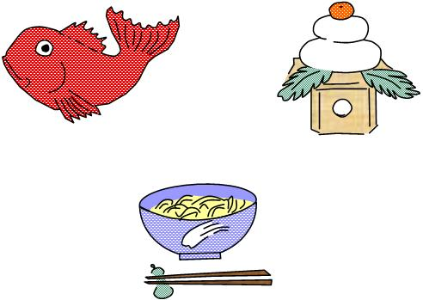
Schools and businesses close for 5 days around New Year’s Day. People spend those days cleaning the house and preparing food for a big feast on January 1st. Many of the dishes have auspicious symbolism. Rice and beans represent prosperity and health. Anything long like noodles and celery are symbolic of long life. In Japan, the color red is considered lucky so red snapper, lobster, and shrimp are popular main dishes for the New Year table.
On December 31st, New Year’s Eve, everyone eats noodles. It’s called “toshi-koshi soba”, or “noodles to bring in the New Year.” The superstition is that if you must eat your noodles by the last strike of midnight, to ensure you’ll have a long life.
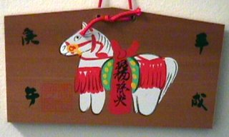
The next morning, New Year’s Day, each person in the family uses a fresh new pair of chopsticks to eat the dishes that were prepared beforehand. Similar to the holidays in the US, relatives travel from far and wide to see each other. Children receive money envelopes from uncles, aunts, and grandparents. Sometime during the day, the family goes to visit a shrine to pray for a Happy New Year. They write prayers or wishes on special wooden tiles “ema” which they leave at the shrine in hopes that the prayers and wishes will come true. Children pray for anything from good health to good grades on tests.
The area around the shrine is like a festival with many booths containing food, games, and toys. A popular booth for kids is the one where they can purchase costume masks of their favorite characters from anime like Dragonball Z, Pokemon, and others. Boys also gather around the shooting gallery where they use cork rifles to knock down small prizes of toys and candy.

Japanese Celebration Words
Happy New Year Akemashite omedeto gozaimasu
Festival matsuri
Good morning Ohayo (gozaimasu)
Good afternoon Konnichi wa
Good evening Konban wa
Thank you Domo arigato (gozaimasu)
You’re welcome Doitashimashite
Good bye Sayonara
See ya Ja ne
Wow! (Cool!) Sugoi!
Father otosan
Mother okasan
Let’s go! Ikimasho
Come here.(welcome) Irasshai(mase)
(Say before you start eating. The literal meaning is, “I humbly receive.”) Itadakimasu
(Say when you’ve finished eating. The literal meaning is, “It was a feast.”) Gochisosama
Please pass the __, or May I have ____, please? ________ kudasai
Chopsticks ohashi
Water omizu
Tea ocha
Rice gohan
Soy sauce shoyu

NUMBERS

1 ichi
2 ni
3 san
4 yon
5 go
6 roku
7 nana
8 hachi
9 kyu
10 ju

SONGS

The Frog Song - Kaeru no Uta
(Canon)

Japanese: Melody:

Ka-eru no uta ga (Do, re, mi, fa, mi, re, do)
Kiko-e-te kuru yo (Re, mi, fa, sol, fa, mi, re)
Gwa, gwa, gwa, gwa (Do, do, do, do)
Gero, gero, gero, gwa, gwa, gwa (Do, do, re, re, mi, mi, fa, fa, mi, re, do

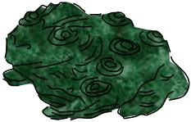
English version:
Can you hear the frog’s song
Echoing across the pond?
Gwa, gwa, gwa, gwa
Gero, gero, gero, gwa, gwa, gwa

The Tulip Song – Churippu

Japanese: Melody:

Saita, saita (Do, re, mi-. Do, re, mi-)
Churippu no hana ga (Sol, mi, re, do, re, mi, re-)
Naranda, naranda (Do, re, mi-. Do, re, mi-)
Aka, shiro, kiiro (Sol, mi, re, do, re, mi, do-)
Dono hana mite mo (Sol, sol, mi, sol, la, la, sol-)
Kire-i da na (Mi, mi, re, re, do-)

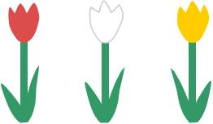
English version:

Blooming, blooming
Tulips are blooming
All lined up, in a row
Red, white, and yellow
Every tulip I can see
Is beautiful to me.

SKIT

Ramen booth
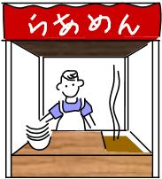
Cast: vendor, customer

Vendor: Ramen! Get your hot ramen noodles here!
Customer: I’ll have a bowl of ramen noodles, please.
Vendor: Here you go. That’ll be two dollars.
Customer: Thank you. Here’s a ten dollar bill.
Vendor: Okay, so that’s two, three, four
Customer: Do you have the time?
Vendor: Yes, it’s two.
Customer: Thanks
Vendor: Where was I? Oh, yes, two, three, four
Customer: Wait a minute. What time did you say it was?
Vendor: Um (looks at his watch). It’s TWO! Now where was I? Oh, yes, three, four,
Customer: You said it was two, right?
Vendor: YES!!!! Um, three, four… hey! This is too much change! Hey, you’re trying to trick me! Get out of here, you!

Japanese Proverbs

Sen-ri no michi mo ippo kara.
Even a thousand-mile journey begins with the first step.
Or, You have to start somewhere.

Toranu tanuki no kawa-zan’yo.
Don’t estimate the value of a raccoon skin before catching the raccoon.
Or, Don’t count your chickens before they hatch.

Chinkyaku mo choza ni sugireba itowaru.
Fish and visitors stink in three days.
Or, Even a welcome guest becomes tiresome by overstaying.

Zen wa isoge.
Do quickly what is good.
Or, Strike while the iron is hot.

Tanki wa sonki.
A short temper is a disadvantage.
Or, Be slow to anger, quick to befriend.

Nana-korobi, ya-oki.
Fall down seven times, get up eight.
Or, If at first you don’t succeed, try, try again.

CRAFTS

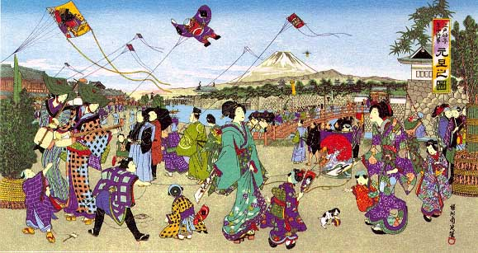

Origami

Ninja star (Shuriken)

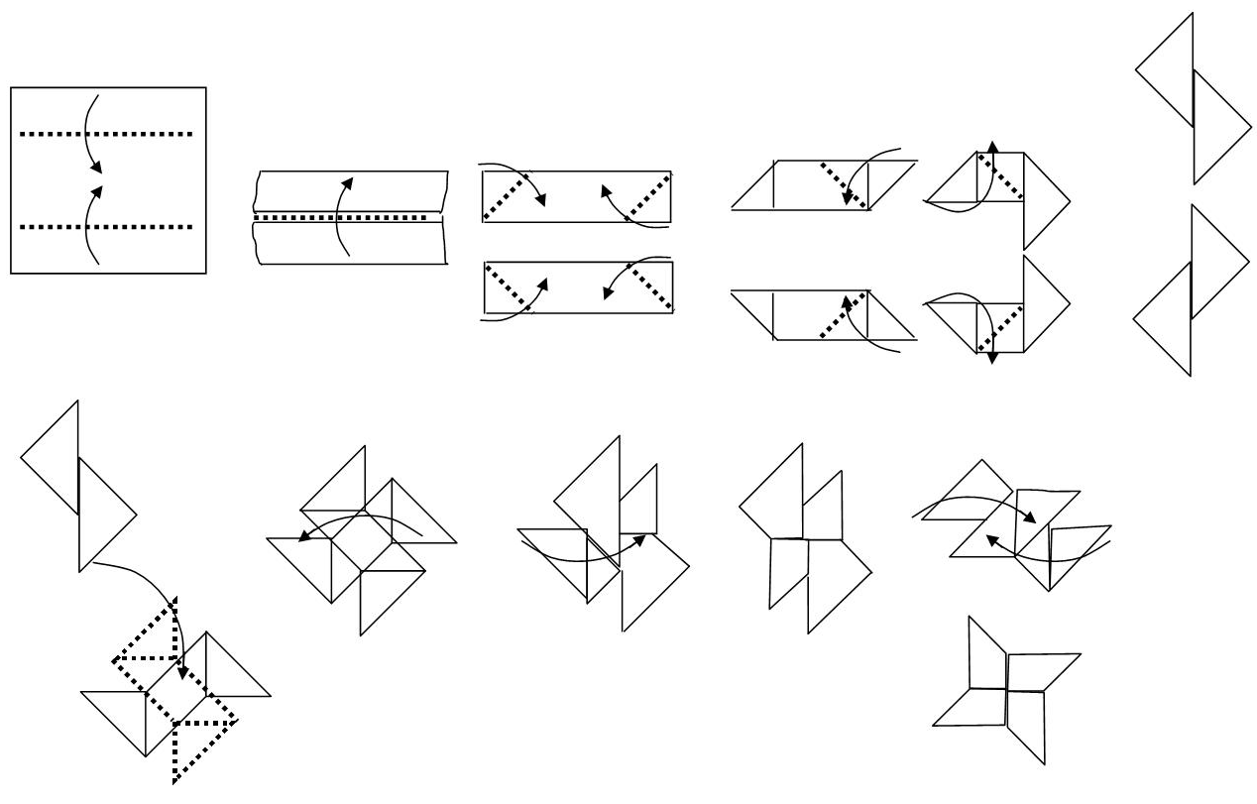

Jumping frog
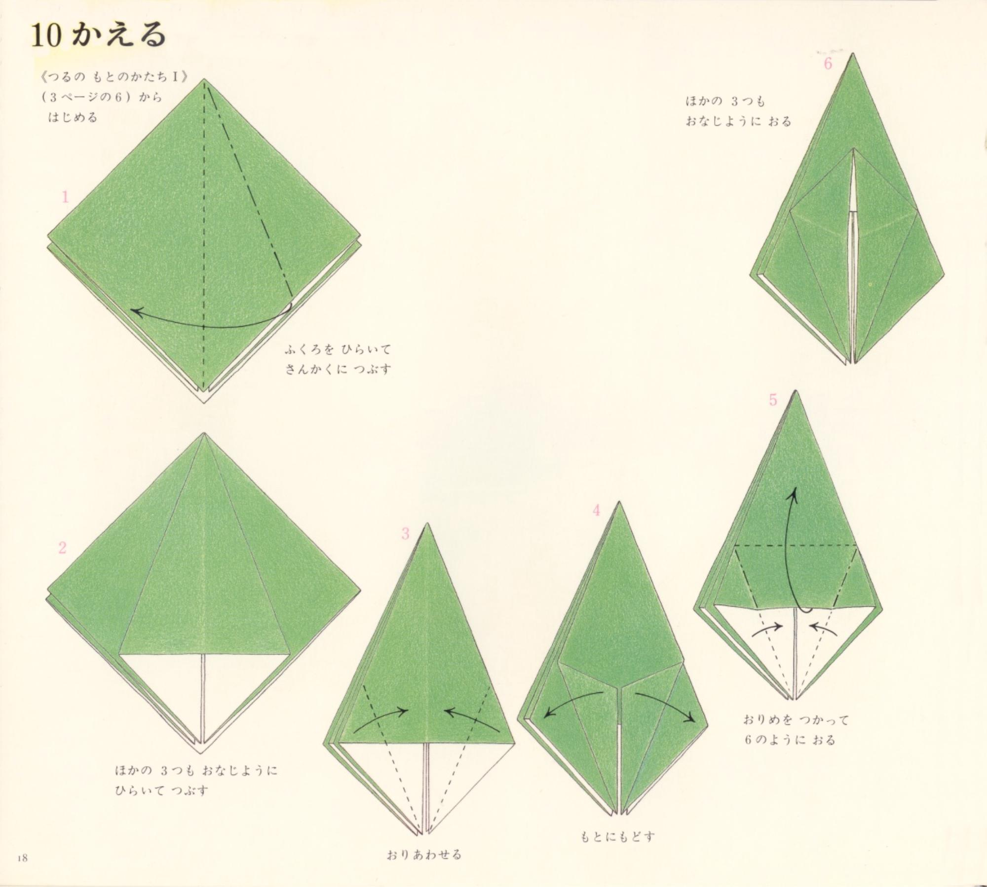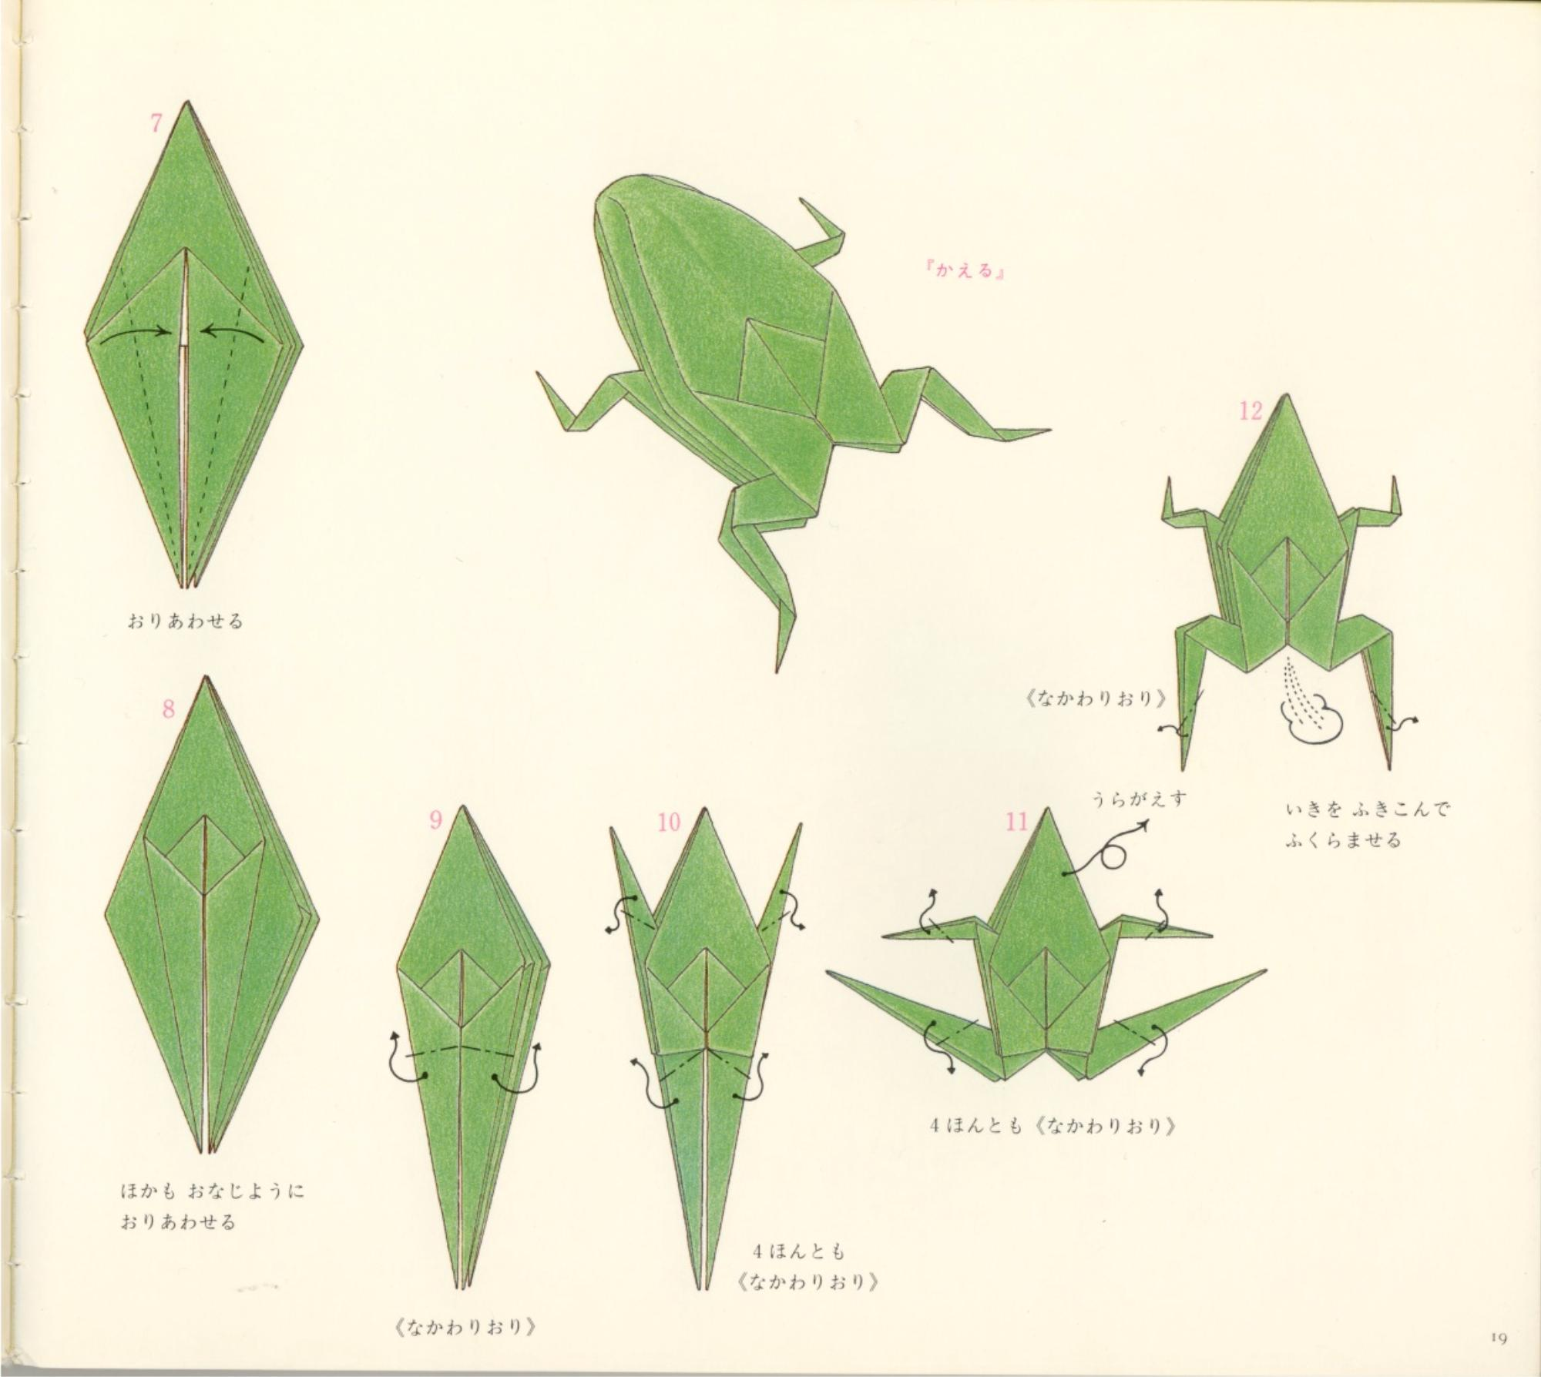

Menko
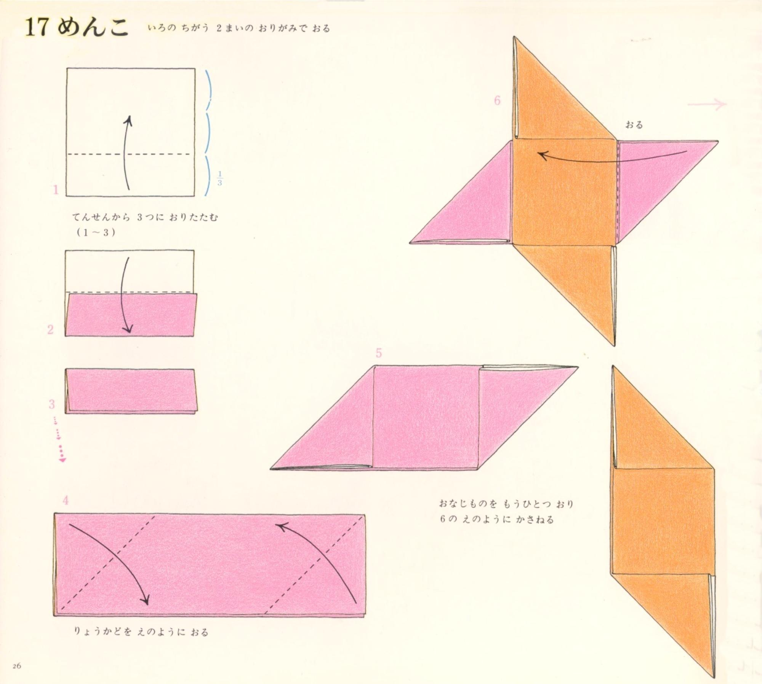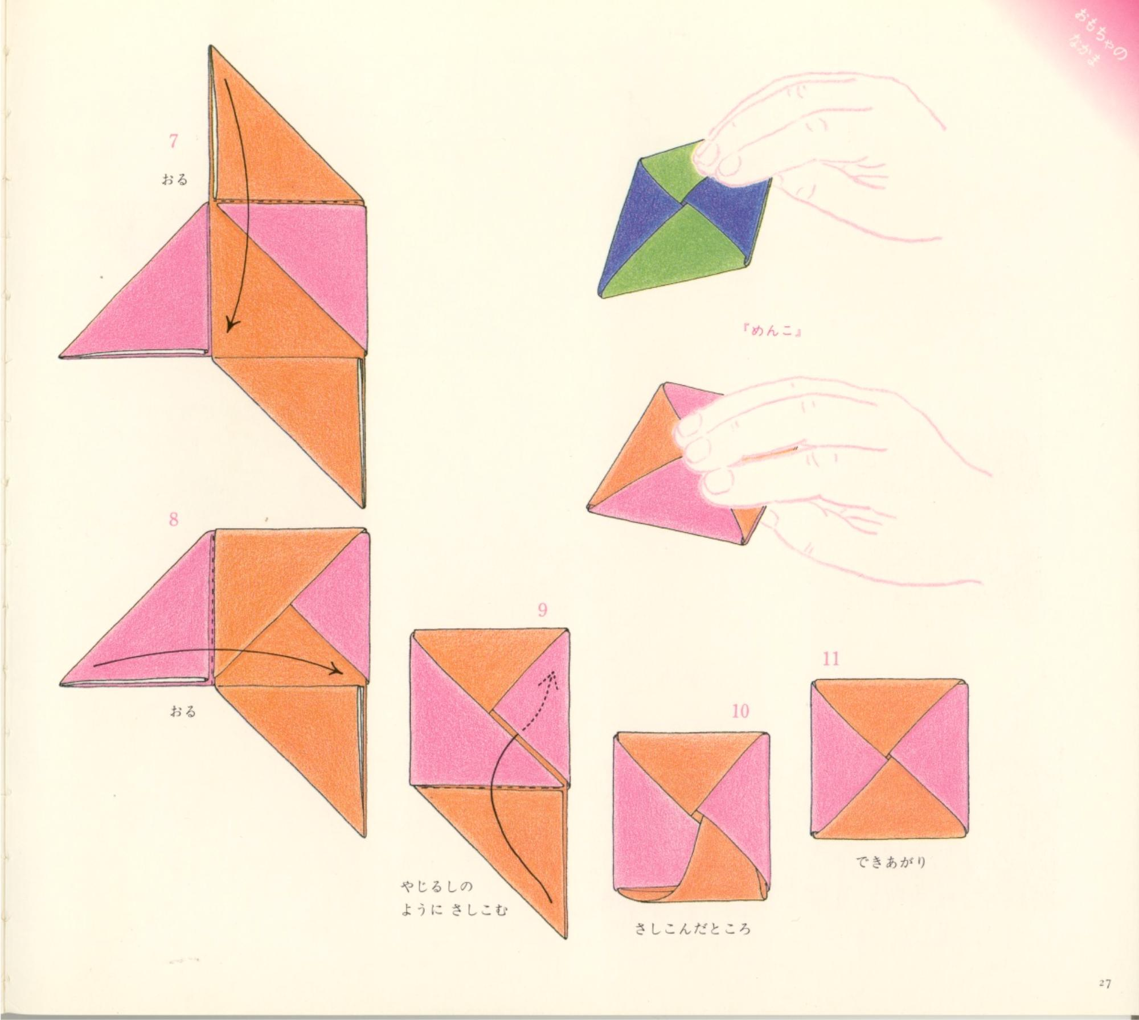

Daruma
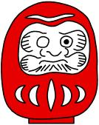
Daruma, or Dharma, was a Buddhist monk who meditated for __ years until reaching enlightenment. The thought is that his meditative power was so strong he couldn’t be pushed over if the attempt were made. The daruma doll has come to represent hard work and perseverance. To make your own daruma doll, follow the directions below.

One balloon
Play sand
paper mache materials:
strips of newspaper
liquid starch
paint – red, white, black

Insert sand into the balloon before inflating to give weight to the finished daruma doll and help it remain erect; inflate balloon and tie off opening. Cover balloon with strips of newspaper soaked with liquid starch (removing excess starch from each strip before applying). Let dry. Paint the entire form red; let dry. Glue a copy of daruma’s face onto the red paper mache form, or paint the face directly onto it making sure to leave one eye blank. Make a wish or resolution for the New Year and when the wish comes true or the resolution is kept, paint in the other eye.

TOYS

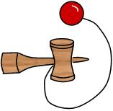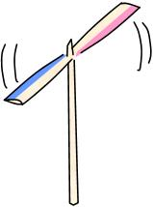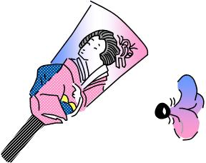

Kendama Taketombo Hagoita (Badminton)

GAMES

Kemari
A game similar to hackey sack, but played with a ball. The object is to keep the ball in the air and pass among all the players without letting the ball touch the ground.

Calico tops
Stretch a piece of cloth (calico) over a bucket and bind in place with string or rope. Two or more players release their tops onto the cloth and try to knock the opponents’ tops off the cloth.

Karuta
A card game in which each card bears the second half of a famous poem. The caller reads out the first half of a poem and players race to locate and snatch the card being described. A popular variation for children is to lay out cards bearing scenes from a favorite anime. The caller reads descriptions of those cards and the other children seek out and lay their hand down on the matching card. The caller confirms that it is the correct card and allows the player to take it. The person with the most cards at the end of the game is the winner.
To make you own karuta, cut a cereal box into 2” squares. Cut out squares from the Sunday comics and glue to the cereal box squares. Let dry. Appoint a caller to describe cards one at a time allowing for players to locate and grab each card.

Menko
Players take turns throwing large heavy round cards (like huge POGs) down on top of opponents’ cards attempting to flip them over. Any flipped cards go to the player who threw the card (menko).
To make you own menko, cut up cereal boxes into 3” circles. Glue 3 circles together to make the menko heavier; let dry. Repeat until you have 5 heavy menkos. Now play against your friends. (Or, fold menkos out of origami paper.)

Rock, paper, scissors (Jan-ken)
Jan-ken in its simplest form is used like a coin toss. Players face each other and say, “Jan, ken, pon!” holding out their hand in the shape of a rock (fist), paper (flat, palm up), or scissors (holding out the index and middle fingers like the Cub Scout sign.) Rock beats scissors, scissors beats paper, and paper beats rock. If the two players hold out matching shapes, they both call out, “Aiko desho!” while holding out a new shape and repeat as long as they continue to tie each other.
Jan-ken is also used to choose teams. People pair up and play a round of Jan-ken against each other. The winners form one team and their partners form the other team.
There are many variations of this game, but here’s one for two players. It begins with a round of the basic Jan-ken, but the winner of the round (without missing a beat) says, “Atchi mite hoi!” pointing up, down, left, or right. The opponent tries his hardest to look in any direction but the direction that the other player is pointing. If he looks in the same direction, he loses on the spot. If he successfully avoids following the pointing finger, another round of Jan-ken commences, again without missing a beat, and this continues until someone loses. The focus can be on how long they can keep the “volley” going as opposed to how fast someone loses.

Japanese: English version:
“Jan, ken, pon!” 1, 2, 3!
“Aiko desho!” Tie goes again!
“Atchi mite hoi!” Look this way!

MUSIC

Taiko (Drum)
With each Cub using two dowels (bachi) and the bottom of a bucket, they can play a simple taiko drum piece in unison.
Bachi (Japanese drum sticks) are hard wood dowels about 16" by 3/4" to 1", depending on the size of the hands. Birch is good from your local hardware store like Home Depot or OSH. You’ll need medium sandpaper to round the ends. Buckets, garbage cans, cardboard buckets and packing tape are great for a makeshift drum. This is a great project for Cubs!
For a complete lesson, check out http://sers.lmi.net/taikousa/lesson.html

DANCE

Fool’s dance (Awa odori)

Check out these websites:

http://ww.nminato.net/awaodori/awaodori.html
http://ww.youtube.com/watch?v=u0kDxPOUDKE

Moon Dance (Tankobushi)

http://ww.youtube.com/watch?v=WH-QoMAz5Rg

FOOD

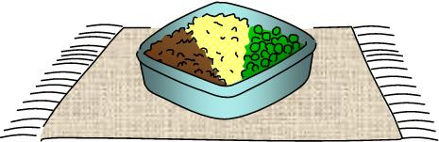
Three color lunch box
(Sanshoku bento)

Ground chicken
Scrambled eggs
Peas (green beans, or spinach)
Rice
Soy sauce
Sugar
Salt
5 Disposable re-sealable plastic tubs (2 cup volume)

Rice:
- 2 cups short-grain rice
- 2 ¼ cups of water
Put rice and water in a saucepan; cover. Bring to a boil. Turn down to low and simmer for 15 minutes or until “crab holes” form in the surface of the rice. Remove from heat and let steam for 15 minutes more.

Ground chicken:
- 1 ½ pounds Ground chicken
- ¼ cup Soy sauce
- ¼ cup Sugar
Lightly oil a frying pan. Add chicken to pan. As chicken begins to brown, add soy sauce and sugar. Cook until done and crumbly.

Scrambled eggs:
- 5 eggs, scrambled
- Salt, to taste
Lightly oil a frying pan. Add salt to eggs. Cook eggs until done. Set aside.

Peas:
- 1 ½ cup Peas
- Salt, to taste
Bring water to a boil in a pan. Cook peas with a little salt. Drain; set aside.
Arrange in plastic tub in this manner. Line bottom of tub with 1/5 of cooked rice. Cover 1/3 of the rice with chicken, 1/3 with egg, and 1/3 with peas. Serve hot or pack for lunch.
Serves: five (Four is a superstitious number, so everything comes in fives.)

Den Activities and the Pack Meeting Resources

PRAYERS & POEMS FOR SCOUTERS

Christmas is for Children
Christmas is for children, at least that's what they say,
It's time of wide-eyed wonder, a magic holiday
When candy canes and gingerbread fill tummies with delight
And little sleepyheads try hard to stay up through the night.
Yes, Christmas is for children, anyone will tell you so.
The twinkling, colored lights on trees, make youngsters' eyes just glow!
Each package and each stocking, is approached with childish joy
And toys bring squeals of laughter , from each eager girl and boy.
Yes, Christmas is for children, all they say is true.
How wonderful that at Christmas time, grownups are children, too!
-- Unknown

PRE-OPENING ACTIVITY

How Many?
Fill a clear container filled with red, green and white jellybeans, holiday M&Ms, counting as you fill. Everyone makes a guess on a slip a paper (be sure they include their first and last name) as to how many treats are in the jar. The winner gets the container & candy.

Gingerbread Person Photo Shoot
Get a refrigerator or wardrobe box. Decorate the front with a gingerbread man. Cut a hole in the front of box so cubs can show their faces while having their picture taken.

Santa’s Bag
Number ten brown paper bags from one to ten. Put a familiar Christmas - related article in each bag and staple shut. Each boy is given a pencil and paper on which he lists numbers one through ten. He tries to guess what is in each bag by feeling through the paper, and records on his paper his guess. Boy with greatest number of correct answers is winner.

OPENING CEREMONIES

Opening Ceremony 1
Props: Box wrapped with holiday paper and tied with a bow. In the box are a menorah, small Christmas tree, invitation, (Kwanzaa candelabra if appropriate), Instant Recognition patch and beads, small wrapped gift, small felt stocking, and card saying "Do Your Best."
Cubmaster: (Opens box and looks inside.) December is one of the most exciting months of the year, and certainly one of the busiest. This month we have: Christmas (Takes out tree.); Hanukkah (Removes menorah.); Kwanzaa (Removes candle holder.), and Holiday parties (Takes out invitation.). What a great time for all of us! Our pack has had lots of fun this month working on advancements (Takes patch and beads from box.), but one of the best things was our special service project/Good Turn (Takes stocking from box.) We've been busy, and all the time we have followed the Cub Scout Motto: (takes paper out of box and shows it while saying motto) "Do Your Best". Now den ___ will present the colors.

Opening Ceremony 2
Setting-. Cub Scouts come on stage one at a time, carrying appropriate props, and line up facing the audience. A narrator reads the poem.
(Boy 1 enters, carrying a wreath with sign on it saying "Season's Greetings".)
Narrator: Season's greetings to everyone, We're glad you joined us for the fun; 'Tis certainly the happy time of the year, with everyone bursting with Holiday Cheer.
(Boy 2 enters, carrying a globe with some Christmas tinsel wrapped around the base.)
Narrator: Each country has its special ways of celebrating the Holidays. Let's see what other people do to celebrate their customs, too.
(Boy 3 enters carrying a candle.)
Narrator: On Christmas Eve in Ireland, candles shine so bright, as children place them in windows, to shine into the night.
(Boy 4 enters carrying a piñata.)
Narrator: In Mexico the children gather goodies from the floor after they break the Piñata filled with prizes by the score.

Starry Night
(Dim or turn off room lights except for an electric candle or flashlight)
This is the season of lights and stars, when days are short and nights are long with beautiful stars.
Lord Baden-Powell, the founder of Scouting, once said this to his scouts, "I often think when the sun goes down, the world is hidden by a big blanket from the light of heaven. But the stars are little holes pierced in that blanket by those who have done good deeds in this world. The stars are not all the same size; some are big, and some are little. So some men have done great deeds, and some men have done small deeds, but they have all made their hole in the blanket by doing good before they went to heaven."
Let's remember when we look at the starry sky, to make our own hole in the blanket, by doing good deeds and helping other people.

Opening Ceremony
Preparation: Find the following items and attach the words for that item on them somewhere.
Candle, wreath, candy cane, red tree ornament, and star tree topper.
Put all items in a basket to have boys pulI out during ceremony. You could predetermine who is going to pull out what from the basket, reminding them that the star is last if you use the alternative ending. This is a ceremony that you can be creative with, you can add other items as necessary for the number of boys in your den.
Candle: This is the candle Mary and Joseph used to find their way in the dark.
Wreath: This wreath symbolizes the eternal nature of man; it has no beginning and no end.
Candy cane: This candy cane reminds me of the shepherd's crook used at the time of the birth of Christ.
Red tree ornament: This ornament is used to symbolize the blood Jesus shed for us.
Star tree topper: This star is a symbol of the “new star” seen when Jesus was born.
Alternative ending: This star is a symbol of the “‘new star” seen when Jesus was born; it is also a part of our American flag, let’s stand and pledge allegiance to that flag.

DEN DOODLE

What do you want to do at Holiday time?
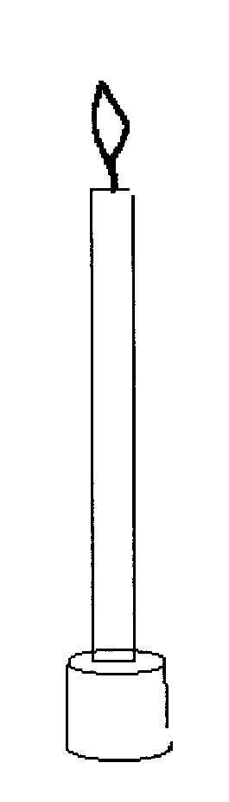

Put a thin dowel or birthday candle in a pony bead. The pony bead becomes the candle stand.

CEREMONIES FOR UNIT LEADERS

Recognition Ceremony For Trained Leaders
Materials: large pine bough, bucket of dirt, mylar patches, attendance cards (#3767) or tri-fold progress cards, straight pins.
Objective: to demonstrate an inspirational "Advancement Ceremony"
Akela: Old Wolves, you were charged with teaching these Cubs in the ways you have been taught. Has this been done?
Old Wolves: Aye, old lone one, it has been done.
Akela: Baloo, do they know the ways of the Pack?
Baloo: Aye, Akela
Akela: Bagheera, have you taught them the ways of our Program?
Bagheera: Yes, Akela, it has been done.
Akela: Then let the ceremonies begin. (Plant pine bough in front of you) Throughout this weekend, you have become acquainted with the Cub Scout program. Let this pine bough represent that program. The heavy main stem represents the Aims of the Cub Scout Program. The smaller stems are the Ideals. (Point out each, as you explain) Each needle is a part of the Program; the Den Meetings, Pack Meetings, Outings, Advancement, etc. The needles grow in clusters. The clusters need many needles to appear healthy and beautiful. Let us keep in mind as we return to our own Packs, the need to develop all parts of the Program. As I read the names of those to be recognized, would you please come forward. (Read off each name, pin on trained Den Leader patch, give card and have D.L.C. give each a needle cluster from the bough. Have the participants form a "U" in front of you.) When all have received their recognition, go on.
Akela: You have each received two tokens here today. The pine needle cluster is to keep you ever mindful of the many parts that make up a healthy Cub Scout program. The trained Den Leader Insignia is for you to display on your uniform to alert others to your knowledge and dedication to the Cub Scout program. Do you pledge to accept the responsibility of seeing that the Cub Scouts in your own Packs, put in your charge, benefit from the lessons you have learned here this weekend? If so, answer "I will". Then you have achieved the right to join the Old Wolves and take your place as leaders of Cub Scouts. Do this with dignity, dedication, and honor. Do not let the Tabaqui and Shere Khan distract you from your task.
(Participants return to their seats)

PACK/DEN ACTIVITIES

HOLIDAY TIME?
The holidays are a time of laughter and good cheer, for gathering together and making memories that will last forever. These holiday traditions will live from year to year. Some outdoor activities that you and your den can do are:
1. Decorate an outside tree with homemade animal-friendly decorations, such as strings of popcorn, birdseed balls, and pinecone/peanut butter feeders.
2. Take a car or bus ride through neighborhoods gaily decorated with bright shining lights and lawn ornaments.
3. Stroll through the neighborhood singing holiday carols.
4. Take a walk in the woods gathering pinecones and other nature items to use to make holiday decorations and presents. End each activity with a holiday party!

Caroling Party
The whole idea is to spread good cheer and holiday spirit to each of your Scouts' families by having the boys sing carols at each boy's house. At each house have the parent provide a different refreshment. For instance, the first house could provide hot cocoa. The next house could provide cookies. The next house could provide some finger sandwiches, and so on, until all of the boys' homes have been visited.

Pomander
Materials: Firm, fresh oranges or lemons, whole dried cloves, toothpick, nylon net, ribbons or pretty yarn
Directions: Use the toothpick to poke holes in the orange skin inserting a whole clove into each hole. You can randomly place the cloves in the orange, as close together as you can or you can make a neat vertical or horizontal pattern. If you want to add a richer, spicier scent, roll the finished pomander in a mixture of cinnamon, allspice, and nutmeg. Now, set the pomander aside to dry for several weeks. It will shrink and get hard (as the orange gets dehydrated). Wrap it in a square of nylon net and tie the ends with the ribbon. It's ready to hang in a closet or kitchen, or give as a gift.

Popcorn Wreath
Materials: Cardboard base (a pizza box is perfect or a cake round), lots of popped corn, glue, yarn, ribbon, scissors
Directions: Cut the center of the cardboard out to create the wreath base. Punch a hole near the edge and tie a loop of yarn through it to be used for hanging later. Pour glue out on a recycled meat tray. Put the popped corn into a bowl, and one at a time dip in the glue and stick onto the wreath base. Cover the base completely with the popcorn. Decorate with tiny yarn or ribbon bows, glued on here and there.

Gumdrop Tree
Materials: Styrofoam cone, toothpicks, candy gumdrops
Directions: Place gumdrops on table. Stick a toothpick into each gumdrop. Press toothpicks into Styrofoam cone. Cover the cone completely. Tie ornaments are edible.

Stamped Christmas Wrapping Paper
Materials: Pre-cut shaped sponges, or sponges you cut into shapes, tempera paint paper towels, construction paper or white butcher paper, paint tray
Directions: Pour tempera paint over several layers of paper towels on tray to form an inkpad. Dip sponges into paint. Tamp onto paper. When dry, use as gift-wrap.

Potted Christmas Tree
Materials: Tree branch, potting dish, Styrofoam, fabric, scissors
Directions: Find a nicely shaped tree branch on the ground. (Do not cut a live branch). Place it in a pot. Secure it in a piece of Styrofoam or bed of small rocks. Cut a piece of fabric large enough to cover the top of the pot. Cut a hole in the center and slash to the outer edge. Use it as a tree skirt. As the Christmas season progresses, decorate with ornaments you have made.

Christmas Bells
Materials: Paper cups, tin foil, ribbon, jingle bells
Directions: Cover cups with foil. Punch a hole in the bottom of each and string a ribbon through the hole, securing with a knot. Tie a jingle bell (or two) at the other end of the ribbon. Hang from Christmas tree.

Holiday Smells From Far Away
Materials: Stamps, construction paper, medium grade sandpaper, holiday cookie cutter, pencil, scissors, ground cinnamon, glue, markers, envelope
Directions: Fold a. piece of construction paper in half to form a card. Trace cookie cutter onto sandpaper and cut out shape. Sprinkle cinnamon on the sandpaper, and rub in with your finger. Shake off the excess spice. Glue the cookie shapes on the front of the card. Write your holiday message inside the card. Mail to someone special.

Pinecone Ornaments
Materials: Pinecones, red, green, or white spray paint gold or silver paint, string or thread, paint brush
Directions: Put the pinecones on a sheet of newspaper. Spray the cones on one side. Allow them to dry, then spray the other side. When dry, paint the tips in gold or silver and let dry. If cones are "soft', sew a foot-long heavy thread through the bottom of each cone. If they are wooden-like, tie a ribbon through the bottom spurs of each cone. Now, you have ornaments for packages, a wreath, a Christmas tree, or to hang on a door with a big bow.

Christmas Tree Ornaments
Ingredients: 4 cups flour, 1 cup salt, 1 1/2 cups water, paper clips, tempera paints, thread, clear plastic spray
Directions: Mix the flour, salt and water to make flour clay. Rub your hands with flour and knead the mixture for at least five minutes, until thickened. Mold and shape the clay into Christmas wreaths, trees, stars, or whatever you like. For adding details, try using a toothpick to "etch" the clay. Finished pieces should be no thicker than 1/2 inch and no bigger than 3 inches. For a hanging hook, stick one end of a paper clip into the shape. Cover a cookie sheet with foil, and place your clay shapes on it. Bake in an oven at 350 degrees for about 12 to 20 minutes. When done, your clay will be light brown in color. When tapped with a fork, it will make a solid ringing sound. Decorate your clay ornaments with paints. When paint is dry, spray the ornaments with clear plastic coating. Tie a thread through each paper clip and hang them on your tree.

Gift Tags
Materials: Used greeting cards, scissors, thread or thin string, and a hole punch
Directions: Select pictures, designs or greetings that would make attractive gift tags (make sure there is no writing on the back). Cut the tags into different shapes and sizes or make small folders. Punch a hole in the corner of each tag. Cut a 5" piece of string, loop it through the hole and knot.

Make a Snow Gauge
You can measure the amount of snowfall with a homemade gauge made from any container that you can mark off in inches or centimeters. A simple but effective gauge can be made from the bottom half of a clear plastic soda bottle, marked with an indelible laundry marker on the outside. Though less reliable because of the way snow drifts, you can also measure snowfall with a yardstick. Compare your findings with the forecasted amount.
Put several gauges outdoors--near a tree, out in the open, on your front steps--and see if they all measure the same. Are you surprised?

Candy Menorah
Materials: Styrofoam pieces for base, 9 peppermint sticks, 9 candy kisses
Cut a 1" square of foam and glue to center of foam base. Push four peppermint sticks into the foam to one side of the center. Push four peppermint sticks into the other side. Push the central peppermint stick into the center.
On the first day of Hanukkah, "light" the Shamash and the first "candle" on the right. To light the candles, dab some frosting onto the top of the candy stick and attach a candy kiss. Candles are lit from right to left. On the eighth day, the edible parts of the menorah may be eaten in celebration of the holiday.

Milk Jug Luminary
Materials
Sand, empty plastic gallon milk containers, tea lights, scissors, fireplace matches
1. Clean milk gallons and remove all labels.
2. On the side nearest the handle, cut a slit one inch tall and three inches long about one inch up from the bottom.
3. Pour about one inch of sand into the container. Shake to distribute sand evenly.
4. Push tea light into the middle of the sand. Use fireplace matches to light.
Cost for 8= $1.00 or less.

Tips
These are very unusual luminary. They don't blow over or get snuffed out if it's wet and windy. They give a lovely white light. At a cost of 10 cents each, they are a very inexpensive way to decorate the outdoors at Christmas and other times of the year. Care must be taken to place the tea light near the center of the container but not directly under the spout.

Magic Reindeer Food
Santa's reindeer will be hungry when they get to your house. While Santa's inside eating the cookie and milk you left him, the reindeer will be waiting outside. How about leaving them some reindeer food?
Uncooked oatmeal, glitter, ziplock bags, ribbon
In a Ziplock bag, put a little bit of uncooked oats and glitter. Shake to mix.
Place this poem inside the bag and hand out.
On Christmas Eve Night
Before the little ones yawn
Sprinkle "Magic Reindeer Rood"
On your front lawn
The smell of the oats
And the sparkles so bright
Will surely help Rudolph
With his Christmas Eve flight.
If you live in an area where you have lots of animals like pets or wild animals they might get to the reindeer food, before the reindeer and they might eat it. Glitter might hurt real animal stomachs and Santa's reindeer will still enjoy the feast without glitter.

Crafts On Theme Table
Many families have traditions surrounding ornaments and decorations for the holidays. Have the boys in your den or pack share their traditions with each other. Here are some ideas that you can share with them.

Popcorn Chain
Decorate the tree with a chain made by pushing a needle and thread through pieces of popcorn. Easier still thread string or yarn through items with a hole already in it such as Cheerios, Fruit Loops. or Apple Jacks. Noodles of various types can be dyed with food coloring, painted or used as is to make an interesting chain.

Countdown Chain
Boys love counting down the days left to Christmas. A simple count down chain can be made by gluing or taping strips of paper though each other to make a chain. Use a strip of paper for each day needed for the count down. The chain can be attached to a paper that is decorated to represent the holiday.

Egg Cup Santa
Here is a fat, jolly Santa made from egg cartons, cotton, and paint. Cut out four of the eggcup sections below the portion of carton which joins one cup to another so that you have only the round bottom half. Color three of the cups red on the outside with poster paint or crayon and one white. Glue two of the red sections together where they have been cut. Glue the third red section on top of the white one, again joining at the cut part. Twist some cotton into a thick cord and glue this around the seams you have made on the cups for the trim on Santa’s hat bottom jacket trim. Make a tassel for his hat, hair and whiskers out of cotton. With paint or crayon color his eyes, nose, mouth and buttons for his coat. Glue the two halves together.

Orange Slice Ornaments
Materials: Oranges, paring knife, cutting boards, yarn, raffia or ribbon, and pencils.
Give each Cub Scout his own orange and experiment slicing his orange, along with knife safety instructions. When it’s time to deck the tree or shrub, tie each slice to a branch.

Cookie Cutter Bird Treats
Materials: Mixing bowls, measuring cups, measuring spoons, mixers-electric or manual, rolling pin, drinking straws, and ribbon.
1 Cup unsalted butter, softened 3 eggs, beaten, 3 l/2 cups all-purpose flour, sifted 1 teaspoon baking soda, 1 1/2 teaspoons cream of tartar 1/2 teaspoon salt, mixed birdseed
Cream the butter, then beat in the eggs. Sift together the flour, baking soda, cream of tartar, and salt. Gradually add the dry ingredients to the butter and egg mixture. When well mixed, cover and chill. Flour surface of cabinet top and roll out the dough to about a 1/4 in thickness. Cut out shapes with the cookie cutters; at the top of each cookie, make a hole with a drinking straw. Press in a coating of the birdseed. Preheat oven to 350 and bake for about 12 minutes. When cookies are cool, insert a length of ribbon through each and tie.
Since the cookie dough will need to chill, make dough first and chill. Then try the Orange Slice Ornaments while waiting for the dough.

AUDIENCE PARTICIPATION

A Trip Through Santa's Workshop
Narrator: Hi folks. We've had a special invitation from old Santa himself to come up and visit his toyshop at the North Pole. He told me that we must make our trip through the toyshop as quietly as possible, so we won't disturb the elves or the toys. You see, the toys come to life when they see visitors, so if they spot us we may have to pretend we're toys too. The elves get very nervous when they see people. So you just follow me and do exactly as I do and we'll be able to visit without disturbing anyone.
Come on. Let's follow Santa. (Walking in place) on a trip through his toyshop. Since the hour's late, we can't take time to stop (hold finger to lips and hump over, pretending to sneak by). Sh-h-h, the jack-in-the-box is sound asleep, so come on quietly and past him we'll creep.
Look! There's the dancing ballerina (point ahead with finger) standing on one toe. Oh no! She saw us! So round and round we go (hold one hand over head and turn around several times.) Now that the ordeal is over, let's continue on our way (walking in place); we want to see some more but too long we cannot stay.
Look over there to the right, (shade eyes with hand, point to right) back in that corner dark; I think that I can see a very tiny spark (pretend to be quietly sneaking up on something). Oh, it's an elf I see, building a Rudolph toy. Oh, oh, he sees us! Pretend you're not a boy! (Cup hand over nose to simulate Rudolph's large nose while saying "blink, blink, blink").
Whew! That was a close call (wipe brow with hand) but we fooled him I guess. We'd better follow Santa (walk in place) before we get into a mess. Oh, Santa has stopped again (stop walking and hold up hand in halt sign). I wonder what he sees. Uh oh, look out, I think I'm going to sneeze! (Hold finger under nose while saying a-a-a-a-choo!") Oh my goodness, that did it! Come on, we'd better run (start running in place). Let's hurry and get out of here, or it may not be such fun!
Come on and blink your nose (all do as before while running in place) as past the Rudolphs we run, just to make the elf think that we are one. There's the ballerina, dancing on her toe. Let's twirl around once (all twirl while continuing running) so past her we can go. Here's the jack-in-the-box, let's get down low and crouch, (get down low and sneak quietly by. Here's the jack-in-the-box, let's get down and crouch, (get down low and sneak quietly by). Out he comes with a b-o-i-n-g! (All shout "boing" as they spring up high in the air and then sit back down in chairs) Now we're back home on the couch! (Drop in chair with hands hanging down sides; wipe brow.

The House Where Santa Claus Lives
House - hands over head in a inverted V
Shed - hand in front of chest in an inverted V
Sled- hands together is waving motion, left to right.
Reindeer - one hand, palm out, at each side of head as antlers
Pack - both hands over right shoulder as if carrying a load
Little girls - all girls, young and old, stand up
Little boys - all boys, young and old, stand up
Box - show dimensions of the box, length and width, with hands
Doll - both hands under right side of head, as if asleep
Lion - Extend both hands and paws and give a deep growl
Soldier - Give the Cub Scout salute while at attention
Santa Claus- pat stomach with both hands and say “Ho, Ho, Ho”
This is the House where Santa Claus lives. This is the Sled behind the House where Santa Claus lives. This is the Sled that is kept in the Shed behind the House where Santa Claus lives. These are the Reindeer that pull the Sled that is kept in the Shed behind the House were Santa Claus lives. This is old Santa Claus who guides the Reindeer that pull the Sled that is kept in the Shed behind the House where Santa Claus lives.
This is the Pack all filled with toys for good Little Girls and good Little Boys that is carried by old Santa Claus who guides the Reindeer that pull the Sled that is kept in the Shed that is behind the House where Santa Claus lives.
This is the Box that is in the Pack all filled with toys for good Little Girls and good Little Boys that is carried by old Santa Claus who guides the Reindeer that pull the Sled that is kept in the Shed that is behind the House where Santa Claus lives.
This is the Doll that is in the Box that is in the Pack all tilled with toys for good Little Girls and good Little Boys that is carried by old Santa Claus who guides the Reindeer that pull the Sled that is kept in the Shed that is behind the House where Santa Claus lives.
This is the Lion that frightened the Doll that is in the Box that is in the Pack all filled with toys for good Little Girls and good Little Boys that is carried by old Santa Claus who guides the Reindeer that pull the Sled that is kept in the Shed that is behind the House where Santa Claus lives.
This is the Soldier that captured the Lion that frightened the Doll that is in the Box that is in the Pack all filled with toys for good Little Girls and good Little Boys that is carried by old Santa Claus who guides the Reindeer that pull the Sled that is kept in the Shed that is behind the House where Santa Claus wishes you a Merry Christmas!

ADVANCEMENT CEREMONIES

'Twas the Night of the Pack Meeting
'Twas the night of the pack meeting and all through the place,
Not a boy was stirring, anticipation on each face.
It was time for advancements and they all turned an ear,
So when their name was called, they would hear it loud and clear.
The Cubmaster was checking his list, not only once but twice,
To see which boys had worked hard and earned awards this night.
When all of a sudden the Cubmaster as ready with helpers nigh,
To pass out awards as the boys called were filing by.
First came the Bobcats all new to the pack.
Akela is ready, with the guidance and experience they lack,
Come up all you new Cubs
You're our Bobcats tonight.
Your final step as a Bobcat is to do a good deed and you must do it right.
(Call boys and their parents forward and present awards.)
Second are the Wolves, experienced that is true
But there is still much to learn, Akela's not through
Come up all our Wolf Cubs, you are Wolves to be praised,
Achievements and electives you've done
So with Wolf Badge and arrow point, to rank you are raised.
(Call boys and their parents forward and present awards).
Third are the Bears most experienced so far,
Akela's teachings they've heeded, they're way above par.
Come all our Bear Cubs, your work and learning is applauded,
For completing achievement and electives, tonight you're rewarded.
(Call boys and their parents forward and present awards.)
Last are the Webelos, but not least to be sure,
Akela's lessons they've learned, now Boy Scouts is their lure.
Come up all our Webelos, your activities are harder,
Your accomplishments you wear so proudly on your shoulder.
(Call boys and their parents forward and present awards).
Now, let's give all these Cubs our Santa applause for a job well done.

Christmas Tree Advancement Ceremony
All advancement awards are placed in Christmas tree wrappings and hung on the tree. Also in each package is a Christmas tree light bulb with the Cub Scout's first name lettered on with felt-tip pen.
Use pink bulbs for Bobcat; red for Wolf; green for Bear; gold for Arrow points; silver or white for silver arrow points; orange for Webelos activity badges; and a multicolored or special bulb for Arrow of Light.
Boys being given awards are called forward with their parents and pin on their new award and the boys then screw in their bulbs, which remain on the tree for the rest of the meeting. Afterward, let the boys have them to take home.
For boys graduating into a Scout troop, use one of the more formal ceremonies from "Staging Den and Pack Ceremonies".

Advancement Ceremonies
1. Awards could be gift wrapped and given out by Santa or one of his helpers.
2. Awards could be hung on a Christmas tree (either a small one from home or the decorated one where you hold your pack meetings.
3. Santa or helper could pull the awards out of a “toy” pack.
4. In one of the Scandinavian countries, the goodies are found in a wooden shoe-the awards could be put in a wooden shoe.
5. Awards could be attached to a candy piece of coal, reminding boys to be good if they want visit from Santa.

Easy Fun Dough
Mix: 1 1/4 cup Bisquick Original baking mix - 1/4 cup salt, 1 teaspoon cream of tartar
Mix: l-cup water and 1 teaspoon food coloring - Stir the colored water into the dry mixture, a little at a time, until all the liquid is added. Microwave uncovered on high 1 minute. Scrape the mixture from the side of the cup and stir.
Microwave uncovered 2 - 3 minutes longer, stirring every minute, until the mixture forms form of a ball. Let the dough stand uncovered about 3 minutes. Use the spoon to take the dough out of the measuring cup. Knead dough in your hands or on the counter about 1 minute or until smooth. If sticky add 1 - 2 tablespoons Bisquick. Cool about 15 minutes or until cook enough to handle. Store in refrigerator in plastic bag.
Easy Fun Dough - can also be baked like cookie dough.
Heat oven to 225 degrees. Roll dough about l/8 inch thick. Cut out desired shaped with cookie cutters, or shape the dough into whatever you want. Make a hole in the top of each ornament using the end of a plastic straw. Place on ungreased sheet. Bake 1 hour. Turn the ornaments over. Bake 1 to 1 1/2 hours longer or until ornaments sound brittle when tapped. Remove ornaments from cookie sheet with spatula to wire rack. Cool completely. Tie ribbon or yarn through holes.

GAMES

Presents
Each boy thinks of a present he would like to give a make-believe friend (or a real friend) and then decides how to act out movements for his chosen present. (For example, if he chose a dog, he could chase his tail around in a circle, give a paw to "shake", or roll over with paws up in the air.) There are no limits on the price, or availability of this pretend present. The leader should consult with each boy as needed to choose a present and work out the movements. When all the boys have decided on the presents and movements, have each in turn act out his present and see who can guess what it is.

Trim the Tree
Line up the dens for a relay. Attach large sheets of paper to the opposite wall and give each boy a different colored crayon. On signal, the first boy runs to his paper and outlines a Christmas tree. Then the next boy runs up and draws in a stand. The others draw ornaments or lights. The first team to trim its treethe wins.

Hide the Dreidel (Chanukah top)
One Cub leaves the room. The others hide the dreidel. The Cub returns. The others yell "hot" and "cold" depending on whether he is near or far. You can use real or paper dreidel.

Chanukah Peanut Hunt
Buy package of peanuts. Write K on 4, H on 4, N on 4, U on 4 and A on 4. Hide all the peanuts, lettered and unlettered, hunt for 5 minutes.
10 points for greatest number
5 points for each lettered peanut
20 points for a Cub finding enough to write HANUKKAH

Pass the Dreidel
Cubs sit in circle, start music. Pass the top around the circle. When the music stops, the Cub holding the dreidel drops out. Last Cub is the winner.
You can find some Hanukkah games in the Game Section.

Christmas Stocking Contest
Two or more red stocking are hung up, the number depending on the number of contestants you have for each side. Each boy is provided with a teaspoon and three apples, or tennis balls. These apples must be picked up off the floor with the spoon, carried to the stocking and dropped into it. It may be run as a relay, with each runner putting in just one apple, returning and handing the spoon to the next runner. The apples must be gotten into the stocking without the aid of the extra hand.

Christmas Swipe
A large sack containing candies and trinkets of various sorts is hung in the center of the room. Players from the Red Caps and the Green Caps take turns in being blindfolded, turned about, and given an opportunity to bring the sack down with a swipe of the wand. If a Red Cap brings down the sack, then his teammates are privileged to scramble for the contents. If it is brought down by a Green Cap, only the Greens have the privilege. Players are not allowed to coach a contestant.

What’s Wrong with Christmas
This is a good quiet game for use at den meetings. On a table or tray place a number of Christmas type objects, such as a candy canes, bell, sprig of holly, etc. Scatter through these a number of objects which are not a part of Christmas, such as Halloween mask, green shamrock, red heart, hard-boiled egg, etc. Cover all objects until time to play the game; then remove the cover and give Cub Scouts two minutes to look at all the objects. Recover all objects, and give each boy a pencil and paper. Ask them to write down all non-Christmas items. Cub Scout with longest list wins.

Snowball Relay
Players divide into two teams and line up behind starting line.
Give each team a “snowball”, either Styrofoam or cotton and a piece of cardboard. On signal, first player on each team tries to move ball across floor and back by fanning it with cardboard. Player may not touch snowball with hands or cardboard. First team to finish is winner.

SONGS

Every Year
Tune: Old MacDonald Had A Farm
Every year we bake some pies,
Yum, yum, yum, yum, yum.
Coconut and lemon pies,
Yum, yum, yum, yum, yum.
With a big slice now and a glass of milk.
Extra slices if I may.
Every year we bake some pies,
Yum, yum, yum, yum, yum.

Every year we go see Grandma,
Ho, ho, ho, ho, ho.
She always lets us trim the tree.
Ho, ho, ho, ho, ho.
Up go the lights, and up goes the tinsel.
Everyone helps as we decorate it.
Every year we go see Grandma,
Ho, ho, ho, ho, ho.

Helping Santa Claus
Tune: Up On The Housetop
Down 'in the basement Cub Scouts pause,
They are helping Santa Claus.
Toys, games and puzzles and goodies, too.
Make children happy, yes they do.
Ho, ho, ho, who wouldn't go?
Ho, ho, ho, who wouldn't go?
Out helping Santa, click, click, click.
Try a goodwill project quick, quick, quick.

Hanukkah Fun
Tune: Mary Had A Little Lamb
Hanukkah is here at last,
Here at last here at last.
Hanukkah is here at last.
Oh what fun we'll have.

We spin the dreidel merrily,
Merrily, merrily.
We spin the dreidel merrily,
Oh what fun we'll have.

The candles burn so happily,
Happily, happily.
The candles burn so happily
Oh what fun we'll have.

Share With Others
Tune: Rudolph The Red Nosed Reindeer
Here's to the Cubs in our den,
As they follow, help and give.
All of the boys in our den,
Know just how a Cub should live.

Now that it's time for Christmas,
We've been very helpful boys,
We've gathered lots of old things,
Fixed them up like brand new toys.

Saved our pennies every meeting,
Bought a lovely Christmas tree,
Trimmed it up to take to our
Den adopted family.

Bright and early Christmas morning,
When they see our shiny toys,
We'll be happy that we shared
Our Christmas joy with other boys.

Santa's Coming 'Round The World
Tune: Are You Sleeping
Santa's coming, Santa's coming,
Round the world, round the world;
He has many faces;
Seen in many places;
Santa Claus, Santa Claus.

Santa's coming, Santa's coming,
Round the world, round the world;
In France he's Father Christmas,
Who fills the children's wishes;
Santa Claus, Santa Claus.

Santa's coming, Santa's coming,
Round the world, round the world;
In Hungary, Kris Kringle
Brings gifts to make tots tingle,
Santa Claus, Santa Claus.

Santa's coming, Santa's coming,
Round the world, round the world;
A Belgium child leaves carrots bunched
For Nicholas' horse to munch;
Santa Claus, Santa Claus.

Santa's coming, Santa's coming,
Round the world, round the world;
No matter what his face or name
Goodwill and peace are just the same,
Santa Claus, Santa Claus.

When Your Helping And You Know It
(Tune: When you’re happy and you know it)
When you’re helping and you know it,
Lend a hand
When you’re giving and you show it
Things are grand
If you’re helping and you’re giving
Then you help make life worth living
Keep on helping, keep on giving
Take a stand

Holiday Magic
(Tune: Up on the House Top)
Holiday magic is in the air
Whimsical feelings I feel every year
By helping others without being told
All for the magic that I behold
HO HO HO, I’ll shovel snow
HO HO HO, to the store I’ll go
OOOOH Holiday Magic
Click, click, click
By helping others does the trick

Giving Time
(Tune: Jingle Bells-chorus)
Giving time, sharing time
Fun for everyone
Scouters know that Christmas is
The time for deeds well done
Giving time, sharing time
Let us all take part
Join with Cub Scouts all around
And give gifts from the heart

Cub Grub and Fun Food

Hot Spiced Apple Cider
1 Gal. Apple Cider or Apple Juice 20 - 25 Whole Cloves
1-9 oz bag of Cinnamon Red Hot Candy 1 cup Prepared Cranberry Juice
1/2 cup Sugar 1 cup Prepared Orange Juice
5 cinnamon sticks Butter
In a large pot, combine all ingredients except the butter. Over a medium heat, bring to a boil. Stir frequently until sugar and candies are dissolved. Reduce heat and simmer for about an hour. Before serving, place a small pad of butter in each mug. Pour cider into mug over butter. Add cinnamon stick and stir.

Santa Claus Punch
Mix two packages unsweetened raspberry punch powder with 1-cup sugar. Add 4 cups cranberry juice. Stir in 12 cups crushed ice and water. Makes 16 cups.

Edible Ornaments
1 cup butter or margarine
1 1/2 cup powdered sugar
3 cups flour
2 - 4 tablespoons heavy cream
red and green food coloring
2 dozen chocolate kisses
2 dozen maraschino cherries
Preheat oven to 350 degrees.

1. Cream butter, sugar, and vanilla until fluffy.
2. Blend in flour, salt, and enough cream to hold dough together.
3. Divide dough in half.
4. Tint one half with red food coloring and the other half with green food coloring.
5. Mold a Tablespoon of red dough around each Kiss (that is unwrapped)
6. Mold green dough around cherry.
7. Roll cookies between palms of hand to make smooth, round balls.
8. Place balls 1” apart on ungreased cookie sheet.
9. Bake 12-14 minutes, or just until cookies are set (cookies must not brown)
10. Let cool completely.
11. Dip each cookie into icing
Icing
Blend together: 2 Cups powdered sugar . 1/3C heavy cream and 2 teaspoons vanilla
Mix and divide into two bowls. Tint one red and the other green. Then roll into desired topping (Chocolate jimmies, colored sugar, crushed peppermint, confetti, sprinkles, etc.)

Peanutty Nuggets
1/3 cup peanut butter 3 cups miniature marshmallows
1/4 cup margarine 4 cups Life Cereal (whole pieces)
Combine peanut butter and margarine in medium pan. Melt over low hear, mixing well. Add marshmallows, stirring constantly until melted and smooth. Fold in cereal. Spread onto greased cookie sheet. Chill until firm break into nuggets. You can spoon into muffin cups before chilling if you so desire

Yummy Igloo
Ingredients: 1/2 apple, cored, miniature marshmallows, peanut butter
Place apple cut side down on a plate. Spread with peanut butter all over the outside of the apple. Cover peanut butter with the miniature marshmallows

Festive Popcorn Trees
12 Cups popped popcorn 1/2 cup peanut butter
1 cup sugar Green food coloring
1 cup light corn syrup 1/2 cup M&M’s
Pop popcorn and pour into a large bowl. Combine sugar and corn syrup in medium saucepan. Bring to a boil over medium heat. Stirring constantly, boil 1 minute. Remove from heat. Add peanut butter and green food coloring. Stir until peanut butter is melted completely. Pour over popcorn and mix well. Lightly butter hands and shape into trees. While still warm add M&M's candies by pressing them into the trees. Place on a baking sheet covered with wax paper. Let cool completely.

Graham Cracker Treasure Chest
Graham Crackers M&M candies or other coated Christmas Candies, tube of frosting, peppermint candy canes (if desired)
You will need 4 graham crackers; one graham cracker broke in half. For the bottom, frost all the way around the edges of one graham cracker. Frost three sides of each of the graham crackers that make up the main body of the treasure chest. Push them together, you’ll want to have some sort of surface that will help support them while they dry. I used a cookie sheet. Once you have all the graham crackers together let dry about 15 minutes then decorate with frosting and candies. If you wish you may add candies or some other prize inside the treasure chest.

STUNTS & APPLAUSES

Rudolph Applause
Put thumbs to head with fingers pointing up to form antlers. Wrinkle nose and say, "Blink, blink, blink!"

Goodbye Santa Applause
Pretend to throw a pack onto your back and say, "Merry Christmas to all and to all a good night."
Cub #1: What do bears and wolves get when they walk along the beach?
Cub #2: I don't know.
Cub #1: Sandy Claws!

Rudolph
Put thumbs to head with fingers pointing up to form antlers, Wrinkle nose and say, “Blink, blink, blink?

SKITS

Trimming The Christmas Tree
Cast: Group of Cubs, den leader, Scout staff with sprig of evergreen lashed to the top; materials to make snipping and sawing sounds (You can prerecord these on a cassette tape.)
Setting: Den leader is on stage; the Cubs are off to the side. Two Cubs enter.
Cub #1: Go ask the den leader how this tree is supposed to look.
Cub #2 goes to leader, acts out asking question. Leader acts out response. The Cubs run off stage, and audience can hear the sounds of sawing, snipping etc.)
Cub #3: (Enters, goes to leader.) Like this?
Leader: (Looks over at the Cubs who are positioned to let the leader see, but not the audience.) More off of this side. (Gestures Cub runs off stage.) (More sawing sounds are heard. Repeat this several times, with leader pointing and gesturing about different sides of the tree. Everyone is getting more and more tired. Finally after many sounds of sawing and snipping the Cubs all march over to the leader, carrying the staff with the sprig attached to the top, and show it to the leader and the audience. Leader groans and all leave.)

Santa's Help-In
Cast: Santa with list and empty sack, helpers with red caps, helper "X" with green cap
Setting: Santa's workshop with all helpers busy working on toys, whistling or singing "Jingle Bells". Santa enters, puzzled, and desperate, checking his list in his hand.
SANTA: Ho! Ho! This is an unusual list from the Cub Scouts of pack __. We are running out of time! Good grief!
HELPER 1: I've worked hard on trains. Have they run out of brains?
HELPER 2: It's clear to see they don't want trucks from me.
HELPER 3: Surely Santa, you know the score. That's ho, ho, ho, please tell us more.
HELPER 4: I know, great red and white one, they need a change. (Rattles coins in his pocket.)
HELPER 5: That's right, wise leader. Any new ideas in our "goody range"?
HELPER 6: Me thinks the Cubs are tired of toys. How about more arrow points for those boys?
HELPER X: (runs across stage, carrying large cardboard shield with arrow points painted on) Sock it to 'em, Santa! (He places shield in Santa's sack. All stand and bow together, and exit, singing "Jingle Bells."

Santa's Noisy Christmas
Sound Effects
(1) Beat on drum
(2) Blow whistle
(3) Ring bells
(4) Rub sandpaper blocks together
(5) Clap blocks of wood together
(6) Sing through hummer or kazoo
(7) Strike two heavy lids together

Divide audience into 7 groups. Assign each a sound effect and let each group practice. Narrator reads story and holds up numbered cards as groups respond with their sound effects.

Narrator: It was a blowing, snowy Christmas Eve (1) (2). Santa was just about finished with his rounds. His reindeer landed on the last roof with a great jingle of bells (3). Santa jumped from his sleigh and squeezed down the chimney (4), landing softly on the floor (5). Reaching into the bottom of his almost-empty pack, Santa hummed a tune (6), as he decorated the tree and filled the stockings. The clock on the mantel struck two, (7) (7) as he put the last ornament in place. Then Santa began stacking presents under the tree (5) (5) (5).
As he finished and stood back to survey his work proudly, he noticed that an ornament was slipping from a branch (4), he lunged frantically for it, but he missed, and it crashed to the floor (7). In his hurry, Santa knocked over the beautifully wrapped presents that he had arranged so carefully (4) (5) (7). A toy airplane started zooming around the room (6) up and down, just as a bowling ball bumped over some small thing that had fallen (1). A baby doll, still smiling sweetly, tumbled to the floor, loudly calling for her 'mama' (6).
Reaching quickly for her, Santa stumbled across a rocking horse, which started to rock frantically with its bells jingling (3). A large rubber ball, carefully balanced on the horse's saddle, slid off and began bouncing merrily around the room (1) (1) (1). It struck a pile of blocks, crashing them loudly to the floor (1) (4) (5) (6) (7). A toy engine, beneath the blocks began to whistle shrilly (2), as a block hit its switch, and it raced around and around on its track.
As the wind outside got louder and louder (6), the shutters began to bang (1) the windows rattled (5) and the rafters creaked (2). "What a bedlam!" Santa groaned (6) as he could hear the reindeer up on the roof prancing lightly (5) and jingling their bells (3). "Oh dear" sighed Santa, scratching his head (4). "Why does everything seem to happen at once?" He scurried around the room picking things up and putting them back in their boxes, just as the clock struck three (7) (7) (7), many pairs of feet began running down the stairs, so Santa hastily squeezed up the chimney (4), jumped into his sleigh and flew away. Through the noise of the jingling bells (3), crashing storm (1) (7). and whistling wind (2), you could hear him exclaim as he drove out of sight: "Christmas is fun, but oh!! what a night."

The Twelve Days of Christmas
Characters: Bob, 12 Cub Scout friends (if den has less than 12 boys, have them repeat their entrance on stage)

Props: Items called for in skit on a table (use your imagination to create wilder items)
Setting: Bob is standing by table with props. As each boy enters, he hands him the appropriate item.
Cub #1: On the first day of Christmas my good friend gave to me -- a knob to adjust my TV. Thanks Bob.
Bob: You're welcome!
(Each cub takes items and exits. Then next cub enters from opposite side of stage)
Cub #2: On the second day of Christmas my good friend gave to me -- two napkins. Thanks Bob.
Bob: You bet!
Cub #3: On the third day of Christmas my good friend gave to me -- three French fries. Thanks Bob!
Bob: No problem!
Cub #4: On the fourth day of Christmas my good friend gave to me -- four comic books. Thanks Bob!
Bob: Glad to do it!
Cub #5: On the fifth day of Christmas my good friend gave to me -- five rusty nails. Thanks Bob!
Bob: Don't mention it!
Cub #6: On the sixth day of Christmas my good friend gave to me -- six greasy rags. Thanks Bob!
Bob: OK!
Cub #7: On the seventh day of Christmas my good friend gave to me -- seven soggy sweatshirts. Thanks Bob!
Bob: Yeah, you're right!
Cub #8: On the eighth day of Christmas my good friend gave to me -- eight mugs for milk shakes. Thanks Bob!
Bob: Give me five! (does high five with Cub #8)
Cub #9: On the ninth day of Christmas my good friend gave to me -- nine dirty dustpans. Thanks Bob!
Bob: Cool dude!
Cub #10: On the tenth day of Christmas my good friend gave to me -- ten leaping lizards. Thanks Bob!
Bob: Check you later!
Cub #11: On the eleventh day of Christmas my good friend gave to me -- eleven pies for pitching. Thanks Bob: ( A pie plate full of whipped cream can actually be thrown at Bob here - if you like!)
Bob: (wiping off cream) That's what friends are for!
Cub #12: On the twelfth day of Christmas my good friend gave to me -- twelve dump trucks dumping. Thanks Bob!
Bob: Bye, pal! (last cub exits, table is cleared of all props) Now, let's see. That was (singing) twelve dump trucks dumping, eleven pies for pitching, ten leaping lizards, nine dirty dustpans, eight mugs for milk shakes, seven soggy sweatshirts, six greasy rags, FIVE RUSTY NAILS, four comic books, three French fries, two napkins and a knob to adjust my TV. (looks at audience and wipes brow) Whew! I finally did it. I finally got my closet cleaned out!

CLOSING CEREMONY

Closing Ceremony 1
Cubmaster: This is the season of lights. It is a time when the days are shorter so the nights are longer, yet somehow things are brighter. Stores and homes are bright with holiday lights. Thousands of homes have a single light to show the way for the Christ child, others have candles burning to commemorate the miracle of Hanukkah, and some light candles to honor the heritage of Kwanzaa. Even the stars in the winter sky seem brighter at this time of year. But the most important glow is from the spirit of goodwill that WE live with year-round in the Cub Scout Promise and the Law of the Pack. Before we all leave to get on with our holiday celebrations, let's stand and repeat the Promise and Law together. Happy Holidays!

Closing Ceremony 2
Cubmaster: Each of us have some traditions that are only practiced by our own families. Let’s remember to enjoy those traditions and our families at this time of year. Remember it is better to give than to get. See if you can find the joy in giving this year!

What Do You Do At Holiday Time?
In the November-December issue of Scouting magazine, there is a story about a Webelos Scout named Daniel Simon of Pack 381, Buffalo Grove, Illinois. Daniel earned a $750 gift certificate, and instead of spending the money on himself, he filled seven shopping carts with toys for other children who might not get anything that holiday season. It was a fine act of kindness and generosity. For Daniel, the Cub Scout Promise and the Law of the Pack aren’t just words; they represent a way of life. Wouldn’t it be a great holiday tradition if we all followed Daniel’s example and performed some special good turn for someone in need? That would bring a lot of joy to the people we served. It would also bring a lot of joy to us, knowing that we had done something to make someone’s life a little better. When you think about the question, “What do you do at holiday time?” also think about what you can do to serve others at holiday time. What better way to build good memories that will last forever?

