Hiking Yosemite’s Half Dome

By Rick Deutsch

“No Temple made with hands can compare with Yosemite. Every rock in its walls seems to glow with life; the true ownership of the wilderness belongs in the highest degree to those who love it most.”
John Muir

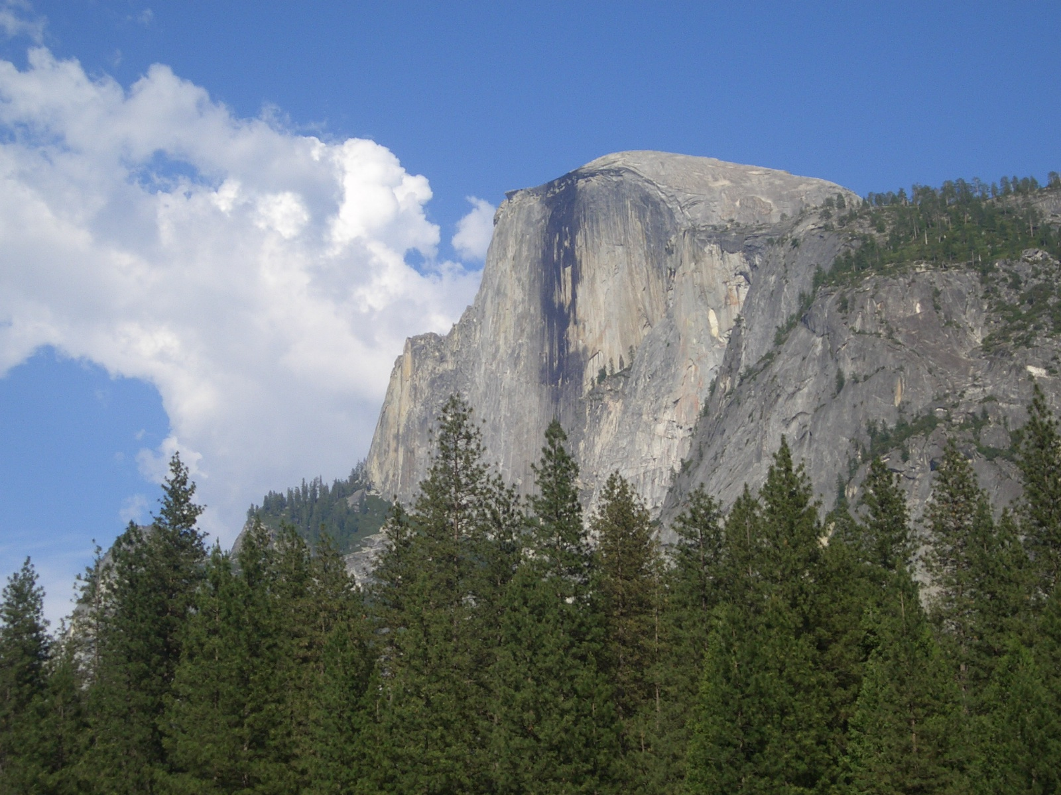

Half Dome Overview
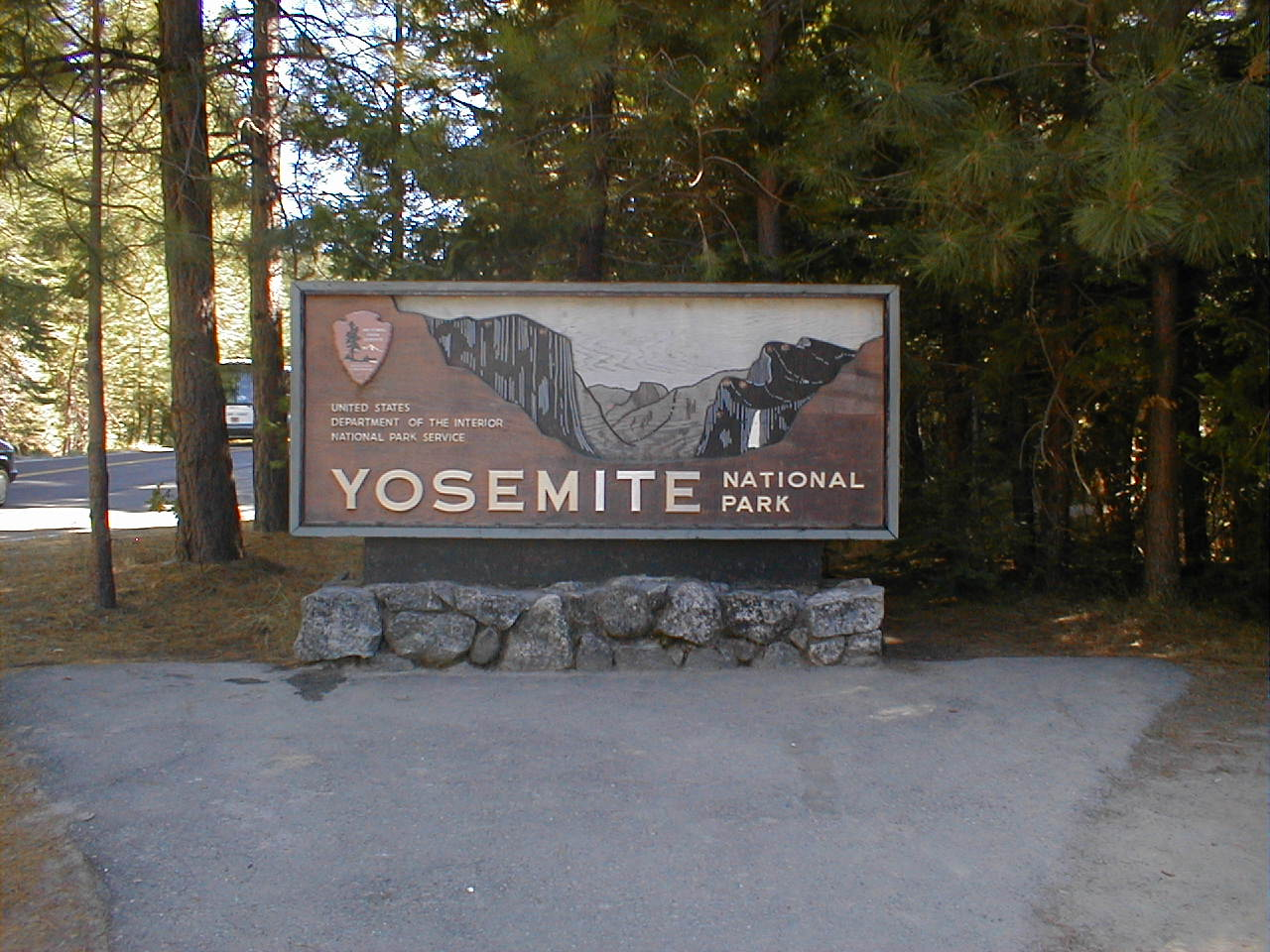
Of all the hikes possible in Yosemite, one of the favorite day hikes is up to the top of Half Dome, at the eastern edge of Yosemite Valley. It is the most climbed mountain in the Sierra Nevada, with about 50,000 ascents per year! Recent studies have determined that weekend trips have increased 32% since 1994. This is a big hike - a full ten- to twelve-hour day for most, comprising nearly sixteen miles round trip. Included is a harrowing 425-foot vertical climb up the nearly 45 degree incline of Half Dome’s granite slope. Not to worry; this is accomplished with the aid of two steel cable handrails.
The area can be traced back literally hundreds of millions of years. Deep below the surface, constant earth movement and the effects of pressure and heat created magma, which gradually rose to the surface and cooled into a huge block of granite. The eroding action of river flows and glacial activity eventually carved the valley into its present shape.
Yosemite is undergoing change even today. Occasional fires ravage parts of the park. Rockslides in the park as recently as 1996 and 1999, dropped enormous sheets of granite near Happy Isles. They produced massive shock waves that literally snapped thousands of trees. These events are unpredictable, but they are a reminder that Yosemite is undergoing constant change. The Merced River flood of 1997 set records and the high water marks are still visible. In a great honor, Yosemite was selected by the US Government to be the theme for California on the 2005 U.S. Quarter coin. California’s quarter depicts naturalist and conservationist John Muir, admiring Yosemite Valley’s monolithic granite headwall known as "Half Dome”. The coin bears the inscriptions: "California," "John Muir," "Yosemite Valley," and "1850," the year of admission to the Union. When you consider all the varied attractions in California, it is quite a testament to have Yosemite represent the Golden State to the country and the world.

Half Dome – The People
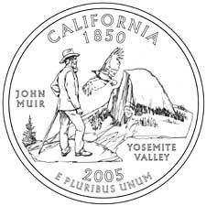
Native Americans arrived in the area about 1,000 BC. Today, we know their descendants as the “Ahwahneechee”. They called Half Dome, “Tis-sa-ack,” meaning “Cleft Rock”, in honor of a maiden whose teary profile is believe captured on its face for all time.
The first explorer to see the park was Joseph Walker, in 1833. He was hunting beaver in the Sierra and passed through the Yosemite area as he continued to Monterey. The great California Gold Rush started in 1848, just a hundred miles to the north. However, Yosemite wasn’t entered by non-Indians until 1851, when the Mariposa Battalion participated in the “Mariposa Indian War." 1854 saw the first organized commercial tours begin in the area. The next year, James Hutchins led a tour party and he kindled interest through his writings in his San Francisco illustrated work, Hutchings' California Magazine. He later authored many popular books on Yosemite. The lands of Yosemite were charted by the US Geologic Survey of California in 1863. Early visitors originally called Half Dome “South Dome”, because they felt it balanced “North Dome” across the Valley. However, the current name, “Half Dome", was soon the common name.
To help protect the pristine environs from commercial interests, in June, 1864, President Abraham Lincoln signed the Yosemite Grant that deeded Yosemite Valley and the Mariposa Grove of Big Trees (at the southern end) to the state of California. The bill stated that this land be used for resort and recreation, “for all time”. Galen Clark was the first “caretaker” of the park. John Muir arrived in 1868 and his writings influenced the country so much that, in 1890, Yosemite obtained federal protection as a “national park.” Today the park has two guardians: the National Park Service and the non-profit Yosemite Association. Ansel Adams, the famous environmentalist and photographer, recorded images of what Yosemite was like before human intervention. His work promoted the goals of the Sierra Club and brought environmental issues to light. The park is ever changing and fragile. Care must be taken to preserve it In recognition of its grandeur, in 1984, the park was designated as a World Heritage Site.

Half Dome – Going Up!
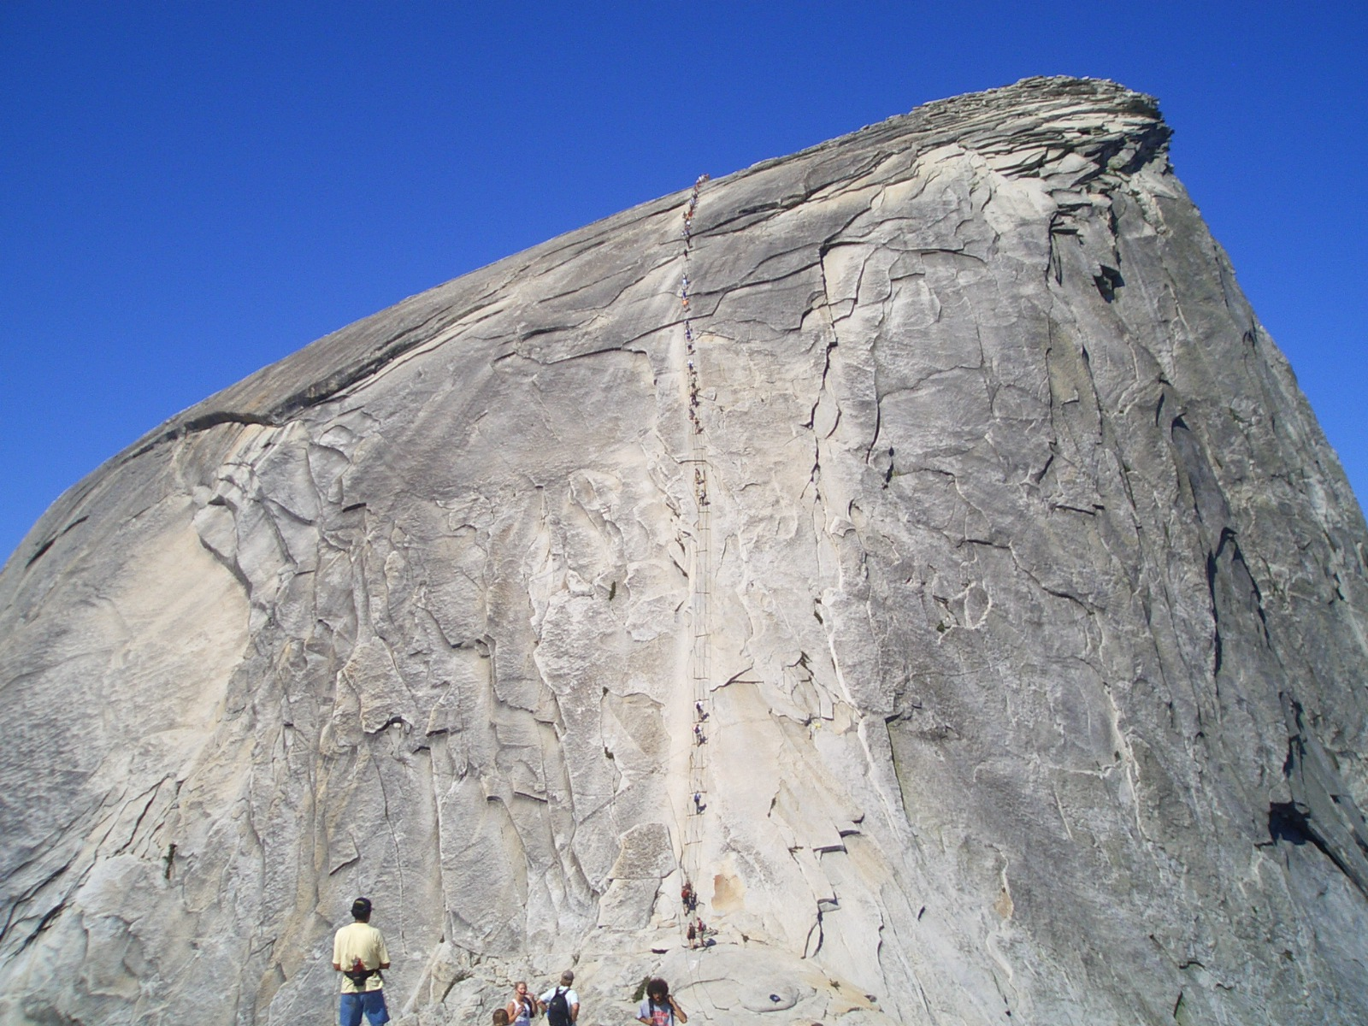
Getting to the top of Half Dome was considered impossible until 1875, when George Anderson, a Scottish blacksmith and jack-of-all-trades, labored weeks to drill holes into the granite of the backside to create a ropeway. This was comprised of a five-strand 975-foot-long rope. The knotted rope was affixed through eyelets that Anderson put into the holes he drilled. As he set an eyelet, he would ascend and stand on it for footing in order to drill the next hole. Slowly, but steadily, he worked until he finally reached the summit. He then secured the rope to the eyelets with knots to allow a hand-over-hand traverse. The great John Muir was the eighth person to reach the summit using the Anderson rope system. In 1910, the Sierra Club placed a single cable down Half Dome's slope and removed the rope. The current system of steel cables, “pipe” supports, and 2’ x 4’ wooden foot rests (ten feet apart), was first put up by the Sierra Club in 1919.
Today, the ascent up the cables (a bi-directional “banister”) allows a hiker to travel over 425 feet vertically to a point near the very top. A physically fit person can reach the summit in fifteen minutes. That is, if you arrive early (by 11 am). This will necessitate a 6 am departure. Usually, on weekends, soon after noon, the cables are so crowded that it resembles a very slow-moving caterpillar. The top surface consists of a few large hunks of granite at the north peak and a smooth, sloping area as big as seventeen football fields to the south.

Half Dome – You CAN do it!
Almost anyone physically able can do this EXTREMLY STRENUOUS one day hike. All you need is knowledge. Understand the precautions, prepare physically, bring the proper gear and a sense of adventure. The reward of getting to the top is a worthy goal. This is a long ordeal. You cannot jump out of the car and expect to do the hike – without feeling very sore and wishing you had trained. Water is the most important success factor. Avoiding deal lightning storms and hike to your plan and you can do this safely and Have FUN!
The elevation profile for the Half Dome hike will help you gauge if you are up for it.

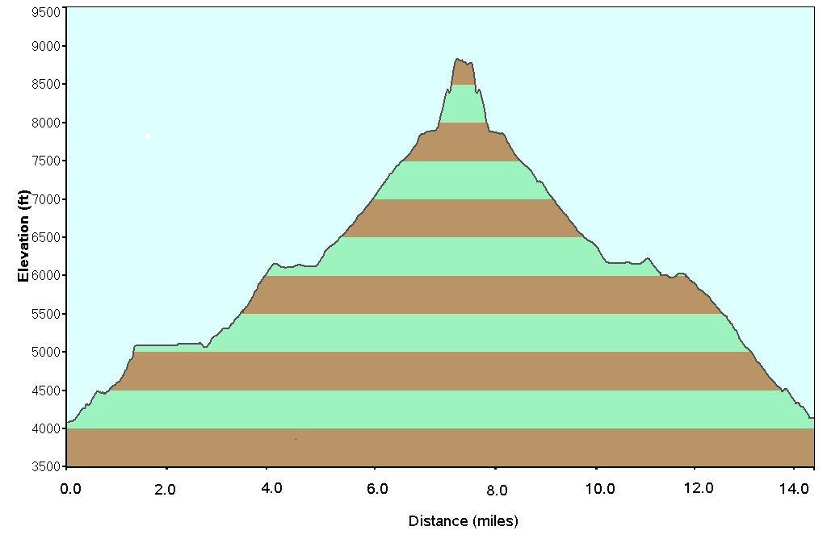

Half Dome – Need more Info?
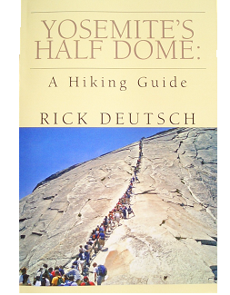  Available from Amazon.com | 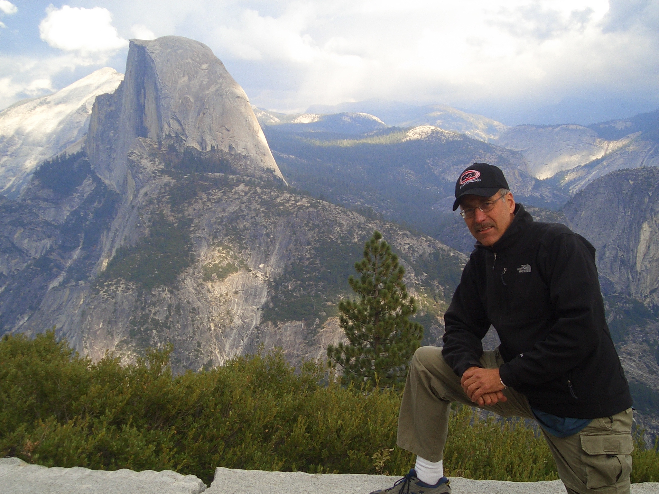  Author Rick Deutsch is available for presentations and book signings. www.halfdomeguide.com

