Little George’s Cub Scout Songbook

Pow Wow – University of Scouting - 2007

Billy the Cub Scout
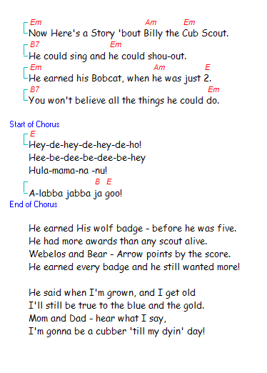

Cub Scouts Sound off
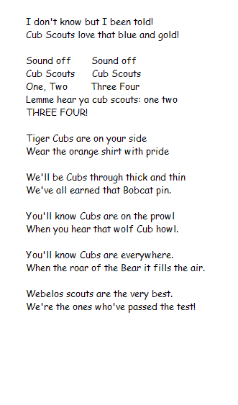

She’ll Be Comin’ Round the Mountain (Cub Scout Style)
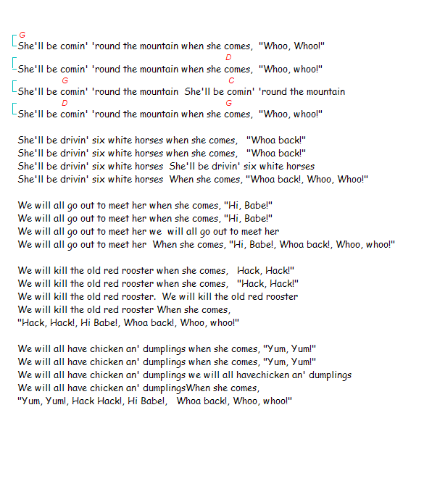

Boom Chick-a Boom
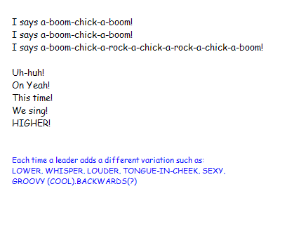

Bug Juice
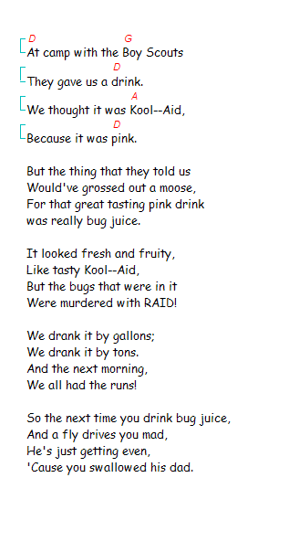

Shaving Cream
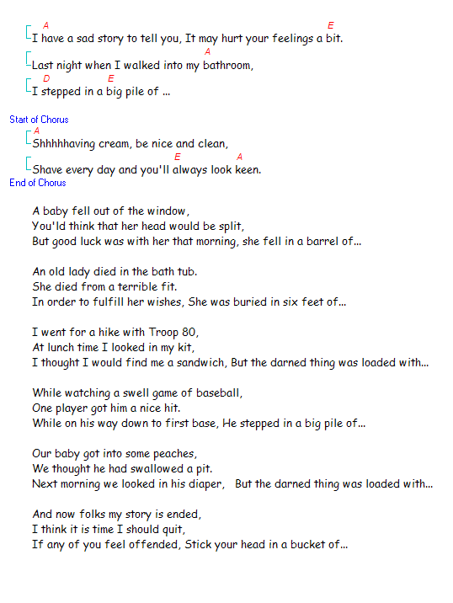

Banana Boat Song
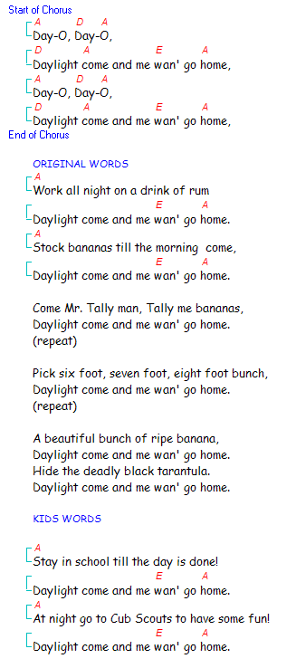
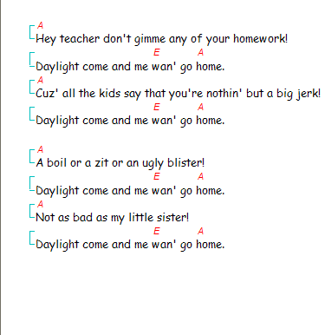

Boa Constrictor
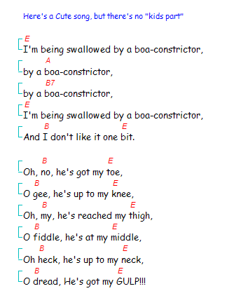

Battle of New Orleans
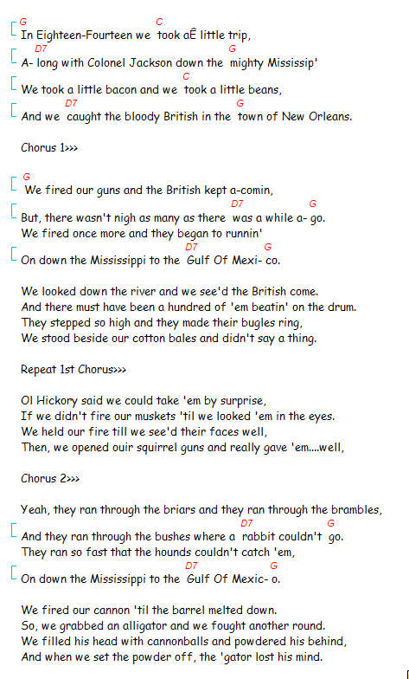

Ravioli (To the Tune of “Alouette”)
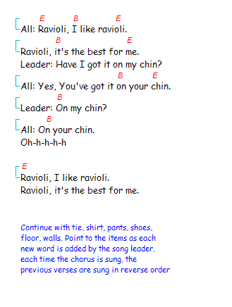

My Bonnie (With Cub Scout Words)
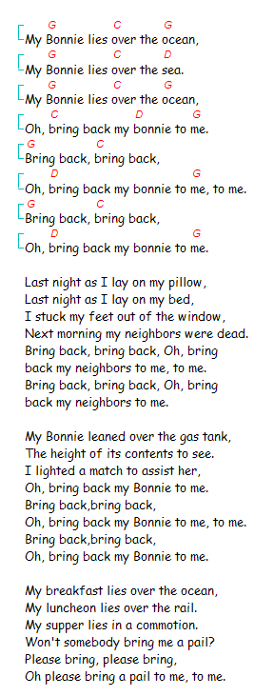
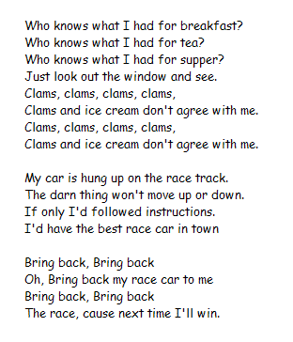

Another Pinewood Derby Song
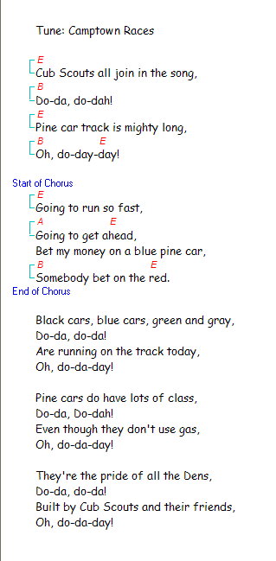

Trash Rap
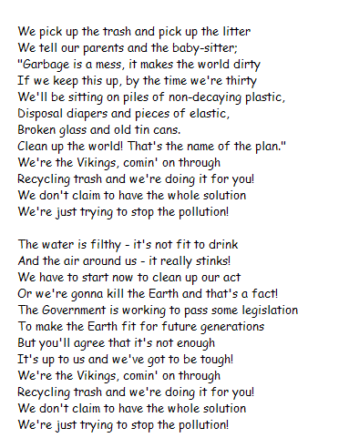
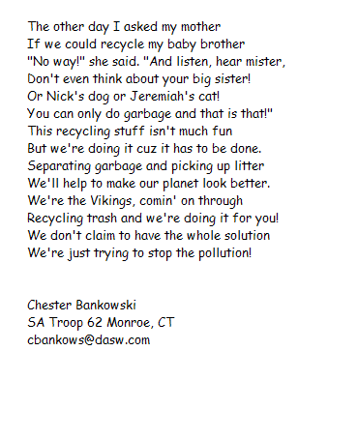

God Bless My Underwear
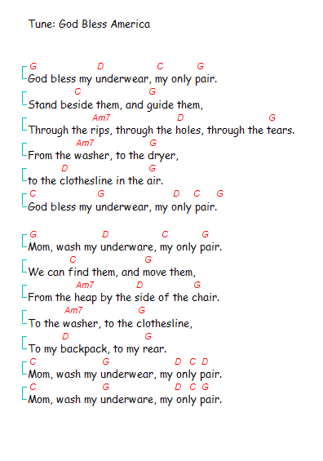

Little George's Ten Rules For Using Songs And Music At Cub Scout Meetings:

- Nobody came to your Cub Scout meeting to hear you sing. It's not a concert. They came to have fun. Your job is to help them do that.
- Don't worry about whether or not you're on-key. If you sing so badly that the kids try to drown you out, you win.
- If you're not having fun, neither will they. If the kids aren't singing along, it may be because you don't look like you're enjoying yourself.
- Remember - you're there to sing and play Kid's Music, (not children's music). This isn't the "Barney" show, and you're not a purple dinosaur.
- Make sure that every song you sing has a part for the kids to sing.
- If you know how to play an instrument (guitar, banjo, whatever), don't forget rule 1. If you don't know how to play an instrument, get some help. Maybe there's someone in your church or sponsoring organization who will agree to play a little guitar at your meetings. But make sure they understand the rules.
- Kids can make their own instruments at den meetings and join in the fun .
- Help the kids in your Pack, Troop or Den to Write their own song.
- Remember - Gross is Good
- Remember - Louder is Better

