Rock Climbing

For Physical and Mental Strength

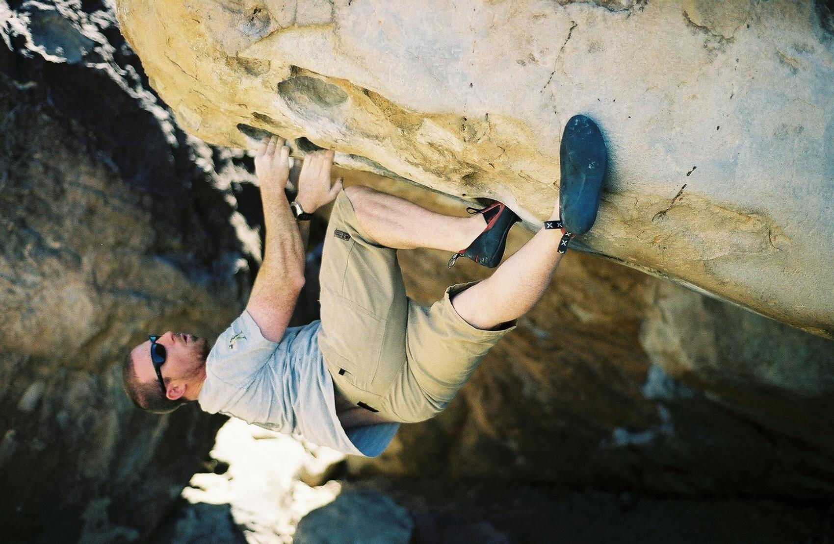
Photo by Brent Plow (Sept. 2006); Hueco Tanks State Park, TX

Presented by: Jess McCauley

Manager/Head Coach; Twisters Rock Climbing Gym; Mountain View, CA

Member and expedition climber; Climbing For A Cure 2001 Imja Tse (Island
Peak) Memorial Expedition; Lower Khumbu, Nepal, Himalaya

Eagle Scout; Troop 74; Santa Clara, CA. 1996

“Climbing requires intense concentration. I know of no other activity in which I can so easily lose all the hours of an afternoon without a trace. Or a regret. I have had storms creep up on me as if I had been asleep, yet I knew the whole time I was in the grip of an intense concentration…. Sometimes in the lowlands when it is hard to work I am jealous of how easily concentration comes in climbing. This concentration may be intense, but it is not the same as the intensity of the visionary periods….”

An excerpt from: The Climber As Visionary – Doug Robinson
Climbing has evolved in so many ways since Doug Robinson wrote about it in 1969. Chalk, climbing shoes, camming devices, nuts, sticky rubber and years of hard work, have taken climbing from the extreme to the mainstream. These innovations and the daring accomplishments of athletes in the last century have contributed to the popularity of rock climbing today. Climbing, much like snowboarding has become a ritual activity for many people in and out of scouting. If you asked around your pack or troop you may find that many boys have attended a birthday party at a local climbing gym, ascended a structure at a community fair, or tried it at the YMCA. Some kids likely have gone with a parent or a relative to Castle Rock State Park for the day and scrambled on the boulders. Bouldering, as that would be called, is an unencumbered style of climbing that many of us have done without even knowing it! Without quoting Sir Edmund Hillary, whatever it is that attracts us to the rocks is the same thing that has attracted us to scouting and the outdoors. We all know the bond between the natural world and ourselves that comes with maturity and experience in the outdoors. We also know the bonds we make with each other on the scouting trail are lasting, no matter where that trail may take us. Kids today crave exciting and new activities and climbing is a great way to keep your boys interested in the outdoors and scouting. Much like climbing has evolved over the years, scouting has too. It can be difficult to keep up with the things kids are into, but climbing is sure to be safe enough for you and “cool” enough for them. Here are a few ways to get started and some of the things you should know before taking your scouts out to climb.



Boy Scout/Cub Scout/Girl Scout Special Event Coupon

TW STERS
ROCK CLIMBING GYM

This coupon entitles all scout groups to a two hour instructional and fun climbing experience at Twisters Gym in Mountain View. Twisters is the best instructional rock climbing facility in California and will show your scouts the latest techniques and safety tips to help get you into the vertical world!
$10/Scout; equipment included.

Highway 101
2639 Terminal Blvd.
San Antonio Rd.
To S.F.
2639 Terminal Blvd. Mountain View, CA 94043; Ph: 650-967-5581; Email: JessMcCauley@gmail.com

Boy Scout/Cub Scout/Girl Scout Special Event Coupon

TW STERS
ROCK CLIMBING GYM

This coupon entitles all scout groups to a two hour instructional and fun climbing experience at Twisters Gym in Mountain View. Twisters is the best instructional rock climbing facility in California and will show your scouts the latest techniques and safety tips to help get you into the vertical world!
$10/Scout; equipment included.

Highway 101
2639 Terminal Blvd.
San Antonio Rd.
To S.F.
2639 Terminal Blvd. Mountain View, CA 94043; Ph: 650-967-5581; Email: JessMcCauley@gmail.com

Main Points of Presentation
I Physical Strength Benefits of Climbing
--Approaches (hiking in)
--The myth of upper v. lower body strength
--Full body muscle toning; especially abs, back and shoulders

II Mental Strength Benefits of Climbing
--Concentration
--Body control
--Trust
--Self confidence
--Preparedness and awareness
--Problem solving
--Planning

III Basic Terms
--A.T.C./belay device (Gri-Gri –Petzl)
--Belay
--Bouldering
--Free climbing
--Aid climbing/big wall
--Mountaineering
--Rappelling
--Dynamic/static rope
--Anchoring
--And more!

IV Basic Gear
--A few recommendations for your personal use

V Indoor Climbing Gyms
--Pros and cons

VI Heading outside
--Leave it to the pros; who to use (see Pt. VIII) and where to go

VII Climb On Safely
--B.S.A. recommended procedures for organizing climbing and rappelling
activities (included in this document as a reference)

VIII Other References and Recommendations
--A list of books and guides to help you start on the right track (included in this
document as a reference)

VII Climb On Safely Full Text
Climb On Safely is the Boy Scouts of America's recommended procedure for organizing BSA climbing/rappelling activities at a natural site or a specifically designed facility such as a climbing wall or tower.
Young people today seek greater challenges, and climbing and rappelling offer a worthy challenge. The satisfaction of safely climbing a rock face is hard to top. While introduction of the Climbing merit badge in spring 1997 spurred interest in these activities through the BSA, the proliferation of climbing gyms and facilities has also made climbing and rappelling readily available throughout the United States.
This increased interest has made the BSA more aware of the inherent risks of climbing and rappelling. More accidents occur during unit rappelling than during council-managed climbing or rappelling, and more accidents have occurred during rappelling than climbing. Many climbing rappelling accidents could be avoided by having qualified instruction from a conscientious adult who has the attention and respect of the youth entrusted to his or her care. Supervision by a caring adult who fully understands and appreciates the responsibility he or she assumes helps assure safety when youth engage in or prepare for climbing or rappelling.
The adult supervisor's relationship with youth should reinforce the importance of following instructions. The adult leader in charge and the climbing instructor share this responsibility. The instructor is responsible for all procedures and for safely conducting the climbing/rappelling activity. The adult supervisor works cooperatively with the climbing instructor and is responsible for all matters outside of the climbing/rappelling activity.
Mountaineering: The Freedom of the Hills, sixth or seventh edition, edited by Don Graydon and Kurt Hanson, is a recommended reference for specific questions not covered in BSA literature.
Units that elect to participate in lead climbing and snow and ice climbing should receive training from a nationally recognized organization that trains climbing and rappelling instructors. All council and district climbing must be top-roped.
Passport to High Adventure, No. 4310, published by the BSA, is an appropriate guidebook to safely get your unit to and from the climbing/rappelling site.
Cub Scouts and Webelos Scouts are encouraged to engage in climbing in a controlled environment with close supervision by instructors who are knowledgeable about instructing this age group. Webelos Scouts also may participate in rappelling. Normally this means going to a climbing gym where the degree of difficulty is age-appropriate and the harnesses are size-appropriate for Cub Scouts. It is not recommended that Cub Scouts use climbing towers and walls in camp that have been designed for Boy Scout use. See the age-appropriate information on the BSA Web site.
Each of the following points plays an important role in the overall Climb On Safely. Fun and safe climbing/rappelling activities require close compliance of Climb On Safely by the adult supervisor and instructor. These points also apply to bouldering—traversing a few feet above ground level. (This is not an accurate description of bouldering; I have given you a much better definition.)

1. Qualified Supervision
All climbing and rappelling must be supervised by a mature, conscientious adult at least 21 years of age who understands the risks inherent to these activities. This person knowingly accepts responsibility for the well-being and safety of the youth in his or her care. This adult supervisor is trained in and committed to compliance with the eight points of the Boy Scouts of America's Climb On Safely procedure. One additional adult who is at least 18 years of age must also accompany the unit. Units with more than 10 youths in the same climbing/rappelling session must have an additional adult leader at least 18 years of age for each 10 additional youth participants. In other words, a group of 11 to 20 youths requires at least three adult leaders; a group of 21 to 30 youths would require four adult leaders, and so on.
The adult supervisor is responsible for ensuring that someone in the group is currently trained in American Red Cross Standard First Aid and CPR (a 6 1/2-hour course). In addition, Wilderness First Aid Basic (a 16-hour course) is recommended for units going to remote areas. A course of equivalent length and content from another nationally recognized organization can be substituted. A higher level of certification such as emergency medical technician (EMT), licensed practical nurse (LPN), registered nurse (RN), and licensed health-care practitioner is also acceptable. The ARC's Emergency Response, a 43 1/2-hour course that includes CPR, is highly recommended.

2. Qualified Instructors
A qualified rock climbing instructor who is at least 21 years of age must supervise all BSA climbing/rappelling activities. A currently trained BSA climbing director or instructor is highly recommended. Contact your local council or regional service center to locate a qualified individual. The climbing instructor has successfully completed a minimum of 10 hours of instructor training for climbing/rappelling from a nationally or regionally recognized organization, a climbing school, a college-level climbing/rappelling course.
The BSA offers a section of National Camping School for climbing directors who in turn can train climbing instructors. Contact your local council or regional service center for a schedule of National Camping Schools. Every instructor must have prior experiences in teaching climbing/rappelling to youth and must agree to adhere to Climb On Safely and the guidelines set in Topping Out.
A capable instructor has experience in teaching climbing and rappelling to youth, acknowledges personal limitations, and exercises good judgment in a variety of circumstances. The person who just spent four days of free-solo climbing on a sheer rock face may have technical skills but may lack teaching ability or the ability to empathize with youth who may be apprehensive about climbing.
Examples of sources of qualified climbing and rappelling instructors include, but are not limited to, the following:
- BSA climbing directors or instructors
- National Outdoor Leadership School
- Wilderness Education Association
- American Mountain Guides Association
- The Mountaineers
- Recreational Equipment Inc.
- Eastern Mountain Sports
- University or college climbing/rappelling instructors or students
- Project Adventure instructors
- National Speleological Society chapters
Leaders and instructors should also consult current literature on climbing and rappelling for additional guidance. Topping Out: A BSA Climbing/Rappelling Manual, No. 3207A, is the most authoritative guide currently available from the Boy Scouts of America.

3. Physical Fitness
Require evidence of fitness for the climbing/rappelling activity with at least a current BSA Personal Health and Medical Record—Class 1, No. 34414. A fitness regimen is recommended prior to participation in climbing/rappelling. The adult supervisor should adapt all supervision, discipline, and precautions to anticipate any potential risks associated with individual health conditions.
If a significant health condition is present, an examination by a licensed health-care practitioner should be required by the adult supervisor before permitting participation in climbing or rappelling. The adult supervisor should inform the climbing instructor about each participant's medical conditions.

4. Safe Area
All BSA climbing/rappelling activities must be conducted using an established climbing/rappelling site or facility, including a portable or commercial facility. A qualified climbing instructor should survey the site in advance of the activity to identify and evaluate possible hazards and to determine whether the site is suitable for the age, maturity, and skill level of the participants. The instructor should also verify that the site is sufficient to safely and comfortably accommodate the number of participants in the activity within the available time. An emergency evacuation route must be identified in advance.

5. Equipment
The climbing instructor should verify that the proper equipment is available for the size and ability level of participants. Helmets, rope, and climbing hardware must be approved by the UIAA (Union Internationale des Associations d' Alpinisme) or CE (European Community Norm), or meet ASTM (American Society for Testing and Materials) standards. All equipment must be acquired new or furnished by the instructor.
An approved climbing helmet must be worn during all BSA climbing/rappelling activities where the participant's feet are more than shoulder height above ground level. When using a commercial climbing gym, the climbing facility's equipment procedures apply.

6. Planning
When planning, remember the following:
- Obtain written parental consent to participate in climbing/rappelling activities for each participant.
- In the event of severe weather or other problem, share the climbing/rappelling plan and an alternate with parents and the unit committee.
- Secure the necessary permits or written permission for using private or public lands.
- Enlist the help of a qualified climbing instructor.
- Be sure the instructor has a map for the area being used and obtains a current weather report for the area before the group's departure.
It is suggested that at least one of the adult leaders has an electronic means of communication in case of an emergency.
Before any activity, an adult leader should develop and share an emergency plan that includes the location of a nearby medical facility and the means of communicating with parents during the outing.

7. Environmental Conditions
The instructor, each adult leader, and each participant assume responsibility for monitoring potentially dangerous environmental conditions that may include loose, crumbly rock; poisonous plants; wildlife; and inclement weather. Use the buddy system to monitor concerns such as dehydration, hypothermia, and an unusually high degree of fear or apprehension. The adult supervisor is responsible for ensuring that the group leaves no trace of its presence at the site. See the Principles of Leave No Trace, No. 21-105.

8. Discipline
Each participant knows, understands, and respects the rules and procedures for safely climbing and rappelling and has been oriented in Climb On Safely and Leave No Trace. All BSA members should respect and follow all instructions and rules of the climbing instructor. The applicable rules should be presented and learned prior to the outing and should be reviewed for all participants before climbing or rappelling begins. When participants know the reasons for rules and procedures, they are more likely to follow them. The climbing instructor must be strict and fair, showing no favoritism.

VIII Other References and Recommendations

Books:
Cox, Steven M. and Kris Fulsaas. Editors, Mountaineering; The Freedom of the Hills. Seattle: The Mountaineers Press, 2003.
Rebuffat, Gaston. Starlight and Storm; The Conquest of the Great North Faces of the Alps. New York: Modern Library, 1999.
Roper, Steve and Allen Steck. Editors, The Best of Ascent. San Francisco: Sierra
Club Books, 1993.
Williamson, John E. (Jed) and Edwina Podemski. Editors, Accidents In North American Mountaineering. Golden, CO: American Alpine Club, 2006.
Author Unknown. Topping Out. B.S.A. Publication

Guide Services:
Mountain Adventure Seminars. Bear Valley, CA.

MAS
P.O. Box 5450
Bear Valley, CA 95223.

Ph: (209) 753-6556 ext. 1
Fax: (209) 753-2313
Email: mail@mtadventure.com
Web: http://www.mtadventure.com

Rick Picar; Instructor. Sierra Rock Climbing School & Joshua Tree Guides.

Ph: 1-877-686-ROCK
Email: info@sierrarockclimbingschool.com
Web: www.SierraRockClimbingSchool.com & www.JoshuaTreeGuides.com

Outback Adventures - San Jose, CA
1158 Saratoga Avenue
San Jose, CA 95129
Ph: 408-551-0588
Web: adventure@outbackadventures.com

Climbing Gym:
Twisters Rock Climbing Gym
2639 Terminal Blvd.
Mountain View, CA 94043
Ph: 650-967-5581 Fax: 650-967-7149
Email: JessMcCauley@gmail.com

