ATHLETE -- PHYSICAL SKILLS GROUP

An athlete is one who keeps his body physically fit, strong, graceful and agile - a desire of practically every boy. Tell your Webelos Scouts about the athlete and what it takes to become one. Impress them with the fact that the body is a priceless gift and only a few minutes of exercise each day are required to keep it physically fit.
By adequate exercise, getting the proper food each day and taking care of himself, a boy can become an athlete. The activities for this badge can help the Webelos Scout measure up to the standards of strength, agility, endurance, and coordination necessary for good active Scouting activities in later life.
Many Webelos leaders use this badge to introduce a new Webelos Scout to the program. This begins their Webelos year with an appealing badge to inspire them onward. By laying out a permanent accurately measured 50 yard dash and 600 yard run near your meeting place, you can easily test your new Webelos Scouts in less than half an hour. Use a stopwatch when timing these sprint and distance runs.
Make up a permanent Fitness Progress Chart and retest the boys at different times throughout the year and chart their progress. They will be interested in bettering their records.
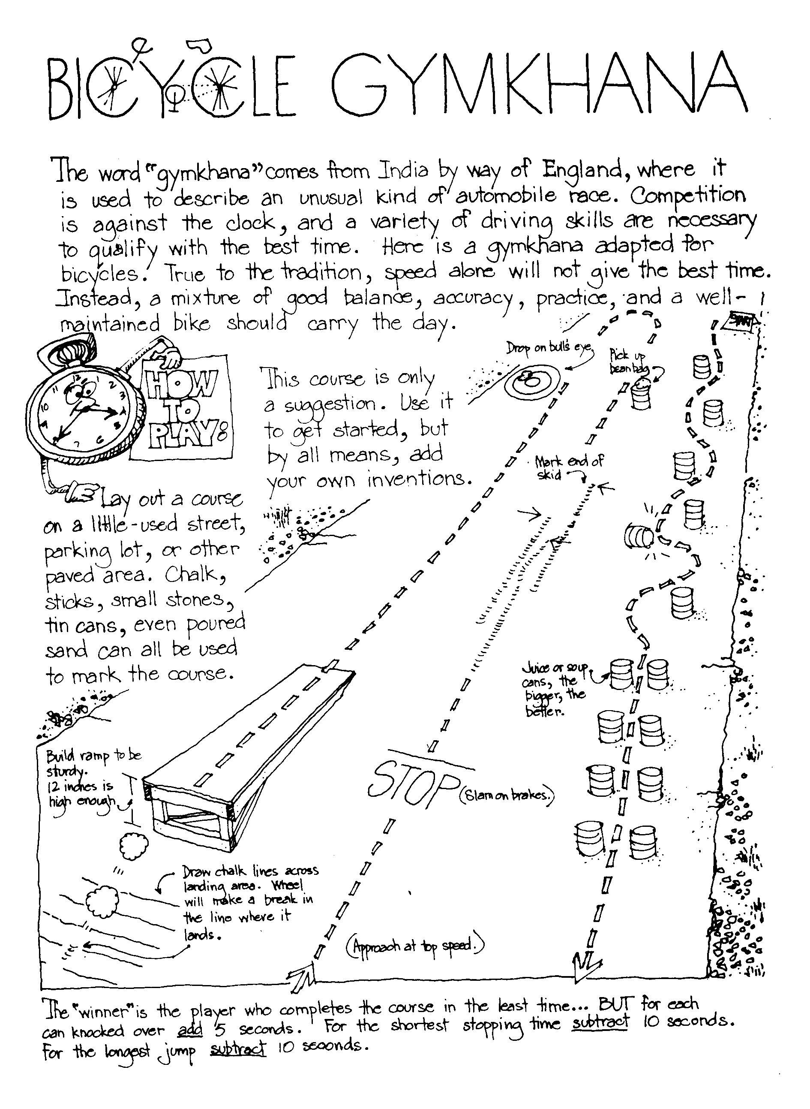
The boys can make their own physical fitness equipment. A barbell can be made using a 3 foot dowel or broomstick with 3/4" pipe caps on the ends. The latter are then embedded in 46 oz. cans filled with cement. Allow cement to set overnight. Dumbbells can be made similarly by using foot long dowels and No. 2 size cans filled with cement and placed on the ends of dowels. Plastic quart containers filled with sand may be used instead of the cans. A broomstick suspended at both ends in a garage, basement, or backyard makes an excellent chinning bar. A deflated bicycle inner tube makes a good exerciser.

Being Healthy
Good Health Habits Quiz
Circle the correct answer(s).
- Bathe/shower (everyday OR once per week) and especially after exercise.
- Wash your hair (1/month OR 2+ times/week).
- Wash hands (before eating OR after using the restroom) and when they're dirty.
- Eat right - (3 OR 4 OR 6) regular meals each day at regular times!
- Eat (just some OR a variety of) food from each of the 4 food groups.
- The average 10 year old should get at least (6 OR 9 OR 12) hours of sleep each night.
ANSWERS: 1. Everyday, 2. 2+ times, before eating and after using restroom, 3. 3 meals, 4. Variety, 9 hours

Clean & Strong
Circle T for True or F for False.
T F | Our bodies "repair" themselves while we sleep.
T F | Clean clothes aren't necessary after a bath or shower - they are just in the morning.
T F | Use proper lighting for all activities including reading, TV viewing, and playing.
T F | Fitness is never just physical - it involves  both the mind and body together.
T F | Stand tall, and walk tall with shoulders  back and stomach in.
T F | It's OK to share drinking cups,  washcloths and towels.
T F | Different foods provide different nutrients,  and no one food can sustain us.
T F | Rushing meals or skipping meals can be harmful  to your body.
ANSWER: 1 - T, 2 - F, 3 - T, 4 - T, 5 - T, 6 - F, 7 - T, 8 - T

Volleyball Serve it Underhand
The underhand serve is the easiest to master for volleyball. In a game you must put the ball into play from a 10 foot wide area behind the end line. Always practice with a line in front of you so you will learn not to cross it until you have released the ball.
For the underhand serve (if right handed), stands with your left foot about 13” in front of the right foot. Bend both knees a little, lift the ball in both hands out in front of your chest, to your right side. Hold the ball in the left hand and start to bring the right hand down. Close the finger of the right hand as if you were making a loose fist.
Keep your eyes on the ball. Bring right hand down, back, and up behind you. Step a quarter step forward on your left foot. Swing your right hand at ball. Just before you hit it, toss the ball up a little and drop your left hand away from it. (The rules say – release your left hand from the ball before hitting it.) Strike ball solidly with the palm side of your fist and follow through. (Of left handed, reverse from right to left.)
Once you master the serve, try using the heel of hand instead of fist. Close hand instead of your fist. Close your hand half-way so fingertips come just below the base of the fingers with thumb-tip beside the first joint of forefingers

SONGS
Scout Wetspers
(provided by Dave Lyons)
Softly falls the rain today
As our campsite floats away
Silently each Scout should ask
Did I bring my SCUBA mask?
Have I tied my tent flaps down?
Learned to swim, so I won't drown?
Have I done and will I try
Everything to keep me dry??

The Athlete
Tune: My Bonnie
They gave me a suit and a number
And sent me out on the field
They gave me a ball called the pigskin,
And shoes with some cleats, toe and heel
CHORUS
Muscles, Cramps, wracking my body with pain, with pain
I stand, wondering, if ever I’ll do this again!
Next time they gave me a racquet,
They sent me out on the court
Funny the things you encounter,
While trying to learn a new sport.
(CHORUS)
The ordeal was finally over,
At least, that’s what I thought,
When they shoved me the soccer equipment
I fainted dead on the spot!
(CHORUS)

Athlete Den Activities
TOWEL PICKUP - Take off your shoes and socks. Pick up a towel with your toes.
PAPER PICKUP - Pick up a piece of paper from the floor without bending your knees
BOOK CARRY - Walk across the room with a book balanced on your head.
SKIN THE CAT - Clasp your hands in front of you. Try to step through the ring formed by your hands and finish standing upright with them clasped behind you. Return to your original position by stepping backwards through the ring.
TOE WRESTLING - Two wrestlers sit on the floor, facing each other with arms clasped around knees. When they are in this position, place a stick over each person’s elbows and under his bent knees. Their feet should be flat on the ground with the toes of one touching the toes of his opponent. The object is for one wrestler to get his toes under the toes of his opponent and roll him over backwards. If either wrestler breaks the handclasp above his knees, the other wins the contest.
SIDEWALK TENNIS - Played with a tennis ball on two squares of sidewalk or patch of level ground marked off in similar size. Ball is batted with the hands. Use regular tennis rules, except that there is no serving court

SUGGESTIONS FOR COMPLETING ATHLETE ACTIVITY BADGE
Requirement #1
Can be combined with the Fitness Activity Badge and the Sportsman Activity Badge. The subjects of being physically healthy, balanced diets, and bad effects of drugs, alcohol, and tobacco can be combined and signed off all together.
Requirement #2
Takes the longest amount of time to complete and sign off of all the Physical Skills Group. To earn the Physical Fitness Sports Pin, the boy needs to earn 60 points in a 90 day period. They must exercise or be involved in some activity for 30 minutes to earn one point. The boy can earn a maximum of five points in a day. Just remember 30 minutes for one point, 60 points total in a 90 day period.
You can pass off requirements 3 through 9 as part of this pin, use requirement 3 and 4 of the Sportsman badge to meet the requirement.

Den Activities
· Make your own physical fitness equipment (see above)
· Watch a high school track meet.
· Have a Physical Education instructor talk to your den concerning fitness.
· Invite a professional weight lifter to talk to your den and demonstrate.
· Attend a gymnastics exhibition or meet.
· Plan a physical fitness demonstration for pack meeting.

Barbell Slide
Materials: 2 small 1" styrene balls, 1/2 of a black pipe cleaner, black paint, white paint, paint marker, or vinyl stick-on letters
Directions: Paint the two balls black. Cut the pipe cleaner into 2 equal pieces. Push the pieces into the ball about 1/4" apart. Pull the pieces apart slightly, curving them outward. With the white paint put the lbs. on the two balls. You can use 5 lbs., the Pack number, or some outrageous amount of weight.

Games
La Plama (Bolivia) -- The Indians of Bolivia used a bone, but you can use a stick for this game. Set the stick up on end in a hole in the ground. Draw a straight line away from the stick. Measure out a distance of 3' along the line and from the stick. Drive in a peg. Repeat until 6 pegs are in the ground along the line and spaced 3' apart. You will need a supply of tennis balls. The boys take turns trying to hit the stick from the first peg. Those who do hit it move on to the next peg. Those who do not stay at one peg until they hit the stick. The first boy to complete the six throws from the 6 pegs wins the game.

Crossing the Rice Fields (China) -- Players line up in teams of two, forming two or more columns as in relay formation. On the word "rice" the first team in each column forms a wheelbarrow and races across the rice fields to the river (two parallel ropes stretched out on the floor crossed by two 2 x 4's - one for each team). At the edge of the river, the players break up and walk across the "bridge" being careful not to fall in the river. On the other bank they turn around and come back across the bridge and then reform their wheelbarrow reversing positions and "roll" home again. The first team to get all of the pairs across the river and back again wins.

Activity Ideas
Agility Exercises -- Perform these exercises within the designated time limits. Rest two minutes between each set of exercises.
Set 1. (8 minutes)
- Fish Flops: Lie flat on your stomach, arms and legs extended and off the ground. Rock back and forth. (2 min.)
- Grass Drill: Run in place. Drop to ground and bounce up again. (2 min.)
- Quick Foot-Knee Touch: Drop quickly to one knee and bounce up again. Alternate knees. (2 min.)
- Root Drill: You need a partner for this one. Square off on all fours, locking right shoulder to right shoulder. Try to rock your opponent back off his feet. (2 min.)
Rest Two Minutes
Set 2. (6 minutes)
1. Crab Mirror: Two players on all fours. One moves at random to the left, right, back or forward and the other mirrors his moves. Switch leaders and repeat. (2 min.)
2. Bear Hug Take-Down: Two players, one standing behind the other. Player in rear grasps other player around arms and chest and tries to pull him down. Reverse positions and repeat. (3 min.)
3. Sit-ups: Lie on back, feet together, hands clasped behind head. Raise up and touch elbows to knees. Do as many as possible. (1 min.)
Rest Two Minutes

Flexibility Exercises
· Fingers: Extend arms to the side, palms down. Quickly flex fingers by alternating between fist and open-hand position. (30 sec.)
· Palms: Extend arms to the front, palms down, wrists locked. Turn palms inward and outward in quick, short movements. (30 sec.)
· Wrists: Same position as palms (above). Rotate wrists clockwise, then counter-clockwise.(30 sec.)
· Forearm Twist: Arms extended sideward and parallel to ground. Flex at elbow bringing tips of fingers to shoulders. Return to starting position. Perform both palms up and palms down. (1 min.).
Shoulder Stretches: 3-part exercise. (a) Rotate one arm over your head and down slowly. Repeat with other arm. (b) Shrug your shoulders slowly in complete circle starting the movement by moving up and back. (c) lock your hands behind head and pull back slowly from shoulders. (2 min.)
This page intentionally left blank. Well, maybe not exactly intentionally, but not by accident either. See, it’s often a good idea to have a section or chapter start on an odd numbered page. And this last section had an odd number of pages. So, to get the next section to start on the usual odd numbered page, it’s common practice to insert a blank page, so that the previous section, which started on an odd numbered page, has an even number of pages. Oddly enough, some people think that it’s necessary to put something on the page, like, “This page intentionally left blank.” That idea probably began with the military industrial complex and their specifications and instructions. For our military folk it’s really important that nothing ever be blank, unused, pristine. Something found blank might mean that something important was left out, and they never, ever leave anything out. And they would never want you to think that something had been left out. Anyway, back to this epic document. The problem now is that even though this page was supposed to be intentionally left blank, it is now unintentionally left messy. But it truly did not contain anything useful, interesting or instructional. So at least part of the original intent was accomplished. And now, intentional or unintentional, blank or messy, it’s time to get back to the Book.

