CITIZEN(2) -- COMMUNITY GROUP
One of the purposes of Cub Scouting is developing habits and attitudes of good citizenship". A Scout promises to do his duty to his country. The Citizen Activity Badge helps the Webelos understand what a good citizen is and teaches him the history of our flag. Citizen Activity Badge is in the Community group.
The Citizen activity badge relates directly to developing responsible citizens, one of the prime purposes of the BSA. The appeal of this badge will be determined in a large part by the method used by the Webelos Leader in presenting it. It can be fun and exciting, or it can just be some more reports to write. Do your best in planning the program. The Webelos leader should plan carefully so that boys get a feeling for the real meaning of citizenship without spending a lot of time in study. There are various ways to do this. You might give them the opportunity to get a close look at government by planning a field trip to a local government agency or court. One of the best ways to stress the meaning of good citizenship is by practicing the good turn. This should be a "must" for every boy. Working on this badge can be exciting, fun and informative, or it can be just more reports to write.
Good citizenship is emphasized throughout Scouting. Being a good citizen means helping other people, knowing the history of our country, appreciating the contributions and sacrifices of others who have made our country better, knowing our public officials, understanding how our government works, obeying the laws, and doing things that will benefit the community.
The Citizen activity badge is important since the work involved relates directly to developing responsible citizens, one of the primary aims of the Boy Scouts of America. The Citizen activity badge is a requirement for the Arrow of Light Award. It is the first of several citizenship requirements on the trail to Eagle Scout. By completing this activity badge, all of the requirements for the Boy Scout Citizenship skill award can also be met.
Webelos Scouts get a feeling for the real meaning of citizenship in two ways. First by getting a closer look at local government by going to see it in action. Second. and most effective, by practicing good citizenship through Good Turns. The Good Turn is one of the optional requirements for the activity badge, but it should be a way of life for all Scouts.
Objectives:
- To foster citizenship in Webelos Scouts, to teach boys to recognize the qualities of a good citizen, to introduce boys to the structure of the U.S. government,
- To familiarize boys with basics of American history,
- To convince boys that laws are beneficial
- To encourage Webelos Scouts to become community volunteers.

Pack and Den Ideas
  - Discuss the various organizations in your community which help people. How are they financed and run? Do they use volunteer help? Visit one of these organizations.
  - Buy a pack of U.S. commemorative stamps. Pass out several to each Webelos and challenge them to discover the story behind the stamp.
  - Visit a historic site in or near your community, learn your state's bird, tree, flower and flag, or take part in a Veteran's Day ceremony in your community. Take photos and prepare a report for the pack meeting.
  - Make a pack meeting display of magazine pictures of places of historical interest or great beauty in America.
  - Discuss requirement of Badge with a community leader
  - A campaign against litter is a "must" for good citizenship. Discuss how your den can carry on such a campaign and do it. This could include making posters for display, litter clean up, making litterbags, a fight against pollution, and collecting items for recycling.
  - Discuss the various organizations in the community, which help people. How are they financed and run? Do they use volunteer help?
  - Observe the voting process.
  - Remind people to fly the flag.
  - Discuss difference between the rights and duties of a citizen.
  - Select a Good Turn for school, church, or community and carry it out.
  - Plan a special Good Turn for the next pack meeting, such as setting up chairs, acting as welcoming committee, ushering, cleaning up.
  - Make logbooks to record work on the activity badge.
  - Learn flag courtesy. (See the booklet, Your Flag.) Use the flag courtesy kit described later in this section to learn proper procedures. Then demonstrate to a group of younger Cub Scouts.
  - Plan an anti-litter campaign. This could include making and displaying posters, picking up litter, making litter bags, etc.
  - Discuss the community organizations that help people. How are they run and financed? Do they use volunteer help?
  - Invite a new US citizen to speak to the den on what becoming an American means to him or her.
  - Discuss the rights and the responsibilities of good citizens.
  - Invite a local public official to talk with the den about government. This might be a city council member or clerk.
  - Invite a guest speaker from a local community board to explain his/her duties and tell the Scouts why he/she volunteers time.
  - Fly a flag at home, particularly on appropriate occasions.
  - Learn more about your community. Your local historical society can help with this.
  - 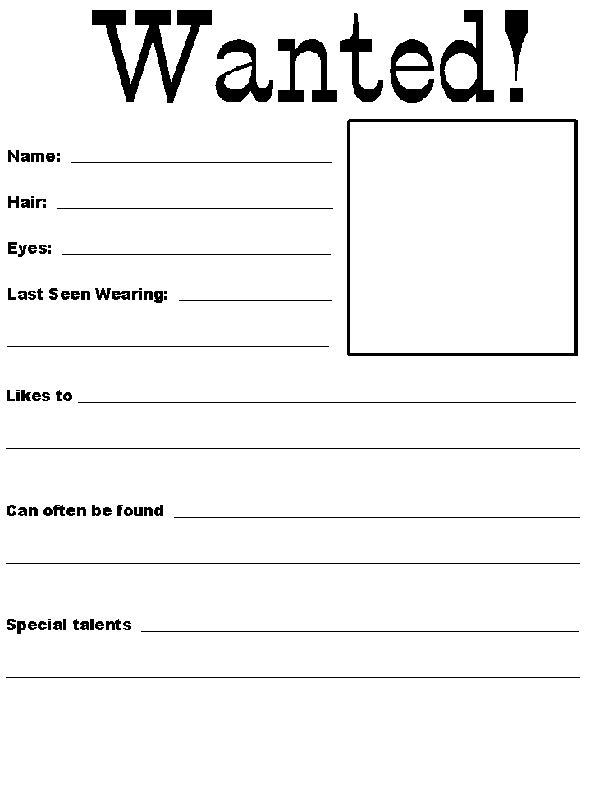Make and hand out small posters showing how to raise and lower the flag; give a demonstration on folding the flag.
  - Make “GET OUT AND VOTE” door hangers and help the pack place them on every door in your neighborhood. Remember - DO NOT put them in the mailbox. It is against the law!

Ceremonies
Have two Webelos hold the U.S. flag.
Narrator: The 13 stripes of alternating red and white remind us of the original 13 founding colonies and of the brave people who have courageously risked their lives - and sometimes lost them - to make the United States of America a democracy of the people, by the people, and for the people.
Each of the 50 stars represents one of our sovereign states and the opportunity and freedom we enjoy. Let us join now in singing “God Bless America.” (Song leader leads song.)

Skit
The Greatest President-
Scene: First boy is sitting on stage looking sad and thinking very hard. Other boys come on stage talking to each other. They walk over to the first boy.
- You look upset. What's the matter?
- I've got a problem. I'm supposed to write a report on the greatest President that the United States has ever had, but I don't know who that is. Do you guys know?
- I think George Washington was the greatest President we have ever had. After all, he became our leader after the Revolutionary War and helped mold the United States into a great nation.
- Oh, no! Abe Lincoln was our greatest President. He was President during the Civil War and fought to free the slaves and re-unite all the states.
- I think John Kennedy has to be the greatest. Look how well he handled the Russians when they were installing missiles in Cuba.
- Don't forget Harry Truman. It was his decision that won World War II for us.
- You're all wrong! I know who the greatest President is. You hear on the radio and TV and see it in the newspaper all the time.
Others: Yeah? Who?
Cub #7: The man who wants to be elected the NEXT president!

Games
American Heritage- Find pictures of well-known buildings, symbols or people and tape each one onto construction paper. (Example: White House, Uncle Sam, President Clinton, Eagle, plus some harder ones like the Presidential Seal or your state Governor.)
- Number each picture and then hang on the wall.
- Give each boy a paper and pencil and have them list numbers down the side.
- Set a time limit, ask the boys to circulate, look at the pictures and write down the names.
- The den historian is the person who has the most written down correctly at the end of time.
- Be sure to review all the answers out loud so all can hear the correct answers.

Flying Flags-
Buy a bunch of small plastic flags.
Divide them up to all the den members during the closing ceremony.
Tell them to carry the flags around this week and give them to people who are being "Good Citizens," explaining why.

Citizen Test-
Divide den into two teams.
They line up facing each other with a wide space between them.
The leader asks each player a question (Questions should be made up from the requirements for the Citizen Activity Award)
A correct answer entitles that whole team to take one step forward.
An incorrect answer passes to the other team.
The members of first team to cross the other’s starting line are the Good Citizens for the Day.
Heads Of Government Game-
Material needed: Pictures of government officials from newspapers or magazines, nametags with the officials’ names written on them.
- Have Webelos match the correct name with each official.
- You may wish to try this at the local, state and federal government levels.

Newspaper Study
Material needed: One current newspaper per team.
Divide boys into teams.
- On signal, each team starts a search for news items that illustrate good citizenship.
- Team with the most clippings in a given time period is the winner.

Build A Flag-
Materials needed: For each team, 1 set of the five US flags shown in Citizen section of the Webelos handbook. Each flag is to be on a standard letter size sheet of cover stock or paper. This can be done with a color printer, copier or by hand drawing a set of the flags for each team. When the copies are ready, cut each flag picture into 2 pieces, the stripes and the field of stars. Prepare cards with the name of each flag and year of each flag. A corkboard and pushpins are needed. Divide Webelos into two teams. First boy from each team runs to his team’s pile of pieces, grabs a stripe piece and a push pin and pins it to the corkboard. He runs back and touches off the second boy, who pins up the star field piece that matches the striping. Next team member matches appropriate flag name and fourth member pins up the year of the flag. Continue to rotate until all five flags have been properly constructed, named, and dated.

Crafts
Wanted: Good Citizen Poster Project-
Imagine the type of citizen you would want to be part of your community.
How would that person act?
What would that person look like?
Design a WANTED poster of the ideal citizen.
Cut and paste a picture or photo on a sheet of paper of the citizen you are wanting. It can be a picture or photo of someone you cut from a magazine or you can draw a picture of a real or pretend person.
Then, describe the person physically and also describe his/her personality traits.
Example:
WANTED person with good humor, a concern for others and ability to get along with others. Then, complete the following statements on your poster:
This person was last seen in ____________.
He/she was, once again __________ showing himself/herself as an active and responsible citizen. If you have seen or have any information about this person, please contact . This person is an ideal citizen because ______________.
Good Turns- Patriotic Wall Plaque- Using a copy of the Declaration of Independence, Bill of Rights or the Gettysburg Address make a wall plaque by mounting one of these on ¼ inch plywood shaped into the design of a scroll.
Make your scroll slightly larger than your copy.
Finish plywood by sanding, staining a natural color and varnishing -- or leave the wood grain and color show through by eliminating stain and just finishing with varnish.

Activities
Plan a special Good Turn to do at the next pack meeting.
Perhaps setting up chairs, cleaning up, bringing food or drinks…
Offer to help the school or church with the overflowing Lost and Found.
If items have not been recovered at the end of the school year, sort and wash them and take them to Goodwill or another organization.
Arrange for a tour while you're there, to see how their organization helps other people.
Get ideas for what else you can do…
Go around your neighborhood and remind people to fly their flags on the next holiday…
Ask at city hall what a den of Webelos could do to help the city with a job…
Scavenger Hunt-
Arrange a tour of a local government building.
Make up a scavenger hunt based on the example below.
Contact the public relations department if you need help or visit the building yourself to make up the game.
Upon arrival at the building, divide the Webelos into teams.
Set a time limit and place to meet to compare answers.
- What is the town mayor's name?
- Draw a fast picture of the state flag.
- What is the name of the room where the city council meets?
- What are the office hours of the Water Department?
- What is the phone number of the building?
- Find out what job one person does in the building?

Citizen
Sung to “Row, Row, Row Your Boat”
Fly, fly, fly your flag,
On our holidays,
Be a loyal citizen,
In this and other ways.
We're good citizens,
From a land that's free,
We should all be proud to serve,
So patriotically.
Be good citizens,
Webelos like me,
I'll be loyal, honest, true,
And keep my country free.

Note – It may seem very tempting for a First Year Webelos leader to jump in and do Citizen, which is a specifically required activity badge, versus the recommended Communicator or maybe Outdoorsman (If your council has a Fall Webelos weekend) but please don’t do this. Your new Webelos need to start with a few fun badges until they get the hang of the Webelos program. I have seen many Leaders and boys who did Citizen for their first badge discouraged by the time they finished. By next Fall both the boys and you will understand Webelos better and be ready to earn this badge. CD
The Webelos Leader must plan so the boys get feeling for the real meaning of citizenship without spending a lot of time in study. One of the best ways to stress the meaning of citizenship is by practicing the good turn.
The appeal of this badge to the boys will be determined in large part by the method used by the Webelos Leader in presenting it. It can be exciting, fun and informative; or it can be just some more reports to write. Because of its importance, the leader is encouraged to make a special effort in planning it.
Exactly what is citizenship? What does it mean? Where does the word come from? Citizenship comes from the Latin word civitas which means citizens united in a community. Citizenship means full membership of a nation, state, or community and full membership means taking part in every aspect of the community or nation that is possible.
The following is a partial list of the qualities of a citizen and some of the rights and duties of a citizen. Our Constitution says that we have these rights and guarantees them to us.

Your Rights As A Citizen:
The right to equal protection under the law and equal justice in court.
The right to be free from arbitrary arrest or search.
The right to equal education and economic opportunity.
The right to select public offices in free elections.
The right to own property.
The right to free speech, press, and assembly.
The right of religious freedom.
The right to have a lawyer and a speedy court trial if accused of a crime.

Your Duties As A Citizen:
If you are going to have rights as a citizen and you want to keep. them, then you also have certain duties that you must take care of. Your duties as a citizen are:
- Obey the laws.
- Respect the rights of others.
- Keep informed on issues of National and local government.
- To vote in elections.
- To serve and defend your country.
- To assist the agencies of law enforcement.
- To practice and teach good citizenship in your home.

Citizenship Pledge:
"As future citizens, we will do our best to be prepared in body and will, in spirit and skill. We accept our obligation to God and will show by our actions we are willing to serve others and be good members of the Scouting team".

Den Activities:
- While working on this badge is a good time to teach the history of the flag, how to display it, how to respect it, and the care and handling of it. If you should need to know more information about the flag you could use as your source a good encyclopedia. The Marines have a pamphlet out about out flag and also have posters.
- Discuss requirements of Badge with boys. Decide on a good turn for the school, church or community and plan how to carry it out. Perhaps the den will want to involve the whole pack in their good turn, so that all the boys will be included in the excitement and rewarding feeling of doing something for others.
- Make log books for boys to record their work on the badge.
- Plan a special good turn for the next pack meeting, such as setting up chairs, ushering, cleanup, etc.
- Visit a local city government agency. Find out how it works, what services it provides, how it affects you and your family.
- A campaign against litter is a "must" for good citizenship. Discuss how your den can carry on such a campaign and do it. This could include making posters for display, litter clean-up, making litter bags, a fight against pollution, collecting items for recycling.
- Discuss the various organizations in the community which help people. How are they financed and run? Do they use volunteer help?
- Attend a naturalization ceremony.
- Observe the voting process.
- Visit a city council meeting or school board meeting.
- Remind people to fly the flag.
- Invite a new citizen to speak to your den on what becoming an American citizen means to him.
- Visit a court. Ask the judge to speak to the boys about citizenship. Acquaint boys with the court procedure.
- Visit police and/or fire department.
- Learn more about your community from the Chamber of Commerce.
- Discuss difference between the rights and duties of a citizen.

Games
Scrambled Presidents - Scramble up the letters in the names of various presidents of the United States. Let your Webelos Scouts unscramble them.
Name The Office - You Name The Man -
You say the word "President”, Webelos Scout Says "Bush", "Governor" "Schwartseneger” (CA) - "Mayor" (will vary), etc.
Flag Quiz - After your Webelos have studied flag history in the Scout Handbook, give them a quiz.

Gathering Activity:
Great Documents Quiz How much do you know about two of the greatest documents ever written...the Declaration of Independence and the Constitution of the United States?
1. The first words of the Declaration of Independence are:
"We hold these truths to be self-evident..."
"We, the People of the United States..."
"When in the course of human events..."
"Four score and seven years ago..."
2. The first draft of the Declaration of Independence was written by:
John Hancock
Button Gwinnett
George Washington
Thomas Jefferson
3. The Constitution of the United States was signed in what year?
1776
1492
1787
1620
4. What is the minimum age for a President of the United States, and in what document is this stated?
5. Which amendment to the Constitution provided for the abolition of slavery?
Tenth Amendment
Thirteenth Amendment
Third Amendment
Sixteenth Amendment
6. A senator serves a term of:
Six years
Two years
Four years
Eight years
7. What is the maximum number of years a President may serve?
8. Which amendment to the Constitution guarantees freedom of speech?
Fourteenth Amendment
First Amendment
Twenty-ninth Amendment
Fifth Amendment
9. What legislative body has the sole power to impeach a President?
10. Who takes over in the event of death of the President?

Answers:
- "When in the course of human events..."
- Thomas Jefferson
- 1787
- Age 35, as stated in the Constitution
- Thirteenth
- Six years
- Ten years (two terms plus the remainder of a predecessor's term if 2 years or less)
- First Amendment
- House of Representatives
- Vice President

Do You Know Your Flag?
(This quiz can be very tricky!)
- The flag is raised: (a) slowly (b) briskly (c) at any speed that is comfortable.
- If you carried the flag in a parade before the President of the United States, you would dip the flag in salute to the President as you walk past him. True or False?
- The flag must never be lowered no matter how bad the weather conditions. True or False?
- The flag is never allowed to fly after daylight hours anywhere in the world. True or False?
- When the flag is carried in parades or other occasions, it is escorted by an honor guard. True or False?
- The flag's honor guard walks: (a) on the flag's right (b) just behind the flag (c) on either side of the flag.
- If you are a Cub Scout, Scout, or Explorer, you always give the Cub Scout, Scout, or Explorer salute to the flag whether or not you are in uniform. True or False?
- When you carry the flag in a parade with other flags, the U.S. flag must go on the left of and in line with the other flags. True or False?
- When the flag is hung against the wall, the stars are placed in the upper left corner (as you look at it) when the stripes are horizontal, but in the upper right corner when the stripes are vertical. True or False?
- The only time a flag is flown upside down is as a signal for help. True or False?
Answers:
- (b) briskly. It is a happy occasion.
- False. The flag is never dipped to anyone.
- False. The flag is not flown in bad weather.
- False. Although it is the custom to display the flag only from sunrise to sunset, there is no law prohibiting its being flown both day and night with illumination.
- True.
- On either side of the flag.
- False. When you are in civilian clothes, you remove your hat and place your right hand over your heart when the flag passes.
- False. It is carried on the right of the other flags or at the front of the center of the line of other flags.
- False. The stars should be in the upper left corner as you look at it (the flag's right) regardless of whether the stripes are horizontal or vertical.
- True.

