ENGINEER(2) --TECHNOLOGY GROUP
Boys have a natural interest in how things work. The Engineer Activity
Badge gives an introduction to how the big things in our lives work.
One of the purposes of Cub Scouting is "fostering a sense of personal achievement by developing new interests and skills" in boys. This activity badge probably does this more than any of the other badges.
Engineering is one of the most exacting of the professions and the badge includes projects that will give a boy an insight into some types of engineering.
One of the purposes of Cub Scouting is “fostering a sense of personal achievement by developing new interests and skills” in boys. This activity badge probably does this more than any of the other badges. Engineering is all about applied science, and it is one of the most exacting of the professions. This badge includes projects that give boys an understanding of this profession.
There are many types of engineers; chemical, electrical, civil, petroleum, mechanical and industrial are just a few. It usually takes a creative mind and attention to detail to be a good engineer. Through work on the Engineer Activity Badge, your Webelos Scouts will get an appreciation for engineering and what it takes to accomplish engineering feats.

Types of Engineers
- Aeronautical Engineering: Deals with the whole field of design, manufacture, maintenance, testing, and the use of aircraft both for civilian and military purposes.
- Astronautical Engineering: Closely related to aeronautics, but is concerned with the flight of vehicles in space, beyond the earth's atmosphere, and includes the study and development of rocket engines, artificial satellites, and spacecraft for the exploration of outer space.
- Chemical Engineering: Concerned with the design, construction, and management of factories in which the essential processes consist of chemical reactions.
- Civil Engineering: Perhaps the broadest of the engineering fields; deals with the creation, improvement, and protection of the communal environment; providing facilities for living, industry, and transportation, including large buildings, roads, bridges, canals, railroad lines, airports, harbors, and other constructions.
- Electrical Engineering/Computer Science: Divided broadly into the engineering of electrical power distribution systems, electrical machinery, and communication, information, and control systems.
- Geological & Mining Engineering: Includes activities related to the discovery and exploration of mineral deposits and the financing, construction, development, operation, recovery, processing, purification, and marketing of crude minerals and mineral products.
- Industrial or Management Engineering: Pertains to the efficient use of machinery, labor, and raw materials in industrial production.
- Mechanical Engineering: Covers the design and operation of all types of machinery and small structures.
- Safety Engineering: Concerned with the prevention of accidents.
- Sanitary Engineering: A branch of civil engineering that has acquired the importance of a specialized field due to its great importance for a healthy environment, especially in dense urban population areas.

Make Electricity with a Lemon Battery
Materials: Lemon, steel wool, copper nail, zinc nail.
- Scrub a copper nail and a zinc nail with a piece of wool until they are clean and shiny.
- Rinse the nails under the water faucet.
- Poke the pointed ends of the nails into the center of a fresh lemon. Spaces the two nails about
- 1” apart and leave 1/2” of each nail protruding.
- Take a small LED (light emitting diode) and touch the leads to the two nails. You should see a glow.
When I was a Cub Scout, we stuck out our tongue and touched the tops of the two nails and felt a tingle. What Happened? You have just made a simple chemical battery and the glow you saw or the tingle you felt on your tongue was electricity! Because the lemon contains acid and water, which reacts with the metals, zinc and copper, a slight electrical current was formed and it passed over your tongue from one nail to the other.

Unusual Catapult
Materials: Thin cardboard, colored pencils, long rubber band, scissors
Directions
- Draw two separate five sided shapes, tracing the pattern as shown.
- Cut out. Lightly fold back along dotted lines.
- Color each of the six separate sections a different color.
- Overlap the two shapes and loop the rubber band over every other corner to hold the two pieces of cardboard together. The rubber band should be stretched slightly but not too tight.
- When you let go of the cards, which should be laying flat on the table, the slightly stretched rubber band will contract which will cause your contraption to “leap” into a solid shape.
Why does this happen and is this really a Catapult? The energy in the stretched rubber band pulls the cardboard contraption into the shape. This illustrates what makes a catapult spring in the simplest way imaginable.
Explain to your Scouts that some substances, such as elastic or rubber, stretch when you pull them, but spring back into their original shape when released
Although most catapults “fling” or “throw” something away from them, this one uses the spring or force of the catapult to “throw its flat shape “up” into a ball or solid shape. Even though it is very different from a standard catapult, it nevertheless operates on the same principles, only in reverse.

SUGGESTED PATROL ACTIVITIES
- Have the boys find pictures of different bridges and put together a poster for the pack meeting.
- Visit a college engineering or architecture department.
- Invite an engineer or architect to visit the patrol meeting to talk about their job.
- Measure the dimensions of your meeting place and include the locations of doors and windows. Show how to sketch a simple floor plan with these measurements.
- Make a block and tackle and demonstrate its use.
- Make catapults and have a contest.
- Compare design and Construction of various kinds of bridges and make a model of one or more.
- Visit a construction site with a contractor. Ask him to explain the use of blue prints and the order of construction.
- Visit a power generation plant.
- Work on the Academics belt loop and pin for mathematics.

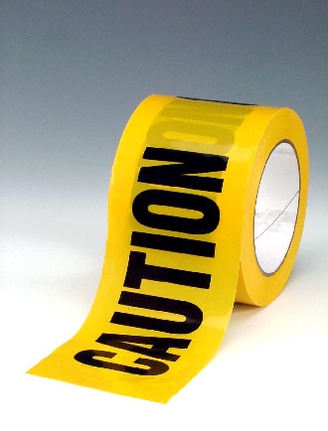
CATAPULTS ARE DANGEROUS
Be forewarned that like most machines, all catapults have the opportunity to be dangerous, even small ones. Catapults were originally invented with the intent to hurt people, so leaders need to be very safety conscious with boys around catapults. Be safe, so that mistakes won’t lead to injuries.

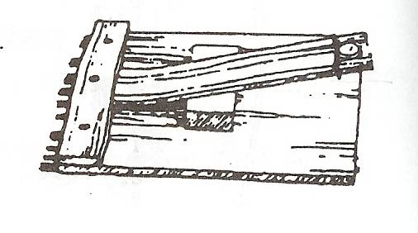

LEAF SPRING CATAPULT
Using wood scraps and an old ruler. Lay the ruler flat onto a larger board and nail another board over and inch of the end of the ruler. Then wedge a small board under the ruler to form the leaf spring catapult.
LEVER CATAPULT
Catapult Experiment: Use ruler and rubber eraser or other soft projectile. Have boy strike the short end of the ruler balanced on a dowel. How far did the eraser go? Now have him try it with half the ruler over the edge of a table and hit it with the same force. Why is there a difference in the distance that the eraser flies?
MOUSE TRAP-A-PULTS
The spring and lever action of a mousetrap can be harnessed for many kinds of fun machines. Give the boys mousetraps, string, tinker toys or K-nex and have a contest to build and see how far their mousetrap contraption could throw a small object like a dry bean. Below is an example with the mousetrap pulling a lever that then throws the bean.
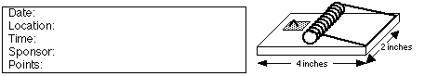

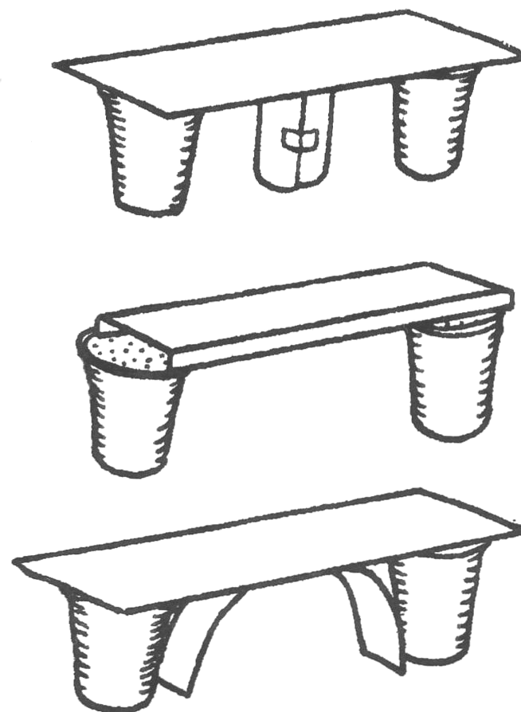
BUILDING CHALLENGES
PAPER BRIDGE CONTEST
Hand the Webelos each one sheet of 8½ x 11 paper, two foam cups, 4” of tape and a matchbox-sized car. Tell them to build a bridge that will support the toy car as it rolls across the bridge. They can cut or fold the paper into any shapes that they want. They may use small pieces of tape to help hold the paper in desired shapes but not to tape to the cups. This can be a group effort, team play or on an individual project. You can do something similar as a tower-building contest.
Strong Bridge Ideas:
- Cut a strip and roll it up. Use this as a center support.
- Fold two long edges of the card.
- Cut a strip and curve it under the bridge as a support.
- Cut three strips and sandwich one folded in a zig-zag.

TRUSS BRIDGES
You will need: Lots of mini-marshmallows, toothpicks, various weight objects.
- Give teams of boys an equal number of marshmallows and toothpicks.
- Between two equal-height objects (like tables) show them the distance that they must span with their bridge. Tell them that the contest will be to see how much weight their bridge can hold in the very center of the bridge
.
- The bridge must be at least one toothpick wide and you suggest that they use the marshmallows to connect the toothpicks.
- Tell them that the strongest shape is a triangle, so build a truss bridge that has lots of triangles in it.

PULLEYS, BLOCKS AND TACKLES
There are five kinds of basic machines that were discovered in ancient times. All complex machines are built out of some or all of these basic machines: wheel (with axle), pulley, wedge, screw and lever. This exercise will show the magic of how pulleys, and blocks and tackles can make lifting something heavy possible by exerting very little effort.
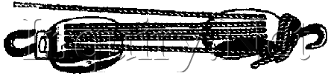
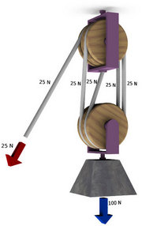
A pulley is a special kind of axle and wheel, where the axle is connected to some object, and a rope goes around the wheel. A block and tackle is formed by two pulleys that may each have several wheels, and a rope goes around both pulleys. Ropes and pulleys can be connected in many assorted ways to create different degrees of how easy it is to pull.
A simple “Come-along” can be made by tying a rope to a fixed object (like a tree), running the rope behind the object that you want to move, and pull on the rope while standing near the tree. You will only have to pull half as hard to make the object move, as if you tried to pull it directly, because the tree actually helps you pull. You can also achieve the same result by attaching a single-wheel pulley to the object that you want to move.
By using two pulleys, you may form a block and tackle. With pulleys that have enough wheels and enough rope, it would be possible for a Webelos Scout to move just about any heavy object that the rope and pulleys can support. The illustrations below show how to move more than what you normally are capable of pulling directly with a rope. The Mother Earth News website also has some excellent illustrations of blocks and tackles.

ELECTRICITY
All matter has electrons and when electrons move we see the effects of electricity. Metal and water are both good conductors of electricity. Metals like copper and aluminum are most often used to safely move electricity in appliances. Our bodies are also fairly good electrical conductors, because our bodies have a lot of water, which is why people have to be very careful around electricity.
Insulators are things that do not conduct electricity very well. Wood and plastic are two good examples of electrical insulators.
MAKE AN ELECTROMAGNET
Materials:
- Ten feet of 22-gauge coated copper wire
- 6-volt lantern battery
- 6 inch iron nail
- Steel paperclips
- Wire stripper and needle-nose pliers
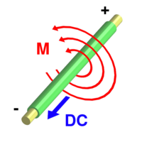
- Gloves
Electromagnets take advantage of a phenomenon where electricity moving in a wire causes a magnetic field around the wire (shown left).
A single straight wire, with electricity flowing through it, however, has a very small magnetic field. But when you wrap that wire round and round about 50 times in a long neat coil, the magnetic fields from all of the wraps add together to form a strong magnetic field. You can also multiply the strength of the coiled magnetic field, and make the coils much neater, by wrapping the coil around a long piece of iron or steel (like a nail). The more tight and neat the wraps are, the better it will work.
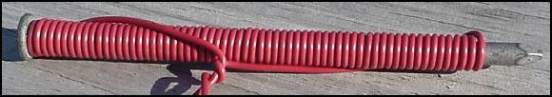
To make current flow through the wire, we need to make an electrical circuit. Strip a half inch of insulating plastic off of each loose end of the wire, and with the pliers curl the ends of the bare wires into U shapes. Scatter the paper clips on a table nearby. Put on a pair of dry, cloth gloves, because the wires may get hot when the current is flowing. Hook one bare wire onto one of the springs on the lantern battery. Now hook the other bare wire to the other spring connection on the battery and voila you now have an electromagnet that can pick up the paper clips and any other small ferrous objects. The electromagnet will work until the battery is drained or the circuit is broken.
Did you notice a spark when the second wire was connected to the battery? Notice how warm the wires get as the electrical current flows through them. Disconnect the wires while the electromagnet is holding paperclips and watch it drop them. Connect the circuit, pick-up paper clips in one place and move the electromagnet over a box, then disconnect a wire and drop the paperclips in the box. Continue this until all paperclips have been moved.

