READYMAN -- COMMUNITY GROUP
The Boy Scout motto is “Be Prepared”. It means that the Scout is always ready in mind and body to do his duty and to face danger, if necessary, to help other people. He learns first aid. He learns how to swim safely and how to ride his bicycle without danger to himself or others. He also learns how to make his home safer and the safety rules for passengers in the car. In earning the Readyman Activity Badge, you will get a faster start on being prepared as a Scout. Many of the things you learn help you advance as a Boy Scout.

Den Activities
- Visit your local ambulance service or fire department rescue squad.
- Ask a member of the local Red Cross or emergency trauma team to visit your den and show you how to save lives by learning: Hurry cases, shock, other minor emergencies.
- Learn how to get help from the local authorities such as the police, fire department, ambulance, or hospital, contact the police department to find out how to report or summon help in these situations.
- Consult with the local fire marshal, emergency services team, or police department to find out how to plan an emergency escape route, or find where most home accidents are likely to occur.
- Invite a member of the local Red Cross or a qualified swimming instructor who is a Water safety Instructor to show your den how to have a safe and fun time at the beach or the local pool.
- Build a buddy tag board and use it on an outing that involves water sports.
- Attend a Boy Scout first-aid demo.

General Directions for Giving First Aid - American Red Cross
- Keep the injured person lying down.
- Do not give liquids to an unconscious person.
- Restart breathing with mouth-to-mouth artificial respiration.
- Control bleeding by pressing on the wound.
- Dilute swallowed poisons and call the poison Control Center.
- Keep broken bones from moving.
- Cover burns with thick layers of cloth.
- Keep heart-attack cases quiet and give cardiopulmonary resuscitation (CPR) if it is necessary and if you have been trained.
- Keep a fainting victim lying flat.
- For eye injuries, pad and bandage both eyes.
- ALWAYS CALL A DOCTOR.

Fire Prevention

Kitchen Fire Extinguisher
Materials:
- Glass bottle
- Red and black construction paper
- Funnel (optional)
- Baking soda
- Black marker, scissors, glue
Directions:
Wash and dry the bottle.
Cover the outside with red paper; glue ends.
Draw extinguisher shape on front of bottle.
Write the words with black marker.
Fill the jar with baking soda (the funnel helps, if you have one).
Place next to kitchen stove.
If there should ever be a stove fire, pour the baking soda on the flames to put them out.

Possible Kit (It’s possible that what you forgot is here.)
35 mm film canister Rubber bands
Masking tape thumb tacks
paper clips Band-Aids
piece of chalk straight pins
Book matches Fishing line and fishhook
2 safety pins 1 quarter and 1 dime
2 kitchen matches 2 stamps
1 pencil stub 1 piece of string
Directions:
Wrap masking tape and rubber bands around the outside of the film canister and carefully put all other items into the canister.
And it’s just possible that what you forgot is in there.
You will survive a little longer.

Make Your Own First Aid Kit
What to Include:
For open wounds, cuts, skinned knees, and scratches
- 1 box 12 adhesive compresses
- 3 sizes sterile bandages
- 3 sterile gauze squares
- a small bottle antiseptic
For blisters
- - Adhesive compresses or gauze squares
- - narrow adhesive
For sprains
- - 1 triangular bandage
- - small scissors
For burns, sunburn
- - tube burn ointment - 5%
For splinters
- - small tweezers
- - needle
- - matches to sterilize
For fainting
- - small bottle aromatic spirits of ammonia
For bites or stings
- - small box bicarbonate of soda
For toothache
- - small bottle oil of cloves
For plant poisoning
- - small bar yellow soap
Ideas for containers to use:
- - A cigar box, a tin cracker or candy box - paint and decorate. Put a list of what-to-do inside the lid.
- - Make a cloth case with a strap.
- - A cloth kit with pockets. Fold over the top, roll up, and tie.

At your first meeting you will want the boys to explain what first aid is. FIRST AID is immediate help right after an injury. First aid isn’t playing doctor. It’s doing the things that must be done before expert help arrives. How will you act in an emergency? Would you know what to do? If you do, you’ll be cool and calm, because you know you can help. Your confidence will show and it will help the injured as you ease their pain and worry.

Activities:
- Ask a First Aid Merit Badge Counselor from a Scout Troop in your area to attend the meeting and explain the items in a first aid kit, or have him shoe what to do for “hurry cases.”
- Invite a Scout Troop to your meeting to show first aid for cuts and scratches, burns and scalds, and choking.
- Invite a police officer to speak on bicycle safety.
- Have a swim instructor go over the safe swim defense plan.
- Visit a fire station with an E.M.S. Unit.
- Visit a hospital E.R. or an Emergency Clinic.
- Put together a first aid kit for you Pack to take on outings.
- Stage a mock disaster involving injuries and have the boys treat the injuries. This could be done in conjunction with a Patrol from a nearby Troop. With the Scouts demonstrating more complicated skills and acting the part of the injured.
- Attend A First aid Rally in your area
- Visit the local Red Cross office and learn about how the teach First Aid
- Plan a fire escape plan for your home.

First Aid Actions
Severe Bleeding - Do not take any objects out that may have caused the bleeding and do not try to wash the wound. With one hand take a gauze pad and apply pressure with your hand. With the opposite hand wrap the wound. Continue to add pressure. If the wound continues to bleed apply pressure to an artery and seek medical attention. While doing all of the above elevate the wound above the heart to help reduce bleeding.
Stopped Breath - It is not necessary to determine if the victim has a pulse or not. In the event that the victim has a pulse, one would begin doing rescue breathing which is a process of blowing air into the lungs every 5 seconds in a effort to try to get them to breathe on their own. In the vent that the victim has no pulse one would begin CPR which is a process of blowing air into the lungs and pumping the heart at the same time. It is best that you do not give rescue breathing or CPR if you have not been trained. The best thing for you to do is seek medical attention as soon as possible. The brain can only go without oxygen for 4 - 6 minutes without damage.
Internal Poisoning - Poisons can be swallowed, inhaled, absorbed or injected into ones system. It is important that you call the Poison Control Center and get instructions on how to handle the emergency. Dial 911.
Heart Attack - Seek medical attention as soon as possible. It may be necessary to apply CPR.
Shock - Shock is a normal reaction to many emergencies and is the process of the body shutting down the normal flow of blood on a temporary basis. To treat, ask the victim to line down on their back and elevate their feet slightly. If they are conscious, get them to take some deep breaths and give them some water to sip. If they suffer from chills, offer them a blanket. If shock continues, seek medical attention.
Cuts and Scratches - Wash with clear water and bandage. Watch and treat for infection.
Burns and Scalds - Burns can be obtained by heat, chemicals, and electricity or radiation. Rinse all burns with dear water and wrap with dean and dry bandages. All burns except some first degree burns needs to have medical attention.
Choking - As long as a victim can speak, breath, or cough, encourage them to continue coughing. If the victim shows signs of troubled breathing, apply abdominal thrusts until the object is dislodged.

Things to Make
Buddy Board and Tags: One of the eight parts of the Safe Swim Defense is the use of the buddy system. In this everyone pairs off BUDDY TAGS with another person of his own swimming ability. Buddies check in and out of the swim area together.
The swim supervisor issues everyone a buddy tag so that he knows at all times that certain Scouts are paired with certain others. No one swims without a buddy tag displayed in the proper spot.
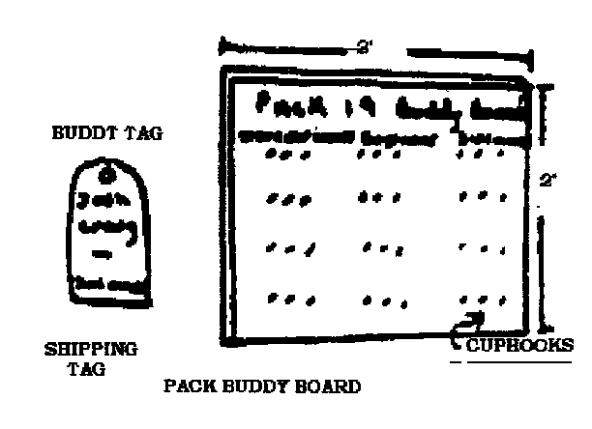
Simple badge tags make good buddy tags. So do wooden tongue depressors stuck into the ground or sand beach near the swim area. Both may be marked in pencil or waterproof marker with the swimmers name and his classification: non-swimmer, beginner, or swimmer.
Display the buddy tags by hanging them on inverted cup hooks screwed into a rectangle of plywood. Buddies hang their tags on the same hook. Have Scouts make a buddy board. Cut the wood, drill holes as show, and mark off the areas of equal dimensions. Shellac or varnish the whole works. Your Scouts may also make buddy tags for your pack.
Car Breakdown Marker
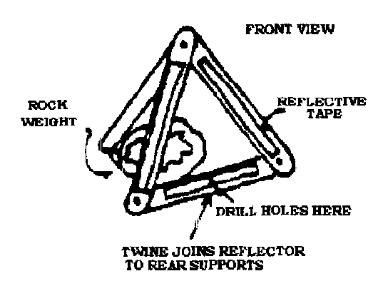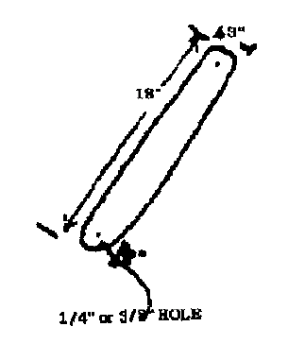
Equipment Needed:
- 5 Wooden paddles cut from 1/4” thick plywood/ wooden crate or similar
- ROCK WEIGHT
- 3 large brass paper fasteners or 1/4” x 1” threaded stock,
- long bolts with wing nuts,
- Self-adhesive reflective tape, and
- Some strong twine.
Cut paddles as shown. Cover one side of 3 paddles with reflective tape. Drill 1/4 or 3/8 inch holes as shown. In actual use, bolt or fasten the paddles together into a triangle shape as Illustrated. Fasten rear supports by tying with twine. Place the warning marker about 100’ behind the disabled car parked on the shoulder of the road. Reflective tape faces oncoming traffic. Weigh down the bottom rear support with a large rock or something similar.

GAMES

Pressure Pad Relay:
Equipment - Each boy using his own neckerchief.
One boy lies about 30 feet in front of the team with arterial bleeding” of the left wrist.
There is one judge for each victim.
On signal, the first boy from each team runs up and applies a pressure pad over the simulated would.
When correct, the judge yells “off’, the boy removes the pad and runs back to the team, tags off the next boy who repeats the operation.

Bandage Demonstration:
Equipment - As needed. One member of a den is the patient; the rest are first-aiders.
On “go” Number 1 runs to the patient and ties a head bandage and runs back;
Number 2 ties cross chest;
Number 3, thigh;
Number 4, ankle bandage;
Number 5, sling for arm; then
Numbers 6 and 7 go up and be chair carry transport for the patient back to the starting point. NO TIME ELEMENT (Note: In case of a small den, one or more boys may go up twice, until the project is completed).

What’s Wrong With Me?
Write down several different accidents or afflictions. (example: A broken legs A nose bleed, Choking, Shock, etc...) Place these in a hat and have the boys draw them out one at a time. The boy that drew will have to act out that particular problem. The first boy to identify the problem must show how to treat it, he now gets to pick and act out an accident.

Fire:
Seat Webelos Scouts in a circle with one in the center.
The one in the center calls out one of the following and points to one of the seated players: “Earth”, “Air”, “Water”, or “Fire”. (If there are more than four players, the names may be repeated.)
As he points, he begins counting slowly to 10.
The player to whom he points must answer as follows:
“Earth” must name four animals,
“Air” must name four birds or flying insects,
“Water” must name four fish or sea creatures.
If “Fire” is called, he remains silent.
If the player succeeds before the count of 10, another seated player gets a turn, and the Webelos in the center remains there.
If the player fails, he becomes the new leader and the old leader takes his place in the circle.

Douse That Fire:
Each team has a pail with a candle stub in a holder on the bottom. Fill the bucket to two inches below the candle wick and light the candle. Divide the den into two teams and give each team a cp and a jar of water. On signal, the first player on each team fills his cup, runs to the bucket, and empties the water into it. He then runs back with his cup and the next player repeats the action. Continue until one team has doused its fire by filling the bucket to candlewick level. A team is disqualified if a player pours water on the candle flame.

Fire Hazard Hunt:
Prepare for this game by creating some fire hazards in and around your meeting place -- matches left carelessly within reach of children; outside door blocked by a chair, oily rags in a pile in the garage; grease spilled near stove burner, newspaper piled near furnace; fireplace screen away from fireplace; frayed electric cord, etc. Ask boys to find and list on paper as many hazards as they can find. At the end of the game, check findings and explain the hazards. Urge Webelos to check their own home.

Fireman. Save My Child:
Divide den into two teams. One member of each team (the “child”) sits on an old throw rug or heavy cloth about 2’ x 3’ about 15 feet from his team. Each of the other players has a four foot length of rope. On signal, the boys tie their ropes together with square knots to form a rescue rope. When all ropes are tied, a player throws the rescue to the child and the team pulls him to safety. The den that ties all knots correctly and first pulls its child to safety is the winner.

The Search For Bigfoot Game:
This is a series of tests for each den leading to the discovery of Bigfoot. It can be adapted to either indoors or outdoors, but if you have a choice, make it outdoors. The object of the hunt is to complete the tests and find Bigfoot in the shortest time.
Station #1: Climbing the Mountain –
Build a string trail, with the string leading high and low between tree trunks, branches, etc. The den is blindfolded and each member follows the trail by sliding one hand along the string. (If indoors, run the string from chair to table to side of the room and back again.)
Station #2: One member of the den is lost and presumably injured in the mountains. That Cub Scout is sent some distance away and left lying on the ground. The other den members must find him, apply some simple-first aid, and bring him back to the stretcher made from two poles and a blanket.
Station #3: Finding Shelter - One the way up the mountain, a fierce storm stops the den. The boy must build a shelter with a blanket and a few poles that all den members can get under.
Station #4: After the storm, the den finds Bigfoot’s footprints near the camp. (The footprints are huge cardboard cutouts of an ape’s print and lead toward a wooded area or, toward another room.)
Station #5: As the den follows the footprints, the boys see Bigfoot (a leader in a fur coat and mask) scurrying off into the woods (or other room). Start dens at four or five minute intervals. Time each start. The winning den is the one which tags Bigfoot in the shortest time.

