SCIENTIST(2) -- TECHNOLOGY GROUP
A scientist studies things to team how they behave and why. Scientists try to find out the laws of nature about the things they study. People can use these rules or laws in making things. While working on this activity badge, you will learn a few of the main ideas in physics. Physics is a science with several branches. One of these branches will be weather. You can learn a little about weather in these activity badge requirements. Another branch of physics is called optics. You will have a chance to learn something about sight and find out how your eyes work. Scientists learn a lot by experimenting or trying things out. Try things for yourself. Scientists take nothing for granted. They may be sure an idea is true, but they always test it, if possible, to make certain they are right.
Speakers:
Lab Technician Researcher Zoologist
Optometrist Ophthalmologist Nuclear Physicist
Weather Forecaster Nurse X-Ray Technician
Science Teacher

Pack Meeting
- Honor your Pack leaders by making up some "Scientific Awards." Cut them out of poster board. For example:
  - Gravity is a heavy subject. (Shape of the Earth)
  - Stars are night lights that don't run up bills. (Stars)
  - Astronomers are far-sighted. (Glasses with big eyeballs)
  - Chemists really, stir things up! (Beaker with bubbling mix.)
- Science Fair: Set up and hold a science fair during your Pack meeting. Show some of the simple experiments you have been doing in your Den meetings.
- Display items that you have made.

Den Activities
- Talk about the various branches of science and how they differ.
- Do the atmospheric pressure tests or balance tests in the Webelos Book.
- Make Fog.
- Make Crystals.
- Do the inertia experiments in the Webelos Book.
- Visit an eye specialist and learn how the eyes converge and find out what the various eye tests measure
- Invite a local weatherman to your Den meeting to talk about the climate during the year. How is weather different in
- the Southern Hemisphere?
- Have a slow-motion bicycle riding contest to illustrate balancing skills.
- Plan a scientific experiment to be demonstrated at the Pack meeting.
Field Trips
- Visit an eye specialist and learn how the eyes work.
- Visit the control tower of the Metropolitan Airport or visit a Municipal Airport.
- Learn about the principles of fight for an airplane and look at all the control dials.

INERTIA
Inertia is the tendency of a thing at rest to remain at rest and a thing in motion to continue in the same straight line.
Get a small stick about 10-inches in length and the diameter of a pencil. Fold a newspaper and place it near the edge of a table. Place the stick under the newspaper on the table and let about half the stick extend over the edge of the table. Strike the stick sharply with another stick. Inertia should cause the stick on the table to break into two parts.

PASCAL'S LAW
Materials:
Rubber balloon
Several pins with large heads
Roll of plastic tape
Inflate the balloon and affix little squares of plastic tape to it. Stick each pin through the center of the tape and to their amazement, the balloon will not burst. When you remove the pins, the balloon still will not burst.
What happens: The adhesive substance on the tape acts like a self healing automobile tire, adhering to the pin as it is pressed inward. When the pin is removed, the adhesive is forced outward by the air pressure from within the balloon, atomically sealing the tiny pinholes.

MYSTIC MATCHES
Put several matches in a bowl almost full of water, making a shape like a star.
Stick a pin into a small piece of soap.
Gently dip the soap into the water at the center of the star of matches, taking care not to disturb them. The matches will all move away from the soap.
What happens: When you dip the soap in the water a little of the soap dissolves. The surface tension of the clean water is stronger that that of soapy water, so the clean water around them pulls the matches outward.

MAKE A FIRE EXTINGUISHER
Materials: 1 or 2 quart bottle with stopper to fit
3” of ½ “ glass, metal or plastic tubing (Tube from an old Windex bottle can be used)
Baking soda, Vinegar, Facial tissue
- Drill hole in stopper and insert tubing
- Wrap soda in tissue and attach tissue to tube with rubber band
- Fill bottle one half full of 1 part vinegar and 1 part water
- Insert stopper in bottle with soda inside bottle, but not touching vinegar solution
- To operate, tip bottle upside down, soaking the tissue paper with vinegar

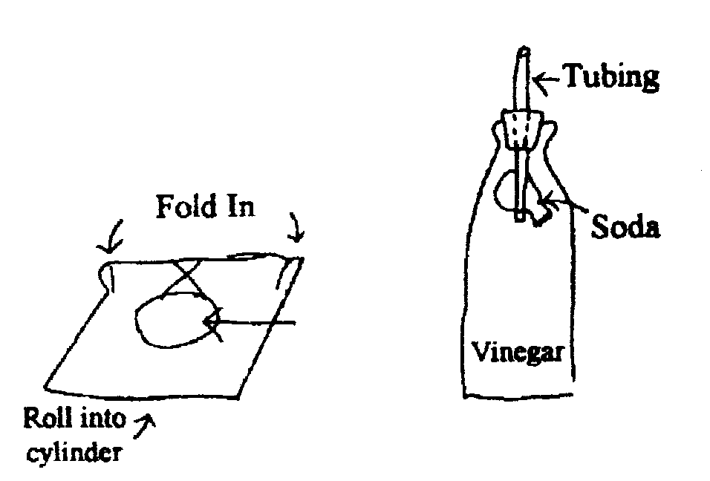

RECORD WIND SPEED
To see how fast or slow the wind blows, make an anemometer (a wind speed measurer)
You will need - stiff cardboard 24” x 12”
- Measure four 6” widths with a ruler, and draw pencil lines with scissors.
- Set a compass to 4” and draw an arc on the cardboard as shown.
- Cut out a narrow slot along the arc.
- Mark numbers at equal intervals along the slot.
- Fold the cardboard inward along the scored lines.
- Put cellophane tape along the two edges and along all the folded edges.
- Cut a piece of paper 4 ¾” square and tape it to the end of the box as shown. Take the anemometer outside and point the flap toward the wind. Each night and morning, record the level that the flap reaches

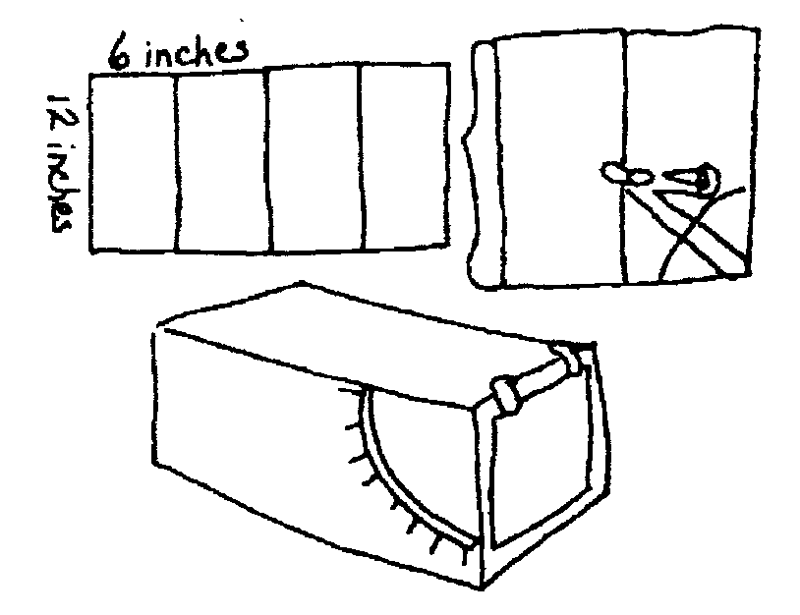

BOILING ICE
In a heatproof jar with lid, boil a half-inch of water with the lid on loosely so some of the steam can escape. Then tighten the lid and turn jar over. Put an ice cube or two on the jar bottom. In a moment the water will boil again.
What happens? The air pressure has been reduced in the jar by the ice condensing the water vapor inside. The boiling point of a liquid depends on atmospheric pressure.

BALLOON AND CAN RACE
Each team will need a balloon for every Webelos and a fruit can for each team. Each team will have a chair on each end of the room. Each team is divided with half of the team behind each of that teams chairs. The can is placed on a chair.
One boy holds the balloon in the can and blows it up enough to make the can stick on around the balloon. He then carries the balloon, with the can hanging on, to the other chair. He then deflates his balloon and the next boy inflates his own balloon and carries it and the can back to the original chair. The first team to switch locates wins.

EXPERIMENTS IN AIR PRESSURE
Shooting Back
Place an empty soda bottle on its side. Put a wad of paper in the neck and try to blow it in. It comes back out.
Why? When you blow into an enclosed space like a bottle, you increase the air pressure inside. Since pressure will equalize when it can, the air rushes out of the bottle, taking the wad of paper with it.

Balloon in Bottle
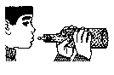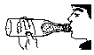
Place a deflated balloon inside a two-liter bottle, with the lip of the balloon over the top of the bottle. "Cry to blow up the balloon.
What happens? Air pressure inside the bottle increases as the balloon takes up space, so air pressure is fighting against you. To inflate the balloon, you would need to compress the air trapped between the balloon and the bottle. To compress air requires force. The human lungs are not strong enough to inflate the balloon and to compress the trapped air.

Making Air Work for Us
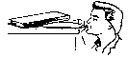
Use a balloon to pick up a glass -- Place a deflated balloon in a glass. Blow up the balloon until it is tight around the edge of the glass. Hold the end of the balloon shut and pick up the glass.
Use a balloon to lift books -- Place a deflated balloon under a stack of books. As you blow the balloon up, the books will rise. A hydraulic lift is based on this principle.

EXPERIMENTS IN ATMOSPHERIC PRESSURE
We live under a blanket of air called the earth's atmosphere. The air in the atmosphere exerts pressure of almost fifteen pounds per inch on every surface on earth.

Diving Bell
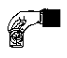
Place a piece of crumpled paper in the bottom of a glass or tin can. Turn the glass upside down and submerge it in a bucket of water. The paper will remain dry. Why? The air, which filled the "empty" space in the glass, stopped the water from entering.

Hanging Water
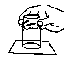
Fill a glass to overflowing and lay a piece of cardboard atop it. Support the card with one hand, turn the glass upside down, and remove your hand from the card. The card does not fall. It remains on the glass and allows no water to escape. Why? The air pressure from below the cardboard is greater than the pressure of the water above and presses the card tightly against the glass.

Wedged Glasses
Place two glasses together with a piece of wet construction paper between them. Burn a candle in the bottom glass. The glasses become "welded" together. Why? The flame uses up the oxygen in the bottom glass, so the pressure is now lower in this glass.

Auto Gyro
Materials: Paper 3 1/2" wide by 8 1/4" long
The principle of the Auto Gyro can be easily demonstrated by making one as shown in the sketch.
- Using a piece of paper 3 ½" wide by 8 ¼” long, cut down the center of the paper 4" and then fold the cut sections to opposite sides as shown, to form the two wings.
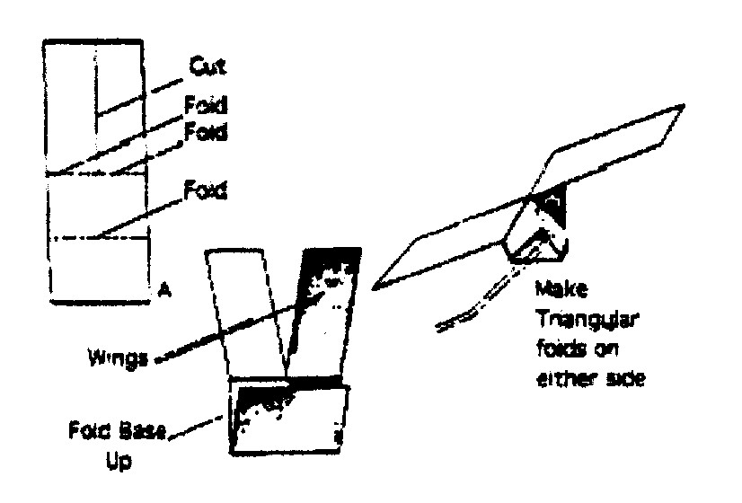
- Fold the balance in halt: and then make two triangular folds to the midline and your Auto Gyro is ready.
- Make two other Auto Gyros basically the same as the first one, but shorten the wing length from four inches to three inches on the second one and to two inches on the third one.
Try flying from the same height and observe how each model reacts. Does any thing seem to slow their descent'? What actually makes it spin'? Note the order in which the three models reached the ground. Are wing size, air resistance, and rate of descent related?

Spinner Scope
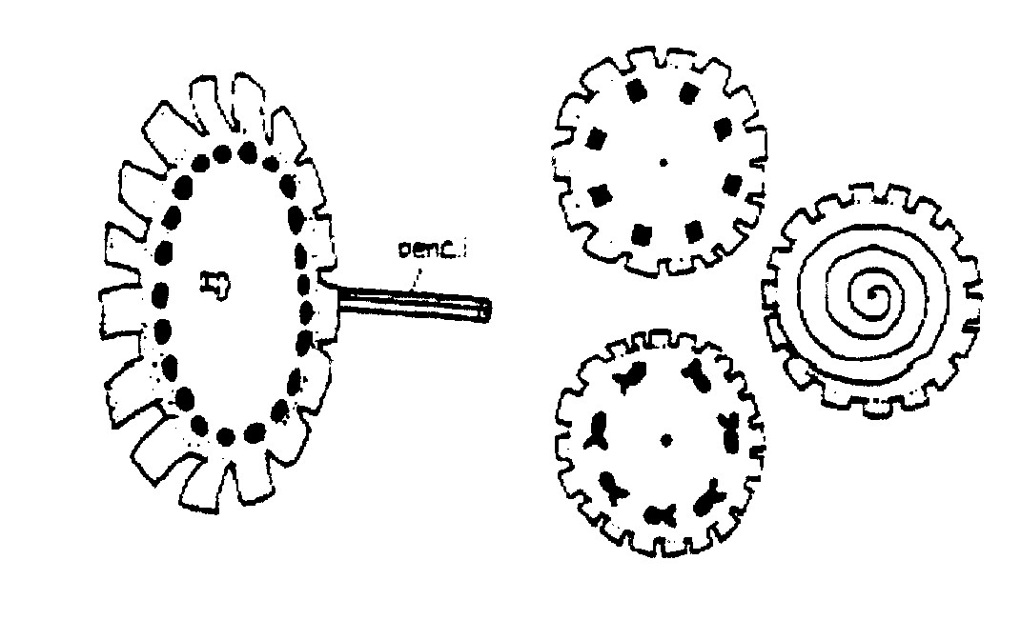Materials: Paper plates, scissors, watercolor markers, pushpin, unsharpened pencil with eraser top
- Cut out notches around edge of plates as shown.
- Draw a design on each plate with markers. Draw a spiral, small circles close to each other, or a simple object, such as a fish.
- Poke a pushpin through center of plate, then into eraser end of pencil.
- Stand in front of mirror. Spin pencil between hands as you peer through the notches. Each design will produce a different optical illusion as the spinning elements appear to merge.

