SPORTSMAN -- PHYSICAL SKILLS GROUP
Sports are high on the list of favorites of Webelos-age boys. Most members of your patrol will show real interest in the Sportsman badge. Chances are the boys spend much of their leisure time in organized sports and loosely organized neighborhood games. Some of them probably already know enough about rules, scoring, and techniques of play for several sports and can pass those requirements immediately. But that’s not really enough. On of the prime purposes of the Scouting program is to encourage good sportsmanship and pride in growing strong mind and body. If the boys learn all the skills and rules involved in every sport this month, but don’t get an inkling of what good sportsmanship means, then everyone has wasted their time, including the den leader. Sportsmanship is important whether you win or lose.
Suggested Patrol Activities
- Invite a referee or official to your patrol meeting to teach signals and talk about teamwork, fair play and sportsmanship.
- Hold a parent/son sports tournament, such as bowing, tennis, volleyball, archery, etc.
- Have a patrol board game marathon. Provide treats and boys bring their favorite board games to play. Allow time for rotation to different games.
- Have Webelos figure out a football, soccer or basketball play and diagram it. Local high school or little league coaches are sources of assistance.
- Go roller-skating or ice-skating.
- Visit an archery range and receive instructions on safety and procedures.
- Play some backyard games such as horseshoes, croquet, volleyball or badminton.
- Visit a sports shop and talk with the owner about selecting equipment.
- Have a patrol outing to a sports event.
- Hike around a golf course. Explain rules of etiquette and play to boys first so as not to disturb players.
- Watch a pro or college game on TV and have the boys practice the officials’ signals.
- Earn Sports belt loops for 2 sports that are new to the boys.

BALLOON VOLLEYBALL
You will need
1 - large inflated balloon and
1 - long piece of string.
- Divide boys into two teams
- Seat them on the ground in volleyball positions.
- The net is the string fastened between two trees, poles or attached to the walls for indoor use.
- The balloon is put into play by a serve
- Normal volleyball rules apply, except that the players cannot move from their seated positions on the floor or ground.

BALL OVER
You will need a ball about volleyball size.
Draw a line.
One team on each side of the line.
Players cannot cross the line.
The leader with a whistle is blindfolded or stands so he cannot see players.
When he blows the whistle, the ball is put into play.
Object of the game
To keep the ball in the opposing team’s territory.
When the leader blows the whistle again, a point is counted against the team on the side where the ball was when the whistle blew.

THE PENALTY BOX
Match the Officials’ Signal Calls to the correct sport.
FOOTBALL BASKETBALL BASEBALL
SOCCER HOCKEY
In which of the above sports would an official call -
Pass interference
Illegal Dribble
Technical Foul
Holding the Face Mask
Kneeing
Time-in
Slashing
Time-out
Charging
Fair Ball
Offside
Substitution
Ball
Hooking
Corner Kick
Incomplete Pass
Strike
Touchdown
Penalty Kick
Out
Delay of Game
Holding
Clipping
Foul Ball
Safe
Unsportsmanlike Conduct
Traveling
Tripping
Illegal Motion
Foul

INDOOR BASEBALL GAME
You will need
- 1 - large sheet of cardboard (can be any size so long as it is square).
- Marking pens,
Using the pens, draw a baseball diamond like one shown.
Mark home plate and the three bases.
Outside of the baselines write as shown: home run, strike, single, out, double, ball, triple and out.
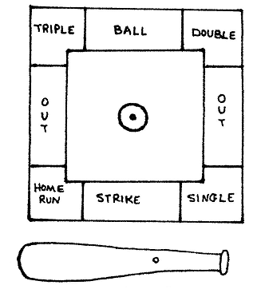
Draw pitcher’s mound in the center.
Cut a bat shape spinner from cardboard.
Punch small hole in bat and center of pitcher’s mound.
Attach bat with a paper brad to pitchers mound.
Be sure that the hole is not too small or too large, needs to be large enough for the bat to spin freely.
Follow regular baseball rules when playing. Keep score. Each player keeps his turn until he has three outs.

TOUGH SPORT
Want to give your Webelos Scouts the idea of “Good Sportsmanship?” Pick any really easy game to play like Red Light, Green Light. Leader is the light. Make it so tough that nobody wins. Usually after a short time they will start to complain about being too hard, not fair, no one can win. That’s a great opening for a sportsman-like conduct, good loser vs. bad loser discussion. It’s not just winning but playing and how you play. Then continue to play the same game in the same way. They should laugh a little longer this time.

Sports are high on the list of favorites of Webelos age boys. You can be certain of instant interest by most members of your den. Chances are that they spend much of their leisure time in organized sports and loosely organized neighborhood games. Some of them probably know enough already about rules, scoring, and techniques for several sports so that they could pass the badge requirements easily.
But that’s not really enough. One of the prime purposes of Cub Scouting is encouraging good sportsmanship and pride in growing strong in mind and body. If your boys learn all the skills and rules involved in every sport this month, and don’t get an inkling of what good sportsmanship means…then the den, and you, have wasted your time.
Agree on the importance of learning sportsmanship. What does that mean in practice? It means that the least skilled gets just as much instruction and encouragement as the best athlete. It means that the better athletes learn not just to tolerate the awkward boy, but learn to help him. It means that all boys can win and loss with grace and good sportsmanship.
Your own example will help to achieve these goals. Put stress on the fun of the game, not on the winning. When you have den competitions, make up the teams so that the strength is about even. If you let boys choose teammates, there is a good chance that most of the best players will wind up on the same team. Encourage the less skillful players. Discourage others from belittling them. Sports in a Webelos den should be fun for all the boys.

BASEBALL GAME
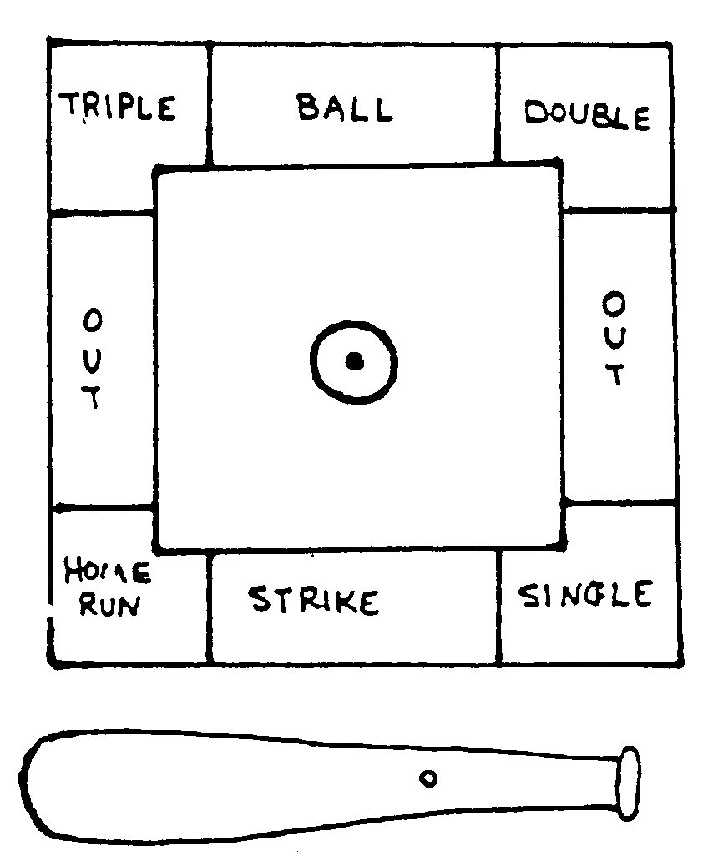
Need:
- Sheet of cardboard (can be any size, must be square)
- Marking pens
- Paper brad
Let each of the boys make his own to take home. Cut a large square from the cardboard. Using marking pens draw a baseball diamond on it like the one shown.
Mark home plate and three bases.
Outside of the baselines write as shown: Home Run, Strike, Single, Out, Double, Ball, and Triple.
Draw pitcher’s mound in the center.
Cut a bat shape spinner from cardboard.
Punch small hole in bat and center of pitcher’s mound.
Attach bat with paper brad to pitchers mound. Be sure that the hole is not too large or too small, needs to be large enough for the bat to spin freely.
Follow regular baseball rules when playing. Keep score. Each player keeps his turn until he has three outs.

WHAT ARE WE???
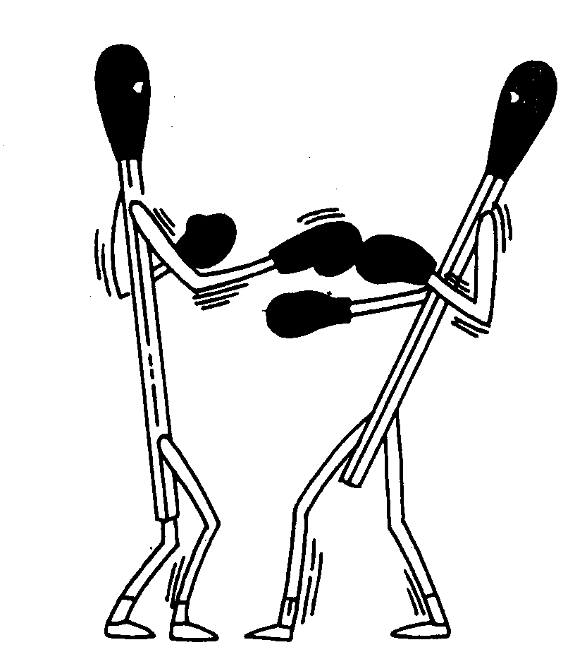
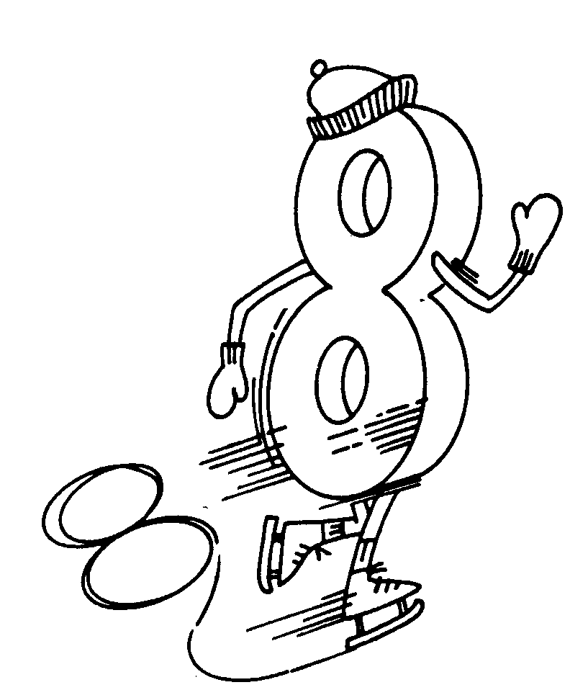
ANSWER :Boxing match, figure 8 skating

Den Meeting Ideas
Demonstrate the signals of baseball and have the boys do them
Hold parent/son bowling contest
Discuss the rules and regulations of various sports
Attend a high school, college or professional sporting event
Have a Sports Sunday and watch a pro game on TV (combine with a backyard tailgate cookout)
Have a fishing derby
Play miniature golf
Have a referee talk to the boys about the rules of his sport
Walk a golf course and observe play (get permission first!)
Have archery practice using targets against bales of hay
Visit a tennis court or racquet club
Have a high school coach come and talk about what it takes to become a good athlete

SKI-SKATE TAG
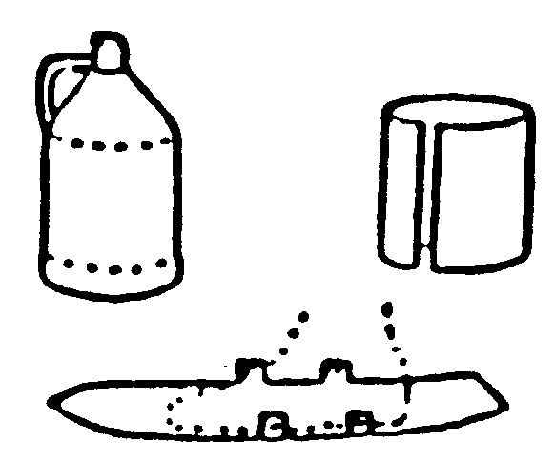
For a pair of shorty skis, remove top and bottom of two gallon plastic bottles. Cut down seams and flatten into strips, curved at the ends. Stand on center of the plastic and mark width of shoe at the widest point. Mark small tabs on each side of foot and a second pair of tabs near ankles. Cut plastic to the width of foot with tabs attached. Trim skis to a point at the front. To fasten skis to shoes, punch holes in tabs. Bend tabs up and lace with ribbon or cord, lacing over tops of shoes and around ankles.

SOCCER BALL NECKERCHIEF SLIDE
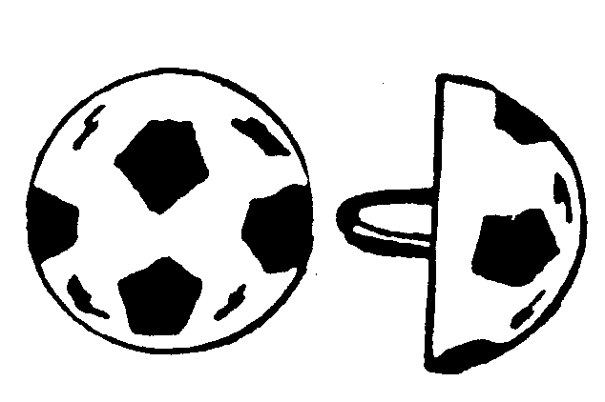Materials:
Ping Pong ball
Plaster
Pop top ring or small ½” PVC pipe ring
Black acrylic paint
Directions:
Cut a ping-pong ball in half.
Fill the half of ball with plaster and
Insert pop-top or PVC ring for slide.
Decorate with black paint.
The same idea can be used to make a Basketball, etc.

